
BUSINESS PLAN

[YEAR]

A Food Franchise

Add a joy of best taste

John Doe

10200 Bolsa Ave, Westminster, CA, 92683

(650) 359-3153

info@upmetrics.co

https://upmetrics.co
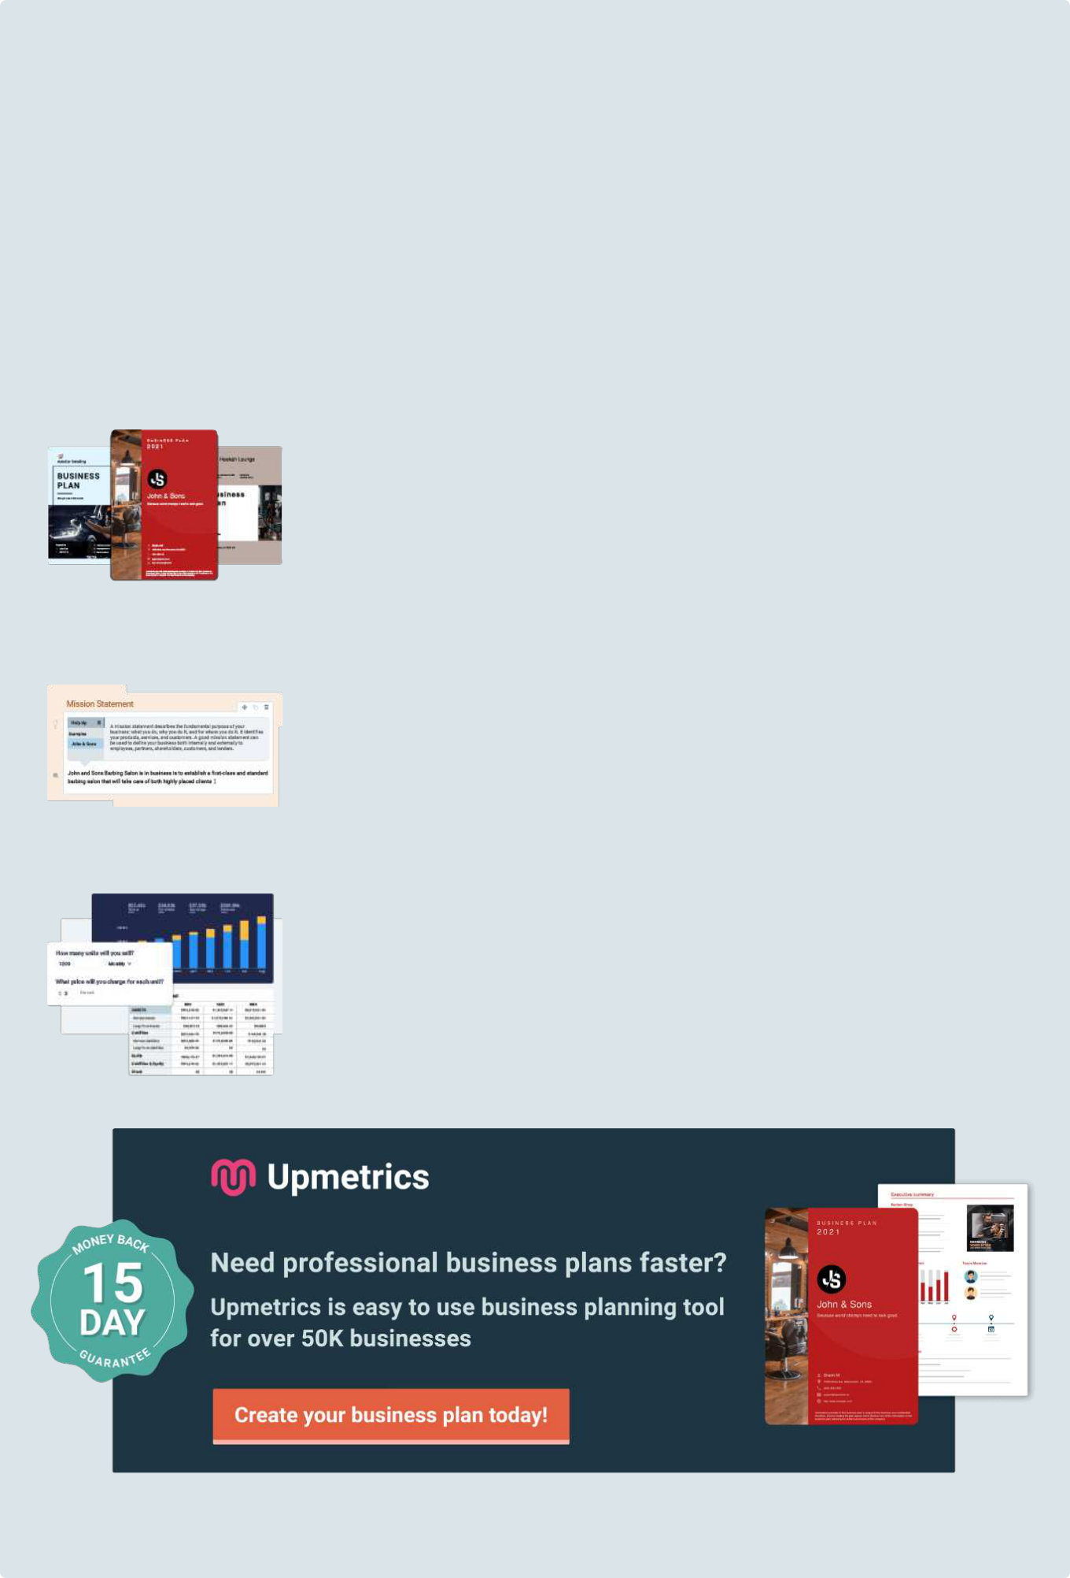
Easy to use Business Plan Software

Get started using a business plan template is always the fastest way to write your business plan, but as you know, you can't just fill in the blanks along with a template. You will need a collaborative tool that guides you on every step of your planning.

Upmetrics can help. With Upmetrics, you can easily bring your team to write a professional business plan with automated financial forecasts. You can also do:

200+ Sample business plans

Get access to hundreds of sample business plans covering almost all industries to kick start your business plan writing. This helps you to get an idea how the perfect business plan should look like.

View Sample Business Plans

Step-By-Step Guide

You'll receive step-by-step instruction as soon as you select any business plan template. We made business planning easy with prompt help and examples on every step of your business plan writing.

See How It Works

Conduct accurate financial projections

Do not worry about not having accounting skills. With Upmetrics, Simply enter your sales and costs figures, and we'll prepare all of your monthly/quarterly and yearly financial projections.

See How It Works

1.


EXECUTIVE

SUMMARY

PRELUDE

ANALYZING THE MARKET

PRODUCT OFFERING

MISSION

MARKETING OBJECTIVES

TEAM

FINANCIAL SUMMARY
PRELUDE

Start Writing here...

ANALYZING THE MARKET

Start Writing here...

PRODUCT OFFERING

Start Writing here...

MISSION

Start Writing here...

MARKETING OBJECTIVES

Start Writing here...

TEAM

Start Writing here...
FINANCIAL SUMMARY

Profit & Loss Chart

Start writing here...

2.

INTRODUCTION

ABOUT THE CHEF

ABOUT RITZA

PROOF OF CONCEPT

INDUSTRY OVERVIEW

OUR TARGET MARKET

OUR OPPORTUNITIES AHEAD
ABOUT THE CHEF

Start Writing here...

ABOUT RITZA

Start Writing here...

PROOF OF CONCEPT

Start Writing here...
INDUSTRY OVERVIEW

FOOD INDUSTRY IN THE UAE

Start writing here...

Start Writing here...

CURRENT INDUSTRY PROBLEMS

Whom ?


People,

Restaurant/Street Food

consumers.

Causes

Fast foods are high in saturated fats which are widely held to be a risk factor in heart disease. It has high sugar levels and usually, food safety standards are not maintained.

Fast-food consumption has been shown to increase caloric intake, promote weight gain, and an elevated risk for diabetes

Excessive use of Artificial Preservatives- The products used are usually high on preservatives or are stale having a negative impact on consumer’s health.


Impact

Health Problems, Rapid increase in Obesity among the kids , Excessive use of Artificial Preservatives

Solution


We at Ritza have a clear intent of preparing fresh and healthy food at quick service and this would be done by serving it with integrity. One of the many steps that would be adopted is the use of fresh ingredients, stop relying on artificial flavors or fillers, and even making health safety and hygiene acquire the pole position in the use of the Central Food Production Unit. To couple this with the fact that wraps are any day healthier and lighter than bread

and to use fillers like spinach and tomato would certainly make the food high on taste yet modest on the calorie-front.

Solution Features


Fresh Healthy Quick

Write something about a

feature.

OUR TARGET MARKET

Start Writing here...

OUR OPPORTUNITIES AHEAD

Start Writing here...

3.

5 C ANALYSIS

COMPANY

OUR TEAM

OUR MILESTONE: SUCCESSFUL IN UK

COLLABORATORS

CUSTOMERS

COMPETITORS

COMPETITORS MAPPING
COMPANY

Start Writing here...

OUR TEAM


JOHN DOE

CEO - johnd@example.com

He is the man behind Ritza With more than 15 years of experience in the food industry, John has had education completed from dream institutions like Harvard and Preston. He is a Michelin star trained chef and there are no surprises that previously, he has also held high positions such as the Site Development Head Chef in Fuller, Smith and Turner, Surrey, UK. developing recipes.

OUR MILESTONE: SUCCESSFUL IN UK

Start Writing here...

RITZA’S OPERATIONAL MODEL

Start writing here...

Start Writing here...

CENTRAL FOOD PRODUCTION UNIT (CFPU) – RITZA’S CORNERSTONE

Start writing here...

COLLABORATORS

Start Writing here...

CUSTOMERS

Start Writing here...

COMPETITORS

Start Writing here...

COMPETITORS MAPPING

Start Writing here...

4.

SWOT ANALYSIS


Strengths

Ritza's main strength lies in its taste as the entire catering would be managed by a Michelin Star trained chef Krishna Parekh

This comes with the high nutrition value that would be consciously taken care of locally adapted food/taste that suits the natives

Ritza, despite being launching itself has all the experience of how to start from the scratch situation as it had established itself successfully in the UK

Quick serving speed

Reasonable cost

Weaknesses


No proven business venture success achieved so far in the UAE

Sufficient funds that would be required to fulfill the marketing and advertising obligations


Opportunities

The expansion of the fast-food industry acts as a big plus for fast food restaurants

Increasing demand for healthy fast food

Changing the eating habits of the people due to fast-paced life has further strengthened the demand in the UAE

The ease of doing business in the country puts start-ups with plenty of opportunities

Threats

Natural threats that arise from the already existing players in the market

High iteration rate at fast-food restaurants

Any fast food restaurant is highly sensitive to any kind of negative publicity

5.

CLIMATE

PEST ANALYSIS

BUSINESS MODEL
PEST ANALYSIS

POLITICAL

Start writing here...

ECONOMICAL

Start writing here...

SOCIAL

Start writing here...

TECHNOLOGICAL

Start writing here...

BUSINESS MODEL

Key Partners | Key Activities
Already existing players in the fast food and | Our mission is simple and that is, “Fast, cheap,
health &well being industry | fresh, delicious food with a fine dining taste
 | profile” which unequivocally implies to serve
Angel Investors who could be top executives to | high-end fast food and beverages at a quick
celebrities to entrepreneur s etc. | pace having high nourishment value that pleases
 | our customers
VALUE PROPOSITION | Customer Relationship
Ritza’s tends to serve high-quality fast food | Ritza aims to build customer relationship by
without compromising on the nutrition value with | taking their opinions about critical elements of
quick serving speed | the dining experience which may include staff
 | courtesy, service speed, order accuracy, food &
For all units, the price of food would always be at | beverage quality, food services, restaurant
par with what people can afford despite all the | layout, and cleanliness
frustrating ambiance and services
 | Keeping all your customers updated with what’s
 | new and also sharing success stories through
 | emails and social media channels.

COST STRUCTURE | Key Resources
Cost of production - Operating expenses - Rent, | The restaurant units that includes all operational
Salaries, etc. | models viz., Ranch, Wrap and Go
Marketing commitments would be an ever going | Our Michelin Star trained chef – John Doe
disbursement
 | Our team of planning pundits, managers, and
 | staff supervisors.

 | Customer Segments | Channels
 | Health Conscious people | Ritza would locate itself strategically at different
 |  | places with the maximum footfall that grabs
 | Youngsters | paramount attention
 | Family | This would cover the Airport to Malls to high-end
 | Working professionals | residential areas
 | REVENUE STREAM
 | Fast food – Wraps, Salads, Soups, and
 | Beverages
 | Corporate Orders - Franchising at a later stage

6.

STRATEGY

SEGMENTATION, TARGETING, AND POSITIONING (STP)

MARKETING STRATEGY

THE 5 CRITICAL SUCCESS FACTORS

EXPANSION PLAN

RISK
SEGMENTATION, TARGETING, AND POSITIONING (STP)

Segmentation: | Targeting : | Positioning :
Demographics: Primarily | Our main focus would | Highly nutritious to separate it from the
young men and women | always be to target young | other fast foods thereby inviting from all
belonging to each section of | people, males or females | sections from job professionals to
the society from | from all economic sections | businessmen to students to health-
professionals to students. | of the society • | conscious freaks
Geographic: Launch | Our family restaurants aim | The Ritza Sauces will get people
ourselves in Dubai and then | to cater to the conventional | addicted to it
float to other places in UAE | section of the society
and then target India as the
next country
Psychographic:
Trendsetting youngsters
always looking to
experiment

MARKETING STRATEGY

ONLINE STRATEGY

Start writing here...

OFFLINE STRATEGIES

Start writing here...

LOYALTY PROGRAMS

Start writing here...

CORPORATE TIE-UPS

Start writing here...

OTHER DRIVERS OF FOOTFALLS

Start writing here...

THE 5 CRITICAL SUCCESS FACTORS

We believe in consistent quality and service that will fetch us sustainable growth. Following touchpoints are the most critical aspects of our business which need to be focused on and checked regularly.


Price Speed Of Service


Location Quality of food

Cleanliness

EXPANSION PLAN

Start Writing here...

Phase I

Start writing here...

Phase II

Start writing here...

Phase III

Start writing here...

RISK

Start Writing here...

7.

FINANCIALS

PROFIT & LOSS STATEMENT

CASH FLOW STATEMENT

BALANCE SHEET

FUNDING DETAILS
PROFIT & LOSS STATEMENT

CASH FLOW STATEMENT

BALANCE SHEET

FUNDING DETAILS

Want to make it more presentable?

Want help tips on each section?

You'll save time and can write your professional business plan effectively and faster with Upmetrics' business plan software.

Every feature you need to convert your great business idea into a reality.

Write your plan easily and faster without any hassles.

Structure your idea and create stunning pitches that awe your investors.

Get access to Upmetrics software, invite your team members and start writing your business plan.

1. Get tried and tested tips

Upmetrics business plan builder gives you everything you need to stay in sync and guides you on every step of your business plan writing.

2. Write an interactive plan

Use our business plan sections - competitive Analysis, comparison tables, SWOT Analysis, charts, timelines, milestones, etc to create a visually impactful business plan.

- Stunning business plan cover pages

Upmetrics business plan builder comes with beautifully designed cover pages. Choose professional, creative cover pages to make your business plan stand out.

4. Financial forecasting

With Upmetrics you don’t have to worry about navigating complex spreadsheets. Just input your numbers and we’ll provide you with well-structured financial reports that you and your investors understand.

5. Share easily with anyone

Upmetrics plans are easily shareable in pdf and word documents. And if either doesn’t work, you can share it with a quick link too and track the reader's activity!

6. Real-time and Collaborative

Invite your team members to initiate conversations, discuss ideas and strategies in real-time, share respective feedback, and write your business plan.

Join over 100k+ entrepreneurs who have used Upmetrics to create their business plans.

Start writing your business plan today

