
AffiliateMarketing BusinessPlan
"TurnClicksIntoCash."

BusinessPlan
2024

JohnDoe
10200BolsaAve,Westminster,CA,92683

(650)359-3153

info@example.comhttps://www.example.com/

Information provided in this business plan is unique to this business and confidential; therefore, anyone readingthisplanagreesnottodiscloseanyoftheinformationinthisbusinessplanwithoutpriorwritten permission of the company.

TableofContents

ExecutiveSummary
6
Marketopportunity 7
UniqueSellingPoints(USPs) 7
Marketing&SalesStrategies 8
FinancialHighlights 8
UnitsSoldv/sRevenueChart 8
CompanyOverview
10
Ownership 11
BusinessOwners 11
Missionstatement 12
Business history 12
Futuregoals 12
MarketAnalysis
13
TargetAudience 14
Marketsizeandgrowthpotential 14
MarketSize 15
Competitiveanalysis 15
ShareASale 15
CJAffiliate 15
RakutenAdvertising 16
Markettrends 16
Regulatoryenvironment 17
ProductsandServices
18
Services 19
AffiliateRecruitmentandVetting 19
AffiliateProgramManagement 19
BrandStrategyConsultation 20
AffiliateTrainingandSupport 20

MarketingCampaignCreation 20
AdditionalServices 21
SalesAndMarketingStrategies
22
UniqueSellingProposition(USP) 23
PricingStrategy 23
Marketingstrategies 24
Online 24
Offline 24
Salesstrategies 25
Customerretention 25
OperationsPlan
27
Staffing&Training 28
OperationalProcess 28
Equipment&Tools 29
ManagementTeam
30
Founders/CEO 31
RachelMartinez 31
DavidChen 32
Keymanagers 32
EmilyCarter 32
JamesWilson 33
SophiaLopez 33
Organizationalstructure 34
Organizationchart 34
Compensationplan 34
Boardofadvisors 35
Dr.Amanda Blake 35
MichaelRivera 35

Financial Plan
36
Profit&lossstatement 37
Cashflowstatement 42
Balancesheet 44
Break-evenPoint 46
Financingneeds 48
Appendix
50
EmbedLink 51


Businessplanningthat’ssimplerandfasterthanyouthink

CreatingabusinessplanusingUpmetricstostartandgrowabusinessisliterallytheeasiest thingintheWorld.Simplyreadtheinstructionsandfillintheblanks.It’sassimpleasthat.

Upmetrics has everything you need to create a comprehensive business plan.
❛
❜

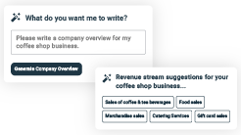
AI-poweredUpmetricsAssistant

AI-poweredinsightstostreamlineyourplan
Not sure where to start? Upmetrics’ AI Assistant will automaticallygenerateideasforeachsectionofyourplanand offerimprovedversionsofyourwriting,adjustingfortone,voice, and grammar or spelling errors.

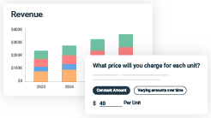
FinancialForecastingTool

Allthefinancialsarecalculatedforyou
Forget the complex formulas and clumsy spreadsheets — withautomaticfinancialsanddrag-and-dropforecasting,you canfinishyourplanfasterandbeconfidentthatyour numbers are accurate.

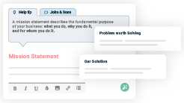
BusinessPlanBuilder

Guidesyoulikeabusinessmentor
Upmetrics’step-by-stepinstructions,prompts,andthelibraryof 400+samplebusinessplanswillguideyouthrougheachsection of your plan as a business mentor.

1.

ExecutiveSummary

Marketopportunity
Unique Selling Points (USPs)Marketing & Sales StrategiesFinancial Highlights



Anexecutivesummaryisthefirstsectionofthebusinessplanintendedto provide an overview of the whole business plan.
Tounlock helptry Upmetrics!

Helptip
AffiliateGrowthHub
Startyourexecutivesummarybybrieflyintroducingyourbusinesstoyourreaders.Thissection mayincludethenameofyouraffiliatebusiness,itslocation,whenitwasfounded,etc.
Tounlock helptry Upmetrics!
Startwritinghere..

Marketopportunity

Helptip
AffiliateGrowthHub
Summarize your market research, including market size, growth potential, and marketing trends.Highlighttheopportunitiesinthemarketandhowyourbusinesswillfitintofillthegap.
Tounlock helptry Upmetrics!
Startwritinghere..

UniqueSellingPoints(USPs)

Helptip
AffiliateGrowthHub
Emphasize what sets your affiliate business apart—highlighting unique selling points (USPs) and special features that make it distinctive is always a plus.
Tounlock helptry Upmetrics!
Startwritinghere..

Marketing&SalesStrategies

Helptip
AffiliateGrowthHub
Outline your sales and marketing strategies—what marketing platforms you use, how you plan on acquiring customers, etc.
Tounlock helptry Upmetrics!
Startwritinghere..

FinancialHighlights

Helptip
AffiliateGrowthHub
Brieflysummarizeyourfinancialprojectionsfortheinitialyearsofbusinessoperations.Include
capitalorinvestmentrequirements,associatedstartupcosts,projectedrevenues,andprofit
forecasts.
Tounlock helptry Upmetrics!
Startwritinghere..

UnitsSoldv/sRevenueChart

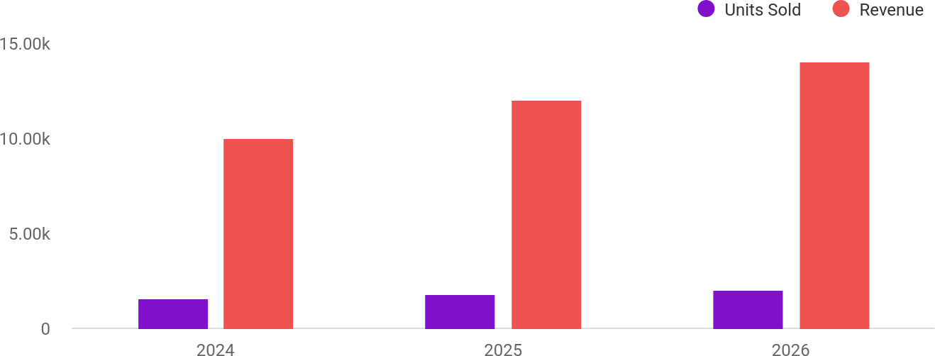

FinancialYear | UnitsSold | Revenue
2024 | 1,550 | $10,000
2025 | 1,800 | $12,000

FinancialYear | UnitsSold | Revenue
2026 | 2,050 | $14,000

Helptip
AffiliateGrowthHub
SummarizeyourexecutivesummarysectionwithaclearCTA,forexample,invitingangel investors to discuss the potential business investment.
Tounlock helptry Upmetrics!

Writeacalltoactionforyourbusinessplan.

2.

CompanyOverview

OwnershipMission statementBusiness historyFuture goals

Dependingonwhatdetailsofyourbusinessareessential,you’llneed different elements in your business overview.
Tounlock helptry Upmetrics!
Helptip
AffiliateGrowthHub
Describeyour businessin this sectionby providingall the basicinformation:

Describewhatkindofaffiliatemarketingcompanyyourunandthenameofit.Youmay
Tounlock helptry Upmetrics!
Startwritinghere..

Ownership

Helptip
AffiliateGrowthHub
List the names of your affiliate company’s founders or owners. Describe how much shares they own and their responsibilities for efficiently managing the business.
Tounlock helptry Upmetrics!
Startwritinghere..

BusinessOwners

RachelMartinez
75%

DavidChen
25%

Missionstatement

Helptip
AffiliateGrowthHub
Summarizeyourbusiness’objective,coreprinciples,andvaluesinyourmissionstatement.This statement needs to be memorable, clear, and brief.
Tounlock helptry Upmetrics!

At [AffiliateGrowthHub],ourmission is to empowerbrandsand affiliates to achieve measurable success through innovative
❛
marketing strategies, seamless collaboration, and transparent partnerships. We are committed to fostering a results-drivencommunity built on trust and mutual growth.
❜

Businesshistory

Helptip
AffiliateGrowthHub
Ifyou’reanestablishedaffiliateserviceprovider,brieflydescribeyourbusinesshistory,like— whenitwasfounded,howitevolvedovertime,etc.
Tounlock helptry Upmetrics!
Startwritinghere..

Futuregoals

Helptip
AffiliateGrowthHub
It’scrucialtoconveyyouraspirationsandvision.Mentionyourshort-termandlong-termgoals; they can be specific targets for revenue, market share, or expanding your services.
Tounlock helptry Upmetrics!
Startwritinghere..

3.

MarketAnalysis

TargetAudience
MarketsizeandgrowthpotentialCompetitive analysis
Market trendsRegulatoryenvironment

Marketanalysisprovidesaclearunderstandingofthemarketinwhichyour
printingbusinesswillrunalongwiththetargetmarket,competitors, and
growthopportunities.
Tounlock helptry Upmetrics!
Helptip
AffiliateGrowthHub
Towritetheintroductionsectionofyourmarketanalysis,startbyclearlyidentifyingyour primary target market.
Tounlock helptry Upmetrics!
Startwritinghere..

TargetAudience

Helptip
AffiliateGrowthHub
Startthissectionbydescribingyourtargetaudience.Defineyouridealcustomerandexplain
whattypesofservicestheyprefer.Creatingabuyerpersonawillhelpyoueasilydefineyour
targetmarkettoyourreaders.
Tounlock helptry Upmetrics!
Startwritinghere..

Marketsizeandgrowthpotential

Helptip
AffiliateGrowthHub
Describeyourmarketsizeandgrowthpotentialandwhetheryouwilltargetanicheoramuch broader market.
Tounlock helptry Upmetrics!
Startwritinghere..

MarketSize

AvailableMarket
7M
All businesses using or considering affiliate marketing strategies.

ServedMarket
1M
U.S.-based businesses seeking performance-drivenmarketingsolutions.

TargetMarket
Niche-focused brands in e-commerce, SaaS, and wellness industries needing quality affiliates.
200k


Helptip
AffiliateGrowthHub
Identifyandanalyzeyourdirectandindirectcompetitors.Identifytheirstrengths and
weaknesses,anddescribewhatdifferentiatesyouraffiliateservicesfromthem.Pointouthow
youhaveacompetitiveedgeinthemarket.
Tounlock helptry Upmetrics!

Competitiveanalysis

ShareASale
ShareASale is a popular affiliate network catering to small-to-mid-sized businesses across various industries. It has been in operation for over 20 years and boasts a vast affiliate network.

Features
Accesstoawidenetworkof affiliates.
Customizable tracking and reporting tools.
Support for multiple commission structures.

Strengths
Largeanddiverseaffiliate base.
Competitivepricingforsmall businesses.
Easy-to-use platform with robusttrackingcapabilities.

Weaknesses
Limitedfocusonnichemarkets.
Minimal personalized support for brands or affiliates.
Outdatedinterfacecomparedto newer platforms.

CJAffiliate
FormerlyknownasCommissionJunction,CJAffiliateisaleaderintheaffiliatemarketingspace, primarily catering to large enterprises and global brands.

Features
Advanced performance tracking and analytics.
Globalreachwithaffiliatesin various markets.
Dedicated account managementforpremium clients.

Strengths
High-qualityaffiliatesand established brand partnerships.
Superiordataanalyticsand reporting tools.
Well-suitedforscalinglarge affiliate programs.

Weaknesses
High costs and fees, making it lessaccessibleforsmallormid- sizedbrands.
Focus on established brands, neglectingstartupsorniche players.

RakutenAdvertising
RakutenAdvertisingisapremiumaffiliatenetworkofferingperformance-drivensolutionsforglobal brands, focusing on data and insights to drive results.

Features
Globalaffiliatenetworkwith multilingual support.
AI-driven insights for optimizing campaigns.
Exclusivepublisher relationships.

Strengths
Strong presence in internationalmarkets.
Advanced AI tools for campaignoptimization.
Partnershipswithhigh- performingpublishers.

Weaknesses
Limited focus on smaller businesses.
Complexpricingmodelsthat may deter budget-conscious clients.

Markettrends

Helptip
AffiliateGrowthHub
Analyze emerging trends in the industry, such as technology disruptions, changes in customer behavior or preferences, etc. Explain how your business will cope with all the trends.
Tounlock helptry Upmetrics!
Startwritinghere..

Regulatoryenvironment

Helptip
AffiliateGrowthHub
List regulations and licensing requirements that may affect your affiliate business, such as business registration, licensing, staffing requirements, financial regulations, etc.
Tounlock helptry Upmetrics!
Startwritinghere..

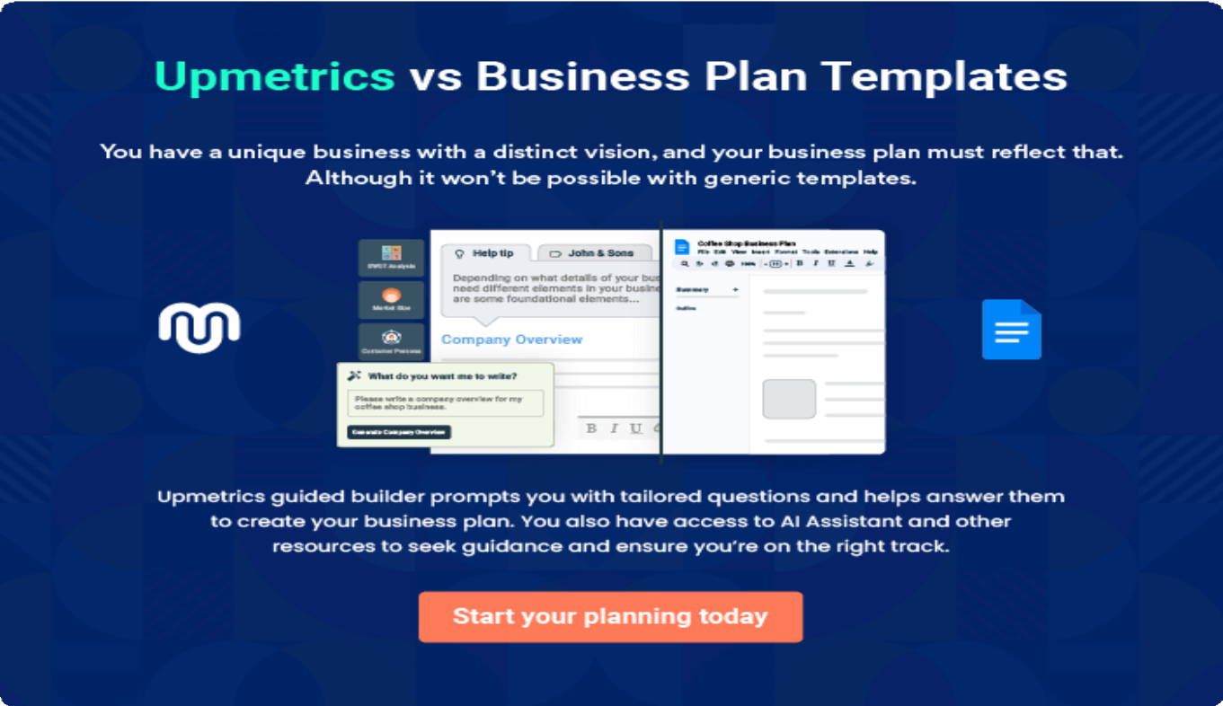

4.

Productsand Services

Services
AdditionalServices

Theproductandservicessectionofaaffiliatemarketingbusinessplan
shoulddescribethespecificservicesandproductsthatwillbeoffered to
customers.Towritethissectionshouldincludethefollowing:
Tounlock helptry Upmetrics!
Helptip
AffiliateGrowthHub
Tocrafttheintroductionforyour"ProductsandServices"chapter,beginbypositioningyour business within its industry, emphasizing its unique strengths or value proposition.
Tounlock helptry Upmetrics!

Startwritinghere..
Helptip
Describealltheaffiliateservicesyouwillbeprovidingtoyourclients.
Tounlock helptry Upmetrics!

Services


AffiliateRecruitmentandVetting

Price:[$500]perbrandcampaignsetup

A comprehensive service to connect brands with high- performing affiliates.

Specifications
- AI-poweredaffiliatematchingsystem.
- Databaseof10,000+vetted affiliates.
- Detailedaffiliateprofileswithperformancemetrics.

AffiliateProgramManagement

Price:[$1,500]/month(includesupto3campaigns)

End-to-endmanagementofaffiliateprograms,including tracking and optimization.

Specifications
  - Program setup and trackingvia our platform.
  - Monthlyperformancereportswithactionable insights.
  - Dedicatedaccountmanagerforpersonalizedsupport.

BrandStrategyConsultation
Price:[$1,000]/strategysession

Tailored consultation sessions to design and optimize affiliate programs.

Specifications
  - SWOTanalysisofcurrentaffiliatestrategies.
  - Niche-specificpromotionalrecommendations.
  - BudgetallocationguidanceandKPIsetup.

AffiliateTrainingandSupport

Price:[$200]/workshopor$50/affiliatefortraining modules
Workshops and resources to enhance affiliate performance and knowledge.

Specifications
  - LivewebinarsonSEO,contentcreation,andsocial media marketing.
  - Accesstoanonlineresourcelibrary.
  - Affiliatecertificationuponcoursecompletion.

MarketingCampaignCreation

Price:[$800]percampaign(upto5promotionalpieces)

Collaborative development of marketing campaigns with affiliates to maximize engagement.

AdditionalServices
Helptip
AffiliateGrowthHub
Ifyouconsiderofferingsupplementalservicesthatcomplementyourcoreofferings,mention them here.
Tounlock helptry Upmetrics!

Startwritinghere..

Specifications
- Creationofvideocontent,blogposts,andsocial media ads.
- Custom-designed campaigns to align with brand identity.
- Supportforlaunchingcampaignsacrossmultiple platforms.

5.

SalesAndMarketing
Strategies

Unique Selling Proposition (USP)Pricing Strategy
Marketing strategiesSales strategiesCustomer retention

Writing the sales and marketing strategies section means a list of strategies you will use to attract and retain your clients.
Tounlock helptry Upmetrics!
Helptip
AffiliateGrowthHub
Tocreateaneffectiveintroductionforyour"SalesandMarketingStrategies"chapter,startby setting the stage within your specific industry or market.
Tounlock helptry Upmetrics!
Startwritinghere..

UniqueSellingProposition(USP)

Helptip
AffiliateGrowthHub
Define your business’s USPs depending on the market you serve, the equipment you use, and theuniqueservicesyouprovide.IdentifyingUSPswillhelpyouplanyourmarketingstrategies.
Tounlock helptry Upmetrics!
Startwritinghere..

PricingStrategy

Helptip
AffiliateGrowthHub
Describeyourpricingstrategy—howyouplantopriceyourservicesandstaycompetitiveinthe local market. You can mention any discounts you plan on offering to attract new customers.
Tounlock helptry Upmetrics!
Startwritinghere..

Helptip
Discussyourmarketingstrategiestomarketyourservices.Youmayincludesomeofthese
marketingstrategiesinyourbusinessplan—socialmediamarketing,Googleads,brochures,
emailmarketing,contentmarketing,andprintmarketing.
Tounlock helptry Upmetrics!

Marketingstrategies

Online


SocialMedia Marketing
Leveraging platforms likeLinkedIn,Instagram, and Facebook to showcase successstories and attract affiliates.

EmailMarketing
Personalized campaigns targeting potential brands and affiliateswithindustry updates,casestudies, andplatformbenefits.

GoogleAdsandSEO
Running PPC campaigns and optimizingourwebsite for high-ranking keywords to drive traffic.

ContentMarketing
Publishing blogs, webinars, and eBooks onaffiliatemarketing best practices to establish thought leadership.

Offline

PrintMarketing
Distributingbrochuresatindustryeventsandtradeshowstoreachoffline audiences.

Helptip
Outlinethestrategiesyou’llimplementtomaximizeyoursales.Yoursalesstrategiesmay include partnering with other local businesses, offering referral programs, etc.
Tounlock helptry Upmetrics!

Salesstrategies

Partnership Programs
Collaborating with digital marketing agencies and e- commerce platforms to offer affiliate solutions as an add-on service.

Customized Onboarding
Providing tailored onboarding packagestonewclients,ensuring seamless integration with our platform.

ReferralIncentives
Offeringcommission- based rewards for existing clients who refer new brands or affiliates.

Helptip
Describeyourcustomerretentionstrategiesandhowyouplantoexecutethem.Forinstance, introducing loyalty programs, discounts on annual membership, personalized service, etc.
Tounlock helptry Upmetrics!

Customerretention

LoyaltyPrograms
Offering discounts and perks to affiliates and brands who meet engagement milestones.

PersonalizedSupport
Assigning dedicated accountmanagersto provide one-on-one assistance.

AnnualMembership Discounts
Reduced pricing for clientscommittingto yearly subscriptions.

FeedbackIntegration
Actively seeking client feedback to improve servicesandbuildtrust.

6.

OperationsPlan

Staffing & TrainingOperational ProcessEquipment & Tools

Whenwritingtheoperationsplansection,it’simportanttoconsiderthe various aspects of your business operations.
Tounlock helptry Upmetrics!
Helptip
AffiliateGrowthHub
Tocreateaneffectiveintroductionforyour"OperationalPlan"chapter,startbyemphasizingthe
pivotalroleofefficientoperationsinthesuccessofyourbusiness,underscoringhowthey
directlyimpactthequalityofservicesdelivered.
Tounlock helptry Upmetrics!
Startwritinghere..

Staffing&Training

Helptip
AffiliateGrowthHub
Mentionyourbusiness’sstaffingrequirements,includingthenumberofemployeesneeded. Includetheirqualifications,theexperiencerequired,andthedutiestheywillperform.
Tounlock helptry Upmetrics!
Startwritinghere..

OperationalProcess

Helptip
AffiliateGrowthHub
Outlinetheprocessesandproceduresyouwillusetorunyouraffiliatebusiness.Your
operationalprocessesmayincludeaffiliateonboarding,brandcollaboration,campaign
monitoring,etc.
Tounlock helptry Upmetrics!
Startwritinghere..

Equipment&Tools

Helptip
AffiliateGrowthHub
Outlinetheessentialtoolsandequipmentusedforaffiliateservices.Also,considersettingup technology and software systems to streamline your daily operations.
Tounlock helptry Upmetrics!
Startwritinghere..

7.

ManagementTeam

Founders/CEOKeymanagers
OrganizationalstructureCompensation planBoard of advisors

The management team section provides an overview of the individuals responsible for running your business plan.
Tounlock helptry Upmetrics!
Helptip
AffiliateGrowthHub
Tocraftanintroductionforyour"ManagementTeam"chapter,beginbyemphasizingthecrucial role of leadership in the success of any business.
Tounlock helptry Upmetrics!
Startwritinghere..

Founders/CEO

Helptip
MentionthefoundersandCEOofyouraffiliatebusiness,anddescribetheirrolesand responsibilities in successfully running the business.
Tounlock helptry Upmetrics!
Startwritinghere..

RachelMartinez


FounderandCEO-rachel.martinez@example.com

EducationalBackground:



- Bachelor’s degree in Business Administration from University of California, Berkeley.

ProfessionalBackground:

- Rachelhasoveradecadeofexperienceindigitalmarketingandaffiliate program management.
- BeforefoundingAffiliateGrowthHub,sheworkedastheDirectorof Affiliate Marketing at a leading SaaS company, where she increased affiliate-driven revenue by 40% in three years.
- Her strategic insight into market trends and her passion for building meaningful partnerships form the backbone of the company’s vision.


DavidChen

Co-FounderandCOO-david.chen@example.com

EducationalBackground:

- MBAinFinancefromStanfordGraduateSchoolofBusiness.

ProfessionalBackground:

- Davidhasovereightyearsofexperienceinfinancialmanagementand technology integration.
- HepreviouslyservedastheChiefFinancialOfficeratatechstartup, where he successfully managed $15 million in venture funding.
- AtAffiliateGrowthHub,heoverseesday-to-dayoperations,financial planning, and platform development to ensure seamless business functionality.

Keymanagers

Helptip
Introduceyourmanagementandkeymembersofyourteam,andexplaintheirrolesand responsibilities.
Tounlock helptry Upmetrics!
Startwritinghere..

EmilyCarter


HeadofMarketing-emily.carter@example.com

EducationalBackground:

- MBAinMarketingfromUniversityofCalifornia,LosAngeles(UCLA).

ProfessionalBackground:

- Emilybringssevenyearsofexperienceindigitalmarketing,specializingin affiliate strategies and brand partnerships.
- ShepreviouslyledamarketingteamataFortune500company, generatingover$10millioninaffiliate-drivenrevenueannually.
- AtAffiliateGrowthHub,sheleadsallmarketinginitiatives,includingSEO strategies, content marketing, and customer acquisition campaigns.


JamesWilson

DirectorofAnalytics-james.wilson@example.com

EducationalBackground:

- Master’sdegreeinDataSciencefromStanfordUniversity.

ProfessionalBackground:

- Withsixyearsofexperienceindataanalyticsandperformancemarketing, James specializes in extracting actionable insights to optimizecampaigns.
- BeforejoiningAffiliateGrowthHub,heworkedasaSeniorDataAnalystat an e-commerce company, where he improved campaign ROI by 25%.
- At Affiliate Growth Hub, James manages campaign performance analytics, ensuring clients achieve their marketing goals.

SophiaLopez


AffiliateRelationsManager-sophia.lopez@example.com

EducationalBackground:

- Bachelor’s degree in Communications from University of Southern California (USC).

ProfessionalBackground:

- Sophiahasfiveyearsofexperienceinaffiliaterecruitmentand relationship management.
- She previously worked at an affiliate network company, where she onboarded over 500 affiliates and maintained a 90% satisfaction rate.
- Affiliate Growth Hub, Sophia focuses on building strong affiliate relationships and optimizing their performance through ongoing support and resources.

Organizationalstructure
Helptip
AffiliateGrowthHub
Explaintheorganizationalstructureofyourmanagementteam.Includethereportinglineand decision-making hierarchy.
Tounlock helptry Upmetrics!

Startwritinghere..

Organizationchart



Rachel Martinez Founderand CEO


David Chen
Co-Founderand COO


EmilyCarter Operations Manager
JamesWilson Directorof Analytics
MichaelGrant
ITManager
SophiaLopez AffiliateRelations Manager

Compensationplan

Helptip
AffiliateGrowthHub
Describeyourcompensationplanforthemanagementandstaff.Includetheirsalaries, incentives, and other benefits.
Tounlock helptry Upmetrics!
Startwritinghere..

Helptip
Mentioningadvisorsorconsultantsinyourbusinessplansaddscredibilitytoyourbusiness idea.
Tounlock helptry Upmetrics!

Boardofadvisors

Dr.AmandaBlake


AffiliateMarketingAdvisor

- Experience:15yearsinaffiliatemarketingande-commerceconsulting.
- Role:Dr.Blakeprovidesstrategicguidanceonindustrytrends,program optimization, and market expansion.

MichaelRivera


TechnologyConsultant

- Experience: 12 yearsin technologysolutions andSaaS platforms.
- Role:Michaeladvisesonplatformdevelopment,AIintegration,and system scalability.

8.

FinancialPlan

Profit&lossstatementCash flow statementBalance sheet
Break-evenPointFinancing needs

Helptip
Describedetailssuchasprojectedrevenue,operationalcosts,andservicecostsinyourprojectedprofitandlossstatement.Makesuretoinclude
yourbusiness’sexpectednetprofitorloss.

Whenwritingthefinancialplansectionofabusinessplan,it’simportanttoprovideacomprehensiveoverviewofyourfinancial projections for the first few years of your business, You may provide the following:
Tounlock helptry Upmetrics!
Helptip
AffiliateGrowthHub
Tocreateaneffectiveintroductionforyour"FinancialPlan"chapter,beginbystressingthecriticalroleofawell-structuredfinancialplaninthe success of your venture.
Tounlock helptry Upmetrics!
Startwritinghere..

 |  |  | Tounlock helptry Upmetrics!
Profit&lossstatement | 2024 | 2025 | 2026
Revenue | $341,541.84 | $596,377.67 | $962,692.17
SponsoredContent | $36,000 | $36,000 | $36,000

MembershipFees
2024 |  | 2025 | 2026
AffiliateProgram $208,041.84 |  | $461,377.67 | $827,692.17
Users | 1,555 | 3,569 | 6,463
RecurringCharges | $8.33 | $8.33 | $8.33
AffiliateMarketingCourse Sales | $97,500 | $99,000 | $99,000
UnitSales | 650 | 660 | 660
UnitPrice | $150 | $150 | $150

CostOf Sales | $64,292.73 | $96,147.21 | $141,936.52
GeneralCosts | $64,292.73 | $96,147.21 | $141,936.52
AffiliateProgram ManagementCosts | $12,138.55 | $18,509.44 | $27,667.30
AffiliatePlatformFees | $3,600 | $3,600 | $3,600
PaymentGatewayFees | $8,538.55 | $14,909.44 | $24,067.30
MarketingandContent ProductionCosts | $52,154.18 | $77,637.77 | $114,269.22
BlogContentProduction | $18,000 | $18,000 | $18,000
SocialMediaAds | $34,154.18 | $59,637.77 | $96,269.22

 | 2024 | 2025 | 2026
RevenueSpecificCosts | $0 | $0 | $0
PersonnelCosts(Direct Labor) | $0 | $0 | $0

GrossMargin | $277,249.11 | $500,230.46 | $820,755.65
GrossMargin(%) | 81.18% | 83.88% | 85.26%

Operating Expense | $332,981.15 | $346,570.65 | $367,543.26
PayrollExpense(Indirect Labor) | $312,300 | $327,063 | $342,542.88
ContentTeam | $128,700 | $134,775 | $141,139.44
ContentWriter | $92,700 | $97,335 | $102,201.84
Editor | $36,000 | $37,440 | $38,937.60
MarketingTeam | $114,000 | $120,120 | $126,571.20
SocialMediaManager | $42,000 | $44,520 | $47,191.20
PPCSpecialist | $72,000 | $75,600 | $79,380
AdministrativeTeam | $69,600 | $72,168 | $74,832.24

 | 2024 | 2025 | 2026
OfficeManager | $48,000 | $49,920 | $51,916.80
VirtualAssistant | $21,600 | $22,248 | $22,915.44
GeneralExpense | $15,683.13 | $19,505.67 | $25,000.38
TechnologyCosts | $3,000 | $3,000 | $3,000
WebsiteHosting | $600 | $600 | $600
Marketing Software | $2,400 | $2,400 | $2,400
AdministrativeCosts | $1,560 | $1,560 | $1,560
OfficeSupplies | $360 | $360 | $360
InternetandPhoneBills | $1,200 | $1,200 | $1,200
ProfessionalServices | $11,123.13 | $14,945.67 | $20,440.38
LegalFees | $6,000 | $6,000 | $6,000
AccountingServices | $5,123.13 | $8,945.67 | $14,440.38
BadDebt | $0 | $0 | $0

AmortizationofCurrent Assets

$4,998 $2 $0

EBITDA ($55,732.04) $153,659.81 $453,212.38

2024 |  | 2025 | 2026
AdditionalExpense | $3,890.97 | $3,429.11 | $2,943.59
LongTermDepreciation | $1,596 | $1,596 | $1,596
GainorlossfromSaleof Assets | $0 | $0 | $0
EBIT | ($57,328.04) | $152,063.81 | $451,616.38
InterestExpense | $2,294.98 | $1,833.10 | $1,347.59
EBT | ($59,623.01) | $150,230.70 | $450,268.79

IncomeTaxExpense/ Benefit

$0 $0 $0

TotalExpense | $401,164.85 | $446,146.97 | $512,423.38
NetIncome | ($59,623.01) | $150,230.70 | $450,268.79
NetIncome(%) | (17.46%) | 25.19% | 46.77%

RetainedEarningOpening | $0 | ($67,698.41) | $62,532.29
Owner'sDistribution | $8,075.40 | $20,000 | $20,000

Helptip
Thecashflowforthefirstfewyearsofyouroperationshouldbeestimatedanddescribedinthissection.Thismayincludebillinginvoices, payment receipts, loan payments, and any other cash flow statements.
Tounlock helptry Upmetrics!
 | 2024 | 2025 | 2026
RetainedEarningClosing | ($67,698.41) | $62,532.29 | $492,801.08

Cashflowstatement | 2024 | 2025 | 2026
CashReceived | $341,541.84 | $596,377.67 | $962,692.17
CashPaid | $394,570.84 | $444,548.97 | $510,827.38
COS&GeneralExpenses | $79,975.87 | $115,652.86 | $166,936.91
Salary&Wages | $312,300 | $327,063 | $342,542.88
Interest | $2,294.98 | $1,833.10 | $1,347.59
SalesTax | $0 | $0 | $0
IncomeTax | $0 | $0 | $0

Operations
2024 | 2025 | 2026
NetCashFrom ($53,029) | $151,828.70 | $451,864.79

AssetsSell | $0 | $0 | $0
AssetsPurchase | $15,000 | $0 | $0

NetCashFrom Investments

($15,000) $0 $0

AmountReceived | $70,000 | $0 | $0
LoanReceived | $50,000 | $0 | $0
CommonStock
PreferredStock | $0 | $0 | $0
Owner'sContribution | $20,000 | $0 | $0
AmountPaid | $17,103.15 | $29,489.61 | $29,975.13
LoanCapital | $9,027.74 | $9,489.62 | $9,975.13
Dividends&Distributions | $8,075.40 | $20,000 | $20,000

NetCashFrom Financing

$52,896.85 ($29,489.61) ($29,975.13)

Helptip
Createaprojectedbalancesheetdocumentingyouraffiliatebusiness’sassets,liabilities,andequity.
2024 |  | 2025 | 2026
Summary
StartingCash | $0 | ($15,132.15) | $107,206.94
CashIn | $411,541.84 | $596,377.67 | $962,692.17
CashOut | $426,673.99 | $474,038.58 | $540,802.51
Change inCash | ($15,132.15) | $122,339.09 | $421,889.66
Ending Cash | ($15,132.15) | $107,206.94 | $529,096.60

 |  |  | Tounlock helptry Upmetrics!
Balancesheet | 2024 | 2025 | 2026
Assets | ($6,726.15) | $114,014.94 | $534,308.60
CurrentAssets | ($15,130.15) | $107,206.94 | $529,096.60

 | 2024 | 2025 | 2026
Cash | ($15,132.15) | $107,206.94 | $529,096.60
AccountsReceivable | $0 | $0 | $0
Inventory | $0 | $0 | $0
OtherCurrentAssets | $2 | $0 | $0
LongTermAssets | $8,404 | $6,808 | $5,212
GrossLong TermAssets | $10,000 | $10,000 | $10,000
Accumulated Depreciation | ($1,596) | ($3,192) | ($4,788)

Liabilities&Equity | ($6,726.15) | $114,014.93 | $534,308.59
Liabilities | $40,972.26 | $31,482.64 | $21,507.51
CurrentLiabilities | $9,489.61 | $9,975.13 | $10,485.48
AccountsPayable | $0 | $0 | $0
IncomeTaxPayable | $0 | $0 | $0
SalesTaxPayable | $0 | $0 | $0
ShortTermDebt | $9,489.61 | $9,975.13 | $10,485.48
LongTermLiabilities | $31,482.65 | $21,507.51 | $11,022.03
LongTermDebt | $31,482.65 | $21,507.51 | $11,022.03

 | 2024 | 2025 | 2026
Equity | ($47,698.41) | $82,532.29 | $512,801.08
Paid-inCapital | $0 | $0 | $0
CommonStock | $0 | $0 | $0
PreferredStock | $0 | $0 | $0
Owner'sContribution | $20,000 | $20,000 | $20,000
RetainedEarnings | ($67,698.41) | $62,532.29 | $492,801.08

Check $0 $0 $0

Helptip
Determineandmentionyourbusiness’sbreak-evenpoint—thepointatwhichyourbusinesscostsandrevenuewillbeequal.

Thisexercisewillhelpyouunderstandhowmuchrevenueyouneedtogeneratetosustainorbeprofitable.
Tounlock helptry Upmetrics!

Break-evenPoint

2024 2025 2026

StartingRevenue $0 $341,541.84 $937,919.51

MembershipFees
 | 2024 | 2025 | 2026
NetRevenue | $341,541.84 | $596,377.67 | $962,692.17
ClosingRevenue | $341,541.84 | $937,919.51 | $1,900,611.68
StartingExpense | $0 | $401,164.85 | $847,311.82
NetExpense | $401,164.85 | $446,146.97 | $512,423.38
ClosingExpense | $401,164.85 | $847,311.82 | $1,359,735.20
IsBreakEven? | No | Yes | Yes
BreakEvenMonth | 0 | Aug'25 | 0
DaysRequired | 0 | 8Days | 0
BreakEvenRevenue | $401,164.85 | $666,848.33 | $0
SponsoredContent $0 |  | $57,800 | $0
AffiliateProgram $0 |  | $451,598.33 | $0
AffiliateMarketingCourse $0 |  | $157,450 | $0

Sales

BreakEvenUnits

MembershipFees
2024 | 2025 | 2026
SponsoredContent $0 | $57,800 | $0
AffiliateProgram 0 | 2,718 | 0
AffiliateMarketingCourse 0 | 1,050 | 0

Sales

Financingneeds

Helptip
AffiliateGrowthHub
Calculate costs associated with starting a affiliate business, and estimate your financing needs and how much capital you need to raise to operate your business. Be specific about your short-term and long-term financing requirements, such as investment capital or loans.
Tounlock helptry Upmetrics!
Startwritinghere..

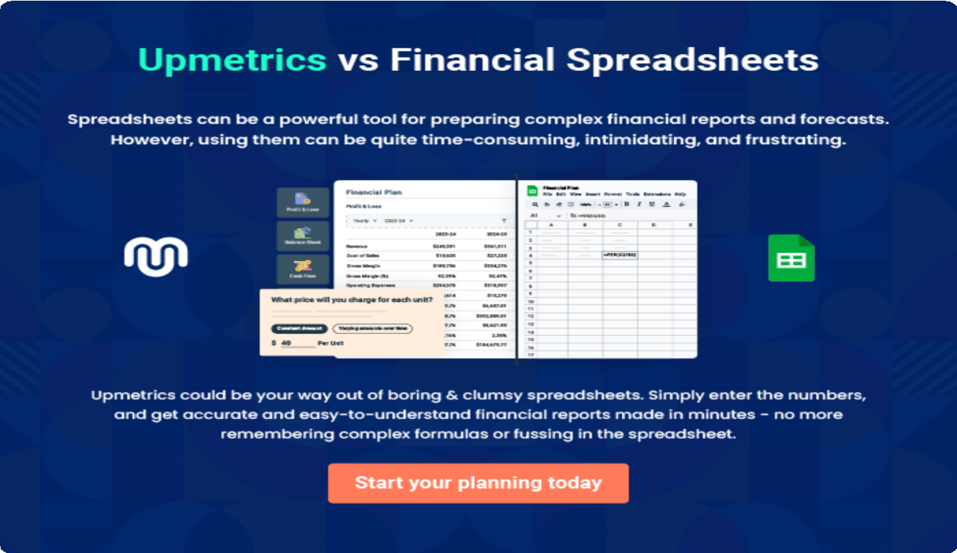

9.

Appendix
EmbedLink

Whenwritingtheappendixsection,youshouldincludeanyadditional
informationthatsupportsthemaincontentofyourplan.Thismayinclude
financialstatements,marketresearchdata,legaldocuments,andother
Tounlock helptry Upmetrics!
EmbedLink

Createawinningbusinessplanthatgetsyoufunded

Creatingastunningandinvestment-readyplanrequiresnowriting,graphicdesigning,orfinancial planning expertise.

Upmetricshasallthefeaturesrequiredtohelpyoucreateacomprehensivebusinessplan—fromstarttofinish. Makenomistakes,it’sthemodernwayofplanningtostructureideas,makeplans,andcreatestunningpitch decks to awe investors.

Pitchdecksthatimpressinvestors
Create pitch decks that provide a visual representation of your business, engage investors,andmakethemwanttoinvestinyour businessidea.

Interactiveplansinnotime
Import business plan sections like—SWOT analysis,comparisontables,andotherstocreate an interactive business plan. No designing skills arerequired.

Stunningcoverpagedesigns
WithUpmetrics,youhavethelibertytochoose from multiple stunning cover page designs.
Chooseacreativedesignandmakeyourplan standout.

500+samplebusinessplans
Simplyimportatemplatefromourlibraryof sample plans into the editor and start customizingittomakeityours.Ittakesonlyafew clicks to get started.

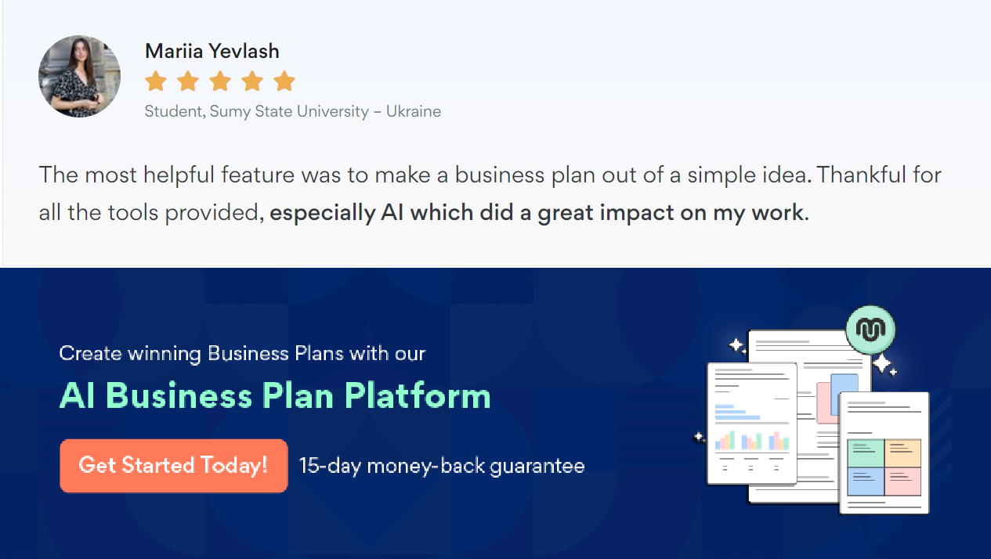Onlinesharingmadesimple
Upmetricsmakesonlinesharingquickandeasier forusers.Easilyshareyourbusinessplanswitha linkwhiletrackingreaderactivity.

Collaboratewithteaminreal-time
Invite team members, initiate conversations, discussideas&strategies,sharefeedback,and work on a business plan in real-time.

