
ApothecaryBusinessPlan

Business Plan
2024

"PureHerbs,PowerfulResults."
Informationprovidedinthisbusinessplanisuniquetothisbusinessandconfidential;therefore, anyone reading this plan agrees not to disclose any of the information in this business plan without prior written permission of the company.

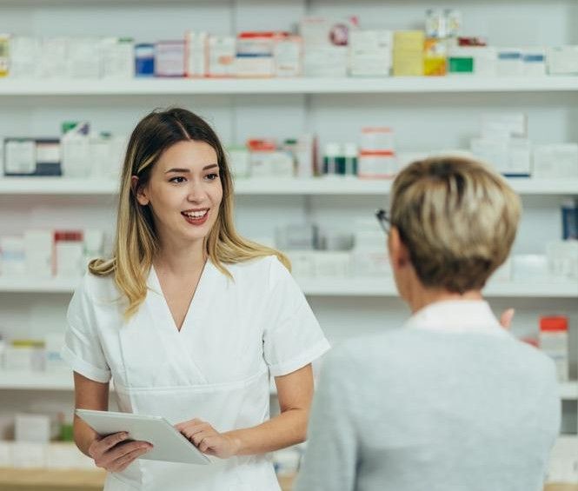PreparedBy
JohnDoe
(650)359-3153
10200 Bolsa Ave, Westminster, CA, 92683 info@example.comhttps://www.example.com/

TableofContents

ExecutiveSummary
6
Marketopportunity 7
UniqueSellingPoints(USPs) 7
Marketing&SalesStrategies 8
FinancialHighlights 8
UnitsSoldv/sRevenueChart 8
CompanyOverview
10
Ownership 11
BusinessOwners 11
Missionstatement 11
Business history 12
Futuregoals 12
MarketAnalysis
13
TargetMarket 14
Marketsizeandgrowthpotential 14
MarketSize 15
Competitiveanalysis 15
TheHealingTreeApothecary 15
WildflowerApothecary 15
MoonlightApothecary 16
Markettrends 16
Regulatoryenvironment 17
ProductsandServices
18
ProductsandServices 19
HerbalRemedies 19
HerbalTeasandBlends 19
EssentialOils 20
NaturalSkincareProducts 20

OrganicBeautyProducts 20
Quality Measures 21
AdditionalServices 21
SalesAndMarketingStrategies
22
UniqueSellingProposition(USP) 23
PricingStrategy 23
Marketingstrategies 24
Online 24
Offline 24
Salesstrategies 25
Customerretention 25
OperationsPlan
27
Staffing&Training 28
OperationalProcess 28
Equipment&Tools 29
ManagementTeam
30
Founders/CEO 31
EmilyHarper 32
Keymanagers 32
MichaelTorres 33
JessicaLee 33
SamanthaPatel 34
Organizationalstructure 34
Organizationchart 34
Compensationplan 35
Boardofadvisors 35
Dr.Lauren Mitchell 36
DavidChen 36

Financial Plan
37
Profit&lossstatement 38
Cashflowstatement 43
Balancesheet 45
Break-evenPoint 47
Financingneeds 49
Appendix
51
EmbedLink 52


Businessplanningthat’ssimplerandfasterthanyouthink

CreatingabusinessplanusingUpmetricstostartandgrowabusinessisliterallytheeasiest thingintheWorld.Simplyreadtheinstructionsandfillintheblanks.It’sassimpleasthat.

Upmetrics has everything you need to create a comprehensive business plan.
❛
❜

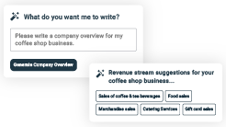
AI-poweredUpmetricsAssistant

AI-poweredinsightstostreamlineyourplan
Not sure where to start? Upmetrics’ AI Assistant will automaticallygenerateideasforeachsectionofyourplanand offerimprovedversionsofyourwriting,adjustingfortone,voice, and grammar or spelling errors.

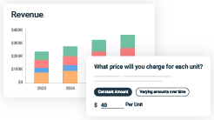
FinancialForecastingTool

Allthefinancialsarecalculatedforyou
Forget the complex formulas and clumsy spreadsheets — withautomaticfinancialsanddrag-and-dropforecasting,you canfinishyourplanfasterandbeconfidentthatyour numbers are accurate.

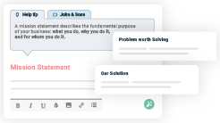
BusinessPlanBuilder

Guidesyoulikeabusinessmentor
Upmetrics’step-by-stepinstructions,prompts,andthelibraryof 400+samplebusinessplanswillguideyouthrougheachsection of your plan as a business mentor.

1.

ExecutiveSummary

Marketopportunity
Unique Selling Points (USPs)Marketing & Sales StrategiesFinancial Highlights



Anexecutivesummaryisthefirstsectionofthebusinessplanintendedto provide an overview of the whole business plan.
Tounlock helptry Upmetrics!

Helptip
TheGreenRemedyApothecary
Startyourexecutivesummarybybrieflyintroducingyourbusinesstoyourreaders.

Thissectionmayincludethenameofyourapothecarybusiness,itslocation,whenitwas
Tounlock helptry Upmetrics!
Startwritinghere..

Marketopportunity

Helptip
TheGreenRemedyApothecary
Summarizeyourmarketresearch,includingmarketsize,growthpotential,andmarketing trends.
Tounlock helptry Upmetrics!
Startwritinghere..

UniqueSellingPoints(USPs)

Helptip
TheGreenRemedyApothecary
Emphasize what sets your apothecary business apart—highlighting unique selling points (USPs) and special features that make it distinctive is always a plus.
Tounlock helptry Upmetrics!
Startwritinghere..

Marketing&SalesStrategies

Helptip
TheGreenRemedyApothecary
Outline your sales and marketing strategies—what marketing platforms you use, how you plan on acquiring customers, etc.
Tounlock helptry Upmetrics!
Startwritinghere..

FinancialHighlights

Helptip
TheGreenRemedyApothecary
Brieflysummarizeyourfinancialprojectionsfortheinitialyearsofbusinessoperations.Include
capitalorinvestmentrequirements,associatedstartupcosts,projectedrevenues,andprofit
forecasts.
Tounlock helptry Upmetrics!
Startwritinghere..

UnitsSoldv/sRevenueChart

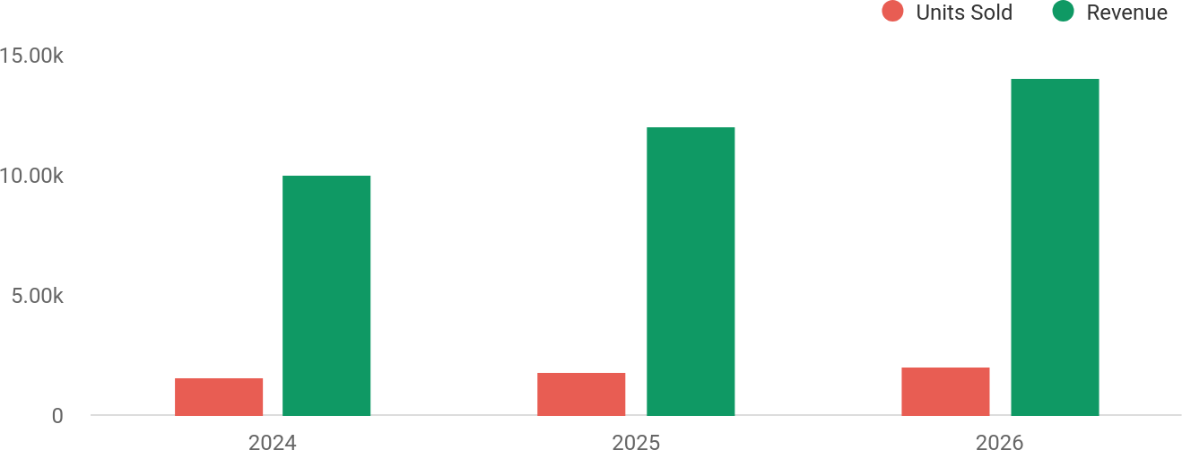

FinancialYear | UnitsSold | Revenue
2024 | 1,550 | $10,000
2025 | 1,800 | $12,000

FinancialYear | UnitsSold | Revenue
2026 | 2,050 | $14,000

Helptip
TheGreenRemedyApothecary
SummarizeyourexecutivesummarysectionwithaclearCTA,forexample,invitingangel investors to discuss the potential business investment.
Tounlock helptry Upmetrics!

Writeacalltoactionforyourbusinessplan.

2.

CompanyOverview

OwnershipMission statementBusiness historyFuture goals

Dependingonwhatdetailsofyourbusinessareessential,you’llneed different elements in your business overview.
Tounlock helptry Upmetrics!
Helptip
TheGreenRemedyApothecary
Describeyour businessin this sectionby providingall the basicinformation:

Mentionwhatkindofapothecarybusinessyourunandthenameofit.Youmayspecializein
Tounlock helptry Upmetrics!
Startwritinghere..

Ownership

Helptip
TheGreenRemedyApothecary
List the names of your apothecary business’s founders or owners. Describe what shares they own and their responsibilities for efficiently managing the business.
Tounlock helptry Upmetrics!
Startwritinghere..

BusinessOwners

EmilyHarper
100%

Missionstatement


Helptip
TheGreenRemedyApothecary
Summarizeyourbusiness’objective,coreprinciples,andvaluesinyourmissionstatement.This statement needs to be memorable, clear, and brief.
Tounlock helptry Upmetrics!

At [The Green Remedy Apothecary], our mission isto empowerindividualstoembraceholisticwellnessthroughsustainably
❛
sourced, natural products. Weare committed to enhancing lives while preserving the environment for future generations.
❜

Businesshistory

Helptip
TheGreenRemedyApothecary
Ifyou’reanestablishedapothecarybusiness,brieflydescribeyourbusinesshistory,like—when itwasfounded,howitevolvedovertime,etc.
Tounlock helptry Upmetrics!
Startwritinghere..

Futuregoals

Helptip
TheGreenRemedyApothecary
It’scrucialtoconveyyouraspirationsandvision.Mentionyourshort-termandlong-termgoals; they can be specific targets for revenue, market share, or expanding your services.
Tounlock helptry Upmetrics!
Startwritinghere..

3.

MarketAnalysis

TargetMarket
MarketsizeandgrowthpotentialCompetitive analysis
Market trendsRegulatoryenvironment

Marketanalysisprovidesaclearunderstandingofthemarketinwhichyour
printingbusinesswillrunalongwiththetargetmarket,competitors, and
growthopportunities.
Tounlock helptry Upmetrics!
Helptip
TheGreenRemedyApothecary
Towritetheintroductionsectionofyourmarketanalysis,startbyclearlyidentifyingyour primary target market.
Tounlock helptry Upmetrics!
Startwritinghere..

TargetMarket

Helptip
TheGreenRemedyApothecary
Startthissectionbydescribingyourtargetmarket.Defineyouridealcustomerandexplainwhat
typesofservicestheyprefer.Creatingabuyerpersonawillhelpyoueasilydefineyourtarget
markettoyourreaders.
Tounlock helptry Upmetrics!
Startwritinghere..

Marketsizeandgrowthpotential

Helptip
TheGreenRemedyApothecary
Describeyourmarketsizeandgrowthpotentialandwhetheryouwilltargetanicheoramuch broader market.
Tounlock helptry Upmetrics!
Startwritinghere..

MarketSize

AvailableMarket
ThetotalUSmarketfornaturalandorganic wellness products, including herbal remedies and skincar

50B

ServedMarket
9B
The specific US market for herbal apothecaryproducts,includingtinctures, essential oils, and teas

TargetMarket
Health-consciousindividualsaged25–45in Westminster and nearby regions seeking personalized solut
3M

Helptip
TheGreenRemedyApothecary
Identifyandanalyzeyourdirectandindirectcompetitors.Identifytheirstrengths and
weaknesses,anddescribewhatdifferentiatesyourapothecarybusinessfromthem.Pointout
howyouhaveacompetitiveedgeinthemarket.
Tounlock helptry Upmetrics!

Competitiveanalysis

TheHealingTreeApothecary
Located in Long Beach, CA, The Healing Tree Apothecary specializes in herbal tinctures and aromatherapy products.They have a robust e-commerce presence and a loyal customer base.

Features
Widerangeofherbaltinctures and essential oils.
Onlineconsultationservices for personalized wellness plans.
Subscription boxes featuring curated products.

Strengths
Strongonlinepresencewith nationwide shipping.
High-quality,well-branded product packaging.
Competitivepricingonpopular wellness items.

Weaknesses
Lack of community engagement and local partnerships.
Limitedfocusonsustainabilityin packaging and sourcing.

WildflowerApothecary
Based in Santa Monica, CA, Wildflower Apothecary emphasizes organic, plant-based skincare and wellness products.They are well-known for their minimalist, luxury brand aesthetic.

Features
Plant-based skincare solutions tailored for sensitive skin.
Eco-conscious, minimalist packaging.
In-storeworkshopsonnatural beauty and wellness.

Strengths
Well-establishedreputationin the natural skincare market.
Appealingbrandimageand premium product line.
Stronglocalcustomerloyalty.

Weaknesses
Higherpricepointsthatmay deter budget-conscious customers.
Limitedproductvarietybeyond skincare and beauty.

MoonlightApothecary
Operating outof SanDiego, CA,Moonlight Apothecaryblends traditionalapothecary methodswith modern CBD-infused products. They have a niche focus on CBD wellness.

Features
CBD-infusedherbaltinctures and teas.
Educational resources about CBD and holistic health.
Focused niche marketing targeting younger demographics.

Strengths
Niche expertise in CBD products,agrowingmarket segment.
Innovativeproductofferings not widely available.
Effectiveuseofsocialmedia for customer engagement.

Weaknesses
Narrow product focus limits appealtoabroaderaudience.
DependenceonCBDtrends, which may fluctuate with regulations.

Markettrends

Helptip
TheGreenRemedyApothecary
Analyze emerging trends in the industry, such as technology disruptions, changes in customer behavior or preferences, etc. Explain how your business will cope with all the trends.
Tounlock helptry Upmetrics!
Startwritinghere..

Regulatoryenvironment

Helptip
TheGreenRemedyApothecary
List regulations and licensing requirementsthat may affect yourapothecary business, such as
productlabeling&claims,goodmanufacturingpractices,ingredientsafety&documentation,
compliancewithPharmacopeias,environmentalregulations,etc.
Tounlock helptry Upmetrics!
Startwritinghere..

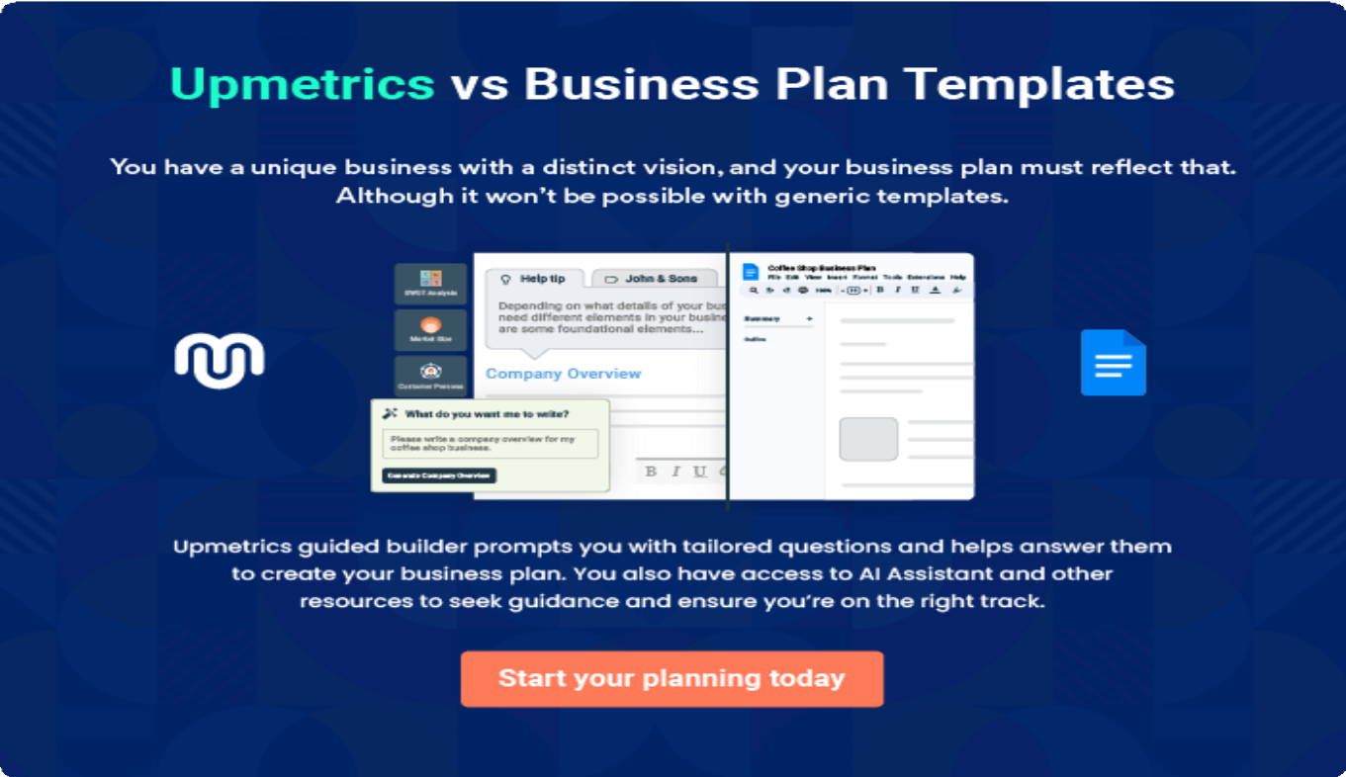

4.

Productsand Services

ProductsandServicesQuality MeasuresAdditional Services

Theproductandservicessectionofanapothecarybusinessplanshould
describethespecificservicesandproductsthatwillbeofferedtocustomers.
Towritethissectionshouldincludethefollowing:
Tounlock helptry Upmetrics!
Helptip
TheGreenRemedyApothecary
Tocrafttheintroductionforyour"ProductsandServices"chapter,beginbypositioningyour business within its industry, emphasizing its unique strengths or value proposition.
Tounlock helptry Upmetrics!

Startwritinghere..
Helptip
Mention and explain in detail the products and services your business offers.This list may include:
Tounlock helptry Upmetrics!

ProductsandServices


HerbalRemedies

Price:[$15–$25]perbottle(2floz)

Ourhandcraftedherbaltincturesaredesignedtoaddress commonwellnessconcernssuchasstress,digestion, and sleep.

Specifications
- Ingredients:Organicherbs,alcoholorvegetable glycerin.
- Variants:SleepAid,DigestiveSupport,Immune Boost.
- Usage: Take 1–2 droppers daily under the tongue or in water.

HerbalTeasandBlends
Price:[$12–$18]perpack(3.5oz)

Arangeoforganic,hand-blendedherbalteastopromote relaxation,detoxification,andenergy.Ourblendsare caffeine-free and crafted with dried herbs and flowers.

Specifications
  - Variants:Calm&CozyChamomile,DetoxDelight, Morning Energizer.
  - Packaging:Resealableeco-friendlypouches.
  - BrewingInstructions:Steep1tspinhotwaterfor5–7 minutes.

EssentialOils

Price:[$10–$30]perbottle(10ml)

Therapeutic-grade essential oils for aromatherapy, skincare, and emotional wellness. Each oil is 100% pure and extracted using steam distillation or cold pressing.

Specifications
  - Variants:Lavender,Eucalyptus,Peppermint,TeaTree.
  - Purity:100%natural,noadditivesorfillers.
  - Usage:Suitablefordiffusers,topicalapplication(with carrier oil), or baths.

NaturalSkincareProducts
Price:[$20–$40]perproduct

Our plant-based skincare line includes moisturizers, serums, and scrubs designed to nourish and protect your skin.

Specifications
  - Products:HydratingRoseSerum(1oz),Rejuvenating Body Scrub (8 oz).
  - KeyIngredients:Aloevera,jojobaoil,rosehipextract.
  - Usage:Applyasdirectedforradiant,healthyskin.

OrganicBeautyProducts
Price:[$10–$25]perproduct

QualityMeasures
Helptip
TheGreenRemedyApothecary
This section should explain how you maintain quality standards and consistently provide the highest quality service.
Tounlock helptry Upmetrics!

Startwritinghere..

AdditionalServices
Helptip
TheGreenRemedyApothecary
Mention ifyourapothecarybusinessoffers anyadditionalservices.

Youmayincludeserviceslikeholistichealthconsultations,nutritionalcounseling,herbal
Tounlock helptry Upmetrics!

Startwritinghere..
Eco-conscious beauty products made with natural ingredients for safe and effective results.

Specifications
- Products:HerbalLipBalm,NourishingHairOil.
- KeyIngredients:Sheabutter,coconutoil,herbal infusions.
- Packaging:Recyclableandbiodegradable containers.

5.

SalesAndMarketing
Strategies

Unique Selling Proposition (USP)Pricing Strategy
Marketing strategiesSales strategiesCustomer retention

Writing the sales and marketing strategies section means a list of strategies you will use to attract and retain your clients.
Tounlock helptry Upmetrics!
HelpTip
TheGreenRemedyApothecary
Tocreateaneffectiveintroductionforyour"SalesandMarketingStrategies"chapter,startby setting the stage within your specific industry or market.
Tounlock helptry Upmetrics!
Startwritinghere..

UniqueSellingProposition(USP)

Helptip
TheGreenRemedyApothecary
Define your business’s USPs depending on the market you serve, the equipment you use, and theuniqueservicesyouprovide.IdentifyingUSPswillhelpyouplanyourmarketingstrategies.
Tounlock helptry Upmetrics!
Startwritinghere..

PricingStrategy

Helptip
TheGreenRemedyApothecary
Describeyourpricingstrategy—howyouplantopriceyourproductsandservicestostay
competitiveinthelocalmarket.Youcanmentionanydiscountsyouplanonofferingtoattract
newcustomerstoyourbusiness.
Tounlock helptry Upmetrics!
Startwritinghere..

Helptip
Discussyourmarketingstrategiestomarketyourservices.Youmayincludesomeofthese
marketing strategies inyour business plan—socialmedia marketing, brochures,email
marketing,contentmarketing,andprintmarketing.
Tounlock helptry Upmetrics!

Marketingstrategies

Online


Offline

SocialMedia Marketing
Regularposts,stories, and live sessions on platforms like Instagram and Facebook to engage with our target audience.

ContentMarketing
Ablogonourwebsite offering educational content about herbal remedies and holistic health practices.

EmailMarketing
Monthly newsletters featuringwellnesstips, product promotions, and workshop announcements.

LocalOutreach
Flyers and brochures distributed in wellness centers, yoga studios, and community events.

Helptip
Outlinethestrategiesyou’llimplementtomaximizeyoursales.Yoursalesstrategiesmay include product demonstrations, subscription-based programs & discounts, etc.
Tounlock helptry Upmetrics!

Salesstrategies

Product Demonstrations
In-store and virtual demonstrations to educate customers aboutthebenefitsof our products.

Workshops
Hosting herbal workshops that include product samplings, encouragingattendees to make purchases.

Subscription-Based Programs
Offeringwellnesskits delivered monthly to encourage repeat purchases.

Helptip
Describeyourcustomerretentionstrategiesandhowyouplantoexecutethem.Forinstance,
introducing loyalty programs,personalized recommendations,subscription services,
educationalcontent&workshops,etc.
Tounlock helptry Upmetrics!

Customerretention

LoyaltyProgram
Customers earn points for every purchase, redeemable for discounts or exclusive products.

Personalized
Recommendations
Tailored product suggestions based on individualpreferences and purchase history.

EducationalContent
Free access to webinarsandguideson holistic wellness to keep customers engagedandinformed.

ExclusiveEvents
Invite loyal customers to special events like productlaunchesorVIP workshops.

6.

OperationsPlan

Staffing & TrainingOperational ProcessEquipment & Tools

Whenwritingtheoperationsplansection,it’simportanttoconsiderthe various aspects of your business operations.
Tounlock helptry Upmetrics!
Helptip
TheGreenRemedyApothecary
Tocreateaneffectiveintroductionforyour"OperationalPlan"chapter,startbyemphasizingthe
pivotalroleofefficientoperationsinthesuccessofyourbusiness,underscoringhowthey
directlyimpactthequalityofservicesdelivered.
Tounlock helptry Upmetrics!
Startwritinghere..

Staffing&Training

Helptip
TheGreenRemedyApothecary
Mentionyourbusiness’sstaffingrequirements,includingthenumberofretailstafforherbalists needed.Includetheirqualifications,thetrainingrequired,andthedutiestheywillperform.
Tounlock helptry Upmetrics!
Startwritinghere..

OperationalProcess

Helptip
TheGreenRemedyApothecary
Outlinetheprocessesandproceduresyouwillusetorunyourapothecarybusiness.

Youroperationalprocessesmayincludeproductsourcing&procurement,qualitycontrol&
Tounlock helptry Upmetrics!
Startwritinghere..

Equipment&Tools

Helptip
TheGreenRemedyApothecary
Includethelistofequipmentrequiredforapothecarybusiness,suchasherbgrinder,mortar& pestle, infusion devices, mixing bowls, measuring equipment, etc.
Tounlock helptry Upmetrics!
Startwritinghere..

7.

ManagementTeam

Founders/CEOKeymanagers
OrganizationalstructureCompensation planBoard of advisors

The management team section provides an overview of the individuals responsible for running your business plan.
Tounlock helptry Upmetrics!
Helptip
TheGreenRemedyApothecary
Tocraftanintroductionforyour"ManagementTeam"chapter,beginbyemphasizingthecrucial role of leadership in the success of any business.
Tounlock helptry Upmetrics!
Startwritinghere..

Founders/CEO

HelpTip
Mention the founders and CEO of your apothecary business, and describe their roles and responsibilities in successfully running the business.
Tounlock helptry Upmetrics!
Startwritinghere..


EmilyHarper

FounderandCEO-emily.harper@example.com

Education:



- CertifiedHerbalistwithaDiplomainHerbalMedicinefrom[Institute Name].

ProfessionalBackground:

- With over 10 years of experience in the holistic wellness industry, Emily hasadeepunderstandingofherbalmedicine,sustainablepractices,and small business management.
- Herpassionfornaturalhealthandherentrepreneurialspiritledherto establish The Green Remedy Apothecary in 2024.

Responsibilities:

- Emily oversees the strategic direction of the business, product development,customerengagement,andcommunityoutreach.
- She is also responsible for building partnerships with local suppliers and ensuring adherence to sustainability goals.

Keymanagers

Helptip
Introduceyourmanagementandkeymembersofyourteam,andexplaintheirrolesand responsibilities.
Tounlock helptry Upmetrics!
Startwritinghere..


MichaelTorres

MarketingManager-michael.torres@example.com

Education:

- Master’sdegreeinMarketingfrom[UniversityName].

ProfessionalBackground:

- Michaelhas5yearsofexperienceindigitalmarketing,withafocuson buildingbrandidentityforwellness-basedcompanies.
- Hiscreativecampaignsanddata-drivenstrategieshavesuccessfully driven customer engagement and increased sales for previous employers.

Responsibilities:

- MichaelleadsthemarketingstrategyforTheGreenRemedyApothecary, manages social media campaigns, and handles public relations to grow the brand’s visibility both locally and online.

JessicaLee


OperationsManager-jessica.lee@example.com

Education:

- Bachelor’sdegreeinBusinessAdministrationfrom[UniversityName].

ProfessionalBackground:

- Jessica brings over 7 years of experience in managing operations for retail and wellness businesses. Her expertise lies in inventory management, process optimization, and customer service excellence.

Responsibilities:

- She is responsible for streamlining daily operations, ensuring inventory levelsareoptimal,andmaintainingqualitystandardsacrossallproducts and services.


SamanthaPatel

LeadHerbalist-samantha.patel@example.com

Education:

- CertifiedinHerbalMedicineandAromatherapyfrom[InstituteName].

ProfessionalBackground:

- With6yearsofexperience,Samanthaisaskilledherbalistspecializingin creatingnaturalremediesandskincareproducts.
- Shehasworkedwithvariouswellnessbrandsandhasastrongtrack recordofcustomerconsultationsandproductformulation.

Responsibilities:

- Samantha oversees all product formulations, ensures the quality of ingredients, and leads workshops to educate customers on the benefits of herbal remedies.

Organizationalstructure

Helptip
TheGreenRemedyApothecary
Explaintheorganizationalstructureofyourmanagementteam.Includethereportinglineand decision-making hierarchy.
Tounlock helptry Upmetrics!
Startwritinghere..

Organizationchart

EmilyHarper
FounderandCEO


MichaelTorres
MarketingManager
JessicaLee
OperationsManager


SamanthaPatel
LeadHerbalist

DanielBrooks

InventorySpecialist
RachelAdams
RetailAssociate

Compensationplan

Helptip
TheGreenRemedyApothecary
Describeyourcompensationplanforthemanagementandstaff.Includetheirsalaries, incentives, and other benefits.
Tounlock helptry Upmetrics!
Startwritinghere..

Helptip
Mentioningadvisorsorconsultantsinyourbusinessplansaddscredibilitytoyourbusiness idea.
Tounlock helptry Upmetrics!

Boardofadvisors


Dr.LaurenMitchell

Holistic HealthAdvisor

- Experience:15yearsasanaturopathicdoctor,specializinginherbal medicine.
- Role: Provides guidance on product formulations and ensures compliance with health regulations.

DavidChen


Financial Consultant

- Experience:12yearsofexperienceasafinancialadvisorforsmall businesses.
- Role:Assistswithfinancialplanning,budgeting,andscalingstrategiesto ensure sustainable growth.

8.

FinancialPlan

Profit&lossstatementCash flow statementBalance sheet
Break-evenPointFinancing needs

Helptip
Describedetailssuchasprojectedrevenue,operationalcosts,andservicecostsinyourprojectedprofitandlossstatement.Makesuretoinclude
yourbusiness’sexpectednetprofitorloss.

Whenwritingthefinancialplansectionofabusinessplan,it’simportanttoprovideacomprehensiveoverviewofyourfinancial projections for the first few years of your business, You may provide the following:
Tounlock helptry Upmetrics!
Helptip
TheGreenRemedyApothecary
Tocreateaneffectiveintroductionforyour"FinancialPlan"chapter,beginbystressingthecriticalroleofawell-structuredfinancialplaninthe success of your venture.
Tounlock helptry Upmetrics!
Startwritinghere..

 |  |  | Tounlock helptry Upmetrics!
Profit&lossstatement | 2024 | 2025 | 2026
Revenue | $220,084.40 | $430,553.60 | $733,529.50
HerbalProductsSales | $106,439.40 | $151,757.10 | $216,368.70

 | 2024 | 2025 | 2026
UnitSales | 7,096 | 10,117 | 14,425
UnitPrice | $15 | $15 | $15
ApothecaryWorkshops | $32,170 | $40,796 | $51,744
UnitSales | 161 | 204 | 259
UnitPrice | $200 | $200 | $200
SubscriptionBoxes | $81,475 | $238,000.50 | $465,416.80
Users | 204 | 487 | 905
RecurringCharges | $50 | $50 | $50

CostOf Sales | $56,428.48 | $59,323.78 | $62,586.13
GeneralCosts | $56,428.48 | $59,323.78 | $62,586.13
HerbalProducts | $42,682.53 | $44,291.10 | $46,103.44
Raw Materials | $30,000 | $30,000 | $30,000
ManufacturingLabor | $12,682.53 | $14,291.10 | $16,103.44
SubscriptionBoxes | $13,745.95 | $15,032.68 | $16,482.69
PackagingandShipping | $3,600 | $3,600 | $3,600
FulfillmentServices | $10,145.95 | $11,432.68 | $12,882.69

 | 2024 | 2025 | 2026
RevenueSpecificCosts | $0 | $0 | $0
PersonnelCosts(Direct Labor) | $0 | $0 | $0

GrossMargin | $163,655.92 | $371,229.82 | $670,943.37
GrossMargin(%) | 74.36% | 86.22% | 91.47%

Operating Expense | $233,520 | $235,464 | $237,505.20
PayrollExpense(Indirect Labor) | $189,720 | $191,664 | $193,705.20
Management | $64,080 | $66,024 | $68,065.20
StoreManager | $38,880 | $40,824 | $42,865.20
AssistantManager | $25,200 | $25,200 | $25,200
SalesStaff | $28,440 | $28,440 | $28,440
SalesAssociate | $18,360 | $18,360 | $18,360
SeasonalSalesperson | $10,080 | $10,080 | $10,080
ProductionStaff | $97,200 | $97,200 | $97,200

 | 2024 | 2025 | 2026
Herbal Specialist | $38,880 | $38,880 | $38,880
ProductionAssistant | $58,320 | $58,320 | $58,320
GeneralExpense | $43,800 | $43,800 | $43,800
RentandUtilities | $16,800 | $16,800 | $16,800
StoreRent | $12,000 | $12,000 | $12,000
Utilities | $4,800 | $4,800 | $4,800
Marketingand Advertising | $11,400 | $11,400 | $11,400
Digital Advertising | $9,600 | $9,600 | $9,600
FlyersandMaterials | $1,800 | $1,800 | $1,800
MaintenanceandRepairs | $15,600 | $15,600 | $15,600
EquipmentMaintenance | $3,600 | $3,600 | $3,600
BuildingRepairs | $12,000 | $12,000 | $12,000
BadDebt | $0 | $0 | $0

AmortizationofCurrent Assets

$0 $0 $0

EBITDA ($69,864.08) $135,765.82 $433,438.17

2024 |  | 2025 | 2026
AdditionalExpense | $10,733.98 | $9,810.21 | $8,839.20
LongTermDepreciation | $6,144 | $6,144 | $6,144
GainorlossfromSaleof Assets | $0 | $0 | $0
EBIT | ($76,008.08) | $129,621.82 | $427,294.17
InterestExpense | $4,589.96 | $3,666.20 | $2,695.19
EBT | ($80,598.06) | $125,955.61 | $424,598.97

IncomeTaxExpense/ Benefit

$0 $0 $0

TotalExpense | $300,682.46 | $304,597.99 | $308,930.53
NetIncome | ($80,598.06) | $125,955.61 | $424,598.97
NetIncome(%) | (36.62%) | 29.25% | 57.88%

RetainedEarningOpening | $0 | ($120,598.06) | ($34,642.45)
Owner'sDistribution | $40,000 | $40,000 | $40,000

Helptip
Thecashflowforthefirstfewyearsofyouroperationshouldbeestimatedanddescribedinthissection.Thismayincludebillinginvoices, payment receipts, loan payments, and any other cash flow statements.
Tounlock helptry Upmetrics!
 | 2024 | 2025 | 2026
RetainedEarningClosing | ($120,598.06) | ($34,642.45) | $349,956.52

Cashflowstatement | 2024 | 2025 | 2026
CashReceived | $220,084.40 | $430,553.60 | $733,529.50
CashPaid | $294,538.46 | $298,453.99 | $302,786.53
COS&GeneralExpenses | $100,228.48 | $103,123.78 | $106,386.13
Salary&Wages | $189,720 | $191,664 | $193,705.20
Interest | $4,589.96 | $3,666.20 | $2,695.19
SalesTax | $0 | $0 | $0
IncomeTax | $0 | $0 | $0

Operations
2024 | 2025 | 2026
NetCashFrom ($74,454.06) | $132,099.61 | $430,742.97

AssetsSell | $0 | $0 | $0
AssetsPurchase | $40,000 | $0 | $0

NetCashFrom Investments

($40,000) $0 $0

AmountReceived | $150,000 | $0 | $0
LoanReceived | $100,000 | $0 | $0
CommonStock
PreferredStock | $0 | $0 | $0
Owner'sContribution | $50,000 | $0 | $0
AmountPaid | $58,055.46 | $58,979.23 | $59,950.24
LoanCapital | $18,055.48 | $18,979.24 | $19,950.25
Dividends&Distributions | $40,000 | $40,000 | $40,000

NetCashFrom Financing

$91,944.54 ($58,979.23) ($59,950.24)

Helptip
Createaprojectedbalancesheetdocumentingyourapothecarybusiness’sassets,liabilities,andequity.
2024 |  | 2025 | 2026
Summary
StartingCash | $0 | ($22,509.52) | $50,610.86
CashIn | $370,084.40 | $430,553.60 | $733,529.50
CashOut | $392,593.92 | $357,433.22 | $362,736.77
Change inCash | ($22,509.52) | $73,120.38 | $370,792.73
Ending Cash | ($22,509.52) | $50,610.86 | $421,403.59

 |  |  | Tounlock helptry Upmetrics!
Balancesheet | 2024 | 2025 | 2026
Assets | $11,346.48 | $78,322.86 | $442,971.59
CurrentAssets | ($22,509.52) | $50,610.86 | $421,403.59

 | 2024 | 2025 | 2026
Cash | ($22,509.52) | $50,610.86 | $421,403.59
AccountsReceivable | $0 | $0 | $0
Inventory | $0 | $0 | $0
OtherCurrentAssets | $0 | $0 | $0
LongTermAssets | $33,856 | $27,712 | $21,568
GrossLong TermAssets | $40,000 | $40,000 | $40,000
Accumulated Depreciation | ($6,144) | ($12,288) | ($18,432)

Liabilities&Equity | $11,346.46 | $78,322.83 | $442,971.55
Liabilities | $81,944.52 | $62,965.28 | $43,015.03
CurrentLiabilities | $18,979.23 | $19,950.24 | $20,970.94
AccountsPayable | $0 | $0 | $0
IncomeTaxPayable | $0 | $0 | $0
SalesTaxPayable | $0 | $0 | $0
ShortTermDebt | $18,979.23 | $19,950.24 | $20,970.94
LongTermLiabilities | $62,965.29 | $43,015.04 | $22,044.09
LongTermDebt | $62,965.29 | $43,015.04 | $22,044.09

 | 2024 | 2025 | 2026
Equity | ($70,598.06) | $15,357.55 | $399,956.52
Paid-inCapital | $0 | $0 | $0
CommonStock | $0 | $0 | $0
PreferredStock | $0 | $0 | $0
Owner'sContribution | $50,000 | $50,000 | $50,000
RetainedEarnings | ($120,598.06) | ($34,642.45) | $349,956.52

Check $0 $0 $0

Helptip
Determineandmentionyourbusiness’sbreak-evenpoint—thepointatwhichyourbusinesscostsandrevenuewillbeequal.

Thisexercisewillhelpyouunderstandhowmuchrevenueyouneedtogeneratetosustainorbeprofitable.
Tounlock helptry Upmetrics!

Break-evenPoint

2024 2025 2026

StartingRevenue $0 $220,084.40 $650,638

 | 2024 | 2025 | 2026
NetRevenue | $220,084.40 | $430,553.60 | $733,529.50
ClosingRevenue | $220,084.40 | $650,638 | $1,384,167.50
StartingExpense | $0 | $300,682.46 | $605,280.45
NetExpense | $300,682.46 | $304,597.99 | $308,930.53
ClosingExpense | $300,682.46 | $605,280.45 | $914,210.98
IsBreakEven? | No | Yes | Yes
BreakEvenMonth | 0 | Oct'25 | 0
DaysRequired | 0 | 19Days | 0
BreakEvenRevenue | $300,682.46 | $545,539.30 | $0
HerbalProductsSales | $0 | $223,908.43 | $0
ApothecaryWorkshops | $0 | $64,142.80 | $0
SubscriptionBoxes | $0 | $257,488.07 | $0
BreakEvenUnits

HerbalProductsSales 0 14,927 0

 | 2024 | 2025 | 2026
ApothecaryWorkshops | 0 | 321 | 0
SubscriptionBoxes | 0 | 428 | 0

Financingneeds

Helptip
TheGreenRemedyApothecary
Calculate costs associated with starting an apothecary business, and estimate your financing needs and how much capital you need to raise to operate your business.
Tounlock helptry Upmetrics!
Startwritinghere..

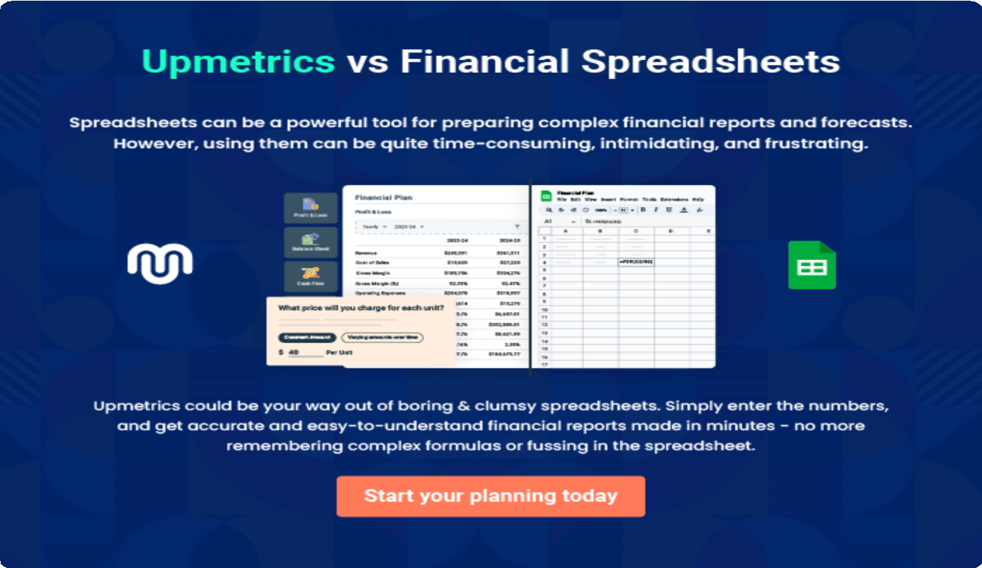

9.

Appendix
EmbedLink

Whenwritingtheappendixsection,youshouldincludeanyadditional
informationthatsupportsthemaincontentofyourplan.Thismayinclude
financialstatements,marketresearchdata,legaldocuments,andother
Tounlock helptry Upmetrics!
EmbedLink

Createawinningbusinessplanthatgetsyoufunded

Creatingastunningandinvestment-readyplanrequiresnowriting,graphicdesigning,orfinancial planning expertise.

Upmetricshasallthefeaturesrequiredtohelpyoucreateacomprehensivebusinessplan—fromstarttofinish. Makenomistakes,it’sthemodernwayofplanningtostructureideas,makeplans,andcreatestunningpitch decks to awe investors.

Pitchdecksthatimpressinvestors
Create pitch decks that provide a visual representation of your business, engage investors,andmakethemwanttoinvestinyour businessidea.

Interactiveplansinnotime
Import business plan sections like—SWOT analysis,comparisontables,andotherstocreate an interactive business plan. No designing skills arerequired.

Stunningcoverpagedesigns
WithUpmetrics,youhavethelibertytochoose from multiple stunning cover page designs.
Chooseacreativedesignandmakeyourplan standout.

500+samplebusinessplans
Simplyimportatemplatefromourlibraryof sample plans into the editor and start customizingittomakeityours.Ittakesonlyafew clicks to get started.

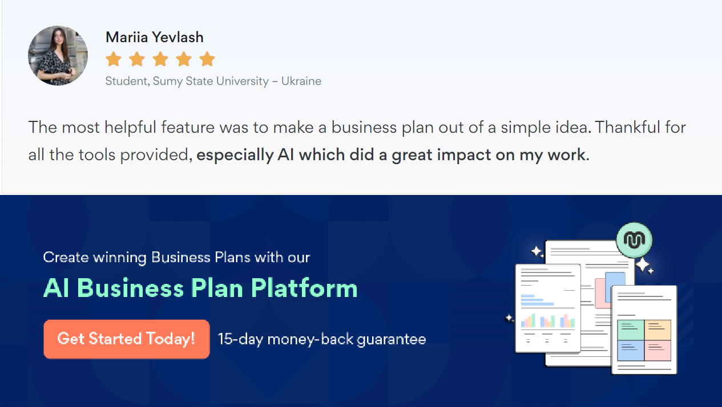Onlinesharingmadesimple
Upmetricsmakesonlinesharingquickandeasier forusers.Easilyshareyourbusinessplanswitha linkwhiletrackingreaderactivity.

Collaboratewithteaminreal-time
Invite team members, initiate conversations, discussideas&strategies,sharefeedback,and work on a business plan in real-time.

