BUSINESSPLAN
2024



Baseball Batting Cage Business Plan
"SwingStronger,HitFarther!"

JohnDoe
10200BolsaAve,Westminster,CA,92683

(650)359-3153

info@example.comhttps://www.example.com

Information provided in this business plan is unique to this business and confidential; therefore,anyonereadingthisplanagreesnottodiscloseanyoftheinformationinthis business plan without prior written permission of the company.

TableofContents

ExecutiveSummary
6
Marketopportunity 7
ProductsandServices 7
Marketing&SalesStrategies 8
FinancialHighlights 8
UnitsSoldv/sRevenueChart 8
CompanyOverview
10
Ownership 11
BusinessOwners 11
Missionstatement 11
Business history 12
Futuregoals 12
MarketAnalysis
13
TargetMarket 14
Marketsizeandgrowthpotential 14
MarketSize 15
Competitiveanalysis 15
D-BATAnaheim 15
TheCagesTrainingFacility 16
HitFactoryIndoorBattingCages 16
Markettrends 16
Regulatoryenvironment 17
ProductsandServices
18
ProductsandServices 19
BattingCageSessions 19
ProtectiveGearRental 19
MembershipPackages 20
PersonalizedCoachingPrograms 20

Quality Measures 21
SalesAndMarketingStrategies
22
UniqueSellingProposition(USP) 23
PricingStrategy 23
Marketingstrategies 24
Online 24
Offline 24
Salesstrategies 25
Customerretention 25
OperationsPlan
27
Staffing&Training 28
OperationalProcess 28
Equipment&Tools 29
ManagementTeam
30
Founders/CEO 31
MichaelThompson 32
Keymanagers 32
EmilyCarter 33
Laura Bennett 33
JacobMartinez 34
Organizationalstructure 34
Organizationchart 34
Compensationplan 35
Boardofadvisors 35
JohnPeterson 36
SarahWilliams 36
Financial Plan
37
Profit&lossstatement 38
Cashflowstatement 43

Balancesheet 45
Break-evenPoint 47
Financingneeds 49
Appendix
51
EmbedLink 52


Businessplanningthat’ssimplerandfasterthanyouthink

CreatingabusinessplanusingUpmetricstostartandgrowabusinessisliterallytheeasiest thingintheWorld.Simplyreadtheinstructionsandfillintheblanks.It’sassimpleasthat.

Upmetrics has everything you need to create a comprehensive business plan.
❛
❜

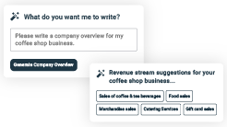
AI-poweredUpmetricsAssistant

AI-poweredinsightstostreamlineyourplan
Not sure where to start? Upmetrics’ AI Assistant will automaticallygenerateideasforeachsectionofyourplanand offerimprovedversionsofyourwriting,adjustingfortone,voice, and grammar or spelling errors.

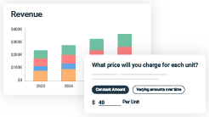
FinancialForecastingTool

Allthefinancialsarecalculatedforyou
Forget the complex formulas and clumsy spreadsheets — withautomaticfinancialsanddrag-and-dropforecasting,you canfinishyourplanfasterandbeconfidentthatyour numbers are accurate.

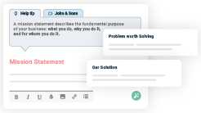
BusinessPlanBuilder

Guidesyoulikeabusinessmentor
Upmetrics’step-by-stepinstructions,prompts,andthelibraryof 400+samplebusinessplanswillguideyouthrougheachsection of your plan as a business mentor.

1.

ExecutiveSummary

Market opportunityProducts and Services
Marketing & Sales StrategiesFinancial Highlights



Anexecutivesummaryisthefirstsectionofthebusinessplanintendedto provide an overview of the whole business plan.
Tounlock helptry Upmetrics!

Helptip
GrandSlamBattingCages
Start your executive summary by briefly introducing your business to your readers. It may includethenameofyourbaseballbattingcagebusiness,itslocation,whenitwasfounded,etc.
Tounlock helptry Upmetrics!
Startwritinghere..

Marketopportunity

Helptip
GrandSlamBattingCages
Summarize your market research, including market size, growth potential, and marketing trends.Highlighttheopportunitiesinthemarketandhowyourbusinesswillfitintofillthegap.
Tounlock helptry Upmetrics!
Startwritinghere..

ProductsandServices

Helptip
GrandSlamBattingCages
Highlight the baseball batting products and services you offer your clients.The USPs and differentiators you offer are always a plus.
Tounlock helptry Upmetrics!
Startwritinghere..

Marketing&SalesStrategies

Helptip
GrandSlamBattingCages
Outline your sales and marketing strategies—what marketing platforms you use, how you plan on acquiring customers, etc.
Tounlock helptry Upmetrics!
Startwritinghere..

FinancialHighlights

Helptip
GrandSlamBattingCages
Brieflysummarizeyourfinancialprojectionsfortheinitialyearsofbusinessoperations.Include
anycapitalorinvestmentrequirements,associatedstartupcosts,projectedrevenues,and
profitforecasts.
Tounlock helptry Upmetrics!
Startwritinghere..

UnitsSoldv/sRevenueChart

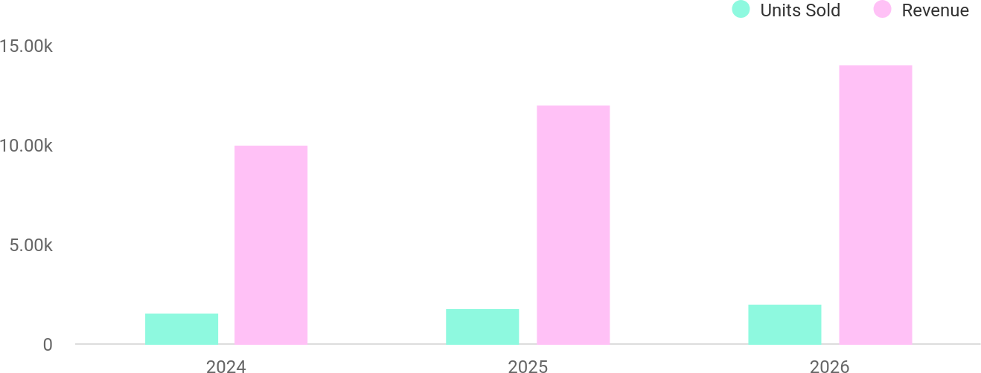

FinancialYear | UnitsSold | Revenue
2024 | 1,550 | $10,000
2025 | 1,800 | $12,000

FinancialYear | UnitsSold | Revenue
2026 | 2,050 | $14,000

Helptip
GrandSlamBattingCages
SummarizeyourexecutivesummarysectionwithaclearCTA,forexample,invitingangel investors to discuss the potential business investment.
Tounlock helptry Upmetrics!

Writeacalltoactionforyourbusinessplan.

2.

CompanyOverview

OwnershipMission statementBusiness historyFuture goals

Dependingonwhatdetailsofyourbusinessareessential,you’llneed different elements in your business overview.
Tounlock helptry Upmetrics!
Helptip
GrandSlamBattingCages
Describeyour businessin this sectionby providingall the basicinformation:

Describewhatkindofbaseballbattingbusinessyourunandthenameofit.Youmayspecialize
Tounlock helptry Upmetrics!
Startwritinghere..

Ownership

Helptip
GrandSlamBattingCages
List the names of your baseball batting business’s founders or owners. Describe what shares they own and their responsibilities for efficiently managing the business.
Tounlock helptry Upmetrics!
Startwritinghere..

BusinessOwners

MichaelThompson
100%
2000Shares

Missionstatement


Helptip
GrandSlamBattingCages
Summarizeyourbusiness’objective,coreprinciples,andvaluesinyourmissionstatement.This statement needs to be memorable, clear, and brief.
Tounlock helptry Upmetrics!

Ourmissionistofosteraloveforbaseballbyprovidingan
❛
exceptional training experience through innovative technology, professionalcoaching,andawelcomingenvironment.At[Grand
Slam Batting Cages], weare committed to helping players achievetheir full potential while cultivating a strong sense of community.
❜

Businesshistory

Helptip
GrandSlamBattingCages
Ifyou’reanestablishedbaseballbattingserviceprovider,brieflydescribeyourbusinesshistory, like—whenitwasfounded,howitevolvedovertime,etc.
Tounlock helptry Upmetrics!
Startwritinghere..

Futuregoals

Helptip
GrandSlamBattingCages
It’scrucialtoconveyyouraspirationsandvision.Mentionyourshort-termandlong-termgoals; they can be specific targets for revenue, market share, or expanding your services.
Tounlock helptry Upmetrics!
Startwritinghere..

3.

MarketAnalysis
TargetMarket
MarketsizeandgrowthpotentialCompetitive analysis
Market trendsRegulatoryenvironment

Marketanalysisprovidesaclearunderstandingofthemarketinwhichyour
printingbusinesswillrunalongwiththetargetmarket,competitors, and
growthopportunities.
Tounlock helptry Upmetrics!
Helptip
GrandSlamBattingCages
Towritetheintroductionsectionofyourmarketanalysis,startbyclearlyidentifyingyour primary target market.
Tounlock helptry Upmetrics!
Startwritinghere..

TargetMarket

Helptip
GrandSlamBattingCages
Startthissectionbydescribingyourtargetmarket.Defineyouridealcustomerandexplainwhat
typesofservicestheyprefer.Knowingthesethingswillhelpyouunderstandwhomyoucan
targetandwhatthechancesareofthemconverting.
Tounlock helptry Upmetrics!
Startwritinghere..

Marketsizeandgrowthpotential

Helptip
GrandSlamBattingCages
Describeyourmarketsizeandgrowthpotential,andwhetheryouwilltargetanicheoramuch broader market.
Tounlock helptry Upmetrics!
Startwritinghere..

MarketSize

AvailableMarket
This represents all potential baseball playersinOrangeCounty,includingyouth, amateurs, and prof

50k

ServedMarket
This segment focuses on players in Westminster and nearby areas with access to baseball training fac
20k

TargetMarket
8k
Ouridealcustomersincludeyouthleagues, amateur players, and baseball enthusiasts seeking modern

Helptip
GrandSlamBattingCages
Identifyandanalyzeyourdirectandindirectcompetitors.Identifytheirstrengths and
weaknesses,anddescribewhatdifferentiatesyourbaseballbattingservicesfromthem. Point
outhowyouhaveacompetitiveedgeinthemarket.
Tounlock helptry Upmetrics!

Competitiveanalysis

D-BATAnaheim
D-BATAnaheimisawell-knownbattingcagefacilitylocatedinAnaheim,CA,offeringbaseballand softballtrainingprograms.Theirfocusisonprovidingprofessional-gradetrainingforplayersofall ages.

Features
Climate-controlled indoor battingcageswithadvanced pitching machines.
Private lessons from professionalcoaches.
Equipment sales, including bats,gloves,andtraininggear.
Membership plans with access to exclusive benefits.

Strengths
Professional-gradefacilities suitable for all levels.
A wide range of services, includingequipmentretail.
Strongreputationwithinthe local baseball community.

Weaknesses
Higherpricingforprivatelessons andmemberships.
Limitedavailabilityduringpeak hours due to high demand.

TheCagesTrainingFacility
Located in Diamond Bar, CA,The CagesTraining Facility is a community-focused baseball and softball training center offering flexible training options and team rentals.

Features
Self-serviceandstaff-operated batting cages.
Teamrentalpackageswith access to multiple cages.
Specializedhittingclinicsand seasonal training camps.

Strengths
Affordablepay-as-you-go pricing.
Strong local ties with schools and recreational leagues.
Dedicatedteamrentaloptions, catering to youth leagues and amateur teams.

Weaknesses
Limitedtechnologicalfeatures compared to competitors.
Smallerfacilitywithfewerbatting cages, leading to longer wait times.

HitFactoryIndoorBattingCages
HitFactoryIndoorBattingCages,locatedinHuntingtonBeach,CA,specializesinprovidinghigh-tech batting cages and professional coaching for advanced players.

Features
State-of-the-art pitching machines with variable speeds and styles.
Real-timevideoanalysisand swing tracking technology.
Private coaching with professionalbaseballtrainers.

Strengths
Cutting-edgetechnologyfor advanced player training.
Highly skilled coaching staff with professional baseball experience.
Focusonanalytics,appealing to competitive players.

Weaknesses
Premium pricing limits accessibilityforbudget- conscious customers.
Facilitycatersprimarilyto advanced players.

Markettrends

Helptip
GrandSlamBattingCages
Catchingupwithmarkettrendsisimportanttobeinthecompetitivelandscapeofyour business.
Tounlock helptry Upmetrics!
Startwritinghere..

Regulatoryenvironment

Helptip
GrandSlamBattingCages
Whiletherearestate-specificregulations,hereisalistofcommonregulationsthatabaseball batting cage should follow:
Tounlock helptry Upmetrics!
Startwritinghere..

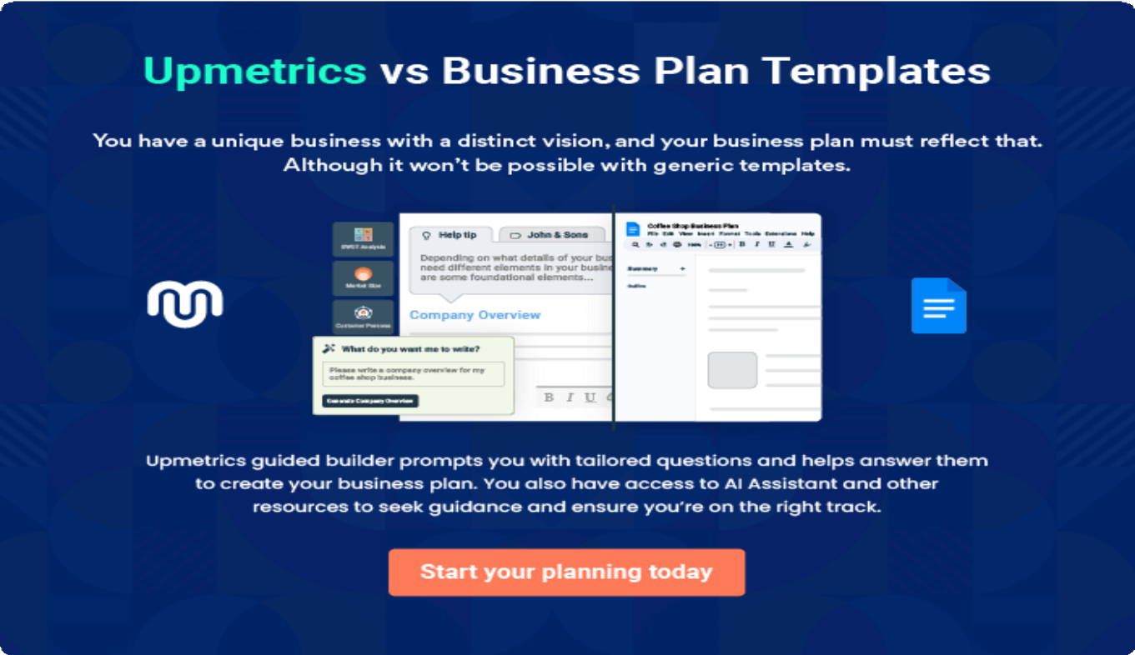

4.

Productsand Services

ProductsandServicesQuality Measures

Theproductandservicessectionofaseniordaycarebusinessplanshould
describethespecificservicesandproductsthatwillbeofferedtocustomers.
Towritethissectionshouldincludethefollowing:
Tounlock helptry Upmetrics!
Helptip
GrandSlamBattingCages
Tocrafttheintroductionforyour"ProductsandServices"chapter,beginbypositioningyour business within its industry, emphasizing its unique strengths or value proposition.
Tounlock helptry Upmetrics!

Startwritinghere..
Helptip
Mention the baseball batting products and services your business will offer.This list may include services like:
Tounlock helptry Upmetrics!

ProductsandServices


BattingCageSessions
Price:[$20]/hour(individual)|[$50]/hour(groupupto5 players)
Accesstoourstate-of-the-artbattingcagesequipped with adjustable-speed pitching machines. Perfect for players of all skill levels to practice their swings in a controlled environment.

Specifications
- Pitchingspeeds:Adjustablefrom40mphto90mph
- Balltypes:Softball,hardball,andcustomtraining balls
- Real-timeswinganalysisviaintegratedtracking technology

ProtectiveGearRental
Price:[$5]/session

High-qualityprotectivegearrentalstoensureasafeand comfortable practice session. Gear includes helmets, gloves, and bats that meet industry standards.

Specifications
  - Helmets:Lightweight,shock-resistant,andavailable in multiple sizes
  - Bats: Aluminum and composite options, varying weights and lengths
  - Gloves:Paddedforcomfortandavailableinvarious hand sizes

MembershipPackages
Price:Monthly:[$75]|Quarterly:[$200]|Annual:[$700]

Membership plans for regular customers offering exclusive benefits such as discounted session rates, free gear rentals, and priority booking. Ideal for frequent players and teams.

Specifications
  - Monthlyplan:5freebattingcagesessions
  - Quarterly plan: 15 free sessions + 10% off additional bookings
  - Annual plan: Unlimited sessions + free personalized coaching session

PersonalizedCoachingPrograms
Price: [$50]/session (individual) | [$100]/session (group up to 3 players)
One-on-oneorgrouptrainingwithprofessionalbaseball coaches. Customized plans designed to improve swing mechanics, speed, and overall game performance.

Specifications
  - Duration:1-hoursessions
  - Includes:Videoswinganalysis,drills,andtechnique correction
  - Levels:Beginner,intermediate,andadvanced

QualityMeasures

Helptip
GrandSlamBattingCages
This section should explain how you maintain quality standards and consistently provide the highest quality service.
Tounlock helptry Upmetrics!
Startwritinghere..

5.

SalesAndMarketing
Strategies

Unique Selling Proposition (USP)Pricing Strategy
Marketing strategiesSales strategiesCustomer retention

Writing the sales and marketing strategies section means a list of strategies you will use to attract and retain your clients.
Tounlock helptry Upmetrics!
Helptip
GrandSlamBattingCages
Tocreateaneffectiveintroductionforyour"SalesandMarketingStrategies"chapter,startby setting the stage within your specific industry or market.
Tounlock helptry Upmetrics!
Startwritinghere..

UniqueSellingProposition(USP)

Helptip
GrandSlamBattingCages
Define your business’s USPs depending on the market you serve, the equipment you use, and theuniqueservicesyouprovide.IdentifyingUSPswillhelpyouplanyourmarketingstrategies.
Tounlock helptry Upmetrics!
Startwritinghere..

PricingStrategy

Helptip
GrandSlamBattingCages
Describeyourpricingstrategy—howyouplantopriceyourservicesandstaycompetitiveinthe
localmarket.Youcanmentionanydiscountsyouplanonofferingtoattractnewcustomers to
yourbusiness.
Tounlock helptry Upmetrics!
Startwritinghere..

Helptip
Discussyourmarketingstrategiestomarketyourservices.Youmayincludesomeofthese
marketingstrategiesinyourbusinessplan—socialmediamarketing,videomarketing,email
marketing,influencercollaboration,etc.
Tounlock helptry Upmetrics!

Marketingstrategies

Online


Offline

SocialMedia Marketing
Active campaigns on platforms like Facebook, Instagram, andYouTubetargeting local baseball players and families.

EmailMarketing
Personalized emails offering promotions, updates,andtipstoour subscribers.

Influencer Collaboration
Partnering with local athletes and coaches to promote our services.

VideoMarketing
Highlighting success stories,facilityfeatures, and training sessions throughengagingvideo content.

LocalPartnerships
Collaborating with schools,youthleagues, and sports organizations to increase community presence.

Helptip
Outline the strategies you’ll implement to maximize your sales. Your sales strategies may includedirectsalescalls,partneringwithotherbusinesses,offeringreferralprograms,etc.
Tounlock helptry Upmetrics!

Salesstrategies

DirectSalesCalls
Reaching out to local schools and baseball teamstopromoteteam rentals and memberships.

Corporate Partnerships
Partnering with local businesses for employee wellness programs involving recreational activities.

ReferralPrograms
Offering discounts or free sessions to customerswhorefer new clients.

Helptip
Describeyourcustomerretentionstrategiesandhowyouplantoexecutethem.Forinstance, package deals & discounts, frequent player rewards, membership programs, etc.
Tounlock helptry Upmetrics!

Customerretention

Membership Rewards
Exclusive benefits such asfreegearrentalsand priority booking for members.

PackageDeals
Offering discounts on recurring bookings to encourage long-term commitments.

FrequentPlayer Rewards
Providing incentives like free sessions for customers who book frequently.

FeedbackIntegration
Regularlycollectingand implementing customer feedback to enhance service quality.

6.

OperationsPlan

Staffing & TrainingOperational ProcessEquipment & Tools

Whenwritingtheoperationsplansection,it’simportanttoconsiderthe various aspects of your business operations.
Tounlock helptry Upmetrics!
Helptip
GrandSlamBattingCages
Tocreateaneffectiveintroductionforyour"OperationalPlan"chapter,startbyemphasizingthe
pivotalroleofefficientoperationsinthesuccessofyourbusiness,underscoringhowthey
directlyimpactthequalityofservicesdelivered.
Tounlock helptry Upmetrics!
Startwritinghere..

Staffing&Training

Helptip
GrandSlamBattingCages
Mentionyourbusiness’sstaffingrequirements,includingthenumberofemployeesorcoaches
&trainersneeded.Includetheirqualifications,thetrainingrequired,andthedutiestheywill
perform.
Tounlock helptry Upmetrics!
Startwritinghere..

OperationalProcess

Helptip
GrandSlamBattingCages
Outlinetheprocesses andprocedures youwilluse torun yourbaseballbatting business.Your
operationalprocessesmayincludefacilitysetup&maintenance,operatinghours,reservation
system, staffing,customercheck-in,etc.
Tounlock helptry Upmetrics!
Startwritinghere..

Equipment&Tools

Helptip
GrandSlamBattingCages
Includethelistofequipmentandmachineryrequiredforbaseballbatting,suchasbatting
cages,pitchingmachines,L-screens,baseballs&softballs,bats,pitchingmounds,lighting,
CCTVcameras,etc.
Tounlock helptry Upmetrics!
Startwritinghere..

7.

ManagementTeam

Founders/CEOKeymanagers
OrganizationalstructureCompensation planBoard of advisors

The management team section provides an overview of the individuals responsible for running your business plan.
Tounlock helptry Upmetrics!
Helptip
GrandSlamBattingCages
Tocraftanintroductionforyour"ManagementTeam"chapter,beginbyemphasizingthecrucial role of leadership in the success of any business.
Tounlock helptry Upmetrics!
Startwritinghere..

Founders/CEO

Helptip
Mention the founders and CEO of your baseball batting business, and describe their roles and responsibilities in successfully running the business.
Tounlock helptry Upmetrics!
Startwritinghere..


MichaelThompson

FounderandCEO-michael.thompson@example.com

Responsibilities:



Michael oversees the strategic direction of the business, manages high-level operations, and works closely with the team to deliver a superior customer experience.
Education:

- Bachelor’sDegreeinSportsScience,UniversityofSouthernCalifornia

ProfessionalBackground:

- HeadBaseballCoachatWestminsterHighSchool(2010-2016)
- OperationsManageratProSwingTrainingCenters(2017-2023)
- Developedareputationforimprovingplayerperformancethrough innovative training methods and efficient facility management.

Keymanagers

Helptip
Introduceyourmanagementandkeyteammembers,andexplaintheirrolesand responsibilities.
Tounlock helptry Upmetrics!
Startwritinghere..


EmilyCarter

DirectorofOperations-emily.carter@example.com

Responsibilities:

Emily manages operational staff, schedules, and ensures all equipment and facilities are maintained to the highest standards.
Education:

- Bachelor’sDegreeinBusinessAdministration,CaliforniaStateUniversity, Fullerton
ProfessionalBackground:

- OperationsManageratDiamondSportsComplex(2015-2019)
- FacilityDirectoratGoldenGloveTrainingCenter(2020-2023)
- Knownforherattentiontodetailandoperationalexcellence,shehasa track record of increasing customer satisfaction by 30% at her previous role.

Laura Bennett


MarketingManager-laura.bennett@example.com

Responsibilities:

Laura manages social media campaigns, community partnerships, and marketing events to attract new customers and retain existing ones.
Education:

- Master’sDegreeinMarketing,UniversityofCalifornia,LosAngeles

ProfessionalBackground:

- DigitalMarketingSpecialistatPitchProSports(2016-2019)
- MarketingDirectoratBaseballAcademyPlus(2020-2023)
- Recognizedforherabilitytocreateimpactfulcampaignsthatboosted client engagement by 40%.


JacobMartinez

CustomerServicesManager-jacob.martinez@example.com

Responsibilities:

Jacob handles customer inquiries, manages bookings through the online reservation system, and supervises front-desk operations.
Education:

- Bachelor’sDegreeinCommunications,UniversityofCalifornia,Irvine

ProfessionalBackground:

- CustomerServiceAssociateatPlayBallSports(2016-2019)
- FrontDeskSupervisoratEliteTrainingFacilities(2020-2023)
- Praisedforhisexcellentinterpersonalskillsandabilitytoresolve customer concerns effectively.

Organizationalstructure

Helptip
GrandSlamBattingCages
Explaintheorganizationalstructureofyourmanagementteam.Includethereportinglineand decision-making hierarchy.
Tounlock helptry Upmetrics!
Startwritinghere..

Organizationchart


MichaelThompson
FounderandCEO



EmilyCarter
DirectorofOperations LauraBennett
MarketingManager


JacobMartinez CustomerServices Manager


JohnRiley
HeadCoach
SarahJenkins Administrative Assistant

Compensationplan

Helptip
GrandSlamBattingCages
Describeyourcompensationplanforthemanagementandstaff.Includetheirsalaries, incentives, and other benefits.
Tounlock helptry Upmetrics!
Startwritinghere..

Helptip
Mentioningadvisorsorconsultantsinyourbusinessplansaddscredibilitytoyourbusiness idea.
Tounlock helptry Upmetrics!

Boardofadvisors


JohnPeterson

SportsTrainingAdvisor

With20yearsofexperienceasaprofessionalbaseballcoach,Johnadviseson trainingprogramsandequipmentselection.Hisinsightsensurethefacility meetsthehigheststandardsforplayerdevelopment.

SarahWilliams


BusinessConsultant

Sarah is a seasoned entrepreneur with a track record of helping sports businesses scale operations. She provides strategic guidance on marketing, financial planning, and expansion initiatives.

8.

FinancialPlan

Profit&lossstatementCash flow statementBalance sheet
Break-evenPointFinancing needs

Helptip
Describedetailssuchasprojectedrevenue,operationalcosts,andservicecostsinyourprojectedprofitandlossstatement.Makesuretoinclude
yourbusiness’sexpectednetprofitorloss.

Whenwritingthefinancialplansectionofabusinessplan,it’simportanttoprovideacomprehensiveoverviewofyourfinancial projections for the first few years of your business, You may provide the following:
Tounlock helptry Upmetrics!
Helptip
GrandSlamBattingCages
Tocreateaneffectiveintroductionforyour"FinancialPlan"chapter,beginbystressingthecriticalroleofawell-structuredfinancialplaninthe success of your venture.
Tounlock helptry Upmetrics!
Startwritinghere..

 |  |  | Tounlock helptry Upmetrics!
Profit&lossstatement | 2024 | 2025 | 2026
Revenue | $947,315.40 | $2,592,726 | $4,979,925.80
BattingCageRentals | $120,000 | $120,000 | $120,000

 | 2024 | 2025 | 2026
TotalHours | 4,800 | 4,800 | 4,800
HourlyPrice | $25 | $25 | $25
MembershipSubscriptions | $827,315.40 | $2,472,726 | $4,859,925.80
Users | 2,721 | 6,492 | 12,069
RecurringCharges | $40 | $40 | $40
CostOf Sales | $25,200 | $25,200 | $25,200
GeneralCosts | $25,200 | $25,200 | $25,200
EquipmentandSupplies | $15,000 | $15,000 | $15,000
MaintenanceSupplies | $6,000 | $6,000 | $6,000
Baseballs | $9,000 | $9,000 | $9,000
UtilitiesandConsumables | $10,200 | $10,200 | $10,200
Electricity | $9,000 | $9,000 | $9,000
WaterUsage | $1,200 | $1,200 | $1,200
RevenueSpecificCosts | $0 | $0 | $0

PersonnelCosts(Direct Labor)

$0 $0 $0

2024 2025 2026

GrossMargin | $922,115.40 | $2,567,526 | $4,954,725.80
GrossMargin(%) | 97.34% | 99.03% | 99.49%

Operating Expense | $1,525,008 | $1,780,386.24 | $2,088,039.96
PayrollExpense(Indirect Labor) | $1,432,008 | $1,690,386.24 | $1,998,039.96
Management | $1,320,000 | $1,573,440 | $1,875,667.20
General Manager | $792,000 | $950,400 | $1,140,480
AssistantManager | $528,000 | $623,040 | $735,187.20
Operational Staff | $79,968 | $81,565.44 | $83,290.56
BattingCageAttendants | $60,000 | $60,000 | $60,000
MaintenanceStaff | $19,968 | $21,565.44 | $23,290.56
AdministrativeStaff | $32,040 | $35,380.80 | $39,082.20
Receptionist | $12,600 | $13,608 | $14,696.64
OfficeAssistant | $19,440 | $21,772.80 | $24,385.56
GeneralExpense | $90,000 | $90,000 | $90,000

 | 2024 | 2025 | 2026
Marketingand Advertising | $33,600 | $33,600 | $33,600
SocialMediaAdvertising | $3,600 | $3,600 | $3,600
LocalSponsorships | $30,000 | $30,000 | $30,000
FacilityMaintenance | $19,200 | $19,200 | $19,200
CleaningServices | $4,800 | $4,800 | $4,800
RepairsandMaintenance | $14,400 | $14,400 | $14,400
AdministrativeCosts | $37,200 | $37,200 | $37,200
Insurance | $36,000 | $36,000 | $36,000
SoftwareSubscriptions | $1,200 | $1,200 | $1,200
BadDebt | $0 | $0 | $0

AmortizationofCurrent Assets

$3,000 $0 $0

EBITDA ($602,892.60) $787,139.76 $2,866,685.84

AdditionalExpense | $9,089.98 | $8,166.21 | $7,195.20
LongTermDepreciation | $4,500 | $4,500 | $4,500

Assets
2024 |  | 2025 | 2026
GainorlossfromSaleof $0 |  | $0 | $0
EBIT ($607,392.60) |  | $782,639.76 | $2,862,185.84
InterestExpense $4,589.96 |  | $3,666.20 | $2,695.19
EBT ($611,982.58) |  | $778,973.55 | $2,859,490.64
IncomeTaxExpense/ $0 |  | $0 | $0
TotalExpense | $1,559,297.98 | $1,813,752.45 | $2,120,435.16
NetIncome | ($611,982.58) | $778,973.55 | $2,859,490.64
NetIncome(%) | (64.60%) | 30.04% | 57.42%

Benefit

RetainedEarningOpening | $0 | ($560,784.32) | $140,291.87
Owner'sDistribution | ($51,198.26) | $77,897.36 | $285,949.06
RetainedEarningClosing | ($560,784.32) | $140,291.87 | $2,713,833.45

Cashflowstatement | 2024 | 2025 | 2026
CashReceived | $947,315.40 | $2,592,726 | $4,979,925.80
CashPaid | $1,551,797.98 | $1,809,252.45 | $2,115,935.16
COS&GeneralExpenses | $115,200 | $115,200 | $115,200
Salary&Wages | $1,432,008 | $1,690,386.24 | $1,998,039.96
Interest | $4,589.96 | $3,666.20 | $2,695.19
SalesTax | $0 | $0 | $0
IncomeTax | $0 | $0 | $0

NetCashFrom Operations

($604,482.58) $783,473.55 $2,863,990.64

Helptip
Thecashflowforthefirstfewyearsofyouroperationshouldbeestimatedanddescribedinthissection.Thismayincludebillinginvoices, payment receipts, loan payments, and any other cash flow statements.
Tounlock helptry Upmetrics!

AssetsSell $0 $0 $0

 | 2024 | 2025 | 2026
AssetsPurchase | $28,000 | $0 | $0

NetCashFrom Investments

($28,000) $0 $0

AmountReceived | $150,000 | $0 | $0
LoanReceived | $100,000 | $0 | $0
CommonStock
PreferredStock | $0 | $0 | $0
Owner'sContribution | $50,000 | $0 | $0
AmountPaid | ($33,142.80) | $96,876.59 | $305,899.30
LoanCapital | $18,055.48 | $18,979.24 | $19,950.25
Dividends&Distributions | ($51,198.26) | $77,897.36 | $285,949.06

NetCashFrom Financing

$183,142.80 ($96,876.59) ($305,899.30)

Summary

StartingCash $0 ($449,339.78) $237,257.18

 | 2024 | 2025 | 2026
CashIn | $1,097,315.40 | $2,592,726 | $4,979,925.80
CashOut | $1,546,655.18 | $1,906,129.04 | $2,421,834.46
Change inCash | ($449,339.78) | $686,596.96 | $2,558,091.34
Ending Cash | ($449,339.78) | $237,257.18 | $2,795,348.52

Helptip
Createaprojectedbalancesheetdocumentingyourbaseballbattingbusiness’sassets,liabilities,andequity.
Tounlock helptry Upmetrics!

Balancesheet | 2024 | 2025 | 2026
Assets | ($428,839.78) | $253,257.18 | $2,806,848.52
CurrentAssets | ($449,339.78) | $237,257.18 | $2,795,348.52
Cash | ($449,339.78) | $237,257.18 | $2,795,348.52
AccountsReceivable | $0 | $0 | $0
Inventory | $0 | $0 | $0

 | 2024 | 2025 | 2026
OtherCurrentAssets | $0 | $0 | $0
LongTermAssets | $20,500 | $16,000 | $11,500
GrossLong TermAssets | $25,000 | $25,000 | $25,000
Accumulated Depreciation | ($4,500) | ($9,000) | ($13,500)

Liabilities&Equity | ($428,839.80) | $253,257.15 | $2,806,848.48
Liabilities | $81,944.52 | $62,965.28 | $43,015.03
CurrentLiabilities | $18,979.23 | $19,950.24 | $20,970.94
AccountsPayable | $0 | $0 | $0
IncomeTaxPayable | $0 | $0 | $0
SalesTaxPayable | $0 | $0 | $0
ShortTermDebt | $18,979.23 | $19,950.24 | $20,970.94
LongTermLiabilities | $62,965.29 | $43,015.04 | $22,044.09
LongTermDebt | $62,965.29 | $43,015.04 | $22,044.09
Equity | ($510,784.32) | $190,291.87 | $2,763,833.45
Paid-inCapital | $0 | $0 | $0
CommonStock | $0 | $0 | $0

Helptip
Determineandmentionyourbusiness’sbreak-evenpoint—thepointatwhichyourbusinesscostsandrevenuewillbeequal.

Thisexercisewillhelpyouunderstandhowmuchrevenueyouneedtogeneratetosustainorbeprofitable.
 | 2024 | 2025 | 2026
PreferredStock | $0 | $0 | $0
Owner'sContribution | $50,000 | $50,000 | $50,000
RetainedEarnings | ($560,784.32) | $140,291.87 | $2,713,833.45

Check $0 $0 $0

 |  |  | Tounlock helptry Upmetrics!
Break-evenPoint | 2024 | 2025 | 2026
StartingRevenue | $0 | $947,315.40 | $3,540,041.40
NetRevenue | $947,315.40 | $2,592,726 | $4,979,925.80
ClosingRevenue | $947,315.40 | $3,540,041.40 | $8,519,967.20

 | 2024 | 2025 | 2026
StartingExpense | $0 | $1,559,297.98 | $3,373,050.43
NetExpense | $1,559,297.98 | $1,813,752.45 | $2,120,435.16
ClosingExpense | $1,559,297.98 | $3,373,050.43 | $5,493,485.59

IsBreakEven? | No | Yes | Yes
BreakEvenMonth | 0 | Nov'25 | 0
DaysRequired | 0 | 25Days | 0
BreakEvenRevenue | $1,559,297.98 | $3,199,300.17 | $0
BattingCage Rentals | $0 | $228,333.33 | $0

Membership Subscriptions
$0 $2,970,966.83 $0

BreakEvenUnits

BattingCage Rentals 0 9,133 0

Membership Subscriptions
0 6,157 0

Financingneeds

Helptip
GrandSlamBattingCages
Calculate costs associated with starting a baseball batting business, and estimate your financing needs and how much capital you need to raise to operate your business. Be specific about your short-term and long-term financing requirements, such as investment capital or loans.
Tounlock helptry Upmetrics!
Startwritinghere..

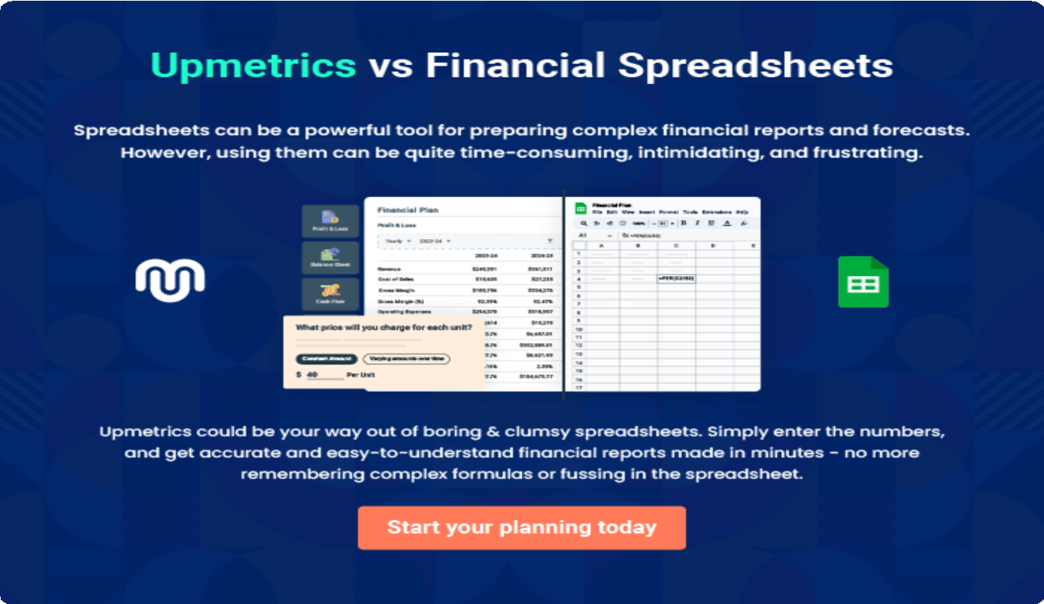

9.

Appendix
EmbedLink

Whenwritingtheappendixsection,youshouldincludeanyadditional
informationthatsupportsthemaincontentofyourplan.Thismayinclude
financialstatements,marketresearchdata,legaldocuments,andother
Tounlock helptry Upmetrics!
EmbedLink

Createawinningbusinessplanthatgetsyoufunded

Creatingastunningandinvestment-readyplanrequiresnowriting,graphicdesigning,orfinancial planning expertise.

Upmetricshasallthefeaturesrequiredtohelpyoucreateacomprehensivebusinessplan—fromstarttofinish. Makenomistakes,it’sthemodernwayofplanningtostructureideas,makeplans,andcreatestunningpitch decks to awe investors.

Pitchdecksthatimpressinvestors
Create pitch decks that provide a visual representation of your business, engage investors,andmakethemwanttoinvestinyour businessidea.

Interactiveplansinnotime
Import business plan sections like—SWOT analysis,comparisontables,andotherstocreate an interactive business plan. No designing skills arerequired.

Stunningcoverpagedesigns
WithUpmetrics,youhavethelibertytochoose from multiple stunning cover page designs.
Chooseacreativedesignandmakeyourplan standout.

500+samplebusinessplans
Simplyimportatemplatefromourlibraryof sample plans into the editor and start customizingittomakeityours.Ittakesonlyafew clicks to get started.

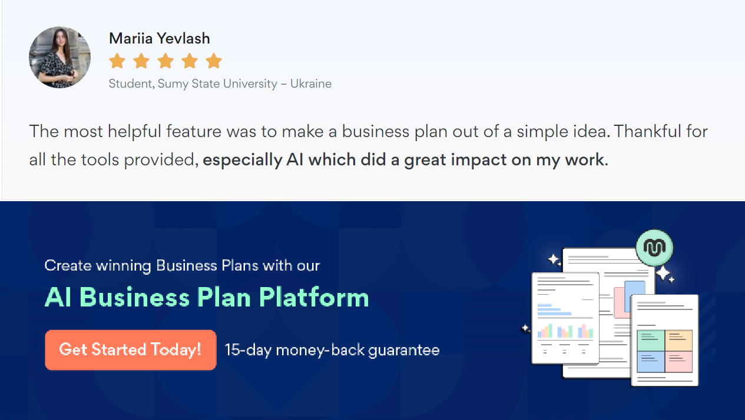Onlinesharingmadesimple
Upmetricsmakesonlinesharingquickandeasier forusers.Easilyshareyourbusinessplanswitha linkwhiletrackingreaderactivity.

Collaboratewithteaminreal-time
Invite team members, initiate conversations, discussideas&strategies,sharefeedback,and work on a business plan in real-time.

