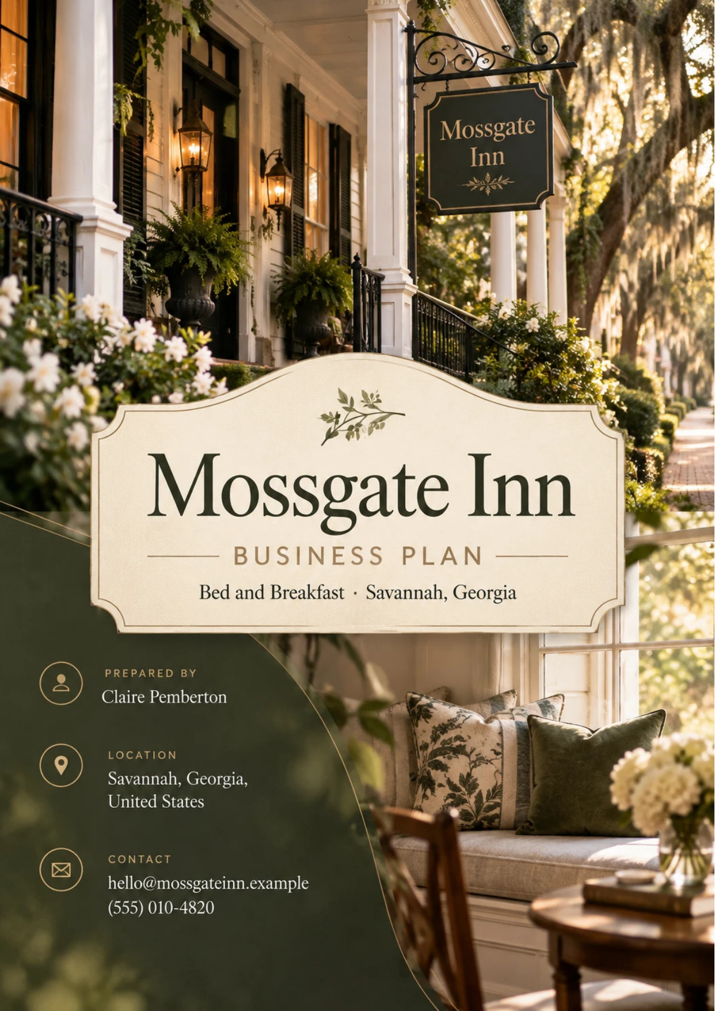
Table of Contents
1. Executive Summary 6
1.1 Business Overview 7
1.2 Mission Statement 7
1.3 Location & Market Opportunity 7
1.4 Unique Selling Points 7
1.5 Financial Highlights 8
1.6 Funding Requirement 8
1.6.1 Income Statement (3 Year projections) 8
2. Company Overview 9
2.1 Legal Structure 10
2.2 Vision Statement 10
2.3 Background & History 10
2.4 Future Goals 10
2.4.1 Business Owners 11
2.4.2 SMART Goal 11
3. Market Analysis 12
3.1 Overview 13
3.2 Market Segmentation 13
3.3 Market Trends 13
3.4 Local Market Outlook 13
3.5 Market Size 14
4. Customer Analysis 15
4.1 Target Market 16
4.2 Customer Segments 16
4.3 Customer Persona 17
4.4 Customer Purchase Journey 17
5. Competitive Analysis 18
5.1 Competitors 19
5.2 Comparison 19
5.3 Competitive Edge 19
5.4 SWOT Analysis 20
6. Services Offered 21
6.1 Our Offering 22
6.2 Signature Items 22
6.3 Additional Services 22
6.4 What Sets Us Apart 22
6.5 Guest Rooms & Suites 22
6.5.1 Elopement & Celebration Packages 24
6.5.2 Features 24
6.5.3 Pricing 25
7. Marketing & Sales Strategies 26
7.1 Market Positioning 27
7.2 Marketing Objectives 27
7.3 Online Marketing 27
7.4 Public Relations and Branding 28
7.5 Partnership & Collaboration Strategy 28
7.6 Customer Loyalty & Retention 28
7.7 Sales Channels 28
8. Operations Plan 29
8.1 Daily Operations 30
8.2 Working Hours 30
8.3 Staffing & Training 30
8.4 Inventory & Equipment Management 30
8.5 Location and Facilities 30
8.6 Milestones & Timeline 31
8.7 Breakfast Service & Food Safety 31
9. Management Team 33
9.1 Key Members 34
9.2 Organization Chart 34
9.3 Advisory Board Members 35
9.3.1 Hiring Plan 35
10. Financial Plan 36
10.1 Key Assumptions 37
10.2 Capital Requirements and Use of Funds 37
10.2.1 Use of Funds 37
10.3 Income Statement (3 Year projections) 39
10.4 Balance Sheet (3 Year projections) 40
10.5 Cash Flow Statement (3 Year projections) 41
10.6 Break Even Analysis 42
11. References 43


CHAPTER 1

Executive Summary

1.1 Business Overview
1.2 Mission Statement
1.3 Location & Market Opportunity
1.4 Unique Selling Points
1.5 Financial Highlights
1.6 Funding Requirement

1.1 Business Overview
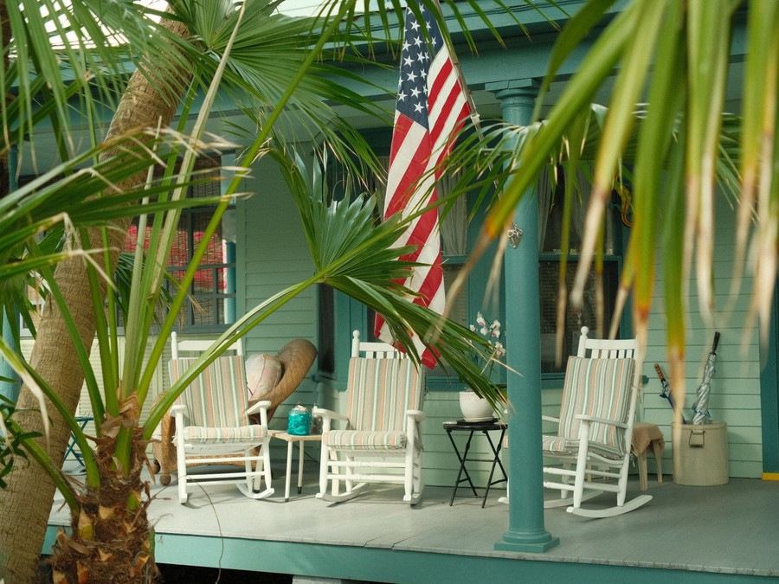
Mossgate Inn is an owner-run bed and breakfast planned for Savannah's historic district: eight guest rooms and suites in a restored 1880s house and its carriage house, with a cooked Southern breakfast included every night. Its owners, Claire and James Pemberton, will live on site and run the house themselves.
The inn sells to couples and leisure travelers on a two or three night getaway, most of them driving in from Atlanta, Charlotte and Jacksonville, and to couples who come to Savannah to elope or mark an anniversary. Elopement and celebration packages in the courtyard garden are sold alongside the rooms.

1.2 Mission Statement
To keep a house in Savannah where every guest is known by name, breakfast is cooked rather than set out, and the people who own the inn are the ones who answer the door.

1.3 Location & Market Opportunity
Savannah received an estimated 12.9 million visitors in 2024, who spent $4.1 billion, and 7.2 million of them stayed overnight. The city's hotels ran at 72.8% occupancy through July 2024 at an average daily rate of $152.43, across more than 18,000 rooms in 214 reporting properties. The historic district, where the inn will trade, is the first demand generator on that list.
Nationally, bed and breakfast and hostel businesses generated $3.2 billion in 2025. Savannah's own lodging market is worth about $728.4 million a year in room revenue, derived from the hotel market's 2024 run rate. A single business in this trade averages about $736,000 a year nationally, and Mossgate's first-year revenue of $558,417 sits below that average, as an eight-room house should.

1.4 Unique Selling Points
- A plated Southern breakfast cooked each morning by an owner, included in every rate.
- Eight rooms and two resident hosts, so service is personal from check-in to checkout.
- Ceremonies for up to 20 guests in the courtyard garden, upstairs from the couple's suite.
- A walk of minutes to the squares, the riverfront and Forsyth Park.
- Rates from $245 to $385 a night, with breakfast included in every one.

1.5 Financial Highlights
Revenue comes from eight rooms at 68% occupancy and a $295 average daily rate, with packages and add-ons worth a further 10% of room revenue. The inn opens at 60% of that level and builds to it over eight months as reviews accumulate.
Revenue is projected at $558,417 in the first year, $625,427 in the second and $700,478 in the third, at a gross margin of 78.0% throughout. Net income is $4,175 in the first year, rising to $25,241 and then $48,607, a net margin of 6.9% by the third year. Break-even revenue is $472,049, the equivalent of 1,600 room nights, which the first year clears. Third-year net income is $8,537 in the conservative case and $102,727 in the upside case.

1.6 Funding Requirement
The startup budget is $364,500. It furnishes eight rooms, pays for leasehold improvements and the breakfast kitchen fit-out, sets up the courtyard and the booking technology, and covers permits, the lease deposit, opening stock, launch marketing and pre-opening staff. It is funded by a $175,000 owner contribution and a $260,000 SBA 7(a) loan at 9.75% over ten years, which leaves an opening cash cushion. Profits stay in the business while the loan is repaid.
The plan rests on owners with hotel and kitchen experience, a destination that draws millions of overnight visitors a year, and an offer that hotels and rentals in the district do not make. The money opens one well-run house with a breakfast and a garden worth the trip.

1.6.1 Income Statement (3 Year projections)
 | Year 1 | Year 2 | Year 3 | Total
Revenue | $558,416.88 | $625,426.91 | $700,478.14 | $1,884,321.93
Cost of Sales | $122,851.71 | $137,593.92 | $154,105.19 | $414,550.82
Gross Margin | $435,565.17 | $487,832.99 | $546,372.95 | $1,469,771.11
Operating Expense | $368,198.41 | $393,662.23 | $422,181.70 | $1,184,042.34
Total Expense | $554,241.81 | $600,185.73 | $651,871.06 | $1,806,298.60
Net Income | $4,175.07 | $25,241.18 | $48,607.08 | $78,023.33

CHAPTER 2

Company Overview

2.1 Legal Structure
2.2 Vision Statement
2.3 Background & History
2.4 Future Goals

2.1 Legal Structure
Mossgate Inn will trade as Mossgate Inn LLC, a Georgia limited liability company owned by its two founders and electing to be taxed as a corporation. The company holds the lease, the SBA loan, the permits and the guest contracts.
Savannah's zoning treats a lodging house of no more than 15 guest rooms as an inn, provided it is owner-occupied or staffed on site around the clock; the Pembertons' residence in the house meets that test. A restaurant, bar or event space open to the public would be a separate use, so breakfast and courtyard ceremonies are offered to staying guests only. The Georgia Department of Public Health permits the inn as a tourist accommodation, and the company registers to collect the city's hotel/motel tax.

2.2 Vision Statement
To become the inn Savannah regulars recommend to their friends: small enough that the owners know every guest, well run enough that guests come back every year, and settled enough in its street that the house is looked after for the next century.

2.3 Background & History
Mossgate Inn is a planned business, and what follows is the founders' stated intent rather than a trading history. Claire Pemberton spent fourteen years in hotel operations, most recently running the rooms division of a full-service hotel. James Pemberton trained as a restaurant sous chef and has spent years restoring older houses. Between them they cover the two things a small inn lives or dies on: the stay and the breakfast.
They chose Savannah after a decade of visiting it as guests. Buying a house large enough for eight rooms is beyond a first venture: Savannah's median home sold for about $370,739 in 2025, and historic district houses run well above that. The plan is to lease a restored 1880s house of about 6,500 square feet, with a carriage house and courtyard, on a ten-year term.
The name comes from the iron gate on the lane behind the house, hung each spring with Spanish moss: the guests' private way into the courtyard.

2.4 Future Goals
In the first 0 to 18 months, the goal is to open the doors in March 2027 for Savannah's spring season, pass the permitting inspection, and reach the planned 68% occupancy by the eighth month of trading. The same period builds the review base on each booking site and runs the first full season of courtyard elopements.
Over 1 to 3 years, matching the three projection years, the inn grows revenue from $558,417 to $700,478 and net income from $4,175 to $48,607. Direct bookings should carry more than half of all nights by the start of the second year, cutting agency commission, and the SBA loan is repaid on schedule from operating cash.
Over 3 to 5 years, the founders intend to refresh every room on a rolling cycle, grow returning-guest stays, and negotiate an option to buy the house when the lease comes up for review.

2.4.1 Business Owners
Claire Pemberton | James Pemberton

Total ownership: 100%
50% | Claire Pemberton  5,000 Shares
50% | James Pemberton  5,000 Shares

2.4.2 SMART Goal
  Specific  - Fill eight rooms to 68% occupancy at a $295 average rate.  - Run from the restored house in the historic district.  - Clear break-even revenue of $472,049 in the first year. |   Measurable  - Occupancy, average rate and RevPAR, reviewed weekly.  - Share of nights booked direct, tracked monthly.  - Review scores and elopement packages sold. |   Achievable  - Savannah hotels ran at 72.8% through July 2024.  - Hotel rooms and kitchen experience between the owners.  - A soft opening seeds the first reviews.
  Relevant  - Room revenue is nearly all of the inn's income.  - Direct bookings protect the 78.0% gross margin.  - 12.9 million visitors came to Savannah in 2024. |   Time-Based  - Doors open for spring in March 2027.  - Target occupancy by the eighth month of trading.  - Direct bookings past half of nights in year two.

CHAPTER 3

Market Analysis

3.1 Overview
3.2 Market Segmentation
3.3 Market Trends
3.4 Local Market Outlook
3.5 Market Size

3.1 Overview
IBISWorld puts US bed and breakfast and hostel accommodations at $3.2 billion of revenue in 2025, up 1.9% on the year, across 4,347 businesses. No operator holds a large share: the trade is made up of independent houses, each competing in its own town against hotels and rentals for the same travelers.
No current national occupancy series exists for bed and breakfasts alone, so the hotel series is the benchmark. US hotels sold 62.3% of their rooms in 2025, down 1.2%, at an average daily rate of $160.54. A small inn's results depend far more on its own market and reviews than on that national figure.

3.2 Market Segmentation
Overnight demand in a destination like Savannah splits into four groups, and an eight-room inn is built for two of them:
- Leisure couples on a short getaway: the core of the inn's nights, choosing a hosted historic house over a hotel.
- Celebration travelers: couples eloping, renewing vows or marking an anniversary, who also buy packages.
- Families and groups: better served by whole-house rentals with kitchens and several bedrooms.
- Business, port and military travelers: weekday demand that downtown hotels with meeting space capture.

3.3 Market Trends
Americans traveled more in 2025 than in any of the previous five years, according to a survey of more than 4,500 active leisure travelers. In short-term rentals, revenue per available rental is projected to grow 2.9% in 2026, carried almost entirely by nightly rates rather than more nights sold, which tells an inn that rate, not volume, is where the market is moving.
At the same time, national hotel occupancy fell in 2025 for the first time since 2020, so demand is not rising everywhere. Food rules matter too: states set the rules for a bed and breakfast's breakfast, and many treat a small inn serving only its own guests differently from a restaurant.

3.4 Local Market Outlook
Savannah received an estimated 12.9 million visitors in 2024, who spent $4.1 billion; 7.2 million stayed overnight, for an average of 2.8 days. Demand is driven by the historic district, the Tybee Island beaches, the port, Gulfstream and nearby military installations, and air traffic in 2024 was 36.8% above 2019.
Supply is large and growing. The hotel market holds more than 18,000 rooms in 214 reporting properties and ran at 72.8% occupancy through July 2024 at a $152.43 average rate. Twelve projects with over 1,500 rooms were in the pipeline, including boutique hotels and historic conversions, and Savannah was forecast to add 4.1% to its lodging supply in 2025, the most of any US market. The average Savannah short-term rental books at $309 a night. No published count of the city's bed and breakfasts exists.
Local rules shape who can compete. Savannah caps non-owner-occupied short-term rentals at 20% of parcels per ward in the Downtown and Victorian historic districts, and defines an inn as no more than 15 rooms with an owner or staff on site. Every stay carries 15% in percentage taxes plus Georgia's $5 nightly fee, and the federal $7.25 minimum wage applies.

3.5 Market Size
The total addressable market is the US bed and breakfast and hostel industry, $3.2 billion of revenue in 2025. The serviceable market is Savannah's own lodging market, about $728.4 million a year in room revenue, derived from the hotel market's 2024 run rate because no published total exists; it is the pool of overnight spending an inn here competes for.
The obtainable market is set at the scale of one business: about $736,000 a year, the national average for a business in this trade. It is a national figure, lifted by larger inns, and Mossgate's first-year revenue of $558,417 sits below it.
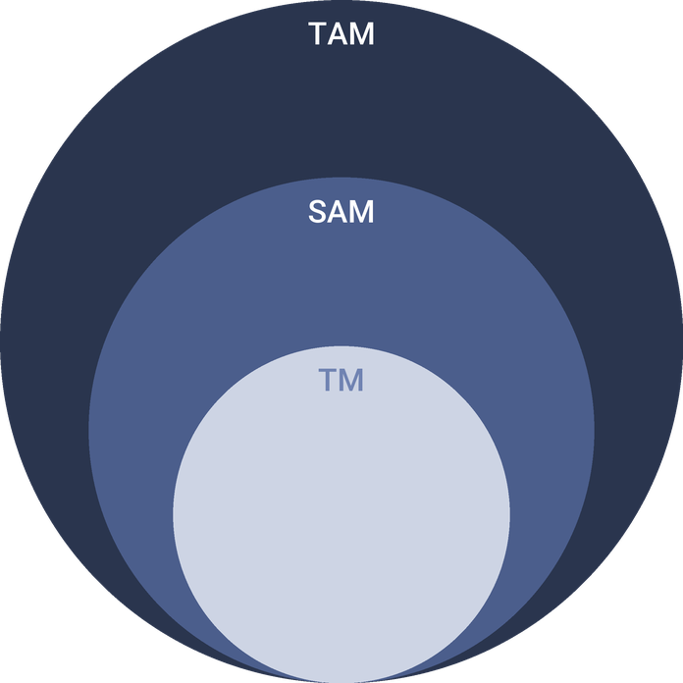
  ● | Total Available Market (TAM)  US bed and breakfast and hostel accommodations generated $3.2 billion in revenue in 2025 (IBISWorld), up 1.9% on the year. | 3.2B
  ● | Served Available Market (SAM)  The Savannah hotel market's annual room revenue is about $728.4 million at the 2024 run rate, derived from over 18,000 rooms at $110.87 RevPAR for 365 nights (HVS / STR); no published Savannah lodging revenue total exists. | 728.4M
  ● | Target Market (TM)  One US bed and breakfast or hostel business averages about $736,000 in annual revenue (IBISWorld 2025, $3.2 billion across 4,347 businesses); a national average, not a Savannah figure. | 736.0k

CHAPTER 4

Customer Analysis

4.1 Target Market
4.2 Customer Segments
4.3 Customer Persona
4.4 Customer Purchase Journey

4.1 Target Market
Mossgate's market is the overnight leisure visitor to Savannah who would rather stay in a hosted historic house than a hotel. Savannah received 7.2 million overnight visitors in 2024, staying an average of 2.8 days, which matches the two or three night stay the inn is built around.
Most guests are expected to be couples aged roughly 35 to 64 driving in from Atlanta, Charlotte, Jacksonville and the wider Southeast, a few hours away. They travel on long weekends and in the spring and fall shoulder seasons, book a few weeks ahead, and judge a stay as much by the breakfast and the hosts as by the room.
Demand follows Savannah's seasons. Spring brings the azaleas, St. Patrick's Day and the busiest weekends of the year, and fall brings the second peak of anniversaries and elopements once the heat breaks. Summer and the late hurricane season are slower, and winter weekdays slower still, which is when the inn leans on midweek rates, returning guests and couples planning a quiet elopement. The guest the inn is built for is the one who could choose a hotel, has done so before, and wants this trip to feel different: a house with a history, a breakfast cooked to order and hosts who know which restaurant has a table at eight.

4.2 Customer Segments
- Getaway couples: the largest group, booking two nights at a weekend rate and buying little beyond the room and breakfast.
- Celebration couples: eloping, renewing vows or marking an anniversary, who book a suite and add a package, flowers or a courtyard dinner.
- Solo and friends travelers: guests who want local advice and company at breakfast, often booking a queen room midweek.
- Returning guests: past guests who rebook directly, usually for the same season the following year, and cost the inn no commission.
The persona below stands for the celebration segment, which buys the most per stay and drives the inn's highest-priced rooms.

4.3 Customer Persona
  Megan, the Anniversary Planner  Demographics  Age: 38  Marital Status: Married, two children  Location: Atlanta, GA  Income: $135,000 household  Professional Role  Education: Bachelor's degree in Marketing  Job: Account Director at an agency | “We get one weekend away a season. I want a room with character, a real breakfast and someone who tells us where to eat.”
   | Identifiers / Personality Traits  - Drives to Savannah, about four hours, rather than flying  - Reads reviews and photos on two or three sites before booking  - Plans an anniversary trip each spring or fall
   | Goals  - Two quiet nights with her husband away from the children  - Walk everywhere once the car is parked  - A stay that feels marked as an occasion
   | Challenges  - Hotel rooms downtown feel the same as any business trip  - Rentals mean cooking breakfast and no one to ask  - Weekend rates in spring sell out weeks ahead

4.4 Customer Purchase Journey
- Inspiration: a friend's recommendation, a travel article or a search for a Savannah anniversary weekend.
- Comparison: photos and reviews on two or three booking sites, then the inn's own site to check rooms and the breakfast menu.
- Booking: on a booking site at first, increasingly direct on the inn's site once the rate promise and returning-guest perks are known.
- Before arrival: a welcome email with parking, dinner suggestions and an allergy form for breakfast.
- The stay: check-in with an owner, the porch hour, breakfast, and any package delivered in the courtyard.
- After the stay: a thank-you note, a review request and an invitation to rebook the same weekend next year.
The step that decides the inn's margin is the second booking: a guest who returns direct costs nothing in commission and brings a friend. The journey is designed so that the first stay ends with that invitation in hand.

CHAPTER 5

Competitive Analysis

5.1 Competitors
5.2 Comparison
5.3 Competitive Edge
5.4 SWOT Analysis

5.1 Competitors
Mossgate competes for the same overnight visitors as every room in Savannah. Three groups matter:
- Downtown hotels: more than 18,000 rooms in 214 reporting properties, selling at a $152.43 average rate through July 2024, with front desks, restaurants and meeting space.
- Whole-house rentals: the average Savannah short-term rental books at $309 a night, offering kitchens and space for families and groups, but no host or breakfast.
- Historic district inns: established houses, including the six boutique hotels and bed and breakfasts grouped as Historic Inns of Savannah, all built in the mid to late 1800s.
New supply is arriving. Savannah was forecast to grow its lodging supply by 4.1% in 2025, the most of any US market, and the pipeline includes boutique hotels and historic conversions that will compete for the same couples. Rentals are constrained in the historic wards by the city's 20% cap on non-owner-occupied rentals, which slows that source of competition in the streets the inn trades in.

5.2 Comparison
The table compares Mossgate with each group on the things a getaway couple weighs. Hotels win on scale and services, rentals on space and a kitchen, and the larger inns on reputation built over years. Mossgate's case rests on what only a small hosted house can offer: a cooked breakfast, owners on site, and a ceremony in its own garden.
Feature | Mossgate Inn | Downtown hotels | Whole-house rentals | Larger historic inns
Cooked breakfast included in the nightly rate | ✓ | ✗ | ✗ | ✓
Hosts on site through every stay | ✓ | ✓ | ✗ | ✓
Fewer than ten rooms | ✓ | ✗ | ✓ | ✗
Courtyard ceremonies for up to 20 guests, planned in house | ✓ | ✗ | ✗ | ✗
Full kitchen for self-catering | ✗ | ✗ | ✓ | ✗

5.3 Competitive Edge
The edge is not price: at $245 to $385 a night the inn sits above the hotel average and near the rental average. It is a combination the others do not sell together, and each part is something the owners do themselves rather than buy in.
   | Breakfast cooked by an owner  James Pemberton cooks a plated Southern breakfast every morning in the inn's own kitchen, so the meal is part of the stay rather than a buffet line.
   | Two hosts for eight rooms  The owners live on site, so every guest gets local advice, a late check-in or a problem solved by the people who run the house.
   | A ceremony space under the same roof  Couples marry in the courtyard garden and walk upstairs to their suite, with no transport, venue fee or second booking to arrange.
   | Built for direct bookings  A booking engine on the inn's own site, a best-rate promise and a returning-guest list keep agency commission off a growing share of nights.

5.4 SWOT Analysis
Strengths  - Eight individually furnished rooms in a restored 1880s house, inside Savannah's most visited district.  - A cooked breakfast and evening porch hour that hotels and rentals in the district do not offer.  - Two owners living on site, keeping guest service personal and payroll lean.  - A courtyard garden that sells elopement and anniversary packages to guests already staying. | Weaknesses  - Eight rooms cap revenue, so one empty room is a large share of a night's sales.  - A new inn starts with no reviews, ranking low on booking sites until they build.  - Rent of $9,500 a month is fixed whether the house is full or not.  - The inn depends on two owners, with little cover for illness or burnout.
Opportunities  - 12.9 million visitors in 2024 and air traffic up 36.8% on 2019 keep demand broad.  - Couples choose Savannah to elope, and a ceremony on site saves them a separate venue.  - Short-term rental growth is capped in historic wards, limiting new whole-house supply nearby.  - Direct bookings from returning guests cut commission as the email list grows. | Threats  - Lodging supply in Savannah was forecast to grow 4.1% in 2025, the fastest of any US market.  - National hotel occupancy fell to 62.3% in 2025, a sign demand is softening.  - Agency commissions of 15% or more erode margin on every night booked through them.  - Hurricane season and summer heat thin out bookings from August to October.

 Strategic Summary
Mossgate should sell what larger competitors cannot: a hosted house, a cooked breakfast and a ceremony on site. It should build reviews and direct bookings fast, so an eight-room inn holds its rate as new rooms open nearby.

CHAPTER 6

Services Offered

6.1 Our Offering
6.2 Signature Items
6.3 Additional Services
6.4 What Sets Us Apart
6.5 Guest Rooms & Suites

6.1 Our Offering
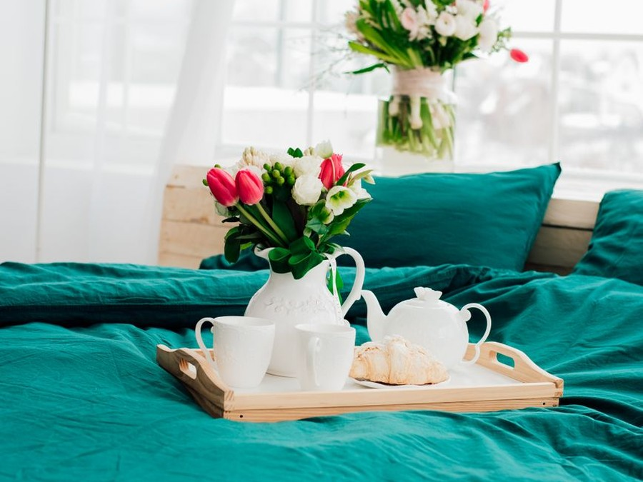
Mossgate sells a night in a restored historic house, with breakfast, hosts and a garden included. Every stay includes a cooked Southern breakfast, the evening porch hour and the owners' help with dinner bookings and the city. Alongside the rooms, the inn sells elopement and celebration packages to couples staying in the house.

6.2 Signature Items
- The Mossgate breakfast: shrimp and grits, buttermilk biscuits, a seasonal fruit course and a rotating hot plate, cooked to order by James Pemberton.
- The Carriage House Suites: two suites with private doors onto the courtyard, the inn's most requested rooms for anniversaries.
- The courtyard elopement: a ceremony under the oaks for up to 20 guests, followed by dinner in the garden.

6.3 Additional Services
- Anniversary add-ons: flowers in the room, a cake from a local bakery, or a candlelit courtyard table.
- Picnic baskets for Forsyth Park or the beach at Tybee Island, packed in the inn's kitchen.
- Gift cards for a night or a package, sold through the website.
- Dinner and tour reservations made by the innkeepers on request.
Packages and add-ons are planned at 10% of room revenue, and every one of them is sold to a guest who is already staying, so none needs a separate marketing budget.

6.4 What Sets Us Apart
Hotels in the district sell a room and a front desk; rentals sell a house with no one in it. Mossgate sells the hosted version: a breakfast cooked in the house, two owners who live there, and a garden that becomes a wedding venue for a few hours on a Saturday. Keeping the house to eight rooms is deliberate, because it is the size at which two hosts can still know every guest.

6.5 Guest Rooms & Suites
The eight rooms fall into three types, priced by size and privacy:
- Three Classic Queen Rooms on the upper floor, at $245 a night, each with a private bathroom.
- Three Historic King Suites on the main floors, at $315 a night, with a sitting area by the original mantel and a clawfoot tub or walk-in shower.
- Two Carriage House Suites, at $385 a night, with a separate sitting room and a door onto the courtyard; the ground-floor suite is built to accessibility standards.
Those are standard rates; spring and fall weekends price at the top of each room's range, and midweek winter nights below it. Weekends from March to May carry a two-night minimum, which protects Saturday nights from one-night stays. Rooms are serviced daily, sheets are changed every second night unless a guest asks otherwise, and each room keeps three sets of linen per bed so laundry never holds up a turnover.
Check-in runs from 3:00 p.m., checkout is by 11:00 a.m., and keyless locks let guests arrive late without a desk. Each room has a written house guide covering parking, the porch hour and breakfast times, and every booking asks for dietary needs in advance so breakfast can be planned for each guest.
Eight rooms across the main house and the carriage house, each furnished individually with period and reproduction pieces. Every night includes a cooked Southern breakfast and the evening porch hour, and the owners live on site.
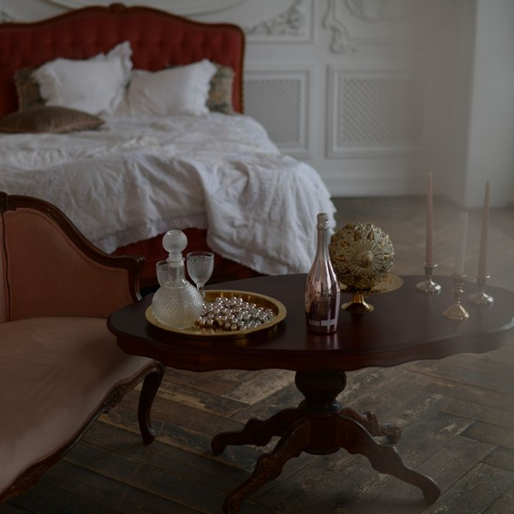 | $245 to $385 per night  Breakfast is included in the rate. Spring and fall weekends price at the top of each room's range, and Savannah's lodging taxes and the Georgia nightly fee are added at checkout.

Specifications
- Three queen rooms and three king suites in the main house
- Two suites in the carriage house opening onto the courtyard
- A private bathroom in every room
- Breakfast served from 8:00 to 10:00 a.m. in the dining room
- Check-in from 3:00 p.m. and checkout by 11:00 a.m.
- Two-night minimum on weekends from March to May

6.5.1 Elopement & Celebration Packages
Ceremonies, vow renewals and anniversary dinners held in the inn's courtyard garden for couples staying at the inn. The innkeepers coordinate the officiant, photographer, flowers and cake through local partners, so the couple books one place.
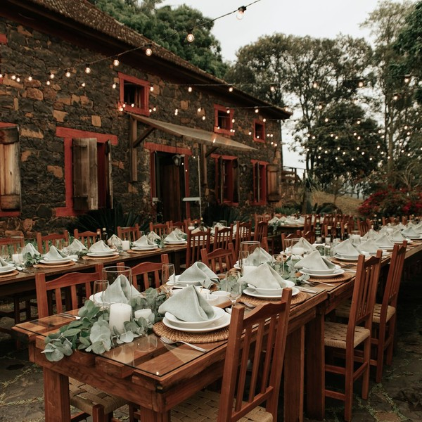 | Elopement packages from $1,450  Packages are sold on top of the room, which is booked at the nightly rate. Anniversary add-ons such as flowers, a cake and a candlelit courtyard table are priced separately.

Specifications
- Ceremonies for up to 20 guests in the courtyard garden
- Officiant and photographer booked through partner vendors
- Ceremony times set around check-in so the garden is private
- Available only to couples staying at the inn
- Weekday elopements offered at a lower package price

6.5.2 Features
  Cooked Southern breakfast
  A plated breakfast every morning, with shrimp and grits, biscuits and seasonal fruit on a rotating menu.
  Evening porch hour
  Sweet tea, lemonade and Savannah pralines on the front porch each evening, with the innkeepers on hand.
  Innkeepers on site
  The owners live in the house, so late arrivals, dinner bookings and questions are handled in person.
   | Courtyard garden  A private garden for morning coffee, ceremonies and anniversary dinners.
   | Keyless entry  Each room and the front door open with a personal code, so guests come and go as they like.
  Walkable location
  The squares, the riverfront and Forsyth Park are reached on foot from the front door.

6.5.3 Pricing
Classic Queen Room  $245  per night  - Queen bed and private bathroom  - Cooked Southern breakfast for two  - Evening sweet tea and pralines on the porch |  | Most Popular  Historic King Suite  $315  per night  - King bed and a sitting area by the original mantel  - Cooked Southern breakfast for two  - Clawfoot tub or walk-in shower  - Late checkout on request |  | Carriage House Suite  $385  per night  - Private entrance onto the courtyard garden  - King bed and separate sitting room  - Breakfast served in the suite on request  - First choice of elopement dates

CHAPTER 7

Marketing & Sales Strategies

7.1 Market Positioning
7.2 Marketing Objectives
7.3 Online Marketing
7.4 Public Relations and Branding
7.5 Partnership & Collaboration Strategy
7.6 Customer Loyalty & Retention
7.7 Sales Channels

7.1 Market Positioning
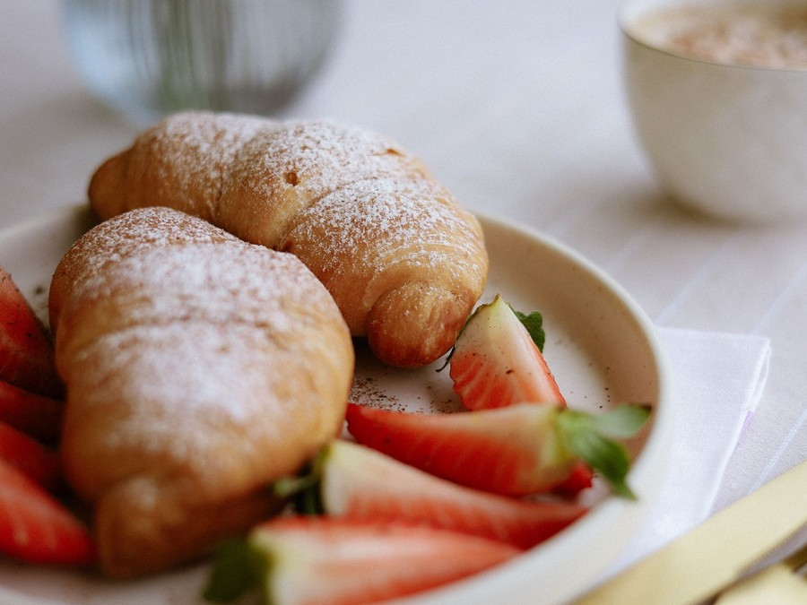
Mossgate is the hosted alternative in Savannah's historic district: smaller and more personal than a hotel, with the breakfast and the people a rental leaves out, priced from $245 to $385 a night for couples who want the stay to be part of the trip.

7.2 Marketing Objectives
- Reach the planned 68% occupancy by the eighth month of trading.
- Build a review base on each booking site before the first fall season.
- Carry more than half of all nights through direct bookings by the start of the second year.
Direct-Booking Search Ads  $815  per month  Search ads on the inn's name and Savannah stay terms, sending travelers to the inn's own booking engine. |  | Website, Photography & Email  $465  per month  Seasonal photography, site updates and the returning-guest email list.
Wedding Planner Partnerships  $582  per month  Styled shoots, planner and officiant familiarization stays and listings in elopement directories. |  | Inn Association & Guidebooks  $465  per month  Membership in a vetted inn association and paid listings in regional travel guides.

Total marketing budget: $27,921 a year, $2,327 a month.

7.3 Online Marketing
The inn's website is its main shop: professional photography of every room, the breakfast menu, package pages and a booking engine with a best-rate promise. Search ads run on the inn's name and on Savannah anniversary, elopement and historic inn searches, so travelers who find the inn on a booking site can book it direct for the same price or better.
Marketing is budgeted at 5% of revenue across search ads, the website and email list, planner partnerships and an inn association; every guest who books joins the email list.

7.4 Public Relations and Branding
The brand is the house itself: the iron gate hung with moss, the porch and the breakfast table. A soft opening for travel writers, wedding planners and photographers puts the inn's first coverage and ceremony photographs out before its first paying guest arrives.

7.5 Partnership & Collaboration Strategy
- Wedding planners, officiants and photographers who refer eloping couples and are booked into packages.
- A florist and a bakery that supply anniversary add-ons and package flowers and cakes.
- Restaurants and tour operators nearby, where the innkeepers make reservations for guests.
- A vetted inn association, whose standards and listing reach travelers who look for small inns.

7.6 Customer Loyalty & Retention
An inn's most valuable guest is last year's. Every departing guest is offered the same weekend next year at this year's rate, booked direct before they leave, and anniversary couples get a note a month before the date. A short record of each guest's preferences means a second stay starts where the first ended.

7.7 Sales Channels
Revenue arrives by four routes, and the plan is to shift its weight from the agencies toward direct bookings as reviews and the email list grow. Agencies fill rooms early at a commission of 15% or more; direct and returning guests are worth the most per night.
  Direct bookings
  Stays booked on the inn's own site or by phone carry no commission and are worth the most per night; they depend on reviews, search ads and returning guests.
  Booking agencies
  Booking.com and Expedia fill rooms while the inn is new, at a commission of 15% or more, so their share is meant to fall.
   | Inn association referrals  Listings with a vetted inn association reach travelers who look for small inns, and depend on keeping its standards.
  Celebration packages
  Elopement and anniversary packages add revenue on top of the room and depend on planner and officiant referrals.

CHAPTER 8

Operations Plan

8.1 Daily Operations
8.2 Working Hours
8.3 Staffing & Training
8.4 Inventory & Equipment Management
8.5 Location and Facilities
8.6 Milestones & Timeline
8.7 Breakfast Service & Food Safety

8.1 Daily Operations
The day starts at 6:30 a.m. with breakfast prep. Breakfast is served from 8:00 to 10:00 a.m., and checkout closes at 11:00 a.m. Between 11:00 a.m. and 3:00 p.m. the housekeepers turn the rooms, guided by a checklist for each room, while the managing innkeeper confirms arrivals, answers booking enquiries and settles any agency payments.
Check-in runs from 3:00 p.m. into the evening, with an owner at the door for each arrival. The porch hour runs from 5:00 to 6:00 p.m., and the owners book dinners and tours for guests on request. Overnight, the owners are on call from their quarters in the house.

8.2 Working Hours
An inn sells every night of the year, so Mossgate never closes. The front door is staffed from 7:30 a.m. to 9:00 p.m.; outside those hours guests come and go with keyless codes and reach an owner by phone. Those hours follow when guests actually need a person: at breakfast, at checkout, and when they arrive tired after a four-hour drive. The relief innkeeper covers two days each weekend so the owners have time off without the house going unattended.

8.3 Staffing & Training
The two owners run the house: Claire Pemberton as managing innkeeper and James Pemberton in the kitchen and on the property. They are joined by a full-time head housekeeper, a part-time housekeeper, a part-time breakfast cook who covers James's days off, and a weekend relief innkeeper. Payroll, including the managing innkeeper's salary and payroll taxes, is planned at 27% of revenue.
Training is practical and written down: a room checklist for housekeeping, a breakfast recipe and allergy file for the kitchen, and a guest welcome script for the front door. Everyone who handles food is trained in safe handling, and the relief innkeeper shadows the owners for two weeks before covering a weekend alone.

8.4 Inventory & Equipment Management
The inn keeps three sets of linen and towels per bed, guest amenities for each room, and a pantry of breakfast stock turned over about every ten days. Sheets and towels go to a commercial laundry; table linen and small items are washed in house. Mattresses, linens and soft furnishings are replaced on a rolling cycle from a capital budget of 2% of revenue a year, so no room is ever out of service for a full refurbishment.

8.5 Location and Facilities
The inn will lease a restored 1880s house of about 6,500 square feet in the historic district, with a carriage house and a walled courtyard garden, at $9,500 a month on a ten-year lease. The main house holds six guest rooms, the dining room, the kitchen and the owners' quarters; the carriage house holds the two suites. Savannah's zoning allows an inn of up to 15 rooms with the owners or staff on site, and keeps any event space open to the public as a separate use, which is why ceremonies are offered to staying guests only.

8.6 Milestones & Timeline
The path to opening runs from the lease and loan in November 2026 to the doors opening for the spring season in March 2027, with the permitting inspection and a soft opening in between. The milestones after that measure the house reaching its planned occupancy and direct bookings taking the lead.
Nov 2026  Setup |  |  | Lease signed and loan closed  A restored 1880s house with a carriage house and courtyard.  The SBA 7(a) loan and the owners' contribution close, and zoning approval for an inn is filed with the city.
Jan 2027  Setup |  |  | Rooms furnished and kitchen fitted  Eight rooms, bathrooms and the breakfast kitchen.  Furniture, linens and the kitchen equipment go in, and the property system, booking engine and keyless locks are set up.
Feb 2027  Launch |  |  | Permit inspection and soft opening  Department of Public Health permit and first guests.  The kitchen and rooms pass the permitting inspection, and travel writers and wedding planners stay at no charge to test the house.
Mar 2027  Launch |  |  | Doors open for spring  Listings live and direct booking open.  The inn opens to the public for Savannah's spring season, with agency listings and the launch offer running together.
Oct 2027  Growth |  |  | Target occupancy reached  First fall elopement season.  The house reaches its planned occupancy and the courtyard hosts its first full season of elopements and anniversaries.
Mar 2028  Growth |  |  | Direct bookings lead  Second spring season.  Returning guests and the email list carry more than half of nights, cutting agency commission.

8.7 Breakfast Service & Food Safety
Georgia permits a bed and breakfast inn of twenty guestrooms or less that serves only breakfast to its registered guests, included in the room price, under the Department of Public Health's tourist accommodation rules. The inn needs a DPH permit, and the rules set specific requirements for preparing that breakfast rather than treating the kitchen as a restaurant. Serving anyone who is not a guest would bring full food service rules, so breakfast is never sold to the public.
The kitchen fit-out installs a commercial-grade range, refrigeration, a high-temperature dishwasher and separate hand and prep sinks. James Pemberton holds a food safety manager certification, and fridge and cooking temperatures are logged every morning. Every booking collects dietary needs and allergies before arrival, and each guest's breakfast is planned against that list.
The menu rotates weekly, with one hot plate each morning and a fixed fruit and biscuit course. Breakfast is planned at about $10 a guest a day, including eggs, grits, fruit and coffee bought from local suppliers twice a week, and it sits in the cost of sales with the other costs of a night.
A typical week rotates five hot plates around the fixed courses:
- Shrimp and grits with a soft egg, the house signature, served twice a week.
- Buttermilk biscuits with sausage gravy or a vegetarian mushroom gravy.
- Baked French toast with Georgia peaches in summer and pecans in winter.
- A vegetable frittata for guests who eat no meat.
- Pecan waffles with fruit compote at weekends.
Any plate can be made without gluten or dairy if the guest says so in advance, and guests with an early departure are offered a packed breakfast instead. Leftover baking goes to the porch hour that evening rather than the bin, which keeps food waste and food cost down together.

CHAPTER 9

Management Team

9.1 Key Members
9.2 Organization Chart
9.3 Advisory Board Members

9.1 Key Members
The managing innkeeper answers for the inn's revenue: occupancy, average rate, the share of nights booked direct and the review score on each booking site, reported weekly against the plan. She also owns payroll, cash and the monthly accounts. The co-owner answers for breakfast and the building: food cost inside the gross margin, the DPH permit and inspection record, and keeping every room in service. The head housekeeper is measured on turnover times and on room standards, checked against the room checklist. The relief innkeeper is measured on the same guest scores as the owners on the weekends he covers.
 | Claire Pemberton  Managing Innkeeper · claire@mossgateinn.example  Fourteen years in hotel operations, most recently as rooms division manager at a full-service hotel.

 | James Pemberton  Co-Owner, Kitchen & Property · james@mossgateinn.example  A former restaurant sous chef with food safety manager certification and years of restoring older houses.

 | Rosa Delgado  Head Housekeeper · rosa@mossgateinn.example  Eight years of housekeeping in boutique hotels, including training new room attendants.

 | Thomas Reid  Relief Innkeeper · thomas@mossgateinn.example  A hospitality graduate who has covered front desk and night audit shifts at a small inn.

9.2 Organization Chart
All three report to the managing innkeeper. The part-time housekeeper reports to the head housekeeper, and the part-time breakfast cook to the co-owner. The owners meet each Monday to review the week's bookings, reviews and cash against the plan.
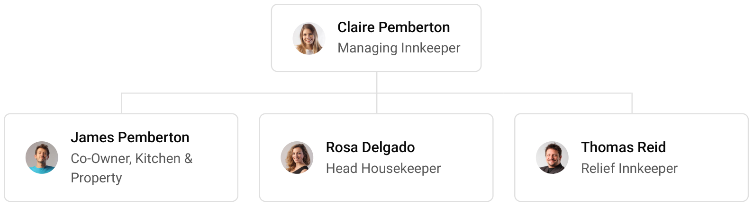

9.3 Advisory Board Members
The inn draws on two paid advisers rather than a formal board. Helen Marsh, a retired innkeeper who ran a six-room inn in the Carolinas for twenty years, reviews the opening plan, rates and housekeeping standards. Daniel Ortiz, an accountant with lodging clients, prepares the annual accounts and advises on hotel/motel tax filings and the SBA loan covenants.
Both are paid by the hour, which keeps fixed costs down while the house fills. Once the inn reaches its planned occupancy, the founders intend to add an adviser with experience of buying a historic property, ahead of any option to buy the house.

9.3.1 Hiring Plan
2  Filled |  | 4  Hiring This Year |  | 4  Open

Group By Department | Position Filled | Time of Hire | Time of Start | Filled
Management | 1 of 1 | 0 days | 0 days | 100%
Kitchen & Breakfast | 1 of 2 | 30 days | 14 days | 50%
Housekeeping | 0 of 2 | 30 days | 14 days | 0%
Guest Services | 0 of 1 | 45 days | 21 days | 0%

CHAPTER 10

Financial Plan

10.1 Key Assumptions
10.2 Capital Requirements and Use of Funds
10.3 Income Statement (3 Year projections)
10.4 Balance Sheet (3 Year projections)
10.5 Cash Flow Statement (3 Year projections)
10.6 Break Even Analysis

10.1 Key Assumptions
Revenue follows one formula: eight guest rooms, times 68% occupancy, times a $295 average daily rate, times 365 nights, plus packages and add-ons at 10% of room revenue. The inn opens at 60% of that level and builds to it over eight months, so the first year is a ramp year and revenue then grows 12% a year as occupancy and rates move toward the Savannah market.
Gross margin is 78.0%: cost of sales covers breakfast, agency commissions on nights booked through them, card fees, amenities, laundry and the contents of packages. Payroll is 27% of revenue, marketing 5% and other operating costs 6%. Fixed costs are rent of $9,500 a month, technology of $1,000 and administration of $2,500, which covers insurance, accounting and permits. Taxes on profit are planned at 25%.
On those inputs, revenue is $558,417 in the first year, $625,427 in the second and $700,478 in the third. Net income is $4,175, $25,241 and $48,607. Break-even revenue is $472,049, or 1,600 room nights, and the first year clears it. In the third year, net income is $8,537 in the conservative case and $102,727 in the upside case, so the plan stays profitable even if occupancy and rate fall short.

10.2 Capital Requirements and Use of Funds
The startup budget is $364,500, spent before and during the first months of trading. The largest items are furniture, beds and linens for eight rooms, leasehold improvements to the house, and the breakfast kitchen fit-out; the rest covers the courtyard, technology and security, permits and legal work, the lease deposit and pre-opening rent, opening stock, launch marketing and pre-opening staff.
It is funded by a $175,000 owner contribution and a $260,000 SBA 7(a) loan at 9.75% over ten years, with no outside equity. Funding above the startup budget is held as opening cash. The loan is repaid from operating cash, and profits stay in the business while it is.

10.2.1 Use of Funds
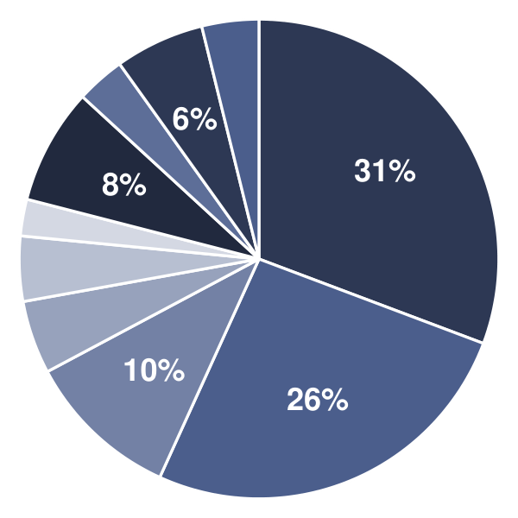 | ● Furniture, Beds & Linens 30.7%  ● Leasehold Improvements 26.1%  ● Breakfast Kitchen Fit-Out 10.4%  ● Courtyard & Celebration Setup 4.9%  ● Technology & Security 4.4%  ● Licenses, Permits & Legal 2.5%  ● Deposit & Pre-Opening Rent 7.8%  ● Initial Inventory 3.3%  ● Launch Marketing 6.0%  ● Pre-Opening Staffing & Training 3.8%

Use Of Funds | Amount
Furniture, Beds & Linens | $112,000.00
Leasehold Improvements | $95,000.00
Breakfast Kitchen Fit-Out | $38,000.00
Courtyard & Celebration Setup | $18,000.00
Technology & Security | $16,000.00
Licenses, Permits & Legal | $9,000.00
Deposit & Pre-Opening Rent | $28,500.00
Initial Inventory | $12,000.00
Launch Marketing | $22,000.00
Pre-Opening Staffing & Training | $14,000.00

10.3 Income Statement (3 Year projections)
 | Year 1 | Year 2 | Year 3 | Total
Revenue | $558,416.88 | $625,426.91 | $700,478.14 | $1,884,321.93
Cost of Sales | $122,851.71 | $137,593.92 | $154,105.19 | $414,550.82
General Costs | $0.00 | $0.00 | $0.00 | $0.00
Revenue Specific Costs | $85,996.20 | $96,315.74 | $107,873.63 | $290,185.57
Personnel Costs (Direct Labor) | $36,855.51 | $41,278.18 | $46,231.56 | $124,365.25
Gross Margin | $435,565.17 | $487,832.99 | $546,372.95 | $1,469,771.11
Gross Margin (%) | 78.00% | 78.00% | 78.00% | 78.00%
Operating Expense | $368,198.41 | $393,662.23 | $422,181.70 | $1,184,042.34
Payroll Expense (Indirect Labor) | $150,772.56 | $168,865.27 | $189,129.10 | $508,766.93
General Expense | $217,425.85 | $224,796.96 | $233,052.60 | $675,275.41
Bad Debt | $0.00 | $0.00 | $0.00 | $0.00
Amortization of Current Assets | $0.00 | $0.00 | $0.00 | $0.00
EBITDA | $67,366.76 | $94,170.76 | $124,191.25 | $285,728.77
Additional Expense | $63,191.69 | $68,929.58 | $75,584.17 | $207,705.44
Long Term Depreciation | $36,450.00 | $37,700.85 | $39,101.81 | $113,252.66
Gain or loss from Sale of Assets | $0.00 | $0.00 | $0.00 | $0.00
EBIT | $30,916.76 | $56,469.91 | $85,089.44 | $172,476.11
Interest Expense | $25,350.00 | $22,815.00 | $20,280.00 | $68,445.00
EBT | $5,566.76 | $33,654.91 | $64,809.44 | $104,031.11
Income Tax Expense / Benefit | $1,391.69 | $8,413.73 | $16,202.36 | $26,007.78
Total Expense | $554,241.81 | $600,185.73 | $651,871.06 | $1,806,298.60
Net Income | $4,175.07 | $25,241.18 | $48,607.08 | $78,023.33
Net Income (%) | 0.75% | 4.04% | 6.94% | 4.14%
Retained Earning Opening | $0.00 | $4,175.07 | $29,416.25
Owner's Distribution | $0.00 | $0.00 | $0.00 | $0.00
Retained Earning Closing | $4,175.07 | $29,416.25 | $78,023.33 | $78,023.33

10.4 Balance Sheet (3 Year projections)
 | Year 1 | Year 2 | Year 3 | Total
Assets | $423,620.39 | $425,828.77 | $451,740.10 | $451,740.10
Current Assets | $95,570.39 | $122,971.08 | $173,974.66 | $173,974.66
Cash | $84,555.04 | $110,633.89 | $160,157.01 | $160,157.01
Accounts Receivable | $7,649.55 | $8,567.49 | $9,595.59 | $9,595.59
Inventory | $3,365.80 | $3,769.70 | $4,222.06 | $4,222.06
Other Current Assets | $0.00 | $0.00 | $0.00 | $0.00
Long Term Assets | $328,050.00 | $302,857.69 | $277,765.44 | $277,765.44
Gross Long Term Assets | $364,500.00 | $377,008.54 | $391,018.10 | $391,018.10
Accumulated Depreciation | $36,450.00 | $74,150.85 | $113,252.66 | $113,252.66
Liabilities & Equity | $423,620.39 | $425,828.77 | $451,740.10 | $451,740.10
Liabilities | $244,445.32 | $221,412.52 | $198,716.77 | $198,716.77
Current Liabilities | $36,445.32 | $39,412.52 | $42,716.77 | $42,716.77
Accounts Payable | $10,097.40 | $11,309.09 | $12,666.18 | $12,666.18
Income Tax Payable | $347.92 | $2,103.43 | $4,050.59 | $4,050.59
Sales Tax Payable | $0.00 | $0.00 | $0.00 | $0.00
Short Term Debt | $26,000.00 | $26,000.00 | $26,000.00 | $26,000.00
Long Term Liabilities | $208,000.00 | $182,000.00 | $156,000.00 | $156,000.00
Long Term Debt | $208,000.00 | $182,000.00 | $156,000.00 | $156,000.00
Equity | $179,175.07 | $204,416.25 | $253,023.33 | $253,023.33
Paid-in Capital | $0.00 | $0.00 | $0.00 | $0.00
Common Stock | $0.00 | $0.00 | $0.00 | $0.00
Preferred Stock | $0.00 | $0.00 | $0.00 | $0.00
Owner's Contribution | $175,000.00 | $175,000.00 | $175,000.00 | $175,000.00
Retained Earnings | $4,175.07 | $29,416.25 | $78,023.33 | $78,023.33
Check | $0.00 | $0.00 | $0.00 | $0.00

10.5 Cash Flow Statement (3 Year projections)
 | Year 1 | Year 2 | Year 3 | Total
Cash Received | $634,529.86 | $718,323.01 | $804,521.76 | $2,157,374.63
Cash Paid | $594,474.82 | $653,735.62 | $714,989.08 | $1,963,199.52
COS & General Expenses | $296,690.45 | $320,304.91 | $340,021.50 | $957,016.86
Salary & Wages | $187,628.07 | $210,143.45 | $235,360.66 | $633,132.18
Interest | $25,350.00 | $22,815.00 | $20,280.00 | $68,445.00
Sales Tax | $83,762.53 | $93,814.04 | $105,071.72 | $282,648.29
Income Tax | $1,043.77 | $6,658.22 | $14,255.20 | $21,957.19
Net Cash From Operations | $40,055.04 | $64,587.39 | $89,532.68 | $194,175.11
Assets Sell | $0.00 | $0.00 | $0.00 | $0.00
Assets Purchase | $364,500.00 | $12,508.54 | $14,009.56 | $391,018.10
Net Cash From Investments | ($364,500.00) | ($12,508.54) | ($14,009.56) | ($391,018.10)
Amount Received | $435,000.00 | $0.00 | $0.00 | $435,000.00
Loan Received | $260,000.00 | $0.00 | $0.00 | $260,000.00
Common Stock | $0.00 | $0.00 | $0.00 | $0.00
Preferred Stock | $0.00 | $0.00 | $0.00 | $0.00
Owner's Contribution | $175,000.00 | $0.00 | $0.00 | $175,000.00
Amount Paid | $26,000.00 | $26,000.00 | $26,000.00 | $78,000.00
Loan Capital | $26,000.00 | $26,000.00 | $26,000.00 | $78,000.00
Dividends & Distributions | $0.00 | $0.00 | $0.00 | $0.00
Net Cash From Financing | $409,000.00 | ($26,000.00) | ($26,000.00) | $357,000.00
Summary
Starting Cash | $0.00 | $84,555.04 | $110,633.89
Cash In | $1,069,529.86 | $718,323.01 | $804,521.76 | $2,592,374.63
Cash Out | $984,974.82 | $692,244.16 | $754,998.64 | $2,432,217.62
Change in Cash | $84,555.04 | $26,078.85 | $49,523.12 | $160,157.01
Ending Cash | $84,555.04 | $110,633.89 | $160,157.01 | $160,157.01

10.6 Break Even Analysis
 | Year 1 | Year 2 | Year 3 | Total
Starting Revenue | $0.00 | $558,416.88 | $1,183,843.79 | $1,183,843.79
Net Revenue | $558,416.88 | $625,426.91 | $700,478.14 | $700,478.14
Closing Revenue | $558,416.88 | $1,183,843.79 | $1,884,321.93 | $1,884,321.93
Starting Expense | $0.00 | $554,241.81 | $1,154,427.54 | $1,154,427.54
Net Expense | $554,241.81 | $600,185.73 | $651,871.06 | $651,871.06
Closing Expense | $554,241.81 | $1,154,427.54 | $1,806,298.60 | $1,806,298.60
Is Break Even? | Yes | Yes | Yes
Break Even Month | Dec '26 | - | -
Days Required | 13 Days | - | -
Break Even Revenue | $558,416.88 | - | -

CHAPTER 11

References

- SRC001: Bed & Breakfast & Hostel Accommodations in the US - Market Size (2006-2032), IBISWorld, 2026-01-01. https:/‌/‌www.‌ibisworld.‌com/‌united-states/‌market-size/‌bed-breakfast-hostel-accommodations/‌1663/‌ (accessed 2026-10-07)
- SRC002: Bed & Breakfast & Hostel Accommodations in the US - Number of Businesses (2006-2032), IBISWorld, 2026-01-01. https:/‌/‌www.‌ibisworld.‌com/‌united-states/‌number-of-businesses/‌bed-breakfast-hostel-accommodations/‌1663 (accessed 2026-10-07)
- SRC003: U.S. hotels report first full-year occupancy, RevPAR declines since 2020, CoStar (STR), 2026-01-20. https:/‌/‌www.‌costar.‌com/‌products/‌str-benchmark/‌resources/‌press-releases/‌us-hotels-report-first-full-year-occupancy-revpar (accessed 2026-10-07)
- SRC004: U.S. Travel forecasts record spending in 2026, Hotel Dive, 2026-01-01. https:/‌/‌hoteldive.‌com/‌news/‌us-travel-spending-forecast-2026/‌819812/‌ (accessed 2026-10-07)
- SRC005: U.S. Travel Association Forecasts Record Spending in 2026, Lodging Magazine, 2026-01-01. https:/‌/‌lodgingmagazine.‌com/‌u-s-travel-association-forecasts-record-spending-in-2026/‌ (accessed 2026-10-07)
- SRC006: Americans Are Traveling More in 2025: Here's What's Driving Their Journeys, MMGY Global, 2025-01-01. https:/‌/‌mmgyintel.‌com/‌americans-are-traveling-more-in-2025-heres-whats-driving-their-journeys/‌ (accessed 2026-10-07)
- SRC007: The Complete Guide to OTA Commission Rates, SmartOrder, 2025-01-01. https:/‌/‌www.‌smartorder.‌ai/‌blog/‌the-complete-guide-to-ota-commission-rates/‌ (accessed 2026-10-07)
- SRC008: 10 Ways Hotels Can Increase Direct Bookings in 2025, Hospitality Net, 2025-01-01. https:/‌/‌www.‌hospitalitynet.‌org/‌opinion/‌4126669.‌html (accessed 2026-10-07)
- SRC009: Slower STR supply growth, Short Term Rentalz (reporting AirDNA), 2026-01-01. https:/‌/‌shorttermrentalz.‌com/‌news/‌slower-str-supply-growth-airdna/‌ (accessed 2026-10-07)
- SRC010: AirDNA 2025 Outlook Report: U.S. Short-Term Rental Industry Finds Balance, Business Wire (AirDNA), 2024-12-05. https:/‌/‌www.‌businesswire.‌com/‌news/‌home/‌20241205094869/‌en/‌AirDNA-2025-Outlook-Report-U.‌S.‌-Short-Term-Rental-Industry-Finds-Balance (accessed 2026-10-07)
- SRC011: Profitability Under Pressure: How 2025 U.S. Hotel Performance Reshapes Valuation Underwriting, Lodging Magazine (CBRE Trends in the Hotel Industry), 2026-01-01. https:/‌/‌lodgingmagazine.‌com/‌profitability-under-pressure-how-2025-u-s-hotel-performance-reshapes-valuation-underwriting/‌ (accessed 2026-10-07)
- SRC012: Bed and Breakfast Boutique Inn Bookkeeping, Beancount, 2026-06-02. https:/‌/‌beancount.‌io/‌blog/‌2026/‌06/‌02/‌bed-and-breakfast-boutique-inn-bookkeeping-ota-commission-asc-606-transient-occupancy-tax-section-47-historic-rehabilitation-credit-section-280a-dwelling-unit-cost-segregation-revpar-occupancy-kpi-guide (accessed 2026-10-07)
- SRC013: Maids and Housekeeping Cleaners, SOC 37-2012, Wagedex (BLS OEWS May 2024), 2025-01-01. https:/‌/‌wagedex.‌com/‌jobs/‌maids-and-housekeeping-cleaners (accessed 2026-10-07)
- SRC014: H.B. No. 2553, 74th Legislature, Texas Legislature, 1995-01-01. https:/‌/‌capitol.‌texas.‌gov/‌tlodocs/‌74R/‌billtext/‌html/‌HB02553I.‌htm (accessed 2026-10-07)
- SRC015: Virginia Register of Regulations, Title 12 Health, Commonwealth of Virginia, 2025-01-01. https:/‌/‌register.‌dls.‌virginia.‌gov/‌details.‌aspx?‌id=‌7028 (accessed 2026-10-07)
- SRC016: Select Registry adds 11 properties to its portfolio, Lodging Magazine, 2025-01-01. https:/‌/‌lodgingmagazine.‌com/‌select-registry-adds-11-properties-to-its-portfolio (accessed 2026-10-07)
- SRC017: Key Hotel Investment Trends and Opportunities in the Carolinas and Georgia, HVS, 2024-11-15. https:/‌/‌www.‌hvs.‌com/‌article/‌10058-key-hotel-investment-trends-and-opportunities-in-the-carolinas-and-georgia (accessed 2026-10-16)
- SRC018: Major markets will lead growth in 2025, Hotel Management, 2024-01-01. https:/‌/‌www.‌hotelmanagement.‌net/‌data-trends/‌major-markets-lead-growth-2025 (accessed 2026-10-16)
- SRC019: Savannah, Georgia short-term rental revenue & daily rates, AirDNA, 2026-01-01. https:/‌/‌www.‌airdna.‌co/‌vacation-rental-data/‌app/‌us/‌georgia/‌savannah/‌revenue (accessed 2026-10-16)
- SRC020: 2024: Building Momentum, Visit Savannah, 2025-01-01. https:/‌/‌visitsavannah.‌com/‌2024-review (accessed 2026-10-16)
- SRC021: Savannah Parks & Squares Rental Information, Visit Savannah. https:/‌/‌visitsavannah.‌com/‌info/‌savannah-parks-squares-rental-information (accessed 2026-10-16)
- SRC022: How to Elope in Georgia: Everything You Need to Know, Simply Eloped. https:/‌/‌simplyeloped.‌com/‌blog/‌how-to-elope-in-georgia-everything-you-need-to-know/‌ (accessed 2026-10-16)
- SRC023: Historic Inns of Savannah, Explore Georgia. https:/‌/‌exploregeorgia.‌org/‌savannah/‌places-to-stay/‌bed-and-breakfasts-inns/‌historic-inns-of-savannah (accessed 2026-10-16)
- SRC024: Savannah City Council votes to raise hotel/motel tax, WTOC, 2023-05-26. https:/‌/‌www.‌wtoc.‌com/‌2023/‌05/‌26/‌savannah-city-council-votes-raise-hotelmotel-tax/‌ (accessed 2026-10-16)
- SRC025: Hotel And Lodging Tax In Savannah 2026: TOT Rate And Rules, Roommaster, 2026-01-01. https:/‌/‌www.‌roommaster.‌com/‌hotel-tax/‌savannah (accessed 2026-10-16)
- SRC026: State Hotel-Motel Fee FAQ, Georgia Department of Revenue. https:/‌/‌dor.‌georgia.‌gov/‌node/‌59166 (accessed 2026-10-16)
- SRC027: Guide to Georgia Minimum Wage, Square, 2025-01-01. https:/‌/‌squareup.‌com/‌us/‌en/‌townsquare/‌guide-to-georgia-minimum-wage (accessed 2026-10-16)
- SRC028: Savannah's 2025 housing market year in review, Stacker, 2026-01-01. https:/‌/‌stacker.‌com/‌stories/‌georgia/‌savannah/‌savannahs-2025-housing-market-year-review (accessed 2026-10-16)
- SRC029: City of Savannah zoning ordinance, City of Savannah. https:/‌/‌www.‌savannahga.‌gov/‌DocumentCenter/‌View/‌6995 (accessed 2026-10-16)
- SRC030: Short-term Vacation Rental Regulations, City of Savannah. https:/‌/‌www.‌savannahga.‌gov/‌2327/‌STVR-Regulation-Updates (accessed 2026-10-16)
- SRC031: Subject 511-6-2 Tourist Accommodations, Georgia Secretary of State (Department of Public Health rules), 2014-01-01. https:/‌/‌rules.‌sos.‌ga.‌gov/‌GAC/‌511-6-2 (accessed 2026-10-16)
