
Table of Contents
1. Executive Summary 6
1.1 Business Overview 7
1.2 Mission Statement 7
1.3 Location & Market Opportunity 7
1.4 Unique Selling Points 7
1.5 Financial Highlights 8
1.6 Funding Requirement 8
1.6.1 Income Statement (3 Year projections) 8
2. Company Overview 9
2.1 Legal Structure 10
2.2 Vision Statement 10
2.3 Background & History 10
2.4 Future Goals 10
2.4.1 Business Owners 10
2.4.2 SMART Goal 11
3. Market Analysis 12
3.1 Overview 13
3.2 Market Segmentation 13
3.3 Market Trends 13
3.4 Local Market Outlook 13
3.5 Market Size 14
4. Customer Analysis 15
4.1 Target Market 16
4.2 Customer Segments 16
4.3 Customer Persona 17
4.4 Customer Purchase Journey 17
5. Competitive Analysis 18
5.1 Competitors 19
5.2 Comparison 19
5.3 Competitive Edge 20
5.4 SWOT Analysis 21
6. Products & Services 22
6.1 Our Offering 23
6.2 Signature Items 23
6.3 Additional Services 23
6.4 What Sets Us Apart 23
6.5 Leagues & Seasons 23
6.5.1 Open Bowling by the Lane Hour 24
6.5.2 Birthday & Corporate Event Packages 25
6.5.3 Features 25
6.5.4 Pricing 26
7. Marketing & Sales Strategies 27
7.1 Market Positioning 28
7.2 Marketing Objectives 28
7.3 Online Marketing 28
7.4 Public Relations and Branding 29
7.5 Partnership & Collaboration Strategy 29
7.6 Customer Loyalty & Retention 29
7.7 Sales Channels 29
8. Operations Plan 30
8.1 Daily Operations 31
8.2 Working Hours 31
8.3 Staffing & Training 31
8.4 Inventory & Equipment Management 31
8.5 Location and Facilities 31
8.6 Milestones & Timeline 32
8.7 Lane & Pinsetter Maintenance 33
9. Management Team 34
9.1 Key Members 35
9.2 Organization Chart 35
9.3 Advisory Board Members 36
9.3.1 Hiring Plan 36
10. Financial Plan 37
10.1 Key Assumptions 38
10.2 Capital Requirements and Use of Funds 38
10.2.1 Use of Funds 38
10.3 Income Statement (3 Year projections) 40
10.4 Balance Sheet (3 Year projections) 41
10.5 Cash Flow Statement (3 Year projections) 42
10.6 Break Even Analysis 43
11. References 44
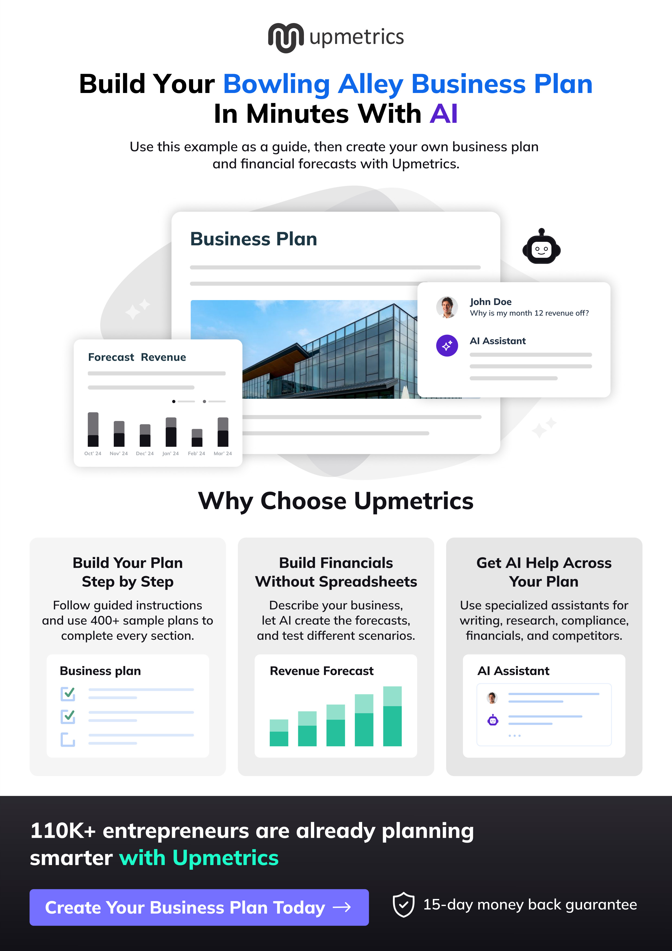

CHAPTER 1

Executive Summary

1.1 Business Overview
1.2 Mission Statement
1.3 Location & Market Opportunity
1.4 Unique Selling Points
1.5 Financial Highlights
1.6 Funding Requirement

1.1 Business Overview
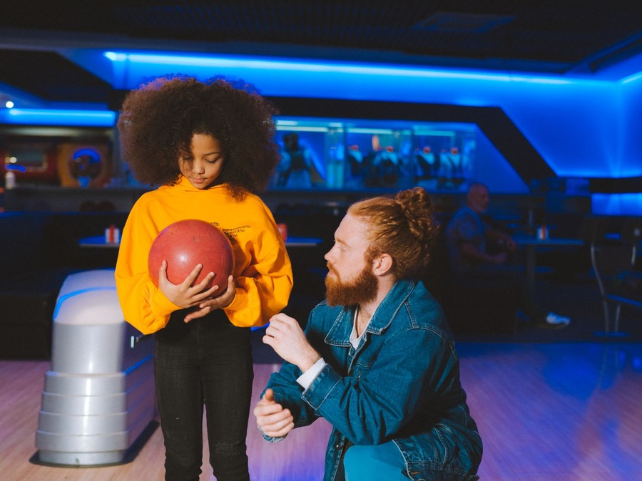
Copperpin Lanes is a 24-lane bowling center opening in south Huntsville, Alabama, in a leased former big-box unit of about 32,000 square feet. It pairs lanes with overhead scoring and string pinsetters with a full kitchen and bar that serves the lanes, an arcade of about 35 games and two private event rooms.
Groups rent lanes by the hour with shoes included, league bowlers pay by the week through fall, winter and summer seasons, and families, employers, schools and churches book hosted event packages at one all-in price.

1.2 Mission Statement
To give south Huntsville a bowling center close to home where a league night, a birthday party and a Friday out with friends are all easy to book, well run and worth coming back to.

1.3 Location & Market Opportunity
The Huntsville metro had 556,444 residents in 2025 after adding 14,322 in a single year, at a median household income of $87,049, and 57,153 of its households include a child. More than 38,000 people work on Redstone Arsenal, and Cummings Research Park holds 300 companies and organizations, a deep pool of office teams looking for somewhere to take a group. Every public bowling center in the metro trades north or west of downtown, which leaves the fast-growing south side a drive across town to bowl.
US bowling centers generate $4.7 billion a year. The Huntsville metro's own bowling market is about $5.0 million a year across four private centers, a thin supply for a metro of this size, and a single US bowling center averages $1.26 million a year. A modern 24-lane center with a full kitchen, an arcade and event rooms is planned to earn above that average from its first year.

1.4 Unique Selling Points
- A south Huntsville site, closer to home for households that now drive north or west to bowl.
- 24 lanes with string pinsetters, cheaper to run than free-fall machines and kept open by one technician.
- A real kitchen and full bar serving the lanes, so a group stays for a second hour.
- Leagues built for newcomers and office teams, with short seasons and mixed teams.
- Hosted event packages at one booked price, with two private rooms beside the lanes.

1.5 Financial Highlights
Revenue comes from 58 open play lane hours a day at an average of $44, a league book of 220 bowlers paying $14 a week for 34 weeks, food and drink that add 62% to bowling revenue, an arcade that adds 24%, and 55 events a month at an average package of $450. The center opens at 60% of that level and reaches it by its ninth month.
Revenue is projected at $1,870,509 in the first year, $2,151,085 in the second and $2,473,748 in the third, at a gross margin of 83.0% throughout. The opening year closes with a net loss of $123,485 while open play builds and loan interest is at its heaviest; net income reaches $6,006 in the second year and $116,999 in the third. Break-even revenue is $1,493,181, the equivalent of 33,936 lane hours a year, which the first year clears. Third-year results range from a net loss of $31,544 in the conservative case to net income of $306,806 in the upside case.

1.6 Funding Requirement
The startup budget is $2,660,000. Most of it buys and installs what bowlers come for: $1,320,000 for the lanes, string pinsetters and scoring, and $560,000 of leasehold improvements to convert the building. The rest covers the kitchen and bar, the arcade, the lane machine and rental shoes, furniture and technology, permits, professional fees, deposits, launch marketing and pre-opening training. It is funded by $850,000 from the two founders and a $2,150,000 SBA 7(a) loan at 10% over ten years, which leaves about $340,000 of cash beyond the startup budget, and profits stay in the business while the loan is repaid.
The plan rests on founders who have run bowling centers and league programs, a growing metro with a deep pool of office teams and young families, and a side of town no bowling center serves. The money builds a complete 24-lane center with its first leagues and holiday events sold before the doors open.

1.6.1 Income Statement (3 Year projections)
 | Year 1 | Year 2 | Year 3 | Total
Revenue | $1,870,508.64 | $2,151,084.94 | $2,473,747.68 | $6,495,341.26
Cost of Sales | $317,986.47 | $365,684.44 | $420,537.11 | $1,104,208.02
Gross Margin | $1,552,522.17 | $1,785,400.50 | $2,053,210.57 | $5,391,133.24
Operating Expense | $1,239,340.27 | $1,358,641.32 | $1,495,837.51 | $4,093,819.10
Total Expense | $1,993,993.41 | $2,145,079.41 | $2,356,748.92 | $6,495,821.74
Net Income | ($123,484.77) | $6,005.53 | $116,998.76 | ($480.48)

CHAPTER 2

Company Overview

2.1 Legal Structure
2.2 Vision Statement
2.3 Background & History
2.4 Future Goals

2.1 Legal Structure
Copperpin Lanes will be organized as an Alabama limited liability company owned by its two founders, Dana Whitcomb and Theo Ramsey, and taxed as a corporation. The structure limits their personal exposure on a lease, a loan and a liquor license while keeping ownership simple, and it lets the company retain profits to repay the SBA 7(a) loan. The founders will personally guarantee the loan, as the SBA requires of owners holding 20% or more.

2.2 Vision Statement
To become the bowling center south Huntsville thinks of first: the place its offices hold their leagues, its children have their birthday parties and its friends meet on a Friday, run well enough that a first visit turns into a weekly one.

2.3 Background & History
Copperpin Lanes is the founders' stated plan for a new business; it has no trading history yet. Dana Whitcomb ran operations and food and beverage for a 32-lane bowling center for nine years, where the bar and kitchen grew into the center's second largest line. Theo Ramsey is a USBC certified coach who managed league programs and group sales for a regional bowling chain for seven years.
Both watched the trade change from lanes rented by the game to a night out sold by the hour, with food, drinks and an arcade around it, and both saw how much a center's winter depends on full league nights. They chose Huntsville because the metro keeps adding residents and employers while its public bowling centers all sit north or west of downtown, leaving the south side and Hampton Cove without one nearby.

2.4 Future Goals
In the first 0 to 18 months, the founders aim to open the center in August 2027 with fall leagues and holiday events pre-sold, fill six weeknight leagues and a Saturday youth league in the first season, and reach the monthly revenue run rate the plan projects by the ninth month of trading. The opening year is planned to clear break-even revenue of $1,493,181.
Over 1 to 3 years, the center is planned to grow revenue from $1,870,509 in the first year to $2,473,748 in the third, turning a first-year net loss of $123,485 into net income of $116,999 by the third year, while repaying the SBA loan on schedule. That growth is meant to come from a second and third winter of league rosters, repeat corporate events from Research Park and Redstone employers, and a kitchen whose share of each visit keeps rising.
Over 3 to 5 years, the founders intend to refresh the arcade and event rooms, add a youth bowling program run with local schools, and judge from the center's own results whether a second south or east side location, or duckpin lanes inside the existing building, would earn its keep.

2.4.1 Business Owners
Dana Whitcomb | Theo Ramsey

Total ownership: 100%
55% | Dana Whitcomb  5,500 Shares
45% | Theo Ramsey  4,500 Shares

2.4.2 SMART Goal
  Specific  - Reach break-even revenue of $1,493,181 in the first year of trading.  - Owned by Dana Whitcomb and Theo Ramsey, with leagues and events led by Theo.  - Delivered from one 24-lane center in south Huntsville. |   Measurable  - Lane hours sold and spend per lane hour, counted daily in the point of sale.  - League bowlers on rosters against a target of 220.  - Events booked each month against a target of 55. |   Achievable  - Leagues and holiday events pre-sold for eight weeks before opening.  - Employer outreach to Cummings Research Park and Redstone Arsenal contractors.  - A founder team with bowling center and league operations experience.
  Relevant  - Revenue of $1,870,509 is projected for the first year.  - Clearing break-even protects payments on the SBA 7(a) loan.  - Leagues fill weeknights that open play alone leaves empty. |   Time-Based  - League sign-ups open in June, eight weeks before the doors open.  - Break-even pace reached by the ninth month, when the run rate peaks.  - Progress reviewed monthly by both founders.

CHAPTER 3

Market Analysis

3.1 Overview
3.2 Market Segmentation
3.3 Market Trends
3.4 Local Market Outlook
3.5 Market Size

3.1 Overview
US bowling centers generate an estimated $4.7 billion of revenue in 2026, down 1.6% on the prior year after growth of 3.0% a year from a pandemic-depressed base. The trade is shrinking in number rather than in appeal: BLS counts 3,320 private bowling center establishments in 2025, about 7% fewer than in 2019, while USBC still reports more than 1.06 million members and more than 28,000 certified leagues.
The centers that remain are larger and earn more of each visit away from the lanes. The biggest operator, Lucky Strike Entertainment, took $1,245.3 million in fiscal 2026, with bowling 45% of it, food and beverage 35% and amusement and other 20%.

3.2 Market Segmentation
A bowling center sells to four groups that use the same lanes in different ways:
- Walk-in groups: friends, couples and families booking a lane for an hour or two, the largest line in the trade and the one that fills weekend nights.
- League bowlers: adults and juniors who commit to one center for a season and pay every week, which carries weeknights from September to April.
- Event bookings: birthday parties, office outings and church and youth groups buying a hosted package at one price.
- Food, drink and arcade spend: sold to all three groups on the same visit, and the line that decides a center's margin.

3.3 Market Trends
- League bowling has steadied: USBC membership fell from 1,698,911 in 2013-14 to 850,699 in 2020-21, recovered to 1,093,909 in 2022-23 and stood at 1,075,194 in 2024-25.
- The largest operator reports leagues growing again, with league revenue up 2.1% in one fiscal 2026 quarter against 1.4% for walk-in play.
- Fewer, bigger centers: IBISWorld counts 2,484 businesses in 2026, falling 2.1% a year since 2021.
- Food and drink now carry the margin, at about 35% of revenue for the largest chain.

3.4 Local Market Outlook
The Huntsville metro had 4 private bowling center establishments in 2024, the same 4 as in 2022 and 2023, all in Madison County; Limestone County has none. Three of the four public centers belong to multi-site operators, and Bowl Madison is the one independent. Redstone Lanes on Redstone Arsenal is open only to those with Arsenal access.
Demand is growing faster than supply. The metro reached 556,444 residents in 2025, up 2.6% in a year, with a median household income of $87,049 and 26.6% of households including a child. More than 38,000 people work on Redstone Arsenal, and Space Command and FBI moves are adding more.
Costs reflect a tight property market and a low wage floor. Colliers put Huntsville retail availability below 3% in the third quarter of 2025, though department store closures are freeing rare large-format units, and no published big-box rent was found. Alabama has no state minimum wage, and metro attendants earned a mean of $12.47 an hour in May 2025. Locally, Alabama levies a 4% amusement tax that names bowling alleys, Huntsville charges $40 a year per lane, and a liquor license costs $300 from the state and $1,200 from the city.

3.5 Market Size
The total addressable market is the $4.7 billion US bowling center industry in 2026. The serviceable market is the Huntsville metro itself, about $5.0 million a year: its 4 private bowling centers multiplied by US revenue of about $1.26 million per establishment. That figure leaves out entertainment centers coded to other activities, so it understates the spend a new center competes for.
The obtainable market is one center's worth of trade, about $1.26 million a year at the national average for a bowling establishment. Copperpin's first-year revenue of $1,870,509 sits above that average, as a 24-lane center with a full kitchen, an arcade and event rooms is planned to, and it would make the metro's fifth public center.
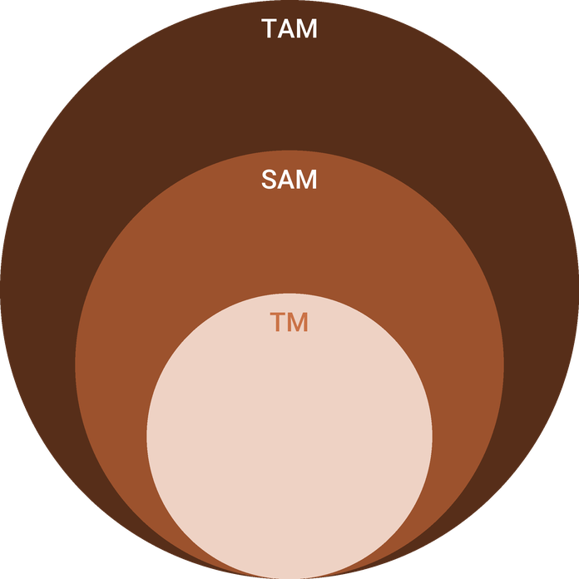
  ● | Total Available Market (TAM)  US bowling centers (NAICS 713950) generate an estimated $4.7 billion of revenue in 2026, according to IBISWorld, down 1.6% on the prior year. | 4.7B
  ● | Served Available Market (SAM)  Huntsville metro bowling centers take in about $5.0 million a year: 4 private NAICS 713950 establishments in the Huntsville MSA in 2024 times US revenue of about $1.26 million per establishment in 2022 ($4,287 million across 3,415 establishments). | 5.0M
  ● | Target Market (TM)  One US bowling center employer establishment took in about $1.26 million in 2022 ($4,287 million across 3,415 establishments); a national average, not a Huntsville figure, and a 24-lane center with a full bar, kitchen, arcade and event space may differ from it. | 1.3M

CHAPTER 4

Customer Analysis

4.1 Target Market
4.2 Customer Segments
4.3 Customer Persona
4.4 Customer Purchase Journey

4.1 Target Market
Copperpin Lanes sells to households, groups and employers within a 15 to 20 minute drive of south Huntsville, in Madison County and the edge of the surrounding area. The metro reached 556,444 residents in 2025, with a median household income of $87,049, and 57,153 households include a child. More than 38,000 people work on Redstone Arsenal, and Cummings Research Park holds 300 companies and organizations, many of them engineering firms whose teams are young, salaried and used to organized activities.
That mix suits a bowling center well: families who need a birthday venue several times a year, adults with the income for a night out, and employers who book group events for teams of ten to thirty.

4.2 Customer Segments
- Friends and couples: adults in their twenties and thirties who book a lane on a Friday or Saturday night, eat and drink at the lanes and play the arcade. They buy open play by the hour and are the center's largest group.
- Families: parents with children aged 4 to 14 bowling on weekend afternoons and school holidays, using bumpers and ball ramps. They also book most of the birthday parties.
- League bowlers: adults on office teams, couples' leagues and returning bowlers who commit to a weeknight for a season, plus juniors in a Saturday youth league. They pay weekly and fill the lanes from September to April.
- Employers and groups: Research Park and Redstone contractors, schools, churches and youth groups booking hosted packages for 15 to 30 people, mostly on weekday evenings and in the holiday season.
The groups fill the building at different times, which is what lets 24 lanes earn across the week. Leagues take weeknights from September to April, families take weekend afternoons and school holidays, and friends and couples take Friday and Saturday nights. Employer and group events fill the weekday evenings between league nights and the weeks before Christmas, when offices hold their holiday parties. Each group also spends differently once it is in the building: adults on a night out spend most at the bar and kitchen, families spend on bumpers, pizza and arcade cards, and league bowlers buy food and drink every week of the season.
The persona below stands for the first and third groups, which overlap more than any others: young professionals who bowl socially and can be turned into league bowlers.

4.3 Customer Persona
  Megan Castillo  Demographics  Age: 29  Status: Single  Location: South Huntsville, AL  Income: $92,000 a year  Professional Role  Education: B.S. in Aerospace Engineering  Job: Systems engineer at a Research Park contractor | “I want somewhere close to home where my team can bowl on Thursday and my friends can eat properly on Saturday.”
   | Identifiers / Personality Traits  - Organizes her office team's evenings out and its charity events  - Bowled in a youth league as a teenager and wants to again  - Books plans on her phone and checks reviews first
   | Goals  - Join a weeknight league that suits a casual bowler  - Find one place for team nights with real food and drinks  - Book a lane online instead of waiting on a Saturday
   | Challenges  - The nearest centers are a 25 minute drive from home  - Lane waits on weekend nights with no way to reserve  - Leagues that feel built for bowlers with long-held averages

4.4 Customer Purchase Journey
- Discovery: most first visits start with a search for bowling near home, a social post from a friend's night out, a flyer at work or a party invitation from another family.
- Evaluation: customers compare distance, whether a lane can be booked online, the food and the price per lane hour, and parents compare what a party package includes.
- Booking: lanes, parties and events are reserved and paid for online, with a deposit on parties and events, so a group arrives to a lane that is waiting for it.
- First visit: shoes are included, food arrives at the lane, and every group is offered a league sign-up card and a party booking link before it leaves.
- Return: league bowlers come back every week; open play guests return with a monthly offer by text, and families who held a party receive a rebooking reminder a year later.

CHAPTER 5

Competitive Analysis

5.1 Competitors
5.2 Comparison
5.3 Competitive Edge
5.4 SWOT Analysis

5.1 Competitors
Bowling in the Huntsville metro is concentrated in four public centers, three of them owned by multi-site operators, and every one trades north or west of downtown.
- AMF Pin Palace Lanes, 2006 Country Club Ave NW: a 36-lane center with a bar, pro shop and arcade, run under the AMF brand of Lucky Strike Entertainment, which operates more than 360 locations in North America.
- Stars and Strikes Huntsville, 930 Old Monrovia Road NW: bowling beside an arcade, laser tag and other attractions, part of a regional chain of 17 centers across Georgia, the Carolinas, Tennessee and Alabama.
- Main Event Huntsville, 6884 Governors W. NW: bowling, an arcade, laser tag, billiards and a restaurant and bar, owned by Dave & Buster's since June 2022.
- Bowl Madison, 8661 Hwy 72 W, Madison: the one independent public center, with 24 lanes, a pro shop, a lane-side grill, an arcade and a bar.
Beyond bowling, Topgolf Huntsville, Dave & Buster's Huntsville and the Urban Air trampoline park compete for the same night out and the same birthday party. Redstone Lanes on Redstone Arsenal serves only those with Arsenal access.

5.2 Comparison
Copperpin's position against these rivals rests on where it is and how it sells rather than on attractions. The chains and entertainment complexes carry national marketing and, in two cases, laser tag and other attractions Copperpin will not have, while the independent center offers bowling and a grill without online booking or hosted event rooms. Copperpin combines lanes booked by the hour, a full kitchen and bar at the lanes, adult and youth leagues and hosted events in one building on the side of town none of them serves.
The rivals' strengths are real. The chain center has the most lanes in the metro and a national brand behind it, and the entertainment complexes give a family more to do in one visit than bowling alone. Copperpin does not try to match them attraction for attraction. It competes on the things a south Huntsville household weighs most often: how far the drive is, whether a lane can be booked before leaving home, whether the food is worth staying for and whether a newcomer would feel welcome in a league. For employers, it competes on having an event room, a host and one booked price for a team of thirty.
Feature | Copperpin Lanes | National chain centers | Entertainment complexes | Independent centers
Center in south Huntsville | ✓ | ✗ | ✗ | ✗
Lanes booked online by the hour | ✓ | ✓ | ✓ | ✗
Full kitchen and bar at the lanes | ✓ | ✓ | ✓ | ✓
Adult and youth leagues | ✓ | ✓ | ✗ | ✓
Private event rooms with a host | ✓ | ✓ | ✓ | ✗

5.3 Competitive Edge
The edge is a mix of location, cost of operation and the way leagues and events are sold, each of which a rival would find slow or costly to copy.
Location matters more in bowling than in most leisure trades, because a league bowler commits to one center for thirty weeks and chooses the one nearest home or work. A rival would need a new building in south Huntsville to answer it, and the market's low retail availability makes large-format space scarce. The cost advantage comes from building new: string pinsetters, a modern scoring system and a kitchen designed around lane service cost less to run than the older machinery and layouts of an established center. The sales advantage is the founders' own experience of running leagues and group sales, which lets Copperpin open with rosters and events already booked rather than waiting for the area to find it.
   | South Huntsville location  Every public bowling center in the metro trades north or west of downtown, so households in south Huntsville and Hampton Cove drive past none of them on the way home.
   | String pinsetters  String machines cost less to buy and run than free-fall pinsetters and need fewer mechanic hours, so one lane technician can keep all 24 lanes open.
   | Leagues built for newcomers  Short 12 week seasons, mixed teams and office leagues for Research Park and Redstone employers bring in bowlers who have never carried an average.
   | A kitchen, not a snack bar  Burgers, flatbreads and shareable plates are cooked to order and served at the lanes, which keeps groups on site for a second hour.
 | One all-in event price  Birthday and corporate packages bundle lanes, shoes, a host, food and drinks at one booked price, with no add-on charges at the desk.

5.4 SWOT Analysis
Strengths  - A south Huntsville site, away from all four public bowling centers in the metro.  - 24 lanes with string pinsetters, cheaper to run and maintain than free-fall machines.  - Food, drink, arcade and event rooms under one roof, lifting spend beyond the lane hour.  - Founders with bowling center operations and league management experience, and no franchise royalty to pay. | Weaknesses  - A new independent name with no league rosters or reviews on opening day.  - Fixed costs of $24,000 a month in rent on a 32,000 square foot lease.  - Interest on a $2,150,000 SBA loan outweighs operating profit in the first year.  - Some serious bowlers prefer free-fall pinsetters, which USBC certifies as a separate category.
Opportunities  - The Huntsville metro added 14,322 residents in a year, reaching 556,444.  - 57,153 metro households include a child, a steady base for birthday parties.  - More than 38,000 people work on Redstone Arsenal, a deep pool for corporate events.  - League bowling is stable nationally, and office leagues suit a workforce of engineers. | Threats  - Chain operators and entertainment complexes already trade in Huntsville with national marketing.  - US bowling center revenue fell 1.6% in 2026 and the number of centers keeps shrinking.  - A serious alcohol incident could bring dram shop claims and higher insurance premiums.  - Household entertainment spending can fall quickly in a downturn.

 Strategic Summary
Copperpin should open with leagues and events pre-sold, own south Huntsville before a chain looks there, and use the kitchen to lift spend per visit. Steady league nights and corporate events carry the loan while walk-in trade builds.

CHAPTER 6

Products & Services

6.1 Our Offering
6.2 Signature Items
6.3 Additional Services
6.4 What Sets Us Apart
6.5 Leagues & Seasons

6.1 Our Offering
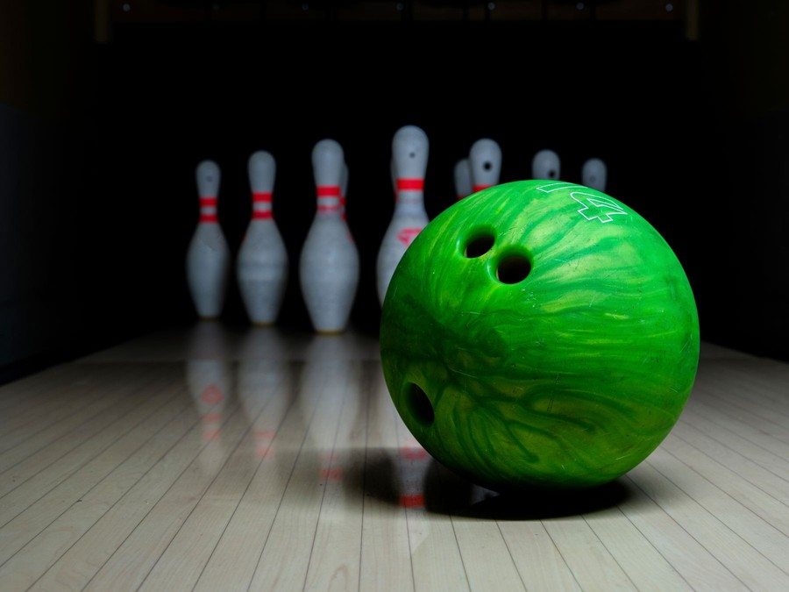
Copperpin Lanes sells a night out built around 24 lanes. Groups rent a lane by the hour with shoes included, league bowlers pay by the week through the season, and families and employers book hosted packages for birthdays and outings. The bar and kitchen serve every lane, and an arcade of about 35 games sits beside them, so a visit can run from a quick hour of bowling to a full evening.

6.2 Signature Items
Two products carry most of the revenue and are priced to be simple to buy.

6.3 Additional Services
- Bar and kitchen: burgers, flatbreads, wings and shareable plates cooked to order and served at the lanes, with a full bar, local draft beer and soft drinks for families.
- Arcade and prize counter: redemption and video games on a reloadable card, sold at the desk or added to a lane booking, with prizes kept to small noncash merchandise.
- Bowling lessons: half hour lessons with Theo Ramsey or a trained staff coach for new league bowlers and juniors.
- League banquets and team nights: the event rooms hired by leagues for end-of-season banquets and by companies for awards nights.

6.4 What Sets Us Apart
Copperpin is designed around how people bowl now: by the hour, in groups, with food. Every lane can be booked online, so a family is not left waiting on a Saturday. String pinsetters keep lanes running with fewer breakdowns and fewer mechanic hours, which matters in a trade short of mechanics. The kitchen is a working kitchen rather than a snack bar, priced so that food and drink add about $62 for every $100 of bowling, and the event rooms let a party or an office group have a space of its own beside the lanes.

6.5 Leagues & Seasons
Leagues are the center's weeknight trade. The fall and winter season runs about 30 weeks from September to April, and a short summer league runs from May to August, for 34 league weeks a year in all. Each league bowls on one weeknight on teams of four, and a bowler pays a weekly fee that covers the center's lineage, about $14 a week, plus a prize fund the center holds for the league and pays back at the season's end.
- Six adult leagues are planned for the first season: two office leagues for Research Park and Redstone teams, a couples' league, a mixed league, a returning bowlers' league and a 12 week starter league for newcomers.
- A Saturday morning youth league teaches juniors the game on bumper-free lanes, with coaching from Theo Ramsey.
- About 220 bowlers are carried on the rosters once the center is open, recruited through employers, sign-up nights and free practice bowling.
- Leagues are certified with USBC under its string pinsetter category, so bowlers keep official averages and can enter sanctioned tournaments.

6.5.1 Open Bowling by the Lane Hour
Groups of up to six book a lane by the hour online or at the desk, with rental shoes included and overhead scoring on every lane. Food and drink are ordered from the lane and brought to the group's table.
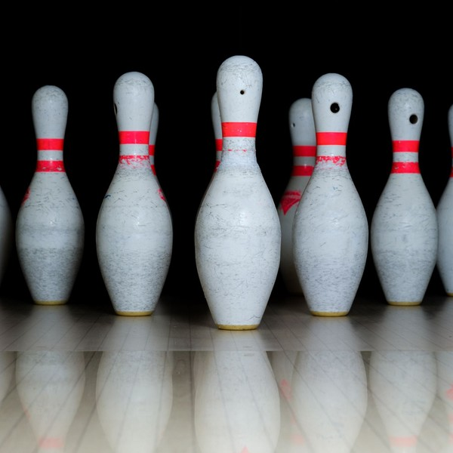 | $36 to $58 per lane hour  The price is for the lane, not the bowler, so a group of six pays the same as a pair. Weekday daytime hours start at $36, weekday evenings run $44, and Friday and Saturday nights reach $58. Rental shoes for every bowler are included in the hour. Bumpers and ball ramps are free for children. Groups that book online can choose a half hour extension at the lane, and most order food, drinks or arcade cards on the same visit.

Specifications
- Lanes can be booked up to 30 days ahead.
- Each lane takes up to six bowlers.
- Bumpers rise and fall by bowler on the same lane.
- Scoring screens hang above every lane pair.
- House balls run from 6 to 16 pounds.

6.5.2 Birthday & Corporate Event Packages
Hosted packages that combine lanes, shoes, food and drinks for birthdays, office outings, church and youth groups. A host runs the event, and larger groups take one of two private event rooms beside the lanes.
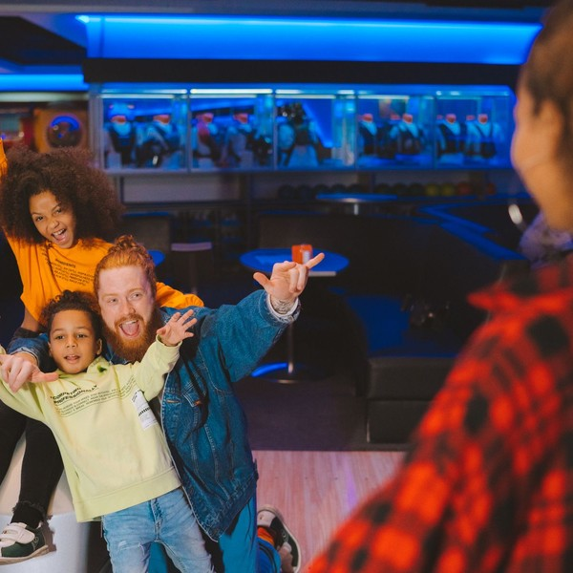 | $329 to $849 per event  Each package is priced per event at one booked total, with a deposit at booking and the balance on the day. Children's parties start at $329 for ten guests on two lanes, and corporate nights reach $849 for thirty guests on six lanes with a buffet. Extra guests, a longer room booking or added drink tickets raise the price. Weekday events cost less than Saturday afternoons. Many groups add arcade cards, a cake or a prize bag for each child, and corporate groups often extend their lanes by an hour on the same invoice.

Specifications
- Two private event rooms seat up to 40 guests each.
- Every package includes a host and rental shoes.
- Bookings open up to 90 days ahead.
- Corporate events are invoiced on 15 day terms.
- Menus run from pizza to a hot buffet.

6.5.3 Features
  24 Lanes With String Pinsetters
  Synthetic lanes with string pinsetters and overhead scoring, with bumpers that rise for children on any lane.
   | Lane-Side Food and Drink  A kitchen and full bar serve burgers, flatbreads, shareable plates and drinks straight to the lanes.
  Arcade and Prize Counter
  About 35 redemption and video games on a reloadable card, with prizes inside Alabama's limit.
   | Two Private Event Rooms  Rooms beside the lanes for birthday parties, office outings and league banquets of up to 40 guests.
   | Online Lane Booking  Lanes, parties and events can be reserved and paid for online up to 90 days ahead.
  Youth and Adult Leagues
  Weeknight adult leagues and a Saturday morning youth league run through fall, winter and summer seasons.

6.5.4 Pricing
Pin Pals Birthday  $329  per party  - Up to 10 children  - Two lanes for 90 minutes with bumpers  - Shoes and a party host  - Pizza and soft drinks |  | Most Popular  Copper Strike Party  $449  per party  - Up to 16 guests  - Three lanes for two hours  - A private event room for 60 minutes  - Pizza, drinks and a $5 arcade card each |  | Corporate Lane Night  $849  per event  - Up to 30 guests  - Six lanes for two hours  - A buffet of shareable plates  - Two drink tickets per guest and a host

CHAPTER 7

Marketing & Sales Strategies

7.1 Market Positioning
7.2 Marketing Objectives
7.3 Online Marketing
7.4 Public Relations and Branding
7.5 Partnership & Collaboration Strategy
7.6 Customer Loyalty & Retention
7.7 Sales Channels

7.1 Market Positioning
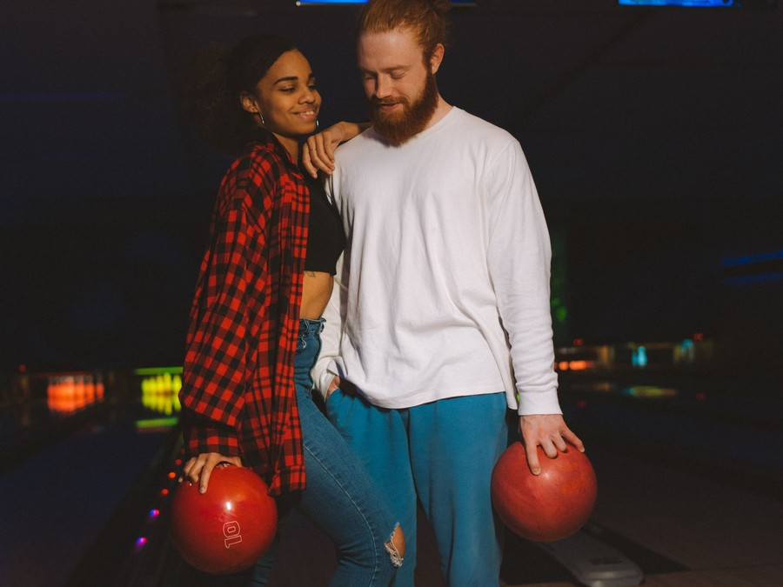
Copperpin Lanes is positioned as south Huntsville's own bowling center: close to home, easy to book and built for groups that want to eat and drink while they bowl, with leagues that welcome newcomers rather than only bowlers who already carry an average.

7.2 Marketing Objectives
- Fill six adult leagues and a youth league before the first fall season starts.
- Book 55 events a month once the center reaches its run rate, half of them from employers and groups.
- Sell 58 open play lane hours on an average day, with weekend nights booked online ahead.
- Hold a rating of 4.5 stars or better on public review sites through the first year.
League Recruitment  $1,870  per month  Sign-up nights, free practice bowling and league flyers placed through employers, churches and schools. |  | Paid Social & Search  $1,871  per month  Ads and search listings aimed at households within a 20 minute drive of south Huntsville.
Corporate & Group Outreach  $1,559  per month  Sales visits, sample events and mailings to Research Park employers, schools and youth groups. |  | Party Referral Rewards  $935  per month  Free game passes for families who book a party and refer another one.

Total marketing budget: $74,820 a year, $6,235 a month.

7.3 Online Marketing
The marketing budget is 4% of revenue, $74,820 in the first year, and most of it is spent where households within a 20 minute drive already look. The website, search listings and social ads all end in a lane or party that can be booked and paid for online. Paid social and search target households in south Huntsville, Hampton Cove and the nearby suburbs, with separate campaigns for parents planning a party, adults planning a weekend night and employers planning a team event.

7.4 Public Relations and Branding
The copper name carries through the building, from the lane-side tables to the uniforms, so the brand reads as warm and modern rather than as a chain. The opening is timed for August 2027 with a ribbon cutting, a free bowling morning for local schools and a charity tournament with a south Huntsville nonprofit, each offered to local media.

7.5 Partnership & Collaboration Strategy
- Employers in Cummings Research Park and contractors at Redstone Arsenal: office leagues, team-building packages and invoiced holiday events.
- Schools, churches and youth groups: weekday group rates and fundraising nights that share a portion of lane sales with the group.
- High school bowling teams: practice lanes on weekday afternoons at a team rate, which brings families in with them.

7.6 Customer Loyalty & Retention
Leagues are the center's strongest form of loyalty: a bowler who joins in September comes back every week until April. The starter league is designed to turn walk-in groups into those bowlers, and every league night includes a food and drink special so the weekly visit is also an evening out. Open play guests earn a free game hour after five paid visits on the booking account, and families who hold a party receive a rebooking offer before the child's next birthday.

7.7 Sales Channels
Revenue arrives through four routes, in order of what each is worth:
  Walk-In and Online Lane Booking
  Open play is the largest line, and it depends on weekend nights filling and weekday afternoons being sold to families.
  Food and Drink at the Lanes
  The bar and kitchen add about $62 for every $100 of bowling, which depends on lane-side ordering being quick.
  Event Bookings
  About 55 hosted parties and outings a month, which depend on employer outreach and parents booking ahead.
  League Rosters
  Bowlers pay weekly through the season, a steady weeknight income that depends on filling leagues before each season starts.

CHAPTER 8

Operations Plan

8.1 Daily Operations
8.2 Working Hours
8.3 Staffing & Training
8.4 Inventory & Equipment Management
8.5 Location and Facilities
8.6 Milestones & Timeline
8.7 Lane & Pinsetter Maintenance

8.1 Daily Operations
Each day starts with the lane technician's checks and the lane conditioning machine's pass down every lane, while the kitchen preps and the desk confirms the day's bookings and events. From opening, the desk checks groups in, issues shoes and assigns lanes; servers take food and drink orders at the lanes; and an event host runs each booked party or outing in an event room. In the evening a manager on duty runs the floor, with leagues bowling from 6:30 pm on weeknights in season. At close the desk reconciles sales, the kitchen and bar close out stock, and the lanes are cleaned for the next morning's pass.

8.2 Working Hours
The center opens from noon to 11 pm Monday to Thursday, noon to 1 am on Friday, 9 am to 1 am on Saturday and 11 am to 10 pm on Sunday. Weekday mornings stay closed except for booked school and group events, because walk-in demand before noon is too thin to staff. Late Friday and Saturday hours serve the adult night-out trade, and the Saturday 9 am start makes room for the youth league before family open play.

8.3 Staffing & Training
The center opens with 32 positions: the two founders, a kitchen and bar manager, an assistant manager, a lane technician with a part-time assistant, and about 26 part-time desk, bar, kitchen, arcade and event staff. Hiring starts eight weeks before opening, and shifts are scheduled each week against the lane booking and event calendar, so staffing rises for league nights, weekend evenings and booked parties and falls back on quiet weekday afternoons. Every employee is trained on the booking and point of sale system and on guest service; bartenders and servers complete responsible alcohol service training before their first shift; kitchen staff work under a ServSafe certified manager; and event hosts are trained to run a party from arrival to cake.

8.4 Inventory & Equipment Management
Kitchen and bar stock is ordered weekly against the event calendar and reordered every week or two, keeping about 15 days of inventory on hand. Arcade prizes are bought monthly as small noncash merchandise. Rental shoes are sprayed after every use and replaced on a schedule, and house balls are checked for cracks each week. Suppliers of food, drink and prizes invoice monthly, and the point of sale tracks stock against sales every night.

8.5 Location and Facilities
The center leases a former big-box unit of about 32,000 square feet in south Huntsville, with parking for several hundred cars already in place. The 24 lanes run along the length of the building, with the approach and settee area facing a central bar and kitchen. The arcade sits near the entrance, two event rooms seating up to 40 guests each open onto the lanes, and the pinsetter area behind the lanes holds the machines, the lane conditioning machine and the parts room.

8.6 Milestones & Timeline
The lease is signed and the SBA loan closed in December 2026, fit-out begins in February 2027, the lanes go in by May, leagues and holiday events go on sale in June, and the doors open in August 2027 ahead of the first fall league season in September.
Dec 2026  Setup |  |  | Lease and financing  South Huntsville building signed and SBA loan closed  A fifteen-year lease is signed on a 32,000 square foot former big-box unit and the $2,150,000 SBA 7(a) loan funds the lanes and fit-out.
Feb 2027  Setup |  |  | Fit-out begins  Permits issued and lanes ordered  Building permits and the Madison County Health Department kitchen review are cleared, and the lanes, string pinsetters and scoring are ordered.
May 2027  Setup |  |  | Lanes installed  Lanes, bar, kitchen and arcade fitted  The 24 lanes and pinsetters are installed and conditioned, and the kitchen, bar, arcade and two event rooms are completed.
Jun 2027  Pre-launch |  |  | League and event pre-sale  Rosters and holiday events booked ahead  Fall league sign-ups and holiday party bookings open, and employers in Research Park are offered launch event packages.
Aug 2027  Launch |  |  | Doors open  Grand opening before the league season  The center opens seven days a week, with staff hired and trained and the liquor and food licenses in place.
Sep 2027  Growth |  |  | Fall leagues begin  Six weeknight leagues and a youth league  The first fall season starts on weeknights and Saturday mornings, filling the lanes on nights open play leaves quiet.

8.7 Lane & Pinsetter Maintenance
The 24 lanes are synthetic and run on string pinsetters, which hold each pin on a cord and reset the deck in seconds. String machines have far fewer moving parts than free-fall pinsetters, use less energy and need fewer mechanic hours, and USBC has certified scores bowled on them as a separate category since August 2023.
- Every morning the lane conditioning machine cleans each lane and lays a fresh oil pattern, with a house pattern for open play and a sport pattern for leagues when they ask for it.
- Each day the technician checks strings for wear, pin positions and ball returns, and clears any lane fault reported on the scoring system.
- Strings are replaced on a fixed cycle by count of frames bowled, and pins are rotated across the 24 lanes so they wear evenly.
- Each quarter the approaches are refinished and the lane surfaces inspected; each summer, between seasons, the lanes are resurfaced and the machines serviced.
- A stock of strings, pins and parts is kept on site so a fault closes one lane for minutes rather than a pair for the evening.
The oil pattern is the part of lane care a bowler notices first. Oil protects the lane surface and decides how a ball hooks, so the house pattern is laid heavier down the middle to help casual bowlers keep the ball in play, while league nights can run a flatter pattern that rewards accuracy. The technician logs each lane's pattern, the machine's oil use and any lane a bowler reports as running differently, and adjusts the machine before the next morning's pass.
Lane availability is the number the technician answers for. Scoring faults, string wear and ball return jams are logged by lane in the scoring system, so a lane that keeps failing is found and repaired before a league night rather than during one. Two lane maintenance days a year, between the summer league and the fall season, take the whole center down for resurfacing, machine servicing and a full pin rotation.
League nights get their own routine. Before 6:30 pm the technician runs a final check of every lane in use, confirms the oil pattern the leagues have asked for and stays on site until the last frame, since a lane down mid-match costs a league its evening. The ball returns, bumpers and scoring screens are tested on open play lanes before families arrive on weekend afternoons, and any lane that cannot be fixed within minutes is closed and its group moved, rather than left to bowl on a fault.

CHAPTER 9

Management Team

9.1 Key Members
9.2 Organization Chart
9.3 Advisory Board Members

9.1 Key Members
Dana Whitcomb is accountable for the center's results as a whole: revenue against plan, payroll at 30% of revenue, food and drink margins and the monthly loan payment, reviewed every month with the founders' accountant. Theo Ramsey answers for the league and event book, measured by league bowlers on the rosters against a target of 220 and events booked each month against a target of 55.
Kendra Hollis is measured on food and drink cost as a share of kitchen and bar sales, ticket times at the lanes and health inspection results. Luis Ortega is measured on lanes available for play, with a target of every lane open on league nights and Friday and Saturday evenings.
 | Dana Whitcomb  Co-Founder & General Manager · dana@copperpinlanes.example  Ran operations and food and beverage for a 32-lane bowling center for nine years before co-founding Copperpin.

 | Theo Ramsey  Co-Founder & Director of Leagues and Events · theo@copperpinlanes.example  A USBC certified coach who managed league programs and group sales for a regional bowling chain for seven years.

 | Kendra Hollis  Kitchen & Bar Manager · kendra@copperpinlanes.example  Managed the kitchen and bar of a 200-seat Huntsville restaurant and holds ServSafe manager certification.

 | Luis Ortega  Lane & Pinsetter Technician · luis@copperpinlanes.example  Has maintained free-fall and string pinsetters and lane conditioning machines for eleven years.

9.2 Organization Chart
The kitchen and bar manager and the lane technician report to Dana Whitcomb, as does the assistant manager who runs the floor on evenings Dana is off. Desk, arcade and event staff report to the manager on duty, and event hosts take bookings from Theo Ramsey.
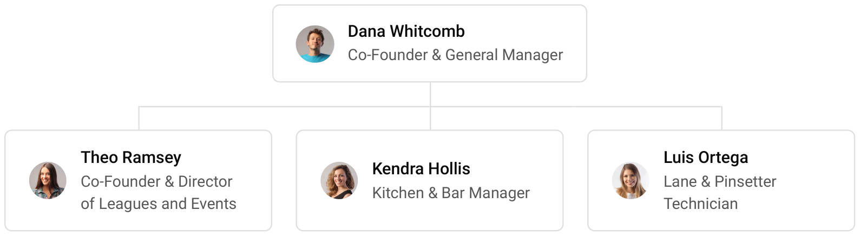

9.3 Advisory Board Members
The founders plan to form an informal advisory group before opening: a Huntsville certified public accountant who works with hospitality businesses, an attorney who advises on Alabama liquor licensing and leases, and a retired bowling center proprietor who has operated through several league seasons. The group will meet each quarter in the first year to review results against the plan and the loan covenants.

9.3.1 Hiring Plan
2  Filled |  | 28  Hiring This Year |  | 30  Open

Group By Department | Position Filled | Time of Hire | Time of Start | Filled
Management | 2 of 4 | 45 days | 60 days | 50%
Bar & Kitchen | 0 of 11 | 30 days | 14 days | 0%
Front Desk, Lanes & Arcade | 0 of 11 | 21 days | 14 days | 0%
Events | 0 of 4 | 21 days | 14 days | 0%
Lane Maintenance | 0 of 2 | 60 days | 30 days | 0%

CHAPTER 10

Financial Plan

10.1 Key Assumptions
10.2 Capital Requirements and Use of Funds
10.3 Income Statement (3 Year projections)
10.4 Balance Sheet (3 Year projections)
10.5 Cash Flow Statement (3 Year projections)
10.6 Break Even Analysis

10.1 Key Assumptions
Revenue is built from the center's own activity rather than from a share of the market: 58 open play lane hours a day at an average of $44 over 360 operating days, plus a league book of 220 bowlers paying $14 a week for 34 weeks. Food and drink add 62% to that bowling revenue and the arcade 24%, and 55 events a month at an average package of $450 are added on top. The center opens at 60% of this level and reaches it by its ninth month, and revenue grows 15% a year after the first.
Cost of sales is kitchen and bar stock, arcade prizes, lane supplies and card processing, for a gross margin of 83.0%. Payroll is 30% of revenue, marketing 4%, and other operating costs, including utilities and Alabama's 4% amusement tax, 8.5%. Rent is $24,000 a month for about 32,000 square feet, a planning assumption because no published Huntsville big-box rent was found.
On these assumptions revenue is $1,870,509 in the first year, $2,151,085 in the second and $2,473,748 in the third. Net income is a loss of $123,485 in the first year, $6,006 in the second and $116,999 in the third. Break-even revenue is $1,493,181, or 33,936 lane hours, and the first year clears it. In the third year, the conservative case shows a net loss of $31,544 and the upside case net income of $306,806.

10.2 Capital Requirements and Use of Funds
The startup budget is $2,660,000. The largest line is $1,320,000 for the 24 lanes, string pinsetters and scoring, followed by $560,000 of leasehold improvements to convert the building, $180,000 for the kitchen and bar and $140,000 for the arcade and prize counter. The balance covers the lane machine, house balls and rental shoes, furniture and technology, permits, professional fees, deposits and pre-opening rent, launch marketing and pre-opening training.
The founders contribute $850,000 and an SBA 7(a) loan provides $2,150,000 at 10% over ten years. Together they fund the full budget and leave about $340,000 of cash to carry the opening months while open play builds, and no profits are distributed in the first three years so that the loan is repaid on schedule.

10.2.1 Use of Funds
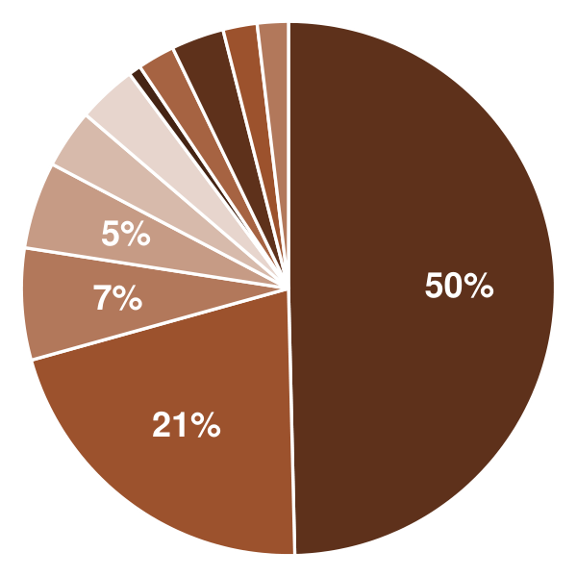 | ● Lanes, String Pinsetters & Scoring 49.6%  ● Leasehold Improvements 21.1%  ● Kitchen & Bar Equipment 6.8%  ● Arcade Games & Prize Counter 5.3%  ● Lane Machine, House Balls & Rental Shoes 3.6%  ● Furniture, POS & Technology 3.6%  ● Licenses, Permits & Plan Review 0.8%  ● Professional Fees 2.3%  ● Deposits & Pre-Opening Rent 3.2%  ● Launch Marketing & League Pre-Sale 2.1%  ● Pre-Opening Staffing & Training 1.9%

Use Of Funds | Amount
Lanes, String Pinsetters & Scoring | $1,320,000.00
Leasehold Improvements | $560,000.00
Kitchen & Bar Equipment | $180,000.00
Arcade Games & Prize Counter | $140,000.00
Lane Machine, House Balls & Rental Shoes | $95,000.00
Furniture, POS & Technology | $95,000.00
Licenses, Permits & Plan Review | $20,000.00
Professional Fees | $60,000.00
Deposits & Pre-Opening Rent | $85,000.00
Launch Marketing & League Pre-Sale | $55,000.00
Pre-Opening Staffing & Training | $50,000.00

10.3 Income Statement (3 Year projections)
 | Year 1 | Year 2 | Year 3 | Total
Revenue | $1,870,508.64 | $2,151,084.94 | $2,473,747.68 | $6,495,341.26
Cost of Sales | $317,986.47 | $365,684.44 | $420,537.11 | $1,104,208.02
General Costs | $0.00 | $0.00 | $0.00 | $0.00
Revenue Specific Costs | $317,986.47 | $365,684.44 | $420,537.11 | $1,104,208.02
Personnel Costs (Direct Labor) | $0.00 | $0.00 | $0.00 | $0.00
Gross Margin | $1,552,522.17 | $1,785,400.50 | $2,053,210.57 | $5,391,133.24
Gross Margin (%) | 83.00% | 83.00% | 83.00% | 83.00%
Operating Expense | $1,239,340.27 | $1,358,641.32 | $1,495,837.51 | $4,093,819.10
Payroll Expense (Indirect Labor) | $561,152.59 | $645,325.48 | $742,124.30 | $1,948,602.37
General Expense | $677,813.58 | $712,885.62 | $753,218.46 | $2,143,917.66
Bad Debt | $374.10 | $430.22 | $494.75 | $1,299.07
Amortization of Current Assets | $0.00 | $0.00 | $0.00 | $0.00
EBITDA | $313,181.90 | $426,759.18 | $557,373.06 | $1,297,314.14
Additional Expense | $436,666.67 | $420,753.65 | $440,374.30 | $1,297,794.62
Long Term Depreciation | $221,666.67 | $225,251.81 | $229,374.72 | $676,293.20
Gain or loss from Sale of Assets | $0.00 | $0.00 | $0.00 | $0.00
EBIT | $91,515.23 | $201,507.37 | $327,998.34 | $621,020.94
Interest Expense | $215,000.00 | $193,500.00 | $172,000.00 | $580,500.00
EBT | ($123,484.77) | $8,007.37 | $155,998.34 | $40,520.94
Income Tax Expense / Benefit | $0.00 | $2,001.84 | $38,999.58 | $41,001.42
Total Expense | $1,993,993.41 | $2,145,079.41 | $2,356,748.92 | $6,495,821.74
Net Income | ($123,484.77) | $6,005.53 | $116,998.76 | ($480.48)
Net Income (%) | -6.60% | 0.28% | 4.73% | -0.01%
Retained Earning Opening | $0.00 | ($123,484.77) | ($117,479.24)
Owner's Distribution | $0.00 | $0.00 | $0.00 | $0.00
Retained Earning Closing | ($123,484.77) | ($117,479.24) | ($480.48) | ($480.48)

10.4 Balance Sheet (3 Year projections)
 | Year 1 | Year 2 | Year 3 | Total
Assets | $2,687,651.10 | $2,483,077.48 | $2,398,834.11 | $2,398,834.11
Current Assets | $249,317.77 | $226,974.26 | $322,630.66 | $322,630.66
Cash | $235,839.86 | $211,474.66 | $304,806.12 | $304,806.12
Accounts Receivable | $409.97 | $471.47 | $542.19 | $542.19
Inventory | $13,067.94 | $15,028.13 | $17,282.35 | $17,282.35
Other Current Assets | $0.00 | $0.00 | $0.00 | $0.00
Long Term Assets | $2,438,333.33 | $2,256,103.22 | $2,076,203.45 | $2,076,203.45
Gross Long Term Assets | $2,660,000.00 | $2,703,021.70 | $2,752,496.65 | $2,752,496.65
Accumulated Depreciation | $221,666.67 | $446,918.48 | $676,293.20 | $676,293.20
Liabilities & Equity | $2,687,651.10 | $2,483,077.48 | $2,398,834.11 | $2,398,834.11
Liabilities | $1,961,135.87 | $1,750,556.72 | $1,549,314.59 | $1,549,314.59
Current Liabilities | $241,135.87 | $245,556.72 | $259,314.59 | $259,314.59
Accounts Payable | $26,135.87 | $30,056.26 | $34,564.69 | $34,564.69
Income Tax Payable | $0.00 | $500.46 | $9,749.90 | $9,749.90
Sales Tax Payable | $0.00 | $0.00 | $0.00 | $0.00
Short Term Debt | $215,000.00 | $215,000.00 | $215,000.00 | $215,000.00
Long Term Liabilities | $1,720,000.00 | $1,505,000.00 | $1,290,000.00 | $1,290,000.00
Long Term Debt | $1,720,000.00 | $1,505,000.00 | $1,290,000.00 | $1,290,000.00
Equity | $726,515.23 | $732,520.76 | $849,519.52 | $849,519.52
Paid-in Capital | $0.00 | $0.00 | $0.00 | $0.00
Common Stock | $0.00 | $0.00 | $0.00 | $0.00
Preferred Stock | $0.00 | $0.00 | $0.00 | $0.00
Owner's Contribution | $850,000.00 | $850,000.00 | $850,000.00 | $850,000.00
Retained Earnings | ($123,484.77) | ($117,479.24) | ($480.48) | ($480.48)
Check | $0.00 | $0.00 | $0.00 | $0.00

10.5 Cash Flow Statement (3 Year projections)
 | Year 1 | Year 2 | Year 3 | Total
Cash Received | $1,929,580.85 | $2,219,427.94 | $2,552,342.14 | $6,701,350.93
Cash Paid | $1,818,740.99 | $1,985,771.44 | $2,194,535.73 | $5,999,048.16
COS & General Expenses | $982,732.12 | $1,076,609.86 | $1,171,501.36 | $3,230,843.34
Salary & Wages | $561,152.59 | $645,325.48 | $742,124.30 | $1,948,602.37
Interest | $215,000.00 | $193,500.00 | $172,000.00 | $580,500.00
Sales Tax | $59,856.28 | $68,834.72 | $79,159.93 | $207,850.93
Income Tax | $0.00 | $1,501.38 | $29,750.14 | $31,251.52
Net Cash From Operations | $110,839.86 | $233,656.50 | $357,806.41 | $702,302.77
Assets Sell | $0.00 | $0.00 | $0.00 | $0.00
Assets Purchase | $2,660,000.00 | $43,021.70 | $49,474.95 | $2,752,496.65
Net Cash From Investments | ($2,660,000.00) | ($43,021.70) | ($49,474.95) | ($2,752,496.65)
Amount Received | $3,000,000.00 | $0.00 | $0.00 | $3,000,000.00
Loan Received | $2,150,000.00 | $0.00 | $0.00 | $2,150,000.00
Common Stock | $0.00 | $0.00 | $0.00 | $0.00
Preferred Stock | $0.00 | $0.00 | $0.00 | $0.00
Owner's Contribution | $850,000.00 | $0.00 | $0.00 | $850,000.00
Amount Paid | $215,000.00 | $215,000.00 | $215,000.00 | $645,000.00
Loan Capital | $215,000.00 | $215,000.00 | $215,000.00 | $645,000.00
Dividends & Distributions | $0.00 | $0.00 | $0.00 | $0.00
Net Cash From Financing | $2,785,000.00 | ($215,000.00) | ($215,000.00) | $2,355,000.00
Summary
Starting Cash | $0.00 | $235,839.86 | $211,474.66
Cash In | $4,929,580.85 | $2,219,427.94 | $2,552,342.14 | $9,701,350.93
Cash Out | $4,693,740.99 | $2,243,793.14 | $2,459,010.68 | $9,396,544.81
Change in Cash | $235,839.86 | ($24,365.20) | $93,331.46 | $304,806.12
Ending Cash | $235,839.86 | $211,474.66 | $304,806.12 | $304,806.12

10.6 Break Even Analysis
 | Year 1 | Year 2 | Year 3 | Total
Starting Revenue | $0.00 | $1,870,508.64 | $4,021,593.58 | $4,021,593.58
Net Revenue | $1,870,508.64 | $2,151,084.94 | $2,473,747.68 | $2,473,747.68
Closing Revenue | $1,870,508.64 | $4,021,593.58 | $6,495,341.26 | $6,495,341.26
Starting Expense | $0.00 | $1,993,993.41 | $4,139,072.82 | $4,139,072.82
Net Expense | $1,993,993.41 | $2,145,079.41 | $2,356,748.92 | $2,356,748.92
Closing Expense | $1,993,993.41 | $4,139,072.82 | $6,495,821.74 | $6,495,821.74
Is Break Even? | No | No | No
Break Even Month | - | - | -
Days Required | - | - | -
Break Even Revenue | - | - | -

CHAPTER 11

References

- SRC001: Bowling Alleys in the US Industry Analysis, 2026, IBISWorld, 2026-03-01. https://www.ibisworld.com/united-states/industry/bowling-centers/1656/ (accessed 2026-10-15)
- SRC002: Total Revenue for Bowling Centers, All Establishments, Employer Firms (REVEF71395ALLEST), Federal Reserve Bank of St. Louis (FRED), 2024-01-01. https://fred.stlouisfed.org/series/REVEF71395ALLEST (accessed 2026-10-15)
- SRC003: Expenses for Bowling Centers, All Establishments, Employer Firms (BCEAEEF371395), Federal Reserve Bank of St. Louis (FRED), 2024-01-01. https://fred.stlouisfed.org/series/BCEAEEF371395 (accessed 2026-10-15)
- SRC004: Quarterly Census of Employment and Wages, 2025 Annual Averages, NAICS 713950 Bowling Centers, U.S. Bureau of Labor Statistics, 2026-01-01. https://data.bls.gov/cew/data/api/2025/a/industry/713950.csv (accessed 2026-10-15)
- SRC005: A Future For The Sport: 2025 recap, 2026 preview, United States Bowling Congress, 2026-01-15. https://bowl.com/news/a-future-for-the-sport-2025-recap,-2026-preview (accessed 2026-10-15)
- SRC006: Press Room, United States Bowling Congress, 2026-01-01. https://bowl.com/press-room (accessed 2026-10-15)
- SRC007: Chad Murphy says USBC membership nearly steady, offers new strings scoring data in 2025 Recap, 2026 Preview, 11thframe.com, 2026-01-16. https://www.11thframe.com/news/article/16353/Chad-Murphy-says-USBC-membership-nearly-steady-offers-new-strings-scoring-data (accessed 2026-10-15)
- SRC008: 2025 USBC Annual Report, United States Bowling Congress, 2026-01-01. https://images.bowl.com/bowl/media/assets/usbc/about/051826_2025-annual-report_final_1.pdf (accessed 2026-10-15)
- SRC009: Lucky Strike Entertainment Reports Fourth Quarter and Full Year Results for Fiscal Year 2026, Lucky Strike Entertainment (Form 8-K, U.S. Securities and Exchange Commission), 2026-08-27. https://www.sec.gov/Archives/edgar/data/0001840572/000162828026059178/pressreleaseq4fy-26.htm (accessed 2026-10-15)
- SRC010: Lucky Strike Entertainment (LUCK): Water Parks Make A Wave In The Latest Quarter, Noble Capital Markets via Channelchek, 2025-11-05. https://www.channelchek.com/news-channel/lucky-strike-entertainment-luck-water-parks-make-a-wave-in-the-latest-quarter (accessed 2026-10-15)
- SRC011: Lucky Strike Entertainment Corp Form 10-K for the fiscal year ended June 28, 2026, U.S. Securities and Exchange Commission, 2026-08-01. https://www.sec.gov/Archives/edgar/data/0001840572/000162828026059179/bowl-20260628.htm (accessed 2026-10-15)
- SRC012: The economics of bowling kingpin Lucky Strike are pretty solid, Sherwood News, 2025-02-19. https://sherwood.news/business/the-economics-of-bowling-kingpin-lucky-strike-are-pretty-solid/ (accessed 2026-10-15)
- SRC013: How Much Does Bowling Cost?, ThePricer, 2026-08-16. https://www.thepricer.org/cost-to-go-bowling/ (accessed 2026-10-15)
- SRC014: Bowling As a Business, Bowling.com. https://bowling.com/braden (accessed 2026-10-15)
- SRC015: Pinstripes goes bankrupt, Restaurant Dive, 2025-09-10. https://www.restaurantdive.com/news/pinstripes-files-chapter-11-bankruptcy/759672/ (accessed 2026-10-15)
- SRC016: Duckpin Bowling's Big Moment: Impressive Revenue From a Small Footprint, Brunswick Bowling, 2026-03-01. https://brunswickbowling.com/company/blog/duckpin-bowlings-big-moment-impressive-revenue-from-a-small-footprint (accessed 2026-10-15)
- SRC017: Bowlero Corp. Announces Record-Breaking Results for the Second Quarter of Fiscal Year 2023, Bowlero Corp. (Form 8-K, U.S. Securities and Exchange Commission), 2023-02-15. https://www.sec.gov/Archives/edgar/data/1840572/000162828023003697/q2fy23earningspressrelea.htm (accessed 2026-10-15)
- SRC018: Costs Are Up, But So Is Confidence: Amex GBT Forecast Finds Events Industry Embracing AI, BizBash, 2025-10-17. https://www.bizbash.com/corporate-events/optimism-trumps-budget-concerns-in-new-report (accessed 2026-10-15)
- SRC019: The Average Cost Of A Child's Birthday Is Now Over $300, Scary Mommy, 2024-07-30. https://www.scarymommy.com/lifestyle/average-cost-of-childs-birthday-party-2024 (accessed 2026-10-15)
- SRC020: How Much Does It Cost to Open a Bowling Alley?, ROLLER, 2026-04-08. https://www.roller.software/blog/how-much-does-it-cost-to-open-a-bowling-alley (accessed 2026-10-15)
- SRC021: How Much Does it Cost to Open a Bowling Alley?, ThePricer, 2026-09-29. https://www.thepricer.org/?p=24536 (accessed 2026-10-15)
- SRC022: USBC certifies string pin bowling as independent competition effective August 1, 2023, United States Bowling Congress, 2023-04-27. https://bowl.com/news/usbc-certifies-string-pin-bowling-as-independent-competition-effective-august-1,-2023 (accessed 2026-10-15)
- SRC023: An innovation in pin racking angers some pro bowlers, NPR (All Things Considered), 2023-01-13. https://www.npr.org/transcripts/1149135745 (accessed 2026-10-15)
- SRC024: American bowling is in a knock-down fight over new high-tech pins, White Hutchinson Leisure & Learning Group, 2023-02-01. https://whitehutchinson.com/news/lenews/2023/february/article102.shtml (accessed 2026-10-15)
- SRC025: Proprietors Share the Top Benefits of EDGE String, International Bowling Industry, 2025-06-01. https://bowlingindustry.com/proprietors-share-the-top-benefits-of-EDGE-string (accessed 2026-10-15)
- SRC026: Occupational Employment and Wage Statistics, May 2025, NAICS 713900 Other Amusement and Recreation Industries, U.S. Bureau of Labor Statistics, 2026-01-01. https://www.bls.gov/oes/current/naics4_713900.htm (accessed 2026-10-15)
- SRC027: Liability Coverage for Alcohol-Related Businesses, Admiral Insurance Group, 2019-12-12. https://www.admiralins.com/blog/liability-coverage-alcohol-related-businesses/ (accessed 2026-10-15)
- SRC028: Insurance That Keeps Entertainment Businesses Center Stage, USLI, 2026-07-24. https://underwritingupdates.usli.com/2026/07/24/insurance-that-keeps-entertainment-businesses-center-stage/ (accessed 2026-10-15)
- SRC029: Bowling giants merge in US, Amusements & Attractions (InterGame), 2021-06-10. https://www.amusementsandattractions.com/amusements/news/bowling-giants-merge-in-us (accessed 2026-10-15)
- SRC030: Dave & Buster's Entertainment, Inc. Form 10-K for the fiscal year ended February 3, 2026, U.S. Securities and Exchange Commission, 2026-03-01. https://www.sec.gov/Archives/edgar/data/1525769/000152576926000008/play-20260203.htm (accessed 2026-10-15)
- SRC031: What is Round1?, Round1 USA, 2026-01-01. https://www.round1usa.com/profile (accessed 2026-10-15)
- SRC032: Consumer Expenditures 2024, U.S. Bureau of Labor Statistics, 2025-12-19. https://www.bls.gov/news.release/cesan.nr0.htm (accessed 2026-10-15)
- SRC033: Expenditures: Entertainment: Fees and Admissions by Income Before Taxes: Less Than $15,000 (CXUFEESADMLB0218M), Federal Reserve Bank of St. Louis (FRED), 2025-01-01. https://fred.stlouisfed.org/series/CXUFEESADMLB0218M (accessed 2026-10-15)
- SRC034: Census Bureau Releases New Estimates on America's Families and Living Arrangements, U.S. Census Bureau, 2025-12-02. https://www.census.gov/newsroom/press-releases/2025/families-and-living-arrangements.html (accessed 2026-10-15)
- SRC035: Total Families with Children under 18 Years Old (TTLFMCU), Federal Reserve Bank of St. Louis (FRED), 2025-01-01. https://fred.stlouisfed.org/series/TTLFMCU (accessed 2026-10-15)
- SRC036: Total Revenue for Bowling Centers, Establishments Subject to Federal Income Tax, Employer Firms (REVEF71395TAXABL), U.S. Census Bureau via FRED, Federal Reserve Bank of St. Louis, 2024-01-31. https://fred.stlouisfed.org/series/REVEF71395TAXABL (accessed 2026-10-15)
- SRC037: QCEW Open Data, 2022 annual averages, industry 713950, U.S. Bureau of Labor Statistics, 2023-01-01. https://data.bls.gov/cew/data/api/2022/a/industry/713950.csv (accessed 2026-10-15)
- SRC038: QCEW Open Data, 2024 annual averages, industry 713950, U.S. Bureau of Labor Statistics, 2025-01-01. https://data.bls.gov/cew/data/api/2024/a/industry/713950.csv (accessed 2026-10-15)
- SRC039: Resident Population in Huntsville, AL (MSA) (HUNPOP), U.S. Census Bureau via FRED, Federal Reserve Bank of St. Louis, 2026-03-27. https://fred.stlouisfed.org/series/HUNPOP (accessed 2026-10-15)
- SRC040: Population (B230RC0A052NBEA), U.S. Bureau of Economic Analysis via FRED, Federal Reserve Bank of St. Louis, 2026-02-20. https://fred.stlouisfed.org/series/B230RC0A052NBEA (accessed 2026-10-15)
- SRC041: Welcome to AMF Pin Palace Lanes, AMF, 2026-01-01. https://amf.com/location/amf-pin-palace-lanes (accessed 2026-10-15)
- SRC042: Our Locations, Stars and Strikes, 2026-01-01. https://starsandstrikes.com/our-locations/ (accessed 2026-10-15)
- SRC043: Bowl Madison, Bowl Madison, 2026-01-01. https://www.bowlmadison.com/ (accessed 2026-10-15)
- SRC044: Main Event Huntsville, AL | Bowling, Arcade & Laser Tag, Main Event, 2026-01-01. https://www.mainevent.com/locations/alabama/huntsville (accessed 2026-10-15)
- SRC045: Bowling, Redstone Arsenal Family and MWR, 2026-01-01. https://redstone.armymwr.com/programs/bowling (accessed 2026-10-15)
- SRC046: AMF River City Lanes, AMF, 2026-01-01. https://amf.com/en/location/amf-river-city-lanes (accessed 2026-10-15)
- SRC047: Huntsville (City, USA), City Population (Census Bureau estimates), 2026-01-01. https://www.citypopulation.de/en/usa/alabama/madison_limestone_mor/0137000__huntsville/ (accessed 2026-10-15)
- SRC048: Huntsville Statistics, City of Huntsville, 2026-01-01. https://maps.huntsvilleal.gov/HuntsvilleStats/ (accessed 2026-10-15)
- SRC049: ACS 2024 1-year, tables B01001, B01002, B09001, B11005, B19013, Census Reporter, 2025-01-01. https://api.censusreporter.org/1.0/data/show/acs2024_1yr?table_ids=B19013,B11005,B09001&geo_ids=31000US26620,16000US0137000,05000US01089,05000US01083 (accessed 2026-10-15)
- SRC050: Government and Public Affairs, Huntsville/Madison County Chamber, 2026-01-01. https://hsvchamber.org/about/departments/government-public-affairs/ (accessed 2026-10-15)
- SRC051: Cummings Research Park, Cummings Research Park, 2026-01-01. https://cummingsresearchpark.com/ (accessed 2026-10-15)
- SRC052: Manufacturing Jobs in No. Alabama, Mazda Toyota Manufacturing, 2026-01-01. https://mazdatoyota.com/ (accessed 2026-10-15)
- SRC053: 500 FBI employees to transfer to Huntsville, 256 Today, 2025-02-21. https://256today.com/500-fbi-employees-to-transfer-to-huntsville/ (accessed 2026-10-15)
- SRC054: Huntsville Commercial Real Estate Report Q3 2026, TenantBase, 2026-01-01. https://www.tenantbase.com/huntsville/q3-2026/ (accessed 2026-10-15)
- SRC055: Madison County named a top tourism spending spot as Alabama breaks tourism record, WAFF, 2026-05-11. https://www.waff.com/2026/05/11/madison-county-named-top-tourism-spending-spot-alabama-breaks-tourism-record/ (accessed 2026-10-15)
- SRC056: Investor Overview, Lucky Strike Entertainment, 2026-01-01. https://ir.luckystrikeent.com/overview/default.aspx (accessed 2026-10-15)
- SRC057: Form 8-K, Exhibit 99.1, Dave & Buster's Entertainment, Inc., 2022-06-29. https://www.sec.gov/Archives/edgar/data/1525769/000110465922075863/tm2219893d1_ex99-1.htm (accessed 2026-10-15)
- SRC058: Topgolf Huntsville | Golf, Dining, Sports Bar & Events, Topgolf, 2026-01-01. https://topgolf.com/us/huntsville/ (accessed 2026-10-15)
- SRC059: Dave & Buster's Huntsville, Dave & Buster's, 2026-01-01. https://www.daveandbusters.com/us/en/about/locations/huntsville (accessed 2026-10-15)
- SRC060: Trampoline Park & Indoor Playground in Huntsville, AL, Urban Air, 2026-01-01. https://www.urbanair.com/alabama-huntsville/ (accessed 2026-10-15)
- SRC061: Locations, Sky Zone. https://www.skyzone.com/locations (accessed 2026-10-15)
- SRC062: Q3 2025 Huntsville Retail, Colliers, 2025-09-30. https://www.colliers.com/en/research/huntsville/q3-2025-huntsville-retail (accessed 2026-10-15)
- SRC063: Q2 2025 Huntsville Retail, Colliers, 2025-06-30. https://www.colliers.com/en/research/huntsville/q2-2025-huntsville-retail (accessed 2026-10-15)
- SRC064: State Minimum Wage Laws, U.S. Department of Labor, 2026-07-01. https://www.dol.gov/agencies/whd/minimum-wage/state (accessed 2026-10-15)
- SRC065: Occupational Employment and Wage Statistics, Huntsville, AL MSA, May 2025, U.S. Bureau of Labor Statistics, 2026-01-01. https://data.bls.gov/oes/#/area/0026620/2025 (accessed 2026-10-15)
- SRC066: Table 5.6.A. Average Price of Electricity to Ultimate Customers by End-Use Sector, by State, U.S. Energy Information Administration, 2026-09-24. https://www.eia.gov/electricity/monthly/epm_table_grapher.php?t=epmt_5_6_a (accessed 2026-10-15)
- SRC067: License Types & Fees, Alabama Alcoholic Beverage Control Board, 2026-01-01. https://alabcboard.gov/licensing-compliance/license-types-fees (accessed 2026-10-15)
- SRC068: License Fees by Schedule, City of Huntsville Finance Department, 2024-01-01. https://www.huntsvilleal.gov/wp-content/uploads/2024/12/2025_City-of-Huntsville-License-Fee-Schedule.pdf (accessed 2026-10-15)
- SRC069: Alcohol Beverage & Consumable Hemp Products License, City of Huntsville, 2026-01-01. https://www.huntsvilleal.gov/business/licensing-permits/alcohol-beverage-license/ (accessed 2026-10-15)
- SRC070: Liquor Tax, City of Huntsville, 2026-01-01. https://www.huntsvilleal.gov/government/finances-budget/city-taxes/tax-types-rates/liquor-tax-rate/ (accessed 2026-10-15)
- SRC071: Items Needed for Commercial Plans Review, City of Huntsville, 2026-01-01. https://www.huntsvilleal.gov/development/building-construction/building-license-permits/6815-2/ (accessed 2026-10-15)
- SRC072: Sales Tax, City of Huntsville, 2026-01-01. https://www.huntsvilleal.gov/government/finances-budget/city-taxes/tax-types-rates/sales-tax-rates/ (accessed 2026-10-15)
- SRC073: Alabama Sales Tax Rates: Huntsville, SalesTaxHandbook, 2026-01-01. https://www.salestaxhandbook.com/alabama/rates/huntsville (accessed 2026-10-15)
- SRC074: HB386 (Engrossed), text of Section 40-23-2, Alabama Legislature, 2025-01-01. https://alison.legislature.state.al.us/files/pdf/SearchableInstruments/2025RS/HB386-eng.pdf (accessed 2026-10-15)
- SRC075: Rule 810-6-1-.125, Places of Amusement or Entertainment, Alabama Department of Revenue. https://www.revenue.alabama.gov/wp-content/uploads/2021/12/810-6-1-.125.pdf (accessed 2026-10-15)
- SRC076: 2MC, Inc. v. State of Alabama Department of Revenue, Docket S. 07-587, Alabama Administrative Law Division. https://taxtribunal.alabama.gov/wp-content/uploads/2023/05/433_07-587.pdf (accessed 2026-10-15)
