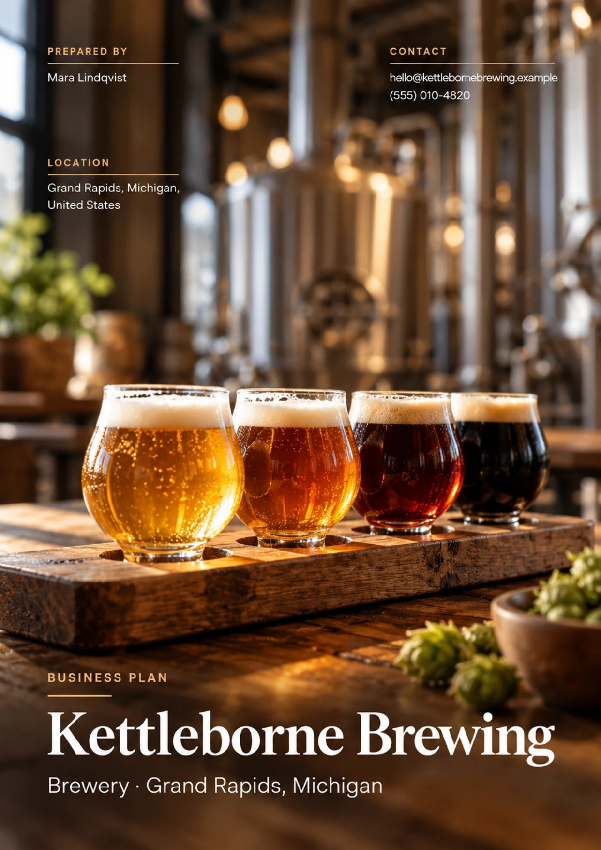
Table of Contents
1. Executive Summary 6
1.1 Business Overview 7
1.2 Mission Statement 7
1.3 Location & Market Opportunity 7
1.4 Unique Selling Points 7
1.5 Financial Highlights 7
1.6 Funding Requirement 8
1.6.1 Income Statement (3 Year projections) 8
2. Company Overview 9
2.1 Legal Structure 10
2.2 Vision Statement 10
2.3 Background & History 10
2.4 Future Goals 10
2.4.1 Business Owners 11
2.4.2 SMART Goal 11
3. Market Analysis 12
3.1 Overview 13
3.2 Market Segmentation 13
3.3 Market Trends 13
3.4 Local Market Outlook 13
3.5 Market Size 14
3.5.1 PESTEL Analysis 15
4. Customer Analysis 16
4.1 Target Market 17
4.2 Customer Segments 17
4.3 Customer Persona 18
4.4 Customer Purchase Journey 18
5. Competitive Analysis 19
5.1 Competitors 20
5.2 Comparison 20
5.3 Competitive Edge 21
5.4 SWOT Analysis 22
6. Products & Services 23
6.1 Our Offering 24
6.2 Signature Items 24
6.3 Additional Services 24
6.4 What Sets Us Apart 24
6.5 Core & Seasonal Beer Lineup 25
6.5.1 Taproom Pints & Flights 25
6.5.2 Kegs for Local Bars 26
6.5.3 Features 26
6.5.4 Pricing 27
7. Marketing & Sales Strategies 28
7.1 Market Positioning 29
7.2 Marketing Objectives 29
7.3 Online Marketing 29
7.4 Public Relations and Branding 30
7.5 Partnership & Collaboration Strategy 30
7.6 Customer Loyalty & Retention 30
7.7 Sales Channels 31
8. Operations Plan 32
8.1 Daily Operations 33
8.2 Working Hours 33
8.3 Staffing & Training 33
8.4 Supply Chain Management 33
8.5 Inventory & Equipment Management 33
8.6 Location and Facilities 34
8.7 Milestones & Timeline 34
8.8 Licensing & Excise Compliance 35
9. Management Team 36
9.1 Key Members 37
9.2 Organization Chart 37
9.3 Advisory Board Members 38
9.3.1 Hiring Plan 38
10. Financial Plan 39
10.1 Key Assumptions 40
10.2 Capital Requirements and Use of Funds 40
10.2.1 Use of Funds 41
10.3 Income Statement (3 Year projections) 42
10.4 Balance Sheet (3 Year projections) 43
10.5 Cash Flow Statement (3 Year projections) 44
10.6 Break Even Analysis 45
11. References 46
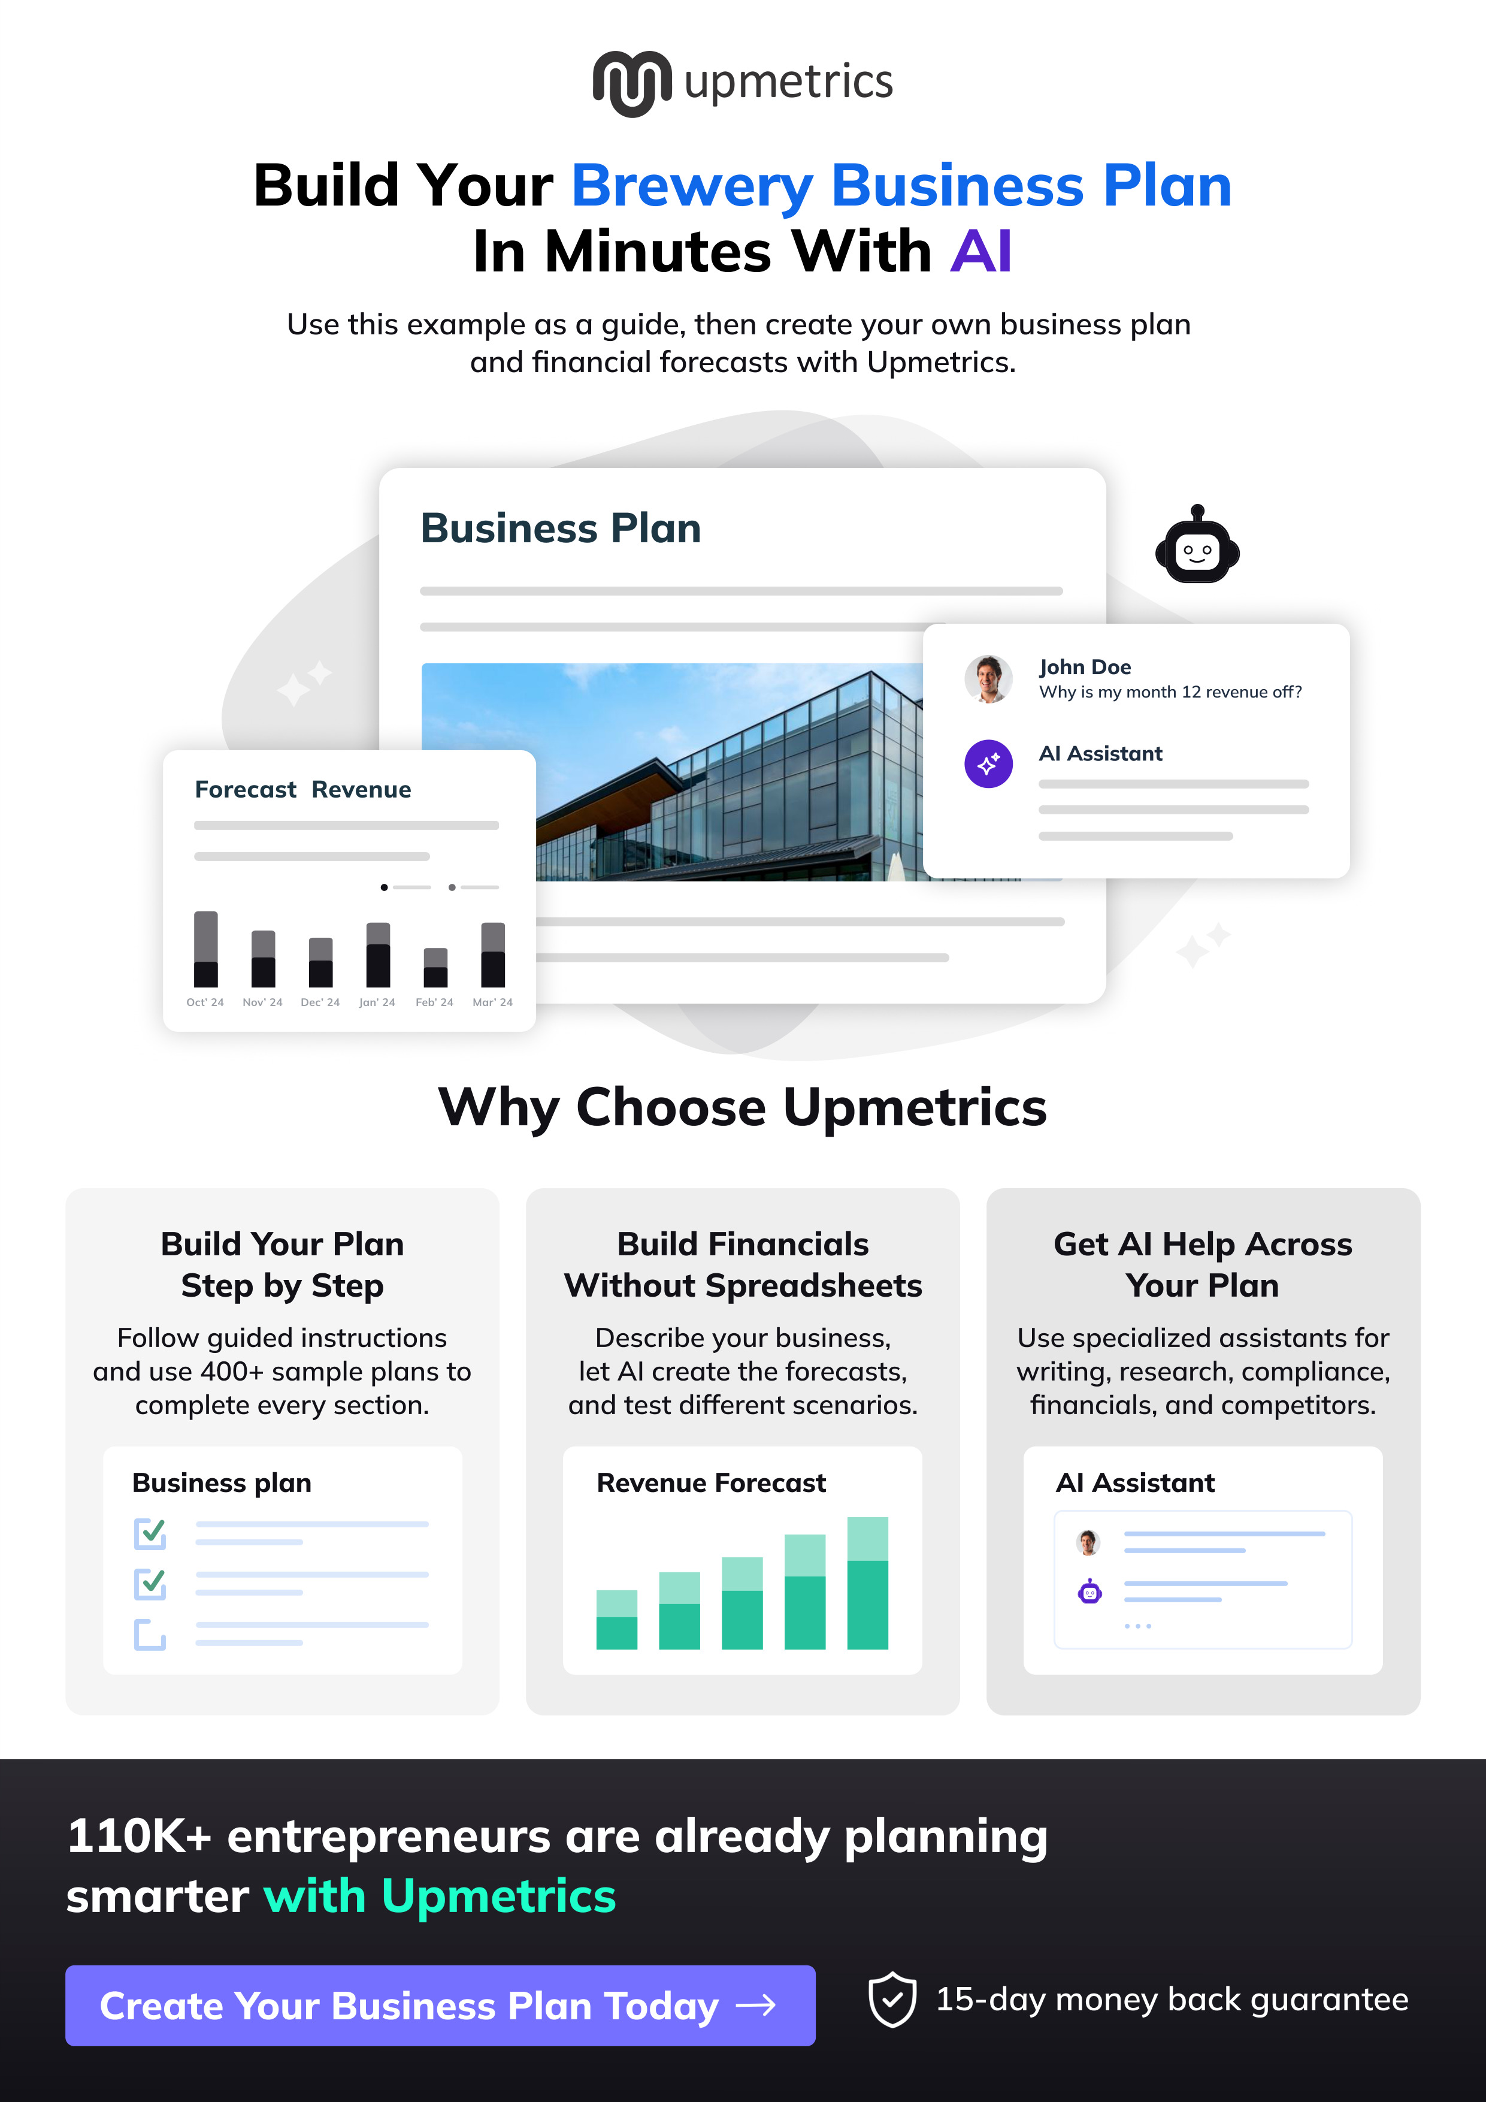

CHAPTER 1

Executive Summary

1.1 Business Overview
1.2 Mission Statement
1.3 Location & Market Opportunity
1.4 Unique Selling Points
1.5 Financial Highlights
1.6 Funding Requirement

1.1 Business Overview
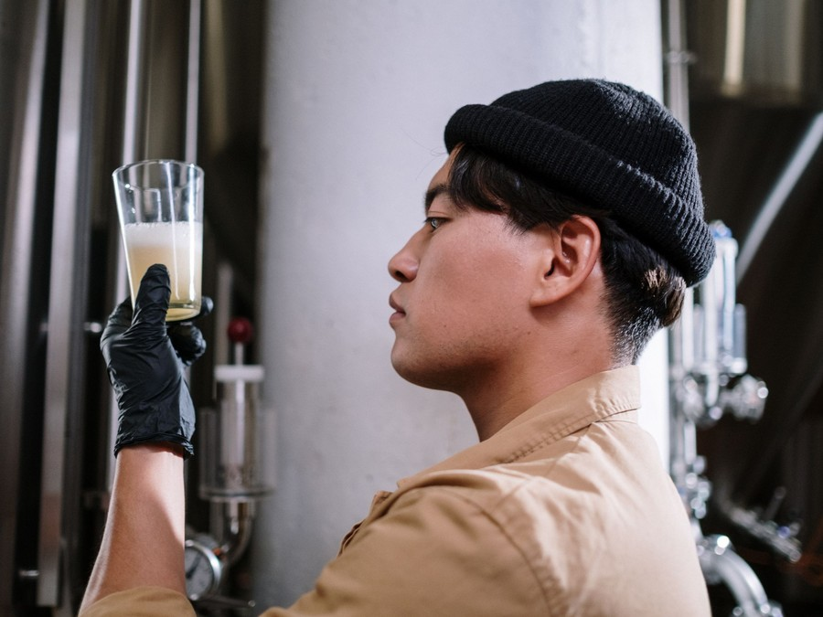
Kettleborne Brewing is an independent taproom brewery planned for Grand Rapids, Michigan. It will brew on a 10 barrel brewhouse behind its own bar and pour most of what it makes in a taproom of about 120 seats with a seasonal patio north of downtown.
It sells pints and flights of a year-round lineup of lagers, pale ales and IPAs beside a new small-batch release every two weeks, cans and crowlers to go, and kegs delivered by its own staff to bars in Kent County. Its guests are neighbourhood regulars, craft beer enthusiasts and visitors on the city's Ale Trail.

1.2 Mission Statement
To brew fresh, well-made beer for our own corner of Grand Rapids and give every guest at the bar something worth ordering, whether they are drinking or not.

1.3 Location & Market Opportunity
Grand Rapids markets itself as Beer City USA, and its Ale Trail lists more than 35 craft breweries. Kent County had 673,002 residents in 2024 with a median household income of $80,685, above Michigan's $72,389, and the city itself is young, with a median age of 33.3. The taproom will lease former light-industrial space north of downtown, close to established neighbourhoods and a short drive from the bars it will supply.
US craft beer sold $28.0 billion at retail in 2025. The Kent County craft beer market, built from the county's 46 small brewery licenses and the national sales per craft brewery, is about $134.5 million a year, and one craft brewery takes about $752,000 a year on the national average.

1.4 Unique Selling Points
- Twelve house beers on tap, led by clean lagers and pale ales, with a new small batch every other Thursday.
- A non-alcoholic pale brewed in house beside a house soda, so non-drinkers order at the bar too.
- Kegs delivered by the brewers themselves, with a line check at every visit.
- A patio with a food truck on every open day from May to October.
- Patio, half-taproom and full buyout bookings for private events.

1.5 Financial Highlights
Revenue comes from the taproom and the keg route. The model assumes 120 guests on an average open day spending $19.50 each over 310 days a year, cans, crowlers, merchandise and events worth a further 14% of bar sales, and 35 barrels a month of kegs sold to bars at $360 a barrel. The taproom opens at 60% of that trade and reaches it over eight months.
Revenue is projected at $847,735 in the first year, $949,463 in the second and $1,063,399 in the third, at a gross margin of 68.0% throughout. Net income is $3,434 in the first year, then $30,884 and $61,176, a net margin of 5.8% by the third year. Break-even revenue is $657,914, the equivalent of 33,739 guests, which the first year clears. Third-year net income is $11,830 in the conservative case and $127,825 in the upside case.

1.6 Funding Requirement
The startup budget is $741,000. It pays for the brewhouse and tanks, cellar and packaging equipment, the drains and utilities a brewhouse needs, the taproom build-out and patio, a delivery van, licenses and legal work, deposits, pre-opening payroll and launch marketing. It is funded by a $300,000 owner contribution from the two founders and a $480,000 SBA 7(a) loan at 10.5% over ten years, and profits stay in the business while the loan is repaid.
The plan rests on an experienced brewer and an experienced operator, a city that already treats its breweries as a reason to go out, and a taproom that sells most of its beer at retail prices. The money builds one well-equipped brewery and the taproom and keg route that keep it busy.

1.6.1 Income Statement (3 Year projections)
 | Year 1 | Year 2 | Year 3 | Total
Revenue | $847,735.20 | $949,463.42 | $1,063,399.03 | $2,860,597.65
Cost of Sales | $271,275.26 | $303,828.29 | $340,287.69 | $915,391.24
Gross Margin | $576,459.94 | $645,635.13 | $723,111.34 | $1,945,206.41
Operating Expense | $447,381.80 | $483,571.61 | $524,104.21 | $1,455,057.62
Total Expense | $844,301.60 | $918,578.92 | $1,002,223.15 | $2,765,103.67
Net Income | $3,433.60 | $30,884.50 | $61,175.88 | $95,493.98

CHAPTER 2

Company Overview

2.1 Legal Structure
2.2 Vision Statement
2.3 Background & History
2.4 Future Goals

2.1 Legal Structure
Kettleborne Brewing will be organised as a Michigan limited liability company owned by its two founders, Mara Lindqvist and Callum Brandt. The LLC structure limits their personal liability, passes profits through to their own tax returns and suits a business with a small number of owners and an SBA lender.
The company will hold a federal Brewer's Notice from the Alcohol and Tobacco Tax and Trade Bureau, a Michigan Micro Brewer license with an On-Premises Tasting Room Permit from the Liquor Control Commission, and a manufacturing license from the Michigan Department of Agriculture and Rural Development.

2.2 Vision Statement
To be the brewery its neighbourhood thinks of first: the place regulars walk to after work, the beer on tap at the bars down the street, and a stop on the Ale Trail that visitors remember for how fresh the beer was and how easy the room was to spend an evening in.

2.3 Background & History
Kettleborne is a new business and has not yet traded. It grew out of the founders' plan to open their own brewery after years in the city's beer and hospitality trades.
Mara Lindqvist has brewed on a production brewhouse in West Michigan for eight years, the last three as lead brewer responsible for recipes and quality control. Callum Brandt has spent ten years in hospitality management, six of them running a high-volume bar and event venue. Together they have written the opening lineup, priced the brewhouse and taproom, and identified the building north of downtown that the plan assumes.
The founders chose a taproom-led model because it sells most of the beer at retail prices, and they chose to self-distribute because it lets them put their beer on nearby tap lines without giving up the wholesale margin to a distributor.

2.4 Future Goals
In the first 0 to 18 months the founders intend to finish the build-out, obtain the federal and state licenses, open the taproom and reach settled trade of about 120 guests on an average open day within eight months of opening. Over the same period they aim to sign enough bar accounts to sell 35 barrels of kegs a month and to keep every year of trading profitable from the first.
Over 1 to 3 years, the period the financial projection covers, the goal is revenue growing from $847,735 to $1,063,399 as the patio season, the private events calendar and the keg route mature, while the SBA loan is paid down on schedule and profits stay in the business.
Over 3 to 5 years the founders plan to add fermentation capacity so the keg route can grow toward Michigan's 2,000 barrel self-distribution limit, and to judge from the taproom's results whether a small canning line for retail stores, or a second taproom in another part of the county, is the better next step.

2.4.1 Business Owners
Mara Lindqvist | Callum Brandt

Total ownership: 100%
55% | Mara Lindqvist  5,500 Shares
45% | Callum Brandt  4,500 Shares

2.4.2 SMART Goal
  Specific  - Open the taproom north of downtown Grand Rapids with a full house lineup.  - Reach 120 guests a day and 35 barrels of keg sales a month.  - Led by both founders: brewing and accounts, taproom and books. |   Measurable  - Average daily guests and spend per guest, read from the point of sale each week.  - Barrels sold to bars each month and the number of active keg accounts.  - First-year revenue of $847,735 against break-even revenue of $657,914. |   Achievable  - The head brewer has years on a production brewhouse, and the general manager has run busy bars.  - Opening at 60% of settled trade and reaching it over eight months is a gradual ramp.  - 120 guests a day is about one full turn of a 120 seat room.
  Relevant  - Taproom sales carry the margin that pays the loan.  - Keg accounts spread the name and fill quiet brew days.  - Taprooms held up better than packaging breweries in 2025. | 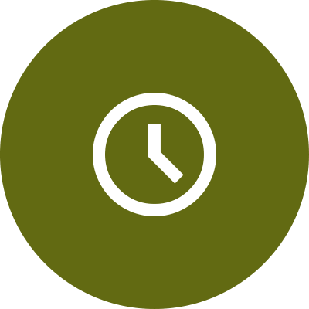  Time-Based  - Settled taproom trade within eight months of opening.  - 35 barrels a month of keg sales by the end of the first year.  - Net income positive in every one of the first three years.

CHAPTER 3

Market Analysis

3.1 Overview
3.2 Market Segmentation
3.3 Market Trends
3.4 Local Market Outlook
3.5 Market Size

3.1 Overview
Craft beer is a mature trade that is getting smaller in volume and holding its value. Craft production fell 4% in 2025 to 22,034,000 barrels while total US beer volume fell 5.7%, so craft's share of volume rose from 13.2% to 13.4%. The US had 9,578 craft breweries at the end of 2025, down 2.9%, and 481 closed against 300 that opened.
The decline is not even. Brewpub production fell 1.7% and taproom production 3.9%, against 8.9% at microbreweries that rely on distribution: the breweries that sell most of their beer across their own bar held up best. That is the model Kettleborne is built on.

3.2 Market Segmentation
The craft beer market a taproom brewery serves divides by where the beer is bought:
- On site: pints, flights and to-go cans sold in brewery taprooms and brewpubs, the highest-priced sale in the trade. The US has 3,784 taprooms and 3,525 brewpubs.
- Draft at bars and restaurants: kegs sold to other licensed premises, a lower price per barrel but steady volume.
- Packaged at retail: cans and bottles sold through stores, mostly by microbreweries and regional brewers working through distributors.
- Non-alcoholic: a small but fast-growing segment, now 2.5% of beer volume.

3.3 Market Trends
- Fewer adults drink: only 54% of US adults said they drink in 2026, a record low for the second year, and 51% believe one or two drinks a day is unhealthy. Beer is still the drink 36% of drinkers choose most often.
- Non-alcoholic beer is growing fast: dollar sales rose 159% from 2021 to 2025, craft brewers hold 36% of non-alcoholic dollar sales, and craft non-alcoholic sales grew 20% in 2025.
- Over 90% of non-alcoholic buyers also buy alcohol, so a non-alcoholic tap keeps a group at the bar rather than replacing a drinker.
- Price holds while volume falls: craft retail dollar sales fell 2.8% in 2025, less than volume, helped by price and by on-site sales.

3.4 Local Market Outlook
Grand Rapids is one of the densest brewery markets in the country. Kent County holds 48 active brewery licenses, 42 of them Micro Brewer licenses, 4 Brew Pub licenses and 2 Brewer licenses for production over 60,000 barrels, and 22 of the 48 are in the City of Grand Rapids. The city's Ale Trail lists more than 35 craft breweries, and Grand Rapids won the Beer City USA title in 2012 and USA Today's Best Beer City every year from 2021 to 2025.
Kent County had 673,002 residents in 2024 and a median household income of $80,685, against Michigan's $72,389. The city had 200,131 residents with a median age of 33.3, and the metro 1,178,826. A 2019 county study counted more than 94,000 beer tourists a year spending $23.9 million; no later study has been published.
Grand Rapids area industrial asking rent averaged about $6.36 a square foot in the first quarter of 2026. Michigan's minimum wage is $13.73 an hour with a $5.49 tipped cash wage, and metro bartenders earned a mean of $23.13 an hour with tips. Michigan taxes beer at $6.30 a barrel, and a Micro Brewer may self-distribute to retailers while it sells fewer than 2,000 barrels a year. No published figure gives local spending on craft beer.

3.5 Market Size
The total addressable market is US craft beer retail sales, $28.0 billion in 2025.
The serviceable market is the Kent County craft beer market, about $134.5 million a year: 46 small brewery licenses multiplied by about $2.92 million of national craft retail sales per craft brewery. It is a county figure and an upper estimate, because the national average includes the largest craft brewers' distributed volume.
The obtainable market is about $752,000 a year, the average revenue of one US craft brewery business in 2026. It is a national figure, not a Grand Rapids one. Kettleborne's first-year projection of $847,735 sits above it because the brewery sells most of its beer at retail prices in its own taproom.
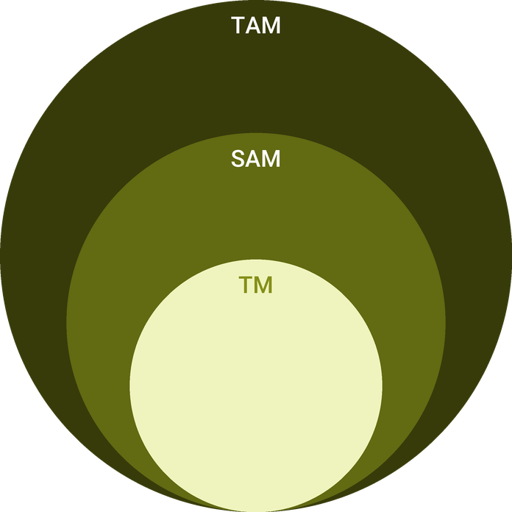
  ● | Total Available Market (TAM)  US craft beer retail dollar sales were $28.0 billion in 2025, down 2.8%, 24.8% of a $113 billion US beer market. | 28.0B
  ● | Served Available Market (SAM)  The Kent County craft beer market is about $134.5 million a year: 46 small brewery licenses (42 Micro Brewer plus 4 Brew Pub, October 2026) x about $2.92 million national craft retail sales per craft brewery (2025). | 134.5M
  ● | Target Market (TM)  One craft brewery takes about $752,000 a year, the average revenue per US craft brewery business in 2026 ($7.4 billion across 9,840 businesses); a national figure, not a Grand Rapids one. | 752.0k

3.5.1 PESTEL Analysis
  Political  - Federal excise is $3.50 a barrel on a small brewer's first 60,000 barrels, and Michigan adds $6.30.  - Section 232 tariffs keep sheet aluminum and finished cans at 50%.  - Michigan lets a micro brewer self-distribute while it sells fewer than 2,000 barrels a year. |   Economic  - Kent County's median household income of $80,685 is above Michigan's $72,389.  - An SBA 7(a) loan at a variable 10.5% ties interest cost to the prime rate.  - Brewers report cost of goods up 40% to 45% since 2020 against price increases in the mid teens. |   Social  - Only 54% of US adults drink, and 51% say one or two drinks a day is unhealthy.  - Beer is still the drink 36% of drinkers have most often.  - Grand Rapids is young, with a median age of 33.3, and markets itself as Beer City USA.
  Technological  - Brewery software tracks every batch from grain to keg and prepares excise returns.  - Taproom point of sale data shows which beers, hours and days sell.  - Maltose-negative yeast makes a non-alcoholic beer possible on a standard brewhouse. |   Environmental  - Brewing uses several barrels of water for each barrel of beer, so water and sewer cost matter.  - Spent grain goes to a local farm as feed rather than to landfill.  - Hop harvests shrank in 2025, which makes contracting flagship varieties ahead more important. |   Legal  - No beer may be brewed until TTB approves the Brewer's Notice and Michigan issues the Micro Brewer license.  - The tasting room permit needs City Commission approval, liquor liability insurance and trained servers.  - Every beer label must be approved by the Liquor Control Commission before it is sold.

CHAPTER 4

Customer Analysis

4.1 Target Market
4.2 Customer Segments
4.3 Customer Persona
4.4 Customer Purchase Journey

4.1 Target Market
Kettleborne sells to adults of legal drinking age in Grand Rapids and the surrounding Kent County suburbs, most of them between 25 and 55, and to the bars in the county that buy kegs of local beer. The core of the taproom's trade is the neighbourhood within a short drive or walk of the building north of downtown.
The county is a strong place to sell beer. It had 673,002 residents in 2024, and the city's median age of 33.3 is younger than the state's. Beer remains the drink 36% of US drinkers choose most often, even though only 54% of adults now drink at all, so the taproom has to give drinkers a reason to choose it and give non-drinkers in the same group something to order.

4.2 Customer Segments
- Neighbourhood regulars: residents who come once or twice a week for a pint after work or a Saturday afternoon on the patio. They are the largest share of daily guests and buy most of the to-go crowlers.
- Craft beer enthusiasts: drinkers who follow new releases and turn up on Release Thursdays. They buy flights and four-packs and spread the word about each new beer.
- Groups and celebrations: friends, coworkers and families booking a table or a private event. They spend the most per visit and often include guests who are not drinking.
- Beer tourists: visitors working through the Ale Trail, strongest from May to October and on weekends. They buy flights, merchandise and cans to take home.
- Bar accounts: bars and restaurants in Kent County that want a local beer on tap and buy half-barrel and sixth-barrel kegs each week.
The segments do not arrive at the same time. Regulars and bar accounts carry the weekdays and the winter months, enthusiasts concentrate on Release Thursdays, and beer tourists and groups fill the patio season from May to October and the weekends. That spread is why the plan averages 120 guests across the week rather than counting on Saturdays, and why the events calendar and the keg route matter most in the months when visitors thin out.
Each segment also needs a different reason to come back: a familiar pint and a bartender who knows the order for the regular, something new on the board for the enthusiast, room for a table of twelve for the group, and a flight and a four-pack to take home for the visitor.

4.3 Customer Persona
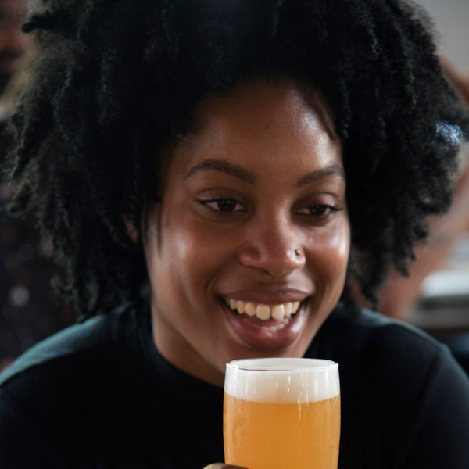  Dana Kowalski  Demographics  Age: 34  Location: Grand Rapids, MI  Household: Married, no children  Income: $78,000 a year  Professional Role  Job: Project engineer at a Kent County manufacturer  Education: Bachelor's degree in engineering | “I want a place ten minutes from home where there is always something new on tap and my friends who are not drinking still have a good pour.”
   | Identifiers / Personality Traits  - Visits a taproom once or twice a week, usually after work or on a Saturday afternoon  - Follows local breweries on social media and turns up for release days  - Often brings a group of friends, at least one of whom is not drinking that night
   | Goals  - A regular spot close to home where the staff know the order  - New beers to try without driving across the city  - Somewhere that suits both a quiet pint and a birthday for twelve
   | Challenges  - Tired of tap lists that never change  - Finds most taprooms offer non-drinking friends only soda  - Has little patience for crowded bars with slow service on a Friday

4.4 Customer Purchase Journey
Most guests hear about Kettleborne before they visit. A neighbour sees the patio from the street, a friend posts a photo from a release night, or a visitor finds it on the Ale Trail listings.
The journey runs in five steps:
- Discovery: social posts about each release, the Ale Trail listings, a pint at a bar account or the patio seen in passing.
- First visit: a flight of four lets a new guest try the lineup, and a bartender suggests a full pour from it.
- Choice: the guest settles on a favourite and often takes a crowler or a four-pack home.
- Return: Release Thursdays, food truck nights and seasonal beers give a reason to come back within the month.
- Advocacy: regulars bring friends, book a birthday or a work event, and ask for Kettleborne at the bars they visit.
Bar accounts buy differently. Jonah Stiles visits with samples, the bar pours a sixth-barrel on a guest tap, and an account that sells it through takes the flagship lager as a standing weekly order on the keg route.

CHAPTER 5

Competitive Analysis

5.1 Competitors
5.2 Comparison
5.3 Competitive Edge
5.4 SWOT Analysis

5.1 Competitors
Kettleborne competes for the same evening out as every other place to drink in Grand Rapids, and most directly with the city's other breweries. Kent County holds 48 active brewery licenses, 46 of them Micro Brewer or Brew Pub licenses held by small independent breweries, and 22 of the 48 are inside the City of Grand Rapids. The city's Ale Trail markets more than 35 craft breweries together, which helps visitors find a new taproom and also puts it beside a long list of alternatives.
The competition falls into four groups:
- Established Grand Rapids taprooms: small breweries with regulars, a known lineup and a place on the Ale Trail. They compete for exactly the same guest and the same evening.
- Brewpubs and larger breweries: breweries built around a full kitchen or a production brewhouse with wide distribution, whose beer is on tap and on shelves across the county.
- Neighbourhood bars and restaurants: places that pour a rotating craft tap list alongside food and sport, and the same premises Kettleborne wants as keg accounts.
- National brands at retail: beer bought in a store and drunk at home, the cheapest option per pint and the one a falling share of adults reach for.
No revenue or performance figure is published for any individual local brewery, and none is assumed here.

5.2 Comparison
Most of what Kettleborne offers, a taproom, a patio and fresh beer brewed on site, is what a good Grand Rapids taproom already offers, and the plan does not pretend otherwise. The differences are in three places.
First, the non-alcoholic tap. Craft brewers hold 36% of non-alcoholic beer dollar sales nationally and craft non-alcoholic sales grew 20% in 2025, yet a non-drinking guest at most taprooms is still offered a soda. Second, the keg route. Michigan lets a Micro Brewer self-distribute while it sells fewer than 2,000 barrels a year, and Kettleborne's own brewers deliver to each account, where many small breweries either leave wholesale alone or hand it to a distributor. Third, the release schedule: a cellar of four 20 barrel fermenters lets the brewery carry its year-round lineup and still put a new beer on every other Thursday.
Where Kettleborne is weaker is in what time gives: an established taproom has regulars, reviews and a reputation that a new brewery has to earn, and a production brewery has shelf space Kettleborne will not reach in its first three years.
Feature | Kettleborne Brewing | Established Grand Rapids taprooms | Neighbourhood bars and restaurants | National brands at retail
Beer brewed on site and poured at its own bar | ✓ | ✓ | ✗ | ✗
A non-alcoholic beer brewed in house | ✓ | ✗ | ✗ | ✗
New small-batch release every two weeks | ✓ | ✓ | ✗ | ✗
Kegs delivered by the brewer who made them | ✓ | ✗ | ✗ | ✗
Seasonal patio with a food truck calendar | ✓ | ✓ | ✗ | ✗
Cans and crowlers to go | ✓ | ✓ | ✗ | ✓

5.3 Competitive Edge
Kettleborne's edge is that it is built around the taproom guest rather than the shelf. Taprooms and brewpubs lost the least volume in 2025, and on-site sales carry the margin that lets a small brewery pay its way. A taproom sized for about 120 guests, a patio with food trucks, a non-alcoholic tap and private bookings give a group a reason to choose it and stay.
Its second edge is the relationship with bar accounts. A brewer who delivers the keg, checks the lines and knows what sold last week can keep a guest tap that a distributor's catalogue would lose, and at $360 a barrel the margin stays with the brewery.
None of these edges is permanent. Another taproom can add a non-alcoholic tap or a release calendar within a season, so Kettleborne treats them as habits to keep rather than claims to make: the release schedule is planned a year ahead, the non-alcoholic pale stays on tap all year, and every account is visited each week by the people who brewed its beer.
  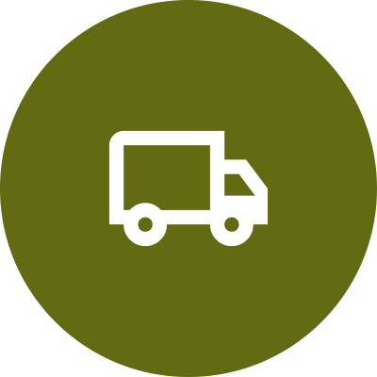 | Kegs Delivered by the Brewer  Kettleborne self-distributes under Michigan's micro brewer rules, so its own staff deliver every keg, check each account's lines and keep the wholesale margin a distributor would take.
   | A Non-Alcoholic Tap Brewed In House  A non-alcoholic pale brewed on the same system sits on tap beside the house sodas, so a group with a driver or a guest who is cutting back still orders at the bar.
   | A Release Every Two Weeks  Four 20 barrel fermenters, double-filled from the 10 barrel brewhouse, let the brewery carry its year-round lineup and still put a new small batch on tap every other Thursday.
   | Built for the Neighbourhood  A taproom north of downtown sized for about 120 guests, with a patio, food trucks and private bookings, made to be the local first and a trail stop second.

5.4 SWOT Analysis
Strengths  - A taproom-led model that sells most beer at retail prices, where on-site brewers held up best in 2025.  - Self-distribution keeps the keg margin in house and puts the brewer in front of every account.  - A non-alcoholic beer brewed in house serves guests who are drinking less.  - A cellar of four fermenters supports a new small-batch release every two weeks. | Weaknesses  - A new name in a county with 48 licensed breweries, with no regulars on opening day.  - A 10 barrel brewhouse caps how far wholesale can grow before more tanks are needed.  - An SBA loan of $480,000 adds interest that keeps first-year net income thin.
Opportunities  - Craft non-alcoholic dollar sales grew 20% in 2025, and craft brewers already hold 36% of them.  - Grand Rapids draws beer tourists to its Ale Trail, a visitor stream a new taproom can join.  - Bars that want a local beer on tap can buy it straight from the brewer under Michigan's 2,000 barrel limit.  - Private events and food truck nights fill weekday hours that pints alone leave quiet. | Threats  - Only 54% of US adults now drink, a record low that shrinks the pool of beer buyers.  - Closings outran openings for a second year, a sign of how crowded taprooms have become.  - Tariffs of 50% on aluminum keep can costs high.  - Established taprooms nearby already hold the loyalty of local regulars.

 Strategic Summary
Kettleborne should win its own neighbourhood first, with a taproom that gives every guest something to order, including non-drinkers, and use brewer-delivered kegs to put its name on nearby tap lines before chasing wider distribution.

CHAPTER 6

Products & Services

6.1 Our Offering
6.2 Signature Items
6.3 Additional Services
6.4 What Sets Us Apart
6.5 Core & Seasonal Beer Lineup

6.1 Our Offering
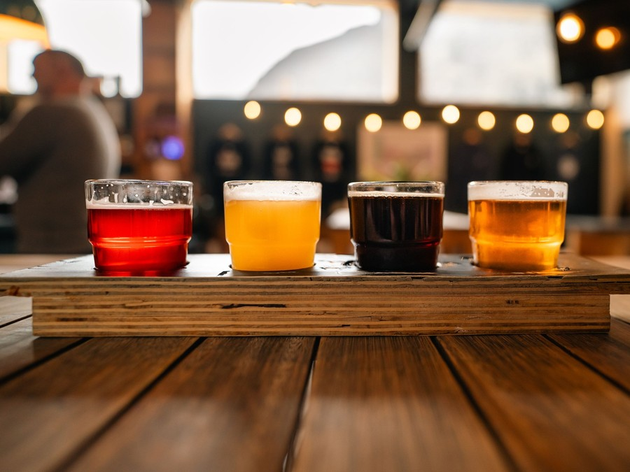
Kettleborne sells fresh beer brewed behind its own bar. Guests drink it by the pint, the 10 ounce glass or the flight in a taproom of about 120 seats and on a seasonal patio, take it home in crowlers and four-packs, and find it on tap at bars across Kent County that buy kegs straight from the brewery.
Everything poured is brewed on the 10 barrel brewhouse and cellared in six 20 barrel tanks on the same site, so beer reaches the tap within days of packaging. The taproom is open Tuesday to Sunday, with a food truck outside on every open day in the patio season and a short snack menu at the bar.

6.2 Signature Items
- House Pilsner: a crisp, pale lager and the flagship, on tap all year and the beer most bar accounts pour, at $7 a pint.
- Kettleborne Pale Ale: a balanced American pale ale with a citrus hop finish, at $7 a pint.
- Northline IPA: a clear, bitter West Coast IPA, at $8 a pint.
- Release Thursday: a new small-batch beer every other week, from a hazy IPA to a fruited sour, at $8 a pint.
- Flight of Four: four 5 ounce tasters chosen from the board, at $13.

6.3 Additional Services
Cans and crowlers to go are filled at the bar: a 32 ounce crowler of any beer on tap, and four-packs of 16 ounce cans of the core beers and each release. Brewery shirts, hats and glassware are sold from a shelf by the door.
The taproom takes private bookings at three levels: a patio reservation for up to 25 guests at $250, the rear half of the taproom for up to 60 at $750, and a full buyout for up to 150 at $2,500. Together, to-go sales, merchandise and events are planned at 14% of bar sales.
Bars in Kent County buy half-barrel kegs at $180 and sixth-barrel kegs at $75, delivered weekly by Kettleborne's own staff.

6.4 What Sets Us Apart
Grand Rapids has no shortage of good taprooms, so Kettleborne competes on three things it can control: freshness, because every beer is poured within days of packaging and every keg is delivered by the people who brewed it; range, because a new beer arrives every other Thursday; and welcome, because a guest who is not drinking can order a non-alcoholic pale brewed in house instead of settling for a soda.

6.5 Core & Seasonal Beer Lineup
The tap list is planned a year ahead around the four fermenters and two brite tanks. A 10 barrel batch is brewed twice into a 20 barrel fermenter, and ales spend about two weeks in the tank while the lagers spend four to five, so the lagers take two fermenters and the ales and releases share the other two.
- Year-round, always on tap: House Pilsner, a Kölsch-style blonde, Kettleborne Pale Ale, Northline IPA, a dry Irish-style stout and the non-alcoholic pale.
- Seasonal, one tap each quarter: a maibock in spring, a wheat beer in summer, a Märzen for autumn and a strong winter porter.
- Small batch, two taps: a new release every other Thursday, brewed in a single 10 barrel batch and poured until it runs out.
- House soda: a rotating draft soda, root beer or ginger, for guests and children.
The non-alcoholic pale is brewed on the same system with a maltose-negative yeast that leaves the beer under 0.5% alcohol. Every batch is checked for gravity and alcohol before it is packaged, and each new recipe is approved for its label by the Liquor Control Commission before it is sold.

6.5.1 Taproom Pints & Flights
Fresh beer poured straight from the brite tanks and kegs behind the bar: a year-round lineup of lagers, pale ales and IPAs beside seasonal and small-batch releases. Guests drink a full pint, a 10 ounce pour of the stronger beers, or a flight of four tasters to work through the board.
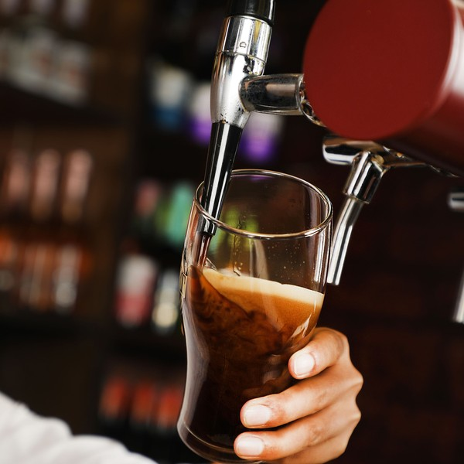 | $7 to $8 a pint  A 16 ounce pint of the lagers and pale ales is $7, and the IPAs and seasonal beers are $8. Stronger beers above 8% are poured as 10 ounce glasses at the same prices, and a flight of four 5 ounce tasters is $13. Prices move with the cost of the hops and malt in each recipe rather than with the day of the week. Most guests pair two pours with a snack from the bar or a meal from the food truck parked outside, and many take a crowler home on the way out.

Specifications
- Twelve house beers on tap, poured within days of packaging.
- Two non-alcoholic taps: a house pale and a rotating house soda.
- Flights of four 5 ounce tasters.
- Pints, 10 ounce glasses and 32 ounce crowlers to go.
- Served Tuesday to Sunday, with Monday kept for brewing and cleaning.

6.5.2 Kegs for Local Bars
Half-barrel and sixth-barrel kegs of the core lineup and seasonal releases, sold to bars in Kent County that want a local beer on their tap lines. Kettleborne's own staff deliver every keg in the brewery van, as Michigan's self-distribution rules require.
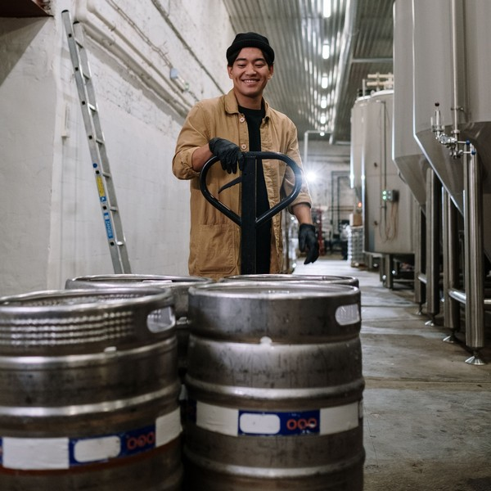 | $180 a half-barrel  A half-barrel keg of any core beer is $180 to a bar, which is $360 a barrel, and a sixth-barrel keg for a smaller tap line is $75. Seasonal and small-batch beers carry the same price so an account can rotate a guest tap freely. The price includes delivery within Kent County on a weekly route, a deposit on the keg shell refunded when it is returned, and a line check by the brewer at each visit. Accounts that pour the flagship lager all year receive tap handles, table tents and a launch night.

Specifications
- Half-barrel and sixth-barrel kegs.
- Delivered weekly by Kettleborne staff in the brewery van.
- Refundable deposit on every keg shell.
- Sold only within Kent County.
- Ordered by text or email by Monday for Wednesday delivery.

6.5.3 Features
  Twelve House Beers on Tap
  A board of lagers, pale ales, IPAs and seasonals, all brewed behind the bar.
  Flights of Four
  Four 5 ounce tasters so a first-time guest can work through the lineup.
  Non-Alcoholic Taps
  A non-alcoholic pale brewed in house and a rotating house soda on draft.
  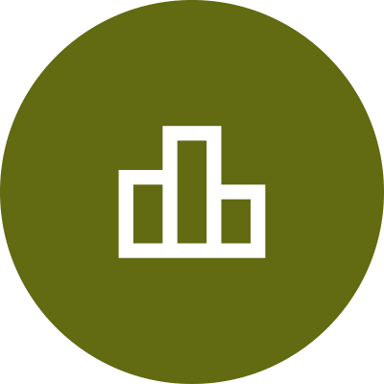 | Release Thursdays  A new small-batch beer goes on tap every other Thursday.
  Patio and Food Trucks
  A seasonal patio with a food truck parked outside on every open day from May to October.
   | Brewhouse Tours  Saturday tours of the brewhouse and cellar led by the brewers.

6.5.4 Pricing
Patio Reservation  $250  per event  - Reserved patio tables for up to 25 guests  - Three hours on a weekday or Sunday  - Food truck booked to match the date  - Fee credited against the bar tab |  | Most Popular  Half Taproom  $750  per event  - The rear half of the taproom for up to 60 guests  - Four hours, with a dedicated bartender  - A welcome flight for every guest  - Brewhouse tour with the head brewer |  | Full Buyout  $2,500  per event  - The whole taproom and patio for up to 150 guests  - Four hours outside regular trading  - A custom tap list chosen with the brewer  - Catering arranged with a partner food truck

CHAPTER 7

Marketing & Sales Strategies

7.1 Market Positioning
7.2 Marketing Objectives
7.3 Online Marketing
7.4 Public Relations and Branding
7.5 Partnership & Collaboration Strategy
7.6 Customer Loyalty & Retention
7.7 Sales Channels

7.1 Market Positioning
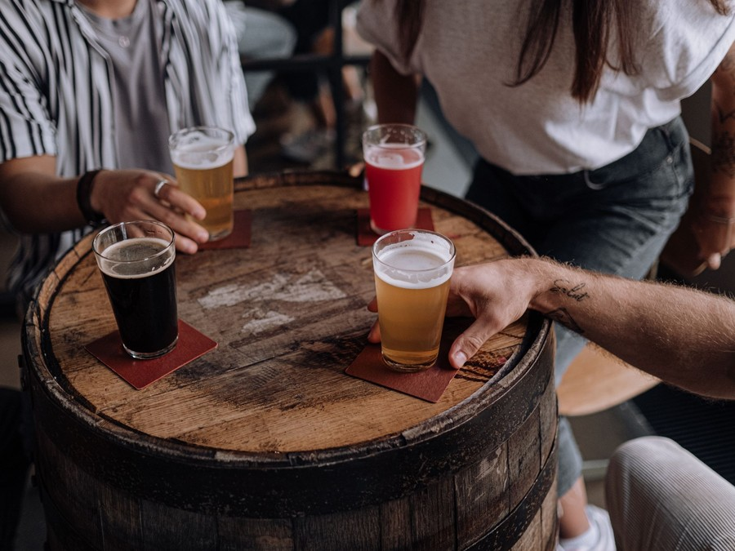
Kettleborne is the neighbourhood brewery north of downtown that gives every guest something worth ordering: fresh house beer, a new release every other week and a non-alcoholic tap brewed on site, with its kegs delivered to nearby bars by the brewers themselves.

7.2 Marketing Objectives
- Reach settled trade of about 120 guests on an average open day within eight months of opening.
- Sign enough Kent County bars to sell 35 barrels of kegs a month by the end of the first year.
- Turn first visits into regular ones, so that weekday trade holds when the patio closes for winter.
- Fill the private events calendar on quiet weekday evenings.
Release & Social Media  $741  per month  Photography and paid posts announcing each small-batch release and event night. |  | Events & Neighbourhood  $530  per month  Sponsoring neighbourhood festivals, a run club and charity pint nights.
Ale Trail & Visitor Listings  $424  per month  Visitor guide listings and passport promotions that reach beer tourists. |  | Account Samples & Tap Takeovers  $424  per month  Sample kegs, tap handles and launch nights at new bar accounts.

Total marketing budget: $25,432 a year, $2,119 a month.

7.3 Online Marketing
Online marketing is built around the release calendar. Every other Thursday a new beer goes on tap, and the week before it the brewery posts the recipe, the brewer's notes and photographs from the brew day on Instagram and Facebook. The website carries the live tap list, opening hours, the food truck calendar and an event booking form, and it is kept current from the point of sale so the list online is the list at the bar.
Kettleborne will claim and keep current its listings on Google, Untappd and the Ale Trail, answer reviews within a day, and use a short email list for release news and seasonal events. Paid posts are kept to release weeks and event nights, aimed at adults within a short drive.

7.4 Public Relations and Branding
The brand is plain and local: the Kettleborne name, a hand-drawn kettle mark and a cream and hop-green palette carried from the tap handles to the cans and the taproom walls. Each core beer has its own can artwork so it is recognised on a bar's tap list.
For press, the founders will invite local food and beer writers to a preview before opening and to the first seasonal release, and will pitch the non-alcoholic tap as a story in its own right. Brewhouse tours on Saturdays give visitors and writers a reason to see how the beer is made.

7.5 Partnership & Collaboration Strategy
- Food trucks: a rotating calendar of local trucks parked on the patio, who promote their dates at Kettleborne to their own followers.
- Neighbourhood groups: sponsorship of festivals, a weekly run club that ends at the taproom and charity pint nights for local causes.
- Bar accounts: tap takeovers and launch nights at the bars that carry Kettleborne, which bring the brewery's name to new drinkers.
- Other breweries: collaboration beers brewed with fellow Grand Rapids brewers, which share audiences rather than split them.
The marketing budget is 3% of revenue, spent mostly on the release calendar, events and the accounts rather than on brand advertising.

7.6 Customer Loyalty & Retention
In a taproom, loyalty comes from a reason to return and from being known. The release schedule gives regulars a new beer every other week, and the seasonal lineup changes each quarter, so a guest who visits monthly always finds something new. Bartenders are trained to learn regulars' names and orders, and a numbered mug club gives regulars a larger pour and first access to limited releases and event tickets.
For bar accounts, retention depends on service: a delivery every week on the same day, a line check at each visit and a beer that sells through. A bar that keeps a Kettleborne tap for a full season is offered first pick of each small-batch release before it reaches the taproom board.

7.7 Sales Channels
Revenue reaches Kettleborne by four routes, in order of what each is worth: the taproom bar, kegs to local bars, cans and crowlers to go, and private events.
The bar is sold by the people behind it. Bartenders offer a flight to every first-time guest, suggest a full pour from it, and mention the to-go cooler as a guest settles the tab, which is how a single visit becomes a pint, a second pour and a crowler. Release Thursdays and food truck nights are scheduled on the quieter weekdays so that the busiest evenings are not the only ones that pay.
The keg route is sold by Jonah Stiles, who visits prospective bars with samples on Tuesdays and delivers on Wednesdays, so a new account can be pouring within a week of saying yes. Cans and crowlers sell from a cooler beside the door that guests pass on the way out, and each release is canned in a short run for regulars who cannot make the release night.
Private events are booked through the website and by Renee Alvarado, who quotes each request within a day and offers weekday dates first, when the taproom has room to spare.
   | Taproom Bar  Pints and flights poured to guests on site are the largest share of revenue and depend on daily guests and spend per guest.
  Kegs to Local Bars
  Self-distributed kegs at $360 a barrel bring steady weekly revenue that depends on signing and keeping accounts in Kent County.
  Cans and Crowlers to Go
  Four-packs and crowlers sold at the bar extend each visit into the home and depend on release days and a visible cooler.
   | Private Events  Patio, half-taproom and full buyout bookings fill quiet weekday hours and depend on word of mouth and the events calendar.

CHAPTER 8

Operations Plan

8.1 Daily Operations
8.2 Working Hours
8.3 Staffing & Training
8.4 Supply Chain Management
8.5 Inventory & Equipment Management
8.6 Location and Facilities
8.7 Milestones & Timeline
8.8 Licensing & Excise Compliance

8.1 Daily Operations
The brewery runs on two clocks. In the brewhouse the day starts early: Mara Lindqvist or Jonah Stiles brews a 10 barrel batch on two or three mornings a week, checks gravity and temperature on every tank, transfers finished beer to the brite tanks and kegs, and cleans each vessel after use. Wednesday morning is the keg route, when Jonah loads the van and delivers to the week's bar accounts.
In the taproom, Renee Alvarado opens with a line and cooler check, sets up the to-go cooler and confirms the food truck. Bartenders pour, fill crowlers and take event bookings, and the closing shift cleans the lines and records stock. Callum Brandt handles purchasing, payroll and the accounts.

8.2 Working Hours
The taproom is open Tuesday to Thursday from 3pm to 10pm, Friday from 3pm to midnight, Saturday from noon to midnight and Sunday from noon to 8pm. Those hours follow how people drink in the neighbourhood: weekday trade comes after work, while weekends carry the afternoon visitors, the Ale Trail and the late groups. Monday is closed to guests so the brewers can brew, clean and receive deliveries without interruption.

8.3 Staffing & Training
The opening team is the two founders, the taproom manager, an assistant brewer and nine part-time bartenders, thirteen people in all. Bartenders are paid Michigan's $5.49 tipped cash wage plus tips, and the salaried staff are paid in line with the metro, where bartenders earned a mean of $23.13 an hour with tips in May 2025.
Every bartender completes the server training Michigan requires for a licensed tasting room before working a shift, and learns the draft system and every beer on the board. Renee Alvarado trains new staff and schedules shifts against the week's expected guests, and Mara Lindqvist runs a short tasting for the team before each release.

8.4 Supply Chain Management
The brewery's margin is set by three suppliers. Hops for the flagship beers are contracted a year ahead with a hop merchant, so the varieties the core lineup depends on are secured even as US growers cut acreage. Base malt is bought by the pallet from a maltster on 30 day terms, and specialty malts by the bag. Cans, crowler cans and labels come from a packaging supplier whose minimum orders set how many cans of each beer are run at a time.

8.5 Inventory & Equipment Management
Inventory is malt, hops, yeast, cans and finished beer, held to a few weeks of each. Hops are kept frozen in a dedicated freezer, malt in a dry store room, and finished beer in the walk-in cooler in kegs ready for the bar or the keg route. Brewery software tracks every batch from grain to keg, records what moves into and out of the cooler, and produces the figures the excise returns need.
Every piece of equipment, from the brewhouse and the glycol chiller to the keg washer, the can filler and about 120 kegs, has a cleaning and maintenance schedule kept in the same software, and the draft lines are cleaned every two weeks.

8.6 Location and Facilities
Kettleborne will lease about 8,000 square feet of former light-industrial space north of downtown Grand Rapids, at about $6,000 a month including taxes and common charges. The brewhouse and cellar sit behind a glass wall at the back of the taproom, so guests can see the tanks from the bar. The taproom seats about 120, with a 24-tap bar, restrooms and a fenced patio facing the street.

8.7 Milestones & Timeline
The path from signing the lease to settled trade runs about fifteen months, and the founders treat three dates as the ones that decide the first year: the licenses issued before the brewhouse is commissioned, the taproom open in time for its first patio season, and settled trade of about 120 guests a day by the eighth month of opening.
Nov 2026  Setup |  |  | Lease and Funding  Building secured north of downtown  The founders sign the lease, close the SBA 7(a) loan and file the TTB Brewer's Notice and the Michigan license application.
Jan 2027  Setup |  |  | Build-Out Begins  Drains, utilities and taproom  Trench drains, three-phase power and the taproom fit-out go in while the brewhouse and tanks are on order.
Apr 2027  Setup |  |  | Equipment and Licenses  Brewhouse commissioned  The brewhouse and tanks are installed and commissioned, the licenses issue and the first trial batches are brewed.
Jun 2027  Launch |  |  | Taproom Opens  Opening week on the patio  The taproom opens with eight house beers, the patio and a food truck calendar, and the first keg accounts take delivery.
Feb 2028  Growth |  |  | Settled Trade  Full taproom and keg route  Daily guests reach about 120 on average and the keg route reaches 35 barrels a month.

8.8 Licensing & Excise Compliance
Three licenses must be in place before the first batch is sold. The federal Brewer's Notice, filed with TTB through Permits Online with the floor plan, the equipment and its capacity, and the ownership and funding details, comes first, because Michigan will not issue the Micro Brewer license until it is supplied. The Liquor Control Commission then issues the Micro Brewer license at $50 a year and the On-Premises Tasting Room Permit at $100 a year, after a $70 inspection fee, the City Commission's approval and proof of liquor liability insurance. MDARD licenses the brewhouse as a food manufacturer.
Excise is paid on every barrel that leaves the brewery or is poured at the bar. Federal excise is $3.50 a barrel on the first 60,000 barrels and Michigan excise is $6.30 a barrel. Both returns are prepared from the brewery software, and the quarterly Michigan report lists every sale to a bar account.
Self-distribution carries its own rules: Kettleborne must sell fewer than 2,000 barrels a year, deliver only with its own employees in its own decaled van, and file its prices to retailers with the Commission. Every new beer label is approved by the Commission before it goes on sale.
Because Kettleborne's federal excise will be well under $50,000 a year, it can claim the small brewer's exemption from the federal bond on its Brewer's Notice and pay its excise quarterly rather than every two weeks. In exchange it must keep its tax payments, returns and monthly reports of operations current, since a brewer that falls behind loses the exemption.
The brewery software records every brew, every transfer between tanks and every keg or can that leaves the cellar, and each barrel poured at the bar is counted as removed for consumption. Those records are the evidence behind every return, and they are kept for the period federal and state rules require, so an inspection by TTB or the Commission can be answered from the system on the day it is asked.

CHAPTER 9

Management Team

9.1 Key Members
9.2 Organization Chart
9.3 Advisory Board Members

9.1 Key Members
The head brewer is accountable for every beer that leaves the brewery: recipes, quality, the brewing calendar and the cost of ingredients. The role is measured on batches that pass quality checks first time, on cost of goods against the 68.0% gross margin, and on beer being on tap when the release calendar says it will be.
The general manager is accountable for the business: guests, staff, purchasing, licenses and the accounts. The role is measured on average daily guests and spend per guest against the plan, payroll as a share of revenue, and cash at month end. The taproom manager answers for service, scheduling and the events calendar and is measured on bookings and on guest reviews. The assistant brewer answers for the cellar and the keg route and is measured on barrels delivered and accounts kept.
 | Mara Lindqvist  Co-Founder & Head Brewer · mara@kettlebornebrewing.example  Eight years brewing on a production brewhouse in West Michigan, the last three as lead brewer responsible for recipes and quality control.

 | Callum Brandt  Co-Founder & General Manager · callum@kettlebornebrewing.example  Ten years in hospitality management, including six running a high-volume bar and event venue, with responsibility for staff, purchasing and the accounts.

 | Renee Alvarado  Taproom Manager · renee@kettlebornebrewing.example  Certified Cicerone Beer Server with five years behind the bar of a busy taproom, including scheduling and training a team of bartenders.

 | Jonah Stiles  Assistant Brewer & Accounts · jonah@kettlebornebrewing.example  Three years of cellar and packaging work at a craft brewery, and a commercial driving record for the weekly keg route.

9.2 Organization Chart
On the chart the head brewer, the taproom manager and the assistant brewer report to the general manager, and the bartending team reports to the taproom manager. The assistant brewer takes direction on brewing and cellar work from the head brewer, and the two co-founders decide recipes, prices and spending above a set limit together at a weekly review of sales, cash and the coming release.
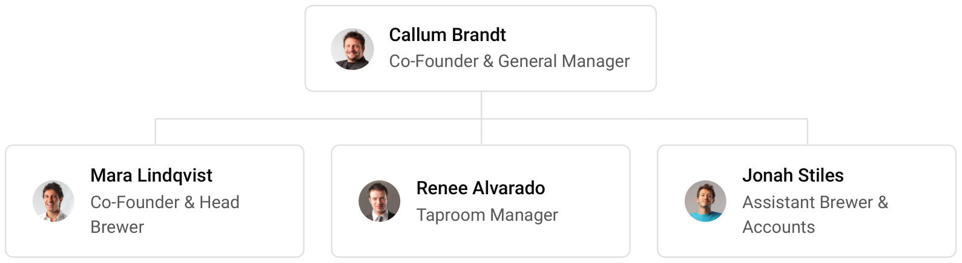

9.3 Advisory Board Members
Kettleborne has no formal board. The founders will draw on an accountant who works with breweries for excise, tax and payroll, a lawyer experienced in Michigan liquor licensing for the lease and the license applications, and a retired brewery owner from West Michigan who has agreed to review the brewing calendar and the keg pricing twice a year.

9.3.1 Hiring Plan
4  Filled |  | 9  Hiring This Year |  | 9  Open

Group By Department | Position Filled | Time of Hire | Time of Start | Filled
Management | 1 of 1 | 0 days | 0 days | 100%
Brewing & Cellar | 2 of 2 | 0 days | 30 days | 100%
Taproom Service | 1 of 10 | 45 days | 14 days | 10%

CHAPTER 10

Financial Plan

10.1 Key Assumptions
10.2 Capital Requirements and Use of Funds
10.3 Income Statement (3 Year projections)
10.4 Balance Sheet (3 Year projections)
10.5 Cash Flow Statement (3 Year projections)
10.6 Break Even Analysis

10.1 Key Assumptions
Revenue follows one formula: taproom guests times the average guest spend times the days open, uplifted by cans, crowlers, merchandise and events, plus barrels of kegs sold to bars times the wholesale price. The model assumes 120 guests on an average open day spending $19.50 each over 310 days a year, to-go sales, merchandise and events worth 14% of bar sales, and 35 barrels a month of kegs at $360 a barrel.
The taproom opens at 60% of settled trade and reaches it over eight months, then revenue grows 12% a year. Gross margin is 68.0%, covering ingredients, packaging, keg costs and federal and state excise. Payroll is 28% of revenue and marketing 3%. Rent is $6,000 a month, technology $650 and administration $5,500, which covers utilities, insurance and accounting. Income tax is modelled at 25%.
On these inputs revenue is $847,735 in the first year, $949,463 in the second and $1,063,399 in the third. Net income is $3,434, $30,884 and $61,176, a net margin of 5.8% by the third year. Break-even revenue is $657,914, equal to 33,739 guests, which the first year clears. In the conservative case third-year net income is $11,830, and in the upside case $127,825.

10.2 Capital Requirements and Use of Funds
The startup budget is $741,000. The largest items are the taproom build-out and patio, the brewhouse and the fermentation and brite tanks, followed by the drains and utilities the brewhouse needs and the cellar and packaging equipment. The rest covers the delivery van, deposits and pre-opening rent, pre-opening payroll and trial brews, the point of sale and signage, launch marketing, and licenses, permits and legal work.
It is funded by a $300,000 owner contribution from the two founders and a $480,000 SBA 7(a) loan at 10.5% over ten years, matched to the working life of the brewhouse and the lease. There is no outside equity, and no profits are distributed in the first three years, so cash stays in the business to repay the loan and add tanks as the keg route grows.
Together the owner contribution and the loan come to more than the startup budget. The balance is held as opening cash, which carries the first stock of malt, hops and cans, the gap before bar accounts settle their invoices, and the payroll of the opening months while the taproom trades below its settled level.
The loan is serviced from operations rather than from fresh capital. Break-even revenue of $657,914 is cleared in the first year, and even the conservative case keeps the third year profitable at $11,830 of net income, so the founders do not plan to add money after opening.

10.2.1 Use of Funds
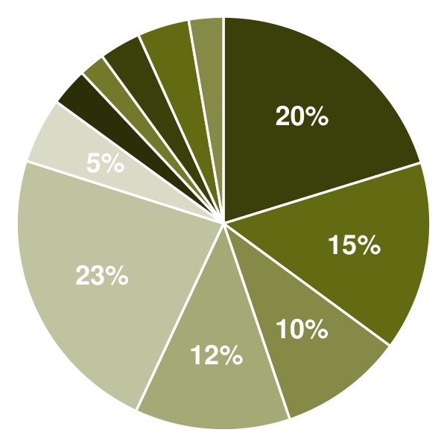 | ● Brewhouse 20.2%  ● Fermentation & Brite Tanks 14.8%  ● Cellar & Packaging Equipment 9.7%  ● Brewery Utilities & Drains 12.1%  ● Taproom Build-Out & Patio 22.9%  ● Delivery Van 5.1%  ● POS, Software & Signage 3.0%  ● Licenses, Permits & Legal 2.0%  ● Deposits & Pre-Opening Rent 3.2%  ● Pre-Opening Payroll & Trial Brews 4.0%  ● Launch Marketing 2.7%

Use Of Funds | Amount
Brewhouse | $150,000.00
Fermentation & Brite Tanks | $110,000.00
Cellar & Packaging Equipment | $72,000.00
Brewery Utilities & Drains | $90,000.00
Taproom Build-Out & Patio | $170,000.00
Delivery Van | $38,000.00
POS, Software & Signage | $22,000.00
Licenses, Permits & Legal | $15,000.00
Deposits & Pre-Opening Rent | $24,000.00
Pre-Opening Payroll & Trial Brews | $30,000.00
Launch Marketing | $20,000.00

10.3 Income Statement (3 Year projections)
 | Year 1 | Year 2 | Year 3 | Total
Revenue | $847,735.20 | $949,463.42 | $1,063,399.03 | $2,860,597.65
Cost of Sales | $271,275.26 | $303,828.29 | $340,287.69 | $915,391.24
General Costs | $0.00 | $0.00 | $0.00 | $0.00
Revenue Specific Costs | $271,275.26 | $303,828.29 | $340,287.69 | $915,391.24
Personnel Costs (Direct Labor) | $0.00 | $0.00 | $0.00 | $0.00
Gross Margin | $576,459.94 | $645,635.13 | $723,111.34 | $1,945,206.41
Gross Margin (%) | 68.00% | 68.00% | 68.00% | 68.00%
Operating Expense | $447,381.80 | $483,571.61 | $524,104.21 | $1,455,057.62
Payroll Expense (Indirect Labor) | $237,365.86 | $265,849.76 | $297,751.73 | $800,967.35
General Expense | $209,380.14 | $217,009.75 | $225,554.93 | $651,944.82
Bad Debt | $635.80 | $712.10 | $797.55 | $2,145.45
Amortization of Current Assets | $0.00 | $0.00 | $0.00 | $0.00
EBITDA | $129,078.14 | $162,063.52 | $199,007.13 | $490,148.79
Additional Expense | $125,644.54 | $131,179.02 | $137,831.25 | $394,654.81
Long Term Depreciation | $74,100.00 | $75,524.19 | $77,119.29 | $226,743.48
Gain or loss from Sale of Assets | $0.00 | $0.00 | $0.00 | $0.00
EBIT | $54,978.14 | $86,539.33 | $121,887.84 | $263,405.31
Interest Expense | $50,400.00 | $45,360.00 | $40,320.00 | $136,080.00
EBT | $4,578.14 | $41,179.33 | $81,567.84 | $127,325.31
Income Tax Expense / Benefit | $1,144.54 | $10,294.83 | $20,391.96 | $31,831.33
Total Expense | $844,301.60 | $918,578.92 | $1,002,223.15 | $2,765,103.67
Net Income | $3,433.60 | $30,884.50 | $61,175.88 | $95,493.98
Net Income (%) | 0.41% | 3.25% | 5.75% | 3.34%
Retained Earning Opening | $0.00 | $3,433.60 | $34,318.10
Owner's Distribution | $0.00 | $0.00 | $0.00 | $0.00
Retained Earning Closing | $3,433.60 | $34,318.10 | $95,493.98 | $95,493.98

10.4 Balance Sheet (3 Year projections)
 | Year 1 | Year 2 | Year 3 | Total
Assets | $758,016.33 | $745,864.00 | $764,560.82 | $764,560.82
Current Assets | $91,116.33 | $140,246.24 | $220,111.36 | $220,111.36
Cash | $49,903.69 | $95,048.09 | $170,449.43 | $170,449.43
Accounts Receivable | $3,483.84 | $3,901.90 | $4,370.13 | $4,370.13
Inventory | $29,728.80 | $33,296.25 | $37,291.80 | $37,291.80
Other Current Assets | $8,000.00 | $8,000.00 | $8,000.00 | $8,000.00
Long Term Assets | $666,900.00 | $605,617.76 | $544,449.46 | $544,449.46
Gross Long Term Assets | $741,000.00 | $755,241.95 | $771,192.94 | $771,192.94
Accumulated Depreciation | $74,100.00 | $149,624.19 | $226,743.48 | $226,743.48
Liabilities & Equity | $758,016.33 | $745,864.00 | $764,560.82 | $764,560.82
Liabilities | $454,582.73 | $411,545.90 | $369,066.84 | $369,066.84
Current Liabilities | $70,582.73 | $75,545.90 | $81,066.84 | $81,066.84
Accounts Payable | $22,296.60 | $24,972.19 | $27,968.85 | $27,968.85
Income Tax Payable | $286.13 | $2,573.71 | $5,097.99 | $5,097.99
Sales Tax Payable | $0.00 | $0.00 | $0.00 | $0.00
Short Term Debt | $48,000.00 | $48,000.00 | $48,000.00 | $48,000.00
Long Term Liabilities | $384,000.00 | $336,000.00 | $288,000.00 | $288,000.00
Long Term Debt | $384,000.00 | $336,000.00 | $288,000.00 | $288,000.00
Equity | $303,433.60 | $334,318.10 | $395,493.98 | $395,493.98
Paid-in Capital | $0.00 | $0.00 | $0.00 | $0.00
Common Stock | $0.00 | $0.00 | $0.00 | $0.00
Preferred Stock | $0.00 | $0.00 | $0.00 | $0.00
Owner's Contribution | $300,000.00 | $300,000.00 | $300,000.00 | $300,000.00
Retained Earnings | $3,433.60 | $34,318.10 | $95,493.98 | $95,493.98
Check | $0.00 | $0.00 | $0.00 | $0.00

10.5 Cash Flow Statement (3 Year projections)
 | Year 1 | Year 2 | Year 3 | Total
Cash Received | $894,479.67 | $1,005,301.07 | $1,125,937.19 | $3,025,717.93
Cash Paid | $835,575.98 | $897,914.72 | $986,584.86 | $2,720,075.56
COS & General Expenses | $496,087.60 | $521,729.90 | $566,841.51 | $1,584,659.01
Salary & Wages | $237,365.86 | $265,849.76 | $297,751.73 | $800,967.35
Interest | $50,400.00 | $45,360.00 | $40,320.00 | $136,080.00
Sales Tax | $50,864.11 | $56,967.81 | $63,803.94 | $171,635.86
Income Tax | $858.41 | $8,007.25 | $17,867.68 | $26,733.34
Net Cash From Operations | $58,903.69 | $107,386.35 | $139,352.33 | $305,642.37
Assets Sell | $0.00 | $0.00 | $0.00 | $0.00
Assets Purchase | $741,000.00 | $14,241.95 | $15,950.99 | $771,192.94
Net Cash From Investments | ($741,000.00) | ($14,241.95) | ($15,950.99) | ($771,192.94)
Amount Received | $780,000.00 | $0.00 | $0.00 | $780,000.00
Loan Received | $480,000.00 | $0.00 | $0.00 | $480,000.00
Common Stock | $0.00 | $0.00 | $0.00 | $0.00
Preferred Stock | $0.00 | $0.00 | $0.00 | $0.00
Owner's Contribution | $300,000.00 | $0.00 | $0.00 | $300,000.00
Amount Paid | $48,000.00 | $48,000.00 | $48,000.00 | $144,000.00
Loan Capital | $48,000.00 | $48,000.00 | $48,000.00 | $144,000.00
Dividends & Distributions | $0.00 | $0.00 | $0.00 | $0.00
Net Cash From Financing | $732,000.00 | ($48,000.00) | ($48,000.00) | $636,000.00
Summary
Starting Cash | $0.00 | $49,903.69 | $95,048.09
Cash In | $1,674,479.67 | $1,005,301.07 | $1,125,937.19 | $3,805,717.93
Cash Out | $1,624,575.98 | $960,156.67 | $1,050,535.85 | $3,635,268.50
Change in Cash | $49,903.69 | $45,144.40 | $75,401.34 | $170,449.43
Ending Cash | $49,903.69 | $95,048.09 | $170,449.43 | $170,449.43

10.6 Break Even Analysis
 | Year 1 | Year 2 | Year 3 | Total
Starting Revenue | $0.00 | $847,735.20 | $1,797,198.62 | $1,797,198.62
Net Revenue | $847,735.20 | $949,463.42 | $1,063,399.03 | $1,063,399.03
Closing Revenue | $847,735.20 | $1,797,198.62 | $2,860,597.65 | $2,860,597.65
Starting Expense | $0.00 | $844,301.60 | $1,762,880.52 | $1,762,880.52
Net Expense | $844,301.60 | $918,578.92 | $1,002,223.15 | $1,002,223.15
Closing Expense | $844,301.60 | $1,762,880.52 | $2,765,103.67 | $2,765,103.67
Is Break Even? | Yes | Yes | Yes
Break Even Month | Dec '26 | - | -
Days Required | 21 Days | - | -
Break Even Revenue | $847,735.20 | - | -

CHAPTER 11

References

- SRC001: National Beer Sales & Production Data, Brewers Association, 2026-06-01. https://www.brewersassociation.org/statistics-and-data/national-beer-stats/ (accessed 2026-10-15)
- SRC002: A Year of Correction for Craft Beer, With Early Signals of Recovery, Brewers Association, 2026-04-14. https://www.brewersassociation.org/association-news/a-year-of-correction-for-craft-beer-with-early-signals-of-recovery/ (accessed 2026-10-15)
- SRC003: Major Revisions to the Brewers Association's 2025 Industry Production Report, New School Beer + Cider, 2026-06-02. https://newschoolbeer.com/home/2026/6/revisions-to-brewers-association-2025-production-report (accessed 2026-10-15)
- SRC004: Quarterly Census of Employment and Wages, NAICS 312120 Breweries, 2025 annual averages, US Bureau of Labor Statistics, 2026-01-01. https://data.bls.gov/cew/data/api/2025/a/industry/312120.csv (accessed 2026-10-15)
- SRC005: A look at sales trends: brewery taprooms and pubs in 2024, Washington Beer Blog, 2025-01-01. https://washingtonbeerblog.com/a-look-at-sales-trends-brewery-taprooms-and-pubs-in-2024/ (accessed 2026-10-15)
- SRC006: Brewers Association Taproom Report: Consumers Seeking Food, Beyond Beer & Expanded Hours, Brewbound, 2025-01-01. https://www.brewbound.com/news/brewers-association-taproom-report-consumers-seeking-food-beyond-beer-expanded-hours (accessed 2026-10-15)
- SRC007: What Top Breweries Are Doing Right: Winning Strategies To Grow Taproom Sales Recap, Arryved, 2024-01-01. https://arryved.com/level-up-with-arryved/what-top-breweries-are-doing-right-winning-strategies-to-grow-taproom-sales-recap/ (accessed 2026-10-15)
- SRC008: Why Is Beer So Expensive?, Toast, 2025-01-01. https://pos.toasttab.com/blog/on-the-line/why-is-beer-so-expensive (accessed 2026-10-15)
- SRC009: San Diego breweries squeezed as costs outpace prices, Axios, 2026-03-04. https://www.axios.com/local/san-diego/2026/03/04/san-diego-breweries-squeezed-as-costs-outpace-prices (accessed 2026-10-15)
- SRC010: Americans' Drinking Remains at Record Low, Gallup, 2026-08-20. https://news.gallup.com/poll/713534/americans-drinking-remains-record-low.aspx (accessed 2026-10-15)
- SRC011: U.S. Drinking Rate at New Low as Alcohol Concerns Surge, Gallup, 2025-08-01. https://news.gallup.com/poll/693362/drinking-rate-new-low-alcohol-concerns-surge.aspx (accessed 2026-10-15)
- SRC012: The State of Non-Alc, Brewers Association, 2026-01-16. https://www.brewersassociation.org/insights/the-state-of-non-alc/ (accessed 2026-10-15)
- SRC013: National Hop Report, USDA National Agricultural Statistics Service, 2025-12-19. https://esmis.nal.usda.gov/sites/default/release-files/795696/hopsan25.pdf (accessed 2026-10-15)
- SRC014: Hop Acreage and Production Continue to Decrease, Brewers Association, 2026-01-14. https://www.brewersassociation.org/brewing-industry-updates/hop-acreage-and-production-continue-to-decrease/ (accessed 2026-10-15)
- SRC015: Can Ends and Lids Among List of 400+ Products Added to Section 232 Tariffs, Brewbound, 2025-08-01. https://www.brewbound.com/news/can-ends-and-lids-among-list-of-400-products-added-to-section-232-tariffs (accessed 2026-10-15)
- SRC016: Restructured Aluminum Tariffs Continue to Pressure Craft Brewers, Brewers Association, 2026-04-03. https://www.brewersassociation.org/government-affairs-updates/restructured-aluminum-tariffs-continue-to-pressure-craft-brewers/ (accessed 2026-10-15)
- SRC017: Tax Rates by Commodity, Alcohol and Tobacco Tax and Trade Bureau, 2026-01-01. https://www.ttb.gov/what-we-do/taxes-and-filing/tax-rates (accessed 2026-10-15)
- SRC018: TTB Brewer's Notices, Bevlaw, 2025-01-01. https://bevlaw.com/ttb-brewers-notices/ (accessed 2026-10-15)
- SRC019: How Much Does it Cost to Open a Brewery? (2025 Startup Costs), Toast, 2025-01-01. https://pos.toasttab.com/blog/on-the-line/how-much-does-it-cost-to-open-a-brewery (accessed 2026-10-15)
- SRC020: How Much Does It Cost to Start a Brewery?, 7shifts, 2025-01-01. https://www.7shifts.com/blog/starting-brewery-cost/ (accessed 2026-10-15)
- SRC021: Occupational Employment and Wages, May 2025: Bartenders, US Bureau of Labor Statistics, 2026-01-01. https://www.bls.gov/oes/current/oes353011.htm (accessed 2026-10-15)
- SRC022: Occupational Employment and Wages, May 2025: Food Batchmakers, US Bureau of Labor Statistics, 2026-01-01. https://www.bls.gov/oes/current/oes513092.htm (accessed 2026-10-15)
- SRC023: Trouble Brewing? Brewer and Wholesaler Laws Restrict Craft Breweries, Mercatus Center, 2018-01-01. https://www.mercatus.org/research/policy-briefs/trouble-brewing-brewer-and-wholesaler-laws-restrict-craft-breweries (accessed 2026-10-15)
- SRC024: Brewers Association: Self-Distribution Leads to More Craft Production, Brewbound, 2017-01-01. https://www.brewbound.com/?p=28594 (accessed 2026-10-15)
- SRC025: Listing of Active, Conditional, and Escrowed Licenses (Master License List), Michigan Liquor Control Commission, 2026-10-09. https://www.michigan.gov/lara/bureau-list/lcc/licensing-list (accessed 2026-10-15)
- SRC026: Craft Beer Production in the US - Market Size, Industry Analysis, Trends and Forecasts, IBISWorld, 2026-08-01. https://www.ibisworld.com/united-states/industry/craft-beer-production/4302/ (accessed 2026-10-15)
- SRC027: Beer City, USA, Experience Grand Rapids, 2025-01-01. https://www.experiencegr.com/things-to-do/beer-city/ (accessed 2026-10-15)
- SRC028: Kent County, MI profile, Census Reporter, 2025-01-01. https://censusreporter.org/profiles/05000US26081-kent-county-mi/ (accessed 2026-10-15)
- SRC029: Grand Rapids, MI profile, Census Reporter, 2025-01-01. https://censusreporter.org/profiles/16000US2634000-grand-rapids-mi/ (accessed 2026-10-15)
- SRC030: Grand Rapids-Wyoming-Kentwood, MI Metro Area profile, Census Reporter, 2025-01-01. https://censusreporter.org/profiles/31000US24340-grand-rapids-wyoming-kentwood-mi-metro-area/ (accessed 2026-10-15)
- SRC031: Study: Economic impact of beer tourism has tripled in Grand Rapids, FOX 17 West Michigan, 2019-10-14. https://fox17online.com/2019/10/14/study-economic-impact-of-beer-tourism-has-tripled-in-grand-rapids (accessed 2026-10-15)
- SRC032: 2026 Development Report, The Right Place (citing NAI Wisinski of West Michigan), 2026-01-01. https://online.flippingbook.com/view/509292138/6/ (accessed 2026-10-15)
- SRC033: Here's how much Michigan's minimum wage will go up in 2026, WXYZ Detroit, 2025-01-01. https://www.wxyz.com/news/heres-how-much-michigans-minimum-wage-will-go-up-in-2026 (accessed 2026-10-15)
- SRC034: Occupational Employment and Wage Statistics, Grand Rapids-Wyoming-Kentwood, MI, May 2025, US Bureau of Labor Statistics, 2026-01-01. https://data.bls.gov/oes/#/area/0024340/2025 (accessed 2026-10-15)
- SRC035: Brewer or Micro Brewer License, Michigan Liquor Control Commission, 2026-01-01. https://www.michigan.gov/lara/bureau-list/lcc/faq/manufacturer-wholesaler-faq/brewer-micro-brewer (accessed 2026-10-15)
- SRC036: Michigan has eighth highest liquor taxes in nation, Axios Detroit, 2026-07-08. https://www.axios.com/local/detroit/2026/07/08/michigan-has-eighth-highest-liquor-taxes-in-nation (accessed 2026-10-15)
- SRC037: Brief Description of All MLCC Licenses & Permits by Licensing Tier, Michigan Liquor Control Commission, 2026-01-01. https://www.michigan.gov/lara/bureau-list/lcc/faq/all-mlcc-licenses-permits (accessed 2026-10-15)
- SRC038: Michigan Bill Would Grant Self-Distribution Rights to More Small Breweries, Brewbound, 2020-01-01. https://www.brewbound.com/news/michigan-bill-would-grant-self-distribution-rights-to-more-small-breweries (accessed 2026-10-15)
