BubbleTeaBusinessPlan

ADDRESS
10200 Bolsa Ave, Westminster, CA, 92683 https://www.example.com/

CONTACT
(650)359-3153
info@example.com

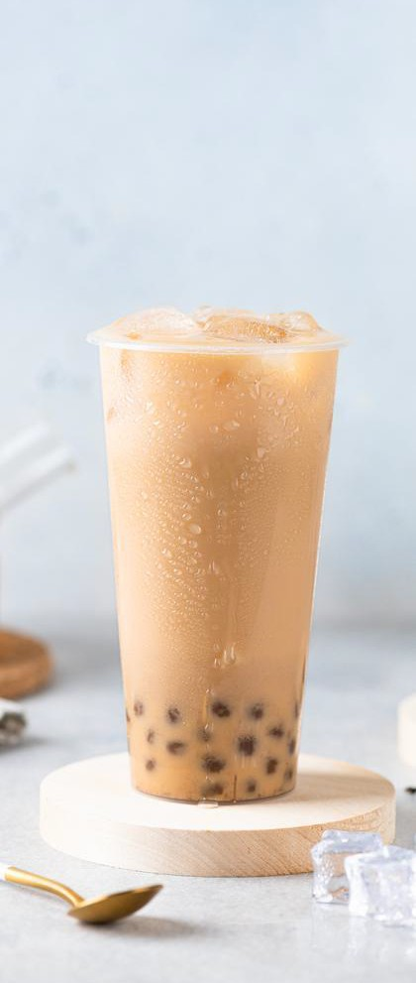
Business Plan
2024

PreparedBy
JohnDoe

"PoptheFlavor,SavortheFun!"
Information provided in this business plan is unique to this business and confidential; therefore, anyone reading this plan agrees not to disclose any of the information in this business plan without prior written permission of the company.

TableofContents

ExecutiveSummary
6
Marketopportunity 7
UniqueSellingPoints(USPs) 7
Marketing&SalesStrategies 8
FinancialHighlights 8
Units Sold v/s Revenue 8
CompanyOverview
10
Ownership 11
BusinessOwners 11
Missionstatement 12
Business history 12
Futuregoals 12
MarketAnalysis
13
TargetMarket 14
Marketsizeandgrowthpotential 14
MarketSize 15
Competitiveanalysis 15
ShareTea 15
LollicupFresh 15
Markettrends 16
Regulatoryenvironment 16
ProductsandServices
18
Products 19
ClassicMilkTea 19
FruitTeaFusion 19
SignatureMatchaLatte 20
SteamedBaoBuns 20
AdditionalServices 20

Quality Measures 21
SalesAndMarketingStrategies
22
UniqueSellingProposition(USP) 23
PricingStrategy 23
Marketingstrategies 24
Online 24
Offline 24
Salesstrategies 25
Customerretention 25
OperationsPlan
27
Staffing&Training 28
OperationalProcess 28
Equipment&Tools 29
ManagementTeam
30
Keymanagers 31
EmilyNguyen 31
DanielTran 32
SophiaMartinez 32
Ryan Carter 32
Organizationalstructure 33
Organizationchart 33
Compensationplan 33
Boardofadvisors 34
MarkThompson 34
Lisa Chen 34
Financial Plan
35
Profit&lossstatement 36
Cashflowstatement 41
Balancesheet 43

Break-evenPoint 45
Financingneeds 47
Appendix
49
EmbedLink 50


Businessplanningthat’ssimplerandfasterthanyouthink

CreatingabusinessplanusingUpmetricstostartandgrowabusinessisliterallytheeasiest thingintheWorld.Simplyreadtheinstructionsandfillintheblanks.It’sassimpleasthat.

Upmetrics has everything you need to create a comprehensive business plan.
❛
❜

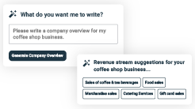
AI-poweredUpmetricsAssistant

AI-poweredinsightstostreamlineyourplan
Not sure where to start? Upmetrics’ AI Assistant will automaticallygenerateideasforeachsectionofyourplanand offerimprovedversionsofyourwriting,adjustingfortone,voice, and grammar or spelling errors.

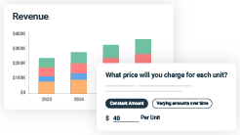
FinancialForecastingTool

Allthefinancialsarecalculatedforyou
Forget the complex formulas and clumsy spreadsheets — withautomaticfinancialsanddrag-and-dropforecasting,you canfinishyourplanfasterandbeconfidentthatyour numbers are accurate.

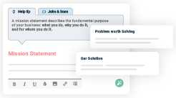
BusinessPlanBuilder

Guidesyoulikeabusinessmentor
Upmetrics’step-by-stepinstructions,prompts,andthelibraryof 400+samplebusinessplanswillguideyouthrougheachsection of your plan as a business mentor.

1.

ExecutiveSummary

Marketopportunity
Unique Selling Points (USPs)Marketing & Sales StrategiesFinancial Highlights



Anexecutivesummaryisthefirstsectionofthebusinessplanintendedto provide an overview of the whole business plan.
Tounlock helptry Upmetrics!

Helptip
BubbleBlissCafé
Startyourexecutivesummarybybrieflyintroducingyourbusinesstoyourreaders.

Thissectionmayincludethenameofyourbubbleteabusiness,itslocation,whenitwas
Tounlock helptry Upmetrics!
Startwritinghere..

Marketopportunity

Helptip
BubbleBlissCafé
Summarizeyourmarketresearch,includingmarketsize,growthpotential,andmarketing trends.
Tounlock helptry Upmetrics!
Startwritinghere..

UniqueSellingPoints(USPs)

Helptip
BubbleBlissCafé
Emphasize what sets your pool hall business apart—highlighting unique selling points (USPs) and special features that make it distinctive is always a plus.
Tounlock helptry Upmetrics!
Startwritinghere..

Marketing&SalesStrategies

Helptip
BubbleBlissCafé
Outline your sales and marketing strategies—what marketing platforms you use, how you plan on acquiring customers, etc.
Tounlock helptry Upmetrics!
Startwritinghere..

FinancialHighlights

Helptip
BubbleBlissCafé
Brieflysummarizeyourfinancialprojectionsfortheinitialyearsofbusinessoperations.Include
capitalorinvestmentrequirements,associatedstartupcosts,projectedrevenues,andprofit
forecasts.
Tounlock helptry Upmetrics!
Startwritinghere..

UnitsSoldv/sRevenue

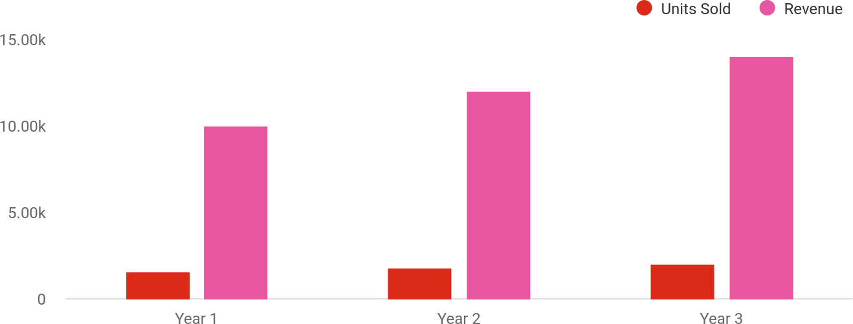

FinancialYear | UnitsSold | Revenue
Year1 | 1,550 | $10,000
Year2 | 1,800 | $12,000

FinancialYear | UnitsSold | Revenue
Year3 | 2,050 | $14,000

Helptip
BubbleBlissCafé
SummarizeyourexecutivesummarysectionwithaclearCTA,forexample,invitingangel investors to discuss the potential business investment.
Tounlock helptry Upmetrics!

Writeacalltoactionforyourbusinessplan.

2.

CompanyOverview

OwnershipMission statementBusiness historyFuture goals

Dependingonwhatdetailsofyourbusinessareessential,you’llneed different elements in your business overview.
Tounlock helptry Upmetrics!
Helptip
BubbleBlissCafé
Describeyour businessin this sectionby providingall the basicinformation:

Describewhatkindofbubbleteambusinessyourunandthenameofit.Youmayspecializein
Tounlock helptry Upmetrics!
Startwritinghere..

Ownership

Helptip
BubbleBlissCafé
List the names of your bubble tea business’s founders or owners. Describe what shares they own and their responsibilities for efficiently managing the business.
Tounlock helptry Upmetrics!
Startwritinghere..

BusinessOwners

EmilyNguyen
60%

DanielTran
40%

Missionstatement

Helptip
BubbleBlissCafé
Summarizeyourbusiness’objective,coreprinciples,andvaluesinyourmissionstatement.This statement needs to be memorable, clear, and brief.
Tounlock helptry Upmetrics!

At [Bubble Bliss Café], our mission isto deliver happiness, onecup ata time. We strive to create an inclusive and welcoming environment where customers can enjoy authentic, innovative bubble tea crafted with love and care.
❛
❜

Businesshistory


Helptip
BubbleBlissCafé
Ifyou’reanestablishedbubbleteaserviceprovider,brieflydescribeyourbusinesshistory,like— whenitwasfounded,howitevolvedovertime,etc.
Tounlock helptry Upmetrics!
Startwritinghere..

Futuregoals

Helptip
BubbleBlissCafé
It’scrucialtoconveyyouraspirationsandvision.Mentionyourshort-termandlong-termgoals; they can be specific targets for revenue, market share, or expanding your services.
Tounlock helptry Upmetrics!
Startwritinghere..

3.

MarketAnalysis

TargetMarket
MarketsizeandgrowthpotentialCompetitive analysis
Market trendsRegulatoryenvironment

Marketanalysisprovidesaclearunderstandingofthemarketinwhichyour
printingbusinesswillrunalongwiththetargetmarket,competitors, and
growthopportunities.
Tounlock helptry Upmetrics!
Helptip
BubbleBlissCafé
Towritetheintroductionsectionofyourmarketanalysis,startbyclearlyidentifyingyour primary target market.
Tounlock helptry Upmetrics!
Startwritinghere..

TargetMarket

Helptip
BubbleBlissCafé
Startthissectionbydescribingyourtargetmarket.Defineyouridealcustomerandexplain
whattypesofservicestheyprefer.Creatingabuyerpersonawillhelpyoueasilydefineyour
targetmarkettoyourreaders.
Tounlock helptry Upmetrics!
Startwritinghere..

Marketsizeandgrowthpotential

Helptip
BubbleBlissCafé
Describeyourmarketsizeandgrowthpotentialandwhetheryouwilltargetanicheoramuch broader market.
Tounlock helptry Upmetrics!
Startwritinghere..

MarketSize

AvailableMarket
Totalpotentialmarketforbubbletea across the United States.
330M

ServedMarket
PopulationinCaliforniawithaccessto bubble tea offerings.
39M

TargetMarket
Bubble tea enthusiasts aged 16-35 in Westminster,CA,seekingqualityand customization.
50k

Helptip
BubbleBlissCafé
Identifyandanalyzeyourdirectandindirectcompetitors.Identifytheirstrengths and
weaknesses,anddescribewhatdifferentiatesyourseniordaycareservicesfromthem. Point
outhowyouhaveacompetitiveedgeinthemarket.
Tounlock helptry Upmetrics!

Competitiveanalysis

ShareTea
ShareTea is a Taiwanese bubble tea chain known for its authentic flavors and focus on quality ingredients.IthasaloyalfollowingintheAsian-Americancommunityandoperatesseveraloutletsin Southern California.

Features
AuthenticTaiwaneserecipes for milk teas and fruit teas.
Optionsforlowersugarand healthier drinks.
Quickserviceandstreamlined operations.

Strengths
High-qualityingredientswitha reputation for authenticity.
Well-established brand in Asian-American communities.
Competitivepricingandquick service.

Weaknesses
Limitedfocusoninnovative flavors or trendy options.
Minimal marketing presence on modern platforms like TikTok.
Standardized store design lacks individuality.

LollicupFresh
LollicupFreshisalocalbubbleteacaféwithatrendyvibe,offeringamixofbubbleteaandAsian- inspired snacks. It is popular among younger customers for its vibrant atmosphere.

Features
Menu includes traditional bubbleteas,smoothies,and Asiansnacks.
Vibrant, Instagram-friendly interiors.
Flexiblemenuwiththeoption to customize drinks.

Strengths
Stronglocalappealwitha trendy ambiance.
Diverse menu includes snacks thatpairwellwithbeverages.
Competitive pricing targeting budget-conscious customers.

Weaknesses
Limitedscalabilityduetobeinga local café.
Inconsistentqualityacrossvisits.
Minimal focus on sustainability and eco-friendly practices.

Markettrends

Helptip
BubbleBlissCafé
Analyze emerging trends in the industry, such as technology disruptions, changes in customer behavior or preferences, etc. Explain how your business will cope with all the trends.
Tounlock helptry Upmetrics!
Startwritinghere..

Regulatoryenvironment

Helptip
BubbleBlissCafé
Listregulationsandlicensingrequirementsthatmayaffectyourbubbletea,suchasage restrictions, licensing & permits, zoning regulations, etc.
Tounlock helptry Upmetrics!
Startwritinghere..

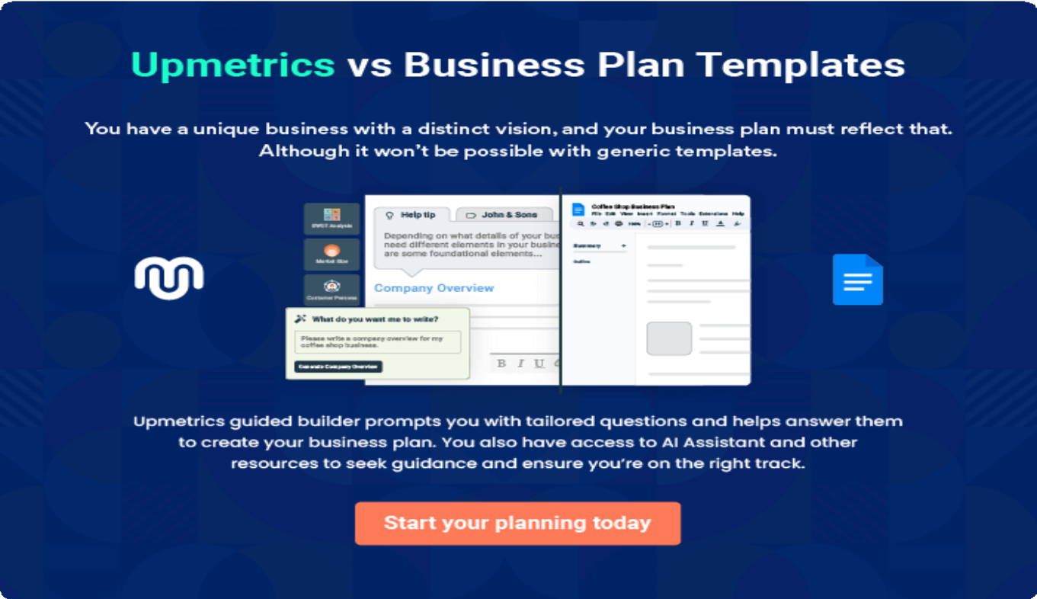

4.

Productsand Services

ProductsAdditional ServicesQuality Measures

Theproductandservicessectionofabubbleteabusinessplanshould
describethespecificservicesandproductsthatwillbeofferedtocustomers.
Towritethissectionshouldincludethefollowing:
Tounlock helptry Upmetrics!
Helptip
BubbleBlissCafé
Tocrafttheintroductionforyour"ProductsandServices"chapter,beginbypositioningyour business within its industry, emphasizing its unique strengths or value proposition.
Tounlock helptry Upmetrics!

Startwritinghere..
Helptip
Mentionthebubbleteaproductsyouwilloffer,alongwiththepricingplans.
Tounlock helptry Upmetrics!

Products


ClassicMilkTea

Price:$4.50(16oz),$5.50(24oz)

Arich,creamyblendofblackteaandmilk,sweetenedto perfection. Served with tapioca pearls or your choice of topping.

ProductSpecifications
- Sweetnesslevels:0%,25%,50%,75%,100%
- Milkoptions:Whole,Almond,Oat,Soy
- Toppings:Tapiocapearls,Poppingboba,Jellycubes

FruitTeaFusion

Price:$4.00(16oz),$5.00(24oz)

Refreshing and vibrant fruit-infused teas, perfect for a light, energizing drink. Choose from flavors like Mango Passionfruit,LycheeGreenTea,orStrawberryLemonade.

ProductSpecifications
  - Baseoptions:Greentea,Blacktea,Herbaltea
  - Add-ons:Aloevera,Chiaseeds,Freshfruitslices

SignatureMatchaLatte

Price:$5.50(16oz),$6.50(24oz)

Premium Japanese matcha blended with creamy milkandlightlysweetened.Asmooth,earthydrinkformatcha lovers.

Specifications
  - Milkoptions:Whole,Almond,Oat,Soy
  - Add-ons:Whippedcream,Tapiocapearls,Honey drizzle

AdditionalServices

SteamedBaoBuns
Price:$3.00each,$8.00for3

FluffybunsfilledwithsavoryoptionslikeBBQPork, Veggie Stir-fry, or Spicy Tofu.

ProductSpecifications
- Vegetarian options available
- Servedwarm

Helptip
BubbleBlissCafé
Ifyouconsiderofferingsupplementalservicesthatcomplementyourcoreofferings,mention them here.
Tounlock helptry Upmetrics!

Startwritinghere..

QualityMeasures

Helptip
BubbleBlissCafé
This section should explain how you maintain quality standards and consistently provide the highest quality service.
Tounlock helptry Upmetrics!
Startwritinghere..

5.

SalesAndMarketing
Strategies

Unique Selling Proposition (USP)Pricing Strategy
Marketing strategiesSales strategiesCustomer retention

Writing the sales and marketing strategies section means a list of strategies you will use to attract and retain your clients.
Tounlock helptry Upmetrics!
HelpTip
BubbleBlissCafé
Tocreateaneffectiveintroductionforyour"SalesandMarketingStrategies"chapter,startby setting the stage within your specific industry or market.
Tounlock helptry Upmetrics!
Startwritinghere..

UniqueSellingProposition(USP)

Helptip
BubbleBlissCafé
Define your business’s USPs depending on the market you serve, the equipment you use, and theuniqueservicesyouprovide.IdentifyingUSPswillhelpyouplanyourmarketingstrategies.
Tounlock helptry Upmetrics!
Startwritinghere..

PricingStrategy

Helptip
BubbleBlissCafé
Describeyourpricingstrategy—howyouplantopriceyourservicesandstaycompetitiveinthe local market. You can mention any discounts you plan on offering to attract new customers.
Tounlock helptry Upmetrics!
Startwritinghere..

Helptip
Discussyourmarketingstrategiestomarketyourservices.Youmayincludesomeofthese
marketing strategies inyour business plan—socialmedia marketing, brochures,content
marketing,printmarketing,etc.
Tounlock helptry Upmetrics!

Marketingstrategies

Online


SocialMedia Marketing
Engaging with customers on Instagram,TikTok,and Facebook through eye- catching visuals, user- generatedcontent,and influencer collaborations.

ContentMarketing
Publishing blog posts about bubble tea trends,healthbenefits, and our unique offerings to drive website traffic.

GoogleAds
Running targeted campaigns to reach bubble tea enthusiasts in [Westminster].

EmailMarketing
Sending personalized emails with exclusive offers,updatesonnew flavors, and event invitations.

Offline

LocalOutreach
Distributingbrochuresandflyersatlocaluniversitiesandcommunity centers.

Helptip
Outlinethestrategiesyou’llimplementtomaximizeyoursales.Yoursalesstrategiesmay include direct sales calls, offering referral marketing, etc.
Tounlock helptry Upmetrics!

Salesstrategies

PartnerwithLocal Businesses
Collaboratewithnearby cafés, restaurants, and event planners for cross-promotions and catering partnerships.

Pop-UpEvents
Set up mobile bubble tea stations at local festivalsandfarmers’ markets to expand reachandattractnew customers.

ReferralPrograms
Encourage customers to refer friends by offering discounts or free drinks for every successful referral.

Helptip
Describeyourcustomerretentionstrategiesandhowyouplantoexecutethem.Forinstance, introducing loyalty programs, discounts on annual membership, personalized service, etc.
Tounlock helptry Upmetrics!

Customerretention

LoyaltyProgram
Points-based rewards system through our mobileapp,redeemable for free drinks and discounts.

PersonalizedService
Offering personalized drink recommendations based on customer preferences.

ExclusivePerksfor Regulars
Early access to new flavorsandinvitation- onlyeventsforloyal customers.

SeasonalPromotions
Special deals during holidays and seasonal menulaunchestokeep customers excited.

6.

OperationsPlan

Staffing & TrainingOperational ProcessEquipment & Tools

Whenwritingtheoperationsplansection,it’simportanttoconsiderthe various aspects of your business operations.
Tounlock helptry Upmetrics!
Helptip
BubbleBlissCafé
Tocreateaneffectiveintroductionforyour"OperationalPlan"chapter,startbyemphasizingthe
pivotalroleofefficientoperationsinthesuccessofyourbusiness,underscoringhowthey
directlyimpactthequalityofservicesdelivered.
Tounlock helptry Upmetrics!
Startwritinghere..

Staffing&Training

Helptip
BubbleBlissCafé
Mention your business’s staffing requirements, including the number of employees or workers needed.Includetheirqualifications,theexperiencerequired,andthedutiestheywillperform.
Tounlock helptry Upmetrics!
Startwritinghere..

OperationalProcess

Helptip
BubbleBlissCafé
Outlinetheprocessesandproceduresyouwillusetorunyourbubbleteabusiness.
Tounlock helptry Upmetrics!
Startwritinghere..

Equipment&Tools

Helptip
BubbleBlissCafé
Outline the essential supplies and equipment used for bubble tea services. Also, consider setting up technology and software systems to streamline your daily operations.
Tounlock helptry Upmetrics!
Startwritinghere..

7.

ManagementTeam

Key managersOrganizationalstructureCompensation planBoard of advisors

The management team section provides an overview of the individuals responsible for running your business plan.
Tounlock helptry Upmetrics!
Helptip
BubbleBlissCafé
Tocraftanintroductionforyour"ManagementTeam"chapter,beginbyemphasizingthecrucial role of leadership in the success of any business.
Tounlock helptry Upmetrics!
Startwritinghere..

Keymanagers

Helptip
Introduceyourmanagementandkeymembersofyourteam,andexplaintheirrolesand responsibilities.
Tounlock helptry Upmetrics!
Startwritinghere..

EmilyNguyen


FounderandCEO-emily.nguyen@example.com



Emily oversees the overall strategic direction of Bubble Bliss Café, ensuring alignment with its vision and mission. She drives menu innovation, manages financial stability, and spearheads community engagement efforts.
- EducationalBackground:Bachelor’sinHospitalityManagement, UniversityofCalifornia,LosAngeles(UCLA).
- ProfessionalBackground:Emilyhasover10yearsofexperienceinthe food and beverage industry. Before founding Bubble Bliss Café, she worked as a regional manager for a leading beverage chain, where she gained valuable insights into operations and customer service.


DanielTran

MarketingManager-daniel.tran@example.com

Daniel leads the marketing efforts for Bubble Bliss Café. His responsibilities include managing social media campaigns, collaborating with influencers, creatingpromotionalstrategies,anddrivingcustomeracquisitionandretention.
- Educational Background: MBA in Marketing, UCLA Anderson School of Management.
- Professional Background: Daniel has 5 years of experience as a digital marketing strategist, with a focus on the food and beverage industry. He previously worked for a boutique marketing agency, managing campaigns for several café chains and local eateries.

SophiaMartinez


OperationsManager-sophia.martinez@example.com

Sophia is in charge of day-to-day operations, staff training, inventory management, and ensuring compliance with health and safety regulations. She oversees baristas and kitchen assistants, ensuring seamless service deliveryand operational efficiency.
- EducationalBackground:Bachelor’sinBusinessAdministration, California State University, Fullerton.
- Professional Background: With 7 years of experience managing café operations for national chains like Starbucks, Sophia brings a wealth of expertise in optimizing workflows and maintaining high service standards.

RyanCarter


FinancialAnalyst-ryan.carter@example.com

Ryanhandlesthefinancialplanning,budgeting,andforecastingforBubbleBliss Café. His role includes preparing financial reports, analyzing performance metrics, and ensuring optimal allocation of resources to meet profitability targets.
- EducationalBackground:Bachelor’sinFinance,UniversityofSouthern California (USC).
- Professional Background: Ryan has 6 years of experience as a financial analyst in the retail sector. He has successfully implemented cost-saving measures and growth strategies for small to mid-sized businesses,making him an asset to Bubble Bliss Café.

Organizationalstructure
Helptip
BubbleBlissCafé
Explaintheorganizationalstructureofyourmanagementteam.Includethereportinglineand decision-making hierarchy.
Tounlock helptry Upmetrics!

Startwritinghere..

Organizationchart


EmilyNguyen
CEO



SophiaMartinez
OperationsManager DanielTran
MarketingManager



Barista
CEO



kitchenassistant
CEO

Ryan Carter
FinancialAnalyst

Compensationplan

Helptip
BubbleBlissCafé
Describeyourcompensationplanforthemanagementandstaff.Includetheirsalaries, incentives, and other benefits.
Tounlock helptry Upmetrics!
Startwritinghere..

Helptip
Mentioningadvisorsorconsultantsinyourbusinessplansaddscredibilitytoyourbusiness idea.
Tounlock helptry Upmetrics!

Boardofadvisors

MarkThompson


Financial Advisor

- Experience:15yearsinfinancialplanningandbusinessconsulting, specializing in small businesses.
- Role:Markassistswithfinancialplanning,ensuringthatBubbleBliss Café’sbudgetingandgrowthstrategiesalignwithindustrybenchmarks.

Lisa Chen


FoodandBeverageConsultant

- Experience:12yearsinthecaféandrestaurantindustry,including advising startups on menu development and branding.
- Role: Lisa provides expertise on menu innovation and market positioning toensureBubbleBlissCaféstaysaheadoftrends.

8.

FinancialPlan

Profit&lossstatementCash flow statementBalance sheet
Break-evenPointFinancing needs

Helptip
Describedetailssuchasprojectedrevenue,operationalcosts,andservicecostsinyourprojectedprofitandlossstatement.Makesuretoinclude
yourbusiness’sexpectednetprofitorloss.

Whenwritingthefinancialplansectionofabusinessplan,it’simportanttoprovideacomprehensiveoverviewofyourfinancial projections for the first few years of your business, You may provide the following:
Tounlock helptry Upmetrics!
Helptip
BubbleBlissCafé
Tocreateaneffectiveintroductionforyour"FinancialPlan"chapter,beginbystressingthecriticalroleofawell-structuredfinancialplaninthe success of your venture.
Tounlock helptry Upmetrics!
Startwritinghere..

Drinks)
 |  | Tounlock helptry Upmetrics!
Profit&lossstatement  2024 | 2025 | 2026
Revenue $339,163.34 | $801,058.70 | $1,419,892.39
BubbleTea(Classic $143,254.15 | $257,263.90 | $462,008.99

 | 2024 | 2025 | 2026
UnitSales | 31,834 | 57,170 | 102,669
UnitPrice | $4.50 | $4.50 | $4.50

Premium Toppings Add- ons

$27,046.44 $43,301.95 $69,328

UnitSales | 18,031 | 28,868 | 46,219
UnitPrice | $1.50 | $1.50 | $1.50

MonthlyMembership Subscription

$168,862.75 $500,492.85 $888,555.40

Users | 1,273 | 2,743 | 4,478
RecurringCharges | $20 | $20 | $20

CostOf Sales | $41,456.22 | $72,392.28 | $114,230.40
GeneralCosts | $41,456.22 | $72,392.28 | $114,230.40
Ingredients | $20,898.05 | $28,739.34 | $39,635.78
TeaLeaves | $14,192.08 | $20,234.60 | $28,849.65
TapiocaPearls | $6,705.97 | $8,504.74 | $10,786.13
Packaging | $20,558.17 | $43,652.94 | $74,594.62

 | 2024 | 2025 | 2026
CupsandLids | $16,958.17 | $40,052.94 | $70,994.62
Straws | $3,600 | $3,600 | $3,600
RevenueSpecificCosts | $0 | $0 | $0

PersonnelCosts(Direct Labor)

$0 $0 $0

GrossMargin | $297,707.12 | $728,666.42 | $1,305,661.99
GrossMargin(%) | 87.78% | 90.96% | 91.95%
Operating Expense | $389,960.67 | $445,261.93 | $523,203.98

PayrollExpense(Indirect Labor)

$307,236 $316,101.96 $325,280.04

ManagementStaff | $85,932 | $89,475.96 | $93,174.48
StoreManager | $48,300 | $50,715 | $53,250.72
AssistantManager | $37,632 | $38,760.96 | $39,923.76
Baristas | $125,400 | $129,426 | $133,583.64
SeniorBarista | $26,400 | $27,456 | $28,554.24

 | 2024 | 2025 | 2026
JuniorBaristas | $99,000 | $101,970 | $105,029.40
SupportStaff | $95,904 | $97,200 | $98,521.92
CleaningStaff | $31,104 | $31,104 | $31,104
DeliveryStaff | $64,800 | $66,096 | $67,417.92
GeneralExpense | $77,724.66 | $129,159.95 | $197,923.94
RentandUtilities | $33,804.70 | $34,287.13 | $34,830.73
StoreRent | $30,000 | $30,000 | $30,000

Utilities(Electricityand Water)
$3,804.70 $4,287.13 $4,830.73

Marketingand Advertising | $38,728.33 | $85,062.23 | $147,094.29
Digital Advertising | $33,916.33 | $80,105.87 | $141,989.24
SocialMediaPromotions | $4,812 | $4,956.36 | $5,105.05
MaintenanceandSupplies | $5,191.63 | $9,810.59 | $15,998.92
EquipmentMaintenance | $1,800 | $1,800 | $1,800
CleaningSupplies | $3,391.63 | $8,010.59 | $14,198.92
BadDebt | $0 | $0 | $0

AmortizationofCurrent Assets

$5,000 $0 $0

2024 |  | 2025 | 2026
EBITDA | ($92,253.55) | $283,404.49 | $782,458

AdditionalExpense | $7,045.02 | $5,770.40 | $4,390.01
LongTermDepreciation | $3,600 | $3,600 | $3,600
GainorlossfromSaleof Assets | $0 | $0 | $0
EBIT | ($95,853.55) | $279,804.49 | $778,858
InterestExpense | $3,445.02 | $2,170.41 | $790.01
EBT | ($99,298.57) | $277,634.09 | $778,067.99

IncomeTaxExpense/ Benefit

$0 $0 $0

TotalExpense | $438,461.91 | $523,424.61 | $641,824.40
NetIncome | ($99,298.57) | $277,634.09 | $778,067.99
NetIncome(%) | (29.28%) | 34.66% | 54.80%

 | 2024 | 2025 | 2026
RetainedEarningOpening | $0 | ($126,298.57) | $139,335.52
Owner'sDistribution | $27,000 | $12,000 | $12,000
RetainedEarningClosing | ($126,298.57) | $139,335.52 | $905,403.51

Helptip
Thecashflowforthefirstfewyearsofyouroperationshouldbeestimatedanddescribedinthissection.Thismayincludebillinginvoices, payment receipts, loan payments, and any other cash flow statements.
Tounlock helptry Upmetrics!

Cashflowstatement | 2024 | 2025 | 2026
CashReceived | $339,163.34 | $801,058.70 | $1,419,892.39
CashPaid | $429,861.91 | $519,824.61 | $638,224.40
COS&GeneralExpenses | $119,180.89 | $201,552.25 | $312,154.35
Salary&Wages | $307,236 | $316,101.96 | $325,280.04
Interest | $3,445.02 | $2,170.41 | $790.01
SalesTax | $0 | $0 | $0

 | 2024 | 2025 | 2026
IncomeTax | $0 | $0 | $0

NetCashFrom Operations

($90,698.57) $281,234.09 $781,667.99

AssetsSell | $0 | $0 | $0
AssetsPurchase | $25,000 | $0 | $0

NetCashFrom Investments

($25,000) $0 $0

AmountReceived | $80,000 | $0 | $0
LoanReceived | $50,000 | $0 | $0
CommonStock
PreferredStock | $0 | $0 | $0
Owner'sContribution | $30,000 | $0 | $0
AmountPaid | $42,356.82 | $28,631.44 | $30,011.76
LoanCapital | $15,356.82 | $16,631.43 | $18,011.76
Dividends&Distributions | $27,000 | $12,000 | $12,000

Financing
2024 | 2025 | 2026
NetCashFrom $37,643.18 | ($28,631.44) | ($30,011.76)

Summary
StartingCash | $0 | ($78,055.39) | $174,547.26
CashIn | $419,163.34 | $801,058.70 | $1,419,892.39
CashOut | $497,218.73 | $548,456.05 | $668,236.16
Change inCash | ($78,055.39) | $252,602.65 | $751,656.23
Ending Cash | ($78,055.39) | $174,547.26 | $926,203.49

Helptip
Createaprojectedbalancesheetdocumentingyourbubbleteabusiness’sassets,liabilities,andequity.
Tounlock helptry Upmetrics!

Balancesheet

 | 2024 | 2025 | 2026
Assets | ($61,655.39) | $187,347.26 | $935,403.49
CurrentAssets | ($78,055.39) | $174,547.26 | $926,203.49
Cash | ($78,055.39) | $174,547.26 | $926,203.49
AccountsReceivable | $0 | $0 | $0
Inventory | $0 | $0 | $0
OtherCurrentAssets | $0 | $0 | $0
LongTermAssets | $16,400 | $12,800 | $9,200
GrossLong TermAssets | $20,000 | $20,000 | $20,000
Accumulated Depreciation | ($3,600) | ($7,200) | ($10,800)

Liabilities&Equity | ($61,655.39) | $187,347.28 | $935,403.51
Liabilities | $34,643.18 | $18,011.76 | $0
CurrentLiabilities | $16,631.44 | $18,011.76 | $0
AccountsPayable | $0 | $0 | $0
IncomeTaxPayable | $0 | $0 | $0
SalesTaxPayable | $0 | $0 | $0
ShortTermDebt | $16,631.44 | $18,011.76 | $0

 | 2024 | 2025 | 2026
LongTermLiabilities | $18,011.74 | $0 | $0
LongTermDebt | $18,011.74 | $0 | $0
Equity | ($96,298.57) | $169,335.52 | $935,403.51
Paid-inCapital | $0 | $0 | $0
CommonStock | $0 | $0 | $0
PreferredStock | $0 | $0 | $0
Owner'sContribution | $30,000 | $30,000 | $30,000
RetainedEarnings | ($126,298.57) | $139,335.52 | $905,403.51

Check $0 $0 $0

Helptip
Determineandmentionyourbusiness’sbreak-evenpoint—thepointatwhichyourbusinesscostsandrevenuewillbeequal.

Thisexercisewillhelpyouunderstandhowmuchrevenueyouneedtogeneratetosustainorbeprofitable.
Tounlock helptry Upmetrics!

Break-evenPoint

 | 2024 | 2025 | 2026
StartingRevenue | $0 | $339,163.34 | $1,140,222.04
NetRevenue | $339,163.34 | $801,058.70 | $1,419,892.39
ClosingRevenue | $339,163.34 | $1,140,222.04 | $2,560,114.43
StartingExpense | $0 | $438,461.91 | $961,886.52
NetExpense | $438,461.91 | $523,424.61 | $641,824.40
ClosingExpense | $438,461.91 | $961,886.52 | $1,603,710.92
IsBreakEven? | No | Yes | Yes
BreakEvenMonth | 0 | Jul'25 | 0
DaysRequired | 0 | 19Days | 0
BreakEvenRevenue | $438,461.91 | $716,979.98 | $0
BubbleTea(Classic $0 |  | $266,909.28 | $0
PremiumToppingsAdd- $0 |  | $48,471.03 | $0
MonthlyMembership $0 |  | $401,599.67 | $0

Drinks)

ons

Subscription

Drinks)
2024 | 2025 | 2026
BreakEvenUnits
BubbleTea(Classic 0 | 59,313 | 0
PremiumToppingsAdd- 0 | 32,314 | 0
MonthlyMembership 0 | 2,070 | 0

ons

Subscription

Financingneeds

Helptip
BubbleBlissCafé
Calculate costs associated with starting a senior daycare business, and estimate your financing needs and how much capital you need to raise to operate your business.
Tounlock helptry Upmetrics!
Startwritinghere..

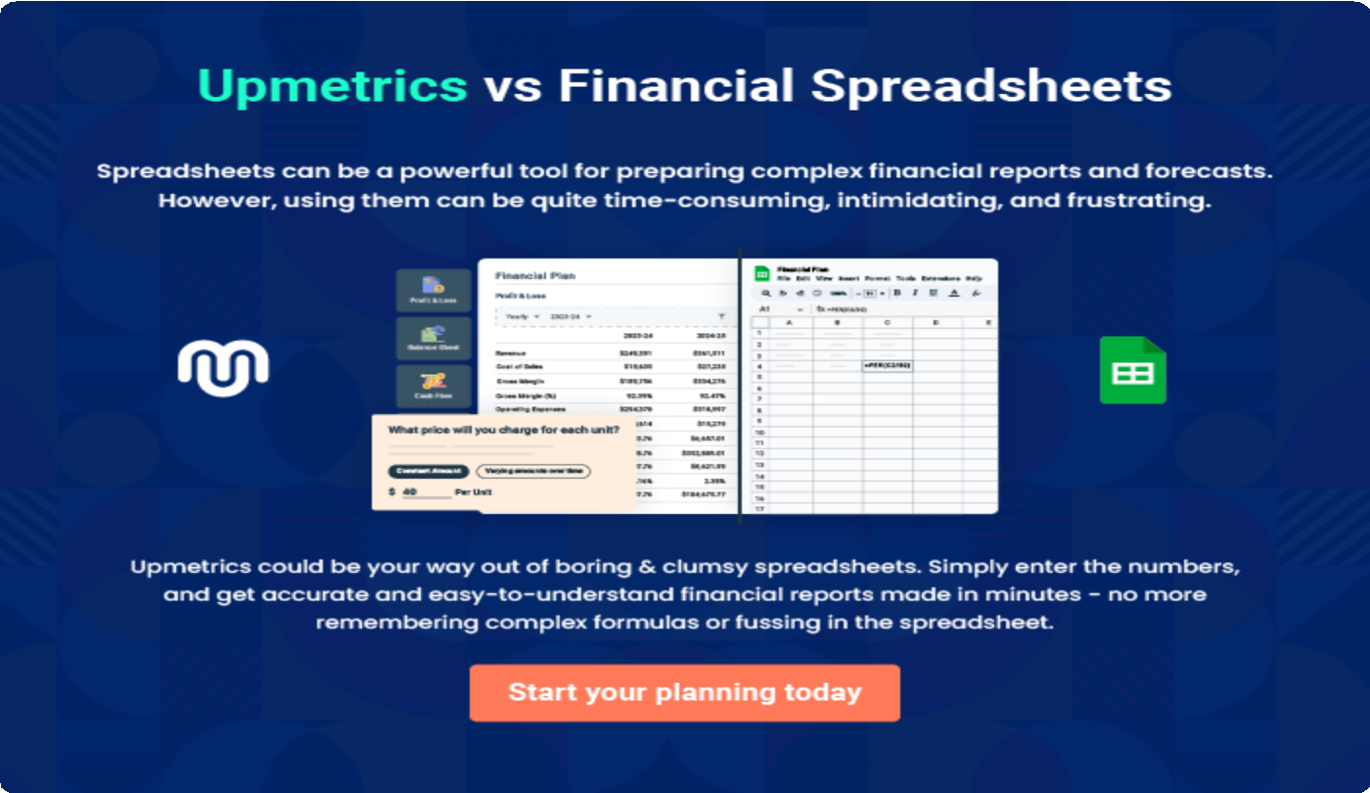

9.

Appendix
EmbedLink

Whenwritingtheappendixsection,youshouldincludeanyadditional
informationthatsupportsthemaincontentofyourplan.Thismayinclude
financialstatements,marketresearchdata,legaldocuments,andother
Tounlock helptry Upmetrics!
EmbedLink

Createawinningbusinessplanthatgetsyoufunded

Creatingastunningandinvestment-readyplanrequiresnowriting,graphicdesigning,orfinancial planning expertise.

Upmetricshasallthefeaturesrequiredtohelpyoucreateacomprehensivebusinessplan—fromstarttofinish. Makenomistakes,it’sthemodernwayofplanningtostructureideas,makeplans,andcreatestunningpitch decks to awe investors.

Pitchdecksthatimpressinvestors
Create pitch decks that provide a visual representation of your business, engage investors,andmakethemwanttoinvestinyour businessidea.

Interactiveplansinnotime
Import business plan sections like—SWOT analysis,comparisontables,andotherstocreate an interactive business plan. No designing skills arerequired.

Stunningcoverpagedesigns
WithUpmetrics,youhavethelibertytochoose from multiple stunning cover page designs.
Chooseacreativedesignandmakeyourplan standout.

500+samplebusinessplans
Simplyimportatemplatefromourlibraryof sample plans into the editor and start customizingittomakeityours.Ittakesonlyafew clicks to get started.

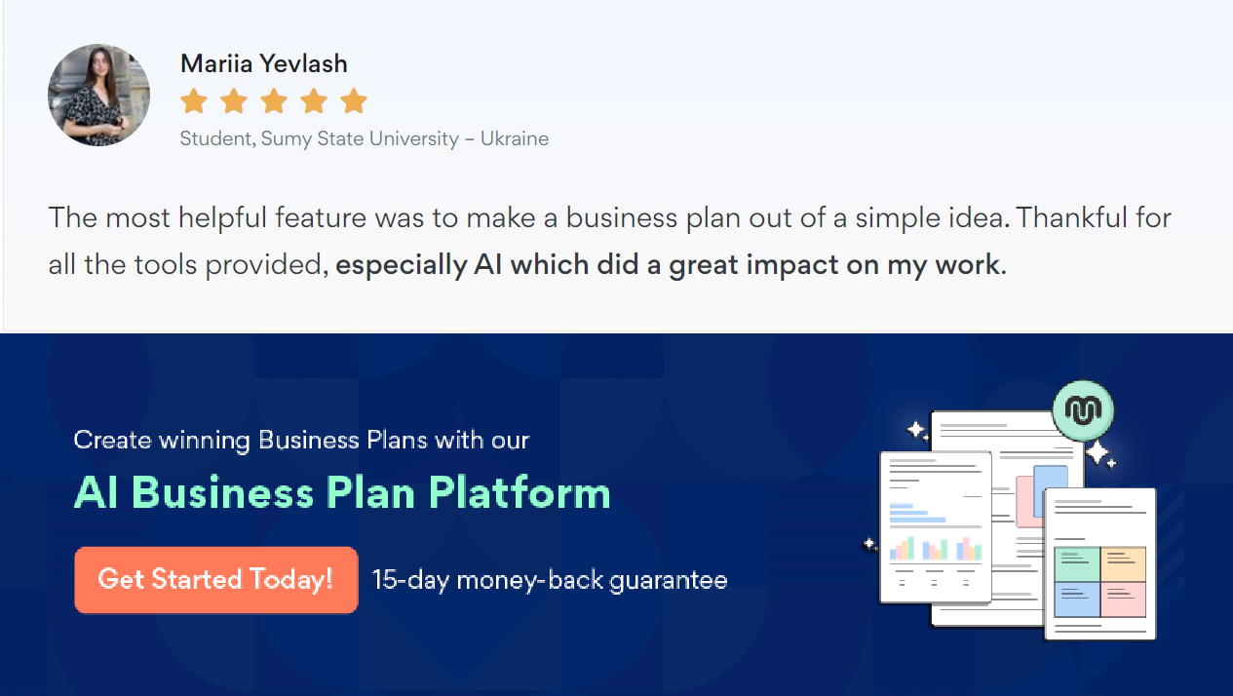Onlinesharingmadesimple
Upmetricsmakesonlinesharingquickandeasier forusers.Easilyshareyourbusinessplanswitha linkwhiletrackingreaderactivity.

Collaboratewithteaminreal-time
Invite team members, initiate conversations, discussideas&strategies,sharefeedback,and work on a business plan in real-time.

