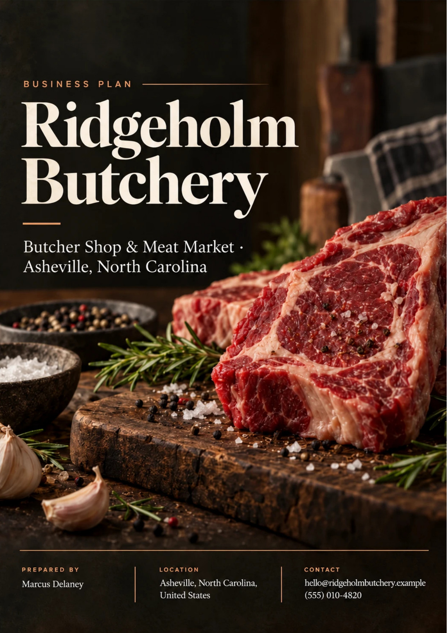
Table of Contents
1. Executive Summary 6
1.1 Business Overview 7
1.2 Mission Statement 7
1.3 Location & Market Opportunity 7
1.4 Unique Selling Points 7
1.5 Financial Highlights 8
1.6 Funding Requirement 8
1.6.1 Income Statement (3 Year projections) 8
2. Company Overview 9
2.1 Legal Structure 10
2.2 Vision Statement 10
2.3 Background & History 10
2.4 Future Goals 11
2.4.1 Business Owners 11
2.4.2 SMART Goal 12
3. Market Analysis 13
3.1 Overview 14
3.2 Market Segmentation 14
3.3 Market Trends 14
3.4 Local Market Outlook 14
3.5 Market Size 15
4. Customer Analysis 16
4.1 Target Market 17
4.2 Customer Segments 17
4.3 Customer Persona 18
4.4 Customer Purchase Journey 18
5. Competitive Analysis 19
5.1 Competitors 20
5.2 Comparison 20
5.3 Competitive Edge 21
5.4 SWOT Analysis 22
6. Products & Services 23
6.1 Our Offering 24
6.2 Signature Items 24
6.3 Additional Services 24
6.4 What Sets Us Apart 24
6.5 Whole-Animal Program 25
6.5.1 Farm-Named Fresh Cuts 25
6.5.2 Features 26
6.5.3 Pricing 26
7. Marketing & Sales Strategies 27
7.1 Market Positioning 28
7.2 Marketing Objectives 28
7.3 Online Marketing 29
7.4 Public Relations and Branding 29
7.5 Partnership & Collaboration Strategy 29
7.6 Customer Loyalty & Retention 29
7.7 Sales Channels 30
8. Operations Plan 31
8.1 Daily Operations 32
8.2 Working Hours 32
8.3 Staffing & Training 32
8.4 Supply Chain Management 32
8.5 Inventory & Equipment Management 32
8.6 Location and Facilities 33
8.7 Milestones & Timeline 33
8.8 Food Safety & HACCP Compliance 34
9. Management Team 35
9.1 Key Members 36
9.2 Organization Chart 36
9.3 Advisory Board Members 37
9.3.1 Hiring Plan 37
10. Financial Plan 38
10.1 Key Assumptions 39
10.2 Capital Requirements and Use of Funds 39
10.2.1 Use of Funds 40
10.3 Income Statement (3 Year projections) 41
10.4 Balance Sheet (3 Year projections) 42
10.5 Cash Flow Statement (3 Year projections) 43
10.6 Break Even Analysis 44
11. References 45
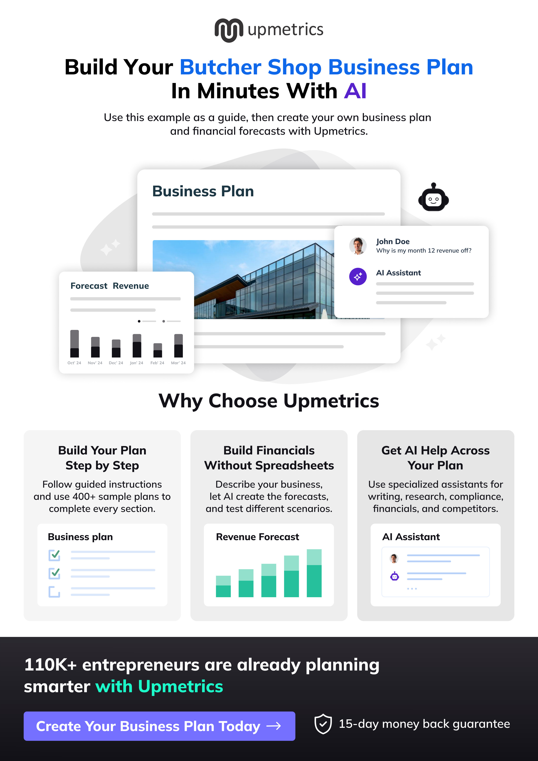

CHAPTER 1

Executive Summary

1.1 Business Overview
1.2 Mission Statement
1.3 Location & Market Opportunity
1.4 Unique Selling Points
1.5 Financial Highlights
1.6 Funding Requirement

1.1 Business Overview
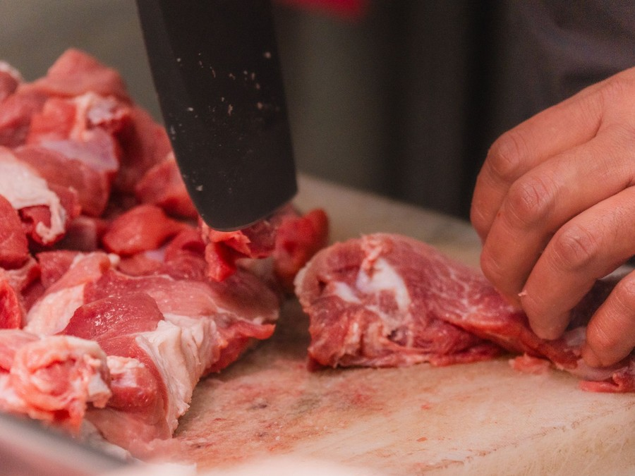
Ridgeholm Butchery is a whole-animal butcher shop planned for Asheville, North Carolina. It will buy whole and half carcasses of beef, pork and lamb from western North Carolina farms, break them down in its own cutting room, and sell the result over a retail counter as fresh cuts, house-made sausage, bacon and smoked items, bone broth and rendered fats.
It sells to Asheville households who cook at home and want to know where their meat was raised, to home cooks buying for weekend grilling and the holidays, and to a small group of chef-owned restaurants in the city that buy specific cuts wholesale. The business is pre-launch and owner-managed.

1.2 Mission Statement
To put meat from farms we can name on Asheville tables, cut to order by people who can explain it, and to sell every part of every animal we buy.

1.3 Location & Market Opportunity
Asheville had 94,983 residents in 38,210 households in the latest Census estimates, with a median household income of $78,996, and 57.7% of adults hold a bachelor's degree or higher. That is a city of home cooks with the income and the interest to pay for provenance, and a single counter can reach much of it.
The US meat markets industry, the butcher shops and delicatessens that sell fresh, frozen and cured meat, is a $13,900,000,000 market. The market Ridgeholm can actually serve is Asheville's household spending on meat and poultry, about $33,280,000 a year across every channel. The scale of one comparable shop is set by the average US butcher shop's revenue of $805,115, against a first-year projection for Ridgeholm of $761,981.
Demand is moving toward what a craft counter sells. Only 22% of shoppers said they were trying to eat less meat in 2024, the lowest level in years, and traditional grocery's share of meat spending has fallen from 52.8% in 2019 to 46.3% in 2024.

1.4 Unique Selling Points
- Every animal is bought whole from a named western North Carolina farm and broken down in the shop.
- Cuts are made to order at the counter, to the thickness and trim a recipe calls for.
- Trim becomes house-made sausage, bacon, smoked items and bone broth, sold beside the fresh case.
- Staff who cut the meat explain how to cook it, which makes unfamiliar cuts an easy purchase.

1.5 Financial Highlights
Revenue is projected at $761,981 in 2026, $830,559 in 2027 and $905,309 in 2028, at a gross margin of 41.0% throughout. Net income is $3,508 in the first year, $12,276 in the second and $21,685 in the third, a margin that widens from 0.5% to 2.4% as fixed costs are spread over a growing book. The shop breaks even at revenue of $620,420, or 10,697 transactions a year.
The projection holds under pressure. In the conservative scenario the shop still earns $1,512 in 2028, and in the upside scenario $48,931.

1.6 Funding Requirement
The total startup cost is $326,000. The owners contribute $126,000 of equity, and the remaining $200,000 is sought as an SBA 7(a) style term loan at 10.5% over 10 years. The funds pay for the cold rooms, cutting equipment and smoker, the fit-out of the cutting room and counter, opening inventory, launch marketing and a working capital reserve to carry the business through its first months of trading.
Ridgeholm rests on a skilled cutting room, farms it can name and a city of households already buying for provenance. The loan and the owners' equity build the one room that turns those three into a business, and profits are retained to repay it.

1.6.1 Income Statement (3 Year projections)
 | Year 1 | Year 2 | Year 3 | Total
Revenue | $761,980.80 | $830,559.07 | $905,309.39 | $2,497,849.26
Cost of Sales | $449,568.67 | $490,029.85 | $534,132.54 | $1,473,731.06
Gross Margin | $312,412.13 | $340,529.22 | $371,176.85 | $1,024,118.20
Operating Expense | $254,372.20 | $272,243.70 | $291,723.63 | $818,339.53
Total Expense | $758,473.26 | $818,282.72 | $883,624.35 | $2,460,380.33
Net Income | $3,507.54 | $12,276.35 | $21,685.04 | $37,468.93

CHAPTER 2

Company Overview

2.1 Legal Structure
2.2 Vision Statement
2.3 Background & History
2.4 Future Goals

2.1 Legal Structure
Ridgeholm Butchery will be organised as a North Carolina limited liability company owned by its two founders, Marcus Delaney and Hannah Okafor, and will elect to be taxed as a corporation, which is why the financial model applies a 21% income tax rate. The structure limits personal liability for a business that handles raw meat, employs staff and signs a commercial lease, and keeps the shop's finances separate from the founders' own.
Before opening, the company will register with the North Carolina Secretary of State, obtain a federal employer identification number and hold a food establishment permit from Buncombe County Environmental Health. General liability, product liability and workers' compensation cover will be in place before the first employee starts, and the lease will be signed in the company's name.

2.2 Vision Statement
To be the counter Asheville trusts when a meal matters: where a household knows the farm, can ask for the cut it needs, and leaves knowing how to cook it.
In practice that means a case filled from animals the staff broke down themselves, a counter that explains a cheaper cut as readily as a steak, and a second visit that is easier than the first because the shop remembers what the customer bought.

2.3 Background & History
Ridgeholm Butchery has not yet opened. It grows out of Marcus Delaney's years behind butcher counters, where he saw how much of an animal a boxed-meat supply chain discards and how rarely a customer can be told where a steak was raised. The shop is the founders' plan to do it the other way: buy the whole animal from a farm they can name, cut it in view of the customer, and sell every part of it.
Hannah Okafor brings the other half of the business. She has run front-of-house operations and supplier accounts in independent food retail, and she will own the counter, the order-ahead book and the restaurant accounts, leaving the cutting room to Marcus. The name comes from the ridgelines that surround the city, a reminder that the product is regional before it is anything else.
The founders have set three rules from the start. Every animal comes from a farm the shop has visited. Every part of it is sold, as a cut, a sausage, a broth or a rendered fat, before the next one is ordered. And nobody leaves the counter without knowing how to cook what they bought.
The timing follows the shopper. Only 22% of shoppers were trying to cut back on meat in 2024, the lowest level in years, and shoppers averaged more than 56 meat shopping trips a year in 2025, with quality and appearance the top purchase drivers for nearly half of them. A counter that sells provenance, advice and cutting to order is aimed at exactly that buyer.
The months before opening go to three pieces of groundwork that take longer than fitting out a shop: agreeing terms with partner farms for beef, pork and lamb, booking regular slaughter dates with an inspected processor within reach of Asheville, and testing the sausage and cure recipes the HACCP plan will cover. Each decides whether the counter opens with a full case or a thin one. The founders also intend to collect names for an opening-week email list at farmers markets, so the counter opens to households that already know it is coming.

2.4 Future Goals
In the first 0 to 18 months, the goal is to open the counter, reach steady trade of 46 customers a day within eight months, and settle a weekly carcass schedule with a short list of partner farms. By the end of that period the shop should have its first standing restaurant accounts, a working order-ahead book, one full holiday season behind it and an approved HACCP plan for its smoked products. The measure of the period is yield as much as revenue: the share of each carcass sold at full price.
From 1 to 3 years, the period the financial projection covers, the aim is to grow revenue from $761,981 in 2026 to $905,309 in 2028 while holding gross margin at 41.0%. That growth is planned to come from repeat customers, a restaurant book worth about a tenth of sales and a regular class programme, not from discounting.
From 3 to 5 years, the founders intend to reduce the term loan meaningfully, add a further full-time butcher, and decide on three years of carcass and sales records whether a larger smokehouse line or a second counter is the better use of capital. They also intend to turn the farm relationships into annual supply agreements, so partner farms can plan herd sizes around the shop's demand.
Across all three horizons, the founders intend to hold the same three measures: the share of each carcass sold at full price, the number of households that return within a month, and cash on hand against the next loan payment. Growth that weakens any of the three is deferred.

2.4.1 Business Owners
Marcus Delaney | Hannah Okafor

Total ownership: 100%
75% | Marcus Delaney  7,500 Shares
25% | Hannah Okafor  2,500 Shares

2.4.2 SMART Goal
  Specific  - Open the Asheville counter and reach steady trade of 46 customers a day at an average ticket of $58.  - Owner Marcus Delaney leads the cutting room; co-owner Hannah Okafor leads the counter and restaurant accounts.  - Every carcass is bought from a named western North Carolina farm through an inspected processor. |   Measurable  - Daily customer count and average ticket, read from the point-of-sale system every week.  - Share of each carcass sold at full price, tracked by animal against its cutting sheet.  - Gross margin held at 41.0% across the counter and the wholesale book. |   Achievable  - The owner has spent years behind butcher counters and can train a small cutting team himself.  - The target sits just above the middle of the 30 to 60 customer range for a staffed counter.  - Established farm and processor relationships remove the largest supply uncertainty before opening.
  Relevant  - Steady counter trade pays the fixed costs that a single cutting room carries every week.  - Asheville households with a median income of $78,996 are the buyers a provenance-led counter serves.  - Hitting the target funds loan repayments without new owner capital. |   Time-Based  - Steady trade within eight months of opening, in line with the ramp the financial model assumes.  - First standing restaurant account within three months of opening.  - Monthly review of customer count and yield, with the cutting schedule reset at each review.

CHAPTER 3

Market Analysis

3.1 Overview
3.2 Market Segmentation
3.3 Market Trends
3.4 Local Market Outlook
3.5 Market Size

3.1 Overview
US retail meat is a large and steady market. Meat department sales across all retail channels reached a record $112 billion in 2025, up 6.8% in dollars and 2% in volume on 2024. Inside it, the meat markets industry, the butcher shops and delicatessens selling fresh, frozen and cured meat, is sized at $13.9 billion and grew at a 4.3% compound annual rate from 2020 to 2025, though only 0.2% in 2025.
Nearly every household is a customer of the category: 98% of US households bought meat or poultry in 2024, spending an average of $871 a year. The question for an independent butcher is not whether people buy meat but where, and for what reason they would choose a counter over a supermarket case.

3.2 Market Segmentation
- Provenance-led households: home cooks who want to know the farm and will pay for it, the core of a craft counter's trade.
- Occasion buyers: households buying roasts, steaks and larger cuts for weekend grilling, holidays and gatherings.
- Value-seeking regulars: shoppers who come for grind, sausage and cheaper cuts once they learn how to cook them.
- Chef-owned restaurants: kitchens buying specific cuts in steady weekly volumes, served through a small wholesale book.

3.3 Market Trends
- Premium demand: IBISWorld reports that demand for organic, grass-fed and custom cuts supports foot traffic to meat markets, with butchers concentrating on sausages, dry-aged steaks and smoked meats.
- Shoppers are not cutting back: only 22% of shoppers were trying to eat less meat in 2024, and Millennials accounted for 62% of new unit sales.
- Quality over price at the point of purchase: quality and appearance were the top purchase drivers for nearly half of shoppers, and 95% had at least one reason to splurge.
- Beef costs rising fast: USDA forecasts beef and veal retail prices up 9.8% in 2026, against 2.5% for all food at home.
- Grocery losing share: traditional grocery's share of meat sales fell from 52.8% in 2019 to 46.3% in 2024.

3.4 Local Market Outlook
Asheville city had 94,983 residents in 38,210 households in the ACS 2024 1-year estimates, with a median household income of $78,996 and a per capita income of $53,338; 57.7% of adults hold a bachelor's degree or higher. Visitors add to the catchment but are measured for Buncombe County as a whole, which received $2.6 billion in visitor spending in 2025, down 2.1% as the county recovered from Hurricane Helene.
The city already has an established independent butcher trade. Yelp lists The Chop Shop Butchery, Foothills Butcher Shop, New York Butcher Shoppe, PF Meat Co. Butchery & Market and Hickory Nut Gap Farm among the area's butchers, and no chain butcher operates in Asheville; the main rival for a craft counter is the supermarket meat case.
Trading costs are set locally. Commercial space in Asheville averages $23.71 per square foot a year, with retail the most expensive property type. North Carolina's minimum wage is $7.25 an hour, but the 2026 Buncombe County living wage is $24.10.
A retail butcher in Asheville is permitted and inspected by Buncombe County Environmental Health rather than the state meat inspection division, under the 2017 FDA Food Code as adopted in 15A NCAC 18A .2600, which governs curing and smoking through its HACCP and variance provisions.

3.5 Market Size
The total addressable market is the US meat markets industry at $13,900,000,000.
The serviceable available market is Asheville's own household spending on meat and poultry, about $33,280,000 a year across every channel, derived from the city's 38,210 households multiplied by the $871 average annual household spend.
The serviceable obtainable market is the revenue of one comparable business, the average US butcher shop at $805,115 a year.
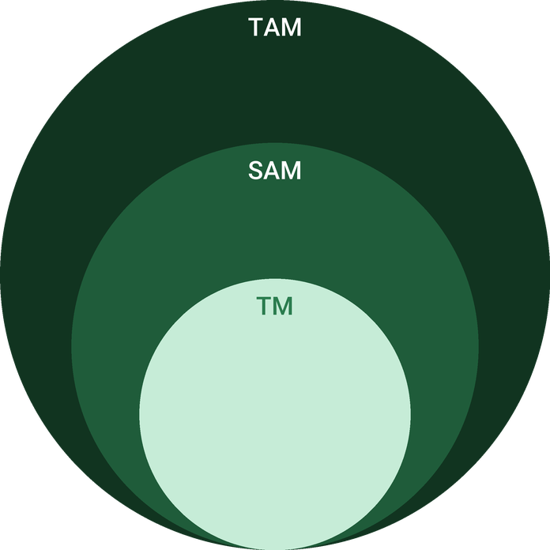
  ● | Total Available Market (TAM)  The US Meat Markets industry, covering butcher shops and delicatessens retailing fresh, frozen and cured meats, is sized at 13.9 billion dollars in annual revenue in 2025. | 13.9B
  ● | Served Available Market (SAM)  Asheville city households spend about 33.3 million dollars a year on meat and poultry across all channels, derived from the city's 38,210 households multiplied by the 871 dollar average annual household meat spend. | 33.3M
  ● | Target Market (TM)  The average US butcher shop generates about 805,115 dollars in annual revenue, the scale of one comparable business. | 805.1k

CHAPTER 4

Customer Analysis

4.1 Target Market
4.2 Customer Segments
4.3 Customer Persona
4.4 Customer Purchase Journey

4.1 Target Market
Ridgeholm's market is the households of Asheville that cook at home, buy meat regularly and care where it comes from. Nearly every household buys meat, spending an average of $871 a year, and shoppers make more than 56 meat shopping trips a year, so the opportunity is to win a share of trips that already happen rather than to create a new habit.
What decides where those trips go is quality. Quality and appearance were the top purchase drivers for nearly half of shoppers in 2025, and 95% reported at least one reason to splurge on meat or poultry. A counter that shows the farm, cuts to order and explains the cut answers those reasons directly, where price alone does not.
A second, smaller market sits alongside the households: chef-owned Asheville restaurants that want specific local cuts in steady weekly volumes and cannot get them easily from a broadline distributor.
Distance shapes the market as much as income does. A butcher is a regular errand rather than a destination, so the core catchment is the households within a short drive of the shop, who can fit it into a weekly routine; customers further out come for occasions, pre-orders and freezer quarters, which justify a longer trip. No published figure shows how often Asheville households buy from independent butchers rather than supermarkets, so the plan assumes no share of the city's spending and measures repeat visits from the first month instead. Restaurants judge a supplier differently again: on consistency of cut and delivery day more than on price, because a missed order costs them a menu item.

4.2 Customer Segments
- Weekly home cooks: buy two or three meals' worth of fresh cuts, grind and sausage each visit, and are the base of repeat trade.
- Weekend and holiday hosts: buy roasts, steaks and larger cuts for gatherings and grilling season, and pre-order for the holidays.
- Budget-conscious regulars: come for grind, sausage, pork shoulder and soup bones, and move up to other cuts as they learn to cook them.
- Health and provenance buyers: seek grass-fed beef and pasture-raised pork for what they eat, not only for the occasion.
- Restaurant kitchens: buy specific cuts and grind on a standing weekly order, invoiced on short terms.
The persona below stands for the weekend and holiday host, the segment that spends the most per visit and whose pre-orders shape the cutting schedule.

4.3 Customer Persona
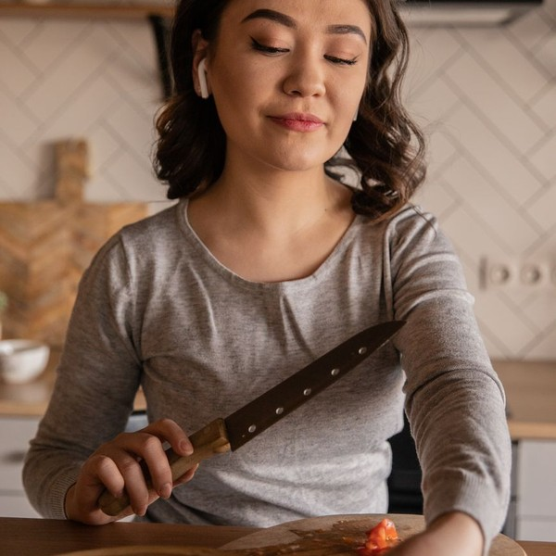  Claire, the Weekend Cook  Demographics  Age: 41  Household: Married, two children  Location: West Asheville, NC  Income: 95,000 dollars household  Professional Role  Education: Bachelor's degree  Job: School administrator | “I want to know which farm the roast came from, and I want someone to tell me how long to cook it.”
   | Identifiers / Personality Traits  - Cooks at home five nights a week and plans the weekend meal ahead  - Shops a farmers market on Saturdays when the season allows  - Reads labels and asks where food was raised
   | Goals  - Serve meat she trusts without paying steakhouse prices every week  - Learn cheaper cuts that feed a family well  - Order holiday roasts early and collect them on the day
   | Challenges  - Supermarket packs give no farm and no advice  - Limited time on weekdays to shop at more than one store  - Rising beef prices make every roast a bigger decision

4.4 Customer Purchase Journey
- Discovery: a neighbour's recommendation, a post about which farm's beef came in this week, or a sausage sample at the farmers market.
- First visit: the customer asks for one cut and leaves with advice on how to cook it and a second, cheaper cut to try.
- Return: the counter remembers the order, and a text or post about a new carcass prompts the next visit.
- Commitment: the customer pre-orders a holiday roast or a Butcher's Box and plans meals around the shop's week.
- Advocacy: the regular books a class, brings a friend or buys a freezer quarter, and the shop becomes part of how the household eats.
Each stage depends on the same thing: a conversation at the counter that a supermarket case cannot have. The plan's marketing spend is aimed at the first stage; the staff are what carry a customer through the rest.

CHAPTER 5

Competitive Analysis

5.1 Competitors
5.2 Comparison
5.3 Competitive Edge
5.4 SWOT Analysis

5.1 Competitors
Asheville already has an established independent butcher trade. Yelp's listing of the area's butchers includes The Chop Shop Butchery, Foothills Butcher Shop, New York Butcher Shoppe, PF Meat Co. Butchery & Market and Hickory Nut Gap Farm, and no chain butcher operates in the city.
The Chop Shop Butchery on Charlotte Street positions itself as Asheville's whole-animal butcher, selling dry-aged beef, heritage pork, lamb and house-made sausage, and it opened a second shop in Charlotte in 2024. Foothills Butcher Shop has sold local, pasture-raised meats in the Asheville area since 2013 and supplies its sister restaurants. Both are proof that the city supports provenance-led butchery, and both hold regulars a new counter has to earn. No revenue or performance figures are published for any of them, and none is assumed here.
The larger competitor is not another butcher. Most meat is still bought at supermarket counters, club stores and mass merchants, although traditional grocery's share of US meat sales fell from 52.8% in 2019 to 46.3% in 2024 as supercenters, club stores and online grew. Direct-to-consumer meat subscription boxes compete for the same quality-led buyer from outside the city altogether.

5.2 Comparison
The table compares Ridgeholm with three groups rather than with named rivals. Against other independents, the difference is execution rather than category: the same whole-animal model, run by a different team, on a different part of the city. Against supermarkets and subscription boxes, the difference is category. Ridgeholm offers provenance, custom cutting and advice they do not, and it gives up two things they do offer: home delivery and the lowest shelf price.
Two rows in the table are deliberate gaps rather than oversights. Delivery would add vans, drivers and cold-chain risk to a business built around one cutting room, and matching supermarket shelf prices on steak would mean buying boxed meat instead of whole animals. Both are choices the plan revisits only once the counter trades at its steady level.
Feature | Ridgeholm Butchery | Independent craft butchers | Supermarket meat counters | Meat subscription boxes
Whole animals broken down in house | ✓ | ✓ | ✗ | ✗
Farm named on every cut | ✓ | ✓ | ✗ | ✗
Custom cutting at the counter | ✓ | ✓ | ✓ | ✗
House-made sausage and smoked items | ✓ | ✓ | ✗ | ✗
Home delivery | ✗ | ✗ | ✓ | ✓
Lowest everyday shelf prices | ✗ | ✗ | ✓ | ✗

5.3 Competitive Edge
Ridgeholm's edge comes from how it buys and how it sells. Buying whole carcasses rather than boxed primals lets it price a cheaper cut to move and turn trim into sausage, bacon and broth, so margin does not rest on steaks alone. That matters more as USDA forecasts beef and veal retail prices up 9.8% in 2026, against 2.5% for all food at home.
At the counter, the edge is time with the customer. Cutting to order, labelling every tray with its farm and explaining how to cook what was bought answer the reasons shoppers give for choosing where they buy meat, and they are the parts of the sale a supermarket or a subscription box cannot copy cheaply. Against the established independents, Ridgeholm competes on consistency of the case, the ease of ordering ahead, and a class programme that turns customers into regulars.
The edge has limits. The established independents already sell whole-animal cuts, sausage and dry-aged beef, so on product alone Ridgeholm is one more option rather than a new category, and customers who already shop elsewhere will judge its case against the one they know. Supermarkets can run a price promotion on steak at any time, and subscription boxes deliver to the door, which the shop does not. Where Ridgeholm has room is in the parts of the sale that take time and do not scale: the counter conversation, cutting to order, and a pre-order book that remembers each household. Those are also the parts that cost the most in skilled labour, so keeping experienced butchers is a competitive question for this business, not only an operating one.
   | Carcass-level buying  Buying whole and half animals direct from farms, rather than boxed primals, lets the shop price cheaper cuts to move and turn trim into sausage and grind instead of waste.
   | Provenance at the counter  Every tray is labelled with the farm it came from and the date the animal was cut, which a supermarket case supplied through a distribution centre cannot show.
   | Cutting to the customer  Thickness, trim and portion are set at the counter while the customer waits, so a recipe decides the cut rather than whatever is already packed.
   | A kitchen behind the case  Sausage, bacon, smoked items and bone broth made on site carry higher margins than fresh cuts and give regulars a reason to add to the basket.
 | Advice as part of the sale  Staff who broke the animal down explain how to cook each cut, which makes an unfamiliar, lower-priced cut an easy sell.

5.4 SWOT Analysis
Strengths  - Whole-animal buying from named western North Carolina farms gives provenance a supermarket case cannot match.  - House-made sausage, bacon and smoked items raise margin on trim that would otherwise sell as low-value grind.  - Custom cutting and cooking advice at the counter turn a routine purchase into a reason to return.  - An owner who cuts meat daily keeps yield, pricing and quality decisions close to the product. | Weaknesses  - A new name enters a city where established independent butchers already hold loyal regulars.  - Thin early net margins leave little room for a slow ramp or an equipment failure.  - Skilled butchers are scarce, so one departure can stall the cutting schedule for weeks.  - A single counter with no delivery reaches only the households willing to travel to it.
Opportunities  - Grass-fed beef sales grew 29.8% in 2024, far faster than the meat market as a whole.  - Chef-owned Asheville restaurants want specific local cuts in quantities a small wholesale book can supply.  - Holiday pre-orders and grilling-season bundles can smooth a cutting schedule set weeks in advance.  - Butchery classes can build loyalty and a paid revenue line from the same cutting room. | Threats  - USDA forecasts beef retail prices rising 9.8% in 2026, squeezing margin or pushing prices up.  - Supercenters, club stores and online grocers keep taking share of household meat spending.  - Visitor spending in Buncombe County fell 2.1% in 2025 as the county recovered from Hurricane Helene.  - A farm supply disruption or processor backlog can empty the case at short notice.

 Strategic Summary
Ridgeholm should compete on provenance and craft rather than price, using whole-animal yield and house-made product to protect margin as beef costs rise. Its first priority is repeat trade from nearby households, with wholesale and classes built only as the cutting schedule allows.

CHAPTER 6

Products & Services

6.1 Our Offering
6.2 Signature Items
6.3 Additional Services
6.4 What Sets Us Apart
6.5 Whole-Animal Program

6.1 Our Offering
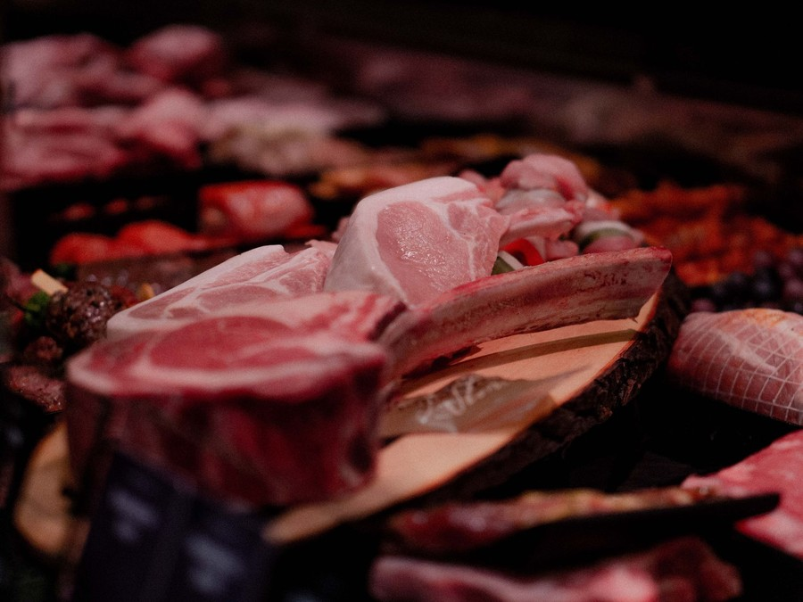
Ridgeholm sells meat from whole animals it breaks down itself. Beef, pork and lamb arrive as whole and half carcasses from western North Carolina farms, are cut in the shop's own room, and go into the case as fresh cuts labelled with the farm and the date they were cut. Poultry is bought in whole and portioned in house.
Around the fresh case sits a small kitchen that makes the rest of each animal worth buying: sausage from trim, bacon and smoked items under a HACCP plan, bone broth from the bones and tallow and lard from the fat. Most customers buy from both sides of the counter in one visit.

6.2 Signature Items
- Dry-aged ribeye and strip: beef aged in a dedicated cabinet and cut to the thickness the customer asks for.
- House sausage: fresh sausage in a rotating range, made in small batches from the week's pork and beef trim.
- Smoked bacon: pork belly cured and smoked on site and sliced to order.
- The Butcher's Box: about ten pounds of mixed cuts chosen from the current carcasses, with cooking notes for each.
- Bone broth: slow-cooked from the week's beef and pork bones and sold chilled or frozen.

6.3 Additional Services
Custom cutting to order is part of every sale rather than an extra. Beyond it, the shop takes holiday pre-orders for roasts, crown racks and whole birds, sells freezer quarters of beef cut to the customer's sheet, and runs small evening butchery classes. Restaurants buy fresh cuts and grind on standing weekly orders within the limits of the retail exemption.

6.4 What Sets Us Apart
Two things separate the offer from a supermarket case. The first is information: every cut carries its farm, and the person selling it cut it and can say how to cook it. The second is choice: a customer can have a steak cut an inch and a half thick, a roast tied, or a chop trimmed, while they wait.
House-made product is what keeps the offer affordable. Sausage, bacon and broth carry higher margins than fresh cuts, which lets the case price the cheaper cuts of each animal to sell and holds the whole business at a 41.0% gross margin.

6.5 Whole-Animal Program
The program starts at the farm. Ridgeholm plans to buy a steady weekly number of beef sides and whole hogs, and lambs in season, from a short list of partner farms, slaughtered at an inspected plant and delivered chilled. Fed cattle dress at about 62% to 64% of live weight, so a 1,200 pound steer yields a carcass of roughly 740 to 770 pounds, and retail cut yield from that carcass runs about 55% to 75% depending on fatness, muscling and cut style.
Each carcass is broken down to a cutting sheet that plans every pound before the saw starts: which primals become steaks and roasts, which trim goes to grind and sausage, which bones go to broth and which fat is rendered. Bone-in cuts average about 71% yield and boneless about 62%, so the sheet balances what sells at full price against what the kitchen can use.
The measure of the program is sell-through. A whole-animal butcher pays for bone, fat and trim along with the prime cuts, so margin depends on selling the full yield. The shop tracks the share of each animal sold at full price and adjusts the next week's order and cutting sheet to match.

6.5.1 Farm-Named Fresh Cuts
Beef, pork and lamb broken down in the shop from whole and half carcasses raised on western North Carolina farms, and cut to order at the counter. Each tray carries the farm's name and the date the animal was cut. Poultry is bought in whole and portioned in house.
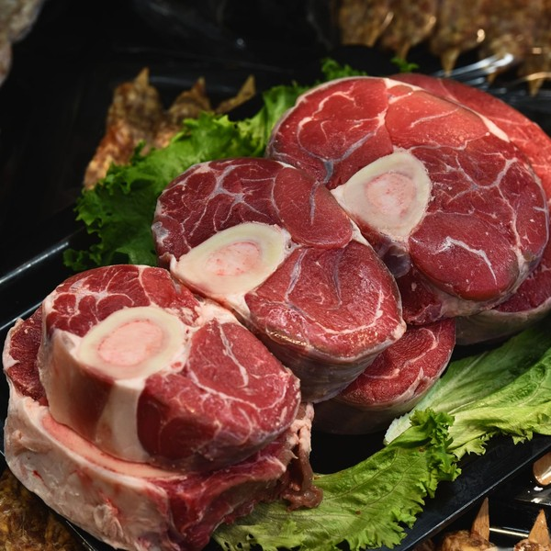 | $7 to $38 per pound  Soup bones, grind and pork shoulder sit at the low end and dry-aged ribeye and strip at the top. Prices move with what the farms charge per carcass, and the case is priced to sell the whole animal rather than the steaks alone.

Specifications
- Whole and half carcasses from inspected slaughter, delivered weekly
- Cut to the customer's thickness and trim while they wait
- Beef dry-aged in a dedicated cabinet for 21 to 35 days
- Wrapped in butcher paper or vacuum packed on request
- Farm and cut date printed on every label

6.5.2 Features
  Custom Cutting
  Steaks, chops and roasts cut to thickness and trimmed to order while the customer waits.
  House-Made Sausage
  Fresh sausage made in small batches from the shop's own trim and seasonings.
   | Smoked & Cured Items  Bacon, ham hocks and smoked sausage made on site under the shop's HACCP plan.
   | Bone Broth & Fats  Broth, tallow and lard made from the bones and fat of the animals broken down each week.
   | Holiday Pre-Orders  Roasts, crown racks and whole birds reserved weeks ahead and ready for collection.
   | Butchery Classes  Small evening classes on breaking down a primal and cooking the cuts that come from it.

6.5.3 Pricing
Everyday Counter  $7 to $14  per pound  - House grind, sausage and stewing cuts  - Pork shoulder, chops and chicken thighs  - Soup bones and rendered fats |  | Most Popular  Butcher's Box  $120  per box  - About ten pounds of mixed beef, pork and lamb  - Chosen each week from the current carcasses  - Cooking notes for every cut  - Order ahead and collect at the counter |  | Freezer Quarter  $1,150  per quarter beef  - A quarter of one grass-fed animal from a named farm  - Cut, wrapped and labelled to the customer's sheet  - Vacuum packed for the freezer  - Booked six weeks ahead

CHAPTER 7

Marketing & Sales Strategies

7.1 Market Positioning
7.2 Marketing Objectives
7.3 Online Marketing
7.4 Public Relations and Branding
7.5 Partnership & Collaboration Strategy
7.6 Customer Loyalty & Retention
7.7 Sales Channels

7.1 Market Positioning
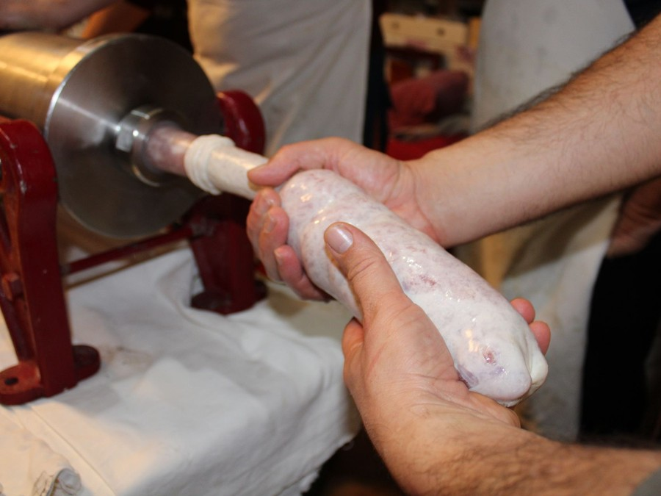
Ridgeholm is positioned as the Asheville counter for meat from named local farms, cut to order and explained by the people who cut it. It does not compete on shelf price or delivery; it competes on provenance, craft and advice, and on a case priced so that a household can buy the whole animal, not only its steaks.

7.2 Marketing Objectives
- Reach steady trade of 46 customers a day within eight months of opening.
- Turn first-time visitors into regulars, measured by repeat visits recorded at the till.
- Fill the first holiday season through pre-orders opened in October.
- Secure standing weekly orders from chef-owned restaurants within three months of opening.
The budget is 2.5% of revenue, spent where it reaches people already nearby or already buying rather than on brand advertising.
Each objective is reviewed monthly against the till data, and money moves between channels according to which one brings customers who come back, not which one brings the most first visits.
Classes & In-Store Events  $476  per month  Monthly butchery classes, tastings and a whole-hog demonstration that bring new households to the counter. |  | Local Social Media  $397  per month  Weekly posts on what came in from which farm, with targeted ads to Asheville households.
Farmers Market Presence  $397  per month  A tasting stall in the first season that hands out cards and sausage samples. |  | Signage & Local Print  $317  per month  Street signage, neighbourhood flyers and holiday pre-order mailers.

Total marketing budget: $19,050 a year, $1,587 a month.

7.3 Online Marketing
The shop's own posts do most of the work. Each week they say which farm's animals came in, what was cut from them and what is in the case, with a photograph of the cutting room rather than a stock image. A small targeted budget puts those posts in front of Asheville households within a short drive of the counter.
The website carries the order-ahead book, holiday pre-orders and class bookings, and a short email every week lists the cuts available and a recipe for the least familiar of them. A listing on the main map and review services, kept current with hours and photographs, is how most first visits will start.
Search matters as much as social. A household new to the city looks for a butcher on a map, so the listing carries photographs of the case and the cutting room, current hours, and answers to the questions asked before a first visit: whether the shop takes pre-orders, whether it cuts to order, and where to park. Every review is answered, and a critical one gets a reply from an owner within a day.

7.4 Public Relations and Branding
The brand is the product: the farm name on the label, butcher paper and a plain storefront that shows the cutting room through the glass. Opening coverage is sought from Asheville's food writers and local radio, built around the whole-animal story and the farms behind it rather than around the shop itself.
After opening, the class programme and seasonal events such as a whole-hog demonstration give local press something new to cover, and each one brings a group of new customers through the door.
Inside the shop the brand is carried by small, consistent details: a chalkboard naming the week's farms, a printed card with cooking notes for the less familiar cuts, and staff aprons and paper that match the storefront. None of it costs much, and all of it tells a first-time customer what kind of counter this is before anyone speaks.

7.5 Partnership & Collaboration Strategy
- Partner farms: named on the counter and in every post, with farm visits offered to regulars.
- Chef-owned restaurants: wholesale accounts whose menus credit the shop, bringing their diners to the counter.
- Farmers markets: a stall in the first season to meet the shoppers already buying direct from farms.
- Neighbouring food businesses: bakeries and wine shops for joint events and shared promotion.
Each partnership is kept small enough to serve well. The shop would rather supply four restaurants every week without a missed order than ten on an irregular basis, because a chef who credits Ridgeholm on a menu is also vouching for it to diners.

7.6 Customer Loyalty & Retention
In a butcher shop, loyalty is built at the counter. Staff learn regulars' names and usual orders, suggest a new cut when a carcass allows it, and put aside what a regular asked for. A simple points card on the till rewards frequency, and regulars get first access to holiday pre-orders and limited items such as dry-aged cuts.
The classes do the rest. A customer who has broken down a pork shoulder in the cutting room buys differently afterwards, and the shop becomes where that household learns to cook meat as well as where it buys it.
The pre-order book reaches furthest. A household that ordered a holiday roast once is asked again the following year at the same point in the season, with its previous order ready to repeat. Restaurant accounts get the same care in another form: a standing weekly order confirmed two days ahead, and a call when a carcass allows a cut that is not on the usual list.

7.7 Sales Channels
Revenue arrives through five routes, in order of what each is worth. The retail counter carries most of it. Restaurant wholesale accounts add a steady weekly book invoiced on short terms. Order-ahead pick-up turns online orders for boxes and custom cuts into counter collections, holiday pre-orders concentrate a large share of the year's larger cuts in November and December, and paid classes add a small margin of their own while bringing new customers in. The whole mix is planned at a 41.0% gross margin.
  Retail Counter
  Walk-in trade at the counter carries most of the revenue and depends on repeat visits from nearby households.
  Restaurant Wholesale Accounts
  Standing weekly orders of fresh cuts and grind for chef-owned Asheville restaurants, limited by the retail exemption.
  Order-Ahead Pick-Up
  Online orders for boxes and custom cuts collected at the counter, which depends on a reliable cutting schedule.
  Holiday Pre-Orders
  Reserved roasts and whole birds concentrated in November and December, which depend on booking farm supply early.
 | Classes and Events  Paid butchery classes that add a small margin of their own and bring new customers to the counter.

CHAPTER 8

Operations Plan

8.1 Daily Operations
8.2 Working Hours
8.3 Staffing & Training
8.4 Supply Chain Management
8.5 Inventory & Equipment Management
8.6 Location and Facilities
8.7 Milestones & Timeline
8.8 Food Safety & HACCP Compliance

8.1 Daily Operations
Each trading day starts in the cutting room. Carcasses from the week's delivery are broken down to the cutting sheet, the case is set before opening, and grind and sausage are made from the day's trim. During trading the counter serves walk-in customers and cuts to order, while the cutting room works ahead on pre-orders and restaurant accounts. The day ends with the case pulled, product wrapped and chilled, temperatures logged and the room cleaned and sanitised.

8.2 Working Hours
The counter opens Tuesday to Saturday from 10am to 7pm and Sunday from 10am to 4pm, and closes on Mondays. The late weekday close catches households shopping for dinner on the way home, and Saturday is the longest and busiest trading day for weekend cooking.
Monday is the production day. Carcasses are delivered and broken down, sausage and smoked items are made in larger batches, and the room is deep cleaned without customers in the shop. Restaurant deliveries go out on Tuesday and Friday mornings before the counter opens.

8.3 Staffing & Training
The team at opening is the two owners, a butcher and charcuterie lead, a second butcher and part-time counter staff. Butchers are paid at or above the level at which Buncombe County employers can certify as pledged living wage employers, because skilled cutters are scarce and hard to replace.
Every counter hire is trained to break down a primal and to explain every cut in the case, so any member of staff can advise a customer. All staff hold food handler certification before they work unsupervised, and the charcuterie lead is trained on the HACCP plan for cured and smoked product.

8.4 Supply Chain Management
Supply is set weekly. Ridgeholm plans to buy beef sides, whole hogs and seasonal lambs from a short list of western North Carolina farms, slaughtered and chilled at an inspected processor and delivered on Mondays. Orders are placed two to three weeks ahead so farms and the processor can schedule animals, and each farm is paid within about two weeks of delivery.
Holding more than one farm per species protects the case if one farm has no animals ready or the processor falls behind. Casings, spices, cure and packaging come from specialist suppliers on standing orders.

8.5 Inventory & Equipment Management
Fresh meat turns in days, so inventory is managed by the carcass rather than by the shelf. Each animal is tracked from delivery to sale against its cutting sheet, and the next week's order is set from what sold. Dry-aged, cured and frozen stock stretch the average to about ten days on hand.
The core equipment is a walk-in cooler and freezer, a dry-aging cabinet, refrigerated display cases, a band saw, a grinder, a sausage stuffer, a smoker and a vacuum packer. Saws and grinders are serviced on a fixed schedule, blades are replaced out of the annual equipment budget, and refrigeration runs on a maintenance contract with temperature alarms.

8.6 Location and Facilities
The shop needs about 1,700 square feet in an Asheville neighbourhood with residential streets close by and parking at the door: a retail counter at the front, the cutting room behind glass so customers can see the work, and the walk-in cooler, freezer and smoker at the back. The space must take floor drains, washable surfaces and the electrical load of the refrigeration, which rules out many older storefronts.

8.7 Milestones & Timeline
The milestones below take the business from a signed lease to its first holiday season, when the counter, the wholesale book and the pre-order system will all have run at full volume.
Oct 2026  Setup |  |  | Site secured  A storefront with room for a cutting room.  The lease is signed on space that can hold a walk-in cooler, a cutting room and a retail counter.
Dec 2026  Setup |  |  | Permits and financing  Plan review and the term loan close.  Buncombe County Environmental Health reviews the fit-out plans while the owners' equity and the term loan are put in place.
Feb 2027  Setup |  |  | Fit-out complete  Refrigeration and equipment commissioned.  The cold rooms are temperature logged, the smoker is installed and the HACCP plan for smoked items is filed.
Mar 2027  Launch |  |  | Counter opens  A soft opening, then full hours.  The case opens with the first carcasses from partner farms and order-ahead pick-up live from day one.
Jun 2027  Growth |  |  | Restaurant accounts begin  Standing weekly wholesale orders.  The first chef-owned restaurants move from trial orders to a weekly standing order of fresh cuts.
Nov 2027  Growth |  |  | First holiday season  Pre-orders for roasts and whole birds.  Holiday pre-orders open in October so farm orders and the cutting schedule can be fixed weeks ahead.

8.8 Food Safety & HACCP Compliance
A retail butcher cutting meat for household consumers operates under the federal retail store exemption from USDA inspection, and the animals themselves must come from inspected slaughter. In Asheville the shop is permitted and inspected by Buncombe County Environmental Health under the 2017 FDA Food Code, adopted in North Carolina as 15A NCAC 18A .2600.
Curing and smoking are specialized processes under that code, so Ridgeholm will file a HACCP plan for its bacon and smoked items before selling them. Each plan identifies the critical control points, such as cure concentration, smoking temperature and cooling time, and sets the limit, the check and the corrective action for each.
- Cold chain: carcasses received at 41 degrees Fahrenheit or below, cooler and case temperatures logged twice daily with alarms on every unit.
- Grinding: equipment broken down and sanitised between species, with grind dated and sold within the day.
- Traceability: every carcass logged by farm, processor and kill date, so any cut in the case can be traced back.
- Wholesale limits: restaurant sales of fresh cuts kept within the dollar and volume limits of the retail exemption, with no cured or smoked product sold wholesale.
Records are what an inspector reads first. Temperature logs, cure batch sheets, sanitising checks and carcass receiving records are kept at the point of use and filed weekly, and the owner reviews them every Monday before production starts. Any reading outside its limit is written up with the action taken, so a missed check is visible rather than hidden, and staff are retrained whenever a product or process in the plan changes.

CHAPTER 9

Management Team

9.1 Key Members
9.2 Organization Chart
9.3 Advisory Board Members

9.1 Key Members
The owner and head butcher answers for the cutting room: yield from every carcass, the weekly order from the farms, and the quality of the case. He is measured on the share of each animal sold at full price and on gross margin against the 41.0% the plan assumes.
The co-owner and operations manager answers for everything on the customer side of the glass: counter staffing, the order-ahead book, restaurant accounts and the shop's cash. She is measured on daily customer count, average ticket, and wholesale invoices paid on time.
The butcher and charcuterie lead answers for house-made product and for food safety records. He is measured on the HACCP logs being complete and on the sell-through of sausage, bacon and broth.
 | Marcus Delaney  Owner & Head Butcher · marcus@ridgeholmbutchery.example  Twelve years cutting meat, the last five breaking down whole beef and hog carcasses for an independent butcher counter.

 | Hannah Okafor  Co-owner & Operations Manager · hannah@ridgeholmbutchery.example  Eight years managing front-of-house operations and supplier accounts in independent food retail.

 | Eli Brandt  Butcher & Charcuterie Lead · eli@ridgeholmbutchery.example  Trained in sausage making and smoking, with ServSafe certification and experience writing HACCP logs for cured products.

9.2 Organization Chart
The owner and head butcher leads the business. The operations manager, the charcuterie lead and the counter lead report to him directly; part-time counter staff report to the counter lead, and the second butcher to the charcuterie lead. The two owners meet weekly to review sales, yield and the next week's farm order.
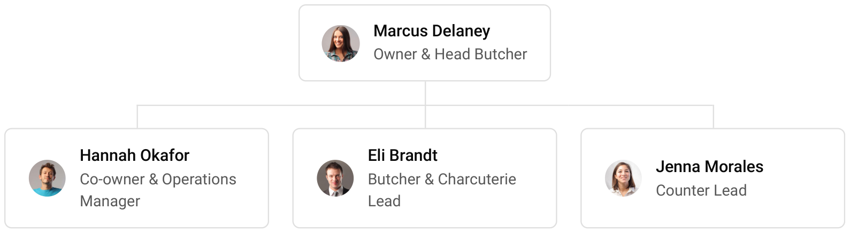

9.3 Advisory Board Members
The founders intend to form an informal advisory group before opening rather than a formal board. It will draw on an accountant with food retail clients to review the monthly accounts, a food safety consultant to review the HACCP plan before it is filed, and a partner farmer to advise on supply and pricing. Each is consulted on the decisions within their field, and none holds equity.
The group meets as a whole twice a year, before the holiday season and before grilling season, to review trading against the plan and to test the next season's farm orders and staffing. Between meetings the founders call on each adviser when a decision falls in their field, such as a change to a cured product, a new supply agreement or a lease question.

9.3.1 Hiring Plan
4  Filled |  | 2  Hiring This Year |  | 3  Open

Group By Department | Position Filled | Time of Hire | Time of Start | Filled
Management | 2 of 2 | 0 days | 0 days | 100%
Cutting Room | 1 of 2 | 45 days | 30 days | 50%
Counter & Sales | 1 of 2 | 30 days | 14 days | 50%
Wholesale & Delivery | 0 of 1 | 30 days | 14 days | 0%

CHAPTER 10

Financial Plan

10.1 Key Assumptions
10.2 Capital Requirements and Use of Funds
10.3 Income Statement (3 Year projections)
10.4 Balance Sheet (3 Year projections)
10.5 Cash Flow Statement (3 Year projections)
10.6 Break Even Analysis

10.1 Key Assumptions
Revenue is built as customers per day multiplied by average ticket, trading days and one plus the wholesale share. The shop is assumed to serve 46 customers a day at an average ticket of $58 over 306 trading days, with restaurant wholesale adding 12% on top of counter sales. Trade opens at 50% of that level and ramps over eight months, then grows 9% a year.
Gross margin is held at 41.0%, inside the 30% to 45% range for the trade and below its top because beef input costs are rising faster than general food prices. Payroll is 20% of revenue, marketing 2.5% and other operating costs 3.5%. Rent is $3,700 a month, with technology at $250 and administration at $700 a month. The startup base is written off over a ten year blended life, and income tax is taken at 21%.
On those assumptions revenue grows from $761,981 in 2026 to $830,559 in 2027 and $905,309 in 2028. Net income rises from $3,508 to $12,276 and $21,685, and the business breaks even at revenue of $620,420, or 10,697 transactions a year. The conservative scenario still returns $1,512 of net income in 2028 and the upside $48,931.
That break-even figure is an annual rate: the revenue at which a full year's gross margin covers a full year's fixed costs. The Break Even Analysis table measures something different, counting cumulative revenue against cumulative costs from the first month, so it shows the month in which the business has earned back everything it has spent since opening.

10.2 Capital Requirements and Use of Funds
The total startup cost is $326,000. The owners contribute $126,000 of equity and the balance of $200,000 is sought as an SBA 7(a) style term loan at 10.5% over 10 years. No outside shares are issued, and no profits are distributed during the projection, so earnings go to rebuilding cash and repaying the loan.
The largest uses are the equipment of $138,000, which covers the cold rooms, dry-aging cabinet, display cases, saw, grinder, stuffer and smoker, and leasehold improvements of $86,000 for drains, washable finishes, sinks and the refrigeration installation. A working capital reserve of $50,600 carries about three months of fixed costs and payroll through the ramp. The rest funds opening inventory, launch marketing, technology, deposits, permits and professional fees.

10.2.1 Use of Funds
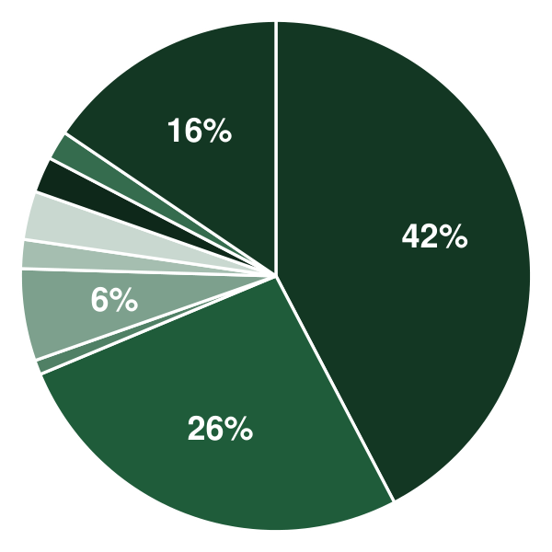 | ● Equipment 42.3%  ● Leasehold Improvements 26.4%  ● Licenses & Permits 0.9%  ● Initial Inventory 5.8%  ● Technology 1.8%  ● Launch Marketing 3.1%  ● Deposits & Pre-Opening Rent 2.3%  ● Professional Fees 1.8%  ● Working Capital Reserve 15.5%

Use Of Funds | Amount
Equipment | $138,000.00
Leasehold Improvements | $86,000.00
Licenses & Permits | $3,000.00
Initial Inventory | $19,000.00
Technology | $6,000.00
Launch Marketing | $10,000.00
Deposits & Pre-Opening Rent | $7,400.00
Professional Fees | $6,000.00
Working Capital Reserve | $50,600.00

10.3 Income Statement (3 Year projections)
 | Year 1 | Year 2 | Year 3 | Total
Revenue | $761,980.80 | $830,559.07 | $905,309.39 | $2,497,849.26
Cost of Sales | $449,568.67 | $490,029.85 | $534,132.54 | $1,473,731.06
General Costs | $0.00 | $0.00 | $0.00 | $0.00
Revenue Specific Costs | $314,698.07 | $343,020.90 | $373,892.78 | $1,031,611.75
Personnel Costs (Direct Labor) | $134,870.60 | $147,008.95 | $160,239.76 | $442,119.31
Gross Margin | $312,412.13 | $340,529.22 | $371,176.85 | $1,024,118.20
Gross Margin (%) | 41.00% | 41.00% | 41.00% | 41.00%
Operating Expense | $254,372.20 | $272,243.70 | $291,723.63 | $818,339.53
Payroll Expense (Indirect Labor) | $152,396.16 | $166,111.81 | $181,061.88 | $499,569.85
General Expense | $101,518.85 | $105,633.55 | $110,118.56 | $317,270.96
Bad Debt | $457.19 | $498.34 | $543.19 | $1,498.72
Amortization of Current Assets | $0.00 | $0.00 | $0.00 | $0.00
EBITDA | $58,039.93 | $68,285.52 | $79,453.22 | $205,778.67
Additional Expense | $54,532.39 | $56,009.17 | $57,768.18 | $168,309.74
Long Term Depreciation | $32,600.00 | $33,845.84 | $35,203.80 | $101,649.64
Gain or loss from Sale of Assets | $0.00 | $0.00 | $0.00 | $0.00
EBIT | $25,439.93 | $34,439.68 | $44,249.42 | $104,129.03
Interest Expense | $21,000.00 | $18,900.00 | $16,800.00 | $56,700.00
EBT | $4,439.93 | $15,539.68 | $27,449.42 | $47,429.03
Income Tax Expense / Benefit | $932.39 | $3,263.33 | $5,764.38 | $9,960.10
Total Expense | $758,473.26 | $818,282.72 | $883,624.35 | $2,460,380.33
Net Income | $3,507.54 | $12,276.35 | $21,685.04 | $37,468.93
Net Income (%) | 0.46% | 1.48% | 2.40% | 1.50%
Retained Earning Opening | $0.00 | $3,507.54 | $15,783.89
Owner's Distribution | $0.00 | $0.00 | $0.00 | $0.00
Retained Earning Closing | $3,507.54 | $15,783.89 | $37,468.93 | $37,468.93

10.4 Balance Sheet (3 Year projections)
 | Year 1 | Year 2 | Year 3 | Total
Assets | $326,984.37 | $321,395.39 | $325,397.31 | $325,397.31
Current Assets | $33,584.37 | $49,382.84 | $75,008.92 | $75,008.92
Cash | $20,766.39 | $35,411.24 | $59,779.88 | $59,779.88
Accounts Receivable | $501.03 | $546.12 | $595.27 | $595.27
Inventory | $12,316.95 | $13,425.48 | $14,633.77 | $14,633.77
Other Current Assets | $0.00 | $0.00 | $0.00 | $0.00
Long Term Assets | $293,400.00 | $272,012.55 | $250,388.39 | $250,388.39
Gross Long Term Assets | $326,000.00 | $338,458.39 | $352,038.03 | $352,038.03
Accumulated Depreciation | $32,600.00 | $66,445.84 | $101,649.64 | $101,649.64
Liabilities & Equity | $326,984.37 | $321,395.39 | $325,397.31 | $325,397.31
Liabilities | $197,476.83 | $179,611.50 | $161,928.38 | $161,928.38
Current Liabilities | $37,476.83 | $39,611.50 | $41,928.38 | $41,928.38
Accounts Payable | $17,243.73 | $18,795.67 | $20,487.28 | $20,487.28
Income Tax Payable | $233.10 | $815.83 | $1,441.10 | $1,441.10
Sales Tax Payable | $0.00 | $0.00 | $0.00 | $0.00
Short Term Debt | $20,000.00 | $20,000.00 | $20,000.00 | $20,000.00
Long Term Liabilities | $160,000.00 | $140,000.00 | $120,000.00 | $120,000.00
Long Term Debt | $160,000.00 | $140,000.00 | $120,000.00 | $120,000.00
Equity | $129,507.54 | $141,783.89 | $163,468.93 | $163,468.93
Paid-in Capital | $0.00 | $0.00 | $0.00 | $0.00
Common Stock | $0.00 | $0.00 | $0.00 | $0.00
Preferred Stock | $0.00 | $0.00 | $0.00 | $0.00
Owner's Contribution | $126,000.00 | $126,000.00 | $126,000.00 | $126,000.00
Retained Earnings | $3,507.54 | $15,783.89 | $37,468.93 | $37,468.93
Check | $0.00 | $0.00 | $0.00 | $0.00

10.5 Cash Flow Statement (3 Year projections)
 | Year 1 | Year 2 | Year 3 | Total
Cash Received | $776,262.20 | $846,626.82 | $922,823.24 | $2,545,712.26
Cash Paid | $735,495.81 | $799,523.58 | $864,874.96 | $2,399,894.35
COS & General Expenses | $411,290.14 | $448,211.04 | $483,528.02 | $1,343,029.20
Salary & Wages | $287,266.76 | $313,120.76 | $341,301.64 | $941,689.16
Interest | $21,000.00 | $18,900.00 | $16,800.00 | $56,700.00
Sales Tax | $15,239.62 | $16,611.18 | $18,106.19 | $49,956.99
Income Tax | $699.29 | $2,680.60 | $5,139.11 | $8,519.00
Net Cash From Operations | $40,766.39 | $47,103.24 | $57,948.28 | $145,817.91
Assets Sell | $0.00 | $0.00 | $0.00 | $0.00
Assets Purchase | $326,000.00 | $12,458.39 | $13,579.64 | $352,038.03
Net Cash From Investments | ($326,000.00) | ($12,458.39) | ($13,579.64) | ($352,038.03)
Amount Received | $326,000.00 | $0.00 | $0.00 | $326,000.00
Loan Received | $200,000.00 | $0.00 | $0.00 | $200,000.00
Common Stock | $0.00 | $0.00 | $0.00 | $0.00
Preferred Stock | $0.00 | $0.00 | $0.00 | $0.00
Owner's Contribution | $126,000.00 | $0.00 | $0.00 | $126,000.00
Amount Paid | $20,000.00 | $20,000.00 | $20,000.00 | $60,000.00
Loan Capital | $20,000.00 | $20,000.00 | $20,000.00 | $60,000.00
Dividends & Distributions | $0.00 | $0.00 | $0.00 | $0.00
Net Cash From Financing | $306,000.00 | ($20,000.00) | ($20,000.00) | $266,000.00
Summary
Starting Cash | $0.00 | $20,766.39 | $35,411.24
Cash In | $1,102,262.20 | $846,626.82 | $922,823.24 | $2,871,712.26
Cash Out | $1,081,495.81 | $831,981.97 | $898,454.60 | $2,811,932.38
Change in Cash | $20,766.39 | $14,644.85 | $24,368.64 | $59,779.88
Ending Cash | $20,766.39 | $35,411.24 | $59,779.88 | $59,779.88

10.6 Break Even Analysis
 | Year 1 | Year 2 | Year 3 | Total
Starting Revenue | $0.00 | $761,980.80 | $1,592,539.87 | $1,592,539.87
Net Revenue | $761,980.80 | $830,559.07 | $905,309.39 | $905,309.39
Closing Revenue | $761,980.80 | $1,592,539.87 | $2,497,849.26 | $2,497,849.26
Starting Expense | $0.00 | $758,473.26 | $1,576,755.98 | $1,576,755.98
Net Expense | $758,473.26 | $818,282.72 | $883,624.35 | $883,624.35
Closing Expense | $758,473.26 | $1,576,755.98 | $2,460,380.33 | $2,460,380.33
Is Break Even? | Yes | Yes | Yes
Break Even Month | Dec '26 | - | -
Days Required | 22 Days | - | -
Break Even Revenue | $761,980.80 | - | -

CHAPTER 11

References

- SRC001: Meat Markets in the US - Market Size Statistics, IBISWorld, 2025-01-01. https://www.ibisworld.com/united-states/market-size/meat-markets/1043/ (accessed 2026-09-24)
- SRC002: What The Power of Meat 2026 Reveals About Today's Shopper, FMI - The Food Industry Association, 2026-03-10. https://www.fmi.org/blog/view/fmi-blog/2026/03/10/what-the-power-of-meat-2026-reveals-about-today-s-shopper (accessed 2026-09-24)
- SRC003: Sales at record high, Americans view meat as part of a healthy, balanced lifestyle, Meat Institute, 2025-03-24. https://www.meatinstitute.org/press/sales-record-high-americans-view-meat-part-healthy-balanced-lifestyle (accessed 2026-09-24)
- SRC004: Power of Meat report reveals record meat sales in 2024, Western Livestock Journal, 2025-03-28. https://www.wlj.net/power-of-meat-report-reveals-record-meat-sales-in-2024/ (accessed 2026-09-24)
- SRC005: Market Share of Grass-Fed Beef, South Dakota State University Extension. https://extension.sdstate.edu/grass-fed-beef-market-share-grass-fed-beef (accessed 2026-09-24)
- SRC006: Food Price Outlook - Summary Findings, USDA Economic Research Service, 2026-08-25. https://www.ers.usda.gov/data-products/food-price-outlook/summary-findings (accessed 2026-09-24)
- SRC007: From Record Beef Costs to Cheaper Eggs: USDA's 2026 Food Price Outlook Signals Major Market Shift, Hoosier Ag Today, 2026-07-28. https://www.hoosieragtoday.com/2026/07/28/usda-july-2026-food-price-outlook/ (accessed 2026-09-24)
- SRC008: Butchers: Occupational Outlook Handbook, US Bureau of Labor Statistics, 2025-01-01. https://www.bls.gov/ooh/production/butchers-and-meat-cutters.htm (accessed 2026-09-24)
- SRC009: 9 CFR 303.1 -- Exemptions, Electronic Code of Federal Regulations. https://www.ecfr.gov/current/title-9/chapter-III/subchapter-A/part-303/section-303.1 (accessed 2026-09-24)
- SRC010: askFSIS Public Q&A: Can a Retail Exempt Establishment Cure, Cook and Smoke a Multi-ingredient Meat Product and Sell it to HRI?, USDA Food Safety and Inspection Service. https://ask.fsis.usda.gov/article/askFSIS-Public-Q-A-retempccs (accessed 2026-09-24)
- SRC011: Retail Meat and Poultry Processing Guidelines, Association of Food and Drug Officials, 2011-01-01. https://www.afdo.org/wp-content/uploads/2020/11/Retail_Meat_and_Poultry_Processing_Guidelines_acc_updated_2011.pdf (accessed 2026-09-24)
- SRC012: Meat Delivers Continued Growth, Bucking Total Store Trends, Meatingplace, 2025-10-06. https://meatingplace.com/meat-delivers-continued-growth-bucking-total-store-trends/ (accessed 2026-09-24)
- SRC013: Target beefs up online grocery offerings with ButcherBox partnership, Grocery Dive, 2025-01-01. https://www.grocerydive.com/news/target-butcherbox-partnership-ecommerce/744988/ (accessed 2026-09-24)
- SRC014: How Much Meat Can You Expect from a Fed Steer?, South Dakota State University Extension. https://extension.sdstate.edu/how-much-meat-can-you-expect-fed-steer (accessed 2026-09-24)
- SRC015: How much meat should a beef animal yield, University of Wisconsin-Madison Division of Extension. https://livestock.extension.wisc.edu/articles/how-much-meat-should-a-beef-animal-yield (accessed 2026-09-24)
- SRC016: Asheville, NC - Profile data, Census Reporter (US Census Bureau ACS 2024 1-year), 2025-01-01. http://censusreporter.org/profiles/16000US3702140-asheville-nc/ (accessed 2026-10-07)
- SRC017: Amid Hurricane Helene Recovery, NC Tourism Spending Charts Variable Growth, NC Department of Commerce, 2026-08-13. https://www.commerce.nc.gov/news/press-releases/2026/08/13/amid-hurricane-helene-recovery-nc-tourism-spending-charts-variable-growth (accessed 2026-10-07)
- SRC018: How Much Do Butcher Shops Make? (2025 Data), Toast, 2025-01-01. https://pos.toasttab.com/blog/on-the-line/how-much-do-butcher-shops-make (accessed 2026-10-07)
- SRC019: The Best 10 Butcher in Asheville, NC, Yelp, 2026-09-01. https://www.yelp.com/search?cflt=butcher&find_loc=Asheville%2C+NC (accessed 2026-10-07)
- SRC020: The Chop Shop Butchery, Explore Asheville. https://www.exploreasheville.com/asheville/listing/shopping/chop-shop-butchery (accessed 2026-10-07)
- SRC021: Beloved Asheville butcher is now open in Myers Park, Axios Charlotte, 2024-02-04. https://www.axios.com/local/charlotte/2024/02/04/asheville-butcher-chop-shop-expands-to-charlotte (accessed 2026-10-07)
- SRC022: Foothills Butcher Shop, Explore Asheville. https://www.exploreasheville.com/black-mountain/listing/food-drink/foothills-butcher-shop (accessed 2026-10-07)
- SRC023: Asheville, NC Commercial Real Estate for Lease or Sale, CommercialCafe, 2026-09-10. https://www.commercialcafe.com/commercial-real-estate/us/nc/asheville/ (accessed 2026-10-07)
- SRC024: North Carolina minimum wage 2026, OnPay, 2026-01-01. https://onpay.com/insights/minimum-wage-by-state-summary/north-carolina/ (accessed 2026-10-07)
- SRC025: Living wage in Buncombe County rises to $24.10, increasing $1 higher than last year, WLOS, 2026-01-01. https://wlos.com/news/local/buncombe-county-living-wage-rises-just-economics-wnc-empoyees-federal-data-nonprofit-increase-local-employers-certify-evaluate-pay (accessed 2026-10-07)
- SRC026: Frequently Asked Questions, NCDA&CS Meat and Poultry Inspection Division. https://www.ncagr.gov/meat-poultry-inspection/FAQ (accessed 2026-10-07)
- SRC027: North Carolina Food Code Manual: A Reference for 15A NCAC 18A .2600, NC DHHS Environmental Health Section, 2021-10-01. https://ehs.dph.ncdhhs.gov/faf/docs/foodprot/NC-FoodCodeManual-2021-FINAL-10-1-2021.pdf (accessed 2026-10-07)
