
Table of Contents
1. Executive Summary 6
1.1 Business Overview 7
1.2 Mission Statement 7
1.3 Location & Market Opportunity 7
1.4 Unique Selling Points 7
1.5 Financial Highlights 8
1.6 Funding Requirement 8
1.6.1 Income Statement (3 Year projections) 8
2. Company Overview 9
2.1 Legal Structure 10
2.2 Vision Statement 10
2.3 Background & History 10
2.4 Future Goals 10
2.4.1 Business Owners 11
2.4.2 SMART Goal 11
3. Market Analysis 12
3.1 Overview 13
3.2 Market Segmentation 13
3.3 Market Trends 13
3.4 Local Market Outlook 13
3.5 Market Size 14
4. Customer Analysis 15
4.1 Target Market 16
4.2 Customer Segments 16
4.3 Customer Persona 17
4.4 Customer Purchase Journey 17
5. Competitive Analysis 18
5.1 Competitors 19
5.2 Comparison 19
5.3 Competitive Edge 20
5.4 SWOT Analysis 21
6. Services Offered 22
6.1 Our Offering 23
6.2 Signature Items 23
6.3 Additional Services 23
6.4 What Sets Us Apart 23
6.5 Cleaning Methods & Equipment 24
6.5.1 Residential Carpet Cleaning 24
6.5.2 Upholstery, Rug and Tile Cleaning 25
6.5.3 Features 25
6.5.4 Pricing 26
7. Marketing & Sales Strategies 27
7.1 Market Positioning 28
7.2 Marketing Objectives 28
7.3 Online Marketing 28
7.4 Public Relations and Branding 29
7.5 Partnership & Collaboration Strategy 29
7.6 Customer Loyalty & Retention 29
7.7 Sales Channels 29
8. Operations Plan 30
8.1 Daily Operations 31
8.2 Working Hours 31
8.3 Staffing & Training 31
8.4 Inventory & Equipment Management 31
8.5 Location and Facilities 31
8.6 Milestones & Timeline 32
8.7 IICRC Certification & Insurance 33
9. Management Team 34
9.1 Key Members 35
9.2 Organization Chart 35
9.3 Advisory Board Members 36
9.3.1 Hiring Plan 36
10. Financial Plan 37
10.1 Key Assumptions 38
10.2 Capital Requirements and Use of Funds 38
10.2.1 Use of Funds 38
10.3 Income Statement (3 Year projections) 39
10.4 Balance Sheet (3 Year projections) 40
10.5 Cash Flow Statement (3 Year projections) 41
10.6 Break Even Analysis 42
11. References 43


CHAPTER 1

Executive Summary

1.1 Business Overview
1.2 Mission Statement
1.3 Location & Market Opportunity
1.4 Unique Selling Points
1.5 Financial Highlights
1.6 Funding Requirement

1.1 Business Overview
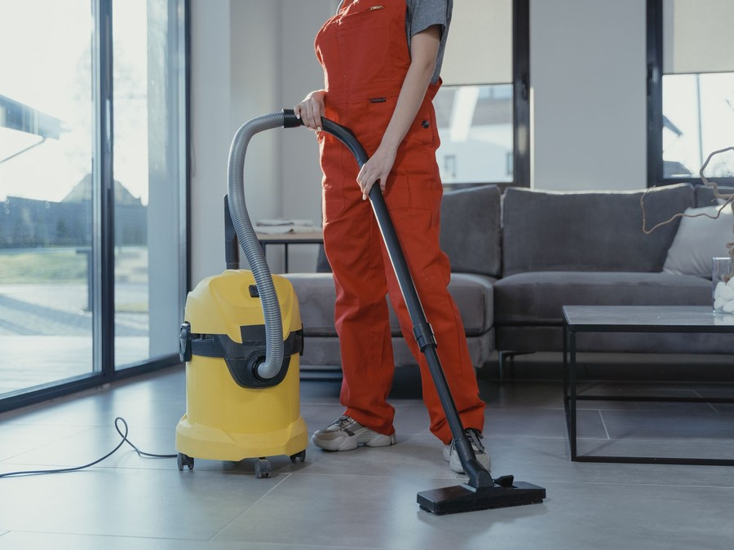
FreshHaven is a carpet, upholstery and rug cleaning company planned for Phoenix, Arizona. Two truck-mounted hot water extraction vans drive to customers' homes and premises across the city and its neighboring Valley suburbs, run by IICRC-trained technicians.
It sells a residential carpet clean priced by the room, with protector, pet odor treatment, upholstery, rugs and tile added on the same visit. Its customers are Phoenix homeowners, especially households with pets or allergies, and the landlords, property managers and short-term rental hosts who need a fast clean between occupants.

1.2 Mission Statement
To leave every Phoenix home cleaner and healthier than we found it, at the price we quoted, in the window we promised, and with a record of the work the customer can keep.

1.3 Location & Market Opportunity
Phoenix is the fifth largest city in the United States, with 1,673,164 residents in 2024 and 5.19 million across the metro area. The city holds 601,397 households, and 42.9% of its homes are rented, which gives a steady flow of turnover cleans for landlords and property managers. Monsoon dust storms each summer add a predictable autumn peak in demand.
US carpet cleaning generated $6.8 billion in revenue in 2025. Maricopa County's carpet cleaning establishments with employees represent about $94.3 million of annual revenue, and one such establishment averages about $669,000 a year nationally. FreshHaven's first-year revenue of $402,828 sits well inside that single-establishment figure.

1.4 Unique Selling Points
- Truck-mounted hot water extraction on every job, the restorative cleaning the Carpet and Rug Institute recommends every 12 to 18 months.
- Two vans from launch, so next-day slots are available on both sides of the Valley.
- Prices quoted by the room before the van arrives, with every add-on listed.
- Monthly invoicing and photo records for property managers and rental hosts.
- A dated service record after each job, ready for a warranty claim.

1.5 Financial Highlights
Revenue comes from two trucks, each completing 3.5 jobs a day at an average base clean of $200 across 290 operating days, with add-ons worth a further 25% of the base clean. The business opens at 45% of that level and builds to it over nine months as reviews and repeat bookings accumulate.
Revenue is projected at $402,828 in the first year, $475,337 in the second and $560,898 in the third, at a gross margin of 82.0% throughout. Net income is $17,129 in the first year, rising to $34,508 and then $54,717, a net margin of 9.8% by the third year. Break-even revenue is $323,961, the equivalent of 1,620 jobs, which the first year clears. Third-year net income is $30,203 in the conservative case and $87,828 in the upside case.

1.6 Funding Requirement
The startup budget is $185,200. Most of it buys the two truck-mounted extraction vans; the rest covers portable and specialty equipment, opening chemistry, van wraps, the shop fit-out, the unit deposit, licenses and insurance, IICRC training, the booking website and launch marketing. It is funded by a $75,000 owner contribution and a $150,000 SBA 7(a) loan at 10.25% over seven years, which leaves opening cash above the budget. Profits stay in the business while the loan is repaid.
The plan rests on an experienced owner-technician, a large and dusty metro with a high renter share, and an offer built around honest pricing and records that property managers and pet owners value. The money puts two fully equipped vans on Phoenix streets with the people and systems to keep them busy.

1.6.1 Income Statement (3 Year projections)
 | Year 1 | Year 2 | Year 3 | Total
Revenue | $402,828.13 | $475,337.19 | $560,897.88 | $1,439,063.20
Cost of Sales | $72,509.06 | $85,560.69 | $100,961.62 | $259,031.37
Gross Margin | $330,319.07 | $389,776.50 | $459,936.26 | $1,180,031.83
Operating Expense | $265,648.01 | $302,772.64 | $346,579.71 | $915,000.36
Total Expense | $385,698.94 | $440,829.66 | $506,180.43 | $1,332,709.03
Net Income | $17,129.19 | $34,507.53 | $54,717.45 | $106,354.17

CHAPTER 2

Company Overview

2.1 Legal Structure
2.2 Vision Statement
2.3 Background & History
2.4 Future Goals

2.1 Legal Structure
FreshHaven will be organized as an Arizona limited liability company owned by its two founders, Marisol Vega and Daniel Brooks, and taxed as a corporation. The LLC holds the vans, the equipment and the lease on the shop unit, and keeps the founders' personal assets separate from the liabilities of working inside customers' homes.
Marisol, who holds the majority stake, manages the company and leads the field work; Daniel keeps his property management career and brings capital and the commercial accounts. The operating agreement sets decision rights and a buy-sell arrangement.

2.2 Vision Statement
To be the carpet cleaner Phoenix households and property managers call first because the price, the timing and the result are the same every time, and to grow from two vans to a fleet without losing the habit of quoting honestly and recording the work.

2.3 Background & History
FreshHaven is a pre-launch business. Its plan grew out of the founders' own working lives. Marisol has spent nine years on truck-mounted equipment for a Valley cleaning and restoration company, and saw how often customers called back after a cheap clean let odor return or a quote grew at the door. Daniel has spent twelve years managing rental homes, booking turnover cleans for units that had to be ready for the next tenant within days.
Between them they saw two groups poorly served by the same market: households that wanted a straightforward price and a reliable arrival window, and property managers who wanted one vendor that could clean several units a week, invoice monthly and send photos. FreshHaven is designed around both, with two vans so capacity is never one sick day from a cancellation.
The company has no trading history, customers or revenue yet. Everything that follows describes the founders' stated intent and the plan they have built to carry it out.

2.4 Future Goals
In the first 0 to 18 months, FreshHaven will fit and wrap both vans, certify both technicians, open the booking website, and take its first paid jobs. By month nine both vans should be running at the planned 3.5 jobs a day, with the first property manager accounts signed and a base of reviews in place before the first post-monsoon autumn peak.
Over 1 to 3 years, matching the period the financial projections cover, the goal is steady growth from $402,828 of revenue in the first year to $560,898 in the third, driven by a fuller calendar, more add-ons sold per visit, repeat bookings from service reminders, and denser routes as more customers cluster in the same neighborhoods. Net income is planned to rise from $17,129 to $54,717 over the same years while the equipment loan is paid down.
Over 3 to 5 years, FreshHaven aims to add a third van and technician and extend its commercial book, funded from retained profit rather than new borrowing and only once the existing vans are consistently full.

2.4.1 Business Owners
Marisol Vega | Daniel Brooks

Total ownership: 100%
60% | Marisol Vega  6,000 Shares
40% | Daniel Brooks  4,000 Shares

2.4.2 SMART Goal
  Specific  - Both FreshHaven vans running 3.5 jobs a day across Phoenix and the neighboring Valley.  - Marisol Vega leading, with one technician and a part-time scheduler.  - Standing accounts with property managers and rental hosts. |   Measurable  - Jobs per truck per day, tracked weekly.  - Add-on share against the planned 25%.  - First-year revenue of $402,828, above break-even of $323,961. |   Achievable  - Both technicians IICRC-certified before launch.  - 3.5 jobs a day, below the four to six of established trucks.  - Repeat work booked from service records.
  Relevant  - Full calendars turn a financed fleet into profit.  - Renters and dust season give steady demand.  - Commercial accounts smooth slow household months. |   Time-Based  - Vans fitted and team certified before launch.  - Calendars full by month nine.  - Second-year revenue of $475,337.

CHAPTER 3

Market Analysis

3.1 Overview
3.2 Market Segmentation
3.3 Market Trends
3.4 Local Market Outlook
3.5 Market Size

3.1 Overview
US carpet cleaning generated $6.8 billion in revenue in 2025, essentially flat on 2024, with $6.9 billion estimated for 2026. Growth has been slow, at a compound annual rate of about 0.2% between 2021 and 2026, but steady: demand is held up by recurring household cleaning tied to indoor health and by routine commercial maintenance.
The trade is highly fragmented. There were 40,945 carpet cleaning businesses in 2025, most of them owner-operators running one van, and they compete locally on reputation, reviews and repeat business. A two-truck company with employees already sits above the typical operator in scale.

3.2 Market Segmentation
The market FreshHaven serves divides into four groups that buy differently:
- Homeowners in carpeted houses, who book a whole-home clean every 12 to 18 months and buy add-ons such as protector and pet treatment.
- Landlords and property managers, who need turnover cleans between tenants on short notice and value monthly invoicing.
- Short-term rental hosts, who need fast cleans between guests and pay for speed and reliability.
- Small offices with carpeted floors, which buy scheduled maintenance cleans on contract.
Households are the largest group by volume; property managers and rental hosts provide the most predictable repeat work.

3.3 Market Trends
- Pets drive demand: 94 million US households own at least one pet, up from 82 million in 2023, and dog ownership reached 53% of households in 2025.
- Allergies keep cleaning on the calendar: more than 100 million people in the US experience allergies each year.
- Carpet keeps losing share to hard flooring, at 43.8% of the US flooring market in 2024 against 62.1% a decade earlier, though the rate of loss has slowed.
- Costs are rising: tariffs on equipment and chemistry are a pressure operators either absorb or pass on in service fees.

3.4 Local Market Outlook
Phoenix had 1,673,164 residents in 2024, the fifth largest US city, and added 16,933 in the year. The wider Phoenix-Mesa-Chandler metro holds 5.19 million people. The city's 601,397 households have a median income of $77,041, and 57.1% of homes are owner-occupied, leaving a large rental stock served by landlords and property managers. One to three major dust storms a year, mostly in the July and August monsoon, add to the soil a carpet collects.
Supply is dense. Maricopa County, the smallest published geography containing FreshHaven's catchment, had 134 carpet cleaning establishments with employees in 2024, employing 609 people, and a location quotient of 1.63, meaning 63% more carpet cleaning employers relative to its economy than the nation. Directory listings for Phoenix run higher, at 384 on HomeAdvisor, because they include owner-operators. Arizona's minimum wage is $15.15 an hour in 2026, and recovered cleaning water must go to a sanitary sewer under Phoenix stormwater rules.

3.5 Market Size
The total addressable market is US carpet cleaning revenue, $6.8 billion in 2025. The serviceable market is the Maricopa County trade, about $94.3 million a year, derived from the county's 141 carpet cleaning establishments with employees at the national average revenue per establishment in 2022; it excludes owner-operators without employees, so local spend is higher.
The obtainable market is one establishment of this kind, about $669,000 a year on the national average. FreshHaven's first-year revenue of $402,828 is below that figure, as a new two-van business should be, and leaves room to grow within a single location.
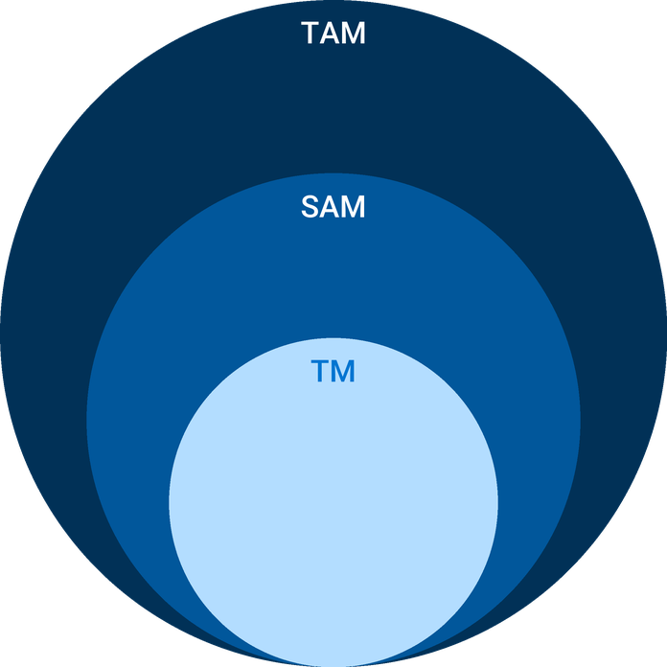
  ● | Total Available Market (TAM)  US carpet cleaning generated $6.8 billion in revenue in 2025 (IBISWorld), essentially flat on 2024, with $6.9 billion estimated for 2026. | 6.8B
  ● | Served Available Market (SAM)  Maricopa County's 141 carpet and upholstery cleaning establishments with employees represent about $94.3 million of annual revenue in 2022, at the national average of about $669,000 per employer establishment; owner-operators without employees are excluded. | 94.3M
  ● | Target Market (TM)  One US carpet and upholstery cleaning establishment with employees averaged about $669,000 in revenue in 2022 ($4,906 million across 7,334 establishments); a national average, not a Phoenix figure. | 669.0k

CHAPTER 4

Customer Analysis

4.1 Target Market
4.2 Customer Segments
4.3 Customer Persona
4.4 Customer Purchase Journey

4.1 Target Market
FreshHaven's target market is the carpeted homes and premises within a working drive of its shop near Sky Harbor: the city of Phoenix and its neighboring Valley suburbs. The city alone holds 601,397 households at a median income of $77,041, close to the national figure, so a professional clean every year or so is within reach of most of them.
Two facts shape who calls. First, 42.9% of Phoenix homes are rented, so a large share of carpet changes hands between tenants and is cleaned on a landlord's or property manager's order rather than a resident's. Second, dust storms in the monsoon and the pets that 94 million US households keep put more soil and odor into carpet than in a milder, pet-free home.
Within that market FreshHaven starts close to home. Routes are built outward from the shop near Sky Harbor, so the first customers are won in the neighborhoods a van can reach in under half an hour, and each finished job is used to win the next one on the same street. Wider suburbs are added as the calendar fills and the drive between jobs can be shared.

4.2 Customer Segments
- Pet-owning homeowners: the core household buyer, booking a whole-home clean with enzyme odor treatment and protector, often yearly and sometimes more often.
- Warranty-minded homeowners: owners of newer carpet who clean every 12 to 18 months, as the Carpet and Rug Institute recommends, using the method their manufacturer's warranty asks for.
- Property managers and landlords: book turnover cleans for several units a month, want one contact, monthly invoicing and before and after photos.
- Short-term rental hosts: need a clean between guests within a day or two and value the second van's availability over price.
- Small offices: buy a quarterly or monthly maintenance clean for carpeted suites, usually early or late in the day.
The segments buy on different triggers and at different rhythms. Households book around events: a move, a holiday visit, a pet accident, or the dust that follows a monsoon storm, and most clean once a year. Property managers book by the unit, several times a month, and judge a vendor on whether the unit is ready for the next tenant on the promised day. Rental hosts book at short notice and pay for a slot tomorrow rather than next week. Offices book on a schedule set months ahead. That spread is useful: the commercial segments fill weekday gaps that household demand leaves, and the household peak after the monsoon arrives when property turnover is quieter. The persona below stands for the first segment, which is the largest single source of household revenue and the most likely to buy add-ons.

4.3 Customer Persona
  Rachel, the Pet-Owning Homeowner  Demographics  Age: 38  Household: married, two children, one dog  Location: North Phoenix  Income: about 95,000 dollars a year  Professional Role  Job: Nurse at a Phoenix hospital  Home: carpeted three-bedroom house | “I need someone who gets the dog smell out, shows up when they say, and tells me the price before they start.”
   | Identifiers / Personality Traits  - Books by phone or online in the evening after her shift  - Reads recent reviews before calling anyone  - Cleans the carpets every year, more often after the summer dust
   | Goals  - Remove pet odor and stains from bedrooms and the family room  - Keep the carpet warranty valid with proof of professional cleaning  - Get carpets dry before the children are home
   | Challenges  - Coupon prices that grew at the door the last time  - Arrival windows that took a whole day off work  - Odor that returned within weeks of a cheap clean

4.4 Customer Purchase Journey
A household journey usually starts with a trigger: a pet accident, a move, guests arriving, or the dust left after a storm. The customer searches for a carpet cleaner near them, compares the first few results on reviews and stated prices, and books online or by phone in the evening. FreshHaven aims to win that comparison with recent reviews, a per-room price on the website and a two-hour arrival window confirmed at booking.
On the day, the technician walks the rooms with the customer, confirms the quote and any add-ons before starting, and leaves a dated service record when the job is done. A review request follows by text that evening, and the scheduler sets a reminder for a return visit in about a year.
Property managers follow a shorter, repeated path. They are introduced through Daniel Brooks or a referral, try FreshHaven on one turnover, and move to a standing account once the unit is ready on time and the photos arrive with the invoice. After that, work arrives by email or text with an address and a deadline, and the relationship depends on meeting that deadline every time.

CHAPTER 5

Competitive Analysis

5.1 Competitors
5.2 Comparison
5.3 Competitive Edge
5.4 SWOT Analysis

5.1 Competitors
Phoenix carpet cleaning is crowded and mostly independent. Maricopa County had 134 carpet cleaning establishments with employees in 2024, a concentration 63% above the national norm for its economy, and directory listings for Phoenix alone run to 384 providers on HomeAdvisor and 564 on Yellow Pages once owner-operators are counted. National franchise territories operate alongside the independents. No revenue for any named local business is published, so the competition is described here by type rather than by name.
FreshHaven will meet four kinds of rival:
- Owner-operators: one technician and one van, often with a portable or truck-mounted unit, competing on price and personal service but limited in capacity and rarely set up to invoice property managers.
- National franchise territories: recognizable brands with marketing budgets, booking systems and trained technicians, priced at the upper end and run as separate local franchises.
- Coupon discount cleaners: advertise low whole-house prices and sell add-ons at the door, which wins first bookings and loses repeat ones.
- Do-it-yourself rental machines: the cheapest option for households, with weaker suction and longer drying times than a truckmount.

5.2 Comparison
The table below compares FreshHaven with the three professional rival types on what Phoenix customers weigh most when choosing a cleaner. Owner-operators match FreshHaven on method but not on capacity, certification or commercial billing; franchises match it on most points but not on monthly invoicing for property managers; coupon cleaners compete on headline price alone.
Price is deliberately left out of the table, because a headline price says little about the final bill. FreshHaven's per-room price sits around the national average professional clean, above the coupon cleaners' advertised figure and below the franchises' typical rates, and the invoice matches the quote.
Two rows matter most to the customers FreshHaven wants first. Monthly invoicing is the row property managers ask about before anything else, and certification is the row a pet owner or a warranty-minded homeowner checks when deciding whom to let in. On both, FreshHaven matches or beats every rival type in the table.
Feature | FreshHaven | Owner-operators | National franchises | Coupon discount cleaners
Truck-mounted hot water extraction on every job | ✓ | ✓ | ✓ | ✓
IICRC-certified technicians | ✓ | ✗ | ✓ | ✗
Online booking with a two-hour arrival window | ✓ | ✗ | ✓ | ✗
Pet odor and allergen treatment | ✓ | ✓ | ✓ | ✗
Monthly invoicing for property managers | ✓ | ✗ | ✗ | ✗
Upholstery, rugs and tile on the same visit | ✓ | ✗ | ✓ | ✗

5.3 Competitive Edge
FreshHaven's edge is a combination rather than a single feature. Two vans give it capacity that the owner-operators who make up most of the market cannot match, which matters most to property managers turning several units a week and to rental hosts with a guest arriving tomorrow. Monthly invoicing and photo records are what those accounts need and what franchises, run around household bookings, rarely offer.
For households, the edge is honesty and proof. Every price is quoted by the room before the van arrives, so the invoice matches the quote, and every job ends with a dated record of the method used, which a homeowner can show a carpet manufacturer when a warranty claim needs proof of professional cleaning. In a fragmented market where reputation decides who gets the next booking, consistent results and reviews that mention them are the advantage that compounds.
None of these advantages is permanent. A franchise territory can add monthly invoicing, and an owner-operator can buy a second van. FreshHaven's defense is to be first to the property managers and pet-owning households in its catchment, and to hold them with records and reminders that make switching cleaners more trouble than it is worth. The rivals most likely to win a customer back are coupon cleaners on price, which is why FreshHaven quotes the whole job up front and lets the comparison happen on the final bill rather than the headline.
   | Two Vans From Day One  A second truck lets FreshHaven offer next-day slots on both sides of the Valley and keep a booking when one van is in for service.
   | Built for Property Managers  Turnover cleans are booked through one contact, invoiced monthly and documented with before and after photos, which most one-van operators cannot offer.
   | Warranty-Ready Records  Every job ends with a dated service record naming the method, so a homeowner can prove professional cleaning when a carpet warranty claim needs it.
   | Priced Up Front by the Room  Customers see the per-room price and every add-on before the van arrives, so the invoice matches the quote with no upsell at the door.

5.4 SWOT Analysis
Strengths  - Two truck-mounted vans from launch give capacity and next-day availability that single-van operators cannot match.  - IICRC-trained technicians and a written method on every job support carpet warranty claims.  - Same-visit add-ons lift the average ticket without another trip across the Valley.  - Monthly invoicing and photo records suit property managers who book many units a year. | Weaknesses  - A new name with no reviews competes against established cleaners for the first months.  - Two vans financed by a loan carry fixed payments whether or not the calendar is full.  - Long drives between Phoenix suburbs cap the jobs a truck can finish in a day.
Opportunities  - A 42.9% renter share in Phoenix means steady turnover cleans for landlords and property managers.  - Dust from monsoon storms each summer creates a predictable autumn booking peak.  - Pet-owning households need odor treatment and more frequent cleaning than the 12 to 18 month norm.  - Short-term rental hosts need fast cleans between guests on short notice. | Threats  - Carpet keeps losing share to hard flooring, slowly shrinking the installed base to clean.  - Coupon cleaners advertise low headline prices that anchor what households expect to pay.  - Tariffs and inflation raise chemistry, parts and van costs faster than prices can follow.  - Summer heat above 110 degrees slows outdoor setup and strains truckmount engines.

 Strategic Summary
FreshHaven should win property manager accounts and pet-owning households first, where its capacity, records and add-ons count most, and build reviews fast enough to offset its new name before the first post-monsoon peak.

CHAPTER 6

Services Offered

6.1 Our Offering
6.2 Signature Items
6.3 Additional Services
6.4 What Sets Us Apart
6.5 Cleaning Methods & Equipment

6.1 Our Offering
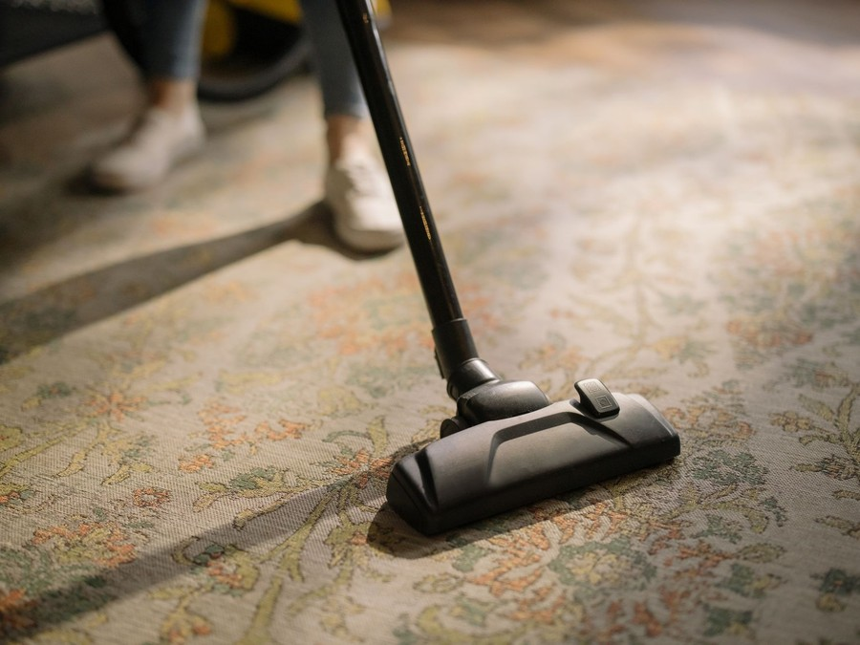
FreshHaven cleans the soft surfaces in Phoenix homes and premises: wall-to-wall carpet, upholstery, area rugs, and the tile and grout around them. The headline service is a residential carpet clean by truck-mounted hot water extraction, priced by the room, and most visits add at least one further service at the same door.
The offer is built so that a customer knows the whole price before the van arrives. Rooms, stairs, add-ons and any upholstery are listed on the quote, and the technician confirms it on arrival before starting. Commercial and property manager work uses the same prices, invoiced monthly.

6.2 Signature Items
Two services carry the business, and each has its own card below. The residential carpet clean is the core job, at $65 a room with a $149 minimum; a typical three-room home with a hallway comes to about $200 before add-ons, close to the national average professional clean. Upholstery, rug and tile cleaning is the second line, sold on the same visit or booked on its own.
The three packages in the pricing table bundle the most common jobs, from a two-room Essentials clean to a Pet & Allergy Deep Clean with enzyme odor treatment and protector on every cleaned room.

6.3 Additional Services
- Carpet protector applied after cleaning, which helps carpet resist the next spill and the next dust storm.
- Pet odor treatment with an enzyme product worked into the backing where pets have been.
- Spot dyeing for small bleach marks on nylon carpet.
- Stair and hallway cleaning priced separately from rooms.
- Turnover cleans for property managers and short-term rental hosts, scheduled at short notice and documented with photos.

6.4 What Sets Us Apart
Most of what a customer remembers about a carpet cleaner happens before and after the cleaning. FreshHaven confirms a two-hour arrival window when the job is booked and sends a text when the technician is on the way. The price does not change at the door. Furniture is moved and blocked, air movers run while the technician packs up, and the customer receives a dated service record that names the method, for any warranty claim. Every one of those steps is written into the job checklist rather than left to the technician's memory.

6.5 Cleaning Methods & Equipment
FreshHaven uses hot water extraction, a restorative method of the kind the Carpet and Rug Institute recommends every 12 to 18 months, delivered from a truck-mounted unit in each van. The unit heats water and generates suction from its own engine, so only the hoses and the cleaning wand come into the home, and the soiled water is recovered into a waste tank in the van rather than poured into a drain. Each job follows the ANSI/IICRC S100 sequence: inspect and test the fiber, pre-vacuum, prespray, agitate, rinse and extract, groom, and speed drying with air movers.
Not every surface suits that method. Upholstery is fiber-tested first and cleaned by low-moisture or extraction methods according to the fabric; delicate area rugs go back to the shop to dry; and high-rise units the hoses cannot reach are cleaned with a portable extractor. A mid-range truckmount costs $20,000 to $45,000, and FreshHaven's two complete vans are the largest item in its startup budget. Recovered water is emptied only at a sanitary sewer connection, as Phoenix stormwater rules require.

6.5.1 Residential Carpet Cleaning
A truck-mounted hot water extraction clean for carpeted homes, priced by the room. Each visit includes a pre-vacuum, prespray, spot treatment and a thorough rinse, with furniture moved and blocked and air movers set to speed drying.
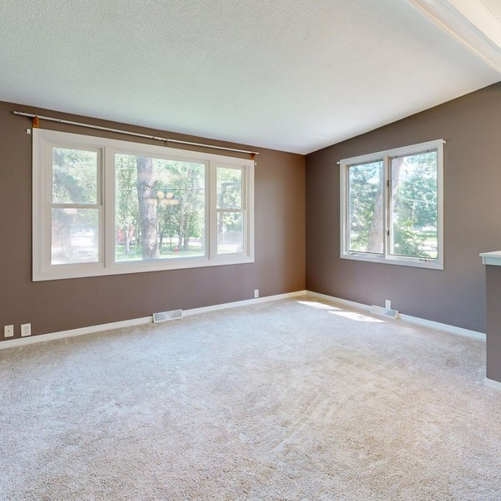 | $65 per room, $149 minimum visit  A typical three-room job with a hallway comes to about $200 before add-ons, close to the national average professional clean.

Specifications
- Hot water extraction from a truck-mounted unit parked outside the home
- Pre-vacuum and prespray on every cleaned room
- Furniture moved and blocked on tabs to protect the carpet
- Carpets usually dry in four to six hours with air movers
- Dated service record naming the method, for warranty claims

6.5.2 Upholstery, Rug and Tile Cleaning
Cleaning for the surfaces around the carpet: sofas, sectionals and dining chairs, area rugs laid over hard floors, and tile and grout in kitchens and bathrooms. It is sold on the same visit as a carpet clean or booked on its own.
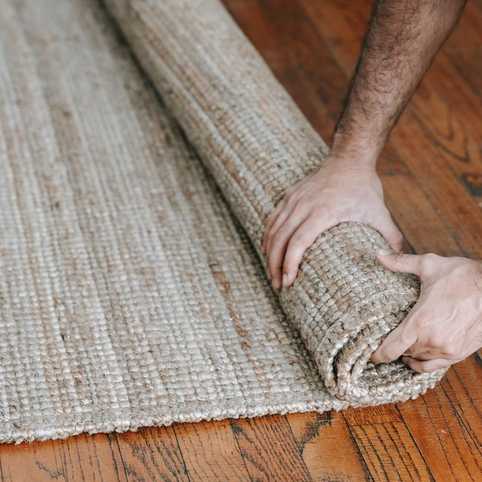 | From $99 per sofa  Area rugs are priced by size and fiber, and tile and grout by the square foot, each quoted before work starts.

Specifications
- Fiber tested before any upholstery is cleaned
- Low-moisture or extraction method chosen by fabric
- Area rugs cleaned on site or taken to the shop for drying
- Tile and grout cleaned with a high-pressure rotary tool
- Optional grout sealing after cleaning

6.5.3 Features
  Truck-Mounted Extraction
  Hot water and strong suction from a unit in the van, so only the hoses come into the home.
   | Two-Hour Arrival Windows  Customers get a two-hour window when they book and a text when the technician is on the way.
  Pet Odor Treatment
  Enzyme treatment applied where pets have been, so odor is broken down rather than masked.
   | Fast-Dry Finish  Air movers run while the technician packs up, cutting drying time to a few hours.
  Service Records
  A dated record of the method used on every job, ready for a carpet warranty claim.
  Up-Front Pricing
  Every price and add-on is quoted before work starts, and the invoice matches the quote.

6.5.4 Pricing
Essentials Clean  $149  per visit, up to 2 rooms  - Pre-vacuum, prespray and hot water extraction  - Spot treatment on common stains  - Furniture moved and blocked |  | Most Popular  Whole Home Fresh  $229  per visit, up to 4 rooms and a hallway  - Everything in Essentials  - Protector on main traffic lanes  - Air movers for a faster dry  - Warranty-ready service record |  | Pet & Allergy Deep Clean  $329  per visit, up to 4 rooms and a hallway  - Everything in Whole Home Fresh  - Enzyme odor treatment on all pet areas  - Protector on all cleaned carpet  - Upholstery cushion refresh on one sofa

CHAPTER 7

Marketing & Sales Strategies

7.1 Market Positioning
7.2 Marketing Objectives
7.3 Online Marketing
7.4 Public Relations and Branding
7.5 Partnership & Collaboration Strategy
7.6 Customer Loyalty & Retention
7.7 Sales Channels

7.1 Market Positioning
FreshHaven is positioned as the reliable, honestly priced carpet cleaner for Phoenix households and the property managers who look after rented homes: priced near the middle of the market, never discounted at the door, and backed by records and capacity that most local operators do not offer.

7.2 Marketing Objectives
- Fill both vans to 3.5 jobs a day by month nine.
- Reach a high review rating on Google with a steady count of new reviews each month.
- Sign standing accounts with property managers and rental hosts within the first year.
- Sell add-ons on enough visits to reach the 25% add-on share the plan assumes.
- Rebook first-year customers from reminders at their 12 month anniversary.
Marketing is budgeted at 8% of revenue, $32,226 in the first year, split across the four channels shown below.
Local Services & Search Ads  $1,343  per month  Pay-per-lead and search ads that put FreshHaven in front of Phoenix households searching for a carpet cleaner today. |  | Property Manager Referrals  $537  per month  Referral credits, leave-behind kits and lunch visits to the property managers who book turnover cleans.
Neighborhood Door Hangers  $403  per month  Door hangers on the street around each finished job, while the van is still parked outside. |  | Website, SEO & Reviews  $403  per month  The booking site, local search pages and an automated review request after every job.

Total marketing budget: $32,226 a year, $2,686 a month.

7.3 Online Marketing
Most household bookings start with a search, so most of the budget goes to being found there. Pay-per-lead Local Services ads and search ads put FreshHaven in front of people looking for a carpet cleaner now. The website shows per-room prices and takes bookings online, and local pages cover the neighborhoods the vans serve. An automated text after each job asks for a review, because recent reviews decide most comparisons in a market of this density.

7.4 Public Relations and Branding
The vans are the brand's largest advertisement: fully wrapped, clean and parked outside every job. Technicians wear uniforms, carry shoe covers, and leave door hangers on the surrounding street while the van is still outside. The brand's promise is simple and repeated everywhere: the price you were quoted, the window you were given, and a record of the work.

7.5 Partnership & Collaboration Strategy
Daniel Brooks's years in property management give FreshHaven a starting list of managers, leasing offices and landlords to call on. Partnerships will be built with property management firms, short-term rental cleaning crews who do not clean carpet, flooring retailers whose customers need warranty-compliant cleaning, and pet groomers and veterinary clinics whose clients have the strongest need for odor treatment. Each partner gets a referral credit for jobs it sends.

7.6 Customer Loyalty & Retention
Carpet cleaning is a repeat purchase on a long cycle, so retention is a calendar task. Every customer receives a reminder about a year after the first clean, timed where possible for the weeks after the monsoon, with their previous rooms and price already on file. Households that rebook keep their quoted price for a second year. Property managers keep the same technician on their units where possible, and a missed deadline is credited on the next invoice.

7.7 Sales Channels
Revenue arrives by five routes, in order of what each is worth to the business:
   | Household Bookings  Homeowners who book online or by phone are the largest share of revenue, and depend on search ranking and recent reviews.
   | Property Manager Accounts  Standing accounts for turnover cleans, invoiced monthly, worth the most steady volume and dependent on fast scheduling and photo records.
   | Repeat and Referral Visits  Past customers rebooked from 12 month reminders and the friends they send, which cost little but depend on a first clean done well.
  Short-Term Rental Hosts
  Fast cleans between guests, booked at short notice, dependent on same-week availability from the second van.
Small Office Contracts
Quarterly or monthly maintenance cleans for carpeted offices, a smaller line that fills weekday gaps.

CHAPTER 8

Operations Plan

8.1 Daily Operations
8.2 Working Hours
8.3 Staffing & Training
8.4 Inventory & Equipment Management
8.5 Location and Facilities
8.6 Milestones & Timeline
8.7 IICRC Certification & Insurance

8.1 Daily Operations
Each van starts the day at the shop near Sky Harbor, loaded with chemistry, filters and the day's job sheets. The scheduler routes the two vans to opposite sides of the Valley to keep drive times short, and each technician works three or four jobs: walk the rooms with the customer, confirm the quote, move furniture, clean, set air movers, and record the job with photos in the scheduling software. Recovered water is emptied at the shop's sanitary sewer connection at the end of the day, and the van is restocked for the morning.

8.2 Working Hours
Jobs run from 8:00 a.m. to 5:00 p.m., Monday to Saturday, with the last job starting by 3:00 p.m. so carpets dry before evening. Saturday is kept for households that cannot be home on a weekday, and Sunday is used for van maintenance and urgent property manager turnovers only. In June to September the first job starts at 7:00 a.m., to set up hoses and run the truckmount before the hottest hours of the day. Phone and online bookings are answered from 7:30 a.m. to 6:00 p.m.

8.3 Staffing & Training
The launch team is four people: Marisol Vega runs one van and the business, Luis Ortega runs the second van, Hannah Price schedules jobs and answers calls part time, and co-owner Daniel Brooks handles commercial accounts. Technicians are paid above the BLS mean for the occupation of $21.03 an hour and well above Arizona's $15.15 minimum wage, because a careful technician is what customers review.
Every technician completes IICRC carpet cleaning certification before working alone and rides along for two weeks on the other van. Training covers fiber identification, chemistry, customer walk-throughs, furniture handling and how to quote add-ons without pressure. A third technician is planned once both vans are consistently full.

8.4 Inventory & Equipment Management
Each van carries a truck-mounted extraction unit with hoses, wands, a stair tool, air movers and a day's chemistry. The shop holds about a month of prespray, rinse, protector, enzyme treatment and spotters, plus spare hoses and filters, reordered monthly from a distributor. Chemistry and supplies are tracked against the 5% to 7% of revenue that efficient operators spend.
Truckmounts are serviced on the manufacturer's hour schedule and vans on mileage, with service logged in the scheduling software. Wear is planned at about $10 an operating hour, and wands, hoses and air movers are replaced on a rolling cycle.

8.5 Location and Facilities
FreshHaven leases a small-bay industrial unit of about 1,200 square feet near Sky Harbor, central enough to reach both the east and west sides of the Valley. Small-bay space there asks about $15 a square foot a year on triple net terms. The unit parks both vans indoors, holds chemistry in a ventilated store, provides a utility sink on the sanitary sewer for recovered water, and has room to dry rugs taken back from jobs. Customers never visit it; the business comes to them.

8.6 Milestones & Timeline
The company is formed and funded in late 2026, the vans fitted and the team certified over the winter, and the first paid jobs taken in early 2027. The timeline below sets out each step to full calendars ahead of the first post-monsoon peak.
Nov 2026  Setup |  |  | Company Formed and Loan Approved  Legal and funding in place  The LLC is registered, state and city tax registration filed, and the SBA 7(a) loan approved for the two vans.
Dec 2026  Setup |  |  | Vans Fitted and Unit Leased  Equipment and base ready  Both truckmounts are installed, the vans wrapped, and the small-bay unit fitted with shelving and a sanitary sewer sink.
Jan 2027  Training |  |  | Technicians Certified  IICRC training complete  Luis Ortega completes IICRC carpet cleaning certification and both technicians practice on discounted friends and family jobs.
Feb 2027  Launch |  |  | First Paid Jobs  Booking site and ads go live  Search and Local Services ads start, the booking site opens, and both vans take their first paid jobs.
Apr 2027  Growth |  |  | First Property Manager Accounts  Standing turnover work  Daniel Brooks signs the first property manager accounts for monthly invoiced turnover cleans.
Oct 2027  Growth |  |  | Full Calendars for Dust Season  Post-monsoon peak  Both vans run at planned capacity into the autumn peak, with reminders sent to every first-year customer.

8.7 IICRC Certification & Insurance
Customers let a stranger into their home and trust them with carpet, furniture and pets, so certification and cover are part of what FreshHaven sells. Both technicians will hold the IICRC Carpet Cleaning Technician certification, which tests fiber identification, soiling and cleaning methods, costs $80 an exam on top of the course, and requires 14 hours of continuing education every four years. Jobs follow the ANSI/IICRC S100 standard, the trade's reference for professional carpet and rug cleaning.
FreshHaven will carry general liability insurance for damage in customers' homes, commercial auto cover for both vans, workers' compensation for its employees, and a bond for property manager contracts that require one. Arizona does not tax most services, but protector or deodorizer sold and listed separately on an invoice can be taxable, so FreshHaven quotes them inside the job price and will seek a written ruling from the Arizona Department of Revenue before launch.
Certification only counts if a customer can see it. Each technician's IICRC certification is shown on the booking site and on the job confirmation, and property managers receive a copy of the insurance certificate before their first job. Every technician passes a background check before working in customers' homes, and wears a uniform and name badge on site.
When something goes wrong, the process is written down. The technician photographs pre-existing damage, stains that may not come out, and loose seams during the walk-through, and notes them on the job sheet before starting. If a customer reports damage, Marisol inspects it within two working days; small items are repaired or paid for directly, and larger claims go to the insurer. A callback for a stain that returns is free within 30 days of the clean. Both the walk-through photographs and the dated service record are kept with the job, so any dispute starts from the same evidence on both sides.
Safety is part of the same regime. Each van carries the safety data sheet for every product on board, and technicians are trained on the chemistry they use, on handling hoses across driveways and stairs, and on protecting floors and furniture during setup. Phoenix summers add a heat risk to the work outside the van: summer jobs start early, technicians carry water and take breaks in the shade or the cab, and the truckmount is serviced before the hottest months so it does not overheat at a customer's door.

CHAPTER 9

Management Team

9.1 Key Members
9.2 Organization Chart
9.3 Advisory Board Members

9.1 Key Members
Marisol Vega is accountable for the business as a whole: revenue, the quality of every job and the safety of the team. She is measured on jobs per truck per day, the review rating and monthly profit against the plan. Daniel Brooks is accountable for commercial accounts, measured on the number of standing property manager and rental host accounts and how much of their work arrives each month.
Luis Ortega answers for the work on the second van, measured on completed jobs, add-ons sold and callbacks. Hannah Price answers for the calendar, measured on how full both vans are, arrival windows met and how many reminders turn into rebookings.
 | Marisol Vega  Owner & Lead Technician · marisol@freshhaven.example  IICRC-certified carpet cleaning technician with nine years on truck-mounted equipment for a Valley cleaning and restoration company.

 | Daniel Brooks  Co-Owner, Commercial Accounts · daniel@freshhaven.example  Twelve years in residential property management in Phoenix, responsible for unit turnovers and vendor contracts.

 | Luis Ortega  Carpet Cleaning Technician · luis@freshhaven.example  Four years of residential carpet and upholstery cleaning, completing IICRC certification before launch.

 | Hannah Price  Scheduler & Customer Care · hannah@freshhaven.example  Former dispatcher for a home services company, experienced in routing technicians and handling customer calls.

9.2 Organization Chart
All three report to Marisol, who sets prices, approves anything outside the standard quote and handles any complaint not resolved on the day. Technicians escalate to her during jobs; Hannah escalates scheduling conflicts and Daniel brings commercial terms to her for sign-off. The chart stays flat until a third van is added, when a lead technician role is planned between Marisol and the field team.
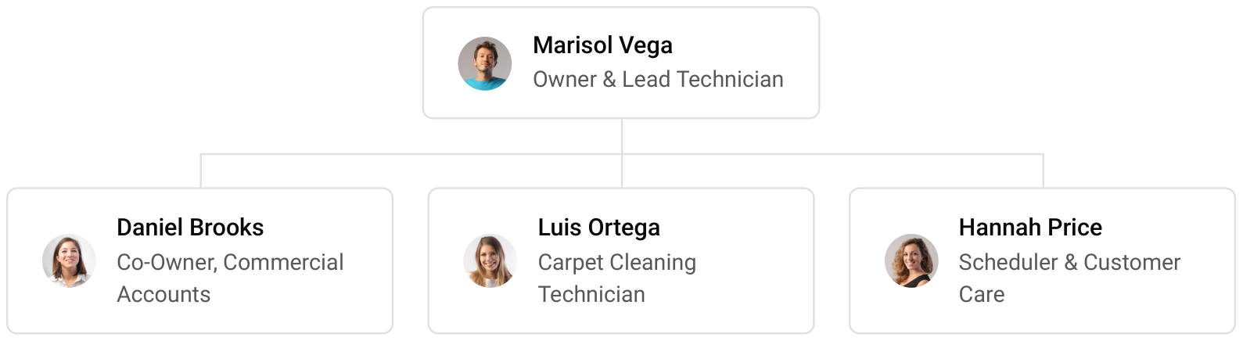

9.3 Advisory Board Members
FreshHaven will form an informal advisory group rather than a paid board. It is planned to include an accountant familiar with small service businesses for tax and the loan covenants, an insurance broker who places cover for cleaning and restoration firms, and an experienced carpet cleaning operator from outside the Valley who can advise on pricing and equipment without competing for the same customers. The group will meet each quarter to review results against the plan.

9.3.1 Hiring Plan
2  Filled |  | 2  Hiring This Year |  | 3  Open

Group By Department | Position Filled | Time of Hire | Time of Start | Filled
Field Service | 1 of 3 | 45 days | 14 days | 33%
Scheduling & Customer Care | 0 of 1 | 30 days | 7 days | 0%
Management & Commercial Accounts | 1 of 1 | 0 days | 0 days | 100%

CHAPTER 10

Financial Plan

10.1 Key Assumptions
10.2 Capital Requirements and Use of Funds
10.3 Income Statement (3 Year projections)
10.4 Balance Sheet (3 Year projections)
10.5 Cash Flow Statement (3 Year projections)
10.6 Break Even Analysis

10.1 Key Assumptions
Revenue follows one formula: two trucks, times 3.5 jobs a truck a day, times a $200 average base clean, times 290 operating days, plus add-ons at 25% of the base clean. The business opens at 45% of that level and builds to it over nine months, so the first year is a ramp year; revenue then grows 18% a year as the calendar fills, routes densify and add-ons are sold on more visits.
Gross margin is 82.0%: cost of sales covers chemistry and supplies, fuel for the vans and truckmounts, equipment wear and card processing. Payroll is 38% of revenue, marketing 8% and other operating costs 5%. Fixed costs are rent of $1,900 a month, technology of $450 and administration of $2,600, which covers insurance, workers' compensation and accounting. Taxes on profit are planned at 25%.
On those inputs, revenue is $402,828 in the first year, $475,337 in the second and $560,898 in the third. Net income is $17,129, $34,508 and $54,717. Break-even revenue is $323,961, or 1,620 jobs, and the first year clears it. In the third year, net income is $30,203 in the conservative case and $87,828 in the upside case, so the plan stays profitable if jobs or prices fall short.

10.2 Capital Requirements and Use of Funds
The startup budget is $185,200, spent before the first paid job. By far the largest item is the two truck-mounted extraction vans; the rest covers portable and specialty equipment, opening chemistry and supplies, van wraps and branding, the shop fit-out, the unit deposit and pre-opening rent, licenses, insurance and legal work, IICRC training, the website and technology, and launch marketing.
It is funded by a $75,000 owner contribution and a $150,000 SBA 7(a) loan at 10.25% over seven years, matched to the working life of the vans, with no outside equity. Funding above the startup budget is held as opening cash. The loan is repaid from operating cash, and profits stay in the business while it is.

10.2.1 Use of Funds
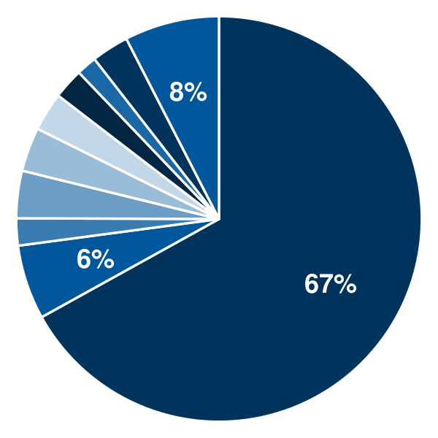 | ● Truck-Mounted Extraction Vans 67.0%  ● Portable & Specialty Equipment 5.9%  ● Initial Chemistry & Supplies 2.2%  ● Van Wraps & Branding 3.8%  ● Shop Fit-Out 3.5%  ● Deposit & Pre-Opening Rent 3.1%  ● Licenses, Insurance & Legal 2.4%  ● IICRC Training & Certification 1.6%  ● Technology & Website 3.0%  ● Launch Marketing 7.6%

Use Of Funds | Amount
Truck-Mounted Extraction Vans | $124,000.00
Portable & Specialty Equipment | $11,000.00
Initial Chemistry & Supplies | $4,000.00
Van Wraps & Branding | $7,000.00
Shop Fit-Out | $6,500.00
Deposit & Pre-Opening Rent | $5,700.00
Licenses, Insurance & Legal | $4,500.00
IICRC Training & Certification | $3,000.00
Technology & Website | $5,500.00
Launch Marketing | $14,000.00

10.3 Income Statement (3 Year projections)
 | Year 1 | Year 2 | Year 3 | Total
Revenue | $402,828.13 | $475,337.19 | $560,897.88 | $1,439,063.20
Cost of Sales | $72,509.06 | $85,560.69 | $100,961.62 | $259,031.37
General Costs | $0.00 | $0.00 | $0.00 | $0.00
Revenue Specific Costs | $50,756.34 | $59,892.48 | $70,673.13 | $181,321.95
Personnel Costs (Direct Labor) | $21,752.72 | $25,668.21 | $30,288.49 | $77,709.42
Gross Margin | $330,319.07 | $389,776.50 | $459,936.26 | $1,180,031.83
Gross Margin (%) | 82.00% | 82.00% | 82.00% | 82.00%
Operating Expense | $265,648.01 | $302,772.64 | $346,579.71 | $915,000.36
Payroll Expense (Indirect Labor) | $153,074.69 | $180,628.13 | $213,141.19 | $546,844.01
General Expense | $111,767.66 | $121,193.84 | $132,316.72 | $365,278.22
Bad Debt | $805.66 | $950.67 | $1,121.80 | $2,878.13
Amortization of Current Assets | $0.00 | $0.00 | $0.00 | $0.00
EBITDA | $64,671.06 | $87,003.86 | $113,356.55 | $265,031.47
Additional Expense | $47,541.87 | $52,496.33 | $58,639.10 | $158,677.30
Long Term Depreciation | $26,457.14 | $27,815.25 | $29,417.81 | $83,690.20
Gain or loss from Sale of Assets | $0.00 | $0.00 | $0.00 | $0.00
EBIT | $38,213.92 | $59,188.61 | $83,938.74 | $181,341.27
Interest Expense | $15,375.00 | $13,178.57 | $10,982.14 | $39,535.71
EBT | $22,838.92 | $46,010.04 | $72,956.60 | $141,805.56
Income Tax Expense / Benefit | $5,709.73 | $11,502.51 | $18,239.15 | $35,451.39
Total Expense | $385,698.94 | $440,829.66 | $506,180.43 | $1,332,709.03
Net Income | $17,129.19 | $34,507.53 | $54,717.45 | $106,354.17
Net Income (%) | 4.25% | 7.26% | 9.76% | 7.39%
Retained Earning Opening | $0.00 | $17,129.19 | $51,636.72
Owner's Distribution | $0.00 | $0.00 | $0.00 | $0.00
Retained Earning Closing | $17,129.19 | $51,636.72 | $106,354.17 | $106,354.17

10.4 Balance Sheet (3 Year projections)
 | Year 1 | Year 2 | Year 3 | Total
Assets | $228,087.70 | $243,687.60 | $279,926.47 | $279,926.47
Current Assets | $69,344.84 | $103,253.25 | $157,691.97 | $157,691.97
Cash | $61,840.10 | $94,397.65 | $147,242.36 | $147,242.36
Accounts Receivable | $1,545.09 | $1,823.21 | $2,151.39 | $2,151.39
Inventory | $5,959.65 | $7,032.39 | $8,298.22 | $8,298.22
Other Current Assets | $0.00 | $0.00 | $0.00 | $0.00
Long Term Assets | $158,742.86 | $140,434.35 | $122,234.50 | $122,234.50
Gross Long Term Assets | $185,200.00 | $194,706.74 | $205,924.70 | $205,924.70
Accumulated Depreciation | $26,457.14 | $54,272.39 | $83,690.20 | $83,690.20
Liabilities & Equity | $228,087.70 | $243,687.60 | $279,926.47 | $279,926.47
Liabilities | $135,958.51 | $117,050.88 | $98,572.29 | $98,572.29
Current Liabilities | $28,815.65 | $31,336.59 | $34,286.58 | $34,286.58
Accounts Payable | $5,959.65 | $7,032.39 | $8,298.22 | $8,298.22
Income Tax Payable | $1,427.43 | $2,875.63 | $4,559.79 | $4,559.79
Sales Tax Payable | $0.00 | $0.00 | $0.00 | $0.00
Short Term Debt | $21,428.57 | $21,428.57 | $21,428.57 | $21,428.57
Long Term Liabilities | $107,142.86 | $85,714.29 | $64,285.71 | $64,285.71
Long Term Debt | $107,142.86 | $85,714.29 | $64,285.71 | $64,285.71
Equity | $92,129.19 | $126,636.72 | $181,354.18 | $181,354.18
Paid-in Capital | $0.00 | $0.00 | $0.00 | $0.00
Common Stock | $0.00 | $0.00 | $0.00 | $0.00
Preferred Stock | $0.00 | $0.00 | $0.00 | $0.00
Owner's Contribution | $75,000.00 | $75,000.00 | $75,000.00 | $75,000.00
Retained Earnings | $17,129.19 | $51,636.72 | $106,354.18 | $106,354.18
Check | $0.00 | $0.00 | $0.00 | $0.00

10.5 Cash Flow Statement (3 Year projections)
 | Year 1 | Year 2 | Year 3 | Total
Cash Received | $400,477.38 | $474,108.40 | $559,447.90 | $1,434,033.68
Cash Paid | $357,008.71 | $410,615.54 | $473,956.66 | $1,241,580.91
COS & General Expenses | $162,524.00 | $181,086.32 | $202,989.85 | $546,600.17
Salary & Wages | $174,827.41 | $206,296.34 | $243,429.68 | $624,553.43
Interest | $15,375.00 | $13,178.57 | $10,982.14 | $39,535.71
Sales Tax | $0.00 | $0.00 | $0.00 | $0.00
Income Tax | $4,282.30 | $10,054.31 | $16,554.99 | $30,891.60
Net Cash From Operations | $43,468.67 | $63,492.86 | $85,491.24 | $192,452.77
Assets Sell | $0.00 | $0.00 | $0.00 | $0.00
Assets Purchase | $185,200.00 | $9,506.74 | $11,217.96 | $205,924.70
Net Cash From Investments | ($185,200.00) | ($9,506.74) | ($11,217.96) | ($205,924.70)
Amount Received | $225,000.00 | $0.00 | $0.00 | $225,000.00
Loan Received | $150,000.00 | $0.00 | $0.00 | $150,000.00
Common Stock | $0.00 | $0.00 | $0.00 | $0.00
Preferred Stock | $0.00 | $0.00 | $0.00 | $0.00
Owner's Contribution | $75,000.00 | $0.00 | $0.00 | $75,000.00
Amount Paid | $21,428.57 | $21,428.57 | $21,428.57 | $64,285.71
Loan Capital | $21,428.57 | $21,428.57 | $21,428.57 | $64,285.71
Dividends & Distributions | $0.00 | $0.00 | $0.00 | $0.00
Net Cash From Financing | $203,571.43 | ($21,428.57) | ($21,428.57) | $160,714.29
Summary
Starting Cash | $0.00 | $61,840.10 | $94,397.65
Cash In | $625,477.38 | $474,108.40 | $559,447.90 | $1,659,033.68
Cash Out | $563,637.28 | $441,550.85 | $506,603.19 | $1,511,791.32
Change in Cash | $61,840.10 | $32,557.55 | $52,844.71 | $147,242.36
Ending Cash | $61,840.10 | $94,397.65 | $147,242.36 | $147,242.36

10.6 Break Even Analysis
 | Year 1 | Year 2 | Year 3 | Total
Starting Revenue | $0.00 | $402,828.13 | $878,165.32 | $878,165.32
Net Revenue | $402,828.13 | $475,337.19 | $560,897.88 | $560,897.88
Closing Revenue | $402,828.13 | $878,165.32 | $1,439,063.20 | $1,439,063.20
Starting Expense | $0.00 | $385,698.94 | $826,528.60 | $826,528.60
Net Expense | $385,698.94 | $440,829.66 | $506,180.43 | $506,180.43
Closing Expense | $385,698.94 | $826,528.60 | $1,332,709.03 | $1,332,709.03
Is Break Even? | Yes | Yes | Yes
Break Even Month | Nov '26 | - | -
Days Required | 9 Days | - | -
Break Even Revenue | $360,536.46 | - | -

CHAPTER 11

References

- SRC001: Carpet Cleaning in the US - Market Size (2005-2032), IBISWorld, 2026-04-01. https://www.ibisworld.com/united-states/market-size/carpet-cleaning/1498/ (accessed 2026-10-08)
- SRC002: Carpet Cleaning in the US - Number of Businesses (2005-2032), IBISWorld, 2026-04-01. https://www.ibisworld.com/united-states/number-of-businesses/carpet-cleaning/1498/ (accessed 2026-10-08)
- SRC003: What Are Average Carpet Cleaning Prices?, Angi, 2025-01-01. https://www.angi.com/articles/what-are-average-carpet-cleaning-prices.htm (accessed 2026-10-08)
- SRC004: How Much Does It Cost to Clean a Carpet?, Fixr, 2025-01-31. https://www.fixr.com/costs/carpet-cleaning (accessed 2026-10-08)
- SRC005: GTM Playbook for Carpet Cleaning Services in 2027, Pulse RevOps, 2026-01-01. https://pulserevops.com/go-to-market-playbooks/gp0309 (accessed 2026-10-08)
- SRC006: Carpet Cleaning in the US - Industry Market Research Report, IBISWorld, 2026-04-01. https://www.ibisworld.com/united-states/industry/carpet-cleaning/1498/ (accessed 2026-10-08)
- SRC007: Carpet and Upholstery Cleaning Bookkeeping: Why Every Truck Is Its Own Profit Center, Beancount.io, 2026-07-21. https://beancount.io/blog/2026/07/21/carpet-upholstery-cleaning-business-bookkeeping-chemical-cogs-route-profitability-guide (accessed 2026-10-08)
- SRC008: Dream Cleaning Van, Very Low Miles with New Truckmount, Fully Loaded, Jon-Don, 2025-01-01. https://used.jondon.com/view-classifieds/show-classified/8656/dream-cleaning-van-very-low-miles-with-new-truckmount-fully-loaded/slide-in (accessed 2026-10-08)
- SRC009: Occupational Employment and Wages, May 2023: 37-2019 Building Cleaning Workers, All Other, U.S. Bureau of Labor Statistics, 2024-04-01. https://www.bls.gov/oes/2023/may/oes372019.htm (accessed 2026-10-08)
- SRC010: ANSI/IICRC S100 Standard for Professional Cleaning of Textile Floor Coverings, IICRC, 2021-01-01. https://iicrc.org/s100/ (accessed 2026-10-08)
- SRC011: IICRC Carpet Cleaning Technician (CCT), Zack Academy, 2026-01-01. https://www.zackacademy.com/class/cleaning-restoration-water-damage/iicrc-carpet-cleaning-technician--cct- (accessed 2026-10-08)
- SRC012: Carpet and Rug Care Guide, The Carpet and Rug Institute, 2024-09-01. https://carpet-rug.org/wp-content/uploads/2024/09/Carpet-and-Rug-Care-Guide.pdf (accessed 2026-10-08)
- SRC013: Oxi Fresh Carpet Cleaning, PeerSense, 2025-10-01. https://peersense.com/franchise/oxi-fresh-carpet-cleaning (accessed 2026-10-08)
- SRC014: Oxi Fresh Celebrates 30 New Locations in 2024, Oxi Fresh, 2025-01-01. https://www.oxifresh.com/?p=236245 (accessed 2026-10-08)
- SRC015: Carpet stats: High rates put damper on soft surfaces' comeback, Floor Covering News, 2025-07-01. https://fcnews.net/2025/07/carpet-high-rates-put-damper-on-soft-surfaces-comeback (accessed 2026-10-08)
- SRC016: The American Pet Products Association (APPA) Releases 2025 State of the Industry Report, American Pet Products Association, 2025-03-28. https://americanpetproducts.org/news/the-american-pet-products-association-appa-releases-2025-state-of-the-industry-report-archive (accessed 2026-10-08)
- SRC017: Graph: Cats and dogs lead US pet ownership growth 2023-2025, Petfood Industry, 2026-01-01. https://www.petfoodindustry.com/pet-ownership-statistics/article/15747936 (accessed 2026-10-08)
- SRC018: Allergy Facts and Figures, Asthma and Allergy Foundation of America, 2025-04-01. https://aafa.org/wp-content/uploads/2025/04/aafa-allergy-facts-and-figures.pdf (accessed 2026-10-08)
- SRC019: QCEW Open Data: 2022 Annual Averages, NAICS 561740, U.S. Bureau of Labor Statistics, 2023-01-01. https://data.bls.gov/cew/data/api/2022/a/industry/561740.csv (accessed 2026-10-08)
- SRC020: Total Revenue for Carpet and Upholstery Cleaning Services, All Establishments, Employer Firms (REVEF56174ALLEST), U.S. Census Bureau via FRED, Federal Reserve Bank of St. Louis, 2024-01-31. https://fred.stlouisfed.org/series/REVEF56174ALLEST (accessed 2026-10-08)
- SRC021: QCEW Open Data: 2024 Annual Averages, NAICS 561740, U.S. Bureau of Labor Statistics, 2025-01-01. https://data.bls.gov/cew/data/api/2024/a/industry/561740.csv (accessed 2026-10-08)
- SRC022: Phoenix solidifies spot as 5th largest US city; other AZ cities show population surges, ABC15 Arizona, 2025-05-01. https://www.abc15.com/news/business/phoenix-solidifies-spot-as-5th-largest-us-city-other-az-cities-show-population-surges (accessed 2026-10-08)
- SRC023: How many people live in the Phoenix metro area?, USAFacts, 2025-01-01. https://usafacts.org/answers/how-many-people-live-in-the-us/metro-area/phoenix-az/ (accessed 2026-10-08)
- SRC024: QuickFacts: Phoenix city, Arizona, U.S. Census Bureau, 2024-01-01. https://www.census.gov/quickfacts/fact/table/phoenixcityarizona/PST045224 (accessed 2026-10-08)
- SRC025: What is a Haboob?, AccuWeather. https://www.accuweather.com/en/weather-news/what-is-a-haboob/185990 (accessed 2026-10-08)
- SRC026: Top-Rated Carpet and Upholstery Cleaning Services Experts in Phoenix, AZ, HomeAdvisor, 2026-01-01. https://www.homeadvisor.com/c.Carpet-Upholstery-Cleaning.Phoenix.AZ.-12011.html (accessed 2026-10-08)
- SRC027: Best 30 Carpet Rug Cleaners in Phoenix, AZ, Yellow Pages, 2026-01-01. https://www.yellowpages.com/phoenix-az/carpet-rug-cleaners (accessed 2026-10-08)
- SRC028: New Year Brings Increases to Arizona's Minimum Wage, NFIB, 2025-12-01. https://www.nfib.com/news/news/new-year-brings-increases-to-arizonas-minimum-wage/ (accessed 2026-10-08)
- SRC029: Small Warehouse Space for Rent in Phoenix: What Growing Businesses Need to Know, Warespace, 2026-01-01. https://warespace.com/articles/small-warehouse-space-rent-phoenix (accessed 2026-10-08)
- SRC030: Privilege Tax License, City of Phoenix. https://www.phoenix.gov/administration/departments/finance/privilege-sales-use-tax/privilege-tax-license.html (accessed 2026-10-08)
- SRC031: Transaction Privilege Tax Ruling TPR 90-2, Arizona Department of Revenue, 1990-01-01. https://azdor.gov/sites/default/files/2023-03/RULINGS_TPT_1990_tpr90-2.pdf (accessed 2026-10-08)
- SRC032: Stormwater Management, City of Phoenix Water Services. https://www.phoenix.gov/administration/departments/waterservices/environmental-excellence/stormwater-management.html (accessed 2026-10-08)




