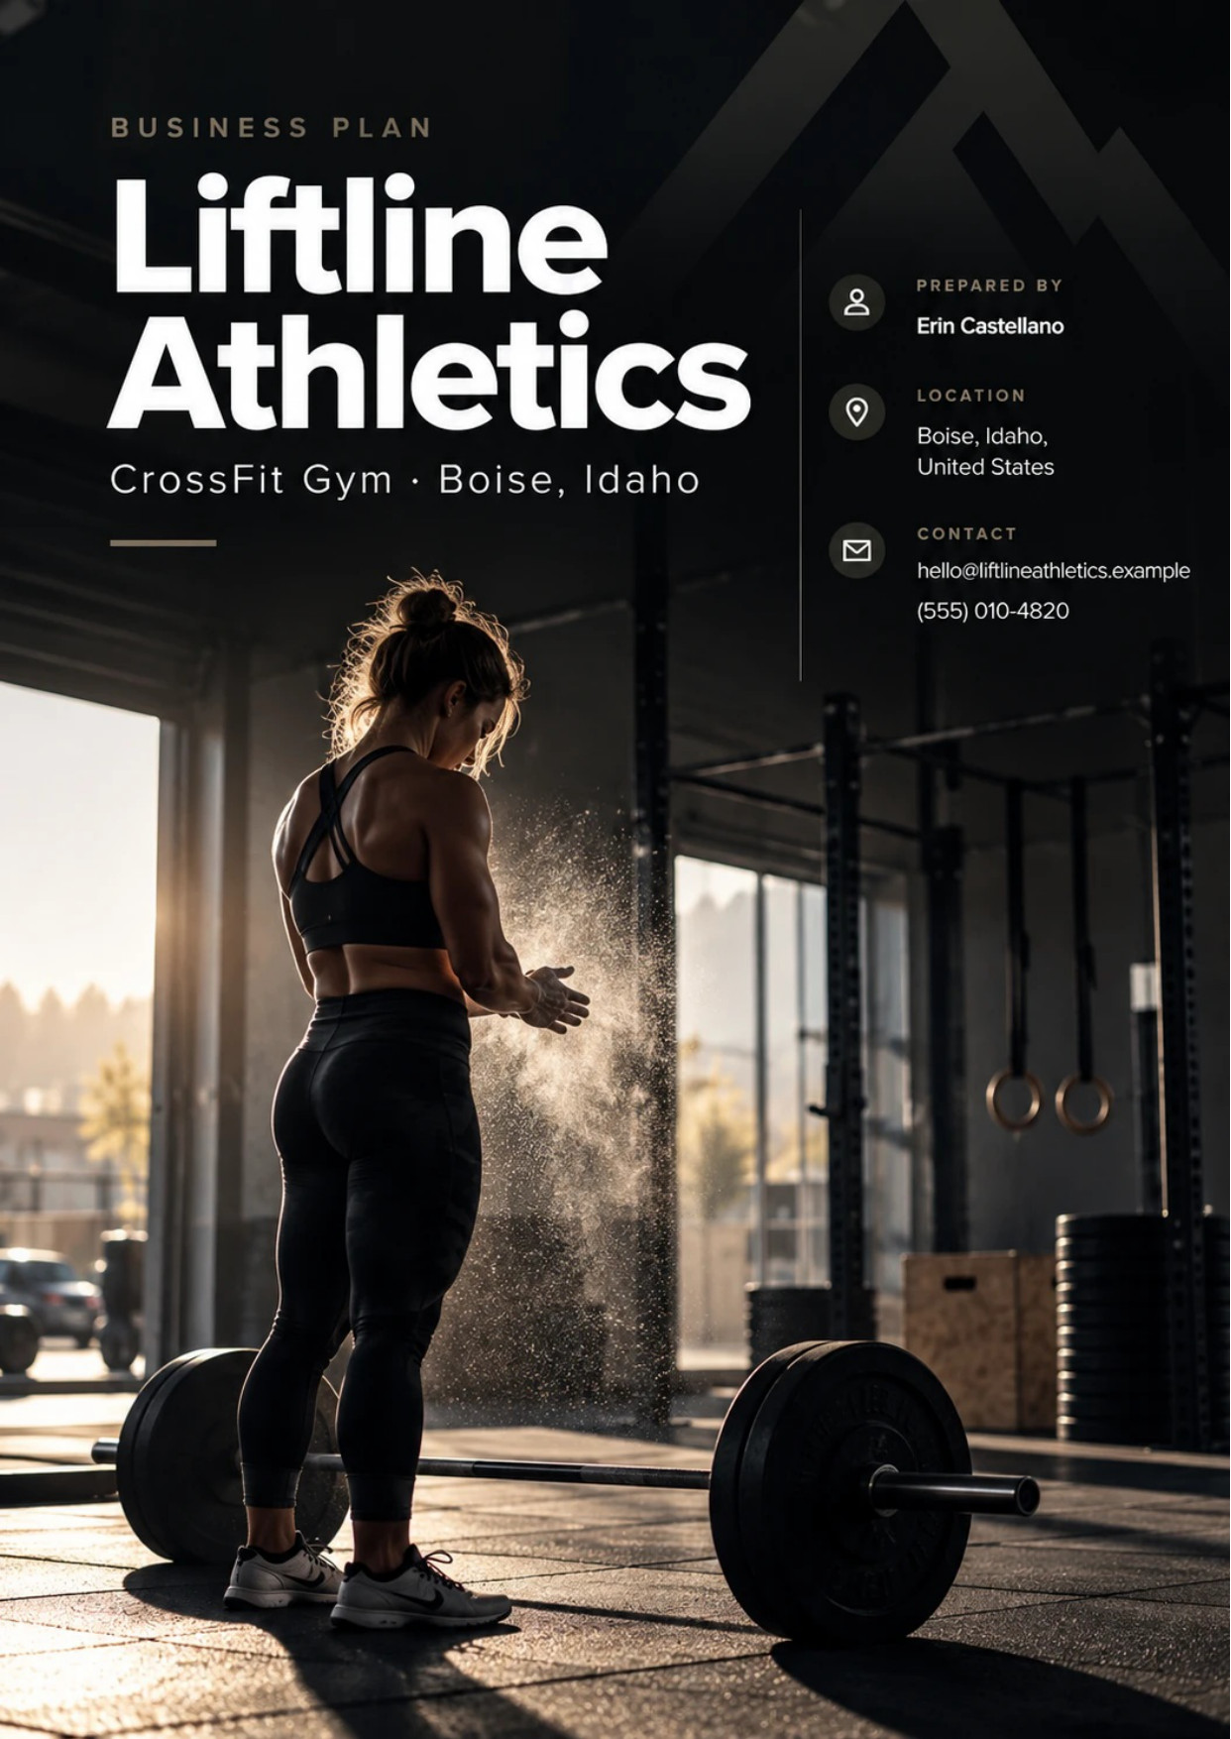
Table of Contents
1. Executive Summary 6
1.1 Business Overview 7
1.2 Mission Statement 7
1.3 Location & Market Opportunity 7
1.4 Unique Selling Points 7
1.5 Financial Highlights 8
1.6 Funding Requirement 8
1.6.1 Income Statement (3 Year projections) 8
2. Company Overview 9
2.1 Legal Structure 10
2.2 Vision Statement 10
2.3 Background & History 10
2.4 Future Goals 10
2.4.1 Business Owners 11
2.4.2 SMART Goal 11
3. Market Analysis 12
3.1 Overview 13
3.2 Market Segmentation 13
3.3 Market Trends 13
3.4 Local Market Outlook 13
3.5 Market Size 14
4. Customer Analysis 15
4.1 Target Market 16
4.2 Customer Segments 16
4.3 Customer Persona 17
4.4 Customer Purchase Journey 17
5. Competitive Analysis 18
5.1 Competitors 19
5.2 Comparison 19
5.3 Competitive Edge 20
5.4 SWOT Analysis 21
6. Services Offered 22
6.1 Our Offering 23
6.2 Signature Items 23
6.3 Additional Services 23
6.4 What Sets Us Apart 23
6.5 Programming & On-Ramp Program 24
6.5.1 Coached CrossFit Membership 24
6.5.2 Personal Training and Nutrition Coaching 25
6.5.3 Features 26
6.5.4 Pricing 26
7. Marketing & Sales Strategies 27
7.1 Market Positioning 28
7.2 Marketing Objectives 28
7.3 Online Marketing 29
7.4 Public Relations and Branding 29
7.5 Partnership & Collaboration Strategy 29
7.6 Customer Loyalty & Retention 30
7.7 Sales Channels 30
8. Operations Plan 31
8.1 Daily Operations 32
8.2 Working Hours 32
8.3 Staffing & Training 32
8.4 Inventory & Equipment Management 32
8.5 Location and Facilities 32
8.6 Milestones & Timeline 33
8.7 Affiliate Licensing & Liability Coverage 34
9. Management Team 35
9.1 Key Members 36
9.2 Organization Chart 36
9.3 Advisory Board Members 37
9.3.1 Hiring Plan 37
10. Financial Plan 38
10.1 Key Assumptions 39
10.2 Capital Requirements and Use of Funds 39
10.2.1 Use of Funds 40
10.3 Income Statement (3 Year projections) 41
10.4 Balance Sheet (3 Year projections) 42
10.5 Cash Flow Statement (3 Year projections) 43
10.6 Break Even Analysis 44
11. References 45
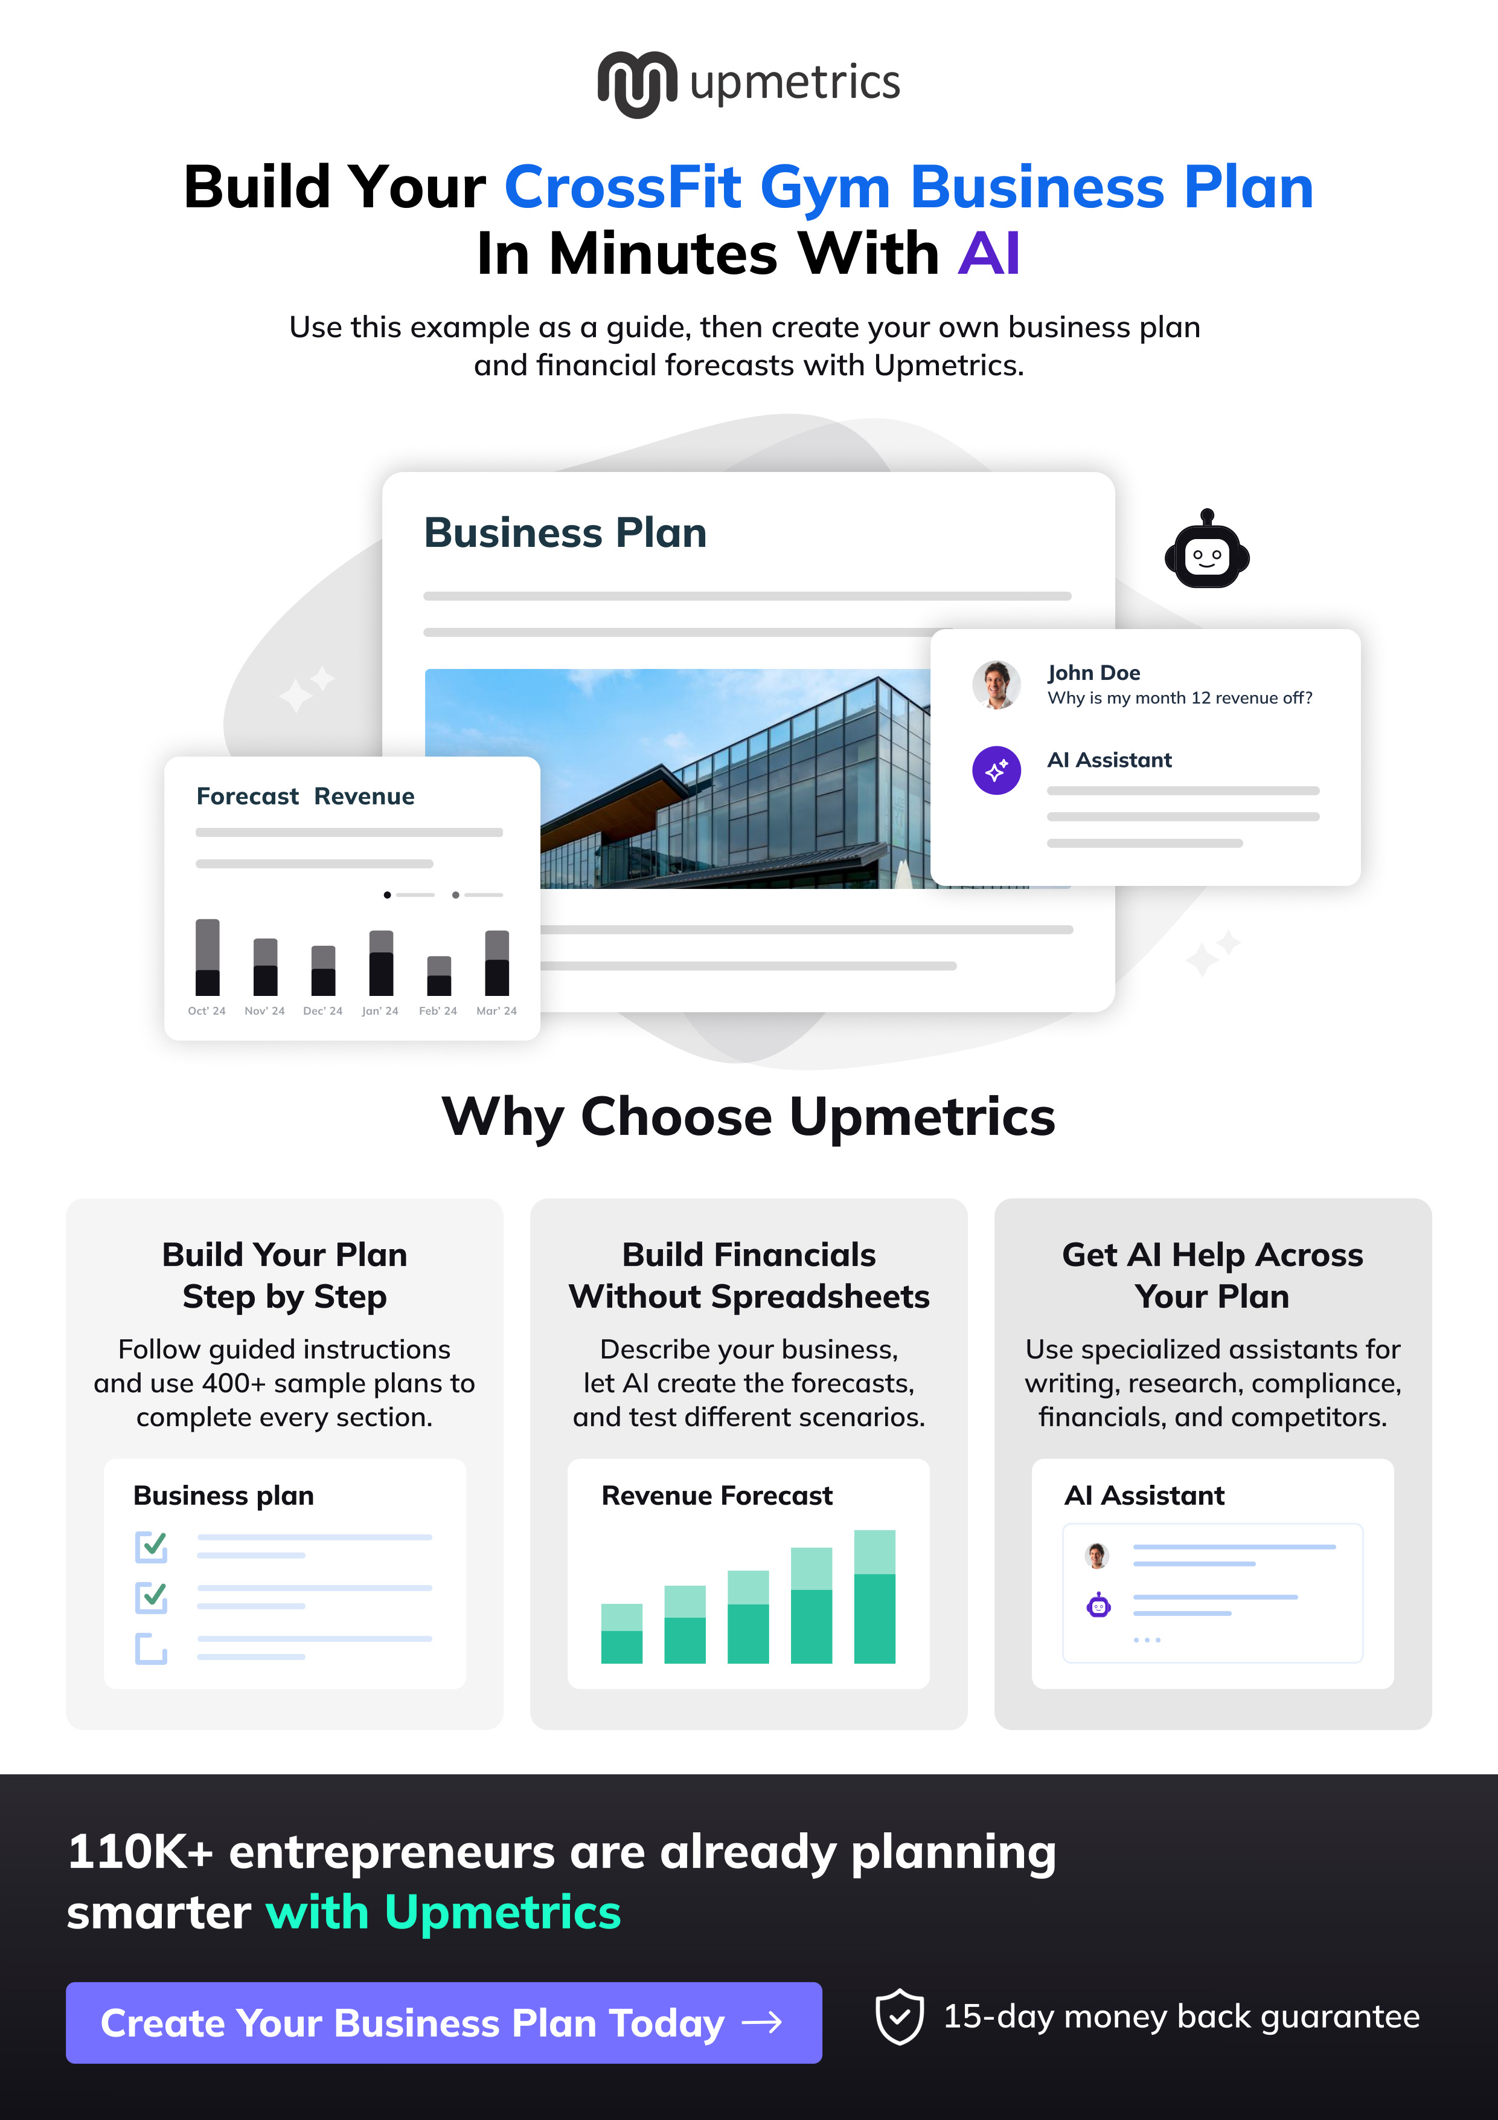

CHAPTER 1

Executive Summary

1.1 Business Overview
1.2 Mission Statement
1.3 Location & Market Opportunity
1.4 Unique Selling Points
1.5 Financial Highlights
1.6 Funding Requirement

1.1 Business Overview
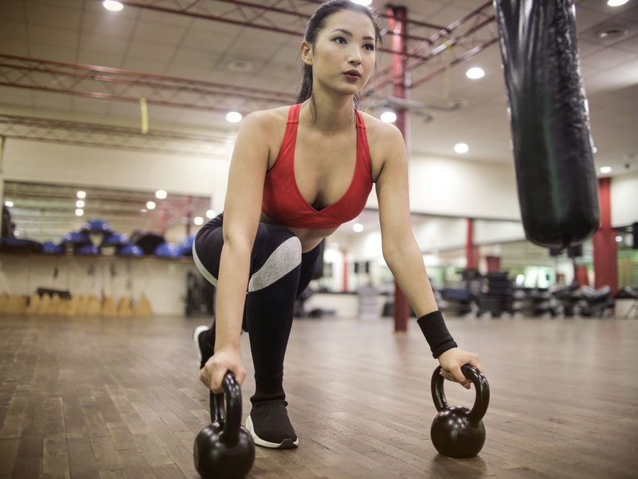
Liftline Athletics is an independent CrossFit affiliate gym planned for Boise, Idaho. It sells coached group classes in strength, conditioning and Olympic lifting on an open training floor of about 4,500 square feet, in hour-long sessions of up to 14 athletes per coach.
Members start with a two-week Fundamentals course, then join on a three-times-weekly or unlimited membership. Personal training, nutrition coaching, a kids and teens program and drop-ins are sold alongside. The gym is built for Boise adults aged roughly 25 to 50 who want to be coached rather than left to train alone.

1.2 Mission Statement
To give Boise a gym where every lift is coached, where a nervous beginner and a seasoned competitor can share the same class, and where members keep training for years because they can see their own progress.

1.3 Location & Market Opportunity
Boise City had 237,963 residents in July 2024 and Garden City, which Boise surrounds, 12,936, a catchment of about 250,900 people. Ada County grew 8.2% between 2020 and 2024 to 535,799 residents, and Boise's median household income was $81,102, a base that can pay for coached fitness.
The CrossFit directory lists seven affiliates in Boise, most of them over a decade old, and two former Boise affiliates have left it. Boise's population is growing faster around the city than the number of boxes serving it.
US gym, health and fitness clubs earn $47.1 billion a year. The Boise and Garden City CrossFit market is about $3.1 million a year, an upper estimate built from the seven affiliates and the national average revenue per gym business, and a single class-based box takes about $231,000 a year on the national benchmark.

1.4 Unique Selling Points
- Classes capped at 14 athletes per coach, so each lift is watched and scaled.
- A required two-week Fundamentals course before anyone joins a class.
- Personal training and nutrition coaching from the same coaches, in the same building.
- A goal review with a coach every 90 days for every member.
- Month-to-month memberships from $149, with no long contract.

1.5 Financial Highlights
Revenue comes from 130 active members at a blended $165 a month, ancillary sales worth a further 12% of the membership book, and 60 personal training sessions a month at $75. The gym opens at 40% of that book on its founding members and builds to it over ten months.
Revenue is projected at $256,716 in the first year, $295,223 in the second and $339,507 in the third, at a gross margin of 88.0% throughout. Net income is $125 in the first year, then $13,082 and $27,830, a net margin of 8.2% by the third year. Break-even revenue is $220,593, the equivalent of 111 members, which the first year clears. Third-year net income is $6,949 in the conservative case and $56,032 in the upside case.

1.6 Funding Requirement
The startup budget is $155,200. It pays for the training equipment, rubber flooring and fit-out, CrossFit affiliation and coach certification, deposits, launch marketing and a working capital reserve. It is funded by a $65,000 owner contribution and a $90,000 SBA 7(a) loan at 10.5% over seven years, and profits stay in the business while the member book fills.
The plan rests on a head coach with years of programming experience, a growing county whose established boxes leave room for a beginner-first gym, and a membership model that covers its costs inside the first year. The money builds one well-coached floor and the member book that keeps it full.

1.6.1 Income Statement (3 Year projections)
 | Year 1 | Year 2 | Year 3 | Total
Revenue | $256,716.00 | $295,223.40 | $339,506.91 | $891,446.31
Cost of Sales | $30,805.92 | $35,426.81 | $40,740.83 | $106,973.56
Gross Margin | $225,910.08 | $259,796.59 | $298,766.08 | $784,472.75
Operating Expense | $194,122.20 | $211,450.53 | $231,378.12 | $636,950.85
Total Expense | $256,591.16 | $282,141.89 | $311,677.11 | $850,410.16
Net Income | $124.84 | $13,081.51 | $27,829.80 | $41,036.15

CHAPTER 2

Company Overview

2.1 Legal Structure
2.2 Vision Statement
2.3 Background & History
2.4 Future Goals

2.1 Legal Structure
Liftline Athletics will be formed as an Idaho limited liability company, filed with the Idaho Secretary of State, which charges $100 for an online Certificate of Organization. The two founders are its members, and an operating agreement sets out decision rights, capital contributions and what happens if either founder leaves.

2.2 Vision Statement
To be the gym in Boise where people learn to lift properly and keep coming back, measured not by how hard a workout feels but by how many members are still training, and still improving, three years after their first class.

2.3 Background & History
Liftline Athletics is a new business that has not yet opened. Its founders, Erin Castellano and Tyler Brandt, plan to open it after years on the coaching and operating sides of fitness and health care.
Erin Castellano has coached CrossFit for nine years, holds a Level 2 certificate, and has written the programming and trained the coaches at an established affiliate. One pattern kept repeating there: members who skipped the basics got hurt or stopped coming, while those who learned the lifts first stayed for years.
Tyler Brandt spent six years managing a physical therapy clinic, running the schedule, the billing and the follow-up that brings patients back. Many of the clinic's patients were recovering from training they had attempted with no coaching at all, and asked where they could train safely once discharged.
Liftline is the answer the two arrived at: a gym that makes coaching the product, requires a Fundamentals course before anyone joins a class, and runs its member follow-up with the discipline of a clinic. The name refers to the bar path, the line a barbell travels in a well-executed lift.

2.4 Future Goals
In the first 0 to 18 months the goal is to open with about 50 founding members from a pre-sale, reach the 111 members that cover the gym's costs within ten months, and complete the ramp at about 130 active members. Two Level 1 coaches join the founders, the kids and teens program opens in the first autumn, and the personal training book reaches about 60 sessions a month.
Over 1 to 3 years, which the financial projection covers, revenue grows from $256,716 to $339,507 by filling the remaining class spots and adding personal training and nutrition coaching. A second full-time coach is hired, HYROX-style race training is added to the schedule, and the gym runs an in-house competition twice a year.
Over 3 to 5 years the founders intend to repay a meaningful share of the SBA loan from retained profits, then choose between adding an adjoining unit for Olympic lifting and recovery or opening a second Treasure Valley box under the same coaching system, depending on whether the first holds a full member book and a waiting list.

2.4.1 Business Owners
Erin Castellano | Tyler Brandt

Total ownership: 100%
60% | Erin Castellano  6,000 Shares
40% | Tyler Brandt  4,000 Shares

2.4.2 SMART Goal
  Specific  - Reach 111 active members, the break-even book.  - Owned by the two founders and the coaching team.  - Filled through intro sessions, Fundamentals and referrals. |   Measurable  - Active members, counted weekly.  - Intro session to Fundamentals conversion.  - Monthly cancellations below 5% of members. |   Achievable  - About 50 founding members at opening.  - Average big group gyms carry 101 to 158 members.  - Two Level 1 coaches add class capacity.
  Relevant  - Break-even revenue is $220,593.  - Memberships carry about 88% of a box's revenue.  - The full book funds a second coach. |   Time-Based  - Pre-sale opens six weeks before opening.  - 111 members within ten months of opening.  - Reviewed monthly from the first month.

CHAPTER 3

Market Analysis

3.1 Overview
3.2 Market Segmentation
3.3 Market Trends
3.4 Local Market Outlook
3.5 Market Size

3.1 Overview
Liftline Athletics sells into the US gym, health and fitness club industry, which IBISWorld puts at $47.1 billion in 2026 across 107,878 businesses. The industry has recovered fully from the pandemic: Census figures for fitness and recreational sports centers show revenue of $38.7 billion in 2022 against $25.1 billion in 2020.
Demand sits at a record. 81 million Americans held a fitness facility membership in 2025, up 5.2% on 2024, a penetration rate of 26.1%. Yet only 32% of Americans met the federal guideline of 150 minutes of activity a week, which leaves a large group who know they should train and have not found a way to keep doing it.

3.2 Market Segmentation
The industry divides by how much coaching a member buys, which is also how it divides on price:
- Budget and big-box gyms: open access at low monthly prices, with little or no coaching.
- Franchise class studios: coached HIIT or strength classes in a branded format, usually in retail space.
- CrossFit affiliates and functional fitness gyms: coached barbell, gymnastics and conditioning classes in small groups, independently owned.
- Personal training studios: one-to-one or very small group coaching at the highest price per member.
CrossFit affiliates are licensees rather than franchises. Each pays $4,500 a year to use the name, its coaches must hold the $1,150 Level 1 certificate, and each owner sets prices and programming, so affiliates compete on coaching quality and community rather than on a shared format.

3.3 Market Trends
- Younger adults are the most likely to belong: 35.5% of 18 to 24 year olds hold a membership, while members aged 65 and over are the fastest-growing group at 8.6% a year.
- Retention is the industry's main economic lever. Larger operators reported a 66.4% member retention rate in 2024, so a gym that keeps members longer needs far fewer new ones.
- Coaching labour is available and growing: fitness trainers held 388,400 positions in 2025, with 7% growth projected to 2035.

3.4 Local Market Outlook
Boise is the whole of Liftline's market. Boise City had 237,963 residents in July 2024 and Garden City 12,936, a catchment of about 250,900. The wider Ada County grew 8.2% to 535,799 between 2020 and 2024, and the Boise City metro grew 10.6% to 845,877, so most new arrivals are settling around the city.
Boise's median household income was $81,102 in 2024 and its median age 40.0. At county level, 17.9% of Ada County adults report no leisure-time physical activity, the beginners a structured on-ramp is built for. No Boise figure for CrossFit participation is published.
Supply is concentrated in seven Boise affiliates, with none in Garden City, and 15 across the Treasure Valley. Most have been affiliated for over a decade, and two former Boise affiliates no longer appear in the directory. Around them sit two Planet Fitness clubs, VillaSport's four former Axiom Fitness clubs across the valley, and a proposed Vasa Fitness site with an Olympic lifting studio.
Trading costs are moderate. Boise industrial asking rent averaged $0.91 per square foot a month in the second quarter of 2026, with vacancy at 9.9%, and fitness trainers in the Boise metro earn a mean $25.62 an hour. Idaho levies 6% sales tax, but a separately stated fee for an instructor-led class is exempt.

3.5 Market Size
The total addressable market is the US gym, health and fitness club industry, $47.1 billion a year in 2026.
The serviceable market is Boise and Garden City, the one market Liftline can reach. No local spending figure is published, so it is sized at about $3.1 million a year: seven affiliates multiplied by the national average revenue per gym business. That average includes large health clubs, so $3.1 million is an upper estimate; on the class-based benchmark the same seven boxes take about $1.6 million.
The obtainable market is one box's revenue, about $231,000 a year at the midpoint of the national range for class-based gyms. Liftline's first-year projection of $256,716 sits inside that range.
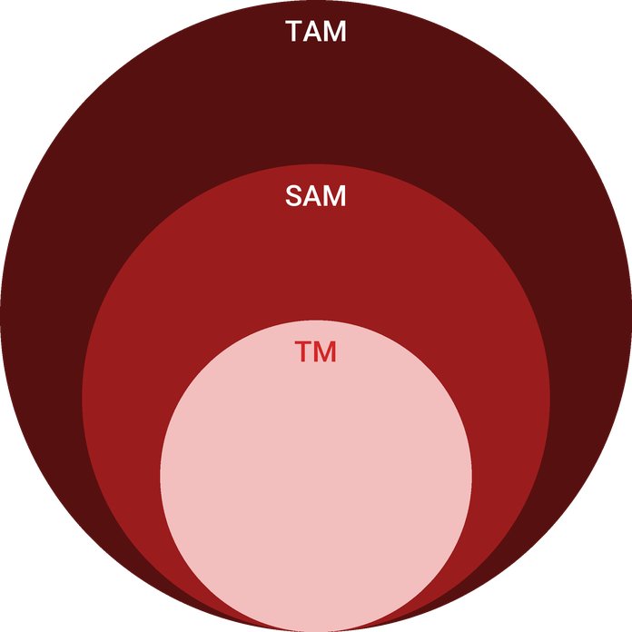
  ● | Total Available Market (TAM)  US gym, health and fitness club revenue is $47.1 billion in 2026 (IBISWorld), up 1.8% on 2025, after 3.7% compound annual growth from 2021 to 2026. | 47.1B
  ● | Served Available Market (SAM)  The Boise and Garden City CrossFit market is about $3.1 million a year in 2026: 7 affiliates x about $436,600 national revenue per gym business (IBISWorld), an upper estimate; at the national class-based benchmark it is about $1.6 million. | 3.1M
  ● | Target Market (TM)  One class-based box takes about $231,000 a year, the midpoint of Two-Brain's 2025 average band of $13,500 to $24,999 a month for big group gyms; a national figure, not a Boise one. | 231.0k

CHAPTER 4

Customer Analysis

4.1 Target Market
4.2 Customer Segments
4.3 Customer Persona
4.4 Customer Purchase Journey

4.1 Target Market
Liftline's market is adults in Boise and Garden City aged roughly 25 to 50 who want structured, coached strength training and will pay for it. The catchment holds about 250,900 people, Boise's median household income was $81,102 in 2024, and its median age 40.0, which places most of the target in its working and family years.
These are people who have tried to get fit before. Many have held a gym membership that lapsed, and nationally only 32% of Americans meet the guideline of 150 minutes of activity a week. What they lack is not access to equipment, which is cheap in Boise, but someone to tell them what to do and check that they are doing it right.
Demand in the catchment is growing. Ada County added residents at 8.2% between 2020 and 2024 and the wider metro at 10.6%, much of it working adults and families settling around the city. At county level 17.9% of adults report no leisure-time physical activity and 29.0% are obese, a large group who would gain from strength training but rarely start without coaching. Boise's seven affiliates serve the market from its experienced end; the newcomer who has never held a barbell is the customer Liftline is built to win.

4.2 Customer Segments
The target splits into four groups, each buying something different:
- Returning athletes, aged 28 to 45: former high school or college athletes who want structure and competition again. They buy unlimited memberships and are the likeliest to add personal training before a competition.
- Busy professionals and parents, aged 30 to 50: people with a fixed hour at 5 a.m., noon or 5:30 p.m. They buy three-times-weekly memberships and value a class that starts and ends on time.
- Big-box gym leavers, aged 25 to 40: people who paid for open access and never built a routine. They come in through the free intro session and Fundamentals course, and stay if the coaching holds them.
- Teenagers and their parents: school athletes and beginners aged 12 to 17 in the kids and teens program, usually enrolled by a member parent.
By value, returning athletes and professionals will make up most of the member book, since they buy the monthly memberships. Gym leavers matter most for growth, as the largest group in the catchment and the one no established box targets directly, and the youth program adds a second book that runs on the school calendar.
The persona below stands for the first group, the returning athlete, because that segment converts fastest, refers most and buys the most add-on coaching.

4.3 Customer Persona
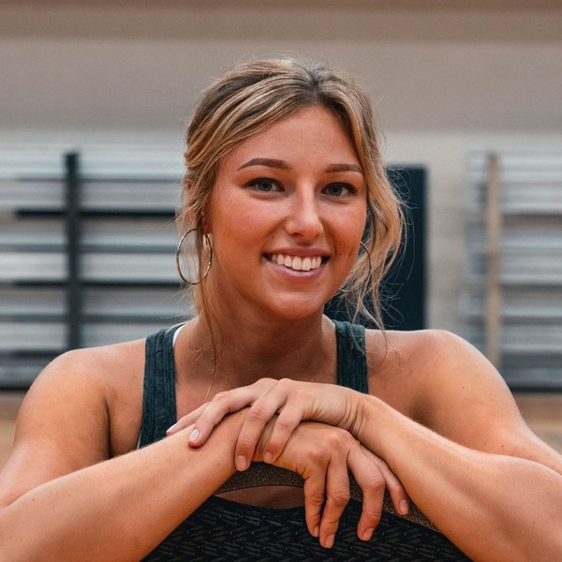  Lauren Park  Demographics  Age: 34  Marital Status: Married, one child  Location: Boise, ID  Income: $92,000 household  Professional Role  Education: Bachelor's degree in Nursing  Job: Registered nurse on rotating shifts | “I want a coach to tell me exactly what to do for an hour and make sure I am doing it right.”
   | Identifiers / Personality Traits  - Played high school volleyball and has lifted on and off since  - Lets a big-box membership lapse every few months  - Trains before or after shifts, often at 6 a.m. or 5:30 p.m.
   | Goals  - Get stronger and fitter without having to design the workouts  - Learn to lift a barbell with safe technique  - Train three or four times a week around changing shifts
   | Challenges  - Worries that CrossFit classes are too intense for a returning beginner  - Has tried group classes where no coach corrected technique  - Needs class times that fit a rotating schedule

4.4 Customer Purchase Journey
A CrossFit membership is a considered purchase, made by people who usually know someone who trains. The journey runs in five steps:
- Awareness: a friend's invitation to a Saturday partner workout, an Instagram post or a search for CrossFit in Boise.
- Intro session: a free 30-minute meeting with a coach covering goals, past injuries and a short movement screen, booked online.
- Fundamentals: six small-group sessions over two weeks that teach the core lifts and gymnastics movements, paid upfront.
- Joining: a three-times-weekly or unlimited membership, billed monthly, chosen with the coach at the end of Fundamentals.
- Retention: a goal review with a coach every 90 days, progress logged in the member app, and in-house competitions that give the training a target.
The choice between boxes is made at the intro session and in the first weeks of Fundamentals. Boise's affiliates route prospects to a free intro rather than publishing prices, so Liftline wins or loses on the quality of that first conversation and how well the beginner is coached through it.

CHAPTER 5

Competitive Analysis

5.1 Competitors
5.2 Comparison
5.3 Competitive Edge
5.4 SWOT Analysis

5.1 Competitors
Liftline competes for the same Boise adults as four kinds of gym. The direct competition is the seven CrossFit affiliates listed in Boise. Most have trained members for over a decade, and one operator, Verdant, runs two of the seven. They have loyal members, referral networks and coaches the community already knows.
Those strengths are the ones a new box cannot buy: years of member relationships, coaches with local reputations and a calendar of community events. Their constraint is the same history. Members who have trained together for a decade set the pace of a class, which can make a beginner's first weeks harder.
None of the Boise boxes checked publishes a monthly membership price, but their drop-in rates show where the local market sits: $30 a class at Verdant CrossFit, and $20 a class or $50 a week at Boise CrossFit. Boise CrossFit also runs a short on-ramp for newcomers.
Around the affiliates sit the cheaper options. Planet Fitness runs two Boise clubs, nationally at $15 a month for its Classic membership, and the YMCA of the Treasure Valley charges about $53.90 a month for an adult. VillaSport owns four former Axiom Fitness clubs across the valley, and Vasa Fitness has filed plans for a Boise gym with an Olympic lifting studio.
The market is not closed. Two former Boise affiliates no longer appear in the CrossFit directory, which points to turnover, and Ada County is adding residents faster than the boxes are adding capacity.

5.2 Comparison
Against the other affiliates, Liftline offers the same core service, coached barbell and conditioning classes, so the comparison is on how it is delivered rather than on what it is. Against the big-box gyms and the YMCA, Liftline costs several times more and offers no 24-hour access; what it sells instead is an hour with a coach watching every lift.
Its differences from the established boxes are a firm cap of 14 athletes per class, a Fundamentals course that every new member must complete, quarterly goal reviews, and personal training and nutrition coaching delivered by the same coaches who run classes. Its disadvantages are equally clear: no member base, no reviews, and no referral history on opening day.
Feature | Liftline Athletics | Established CrossFit affiliates | Big-box gyms | Franchise HIIT studios
Coach-led barbell and Olympic lifting instruction | ✓ | ✓ | ✗ | ✗
Structured on-ramp course for beginners | ✓ | ✓ | ✗ | ✗
Personal training and nutrition coaching in-house | ✓ | ✓ | ✓ | ✗
Membership under $60 a month | ✗ | ✗ | ✓ | ✗
24-hour open access | ✗ | ✗ | ✓ | ✗

5.3 Competitive Edge
Liftline's edge is a beginner-first coaching system run with clinic-style follow-up. The head coach brings nine years of experience writing programming and developing coaches, and the operations founder brings six years of running patient scheduling and retention at a physical therapy clinic.
The edge is not price. Open-access gyms run from $15 to about $53.90 a month; Boise's affiliates sit well above them, with drop-ins at $20 to $30 a class; and Liftline's memberships at $149 and $179 a month place it inside the affiliate band rather than below it. A lower price would need more members per coach, which would undo the product.
That combination targets the point where gyms lose members. Larger operators retained 66.4% of members in 2024, so roughly a third leave each year; a box that keeps members longer needs fewer new ones to fill its classes. Liftline's 90-day reviews, tracked progress and small classes are designed to hold members past the first year.
The edge has limits. Nothing stops an established box adding a stricter on-ramp or smaller classes, and at least one in Boise already runs a short on-ramp. What is harder to copy is the follow-up: a quarterly review for every member and a coach who messages anyone absent for ten days take staff time that a box at its member ceiling rarely has, and both are built into Liftline's schedule from the first week.
A new box also has practical advantages over established ones: new equipment chosen for its own programming, a layout planned for classes of 14, and the freedom to set its schedule around the 5 a.m., noon and evening hours its target market actually trains.
   | Classes capped at 14 athletes  Every class runs with one coach to at most 14 athletes, so each lift is watched and scaled in the moment rather than corrected after the fact.
   | A two-week Fundamentals course  No one joins a class until they have learned the core lifts in six small coached sessions, which keeps beginners safe and keeps classes moving.
   | Coaching beyond the class hour  Personal training and nutrition coaching are sold in the same building by the same coaches, so a member can add help without changing gyms.
   | 90-day goal reviews  Each member sits down with a coach every quarter to set targets and review progress, the habit that keeps members training past their first year.

5.4 SWOT Analysis
Strengths  - Classes capped at 14 athletes give every member a coach's eye on each lift.  - A Level 2 head coach with nine years of coaching leads programming and coach development.  - A required Fundamentals course turns beginners into safe class members within two weeks.  - Personal training and nutrition coaching add revenue from members already in the building. | Weaknesses  - A new box opens with no member base, reviews or referral history in Boise.  - Two founders carry most of the coaching hours until the second coach is hired.  - Fixed rent and the affiliate fee are owed whether classes are full or not.
Opportunities  - Ada County grew 8.2% since 2020, adding adults who have not yet chosen a gym.  - Two former Boise affiliates have left the CrossFit directory, so their members may be looking for a new box.  - HYROX-style race training draws runners and endurance athletes into strength classes.  - A kids and teens program reaches member families and local school athletes. | Threats  - Seven established Boise affiliates already hold loyal members and referral networks.  - Big-box gyms at $15 a month anchor what newcomers expect to pay.  - A further rise in the CrossFit affiliate fee would raise fixed costs again.  - Rising Boise industrial rents could raise the cost of a renewal or expansion.

 Strategic Summary
Liftline should compete on coaching rather than price, filling classes through the Fundamentals course and member referrals. Personal training and quarterly goal reviews should carry retention while fixed costs are covered.

CHAPTER 6

Services Offered

6.1 Our Offering
6.2 Signature Items
6.3 Additional Services
6.4 What Sets Us Apart
6.5 Programming & On-Ramp Program

6.1 Our Offering

Liftline sells coaching. Every product is a way of buying time with a coach who knows the member's training history: in a class of up to 14 athletes, one to one, or around food and recovery outside the gym.
The core is the coached CrossFit membership. Classes run for an hour and follow the same structure every day: a warm-up, a strength or skill block, a conditioning workout scaled to each athlete, and a cool-down. Members train on either a three-times-weekly plan at $149 a month or unlimited at $179 a month, both month to month.

6.2 Signature Items
- Unlimited membership at $179 a month: every class on the schedule, open gym, member events and a 90-day goal review.
- Three Times Weekly at $149 a month: 12 coached classes a month for members with a fixed routine.
- Unlimited Plus Coaching at $299 a month: unlimited classes, two personal training sessions a month and a monthly nutrition check-in.
- Olympic lifting clinic: a weekly technique class on the snatch and the clean and jerk, included in unlimited memberships.

6.3 Additional Services
Personal training is sold at $75 a session in packs of four or eight, booked through the member app and delivered outside class times. Most of it is bought by new members in their first months and by athletes preparing for a competition. Nutrition coaching runs alongside as a monthly check-in.
The kids and teens program, opening in the first autumn, runs after-school classes for ages 8 to 17 with a coach who has worked in youth strength and conditioning. Drop-ins are open to visiting athletes who book a single class online, and a small retail shelf carries Liftline apparel, grips, wrist wraps and supplements.

6.4 What Sets Us Apart
Three things set the offer apart in Boise. Classes are capped at 14 athletes per coach, so the coach can watch and correct every lift rather than run the clock. No one joins a class without passing through Fundamentals, which keeps beginners safe and keeps classes moving. And each member sits down with a coach every 90 days to review progress against goals they set, so the training always points somewhere.
Coaching outside the class is sold by the same people who coach the class. A member who needs help with a lift, a return from injury or a diet does not have to find a separate trainer; the coach who already knows their history books the session.

6.5 Programming & On-Ramp Program
Programming is written in-house each week by the head coach and published in the member app the Sunday before. It runs in eight-week strength cycles, built around the squat, deadlift, press and Olympic lifts, with conditioning that varies daily across rowers, air bikes, ski ergs, kettlebells, gymnastics and running. Every workout carries three written versions, beginner, intermediate and competitor, with the loads and movements for each.
The on-ramp is the Fundamentals course: six coached sessions over two weeks, in groups of no more than four. It teaches the nine foundational movements (air squat, front squat, overhead squat, shoulder press, push press, push jerk, deadlift, sumo deadlift high pull and medicine ball clean), plus the pull-up progressions, rowing technique and how to read the whiteboard. A coach signs off each movement before the member joins a class.
Testing anchors the cycle. Members retest a benchmark workout and a strength lift every eight weeks, and the results feed the 90-day goal review, so progress is measured rather than assumed.

6.5.1 Coached CrossFit Membership
Coached group classes in strength, conditioning and Olympic lifting, run in hour-long sessions of up to 14 athletes. Every workout is written in-house and scaled for each athlete, so a beginner and a competitor train side by side.
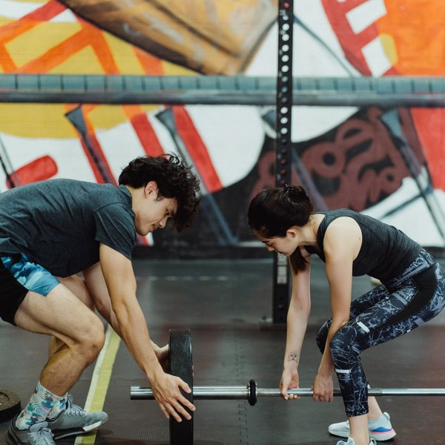 | From $149 per month  Three-times-weekly and unlimited memberships are billed monthly by card with no long contract. New members start with the two-week Fundamentals course before joining classes.

Specifications
- About 32 coached classes a week from 5 a.m. to 7:30 p.m.
- Classes capped at 14 athletes per coach.
- Programming written weekly and published in the member app.
- Saturday open gym and partner workouts.
- A goal review with a coach every 90 days.

6.5.2 Personal Training and Nutrition Coaching
One-to-one sessions with a Liftline coach for members who want faster progress, to fix a lift, to come back from time off or to prepare for a competition. Nutrition coaching runs alongside it as a monthly check-in on habits, meals and body composition.
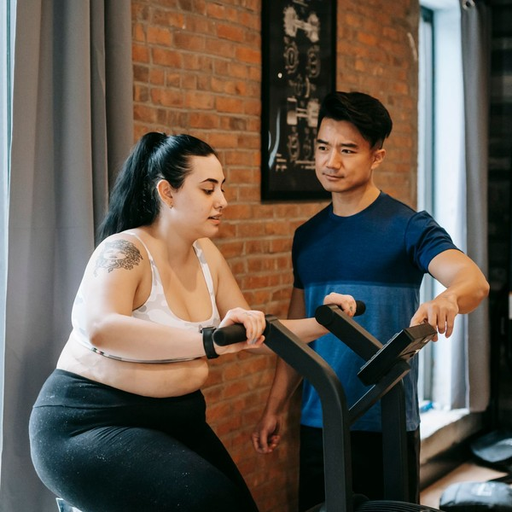 | $75 per session  Sold in packs of four or eight sessions and booked through the member app. Members on the Unlimited Plus Coaching tier receive two sessions a month in their membership.

Specifications
- Sixty-minute sessions on the main floor outside class times.
- Delivered by Level 1 certified coaches.
- Individual program written after an initial movement assessment.
- Nutrition check-ins held monthly in person or by video.
- Progress tracked in the same app as class workouts.

6.5.3 Features
  Fundamentals on-ramp
  Six small-group sessions over two weeks teach the core lifts and gymnastics movements before a member joins class.
   | Scaled programming  Every workout has written beginner, intermediate and competitor versions so each athlete trains at the right load.
   | Olympic lifting clinic  A weekly technique class on the snatch and clean and jerk, included in unlimited memberships.
   | Open gym  Members use the floor for their own training whenever no class or session is booked.
  Member app tracking
  Workouts, scores and personal records are logged in the gym's app so progress is visible over months.
  90-day goal reviews
  A coach meets each member quarterly to review progress and set the next targets.

6.5.4 Pricing
Three Times Weekly  $149  per month  - 12 coached classes a month  - Saturday open gym  - Workouts and scores in the member app  - 90-day goal review |  | Most Popular  Unlimited  $179  per month  - Unlimited coached classes  - Open gym whenever the floor is free  - 90-day goal review  - Member events and in-house competitions |  | Unlimited Plus Coaching  $299  per month  - Everything in Unlimited  - Two personal training sessions a month  - Monthly nutrition coaching check-in  - Individual accessory programming

CHAPTER 7

Marketing & Sales Strategies

7.1 Market Positioning
7.2 Marketing Objectives
7.3 Online Marketing
7.4 Public Relations and Branding
7.5 Partnership & Collaboration Strategy
7.6 Customer Loyalty & Retention
7.7 Sales Channels

7.1 Market Positioning
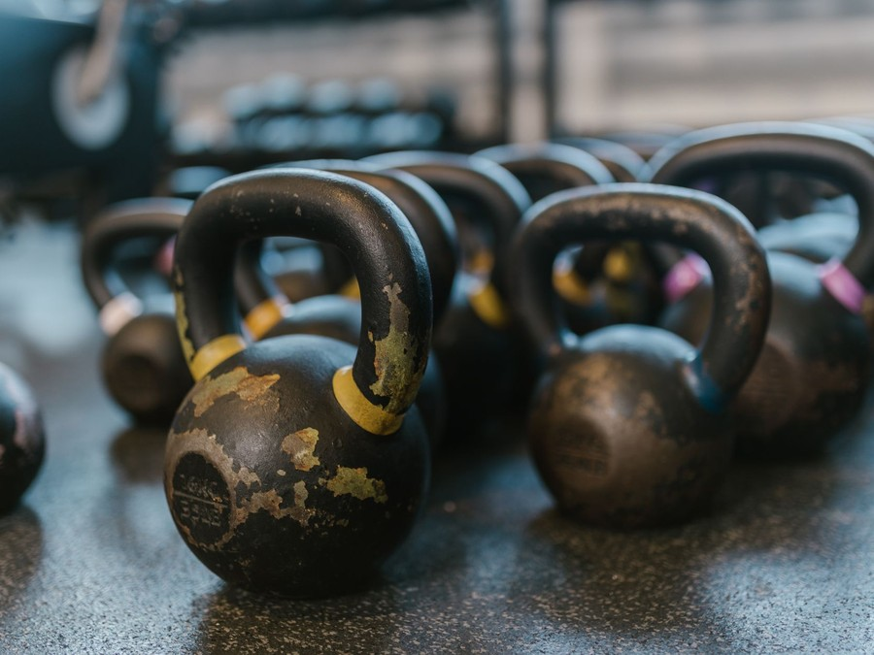
Liftline is positioned as the coached, beginner-first CrossFit box in Boise: more personal than the big-box gyms and the YMCA, and more structured for newcomers than the established affiliates. It competes on coaching quality and how long members stay, not on price.

7.2 Marketing Objectives
- Sign about 50 founding members through the pre-sale before opening.
- Reach 111 active members, the break-even book, within ten months of opening.
- Complete the ramp at about 130 active members.
- Convert at least half of intro sessions into the Fundamentals course.
- Build personal training to about 60 sessions a month.
- Hold monthly cancellations below 5% of the member book.
Marketing is budgeted at 5% of revenue, spent on referral rewards, local paid social, community events and the search listing, because at this size the people who join are mostly a short drive away or know someone who trains.
Member referral rewards  $322  per month  Bring-a-friend Saturdays and a free month for each member who refers someone who joins. |  | Local paid social  $321  per month  Instagram and Facebook ads aimed at adults within a short drive of the box.
Community events  $267  per month  Free outdoor workouts, a twice-yearly in-house competition and local race booths. |  | Search and maps listing  $160  per month  Google Business Profile upkeep and search ads for gym and CrossFit searches in Boise.

Total marketing budget: $12,836 a year, $1,070 a month.

7.3 Online Marketing
Instagram carries the brand: short videos of members hitting a first pull-up or a lifting record, coaching tips and the week's workouts, posted daily by the coaches. Paid social on Instagram and Facebook targets adults within a short drive of the box, with one offer only: book a free intro session.
The website exists to book that session. It carries the schedule, the coaches, the Fundamentals course and member stories, with prices listed openly, which no Boise box checked currently does. A maintained Google Business Profile and a small search budget capture people searching for CrossFit or a gym in Boise, and every new member is asked for a review after their first month.
Email carries the rest of the funnel. Everyone who books an intro receives a short sequence explaining Fundamentals and the first month, and members get a weekly note with the coming week's training focus and events. Results are read monthly from the gym software: cost per booked intro by channel, intro to Fundamentals conversion and Fundamentals to membership conversion, so spend moves to what produces members rather than clicks.

7.4 Public Relations and Branding
The brand is built around the idea in the name: the bar path, the clean line of a well-coached lift. The visual identity is restrained, deep red on charcoal with chalked hands and barbells rather than shirtless athletes, so the gym reads as serious about technique and welcoming to beginners.
Public relations comes from the community rather than the press. Liftline will run free outdoor workouts in Boise parks before opening, host a twice-yearly in-house competition open to other boxes' athletes, and staff booths at local running races, where the people most likely to want strength training already gather.
Each of those moments is also a local story. The pre-sale, the opening and the first in-house competition give Boise's community news sites and radio something concrete to report, and members' own milestones, a first competition or a first bodyweight deadlift, are shared with their permission as the gym's most credible advertising.

7.5 Partnership & Collaboration Strategy
- Physical therapy clinics: a referral relationship for patients cleared to return to training, built on Tyler Brandt's years in a clinic.
- Running and triathlon clubs: strength sessions for endurance athletes, especially in the off-season.
- Local employers: corporate rates for teams that train together at the 5 a.m. or noon class.
- High school athletic programs: off-season strength classes through the kids and teens program.
Each partnership is measured like a paid channel: intro sessions booked under the partner's code, and members still training three months later. A partner that sends no one in two quarters gets less of the founders' time.

7.6 Customer Loyalty & Retention
In a coached gym, members stay when they can see their own progress and when someone notices they have not come in. Every member has a goal review with a coach every 90 days. Attendance is checked weekly, and anyone absent for ten days gets a message from their coach, not an automated email.
Progress is made visible: lifts and benchmark results are logged in the member app, retested every eight weeks, and celebrated on the whiteboard and in posts. In-house competitions give members a date to train for, and Saturday partner workouts are where friendships form, which is what keeps a member in a box after the first year.
The first 90 days carry the most risk, so new members also get a coach check-in after their second and sixth weeks. Members who move away for a season, get injured or need a break can freeze for up to two months instead of cancelling, which keeps the door open for their return.

7.7 Sales Channels
Most revenue arrives by one route: a free intro session that leads into the paid Fundamentals course and then a monthly membership, so the conversion rate at each step is the number the business watches most closely. Referrals feed the top of that route at almost no cost. Personal training and the kids and teens program are second books sold to people already in the building, and drop-ins add little revenue but carry the gym's name to visiting athletes.
  Intro session to membership
  A free intro session leads into the paid Fundamentals course and then a monthly membership, the route most members take.
   | Member referrals  Members bring friends to Saturday partner workouts, and a referred friend who joins earns the member a free month.
  Personal training for members
  Coaches sell session packs to members who want extra help, which depends on full classes and coach availability.
  Kids and teens program
  Member parents enroll children in after-school classes, building a second book of monthly fees.
 | Drop-ins  Visiting athletes book single classes online, small in value but a steady source of word of mouth.

CHAPTER 8

Operations Plan

8.1 Daily Operations
8.2 Working Hours
8.3 Staffing & Training
8.4 Inventory & Equipment Management
8.5 Location and Facilities
8.6 Milestones & Timeline
8.7 Affiliate Licensing & Liability Coverage

8.1 Daily Operations
The day is built around the class schedule. The opening coach arrives at 4:30 a.m., sets up the floor for the first class and runs the 5 a.m. and 6 a.m. sessions. Each class follows the same hour: arrival and check-in through the app, a coached warm-up, a strength or skill block, the conditioning workout, and a cool-down while scores are logged.
Between the morning and noon classes, coaches run personal training sessions and Fundamentals groups, the operations manager handles billing, new member onboarding and follow-up, and the floor is cleaned. Afternoons repeat the pattern, with the busiest classes at 4:30 and 5:30 p.m., then open gym until close and a full equipment reset for the next morning.

8.2 Working Hours
Liftline opens Monday to Friday from 5 a.m. to 7:30 p.m. and Saturday from 8 a.m. to noon, and closes on Sunday. The hours follow when its members can train: before work, at lunch and after work, which is when a box's classes fill. Weekday classes run at 5, 6 and 9 a.m., noon, and 4:30 and 5:30 p.m., about 32 coached classes a week with Saturday's two.
Sunday closing gives the coaches a fixed day off and keeps the floor free for the weekly deep clean and equipment inspection. The kids and teens program adds afternoon classes during the school year.

8.3 Staffing & Training
The founders open the box with two Level 1 coaches, one leading nutrition coaching and one the youth program. Every coach holds the CrossFit Level 1 certificate, current CPR and first aid, and passes an internal coaching review before running classes alone.
New coaches shadow ten classes, co-coach ten more and then coach under observation before taking classes of their own. The head coach reviews every coach's classes monthly and runs a quarterly workshop on a movement or a coaching skill. Coaches are paid per class, with a separate rate for personal training.

8.4 Inventory & Equipment Management
The floor is equipped for classes of 14: a pull-up rig with ten stations, 20 barbells with bumper plate sets, eight rowers, six air bikes, four ski ergs, kettlebells and dumbbells in a full range of weights, 20 plyo boxes, gymnastics rings, two climbing ropes and medicine balls.
Equipment is cleaned daily, barbells are brushed and oiled weekly, and a monthly inspection log covers the rig, ropes, rings and machines; anything worn comes out of use the same day. The retail shelf of apparel, grips and supplements holds about ten days of stock and is reordered as it sells.

8.5 Location and Facilities
Liftline will lease about 4,500 square feet of flex or light industrial space in Boise, close to the average 4,837 square feet of a class-based gym. The unit needs ceilings of at least 18 feet for rope climbs and overhead lifts, a roll-up door for outdoor running and summer airflow, a concrete floor for rubber matting and parking for a full class.
Rent is budgeted at $4,700 a month including triple-net charges, and Boise's industrial vacancy, at the highest of the current cycle, gives a new tenant room to negotiate a fit-out allowance or a rent-free month. The fit-out adds rubber flooring, restrooms and changing areas, a check-in desk, lighting and large fans. Boise lists no fitness facility licence, but the change of use needs zoning, building and fire review.

8.6 Milestones & Timeline
The launch runs in a fixed order, and each step depends on the one before it. The lease and SBA loan come first because the fit-out and the affiliate application both need an address. The pre-sale only opens once the floor is built, so prospects can train in the space before they pay. The kids program waits for the autumn school term, and the full member book is the milestone that funds the second full-time coach.
Nov 2026  Setup |  |  | Lease and financing  Flex unit signed and SBA loan closed  A lease is signed on about 4,500 square feet of flex space in Boise and the SBA 7(a) loan funds equipment and fit-out.
Jan 2027  Setup |  |  | Affiliation and fit-out  CrossFit affiliate approval and floor built  The affiliate application is approved, rubber flooring and the pull-up rig go in, and two coaches complete their Level 1 certificates.
Feb 2027  Pre-launch |  |  | Founding member pre-sale  Discounted founding memberships and first Fundamentals courses  A six-week pre-sale and free outdoor workouts aim to sign about 50 founding members before opening.
Mar 2027  Launch |  |  | Doors open  Full class schedule begins  About 32 coached classes a week start, with personal training and nutrition coaching bookable from the first day.
Sep 2027  Growth |  |  | Kids and teens program  After-school classes launch  Sam Delgado opens after-school classes for ages 8 to 17, timed to the school year.
Jan 2028  Growth |  |  | Full member book  About 130 active members  The ramp completes at about 130 members and the box holds its first in-house competition.

8.7 Affiliate Licensing & Liability Coverage
Using the CrossFit name requires an affiliate licence. The application costs $1,000 and, once approved, the annual affiliate fee is $4,500, paid in monthly instalments of $375 that sit in the administrative budget. Every coach who runs a CrossFit class must hold the Level 1 certificate, which costs $1,150, takes two days and is valid for five years; renewal dates are tracked so no certificate lapses.
CrossFit requires each US affiliate to submit proof of insurance. Liftline will carry general liability of $1 million per occurrence and $2 million aggregate, professional liability for coaching, property cover for the equipment and workers' compensation once coaches are on payroll. Indicative general liability premiums for a small gym run about $825 to $1,244 a year, and barbell training is rated above yoga or Pilates.
Every member signs a liability waiver and completes a health questionnaire before the intro session. Incidents are logged the same day, coaches hold current CPR and first aid, and an automated external defibrillator and first aid kit are kept by the check-in desk.
Compliance runs on one calendar. The affiliate agreement renews on its anniversary date and the insurance policies annually, and each coach's Level 1, CPR and first aid expiry dates are tracked so renewals are booked months ahead. Waivers, health questionnaires and incident reports are stored against each member's record in the gym software, and the founders review every incident monthly to see whether a movement, a piece of equipment or a class format needs to change.

CHAPTER 9

Management Team

9.1 Key Members
9.2 Organization Chart
9.3 Advisory Board Members

9.1 Key Members
Erin Castellano answers for everything that happens on the floor: the weekly programming, coach hiring and development, class quality and the Fundamentals course. The measures are member results at retests, coach review scores and the share of Fundamentals graduates who join.
Tyler Brandt answers for the business behind the floor: billing, the member software, scheduling, the lease and the SBA lender. The measures are active members, monthly cancellations, collections and costs against budget. Kayla Moreno owns personal training and nutrition coaching, measured on sessions sold and client renewals, and Sam Delgado owns the kids and teens program, measured on enrollment and retention by term.
 | Erin Castellano  Founder & Head Coach · erin@liftlineathletics.example  CrossFit Level 2 trainer with nine years of coaching at an established affiliate, leading its programming and coach development.

 | Tyler Brandt  Co-founder & Operations Manager · tyler@liftlineathletics.example  Spent six years managing a physical therapy clinic, running scheduling, billing and patient retention.

 | Kayla Moreno  Coach & Nutrition Lead · kayla@liftlineathletics.example  CrossFit Level 1 trainer and certified nutrition coach with four years of group and one-to-one coaching.

 | Sam Delgado  Coach & Youth Program Lead · sam@liftlineathletics.example  CrossFit Level 1 trainer and former high school strength coach who has run youth athletic development classes.

9.2 Organization Chart
The head coach leads the business and the three others report directly. Part-time coaches added as the schedule grows report to the head coach on coaching and to the operations manager on scheduling and pay. The two founders meet weekly on members, cash and the class schedule, and monthly with the full team.
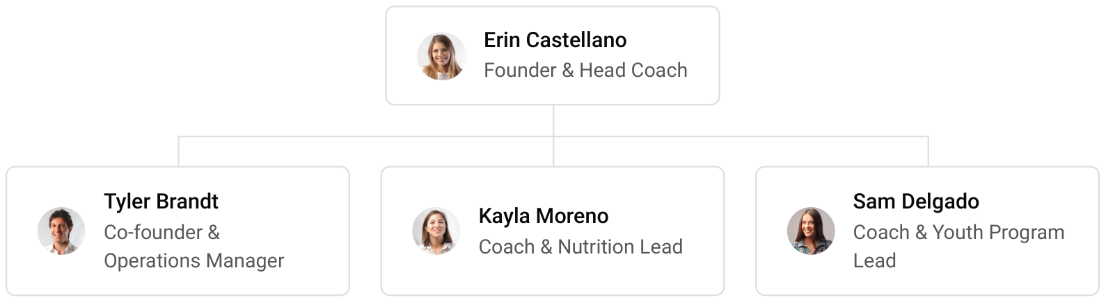

9.3 Advisory Board Members
Liftline will form an informal advisory group before opening rather than a paid board. It is intended to include an accountant with small-business clients to review the monthly accounts and the sales tax treatment of memberships, a physical therapist to advise on injury screening and return-to-training, and an experienced gym owner from outside Boise to act as a sounding board on pricing and coach pay. The group will meet quarterly, and its members have not yet been named.

9.3.1 Hiring Plan
2  Filled |  | 3  Hiring This Year |  | 4  Open

Group By Department | Position Filled | Time of Hire | Time of Start | Filled
Coaching | 1 of 3 | 45 days | 14 days | 33%
Operations & Membership | 1 of 1 | 0 days | 0 days | 100%
Personal Training & Nutrition | 0 of 1 | 30 days | 14 days | 0%
Youth Program | 0 of 1 | 60 days | 21 days | 0%

CHAPTER 10

Financial Plan

10.1 Key Assumptions
10.2 Capital Requirements and Use of Funds
10.3 Income Statement (3 Year projections)
10.4 Balance Sheet (3 Year projections)
10.5 Cash Flow Statement (3 Year projections)
10.6 Break Even Analysis

10.1 Key Assumptions
Revenue follows one formula: active members times the monthly membership price, uplifted by ancillary sales, plus personal training sessions times their price, over twelve months. The model assumes 130 active members at a blended $165 a month, ancillary revenue of 12% of the membership book from drop-ins, the kids program, apparel and competitions, and 60 personal training sessions a month at $75.
The gym opens at 40% of its member book on founding members and reaches the full book over ten months, then grows revenue 15% a year. Gross margin is 88.0%, since coaches sit below the gross line and cost of sales is card fees, software fees and the retail shelf. Payroll is 36% of revenue and marketing 5%. Rent is $4,700 a month, technology $450 and administration $1,400, which includes the $375 monthly affiliate fee and insurance.
Idaho's 6% sales tax applies to facility use, drop-ins and retail, while a separately stated instructor-led class fee is exempt, so the model carries a blended 1% on all revenue; Liftline will bill coaching as a separate line and confirm the treatment with its accountant. Income tax is modelled at 25%.
On these inputs revenue is $256,716 in the first year, $295,223 in the second and $339,507 in the third. Net income is $125, $13,082 and $27,830, a net margin of 8.2% by the third year. Break-even revenue is $220,593, equal to 111 members, which the first year clears. In the conservative case third-year net income is $6,949, and in the upside case $56,032.

10.2 Capital Requirements and Use of Funds
The startup budget is $155,200. The largest items are the training equipment and the leasehold improvements, chiefly rubber flooring and changing areas, followed by a working capital reserve that carries the box while the member book fills. The rest covers deposits and pre-opening rent, launch marketing, front desk and sound equipment, affiliation and coach certification, professional fees, permits and insurance, pre-opening staffing and initial retail stock.
It is funded by a $65,000 owner contribution from the founders' savings and a $90,000 SBA 7(a) loan at 10.5% over seven years, matched to the useful life of the equipment. There is no outside equity, and no profits are distributed in the first three years, so cash stays in the business to fund the second coach and equipment replacement.
The loan is serviced from operations rather than from fresh capital. Break-even revenue of $220,593 is cleared in the first year, and even the conservative case keeps the third year profitable at $6,949 of net income, so the owners do not plan to add money after opening. The upside case, at $56,032 in the third year, is what would bring an expansion forward.

10.2.1 Use of Funds
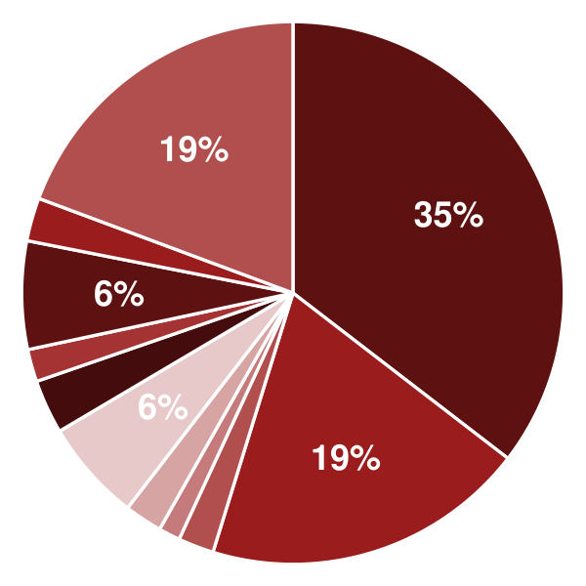 | ● Training Equipment 35.4%  ● Leasehold Improvements 19.3%  ● Affiliation & Coach Certification 2.1%  ● Licenses, Permits & Insurance 1.3%  ● Professional Fees 2.3%  ● Deposits & Pre-Opening Rent 6.1%  ● Front Desk, Sound & Technology 3.2%  ● Initial Retail Inventory 1.9%  ● Launch Marketing 6.4%  ● Pre-Opening Staffing 2.6%  ● Working Capital Reserve 19.3%

Use Of Funds | Amount
Training Equipment | $55,000.00
Leasehold Improvements | $30,000.00
Affiliation & Coach Certification | $3,300.00
Licenses, Permits & Insurance | $2,000.00
Professional Fees | $3,500.00
Deposits & Pre-Opening Rent | $9,400.00
Front Desk, Sound & Technology | $5,000.00
Initial Retail Inventory | $3,000.00
Launch Marketing | $10,000.00
Pre-Opening Staffing | $4,000.00
Working Capital Reserve | $30,000.00

10.3 Income Statement (3 Year projections)
 | Year 1 | Year 2 | Year 3 | Total
Revenue | $256,716.00 | $295,223.40 | $339,506.91 | $891,446.31
Cost of Sales | $30,805.92 | $35,426.81 | $40,740.83 | $106,973.56
General Costs | $0.00 | $0.00 | $0.00 | $0.00
Revenue Specific Costs | $21,564.14 | $24,798.77 | $28,518.58 | $74,881.49
Personnel Costs (Direct Labor) | $9,241.78 | $10,628.04 | $12,222.25 | $32,092.07
Gross Margin | $225,910.08 | $259,796.59 | $298,766.08 | $784,472.75
Gross Margin (%) | 88.00% | 88.00% | 88.00% | 88.00%
Operating Expense | $194,122.20 | $211,450.53 | $231,378.12 | $636,950.85
Payroll Expense (Indirect Labor) | $92,417.76 | $106,280.42 | $122,222.49 | $320,920.67
General Expense | $101,704.44 | $105,170.11 | $109,155.63 | $316,030.18
Bad Debt | $0.00 | $0.00 | $0.00 | $0.00
Amortization of Current Assets | $0.00 | $0.00 | $0.00 | $0.00
EBITDA | $31,787.88 | $48,346.06 | $67,387.96 | $147,521.90
Additional Expense | $31,663.04 | $35,264.55 | $39,558.16 | $106,485.75
Long Term Depreciation | $22,171.43 | $22,804.05 | $23,531.56 | $68,507.04
Gain or loss from Sale of Assets | $0.00 | $0.00 | $0.00 | $0.00
EBIT | $9,616.45 | $25,542.01 | $43,856.40 | $79,014.86
Interest Expense | $9,450.00 | $8,100.00 | $6,750.00 | $24,300.00
EBT | $166.45 | $17,442.01 | $37,106.40 | $54,714.86
Income Tax Expense / Benefit | $41.61 | $4,360.50 | $9,276.60 | $13,678.71
Total Expense | $256,591.16 | $282,141.89 | $311,677.11 | $850,410.16
Net Income | $124.84 | $13,081.51 | $27,829.80 | $41,036.15
Net Income (%) | 0.05% | 4.43% | 8.20% | 4.60%
Retained Earning Opening | $0.00 | $124.85 | $13,206.36
Owner's Distribution | $0.00 | $0.00 | $0.00 | $0.00
Retained Earning Closing | $124.84 | $13,206.36 | $41,036.16 | $41,036.16

10.4 Balance Sheet (3 Year projections)
 | Year 1 | Year 2 | Year 3 | Total
Assets | $144,810.09 | $146,493.98 | $163,132.44 | $163,132.44
Current Assets | $11,781.52 | $31,841.11 | $66,918.53 | $66,918.53
Cash | $10,937.52 | $30,870.51 | $65,802.34 | $65,802.34
Accounts Receivable | $0.00 | $0.00 | $0.00 | $0.00
Inventory | $844.00 | $970.60 | $1,116.19 | $1,116.19
Other Current Assets | $0.00 | $0.00 | $0.00 | $0.00
Long Term Assets | $133,028.57 | $114,652.87 | $96,213.91 | $96,213.91
Gross Long Term Assets | $155,200.00 | $159,628.35 | $164,720.95 | $164,720.95
Accumulated Depreciation | $22,171.43 | $44,975.48 | $68,507.04 | $68,507.04
Liabilities & Equity | $144,810.09 | $146,493.98 | $163,132.44 | $163,132.44
Liabilities | $79,685.24 | $68,287.62 | $57,096.28 | $57,096.28
Current Liabilities | $15,399.53 | $16,859.05 | $18,524.85 | $18,524.85
Accounts Payable | $2,531.99 | $2,911.79 | $3,348.56 | $3,348.56
Income Tax Payable | $10.40 | $1,090.12 | $2,319.15 | $2,319.15
Sales Tax Payable | $0.00 | $0.00 | $0.00 | $0.00
Short Term Debt | $12,857.14 | $12,857.14 | $12,857.14 | $12,857.14
Long Term Liabilities | $64,285.71 | $51,428.57 | $38,571.43 | $38,571.43
Long Term Debt | $64,285.71 | $51,428.57 | $38,571.43 | $38,571.43
Equity | $65,124.85 | $78,206.36 | $106,036.16 | $106,036.16
Paid-in Capital | $0.00 | $0.00 | $0.00 | $0.00
Common Stock | $0.00 | $0.00 | $0.00 | $0.00
Preferred Stock | $0.00 | $0.00 | $0.00 | $0.00
Owner's Contribution | $65,000.00 | $65,000.00 | $65,000.00 | $65,000.00
Retained Earnings | $124.85 | $13,206.36 | $41,036.16 | $41,036.16
Check | $0.00 | $0.00 | $0.00 | $0.00

10.5 Cash Flow Statement (3 Year projections)
 | Year 1 | Year 2 | Year 3 | Total
Cash Received | $259,283.16 | $298,175.63 | $342,901.98 | $900,360.77
Cash Paid | $235,288.50 | $260,957.15 | $290,020.41 | $786,266.06
COS & General Expenses | $121,580.59 | $129,715.68 | $137,383.03 | $388,679.30
Salary & Wages | $101,659.54 | $116,908.46 | $134,444.74 | $353,012.74
Interest | $9,450.00 | $8,100.00 | $6,750.00 | $24,300.00
Sales Tax | $2,567.16 | $2,952.23 | $3,395.07 | $8,914.46
Income Tax | $31.21 | $3,280.78 | $8,047.57 | $11,359.56
Net Cash From Operations | $23,994.66 | $37,218.48 | $52,881.57 | $114,094.71
Assets Sell | $0.00 | $0.00 | $0.00 | $0.00
Assets Purchase | $155,200.00 | $4,428.35 | $5,092.60 | $164,720.95
Net Cash From Investments | ($155,200.00) | ($4,428.35) | ($5,092.60) | ($164,720.95)
Amount Received | $155,000.00 | $0.00 | $0.00 | $155,000.00
Loan Received | $90,000.00 | $0.00 | $0.00 | $90,000.00
Common Stock | $0.00 | $0.00 | $0.00 | $0.00
Preferred Stock | $0.00 | $0.00 | $0.00 | $0.00
Owner's Contribution | $65,000.00 | $0.00 | $0.00 | $65,000.00
Amount Paid | $12,857.14 | $12,857.14 | $12,857.14 | $38,571.42
Loan Capital | $12,857.14 | $12,857.14 | $12,857.14 | $38,571.42
Dividends & Distributions | $0.00 | $0.00 | $0.00 | $0.00
Net Cash From Financing | $142,142.86 | ($12,857.14) | ($12,857.14) | $116,428.58
Summary
Starting Cash | $0.00 | $10,937.52 | $30,870.51
Cash In | $414,283.16 | $298,175.63 | $342,901.98 | $1,055,360.77
Cash Out | $403,345.64 | $278,242.64 | $307,970.15 | $989,558.43
Change in Cash | $10,937.52 | $19,932.99 | $34,931.83 | $65,802.34
Ending Cash | $10,937.52 | $30,870.51 | $65,802.34 | $65,802.34

10.6 Break Even Analysis
 | Year 1 | Year 2 | Year 3 | Total
Starting Revenue | $0.00 | $256,716.00 | $551,939.40 | $551,939.40
Net Revenue | $256,716.00 | $295,223.40 | $339,506.91 | $339,506.91
Closing Revenue | $256,716.00 | $551,939.40 | $891,446.31 | $891,446.31
Starting Expense | $0.00 | $256,591.16 | $538,733.05 | $538,733.05
Net Expense | $256,591.16 | $282,141.89 | $311,677.11 | $311,677.11
Closing Expense | $256,591.16 | $538,733.05 | $850,410.16 | $850,410.16
Is Break Even? | Yes | Yes | Yes
Break Even Month | Dec '26 | - | -
Days Required | 29 Days | - | -
Break Even Revenue | $256,716.00 | - | -

CHAPTER 11

References

- SRC001: Gym, Health & Fitness Club Operation in the US - Market Size Statistics 2026, IBISWorld, 2026-01-01. https:/‌/‌www.‌ibisworld.‌com/‌united-states/‌market-size/‌gym-health-fitness-clubs/‌1655/‌ (accessed 2026-10-08)
- SRC002: Gym, Health & Fitness Club Operation in the US - Number of Businesses, IBISWorld, 2026-01-01. https:/‌/‌www.‌ibisworld.‌com/‌united-states/‌number-of-businesses/‌gym-health-fitness-clubs/‌1655/‌ (accessed 2026-10-08)
- SRC003: Total Revenue for Fitness and Recreational Sports Centers, All Establishments, Employer Firms (REVEF71394ALLEST), Federal Reserve Bank of St. Louis (FRED), from US Census Bureau Service Annual Survey, 2024-01-31. https:/‌/‌fred.‌stlouisfed.‌org/‌series/‌REVEF71394ALLEST (accessed 2026-10-08)
- SRC004: 2025 CrossFit Open Registration Continues to Lag, Competitive Regions Hold Steady Year-Over-Year, Morning Chalk Up, 2025-02-25. https:/‌/‌morningchalkup.‌com/‌2025/‌02/‌25/‌2025-crossfit-open-registration-continues-to-lag/‌ (accessed 2026-10-08)
- SRC005: 2025 CrossFit Open Registrations Down 32%; Lowest Total Since 2014, BarBend, 2025-05-28. https:/‌/‌barbend.‌com/‌news/‌2025-crossfit-open-registrations-down-32-percent/‌ (accessed 2026-10-08)
- SRC006: The 2026 CrossFit Open Begins Today: A Look at Registration, Morning Chalk Up, 2026-02-25. https:/‌/‌morningchalkup.‌com/‌2026/‌02/‌25/‌the-2026-crossfit-open-begins-today-a-look-at-registration/‌ (accessed 2026-10-08)
- SRC007: Two-Brain State of the Industry Report Suggests CrossFit Gyms Lag Behind Others in Key Metrics, Morning Chalk Up, 2025-11-13. https:/‌/‌morningchalkup.‌com/‌2025/‌11/‌13/‌two-brain-state-of-the-industry-report-crossfit-gyms-lag/‌ (accessed 2026-10-08)
- SRC008: CrossFit's Affiliate Fee Increase One Year Later: How Are Gyms Adapting?, Morning Chalk Up, 2025-04-15. https:/‌/‌morningchalkup.‌com/‌2025/‌04/‌15/‌crossfits-affiliate-fee-increase-one-year-later/‌ (accessed 2026-10-08)
- SRC009: Affiliate FAQ, CrossFit LLC, 2026-01-01. https:/‌/‌www.‌crossfit.‌com/‌faq/‌affiliates (accessed 2026-10-08)
- SRC010: CrossFit Level 1 Certificate Course, CrossFit LLC, 2026-01-01. https:/‌/‌www.‌crossfit.‌com/‌certificate-courses/‌level-1 (accessed 2026-10-08)
- SRC011: CrossFit No Longer Up for Sale, CEO Says, Athletech News, 2026-07-07. https:/‌/‌athletechnews.‌com/‌crossfit-no-longer-up-for-sale-ceo-says/‌ (accessed 2026-10-08)
- SRC012: 81 Million Americans Were Members of a Fitness Facility in 2025, New HFA Report Finds, Health & Fitness Association, 2026-04-09. https:/‌/‌www.‌healthandfitness.‌org/‌81-million-americans-were-members-of-a-fitness-facility-in-2025-new-hfa-report-finds/‌ (accessed 2026-10-08)
- SRC013: Participation Hits New High, But Majority of Americans Not Yet Meeting Recommended Guidelines of 150 Minutes of Weekly Activity, SFIA's 2026 Topline Report Finds, Sports & Fitness Industry Association, 2026-03-01. https:/‌/‌sfia.‌org/‌resources/‌participation-hits-new-high-but-majority-of-americans-not-yet-meeting-recommended-guidelines-of-150-minutes-of-weekly-activity-sfias-2026-topline-report-finds/‌ (accessed 2026-10-08)
- SRC014: Client Retention Up, Coach Pay and Membership Rates Still Need Work, Says 2024 State of the Industry Report, BarBend, 2025-05-28. https:/‌/‌barbend.‌com/‌news/‌2024-state-of-the-industry-report-crossfit-gyms/‌ (accessed 2026-10-08)
- SRC015: Planet Fitness price hike: Classic membership, Fortune, 2024-05-10. https:/‌/‌fortune.‌com/‌2024/‌05/‌10/‌planet-fitness-price-hike-classic-membership (accessed 2026-10-08)
- SRC016: Fitness Trainers and Instructors, US Bureau of Labor Statistics, Occupational Outlook Handbook, 2026-08-27. https:/‌/‌www.‌bls.‌gov/‌ooh/‌personal-care-and-service/‌fitness-trainers-and-instructors.‌htm (accessed 2026-10-08)
- SRC017: 2025 Fitness Industry Benchmarking Report, Health & Fitness Association, 2025-09-30. https:/‌/‌www.‌healthandfitness.‌org/‌2025-fitness-industry-benchmarking-report/‌ (accessed 2026-10-08)
- SRC018: How Does Your Gym Stack Up? Two-Brain Business Releases Annual State of the Industry Report, Morning Chalk Up, 2025-11-11. https:/‌/‌morningchalkup.‌com/‌2025/‌11/‌11/‌how-does-your-gym-stack-up-two-brain-business-releases-annual-state-of-the-industry-report/‌ (accessed 2026-10-08)
- SRC019: L Catterton-led consortium buys Hyrox stake as founders regain control, Health Club Management, 2026-09-08. https:/‌/‌www.‌healthclubmanagement.‌co.‌uk/‌health-club-management-news/‌L-Catterton-led-consortium-buys-Hyrox-stake-as-founders-regain-control/‌363576 (accessed 2026-10-08)
- SRC020: U.S. Industrial Market Dynamics, Q2 2026, JLL, 2026-07-21. https:/‌/‌www.‌jll.‌com/‌en-us/‌insights/‌market-dynamics/‌industrial-market-statistics-trends.‌html (accessed 2026-10-08)
- SRC021: U.S. Industrial Market Outlook - July 2026, Yardi Matrix, 2026-08-17. https:/‌/‌www.‌yardimatrix.‌com/‌blog/‌u-s-industrial-market-outlook-july-2026/‌ (accessed 2026-10-08)
- SRC022: Cushman & Wakefield Report: Modest New Supply and Intensifying Demand Push Vacancy Back Below 7%, Cushman & Wakefield, 2026-07-17. https:/‌/‌www.‌cushmanwakefield.‌com/‌en/‌united-states/‌news/‌2026/‌07/‌us-industrial-marketbeat (accessed 2026-10-08)
- SRC023: How much does gym and fitness center insurance cost?, Insureon, 2025-06-11. https:/‌/‌www.‌insureon.‌com/‌sports-fitness-business-insurance/‌gyms-and-fitness-centers/‌cost (accessed 2026-10-08)
- SRC024: How Much Does Gym Business Insurance Cost?, MoneyGeek, 2026-09-18. https:/‌/‌www.‌moneygeek.‌com/‌insurance/‌business/‌fitness-services/‌gym/‌cost/‌ (accessed 2026-10-08)
- SRC025: CrossFit Gyms in Idaho, CrossFit LLC, 2026-01-01. https:/‌/‌www.‌crossfit.‌com/‌gyms/‌united-states/‌west/‌idaho (accessed 2026-10-16)
- SRC026: Local gyms in Boise, Idaho, Planet Fitness, 2026-01-01. https:/‌/‌www.‌planetfitness.‌com/‌clubs/‌id/‌boise (accessed 2026-10-16)
- SRC027: Axiom Fitness sold: California company buys local chain of health clubs, BoiseDev, 2022-05-11. https:/‌/‌boisedev.‌com/‌news/‌2022/‌05/‌11/‌axiom-villasport-boise/‌ (accessed 2026-10-16)
- SRC028: Out-of-state gym chain eyes first Boise location, BoiseDev, 2025-08-21. https:/‌/‌boisedev.‌com/‌news/‌2025/‌08/‌21/‌vasa-fitness-boise/‌ (accessed 2026-10-16)
- SRC029: City and Town Population Totals: 2020 to 2024 (SUB-EST2024, Idaho), U.S. Census Bureau, 2025-05-01. https:/‌/‌www2.‌census.‌gov/‌programs-surveys/‌popest/‌datasets/‌2020-2024/‌cities/‌totals/‌sub-est2024_‌16.‌csv (accessed 2026-10-16)
- SRC030: Metropolitan and Micropolitan Statistical Area Population Totals: 2020 to 2024 (CBSA-EST2024-ALLDATA), U.S. Census Bureau, 2025-03-01. https:/‌/‌www2.‌census.‌gov/‌programs-surveys/‌popest/‌datasets/‌2020-2024/‌metro/‌totals/‌cbsa-est2024-alldata.‌csv (accessed 2026-10-16)
- SRC031: Boise City, ID profile (ACS 2024 1-year, tables B19013 and B01002), Census Reporter (U.S. Census Bureau ACS), 2025-01-01. https:/‌/‌censusreporter.‌org/‌profiles/‌16000US1608830-boise-city-id/‌ (accessed 2026-10-16)
- SRC032: PLACES: Local Data for Better Health, County Data, 2025 release, Centers for Disease Control and Prevention, 2025-12-01. https:/‌/‌data.‌cdc.‌gov/‌resource/‌swc5-untb.‌json (accessed 2026-10-16)
- SRC033: Verdant CrossFit, Verdant, 2026-01-01. https:/‌/‌www.‌verdantfit.‌com/‌ (accessed 2026-10-16)
- SRC034: Boise CrossFit gym page, CrossFit LLC, 2026-01-01. https:/‌/‌www.‌crossfit.‌com/‌gym/‌491/‌boise-crossfit (accessed 2026-10-16)
- SRC035: Drop In, Verdant, 2026-01-01. https:/‌/‌www.‌verdantfit.‌com/‌drop-in (accessed 2026-10-16)
- SRC036: Drop In, Boise CrossFit, 2026-01-01. https:/‌/‌www.‌boisecrossfit.‌com/‌drop-in (accessed 2026-10-16)
- SRC037: Membership Rates, YMCA of the Treasure Valley, 2026-01-01. https:/‌/‌www.‌ymcatvidaho.‌org/‌membership/‌fees-rates/‌ (accessed 2026-10-16)
- SRC038: Boise Industrial Figures Q2 2026, CBRE, 2026-07-16. https:/‌/‌www.‌cbre.‌com/‌insights/‌figures/‌boise-industrial-figures-q2-2026 (accessed 2026-10-16)
- SRC039: Boise Q2 2026, TenantBase, 2026-01-01. https:/‌/‌www.‌tenantbase.‌com/‌boise/‌q2-2026/‌ (accessed 2026-10-16)
- SRC040: Occupational Employment and Wage Statistics, Boise City, ID, May 2025, U.S. Bureau of Labor Statistics, 2026-01-01. https:/‌/‌www.‌bls.‌gov/‌oes/‌current/‌oes_‌14260.‌htm (accessed 2026-10-16)
- SRC041: Idaho Minimum Wage 2026, HiveDesk, 2026-01-01. https:/‌/‌www.‌hivedesk.‌com/‌compliance/‌united-states/‌minimum-wage-idaho (accessed 2026-10-16)
- SRC042: Schedule 7, Small General Service, Idaho Power Company, 2025-12-30. https:/‌/‌docs.‌idahopower.‌com/‌pdfs/‌aboutus/‌ratesregulatory/‌tariffs/‌37.‌pdf (accessed 2026-10-16)
- SRC043: Sales and Use Taxes: Basics Guide, Idaho State Tax Commission, 2026-04-01. https:/‌/‌tax.‌idaho.‌gov/‌?‌p=‌2055 (accessed 2026-10-16)
- SRC044: IDAPA 35.01.02, Idaho Sales and Use Tax Administrative Rules, Idaho State Tax Commission, 2026-07-01. https:/‌/‌files.‌dfm.‌idaho.‌gov/‌dfm-admin-website/‌rules/‌current/‌35/‌350102.‌pdf (accessed 2026-10-16)
- SRC045: Recreation and Admissions Basics Guide, Idaho State Tax Commission, 2026-08-21. https:/‌/‌tax.‌idaho.‌gov/‌?‌p=‌3470 (accessed 2026-10-16)
- SRC046: Licensing, City of Boise City Clerk, 2026-01-01. https:/‌/‌www.‌cityofboise.‌org/‌departments/‌city-clerk/‌licensing/‌ (accessed 2026-10-16)
- SRC047: Business Forms, Idaho Secretary of State, 2026-01-01. https:/‌/‌sos.‌idaho.‌gov/‌business-forms/‌ (accessed 2026-10-16)
