BUSINESSPLAN
2024



CryptoBusinessPlan
"BuildingWealth,OneCoinataTime."

JohnDoe
10200BolsaAve,Westminster,CA,92683

(650)359-3153

info@example.comhttps://www.example.com/

Information provided in this business plan is unique to this business and confidential; therefore,anyonereadingthisplanagreesnottodiscloseanyoftheinformationinthis business plan without prior written permission of the company.

TableofContents

ExecutiveSummary
6
Marketopportunity 7
UniqueSellingPoints(USPs) 7
Marketing&SalesStrategies 8
FinancialHighlights 8
Units Sold v/s Revenue 8
CompanyOverview
10
Ownership 11
BusinessOwners 11
Missionstatement 12
Business history 12
Futuregoals 12
MarketAnalysis
13
TargetMarket 14
Marketsizeandgrowthpotential 14
MarketSize 15
Competitiveanalysis 15
Coinbase 15
Binance 15
Kraken 16
Markettrends 16
Regulatoryenvironment 17
ProductsandServices
18
CoreProductsandServices 19
CryptocurrencyExchange Platform 19
CryptoWalletServices 19
EducationalResources 20
AdditionalServices 20

SalesAndMarketingStrategies
21
UniqueSellingProposition(USP) 22
PricingStrategy 22
Marketingstrategies 23
Online 23
Offline 23
Salesstrategies 24
Customerretention 24
OperationsPlan
26
Staffing&Training 27
OperationalProcess 27
Equipment&Tools 28
ManagementTeam
29
Founders/CEO 30
NathanSterling 31
SophiaLang 31
Keymanagers 32
AlexRivera 32
MayaPatel 33
EthanWong 33
Organizationalstructure 34
Organizationchart 34
Compensationplan 34
Boardofadvisors 35
Dr.EmilyCarter 35
MichaelGreene 35
Financial Plan
36
Profit&lossstatement 37
Cashflowstatement 42
Balancesheet 45

Break-evenPoint 47
Financingneeds 48
Appendix
50
EmbedLink 51


Businessplanningthat’ssimplerandfasterthanyouthink

CreatingabusinessplanusingUpmetricstostartandgrowabusinessisliterallytheeasiest thingintheWorld.Simplyreadtheinstructionsandfillintheblanks.It’sassimpleasthat.

Upmetrics has everything you need to create a comprehensive business plan.
❛
❜

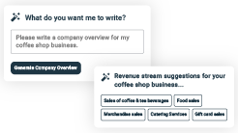
AI-poweredUpmetricsAssistant

AI-poweredinsightstostreamlineyourplan
Not sure where to start? Upmetrics’ AI Assistant will automaticallygenerateideasforeachsectionofyourplanand offerimprovedversionsofyourwriting,adjustingfortone,voice, and grammar or spelling errors.

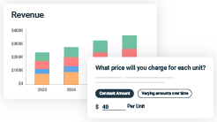
FinancialForecastingTool

Allthefinancialsarecalculatedforyou
Forget the complex formulas and clumsy spreadsheets — withautomaticfinancialsanddrag-and-dropforecasting,you canfinishyourplanfasterandbeconfidentthatyour numbers are accurate.

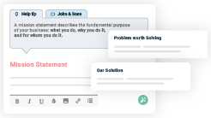
BusinessPlanBuilder

Guidesyoulikeabusinessmentor
Upmetrics’step-by-stepinstructions,prompts,andthelibraryof 400+samplebusinessplanswillguideyouthrougheachsection of your plan as a business mentor.

1.

ExecutiveSummary

Marketopportunity
Unique Selling Points (USPs)Marketing & Sales StrategiesFinancial Highlights



Anexecutivesummaryisthefirstsectionofthebusinessplanintendedto provide an overview of the whole business plan.
Tounlock helptry Upmetrics!

Helptip
CryptoNovaSolutions
Startyourexecutivesummarybybrieflyintroducingyourbusinesstoyourreaders.Thissection may include the name of your crypto business, its location, when it was founded, etc.
Tounlock helptry Upmetrics!
Startwritinghere..

Marketopportunity

Helptip
CryptoNovaSolutions
Summarize your market research, including market size, growth potential, and marketing trends.Highlighttheopportunitiesinthemarketandhowyourbusinesswillfitintofillthegap.
Tounlock helptry Upmetrics!
Startwritinghere..

UniqueSellingPoints(USPs)

Helptip
CryptoNovaSolutions
Emphasize what sets your crypto business apart—highlighting unique selling points (USPs) and special features that make it distinctive is always a plus.
Tounlock helptry Upmetrics!
Startwritinghere..

Marketing&SalesStrategies

Helptip
CryptoNovaSolutions
Outline your sales and marketing strategies—what marketing platforms you use, how you plan on acquiring customers, etc.
Tounlock helptry Upmetrics!
Startwritinghere..

FinancialHighlights

Helptip
CryptoNovaSolutions
Brieflysummarizeyourfinancialprojectionsfortheinitialyearsofbusinessoperations.Include
capitalorinvestmentrequirements,associatedstartupcosts,projectedrevenues,andprofit
forecasts.
Tounlock helptry Upmetrics!
Startwritinghere..

UnitsSoldv/sRevenue

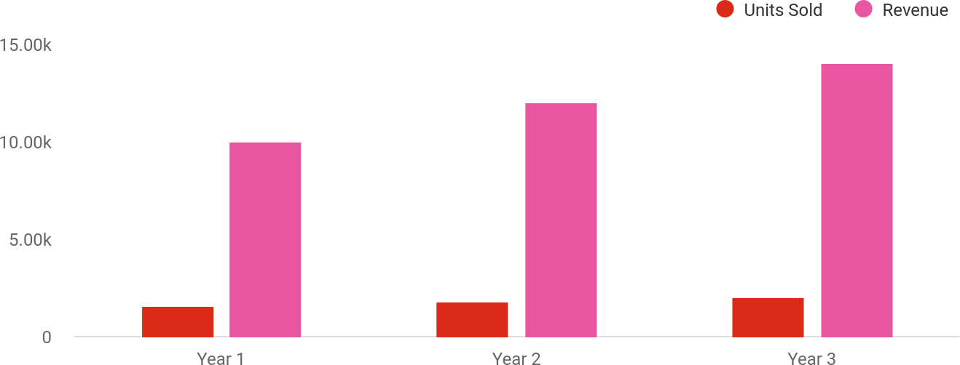

FinancialYear | UnitsSold | Revenue
Year1 | 1,550 | $10,000
Year2 | 1,800 | $12,000

FinancialYear | UnitsSold | Revenue
Year3 | 2,050 | $14,000

Helptip
CryptoNovaSolutions
SummarizeyourexecutivesummarysectionwithaclearCTA,forexample,invitingangel investors to discuss the potential business investment.
Tounlock helptry Upmetrics!

Writeacalltoactionforyourbusinessplan.

2.

CompanyOverview

OwnershipMission statementBusiness historyFuture goals

Dependingonwhatdetailsofyourbusinessareessential,you’llneed different elements in your business overview.
Tounlock helptry Upmetrics!
Helptip
CryptoNovaSolutions
Describeyour businessin this sectionby providingall the basicinformation:

Describewhatkindofcryptocompanyyourunandthenameofit.Youmayspecializeinoneof
Tounlock helptry Upmetrics!
Startwritinghere..

Ownership

Helptip
CryptoNovaSolutions
List the names of your crypto company’s founders or owners. Describe how much shares they own and their responsibilities for efficiently managing the business.
Tounlock helptry Upmetrics!
Startwritinghere..

BusinessOwners

NathanSterling
60%

SophiaLang
40%

Missionstatement

Helptip
CryptoNovaSolutions
Summarizeyourbusiness’objective,coreprinciples,andvaluesinyourmissionstatement.This statement needs to be memorable, clear, and brief.
Tounlock helptry Upmetrics!

At[CryptoNovaSolutions],ourmissionistoempowerindividuals andbusinesseswiththetoolsandknowledgetoparticipate
❛
confidentlyintheblockchaineconomy.Wearecommittedto
fostering trust, security, and accessibility while driving innovation in cryptocurrency trading and financial solutions.
❜

Businesshistory

Helptip
CryptoNovaSolutions
Ifyou’reanestablishedcryptoserviceprovider,brieflydescribeyourbusinesshistory,like— whenitwasfounded,howitevolvedovertime,etc.
Tounlock helptry Upmetrics!
Startwritinghere..

Futuregoals

Helptip
CryptoNovaSolutions
It’scrucialtoconveyyouraspirationsandvision.Mentionyourshort-termandlong-termgoals; they can be specific targets for revenue, market share, or expanding your services.
Tounlock helptry Upmetrics!
Startwritinghere..

3.

MarketAnalysis

TargetMarket
MarketsizeandgrowthpotentialCompetitive analysis
Market trendsRegulatoryenvironment

Marketanalysisprovidesaclearunderstandingofthemarketinwhichyour
printingbusinesswillrunalongwiththetargetmarket,competitors, and
growthopportunities.
Tounlock helptry Upmetrics!
Helptip
CryptoNovaSolutions
Towritetheintroductionsectionofyourmarketanalysis,startbyclearlyidentifyingyour primary target market.
Tounlock helptry Upmetrics!
Startwritinghere..

TargetMarket

Helptip
CryptoNovaSolutions
Startthissectionbydescribingyourtargetmarket.Defineyouridealcustomerandexplainwhat
typesofservicestheyprefer.Creatingabuyerpersonawillhelpyoueasilydefineyourtarget
markettoyourreaders.
Tounlock helptry Upmetrics!
Startwritinghere..

Marketsizeandgrowthpotential

Helptip
CryptoNovaSolutions
Describeyourmarketsizeandgrowthpotentialandwhetheryouwilltargetanicheoramuch broader market.
Tounlock helptry Upmetrics!
Startwritinghere..

MarketSize

AvailableMarket
1B
Totalpotentialusersinterestedincrypto, including all demographics and geographies.

ServedMarket
Subsetoftheavailablemarketactively engaged or ready to engage in crypto trading.

350M

TargetMarket
Focused group of tech-savvy users and small businesses adopting decentralized financial tools.
50M

Helptip
CryptoNovaSolutions
Identifyandanalyzeyourdirectandindirectcompetitors.Identifytheirstrengths and
weaknesses,anddescribewhatdifferentiatesyourseniordaycareservicesfromthem. Point
outhowyouhaveacompetitiveedgeinthemarket.
Tounlock helptry Upmetrics!

Competitiveanalysis

Coinbase
Coinbase is one of the most recognized cryptocurrency exchanges globally, offering a user-friendly platform for buying, selling, and managing cryptocurrency.

Features
Securetradingplatform.
Supportforover100 cryptocurrencies.
Educational resources for crypto beginners.
Advancedtradingtools (Coinbase Pro).

Strengths
Strongbrandrecognitionand trust.
Simpleinterfacesuitablefor beginners.
Regulatorycompliancein multiple jurisdictions.

Weaknesses
High transaction fees compared to other platforms.
Limited customization options for advanced traders.
Customerserviceoftencriticized for slow response times.

Binance
Binanceistheworld’slargestcryptocurrencyexchangebytradingvolume,offeringabroadrangeof services, including spot trading, futures, staking, and DeFi solutions.

Features
Supportforover350 cryptocurrencies.
Lowtradingfees.
Advancedchartingtoolsfor experienced traders.
Integrationwithdecentralized finance (DeFi) platforms.

Strengths
Diverseproductofferingsand services.
Competitivefeestructure.
Strong global presence and userbase.

Weaknesses
Complexitymayoverwhelm beginners.
Regulatoryscrutinyinseveral countries.
Limitedfiatcurrencysupportin specific regions.

Kraken
Kraken is a US-based cryptocurrency exchange focusing on secure trading, offering spot and futures trading alongside staking services.

Features
Supportforover70 cryptocurrencies.
Advancedsecurityfeatureslike cold storage.
Marginandfuturestrading options.
24/7livecustomersupport.

Strengths
Reputationforstrongsecurity protocols.
Highliquidityandtransparent fee structures.
Reliablecustomersupport.

Weaknesses
Fewercryptocurrencyoptions compared to competitors.
Higherfeesforsmaller transactions.
Lessintuitiveinterfacefor beginners.

Markettrends

Helptip
CryptoNovaSolutions
Analyze emerging trends in the industry, such as technology disruptions, changes in customer behavior or preferences, etc. Explain how your business will cope with all the trends.
Tounlock helptry Upmetrics!
Startwritinghere..

Regulatoryenvironment

Helptip
CryptoNovaSolutions
Listregulationsandlicensingrequirementsthatmayaffectyourcrypto, suchasage restrictions, licensing & permits, zoning regulations, etc.
Tounlock helptry Upmetrics!
Startwritinghere..



4.

Productsand Services

Core Products and ServicesAdditional Services

Theproductandservicessectionofacryptobusinessplanshoulddescribe
thespecificservicesandproductsthatwillbeofferedtocustomers.Towrite
thissectionshouldincludethefollowing:
Tounlock helptry Upmetrics!
Helptip
CryptoNovaSolutions
Tocrafttheintroductionforyour"ProductsandServices"chapter,beginbypositioningyour business within its industry, emphasizing its unique strengths or value proposition.
Tounlock helptry Upmetrics!

Startwritinghere..
Helptip
Mentionthecryptoproducts&servicesyouwilloffer.
Tounlock helptry Upmetrics!

CoreProductsandServices


CryptocurrencyExchangePlatform

Price:[$0.25] pertransaction (flatfee)

Auser-friendlyplatformforbuying,selling,andtrading cryptocurrencies with ease.

Specifications
- Supportfor100+cryptocurrencies.
- Real-timemarketdataandcharts.
- Instantbuy/sellfeaturewithcustomizable dashboards.
- Integrationwith[CryptoNovaWallet]forseamless transactions.

CryptoWalletServices

Price:[$5]/month(basicplan)or[$15]/month(premium plan with added security features).

Asecuredigitalwalletforstoring,managing,and transferring cryptocurrencies.

Specifications
  - Multi-layerencryptionandmulti-factorauthentication.
  - Cross-deviceaccessibility(desktopandmobile).
  - Coldstorageoptionforenhancedsecurity.
  - Instantwallet-to-wallettransfers.

EducationalResources

Price:Freeforregisteredusers.Premiumcontent available at [$9.99]/month.
A comprehensive learning platform offering cryptocurrencytutorials,articles,andwebinars.

Specifications
  - Beginnertoadvanced-levelcontent.
  - InteractivelivewebinarsandQ&Asessions.
  - Downloadableguidesandwhitepapers.
  - Access to expert tipsand trading strategies.

AdditionalServices

Helptip
CryptoNovaSolutions
Ifyouconsiderofferingsupplementalservicesthatcomplementyourcoreofferings,mention them here.
Tounlock helptry Upmetrics!
Startwritinghere..

5.

SalesAndMarketing
Strategies

Unique Selling Proposition (USP)Pricing Strategy
Marketing strategiesSales strategiesCustomer retention

Writing the sales and marketing strategies section means a list of strategies you will use to attract and retain your clients.
Tounlock helptry Upmetrics!
Helptip
CryptoNovaSolutions
Tocreateaneffectiveintroductionforyour"SalesandMarketingStrategies"chapter,startby setting the stage within your specific industry or market.
Tounlock helptry Upmetrics!
Startwritinghere..

UniqueSellingProposition(USP)

Helptip
CryptoNovaSolutions
Define your business’s USPs depending on the market you serve, the equipment you use, and theuniqueservicesyouprovide.IdentifyingUSPswillhelpyouplanyourmarketingstrategies.
Tounlock helptry Upmetrics!
Startwritinghere..

PricingStrategy

Helptip
CryptoNovaSolutions
Describeyourpricingstrategy—howyouplantopriceyourservicesandstaycompetitiveinthe local market. You can mention any discounts you plan on offering to attract new customers.
Tounlock helptry Upmetrics!
Startwritinghere..

Helptip
Discussyourmarketingstrategiestomarketyourservices.Youmayincludesomeofthese
marketingstrategiesinyourbusinessplan—socialmediamarketing,Googleads,brochures,
emailmarketing,contentmarketing,andprintmarketing.
Tounlock helptry Upmetrics!

Marketingstrategies

Online



Offline

SocialMedia Marketing
Engaging audiences on Instagram, TikTok, and LinkedIn with educational content andpromotionaloffers.

ContentMarketing
Publishing blogs, guides,andtutorialsto establish authority in the crypto space.

GoogleAds
Targeted campaigns to drive traffic to our platform.

EmailCampaigns
Personalizedemailsto nurtureleadsandkeep customersinformedof updates and offers.

OfflineOutreach
Distributingbrochuresatblockchainconferencesandfintechevents.

Helptip
Outlinethestrategiesyou’llimplementtomaximizeyoursales.Yoursalesstrategiesmay include partnering with other local businesses, offering referral programs, etc.
Tounlock helptry Upmetrics!

Salesstrategies

ReferralPrograms
Offering rewards for userswhoreferfriends or family to our platform.

BundledServices
Providing discounts on combinedservices,like wallet and advisory packages.

Partnerships
Collaborating with financialadvisors,tech bloggers, and educational platforms to broaden our reach.

Helptip
Describeyourcustomerretentionstrategiesandhowyouplantoexecutethem.Forinstance, introducing loyalty programs, discounts on annual membership, personalized service, etc.
Tounlock helptry Upmetrics!

Customerretention

LoyaltyPrograms
Offering discounts on transaction fees for long-term users.

Personalized Experiences
Using AI to provide customized recommendationsand notifications.

Exclusive
MembershipBenefits
Premium users gain access to advanced tradingtoolsandVIP support.

6.

OperationsPlan

Staffing & TrainingOperational ProcessEquipment & Tools

Whenwritingtheoperationsplansection,it’simportanttoconsiderthe various aspects of your business operations.
Tounlock helptry Upmetrics!
Helptip
CryptoNovaSolutions
Tocreateaneffectiveintroductionforyour"OperationalPlan"chapter,startbyemphasizingthe
pivotalroleofefficientoperationsinthesuccessofyourbusiness,underscoringhowthey
directlyimpactthequalityofservicesdelivered.
Tounlock helptry Upmetrics!
Startwritinghere..

Staffing&Training

Helptip
CryptoNovaSolutions
Mention your business’s staffing requirements, including the number of employees or workers needed.Includetheirqualifications,theexperiencerequired,andthedutiestheywillperform.
Tounlock helptry Upmetrics!
Startwritinghere..

OperationalProcess

Helptip
CryptoNovaSolutions
Outlinetheprocessesandproceduresyouwillusetorunyourcryptobusiness.
Tounlock helptry Upmetrics!
Startwritinghere..

Equipment&Tools

Helptip
CryptoNovaSolutions
Outlinetheessentialtoolsandequipmentusedforcryptoservices.Also,considersettingup technology and software systems to streamline your daily operations.
Tounlock helptry Upmetrics!
Startwritinghere..

7.

ManagementTeam

Founders/CEOKeymanagers
OrganizationalstructureCompensation planBoard of advisors

The management team section provides an overview of the individuals responsible for running your business plan.
Tounlock helptry Upmetrics!
Helptip
CryptoNovaSolutions
Tocraftanintroductionforyour"ManagementTeam"chapter,beginbyemphasizingthecrucial role of leadership in the success of any business.
Tounlock helptry Upmetrics!
Startwritinghere..

Founders/CEO

Helptip
MentionthefoundersandCEOofyourcryptocompany,anddescribetheirrolesand responsibilities in successfully running the business.
Tounlock helptry Upmetrics!
Startwritinghere..


NathanSterling

FounderandCEO-nathan.sterling@example.com

Education:



- Bachelor’sdegreeinComputerSciencefromtheUniversityofCalifornia, Berkeley.

ProfessionalBackground:

- Nathan has over 10 years of experience in software development and blockchain technology.
- Before founding CryptoNova Solutions, he worked as a blockchain architect at a Fortune 500 tech company, where he led teams in developing secure, scalable blockchain infrastructures.

RoleandResponsibilities:

- NathanoverseesCryptoNova’sstrategicvision,technologicalinnovation, andoveralloperations,ensuringthecompanyremainsattheforefrontof the cryptocurrency industry.

SophiaLang


Co-FounderandCMO-sophia.lang@example.com

Education:

- MBA in Marketing from Northwestern University (Kellogg School of Management).

ProfessionalBackground:

- Sophiabrings8+yearsofexperienceindigitalmarketingandfintech branding.
- As a former marketing director at a leading financial technology startup, she successfully launched campaigns that resulted in a 300% increase in user acquisition.

RoleandResponsibilities:

- Sophia leads CryptoNova’s branding, partnerships, and user engagement strategies.
- Sheensuresthecompanyconnectseffectivelywithitstargetaudience through innovative marketing campaigns.

Keymanagers

Helptip
Introduceyourmanagementandkeymembersofyourteam,andexplaintheirrolesand responsibilities.
Tounlock helptry Upmetrics!
Startwritinghere..

Alex Rivera


ChiefTechnologyOfficer-alex.rivera@example.com

Education:

- Master’sdegreeinComputerSciencefromStanfordUniversity.

ProfessionalBackground:

- Alexhasoveradecadeofexperienceinblockchaindevelopmentand cybersecurity.
- Hepreviouslyservedastheleaddeveloperatablockchainstartup,where he implemented advanced encryption protocols that reduced security breaches by 60%.

RoleandResponsibilities:

- Alexmanagesthedevelopmentteam,overseesplatformsecurity,and ensures that CryptoNova remains technologically advanced.


MayaPatel

ChiefOperatingOfficer-maya.patel@example.com

Education:

- MBAfromHarvardBusinessSchool.

ProfessionalBackground:

- Maya has over12 yearsof experiencein operationsmanagement.
- She has a proven track record of streamlining processes and boosting operationalefficiencyintechnologycompanies,includingherprevious role as an operations director at a fintech firm.

RoleandResponsibilities:

- Mayaensuressmoothday-to-dayoperations,efficientresourceallocation, and compliance with regulatory requirements.

EthanWong


HeadofCustomerSuccess-ethan.wong@example.com

Education:

- Bachelor’sdegreeinCommunicationsfromtheUniversityofCalifornia, Los Angeles (UCLA).

ProfessionalBackground:

- Ethanhas8yearsofexperienceincustomerservice,withafocusontech startups.
- He previously worked as a customer success manager for a SaaS platform,wherehehelpedachievea95%customersatisfactionrate.

RoleandResponsibilities:

- Ethan oversees customer support strategies, manages the support team, andensuresCryptoNovadeliversaseamlesscustomerexperience.

Organizationalstructure
Helptip
CryptoNovaSolutions
Explaintheorganizationalstructureofyourmanagementteam.Includethereportinglineand decision-making hierarchy.
Tounlock helptry Upmetrics!

Startwritinghere..

Organizationchart


NathanSterling

CEO


MayaPatel
ChiefOperatingOfficer
SophiaLang

Co-FounderandCMO
Alex Rivera ChiefTechnology Officer



EthanWong HeadofCustomer Success
MarketingSpecialist

Compensationplan


Helptip
CryptoNovaSolutions
Describeyourcompensationplanforthemanagementandstaff.Includetheirsalaries, incentives, and other benefits.
Tounlock helptry Upmetrics!
Startwritinghere..

Helptip
Mentioningadvisorsorconsultantsinyourbusinessplansaddscredibilitytoyourbusiness idea.
Tounlock helptry Upmetrics!

Boardofadvisors

Dr.EmilyCarter


BlockchainConsultant

- Role:Advisesonblockchainintegrationand scalability.
- Experience:15yearsinblockchainresearchanddevelopment,with publications in leading journals.

MichaelGreene


Financial Advisor

- Role:Providesguidanceonfinancialstrategiesandinvestmentplanning.
- Experience:20+yearsinfinancialconsulting,specializinginfintech startups.

8.

FinancialPlan

Profit&lossstatementCash flow statementBalance sheet
Break-evenPointFinancing needs

Helptip
Describedetailssuchasprojectedrevenue,operationalcosts,andservicecostsinyourprojectedprofitandlossstatement.Makesuretoinclude
yourbusiness’sexpectednetprofitorloss.

Whenwritingthefinancialplansectionofabusinessplan,it’simportanttoprovideacomprehensiveoverviewofyourfinancial projections for the first few years of your business, You may provide the following:
Tounlock helptry Upmetrics!
Helptip
CryptoNovaSolutions
Tocreateaneffectiveintroductionforyour"FinancialPlan"chapter,beginbystressingthecriticalroleofawell-structuredfinancialplaninthe success of your venture.
Tounlock helptry Upmetrics!
Startwritinghere..

 |  |  | Tounlock helptry Upmetrics!
Profit&lossstatement | 2024 | 2025 | 2026
Revenue | $1,169,158.43 | $2,049,148.69 | $3,311,581.70
CryptoTradingFees | $380,475.03 | $428,728.89 | $483,102.30

 | 2024 | 2025 | 2026
UnitSales | 126,825 | 142,910 | 161,034
UnitPrice | $3 | $3 | $3

Subscription for Market Insights

$428,683.40 $1,260,419.80 $2,468,479.40

Users | 2,721 | 6,492 | 12,069
RecurringCharges | $20 | $20 | $20
StakingRewards | $360,000 | $360,000 | $360,000

CostOf Sales | $184,337.38 | $197,537.23 | $216,473.73
GeneralCosts | $184,337.38 | $197,537.23 | $216,473.73

PlatformMaintenance Costs
$106,800 $106,800 $106,800

ServerHosting | $60,000 | $60,000 | $60,000
SoftwareLicensing | $46,800 | $46,800 | $46,800
TransactionCosts | $77,537.38 | $90,737.23 | $109,673.73
BlockchainTransaction Fees | $60,000 | $60,000 | $60,000
PaymentGatewayFees | $17,537.38 | $30,737.23 | $49,673.73

 | 2024 | 2025 | 2026
RevenueSpecificCosts | $0 | $0 | $0

PersonnelCosts(Direct Labor)

$0 $0 $0

GrossMargin | $984,821.05 | $1,851,611.46 | $3,095,107.97
GrossMargin(%) | 84.23% | 90.36% | 93.46%

Operating Expense $1,186,714.02 $1,359,090.18 $1,571,581.92

PayrollExpense(Indirect Labor)

$1,038,000 $1,148,640 $1,273,555.20

(CEO)
LeadershipTeam | $294,000 | $345,600 | $406,440
ChiefExecutiveOfficer $150,000 |  | $180,000 | $216,000
ChiefTechnologyOfficer $144,000 |  | $165,600 | $190,440
DevelopmentTeam | $438,000 | $478,440 | $522,655.20
BlockchainDeveloper | $270,000 | $297,000 | $326,700
Front-EndDeveloper | $168,000 | $181,440 | $195,955.20
Support and Operations | $306,000 | $324,600 | $344,460

(CTO)

2024  CustomerSupport $240,000 |  | 2025  $252,000 | 2026  $264,600
Representative
ComplianceOfficer | $66,000 | $72,600 | $79,860
GeneralExpense | $148,714.03 | $210,450.19 | $298,026.72
MarketingExpenses | $83,822.91 | $131,039.24 | $197,785.62
Digital Advertising | $58,457.92 | $102,457.43 | $165,579.09
ContentCreation | $25,364.99 | $28,581.81 | $32,206.53
Operational Costs | $45,600 | $45,600 | $45,600
OfficeSpaceRental | $36,000 | $36,000 | $36,000
UtilityBills | $9,600 | $9,600 | $9,600

ComplianceandLegal Costs
$19,291.12 $33,810.95 $54,641.10

RegulatoryCompliance Fees | $17,537.38 | $30,737.23 | $49,673.73
LegalServices | $1,753.74 | $3,073.72 | $4,967.37
BadDebt | $0 | $0 | $0

AmortizationofCurrent Assets

$0 $0 $0

 | 2024 | 2025 | 2026
EBITDA | ($201,892.95) | $492,521.29 | $1,523,526.04

AdditionalExpense | $66,780 | $66,780 | $66,740
LongTermDepreciation | $66,780 | $66,780 | $66,740
GainorlossfromSaleof Assets | $0 | $0 | $0
EBIT | ($268,672.95) | $425,741.29 | $1,456,786.04
InterestExpense | $0 | $0 | $0
EBT | ($268,672.95) | $425,741.29 | $1,456,786.04

IncomeTaxExpense/ Benefit

$0 $0 $0

TotalExpense | $1,437,831.38 | $1,623,407.40 | $1,854,795.66
NetIncome | ($268,672.95) | $425,741.29 | $1,456,786.04
NetIncome(%) | (22.98%) | 20.78% | 43.99%

RetainedEarningOpening $0 ($373,672.95) ($52,931.66)

Helptip
Thecashflowforthefirstfewyearsofyouroperationshouldbeestimatedanddescribedinthissection.Thismayincludebillinginvoices, payment receipts, loan payments, and any other cash flow statements.
Tounlock helptry Upmetrics!
 | 2024 | 2025 | 2026
Owner'sDistribution | $105,000 | $105,000 | $105,000
RetainedEarningClosing | ($373,672.95) | ($52,931.66) | $1,298,854.38

Cashflowstatement | 2024 | 2025 | 2026
CashReceived | $1,169,158.43 | $2,049,148.69 | $3,311,581.70
CashPaid | $1,371,051.38 | $1,556,627.40 | $1,788,055.66
COS&GeneralExpenses | $333,051.38 | $407,987.40 | $514,500.46
Salary&Wages | $1,038,000 | $1,148,640 | $1,273,555.20
Interest | $0 | $0 | $0
SalesTax | $0 | $0 | $0
IncomeTax | $0 | $0 | $0

Operations
2024 | 2025 | 2026
NetCashFrom ($201,892.95) | $492,521.29 | $1,523,526.04

AssetsSell | $0 | $0 | $0
AssetsPurchase | $300,000 | $0 | $0

NetCashFrom Investments

($300,000) $0 $0

AmountReceived | $700,000 | $0 | $0
LoanReceived | $0 | $0 | $0
CommonStock | $200,000 | $0 | $0
PreferredStock | $0 | $0 | $0
Owner'sContribution | $500,000 | $0 | $0
AmountPaid | $105,000 | $105,000 | $105,000
LoanCapital | $0 | $0 | $0
Dividends&Distributions | $105,000 | $105,000 | $105,000

NetCashFrom Financing

$595,000 ($105,000) ($105,000)

2024 |  | 2025 | 2026
Summary
StartingCash | $0 | $93,107.05 | $480,628.34
CashIn | $1,869,158.43 | $2,049,148.69 | $3,311,581.70
CashOut | $1,776,051.38 | $1,661,627.40 | $1,893,055.66
Change inCash | $93,107.05 | $387,521.29 | $1,418,526.04
Ending Cash | $93,107.05 | $480,628.34 | $1,899,154.38

Helptip
Createaprojectedbalancesheetdocumentingyourcryptobusiness’sassets,liabilities,andequity.

 |  |  | Tounlock helptry Upmetrics!
Balancesheet | 2024 | 2025 | 2026
Assets | $326,327.05 | $647,068.34 | $1,998,854.38
CurrentAssets | $93,107.05 | $480,628.34 | $1,899,154.38
Cash | $93,107.05 | $480,628.34 | $1,899,154.38
AccountsReceivable | $0 | $0 | $0
Inventory | $0 | $0 | $0
OtherCurrentAssets | $0 | $0 | $0
LongTermAssets | $233,220 | $166,440 | $99,700
GrossLong TermAssets | $300,000 | $300,000 | $300,000
Accumulated Depreciation | ($66,780) | ($133,560) | ($200,300)

 | 2024 | 2025 | 2026
Liabilities&Equity | $326,327.05 | $647,068.34 | $1,998,854.38
Liabilities | $0 | $0 | $0
CurrentLiabilities | $0 | $0 | $0
AccountsPayable | $0 | $0 | $0
IncomeTaxPayable | $0 | $0 | $0
SalesTaxPayable | $0 | $0 | $0
ShortTermDebt | $0 | $0 | $0
LongTermLiabilities | $0 | $0 | $0
LongTermDebt | $0 | $0 | $0
Equity | $326,327.05 | $647,068.34 | $1,998,854.38
Paid-inCapital | $0 | $0 | $0
CommonStock | $200,000 | $200,000 | $200,000
PreferredStock | $0 | $0 | $0
Owner'sContribution | $500,000 | $500,000 | $500,000
RetainedEarnings | ($373,672.95) | ($52,931.66) | $1,298,854.38

Check $0 $0 $0

Helptip
Determineandmentionyourbusiness’sbreak-evenpoint—thepointatwhichyourbusinesscostsandrevenuewillbeequal.

Thisexercisewillhelpyouunderstandhowmuchrevenueyouneedtogeneratetosustainorbeprofitable.

 |  |  | Tounlock helptry Upmetrics!
Break-evenPoint | 2024 | 2025 | 2026
StartingRevenue | $0 | $1,169,158.43 | $3,218,307.12
NetRevenue | $1,169,158.43 | $2,049,148.69 | $3,311,581.70
ClosingRevenue | $1,169,158.43 | $3,218,307.12 | $6,529,888.82
StartingExpense | $0 | $1,437,831.38 | $3,061,238.78
NetExpense | $1,437,831.38 | $1,623,407.40 | $1,854,795.66
ClosingExpense | $1,437,831.38 | $3,061,238.78 | $4,916,034.44
IsBreakEven? | No | Yes | Yes
BreakEvenMonth | 0 | Oct'25 | 0

 | 2024 | 2025 | 2026
DaysRequired | 0 | 21Days | 0
BreakEvenRevenue | $1,437,831.38 | $2,743,215.73 | $0
CryptoTradingFees | $0 | $723,056.02 | $0
SubscriptionforMarket Insights | $0 | $1,369,159.71 | $0
StakingRewards | $0 | $651,000 | $0
BreakEvenUnits
CryptoTradingFees | 0 | 241,019 | 0
SubscriptionforMarket Insights | 0 | 5,734 | 0
StakingRewards | $0 | $651,000 | $0

Financingneeds

Helptip
CryptoNovaSolutions
Calculate costs associated with starting a crypto business, and estimate your financing needs and how much capital you need to raise to operate your business.
Tounlock helptry Upmetrics!

Startwritinghere..

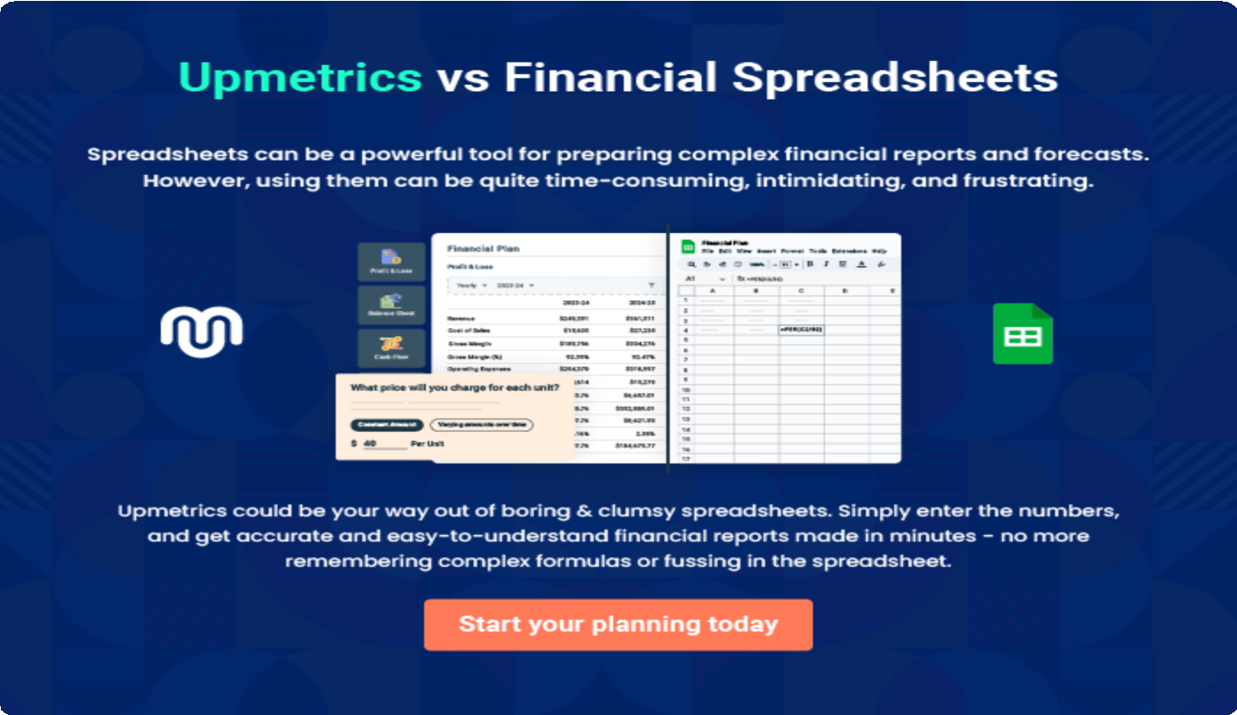

9.

Appendix
EmbedLink

Whenwritingtheappendixsection,youshouldincludeanyadditional
informationthatsupportsthemaincontentofyourplan.Thismayinclude
financialstatements,marketresearchdata,legaldocuments,andother
Tounlock helptry Upmetrics!
EmbedLink

Createawinningbusinessplanthatgetsyoufunded

Creatingastunningandinvestment-readyplanrequiresnowriting,graphicdesigning,orfinancial planning expertise.

Upmetricshasallthefeaturesrequiredtohelpyoucreateacomprehensivebusinessplan—fromstarttofinish. Makenomistakes,it’sthemodernwayofplanningtostructureideas,makeplans,andcreatestunningpitch decks to awe investors.

Pitchdecksthatimpressinvestors
Create pitch decks that provide a visual representation of your business, engage investors,andmakethemwanttoinvestinyour businessidea.

Interactiveplansinnotime
Import business plan sections like—SWOT analysis,comparisontables,andotherstocreate an interactive business plan. No designing skills arerequired.

Stunningcoverpagedesigns
WithUpmetrics,youhavethelibertytochoose from multiple stunning cover page designs.
Chooseacreativedesignandmakeyourplan standout.

500+samplebusinessplans
Simplyimportatemplatefromourlibraryof sample plans into the editor and start customizingittomakeityours.Ittakesonlyafew clicks to get started.

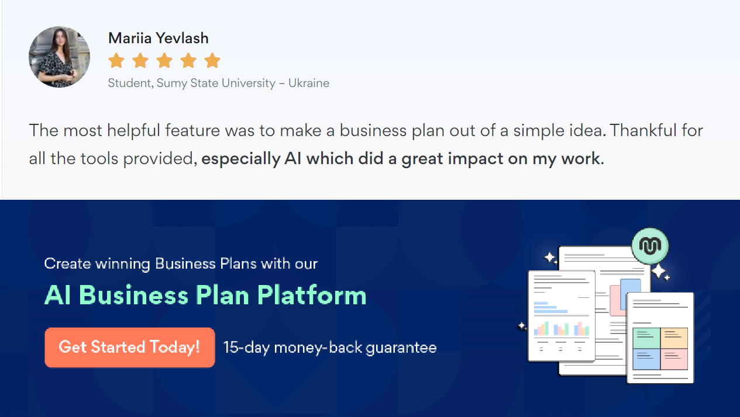Onlinesharingmadesimple
Upmetricsmakesonlinesharingquickandeasier forusers.Easilyshareyourbusinessplanswitha linkwhiletrackingreaderactivity.

Collaboratewithteaminreal-time
Invite team members, initiate conversations, discussideas&strategies,sharefeedback,and work on a business plan in real-time.

