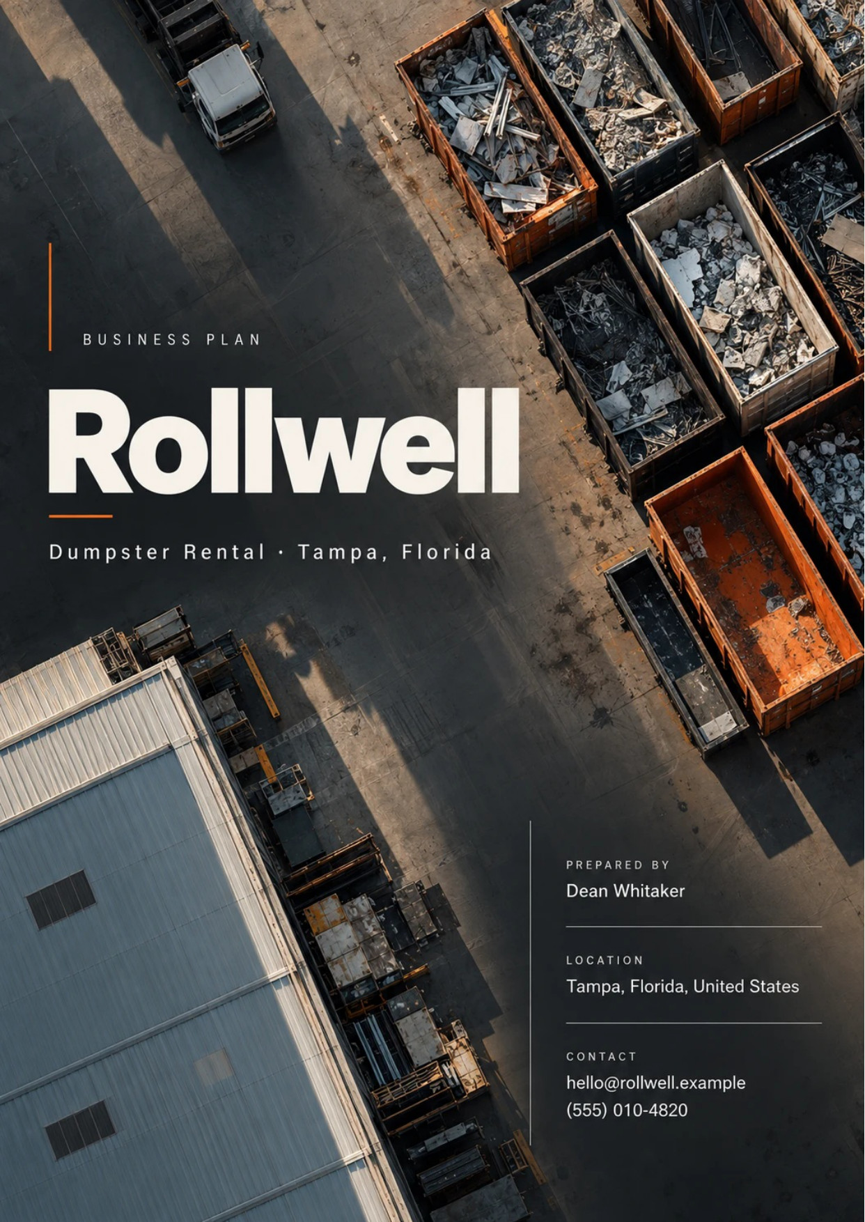
Table of Contents
1. Executive Summary 6
1.1 Business Overview 7
1.2 Mission Statement 7
1.3 Location & Market Opportunity 7
1.4 Unique Selling Points 7
1.5 Financial Highlights 7
1.6 Funding Requirement 8
1.6.1 Income Statement (3 Year projections) 8
2. Company Overview 9
2.1 Legal Structure 10
2.2 Vision Statement 10
2.3 Background & History 10
2.4 Future Goals 10
2.4.1 Business Owners 11
2.4.2 SMART Goal 11
3. Market Analysis 12
3.1 Overview 13
3.2 Market Segmentation 13
3.3 Market Trends 13
3.4 Local Market Outlook 13
3.5 Market Size 14
4. Customer Analysis 15
4.1 Target Market 16
4.2 Customer Segments 16
4.3 Customer Persona 17
4.4 Customer Purchase Journey 17
5. Competitive Analysis 18
5.1 Competitors 19
5.2 Comparison 19
5.3 Competitive Edge 20
5.4 SWOT Analysis 21
6. Services Offered 22
6.1 Our Offering 23
6.2 Signature Items 23
6.3 Additional Services 23
6.4 What Sets Us Apart 23
6.5 Container Sizes & Weight Limits 24
6.5.1 Residential Roll-Off Rental 24
6.5.2 Contractor Swap-Out Accounts 25
6.5.3 Features 26
6.5.4 Pricing 26
7. Marketing & Sales Strategies 27
7.1 Market Positioning 28
7.2 Marketing Objectives 28
7.3 Online Marketing 28
7.4 Public Relations and Branding 29
7.5 Partnership & Collaboration Strategy 29
7.6 Customer Loyalty & Retention 29
7.7 Sales Channels 30
8. Operations Plan 31
8.1 Daily Operations 32
8.2 Working Hours 32
8.3 Staffing & Training 32
8.4 Location and Facilities 32
8.5 Milestones & Timeline 33
8.6 Disposal, Recycling & Permits 34
9. Management Team 35
9.1 Key Members 36
9.2 Organization Chart 36
9.3 Advisory Board Members 37
9.3.1 Hiring Plan 37
10. Financial Plan 38
10.1 Key Assumptions 39
10.2 Capital Requirements and Use of Funds 39
10.2.1 Use of Funds 40
10.3 Income Statement (3 Year projections) 41
10.4 Balance Sheet (3 Year projections) 42
10.5 Cash Flow Statement (3 Year projections) 43
10.6 Break Even Analysis 44
11. References 45


CHAPTER 1

Executive Summary

1.1 Business Overview
1.2 Mission Statement
1.3 Location & Market Opportunity
1.4 Unique Selling Points
1.5 Financial Highlights
1.6 Funding Requirement

1.1 Business Overview
Rollwell is a roll-off dumpster rental company opening in Tampa, Florida. From one fenced yard in east Tampa, a single roll-off truck delivers, swaps and hauls a fleet of thirty open-top containers in 10, 15, 20 and 30 yard sizes.
It rents a container at a flat rate that covers delivery, pickup, a seven day hire and disposal up to a stated weight. Its customers are homeowners clearing out, remodeling or reroofing, and the roofers, remodelers and property managers who need a container on every job.

1.2 Mission Statement
To put the right container on the driveway when it was promised, take it away when the work is done, and charge exactly what was quoted, with a scale ticket for anything more.

1.3 Location & Market Opportunity
Rollwell serves Tampa and the surrounding Tampa Bay metro, with most of its work in Hillsborough County. The metro had 3,405,357 residents in 2024, and Hillsborough County alone grew 8.3% between 2020 and 2024 to 1,581,426. A growing county keeps producing the debris Rollwell hauls: moves and estate cleanouts, kitchen and bath remodels, reroofing, and the gutting and repair that follows every storm season.
US dumpster rental generated $654.0 million in rental revenue in 2025. Scaled to the metro's share of the national population, the Tampa Bay rental market is about $6.55 million a year, a floor because that measure leaves out disposal revenue and the roll-off work of the large integrated haulers. One US dumpster rental business averages about $1.86 million a year, so Rollwell's first-year revenue sits well inside the size of a single operator.

1.4 Unique Selling Points
- An owner-operator drives the truck, so the person who takes the booking is the one who places the container.
- One written price per size, including disposal up to a stated tonnage, quoted online before booking.
- Every overage invoice carries the disposal facility's own scale ticket.
- Contractor accounts with text-booked swap-outs and one monthly statement.
- Containers set down on boards so driveways are left as they were found.

1.5 Financial Highlights
Revenue comes from thirty containers, each rented two and a half times a month at an average flat rate of $545, with overage tonnage, extra days and surcharges adding a further 10%. The fleet opens at half that level and is fully booked within six months.
Revenue is projected at $472,106 in the first year, $542,922 in the second and $624,361 in the third, at a gross margin of 60.0% throughout. The first year closes with a net loss of $3,283 while the fleet fills; net income then reaches $12,805 in the second year and $30,068 in the third. Break-even revenue is $363,233, the equivalent of 666 rentals a year, which the first year clears. Third-year net income is $5,257 in the conservative case and $63,578 in the upside case.

1.6 Funding Requirement
The startup budget is $296,500. Most of it buys a late-model roll-off truck and thirty new steel containers; the rest covers yard preparation, branding, licenses and insurance, the booking system and launch marketing. It is funded by a $100,000 contribution from the two owners and a $250,000 SBA 7(a) loan at 10.5% over ten years, which leaves opening cash above the budget. Profits stay in the business while the loan is repaid.
The plan rests on an owner who has run roll-off routes for years, a growing county that renovates and rebuilds constantly, and an offer built on prices that hold and pickups that happen on time. The money puts a full fleet and a truck on Tampa's streets with the systems to keep every container working.

1.6.1 Income Statement (3 Year projections)
 | Year 1 | Year 2 | Year 3 | Total
Revenue | $472,106.25 | $542,922.19 | $624,360.52 | $1,639,388.96
Cost of Sales | $188,842.50 | $217,168.88 | $249,744.21 | $655,755.59
Gross Margin | $283,263.75 | $325,753.31 | $374,616.31 | $983,633.37
Operating Expense | $217,939.66 | $240,370.60 | $266,166.19 | $724,476.45
Total Expense | $475,389.30 | $530,116.87 | $594,292.76 | $1,599,798.93
Net Income | ($3,283.05) | $12,805.32 | $30,067.76 | $39,590.03

CHAPTER 2

Company Overview

2.1 Legal Structure
2.2 Vision Statement
2.3 Background & History
2.4 Future Goals

2.1 Legal Structure
Rollwell will be organized as a Florida limited liability company, owned by its two founders, Dean Whitaker and Renee Castillo. The LLC keeps the owners' personal assets separate from the liabilities of a business that puts heavy steel containers on other people's property and runs a commercial truck on public roads every day.
The company will carry commercial auto cover on the roll-off truck, general liability, and workers' compensation once its first employee starts. The truck and containers serve as collateral for the SBA loan. The owners intend to elect S corporation tax treatment once profits justify the payroll it requires, on the advice of the company's accountant.

2.2 Vision Statement
To be the dumpster company Tampa's remodelers and roofers call first because the container arrives when promised, and the one homeowners recommend because the bill matched the quote.

2.3 Background & History
Rollwell is a new business. Dean Whitaker spent nine years driving roll-off routes for a regional hauler in central Florida, where he saw the same complaints repeated on job after job: swaps that slipped a day and left a crew standing around, booking brokers who quoted one price and invoiced another, and overage charges with nothing to show how they were reached. Renee Castillo spent those years on the other side of the counter, running dispatch and receivables for a building materials supplier whose customers were the same contractors.
The two concluded that a small fleet run by the people who own it could win steady work from contractors on reliability alone, and from homeowners on plain pricing. The business is planned to open in February 2027, after the yard is leased, the truck and containers are delivered, and the City of Tampa and Hillsborough County have confirmed in writing which roll-off work Rollwell may haul.

2.4 Future Goals
In the first 0 to 18 months, Rollwell's aim is to fill its fleet. That means every one of the thirty containers turning about two and a half times a month by July 2027, a base of contractor accounts that books on every job, and enough reviews to compete in search with the national booking brands. It also means proving the cost side: steering clean concrete, metal and yard waste to outlets cheaper than the landfill, and keeping overage billing honest and fully documented.
Over 1 to 3 years, which is the span the financial projection covers, the goal is profitable growth on the same yard. Revenue is projected to rise from $472,106 in the first year to $624,361 in the third as contractor work deepens and containers are added in the sizes booked most. The SBA loan is serviced from operations throughout, and no profits are distributed while it is outstanding.
Over 3 to 5 years, the owners intend to add a second roll-off truck and a full-time driver, which roughly doubles the number of containers one yard can serve and adds capacity for storm-season surges. A larger fleet would also support standing arrangements with builders on new home sites, where one container stays on a lot for months and is swapped weekly.

2.4.1 Business Owners
Dean Whitaker | Renee Castillo

Total ownership: 100%
70% | Dean Whitaker  7,000 Shares
30% | Renee Castillo  3,000 Shares

2.4.2 SMART Goal
  Specific  - Two owners launch Rollwell from one yard in east Tampa.  - Thirty containers and one truck serve Hillsborough County.  - Every container turning two and a half times a month. |   Measurable  - Rentals per container, tracked weekly.  - First-year revenue of $472,106.  - At least 666 rentals, the break-even count. |   Achievable  - Dean holds a Class B CDL and has run roll-off routes.  - Renee has run dispatch and receivables.  - Launch money goes to search ads and contractor visits.
  Relevant  - A growing county remodels and reroofs every week.  - Contractors pay for a hauler who swaps on time.  - A full fleet services the loan before any expansion. |   Time-Based  - First rentals in February 2027.  - Half the fleet out from the first month.  - Fleet fully booked by July 2027.

CHAPTER 3

Market Analysis

3.1 Overview
3.2 Market Segmentation
3.3 Market Trends
3.4 Local Market Outlook
3.5 Market Size

3.1 Overview
Dumpster rental is the business of delivering an open-top roll-off container to a site, leaving it for a rental period and hauling it full to a landfill, transfer station or recycler. US dumpster rental generated $654.0 million in rental revenue in 2025, up 7.2% on the year before, and IBISWorld puts 2026 at $664.8 million. It counts 351 businesses that specialize in the trade. Much more roll-off work sits inside the large integrated haulers: Waste Management's Industrial line, which carries its roll-off service, earned $3,106 million of net operating revenue in 2025.

3.2 Market Segmentation
Demand splits by who is throwing the debris away and how often.
- Homeowners: cleanouts, moves, estate clearances, DIY remodels and yard projects, usually one rental at a time in a 10 to 20 yard size.
- Remodelers and roofers: a container on every job, often swapped several times, booked on account and highly sensitive to timing.
- Builders and general contractors: longer hires and heavier construction and demolition loads in 20 and 30 yard sizes.
- Property managers and landlords: unit turnovers and evictions cleanouts, small and recurring.
- Storm recovery: surges of gutting and reroofing debris in the weeks after a major storm.

3.3 Market Trends
Construction is flat nationally. US construction spending was about $2.16 trillion in 2025, 1.4% below 2024, with private residential construction down 2.6% to $905.2 billion. Home improvement and repair spending is holding near $519 billion through mid-2027, with growth slowing to 0.5%. For a dumpster company this means growth has to come from share in a growing local market, not from a national boom.
Weather is a rising source of debris. The US recorded 27 billion-dollar weather and climate disasters in 2024, costing about $182.7 billion. Recycling is the third trend: about 600 million tons of construction and demolition debris were generated in 2018, more than twice municipal solid waste, and concrete and metal increasingly go to next-use markets instead of the landfill.
Disposal costs are rising faster than rental prices in many markets, which is changing how operators work. The national average landfill tipping fee rose about 10% in 2024 to $62.28 a ton, and haulers are responding by sorting clean loads, setting firmer weight allowances and billing overage by the ton against a scale ticket. Operators who control where each load goes protect their margin; those who tip everything at the nearest landfill absorb the increase.

3.4 Local Market Outlook
Tampa Bay is a growing market. Hillsborough County had 1,581,426 residents in 2024, up 8.3% since 2020, and the wider metro 3,405,357. Builders took out permits for 9,053 new housing structures in the county in 2024, and three weeks after Hurricane Milton the City of Tampa had cleared over 100,000 cubic yards of storm debris.
Hillsborough County had 44 solid waste collection establishments with employees in 2024, up from 40, a county figure that mixes roll-off operators with garbage haulers. National booking brands quote Tampa rentals at $425 to $1,216, averaging $704. Disposal is expensive here: the county charged $91.50 a ton for construction and demolition debris in 2024. Inside Tampa's 1983 city boundary, commercial solid waste haulers owe the City a franchise fee of 15% of gross revenues, and whether that covers roll-off debris rentals has to be confirmed. No local figure for dumpster rental spend is published.

3.5 Market Size
The total addressable market is US dumpster rental revenue, $654,000,000 in 2025. The serviceable market is the Tampa-St. Petersburg-Clearwater metro's share of it, about $6,550,000 a year, derived from the metro's 1.001% share of the US population because no local rental revenue figure is published. It is a floor: the national figure excludes disposal revenue and the roll-off work booked through integrated haulers, and local prices run above the national average. The obtainable market is one dumpster rental business, which averages about $1,860,000 a year nationally. Rollwell's first-year revenue of $472,106 is about a quarter of that single-operator figure.
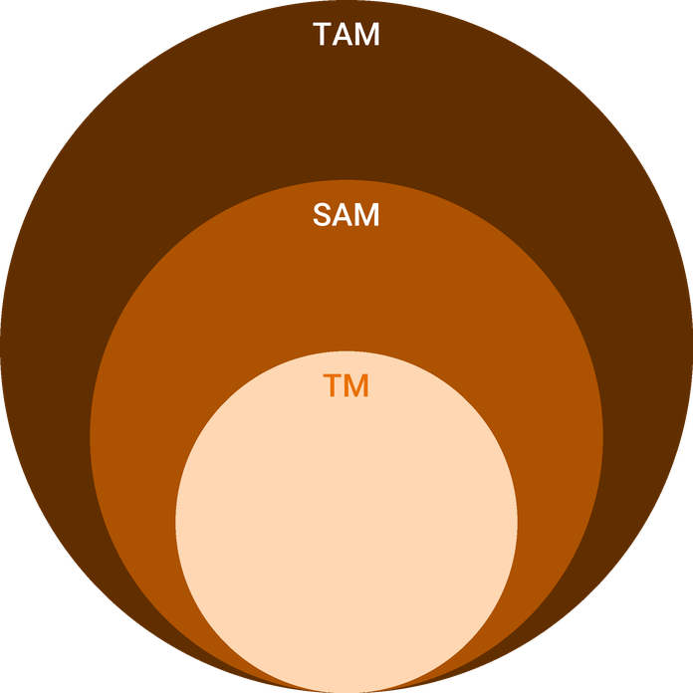
  ● | Total Available Market (TAM)  The US dumpster rental industry (rental revenue, disposal excluded) generated $654.0 million in 2025, up 7.2% on $610.2 million in 2024. | 654.0M
  ● | Served Available Market (SAM)  The Tampa-St. | 6.5M
  ● | Target Market (TM)  One US dumpster rental business averages about $1.86 million of annual revenue in 2025 ($654.0 million across 351 businesses); a national average weighted by larger fleets, not a Tampa figure. | 1.9M

CHAPTER 4

Customer Analysis

4.1 Target Market
4.2 Customer Segments
4.3 Customer Persona
4.4 Customer Purchase Journey

4.1 Target Market
Rollwell sells to anyone in Tampa and the surrounding Tampa Bay metro who has more debris than a curbside pickup will take. That is a broad base: the metro had 3,405,357 residents in 2024, and every remodel, reroof, move and storm repair among them produces a load. The business is built around the part of that base that rents repeatedly, the residential remodelers, roofers and property managers who need a container on every job, while homeowners supply the first orders and the reviews that bring the next ones.
The customer is local by necessity. A container has to be driven to the site, collected and hauled to a disposal facility, so a yard in east Tampa reaches the homes and job sites within a working drive and no further. Inside that radius demand is spread across older neighborhoods being remodeled, newer subdivisions where roofs reach the age for replacement, and rental housing that turns over every year.

4.2 Customer Segments
- Homeowners: one-off rentals for garage and estate cleanouts, moving, DIY remodels and yard clearance. They book online or by phone, pay by card, choose by price and reviews, and rent most often in the 10 and 15 yard sizes.
- Remodelers: kitchen, bath and flooring contractors running several jobs at once. They rent 15 and 20 yard containers, book on account, and value a swap that arrives before the crew does over a lower price.
- Roofers: the heaviest loads per cubic yard. Shingle tear-offs fill a 20 yard container quickly and run to the weight limit, so they care about clear overage pricing and fast pickup once the roof is dried in.
- Property managers and landlords: small, recurring rentals for unit turnovers and cleanouts, invoiced monthly and booked by an office rather than a crew.
- Storm recovery customers: homeowners and contractors gutting and reroofing after a hurricane, who need a container within days and often rent for longer.
The segments differ less in what they throw away than in how they buy. Homeowners decide once, quickly and on price and reviews, and rarely rent again within the year. Remodelers, roofers and property managers decide slowly and then keep renting, so a single account can be worth many homeowner bookings. Rollwell's marketing therefore aims at homeowners for volume in the first months and at the trades for the repeat work that fills the fleet afterwards.

4.3 Customer Persona
  Remodeler Rick  Demographics  Age: 46  Marital Status: Married  Location: Brandon, FL  Income: 95,000 dollars annually  Professional Role  Job: Owner of a residential remodeling company  Crew: five carpenters and laborers | “I need the can on the driveway before my crew shows up, and gone the day the job wraps.”
   | Identifiers / Personality Traits  - Runs three to five kitchen, bath and flooring jobs at a time  - Books containers by text from the job site  - Compares haulers on reliability before price
   | Goals  - Keep crews working without waiting on a swap  - Avoid surprise overage charges he cannot pass on  - Leave clients' driveways undamaged
   | Challenges  - Haulers who miss pickup windows and stall a job  - Brokers who quote one price and bill another  - Paying for permits and street placement on tight lots

4.4 Customer Purchase Journey
A homeowner's journey starts with a search. They type a dumpster rental search into Google, compare the prices and reviews that come back, and usually choose within a single session. Rollwell's site has to answer three questions at once: which size fits the job, what it costs all-in, and whether the container can arrive on the date they need. A clear size guide with photos, a flat price per size and an online calendar do that. After booking they receive a confirmation and a reminder the day before delivery, with a note on where the container will sit.
A contractor's journey is slower to start and far longer. Remodelers and roofers usually already have a hauler and switch only when that hauler lets them down, so Rollwell meets them through job-site visits, supplier counters and referrals from other trades. The first rental is a trial. If the container arrives before the crew, the swap comes when promised and the overage is backed by a scale ticket, the contractor opens an account and books by text on every job after.
For both groups the decisive moment is pickup. A container collected on the day promised, with the driveway left clean and the invoice matching the quote, is what turns a first rental into a review or a standing account. A missed pickup undoes the rest, which is why the operations plan protects pickup windows first.
Property managers follow the contractor's path at a smaller scale: a trial rental for one turnover, then a standing account if the invoicing is clean and the container fits the parking lot without blocking tenants.

CHAPTER 5

Competitive Analysis

5.1 Competitors
5.2 Comparison
5.3 Competitive Edge
5.4 SWOT Analysis

5.1 Competitors
Rollwell competes with four kinds of supplier, none of which publishes its Tampa revenue.
- Integrated waste haulers. In unincorporated Hillsborough County, commercial solid waste collection is an exclusive franchise held since January 2022 by FCC Environmental Services, Republic Services and WM. Firms like these own or contract disposal capacity and run roll-off service alongside garbage collection, which lets them price large contractor accounts keenly.
- National booking brands. Dumpsters.com and Budget Dumpster sell Tampa rentals online and pass delivery to local haulers. They quote $425 to $1,216 across 10 to 40 yard sizes, an average of $704, with delivery typically within five business days.
- Franchised local operators. Residential-focused franchises such as Dumpster Dudez have a Tampa location, with branded containers and a central booking system.
- Independent local haulers. Small owner-run fleets, several of them highly rated on Thumbtack, compete on price and local knowledge.
Supply is fragmented. Hillsborough County had 44 solid waste collection establishments with employees in 2024, a count that includes garbage and recycling haulers as well as roll-off operators, so the number running roll-off rentals is smaller.

5.2 Comparison
The integrated haulers are strongest on large construction accounts and weakest on the small residential job, where a 20 yard rental is a low priority for a company routing garbage trucks. The booking brands are strong in search and weak on control: the customer pays the broker, the delivery is made by whichever hauler takes the order, and an overage dispute has two parties to argue with. Franchised and independent operators come closest to Rollwell's model. The difference Rollwell aims to make is in timing and documentation, which matter most to the contractors who rent most often.
On price, Rollwell's published rates of $425 for a 10 yard to $675 for a 30 yard sit below the $704 average the booking brands quote in Tampa, partly because there is no broker margin and partly because the size mix tops out at 30 yards.
Feature | Rollwell | National booking brands | Integrated waste haulers | Independent local haulers
Flat price including disposal quoted online | ✓ | ✓ | ✗ | ✗
Owner-run local yard and truck | ✓ | ✗ | ✗ | ✓
Scale ticket with every overage invoice | ✓ | ✗ | ✓ | ✗
Next business day delivery on most orders | ✓ | ✗ | ✗ | ✓
Contractor accounts on 30 day terms | ✓ | ✗ | ✓ | ✓
Driveway protection boards on every drop | ✓ | ✗ | ✗ | ✗

5.3 Competitive Edge
Rollwell's edge is that the person who takes the booking is the person who drives the truck. Placement, timing and access are settled by someone who knows the street, and a missed swap is the owner's problem the same day rather than a ticket in a broker's queue. The second edge is documentation: every overage invoice carries the disposal facility's own scale ticket, which removes the most common source of disputes with contractors' bookkeepers.
The third is cost discipline. Hillsborough County charged $91.50 a ton for construction and demolition debris in 2024, so a hauler that routes clean concrete, metal and yard waste to cheaper outlets keeps more of each rental than one that tips everything at the landfill. That margin pays for the on-time service the contractor accounts depend on.
   | The owner drives the truck  The person who takes the booking places the container, so placement, timing and access are settled by one person who knows the street.
   | One price, written down  Each size is quoted as a flat rate that includes delivery, pickup, a seven day hire and a stated tonnage, with overage at a published rate per ton.
   | Scale tickets on every invoice  Any overage charge arrives with the disposal facility's own weight ticket, so a homeowner or a contractor's bookkeeper can check it line by line.
   | Built for repeat contractor work  Roofers and remodelers get a standing account, swap-outs booked by text and one monthly statement, which keeps their crews working instead of waiting.
 | Driveways left as found  Every container goes down on boards, and the truck's route is planned around trees, wires and soft ground before the drop.

5.4 SWOT Analysis
Strengths  - Owner-operator drives the truck, so placement, timing and customer contact sit with one accountable person.  - Flat rates per size include delivery, pickup and a stated tonnage, quoted online before booking.  - Thirty containers in four sizes cover cleanouts, remodels and roofing tear-offs from one yard.  - Overage invoices carry the facility's scale ticket, which builds trust with contractors' bookkeepers. | Weaknesses  - One roll-off truck means a breakdown stops every delivery and pickup until it is repaired.  - A new name starts with no reviews in a search market where buyers compare ratings first.  - Hillsborough's $91.50 a ton for C&D debris makes heavy roofing loads expensive to tip.  - Contractor accounts on 30 day terms tie up cash while the fleet is still filling.
Opportunities  - Hillsborough County added residents steadily since 2020, and every move and remodel produces debris.  - Roofers and remodelers rent on every job and reward a hauler that swaps on time.  - Storm seasons create surges of reroofing and gutting work that need containers quickly.  - Clean concrete, metal and yard waste loads can go to cheaper recycling outlets than the landfill. | Threats  - The City of Tampa and Hillsborough County franchise rules may restrict commercial hauling by non-franchised firms.  - Integrated haulers own disposal sites and can undercut on price for large contractor accounts.  - National booking brands buy the top search positions for dumpster rental terms in Tampa.  - A slowdown in remodeling spending would reduce the steadiest share of contractor demand.

 Strategic Summary
Rollwell should win on reliability with residential remodelers and roofers first, confirm its hauling rights in writing before launch, and route recyclable loads away from the landfill to protect margin.

CHAPTER 6

Services Offered

6.1 Our Offering
6.2 Signature Items
6.3 Additional Services
6.4 What Sets Us Apart
6.5 Container Sizes & Weight Limits

6.1 Our Offering
Rollwell rents open-top roll-off containers to homeowners, contractors and property managers in Tampa and the surrounding Tampa Bay metro. Every rental is sold as one flat price per size that covers delivery, a seven day hire, pickup and disposal up to the container's weight allowance. Anything beyond that is billed after the load is weighed at the disposal facility, at published rates, with the scale ticket attached.
The offer is deliberately simple. Four container sizes cover nearly every residential and light construction job, each with one price, so a customer can book online without a phone call and a contractor can quote the container into a job before it starts.

6.2 Signature Items
The headline service is the residential roll-off rental, priced from $425 for a 10 yard container to $675 for a 30 yard. The 20 yard container at $575 is the workhorse of the fleet: large enough for a kitchen remodel, a whole-room cleanout or a typical roof tear-off, and small enough to fit most driveways.
The second is the contractor swap-out account. Roofers, remodelers and property managers keep a container on site for the length of a job and text a swap request when it is full; an empty container replaces it the next morning. Swaps are priced from $495 on account, and every rental, overage and scale ticket is gathered on one monthly statement payable on 30 day terms.

6.3 Additional Services
- Extra rental days at $15 a day, for projects that run past the seven day hire.
- Right-of-way permits arranged for containers that have to sit in a Tampa street.
- Mattress and tire surcharges, so items with their own disposal fees are accepted rather than refused.
- Clean-load rentals for concrete, brick or yard waste, routed to recycling outlets rather than the landfill.
- Priority scheduling for account holders during storm recovery periods.

6.4 What Sets Us Apart
Three things set the offer apart. The price on the website is the price on the invoice for any load within its allowance. Overage, when it happens, is backed by the facility's own weight ticket rather than an estimate. And the containers are placed by an owner-driver who sets each one on boards, checks for overhead wires and soft ground, and leaves the driveway as it was found.
The flat rate also protects the customer from the cost side of the trade. Disposal is the largest cost of every rental, and the margin assumption behind these prices, a 60.0% gross margin, already carries the county's tipping fees, diesel and container repair, so the customer is not asked to absorb them later.

6.5 Container Sizes & Weight Limits
Each size carries a weight allowance because disposal is charged by the ton, and a container's volume says little about its weight. A 20 yard container of furniture and cardboard may weigh under a ton; the same container of roofing shingles can exceed three.
- 10 yard: about 12 feet long and 3.5 feet high, 1 ton included. Garage and attic cleanouts, a single bathroom remodel, small yard projects, and concrete or brick, which must be loaded alone and no higher than the container's sides.
- 15 yard: about 14 feet by 4.5 feet, 1.5 tons included. A kitchen remodel, flooring removal across several rooms, or a medium cleanout.
- 20 yard: about 22 feet by 4 feet, 2 tons included. Whole-room renovations, most single-story roof tear-offs and larger cleanouts.
- 30 yard: about 22 feet by 6 feet, 3 tons included. Whole-house cleanouts, additions and new construction debris.
Tonnage above the allowance is billed at $100 a ton. Hazardous materials, paint, batteries and liquids are not accepted, and loads must not be filled above the container's walls, because an overfilled container cannot be tarped and legally hauled on public roads.

6.5.1 Residential Roll-Off Rental
An open-top steel container delivered to a driveway or yard, kept for seven days and hauled away full. The flat rate covers delivery, pickup and disposal up to the weight allowance for that size, so the price quoted at booking is the price paid unless the load runs heavy.
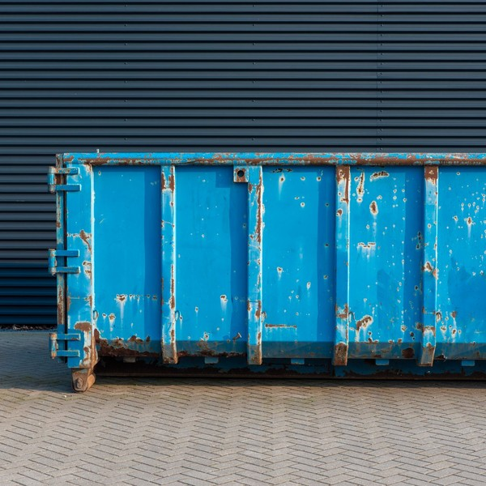 | $425 to $675 per 7 day rental  The price rises with container size, from a 10 yard for a garage cleanout to a 30 yard for a whole-house clearout. Tonnage over the allowance is billed at $100 a ton and extra days at $15 a day.

Specifications
- Sizes of 10, 15, 20 and 30 cubic yards.
- Seven day rental period, extendable by the day.
- Weight allowance of 1 to 3 tons depending on size.
- Placed on boards to protect the driveway surface.
- Booked online or by phone, usually for next business day delivery.

6.5.2 Contractor Swap-Out Accounts
A standing account for roofers, remodelers and property managers who need a container on site for the length of a job. A full container is swapped for an empty one on request, and every rental, overage and scale ticket is gathered on one monthly statement.
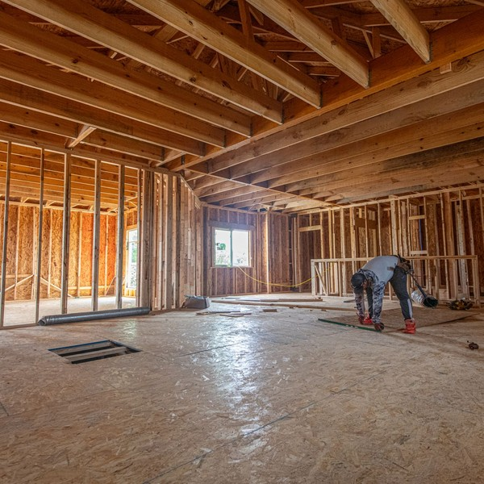 | From $495 per swap on account  Account pricing follows the published rates by size, and the account pays on 30 day terms instead of a card at booking.

Specifications
- Swap requests taken by text or phone until 3 p.m. for next morning service.
- Monthly statement with scale tickets attached.
- Invoiced on 30 day terms after a credit check.
- Priority scheduling during storm recovery periods.
- Right-of-way permits arranged for street placements in Tampa.

6.5.3 Features
  Four container sizes
  10, 15, 20 and 30 yard containers matched to cleanouts, remodels, roofing and construction debris.
  Flat rate with disposal
  Delivery, pickup, a seven day hire and disposal up to the weight allowance are in one quoted price.
  Scale-ticket invoicing
  Overage is billed only against the disposal facility's own weight ticket, attached to the invoice.
   | Driveway protection  Every container is set down on boards to keep driveways and pavers from being marked.
   | Online size guide and booking  Customers pick a size, a date and a placement spot online, with photos of each container.
   | Contractor swap-outs  Account holders text a swap request and get an empty container on site the next morning.

6.5.4 Pricing
Cleanout  From $425  per 7 day rental  - 10 or 15 yard container  - 1 to 1.5 tons included  - Delivery, pickup and disposal included  - Driveway protection boards |  | Most Popular  Remodel & Roofing  $575  per 7 day rental  - 20 yard container  - 2 tons included  - Delivery, pickup and disposal included  - Overage at $100 a ton with scale ticket |  | Construction  $675  per 7 day rental  - 30 yard container  - 3 tons included  - Swap-outs on account for contractors  - Extra days at $15 a day

CHAPTER 7

Marketing & Sales Strategies

7.1 Market Positioning
7.2 Marketing Objectives
7.3 Online Marketing
7.4 Public Relations and Branding
7.5 Partnership & Collaboration Strategy
7.6 Customer Loyalty & Retention
7.7 Sales Channels

7.1 Market Positioning
Rollwell is positioned as the local, owner-run dumpster company for people who rent often: the container arrives when promised, the price holds, and every extra charge comes with a scale ticket. It competes on reliability for contractors and on plain pricing for homeowners, not on being the cheapest container in Tampa.

7.2 Marketing Objectives
- Keep half the fleet out from the first month and every container turning two and a half times a month by July 2027.
- Open standing accounts with roofers, remodelers and property managers that book on every job.
- Build a review base that puts Rollwell alongside the booking brands in Tampa search results within the first year.
- Hold marketing to 5% of revenue, the budget the financial model carries.
Each objective has a measure the office already records: containers out each day, accounts opened, reviews received and the cost of each booking won from paid search. The figures are reviewed weekly, and spending moves to whichever channel is filling the fleet most cheaply.
Search and Local Services ads  $886  per month  Paid placement on dumpster rental searches across Tampa, billed per lead or click. |  | Contractor outreach  $393  per month  Visits to roofers, remodelers and property managers, with printed size guides and account forms.
Website and booking  $393  per month  The booking site, size guide pages and local search listings that turn a search into an order. |  | Reviews and referrals  $295  per month  Review requests after each pickup and a rental credit for contractors who refer another firm.

Total marketing budget: $23,605 a year, $1,967 a month.

7.3 Online Marketing
Most homeowners find a dumpster company in one search, so online spending goes first to paid placement on dumpster rental searches across Tampa and to Google Local Services, where the customer can call directly from the results. The website does the selling: a size guide with photos and measurements, one flat price per size, an online calendar showing the next available delivery date, and booking with card payment in a few steps.
Search visibility grows from local pages for each part of the service area and from reviews. Every customer receives a review request the day the container is collected, when the clean driveway and the matching invoice are fresh. Photos of placed containers, posted with the customer's permission, show the boards and the care taken.
Each job type gets its own landing page: garage and estate cleanouts, kitchen and bath remodels, roof tear-offs, and storm cleanup. Each page recommends a size, shows what fits in it and states the weight allowance, so a customer arriving from a search for a roofing dumpster lands on the 20 yard container with the tonnage a shingle load needs. Ads run hardest on weekday mornings, when contractors book for the next day, and are paused when the fleet is fully out, so money is never spent on a booking that cannot be delivered.

7.4 Public Relations and Branding
The brand is the container itself. Every container is painted in one color and stenciled with the Rollwell name and phone number, so each rental advertises the business to a street of neighbors for a week. The truck carries the same livery. Locally, Rollwell will take part in neighborhood cleanup days and offer reduced-rate containers to community groups and nonprofits clearing lots, which earns coverage in neighborhood newsletters and goodwill with the residents who rent next.
Every touchpoint repeats the same three promises: on time, the quoted price, and a scale ticket for anything extra. They are printed on the size guide, read back on every booking call and written on the invoice, so the brand is something a customer experiences on the driveway rather than a logo they are asked to remember.

7.5 Partnership & Collaboration Strategy
The partnerships that matter are with the trades that generate debris and the businesses they already visit. Rollwell will introduce itself at the supply houses where roofers and remodelers buy materials, leaving size guides and account forms at the counter. Referral arrangements with home inspectors, estate sale organizers, real estate agents and moving companies reach homeowners at the moment a cleanout is decided. Recycling outlets for concrete, metal and yard waste are partners on the cost side, giving Rollwell cheaper disposal for clean loads.
Property management companies and homeowner associations are approached directly, with a standing price list and monthly invoicing, because one office can send a steady run of turnover and cleanout rentals. Ahead of each storm season, Rollwell will agree priority arrangements with the roofers and remodelers it already serves, so that when demand spikes the containers go first to the accounts that kept the fleet busy in quieter months.

7.6 Customer Loyalty & Retention
In this trade, loyalty is earned on the pickup. A contractor stays with a hauler who swaps on time and leaves without a dispute, and leaves after the first stalled crew. Rollwell protects that with text booking for account holders, next-morning swaps, monthly statements with every scale ticket attached, and priority during storm recovery. Contractors who refer another firm receive a rental credit. Homeowners rent less often, but return for the next project and recommend a company that left their driveway undamaged.
Retention is measured rather than assumed: the office tracks rentals per account each month, the time from a swap request to the swap, and every review left. An account whose bookings fall away gets a call from the owner the same week, because in this trade a quiet contractor has usually found another hauler.

7.7 Sales Channels
Revenue arrives by the four routes below, and their mix changes through the first year. Homeowner bookings through the website and the phone carry the opening months, because they need no account and no history. Contractor and property manager accounts take longer to open but rent on every job, so they are planned to become the larger share by the time the fleet is fully booked. Homeowners pay by card at booking; accounts pay on 30 day terms, which is why just under half of sales sit in receivables at any time.
   | Contractor and roofer accounts  The largest and steadiest stream, worth repeat rentals on every job, and dependent on swapping on time.
  Online booking
  Homeowners choose a size and date on the website and pay by card, which depends on search visibility and reviews.
   | Phone and Local Services leads  Calls from paid search and Google Local Services, worth fast first orders and dependent on answering every call.
  Property manager accounts
  Unit turnovers and cleanouts for landlords, worth recurring small rentals and dependent on reliable invoicing.

CHAPTER 8

Operations Plan

8.1 Daily Operations
8.2 Working Hours
8.3 Staffing & Training
8.4 Location and Facilities
8.5 Milestones & Timeline
8.6 Disposal, Recycling & Permits

8.1 Daily Operations
Each day starts at the yard at 6:30 a.m. with the dispatch board: deliveries, swaps and pickups booked for that day, sequenced into a route that groups stops by area and fits the disposal runs around facility opening hours. A delivery takes an empty container from the yard to the site; a pickup brings a full one to a disposal facility, then back to the yard or straight to the next delivery. A swap does both in one visit.
At each delivery the driver checks the placement spot, overhead clearance and ground before dropping the container on boards, and photographs it in place. At pickup the load is checked for prohibited items and overfilling, tarped and hauled. The scale ticket from the facility is photographed and attached to the rental in the dispatch software, which drives any overage charge. The office confirms the next day's bookings by text each afternoon and closes out invoices.
Disposal runs are timed around the facilities rather than the clock. Scale houses are busiest mid-morning, so full containers collected early go straight to tipping before the queue builds, and afternoon pickups are held in the yard overnight when that saves a wait. Swaps are grouped by area so the truck rarely crosses the county twice in one day.

8.2 Working Hours
The office and phone lines are open 7 a.m. to 5 p.m. Monday to Friday and 8 a.m. to noon on Saturday. Trucks run from 6:30 a.m., so containers are on site before contractor crews arrive and disposal runs finish before facilities close. Saturday delivery serves homeowners who start projects at the weekend. Online booking is open at all hours, and contractor swap requests received by 3 p.m. are served the next morning.

8.3 Staffing & Training
Dean Whitaker drives the truck and runs dispatch. A part-time second driver with a Class B commercial driver's license covers swap-heavy days, Saturdays and the owner's time off, and Renee Castillo runs the office, bookings and contractor accounts. Every driver is trained on the truck's hoist and cable system, safe placement on residential driveways, load inspection and the paperwork for scale tickets and right-of-way permits. A yard and container maintenance role is planned once the fleet grows.
Safety is part of the job description, not an addition to it. Every driver completes a documented pre-trip inspection of the truck, hoist and cables each morning, and drivers holding a commercial license are enrolled in the drug and alcohol testing program federal rules require. Containers are inspected at every return for damaged doors, floors and latches, and anything unsafe is pulled from the fleet until it is repaired.

8.4 Location and Facilities
Rollwell will lease about half an acre of fenced, crushed-concrete yard with a small office trailer in east Tampa's industrial corridor, close to the interstates and the county's disposal facilities, at a planned $2,600 a month. The yard holds empty containers, the truck and the boards and tarps, and gives room for container repair and repainting. Its location keeps the deadhead miles short between the yard, customers and the facilities where loads are tipped.
The yard is laid out by size, with each row of containers facing the gate so the truck can pick up the right one without moving others. Damaged containers have their own corner, away from the rental rows, and the boards, tarps and chains are stored by the office trailer where the driver loads them each morning. The truck is serviced by a heavy vehicle shop on a fixed schedule, and a relationship with a second shop and a rental truck provider is arranged before launch, so a breakdown costs a day rather than a week.

8.5 Milestones & Timeline
Funding is secured in November 2026, the yard leased and the truck and containers delivered in December, and written determinations from the City of Tampa and Hillsborough County obtained in January 2027. The first rentals go out in February 2027, the fleet is expected to be fully booked by July 2027, and containers are added from February 2028 in the sizes contractors book most.
Nov 2026  Setup |  |  | Funding secured  SBA 7(a) loan and owners' contribution in place  The $250,000 loan and $100,000 from the owners fund the truck, the container fleet and opening costs.
Dec 2026  Setup |  |  | Yard and fleet  Yard leased, truck and containers delivered  A fenced half-acre yard in east Tampa takes delivery of the roll-off truck and thirty containers, branded with the phone number.
Jan 2027  Compliance |  |  | Hauling rights confirmed  City and county determinations in writing  Written determinations from the City of Tampa and Hillsborough County settle which roll-off work Rollwell may haul and on what terms.
Feb 2027  Launch |  |  | First rentals  Booking site and ads go live  Online booking, search ads and contractor visits start, with half the fleet expected out in the first month.
Jul 2027  Growth |  |  | Fleet fully booked  Every container turning on schedule  All thirty containers turn about two and a half times a month as contractor accounts and reviews build.
Feb 2028  Growth |  |  | Fleet expansion  Containers added as accounts grow  Second-year cash funds additional containers in the sizes contractors book most.

8.6 Disposal, Recycling & Permits
Disposal is the largest cost of every rental, so where each load goes is decided before the truck leaves the site. Hillsborough County charged $91.50 a ton for construction and demolition debris in 2024, $88.00 a ton at its Class I landfill and $195.50 a ton for passenger tires. Mixed debris goes to a permitted C&D facility. Clean loads of concrete, brick and asphalt, scrap metal and yard waste are kept separate and taken to recyclers and mulching facilities that charge less than the landfill or pay for the material. Mattresses and tires carry surcharges because they carry their own disposal fees.
Two sets of rules decide where Rollwell may work. Inside Tampa's 1983 city boundary, commercial solid waste haulers must hold a City franchise agreement and remit 15% of gross revenues from commercial hauling; in unincorporated Hillsborough County, commercial solid waste collection is an exclusive franchise held by three collectors. Neither rule states plainly how it treats roll-off construction debris, so Rollwell will obtain written determinations from both before its first rental and price any franchise fee into affected work. A container placed partly in a Tampa street, sidewalk or alley needs a Temporary Structure in Right-of-Way Permit, which the office arranges; one on a private driveway or job site needs none.
Prohibited items are kept out at the source. Every booking confirmation lists what cannot go in a container, including paint, chemicals, batteries, appliances with refrigerant and medical waste, and the driver checks the load before hooking up. A container holding something the disposal facility will refuse is left on site with a note and a photo, and the customer is told what has to come out before it can be hauled. This keeps rejected loads, and the fees and second trips they bring, rare.

CHAPTER 9

Management Team

9.1 Key Members
9.2 Organization Chart
9.3 Advisory Board Members

9.1 Key Members
The owner and operations manager answers for the fleet: every container placed and collected on the day promised, the truck kept running, and disposal costs held within the margin the plan assumes. He is measured on rentals per container per month, on-time pickups and disposal cost per rental. The office and accounts manager answers for revenue reaching the bank: bookings confirmed, invoices matched to scale tickets, and contractor accounts paid within terms. She is measured on days sales outstanding, bad debt and the share of rentals booked on account. The part-time driver answers for safe, on-time runs on the days he covers.
The two owners review the business together every Monday against a short list of numbers: rentals per container, containers out, disposal cost per ton, open receivables and new accounts. Any figure that drifts from the plan for two weeks running gets a named owner and a fix, which keeps a small team focused on what moves the result rather than on the busiest phone call of the day.
 | Dean Whitaker  Owner & Operations Manager · dean@rollwell.example  Holds a Class B commercial driver's license and spent nine years running roll-off routes for a regional hauler in central Florida.

 | Renee Castillo  Office & Accounts Manager · renee@rollwell.example  Managed dispatch, credit accounts and receivables for a building materials supplier serving Tampa Bay contractors.

 | Tony Reyes  Part-Time CDL Driver · tony@rollwell.example  Licensed Class B driver with experience on hook-lift and cable roll-off trucks for construction sites.

9.2 Organization Chart
Both the office and the driving report to the owner, who sets the daily route and settles any customer dispute. The office manager holds authority over credit terms and account approvals, so a new contractor account never waits on the truck to come back.
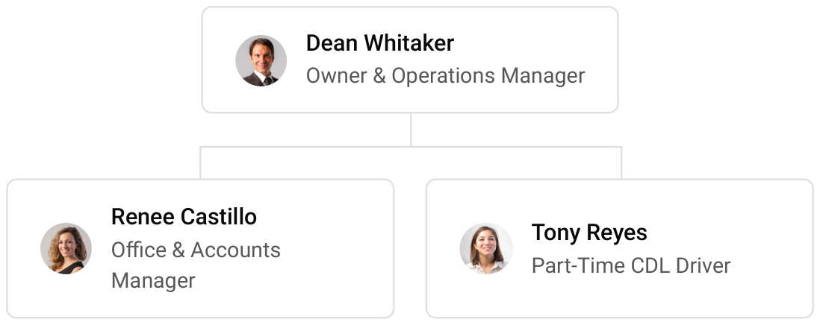

9.3 Advisory Board Members
Rollwell has no formal board. It will draw on three outside advisers: an accountant who files the company's taxes and reviews the monthly accounts against the plan; a commercial insurance broker who places the truck, liability and workers' compensation cover; and an attorney familiar with Florida solid waste regulation who handles the franchise and hauling determinations with the City of Tampa and Hillsborough County.

9.3.1 Hiring Plan
2  Filled |  | 1  Hiring This Year |  | 2  Open

Group By Department | Position Filled | Time of Hire | Time of Start | Filled
Operations & Hauling | 1 of 2 | 45 days | 14 days | 50%
Office & Accounts | 1 of 1 | 0 days | 0 days | 100%
Yard & Container Maintenance | 0 of 1 | 60 days | 14 days | 0%

CHAPTER 10

Financial Plan

10.1 Key Assumptions
10.2 Capital Requirements and Use of Funds
10.3 Income Statement (3 Year projections)
10.4 Balance Sheet (3 Year projections)
10.5 Cash Flow Statement (3 Year projections)
10.6 Break Even Analysis

10.1 Key Assumptions
Revenue is the fleet's arithmetic: 30 containers, each rented 2.5 times a month at an average flat rate of $545, plus overage tonnage, extra days and surcharges worth a further 10% of the flat rate. The fleet opens at 50% of that level and reaches it after 6 months, and revenue grows 15% a year after the first as containers and contractor accounts are added.
Gross margin is 60.0%. Cost of sales is disposal at Hillsborough County's tipping fees, diesel, container repair and card processing. Below the gross line, payroll is 20% of revenue for the owner-driver, a part-time driver and the office; marketing is 5%; yard rent is $2,600 a month; insurance, accounting and administration $2,600 a month; software and phones $500 a month; and truck servicing, permits and other operating costs 6% of revenue. Just under half of sales are to contractor accounts on 30 day terms, giving 14 days sales outstanding, with a 1.5% allowance for bad debt.
The assumptions are deliberately conservative where the plan is least certain. Containers turn 2.5 times a month, inside the trade's range and below what a busy fleet achieves, and the margin carries Hillsborough County's tipping fees rather than the lower rates of recycling outlets that clean loads can use. Depreciation writes the truck and containers off over 7 years, faster than steel containers wear out.
On these assumptions revenue is $472,106 in the first year, $542,922 in the second and $624,361 in the third. The first year closes with a net loss of $3,283 as the fleet fills, then net income of $12,805 and $30,068 follows. Break-even revenue is $363,233, or 666 rentals a year. In the third year net income ranges from $5,257 in the conservative case to $63,578 in the upside case.

10.2 Capital Requirements and Use of Funds
Rollwell needs $296,500 to open. The largest items are the container fleet, thirty new steel containers in four sizes, and a late-model used roll-off truck. The remainder covers yard preparation and fencing, branding on the truck and containers, licenses, insurance deposits and legal work, the booking website and software, launch marketing, the yard deposit and first month's rent, and boards, tarps and tools.
The money comes from a $100,000 contribution from the two owners and a $250,000 SBA 7(a) loan at 10.5% over 10 years, secured on the truck and containers. That leaves cash above the startup budget to carry contractor receivables and the first months of the ramp. No profits are distributed while the loan is outstanding.

10.2.1 Use of Funds
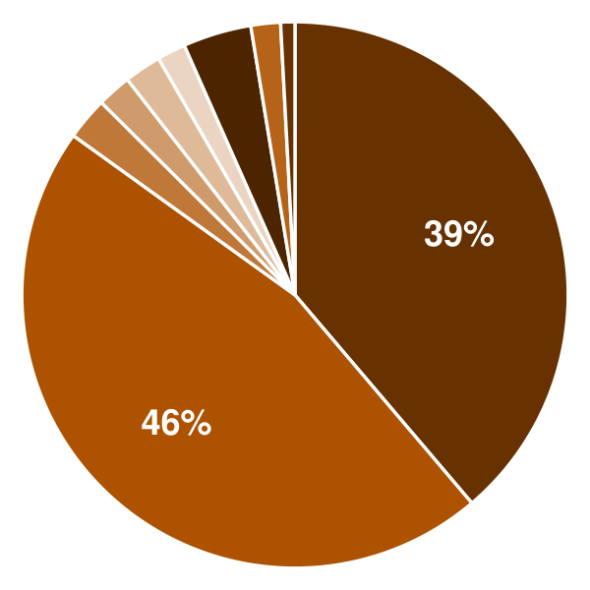 | ● Roll-Off Truck 38.8%  ● Container Fleet 46.1%  ● Yard Preparation & Fencing 2.5%  ● Truck & Container Branding 2.0%  ● Licenses, Insurance & Legal 2.2%  ● Technology & Website 1.7%  ● Launch Marketing 4.0%  ● Deposit & Pre-Opening Rent 1.8%  ● Tools & Site Supplies 0.8%

Use Of Funds | Amount
Roll-Off Truck | $115,000.00
Container Fleet | $136,800.00
Yard Preparation & Fencing | $7,500.00
Truck & Container Branding | $6,000.00
Licenses, Insurance & Legal | $6,500.00
Technology & Website | $5,000.00
Launch Marketing | $12,000.00
Deposit & Pre-Opening Rent | $5,200.00
Tools & Site Supplies | $2,500.00

10.3 Income Statement (3 Year projections)
 | Year 1 | Year 2 | Year 3 | Total
Revenue | $472,106.25 | $542,922.19 | $624,360.52 | $1,639,388.96
Cost of Sales | $188,842.50 | $217,168.88 | $249,744.21 | $655,755.59
General Costs | $0.00 | $0.00 | $0.00 | $0.00
Revenue Specific Costs | $132,189.75 | $152,018.22 | $174,820.95 | $459,028.92
Personnel Costs (Direct Labor) | $56,652.75 | $65,150.66 | $74,923.26 | $196,726.67
Gross Margin | $283,263.75 | $325,753.31 | $374,616.31 | $983,633.37
Gross Margin (%) | 60.00% | 60.00% | 60.00% | 60.00%
Operating Expense | $217,939.66 | $240,370.60 | $266,166.19 | $724,476.45
Payroll Expense (Indirect Labor) | $94,421.25 | $108,584.44 | $124,872.10 | $327,877.79
General Expense | $120,331.69 | $128,121.44 | $137,079.66 | $385,532.79
Bad Debt | $3,186.72 | $3,664.72 | $4,214.43 | $11,065.87
Amortization of Current Assets | $0.00 | $0.00 | $0.00 | $0.00
EBITDA | $65,324.09 | $85,382.71 | $108,450.12 | $259,156.92
Additional Expense | $68,607.14 | $72,577.39 | $78,382.36 | $219,566.89
Long Term Depreciation | $42,357.14 | $44,683.95 | $47,359.78 | $134,400.87
Gain or loss from Sale of Assets | $0.00 | $0.00 | $0.00 | $0.00
EBIT | $22,966.95 | $40,698.76 | $61,090.34 | $124,756.05
Interest Expense | $26,250.00 | $23,625.00 | $21,000.00 | $70,875.00
EBT | ($3,283.05) | $17,073.76 | $40,090.34 | $53,881.05
Income Tax Expense / Benefit | $0.00 | $4,268.44 | $10,022.58 | $14,291.02
Total Expense | $475,389.30 | $530,116.87 | $594,292.76 | $1,599,798.93
Net Income | ($3,283.05) | $12,805.32 | $30,067.76 | $39,590.03
Net Income (%) | -0.70% | 2.36% | 4.82% | 2.41%
Retained Earning Opening | $0.00 | ($3,283.05) | $9,522.27
Owner's Distribution | $0.00 | $0.00 | $0.00 | $0.00
Retained Earning Closing | ($3,283.05) | $9,522.27 | $39,590.03 | $39,590.03

10.4 Balance Sheet (3 Year projections)
 | Year 1 | Year 2 | Year 3 | Total
Assets | $337,238.25 | $328,438.88 | $337,622.59 | $337,622.59
Current Assets | $83,095.39 | $102,692.30 | $140,504.97 | $140,504.97
Cash | $74,946.71 | $93,321.31 | $129,728.34 | $129,728.34
Accounts Receivable | $8,148.68 | $9,370.99 | $10,776.63 | $10,776.63
Inventory | $0.00 | $0.00 | $0.00 | $0.00
Other Current Assets | $0.00 | $0.00 | $0.00 | $0.00
Long Term Assets | $254,142.86 | $225,746.58 | $197,117.62 | $197,117.62
Gross Long Term Assets | $296,500.00 | $312,787.67 | $331,518.49 | $331,518.49
Accumulated Depreciation | $42,357.14 | $87,041.09 | $134,400.87 | $134,400.87
Liabilities & Equity | $337,238.25 | $328,438.88 | $337,622.59 | $337,622.59
Liabilities | $240,521.30 | $218,916.61 | $198,032.56 | $198,032.56
Current Liabilities | $40,521.30 | $43,916.61 | $48,032.56 | $48,032.56
Accounts Payable | $15,521.30 | $17,849.50 | $20,526.92 | $20,526.92
Income Tax Payable | $0.00 | $1,067.11 | $2,505.64 | $2,505.64
Sales Tax Payable | $0.00 | $0.00 | $0.00 | $0.00
Short Term Debt | $25,000.00 | $25,000.00 | $25,000.00 | $25,000.00
Long Term Liabilities | $200,000.00 | $175,000.00 | $150,000.00 | $150,000.00
Long Term Debt | $200,000.00 | $175,000.00 | $150,000.00 | $150,000.00
Equity | $96,716.95 | $109,522.27 | $139,590.03 | $139,590.03
Paid-in Capital | $0.00 | $0.00 | $0.00 | $0.00
Common Stock | $0.00 | $0.00 | $0.00 | $0.00
Preferred Stock | $0.00 | $0.00 | $0.00 | $0.00
Owner's Contribution | $100,000.00 | $100,000.00 | $100,000.00 | $100,000.00
Retained Earnings | ($3,283.05) | $9,522.27 | $39,590.03 | $39,590.03
Check | $0.00 | $0.00 | $0.00 | $0.00

10.5 Cash Flow Statement (3 Year projections)
 | Year 1 | Year 2 | Year 3 | Total
Cash Received | $460,770.85 | $538,035.16 | $618,740.45 | $1,617,546.46
Cash Paid | $414,324.14 | $478,372.89 | $538,602.60 | $1,431,299.63
COS & General Expenses | $237,000.14 | $277,811.46 | $309,223.19 | $824,034.79
Salary & Wages | $151,074.00 | $173,735.10 | $199,795.36 | $524,604.46
Interest | $26,250.00 | $23,625.00 | $21,000.00 | $70,875.00
Sales Tax | $0.00 | $0.00 | $0.00 | $0.00
Income Tax | $0.00 | $3,201.33 | $8,584.05 | $11,785.38
Net Cash From Operations | $46,446.71 | $59,662.27 | $80,137.85 | $186,246.83
Assets Sell | $0.00 | $0.00 | $0.00 | $0.00
Assets Purchase | $296,500.00 | $16,287.67 | $18,730.82 | $331,518.49
Net Cash From Investments | ($296,500.00) | ($16,287.67) | ($18,730.82) | ($331,518.49)
Amount Received | $350,000.00 | $0.00 | $0.00 | $350,000.00
Loan Received | $250,000.00 | $0.00 | $0.00 | $250,000.00
Common Stock | $0.00 | $0.00 | $0.00 | $0.00
Preferred Stock | $0.00 | $0.00 | $0.00 | $0.00
Owner's Contribution | $100,000.00 | $0.00 | $0.00 | $100,000.00
Amount Paid | $25,000.00 | $25,000.00 | $25,000.00 | $75,000.00
Loan Capital | $25,000.00 | $25,000.00 | $25,000.00 | $75,000.00
Dividends & Distributions | $0.00 | $0.00 | $0.00 | $0.00
Net Cash From Financing | $325,000.00 | ($25,000.00) | ($25,000.00) | $275,000.00
Summary
Starting Cash | $0.00 | $74,946.71 | $93,321.31
Cash In | $810,770.85 | $538,035.16 | $618,740.45 | $1,967,546.46
Cash Out | $735,824.14 | $519,660.56 | $582,333.42 | $1,837,818.12
Change in Cash | $74,946.71 | $18,374.60 | $36,407.03 | $129,728.34
Ending Cash | $74,946.71 | $93,321.31 | $129,728.34 | $129,728.34

10.6 Break Even Analysis
 | Year 1 | Year 2 | Year 3 | Total
Starting Revenue | $0.00 | $472,106.25 | $1,015,028.44 | $1,015,028.44
Net Revenue | $472,106.25 | $542,922.19 | $624,360.52 | $624,360.52
Closing Revenue | $472,106.25 | $1,015,028.44 | $1,639,388.96 | $1,639,388.96
Starting Expense | $0.00 | $475,389.30 | $1,005,506.17 | $1,005,506.17
Net Expense | $475,389.30 | $530,116.87 | $594,292.76 | $594,292.76
Closing Expense | $475,389.30 | $1,005,506.17 | $1,599,798.93 | $1,599,798.93
Is Break Even? | No | Yes | Yes
Break Even Month | - | Apr '27 | -
Days Required | - | 2 Days | -
Break Even Revenue | - | $653,080.31 | -

CHAPTER 11

References

- SRC001: Dumpster Rental in the US - Market Size (2005-2031), IBISWorld, 2025-01-01. https://www.ibisworld.com/industry-statistics/market-size/dumpster-rental-united-states/ (accessed 2026-10-08)
- SRC002: Dumpster Rental in the US - Market Size (2005-2031), IBISWorld, 2026-01-01. https://www.ibisworld.com/united-states/market-size/dumpster-rental/5837/ (accessed 2026-10-08)
- SRC003: Dumpster Rental in the US - Number of Businesses, IBISWorld, 2025-01-01. https://www.ibisworld.com/industry-statistics/number-of-businesses/dumpster-rental-united-states/ (accessed 2026-10-08)
- SRC004: Waste Management, Inc. 2025 Annual Report (Form ARS), Waste Management, Inc. via SEC EDGAR, 2026-03-01. https://www.sec.gov/Archives/edgar/data/823768/000110465926037386/tm265027d2_ars.pdf (accessed 2026-10-08)
- SRC005: How Much Does It Cost to Rent a Dumpster? [2025 Data], HomeAdvisor, 2025-01-01. https://www.homeadvisor.com/cost/cleaning-services/rent-a-dumpster (accessed 2026-10-08)
- SRC006: How Much Does It Cost to Rent a Dumpster for My Project? [2025 Data], Angi, 2025-01-01. https://www.angi.com/articles/cost-dumpster-rental.htm (accessed 2026-10-08)
- SRC007: How Much Does It Cost to Rent a Roll Off Dumpster?, Dumpsters.com, 2025-01-01. https://www.dumpsters.com/pricing (accessed 2026-10-08)
- SRC008: 20 Yard and 30 Yard Roll Off Dumpster Guide: Uses, Dimensions and Rental Costs, American Made Dumpsters, 2025-01-01. https://americanmadedumpsters.com/20-yard-and-30-yard-roll-off-dumpster-guide-uses-dimensions-and-rental-costs/ (accessed 2026-10-08)
- SRC009: Monthly Construction Spending, December 2025, U.S. Census Bureau, 2026-02-27. https://www.census.gov/construction/c30/pdf/pr202512.pdf (accessed 2026-10-08)
- SRC010: Remodeling Growth to Slow Sharply in Early 2027, Joint Center for Housing Studies of Harvard University, 2026-01-01. https://www.jchs.harvard.edu/blog/remodeling-growth-slow-sharply-early-2027 (accessed 2026-10-08)
- SRC011: EREF Report Shows 10% Increase in U.S. Landfill Tipping Fees, Largest Increase Since 2022, Waste Advantage Magazine, 2025-01-01. https://wasteadvantagemag.com/eref-report-shows-10-increase-in-u-s-landfill-tipping-fees-largest-increase-since-2022/ (accessed 2026-10-08)
- SRC012: Dumpster Rental Business Profitability Today, CurbWaste, 2025-01-01. https://www.curbwaste.com/dumpster-rental-business-profitability (accessed 2026-10-08)
- SRC013: 2026-209 Roll-Off and Hooklift Unit Truck, City of Thomasville, Georgia via BidBanana, 2026-01-01. https://bidbanana.thebidlab.com/bid/3kWE8HJeVrIqlWNJDwen (accessed 2026-10-08)
- SRC014: How Much Do Roll-Off Dumpsters Cost in 2026?, Dumpster Rental Systems, 2026-01-01. https://www.dumpsterrentalsystems.com/?p=4011 (accessed 2026-10-08)
- SRC015: Heavy and Tractor-Trailer Truck Drivers, Occupational Outlook Handbook, U.S. Bureau of Labor Statistics, 2026-01-01. https://www.bls.gov/ooh/transportation-and-material-moving/heavy-and-tractor-trailer-truck-drivers.htm (accessed 2026-10-08)
- SRC016: Hand Laborers and Material Movers, Occupational Outlook Handbook, U.S. Bureau of Labor Statistics, 2026-01-01. https://www.bls.gov/ooh/transportation-and-material-moving/hand-laborers-and-material-movers.htm (accessed 2026-10-08)
- SRC017: Construction and Demolition Debris: Material-Specific Data, U.S. Environmental Protection Agency, 2024-01-01. https://www.epa.gov/facts-and-figures-about-materials-waste-and-recycling/construction-and-demolition-material-specific (accessed 2026-10-08)
- SRC018: Bin There Dump That Announces Franchise Expansion Across North America, Newsfile, 2022-07-01. https://www.newsfilecorp.com/release/130156/Bin-There-Dump-That-Announces-Franchise-Expansion-Across-North-America (accessed 2026-10-08)
- SRC019: Bin There Dump That, Franzy, 2024-01-01. https://franzy.com/franchises/bin-there-dump-that (accessed 2026-10-08)
- SRC020: 2024: An active year of U.S. billion-dollar weather and climate disasters, NOAA Climate.gov, 2025-01-01. https://www.climate.gov/news-features/blogs/beyond-data/2024-active-year-us-billion-dollar-weather-and-climate-disasters (accessed 2026-10-08)
- SRC021: Roll Off Container KPIs Every Owner Should Track, Financial Models Lab, 2025-01-01. https://financialmodelslab.com/blogs/kpi-metrics/roll-off-container (accessed 2026-10-08)
- SRC022: Resident Population in Tampa-St. Petersburg-Clearwater, FL (MSA) (TMAPOP), U.S. Census Bureau via FRED, Federal Reserve Bank of St. Louis, 2025-01-01. https://fred.stlouisfed.org/series/TMAPOP (accessed 2026-10-09)
- SRC023: QuickFacts: United States, U.S. Census Bureau, 2025-01-01. https://www.census.gov/quickfacts/fact/table/US/PST045224 (accessed 2026-10-09)
- SRC024: QCEW Open Data: 2024 Annual Averages, NAICS 562111, U.S. Bureau of Labor Statistics, 2025-01-01. https://data.bls.gov/cew/data/api/2024/a/industry/562111.csv (accessed 2026-10-09)
- SRC025: QCEW Open Data: 2023 Annual Averages, NAICS 562111, U.S. Bureau of Labor Statistics, 2024-01-01. https://data.bls.gov/cew/data/api/2023/a/industry/562111.csv (accessed 2026-10-09)
- SRC026: QuickFacts: Hillsborough County, Florida, U.S. Census Bureau, 2025-01-01. https://www.census.gov/quickfacts/fact/table/hillsboroughcountyflorida/PST120224 (accessed 2026-10-09)
- SRC027: New Private Housing Structures Authorized by Building Permits for Hillsborough County, FL (BPPRIV012057), U.S. Census Bureau via FRED, 2025-01-01. https://fred.stlouisfed.org/series/BPPRIV012057 (accessed 2026-10-09)
- SRC028: Tampa Bay area crews working around the clock to haul debris from Hurricanes Helene, Milton, FOX 13 Tampa Bay, 2024-10-21. https://fox13news.com/news/tampa-bay-area-crews-working-around-clock-haul-debris-from-hurricanes-helene-milton (accessed 2026-10-09)
- SRC029: Commercial trash service is available to all county businesses, Hillsborough County, 2022-01-01. https://hcfl.gov/businesses/small-business-support/commercial-property-owner/commercial-trash-service (accessed 2026-10-09)
- SRC030: Dumpster Rentals in Tampa, FL, Dumpsters.com, 2026-10-03. https://www.dumpsters.com/service-area/tampa-fl (accessed 2026-10-09)
- SRC031: Tampa Dumpster Rentals, Budget Dumpster, 2026-10-03. https://www.budgetdumpster.com/blog/communities/tampa-fl/ (accessed 2026-10-09)
- SRC032: Dumpster Service Delivery and Pickup in Tampa, FL, HomeAdvisor, 2026-01-01. https://www.homeadvisor.com/tloc/tampa-FL/Dumpster-Service-Delivery-and-Pickup (accessed 2026-10-09)
- SRC033: Dumpster Rental Providers in Tampa, FL, Thumbtack, 2026-01-01. https://www.thumbtack.com/fl/tampa/dumpster-rentals (accessed 2026-10-09)
- SRC034: 2024 Florida Solid Waste Disposal Fees, Florida Department of Environmental Protection, 2024-01-01. https://floridadep.gov/sites/default/files/2024_Solid_Waste_Disposal_Fees.pdf (accessed 2026-10-09)
- SRC035: Florida's Minimum Wage Increases to $14.00/Hour at Month End, Lowndes, 2025-09-01. https://www.lowndes-law.com/printpilot-publication-floridas-minimum-wage-increases-to-14-00-hour-at-month-end.pdf (accessed 2026-10-09)
- SRC036: Tampa Industrial Market Report Q2 2026, Matthews, 2026-01-01. https://www.matthews.com/insights/tampa-industrial-q2-2026 (accessed 2026-10-09)
- SRC037: Private Hauler Franchise Fees, City of Tampa Solid Waste, 2026-01-01. https://www.tampa.gov/solid-waste/info/for-businesses/private-hauler-franchise-fees (accessed 2026-10-09)




