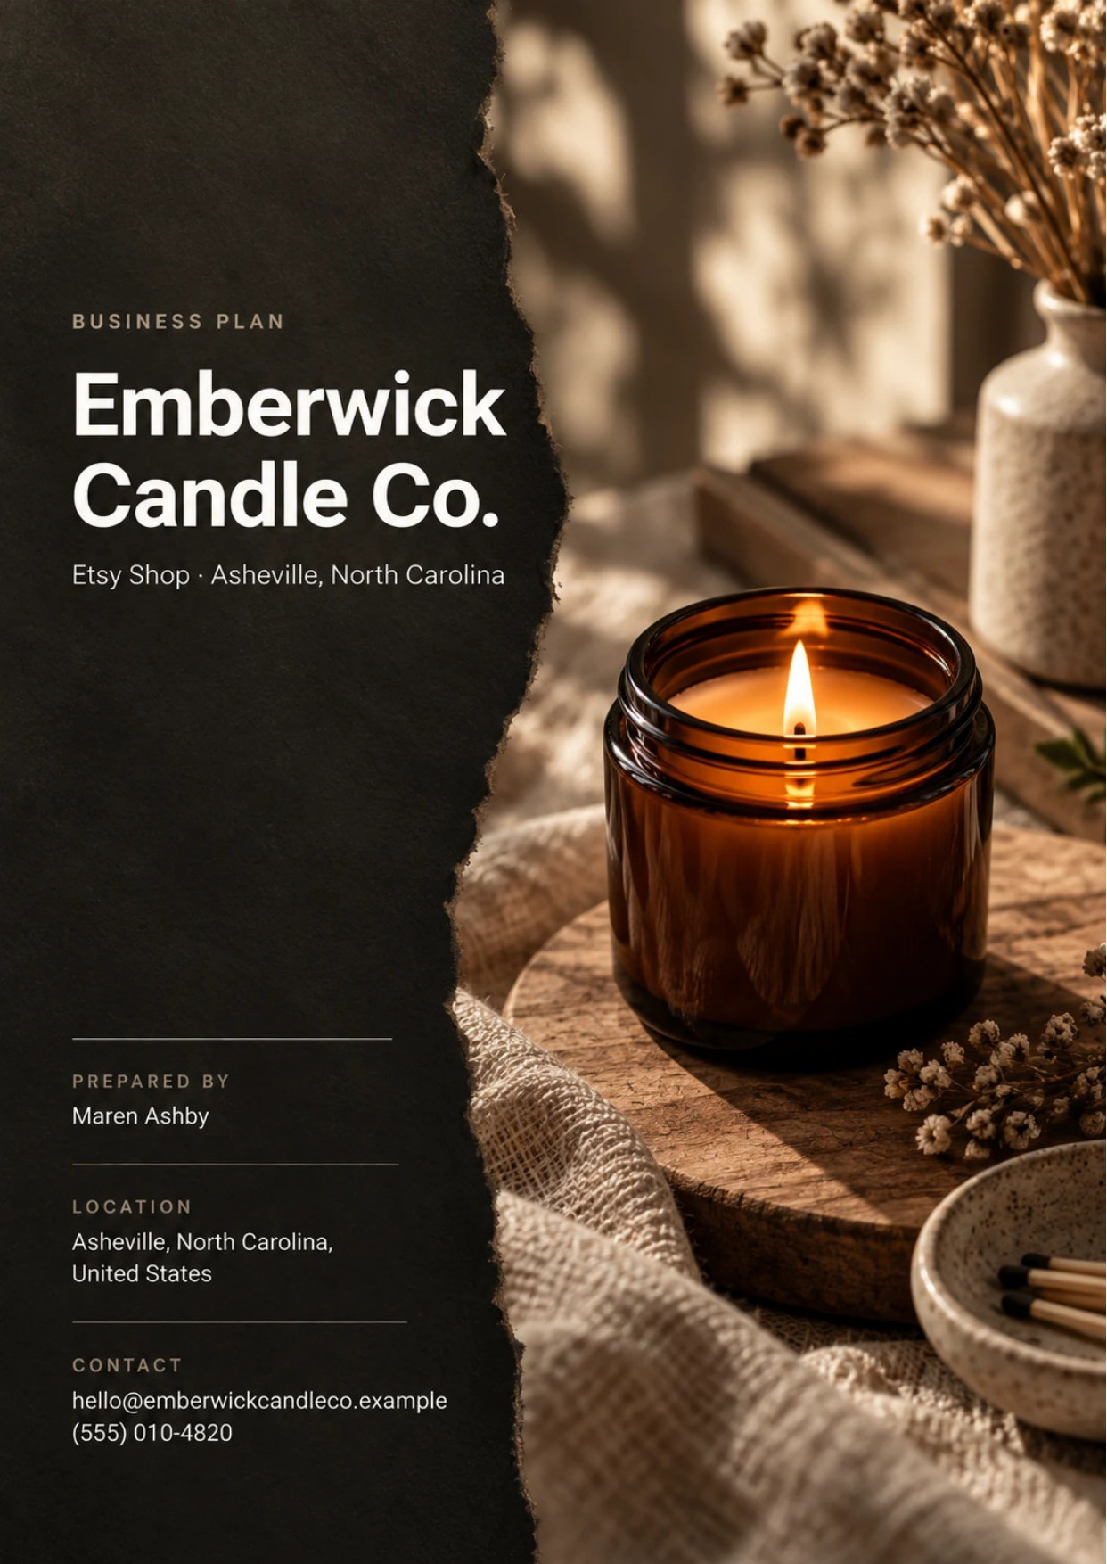
Table of Contents
1. Executive Summary 6
1.1 Business Overview 7
1.2 Mission Statement 7
1.3 Market Opportunity 7
1.4 Unique Selling Points 7
1.5 Financial Highlights 8
1.6 Funding Requirement 8
1.6.1 Income Statement (3 Year projections) 8
2. Company Overview 9
2.1 Legal Structure 10
2.2 Vision Statement 10
2.3 Background & History 10
2.4 Future Goals 10
2.4.1 Business Owners 11
2.4.2 SMART Goal 11
3. Market Analysis 12
3.1 Overview 13
3.2 Market Segmentation 13
3.3 Market Trends 13
3.4 Market Size 13
3.4.1 PESTEL Analysis 14
4. Customer Analysis 16
4.1 Target Market 17
4.2 Customer Segments 17
4.3 Customer Persona 18
4.4 Customer Purchase Journey 18
5. Competitive Analysis 19
5.1 Competitors 20
5.2 Comparison 20
5.3 Competitive Edge 21
5.4 SWOT Analysis 22
6. Products & Services 23
6.1 Our Offering 24
6.2 Signature Items 24
6.3 Additional Services 24
6.4 What Sets Us Apart 24
6.5 Materials Sourcing & Product Safety 25
6.5.1 Hand-Poured Soy Candles 25
6.5.2 Reed Diffusers and Refills 26
6.5.3 Features 27
6.5.4 Pricing 27
7. Marketing & Sales Strategies 28
7.1 Market Positioning 29
7.2 Marketing Objectives 29
7.3 Online Marketing 29
7.4 Public Relations and Branding 30
7.5 Partnership & Collaboration Strategy 30
7.6 Customer Loyalty & Retention 30
7.7 Sales Channels 30
8. Operations Plan 31
8.1 Daily Operations 32
8.2 Staffing & Training 32
8.3 Inventory & Equipment Management 32
8.4 Location and Facilities 32
8.5 Milestones & Timeline 33
8.6 Order Fulfillment & Shipping 34
9. Management Team 35
9.1 Key Members 36
9.2 Organization Chart 36
9.3 Advisory Board Members 37
9.3.1 Hiring Plan 37
10. Financial Plan 38
10.1 Key Assumptions 39
10.2 Capital Requirements and Use of Funds 39
10.2.1 Use of Funds 39
10.3 Income Statement (3 Year projections) 41
10.4 Balance Sheet (3 Year projections) 42
10.5 Cash Flow Statement (3 Year projections) 43
10.6 Break Even Analysis 44
11. References 45


CHAPTER 1

Executive Summary

1.1 Business Overview
1.2 Mission Statement
1.3 Market Opportunity
1.4 Unique Selling Points
1.5 Financial Highlights
1.6 Funding Requirement

1.1 Business Overview

Emberwick Candle Co. is a handmade home fragrance shop opening in Asheville, North Carolina, and selling through Etsy to buyers across the United States. Its two founders hand-pour soy wax candles in small batches and make reed diffusers in the same scents, then pack and ship every order from their own studio.
The shop sells candles in three sizes, diffusers with refill bottles, and gift sets that pair the two. Its buyers are people shopping for a gift or for their own home, most of them in the weeks before the holidays, a birthday, a housewarming or Mother's Day.

1.2 Mission Statement
To make candles and diffusers that are tested before they are sold, smell the same in every room of the house, and arrive in one piece, ready to give.

1.3 Market Opportunity
Etsy is where buyers go looking for handmade goods, and it is a large market in its own right: buyers in the United States bought about $7.74 billion of goods on the Etsy marketplace in 2025. Home and living is the first of the six categories that make up most of that spending, and candles are bought as gifts for the holidays, housewarmings and thank-yous throughout the year.
Asheville is where the studio sits, not where the customers are. Etsy search sends buyers from every state, so the shop's market is national from the first day. The city gives the founders an affordable studio, a long tradition of craft, and a local hourly labor market to hire a packer from. A single owner-run maker in this part of manufacturing takes in about $103,600 a year, which is the scale Emberwick plans to reach and pass in its first year.

1.4 Unique Selling Points
- Every candle scent is also made as a reed diffuser, so a buyer can scent two rooms the same way or give a matched pair.
- Diffuser refills bring buyers back every two to three months without buying the glass again.
- Each scent, vessel and wick pairing is burn tested to the end of the jar before it is listed.
- Packaging is built around the postage tiers so domestic shipping stays under $6.
- Every order ships in a gift box with an optional handwritten note.

1.5 Financial Highlights
Revenue comes from visits to the Etsy shop, the share of those visits that order, and the value of each order, with a small wholesale line to boutiques adding to it. At full run rate the shop expects 9,000 visits a month, a conversion rate of 2.6% and an average order of $46. It opens at half that level while its first reviews build and reaches full run rate within six months.
Revenue is projected at $126,585 in the first year, $151,902 in the second and $182,282 in the third, at a gross margin of 60.0% throughout. The shop is profitable from the first year: net income is $5,601, then $9,946, then $15,115. Break-even revenue is $102,661, or 2,232 orders a year, which the first year clears.

1.6 Funding Requirement
The startup budget is $29,200. It buys the pouring equipment and studio fit-out, the first inventory of wax, fragrance, vessels and packaging, burn testing, product photography, branding, insurance and launch marketing, and keeps a cash reserve for the first months. It is funded by $25,000 from the two founders and a $15,000 SBA Microloan at 9.5% over five years. Profits stay in the business for the first three years to pay for inventory and new scents.
The plan rests on a product line built and tested before launch, a marketplace where buyers already go looking for handmade gifts, and a matched candle and diffuser offer that brings buyers back. The money opens a working studio and carries the shop to the point where it pays its own way.

1.6.1 Income Statement (3 Year projections)
 | Year 1 | Year 2 | Year 3 | Total
Revenue | $126,584.64 | $151,901.57 | $182,281.88 | $460,768.09
Cost of Sales | $50,633.86 | $60,760.63 | $72,912.75 | $184,307.24
Gross Margin | $75,950.78 | $91,140.94 | $109,369.13 | $276,460.85
Operating Expense | $61,596.32 | $70,963.59 | $82,204.30 | $214,764.21
Total Expense | $120,983.97 | $141,955.68 | $167,166.73 | $430,106.38
Net Income | $5,600.67 | $9,945.89 | $15,115.15 | $30,661.71

CHAPTER 2

Company Overview

2.1 Legal Structure
2.2 Vision Statement
2.3 Background & History
2.4 Future Goals

2.1 Legal Structure
Emberwick Candle Co. will be organized as a North Carolina limited liability company owned by its two founders, with Maren Ashby as managing member. The LLC keeps the founders' personal assets separate from the business, which matters for a company that sells a product with an open flame, and it lets profits pass through to the owners' own tax returns. The company carries product liability and studio contents insurance from the day the first candle is sold.
The shop trades on Etsy under the Emberwick Candle Co. name, and wholesale accounts are invoiced by the LLC directly. Sales tax on Etsy orders is collected and remitted by Etsy as the marketplace facilitator; the company registers to collect it on any wholesale and in-person sales that require it.

2.2 Vision Statement
To be the handmade fragrance shop a buyer returns to every season: for a candle to give, a diffuser for a room that needs one, and a refill for the scent they already love.

2.3 Background & History
Emberwick is a new business and has not yet made a sale. It grew out of Maren Ashby's six years of pouring candles for craft markets, friends and family, during which she built the scent library and the burn-testing routine the shop will open with. The diffusers came from a request she heard often at those markets: buyers wanted the same scent in a room where they could not leave a flame burning.
Caleb Ostrander joins her as co-founder after eight years running listings, shipping and customer service for an outdoor gear retailer's online store. The founders chose Etsy because its buyers already search for handmade, small-batch goods, so the shop can reach a national audience without first building one, and they chose Asheville because they live there and can rent a small studio at a cost a two-person business can carry.
Before launch, the founders will have tested every scent, vessel and wick pairing to the end of the jar, fixed the packaging so domestic shipping stays under $6, and photographed every listing in the studio.

2.4 Future Goals
In the first 0 to 18 months, the goal is to open the Etsy shop, earn its first reviews, and get through the first holiday season with every order shipped within two days. That means reaching the break-even level of 2,232 orders a year inside the first year, hiring a part-time packer before the holidays, and opening a small wholesale line to boutiques and gift shops.
Over 1 to 3 years, the shop grows revenue from $126,585 in the first year to $182,282 in the third, as new seasonal scents, a growing review count and diffuser refills bring buyers back. Wholesale accounts and custom gift orders take a larger share, so the business depends less on Etsy search alone.
Over 3 to 5 years, the founders intend to open a direct web shop alongside Etsy for returning buyers, add a second studio employee, and build a standing wholesale list of boutiques across the Southeast.

2.4.1 Business Owners
Maren Ashby | Caleb Ostrander

Total ownership: 100%
60% | Maren Ashby  6,000 Shares
40% | Caleb Ostrander  4,000 Shares

2.4.2 SMART Goal
  Specific  - Open the Etsy shop from the Asheville studio with candles and diffusers in matching scents.  - Reach the break-even level of 2,232 orders a year within the first year.  - Build a review record that lifts the shop's listings in Etsy search. |   Measurable  - First-year revenue of $126,585 at a 60% gross margin.  - Shop conversion rate held at or above 2.6% of visits.  - Average review rating, message response rate and case rate tracked monthly. |   Achievable  - The founders have tested every scent, vessel and wick pairing before launch.  - Production runs in batches of 48, sized to a two-person studio.  - A part-time packer is hired before the first holiday season.
  Relevant  - Break-even proves the shop can pay its own way before the wholesale line grows.  - Reviews earned in year one carry the shop's search placement into later years. |   Time-Based  - Shop opens in February 2027, ahead of Mother's Day buying.  - Holiday stock is poured from August so the season ships on time.  - Break-even reached by the close of the first full year.

CHAPTER 3

Market Analysis

3.1 Overview
3.2 Market Segmentation
3.3 Market Trends
3.4 Market Size

3.1 Overview
Etsy is a marketplace for handmade, vintage and craft goods. In 2025 it carried $10,460.7 million of gross merchandise sales, from 86.5 million active buyers who each spent $121 over the year on average. Fourth-quarter sales were flat against the year before, up 0.1%, while the number of active buyers fell 3.4%, so the marketplace is mature rather than growing quickly, and a new shop wins its sales from other sellers rather than from new buyers arriving.
Most of that spending is domestic: 74% of Etsy marketplace sales came from buyers in the United States in 2025. A shop selling from Asheville ships almost entirely to that national audience.

3.2 Market Segmentation
Etsy's buyers split by why they are buying, which decides what they look for in a listing:
- Gift buyers: shopping for someone else, often on a deadline, and paying close attention to packaging, delivery dates and reviews.
- Home buyers: scenting their own rooms, more likely to return for a favorite scent or a diffuser refill.
- Occasion buyers: ordering favors or gifts in quantity for a wedding, a shower or a client list, booked weeks ahead.
- Trade buyers: boutiques and gift shops buying at wholesale to resell, mostly ahead of the holiday season.
The handmade market has no single published size outside Etsy's own figures. IBISWorld puts the adjacent online market for hobby and craft supplies at $25.3 billion in 2026, but that measures the materials makers buy, not the finished goods they sell.

3.3 Market Trends
- Online keeps taking share of retail: e-commerce was 17.1% of U.S. retail sales in the second quarter of 2026, up from 16.3% a year earlier.
- Buying has moved to the phone, so listing photographs are judged at small size first.
- Etsy ranks listings partly on a shop's review rating, message response rate and case rate over the past three months, which rewards careful packing and fast replies.
- Seller costs are rising: Etsy's transaction fee is 6.5% of the item price plus shipping, and payment processing adds 3% plus $0.25 an order.

3.4 Market Size
The total addressable market is what U.S. buyers spend on the Etsy marketplace: about $7,741,000,000 in 2025, which is 74% of Etsy's $10,460.7 million of marketplace sales. Every Etsy shop competes for a share of it.
The serviceable market is the part of that spending a home fragrance shop can reach. Etsy names home and living as the first of its six largest categories but does not report it separately, so no researched figure exists. This plan therefore uses an estimate of 15% of the total, $1,161,150,000, and states it as an assumption rather than a finding.
The obtainable market is sized at the scale of one business: a single owner-run maker in miscellaneous manufacturing, the part of the economy that includes candle making, took in about $103,600 in tax year 2023. Emberwick's first-year projection of $126,585 sits a little above that average, which is what a two-founder studio with a second product line should be able to reach.
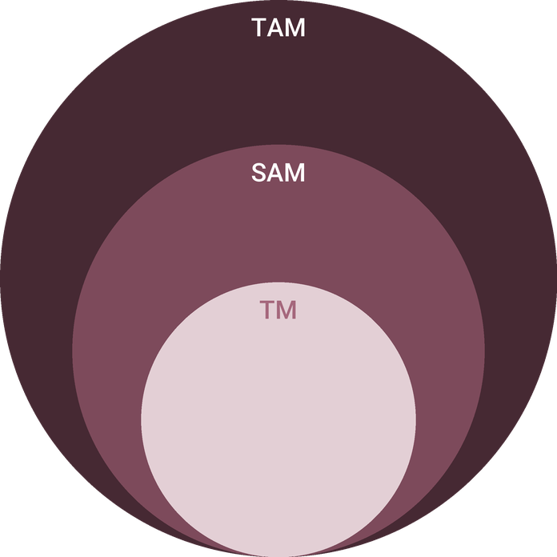
  ● | Total Available Market (TAM)  U.S. | 7.7B
  ● | Served Available Market (SAM)  Estimated at 15 percent of the total market. No published serviceable market figure was found for this business, so this is an assumption. | 1.2B
  ● | Target Market (TM)  A single owner-run business in miscellaneous manufacturing, the NAICS subsector that includes candle making, averaged about $103,600 of business receipts in tax year 2023 (72,182 sole proprietorships, $7.48 billion in total). | 103.6k

3.4.1 PESTEL Analysis
  Political  - Tariffs on imported glass and ceramic vessels raise the cost of the shop's largest packaging input.  - Etsy collects and remits sales tax as marketplace facilitator in the states that require it.  - SBA Microloan lending supports owner-run startups of this size. |   Economic  - Candles are a discretionary purchase, so demand softens when household budgets tighten.  - Holiday spending grew 4.1% in 2025, and the shop's sales lean on that season.  - E-commerce keeps taking share of retail, at 17.1% of sales in mid-2026. |   Social  - Buyers on Etsy look for handmade, small-batch goods and the story of the maker.  - Candles are a habitual gift for holidays, housewarmings and thank-yous.  - Interest in natural waxes and phthalate-free fragrance favors a soy-based line.
  Technological  - Close to half of Etsy buying happens in its mobile app, so listing photos must read on a phone.  - Etsy search ranks listings on relevancy, quality, engagement and customer service signals.  - Shipping label software lets a small shop buy commercial postage rates. |   Environmental  - Soy wax is renewable and vessels are designed to be reused once the candle is finished.  - Recyclable paper packaging replaces plastic fill in every parcel.  - Studio placement away from Asheville's flood-exposed riverside reflects the 2024 Helene flooding. |   Legal  - Wicks must keep lead in any metal core under 0.06% by weight; Emberwick uses cotton and wood wicks.  - Every candle carries a fire safety warning label following ASTM F2058.  - Etsy's seller policies govern listings, fees, reviews and dispute cases.

CHAPTER 4

Customer Analysis

4.1 Target Market
4.2 Customer Segments
4.3 Customer Persona
4.4 Customer Purchase Journey

4.1 Target Market
Emberwick sells to people across the United States who buy home fragrance on Etsy, either as a gift or for their own rooms. They come to Etsy because they want something made by a person rather than a factory, and they are willing to pay more for it than for a candle in a supermarket aisle, provided the listing shows them what they will get and the reviews tell them it arrives intact.
The audience is large and settled. The Etsy marketplace had 86.5 million active buyers at the end of 2025, each spending $121 over the year on average, and 74% of the marketplace's sales came from buyers in the United States. The shop does not need to persuade anyone to shop on Etsy; it needs to be found and chosen among the shops a buyer already sees there.

4.2 Customer Segments
- Gift buyers are the largest group. They buy one candle or a candle and diffuser set, care most about packaging and delivery dates, and concentrate their orders in November and December and around Mother's Day.
- Home buyers scent their own rooms. They buy a diffuser alongside a candle more often than gift buyers do, return for refills, and are the group the seasonal scent releases are aimed at.
- Occasion buyers order in quantity for a wedding, a shower, a housewarming party or a client list. Their orders are larger and booked weeks ahead through custom listings.
- Trade buyers are boutiques and gift shops buying a curated set of scents at wholesale to resell, mostly in late summer and early autumn.
The segments differ most in when they buy and what they ask of the shop. Gift buyers arrive in waves, and a gift bought in the second week of December has to arrive before the holiday, so for them the delivery date shown at checkout is part of the product. Home buyers arrive steadily through the year and judge the shop on whether the scent they liked last time is still there. Occasion buyers message before they order, with a date, a quantity and a label to approve, and they decide on how quickly and clearly the shop replies. Trade buyers want consistency above all: the same scent, the same jar and the same label on every reorder.
The persona below stands for the first group, because gift buyers carry the most orders and set the standard the shop's packing and shipping have to meet.

4.3 Customer Persona
  Hannah, the Thoughtful Gifter  Demographics  Age: 34  Status: Married, one child  Location: Columbus, OH  Income: $78,000 a year  Professional Role  Education: Bachelor's in Nursing  Job: Pediatric nurse on rotating shifts | “I want a gift that looks like someone made it, smells like a real place, and arrives in a box I don't have to rewrap.”
   | Identifiers / Personality Traits  - Shops on the Etsy app in short breaks between shifts  - Buys six to eight gifts a year for family, friends and colleagues  - Reads reviews and looks at buyer photos before ordering
   | Goals  - Find gifts that feel personal without hours of searching  - Have orders arrive on time and ready to give  - Keep a favorite scent going at home through the year
   | Challenges  - Little time to compare dozens of similar listings  - Has received candles that tunnelled or arrived cracked  - Shipping costs that make a small gift feel overpriced

4.4 Customer Purchase Journey
Most buyers start with a search in the Etsy app, typing a scent or an occasion such as "cedar candle gift" or "housewarming candle". Etsy matches the query against listing titles, tags, categories and attributes, then orders the results by relevance, listing quality, engagement and the shop's customer service record. A listing that is not tagged for the words buyers use is never shown at all.
- Discover: the buyer scrolls search results on a phone, so the first photograph decides whether the listing is opened.
- Compare: the buyer reads reviews, looks at buyer photos and checks the shipping price and delivery date.
- Choose: the buyer picks a scent and size, often adding a matching diffuser or choosing the gift set, and adds a gift note.
- Receive: the order arrives in a gift box within the promised window, which is when a review is left.
- Return: a follow-up message and a seasonal release bring the buyer back for a refill or a new scent.
Each review feeds the shop's rating, and Etsy uses the rating, message response rate and case rate from the past three months in search ranking. The way the shop treats one buyer therefore decides how often it is found by the next.

CHAPTER 5

Competitive Analysis

5.1 Competitors
5.2 Comparison
5.3 Competitive Edge
5.4 SWOT Analysis

5.1 Competitors
Emberwick competes for the same buyer in three places, and only the first is a direct contest.
- Other handmade Etsy candle shops. The closest rivals, shown on the same search results page for the same query. Many are run by one person from home, and few sell a second product line in matching scents.
- Mass-market candle brands. Lower prices, national advertising and wide distribution, and a buyer who wants a familiar scent at the lowest price goes to them first.
- Big-box home goods stores. A candle bought on impulse in an aisle, cheap and immediate, but with nothing handmade or personal about it.
The handmade field is crowded and fragmented. The Etsy marketplace had 5.6 million active sellers at the end of 2025 sharing $10,460.7 million of sales, an average of under $2,000 each, so the typical shop is very small and many sell as a sideline. That cuts both ways: there are many shops in every search, but few that run as a business with tested products, consistent packaging and replies within hours.
On Etsy, competition is decided by search placement more than by price. Etsy ranks matching listings on relevance, listing quality, engagement, recency, shopper habits and the shop's customer service record. A new shop with no reviews starts behind established ones on several of those signals at once.

5.2 Comparison
Against other handmade shops, Emberwick's difference is the second product and the refill: buyers can match a candle with a diffuser in the same scent and keep the diffuser going. Against the mass-market brands and big-box stores it does not try to compete on price or availability; it competes on what a handmade shop can offer and a factory line cannot, which is small-batch scents, a personal note and makers who answer every message themselves.
Fees set a floor under price for every Etsy seller alike. A U.S. shop pays a 6.5% transaction fee on the item price and shipping, payment processing of 3% plus $0.25 an order, and, on orders that come from Etsy's own offsite advertising, a further 15% below $10,000 of annual sales and 12% above it. A shop that prices to undercut its neighbors on Etsy gives away margin it cannot get back.
Feature | Emberwick Candle Co. | Other handmade Etsy candle shops | Mass-market candle brands | Big-box home goods stores
Hand-poured in small batches | ✓ | ✓ | ✗ | ✗
Matching candle and diffuser scents | ✓ | ✗ | ✓ | ✗
Diffuser refills sold separately | ✓ | ✗ | ✓ | ✗
Natural soy wax | ✓ | ✓ | ✗ | ✗
Personal gift note on every order | ✓ | ✓ | ✗ | ✗
Stocked in physical stores nationwide | ✗ | ✗ | ✓ | ✓

5.3 Competitive Edge
None of the shop's advantages is hard to copy on its own; any maker could add a diffuser or test a wick. The edge is in doing all of them from the first order, while most shops in the same search do none, and in holding them through the holiday weeks when volume doubles and corners get cut. It is measured where Etsy measures it: an average review rating, a message response rate and a case rate that keep the shop's listings near the top of the page.
What would erode it is just as clear. A batch that tunnels, a parcel that arrives cracked or a message left unanswered over a holiday weekend shows up in the next three months of search placement, so the edge has to be defended at the packing bench as much as in the listing.
   | Candle and diffuser in one scent  Most handmade candle shops sell candles alone. Selling a matching diffuser lifts the order value and covers rooms where a flame does not suit.
   | A refill that brings buyers back  The diffuser refill gives a buyer a reason to return every few months, which a candle shop with no consumable cannot offer.
   | Burn tested before listing  Every scent, vessel and wick pairing is burned to the end of the jar before sale, which keeps tunnelling and soot complaints out of the reviews Etsy ranks on.
   | Holiday stock built in advance  Small batches poured from late summer mean the shop can ship within two days through the holiday weeks when a third of candle sales happen.
 | Shipping held under $6  Packaging is designed around the postage tiers so domestic shipping stays below the threshold Etsy uses to prioritize listings in search.

5.4 SWOT Analysis
Strengths  - Matching candle and diffuser scents raise the order value above a candle-only shop.  - Diffuser refills create a repeat purchase every two to three months.  - Small batches let a new scent be tested and listed within weeks.  - Low fixed costs: a 500 square foot studio and two founders doing most of the work. | Weaknesses  - A new shop starts with no reviews, and Etsy ranks listings partly on review rating.  - Nearly all revenue depends on one marketplace and its fee and search rules.  - Glass vessels add weight and breakage risk to every parcel.  - Two founders carry production, listings and customer messages until a packer is hired.
Opportunities  - About 35% of candle sales fall in the holiday season, when gift buying peaks.  - Candles are a common housewarming, hostess and thank-you gift all year round.  - Boutiques and gift shops buy wholesale from small makers with a consistent look.  - Custom favors for weddings and showers bring larger single orders. | Threats  - Etsy can raise fees or change search ranking at any time.  - Millions of active sellers compete for the same buyers in Etsy search.  - Postage increases, such as the 2026 temporary surcharge, squeeze margin on low-priced orders.  - Mass-market candle brands sell at lower prices in stores and online.

 Strategic Summary
Emberwick should compete on the matched pair and the refill, not on price, and earn reviews fast through tested products and careful packing. Wholesale and custom orders then reduce how much rests on Etsy search.

CHAPTER 6

Products & Services

6.1 Our Offering
6.2 Signature Items
6.3 Additional Services
6.4 What Sets Us Apart
6.5 Materials Sourcing & Product Safety

6.1 Our Offering

Emberwick makes home fragrance in two forms from one scent library: hand-poured soy candles and reed diffusers. Every scent the shop sells is available as both, so a buyer can light a candle in the living room and keep a diffuser running in the hallway or the bathroom, where a flame does not suit, and the two rooms smell the same.
The shop opens with twelve scents built around seasons and rooms rather than around desserts or brand names: cedar and smoked vanilla for winter evenings, fig leaf and black tea for a kitchen, salt air and vetiver for a bathroom. Three new scents arrive each season and the weakest sellers retire, so the library stays at a size the studio can pour in small batches and keep fresh.

6.2 Signature Items
The candles are the headline product and most orders carry one. The 8 oz amber glass jar is the shop's standard size; a 4 oz travel tin serves as a first purchase or a stocking filler, and a 14 oz double-wick ceramic serves as a larger gift. The reed diffusers come in one size, with a refill bottle sold separately, and are the line most likely to bring a buyer back.
The Candle & Diffuser Set pairs an 8 oz candle with a diffuser in the same scent, boxed together with a handwritten note. It is expected to be the most popular single listing, because it answers the gift buyer's question of what to send in one click and lifts the value of the order towards the $46 average the plan is built on.

6.3 Additional Services
- Custom favors for weddings, showers and corporate gifts, in 4 oz tins with a custom label, booked through custom listings with a minimum order and a set lead time.
- A wholesale line of the six steadiest scents for boutiques and gift shops, offered ahead of their holiday buying.
- Gift notes written by hand and sent with the order at no charge.

6.4 What Sets Us Apart
Many handmade candle shops on Etsy sell candles alone. Emberwick's matched diffuser line raises what each buyer spends, and the refill gives a reason to come back that a candle shop has no equivalent for. Behind both sits a testing routine that keeps the product consistent from the first order to the thousandth, which is what earns the reviews the shop depends on.

6.5 Materials Sourcing & Product Safety
The candles are poured from a natural soy wax blend bought from U.S. candle supply houses in 50 lb cases, with phthalate-free fragrance oils used at a 7% to 8% load, cotton or wood wicks, and amber glass and matte ceramic vessels made for candles. The diffusers use an alcohol-free base, natural rattan reeds and clear glass bottles. Each material has a named backup supplier, because a vessel or fragrance that goes out of stock in October cannot be swapped without retesting.
Before any scent is listed, every combination of fragrance, vessel and wick size is burn tested in four-hour sessions to the bottom of the jar, checking for a full melt pool, tunnelling, soot and flame height. Results are logged by batch, and each batch of 48 is numbered so any complaint can be traced to its pour date and materials.
Federal rules for candles are narrow but strict. Metal-cored wicks may hold no more than 0.06% lead by weight in the core; Emberwick uses cotton and wood wicks with no metal core at all. Every vessel carries a fire safety warning label following the voluntary ASTM F2058 standard for candle fire safety labeling, with burning instructions printed beside it.

6.5.1 Hand-Poured Soy Candles
Soy wax candles poured by hand in batches of 48 in the Asheville studio, in reusable amber glass and matte ceramic vessels. Each scent is built around a season or a room, from cedar and smoked vanilla to fig leaf and black tea, and every candle cures for ten days before it is listed for sale.
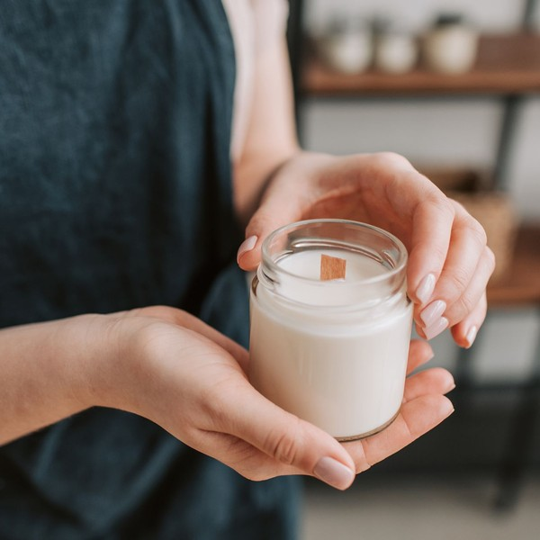 | $18 to $38 per candle  A 4 oz travel tin is $18, the 8 oz jar that most orders carry is $30, and the 14 oz double-wick ceramic is $38. Domestic shipping is held under $6 so listings keep their place in Etsy search.

Specifications
- Natural soy wax poured in small batches of 48
- Cotton or wood wicks with no metal core
- Fragrance oils free of phthalates, at a 7% to 8% load
- Cured for ten days before listing
- About 45 to 50 hours of burn time from the 8 oz jar
- Fire safety warning label on the base of every vessel

6.5.2 Reed Diffusers and Refills
Reed diffusers in the same scents as the candles, for rooms where an open flame does not suit, such as a bathroom, an entryway or a child's room. Each comes in a clear glass bottle with natural rattan reeds, and a refill bottle lets a buyer keep the same scent going without buying the glass again.
 | $32 per diffuser, $18 per refill  The refill is priced to bring a buyer back every two to three months, which is where most repeat orders on the diffuser line are expected to come from.

Specifications
- 100 ml clear glass bottle with a cork stopper
- Eight natural rattan reeds, packed separately for shipping
- Lasts about eight to ten weeks in a mid-sized room
- 100 ml refill bottle with a screw cap
- Available in every scent the candle line carries
- Alcohol-free diffuser base

6.5.3 Features
  Matching scent library
  Every candle scent is also made as a reed diffuser, so a buyer can scent two rooms the same way or give a matched pair.
  Small-batch pours
  Candles are poured 48 at a time, so a new scent can be tested and listed in weeks rather than months.
  Refillable diffusers
  Refill bottles let a buyer keep a diffuser going without buying the glass and reeds again.
   | Gift-ready packaging  Every order ships in a kraft gift box with tissue and an optional handwritten note at no extra charge.
  Tested before listing
  Each scent, vessel and wick pairing is burn tested to the end of the jar before it goes on sale.
   | Seasonal releases  Three new scents arrive each season, which gives returning buyers a reason to come back four times a year.

6.5.4 Pricing
Signature Candle  $30  per candle  - 8 oz amber glass jar  - About 45 to 50 hours of burn time  - Choice of any scent in the library  - Kraft gift box |  | Most Popular  Candle & Diffuser Set  $58  per set  - One 8 oz candle and one reed diffuser  - Matching scent across both pieces  - Gift box with a handwritten note  - Ships in one parcel |  | Seasonal Home Collection  $84  per collection  - Two 8 oz candles and one reed diffuser  - The current season's three scents  - One diffuser refill included  - Gift box with a scent card

CHAPTER 7

Marketing & Sales Strategies

7.1 Market Positioning
7.2 Marketing Objectives
7.3 Online Marketing
7.4 Public Relations and Branding
7.5 Partnership & Collaboration Strategy
7.6 Customer Loyalty & Retention
7.7 Sales Channels

7.1 Market Positioning

Emberwick is positioned as a handmade home fragrance shop for gift buyers and home buyers who want a scent they can carry from room to room: priced above mass-market candles, competing on tested quality, matched pairs and careful delivery rather than on price.

7.2 Marketing Objectives
- Reach 2,232 orders in the first year, the break-even level, and first-year revenue of $126,585.
- Hold the shop's conversion rate at 2.6% of visits or better.
- Build an average review rating of 4.8 or higher by the first holiday season.
- Have one buyer in five return for a second scent or a diffuser refill within a year.
Etsy Ads  $337  per month  Promoted listings for the top-converting scents, raised through the holiday weeks. |  | Offsite Ads fees  $211  per month  Etsy's fee on orders that come from its ads on search engines and social networks.
Samples and gift writers  $169  per month  Candles and diffusers sent to home and gift writers and small creators for honest reviews. |  | Holiday social posts  $127  per month  Paid posts on social media around Mother's Day and the holiday gift season.

Total marketing budget: $10,127 a year, $844 a month.

7.3 Online Marketing
On Etsy, marketing starts with the listing itself. Titles and tags are written in the words buyers type, such as the scent, the room and the occasion, and every listing carries the attributes Etsy uses to match queries. Photographs are shot in the studio in natural light, with the first image showing the candle lit and the second showing its size in a hand, because most buyers see them first on a phone.
Paid promotion is modest and seasonal. The marketing budget is 8% of revenue, weighted towards Etsy Ads on the listings that already convert and raised through November and December, when a third of candle buying happens.

7.4 Public Relations and Branding
The brand is quiet and consistent: amber glass, kraft boxes, a single serif wordmark and scent names that describe a place rather than a dessert. Every parcel looks the same when it is opened, which matters more for a gift than any advertisement. The founders' story, a candle maker from the Blue Ridge pouring in small batches, is told on the shop page and in the insert card, and pitched to regional gift guides each autumn.

7.5 Partnership & Collaboration Strategy
Partnerships are chosen to put the product in front of buyers the shop would not otherwise reach: gift box companies that curate small-batch goods, wedding planners who order favors, and a handful of independent boutiques that stock the wholesale line. Each is approached once the shop has its first fifty reviews, so the partner sees evidence and not a promise.

7.6 Customer Loyalty & Retention
A candle burns down and a diffuser runs dry, and that is the shop's retention plan. Every diffuser ships with a card offering a refill, and buyers receive one message after delivery and one when a new season's scents are released, with a returning-buyer coupon. A buyer who liked a scent can find it again by name, because the library keeps its steady sellers year to year.

7.7 Sales Channels
The Etsy shop carries almost all of the revenue, through search orders from new buyers and repeat orders from returning ones. The shop sells nowhere else in its first year, so the founders' time goes into the channel that pays.
  Etsy search orders
  The largest route by far, worth most of first-year revenue, and dependent on listing photographs, reviews and shipping kept under $6.
  Repeat and refill orders
  Buyers returning for a second scent or a diffuser refill through the shop's follow-up messages and coupons, worth more each year as the review count grows.
  Custom gift and favor orders
  Larger custom listings for weddings, showers and client gifts, booked a few weeks ahead and dependent on clear lead times and minimums.
   | Wholesale boutique accounts  Gift shops and boutiques buying at wholesale prices, worth about a tenth of revenue and dependent on keeping the holiday stock build on schedule.

CHAPTER 8

Operations Plan

8.1 Daily Operations
8.2 Staffing & Training
8.3 Inventory & Equipment Management
8.4 Location and Facilities
8.5 Milestones & Timeline
8.6 Order Fulfillment & Shipping

8.1 Daily Operations
The studio works to a weekly rhythm built around how candles are made. Pouring happens on Mondays and Tuesdays, in batches of 48, so each batch can cure for ten days before it is labelled and moved to finished stock. Diffusers are filled to order or in small runs mid-week, since they need no curing. Orders are packed every weekday morning and handed to the carrier by early afternoon, and customer messages are answered twice a day, because Etsy weighs a shop's response rate in search.
Maren Ashby runs production: the pour schedule, scent development, burn testing and quality checks. Caleb Ostrander runs everything after the jar is filled: listings, photography, the Etsy dashboard, supplier orders, wholesale accounts and the books. Both pack orders in the busy weeks.

8.2 Staffing & Training
The two founders do all the work at launch. A part-time packing and fulfillment assistant joins in August of the first year, working about 20 hours a week, paid near the Asheville rate for hand packers, ahead of the holiday season. A seasonal packer is budgeted for the holiday weeks once volume justifies it.
Training is short and specific. The assistant learns the packing standard for glass, the label and lot-number check every candle passes before it leaves, and the shipping software, then packs alongside a founder for two weeks before working alone. Nobody but Maren pours until the burn-test log for each scent has been read and signed.

8.3 Inventory & Equipment Management
Inventory runs at about 50 days of sales, held as raw materials and as finished stock. Wax, fragrance oil, wicks and vessels are reordered when stock falls to six weeks of use, and vessels and fragrance for the holiday range are bought in July, before suppliers' autumn backlogs. Finished stock is kept at about two weeks of sales for each scent, rising to four weeks from October.
Equipment is simple and cheap to duplicate: two wax melters, pouring pitchers, a digital scale, thermometers, a heat gun and wick-centering tools. A spare melter is kept so a failure in December does not stop production, and every batch's pour temperature and fragrance load is recorded on its lot card.

8.4 Location and Facilities
The studio is a ground-floor space of about 500 square feet in Asheville, at a rent of $850 a month. It holds a pouring area with ventilation and a fire extinguisher, curing racks, finished-stock shelving, a photography corner with natural light, and a packing bench by the door. The founders are looking for space outside the riverside buildings that flooded during Hurricane Helene in 2024, because a single flood would destroy the shop's whole inventory at once.

8.5 Milestones & Timeline
The timeline below runs from signing the studio lease in November 2026 to the opening of the wholesale line in October 2027. The milestone that matters most is the first holiday season: holiday stock is poured from August, so the shop goes into November with its inventory built and a packer trained.
Nov 2026  Setup |  |  | Studio lease and equipment  A 500 square foot ground-floor studio in Asheville  Sign the studio lease, install worktables, curing racks and ventilation, and set up the melters and scale.
Dec 2026  Setup |  |  | Burn testing and first scents  Every scent, vessel and wick pairing tested  Burn test the opening library of twelve scents to the end of the jar and fix the wick size for each vessel.
Feb 2027  Launch |  |  | Etsy shop opens  Candles, diffusers and gift sets listed  Open the shop with 36 listings, product photography shot in the studio, and Etsy Ads switched on at launch.
May 2027  Growth |  |  | First Mother's Day season  The first gifting peak after launch  Release a spring collection and gift sets, and measure conversion and review rate against plan.
Aug 2027  Growth |  |  | Holiday production and packer hire  Stock built ahead of the busiest season  Hire the part-time packer and begin pouring holiday stock so orders ship within two days through December.
Oct 2027  Growth |  |  | Wholesale line opens  Boutiques and gift shops  Offer a wholesale catalog of the six steadiest scents to boutiques and gift shops ahead of their holiday buying.

8.6 Order Fulfillment & Shipping
Shipping glass to every state is the part of this business that most often goes wrong, so it is designed rather than improvised. Each candle ships in a molded pulp insert inside a corrugated box, with recycled paper fill and no plastic; diffusers travel with the reeds packed separately and the bottle sealed and bagged, so a leak cannot reach the reeds or the box. Every packing method is drop tested from waist height before it is used.
- Orders ship within two business days, and within one in the holiday weeks.
- Labels are bought through Etsy at commercial postage rates; a single 8 oz candle ships by USPS Ground Advantage, and larger orders are compared against UPS.
- Box sizes are chosen to keep a single candle under one pound packed, so domestic shipping can be held under $6.
- Every parcel is photographed before it is sealed, so a breakage claim can be settled with the carrier and the buyer at once.
- A broken item is replaced the same day it is reported, without asking the buyer to return anything.
The holiday weeks set the limits of the whole system. The shop publishes a last order date for Christmas delivery in early December, set from the carrier's own ground transit times to the farthest zones, and switches listings to a longer processing time the day after it. Orders that arrive after the cutoff are accepted with the later date shown at checkout, rather than promised and missed, because a late gift costs a review as well as a refund.
Wholesale orders are packed differently. Candles travel by the case in divided cartons, twelve or twenty-four to a box, with the shop's lot numbers on the outer label so a boutique can report a problem by batch. Wholesale accounts pay their own freight, and an order is not released until the shop has enough finished stock left to cover two weeks of Etsy sales in every scent the account has ordered.
Postage is reviewed every time the carriers change their prices, not once a year. The Postal Service's temporary surcharge on ground parcels runs to January 2027, so the shipping profiles are checked again when it ends, and box sizes, the free-shipping threshold for gift sets and the share of postage built into the item price are reset from the new rates rather than left where they were.

CHAPTER 9

Management Team

9.1 Key Members
9.2 Organization Chart
9.3 Advisory Board Members

9.1 Key Members
Accountability is split at the jar. Production answers for everything up to the moment a candle or diffuser is finished: scent quality, consistency from batch to batch, burn test results, and holiday stock built on schedule. It is measured on defect and complaint rates and on whether finished stock meets the two-week target for every scent.
Operations and the shop answer for everything after it: listings, search placement, customer messages, shipping times, wholesale accounts and the books. They are measured on the figures Etsy itself ranks the shop by (review rating, message response rate and case rate), on conversion rate against the 2.6% plan, and on monthly revenue against budget. Fulfillment answers for orders leaving within two business days and for breakage.
 | Maren Ashby  Founder & Head Chandler · maren@emberwickcandleco.example  Six years making candles for craft markets and friends, with a certificate in fragrance blending and every Emberwick scent developed and burn tested by her.

 | Caleb Ostrander  Co-Founder, Operations & Shop · caleb@emberwickcandleco.example  Eight years in e-commerce operations for an outdoor gear retailer, running listings, shipping and customer service.

 | Lena Whitfield  Packing & Fulfillment Assistant · lena@emberwickcandleco.example  Part-time packer joining before the first holiday season, with experience packing fragile goods for a ceramics studio.

9.2 Organization Chart
The structure is flat because the business is small. The founder who runs production has the final say on product and quality, the co-founder has it on the shop and spending, and the two meet each Monday to set the week's pours against open orders. The part-time assistant takes direction from operations on packing and from production on lot checks.
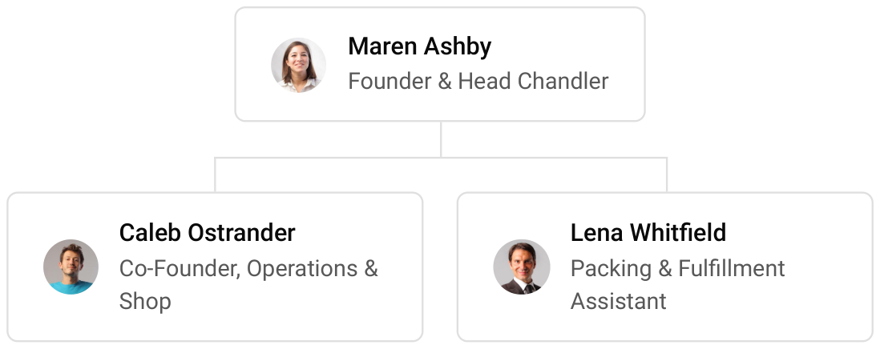

9.3 Advisory Board Members
The founders will draw on two outside advisers rather than a formal board: an accountant who works with small product businesses, to review the monthly accounts and the quarterly tax estimates, and an experienced maker who has run a wholesale line, to advise on pricing and terms before the first boutique accounts open. Both are paid by the hour as needed.

9.3.1 Hiring Plan
2  Filled |  | 1  Hiring This Year |  | 2  Open

Group By Department | Position Filled | Time of Hire | Time of Start | Filled
Production | 1 of 1 | 0 days | 0 days | 100%
Shop & Marketing | 1 of 1 | 0 days | 0 days | 100%
Packing & Fulfillment | 0 of 2 | 30 days | 14 days | 0%

CHAPTER 10

Financial Plan

10.1 Key Assumptions
10.2 Capital Requirements and Use of Funds
10.3 Income Statement (3 Year projections)
10.4 Balance Sheet (3 Year projections)
10.5 Cash Flow Statement (3 Year projections)
10.6 Break Even Analysis

10.1 Key Assumptions
Revenue follows the way an Etsy shop actually earns: monthly shop visits, times the share that order, times the average order, with wholesale added on top. At full run rate the plan assumes 9,000 visits a month, a conversion rate of 2.6%, inside the 2% to 3% that seller guides treat as a working target, an average order of $46, and wholesale worth 12% on top of Etsy sales. The shop opens at 50% of that run rate while its first reviews build, reaches full run rate after 6 months, and grows 20% a year after that.
Gross margin is held at 60.0%, because cost of sales carries the materials and packaging and also Etsy's transaction, processing and listing fees, which every order pays. Payroll is 26% of revenue, covering modest salaries for the two founders and a part-time packer. Marketing is 8% of revenue. Studio rent is $850 a month, technology $120 and administration $260. Etsy collects sales tax as marketplace facilitator, so the shop holds none of its own, and Etsy pays out within 4 days, so almost no cash is tied up in receivables. Inventory is held at 50 days of sales.
On those assumptions revenue is $126,585 in the first year, $151,902 in the second and $182,282 in the third, with net income of $5,601, $9,946 and $15,115. Break-even revenue is $102,661, or 2,232 orders, which the first year passes. Third-year net income ranges from $5,059 in the conservative case to $31,532 in the upside case, so the shop stays profitable even if visits and conversion fall short.

10.2 Capital Requirements and Use of Funds
The shop needs $29,200 to open. The largest single use is the first inventory of wax, fragrance, vessels, reeds, labels and boxes. The rest buys pouring equipment and the studio fit-out, burn testing, product photography, branding and packaging design, formation and insurance, and launch marketing, and holds a working capital reserve for the first months.
The founders put in $25,000 of their own savings and borrow $15,000 through an SBA Microloan at 9.5% over 5 years. The loan is repaid from operating cash, and no profit is distributed for the first three years, so the business funds its own inventory and new scents as it grows.

10.2.1 Use of Funds
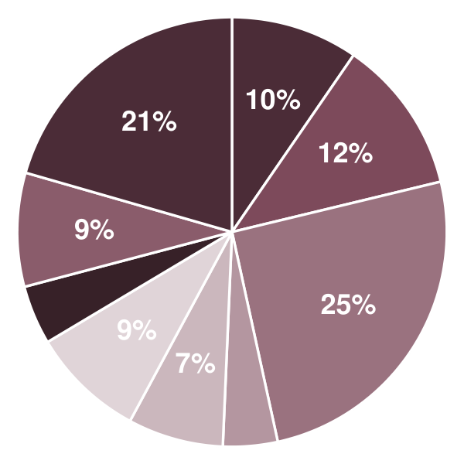 | ● Pouring Equipment 9.6%  ● Studio Fit-Out 11.6%  ● Initial Inventory 25.3%  ● Burn Testing & Sample Batches 4.1%  ● Product Photography 7.2%  ● Branding & Packaging Design 8.6%  ● Licenses, Insurance & Formation 4.5%  ● Launch Marketing 8.6%  ● Working Capital Reserve 20.5%

Use Of Funds | Amount
Pouring Equipment | $2,800.00
Studio Fit-Out | $3,400.00
Initial Inventory | $7,400.00
Burn Testing & Sample Batches | $1,200.00
Product Photography | $2,100.00
Branding & Packaging Design | $2,500.00
Licenses, Insurance & Formation | $1,300.00
Launch Marketing | $2,500.00
Working Capital Reserve | $6,000.00

10.3 Income Statement (3 Year projections)
 | Year 1 | Year 2 | Year 3 | Total
Revenue | $126,584.64 | $151,901.57 | $182,281.88 | $460,768.09
Cost of Sales | $50,633.86 | $60,760.63 | $72,912.75 | $184,307.24
General Costs | $0.00 | $0.00 | $0.00 | $0.00
Revenue Specific Costs | $35,443.70 | $42,532.44 | $51,038.92 | $129,015.06
Personnel Costs (Direct Labor) | $15,190.16 | $18,228.19 | $21,873.83 | $55,292.18
Gross Margin | $75,950.78 | $91,140.94 | $109,369.13 | $276,460.85
Gross Margin (%) | 60.00% | 60.00% | 60.00% | 60.00%
Operating Expense | $61,596.32 | $70,963.59 | $82,204.30 | $214,764.21
Payroll Expense (Indirect Labor) | $32,912.01 | $39,494.41 | $47,393.29 | $119,799.71
General Expense | $28,684.31 | $31,469.18 | $34,811.01 | $94,964.50
Bad Debt | $0.00 | $0.00 | $0.00 | $0.00
Amortization of Current Assets | $0.00 | $0.00 | $0.00 | $0.00
EBITDA | $14,354.46 | $20,177.35 | $27,164.83 | $61,696.64
Additional Expense | $8,753.79 | $10,231.46 | $12,049.68 | $31,034.93
Long Term Depreciation | $5,840.00 | $6,447.61 | $7,176.73 | $19,464.34
Gain or loss from Sale of Assets | $0.00 | $0.00 | $0.00 | $0.00
EBIT | $8,514.46 | $13,729.74 | $19,988.10 | $42,232.30
Interest Expense | $1,425.00 | $1,140.00 | $855.00 | $3,420.00
EBT | $7,089.46 | $12,589.74 | $19,133.10 | $38,812.30
Income Tax Expense / Benefit | $1,488.79 | $2,643.85 | $4,017.95 | $8,150.59
Total Expense | $120,983.97 | $141,955.68 | $167,166.73 | $430,106.38
Net Income | $5,600.67 | $9,945.89 | $15,115.15 | $30,661.71
Net Income (%) | 4.42% | 6.55% | 8.29% | 6.65%
Retained Earning Opening | $0.00 | $5,600.67 | $15,546.56
Owner's Distribution | $0.00 | $0.00 | $0.00 | $0.00
Retained Earning Closing | $5,600.67 | $15,546.56 | $30,661.71 | $30,661.71

10.4 Balance Sheet (3 Year projections)
 | Year 1 | Year 2 | Year 3 | Total
Assets | $44,681.51 | $52,043.57 | $64,658.12 | $64,658.12
Current Assets | $21,321.51 | $32,093.15 | $48,238.79 | $48,238.79
Cash | $14,385.36 | $23,769.78 | $38,250.74 | $38,250.74
Accounts Receivable | $0.00 | $0.00 | $0.00 | $0.00
Inventory | $6,936.15 | $8,323.37 | $9,988.05 | $9,988.05
Other Current Assets | $0.00 | $0.00 | $0.00 | $0.00
Long Term Assets | $23,360.00 | $19,950.42 | $16,419.33 | $16,419.33
Gross Long Term Assets | $29,200.00 | $32,238.03 | $35,883.67 | $35,883.67
Accumulated Depreciation | $5,840.00 | $12,287.61 | $19,464.34 | $19,464.34
Liabilities & Equity | $44,681.51 | $52,043.57 | $64,658.12 | $64,658.12
Liabilities | $14,080.84 | $11,497.01 | $8,996.41 | $8,996.41
Current Liabilities | $5,080.84 | $5,497.01 | $5,996.41 | $5,996.41
Accounts Payable | $2,080.84 | $2,497.01 | $2,996.41 | $2,996.41
Income Tax Payable | $0.00 | $0.00 | $0.00 | $0.00
Sales Tax Payable | $0.00 | $0.00 | $0.00 | $0.00
Short Term Debt | $3,000.00 | $3,000.00 | $3,000.00 | $3,000.00
Long Term Liabilities | $9,000.00 | $6,000.00 | $3,000.00 | $3,000.00
Long Term Debt | $9,000.00 | $6,000.00 | $3,000.00 | $3,000.00
Equity | $30,600.67 | $40,546.56 | $55,661.71 | $55,661.71
Paid-in Capital | $0.00 | $0.00 | $0.00 | $0.00
Common Stock | $0.00 | $0.00 | $0.00 | $0.00
Preferred Stock | $0.00 | $0.00 | $0.00 | $0.00
Owner's Contribution | $25,000.00 | $25,000.00 | $25,000.00 | $25,000.00
Retained Earnings | $5,600.67 | $15,546.56 | $30,661.71 | $30,661.71
Check | $0.00 | $0.00 | $0.00 | $0.00

10.5 Cash Flow Statement (3 Year projections)
 | Year 1 | Year 2 | Year 3 | Total
Cash Received | $126,584.64 | $151,901.57 | $182,281.88 | $460,768.09
Cash Paid | $119,999.28 | $136,479.12 | $161,155.28 | $417,633.68
COS & General Expenses | $68,983.32 | $74,972.67 | $87,015.21 | $230,971.20
Salary & Wages | $48,102.17 | $57,722.60 | $69,267.12 | $175,091.89
Interest | $1,425.00 | $1,140.00 | $855.00 | $3,420.00
Sales Tax | $0.00 | $0.00 | $0.00 | $0.00
Income Tax | $1,488.79 | $2,643.85 | $4,017.95 | $8,150.59
Net Cash From Operations | $6,585.36 | $15,422.45 | $21,126.60 | $43,134.41
Assets Sell | $0.00 | $0.00 | $0.00 | $0.00
Assets Purchase | $29,200.00 | $3,038.03 | $3,645.64 | $35,883.67
Net Cash From Investments | ($29,200.00) | ($3,038.03) | ($3,645.64) | ($35,883.67)
Amount Received | $40,000.00 | $0.00 | $0.00 | $40,000.00
Loan Received | $15,000.00 | $0.00 | $0.00 | $15,000.00
Common Stock | $0.00 | $0.00 | $0.00 | $0.00
Preferred Stock | $0.00 | $0.00 | $0.00 | $0.00
Owner's Contribution | $25,000.00 | $0.00 | $0.00 | $25,000.00
Amount Paid | $3,000.00 | $3,000.00 | $3,000.00 | $9,000.00
Loan Capital | $3,000.00 | $3,000.00 | $3,000.00 | $9,000.00
Dividends & Distributions | $0.00 | $0.00 | $0.00 | $0.00
Net Cash From Financing | $37,000.00 | ($3,000.00) | ($3,000.00) | $31,000.00
Summary
Starting Cash | $0.00 | $14,385.36 | $23,769.78
Cash In | $166,584.64 | $151,901.57 | $182,281.88 | $500,768.09
Cash Out | $152,199.28 | $142,517.15 | $167,800.92 | $462,517.35
Change in Cash | $14,385.36 | $9,384.42 | $14,480.96 | $38,250.74
Ending Cash | $14,385.36 | $23,769.78 | $38,250.74 | $38,250.74

10.6 Break Even Analysis
 | Year 1 | Year 2 | Year 3 | Total
Starting Revenue | $0.00 | $126,584.64 | $278,486.21 | $278,486.21
Net Revenue | $126,584.64 | $151,901.57 | $182,281.88 | $182,281.88
Closing Revenue | $126,584.64 | $278,486.21 | $460,768.09 | $460,768.09
Starting Expense | $0.00 | $120,983.97 | $262,939.65 | $262,939.65
Net Expense | $120,983.97 | $141,955.68 | $167,166.73 | $167,166.73
Closing Expense | $120,983.97 | $262,939.65 | $430,106.38 | $430,106.38
Is Break Even? | Yes | Yes | Yes
Break Even Month | Oct '26 | - | -
Days Required | 5 Days | - | -
Break Even Revenue | $102,473.28 | - | -

CHAPTER 11

References

- SRC001: Etsy, Inc. Reports Fourth Quarter and Full Year 2025 Results, Etsy, Inc. Investor Relations, 2026-02-19. https://investors.etsy.com/news-events/press-releases/detail/218/etsy-inc-reports-fourth-quarter-and-full-year-2025-results (accessed 2026-10-12)
- SRC002: Etsy, Inc. Form 10-K for the fiscal year ended December 31, 2025, Etsy, Inc. / SEC EDGAR, 2026-02-19. https://www.sec.gov/Archives/edgar/data/1370637/000137063726000019/etsy-20251231.htm (accessed 2026-10-12)
- SRC003: E-Commerce Retail Sales as a Percent of Total Sales (ECOMPCTSA), Federal Reserve Bank of St. Louis (FRED), from U.S. Census Bureau data, 2026-08-18. https://fred.stlouisfed.org/series/ECOMPCTSA (accessed 2026-10-12)
- SRC004: Fees & Payments Policy, Etsy, 2026-10-05. https://www.etsy.com/legal/fees/ (accessed 2026-10-12)
- SRC005: What are Payment Processing Fees for Selling on Etsy?, Etsy Help, 2026-01-01. https://help.etsy.com/hc/en-us/articles/115015628847 (accessed 2026-10-12)
- SRC006: Online Hobby & Craft Supplies Sales in the US - Market Size, IBISWorld, 2026-02-01. https://www.ibisworld.com/united-states/industry/online-hobby-craft-supplies-sales/5104/ (accessed 2026-10-12)
- SRC007: Etsy Conversion Rate: 2026 Benchmark And How To Optimize, Gelato, 2026-01-01. https://www.gelato.com/blog/etsy-conversion-rate (accessed 2026-10-12)
- SRC008: What Is A Good Conversion Rate On Etsy In 2026?, Merchize, 2026-01-01. https://merchize.com/what-is-a-good-conversion-rate-on-etsy/ (accessed 2026-10-12)
- SRC009: NRF report: holiday sales grow 4.1 percent, driven by consumer spending surge, FashionUnited, 2026-01-13. https://fashionunited.com/news/business/nrf-report-holiday-sales-grow-4-1-percent-driven-by-consumer-spending-surge/2026011369970 (accessed 2026-10-12)
- SRC010: Etsy marketplace GMS grows in Q4 2025, company agrees to sell Depop, Digital Commerce 360, 2026-02-20. https://www.digitalcommerce360.com/2026/02/20/etsy-marketplace-gms-sales-q4-2025-depop/ (accessed 2026-10-12)
- SRC011: How Etsy Search Works, Etsy Seller Handbook, 2025-08-26. https://www.etsy.com/seller-handbook/article/375461474487 (accessed 2026-10-12)
- SRC012: The New Etsy Search Visibility Page, Etsy Seller Handbook, 2024-08-28. https://www.etsy.com/seller-handbook/article/1289139008351 (accessed 2026-10-12)
- SRC013: USPS postage rate change overview, Pitney Bowes, 2026-01-01. https://www.pitneybowes.com/us/postal-information/usps-rate-change-overview.html (accessed 2026-10-12)
- SRC014: 2026 Postage Price Change, U.S. Postal Service, 2026-01-01. https://faq.usps.com/s/article/2026-Postage-Price-Change (accessed 2026-10-12)
- SRC015: Crafting the future of work: the big impact of microbusinesses (2017 U.S. Etsy Seller Census), Etsy, 2017-01-01. https://extfiles.etsy.com/advocacy/Etsy_US_2017_SellerCensus.pdf (accessed 2026-10-12)
- SRC016: How to Price Your Products on Etsy: The Complete Pricing Guide for Sellers, Craftybase, 2026-01-01. https://craftybase.com/blog/how-to-price-on-etsy (accessed 2026-10-12)
- SRC017: Candles, U.S. Consumer Product Safety Commission. https://www.cpsc.gov/Business--Manufacturing/Business-Education/Business-Guidance/Candles (accessed 2026-10-12)
- SRC018: Metal-Cored Candlewicks Containing Lead and Candles With Such Wicks; Final Rule, Federal Register (U.S. Consumer Product Safety Commission), 2003-04-18. https://www.govinfo.gov/content/pkg/FR-2003-04-18/pdf/03-9255.pdf (accessed 2026-10-12)
- SRC019: Facts & Figures, National Candle Association. https://candles.org/facts-figures/ (accessed 2026-10-12)
- SRC020: Table 1. Nonfarm Sole Proprietorships: Business Receipts, Selected Deductions, Payroll, and Net Income, by Industrial Sectors, Tax Year 2023, IRS Statistics of Income Division, 2025-01-01. https://www.irs.gov/pub/irs-soi/23sp01br.xls (accessed 2026-10-12)
- SRC021: Occupational Employment and Wage Statistics, Asheville, NC MSA, May 2025, U.S. Bureau of Labor Statistics, 2026-01-01. https://api.bls.gov/publicAPI/v1/timeseries/data/OEUM001170000000053706403 (accessed 2026-10-12)
- SRC022: Helene flooding reshaped River Arts District; leaders say recovery is far from over, WLOS, 2026-09-30. https://wlos.com/news/local/helene-asheville-businesses-river-arts-district-mayor-esther-manheimer-fema-north-carolina-western-nc-wnc-cotton-mills-studios-recovery-community (accessed 2026-10-12)
- SRC023: QuickFacts: Asheville city, North Carolina, U.S. Census Bureau, 2024-01-01. https://www.census.gov/quickfacts/fact/table/ashevillecitynorthcarolina/SBO030222 (accessed 2026-10-12)
