
Table of Contents
1. Executive Summary 6
1.1 Business Overview 7
1.2 Mission Statement 7
1.3 Location & Market Opportunity 7
1.4 Unique Selling Points 7
1.5 Financial Highlights 8
1.6 Funding Requirement 8
1.6.1 Income Statement (3 Year projections) 8
2. Company Overview 9
2.1 Legal Structure 10
2.2 Vision Statement 10
2.3 Background & History 10
2.4 Future Goals 10
2.4.1 Business Owners 11
2.4.2 SMART Goal 11
3. Market Analysis 12
3.1 Overview 13
3.2 Market Segmentation 13
3.3 Market Trends 13
3.4 Local Market Outlook 13
3.5 Market Size 14
3.5.1 PESTEL Analysis 15
4. Customer Analysis 16
4.1 Target Market 17
4.2 Customer Segments 17
4.3 Customer Persona 18
4.4 Customer Purchase Journey 18
5. Competitive Analysis 19
5.1 Competitors 20
5.2 Comparison 20
5.3 Competitive Edge 21
5.4 SWOT Analysis 22
6. Services Offered 23
6.1 Our Offering 24
6.2 Signature Items 24
6.3 Additional Services 24
6.4 What Sets Us Apart 24
6.5 Equipment Fleet & Capabilities 25
6.5.1 Foundations & Septic Systems 25
6.5.2 Builder Lot Clearing & Grading 26
6.5.3 Features 26
6.5.4 Pricing 27
7. Marketing & Sales Strategies 28
7.1 Market Positioning 29
7.2 Marketing Objectives 29
7.3 Online Marketing 29
7.4 Public Relations and Branding 30
7.5 Partnership & Collaboration Strategy 30
7.6 Customer Loyalty & Retention 30
7.7 Sales Channels 30
8. Operations Plan 31
8.1 Daily Operations 32
8.2 Working Hours 32
8.3 Staffing & Training 32
8.4 Inventory & Equipment Management 32
8.5 Location and Facilities 32
8.6 Milestones & Timeline 33
8.7 Trench Safety, Utility Locates & Permits 33
9. Management Team 35
9.1 Key Members 36
9.2 Organization Chart 36
9.3 Advisory Board Members 36
9.3.1 Hiring Plan 37
10. Financial Plan 38
10.1 Key Assumptions 39
10.2 Capital Requirements and Use of Funds 39
10.2.1 Use of Funds 40
10.3 Income Statement (3 Year projections) 41
10.4 Balance Sheet (3 Year projections) 42
10.5 Cash Flow Statement (3 Year projections) 43
10.6 Break Even Analysis 44
11. References 45


CHAPTER 1

Executive Summary

1.1 Business Overview
1.2 Mission Statement
1.3 Location & Market Opportunity
1.4 Unique Selling Points
1.5 Financial Highlights
1.6 Funding Requirement

1.1 Business Overview
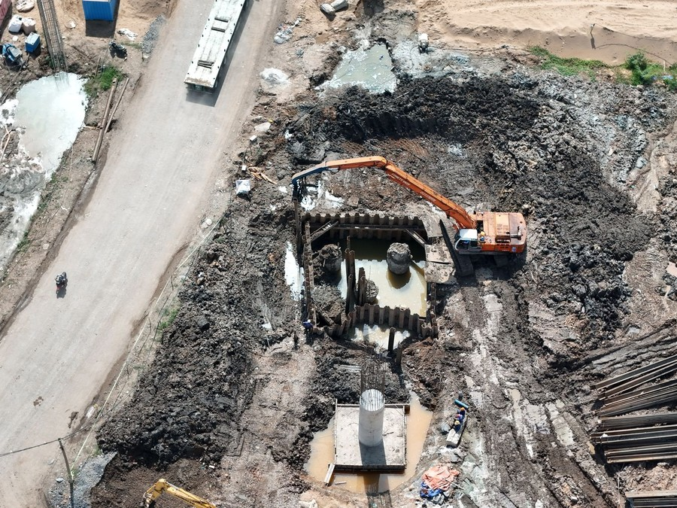
Ledgewick Excavation is an excavation and site work contractor being set up in Huntsville, Alabama. From one equipment yard it will run two crews with a 20-ton excavator, a mini excavator, a compact track loader and a tandem dump truck, working across Madison County and the eastern edge of Limestone County.
It digs house foundations and basements, installs septic systems, cuts driveways and lays drainage for custom builders and owners building on their own land, and it clears, grades and trenches lots for home builders and general contractors by the lot or the phase. Every job is bid in writing, with stone, pipe, fill and trucking billed on top.

1.2 Mission Statement
To dig, grade and trench every site to the lines and levels on the plans, safely and on the day promised, so the builder behind us can pour, frame and close on schedule.

1.3 Location & Market Opportunity
Huntsville keeps growing. The metro's population reached an estimated 556,444 in 2025, up from 542,122 a year earlier, and households earn a median of $87,049 against $81,604 nationally. The city's Planning Commission approved 1,892 single-family lots in 2025, the most since 2007, and issued 4,813 certificates of occupancy for new homes. Every one of those lots has to be cleared, graded, dug and trenched before a house goes up.
US site preparation contractors, the industry excavators belong to, took in $158.7 billion in 2022. Madison County's share of that work is about $92.5 million a year, and a US site preparation firm with 5 to 9 employees averages about $1.72 million. Ledgewick's first-year revenue of $1,035,419 sits below that average, as it should for a firm in its opening year.

1.4 Unique Selling Points
- An owner-operator who has run excavators on Madison County subdivisions and holds the state septic installer license, so one contractor can dig the foundation and put in the septic system.
- Two crews from the first month, so a builder can have a lot cleared while a foundation is dug on another.
- A builder lot package priced per lot, covering clearing, pad, foundation dig, utility trenches and final grade.
- A trench box, a competent person and an 811 locate on every trench, with qualified inspector stormwater checks on disturbed sites.
- Its own dump truck, so stone and spoil move on the crew's schedule rather than a hauler's.

1.5 Financial Highlights
Revenue comes from two crews finishing five to six jobs a month each at an average bid of $8,500, with stone, pipe, fill and trucking adding a further 13% of the bid. The crews open at 45% of that volume and reach a full calendar over eight months as builders add Ledgewick to their bid lists.
Revenue is projected at $1,035,419 in the first year, $1,190,732 in the second and $1,369,342 in the third, at a gross margin of 57.0% throughout. Net income is $27,608 in the first year, rising to $55,393 and then $86,913, a net margin of 6.3% by the third year. Break-even revenue is $776,933, the equivalent of 91 jobs, which the first year clears. Third-year net income is $39,808 in the conservative case and $150,536 in the upside case.

1.6 Funding Requirement
The startup budget is $497,200. It buys a used 20-ton excavator, a mini excavator, a compact track loader, a tandem dump truck, an equipment trailer and two crew trucks, along with a trench box, lasers and attachments, the yard setup, licenses, training, insurance deposits and launch marketing. It is funded by a $150,000 owner contribution and a $400,000 SBA 7(a) loan at 9.75% over ten years, which leaves an opening cash cushion of about $52,800 to carry builder invoices through the ramp. Profits stay in the business while the loan is repaid.
The plan rests on an operator who knows the county's soil and its builders, a metro approving more home lots than at any time since 2007, and a crew that turns up when it says it will. The money puts two equipped, licensed crews to work on those lots from the first month.

1.6.1 Income Statement (3 Year projections)
 | Year 1 | Year 2 | Year 3 | Total
Revenue | $1,035,419.00 | $1,190,731.85 | $1,369,341.63 | $3,595,492.48
Cost of Sales | $445,230.17 | $512,014.70 | $588,816.90 | $1,546,061.77
Gross Margin | $590,188.83 | $678,717.15 | $780,524.73 | $2,049,430.71
Operating Expense | $442,851.79 | $492,629.56 | $549,873.99 | $1,485,355.34
Total Expense | $1,007,810.73 | $1,135,338.50 | $1,282,428.32 | $3,425,577.55
Net Income | $27,608.27 | $55,393.35 | $86,913.31 | $169,914.93

CHAPTER 2

Company Overview

2.1 Legal Structure
2.2 Vision Statement
2.3 Background & History
2.4 Future Goals

2.1 Legal Structure
Ledgewick Excavation will be organized as Ledgewick Excavation LLC, an Alabama limited liability company owned outright by its founder, Cole Pritchard, and taxed as a corporation. The LLC holds the equipment, the yard lease, the SBA loan and every customer contract, which keeps the founder's personal assets apart from the risks of digging on other people's land.
Before the first job it will hold the licenses Alabama requires of this trade. Site work, grading or paving of $50,000 or more needs a license from the Alabama Licensing Board for General Contractors, including for a subcontractor on commercial work, and installing or repairing a septic system needs an Alabama Onsite Wastewater Board license, which the founder holds. General liability, commercial auto, an inland marine policy on the fleet and workers' compensation are in place before a machine leaves the yard.

2.2 Vision Statement
To be the excavator North Alabama's small and mid-size builders call first for a lot: the pad is at grade, the trench is protected, the septic system passes on the first visit and the invoice matches the bid.

2.3 Background & History
Ledgewick is a new business, and what follows is the founder's account of why he intends to start it. Cole Pritchard has spent fourteen years running excavators and dozers for a Madison County site development contractor, working subdivision phases, commercial pads and utility runs. Along the way he earned his septic installer license and his qualified inspector credential for construction stormwater, and he learned to estimate a lot from a site walk.
He also watched the gap that Ledgewick is built to fill. Larger site contractors schedule around subdivision phases worth hundreds of thousands of dollars, so a builder with three scattered lots, or a family building on five acres outside Harvest or Hazel Green, can wait weeks for a crew. The one-machine operators who take that work often have no septic license, no dump truck and no trench box, so the builder has to coordinate three outfits for one house.
Ledgewick answers that with two crews, one yard and a full set of used machines bought rather than rented. Huntsville's growth decided the timing: the city approved 1,892 single-family lots in 2025, the most since 2007, and each one needs clearing, a pad, a foundation and trenches before anything else can happen on it.

2.4 Future Goals
In the first 0 to 18 months, the founder intends to form the company, secure the licenses and the SBA loan, buy and service the fleet, lease the yard and start work with both crews. The aim is a place on the bid lists of at least six active builders, a full calendar for both crews by the eighth month, and revenue past the break-even level of $776,933 within the first year.
Over 1 to 3 years, the projection covers revenue rising from $1,035,419 to $1,190,732 and then $1,369,342, with builder lot work growing as a share of it. In that period Ledgewick intends to win its first small commercial pads, keep every trench incident-free, pay down the equipment loan on schedule and build enough cash to replace machines without borrowing.
Over 3 to 5 years, the plan is to add a third crew with a dozer and a second dump truck, so Ledgewick can take whole subdivision phases and the commercial site work that the Space Command headquarters and new plants around Huntsville are bringing to the county.

2.4.1 Business Owners
Cole Pritchard

Total ownership: 100%
100% | Cole Pritchard  1,000 Shares

2.4.2 SMART Goal
  Specific  - Both crews take Ledgewick past break-even revenue of $776,933 in the first year.  - The work comes from Madison and Limestone County builders and owners. |   Measurable  - Monthly revenue against the $1,035,419 first-year projection.  - Six builders awarding lots by the sixth month. |   Achievable  - The founder knows the county's builders, soils and inspectors.  - Both crews are equipped from the first month.
  Relevant  - The city approved 1,892 single-family lots in 2025, so builders need site crews now.  - Break-even is the point where the equipment loan is carried by the work rather than by the cash cushion. |   Time-Based  - Both crews on full calendars by the eighth month.  - Break-even revenue passed within the first twelve months of work.

CHAPTER 3

Market Analysis

3.1 Overview
3.2 Market Segmentation
3.3 Market Trends
3.4 Local Market Outlook
3.5 Market Size

3.1 Overview
Excavation sits within site preparation, the trade that clears, digs, grades and trenches land before anything is built on it. US site preparation contractors took in $158.7 billion in 2022 across 39,932 establishments employing 482,712 people. Their work follows construction spending, which ran at $2.203 trillion a year in August 2026, 1.7% below a year earlier. Private residential spending was $882.3 billion, down 4.8% on the year, while private nonresidential spending reached $773.0 billion after five monthly gains.

3.2 Market Segmentation
- New homes: foundation and basement digs, backfill, driveways and drainage for each house. Single-family starts ran at a 918,000 annual rate in August 2026, 7.6% above July.
- Builder lots and subdivisions: clearing, rough and finish grading and utility trenching, awarded by the lot or the phase.
- Septic systems: tanks and field lines on lots outside sewer service, a licensed specialty in Alabama.
- Small commercial and industrial pads: building pads, parking areas and stormwater controls for general contractors.
- Trenching for other trades: water, sewer, power and gas runs dug for plumbing and electrical contractors.

3.3 Market Trends
- Fuel is the cost moving fastest. US on-highway diesel averaged $6.179 a gallon in mid-October 2026, $2.514 more than a year earlier, so every machine hour and truck trip costs more than last year's bids allowed for.
- Stone keeps rising. Crushed stone averaged $18.50 a metric ton in 2025, up from $13.26 in 2021, which is why contractors bill it on top of the bid rather than fixing it inside.
- Operators are scarce. 77% of firms that employ heavy equipment operators said the positions were hard to fill in 2025, and 45% had project delays from worker shortages.
- Stormwater rules apply to more sites. Construction disturbing an acre or more needs permit coverage and a pollution prevention plan, and EPA's 2022 general permit expires in February 2027.

3.4 Local Market Outlook
Huntsville's excavation trade is small and stable. Madison County had 39 site preparation establishments in 2025, against 40 the year before, employing 298 people; Limestone County had 14, up from 12; Alabama had 713 in all. At about 7.6 employees each, Madison County's firms are owner-run contractors, with no chain or franchise among them.
Demand is growing faster than that supply. The Huntsville metro reached an estimated 556,444 residents in 2025, and households earn a median of $87,049. The city approved 1,892 single-family lots in 2025, the most since 2007, and issued 4,813 certificates of occupancy for new homes. U.S. Space Command's move to Redstone Arsenal is expected to bring 1,200 to 1,700 direct jobs, and Eli Lilly plans a plant of over $6 billion with 450 jobs.
Labor costs less here than nationally: Huntsville metro equipment operators earned a mean of $25.14 an hour in May 2025 and construction laborers $18.16. Site work of $50,000 or more needs a state contractor license, and sites of an acre or more need ADEM's stormwater permit. No published figure for equipment yard rent in Huntsville could be found.

3.5 Market Size
The total addressable market is $158.7 billion, the 2022 receipts of US site preparation contractors, a total that also covers demolition contractors and septic installers. The serviceable market is about $92.5 million a year: Madison County's 298 site preparation employees in 2025 times Alabama's $310,420 of receipts per employee in 2022. Limestone County's 14 establishments are left out because their employment is not published, so the figure understates the metro.
The obtainable market is $1.72 million, the 2022 average for a US site preparation firm with 5 to 9 employees, the size band a two-crew contractor falls in. Ledgewick's first-year revenue of $1,035,419 sits below that average, as an opening year should.
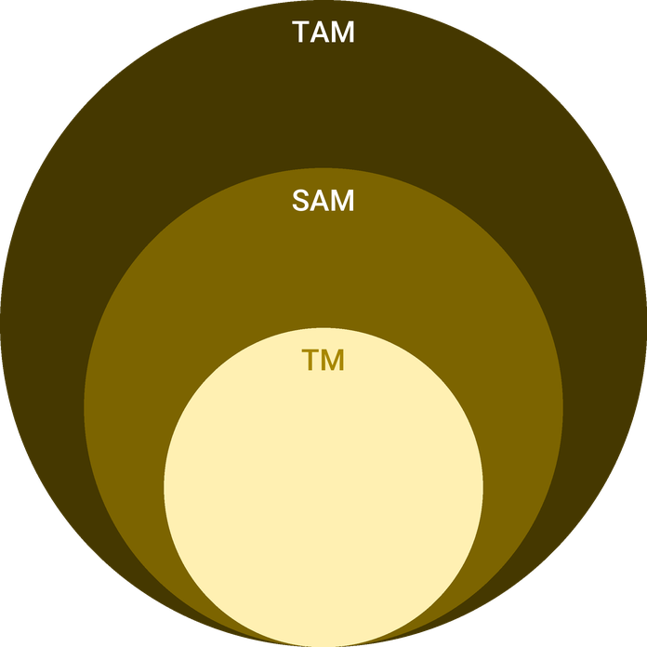
  ● | Total Available Market (TAM)  US site preparation contractors (NAICS 238910), the industry excavation contractors belong to, took in $158.7 billion of receipts in 2022, the latest Economic Census year; the total also covers demolition and septic installers. | 158.7B
  ● | Served Available Market (SAM)  Madison County's site preparation market is about $92.5 million a year: its 298 site preparation employees in 2025 times Alabama's $310,420 of receipts per employee in 2022. | 92.5M
  ● | Target Market (TM)  One US site preparation firm with 5 to 9 employees took in about $1.72 million on average in 2022 ($11,135.2 million across 6,465 firms), the size band of a two-crew contractor; a national average, not a Huntsville figure. | 1.7M

3.5.1 PESTEL Analysis
  Political  - Federal spending on Redstone Arsenal and the Space Command move drives jobs and building across Madison County.  - Alabama's contractor licensing board governs site work of $50,000 or more, including subcontracts.  - Alabama has no state minimum wage, so pay is set by the market for scarce operators. |   Economic  - The prime rate rose to 7.00% in September 2026, raising the cost of the equipment loan and of builders' lot financing.  - Diesel at $6.179 a gallon in mid-October 2026 is $2.514 above a year earlier.  - Crushed stone rose from $13.26 a metric ton in 2021 to $18.50 in 2025. |   Social  - The metro grew from 542,122 residents in 2024 to an estimated 556,444 in 2025.  - Families building on acreage outside the city want one contractor to handle land, septic and driveway.  - Fewer young workers enter the trades, so operators are hard to hire and keep.
  Technological  - Rotating lasers and grade rods let a two-person crew set pads and trench slopes without a surveyor on site.  - GPS telematics on each machine track hours, location and service intervals.  - Estimating and job costing software turns each finished job into data for the next bid. |   Environmental  - Sites disturbing an acre or more need ADEM stormwater coverage, a certified plan and regular inspections.  - Heavy spring rain and red clay soils cost working days and demand erosion controls on every lot.  - Septic systems must suit the soil a perc test finds, which decides the system and its cost. |   Legal  - OSHA requires a protective system in trenches five feet or deeper and daily competent person inspections.  - Alabama's damage prevention law requires an 811 locate at least two full working days before digging.  - Septic installation requires an Alabama Onsite Wastewater Board license.

CHAPTER 4

Customer Analysis

4.1 Target Market
4.2 Customer Segments
4.3 Customer Persona
4.4 Customer Purchase Journey

4.1 Target Market
Ledgewick sells to the people who need ground made ready to build on in Madison County and the eastern edge of Limestone County. Most of its revenue will come from home builders and general contractors, who buy site work again on every house or building they start, with the rest from owners building on their own land and from trades that need a trench dug.
The market is growing on both counts. The city approved 1,892 single-family lots in 2025, the most since 2007, and the metro's median home value is $331,800, high enough that builders expect a pad to grade and a foundation to the inch. Outside the city limits, much of the new building happens on acreage beyond sewer service, where a septic system is part of every house.
Demand follows the building season. Builders clear and dig most heavily from late winter through summer, so lots are started ahead of the spring selling season and houses close before the holidays, while owners building on acreage often start in the fall, once the ground has dried. Wet weeks in winter push work back rather than cancel it, which is why the plan counts finished jobs across the whole year rather than in a peak month.

4.2 Customer Segments
- Small and mid-size home builders, building from a handful to a few dozen houses a year. They buy the builder lot package, clearing, pad, foundation dig, utility trenches and final grade, and they buy it again for every lot, so one builder can be worth dozens of jobs a year.
- Custom builders and owners building on rural acreage. They buy the combinations no one else bundles: a lot cleared, a driveway cut, a foundation dug and a septic system installed and approved by the county health department.
- General contractors on small commercial work. They buy building pads, parking area subgrade, storm pipe and the erosion controls a disturbed site of an acre or more must carry under ADEM's permit.
- Plumbing and electrical contractors. They buy trenches for water, sewer and power runs, dug, protected where deep enough to need it, and backfilled once their pipe or conduit is in.
Builders are the steadiest of the four and the slowest to win: a builder adds a new excavator to its list only after a trial lot. Owners building on acreage are the reverse, quick to award a job after one site visit but rarely buying twice. General contractors and trades fall between, buying when their own bids are won. The persona stands for the builder group, because it carries most of the revenue.

4.3 Customer Persona
  Brandon Hale  Demographics  Age: 38  Location: Madison, AL  Family: Married, two children  Professional Role  Job: Owner of a small home building company  Builds: about 14 houses a year | “I can sell a house in Madison County. What I can't do is wait three weeks for somebody to come dig the foundation.”
   | Identifiers / Personality Traits  - Buys lots in batches of three or four in Madison and Limestone counties  - Runs two superintendents and subcontracts every trade  - Pays on monthly draws from his construction lender
   | Goals  - Start each house the week the lot closes  - Know the site cost of a lot before buying it  - Pass every pad and trench inspection the first time
   | Challenges  - Large site contractors schedule his single lots behind whole subdivisions  - Coordinating separate firms for clearing, septic and hauling  - Site costs rising with fuel and stone prices

4.4 Customer Purchase Journey
A builder rarely shops for an excavator the way a homeowner shops for a service. Ledgewick reaches builders through the Huntsville/Madison County Builders Association, introductions from septic designers and suppliers, and visits to job sites where a lot is staked but not yet cleared. The builder sends plans and a plot survey, Ledgewick walks the lot and returns a written bid within two working days, and the first lot is usually a trial.
What decides whether a second lot follows is how the first one went: whether the crew arrived on the scheduled day, whether the pad was at grade when the surveyor checked it, whether the trenches passed the plumbing and electrical inspections, and whether the invoice matched the bid. Builders who get that award lots by the batch and pay on monthly draws.
An owner building on their own land usually finds Ledgewick through a search, a referral from the health department's list of licensed installers, or a neighbor who saw the trucks. They want one contractor for the whole job, a price they can show their lender, and a crew that explains each step. They pay a deposit at signing and the balance when the septic system is approved and the site is graded.

CHAPTER 5

Competitive Analysis

5.1 Competitors
5.2 Comparison
5.3 Competitive Edge
5.4 SWOT Analysis

5.1 Competitors
Excavation is a local, owner-run trade. Nationally, 51% of site preparation establishments that operated all of 2022 had fewer than five employees, and in Madison County the 39 establishments average about 7.6 employees each. No chain or franchise operates in the market, and no revenue figure for any local contractor is published, so the competition is described here by type rather than by name.
- One-machine owner-operators. The largest group by count: a mini excavator or backhoe on a trailer, quick to price small jobs, but rarely carrying a septic license, a dump truck or a trench box.
- Established site development contractors. Fleets of dozers, large excavators and trucks that grade subdivision phases and commercial sites, priced and scheduled for large work, and slow to fit in a single lot.
- Trades with their own machine. Plumbers and electricians who dig their own shallow trenches, and some builders who own a track loader for cleanup.
- Equipment rental. Owners and handymen who rent a mini excavator by the day and do the work themselves, mostly small drainage and landscaping digs.

5.2 Comparison
The comparison below sets Ledgewick against those four types on the things a builder or owner weighs when awarding a job. The owner-operator wins on a quick quote for a small dig, and the large site contractor on capacity for a whole phase. Ledgewick is built for the work between them: a single lot or a small batch where the builder wants clearing, a foundation, septic and trenches from one contractor, on a date that holds.
None of the four is weak in its own lane. The one-machine operator is often cheapest for a small dig because it carries little overhead, and the large site contractor has the dozers and crews to grade a whole phase in weeks. Where both fall short is the single house that needs several kinds of work in sequence. A builder hiring them for that lot pays in coordination: separate calls for clearing, the foundation, the septic system and hauling, and a schedule that slips each time one outfit runs late.
Feature | Ledgewick Excavation | One-machine owner-operators | Large site development contractors | Equipment rental, do it yourself
Licensed septic system installs | ✓ | ✗ | ✓ | ✗
Own dump truck for stone and spoil | ✓ | ✗ | ✓ | ✗
Trench box on every deep trench | ✓ | ✗ | ✓ | ✗
Schedules a single lot within the week | ✓ | ✓ | ✗ | ✓
Builder lot package priced per lot | ✓ | ✗ | ✗ | ✗
Takes whole subdivision phases | ✗ | ✗ | ✓ | ✗

5.3 Competitive Edge
The edge is a full set of machines and licenses in a firm small enough to schedule one lot at a time. Owning the excavators, loader and dump truck means Ledgewick can move a crew without waiting on a rental yard or a hauler, and the septic license means the house on rural acreage does not need a second contractor. Safety is part of the offer, not a cost hidden from it: every trench five feet or deeper gets a protective system and a daily check by a competent person, as OSHA requires, and every dig starts with an 811 locate.
That matters to builders because a trench collapse or a cut utility line stops their job too. Failure to call 811 caused 24.54% of the 196,977 utility damage reports in 2024, and the risk falls on every contractor who digs without one.
Price is not where Ledgewick means to win. Its bids run $6,000 to $10,000 for a foundation or septic job and $7,500 to $12,000 for a builder lot, priced to the work rather than to undercut anyone, and it competes on how the work is delivered: a crew on the booked date, the lot finished by one firm, and an itemized bid that shows stone, pipe and trucking apart from the dig. Its weakness against the established contractors is that it is new. It has no finished lots to point to in its first months, which is why the plan starts with trial lots and owner jobs and expects builders to commit only after the first lot goes well.
   | The Whole Lot, One Firm  Clearing, foundation, septic system, trenches and final grade come from one contractor, so a builder coordinates one crew instead of three.
   | A Licensed Septic Installer  The founder holds the state installer license, so rural lots outside sewer service do not need a second contractor for the system.
   | Owned Machines and Truck  Owning the excavators, loader and dump truck lets Ledgewick move a crew without waiting on a rental yard or a hauler.
   | Safety Builders Can See  Locates, trench boxes and daily competent person checks protect the builder's schedule as well as the crew.

5.4 SWOT Analysis
Strengths  - The founder brings fourteen years running excavators on Madison County subdivisions and commercial pads.  - A state septic installer license lets one firm deliver a rural lot from clearing to final grade.  - Owned machines and a dump truck keep both crews independent of rental yards and haulers.  - Two crews let a builder's next lot start within the week. | Weaknesses  - A new name with no finished jobs to show builders when bidding the first lots.  - A $400,000 equipment loan adds fixed payments before the calendar is full.  - Used machines carry repair risk, and one breakdown idles a whole crew.  - The founder both runs a crew and prices every bid, which caps how much he can sell.
Opportunities  - Huntsville approved 1,892 single-family lots in 2025, the most since 2007.  - Space Command and a new Eli Lilly plant bring jobs, homes and commercial site work.  - Rural lots outside sewer service need septic systems that few local excavators can install.  - Builders frustrated by large contractors' phase schedules will try a crew that books single lots. | Threats  - Diesel at over $6 a gallon in late 2026 raises the cost of every machine hour.  - Rising interest rates could slow home starts and builders' lot purchases.  - Experienced operators are scarce, and losing one would idle a crew.  - A trench collapse or a cut gas line could cost the business its builders and its insurance.

 Strategic Summary
Ledgewick should sell its one-firm lot package and septic license to the builders Huntsville's lot approvals are bringing, while bidding fuel and stone on top and holding cash for repairs. Safety and booked dates are what keep builders, so neither is traded for volume.

CHAPTER 6

Services Offered

6.1 Our Offering
6.2 Signature Items
6.3 Additional Services
6.4 What Sets Us Apart
6.5 Equipment Fleet & Capabilities

6.1 Our Offering
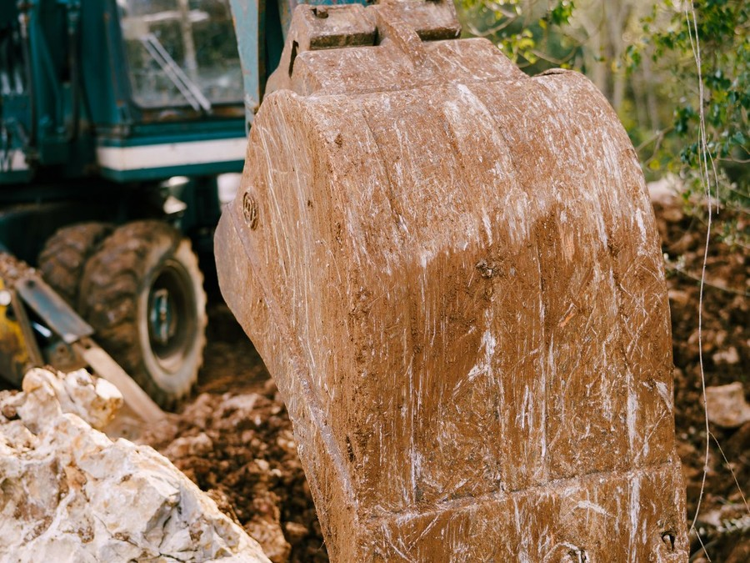
Ledgewick sells excavation and site work by the job, each priced on a written bid after a site walk. A bid states the scope, the price for the digging, grading and trenching, and the rates for stone, pipe, fill and extra truck trips, which are billed on the same job as they are used. Builders can take single jobs or a builder lot package priced per lot, and small work can be booked by the hour with a four-hour minimum.

6.2 Signature Items
Two lines carry most of the revenue: residential foundations and septic systems for custom builders and owners, and lot clearing, grading and trenching for home builders. They are priced and scheduled differently, and each is set out at the end of this chapter with what its price covers.

6.3 Additional Services
- Driveways and building pads: cut to grade, stone base spread and compacted, with culverts where a ditch crosses.
- Drainage and storm pipe: French drains, yard drains, culverts and downspout lines for builders and homeowners.
- Utility trenching: water, sewer, power and gas trenches for plumbing and electrical contractors, protected and backfilled.
- Erosion and stormwater controls: silt fence, construction entrances and inlet protection, with qualified inspector checks on sites of an acre or more.
- Hourly machine work: an excavator or track loader with an operator for small digs, stump and rock removal and cleanup.

6.4 What Sets Us Apart
A builder dealing with Ledgewick deals with one contractor from the first tree down to the final grade. The same firm that clears the lot digs the foundation, installs the septic system under its own state license, trenches for the utilities and hauls the spoil in its own truck, so the builder makes one call and receives one invoice. Every bid separates the price of the work from the price of the materials, so a builder can see what stone and pipe cost and compare the dig on its own.

6.5 Equipment Fleet & Capabilities
The fleet is chosen so that each crew can finish a typical residential job without renting anything. The 20-ton excavator with a hydraulic thumb digs foundations and basements, loads trucks, clears stumps and handles the deeper sewer and storm trenches. The 5 to 6-ton mini excavator works septic systems, utility trenches and lots too tight for the large machine, and the compact track loader with a grading bucket, forks and a brush cutter clears, spreads stone and fine grades pads and yards.
The tandem dump truck hauls stone from the quarry and spoil off site, the equipment trailer moves the excavator and loader between jobs, and two pickups tow the mini excavator and carry pipe and tools. A rotating laser and grade rod set pads and trench slopes to the plans, and an aluminum trench box protects workers in trenches five feet and deeper. Larger work such as a dozer for a full subdivision phase is rented by the job until volume justifies owning one.

6.5.1 Foundations & Septic Systems
House foundation, basement and crawlspace digs, backfilled once the walls are poured, and conventional septic systems installed under the founder's state license on lots outside sewer service. Sold to custom builders and to owners building on their own land, often as one job.
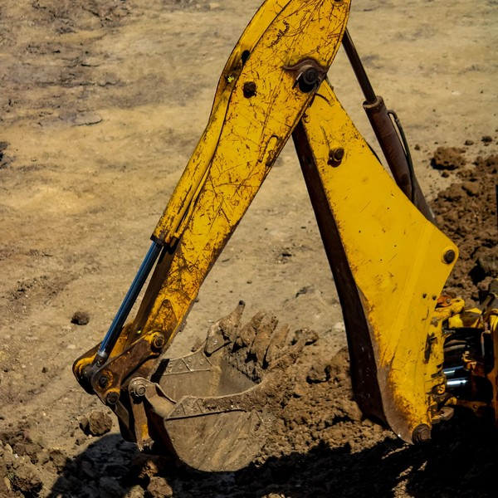 | $6,000 to $10,000 per job  The price covers the dig or the install itself: moving the machines to the lot, excavating to the depth on the plans, stockpiling or hauling the spoil, and backfilling and rough grading around the house. A septic system install runs $6,500 to $8,500 for the trench work and setting the tank and field lines. Stone, pipe, the tank and extra truck trips are billed on top at the rates in the bid. Rock, wet ground, a basement rather than a crawlspace and a long haul to dispose of spoil move the price up; a level, open lot moves it down.

Specifications
- Foundation, basement and crawlspace excavation to the depth on the plans.
- Backfill and rough grade around the house once the walls are poured.
- Conventional septic tanks and field lines installed under an Alabama Onsite Wastewater Board license.
- Septic permit and final approval coordinated with the county health department.
- Trenches five feet or deeper protected with an aluminum trench box.

6.5.2 Builder Lot Clearing & Grading
Site work for home builders, awarded by the lot or by a batch of lots: clearing and grubbing, a building pad cut to grade, utility trenches for water, sewer and power, and final grade once the house is built. Priced so a builder knows the site cost of each house before buying the next lot.
 | $7,500 to $12,000 per lot  The per-lot price covers clearing the lot and hauling or mulching the trees and stumps, cutting and compacting the building pad to the surveyor's grade, digging and backfilling the utility trenches, and returning for final grade before the driveway is poured. Builders awarding three or more lots at once are scheduled as a batch and invoiced on a monthly draw. Heavy timber, rock, steep slopes and lots needing fill raise the price, while open, level lots sit at the lower end. Stone, culverts and imported fill are billed on top, as is a foundation dig on the same lot.

Specifications
- Clearing and grubbing, with trees and stumps hauled off or mulched on site.
- Building pad cut, filled and compacted to the surveyor's grade.
- Water, sewer and power trenches dug and backfilled after inspection.
- Final grade and spread topsoil before the driveway is poured.
- Silt fence and a stone construction entrance on every disturbed lot.

6.5.3 Features
  One Contractor Per Lot
  Clearing, foundation, septic system, trenches and final grade are done by one firm and billed on one invoice.
  Licensed Septic Installs
  Septic systems are installed under the founder's Alabama Onsite Wastewater Board license and taken through the county health department's approval.
   | Two Crews, Booked Dates  With two crews working, a builder's next lot can usually be scheduled within the week.
  Protected Trenches
  Every trench five feet or deeper gets a trench box, and every dig starts with an 811 locate ticket.
  Own Dump Truck
  Stone arrives and spoil leaves on the crew's schedule rather than a hauler's.
   | Itemized Bids  Each bid separates the price of the work from stone, pipe and trucking, so a builder can compare the dig on its own.

6.5.4 Pricing
Hourly Machine Work  $135  per hour  - Excavator or track loader with an operator  - Four-hour minimum per visit  - Trailer move included within 20 miles of the yard  - Stone, pipe and haul-off billed at cost plus handling |  | Most Popular  Residential Job  From $6,000  per job  - Foundation, basement or crawlspace dig with backfill  - Or a conventional septic system, permitted and installed  - Written bid after a site walk  - Deposit at signing, balance on completion |  | Builder Lot Package  From $7,500  per lot  - Clearing, building pad and utility trenches  - Final grade before the driveway is poured  - Batches of three or more lots scheduled together  - Monthly draw invoicing on 30 day terms

CHAPTER 7

Marketing & Sales Strategies

7.1 Market Positioning
7.2 Marketing Objectives
7.3 Online Marketing
7.4 Public Relations and Branding
7.5 Partnership & Collaboration Strategy
7.6 Customer Loyalty & Retention
7.7 Sales Channels

7.1 Market Positioning
Ledgewick is positioned as the complete, licensed site contractor for the single lot and the small batch: big enough to clear, dig, install a septic system, trench and haul with its own crews and machines, and small enough to schedule one builder's next house within the week.

7.2 Marketing Objectives
- Join the bid lists of at least six active Madison and Limestone County builders in the first six months.
- Win a second lot from at least two thirds of the builders who award a first one.
- Collect a Google review from every homeowner job and reach 25 reviews by the end of the first year.
- Keep marketing spend at 2% of revenue, with most of it going on relationships rather than advertising.
Builder Relationships  $604  per month  Builders association membership, site visits and lunches with builders and their superintendents. |  | Search & Google Profile  $518  per month  Search ads on septic, clearing and driveway terms in spring and fall, plus profile photos.
Truck & Job Site Signs  $345  per month  Lettering on machines and trucks and a yard sign on every lot while the crew works. |  | Website & Job Photos  $259  per month  Hosting the website and adding finished job photos and septic permit guidance.

Total marketing budget: $20,708 a year, $1,726 a month.

7.3 Online Marketing
Owners building on their own land search before they call, so Ledgewick needs to be found when they do. The website shows finished jobs by type, explains how a septic system is permitted and installed in Madison County, and takes requests for a site visit. A Google Business Profile with job photos and reviews carries most of the local search traffic, supported by search ads on septic installation, land clearing and driveway terms during the spring and fall building seasons. Builders are reached less through search than through the work itself, so the online effort is aimed at owners.

7.4 Public Relations and Branding
The brand is the equipment and the job site. Every machine, truck and trailer carries the Ledgewick name and phone number, a yard sign goes up on every lot while the crew is working, and crews wear the company's shirts and hard hats. Membership in the Huntsville/Madison County Builders Association puts the founder in the same rooms as the builders he wants to work for, and a short talk on trench safety and 811 locates for the association's members is planned for the first year.

7.5 Partnership & Collaboration Strategy
Ledgewick's best referrals come from the people who see a site before the excavator does. Septic system designers and soil scientists, surveyors, plumbers, electricians and concrete finishers all meet builders and owners at the start of a project, and each can pass on a name they trust. In return Ledgewick refers its own customers to them and keeps to the dates their schedules depend on. Supply accounts with a quarry, a pipe and septic supplier and a trucking firm keep materials moving on the crew's schedule.

7.6 Customer Loyalty & Retention
A builder comes back when the last lot went to plan. That means a crew on site the day it was booked, a pad within tolerance when the surveyor checks it, trenches that pass inspection the first time, a clean site at the end and an invoice that matches the bid. Ledgewick keeps a short record for each builder of what was dug, how the soil behaved and what the next lot will need, so the second bid is faster and closer than the first. Builders who award lots by the batch are invoiced on monthly draws.

7.7 Sales Channels
Revenue reaches Ledgewick by four routes, listed below in order of what each is worth. Builder accounts carry most of the volume, owner jobs carry the widest margins, and the referral and hourly routes fill the calendar between larger jobs.
   | Builder Accounts  Repeat lot packages and foundation digs from home builders, the largest share of revenue, which depends on hitting booked dates lot after lot.
  Owner Jobs by Direct Bid
  Septic systems, foundations and driveways for owners building on their own land, the widest margins, won through search, reviews and site visits.
   | Trade and Designer Referrals  Trenching for plumbers and electricians and septic work passed on by designers and surveyors, steady fill between larger jobs.
  General Contractor Subcontracts
  Pads, storm pipe and erosion controls on small commercial sites, larger tickets that depend on holding the state contractor license.

CHAPTER 8

Operations Plan

8.1 Daily Operations
8.2 Working Hours
8.3 Staffing & Training
8.4 Inventory & Equipment Management
8.5 Location and Facilities
8.6 Milestones & Timeline
8.7 Trench Safety, Utility Locates & Permits

8.1 Daily Operations
The working day starts at the yard. The crews check fluids, tracks and attachments, load stone, pipe and the trench box, and leave for their sites, while the dump truck runs its first trip to the quarry or to a job that needs spoil hauled. The founder runs the first crew on the 20-ton excavator and walks new sites for bids in the afternoons; the second crew, an operator on the mini excavator and one on the track loader, works the septic, trench and grading jobs.
Each job runs from a written scope: the bid, the plot plan, the 811 ticket number and the grades. The office manager books jobs, confirms locates and permits before a machine is moved, orders materials and invoices each job on completion or by monthly draw. The founder reviews every job's costs against its bid weekly, so the next bid of the same kind is priced from what the last one really took.

8.2 Working Hours
Crews work 7 a.m. to 5:30 p.m. Monday to Friday, with Saturdays held for weather days and for jobs that must be finished before a pour or an inspection. Work starts early to use the cooler hours in Huntsville's summer and to clear a site before the concrete or framing crews arrive. The office answers calls from 7 a.m. to 4 p.m. on weekdays, and rain days are spent on equipment service at the yard.

8.3 Staffing & Training
The first-year team is the founder, two equipment operators, a CDL dump truck driver, a laborer and pipe layer, and a part-time office manager. Operators are hard to hire, so Ledgewick recruits early and pays at or above the Huntsville metro mean for equipment operators, $25.14 an hour in May 2025.
Every field employee completes OSHA ten-hour construction training before starting, and both crew leads are trained as competent persons for excavation work. The founder holds the septic installer license and the qualified inspector credential for stormwater, and the second operator is supported to gain the basic installer license after the twelve months of experience it requires.

8.4 Inventory & Equipment Management
Materials are bought for each job, not stocked: stone, pipe, septic tanks and field lines are ordered when a job is booked and held at the yard for about a week before installation. The fleet is the real asset to manage. Each machine carries an hour meter and a GPS unit, oil and filters are changed on the manufacturer's schedule, and tracks, bucket teeth and blade edges are checked weekly. Repairs and wear parts are booked to the job that caused them, and buckets, tracks and undercarriage are replaced from a capital budget of 3% of revenue.

8.5 Location and Facilities
Ledgewick will lease about an acre and a half of fenced, graveled yard in south Madison County or eastern Limestone County, near I-565 and the corridors where lots are being cleared. The yard holds the machines, the trailer and trucks, a stone bay, a double-walled diesel tank and an office trailer, with a small shop bay for servicing. Being central keeps most job sites within a short trailer move, which keeps fuel and drive time off every bid.

8.6 Milestones & Timeline
The milestones below run from forming the company to both crews working full calendars, and then to the first builder lot packages awarded by the batch.
Nov 2026  Setup |  |  | Company Formed  LLC registered and licenses filed  Ledgewick Excavation LLC is registered and the state contractor license application goes to the licensing board.
Dec 2026  Funding |  |  | Equipment Loan Closed  SBA 7(a) loan of $400,000  The loan closes alongside the founder's $150,000, and the excavators, loader, dump truck and trailer are bought and serviced.
Jan 2027  Setup |  |  | Yard Opens, Crews Hired  Yard leased and team in place  The yard is fenced and graveled, the fuel tank and office trailer set, and the operators, driver and laborer start.
Feb 2027  Launch |  |  | First Jobs  Both crews working  The first septic systems, foundation digs and builder lots are worked while Ledgewick bids for a place on builders' lists.
Sep 2027  Growth |  |  | Full Calendars  Both crews booked  Both crews reach a full calendar, with at least six builders awarding lots.
Feb 2028  Growth |  |  | Batch Lot Packages  Builders awarding by the batch  Repeat builders award lot packages by the batch on monthly draws, and the first small commercial pads are bid.

8.7 Trench Safety, Utility Locates & Permits
Every dig starts with a locate. Ledgewick calls Alabama 811 at least two full working days before digging, not counting the day of the call, and works only within the 20 working days a locate request stays valid. Marks are photographed before work begins, and digging near a marked line is done by hand or with careful potholing until the line is exposed. Failure to notify 811 was the largest single cause of the 196,977 utility damage reports in 2024.
Trenches follow OSHA's excavation standard. Any trench five feet or deeper gets a protective system, the aluminum trench box or sloping cut to the soil type, a ladder is placed within 25 feet of every worker in a trench four feet or deeper, spoil is kept back from the edge, and a competent person inspects each excavation daily and after rain.
Permits are confirmed before a machine moves: the septic permit from the county health department, ADEM construction stormwater coverage and a certified best management practices plan for sites of an acre or more, with qualified inspector checks and a daily observation log, and the state contractor license on any job of $50,000 or more.
On site, spoil and machines are kept back from the edge of every trench, the public is kept out with fencing or cones wherever a dig is open near a road or a house, and no one works in a trench alone. Before anyone enters a trench the competent person checks the walls, the soil and any water, and checks again after rain; if water is standing or a wall has cracked, work stops until the trench is drained, cut back or boxed.
If a crew strikes a line, the machine stops, the area is cleared, and the utility owner and Alabama 811 are called at once; a gas line strike also means calling 911 and keeping everyone well back until the gas company arrives. Every strike and near miss is written up the same day and reviewed with both crews the next morning, so the lesson reaches the crew that was not there.
Stormwater controls are part of the job, not an afterthought. Silt fence and a stone construction entrance go in before clearing begins, are checked in the daily observation log and after every rain, and are repaired the same day they fail, because a failed silt fence on a builder's lot is the builder's problem as much as Ledgewick's. Each job file keeps the 811 ticket, the permits, the inspection records and photographs of the marks, the open trench and the finished grade: the record an insurer, an inspector or a builder will ask for.

CHAPTER 9

Management Team

9.1 Key Members
9.2 Organization Chart
9.3 Advisory Board Members

9.1 Key Members
The founder is accountable for winning and pricing work and for running the first crew: he is measured on the share of bids won, on each job's actual cost against its bid, and on keeping the business above break-even. The crew lead answers for the second crew's schedule and safety, measured on jobs finished on the booked date, pads and trenches passing inspection the first time and days without a recordable injury. The office manager answers for cash, measured on invoices sent the day a job closes, days to collect and permits and locates confirmed before a crew is dispatched.
 | Cole Pritchard  Founder, Estimator and Lead Operator · cole@ledgewickexcavation.example  Fourteen years running excavators and dozers on Madison County subdivisions, with an Alabama septic installer license and a stormwater inspector credential.

 | Marcus Bell  Crew Lead and Equipment Operator · marcus@ledgewickexcavation.example  Ten years operating mini excavators and track loaders on residential and utility work, trained as a competent person for excavations.

 | Dana Whitfield  Office and Billing Manager · dana@ledgewickexcavation.example  Eight years running scheduling, permits and invoicing for a residential plumbing contractor.

9.2 Organization Chart
The founder leads the company and runs the first crew himself. The crew lead, the dump truck driver and the office manager report to him directly; the second operator works under the crew lead, and the laborer and pipe layer works on whichever crew the day's jobs need.
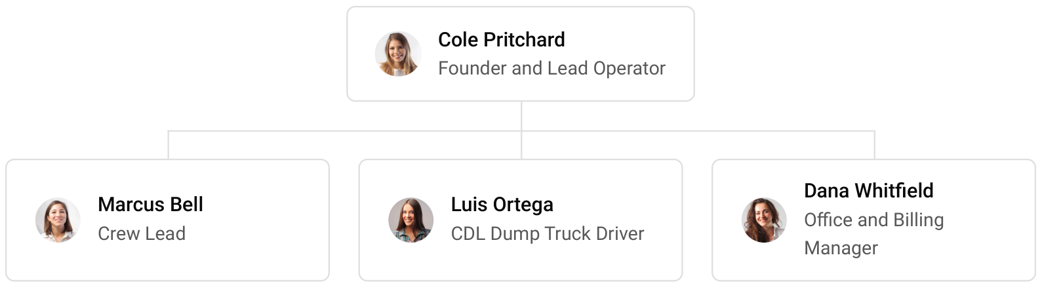

9.3 Advisory Board Members
Ledgewick will draw on three outside advisors rather than a formal board. An accountant who works with construction firms will review job costing, equipment depreciation and tax each quarter. An insurance agent who writes contractors' policies will review cover and safety records each year, and a construction attorney will review the standard bid and contract terms and advise on lien rights before the first builder account opens.
Inside the business, the founder meets the crew lead and the office manager each Monday to set the week's jobs, confirm locates and permits, and review the previous week's job costs against their bids. Safety is part of the same meeting: any near miss, damaged mark or machine fault is discussed and the fix assigned before the crews leave the yard. Once a quarter the founder reviews revenue, job margins and cash against the plan with the accountant.

9.3.1 Hiring Plan
1  Filled |  | 5  Hiring This Year |  | 5  Open

Group By Department | Position Filled | Time of Hire | Time of Start | Filled
Field Crews | 1 of 4 | 45 days | 14 days | 25%
Hauling | 0 of 1 | 30 days | 14 days | 0%
Office | 0 of 1 | 30 days | 14 days | 0%

CHAPTER 10

Financial Plan

10.1 Key Assumptions
10.2 Capital Requirements and Use of Funds
10.3 Income Statement (3 Year projections)
10.4 Balance Sheet (3 Year projections)
10.5 Cash Flow Statement (3 Year projections)
10.6 Break Even Analysis

10.1 Key Assumptions
Revenue is crews times jobs per crew per month times the average job value, times twelve, plus stone, pipe, fill and trucking billed on the same job. The plan assumes two crews finishing five to six jobs a month each at an average bid of $8,500, with materials and hauling adding 13% of the bid. The crews open at 45% of that volume and reach a full calendar over eight months, and revenue then grows 15% a year.
Gross margin is 57.0%, with cost of sales covering diesel, stone and pipe, subcontracted trucking, dump fees, wear parts and repairs. Payroll for the founder, two operators, a driver, a laborer and a part-time office manager is 26% of revenue, marketing 2% and other operating costs 3%. The yard costs $3,200 a month, technology $650 and insurance and administration $5,400. Builders, about 70% of revenue, pay in about five weeks, so receivables are carried at 35 days.
On those assumptions revenue is $1,035,419 in the first year, $1,190,732 in the second and $1,369,342 in the third, and net income rises from $27,608 to $55,393 and then $86,913. Break-even revenue is $776,933, the equivalent of 91 jobs. Third-year net income ranges from $39,808 in the conservative case to $150,536 in the upside case.
The scenarios move the two drivers most likely to change: how many jobs each crew finishes a month and the average bid. Diesel is the cost most likely to move against the plan, so every bid prices stone, pipe and trucking separately and fuel use is reviewed each month against what the jobs actually burned. Cash stays positive through all three years with no further borrowing and no top-up from the owner, because the loan and the owner contribution together exceed the startup budget by the cushion that carries builder invoices while they are collected.

10.2 Capital Requirements and Use of Funds
The business needs $497,200 to open. Most of it is the fleet: the used 20-ton excavator, the mini excavator, the compact track loader, the tandem dump truck, the equipment trailer and two crew pickups, with the trench box, lasers and attachments that complete it. The rest covers the yard setup and fuel tank, licenses, training and insurance deposits, launch marketing and the first months of yard rent.
Funding is a $150,000 owner contribution and a $400,000 SBA 7(a) loan at 9.75% over ten years, which leaves an opening cash cushion of about $52,800 to carry builder invoices through the ramp. No profits are distributed while the loan is repaid.

10.2.1 Use of Funds
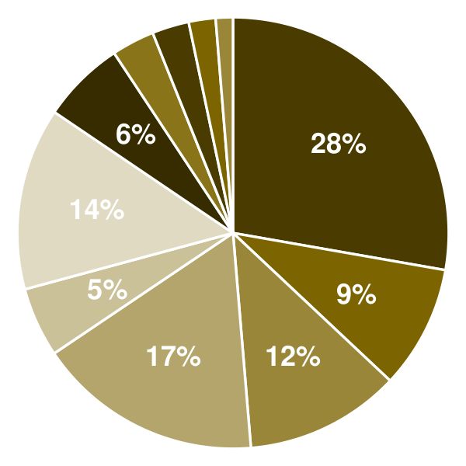 | ● 20-Ton Excavator (Used) 27.8%  ● Mini Excavator (Used) 9.3%  ● Compact Track Loader (Used) 11.7%  ● Dump Truck (Used) 16.9%  ● Equipment Trailer 5.2%  ● Crew Pickup Trucks (Used) 13.7%  ● Trench Box, Lasers & Attachments 6.2%  ● Yard Setup & Fuel Tank 3.2%  ● Licenses, Training & Insurance Deposits 2.8%  ● Launch Marketing & Branding 2.0%  ● Deposit & Pre-Opening Rent 1.3%

Use Of Funds | Amount
20-Ton Excavator (Used) | $138,000.00
Mini Excavator (Used) | $46,000.00
Compact Track Loader (Used) | $58,000.00
Dump Truck (Used) | $84,000.00
Equipment Trailer | $26,000.00
Crew Pickup Trucks (Used) | $68,000.00
Trench Box, Lasers & Attachments | $31,000.00
Yard Setup & Fuel Tank | $16,000.00
Licenses, Training & Insurance Deposits | $13,800.00
Launch Marketing & Branding | $10,000.00
Deposit & Pre-Opening Rent | $6,400.00

10.3 Income Statement (3 Year projections)
 | Year 1 | Year 2 | Year 3 | Total
Revenue | $1,035,419.00 | $1,190,731.85 | $1,369,341.63 | $3,595,492.48
Cost of Sales | $445,230.17 | $512,014.70 | $588,816.90 | $1,546,061.77
General Costs | $0.00 | $0.00 | $0.00 | $0.00
Revenue Specific Costs | $445,230.17 | $512,014.70 | $588,816.90 | $1,546,061.77
Personnel Costs (Direct Labor) | $0.00 | $0.00 | $0.00 | $0.00
Gross Margin | $590,188.83 | $678,717.15 | $780,524.73 | $2,049,430.71
Gross Margin (%) | 57.00% | 57.00% | 57.00% | 57.00%
Operating Expense | $442,851.79 | $492,629.56 | $549,873.99 | $1,485,355.34
Payroll Expense (Indirect Labor) | $269,208.94 | $309,590.28 | $356,028.82 | $934,828.04
General Expense | $162,770.95 | $170,536.60 | $179,467.08 | $512,774.63
Bad Debt | $10,871.90 | $12,502.68 | $14,378.09 | $37,752.67
Amortization of Current Assets | $0.00 | $0.00 | $0.00 | $0.00
EBITDA | $147,337.04 | $186,087.59 | $230,650.74 | $564,075.37
Additional Expense | $119,728.77 | $130,694.24 | $143,737.43 | $394,160.44
Long Term Depreciation | $71,028.57 | $76,131.71 | $82,000.32 | $229,160.60
Gain or loss from Sale of Assets | $0.00 | $0.00 | $0.00 | $0.00
EBIT | $76,308.47 | $109,955.88 | $148,650.42 | $334,914.77
Interest Expense | $39,000.00 | $35,100.00 | $31,200.00 | $105,300.00
EBT | $37,308.47 | $74,855.88 | $117,450.42 | $229,614.77
Income Tax Expense / Benefit | $9,700.20 | $19,462.53 | $30,537.11 | $59,699.84
Total Expense | $1,007,810.73 | $1,135,338.50 | $1,282,428.32 | $3,425,577.55
Net Income | $27,608.27 | $55,393.35 | $86,913.31 | $169,914.93
Net Income (%) | 2.67% | 4.65% | 6.35% | 4.73%
Retained Earning Opening | $0.00 | $27,608.27 | $83,001.62
Owner's Distribution | $0.00 | $0.00 | $0.00 | $0.00
Retained Earning Closing | $27,608.27 | $83,001.62 | $169,914.93 | $169,914.93

10.4 Balance Sheet (3 Year projections)
 | Year 1 | Year 2 | Year 3 | Total
Assets | $576,627.58 | $599,950.65 | $655,945.12 | $655,945.12
Current Assets | $150,456.15 | $214,188.97 | $311,103.51 | $311,103.51
Cash | $72,416.76 | $124,443.67 | $207,896.42 | $207,896.42
Accounts Receivable | $69,500.73 | $79,925.84 | $91,914.71 | $91,914.71
Inventory | $8,538.66 | $9,819.46 | $11,292.38 | $11,292.38
Other Current Assets | $0.00 | $0.00 | $0.00 | $0.00
Long Term Assets | $426,171.43 | $385,761.68 | $344,841.61 | $344,841.61
Gross Long Term Assets | $497,200.00 | $532,921.96 | $574,002.21 | $574,002.21
Accumulated Depreciation | $71,028.57 | $147,160.28 | $229,160.60 | $229,160.60
Liabilities & Equity | $576,627.58 | $599,950.65 | $655,945.12 | $655,945.12
Liabilities | $399,019.31 | $366,949.03 | $336,030.19 | $336,030.19
Current Liabilities | $79,019.31 | $86,949.03 | $96,030.19 | $96,030.19
Accounts Payable | $36,594.26 | $42,083.40 | $48,395.91 | $48,395.91
Income Tax Payable | $2,425.05 | $4,865.63 | $7,634.28 | $7,634.28
Sales Tax Payable | $0.00 | $0.00 | $0.00 | $0.00
Short Term Debt | $40,000.00 | $40,000.00 | $40,000.00 | $40,000.00
Long Term Liabilities | $320,000.00 | $280,000.00 | $240,000.00 | $240,000.00
Long Term Debt | $320,000.00 | $280,000.00 | $240,000.00 | $240,000.00
Equity | $177,608.27 | $233,001.62 | $319,914.93 | $319,914.93
Paid-in Capital | $0.00 | $0.00 | $0.00 | $0.00
Common Stock | $0.00 | $0.00 | $0.00 | $0.00
Preferred Stock | $0.00 | $0.00 | $0.00 | $0.00
Owner's Contribution | $150,000.00 | $150,000.00 | $150,000.00 | $150,000.00
Retained Earnings | $27,608.27 | $83,001.62 | $169,914.93 | $169,914.93
Check | $0.00 | $0.00 | $0.00 | $0.00

10.5 Cash Flow Statement (3 Year projections)
 | Year 1 | Year 2 | Year 3 | Total
Cash Received | $955,046.37 | $1,167,804.06 | $1,342,974.67 | $3,465,825.10
Cash Paid | $895,429.61 | $1,040,055.19 | $1,178,441.67 | $3,113,926.47
COS & General Expenses | $579,945.52 | $678,342.96 | $763,444.39 | $2,021,732.87
Salary & Wages | $269,208.94 | $309,590.28 | $356,028.82 | $934,828.04
Interest | $39,000.00 | $35,100.00 | $31,200.00 | $105,300.00
Sales Tax | $0.00 | $0.00 | $0.00 | $0.00
Income Tax | $7,275.15 | $17,021.95 | $27,768.46 | $52,065.56
Net Cash From Operations | $59,616.76 | $127,748.87 | $164,533.00 | $351,898.63
Assets Sell | $0.00 | $0.00 | $0.00 | $0.00
Assets Purchase | $497,200.00 | $35,721.96 | $41,080.25 | $574,002.21
Net Cash From Investments | ($497,200.00) | ($35,721.96) | ($41,080.25) | ($574,002.21)
Amount Received | $550,000.00 | $0.00 | $0.00 | $550,000.00
Loan Received | $400,000.00 | $0.00 | $0.00 | $400,000.00
Common Stock | $0.00 | $0.00 | $0.00 | $0.00
Preferred Stock | $0.00 | $0.00 | $0.00 | $0.00
Owner's Contribution | $150,000.00 | $0.00 | $0.00 | $150,000.00
Amount Paid | $40,000.00 | $40,000.00 | $40,000.00 | $120,000.00
Loan Capital | $40,000.00 | $40,000.00 | $40,000.00 | $120,000.00
Dividends & Distributions | $0.00 | $0.00 | $0.00 | $0.00
Net Cash From Financing | $510,000.00 | ($40,000.00) | ($40,000.00) | $430,000.00
Summary
Starting Cash | $0.00 | $72,416.76 | $124,443.67
Cash In | $1,505,046.37 | $1,167,804.06 | $1,342,974.67 | $4,015,825.10
Cash Out | $1,432,629.61 | $1,115,777.15 | $1,259,521.92 | $3,807,928.68
Change in Cash | $72,416.76 | $52,026.91 | $83,452.75 | $207,896.42
Ending Cash | $72,416.76 | $124,443.67 | $207,896.42 | $207,896.42

10.6 Break Even Analysis
 | Year 1 | Year 2 | Year 3 | Total
Starting Revenue | $0.00 | $1,035,419.00 | $2,226,150.85 | $2,226,150.85
Net Revenue | $1,035,419.00 | $1,190,731.85 | $1,369,341.63 | $1,369,341.63
Closing Revenue | $1,035,419.00 | $2,226,150.85 | $3,595,492.48 | $3,595,492.48
Starting Expense | $0.00 | $1,007,810.73 | $2,143,149.23 | $2,143,149.23
Net Expense | $1,007,810.73 | $1,135,338.50 | $1,282,428.32 | $1,282,428.32
Closing Expense | $1,007,810.73 | $2,143,149.23 | $3,425,577.55 | $3,425,577.55
Is Break Even? | Yes | Yes | Yes
Break Even Month | Nov '26 | - | -
Days Required | 22 Days | - | -
Break Even Revenue | $929,764.00 | - | -

CHAPTER 11

References

- SRC001: Economic Census: Construction, Summary Statistics for the U.S.: 2022 (EC2223BASIC), U.S. Census Bureau, 2024-11-01. https://www.census.gov/data/tables/2022/econ/economic-census/naics-sector-23.html (accessed 2026-10-15)
- SRC002: Location of Construction Establishments by Employment Size for the U.S. and States: 2022 (EC2223LOCCONS), U.S. Census Bureau, 2024-11-01. https://www2.census.gov/programs-surveys/economic-census/data/2022/sector23/EC2223LOCCONS.zip (accessed 2026-10-15)
- SRC003: Land Excavation Cost: A Budget Breakdown, Bob Vila, 2023-07-25. https://www.bobvila.com/articles/excavation-cost/ (accessed 2026-10-15)
- SRC004: Septic System Installation Cost, Fixr, 2025-01-31. https://www.fixr.com/costs/install-septic-tank-system (accessed 2026-10-15)
- SRC005: Cost of Clearing Land to Build, Fixr, 2025-01-31. https://fixr.com/costs/land-clearing-and-building-site-preparation (accessed 2026-10-15)
- SRC006: Monthly Construction Spending, August 2026, U.S. Census Bureau, 2026-10-01. https://www.census.gov/construction/c30/current/index.html (accessed 2026-10-15)
- SRC007: Private Residential Construction Spending Posts Broad-Based Gains in August, National Association of Home Builders, Eye on Housing, 2026-10-01. https://eyeonhousing.org/2026/10/private-residential-construction-spending-posts-broad-based-gains-in-august/ (accessed 2026-10-15)
- SRC008: Monthly New Residential Construction, August 2026, U.S. Census Bureau and U.S. Department of Housing and Urban Development, 2026-09-17. https://www.census.gov/construction/nrc/pdf/newresconst_202608.pdf (accessed 2026-10-15)
- SRC009: Prime Rate Forecasts and News 2026, FedPrimeRate.com, 2026-09-01. https://primerate.fedprimerate.com/2026/ (accessed 2026-10-15)
- SRC010: Excavator Costs Explained: Your Ultimate Pricing Guide, Purple Wave, 2024-06-18. https://purplewave.com/blog/excavator-cost-guide (accessed 2026-10-15)
- SRC011: 7(a) loans: terms, conditions, and eligibility, U.S. Small Business Administration, 2026-01-01. https://www.sba.gov/partners/lenders/7a-loan-program/terms-conditions-eligibility (accessed 2026-10-15)
- SRC012: Construction Equipment Operators, U.S. Bureau of Labor Statistics, Occupational Outlook Handbook, 2026-01-01. https://www.bls.gov/ooh/construction-and-extraction/construction-equipment-operators.htm (accessed 2026-10-15)
- SRC013: 2025 Workforce Survey Analysis, Associated General Contractors of America and NCCER, 2025-08-01. https://www.agc.org/sites/default/files/users/user21902/2025%20Workforce%20Survey%20Analysis_V2.pdf (accessed 2026-10-15)
- SRC014: Trenching and Excavation, U.S. Occupational Safety and Health Administration, 2026-01-01. https://www.osha.gov/trenching-excavation (accessed 2026-10-15)
- SRC015: Trenching and Excavation, NIOSH, Centers for Disease Control and Prevention, 2024-01-01. https://www.cdc.gov/niosh/topics/trenching (accessed 2026-10-15)
- SRC016: Trench fall fatalities down due to OSHA enforcement efforts, J. J. Keller Compliance Network, 2024-11-01. https://jjkellercompliancenetwork.com/news/trench-fall-fatalities-down-due-to-osha-enforcement-efforts (accessed 2026-10-15)
- SRC017: CGA Releases 2024 DIRT Report Findings, Highlights Need for Industry Improvements, Compact Equipment, 2025-09-03. https://compactequip.com/business/cga-releases-2024-dirt-report-findings-highlights-need-for-industry-improvements/ (accessed 2026-10-15)
- SRC018: Getting Coverage under EPA's Construction General Permit, U.S. Environmental Protection Agency, 2022-01-01. https://epa.gov/npdes/getting-coverage-under-epas-construction-general-permit (accessed 2026-10-15)
- SRC019: EPA Proposes 2022 Construction General Permit, National Association of Home Builders, 2021-05-01. https://www.nahb.org/blog/2021/05/epa-proposes-2022-construction-general-permit (accessed 2026-10-15)
- SRC020: Gasoline and Diesel Fuel Update, U.S. Energy Information Administration, 2026-10-13. https://www.eia.gov/petroleum/gasdiesel/ (accessed 2026-10-15)
- SRC021: Mineral Commodity Summaries 2026: Stone (Crushed), U.S. Geological Survey, 2026-01-01. https://pubs.usgs.gov/periodicals/mcs2026/mcs2026-stone-crushed.pdf (accessed 2026-10-15)
- SRC022: Quarterly Census of Employment and Wages, 2025 annual averages, NAICS 23891 Site preparation contractors, private ownership, U.S. Bureau of Labor Statistics, 2026-01-01. https://data.bls.gov/cew/apps/table_maker/v4/table_maker.htm#type=1&year=2025&qtr=A&own=5&ind=23891&supp=1 (accessed 2026-10-15)
- SRC023: Economic Census: Construction, Summary Statistics for the U.S. and States: 2022 (EC2223BASIC data file), U.S. Census Bureau, 2024-11-01. https://www2.census.gov/programs-surveys/economic-census/data/2022/sector23/EC2223BASIC.zip (accessed 2026-10-15)
- SRC024: 2022 SUSB Annual Data Tables by Establishment Industry: U.S. and states, NAICS detailed employment sizes, U.S. Census Bureau, Statistics of U.S. Businesses, 2025-01-01. https://www2.census.gov/programs-surveys/susb/tables/2022/us_state_naics_detailedsizes_2022.xlsx (accessed 2026-10-15)
- SRC025: Huntsville, AL Metro Area profile, Census Reporter, from U.S. Census Bureau ACS 2024 1-year estimates, 2025-01-01. https://censusreporter.org/profiles/31000US26620-huntsville-al-metro-area/ (accessed 2026-10-15)
- SRC026: Resident Population in Huntsville, AL (MSA) (HUNPOP), Federal Reserve Bank of St. Louis, FRED, from U.S. Census Bureau, 2026-01-01. https://fred.stlouisfed.org/data/HUNPOP (accessed 2026-10-15)
- SRC027: Housing growth remains strong, 2025 Huntsville Development Review reveals, City of Huntsville, 2026-01-27. https://www.huntsvilleal.gov/housing-growth-remains-strong-2025-huntsville-development-review-reveals/ (accessed 2026-10-15)
- SRC028: Report: Huntsville's commercial real estate market stable and poised for more growth, Huntsville Business Journal, 2026-06-15. https://huntsvillebusinessjournal.com/news/2026/06/15/report-huntsvilles-commercial-real-estate-market-stable-and-poised-for-more-growth/ (accessed 2026-10-15)
- SRC029: Occupational Employment and Wage Statistics, May 2025, Huntsville, AL metropolitan area, U.S. Bureau of Labor Statistics, 2026-01-01. https://data.bls.gov/oes/#/area/0026620/2025 (accessed 2026-10-15)
- SRC030: State Minimum Wage Laws, U.S. Department of Labor, Wage and Hour Division, 2026-01-01. https://www.dol.gov/agencies/whd/minimum-wage/state (accessed 2026-10-15)
- SRC031: Subcontractor Application Instructions, Alabama Licensing Board for General Contractors, 2025-06-01. https://genconbd.alabama.gov/wp-content/uploads/2025/06/2022-Sub-App-Instructions.pdf (accessed 2026-10-15)
- SRC032: We are a subcontractor working under a general contractor. Is a license required from the State of Alabama Licensing Board for General Contractors?, Alabama Department of Revenue, 2024-01-01. https://www.revenue.alabama.gov/faqs/we-are-a-subcontractor-working-under-a-general-contractor-is-a-license-required-from-the-state-of-alabama-licensing-board-for-general-contractors/ (accessed 2026-10-15)
- SRC033: Ala. Admin. Code r. 628-X-3-.01, Requirement For Licensing, Legal Information Institute, Cornell Law School, 2024-01-01. https://www.law.cornell.edu/regulations/alabama/Ala-Admin-Code-r-628-X-3-.01 (accessed 2026-10-15)
- SRC034: Eligibility Application, Basic Installer, Alabama Onsite Wastewater Board, 2026-01-01. https://aowb.alabama.gov/PDF/2026/EligibilityApplBasicInstaller.pdf (accessed 2026-10-15)
- SRC035: Construction General Permit, Alabama Department of Environmental Management, 2025-01-01. https://web-prd.adem.alabama.gov/water/construction-general-permit (accessed 2026-10-15)
- SRC036: Alabama 811 Changes, Riviera Utilities, 2019-01-01. https://www.rivierautilities.com/newsroom/alabama-811-changes- (accessed 2026-10-15)




