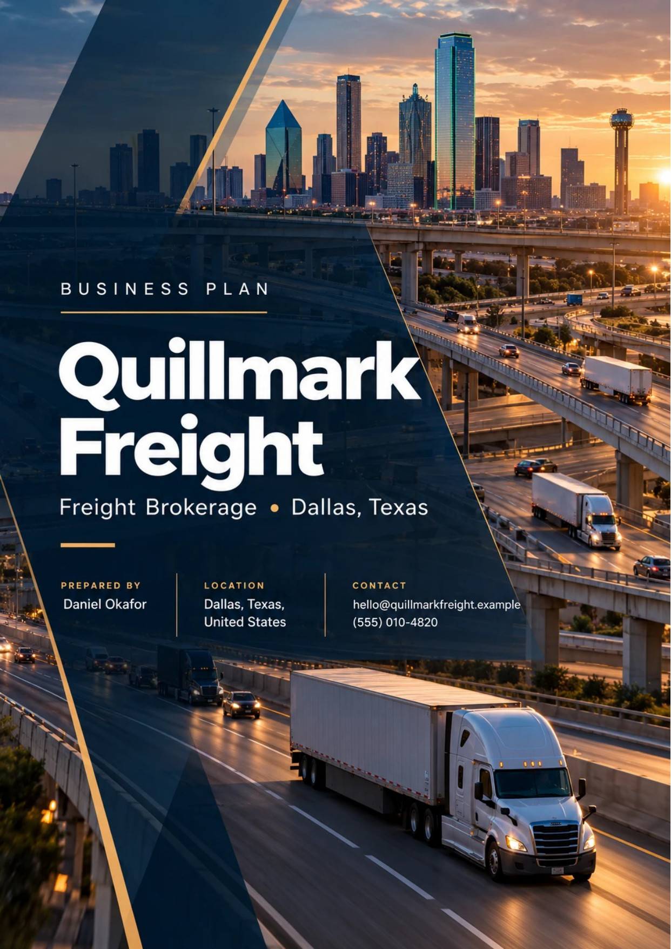
Table of Contents
1. Executive Summary 6
1.1 Business Overview 7
1.2 Mission Statement 7
1.3 Market Opportunity 7
1.4 Unique Selling Points 7
1.5 Financial Highlights 8
1.6 Funding Requirement 8
1.6.1 Income Statement (3 Year projections) 8
2. Company Overview 9
2.1 Legal Structure 10
2.2 Vision Statement 10
2.3 Background & History 10
2.4 Future Goals 10
2.4.1 Business Owners 11
2.4.2 SMART Goal 11
3. Services Offered 12
3.1 Problem Analysis 13
3.1.1 Solution 13
3.1.2 Solution Features 13
3.2 Our Offering 14
3.3 Additional Services 14
3.4 What Sets Us Apart 14
3.5 Freight Modes & Equipment 14
3.5.1 Truckload Brokerage: Dry Van & Reefer 15
3.5.2 Flatbed, Partial & Expedited Loads 15
3.5.3 Features 16
3.5.4 Pricing 17
4. Market Analysis 18
4.1 Overview 19
4.2 Market Segmentation 19
4.3 Market Trends 19
4.4 Market Size 19
4.4.1 PESTEL Analysis 20
5. Customer Analysis 22
5.1 Target Market 23
5.2 Customer Segments 23
5.3 Customer Persona 24
5.4 Customer Purchase Journey 24
6. Competitive Analysis 25
6.1 Competitors 26
6.2 Comparison 26
6.3 Competitive Edge 26
6.4 SWOT Analysis 27
7. Marketing & Sales Strategies 28
7.1 Market Positioning 29
7.2 Marketing Objectives 29
7.3 Online Marketing 29
7.4 Public Relations and Branding 30
7.5 Partnership & Collaboration Strategy 30
7.6 Customer Loyalty & Retention 30
7.7 Sales Channels 30
8. Operations Plan 31
8.1 Daily Operations 32
8.2 Staffing & Training 32
8.3 Location and Facilities 32
8.4 Milestones & Timeline 32
8.5 Carrier Vetting & Compliance 33
9. Management Team 34
9.1 Key Members 35
9.2 Organization Chart 35
9.3 Advisory Board Members 36
9.3.1 Hiring Plan 36
10. Financial Plan 37
10.1 Key Assumptions 38
10.2 Capital Requirements and Use of Funds 38
10.2.1 Use of Funds 38
10.3 Income Statement (3 Year projections) 40
10.4 Balance Sheet (3 Year projections) 41
10.5 Cash Flow Statement (3 Year projections) 42
10.6 Break Even Analysis 43
11. References 44


CHAPTER 1

Executive Summary

1.1 Business Overview
1.2 Mission Statement
1.3 Market Opportunity
1.4 Unique Selling Points
1.5 Financial Highlights
1.6 Funding Requirement

1.1 Business Overview
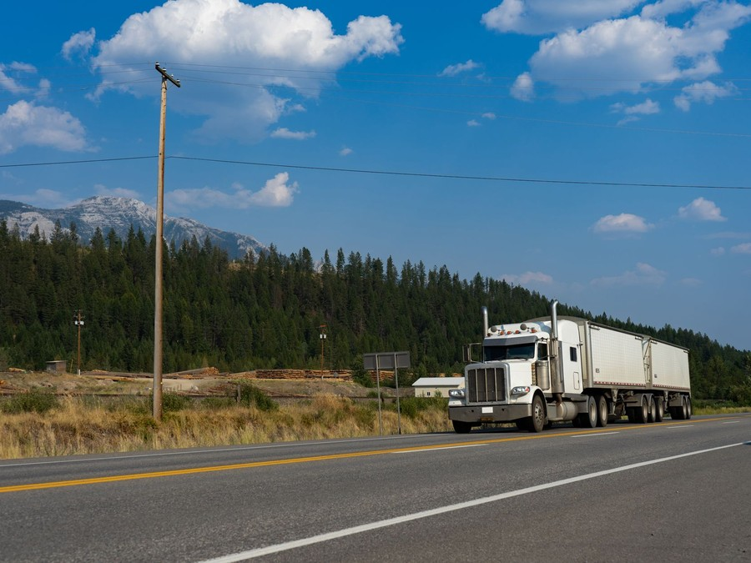
Quillmark Freight is a non-asset truckload freight brokerage planned for Dallas, Texas, licensed by FMCSA as a property broker. It owns no trucks. It books shippers' loads onto vetted independent carriers anywhere in the continental United States, quotes the shipper a rate per load, pays the carrier from it, and tracks each load to proof of delivery.
Its customers are small and mid-sized shippers, such as manufacturers, distributors, food and beverage producers and building products suppliers, that tender truckloads every week but are too small to hold a large broker's attention. Each gets one named broker for dry van and refrigerated loads, and for the flatbed, partial and expedited freight it ships alongside them.

1.2 Mission Statement
To be the broker a shipping manager calls first because the truck shows up, the carrier is who it says it is, and the same person answers the phone every time.

1.3 Market Opportunity
Quillmark works from an office in Dallas, but its market is national: broker authority is federal, and a load booked from Dallas can run between any two points in the country. Dallas-Fort Worth is a working freight hub, home to the BNSF Alliance intermodal facility in north Fort Worth and to 608 freight arrangement establishments, which gives the desk a deep pool of experienced brokers and carrier staff to hire from.
US domestic transportation management, of which freight brokerage is the largest part, generated $128.3 billion of gross revenue in 2025. Truckload accounts for about 72% of broker activity, which puts the truckload brokerage segment Quillmark serves at about $92.4 billion. A single freight arrangement establishment averages about $5.18 million a year, and this plan reaches $5,265,796 by its third year: the scale of one desk, not a share of the nation.
The timing favours a broker that can find trucks. Dry van spot rates were 33.5% higher in October 2026 than a year earlier as driver supply tightened, and contract carriers are turning down more of the loads they were awarded at last year's prices. Every one of those loads needs another truck, usually the same day.

1.4 Unique Selling Points
- One named broker per shipper, from the first quote to the last invoice.
- Carrier authority, insurance and identity confirmed on the day of every load, in a year when cargo theft losses reached an estimated $725 million.
- Founders who work the desk: one runs shipper accounts, the other runs carrier capacity and compliance.
- Proof of delivery and the invoice within a day of delivery, and quick pay that keeps good carriers coming back.

1.5 Financial Highlights
Revenue is projected at $3,781,812 in the first year, $4,462,539 in the second and $5,265,796 in the third. Gross margin is held at 15.0%, the spread between what shippers pay and what carriers are paid. Net income is $28,605 in the first year, rising to $53,844 and then $83,335, or 1.6% of revenue, the thin net margin brokerage runs on.
Break-even revenue is $3,312,820, about 1,541 loads, which the first year clears. The conservative scenario still returns $45,954 of net income in the third year, and the upside case $133,823.

1.6 Funding Requirement
Quillmark needs $61,000 to open, and considerably more to carry the freight it books, because carriers are paid in about 20 days and shippers pay in about 38. The two founders are contributing $150,000 of equity, and a $200,000 SBA 7(a) working capital loan at 10.5% over ten years funds the rest of that gap. No outside equity is sought, and profits stay in the business to fund receivables as volume grows.
Taken together, the plan rests on two founders who already know the shippers and the carriers, aimed at the freight that contract carriers are turning down and mid-sized shippers cannot cover alone. The funding buys the authority, systems and cash cushion that let a three-broker desk say yes to those loads from its first month.

1.6.1 Income Statement (3 Year projections)
 | Year 1 | Year 2 | Year 3 | Total
Revenue | $3,781,812.38 | $4,462,538.61 | $5,265,795.56 | $13,510,146.55
Cost of Sales | $3,214,540.52 | $3,793,157.82 | $4,475,926.23 | $11,483,624.57
Gross Margin | $567,271.86 | $669,380.79 | $789,869.33 | $2,026,521.98
Operating Expense | $496,923.04 | $565,676.39 | $646,805.35 | $1,709,404.78
Total Expense | $3,753,207.79 | $4,408,694.91 | $5,182,460.79 | $13,344,363.49
Net Income | $28,604.59 | $53,843.70 | $83,334.77 | $165,783.06

CHAPTER 2

Company Overview

2.1 Legal Structure
2.2 Vision Statement
2.3 Background & History
2.4 Future Goals

2.1 Legal Structure
Quillmark Freight will be organized as a Texas limited liability company owned by its two founders, Daniel Okafor and Rebecca Lindqvist, and taxed as a corporation. The company, not either founder, holds the FMCSA property broker authority, the BOC-3 process agent filing and the $75,000 BMC-84 surety bond, so the licence and the liability for every load sit with the business.
Relationships on both sides of a load are written down. Every carrier signs a broker-carrier agreement before its first load, setting payment terms and responsibility for cargo claims, and every shipper signs a transportation agreement setting credit terms. The company carries contingent cargo, general liability, errors and omissions and workers' compensation cover from its first day.

2.2 Vision Statement
To be the freight desk that mid-sized shippers trust with every load they ship, known to shippers for answering and to carriers for paying on time.

2.3 Background & History
Quillmark Freight is a new business. Daniel Okafor spent eleven years as an account executive at a large Dallas brokerage, where mid-sized shippers were passed from rep to rep while the desk chased bigger accounts. Rebecca Lindqvist ran carrier sales and compliance at a regional brokerage, building a network of small fleets and screening out the impersonators and double brokers that have become the trade's largest risk.
The two concluded that a small desk run by the people who own it could keep the shippers that large brokers treat as a sideline, provided it covered loads reliably and kept fraud out. They plan to file for broker authority in December 2026 and book the first loads in January 2027, on lanes agreed with shippers while the application is processed.

2.4 Future Goals
In the first 0 to 18 months, the aim is to get the authority active, open the Dallas desk with three brokers, reach full volume of 55 loads a broker a month by June 2027, and turn trial loads into weekly contract lanes, with a clean cargo claims record and every carrier checked on every load.
Over 1 to 3 years, the period the financial projection covers, Quillmark plans to grow revenue to $5,265,796 by the third year, add a broker in each of the second and third years, and earn a place in the routing guides of the shippers it serves, so that more of its volume comes from contract lanes than from spot loads.
From 3 to 5 years, the founders intend to open a second desk for refrigerated food and beverage freight, give shippers a portal for quotes and tracking, and arrange a revolving line of credit sized to receivables so that growth no longer depends on the term loan.

2.4.1 Business Owners
Daniel Okafor | Rebecca Lindqvist

Total ownership: 100%
55% | Daniel Okafor  5,500 Shares
45% | Rebecca Lindqvist  4,500 Shares

2.4.2 SMART Goal
  Specific  - Two founders open a three-broker truckload desk in Dallas.  - Dry van and reefer loads for mid-sized shippers nationwide.  - A book of shippers tendering freight every week. |   Measurable  - First-year revenue of $3,781,812.  - At least 1,541 loads, the break-even count.  - Gross margin held at 15.0% across the book. |   Achievable  - Daniel Okafor has run shipper accounts on a Dallas desk.  - Rebecca Lindqvist has built and vetted carrier networks.  - Founder equity and an SBA loan fund the receivables float.
  Relevant  - Rejected tenders are sending contract freight to brokers.  - Mid-sized shippers want one accountable desk.  - Thin margins make steady volume the priority. |   Time-Based  - Broker authority filed in December 2026.  - First loads in January 2027.  - Full volume by June 2027.

CHAPTER 3

Services Offered

3.1 Problem Analysis
3.2 Our Offering
3.3 Additional Services
3.4 What Sets Us Apart
3.5 Freight Modes & Equipment

3.1 Problem Analysis

The shippers Quillmark serves are not short of carriers on paper. Their problem is the load that falls out of the routing guide on a Thursday afternoon, the broker who has moved on to a bigger account, and the unfamiliar truck that answers a load board post. Each costs a shipping manager hours, and occasionally a customer.

WHOM?
Small and mid-sized shippers that move a few to a few dozen truckloads a week: manufacturers, distributors, food and beverage producers and building products suppliers. Their freight runs through a routing guide set at an annual bid, and one shipping manager answers for every load.

CAUSES  Spot rates climbed through 2026 while contract rates set in a softer market lagged, so contracted carriers reject more of the loads they are offered. Large brokers serve accounts this size from rotating desks, and freight fraud has made every unfamiliar carrier a risk. |  | IMPACT  A rejected load has to be re-covered at short notice at a higher spot rate, or it misses its pickup. Late freight costs the shipper its own customers' confidence, and a load handed to an impersonated carrier can cost far more than the freight bill.

3.1.1 Solution
Quillmark Freight gives each shipper one named broker who covers every tendered load, including the ones a contract carrier turns down, on a carrier whose authority, insurance and identity were checked that day, and who reports on the load until proof of delivery.

3.1.2 Solution Features
   | Cover for Rejected Tenders  A load turned down by a routing guide carrier is re-covered the same day from a vetted carrier network.
   | Same-Day Carrier Checks  Authority, insurance and contact details are matched to federal records before any load is tendered.
   | One Accountable Broker  The shipper's broker quotes, books, tracks and resolves every load on the account.
   | Proof of Delivery Fast  Signed delivery receipts and the invoice reach the shipper within a day of delivery.

3.2 Our Offering
Quillmark sells the movement of a shipper's truckload from dock to dock without owning the truck. A shipper tenders a load by email, phone or its own tendering system; its broker quotes or confirms the lane rate, finds a vetted carrier, books the load under a signed rate confirmation, and tracks it until the receiver signs for it. The shipper gets one invoice per load, and Quillmark pays the carrier.
Loads are sold two ways. Contract lanes carry a rate agreed for three months on freight a shipper moves every week, and form the core of the book. Spot loads are quoted on the day, often for freight a contract carrier has turned down. The spread between the shipper rate and the carrier rate is Quillmark's gross margin, planned at 15.0%.

3.3 Additional Services
Around each load the desk takes on the work a small shipping team has no time for: booking dock appointments with receivers, chasing signed delivery receipts, and documenting detention, layover and lumper charges so they are billed once, with evidence, rather than disputed for weeks.
Each contract shipper also receives a monthly lane review of on-time pickup and delivery, cost per load and tenders covered after a rejection, and help pricing its lanes before its annual bid, using the rates the desk has actually paid carriers on those lanes.

3.4 What Sets Us Apart
Quillmark writes down the service terms most brokers leave unspoken: a named broker and a named backup on every account, a quote within the hour during business hours, and a phone call, not an email, when a load is going to be late. Shippers can hold the desk to them, and the monthly review shows whether it kept them.

3.5 Freight Modes & Equipment
Most of the book moves in 53 foot dry vans: palletised manufactured goods, packaged food and building materials, live loaded or dropped as a pre-loaded trailer. Refrigerated loads carry the set-point temperature and continuous or cycle mode on the rate confirmation, and the carrier's temperature download is requested whenever a receiver questions a load.
- Dry van: palletised and floor-loaded freight, live load or drop and hook.
- Refrigerated: food and beverage loads with the set-point written on every rate confirmation.
- Flatbed and step deck: lumber, steel and building products, with tarps and securement specified.
- Partial truckload: freight that fills part of a trailer, priced by the linear feet it uses.
- Expedited: team drivers for freight that cannot wait on one driver's hours of service.

3.5.1 Truckload Brokerage: Dry Van & Reefer
Full truckloads booked for shippers on vetted independent carriers in 53 foot dry vans and refrigerated trailers, on spot quotes and on contract lanes. Each load is tracked from pickup to delivery by the shipper's own broker, who sends proof of delivery and the invoice once it lands.
 | $1,850 to $2,600 per load  Each rate is quoted per lane on distance, equipment and that week's carrier market, fuel included. The plan models an average of $2,150 a load.

Specifications
- 53 foot dry van and temperature-controlled trailers.
- Spot quotes, or contract rates held for three months on agreed lanes.
- Carrier authority, insurance and identity confirmed before every tender.
- Live tracking updates from pickup to delivery.
- Proof of delivery and invoice within a day of delivery.
- Shipper pays on 30 day terms after a credit check.

3.5.2 Flatbed, Partial & Expedited Loads
The freight that does not fit a standard van: flatbed and step deck loads of lumber, steel and building products, partial truckloads that share a trailer, and team-driven expedited runs. It is booked by the same broker for the same shippers, so an account can move everything it ships through one desk.
 | From $950 per partial load  Partials are priced by the trailer space they use; flatbed and expedited loads are quoted above dry van rates for the extra equipment and drivers.

Specifications
- Flatbed and step deck trailers for building products and steel.
- Partial truckloads priced by linear feet of trailer used.
- Team-driver service for time-critical freight.
- Tarping, securement and permits arranged with the carrier.
- The same carrier vetting and tracking as every truckload.

3.5.3 Features
  Named Account Broker
  One broker owns each shipper's lanes, rates and problems from the first quote onward.
  Carrier Vetting
  Every carrier's authority, insurance, safety record and identity are checked before a load is offered.
  Exception Alerts
  The shipper hears about a late pickup or delivery from its broker before its own customer calls.
  Fast Paperwork
  Signed proof of delivery and the invoice are sent within a day of delivery.
 | Lane Reviews  Each month the broker reviews on-time performance and cost by lane with the shipper.

3.5.4 Pricing
Spot Truckload  From $1,850  per load  - Dry van or reefer, quoted on request  - Rate based on the day's market for the lane  - Carrier vetted on the day of the load  - Tracking to proof of delivery |  | Most Popular  Contract Lanes  $2,150  per load, average  - Rates held for three months on agreed lanes  - Weekly volume planned with the shipper  - One named broker for every load  - Monthly on-time and cost report |  | Specialized & Expedited  From $2,600  per load  - Flatbed and step deck for building products  - Team drivers for time-critical freight  - Partial loads priced by trailer space  - Tarps, straps and permits quoted up front

CHAPTER 4

Market Analysis

4.1 Overview
4.2 Market Segmentation
4.3 Market Trends
4.4 Market Size

4.1 Overview
Freight brokers arrange truck transportation for shippers on carriers they do not own. Armstrong & Associates groups brokerage with managed transportation, intermodal management and last-mile delivery as domestic transportation management, which earned $128.3 billion of gross revenue in 2025, up 4.5% on the year, and $19.6 billion of net revenue once the cost of the trucks is taken out.
The trade is open to anyone who meets the federal requirements: broker authority applied for on FMCSA Form OP-1 for a $300 fee, a process agent filing, and $75,000 of financial security on a BMC-84 bond or BMC-85 trust. Since 16 January 2026 FMCSA suspends any broker whose available security falls below that figure. Low entry costs make the field crowded: Texas alone had 3,086 freight arrangement establishments in 2024, a location quotient of 1.78 against the nation.

4.2 Market Segmentation
By mode, truckload dominates: it made up 72% of broker activity in the second quarter of 2026, against 12% for less-than-truckload and 2% for intermodal. Within truckload, dry van carries most freight, with refrigerated and flatbed as specialist segments that pay more per load. By shipper size the market splits three ways:
- Enterprise shippers run formal bids, use the largest brokers and digital platforms, and award largely on price.
- Mid-sized shippers move a few to a few dozen loads a week with one or two people managing freight. This is Quillmark's segment.
- Small and occasional shippers move irregular loads, often bought on the spot market or through agent brokers.

4.3 Market Trends
Rates turned sharply in 2026. Dry van spot linehaul reached $2.38 a mile in late July, up 45.6% on a year earlier with the load-to-truck ratio up 74.0%, and stood at $2.25 in the first week of October, still 33.5% higher year on year and 21.6% above the nine-year seasonal average. Many contracts had been priced in a softer market: the van contract rate was $2.42 a mile in August 2025, when spot sat near $2.02.
That gap squeezes brokers holding fixed shipper rates. RXO's truck brokerage gross margin fell to 11.9% in the fourth quarter of 2025 from 13.2% a year earlier as carrier costs outran what it could pass on. Regulation is moving too: tighter federal rules on commercial driver licensing are shrinking the driver pool, and a proposed FMCSA rule would give carriers and shippers a broker's transaction records within 48 hours of a request.

4.4 Market Size
The total addressable market is $128.3 billion, US domestic transportation management gross revenue in 2025, of which freight brokerage is the largest part. The serviceable available market is about $92.4 billion: truckload's 72% share of broker activity applied to that total, the segment a truckload desk can sell into. The serviceable obtainable market is about $5.18 million, the average gross revenue of one freight arrangement establishment.
That last figure is the scale of a single desk rather than a share of the national total, and it is the benchmark this plan is measured against: revenue of $3,781,812 in the first year rising to $5,265,796 by the third.
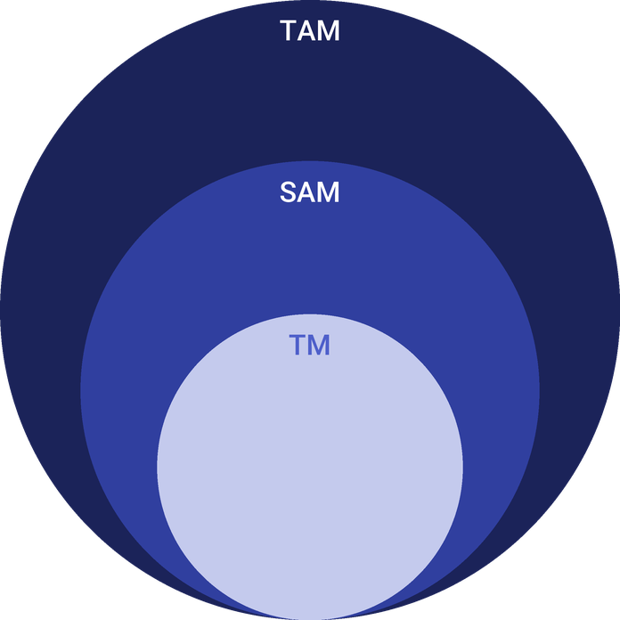
  ● | Total Available Market (TAM)  US domestic transportation management, the Armstrong & Associates segment of which freight brokerage is the largest part, generated $128.3 billion of gross revenue in 2025, up 4.5% on the year. | 128.3B
  ● | Served Available Market (SAM)  US truckload brokerage is about $92.4 billion of gross revenue, derived as truckload's 72% share of broker activity applied to the $128.3 billion domestic transportation management total for 2025. | 92.4B
  ● | Target Market (TM)  One freight arrangement establishment averages about $5.18 million of gross revenue, derived from $128.3 billion of 2025 domestic transportation management revenue across 24,748 US establishments counted in 2024. | 5.2M

4.4.1 PESTEL Analysis
  Political  - Federal broker authority, a $75,000 bond and a process agent filing govern who may broker freight.  - DOT rules on non-domiciled CDLs and English proficiency are removing drivers from the market.  - A pending FMCSA rule would open broker transaction records to carriers within 48 hours. |   Economic  - Dry van spot linehaul was $2.25 a mile in October 2026, up 33.5% in a year.  - Margin compresses when carrier rates rise faster than shipper contracts.  - A variable loan rate makes funding receivables more expensive. |   Social  - Shippers expect live tracking and a fast answer from their broker.  - Dallas County employs 4,519 people in freight arrangement, a deep hiring pool.  - Driver hours and safety rules limit what a carrier can promise.
  Technological  - Load boards, a TMS and carrier vetting tools are standard broker equipment.  - Only 17% of shippers and logistics providers report full automation.  - Digital freight platforms quote instantly and compete on convenience. |   Environmental  - Hurricanes, winter storms and harvests swing capacity and rates by region.  - Shippers increasingly ask carriers for fuel and emissions data.  - Fewer empty miles per load cut both cost and emissions. |   Legal  - Authority is suspended if available bond security falls below $75,000.  - Broker-carrier agreements set cargo claim liability and payment terms.  - Fraud increasingly produces liability claims against brokers.

CHAPTER 5

Customer Analysis

5.1 Target Market
5.2 Customer Segments
5.3 Customer Persona
5.4 Customer Purchase Journey

5.1 Target Market
Quillmark sells to shippers that tender truckload freight every week but are too small to be a priority for a large broker: typically a few to a few dozen loads a week, managed by one transportation or shipping manager who often handles warehousing or purchasing as well. They are located anywhere in the continental United States, though the founders' existing relationships start the book in Texas and the neighbouring states.
When choosing a broker, these shippers weigh four things, roughly in this order. First is whether the broker actually covers the load, including the awkward ones: a Friday afternoon tender, a rural pickup, a reefer load with a tight delivery window. Second is communication, meaning a call before a load runs late rather than an explanation afterwards. Third is the paperwork, with proof of delivery and an invoice that matches the rate confirmation. Price comes fourth: a shipping manager will pay a little more per load to a broker who removes the hours spent re-covering freight, but will not pay much more, because the freight budget was fixed at the last bid.
Their volume is steady but not flat. Produce and beverage shippers peak in summer, building products suppliers follow the construction season, and most manufacturers see a rush at quarter end. A broker that holds capacity through those peaks earns the lanes for the rest of the year.
These shippers buy most of their freight through a routing guide set at an annual or semi-annual bid. What they buy from a broker is cover: a truck for the load the contract carrier did not take, and one accountable contact when something goes wrong. That need grew in 2026, when carriers holding contracts priced in 2025 began turning down loads as the spot market paid more.

5.2 Customer Segments
- Manufacturers ship finished goods on regular outbound lanes to distributors and retailers, buy contract lanes, and judge a broker on on-time pickup.
- Distributors and wholesalers move inbound and outbound dry van freight to appointment-driven receivers, and buy a mix of contract and spot loads.
- Food and beverage producers ship refrigerated loads under temperature and food safety requirements, pay more per load, and weigh carrier vetting heavily.
- Building products suppliers send flatbed and dry van freight to yards and job sites, with volume that rises and falls with the construction season.
The building products distributor is the segment the persona below represents: steady weekly volume, a lean shipping team, and deliveries that cannot miss a job-site window.

5.3 Customer Persona
  Shipping Manager Sandra  Demographics  Age: 31  Location: Dallas-Fort Worth, TX  Company: Building products distributor  Professional Role  Job: Transportation Manager  Freight: 25 to 40 truckloads a week | “I don't need the cheapest truck. I need the one that shows up, and a broker who answers when it doesn't.”
   | Identifiers / Personality Traits  - Ships dry van loads across the South and Midwest  - Runs an annual bid and uses two or three brokers between bids  - Measured on on-time delivery and freight cost per load
   | Goals  - Cover every tendered load without chasing carriers  - Keep on-time delivery above her customers' requirement  - Hold freight spend inside the budget set at the bid
   | Challenges  - Contract carriers rejecting tenders as spot rates climb  - Large brokers rotating her account between reps  - Losing a load to an impersonated carrier

5.4 Customer Purchase Journey
A mid-sized shipper rarely moves its whole book to a new broker at once. The journey runs in four steps:
- First contact: a call or LinkedIn message from a broker, a referral from another shipper or a warehouse, or a quote request through the website.
- Trial loads: the shipper offers one or two spot loads, often tenders its contract carrier rejected, to test whether the desk covers them on time and keeps it informed.
- Credit and onboarding: Quillmark runs a credit check, agrees 30 day terms and signs a transportation agreement.
- Contract lanes: after a run of clean loads the shipper awards lanes in its routing guide, usually at its next bid, and reviews them monthly with its broker.
Most shippers decide on the strength of the trial loads. A broker that covers a rejected Friday load and calls ahead of a late delivery earns the next tender; one that goes quiet does not get a second.

CHAPTER 6

Competitive Analysis

6.1 Competitors
6.2 Comparison
6.3 Competitive Edge
6.4 SWOT Analysis

6.1 Competitors
Quillmark competes for shipper freight with four kinds of broker. Large national brokers run thousands of shippers through structured sales and carrier teams; RXO, one of them, reported a truck brokerage gross margin of 11.9% in the fourth quarter of 2025, a measure of how much rate pressure even scale has to absorb. Digital freight platforms quote online in seconds and book carriers through apps. Regional brokers sell on relationships within a few industries, and one-person agent brokers work a handful of accounts, often under another firm's authority.
Locally the field is dense. The Dallas-Fort Worth metro held 608 freight arrangement establishments in 2024, and Dallas County 259, employing 4,519 people at an average annual pay of $80,815. Every shipper Quillmark calls already has a broker, so the question is never whether it has one, but whether its broker covers the loads that fall out of the routing guide.

6.2 Comparison
Scale gives the national brokers and the platforms instant quoting and broad capacity, and costs them continuity: an account the size of Quillmark's targets is worked by whichever rep is free. Agent brokers offer the continuity but seldom the vetting tools, insurance and back office a shipper's risk team now asks for. Quillmark is built to offer both, and gives up instant online quoting at launch to do it.
Feature | Quillmark Freight | Large national brokers | Digital freight platforms | One-person agent brokers
One named broker on every account | ✓ | ✗ | ✗ | ✓
Carrier identity checked before every tender | ✓ | ✓ | ✓ | ✗
Account broker reachable after hours | ✓ | ✗ | ✗ | ✓
Instant online quotes | ✗ | ✓ | ✓ | ✗
Contingent cargo cover on every load | ✓ | ✓ | ✓ | ✗

6.3 Competitive Edge
None of these advantages depends on technology a rival cannot buy. What makes them hold is the economics of attention: a shipper tendering a few dozen loads a week is a small account to a national broker and a large one to a three-broker desk, so it gets an owner on the phone rather than a queue. The edge lasts as long as the desk stays small enough to keep that promise, which is why the plan adds one broker a year rather than building a sales floor.
  One Broker Per Account
  Each shipper deals with the same broker for quotes, booking and problems, so nobody has to explain the lane, the dock hours or the receiver twice.
  Checks on Every Tender
  Carrier authority, insurance and identity are confirmed on the day a load is offered, not only at onboarding, which is where impersonation fraud gets through.
   | Founders on the Phones  Both owners work the desk, one on shipper accounts and one on carrier capacity, so the people who set the rates also cover the loads.
  Quick Pay Carriers Return For
  Carriers can be paid within days of proof of delivery, which keeps good small fleets coming back when trucks are scarce.

6.4 SWOT Analysis
Strengths  - Founders bring shipper accounts and carrier contacts built over a decade on Dallas brokerage desks.  - Every shipper has one named broker who quotes, books and tracks its loads.  - Owning no trucks keeps the startup budget to $61,000.  - Carrier identity is checked on every tender, not only at onboarding. | Weaknesses  - A new broker authority has no payment history, so some carriers and shippers will hesitate.  - Net income is 0.8% of revenue in the first year, leaving little room for error.  - Three brokers carry the whole book, so one departure removes a third of capacity.  - No instant online quoting at launch.
Opportunities  - Tender rejections above 14% push contracted freight toward brokers that can cover it.  - Small brokerages grew shipments 30.8% in early 2025 while the largest lost volume.  - Shippers reviewing routing guides after a year of rejected tenders. | Threats  - Cargo theft losses reached an estimated $725 million in 2025, much of it through impersonation.  - Spot rates rising faster than contract rates squeeze margin on committed lanes.  - 608 freight arrangement establishments compete for shippers across Dallas-Fort Worth.  - A freight downturn would bring rejections and spot rates back down.

 Strategic Summary
Quillmark should sell reliability where the market lacks it, covering rejected and hard lanes for mid-sized shippers on vetted carriers. While carrier rates are moving, it should price contract lanes for three months rather than twelve.

CHAPTER 7

Marketing & Sales Strategies

7.1 Market Positioning
7.2 Marketing Objectives
7.3 Online Marketing
7.4 Public Relations and Branding
7.5 Partnership & Collaboration Strategy
7.6 Customer Loyalty & Retention
7.7 Sales Channels

7.1 Market Positioning

Quillmark is positioned as the accountable truckload desk for mid-sized shippers: one named broker, carriers checked on every load, and cover for the freight a routing guide drops. It does not compete on instant quotes or on the lowest rate.

7.2 Marketing Objectives
- Open accounts with shippers that tender weekly freight, enough to book at least 1,541 loads in the first year, the break-even count.
- Convert trial loads into contract lanes within each shipper's next bid cycle.
- Bring every broker to full volume of 55 loads a month by June 2027.
- Hold marketing spend to 0.6% of revenue, $22,691 in the first year.
Shipper data and CRM  $662  per month  A subscription naming shipping managers at target manufacturers and distributors, and the CRM that tracks every call. |  | Trade shows and site visits  $567  per month  Passes to regional logistics and industry shows, and visits to shippers' docks once a lane is quoted.
LinkedIn and email outreach  $378  per month  Targeted outreach to shipping and supply chain managers, with lane-specific market notes. |  | Website and quote requests  $284  per month  The website, its quote request and carrier signup forms, and search listings for freight brokerage in Dallas.

Total marketing budget: $22,691 a year, $1,891 a month.

7.3 Online Marketing
Online work supports the sales calls rather than replacing them. A plain website explains the lanes and equipment Quillmark covers, takes quote requests and onboards carriers. On LinkedIn the brokers post short, specific notes on rates in the lanes they run, and targeted email reaches shipping and supply chain managers drawn from a shipper data subscription. The budget goes to that data and the CRM before any advertising.

7.4 Public Relations and Branding
The brand promise is printed in every email signature: a named broker, reachable. The company publishes its FMCSA authority, bond and insurance on its website and in every carrier and shipper packet, joins the Transportation Intermediaries Association, and attends Dallas-Fort Worth logistics and manufacturing events where shipping managers meet their suppliers.

7.5 Partnership & Collaboration Strategy
Partnerships bring freight and capacity rather than publicity. Third-party warehouses and cold storage operators in Dallas-Fort Worth see which of their clients struggle to find trucks, and a referral arrangement makes Quillmark their answer. On the carrier side, the desk builds a core of small fleets that run its lanes, paid on quick pay and offered loads in both directions, which is how a small broker keeps trucks when they are scarce.

7.6 Customer Loyalty & Retention
In this trade a shipper comes back for three things: the truck arrived, the broker called before the problem did, and the invoice matched the rate confirmation. Quillmark measures each on every load and reviews them monthly with contract shippers, alongside the rejected tenders it covered and cost by lane. Contract rates are held for three months and reset by agreement, so a shipper is never surprised by a market it cannot see.

7.7 Sales Channels
Contract lanes are the route that pays for the business; rejected and spot tenders are the route in, since most shippers test a broker on a load their routing guide could not cover. Spot loads are expected to dominate the first months and contract lanes to carry most of the volume by the end of the first year, with referrals and website requests as smaller additions.
  Contract Lanes
  Weekly freight a shipper awards in its routing guide, the steadiest revenue the desk earns, kept by on-time performance.
  Rejected and Spot Tenders
  Loads a shipper's contract carrier turns down, worth more per load, won by answering within the hour.
   | Shipper Referrals  Introductions from satisfied shipping managers and the warehouses that load their freight, which depend on service record.
   | Website Quote Requests  Inbound requests from shippers searching for a broker, small in number and dependent on a quick, accurate quote.

CHAPTER 8

Operations Plan

8.1 Daily Operations
8.2 Staffing & Training
8.3 Location and Facilities
8.4 Milestones & Timeline
8.5 Carrier Vetting & Compliance

8.1 Daily Operations
The desk opens at 7 a.m. Central, when shippers in the eastern states are already loading, and works the day in a fixed rhythm: tenders and quote requests first, carrier booking through midday, check calls and tracking through the afternoon, and proof of delivery and invoicing before close. Every load lives in the transportation management system from tender to invoice.
Brokers own their shippers; carrier operations owns coverage and tracking. Once a broker has quoted a load, carrier operations offers it first to carriers already in the network, posts it to DAT and Truckstop if needed, books the truck and monitors it. Exceptions such as a late pickup, a breakdown or a temperature alarm go straight back to the broker, who calls the shipper. After hours, a broker on rotation answers the phone.

8.2 Staffing & Training
The launch team is the two founders, a senior broker, a carrier operations representative and a part-time billing and collections specialist. Brokers are paid a base salary plus commission on gross margin, so pay follows the profitable loads rather than the number booked. The carrier operations role is paid near the Dallas-Fort Worth mean of $53,900 for cargo and freight agents.
Every hire is trained on the TMS, the carrier vetting process and the warning signs of fraud before handling a load, and shadows a founder for two weeks. Brokers work toward the Transportation Intermediaries Association's Certified Transportation Broker credential.

8.3 Location and Facilities
Quillmark leases a 1,200 square foot office suite in Dallas at $3,480 a month, full-service, with room for six desks so the second- and third-year brokers need no move. A broker needs no dock or yard: the facility is desks, dual monitors, headsets, an internet connection with a cellular backup, and a meeting room for shipper visits. Dallas puts the desk in the Central time zone, able to work both coasts' business hours in one shift.

8.4 Milestones & Timeline
The milestones run from funding to the fourth broker. Two carry the plan: the authority going active, without which no load can be booked, and full volume in June 2027, when every broker is booking a full month's freight.
Nov 2026  Setup |  |  | Funding in place  Founder equity and SBA loan closed  The founders' $150,000 and the $200,000 SBA 7(a) working capital loan fund the startup budget and the receivables float.
Dec 2026  Compliance |  |  | Broker authority filed  OP-1, BOC-3 and BMC-84 bond  The application, process agent filing and $75,000 surety bond go to FMCSA, and the office, TMS and load boards are set up.
Jan 2027  Launch |  |  | First loads  Authority active, desk open  Lanes agreed with shippers during the application period start moving, with the desk at about 45% of full volume.
Jun 2027  Growth |  |  | Full volume  Three brokers at 55 loads a month  Trial loads with each new shipper have become weekly lanes, and every broker is booking a full month's freight.
Jan 2028  Growth |  |  | Fourth broker  Second year hire  A fourth broker joins to carry new accounts as existing shippers add lanes.

8.5 Carrier Vetting & Compliance
Every carrier is checked before its first load and again on the day of each load. Onboarding confirms active FMCSA operating authority, the carrier's USDOT safety record, a certificate of insurance sent by the insurer itself with at least $1,000,000 of auto liability and $100,000 of cargo cover, a signed broker-carrier agreement, and a W-9 that matches the authority. On load day the dispatcher's phone number and email are matched to the carrier's FMCSA contact records before a rate confirmation goes out, and payment goes only to the carrier of record or its named factoring company.
Quillmark's own compliance rests on keeping its authority current. The $75,000 BMC-84 surety bond must stay in full force, since FMCSA now suspends a broker whose available security falls below that level; the BOC-3 filing names a process agent in every state; and Unified Carrier Registration is renewed each year. Loads are never re-brokered without the shipper's written consent, and transaction records are kept electronically so they can be produced quickly if the proposed federal transparency rule takes effect.

CHAPTER 9

Management Team

9.1 Key Members
9.2 Organization Chart
9.3 Advisory Board Members

9.1 Key Members
Accountability is split along the two sides of every load. Shipper sales answers for revenue, gross margin by account and shipper retention, measured monthly against the plan. Carrier operations answers for coverage, on-time pickup and delivery, and cargo claims, measured on every load, and owns the vetting process. Each broker is measured on the gross margin of the accounts in their book, and billing and collections on days sales outstanding against the 38 day assumption.
 | Daniel Okafor  CEO & Head of Shipper Sales · daniel@quillmarkfreight.example  Spent eleven years as an account executive at a large Dallas freight brokerage, managing truckload shippers in manufacturing and distribution.

 | Rebecca Lindqvist  COO & Head of Carrier Operations · rebecca@quillmarkfreight.example  Ran carrier sales and carrier compliance for a regional brokerage, building and vetting a network of small trucking fleets.

 | Jordan Pierce  Senior Freight Broker · jordan@quillmarkfreight.example  Has worked both sides of the desk for eight years, booking refrigerated and dry van freight for food and beverage shippers.

 | Alicia Moreno  Carrier Operations Representative · alicia@quillmarkfreight.example  Dispatched for a Dallas trucking company before moving to carrier onboarding and load tracking at a brokerage.

9.2 Organization Chart
The chief executive leads the company and the shipper side directly. The chief operating officer, the senior broker and the billing specialist report to the chief executive; the carrier operations representative reports to the chief operating officer, who approves every new carrier. Brokers added in the second and third years report to the chief executive.
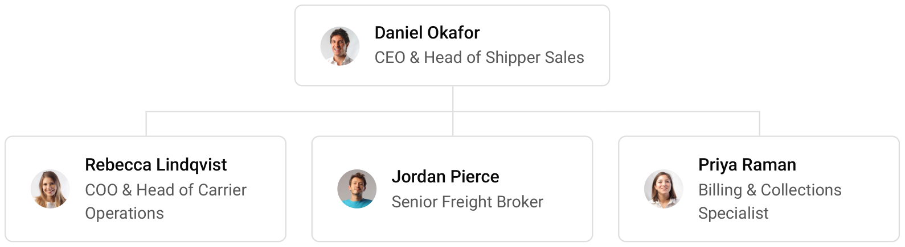

9.3 Advisory Board Members
Three advisers, engaged before launch, cover the gaps a two-founder company has: a transportation attorney who reviews the broker-carrier and shipper agreements and advises on cargo claims; a certified public accountant with brokerage clients, who sets up revenue recognition and the Texas franchise tax filing; and an insurance broker specialising in logistics, who places contingent cargo and errors and omissions cover. Each meets the founders quarterly.

9.3.1 Hiring Plan
2  Filled |  | 3  Hiring This Year |  | 4  Open

Group By Department | Position Filled | Time of Hire | Time of Start | Filled
Leadership | 2 of 2 | 0 days | 0 days | 100%
Brokerage & Sales | 0 of 2 | 45 days | 30 days | 0%
Carrier Operations | 0 of 1 | 30 days | 14 days | 0%
Billing & Collections | 0 of 1 | 30 days | 14 days | 0%

CHAPTER 10

Financial Plan

10.1 Key Assumptions
10.2 Capital Requirements and Use of Funds
10.3 Income Statement (3 Year projections)
10.4 Balance Sheet (3 Year projections)
10.5 Cash Flow Statement (3 Year projections)
10.6 Break Even Analysis

10.1 Key Assumptions
Revenue is built from three brokers, each booking 55 loads a month at full volume, at an average of $2,150 a load, with accessorial charges adding 3%. The desk opens at 45% of full volume, reaches it over six months, and then grows 18% a year as brokers are added. Gross margin is held at 15.0%, and cost of sales is nothing but the carriers Quillmark pays.
Operating costs are payroll at 8.5% of revenue, marketing at 0.6%, office rent of $3,480 a month, technology of $3,500 a month, administration and insurance of $2,600 a month, and other costs at 0.5%. Shippers pay in 38 days and carriers are paid in 20, with 0.5% of revenue held against bad debt. Tax is modelled at 23%.
On those assumptions revenue is $3,781,812 in the first year, $4,462,539 in the second and $5,265,796 in the third, with net income of $28,605, $53,844 and $83,335. Break-even revenue is $3,312,820, about 1,541 loads. The conservative scenario returns $45,954 of third-year net income and the upside case $133,823. A net margin below 2% is normal for brokerage, so the plan's safety lies in volume and collections rather than in price.

10.2 Capital Requirements and Use of Funds
Quillmark needs $61,000 of startup spending and a working capital reserve for the gap between paying carriers and collecting from shippers. It is funded by $150,000 of founder equity and a $200,000 SBA 7(a) working capital loan at 10.5% over ten years, with no outside equity.
The startup budget covers office equipment and furniture, broker authority and legal agreements, the surety bond premium and insurance deposits, systems setup, the website and launch prospecting. The rest of the funding is held as cash against carrier payments, and no profits are distributed while receivables grow.
If receivables grow faster than planned, the founders will add a revolving line of credit secured on those receivables rather than slow carrier payments, since paying carriers late is the quickest way for a broker to lose its capacity.

10.2.1 Use of Funds
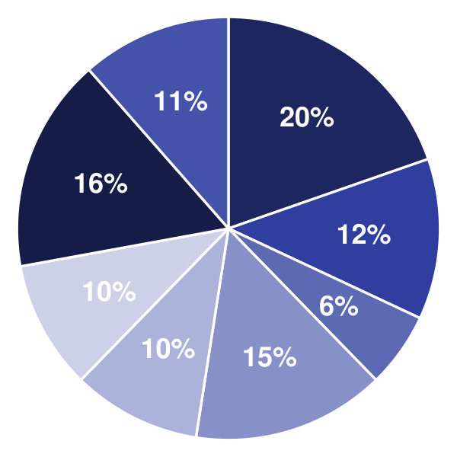 | ● Computers, Monitors & Phones 19.7%  ● Office Furniture 12.3%  ● FMCSA Authority, BOC-3 & Legal Formation 5.7%  ● Surety Bond & Insurance Deposits 14.8%  ● TMS, Load Boards & Carrier Vetting Setup 9.8%  ● Website & Brand 9.8%  ● Launch Marketing & Shipper Data 16.4%  ● Office Deposit & First Month's Rent 11.5%

Use Of Funds | Amount
Computers, Monitors & Phones | $12,000.00
Office Furniture | $7,500.00
FMCSA Authority, BOC-3 & Legal Formation | $3,500.00
Surety Bond & Insurance Deposits | $9,000.00
TMS, Load Boards & Carrier Vetting Setup | $6,000.00
Website & Brand | $6,000.00
Launch Marketing & Shipper Data | $10,000.00
Office Deposit & First Month's Rent | $7,000.00

10.3 Income Statement (3 Year projections)
 | Year 1 | Year 2 | Year 3 | Total
Revenue | $3,781,812.38 | $4,462,538.61 | $5,265,795.56 | $13,510,146.55
Cost of Sales | $3,214,540.52 | $3,793,157.82 | $4,475,926.23 | $11,483,624.57
General Costs | $0.00 | $0.00 | $0.00 | $0.00
Revenue Specific Costs | $3,214,540.52 | $3,793,157.82 | $4,475,926.23 | $11,483,624.57
Personnel Costs (Direct Labor) | $0.00 | $0.00 | $0.00 | $0.00
Gross Margin | $567,271.86 | $669,380.79 | $789,869.33 | $2,026,521.98
Gross Margin (%) | 15.00% | 15.00% | 15.00% | 15.00%
Operating Expense | $496,923.04 | $565,676.39 | $646,805.35 | $1,709,404.78
Payroll Expense (Indirect Labor) | $321,454.05 | $379,315.78 | $447,592.62 | $1,148,362.45
General Expense | $156,559.93 | $164,047.92 | $172,883.75 | $493,491.60
Bad Debt | $18,909.06 | $22,312.69 | $26,328.98 | $67,550.73
Amortization of Current Assets | $0.00 | $0.00 | $0.00 | $0.00
EBITDA | $70,348.82 | $103,704.40 | $143,063.98 | $317,117.20
Additional Expense | $41,744.23 | $49,860.70 | $59,729.21 | $151,334.14
Long Term Depreciation | $12,200.00 | $14,877.52 | $18,037.00 | $45,114.52
Gain or loss from Sale of Assets | $0.00 | $0.00 | $0.00 | $0.00
EBIT | $58,148.82 | $88,826.88 | $125,026.98 | $272,002.68
Interest Expense | $21,000.00 | $18,900.00 | $16,800.00 | $56,700.00
EBT | $37,148.82 | $69,926.88 | $108,226.98 | $215,302.68
Income Tax Expense / Benefit | $8,544.23 | $16,083.18 | $24,892.21 | $49,519.62
Total Expense | $3,753,207.79 | $4,408,694.91 | $5,182,460.79 | $13,344,363.49
Net Income | $28,604.59 | $53,843.70 | $83,334.77 | $165,783.06
Net Income (%) | 0.76% | 1.21% | 1.58% | 1.23%
Retained Earning Opening | $0.00 | $28,604.59 | $82,448.29
Owner's Distribution | $0.00 | $0.00 | $0.00 | $0.00
Retained Earning Closing | $28,604.59 | $82,448.29 | $165,783.06 | $165,783.06

10.4 Balance Sheet (3 Year projections)
 | Year 1 | Year 2 | Year 3 | Total
Assets | $536,879.86 | $604,313.35 | $707,262.34 | $707,262.34
Current Assets | $488,079.86 | $557,003.25 | $662,191.85 | $662,191.85
Cash | $94,356.93 | $92,410.19 | $113,972.04 | $113,972.04
Accounts Receivable | $393,722.93 | $464,593.06 | $548,219.81 | $548,219.81
Inventory | $0.00 | $0.00 | $0.00 | $0.00
Other Current Assets | $0.00 | $0.00 | $0.00 | $0.00
Long Term Assets | $48,800.00 | $47,310.10 | $45,070.49 | $45,070.49
Gross Long Term Assets | $61,000.00 | $74,387.62 | $90,185.01 | $90,185.01
Accumulated Depreciation | $12,200.00 | $27,077.52 | $45,114.52 | $45,114.52
Liabilities & Equity | $536,879.86 | $604,313.35 | $707,262.34 | $707,262.34
Liabilities | $358,275.27 | $371,865.06 | $391,479.28 | $391,479.28
Current Liabilities | $198,275.27 | $231,865.06 | $271,479.28 | $271,479.28
Accounts Payable | $176,139.21 | $207,844.26 | $245,256.23 | $245,256.23
Income Tax Payable | $2,136.06 | $4,020.80 | $6,223.05 | $6,223.05
Sales Tax Payable | $0.00 | $0.00 | $0.00 | $0.00
Short Term Debt | $20,000.00 | $20,000.00 | $20,000.00 | $20,000.00
Long Term Liabilities | $160,000.00 | $140,000.00 | $120,000.00 | $120,000.00
Long Term Debt | $160,000.00 | $140,000.00 | $120,000.00 | $120,000.00
Equity | $178,604.59 | $232,448.29 | $315,783.06 | $315,783.06
Paid-in Capital | $0.00 | $0.00 | $0.00 | $0.00
Common Stock | $0.00 | $0.00 | $0.00 | $0.00
Preferred Stock | $0.00 | $0.00 | $0.00 | $0.00
Owner's Contribution | $150,000.00 | $150,000.00 | $150,000.00 | $150,000.00
Retained Earnings | $28,604.59 | $82,448.29 | $165,783.06 | $165,783.06
Check | $0.00 | $0.00 | $0.00 | $0.00

10.5 Cash Flow Statement (3 Year projections)
 | Year 1 | Year 2 | Year 3 | Total
Cash Received | $3,369,180.39 | $4,369,355.79 | $5,155,839.83 | $12,894,376.01
Cash Paid | $3,543,823.46 | $4,337,914.91 | $5,098,480.59 | $12,980,218.96
COS & General Expenses | $3,194,961.24 | $3,925,500.69 | $4,611,398.01 | $11,731,859.94
Salary & Wages | $321,454.05 | $379,315.78 | $447,592.62 | $1,148,362.45
Interest | $21,000.00 | $18,900.00 | $16,800.00 | $56,700.00
Sales Tax | $0.00 | $0.00 | $0.00 | $0.00
Income Tax | $6,408.17 | $14,198.44 | $22,689.96 | $43,296.57
Net Cash From Operations | ($174,643.07) | $31,440.88 | $57,359.24 | ($85,842.95)
Assets Sell | $0.00 | $0.00 | $0.00 | $0.00
Assets Purchase | $61,000.00 | $13,387.62 | $15,797.39 | $90,185.01
Net Cash From Investments | ($61,000.00) | ($13,387.62) | ($15,797.39) | ($90,185.01)
Amount Received | $350,000.00 | $0.00 | $0.00 | $350,000.00
Loan Received | $200,000.00 | $0.00 | $0.00 | $200,000.00
Common Stock | $0.00 | $0.00 | $0.00 | $0.00
Preferred Stock | $0.00 | $0.00 | $0.00 | $0.00
Owner's Contribution | $150,000.00 | $0.00 | $0.00 | $150,000.00
Amount Paid | $20,000.00 | $20,000.00 | $20,000.00 | $60,000.00
Loan Capital | $20,000.00 | $20,000.00 | $20,000.00 | $60,000.00
Dividends & Distributions | $0.00 | $0.00 | $0.00 | $0.00
Net Cash From Financing | $330,000.00 | ($20,000.00) | ($20,000.00) | $290,000.00
Summary
Starting Cash | $0.00 | $94,356.93 | $92,410.19
Cash In | $3,719,180.39 | $4,369,355.79 | $5,155,839.83 | $13,244,376.01
Cash Out | $3,624,823.46 | $4,371,302.53 | $5,134,277.98 | $13,130,403.97
Change in Cash | $94,356.93 | ($1,946.74) | $21,561.85 | $113,972.04
Ending Cash | $94,356.93 | $92,410.19 | $113,972.04 | $113,972.04

10.6 Break Even Analysis
 | Year 1 | Year 2 | Year 3 | Total
Starting Revenue | $0.00 | $3,781,812.38 | $8,244,350.99 | $8,244,350.99
Net Revenue | $3,781,812.38 | $4,462,538.61 | $5,265,795.56 | $5,265,795.56
Closing Revenue | $3,781,812.38 | $8,244,350.99 | $13,510,146.55 | $13,510,146.55
Starting Expense | $0.00 | $3,753,207.79 | $8,161,902.70 | $8,161,902.70
Net Expense | $3,753,207.79 | $4,408,694.91 | $5,182,460.79 | $5,182,460.79
Closing Expense | $3,753,207.79 | $8,161,902.70 | $13,344,363.49 | $13,344,363.49
Is Break Even? | Yes | Yes | Yes
Break Even Month | Dec '26 | - | -
Days Required | 14 Days | - | -
Break Even Revenue | $3,781,812.38 | - | -

CHAPTER 11

References

- SRC001: U.S. 3PL revenues see strong annual gains, reports Armstrong & Associates, Logistics Management, 2026-06-16. https:/‌/‌www.‌logisticsmgmt.‌com/‌article/‌u.‌s_‌3pl_‌revenues_‌see_‌strong_‌annual_‌gains_‌reports_‌armstrong_‌associates (accessed 2026-10-12)
- SRC002: Truck Freight to Bounce Back in 2025, Material Handling & Logistics, 2025-01-01. https:/‌/‌mhlnews.‌com/‌transportation-distribution/‌news/‌55261973/‌truck-freight-to-bounce-back-in-2025 (accessed 2026-10-12)
- SRC003: Dry Van Report: Rates cool off as summer freight demand normalizes, DAT Freight & Analytics, 2026-07-28. https:/‌/‌www.‌dat.‌com/‌blog/‌dry-van-report-rates-cool-off-as-summer-freight-demand-normalizes (accessed 2026-10-12)
- SRC004: Dry Van Report: Quarter-end freight surge pushes spot rates higher, DAT Freight & Analytics, 2026-10-06. https:/‌/‌www.‌dat.‌com/‌blog/‌dry-van-report-quarter-end-freight-surge-pushes-spot-rates-higher (accessed 2026-10-12)
- SRC005: DAT Truckload volumes, spot rates dipped in August, DAT Freight & Analytics via Business Wire, 2025-09-19. https:/‌/‌businesswire.‌com/‌news/‌home/‌20250919508670/‌en/‌DAT-Truckload-volumes-spot-rates-dipped-in-August (accessed 2026-10-12)
- SRC006: Enforcement Tightens Truck Capacity as Rates Show Early Lift, Transport Topics, 2026-05-15. https:/‌/‌www.‌ttnews.‌com/‌articles/‌dot-enforcement-rebalance (accessed 2026-10-12)
- SRC007: Small Freight Brokers Outperform on Volume; Margin Pressure Mounting, FreightCaviar, 2025-05-28. https:/‌/‌www.‌freightcaviar.‌com/‌small-freight-brokers-outperform-on-volume-margin-pressure-mounting (accessed 2026-10-12)
- SRC008: RXO Announces Fourth-Quarter Results, RXO, 2026-02-06. https:/‌/‌rxo.‌com/‌news/‌rxo-announces-fourth-quarter-results/‌ (accessed 2026-10-12)
- SRC009: 2026 Top Freight Brokerage Firms, Transport Topics, 2026-01-01. https:/‌/‌www.‌ttnews.‌com/‌logistics/‌freightbrokerage/‌2026 (accessed 2026-10-12)
- SRC010: OP-1 Application for Motor Property Carrier and Broker Authority, Instructions, Federal Motor Carrier Safety Administration, 2025-09-01. https:/‌/‌www.‌fmcsa.‌dot.‌gov/‌sites/‌fmcsa.‌dot.‌gov/‌files/‌2025-09/‌OP-1%20Form.‌pdf (accessed 2026-10-12)
- SRC011: 49 CFR 387.307 Property broker surety bond or trust fund, Electronic Code of Federal Regulations, 2026-01-16. https:/‌/‌www.‌ecfr.‌gov/‌current/‌title-49/‌subtitle-B/‌chapter-III/‌subchapter-B/‌part-387/‌subpart-C/‌section-387.‌307 (accessed 2026-10-12)
- SRC012: Final Rule: Broker and Freight Forwarder Financial Responsibility, Extension of Compliance Date, Federal Motor Carrier Safety Administration, 2024-12-01. https:/‌/‌www.‌fmcsa.‌dot.‌gov/‌sites/‌fmcsa.‌dot.‌gov/‌files/‌2024-12/‌Broker%20FF%20Extension%20Final%20Rule%20CLEAN%20for%20A2%20signature%20121324.‌pdf (accessed 2026-10-12)
- SRC013: Transparency in Property Broker Transactions, Notice of Proposed Rulemaking, Federal Motor Carrier Safety Administration, 2024-11-01. https:/‌/‌www.‌fmcsa.‌dot.‌gov/‌sites/‌fmcsa.‌dot.‌gov/‌files/‌2024-11/‌%5BDocket%20No.‌%20FMCSA-2023-0257%5D%20RIN%202126-AC63%20Transparency%20in%20Property%20Broker%20Transactions_‌0.‌pdf (accessed 2026-10-12)
- SRC014: Freight Broker Insurance Costs, Insureon, 2025-06-16. https:/‌/‌www.‌insureon.‌com/‌trucking-business-insurance/‌freight-brokers-forwarders/‌cost (accessed 2026-10-12)
- SRC015: Cargo fraud is generating claims, not just stolen goods, Insurance Business, 2026-01-01. https:/‌/‌www.‌insurancebusinessmag.‌com/‌us/‌news/‌programs/‌cargo-fraud-is-generating-claims-not-just-stolen-goods--amwins-restructures-around-that-shift-583200.‌aspx (accessed 2026-10-12)
- SRC016: Cargo Theft Changed: Fewer Loads, Higher-Dollar Targets, FreightWaves, 2025-01-01. https:/‌/‌www.‌freightwaves.‌com/‌news/‌cargo-theft-changed-fewer-loads-higher-dollar-targets (accessed 2026-10-12)
- SRC017: Freight Market Alert: Why US Tender Rejections Are Skyrocketing, FreightWaves, 2026-09-17. https:/‌/‌www.‌freightwaves.‌com/‌?‌p=‌581041 (accessed 2026-10-12)
- SRC018: TIA report signals continued recovery in freight brokerage market, Logistics Management, 2026-08-31. https:/‌/‌www.‌logisticsmgmt.‌com/‌article/‌tia_‌report_‌signals_‌continued_‌recovery_‌in_‌freight_‌brokerage_‌market (accessed 2026-10-12)
- SRC019: Brush Pass Research: 7.8% Fewer Brokerages Than a Year Ago, FreightCaviar, 2024-01-01. https:/‌/‌www.‌freightcaviar.‌com/‌brush-pass-research-7-8-fewer-brokerages-than-a-year-ago/‌ (accessed 2026-10-12)
- SRC020: Descartes Transportation Management 2025 Survey Trends, Fleet Equipment, 2025-01-01. https:/‌/‌www.‌fleetequipmentmag.‌com/‌transportation-management-2025-survey/‌ (accessed 2026-10-12)
- SRC021: Quarterly Intelligence Q1 2026, Journal of Commerce, 2026-01-01. https:/‌/‌magazine.‌joc.‌com/‌quarterly-intelligence-q1-2026/‌0147991001767649148/‌p11 (accessed 2026-10-12)
- SRC022: Occupational Employment and Wage Statistics, May 2025, national estimates, U.S. Bureau of Labor Statistics, 2026-01-01. https:/‌/‌www.‌bls.‌gov/‌oes/‌ (accessed 2026-10-12)
- SRC023: Freight broker bookkeeping: quick pay vs factoring carrier payables guide, Beancount.io, 2026-07-10. https:/‌/‌beancount.‌io/‌blog/‌2026/‌07/‌10/‌freight-broker-bookkeeping-quick-pay-vs-factoring-carrier-payables-guide (accessed 2026-10-12)
- SRC024: QCEW Open Data: 2024 Annual Averages, NAICS 488510 Freight Transportation Arrangement, U.S. Bureau of Labor Statistics, 2025-01-01. https:/‌/‌data.‌bls.‌gov/‌cew/‌data/‌api/‌2024/‌a/‌industry/‌488510.‌csv (accessed 2026-10-16)
- SRC025: Occupational Employment and Wage Statistics, May 2025, Dallas-Fort Worth-Arlington, TX, U.S. Bureau of Labor Statistics, 2026-01-01. https:/‌/‌www.‌bls.‌gov/‌oes/‌current/‌oes_‌19100.‌htm (accessed 2026-10-16)
- SRC026: Dallas/Fort Worth Office Figures Q2 2026, CBRE, 2026-07-01. https:/‌/‌www.‌cbre.‌com/‌insights/‌figures/‌dallas-fort-worth-office-figures-q2-2026 (accessed 2026-10-16)
- SRC027: Hillwood, BNSF Railway, and City of Fort Worth Launch the Alliance Logistics District, Dallas Innovates, 2025-11-20. https:/‌/‌dallasinnovates.‌com/‌hillwood-bnsf-railway-and-city-of-fort-worth-launch-the-alliance-logistics-district/‌ (accessed 2026-10-16)
- SRC028: Franchise Tax, Texas Comptroller of Public Accounts, 2026-01-01. https:/‌/‌comptroller.‌texas.‌gov/‌taxes/‌franchise/‌ (accessed 2026-10-16)




