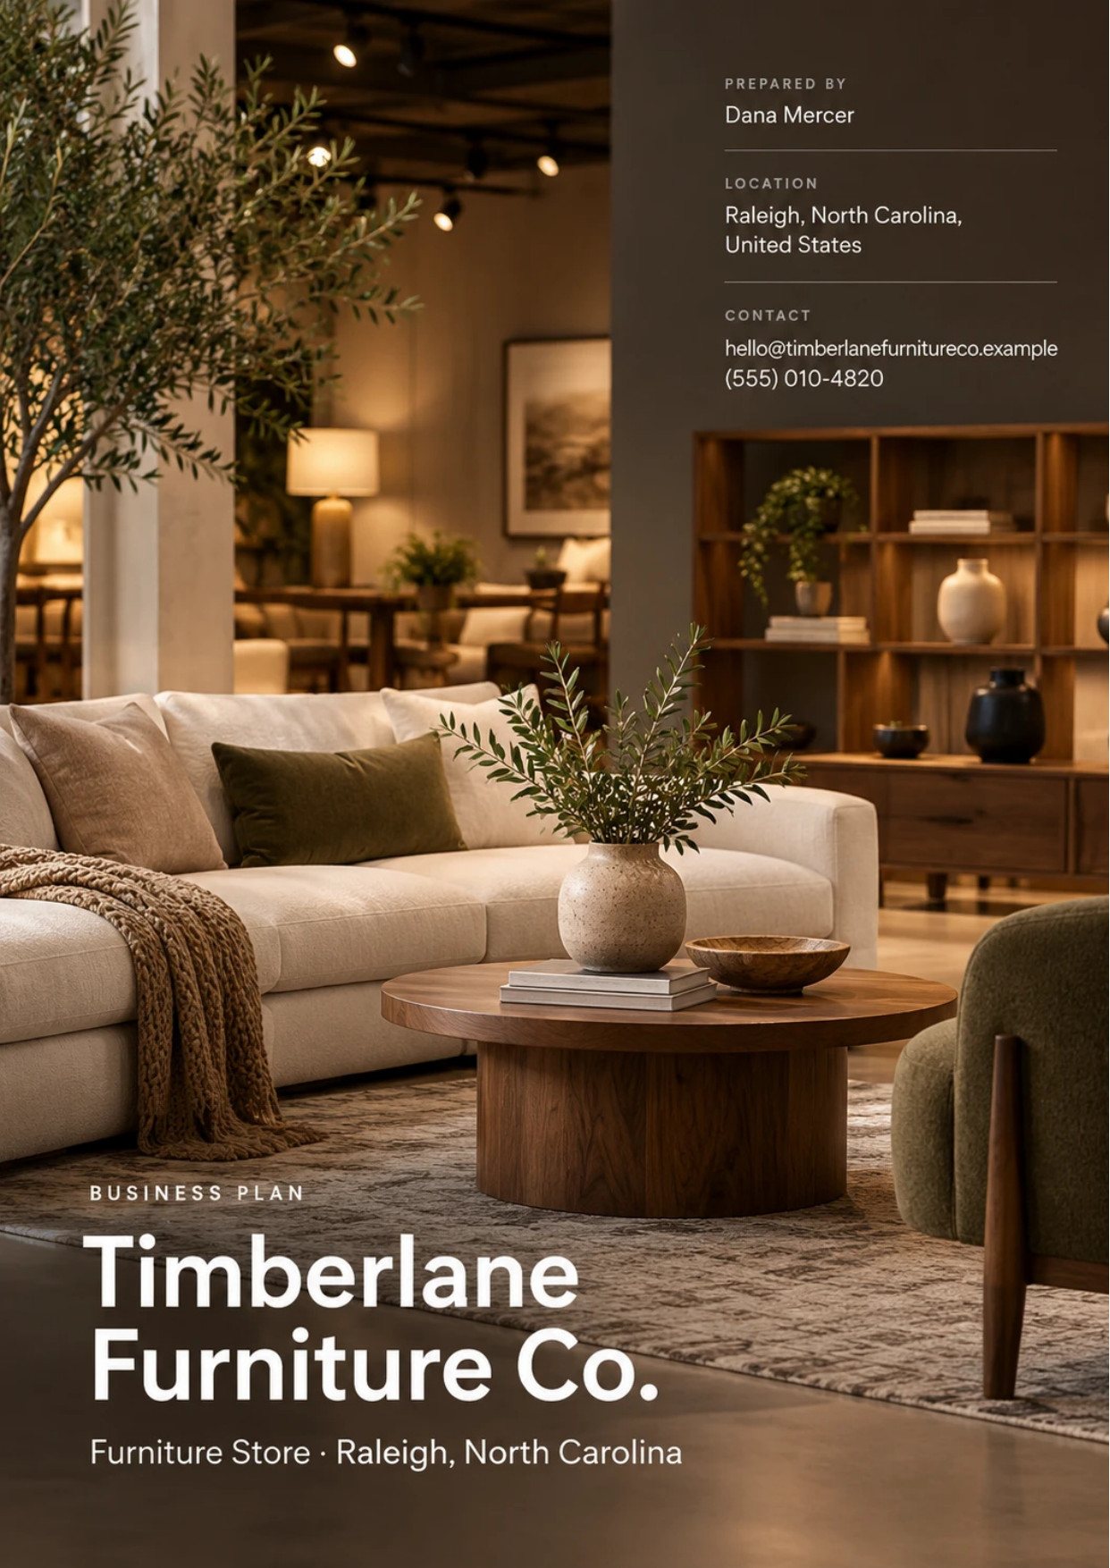
Table of Contents
1. Executive Summary 6
1.1 Business Overview 7
1.2 Mission Statement 7
1.3 Location & Market Opportunity 7
1.4 Unique Selling Points 7
1.5 Financial Highlights 8
1.6 Funding Requirement 8
1.6.1 Income Statement (3 Year projections) 8
2. Company Overview 9
2.1 Legal Structure 10
2.2 Vision Statement 10
2.3 Background & History 10
2.4 Future Goals 10
2.4.1 Business Owners 11
2.4.2 SMART Goal 11
3. Market Analysis 12
3.1 Overview 13
3.2 Market Segmentation 13
3.3 Market Trends 13
3.4 Local Market Outlook 13
3.5 Market Size 14
3.5.1 PESTEL Analysis 15
4. Customer Analysis 16
4.1 Target Market 17
4.2 Customer Segments 17
4.3 Customer Persona 18
4.4 Customer Purchase Journey 18
5. Competitive Analysis 19
5.1 Competitors 20
5.2 Comparison 20
5.3 Competitive Edge 20
5.4 SWOT Analysis 21
6. Products & Services 22
6.1 Our Offering 23
6.2 Signature Items 23
6.3 Additional Services 23
6.4 What Sets Us Apart 23
6.5 Special Orders & Lead Times 23
6.5.1 Showroom Collection 24
6.5.2 Made-to-Order Upholstery 24
6.5.3 Features 25
6.5.4 Pricing 25
7. Marketing & Sales Strategies 26
7.1 Market Positioning 27
7.2 Marketing Objectives 27
7.3 Online Marketing 28
7.4 Public Relations and Branding 28
7.5 Partnership & Collaboration Strategy 28
7.6 Customer Loyalty & Retention 28
7.7 Sales Channels 28
8. Operations Plan 29
8.1 Daily Operations 30
8.2 Working Hours 30
8.3 Staffing & Training 30
8.4 Inventory & Equipment Management 30
8.5 Location and Facilities 30
8.6 Milestones & Timeline 31
8.7 Delivery & In-Home Setup 32
9. Management Team 33
9.1 Key Members 34
9.2 Organization Chart 34
9.3 Advisory Board Members 35
9.3.1 Hiring Plan 35
10. Financial Plan 36
10.1 Key Assumptions 37
10.2 Capital Requirements and Use of Funds 37
10.2.1 Use of Funds 38
10.3 Income Statement (3 Year projections) 39
10.4 Balance Sheet (3 Year projections) 40
10.5 Cash Flow Statement (3 Year projections) 41
10.6 Break Even Analysis 42
11. References 43


CHAPTER 1

Executive Summary

1.1 Business Overview
1.2 Mission Statement
1.3 Location & Market Opportunity
1.4 Unique Selling Points
1.5 Financial Highlights
1.6 Funding Requirement

1.1 Business Overview
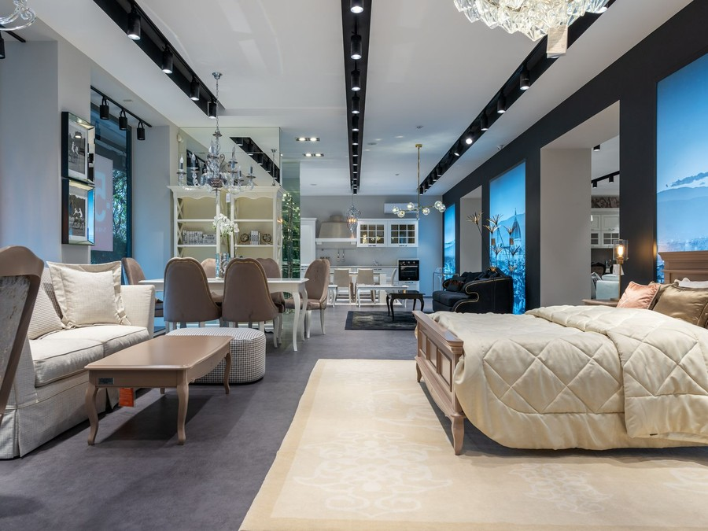
Timberlane Furniture Co. is an independent home furniture store opening in north Raleigh, North Carolina. It trades from a 12,000 square foot showroom with a warehouse behind it, selling living room, dining room and bedroom furniture set out as complete rooms.
Customers buy from the floor or order upholstery built in the fabric they choose, with free design help, and a two-person crew delivers and sets up every order across Wake County and the wider Triangle. Its buyers are households furnishing a new home, families replacing worn pieces, downsizers and interior designers.

1.2 Mission Statement
To help Triangle households furnish their homes with furniture they have seen, sat on and chosen to fit, delivered on the promised date and set up in the room where it belongs.

1.3 Location & Market Opportunity
Wake County had 1,257,235 residents in July 2025, 2.0% more than a year earlier, and a median household income of $106,848. The Raleigh-Cary metro permitted 17,690 new homes in 2025, and 14.7% of the county's residents moved in a single year. A move is the most common reason to furnish a room at once. The county has 94 furniture stores, and the Triangle has no IKEA. The counties around it are thinly served, with 13 furniture stores in Durham County and 8 in Johnston County, and both sit inside the store's delivery run.
Furniture stores sold $72.2 billion nationally in 2025. The Wake County market is about $307.1 million a year, and a single U.S. furniture store averages about $3.27 million in sales. Timberlane's first-year projection sits below that average, as a new independent store should.

1.4 Unique Selling Points
- Upholstery made to order in a fabric or leather chosen from the swatch library.
- Free design help for every customer, with no minimum purchase.
- The store's own two-person crew delivers, assembles and removes all packaging.
- Floor stock held in the warehouse behind the showroom, ready within ten days.
- Two owners working in the business every day.

1.5 Financial Highlights
Revenue comes from 18 shopping parties a day, 20% of whom buy, at an average written sale of $2,100, with delivery fees and protection plans adding 8%. The store opens at 60% of that traffic and reaches it within nine months. Below the gross line, payroll at 19% of revenue and rent of $20,500 a month are the largest costs, and almost every sale is paid for before the furniture leaves the warehouse.
Revenue is projected at $2,137,545 in the first year, $2,458,176 in the second and $2,826,903 in the third, at a gross margin of 49.0%. The first year closes almost exactly at break-even, a net loss of $175, while the floor finds its customers and loan interest is at its highest; net income reaches $49,603 in the second year and $106,267 in the third. Break-even revenue, which counts operating costs before depreciation and loan interest, is $1,937,188, or 922 orders a year. Third-year results range from a net loss of $33,750 in the conservative case to net income of $321,072 in the upside case.

1.6 Funding Requirement
The startup budget is $511,000. The largest lines are the $145,000 showroom fit-out, a $72,000 delivery truck, $66,000 of deposits and pre-opening rent and $48,000 of launch marketing. It is funded by $250,000 from the two owners and a $450,000 SBA 7(a) loan at 10.5% over ten years; the funding beyond the startup budget carries the opening floor stock, and profits stay in the business while the loan is repaid.
The plan rests on owners who have bought, sold and delivered furniture for years, on a county that grew 2.0% in a single year, and on an offer the chains and websites do not make together. The money opens a fully stocked showroom with its own delivery crew in time for the spring season.

1.6.1 Income Statement (3 Year projections)
 | Year 1 | Year 2 | Year 3 | Total
Revenue | $2,137,544.64 | $2,458,176.34 | $2,826,902.79 | $7,422,623.77
Cost of Sales | $1,090,147.77 | $1,253,669.93 | $1,441,720.42 | $3,785,538.12
Gross Margin | $1,047,396.87 | $1,204,506.41 | $1,385,182.37 | $3,637,085.65
Operating Expense | $949,222.34 | $1,042,285.68 | $1,149,308.54 | $3,140,816.56
Total Expense | $2,137,720.11 | $2,408,573.18 | $2,720,636.23 | $7,266,929.52
Net Income | ($175.47) | $49,603.16 | $106,266.56 | $155,694.25

CHAPTER 2

Company Overview

2.1 Legal Structure
2.2 Vision Statement
2.3 Background & History
2.4 Future Goals

2.1 Legal Structure
Timberlane Furniture Co., LLC is a North Carolina limited liability company owned by Dana Mercer and Marcus Hale. The LLC limits each owner's personal liability for the lease, the loan and supplier accounts, and profits pass through to the owners for tax. An operating agreement sets out each owner's responsibilities, how decisions are made when they disagree, and what happens if either owner wants to leave.
Before opening, it registers for sales and use tax and confirms that each upholstery maker holds a North Carolina bedding license, since the state treats sofas as bedding.

2.2 Vision Statement
To be the furniture store Triangle households recommend to the neighbours who admire their living room: the place where furniture is chosen with help, made to fit, and delivered as promised.

2.3 Background & History
Timberlane Furniture Co. is a new business that has not yet traded. Its plan comes from two people who saw the same gap from different sides of the trade.
Dana Mercer spent fourteen years buying furniture and running the sales floor for a regional retailer, and heard the same complaint for most of them: customers loved a sofa on the floor but wanted it in another fabric or another size, and the store had no easy way to sell them one. Marcus Hale ran warehouse and delivery operations for a home goods distributor in the Triangle and watched good sales go wrong on the doorstep, when deliveries arrived late, damaged or without anyone to assemble them.
The two met through a supplier relationship and spent a year planning the store around both problems. The result is a showroom that sells floor stock and made-to-order upholstery side by side, a design center where a customer can plan a room with help, and a delivery crew employed by the store rather than hired from a carrier. They chose Raleigh because Wake County keeps adding households, and because High Point, where the trade buys twice a year, is a short drive away.

2.4 Future Goals
In the first 0 to 18 months, the owners intend to open the showroom in March 2027, reach settled traffic of 18 shopping parties a day within nine months, and close the first year at break-even. They also intend to open designer trade accounts and build the reviews new customers rely on.
From 1 to 3 years, the goal is steady growth on the same floor: revenue of $2,826,903 and net income of $106,267 in the third year, a fourth design consultant, and special orders making up a larger share of what is written. The loan is repaid on schedule from operating cash.
From 3 to 5 years, the owners intend to decide between a second, smaller design showroom elsewhere in the Triangle and a larger warehouse that lets the existing store carry more stock.

2.4.1 Business Owners
Dana Mercer | Marcus Hale

Total ownership: 100%
55% | Dana Mercer  55,000 Shares
45% | Marcus Hale  45,000 Shares

2.4.2 SMART Goal
  Specific  - Open a 12,000 square foot north Raleigh showroom.  - Dana Mercer runs sales; Marcus Hale runs delivery.  - Settled traffic within nine months of opening. |   Measurable  - 18 shopping parties a day at a 20% close rate.  - Average written sale of $2,100.  - First-year revenue of $2,137,545. |   Achievable  - Owners with buying, floor and delivery experience.  - Close rate under the 22% trade median.  - Special orders bought only after a deposit.
  Relevant  - Wake County grows and builds every year.  - Made-to-order upholstery serves unmet demand.  - Profit repays the loan and fills the floor. |   Time-Based  - Lease and loan closed by December 2026.  - Doors open in March 2027.  - Net income of $106,267 in the third year.

CHAPTER 3

Market Analysis

3.1 Overview
3.2 Market Segmentation
3.3 Market Trends
3.4 Local Market Outlook
3.5 Market Size

3.1 Overview
Furniture stores in the United States sold $72.2 billion in 2025, up 0.6% on 2024, through 22,098 employer locations. The trade has low concentration: national chains sit at the top, online retailers close behind, and thousands of single-store independents make up most of the count. The number of locations fell 3.2% in 2025, and IBISWorld describes a soft market held back by a frozen housing market and high borrowing costs.

3.2 Market Segmentation
Furniture is bought for a reason, and the reason divides the market:
- Movers furnishing a new home, who buy several rooms in a short time and spend the most per visit.
- Replacers, families updating a worn sofa or dining set one room at a time.
- Downsizers furnishing a smaller home with fewer, better pieces.
- Trade buyers: interior designers and small businesses ordering for client projects.
By product, living room upholstery is the largest category, followed by dining and bedroom case goods. Made-to-order upholstery sits across all four groups as the option for a buyer who wants a specific size or fabric.

3.3 Market Trends
- Housing turnover is low. Existing-home sales were 4.06 million in 2025, the lowest since 1995, and the 30-year mortgage rate was 7.40% in October 2026.
- Tariffs are raising import costs. Imported upholstered furniture carries a 25% Section 232 tariff, rising to 30% on January 1, 2027.
- Design help is becoming a sales tool. Havertys' design consultants wrote 33.3% of its business in 2025, and La-Z-Boy cited design sales as an offset to lower traffic.
- Store sales are softening. National furniture store sales were 3.3% lower in the first seven months of 2026 than a year earlier.
- Sourcing is shifting. U.S. furniture imports fell 11% in 2025 to $22.7 billion, and Vietnam now supplies 42% of them against China's 16%.
- Financing is part of the sale. Retailers polled at High Point reported financing in 16% of consumer purchases, and promotional cards offer 12 months without interest on purchases of $1,999 or more.

3.4 Local Market Outlook
Wake County is a growing market inside a flat national one. It had 1,257,235 residents in July 2025, 2.0% more than a year earlier and 11.3% more than in 2020, across 499,951 households with a median income of $106,848 and a median home value of $521,600. The Raleigh-Cary metro permitted 17,690 new homes in 2025, and permits ran 3.2% ahead in the first eight months of 2026.
Supply is thinner than demand suggests. Wake County had 94 furniture retailer establishments in 2025, down from 103 in 2024, and the neighbouring Triangle counties are lightly served, with 13 in Durham County and 8 in Johnston County. Retail space in Raleigh is 2.9% vacant at an average asking rent of $28.68 a square foot, while industrial space rents at $12.96. Sales tax is 7.25% in Wake County, charged at the delivery address, so a sofa delivered into Durham County carries that county's 7.5%. The state treats sofas and cushions as bedding and licenses the makers that produce them.
Two local facts shape how a store here trades. Homes keep changing hands: the county recorded 3,104 real estate transactions in December 2025 alone, at a median price of $455,000, and new owners are the buyers most likely to furnish several rooms at once. And the trade's own wholesale show, High Point Market, is held in April and October within a two hour drive, so an independent buyer can see new lines in person twice a year without the cost of a flight.

3.5 Market Size
The total addressable market is U.S. furniture store sales of $72.2 billion. The serviceable market is Wake County, about $307.1 million a year, estimated from the county's 94 furniture stores at the national average of $3.27 million each. The obtainable market is that average for one store, $3.27 million. Timberlane's first-year revenue of $2,137,545 is below it, which is realistic for a new independent store.
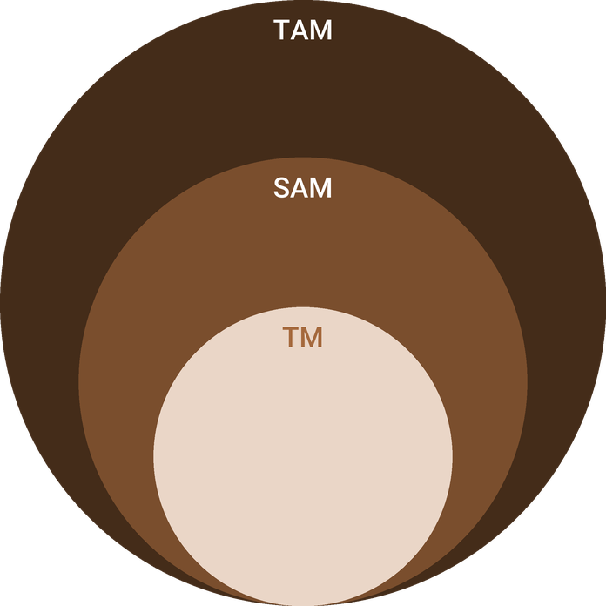
  ● | Total Available Market (TAM)  U.S. | 72.2B
  ● | Served Available Market (SAM)  The Wake County, North Carolina furniture store market is about $307.1 million a year (2025): 94 QCEW furniture retailer establishments x $3.27 million of national furniture store sales per establishment. | 307.1M
  ● | Target Market (TM)  One U.S. | 3.3M

3.5.1 PESTEL Analysis
  Political  - 25% tariff on imported upholstery, 30% from January 2027.  - Tariff increases have been delayed before.  - State sales tax of 4.75% plus county rates. |   Economic  - Mortgage rates near 7.40% slow home sales.  - Wake County median household income of $106,848.  - Financing spreads the cost of a large purchase. |   Social  - Wake County grew 2.0% in a year.  - 14.7% of residents moved in the past year.  - Buyers research online, then visit a showroom.
  Technological  - Room planning tools show a layout before ordering.  - Online booking turns browsing into appointments.  - Text updates keep delivery windows reliable. |   Environmental  - Domestic upholstery travels shorter distances.  - Crews take packaging away for recycling.  - Hurricane season can delay inbound freight. |   Legal  - Sofas and cushions fall under the state bedding law.  - Sales tax charged at the delivery address.  - Written terms for financing and protection plans.

CHAPTER 4

Customer Analysis

4.1 Target Market
4.2 Customer Segments
4.3 Customer Persona
4.4 Customer Purchase Journey

4.1 Target Market
Timberlane sells to homeowners aged about 30 to 60 who live within a delivery run of north Raleigh: Wake County first, then Durham, Johnston, Orange and Chatham counties. Most are buying because something in their home has changed, whether a move, a growing family or a smaller house, and most will spend a few thousand dollars on one visit and come back for the next room.
They are careful buyers. A sofa is a purchase made once a decade, so they research online, visit two or three showrooms and ask about delivery before they commit. Many prefer to spread the cost, which is why financing is offered at the desk.
The catchment is large enough for one showroom to grow in. Wake County had 499,951 households in 2024 at a median income of $106,848, and the median home was worth $521,600, which puts most of them in the mid-market where Timberlane prices its floor. Furniture follows those homes rather than the calendar: buying clusters in the months after a move, a renovation or a new child, and in the spring and fall sale seasons.

4.2 Customer Segments
- New-home households: recent buyers of new or resale homes furnishing several rooms in their first year. They buy whole rooms, value design help and are the largest segment.
- Room-by-room replacers: established families replacing a worn sofa, dining set or bedroom, often choosing made-to-order upholstery for size and durability.
- Downsizers: older couples moving to a smaller home who want fewer, better pieces and value delivery that includes setup and removal of packaging.
- Trade buyers: interior designers and small businesses buying for client projects and model homes, ordering repeatedly at a trade price.
The segments buy at different speeds. New-home households often buy two or three rooms over a few visits within weeks of closing, and many book a design appointment first. Replacers decide in one or two visits, usually on a weekend, and choose by fabric and comfort. Downsizers take longer and ask most about delivery and setup. Designers skip the floor and order by phone or email from the trade desk.

4.3 Customer Persona
  Megan Harper  Demographics  Age: 38  Family: Married, two children  Location: Apex, NC  Household Income: $135,000  Professional Role  Job: Clinical research project manager in Research Triangle Park | “We finally have the house. I want to sit on the sofa before I buy it, and I want it to arrive on the date they promise.”
   | Identifiers / Personality Traits  - Moved into a newly built house in the past year  - Researches online for weeks, then visits two or three showrooms  - Shops with a spouse on a Saturday or a weekday evening
   | Goals  - Furnish the main rooms in a style that will last a decade  - Choose a fabric that stands up to children and a dog  - Spread the cost of a large purchase without paying interest
   | Challenges  - Online photographs do not show scale, comfort or true colour  - Delivery windows from large stores slip and crews leave packaging behind  - Little time to visit stores during the working week

4.4 Customer Purchase Journey
Most customers start online, comparing styles and prices on retailer websites and searching for furniture stores near them. Timberlane's website and reviews turn that research into a visit or a booked design appointment.
In the showroom, a consultant greets every shopping party, learns what the room needs and shows the floor settings that fit. Buyers who want something specific move to the design center to choose a fabric and size, and many leave with swatch cuttings and a room plan before returning to order.
The order is written with a deposit, or financed through the third-party lender at the desk. Floor stock is delivered within ten days and special orders in six to ten weeks, with a two-hour arrival window confirmed the day before. The crew assembles and places the furniture and takes the packaging away.
Payment shapes the decision more than the price tag does. A customer writing a $2,100 sale often asks first what it costs a month, and promotional financing offers in the trade run 12 months without interest on purchases of $1,999 or more, so the consultant explains the terms at the desk before the customer leaves to think it over. Deposits are taken by card, and the balance is collected before the truck is loaded.
After delivery, the consultant follows up within a week and again when the customer is likely to need the next room. Referrals and reviews from these customers bring in the next round of buyers.

CHAPTER 5

Competitive Analysis

5.1 Competitors
5.2 Comparison
5.3 Competitive Edge
5.4 SWOT Analysis

5.1 Competitors
Wake County had 94 furniture retailer establishments in 2025. Several are national and regional chains: Rooms To Go has traded in Raleigh since 1997 and delivers across the Triangle, and Havertys and Ashley also have Raleigh showrooms. Ashley is the largest furniture retailer in the country, with $6,257.3 million of 2025 sales across 854 stores.
Online retailers are the second group. Wayfair sold $5,955.0 million of furniture and bedding in 2025 and Amazon $5,700.0 million, both selling on price and selection to buyers who never visit a store. The remaining local competitors are independent stores, most with one location. The Triangle has no IKEA: a proposed Cary store was withdrawn in 2018, and the nearest is in Charlotte.

5.2 Comparison
Chains match Timberlane on a showroom, design help and their own delivery, and beat it on price through volume buying. Online retailers win on selection and convenience but cannot let a customer sit on a sofa. Other independents offer local ownership but rarely made-to-order upholstery or a crew of their own. Timberlane is the only one of the four offering all five of the capabilities below.
Feature | Timberlane Furniture Co. | National chain showrooms | Online furniture retailers | Other independent stores
Furniture to see and sit on before buying | ✓ | ✓ | ✗ | ✓
Upholstery made to order in a chosen fabric | ✓ | ✓ | ✓ | ✗
Free design help in the store | ✓ | ✓ | ✗ | ✗
Own two-person crew for delivery and setup | ✓ | ✓ | ✗ | ✓
Owners on the floor and reachable after delivery | ✓ | ✗ | ✗ | ✓

5.3 Competitive Edge
Timberlane does not try to beat the chains on price. Its edge is combining the parts of the furniture purchase that customers find hardest: getting the right size and fabric, planning the room, and having it delivered and set up properly. Each of these is run by the store itself rather than outsourced, and the owners are on the floor to back it up.
Domestic made-to-order upholstery also protects the store from the 25% Section 232 tariff on imported upholstered furniture, which rises to 30% in January 2027 and raises costs for competitors that rely on imports.
   | Upholstery built to order  A customer chooses frame, cushion and cover from the swatch library, and the order goes to domestic upholstery makers rather than a container from overseas.
   | Design help without a minimum  Any customer can book a free consultation, and the consultant who plans the room writes the order and follows it to delivery.
   | One crew, warehouse to room  Timberlane's own two-person crew delivers, assembles and places every piece, so the store answers for the last mile instead of a carrier.
   | Owners who answer the phone  Both owners work in the business every day, which lets a problem after delivery reach someone who can decide on the spot.

5.4 SWOT Analysis
Strengths  - Made-to-order upholstery lets a customer choose fabric and size, which chain floor stock cannot match.  - An owner with fourteen years of furniture buying knows the makers and the High Point Market.  - Our own delivery crew controls the arrival date, the setup and the packaging removal.  - Free design help raises the ticket and the close rate without a fee to the customer. | Weaknesses  - A new name with no reviews competes against chains trading in Raleigh for decades.  - One showroom and one truck leave no slack when a crew member is out.  - A small buyer pays full wholesale prices without the volume terms chains negotiate.  - Six to ten week lead times on special orders lose impatient buyers.
Opportunities  - Wake County grew 2.0% in a year to 1,257,235 residents, and each new household needs furniture.  - The Triangle has no IKEA, leaving the furnished-room format to fewer competitors.  - Interior designers and builders furnishing model homes need a reliable local supplier.  - Domestic upholstery avoids the Section 232 tariff on imported upholstered furniture. | Threats  - Mortgage rates near 7.40% hold back home sales, the main trigger for furniture buying.  - The upholstery tariff rises to 30% in January 2027, lifting imported stock costs.  - Online retailers compete on price and selection for buyers who never visit a showroom.  - National furniture store sales fell 3.3% in early 2026, a weak backdrop for a new store.

 Strategic Summary
Timberlane should sell what chains and websites cannot: upholstery built to order, design help and its own delivery crew, aimed at the households moving into Wake County. It should keep floor stock lean while home sales stay slow.

CHAPTER 6

Products & Services

6.1 Our Offering
6.2 Signature Items
6.3 Additional Services
6.4 What Sets Us Apart
6.5 Special Orders & Lead Times

6.1 Our Offering
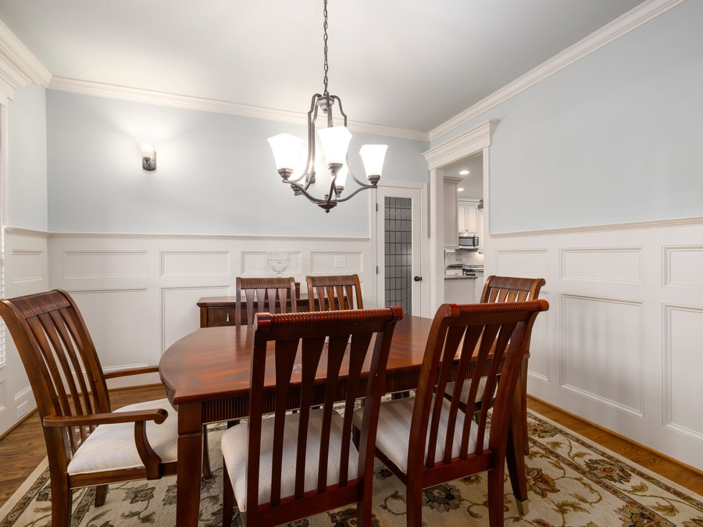
Timberlane sells furniture for the three rooms households furnish most often: the living room, the dining room and the bedroom. Customers can take home what is on the floor or order upholstery built to their choice, and every order can be delivered and set up by the store's own crew.

6.2 Signature Items
Upholstery leads the floor: sofas, sectionals, recliners and accent chairs, shown with the tables, rugs and lamps that complete the room. Solid wood dining tables, chairs and storage, and bedroom sets with beds, dressers and nightstands, fill the rest of the 12,000 square feet.

6.3 Additional Services
Design consultations are free and can be booked online or on arrival. A consultant reviews the customer's room measurements and photographs, draws a layout and assembles fabric and finish samples. Delivery is a flat $149 within Wake County and $199 elsewhere in the Triangle, and warehouse pickup is free.
Furniture protection plans are offered at the point of sale and serviced by a plan provider, and promotional financing is arranged at the desk through a third-party lender.

6.4 What Sets Us Apart
Customers can see the furniture, change the fabric or size, get help planning the room, and have the same company deliver it. The 49.0% gross margin reflects this mix: made-to-order upholstery, delivery and protection plans earn more than floor stock, which keeps the floor priced fairly against the chains.

6.5 Special Orders & Lead Times
A special order begins in the design center. The customer chooses a frame, arm style, cushion fill and leg finish, then a fabric or leather by grade. The consultant checks the size against the room plan, and a cutting of the chosen fabric is attached to the written order.
Timberlane takes a 50% deposit when the order is written and places it with the maker the same week. Upholstery is built in six to ten weeks and case goods in a custom finish in eight to twelve. The customer is told the expected ship week at order and given a delivery date once the piece is inspected in the warehouse.
Because nothing is bought until a deposit is paid, special orders add margin without adding unsold stock.

6.5.1 Showroom Collection
Living room, dining room and bedroom furniture set out on the floor as complete rooms, so a customer can sit, measure and compare before buying. Most pieces are held in the warehouse behind the showroom.
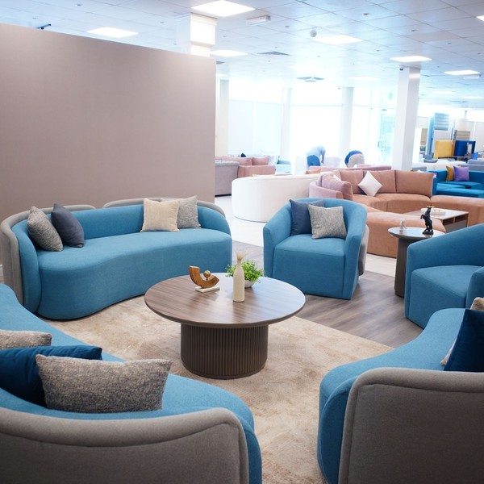 | Sofas from $1,299; dining sets from $1,499  Pieces are chosen for the mid-market buyer, where an average written sale of $2,100 buys a sofa with a chair or a dining set. Delivery and setup are priced separately and carried out by the store's own two-person crew. Most floor pieces are held in the warehouse behind the showroom, so they can be delivered within ten days rather than ordered in. Customers sit, measure and compare in rooms set out as they would be at home, and a design consultant will check a piece against a room before it is bought.

Specifications
- Sofas, sectionals, recliners, accent chairs, coffee and end tables.
- Dining tables, chairs, benches and storage pieces.
- Beds, dressers, chests and nightstands.
- Floor stock held in the warehouse for delivery within ten days.

6.5.2 Made-to-Order Upholstery
Sofas, sectionals and chairs built to order in the fabric or leather a customer picks from the swatch library. A design consultant checks the size against the room before the order is placed.
 | From $1,899 per sofa  Priced by frame and fabric grade, from $1,899 for a sofa. It earns more than floor stock because nothing is bought until the customer has paid a deposit. The customer chooses the frame, arm, fill and leg, then a fabric or leather from the swatch library, and a design consultant checks the size against the room before the order is placed. Pieces are built by domestic upholstery makers, many of them in North Carolina, and arrive six to ten weeks after ordering, delivered and set up by the store's own crew.

Specifications
- Hundreds of fabrics and leathers, sorted by grade; choice of frame, arm, fill and leg.
- Built by domestic upholstery makers, many of them in North Carolina.
- Lead time of six to ten weeks from order to delivery.

6.5.3 Features
   | Room settings  Furniture shown as finished rooms, so scale and colour can be judged.
   | Fabric and finish library  Fabric, leather and finish swatches, with cuttings to take home.
  Free design consultation
  A consultant plans the room from measurements and photographs.
   | Delivery with setup  Our crew carries, assembles and places every piece.

6.5.4 Pricing
Warehouse Pickup  $0  per order  - Dock pickup by appointment  - Loaded by our team |  | Most Popular  Wake County Delivery  $149  per order  - Two-person crew to the room  - Assembly and placement  - Packaging taken away |  | Triangle Delivery  $199  per order  - Four neighbouring counties  - Same crew and setup

CHAPTER 7

Marketing & Sales Strategies

7.1 Market Positioning
7.2 Marketing Objectives
7.3 Online Marketing
7.4 Public Relations and Branding
7.5 Partnership & Collaboration Strategy
7.6 Customer Loyalty & Retention
7.7 Sales Channels

7.1 Market Positioning
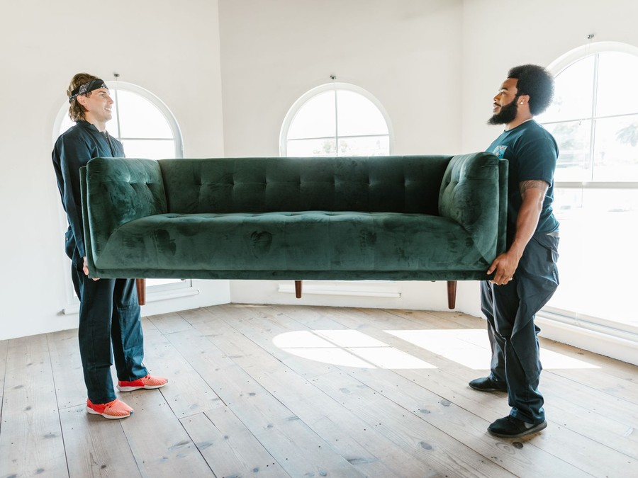
Timberlane is the Triangle furniture store for buyers who want to choose properly and have it delivered properly: furniture they can sit on, upholstery made to their size and fabric, free design help and its own delivery crew, at mid-market prices.

7.2 Marketing Objectives
- Reach 18 shopping parties a day within nine months of opening.
- Hold a close rate of 20% through consultant follow-up and design appointments.
- Build a group of interior designers who order through the trade desk in the first year.
- Collect reviews from customers after delivery and keep the rating high enough to bring in new buyers.
The marketing budget is 5.5% of revenue, $117,565 in the first year, with the opening campaign funded separately from the startup budget.
Search and social advertising  $3,429  per month  Local search ads and social campaigns aimed at Wake County households who have just moved. |  | New-mover mail and print  $2,449  per month  Mailers to recent home buyers and an insert in local home magazines.
Seasonal sale events  $2,449  per month  Spring, fall and holiday sale weekends with in-store events and signage. |  | Designer and referral program  $1,470  per month  Trade open houses for interior designers and thank-you credits for customer referrals.

Total marketing budget: $117,565 a year, $9,797 a month.

7.3 Online Marketing
Most furniture purchases begin with a search, so local search advertising and a well-structured catalogue take the largest share of spend. Every product page shows the piece in a room and offers a design appointment. Social campaigns target Wake County households who have recently moved, with photographs of the room settings and the delivery crew at work.

7.4 Public Relations and Branding
The brand rests on three promises: furniture chosen with help, made to fit and delivered as promised. Delivery trucks, swatch bags and the showroom signage carry the same name and colours. The opening is announced to local home and lifestyle media, and the owners speak at homebuyer seminars and neighbourhood association meetings in new subdivisions.

7.5 Partnership & Collaboration Strategy
Interior designers receive a trade price, a dedicated order contact and room in the design center to meet clients. The store offers home builders and real estate agents furnished model rooms and closing-gift vouchers, which put Timberlane in front of buyers at the moment they get their keys.

7.6 Customer Loyalty & Retention
Furniture customers return one room at a time, so retention depends on the first delivery going well and on keeping in touch afterwards. Each customer's room plan, fabric choices and purchases are kept on file, so the next visit starts where the last one ended. Past customers receive early access to seasonal sales, and a referral credit rewards those who recommend the store to neighbours.

7.7 Sales Channels
The showroom floor carries the plan, and special orders lift its margin.
  Showroom floor sales
  The largest share of revenue, sold from warehouse stock; it depends on traffic and a consultant greeting every party.
  Special orders from the design center
  Made-to-order pieces carry the higher ticket and margin, and depend on planning the whole room.
   | Designer and trade accounts  Designers and small businesses buying at a trade price, worth steady repeat orders once they trust the delivery.
   | Website appointment requests  Online browsers who book a design appointment, a small share that grows with reviews.

CHAPTER 8

Operations Plan

8.1 Daily Operations
8.2 Working Hours
8.3 Staffing & Training
8.4 Inventory & Equipment Management
8.5 Location and Facilities
8.6 Milestones & Timeline
8.7 Delivery & In-Home Setup

8.1 Daily Operations
The day starts in the warehouse. The crew loads the truck for the day's route, checking each piece against its order, and leaves by 8:30 a.m. The showroom opens at 10 a.m., after the floor is walked, tags are checked and any piece sold yesterday is replaced from stock. Consultants work the floor and the design center, and every written order is entered the same day so the warehouse can pull, reserve or order the pieces.
In the afternoon, the warehouse lead receives inbound freight, inspects each piece and books delivery dates for orders that are complete. The office coordinator confirms the next day's arrival windows by text and handles service calls.

8.2 Working Hours
The showroom opens Monday, Tuesday, Thursday, Friday and Saturday from 10 a.m. to 7 p.m., and Sunday from noon to 6 p.m. It closes on Wednesday, usually the quietest day of the week, which gives staff a fixed day off and the warehouse a day to receive freight and prepare deliveries without interruptions. Evening and weekend hours are when couples can shop together, and that is when most furniture is bought.

8.3 Staffing & Training
The opening team is nine people: the two owners, three sales and design consultants, a two-person delivery crew, a warehouse lead and a part-time office coordinator. Consultants receive a base wage plus commission, so their pay rises and falls with sales. A fourth consultant is planned for the second year.
Before opening, every consultant learns the floor stock, the fabric grades and the special order process, and spends a day with the delivery crew. The crew is trained in lifting, assembly and floor protection, and practises setting up a full room in the warehouse before the first delivery.

8.4 Inventory & Equipment Management
Floor and warehouse stock turn about four times a year. Every piece is tracked in the point-of-sale system from receipt to delivery, and slow-moving pieces are marked down in the seasonal sales before they tie up space. Special orders are placed only after a deposit, so they add little stock.
The warehouse carries pallet racking, a pallet jack, furniture dollies, a touch-up station and a receiving bench. The truck is serviced on a fixed schedule, with a rental arrangement for a breakdown.

8.5 Location and Facilities
Timberlane leases a 17,000 square foot freestanding former retail building on a commercial corridor in north Raleigh: a 12,000 square foot showroom at the front and a 5,000 square foot warehouse with a loading dock behind it. The building rents for about $14.50 a square foot including triple net charges, below the Raleigh retail average, because a second-generation building with a dock prices closer to industrial space. It has parking at the door, room for a lit sign facing the road, and a short drive to the main routes into Cary, Wake Forest and Knightdale.

8.6 Milestones & Timeline
The lease and loan close in December 2026, the fit-out and opening orders follow in January, and the team is hired and trained in February. The showroom opens in March 2027, in time for the spring buying season.
Dec 2026  Setup |  |  | Lease and loan closed  Building secured and funding in place  The owners sign a ten-year lease on the north Raleigh building and close the SBA 7(a) loan.
Jan 2027  Setup |  |  | Fit-out and opening orders  Showroom built, floor stock ordered  Lighting, flooring and room settings go in while the opening stock is ordered from makers on payment terms.
Feb 2027  Setup |  |  | Team hired and trained  Sales, delivery and warehouse staff start  Consultants learn the stock and the special order process; the delivery crew rehearses setup in the warehouse.
Mar 2027  Launch |  |  | Grand opening sale  Doors open for the spring season  An opening sale weekend backed by mailers to recent Wake County home buyers and a designer open house.
Apr 2027  Growth |  |  | First High Point Market as a store  Buying for the fall floor  Dana Mercer buys the fall assortment using the first weeks of sales to decide what to reorder.
Mar 2028  Growth |  |  | Fourth design consultant  First anniversary  With traffic settled, a fourth consultant joins to cover weekends and the designer accounts.

8.7 Delivery & In-Home Setup
Delivery is a two-person job. The crew drives a 26 foot box truck with a liftgate, carrying furniture pads, floor runners, door jamb protectors, a tool kit and a touch-up kit. A full day covers six to eight stops across Wake County, planned so that heavy and fragile pieces load last and come off first.
Each customer receives a two-hour arrival window by text the day before and a message when the truck is 30 minutes away. At the home, the crew lays runners, carries each piece to the room, assembles beds and tables, places the furniture where the customer wants it, and removes every carton and wrap for recycling. The customer signs off on the condition of each piece before the crew leaves.
Any damage found at delivery is photographed, and the piece is repaired on site with the touch-up kit or returned for replacement. Delivery to the four other Triangle counties runs on fixed days of the week to keep routes efficient.
Routes are built the evening before from the orders that are complete in the warehouse. Wake County is split into north, south and west zones, and each zone has two regular delivery days, so a customer is offered a date within the week their order is ready. Special orders are scheduled only once every piece in the order has arrived and passed inspection, so a dining set is never delivered without its chairs.
One truck and one crew can carry the first year's volume. The plan adds a second crew on busy weekends from the warehouse lead and a part-time helper before it adds a second truck, and the owners review delivery capacity each quarter against written sales. Service calls after delivery, such as a loose leg or a fabric fault, are booked into the same routes, and faults covered by a maker's warranty are claimed back from the maker.

CHAPTER 9

Management Team

9.1 Key Members
9.2 Organization Chart
9.3 Advisory Board Members

9.1 Key Members
Dana Mercer is accountable for revenue and margin: what is bought, how it is priced and how the floor sells it, measured monthly on written sales, close rate, average sale and gross margin. Marcus Hale is accountable for everything after the sale, from receiving to delivery and service, measured on on-time delivery, damage claims and inventory turns. Priya Raman leads the design center and the trade desk, measured on special orders written and designer accounts opened.
Consultants are measured weekly on close rate, average sale and the share of sales that include delivery and a protection plan, against the floor's traffic count. The owners take a fixed salary through the payroll budget.
 | Dana Mercer  Owner & General Manager · dana@timberlanefurniture.example  Fourteen years buying and managing the sales floor for a regional furniture retailer, including eight years of High Point Market buying trips.

 | Marcus Hale  Owner & Operations Manager · marcus@timberlanefurniture.example  Ran warehouse and last-mile delivery for a home goods distributor serving the Triangle, with responsibility for crews, routing and damage claims.

 | Priya Raman  Lead Design Consultant · priya@timberlanefurniture.example  Interior design graduate who spent six years planning rooms and writing special orders on a furniture showroom floor.

9.2 Organization Chart
All staff report to Dana Mercer as general manager. The three sales and design consultants report to Priya Raman for training and scheduling, and the delivery crew and warehouse lead report to Marcus Hale. Janelle Brooks, part time, handles delivery confirmations, service calls and bookkeeping support. The two owners meet weekly to review sales, stock and the delivery schedule, and agree on any purchase above a set limit together.
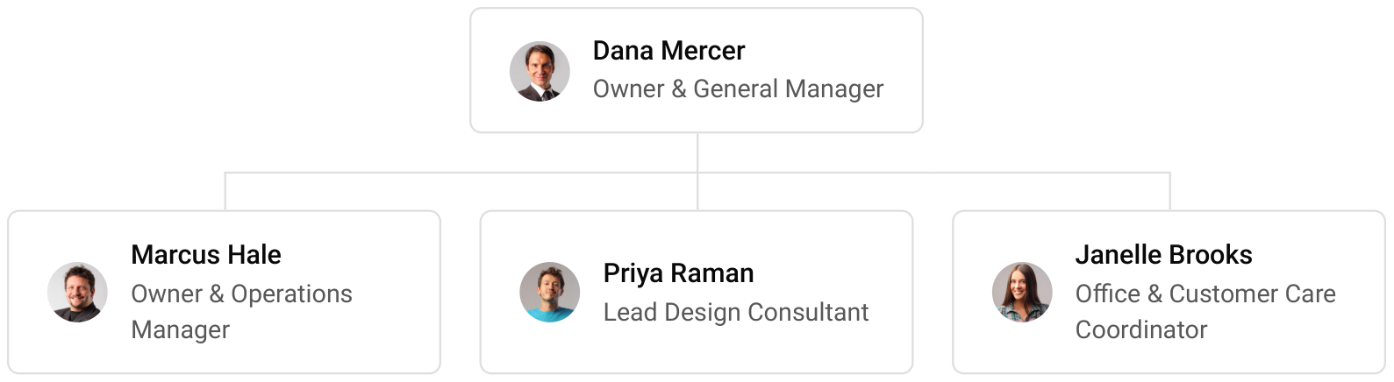

9.3 Advisory Board Members
The owners have arranged three advisers. A certified public accountant reviews the monthly accounts and prepares tax filings. A retired independent furniture store owner meets the owners quarterly to review buying and margins. The SBA lender's relationship manager reviews the annual results against the loan covenants. None holds equity.

9.3.1 Hiring Plan
2  Filled |  | 7  Hiring This Year |  | 8  Open

Group By Department | Position Filled | Time of Hire | Time of Start | Filled
Management | 2 of 2 | 0 days | 0 days | 100%
Sales & Design | 0 of 4 | 45 days | 30 days | 0%
Delivery & Warehouse | 0 of 3 | 30 days | 14 days | 0%
Office & Customer Care | 0 of 1 | 30 days | 14 days | 0%

CHAPTER 10

Financial Plan

10.1 Key Assumptions
10.2 Capital Requirements and Use of Funds
10.3 Income Statement (3 Year projections)
10.4 Balance Sheet (3 Year projections)
10.5 Cash Flow Statement (3 Year projections)
10.6 Break Even Analysis

10.1 Key Assumptions
Revenue follows one formula: showroom traffic times close rate times average sale times operating days, plus delivery fees and protection plans. The model assumes 18 shopping parties a day, a 20% close rate, an average written sale of $2,100 and 308 trading days, with delivery and protection adding 8%. The store opens at 60% of that traffic and reaches it after nine months, and revenue grows 15% a year.
The traffic and close rate are deliberately below what a settled store reaches: the 20% close rate sits under the 22% median Furniture Today reported, and the average sale sits well under the $3,530 that Havertys, an established chain, reports. Gross margin is 49.0%, covering landed furniture costs, freight, tariffs and the cost of protection plans. Payroll is 19% of revenue, marketing 5.5% and other operating costs 4.5%. Rent is $20,500 a month, administration and insurance $5,500, and technology $1,400. Stock turns every 90 days, makers are paid in 45, and almost every sale is paid before delivery.
On those assumptions, revenue is $2,137,545 in the first year, $2,458,176 in the second and $2,826,903 in the third. Net income moves from a loss of $175 to $49,603 and then $106,267. Break-even revenue, counting operating costs before depreciation and loan interest, is $1,937,188, or 922 orders a year. The first year clears it, and its small loss is the depreciation and interest that figure leaves out.

10.2 Capital Requirements and Use of Funds
The business needs $511,000 to open, itemized below: the showroom fit-out, display fixtures, signage, the delivery truck, warehouse equipment, systems, the website, launch marketing, deposits and pre-opening rent, licenses and legal work, and pre-opening payroll. The owners contribute $250,000 and an SBA 7(a) loan provides $450,000 at 10.5% over ten years.
The scenarios move the volume drivers harder than price. In the conservative case fewer shopping parties reach the floor and fewer buy, and the third year returns a net loss of $33,750; the response would be to hold floor stock and marketing to the sales the store is actually writing rather than to cut delivery or design help. In the upside case, net income reaches $321,072 in the third year because traffic settles faster and higher.
The funding beyond the startup budget pays for the opening floor stock that the makers' payment terms do not cover. The loan is repaid from operating cash, and no distributions are taken in the first three years, so profits go toward stock and the loan.

10.2.1 Use of Funds
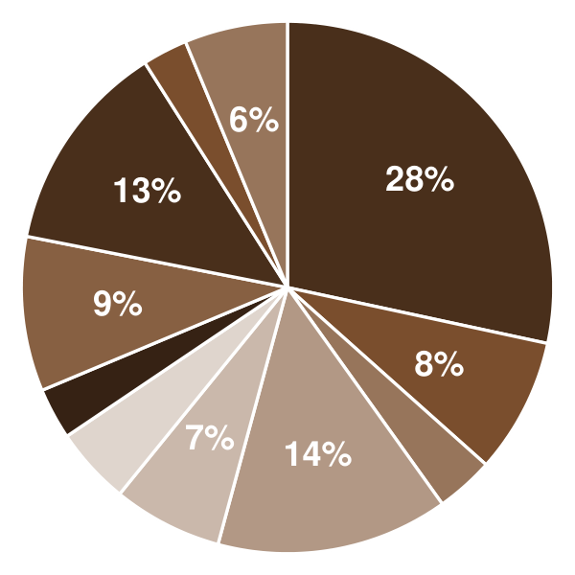 | ● Showroom Fit-Out 28.4%  ● Display Fixtures & Room Settings 8.2%  ● Exterior Signage 3.5%  ● Delivery Truck 14.1%  ● Warehouse Equipment 6.7%  ● Point of Sale & Systems 4.7%  ● Website & Product Photography 3.1%  ● Launch Marketing 9.4%  ● Deposits & Pre-Opening Rent 12.9%  ● Licenses, Insurance & Legal 2.7%  ● Pre-Opening Payroll & Training 6.3%

Use Of Funds | Amount
Showroom Fit-Out | $145,000.00
Display Fixtures & Room Settings | $42,000.00
Exterior Signage | $18,000.00
Delivery Truck | $72,000.00
Warehouse Equipment | $34,000.00
Point of Sale & Systems | $24,000.00
Website & Product Photography | $16,000.00
Launch Marketing | $48,000.00
Deposits & Pre-Opening Rent | $66,000.00
Licenses, Insurance & Legal | $14,000.00
Pre-Opening Payroll & Training | $32,000.00

10.3 Income Statement (3 Year projections)
 | Year 1 | Year 2 | Year 3 | Total
Revenue | $2,137,544.64 | $2,458,176.34 | $2,826,902.79 | $7,422,623.77
Cost of Sales | $1,090,147.77 | $1,253,669.93 | $1,441,720.42 | $3,785,538.12
General Costs | $0.00 | $0.00 | $0.00 | $0.00
Revenue Specific Costs | $1,090,147.77 | $1,253,669.93 | $1,441,720.42 | $3,785,538.12
Personnel Costs (Direct Labor) | $0.00 | $0.00 | $0.00 | $0.00
Gross Margin | $1,047,396.87 | $1,204,506.41 | $1,385,182.37 | $3,637,085.65
Gross Margin (%) | 49.00% | 49.00% | 49.00% | 49.00%
Operating Expense | $949,222.34 | $1,042,285.68 | $1,149,308.54 | $3,140,816.56
Payroll Expense (Indirect Labor) | $406,133.48 | $467,053.50 | $537,111.53 | $1,410,298.51
General Expense | $542,554.47 | $574,617.64 | $611,490.28 | $1,728,662.39
Bad Debt | $534.39 | $614.54 | $706.73 | $1,855.66
Amortization of Current Assets | $0.00 | $0.00 | $0.00 | $0.00
EBITDA | $98,174.53 | $162,220.73 | $235,873.83 | $496,269.09
Additional Expense | $98,350.00 | $112,617.57 | $129,607.27 | $340,574.84
Long Term Depreciation | $51,100.00 | $53,558.18 | $56,385.08 | $161,043.26
Gain or loss from Sale of Assets | $0.00 | $0.00 | $0.00 | $0.00
EBIT | $47,074.53 | $108,662.55 | $179,488.75 | $335,225.83
Interest Expense | $47,250.00 | $42,525.00 | $37,800.00 | $127,575.00
EBT | ($175.47) | $66,137.55 | $141,688.75 | $207,650.83
Income Tax Expense / Benefit | $0.00 | $16,534.39 | $35,422.19 | $51,956.58
Total Expense | $2,137,720.11 | $2,408,573.18 | $2,720,636.23 | $7,266,929.52
Net Income | ($175.47) | $49,603.16 | $106,266.56 | $155,694.25
Net Income (%) | -0.01% | 2.02% | 3.76% | 2.10%
Retained Earning Opening | $0.00 | ($175.47) | $49,427.69
Owner's Distribution | $0.00 | $0.00 | $0.00 | $0.00
Retained Earning Closing | ($175.47) | $49,427.69 | $155,694.25 | $155,694.25

10.4 Balance Sheet (3 Year projections)
 | Year 1 | Year 2 | Year 3 | Total
Assets | $789,226.31 | $818,123.34 | $907,296.15 | $907,296.15
Current Assets | $329,326.31 | $387,199.76 | $504,488.62 | $504,488.62
Cash | $51,058.68 | $68,391.99 | $139,059.68 | $139,059.68
Accounts Receivable | $1,464.07 | $1,683.68 | $1,936.23 | $1,936.23
Inventory | $268,803.56 | $309,124.09 | $355,492.71 | $355,492.71
Other Current Assets | $8,000.00 | $8,000.00 | $8,000.00 | $8,000.00
Long Term Assets | $459,900.00 | $430,923.58 | $402,807.53 | $402,807.53
Gross Long Term Assets | $511,000.00 | $535,581.76 | $563,850.79 | $563,850.79
Accumulated Depreciation | $51,100.00 | $104,658.18 | $161,043.26 | $161,043.26
Liabilities & Equity | $789,226.31 | $818,123.34 | $907,296.15 | $907,296.15
Liabilities | $539,401.78 | $518,695.65 | $501,601.90 | $501,601.90
Current Liabilities | $179,401.78 | $203,695.65 | $231,601.90 | $231,601.90
Accounts Payable | $134,401.78 | $154,562.05 | $177,746.35 | $177,746.35
Income Tax Payable | $0.00 | $4,133.60 | $8,855.55 | $8,855.55
Sales Tax Payable | $0.00 | $0.00 | $0.00 | $0.00
Short Term Debt | $45,000.00 | $45,000.00 | $45,000.00 | $45,000.00
Long Term Liabilities | $360,000.00 | $315,000.00 | $270,000.00 | $270,000.00
Long Term Debt | $360,000.00 | $315,000.00 | $270,000.00 | $270,000.00
Equity | $249,824.53 | $299,427.69 | $405,694.25 | $405,694.25
Paid-in Capital | $0.00 | $0.00 | $0.00 | $0.00
Common Stock | $0.00 | $0.00 | $0.00 | $0.00
Preferred Stock | $0.00 | $0.00 | $0.00 | $0.00
Owner's Contribution | $250,000.00 | $250,000.00 | $250,000.00 | $250,000.00
Retained Earnings | ($175.47) | $49,427.69 | $155,694.25 | $155,694.25
Check | $0.00 | $0.00 | $0.00 | $0.00

10.5 Cash Flow Statement (3 Year projections)
 | Year 1 | Year 2 | Year 3 | Total
Cash Received | $2,290,518.17 | $2,635,559.97 | $3,030,893.96 | $7,956,972.10
Cash Paid | $2,383,459.49 | $2,548,644.90 | $2,886,957.24 | $7,819,061.63
COS & General Expenses | $1,775,104.02 | $1,848,447.83 | $2,076,395.02 | $5,699,946.87
Salary & Wages | $406,133.48 | $467,053.50 | $537,111.53 | $1,410,298.51
Interest | $47,250.00 | $42,525.00 | $37,800.00 | $127,575.00
Sales Tax | $154,971.99 | $178,217.78 | $204,950.45 | $538,140.22
Income Tax | $0.00 | $12,400.79 | $30,700.24 | $43,101.03
Net Cash From Operations | ($92,941.32) | $86,915.07 | $143,936.72 | $137,910.47
Assets Sell | $0.00 | $0.00 | $0.00 | $0.00
Assets Purchase | $511,000.00 | $24,581.76 | $28,269.03 | $563,850.79
Net Cash From Investments | ($511,000.00) | ($24,581.76) | ($28,269.03) | ($563,850.79)
Amount Received | $700,000.00 | $0.00 | $0.00 | $700,000.00
Loan Received | $450,000.00 | $0.00 | $0.00 | $450,000.00
Common Stock | $0.00 | $0.00 | $0.00 | $0.00
Preferred Stock | $0.00 | $0.00 | $0.00 | $0.00
Owner's Contribution | $250,000.00 | $0.00 | $0.00 | $250,000.00
Amount Paid | $45,000.00 | $45,000.00 | $45,000.00 | $135,000.00
Loan Capital | $45,000.00 | $45,000.00 | $45,000.00 | $135,000.00
Dividends & Distributions | $0.00 | $0.00 | $0.00 | $0.00
Net Cash From Financing | $655,000.00 | ($45,000.00) | ($45,000.00) | $565,000.00
Summary
Starting Cash | $0.00 | $51,058.68 | $68,391.99
Cash In | $2,990,518.17 | $2,635,559.97 | $3,030,893.96 | $8,656,972.10
Cash Out | $2,939,459.49 | $2,618,226.66 | $2,960,226.27 | $8,517,912.42
Change in Cash | $51,058.68 | $17,333.31 | $70,667.69 | $139,059.68
Ending Cash | $51,058.68 | $68,391.99 | $139,059.68 | $139,059.68

10.6 Break Even Analysis
 | Year 1 | Year 2 | Year 3 | Total
Starting Revenue | $0.00 | $2,137,544.64 | $4,595,720.98 | $4,595,720.98
Net Revenue | $2,137,544.64 | $2,458,176.34 | $2,826,902.79 | $2,826,902.79
Closing Revenue | $2,137,544.64 | $4,595,720.98 | $7,422,623.77 | $7,422,623.77
Starting Expense | $0.00 | $2,137,720.11 | $4,546,293.29 | $4,546,293.29
Net Expense | $2,137,720.11 | $2,408,573.18 | $2,720,636.23 | $2,720,636.23
Closing Expense | $2,137,720.11 | $4,546,293.29 | $7,266,929.52 | $7,266,929.52
Is Break Even? | No | Yes | Yes
Break Even Month | - | Jan '27 | -
Days Required | - | 1 Days | -
Break Even Revenue | - | $2,342,392.67 | -

CHAPTER 11

References

- SRC001: Retail Sales: Furniture Stores (MRTSSM4421USN), U.S. Census Bureau via Federal Reserve Bank of St. Louis (FRED), 2026-09-16. https:/‌/‌fred.‌stlouisfed.‌org/‌series/‌MRTSSM4421USN (accessed 2026-10-13)
- SRC002: Furniture Stores in the US Industry Analysis, 2026, IBISWorld, 2026-06-01. https:/‌/‌www.‌ibisworld.‌com/‌united-states/‌market-research-reports/‌furniture-stores-industry/‌ (accessed 2026-10-13)
- SRC003: Quarterly Census of Employment and Wages, 2025 Annual Averages, NAICS 449110 Furniture Retailers, U.S. Bureau of Labor Statistics, 2026-01-01. https:/‌/‌data.‌bls.‌gov/‌cew/‌data/‌api/‌2025/‌a/‌industry/‌449110.‌csv (accessed 2026-10-13)
- SRC004: Monthly State Retail Sales, December 2025, U.S. Census Bureau, 2026-04-09. https:/‌/‌www.‌census.‌gov/‌retail/‌mrts/‌www/‌statedata/‌msrs_‌report_‌december2025.‌pdf (accessed 2026-10-13)
- SRC005: Home News Now 125 furniture and bedding retailers 2025: Nos. 1-25, Home News Now, 2026-06-22. https:/‌/‌homenewsnow.‌com/‌blog/‌2026/‌06/‌22/‌home-news-now-125-furniture-bedding-retailers-2025-nos-1-25/‌ (accessed 2026-10-13)
- SRC006: La-Z-Boy Incorporated Form 10-K for the fiscal year ended April 25, 2026, U.S. Securities and Exchange Commission, 2026-06-01. https:/‌/‌www.‌sec.‌gov/‌Archives/‌edgar/‌data/‌0000057131/‌000005713126000019/‌lzb-20260425.‌htm (accessed 2026-10-13)
- SRC007: Existing Home Sales Climb to Near 3-Year High in December, National Association of Home Builders (Eye on Housing), 2026-01-01. https:/‌/‌eyeonhousing.‌org/‌2026/‌01/‌existing-home-sales-climb-to-near-3-year-high-in-december/‌ (accessed 2026-10-13)
- SRC008: Furniture Demand Faces the Elasticity Test, but Housing Turnover and Home Price Appreciation Hold the Key, Zelman & Associates, 2026-02-01. https:/‌/‌www.‌zelmanassociates.‌com/‌resources/‌zelman-insights/‌2026-02-(1)/‌furniture-demand-faces-the-elasticity-test,-but-ho (accessed 2026-10-13)
- SRC009: 30-Year Fixed Rate Mortgage Average in the United States (MORTGAGE30US), Freddie Mac via Federal Reserve Bank of St. Louis (FRED), 2026-10-01. https:/‌/‌fred.‌stlouisfed.‌org/‌series/‌MORTGAGE30US (accessed 2026-10-13)
- SRC010: Vietnam surges ahead as China's grip on U.S. furniture imports weakens, Interior Daily, 2026-01-01. https:/‌/‌www.‌interiordaily.‌com/‌article/‌9824913/‌vietnam-surges-ahead-as-china-s-grip-on-u-s-furniture-imports-weakens/‌ (accessed 2026-10-13)
- SRC011: Section 232 duties delayed on upholstered furniture, kitchen cabinets and vanities, Livingston International, 2026-01-05. https:/‌/‌www.‌livingstonintl.‌com/‌section-232-duties-delayed-on-upholstered-furniture-kitchen-cabinets-and-vanities-2/‌ (accessed 2026-10-13)
- SRC012: President Trump Delays Section 232 Tariff Increase on Wood Furniture, Cabinets and Vanities, Thompson Hine SmarTrade, 2026-01-05. https:/‌/‌www.‌thompsonhinesmartrade.‌com/‌2026/‌01/‌president-trump-delays-section-232-tariff-increase-on-wood-furniture-cabinets-and-vanities/‌ (accessed 2026-10-13)
- SRC013: Close ratios and stock turns decrease; gross margin increases, Furniture Today, 2016-11-29. https:/‌/‌www.‌furnituretoday.‌com/‌business-news/‌close-ratios-and-stock-turns-decrease-gross-margin-increases (accessed 2026-10-13)
- SRC014: Cover Story: Retail Metrics for Furniture Retailing, Home Furnishings Business, 2018-01-01. https:/‌/‌hfbusiness.‌com/‌CurrentIssue/‌CurrentIssueModule/‌ArticleId/‌17410/‌cover-story-retail-metrics-for-furniture-retailing (accessed 2026-10-13)
- SRC015: Havertys Reports Operating Results for Fourth Quarter 2025, Haverty Furniture Companies via Seeking Alpha, 2026-02-24. https:/‌/‌seekingalpha.‌com/‌pr/‌20410442 (accessed 2026-10-13)
- SRC016: How to Increase Your Furniture Store's Closing Rate, The Retail Doctor. https:/‌/‌www.‌retaildoc.‌com/‌blog/‌how-to-increase-your-furniture-stores-closing-rate (accessed 2026-10-13)
- SRC017: Bet On Black, Furniture World. https:/‌/‌mydigitalpublication.‌com/‌article/‌Bet+On+Black/‌1650686/‌199695/‌article.‌html (accessed 2026-10-13)
- SRC018: White Glove Delivery: Elevating Logistics with Premium Care and Precision, FreightAmigo, 2025-01-01. https:/‌/‌www.‌freightamigo.‌com/‌en/‌blog/‌logistics/‌white-glove-delivery-elevating-logistics-with-premium-care-and-precision/‌ (accessed 2026-10-13)
- SRC019: Is it 2025 yet? Retailers polled at High Point express optimism about sales next year, Home Accents Today, 2024-10-31. https:/‌/‌www.‌homeaccentstoday.‌com/‌furniture-retailing/‌is-it-2025-yet-retailers-polled-at-high-point-express-optimism-about-sales-next-year (accessed 2026-10-13)
- SRC020: Everyday promotional financing offers, Synchrony, 2026-01-01. https:/‌/‌www.‌synchrony.‌com/‌home (accessed 2026-10-13)
- SRC021: Furniture and Home Furnishings Stores: NAICS 442, U.S. Bureau of Labor Statistics, 2026-10-01. https:/‌/‌www.‌bls.‌gov/‌iag/‌tgs/‌iag442.‌htm (accessed 2026-10-13)
- SRC022: Quarterly Census of Employment and Wages, 2024 Annual Averages, NAICS 449110 Furniture Retailers, U.S. Bureau of Labor Statistics, 2025-01-01. https:/‌/‌data.‌bls.‌gov/‌cew/‌data/‌api/‌2024/‌a/‌industry/‌449110.‌csv (accessed 2026-10-16)
- SRC023: Wake County, NC Profile (ACS 2024 1-year), Census Reporter, 2025-01-01. https:/‌/‌censusreporter.‌org/‌profiles/‌05000US37183-wake-county-nc/‌ (accessed 2026-10-16)
- SRC024: QuickFacts: Wake County, North Carolina, U.S. Census Bureau, 2026-01-01. https:/‌/‌www.‌census.‌gov/‌quickfacts/‌wakecountynorthcarolina (accessed 2026-10-16)
- SRC025: New Private Housing Units Authorized by Building Permits for Raleigh-Cary, NC (MSA) (RALE537BPPRIV), U.S. Census Bureau via Federal Reserve Bank of St. Louis (FRED), 2026-01-01. https:/‌/‌fred.‌stlouisfed.‌org/‌series/‌RALE537BPPRIV (accessed 2026-10-16)
- SRC026: December 2025's Median Price of Wake County Real Estate decreased by $15,000 to $455,000, Wake County Government, 2026-01-01. https:/‌/‌www.‌wake.‌gov/‌news/‌december-2025s-median-price-wake-county-real-estate-decreased-15000-455000 (accessed 2026-10-16)
- SRC027: High Point Market Fall 2026 registration opens ahead of October furnishings trade show, Surface & Panel, 2026-01-01. https:/‌/‌www.‌surfaceandpanel.‌com/‌high-point-market-fall-2026-registration-opens-ahead-of-october-furnishings-trade-show/‌ (accessed 2026-10-16)
- SRC028: Furniture Store in Raleigh, NC, Rooms To Go, 2026-01-01. https:/‌/‌www.‌roomstogo.‌com/‌stores/‌north-carolina/‌raleigh-patio-1644 (accessed 2026-10-16)
- SRC029: To Grow Its Presence in the Southeast and North Carolina IKEA Proposes Potential Raleigh Area Store in Town of Cary, Business Wire, 2017-05-18. https:/‌/‌www.‌businesswire.‌com/‌news/‌home/‌20170518005274/‌en/‌To-Grow-Its-Presence-in-the-Southeast-and-North-Carolina-IKEA-Proposes-Potential-Raleigh-Area-Store-in-Town-of-Cary (accessed 2026-10-16)
- SRC030: IKEA closing South Charlotte store, Spectrum News, 2026-07-09. https:/‌/‌spectrumlocalnews.‌com/‌nc/‌coastal/‌news/‌2026/‌07/‌09/‌ikea-closing-south-charlotte-store (accessed 2026-10-16)
- SRC031: Q2 2026 Raleigh, NC Retail Market Overview, Lee & Associates, 2026-07-01. https:/‌/‌www.‌lee-associates.‌com/‌wp-content/‌uploads/‌2026/‌07/‌2026-Q2-Raleigh-NC-Retail.‌pdf (accessed 2026-10-16)
- SRC032: Q2 2026 Raleigh, NC Industrial Market Overview, Lee & Associates, 2026-07-01. https:/‌/‌www.‌lee-associates.‌com/‌wp-content/‌uploads/‌2026/‌07/‌2026-Q2-Raleigh-NC-Industrial.‌pdf (accessed 2026-10-16)
- SRC033: Current Sales and Use Tax Rates, North Carolina Department of Revenue, 2026-07-01. https:/‌/‌www.‌ncdor.‌gov/‌taxes-forms/‌sales-and-use-tax/‌sales-and-use-tax-rates/‌current-sales-and-use-tax-rates (accessed 2026-10-16)
- SRC034: North Carolina Bedding Manufacturer License, New Application, North Carolina Department of Agriculture and Consumer Services, 2026-01-01. https:/‌/‌ncagr.‌gov/‌divisions/‌structural-pests-and-pesticides/‌nc-new-bedding-manufacturer-license-application/‌open (accessed 2026-10-16)




