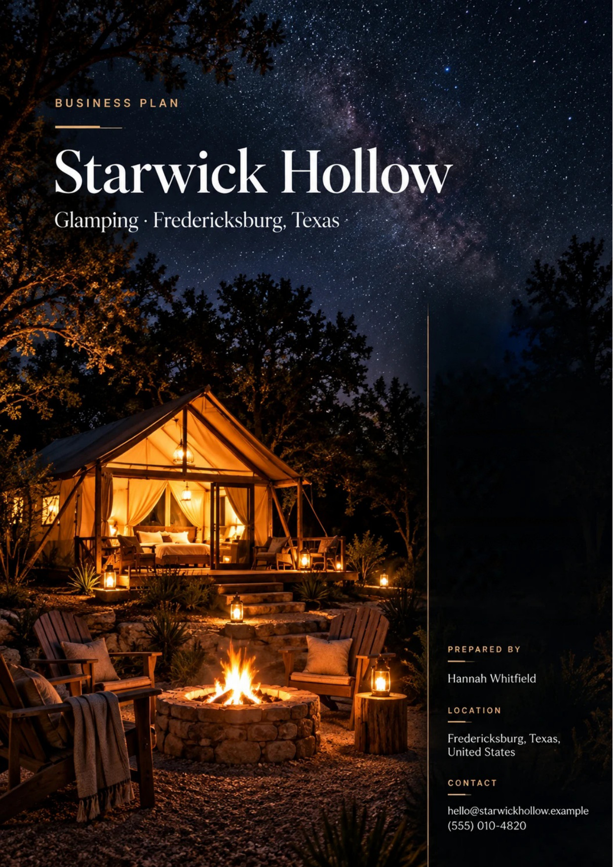
Table of Contents
1. Executive Summary 6
1.1 Business Overview 7
1.2 Mission Statement 7
1.3 Location & Market Opportunity 7
1.4 Unique Selling Points 7
1.5 Financial Highlights 8
1.6 Funding Requirement 8
1.6.1 Income Statement (3 Year projections) 8
2. Company Overview 9
2.1 Legal Structure 10
2.2 Vision Statement 10
2.3 Background & History 10
2.4 Future Goals 10
2.4.1 Business Owners 11
2.4.2 SMART Goal 11
3. Market Analysis 12
3.1 Overview 13
3.2 Market Segmentation 13
3.3 Market Trends 13
3.4 Local Market Outlook 13
3.5 Market Size 14
4. Customer Analysis 15
4.1 Target Market 16
4.2 Customer Segments 16
4.3 Customer Persona 17
4.4 Customer Purchase Journey 17
5. Competitive Analysis 18
5.1 Competitors 19
5.2 Comparison 19
5.3 Competitive Edge 20
5.4 SWOT Analysis 21
6. Services Offered 22
6.1 Our Offering 23
6.2 Signature Items 23
6.3 Additional Services 23
6.4 What Sets Us Apart 23
6.5 Glamping Units & Amenities 24
6.5.1 Safari Tent and Stargazing Dome Stays 24
6.5.2 Celebration and Experience Packages 25
6.5.3 Features 26
6.5.4 Pricing 26
7. Marketing & Sales Strategies 27
7.1 Market Positioning 28
7.2 Marketing Objectives 28
7.3 Online Marketing 29
7.4 Public Relations and Branding 29
7.5 Partnership & Collaboration Strategy 29
7.6 Customer Loyalty & Retention 29
7.7 Sales Channels 30
8. Operations Plan 31
8.1 Daily Operations 32
8.2 Working Hours 32
8.3 Staffing & Training 32
8.4 Inventory & Equipment Management 32
8.5 Location and Facilities 32
8.6 Milestones & Timeline 33
8.7 Flood, Fire & Weather Safety 34
9. Management Team 35
9.1 Key Members 36
9.2 Organization Chart 36
9.3 Advisory Board Members 37
9.3.1 Hiring Plan 37
10. Financial Plan 38
10.1 Key Assumptions 39
10.2 Capital Requirements and Use of Funds 39
10.2.1 Use of Funds 40
10.3 Income Statement (3 Year projections) 41
10.4 Balance Sheet (3 Year projections) 42
10.5 Cash Flow Statement (3 Year projections) 43
10.6 Break Even Analysis 44
11. References 45


CHAPTER 1

Executive Summary

1.1 Business Overview
1.2 Mission Statement
1.3 Location & Market Opportunity
1.4 Unique Selling Points
1.5 Financial Highlights
1.6 Funding Requirement

1.1 Business Overview
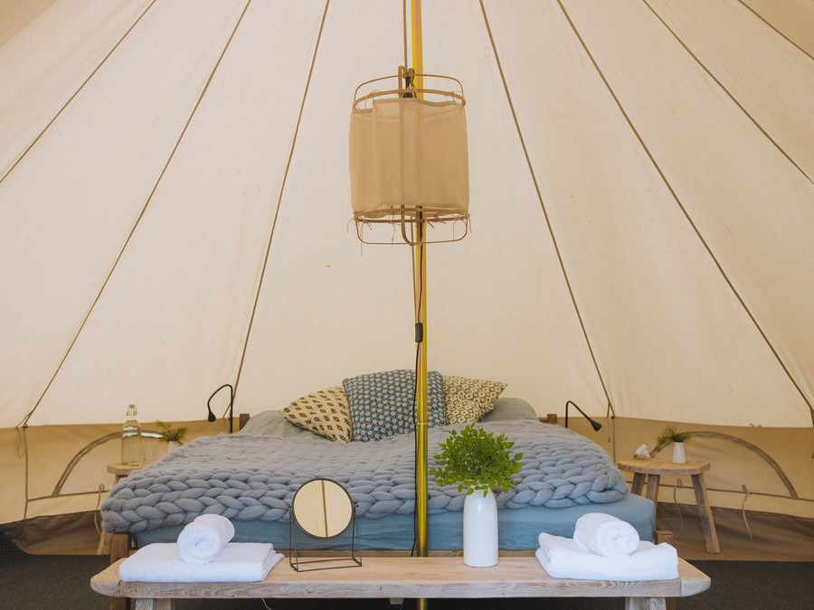
Starwick Hollow is a glamping resort planned for about 20 leased acres of ranch land north of Fredericksburg, Texas, on the road toward Enchanted Rock. It will let eight furnished safari tents and four geodesic stargazing domes by the night, each with a king bed, heating and air conditioning, a private bathroom, a covered deck and a fire pit.
Its guests are couples and small groups of friends driving in for a weekend from Austin, San Antonio, Houston and Dallas-Fort Worth. They add hot tub and fire pit packages, provisions, guided stargazing and celebration packages to the stay, and book the area's wineries through local shuttle operators.

1.2 Mission Statement
To give people from the cities a night under a dark Hill Country sky with none of the work of camping: a real bed, a hot shower, a fire already laid, and a host who knows which stars are up.

1.3 Location & Market Opportunity
Fredericksburg is one of the most visited small towns in Texas. Visitors spent $175 million in Fredericksburg and Gillespie County in 2024, and the area sits within about 80 miles of the Austin and San Antonio metros, home to more than 5.4 million people between them. Enchanted Rock, an International Dark Sky Park since 2014, lies a short drive north of the site, and the county's wineries, peach orchards and Main Street keep visitors coming in every season.
Nationally, the US glamping market generated about $994.5 million in 2025. The Fredericksburg short-term rental market, the private stays a glamping guest chooses between, is worth about $122.5 million a year. Twelve units at that market's average revenue per rental come to about $561,600 a year, which is the scale Starwick Hollow is planned at.

1.4 Unique Selling Points
- Four domes with a clear panel facing north and a private hot tub on the deck, built for stargazing near a certified Dark Sky Park.
- A private bathroom, heating and air conditioning in every unit, so a Texas summer night or a January frost is comfortable.
- Units spaced across 20 acres, out of sight of one another, with low path lighting that keeps the sky dark.
- Hosted stargazing evenings, provisions and celebration packages arranged before arrival, so a guest unpacks and does nothing else.
- A site on high ground above the creek, permitted with a floodplain determination and a written weather plan.

1.5 Financial Highlights
Revenue comes from twelve units at 50% occupancy and a $275 average nightly rate, with experiences and add-ons worth a further 12% of nightly revenue. The site opens at half that level and reaches it over nine months as reviews build.
Revenue is projected at $548,048 in the first year, $646,696 in the second and $763,101 in the third, at a gross margin of 80.0% throughout. The first year closes with a net loss of $36,825, the second with net income of $3,279 and the third with $40,797, a net margin of 5.3%. Break-even revenue, the level that covers operating costs before depreciation and interest, is $401,725 a year, the equivalent of 1,461 site nights. Counting depreciation and interest as well, cumulative revenue overtakes cumulative costs in the third year. Third-year net income is a loss of $3,636 in the conservative case and $99,780 in the upside case.

1.6 Funding Requirement
The startup budget is $1,232,000. It buys the tents and domes, their decks, bathrooms and heat pumps, the well, septic systems, power and road, the hot tubs and fire pits, a guest pavilion, furnishings, permits and engineering, and the launch. It is funded by a $600,000 contribution from the two founders and a $700,000 SBA 7(a) loan at 10.25% over 15 years, which leaves an opening cash reserve. Profits stay in the business while the loan is repaid.
The plan rests on a destination that already draws visitors all year, a sky most of them never see at home, and founders who have run hotels and built rural sites. The money builds twelve units that sell a night outdoors at a hotel's level of comfort.

1.6.1 Income Statement (3 Year projections)
 | Year 1 | Year 2 | Year 3 | Total
Revenue | $548,047.52 | $646,696.07 | $763,101.36 | $1,957,844.95
Cost of Sales | $109,609.50 | $129,339.21 | $152,620.27 | $391,568.98
Gross Margin | $438,438.02 | $517,356.86 | $610,481.09 | $1,566,275.97
Operating Expense | $321,379.96 | $362,812.35 | $411,702.57 | $1,095,894.88
Total Expense | $584,872.79 | $643,416.69 | $722,303.97 | $1,950,593.45
Net Income | ($36,825.27) | $3,279.38 | $40,797.39 | $7,251.50

CHAPTER 2

Company Overview

2.1 Legal Structure
2.2 Vision Statement
2.3 Background & History
2.4 Future Goals

2.1 Legal Structure
Starwick Hollow will be organised as a Texas limited liability company, Starwick Hollow LLC, owned by its two founders, Hannah and Daniel Whitfield, and managed by its members. The LLC holds the ground lease, the loan and the site's permits, and keeps the founders' personal assets separate from the liabilities of an outdoor lodging business. It will register for state and county hotel occupancy tax before the first night is sold.

2.2 Vision Statement
To be the place Texans think of first when they want a night outside the city that asks nothing of them: twelve quiet units under one of the darkest skies within a short drive of Austin and San Antonio, run by the people who built them, and good enough that guests come back with the seasons.

2.3 Background & History
Starwick Hollow is a new business and has no trading history. It is the founders' plan for a site they intend to lease and build from bare ranch land.
Hannah Whitfield has spent eleven years in hotel operations in Austin, most recently running the front office and revenue management for a boutique hotel, where she set nightly rates, managed the booking channels and built a direct-booking list. Daniel Whitfield is a civil engineer who has spent twelve years on rural land development around San Antonio: septic and water systems, drainage, floodplain work and access roads, which is most of what turns a ranch pasture into a site that can host guests.
The idea came from their own weekends near Enchanted Rock, where the choice was a rented house in town or a campsite with a shared bathhouse. Starwick Hollow is the stay in between.
They have identified the acreage, ranch land north of town on high ground above a seasonal creek, and are negotiating a long ground lease.

2.4 Future Goals
In the first 0 to 18 months, the goal is to secure the ground lease, the floodplain determination and the septic permits, build and open all twelve units, and run the first full season. By its end the site should be selling half of its nights, carry a rating of at least 4.8 across the booking platforms, and take a growing share of its bookings direct.
Over 1 to 3 years, the period the projections cover, the aim is to grow revenue from $548,048 to $763,101 and move from a net loss of $36,825 to net income of $40,797, through full years at planned occupancy, midweek offers, rate increases as reviews build and more add-ons.
Over 3 to 5 years, with the loan being repaid and cash building, the founders intend to add a small number of units on the same acreage where the septic capacity allows, and a covered gathering space for elopements and small private events. Any expansion waits until the site has shown two full years of steady occupancy.

2.4.1 Business Owners
Hannah Whitfield | Daniel Whitfield

Total ownership: 100%
55% | Hannah Whitfield  5,500 Shares
45% | Daniel Whitfield  4,500 Shares

2.4.2 SMART Goal
  Specific  - Hannah and Daniel Whitfield open twelve units north of Fredericksburg.  - Sell half of all available nights across the twelve units in the first full year.  - Build a direct-booking list so most guests book on the Starwick Hollow website. |   Measurable  - 50% occupancy at a $275 average nightly rate, tracked weekly.  - Revenue of $646,696 in the second year against $548,048 in the first.  - An average rating of 4.8 or higher across every platform. |   Achievable  - Hannah has set rates and managed booking channels for a boutique hotel in Austin.  - Daniel has designed rural septic, drainage and floodplain work, the hardest part of the build.  - Fredericksburg already draws visitors in every season from two metros within about 80 miles.
  Relevant  - Few sites near Fredericksburg are built for the night sky.  - Occupancy is the one figure that decides whether the loan is covered.  - Direct bookings cut platform commissions on every night sold. |   Time-Based  - Permits and construction complete before the spring opening.  - Planned occupancy reached nine months after opening.  - Direct-booking target met by the end of the second year.

CHAPTER 3

Market Analysis

3.1 Overview
3.2 Market Segmentation
3.3 Market Trends
3.4 Local Market Outlook
3.5 Market Size

3.1 Overview
A glamping stay is a night outdoors with the comforts of a room: a real bed, power, climate control and a private bathroom, in a tent, dome or small cabin set on open land. In the United States the trade is young and mostly independent. Most sites are run by an owner on their own land, alongside a small number of branded operators such as Under Canvas, AutoCamp, Collective Retreats and KOA.
The wider campground and RV park industry, which takes in glamping sites, generates $11.2 billion in 2026. Glamping is the fastest-moving part of it, sold at room rates to people who would not otherwise camp.

3.2 Market Segmentation
A Hill Country glamping site sells to four groups, each buying a different stay:
- Couples on a weekend away, the core of the trade, booking one or two nights in spring and autumn and adding a hot tub or a celebration package.
- Small groups of friends booking two or three units together for a birthday or a reunion weekend.
- Occasion guests: proposals, anniversaries and small elopements, who book further ahead and spend the most on add-ons.
- Wine country and outdoor visitors who come for the wineries, Enchanted Rock or the peach season and want somewhere memorable to sleep.

3.3 Market Trends
- Rate over volume: glamping resorts have traded occupancy for higher nightly rates, and revenue per available site fell 7% over the trailing year, so new sites have to earn their rate.
- Branded entry: national operators are opening in the region, raising guest expectations of bathrooms, climate control and booking.
- Rentals under pressure: Fredericksburg's average short-term rental rate fell 10.3% in the year to September 2026 while revenue per listing rose 7.1%.
- New hotel supply after a decade without it: the 109-room Albert Hotel, opened in January 2025, was the first addition since 2015.

3.4 Local Market Outlook
Fredericksburg and Gillespie County draw visitors all year. They spent $175 million in the area in 2024, supporting 1,200 local jobs, and the county's direct travel spending rose from $130.8 million in 2020 to $187.5 million in 2022. Visitation slipped about 5% in 2024 through August while sales tax kept pace, so visitors are spending more per trip. Enchanted Rock drew 292,167 visitors in 2022, the county's peach season runs from mid-May to mid-August, and Texas Hill Country Wineries counts 69 member wineries.
Supply is dominated by private rentals. The Fredericksburg market had 2,617 active short-term rentals at 42% average occupancy and a $328 average nightly rate in the year to September 2026, while Gillespie County hotels ran 59.1% occupancy in early 2024. Glamping in town is a small, mostly independent part of this, with a 120-room branded resort announced but not yet open. A rural site pays 13% hotel occupancy tax, 6% to the state and 7% to the county, and because Texas counties cannot zone, it is governed by floodplain, septic and fire rules. Housekeepers in the Hill Country nonmetro area earn a median $13.42 an hour.

3.5 Market Size
The total addressable market is the US glamping market, which generated about $994.5 million in 2025 and is projected to grow 11.59% a year to 2034.
The serviceable available market is the Fredericksburg short-term rental market, the private stays a glamping guest weighs against a tent or dome: about $122.5 million a year, from 2,617 active listings at $46,800 of average annual revenue each. No glamping-only figure is published for the town.
The serviceable obtainable market is about $561,600 a year: twelve units at that same average revenue per listing, the scale of one site. Starwick Hollow's first-year revenue of $548,048 sits just below it, as a site still building its reviews should.
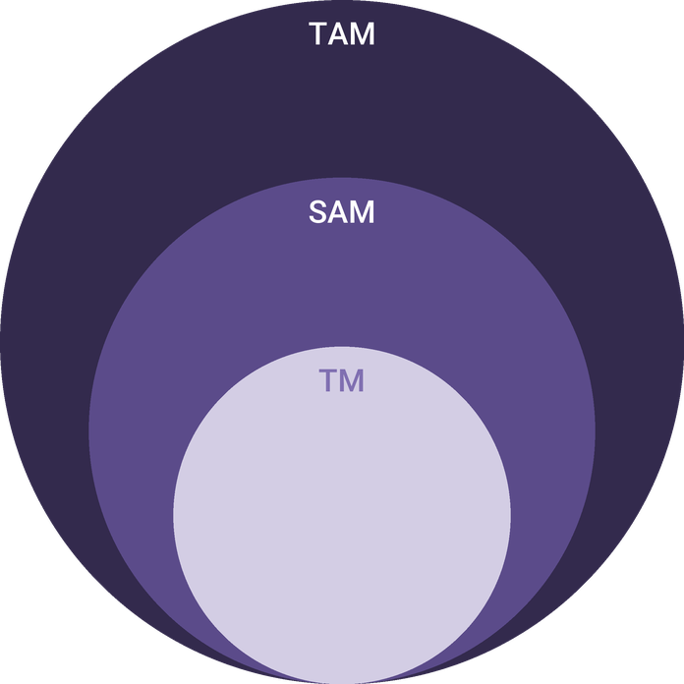
  ● | Total Available Market (TAM)  The US glamping market generated about $994.5 million of revenue in 2025 and is projected to reach $2,801.3 million by 2034, growing 11.59% a year over 2026 to 2034. | 994.5M
  ● | Served Available Market (SAM)  The Fredericksburg short-term rental market, the private stays a glamping guest chooses between, earns about $122.5 million a year: 2,617 active listings times $46,800 average annual revenue per listing (AirDNA, data through September 2026). | 122.5M
  ● | Target Market (TM)  Twelve units at the Fredericksburg average revenue per short-term rental listing of $46,800 a year come to about $561,600 a year, a derived figure at the scale of one business. | 561.6k

CHAPTER 4

Customer Analysis

4.1 Target Market
4.2 Customer Segments
4.3 Customer Persona
4.4 Customer Purchase Journey

4.1 Target Market
Starwick Hollow sells to adults who live in the large Texas metros and want a night or a weekend outdoors without owning any camping gear. Most will drive in from Austin and San Antonio, each within about 80 miles of Fredericksburg, with a further share from Houston and Dallas-Fort Worth for longer weekends. Visitors already spent $175 million in Fredericksburg and Gillespie County in 2024; the site aims at the part of that traffic that wants to stay outside town rather than in a rented house on a street.
The typical booking is two adults for one or two nights, made a few weeks ahead for a Friday or Saturday, and paid for by people with a professional income who spend on experiences. Spring wildflowers, the peach season and autumn are the peaks; summer weekdays and January are the troughs.
Most of these guests have stayed in Fredericksburg before, in a rented house or a hotel, and are looking for a different kind of trip to the same place. That matters for marketing: they already know the town, the wineries and Enchanted Rock, so the site has to sell the night itself, the sky, the quiet and the comfort, rather than the destination.

4.2 Customer Segments
- Weekend couples: the largest group, booking a tent or a dome for one or two nights and often adding a hot tub or fire pit package.
- Celebration guests: proposals, anniversaries and small elopements, booking a dome months ahead and buying the celebration package, flowers and a private stargazing session.
- Friend groups: four to eight people booking two to four units together for a birthday or a reunion, buying provisions and a shared fire circle evening.
- Wine country visitors: couples planning a day on the US 290 wineries who want a memorable place to sleep and a shuttle booked so nobody drives.
- Midweek remote workers and retirees: fewer in number, booking Sunday to Thursday at a lower rate when weekends are full or too busy for them.
Weekend couples carry the occupancy and celebration guests carry the add-on revenue; the persona below stands for the first group, which decides whether the site fills.
The segments also fill different parts of the calendar. Couples and friend groups want Friday and Saturday nights in spring and autumn, celebration guests book whatever date the occasion falls on, and midweek guests take the Sunday to Thursday nights the others leave. Pricing and minimum stays are set to steer each group toward the nights it fills best, so that a strong weekend demand does not leave the rest of the week empty.

4.3 Customer Persona
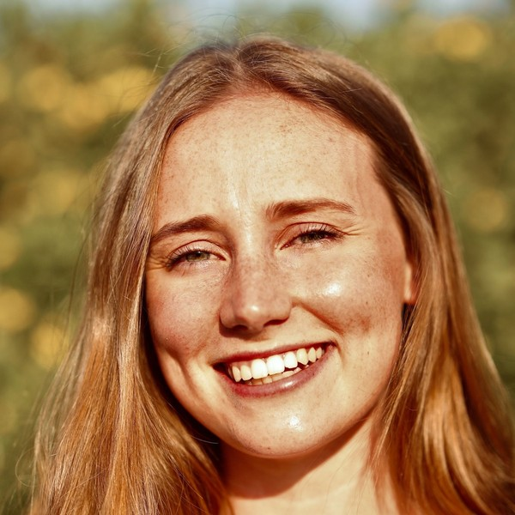  Wren, the Weekend Escaper  Demographics  Age: 34  Status: Married, no children  Location: Austin, TX  Income: $145,000 household  Professional Role  Education: Bachelor's degree  Job: Marketing manager at a technology company | “I want one weekend where nobody needs anything from me, a fire, a real bed and more stars than I ever see in Austin.”
   | Identifiers / Personality Traits  - Takes four or five short trips a year, most of them within a three-hour drive  - Plans anniversaries and birthdays around an experience rather than a gift  - Finds places to stay on Instagram and checks reviews before booking
   | Goals  - A full rest from screens and work for two nights  - A stay that feels like an occasion, with photographs worth keeping  - Comfort she can count on: a private bathroom, air conditioning, a good bed
   | Challenges  - Weekends in Fredericksburg book up early in spring and autumn  - Rentals in town feel like a house on a street, not a getaway  - Campsites mean shared bathrooms and gear she does not have

4.4 Customer Purchase Journey
- Inspiration: a photograph of a lit tent under the stars on Instagram or Pinterest, or a friend's post from a stay, puts the idea of a Hill Country night in mind.
- Search: the guest searches the booking platforms and Google for glamping near Fredericksburg or Enchanted Rock, comparing photographs, bathrooms and the nightly rate.
- Decision: reviews, a private bathroom and air conditioning, and the stargazing domes are what close the booking; a two-night minimum on peak weekends is accepted when the photographs justify it.
- Booking: the guest books on the Starwick Hollow website or a booking platform and chooses add-ons at checkout; returning guests are steered to the website.
- Stay: a self check-in with a code, a fire already laid, provisions in the unit and an optional hosted stargazing hour on the first night.
- Return: a thank-you email with a returning-guest rate, a seasonal note when the wildflowers or the meteor showers arrive, and a review request that feeds the next guest's decision.

CHAPTER 5

Competitive Analysis

5.1 Competitors
5.2 Comparison
5.3 Competitive Edge
5.4 SWOT Analysis

5.1 Competitors
A guest weighing a weekend near Fredericksburg chooses between four kinds of stay, and Starwick Hollow competes with all of them.
- Short-term rentals: the largest group, with 2,617 active listings in the Fredericksburg market at a $328 average nightly rate, mostly houses and guest cottages in and around town.
- Town hotels: Gillespie County hotels ran 59.1% occupancy at a $129.75 average daily rate in early 2024, and the 109-room Albert Hotel opened in January 2025.
- Other glamping sites: Onera Fredericksburg grew from 12 to 35 treehouse units in 2025, and a KOA resort with glamping wagons, cabins and RV sites soft-opened in September 2026. A 120-room AutoCamp Hill Country has been announced, with no confirmed opening date.
- Campgrounds and state parks: the low-cost option for people who own gear, including the campsites near Enchanted Rock.
No revenue or performance figures are published for any of these businesses, and none are estimated here. What matters is the shape of the field: rentals and hotels sell a room in or near town, the branded and larger glamping sites sell scale and amenities, and very few sell darkness, distance between units and a hosted night sky.

5.2 Comparison
Starwick Hollow is built to beat rentals on the outdoor experience, hotels on setting and privacy, and the larger glamping resorts on quiet and the sky. It gives up the town-centre location of a rental or hotel and the pools and restaurants of a larger resort, and prices below the area's average rental.
Feature | Starwick Hollow | Town short-term rentals | Town hotels | Larger glamping resorts | Campgrounds
Private bathroom in every unit | ✓ | ✓ | ✓ | ✓ | ✗
Heating and air conditioning | ✓ | ✓ | ✓ | ✓ | ✗
Units out of sight of each other | ✓ | ✗ | ✗ | ✗ | ✗
Dark-sky lighting and hosted stargazing | ✓ | ✗ | ✗ | ✗ | ✗
Hot tub at the unit | ✓ | ✗ | ✗ | ✓ | ✗
Walk to Main Street | ✗ | ✓ | ✓ | ✗ | ✗

5.3 Competitive Edge
The edge rests on things a guest can check before booking. Every unit has its own bathroom and climate control, which the cheaper outdoor options do not. Twelve units on about 20 acres means a unit for every acre and a half or more, so neighbours are out of sight and out of earshot, where denser sites put units close together. The domes face north with a clear panel and a hot tub, and the site's lighting is kept low and shielded so the sky near a Dark Sky Park stays dark.
The founders' skills match the two hardest parts of the trade. Hannah has set rates and run booking channels for a hotel, which decides occupancy; Daniel has designed rural septic, drainage and floodplain work, which decides whether a site gets permitted and stays safe. Owner-operators on site also answer guests directly, which a chain cannot.
The site also gives some things up, and the plan says so. It is a drive from Main Street and the restaurants, so guests who want to walk to dinner will choose a rental or a hotel in town. It has no pool, restaurant or spa, which the larger resorts use to justify higher rates. And as a new site it starts with no reviews, against competitors with years of them. Starwick Hollow answers these by pricing below the area's average rental, by selling provisions and arranging winery shuttles so the drive matters less, and by asking every early guest for a review.
The newest competitors matter most. A branded resort of 120 rooms and a KOA with glamping wagons will both spend on advertising that raises awareness of glamping near Fredericksburg, which helps a small site as much as it competes with it. They will sell volume and amenities; Starwick Hollow sells the opposite, a small number of quiet units, and prices so that a guest comparing the three sees a clear difference in what the money buys.
   | Built for the night sky  North-facing dome panels, shielded low lighting and hosted stargazing near a certified Dark Sky Park, which rentals and hotels in town cannot offer.
   | Privacy by spacing  Twelve units on about 20 acres keep neighbours out of sight and earshot, where denser sites put units side by side.
   | Hotel comfort outdoors  A private bathroom, a king bed and a heat pump in every unit make the stay comfortable in an August heatwave or a January frost.
   | Founders who fit the trade  One founder has run hotel rates and booking channels; the other has designed rural septic, drainage and floodplain work.

5.4 SWOT Analysis
Strengths  - Every unit has a private bathroom, a king bed and heating and air conditioning.  - North-facing domes and dark-sky lighting near Enchanted Rock give the site a reason to choose it.  - Twelve units across about 20 acres keep stays quiet and private.  - The founders bring hotel revenue management and rural site engineering experience. | Weaknesses  - A new site has no reviews, so the first nine months sell below planned occupancy.  - The startup cost is high for twelve units, and the loan weighs on early profit.  - Outside town, guests must drive to Main Street and the restaurants.  - Summer weekdays and January sell slowly, as for every Hill Country stay.
Opportunities  - Celebration and elopement bookings carry the highest spend per stay.  - Midweek offers to remote workers and retirees can fill the quietest nights.  - Winery and planner partnerships bring guests at no advertising cost.  - Extra units on the same acreage, once septic capacity allows. | Threats  - Branded glamping resorts opening near Fredericksburg raise competition for the same weekends.  - Flash floods, wildfire and burn bans can close parts of the site or cancel stays.  - Falling short-term rental rates in town pull guests toward cheaper houses.  - Higher interest rates would raise the cost of the variable SBA loan.

 Strategic Summary
Starwick Hollow should sell what larger sites cannot, darkness, distance and a hosted sky, and build direct bookings and celebration sales fast. Strict flood and fire plans and a cash reserve protect it through the ramp.

CHAPTER 6

Services Offered

6.1 Our Offering
6.2 Signature Items
6.3 Additional Services
6.4 What Sets Us Apart
6.5 Glamping Units & Amenities

6.1 Our Offering

Starwick Hollow sells a night outdoors with the comforts of a good hotel room. Guests book one of twelve units by the night, check themselves in with a code, and find a made king bed, a private bathroom, a heat pump for summer and winter, a covered deck and a fire pit ready to light. Around the stay the site sells the things that make it an occasion: hot tub and fire pit packages, provisions, hosted stargazing and celebration packages.
Two nights are required on Friday and Saturday in the spring and autumn peaks and on holiday weekends; every other night can be booked singly.

6.2 Signature Items
- Safari tent stay: one of eight canvas tents on timber decks, about $245 a night on average across the year.
- Stargazing dome stay: one of four insulated domes with a north-facing clear panel and a private hot tub, about $335 a night on average.
- Celebration weekend: two nights in a dome with flowers, a private stargazing session, breakfast provisions and a late checkout.

6.3 Additional Services
- Fire pit package: a bundle of seasoned oak, a s'mores kit and blankets, set out before arrival.
- Hot tub package for safari tent guests, booked by the evening at the shared hot tub deck.
- Breakfast provisions: local eggs, bread, peach preserves and coffee left in the unit's cooler, from Gillespie County producers.
- Hosted stargazing hour: a guide, a telescope and a sky map on clear evenings, shared or private.
- Winery shuttle bookings through licensed local operators, so no guest drives between tastings.

6.4 What Sets Us Apart
The site is designed around the sky. Path lights are low and shielded, unit lighting is warm and dimmable, and the domes point north, so on a clear night the Milky Way is visible from bed. Units are spread across the acreage rather than lined up, so a weekend at Starwick Hollow is quiet in a way a busy campground or a house on a street is not. And every add-on is chosen at booking and set out before arrival, so guests spend the stay resting rather than organising.

6.5 Glamping Units & Amenities
Each of the eight safari tents is a heavy cotton canvas tent on a steel and timber frame, about 300 square feet, raised on a timber deck with a covered porch. Each of the four domes is an insulated geodesic dome of about 280 square feet with a clear panel facing north, a blackout cover for daytime and a hot tub on its own deck.
- Sleeping: a king bed with hotel-grade linen, changed after every stay, and a sofa or daybed for reading.
- Bathroom: an attached bathroom pod with a shower, toilet and vanity, plumbed to the site's permitted septic systems, with towels and toiletries.
- Climate: a ductless heat pump in every unit, sized for August afternoons and January nights.
- Outside: a covered deck with seating, a steel fire pit with a spark screen, and a hot tub on every dome.
- Kitchenette: a coffee station, a small refrigerator, a cooler for provisions and an electric kettle; no open-flame cooking inside the units.
- Connection: Wi-Fi in the pavilion and on request in the units, so guests can choose to stay offline.

6.5.1 Safari Tent and Stargazing Dome Stays
A night in one of eight canvas safari tents or four insulated geodesic domes, each on its own deck with a king bed, a private bathroom, a heat pump and a fire pit. The domes add a north-facing clear panel over the bed and a private hot tub.
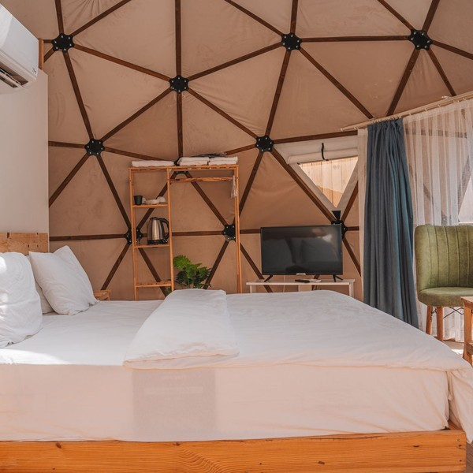 | From $245 a night (tents) and $335 a night (domes)  Both are average rates across the year: weekday and winter nights cost less, and spring, autumn and holiday weekends more, with a two-night minimum on peak weekends. The rate covers the unit for two adults, its private bathroom, heat pump, covered deck and fire pit, and the domes add the clear panel over the bed and a private hot tub. Check-in is self-service from 4 p.m. and check-out is by 11 a.m. Experiences, provisions and celebration packages are booked as add-ons with the stay.

Specifications
- Eight safari tents of about 300 square feet and four domes of about 280 square feet.
- Each unit sleeps two adults in a king bed, with a daybed for a third guest in the tents.
- Attached bathroom with a shower, toilet and vanity in every unit.
- Ductless heat pump for heating and cooling.
- Covered deck, steel fire pit and seating at every unit.
- Self check-in from 4 p.m. and check-out by 11 a.m.

6.5.2 Celebration and Experience Packages
Add-ons chosen at booking and set out before arrival: fire pit and s'mores packages, hot tub evenings for tent guests, breakfast provisions from local producers and a hosted stargazing hour. For proposals, anniversaries and small elopements, the Celebration Weekend bundles two dome nights with flowers, provisions and a private stargazing session.
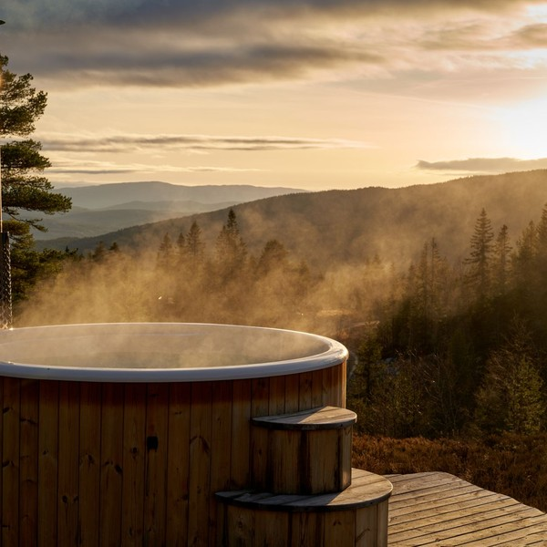 | From $35 per add-on; Celebration Weekend $895 per package  Add-ons are sold per stay and priced by what they include, from $35; the Celebration Weekend is priced as a package for two nights in a dome. Each is chosen at booking and set out before arrival, so nothing has to be arranged on site. The Celebration Weekend brings together the dome nights, flowers, breakfast provisions and a private stargazing session, for proposals, anniversaries and small elopements. Winery shuttles are booked through licensed local operators rather than run by the resort.

Specifications
- Fire pit package with seasoned oak, a s'mores kit and blankets.
- Breakfast provisions left in the unit cooler before arrival.
- Hosted stargazing hour with a guide and a telescope on clear evenings.
- Hot tub evenings at the shared deck for safari tent guests.
- Winery shuttle bookings arranged through licensed local operators.

6.5.3 Features
   | Private bathrooms  Every tent and dome has its own shower, toilet and vanity, with towels and toiletries.
  Year-round comfort
  A ductless heat pump in every unit keeps it cool in August and warm in January.
  Stargazing domes
  Four domes with a north-facing clear panel over the bed and a private hot tub.
  Fire pit at every unit
  A steel fire pit with a spark screen, laid and ready to light on arrival.
  Hosted stargazing
  A guide and a telescope on clear evenings, shared or private.
   | Self check-in  A door code arrives once the unit is inspected, so guests arrive on their own schedule.

6.5.4 Pricing
Safari Tent  $245  per night  - Canvas tent on a covered deck with a king bed  - Private bathroom and heat pump  - Fire pit with a spark screen  - Average rate across the year; weekends and peaks cost more |  | Most Popular  Stargazing Dome  $335  per night  - Insulated dome with a north-facing clear panel  - Private hot tub on the deck  - King bed, private bathroom and heat pump  - Average rate across the year; weekends and peaks cost more |  | Celebration Weekend  $895  per package  - Two nights in a stargazing dome  - Flowers, breakfast provisions and a fire pit package  - A private hosted stargazing session  - Late checkout on the second morning

CHAPTER 7

Marketing & Sales Strategies

7.1 Market Positioning
7.2 Marketing Objectives
7.3 Online Marketing
7.4 Public Relations and Branding
7.5 Partnership & Collaboration Strategy
7.6 Customer Loyalty & Retention
7.7 Sales Channels

7.1 Market Positioning
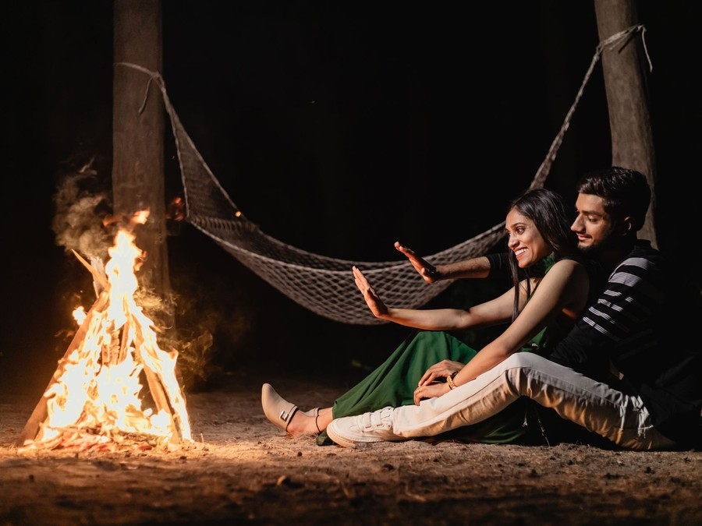
Starwick Hollow is positioned as the quiet, dark-sky stay near Fredericksburg: more comfortable than a campsite, more private than a rental in town, and smaller and darker than a branded resort, at a nightly rate below the area's average rental.

7.2 Marketing Objectives
- Reach 50% occupancy across the twelve units in the first full year after the nine-month ramp.
- Take two thirds of bookings direct through the website by the end of the second year, to keep platform commissions down.
- Hold an average rating of 4.8 or higher across every platform the site lists on.
- Sell an add-on with at least half of all stays.
- Build an email list of returning guests and enquirers large enough to fill midweek offers without paid advertising.
Search advertising  $959  per month  Ads to people in Austin, San Antonio, Houston and Dallas searching for Hill Country glamping. |  | Social media and video  $685  per month  Instagram and Pinterest promotion of night sky photographs and seasonal video.
Media and creator stays  $548  per month  Hosted stays for travel writers and creators timed to each season. |  | Email and partnerships  $548  per month  The returning-guest email list and materials for wineries and planners.

Total marketing budget: $32,883 a year, $2,740 a month.

7.3 Online Marketing
The website is the shop: professional photographs and video of each unit by day and by night, a live availability calendar, add-ons chosen at checkout, and pages for each season and occasion. Search advertising targets people in Austin, San Antonio, Houston and Dallas-Fort Worth searching for glamping, Hill Country getaways and Enchanted Rock stays. Instagram and Pinterest carry the night sky and the units, with guest photographs shared by permission, and short video follows the seasons: wildflowers, the peach harvest, meteor showers and frosty winter mornings by the fire. The email list receives a seasonal note and midweek offers.
Each channel is measured by the bookings it brings rather than by reach. The booking system records where every guest came from, and the founders review the cost per booked night for search advertising, social promotion and media stays each month, moving money toward whatever fills nights at the lowest cost. Midweek and January offers go to the email list first, because a returning guest costs nothing to reach. Guest photographs, shared with permission, supply most of the social content once the site is open, which keeps the feed current and shows prospective guests what a real stay looks like rather than a staged one.

7.4 Public Relations and Branding
The brand is built on the sky and on rest: a dark, simple identity, the night sky in every image, and a voice that is calm rather than adventurous. Before opening, the founders will host travel writers and Texas lifestyle editors for media stays, timed to the first spring season, and pitch stories on dark-sky tourism around Enchanted Rock. Starwick Hollow will follow good outdoor lighting practice across the site and say so, which earns coverage from the night sky community as well as travel press.

7.5 Partnership & Collaboration Strategy
- Wineries and tasting rooms on US 290, which recommend the site to visitors and offer tastings to Starwick Hollow guests.
- Licensed winery shuttle operators, booked through the site so guests do not drive.
- Wedding and elopement planners and officiants in Austin and San Antonio, who bring celebration bookings.
- Local producers for breakfast provisions and peach preserves, which keeps the add-ons local and gives both sides something to share.
- Fredericksburg's visitor bureau, for listings, events calendars and media visits.

7.6 Customer Loyalty & Retention
A glamping stay is bought for an occasion, so loyalty means the next occasion. Every guest receives a returning-guest rate valid for a year, a note before the next meteor shower or wildflower season, and first access to peak autumn and spring weekends when they open. Couples who celebrated an anniversary or a proposal on site are invited back on the same date. Guests who bring friends get a credit toward their next stay. Reviews are asked for the day after checkout, and every one is answered by the founders.

7.7 Sales Channels
Revenue arrives through four routes. Direct bookings on the website carry no commission beyond card processing and are where every add-on is sold. Booking platforms bring new guests while reviews build, at a commission of about 15% on those nights. Celebration bookings come by enquiry from couples and planners, priced as packages. Add-ons sold before and during the stay make up the remaining share of revenue. The 6% marketing budget is spent to move each guest from the second channel to the first on their next visit.
The mix is planned to change as the site matures. In the first months booking platforms bring most of the new guests, because a new site has no list and no reviews of its own. Each platform guest receives the returning-guest rate by email after checkout, so the second stay is booked direct. By the end of the second year the aim is for two thirds of nights to be booked on the website, where each booking also carries the add-ons chosen at checkout.
  Direct website bookings
  The largest and most profitable route, carrying no platform commission and selling every add-on, and it depends on the email list and returning guests.
   | Booking platforms  Bring new guests while reviews build, at a commission of about 15% on those nights, and depend on photographs and ratings.
   | Celebration packages by enquiry  Proposals, anniversaries and elopements booked by couples and planners, the highest spend per stay, and dependent on planner partnerships.
  Add-ons during the stay
  Fire pit, hot tub, provisions and stargazing sold to guests already on site, worth a growing share of revenue as the host offers them.

CHAPTER 8

Operations Plan

8.1 Daily Operations
8.2 Working Hours
8.3 Staffing & Training
8.4 Inventory & Equipment Management
8.5 Location and Facilities
8.6 Milestones & Timeline
8.7 Flood, Fire & Weather Safety

8.1 Daily Operations
The day turns on check-out at 11 a.m. and check-in from 4 p.m. In the hours between, the housekeeping team turns every departing unit: linen stripped and replaced, the bathroom cleaned and restocked, the deck swept, the fire pit cleared and relaid, the hot tub tested and the cooler stocked with any provisions the arriving guest ordered. The general manager inspects each unit before releasing it in the booking system, which sends the guest a door code.
Evenings belong to the guests. A host is on site every night, sets out add-ons, runs the stargazing hour when the sky is clear, and is reachable by phone or message until morning. Laundry is done on site in the pavilion's laundry room, and grounds and maintenance work happens midweek, when occupancy is lowest.
A turnover follows a written checklist for each unit type, and a tent takes about 75 minutes and a dome with a hot tub about 90. On a full Sunday with twelve departures the housekeeping lead splits the units between two teams and the general manager inspects as they finish, so every unit is released before 4 p.m. The booking system blocks a same-day turnover on any unit whose hot tub is due for a full drain and refill, which is scheduled on the quietest weekday of the week.

8.2 Working Hours
The site is open every night of the year, because demand runs through every season and a closed weekend is a sale that does not return. Check-in runs from 4 p.m. to 9 p.m. and check-out is by 11 a.m. Guest messages are answered from 8 a.m. to 10 p.m., and an on-site host covers the hours between for anything urgent. The first week of August is kept for deep maintenance if the summer is slow.

8.3 Staffing & Training
In the first year the site runs with the general manager, a housekeeping lead and a housekeeper on full time, a part-time guest host who also guides the stargazing hours, and a part-time groundskeeper. Weekend and holiday peaks are covered by the founders and on-call housekeepers. Every team member is trained before opening in the unit turnover standard, hot tub water testing, fire safety, the weather plan and guest communication, and pay is set above the Hill Country median for housekeepers.

8.4 Inventory & Equipment Management
Stock is small and fast-moving: two full sets of linen per unit, toiletries, coffee, firewood and the provisions sold as add-ons, counted weekly and reordered from local suppliers. Equipment is tracked in a maintenance log by unit: heat pump filters monthly, hot tub water at every turnover, canvas and decks inspected each season, and septic tanks pumped on their permitted schedule. Canvas, mattresses and deck boards are replaced on a rolling cycle from the capital budget.

8.5 Location and Facilities
The site is about 20 acres of leased ranch land north of Fredericksburg, outside the city limits in Gillespie County, on the road toward Enchanted Rock. The twelve units sit on high ground above a seasonal creek, spaced along gravel paths from a small parking area. A timber pavilion near the entrance holds check-in, the provisions store, a laundry and linen room and a covered space for stargazing talks. Water comes from a permitted well, wastewater goes to two engineered septic systems, and power runs underground to every unit.

8.6 Milestones & Timeline
The founders' sequence runs from lease to the first full season: ground lease and financing first, then the floodplain determination and septic permits, construction of the infrastructure and units, a soft opening with friends and media, the public opening for the spring season, and a review of the first year's occupancy and pricing before the second.
Nov 2026  Setup |  |  | Ground lease and financing  The site and the money  Sign the ground lease on about 20 acres and close the SBA 7(a) loan.
Jan 2027  Setup |  |  | Permits approved  Floodplain and septic  Receive the County Engineer's floodplain determination and the septic permits, and register for hotel occupancy tax.
Feb 2027  Build |  |  | Site construction  Infrastructure and units  Drill the well, install septic and power, build the decks and raise the tents and domes.
Apr 2027  Launch |  |  | Soft opening  Friends and media  Host media and creator stays and test every unit, add-on and the weather plan.
May 2027  Launch |  |  | Public opening  First full season  Open all twelve units to the public for the late spring and summer season.
Feb 2028  Growth |  |  | Planned occupancy reached  End of the ramp  Reach 50% occupancy and review pricing, add-ons and the direct-booking share before the second spring.

8.7 Flood, Fire & Weather Safety
A site of canvas on open land in the Hill Country is exposed to three hazards, and each has its own plan.
- Flood: every unit, path and the parking area sits outside the creek's floodplain, confirmed by the County Engineer's floodplain determination before any septic permit. The site subscribes to National Weather Service flash flood alerts, and the creek crossing on the access road has a depth marker and is closed to guests when water is over it.
- Fire: steel fire pits with spark screens are set on gravel pads with a cleared area around them. During a Gillespie County burn ban the pits are closed and gas fire bowls are used instead. Every unit has a fire extinguisher and a smoke alarm, and the grounds are mowed and cleared of cedar brush around each unit.
- Severe weather: guests receive weather alerts by text, and the pavilion is the designated shelter for high winds, lightning and hail. Tents are rated for wind, inspected after every storm, and closed if damaged.
- Heat: every unit has climate control, and guests are told about heat on arrival in summer, with water stocked in every cooler.
- Plan and drills: a written emergency plan covers each hazard, with evacuation routes and muster points, and staff rehearse it each spring and autumn before the busy seasons.
Weather also decides the booking terms. A stay cancelled by the site for a flood warning, a burn ban that closes the fire pits on a fire package, or storm damage to a unit is refunded or moved to another date at the guest's choice, and guests are told the terms before they book. Every arriving guest receives a short safety note with the unit code: where the pavilion is, how alerts arrive, and what to do if the creek rises. The site's insurance is written for outdoor accommodation and covers the units, the hot tubs and guest liability, and its terms are reviewed with the broker each year before the spring season.

CHAPTER 9

Management Team

9.1 Key Members
9.2 Organization Chart
9.3 Advisory Board Members

9.1 Key Members
Each person on the team is answerable for one part of the stay a guest can judge, and measured on it. The general manager owns revenue: occupancy, the average nightly rate, the share of bookings taken direct and the average rating across platforms, reviewed monthly against the plan. The site and facilities partner owns the land and the units: permits kept current, inspections passed, maintenance done on schedule and no unit closed for a fault that should have been caught.
The guest experience host is measured on add-on sales per stay and on what guests say about the stargazing and the welcome, and the housekeeping lead on turnover time and on cleanliness scores in reviews, the single comment that most affects the next booking.
 | Hannah Whitfield  Co-Founder and General Manager · hannah@starwickhollow.example  Eleven years in Austin hotel operations, most recently running the front office and revenue management for a boutique hotel.

 | Daniel Whitfield  Co-Founder, Site and Facilities · daniel@starwickhollow.example  A civil engineer with twelve years of rural land development around San Antonio, including septic, drainage and floodplain design.

 | Rosa Delgado  Guest Experience Host · rosa@starwickhollow.example  Six years leading guest programmes at a Hill Country lodge and a volunteer night sky guide at public stargazing events.

 | Kayla Brooks  Housekeeping Lead · kayla@starwickhollow.example  Five years as a housekeeping supervisor for a group of Fredericksburg vacation rentals.

9.2 Organization Chart
The general manager leads the day-to-day team, and the site and facilities partner works alongside her on anything to do with the land, the buildings and safety. Part-time housekeepers, the groundskeeper and on-call staff report to the housekeeping lead and the site partner respectively. The two founders meet weekly on bookings, costs and the maintenance log.
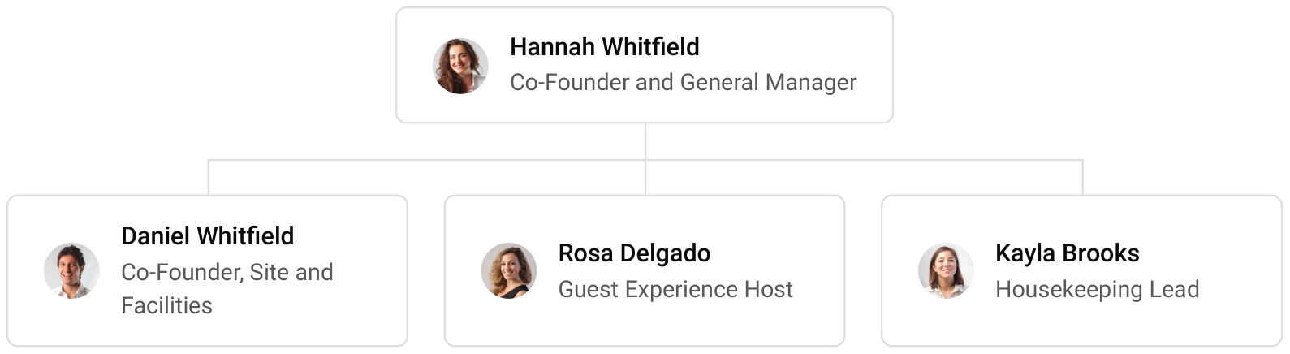

9.3 Advisory Board Members
The founders will build an informal advisory group before opening rather than a formal board: an accountant with hospitality clients to set up the books, hotel occupancy tax filing and the SBA loan reporting; an insurance broker who writes cover for outdoor accommodation; and an experienced Hill Country lodging owner who has run rentals through several seasons. The group meets quarterly in the first year and is consulted on pricing, insurance and any expansion.

9.3.1 Hiring Plan
2  Filled |  | 4  Hiring This Year |  | 5  Open

Group By Department | Position Filled | Time of Hire | Time of Start | Filled
Management | 2 of 2 | 0 days | 0 days | 100%
Housekeeping | 0 of 3 | 45 days | 14 days | 0%
Guest Experience | 0 of 1 | 60 days | 14 days | 0%
Grounds & Maintenance | 0 of 1 | 30 days | 7 days | 0%

CHAPTER 10

Financial Plan

10.1 Key Assumptions
10.2 Capital Requirements and Use of Funds
10.3 Income Statement (3 Year projections)
10.4 Balance Sheet (3 Year projections)
10.5 Cash Flow Statement (3 Year projections)
10.6 Break Even Analysis

10.1 Key Assumptions
Revenue is twelve units multiplied by occupancy, the average nightly rate and 365 nights, plus experiences and add-ons. The site is planned at 50% occupancy and a $275 average nightly rate, with add-ons worth 12% of nightly revenue. It opens at half that level and builds to it over nine months, so the first year carries the ramp and growth of 18% a year reflects the site reaching full occupancy in the second year and rate growth in the third.
Gross margin is 80.0%, after booking platform commissions, card processing, guest amenities, laundry and the cost of add-ons. Payroll is 28% of revenue, marketing 6% and other operating costs 8%. The ground lease is $3,500 a month, technology $900 and administration, including insurance, $3,200. The startup cost is written off over 15 years, and 3% of revenue is set aside each year to replace canvas, linen and decking.
On these assumptions revenue is $548,048 in the first year, $646,696 in the second and $763,101 in the third. Net income moves from a loss of $36,825 to $3,279 and then $40,797, a net margin of 5.3%. Break-even revenue, which covers operating costs before depreciation and interest, is $401,725, the equivalent of 1,461 site nights; with depreciation and interest included, cumulative revenue overtakes cumulative costs in the third year. In the third year the conservative case is a loss of $3,636 and the upside case is net income of $99,780, so occupancy is the figure to watch.

10.2 Capital Requirements and Use of Funds
The site needs $1,232,000 before the first guest arrives. The largest items are the tents and domes, their decks, bathrooms and heat pumps, and the site infrastructure: the well, two septic systems, underground power and the access road. The rest covers furnishings, hot tubs and fire pits, the guest pavilion and laundry, a utility vehicle, technology, engineering and permits, the ground lease deposit, opening stock, launch marketing and pre-opening training.
It is funded by a $600,000 contribution from the founders and a $700,000 SBA 7(a) loan at 10.25% over 15 years, a term matched to the life of the infrastructure it pays for. The difference between the funding and the startup cost stays in the bank as an opening cash reserve for the ramp. No profits are distributed while the loan is being repaid.
The loan is sized so that repayments are met from operations once the site reaches planned occupancy in the second year. The owner contribution covers the early losses of the ramp, and the opening reserve is held for the first winter, the slowest season, rather than spent on growth.

10.2.1 Use of Funds
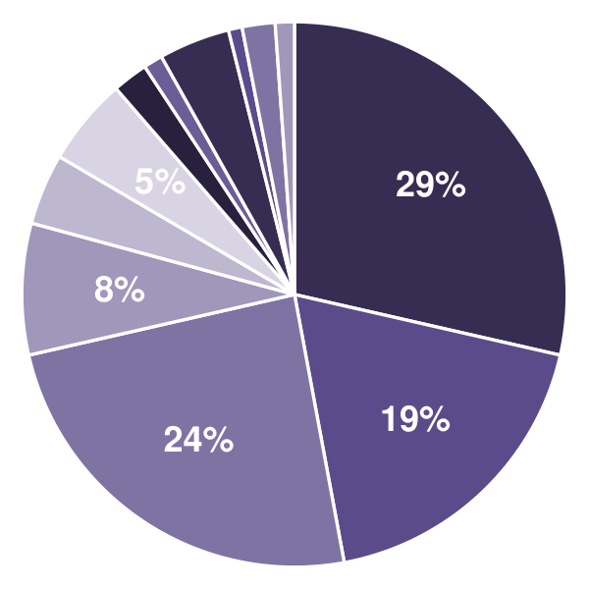 | ● Safari Tents & Geodesic Domes 28.6%  ● Unit Platforms, Private Bathrooms & HVAC 18.5%  ● Site Infrastructure: Well, Septic, Power & Roads 24.4%  ● Furnishings, Beds & Linens 7.8%  ● Hot Tubs & Fire Pits 4.2%  ● Guest Pavilion, Check-In & Laundry Building 5.2%  ● Utility Vehicle & Grounds Equipment 2.1%  ● Technology & Security 1.1%  ● Engineering, Permits, Legal & Lease Deposit 4.2%  ● Initial Inventory 0.8%  ● Launch Marketing & Photography 1.9%  ● Pre-Opening Staffing & Training 1.1%

Use Of Funds | Amount
Safari Tents & Geodesic Domes | $352,000.00
Unit Platforms, Private Bathrooms & HVAC | $228,000.00
Site Infrastructure: Well, Septic, Power & Roads | $300,000.00
Furnishings, Beds & Linens | $96,000.00
Hot Tubs & Fire Pits | $52,000.00
Guest Pavilion, Check-In & Laundry Building | $64,000.00
Utility Vehicle & Grounds Equipment | $26,000.00
Technology & Security | $14,000.00
Engineering, Permits, Legal & Lease Deposit | $52,000.00
Initial Inventory | $10,000.00
Launch Marketing & Photography | $24,000.00
Pre-Opening Staffing & Training | $14,000.00

10.3 Income Statement (3 Year projections)
 | Year 1 | Year 2 | Year 3 | Total
Revenue | $548,047.52 | $646,696.07 | $763,101.36 | $1,957,844.95
Cost of Sales | $109,609.50 | $129,339.21 | $152,620.27 | $391,568.98
General Costs | $0.00 | $0.00 | $0.00 | $0.00
Revenue Specific Costs | $76,726.65 | $90,537.45 | $106,834.19 | $274,098.29
Personnel Costs (Direct Labor) | $32,882.85 | $38,801.76 | $45,786.08 | $117,470.69
Gross Margin | $438,438.02 | $517,356.86 | $610,481.09 | $1,566,275.97
Gross Margin (%) | 80.00% | 80.00% | 80.00% | 80.00%
Operating Expense | $321,379.96 | $362,812.35 | $411,702.57 | $1,095,894.88
Payroll Expense (Indirect Labor) | $153,453.31 | $181,074.90 | $213,668.38 | $548,196.59
General Expense | $167,926.65 | $181,737.45 | $198,034.19 | $547,698.29
Bad Debt | $0.00 | $0.00 | $0.00 | $0.00
Amortization of Current Assets | $0.00 | $0.00 | $0.00 | $0.00
EBITDA | $117,058.06 | $154,544.51 | $198,778.52 | $470,381.09
Additional Expense | $153,883.33 | $151,265.13 | $157,981.13 | $463,129.59
Long Term Depreciation | $82,133.33 | $83,426.73 | $84,952.93 | $250,512.99
Gain or loss from Sale of Assets | $0.00 | $0.00 | $0.00 | $0.00
EBIT | $34,924.73 | $71,117.78 | $113,825.59 | $219,868.10
Interest Expense | $71,750.00 | $66,966.67 | $62,183.33 | $200,900.00
EBT | ($36,825.27) | $4,151.11 | $51,642.26 | $18,968.10
Income Tax Expense / Benefit | $0.00 | $871.73 | $10,844.87 | $11,716.60
Total Expense | $584,872.79 | $643,416.69 | $722,303.97 | $1,950,593.45
Net Income | ($36,825.27) | $3,279.38 | $40,797.39 | $7,251.50
Net Income (%) | -6.72% | 0.51% | 5.35% | 0.37%
Retained Earning Opening | $0.00 | ($36,825.28) | ($33,545.90)
Owner's Distribution | $0.00 | $0.00 | $0.00 | $0.00
Retained Earning Closing | ($36,825.27) | ($33,545.90) | $7,251.49 | $7,251.49

10.4 Balance Sheet (3 Year projections)
 | Year 1 | Year 2 | Year 3 | Total
Assets | $1,225,517.06 | $1,183,969.32 | $1,182,506.84 | $1,182,506.84
Current Assets | $75,650.39 | $98,128.50 | $158,725.91 | $158,725.91
Cash | $67,016.76 | $87,940.82 | $146,704.45 | $146,704.45
Accounts Receivable | $5,630.63 | $6,644.14 | $7,840.08 | $7,840.08
Inventory | $3,003.00 | $3,543.54 | $4,181.38 | $4,181.38
Other Current Assets | $0.00 | $0.00 | $0.00 | $0.00
Long Term Assets | $1,149,866.67 | $1,085,840.82 | $1,023,780.93 | $1,023,780.93
Gross Long Term Assets | $1,232,000.00 | $1,251,400.88 | $1,274,293.92 | $1,274,293.92
Accumulated Depreciation | $82,133.33 | $165,560.06 | $250,512.99 | $250,512.99
Liabilities & Equity | $1,225,517.06 | $1,183,969.32 | $1,182,506.84 | $1,182,506.84
Liabilities | $662,342.34 | $617,515.22 | $575,255.35 | $575,255.35
Current Liabilities | $55,675.67 | $57,515.22 | $61,922.02 | $61,922.02
Accounts Payable | $9,009.00 | $10,630.62 | $12,544.13 | $12,544.13
Income Tax Payable | $0.00 | $217.93 | $2,711.22 | $2,711.22
Sales Tax Payable | $0.00 | $0.00 | $0.00 | $0.00
Short Term Debt | $46,666.67 | $46,666.67 | $46,666.67 | $46,666.67
Long Term Liabilities | $606,666.67 | $560,000.00 | $513,333.33 | $513,333.33
Long Term Debt | $606,666.67 | $560,000.00 | $513,333.33 | $513,333.33
Equity | $563,174.72 | $566,454.10 | $607,251.49 | $607,251.49
Paid-in Capital | $0.00 | $0.00 | $0.00 | $0.00
Common Stock | $0.00 | $0.00 | $0.00 | $0.00
Preferred Stock | $0.00 | $0.00 | $0.00 | $0.00
Owner's Contribution | $600,000.00 | $600,000.00 | $600,000.00 | $600,000.00
Retained Earnings | ($36,825.28) | ($33,545.90) | $7,251.49 | $7,251.49
Check | $0.00 | $0.00 | $0.00 | $0.00

10.5 Cash Flow Statement (3 Year projections)
 | Year 1 | Year 2 | Year 3 | Total
Cash Received | $613,663.07 | $729,753.05 | $861,108.60 | $2,204,524.72
Cash Paid | $567,979.64 | $642,761.44 | $732,785.26 | $1,943,526.34
COS & General Expenses | $238,647.30 | $271,193.82 | $303,592.71 | $813,433.83
Salary & Wages | $186,336.16 | $219,876.66 | $259,454.46 | $665,667.28
Interest | $71,750.00 | $66,966.67 | $62,183.33 | $200,900.00
Sales Tax | $71,246.18 | $84,070.49 | $99,203.18 | $254,519.85
Income Tax | $0.00 | $653.80 | $8,351.58 | $9,005.38
Net Cash From Operations | $45,683.43 | $86,991.61 | $128,323.34 | $260,998.38
Assets Sell | $0.00 | $0.00 | $0.00 | $0.00
Assets Purchase | $1,232,000.00 | $19,400.88 | $22,893.04 | $1,274,293.92
Net Cash From Investments | ($1,232,000.00) | ($19,400.88) | ($22,893.04) | ($1,274,293.92)
Amount Received | $1,300,000.00 | $0.00 | $0.00 | $1,300,000.00
Loan Received | $700,000.00 | $0.00 | $0.00 | $700,000.00
Common Stock | $0.00 | $0.00 | $0.00 | $0.00
Preferred Stock | $0.00 | $0.00 | $0.00 | $0.00
Owner's Contribution | $600,000.00 | $0.00 | $0.00 | $600,000.00
Amount Paid | $46,666.67 | $46,666.67 | $46,666.67 | $140,000.01
Loan Capital | $46,666.67 | $46,666.67 | $46,666.67 | $140,000.01
Dividends & Distributions | $0.00 | $0.00 | $0.00 | $0.00
Net Cash From Financing | $1,253,333.33 | ($46,666.67) | ($46,666.67) | $1,159,999.99
Summary
Starting Cash | $0.00 | $67,016.76 | $87,940.82
Cash In | $1,913,663.07 | $729,753.05 | $861,108.60 | $3,504,524.72
Cash Out | $1,846,646.31 | $708,828.99 | $802,344.97 | $3,357,820.27
Change in Cash | $67,016.76 | $20,924.06 | $58,763.63 | $146,704.45
Ending Cash | $67,016.76 | $87,940.82 | $146,704.45 | $146,704.45

10.6 Break Even Analysis
 | Year 1 | Year 2 | Year 3 | Total
Starting Revenue | $0.00 | $548,047.52 | $1,194,743.59 | $1,194,743.59
Net Revenue | $548,047.52 | $646,696.07 | $763,101.36 | $763,101.36
Closing Revenue | $548,047.52 | $1,194,743.59 | $1,957,844.95 | $1,957,844.95
Starting Expense | $0.00 | $584,872.79 | $1,228,289.48 | $1,228,289.48
Net Expense | $584,872.79 | $643,416.69 | $722,303.97 | $722,303.97
Closing Expense | $584,872.79 | $1,228,289.48 | $1,950,593.45 | $1,950,593.45
Is Break Even? | No | No | Yes
Break Even Month | - | - | Oct '28
Days Required | - | - | 26 Days
Break Even Revenue | - | - | $1,830,661.39

CHAPTER 11

References

- SRC001: US Glamping Market Report, IMARC Group, 2026-08-06. https:/‌/‌www.‌imarcgroup.‌com/‌us-glamping-market (accessed 2026-10-13)
- SRC002: U.S. Glamping Market Research Report 2026-2031, Arizton Advisory & Intelligence, 2026-08-01. https:/‌/‌www.‌arizton.‌com/‌market-reports/‌united-states-glamping-market/‌description (accessed 2026-10-13)
- SRC003: Campgrounds & RV Parks in the US - Market Size, IBISWorld, 2026-01-01. https:/‌/‌www.‌ibisworld.‌com/‌united-states/‌market-size/‌campgrounds-rv-parks/‌1667/‌ (accessed 2026-10-13)
- SRC004: KOA Outdoor Hospitality Report: 52M Americans Camped in 2025, RV PRO, 2026-04-14. https:/‌/‌rv-pro.‌com/‌news/‌koa-outdoor-hospitality-report-52m-americans-camped-in-2025/‌ (accessed 2026-10-13)
- SRC005: New KOA Report Highlights Shift Toward Wellness, Flexibility, Modern Campground, 2025-04-09. https:/‌/‌moderncampground.‌com/‌?‌p=‌62020 (accessed 2026-10-13)
- SRC006: The Dyrt Releases 2026 Camping Report, Finds RVing Most Popular, RV PRO, 2026-01-27. https:/‌/‌rv-pro.‌com/‌news/‌the-dyrt-releases-2026-camping-report-finds-rving-most-popular/‌ (accessed 2026-10-13)
- SRC007: Glamping demand matches tents, ShortTermRentalz, 2025-09-04. https:/‌/‌shorttermrentalz.‌com/‌news/‌glamping-demand-matches-tents/‌ (accessed 2026-10-13)
- SRC008: Glamping ADR Hits $251/Night as Guest Stays Lengthen, Amenities Evolve: Insights from Glamping Show Americas 2025, Modern Campground, 2025-09-30. https:/‌/‌moderncampground.‌com/‌usa/‌colorado/‌glamping-adr-hits-251-night-as-guest-stays-lengthen-amenities-evolve-insights-from-glamping-show-americas-2025 (accessed 2026-10-13)
- SRC009: The U.S. Glamping Industry Enters Its Institutional Era, MMCG Invest, 2026-03-22. https:/‌/‌www.‌mmcginvest.‌com/‌post/‌the-us-glamping-industry-enters-its-institutional-era (accessed 2026-10-13)
- SRC010: The Data Dig, February 2025, Outdoor Hospitality Industry (OHI), 2025-01-01. https:/‌/‌ohi.‌org/‌wp-content/‌uploads/‌2025/‌04/‌The-Data-Dig_‌February-2025-1.‌pdf (accessed 2026-10-13)
- SRC011: FAQ, Glamping Hub, 2026-10-01. https:/‌/‌glampinghub.‌com/‌faq (accessed 2026-10-13)
- SRC012: Airbnb service fees, Airbnb, 2026-10-01. https:/‌/‌www.‌airbnb.‌com/‌help/‌article/‌1857 (accessed 2026-10-13)
- SRC013: How much does it cost to list and is there a commission fee?, Hipcamp, 2026-10-01. https:/‌/‌support.‌hipcamp.‌com/‌hc/‌en-gb/‌articles/‌360024823412-How-much-does-it-cost-to-list-and-is-there-a-commission-fee (accessed 2026-10-13)
- SRC014: How much does Booking.com charge hosts?, Guesty, 2025-01-01. https:/‌/‌www.‌guesty.‌com/‌blog/‌how-much-does-booking-com-charge-hosts (accessed 2026-10-13)
- SRC015: How much money can I make as a Hipcamp Host, Hipcamp, 2026-10-01. https:/‌/‌support.‌hipcamp.‌com/‌hc/‌en-us/‌articles/‌360025121411-How-much-money-can-I-make-as-a-Hipcamp-Host (accessed 2026-10-13)
- SRC016: Local Wages: Maids and Housekeeping Cleaners (BLS OEWS May 2025), O*NET OnLine / U.S. Bureau of Labor Statistics, 2026-01-01. https:/‌/‌www.‌onetonline.‌org/‌link/‌localwages/‌37-2012.‌00 (accessed 2026-10-13)
- SRC017: Local Wages: Lodging Managers (BLS OEWS May 2025), O*NET OnLine / U.S. Bureau of Labor Statistics, 2026-01-01. https:/‌/‌www.‌onetonline.‌org/‌link/‌localwages/‌11-9081.‌00 (accessed 2026-10-13)
- SRC018: Local Wages: Landscaping and Groundskeeping Workers (BLS OEWS May 2025), O*NET OnLine / U.S. Bureau of Labor Statistics, 2026-01-01. https:/‌/‌www.‌onetonline.‌org/‌link/‌localwages/‌37-3011.‌00 (accessed 2026-10-13)
- SRC019: The Dyrt 2025 Camping Report, The Dyrt, 2025-01-01. https:/‌/‌thedyrt.‌com/‌press/‌more-than-half-of-campers-report-difficulty-booking-campsites-because-they-are-sold-out/‌ (accessed 2026-10-13)
- SRC020: Hipcamp 2025 trends, Modern Campground, 2025-01-01. https:/‌/‌moderncampground.‌com/‌?‌p=‌59871 (accessed 2026-10-13)
- SRC021: Campspot booking lead times, Modern Campground, 2023-01-01. https:/‌/‌moderncampground.‌com/‌?‌p=‌40218 (accessed 2026-10-13)
- SRC022: Fredericksburg, Texas short-term rental market overview, AirDNA, 2026-10-13. https:/‌/‌www.‌airdna.‌co/‌vacation-rental-data/‌app/‌us/‌texas/‌fredericksburg/‌overview (accessed 2026-10-16)
- SRC023: FCVB Annual Report 2022, Fredericksburg Convention & Visitor Bureau, 2023-01-01. https:/‌/‌assets.‌noviams.‌com/‌novi-file-uploads/‌tacvb/‌pdfs-and-documents/‌Annual_‌Reports/‌Annual-Report-FBG.‌pdf (accessed 2026-10-16)
- SRC024: 2025 Destination Marketing Plan, Fredericksburg Convention & Visitor Bureau, 2024-01-01. https:/‌/‌assets.‌simpleviewinc.‌com/‌simpleview/‌image/‌upload/‌v1/‌clients/‌fredericksburgtx/‌Destination_‌Marketing_‌Plan_‌2025_‌7c3a6b13-da39-481e-9a22-a4811ca3cd29.‌pdf (accessed 2026-10-16)
- SRC025: Data / Tourism Impact, Visit Fredericksburg (Fredericksburg CVB), 2026-10-01. https:/‌/‌www.‌visitfredericksburgtx.‌com/‌data/‌ (accessed 2026-10-16)
- SRC026: Enchanted Rock State Natural Area Dark Sky Park, DarkSky International, 2014-01-01. https:/‌/‌demo.‌darksky.‌org/‌places/‌enchanted-rock-state-natural-area-dark-sky-park/‌ (accessed 2026-10-16)
- SRC027: Texas Hill Country Wineries Partners with Wine Folly to Launch Dynamic Online Region Guide, Wine Industry Advisor, 2025-07-22. https:/‌/‌wineindustryadvisor.‌com/‌2025/‌07/‌22/‌texas-hill-country-wineries-partners-with-wine-folly-to-launch-dynamic-online-region-guide/‌ (accessed 2026-10-16)
- SRC028: 2026 Gillespie County Peach Season, Visit Fredericksburg, 2026-05-12. https:/‌/‌www.‌visitfredericksburgtx.‌com/‌media/‌press-releases/‌2026-gillespie-county-peach-season/‌ (accessed 2026-10-16)
- SRC029: Vintage 2025 population estimates, metropolitan statistical area totals, U.S. Census Bureau, 2026-01-01. https:/‌/‌www2.‌census.‌gov/‌programs-surveys/‌popest/‌datasets/‌2020-2025/‌metro/‌totals/‌cbsa-est2025-alldata.‌csv (accessed 2026-10-16)
- SRC030: Vintage 2025 population estimates, county totals, U.S. Census Bureau, 2026-01-01. https:/‌/‌www2.‌census.‌gov/‌programs-surveys/‌popest/‌datasets/‌2020-2025/‌counties/‌totals/‌co-est2025-alldata.‌csv (accessed 2026-10-16)
- SRC031: Onera Fredericksburg Expands Resort With 23 New Luxury Treehouse Units, Modern Campground, 2025-09-02. https:/‌/‌moderncampground.‌com/‌?‌p=‌66242 (accessed 2026-10-16)
- SRC032: Notes on camp, CultureMap Austin, 2026-07-29. https:/‌/‌austin.‌culturemap.‌com/‌news/‌travel/‌koa-glamping-fredericksburg-wagons/‌ (accessed 2026-10-16)
- SRC033: AutoCamp Hill Country, Teneo Hospitality Group, 2026-10-01. https:/‌/‌teneohg.‌com/‌member-hotel/‌autocamp-hill-country-tx/‌ (accessed 2026-10-16)
- SRC034: Texas minimum wage summary, OnPay, 2026-06-11. https:/‌/‌onpay.‌com/‌insights/‌minimum-wage-by-state-summary/‌texas/‌ (accessed 2026-10-16)
- SRC035: Local Wages: Maids and Housekeeping Cleaners, Texas (BLS OEWS May 2025), O*NET OnLine / U.S. Bureau of Labor Statistics, 2026-01-01. https:/‌/‌www.‌onetonline.‌org/‌link/‌localwages/‌37-2012.‌00?‌st=‌TX (accessed 2026-10-16)
- SRC036: Local Wages: Lodging Managers, Texas (BLS OEWS May 2025), O*NET OnLine / U.S. Bureau of Labor Statistics, 2026-01-01. https:/‌/‌www.‌onetonline.‌org/‌link/‌localwages/‌11-9081.‌00?‌st=‌TX (accessed 2026-10-16)
- SRC037: Local Wages: Landscaping and Groundskeeping Workers, Texas (BLS OEWS May 2025), O*NET OnLine / U.S. Bureau of Labor Statistics, 2026-01-01. https:/‌/‌www.‌onetonline.‌org/‌link/‌localwages/‌37-3011.‌00?‌st=‌TX (accessed 2026-10-16)
- SRC038: Hotel Occupancy Tax, Texas Comptroller of Public Accounts, 2026-10-01. https:/‌/‌comptroller.‌texas.‌gov/‌economy/‌development/‌sales-tax/‌hotel.‌php (accessed 2026-10-16)
- SRC039: HOT FAQs, City of Fredericksburg, 2026-10-01. https:/‌/‌www.‌fbgtx.‌org/‌HOT-FAQs (accessed 2026-10-16)
- SRC040: County Authority, Hill Country Alliance, 2020-01-01. https:/‌/‌www.‌hillcountryalliance.‌org/‌uploads/‌HCA/‌cacountyauthority.‌pdf (accessed 2026-10-16)
- SRC041: Sanitation Office, Gillespie County, 2026-10-01. https:/‌/‌gillespiecounty.‌gov/‌1287/‌Sanitation-Office (accessed 2026-10-16)
- SRC042: Texas governor signs camp safety bills into law after fatal July 4 flooding, KBTX, 2025-09-05. https:/‌/‌www.‌kbtx.‌com/‌2025/‌09/‌05/‌texas-governor-signs-camp-safety-bills-into-law-after-fatal-july-4-flooding (accessed 2026-10-16)




