
Table of Contents
1. Executive Summary 6
1.1 Business Overview 7
1.2 Mission Statement 7
1.3 Location & Market Opportunity 7
1.4 Unique Selling Points 7
1.5 Financial Highlights 8
1.6 Funding Requirement 8
1.6.1 Income Statement (3 Year projections) 8
2. Company Overview 9
2.1 Legal Structure 10
2.2 Vision Statement 10
2.3 Background & History 10
2.4 Future Goals 10
2.4.1 Business Owners 10
2.4.2 SMART Goal 11
3. Market Analysis 12
3.1 Overview 13
3.2 Market Segmentation 13
3.3 Market Trends 13
3.4 Local Market Outlook 13
3.5 Market Size 14
4. Customer Analysis 15
4.1 Target Market 16
4.2 Customer Segments 16
4.3 Customer Persona 16
4.4 Customer Purchase Journey 17
5. Competitive Analysis 18
5.1 Competitors 19
5.2 Comparison 19
5.3 Competitive Edge 20
5.4 SWOT Analysis 21
6. Services Offered 22
6.1 Our Offering 23
6.2 Signature Items 23
6.3 Additional Services 23
6.4 What Sets Us Apart 23
6.5 Seasonal Service Calendar 24
6.5.1 Weekly Lawn Maintenance 24
6.5.2 Lawn Treatment & Fall Renovation 25
6.5.3 Features 26
6.5.4 Pricing 26
7. Marketing & Sales Strategies 27
7.1 Market Positioning 28
7.2 Marketing Objectives 28
7.3 Online Marketing 28
7.4 Public Relations and Branding 28
7.5 Partnership & Collaboration Strategy 29
7.6 Customer Loyalty & Retention 29
7.7 Sales Channels 29
8. Operations Plan 30
8.1 Daily Operations 31
8.2 Working Hours 31
8.3 Staffing & Training 31
8.4 Inventory & Equipment Management 31
8.5 Location and Facilities 32
8.6 Milestones & Timeline 32
8.7 Pesticide Licensing & Insurance 33
9. Management Team 34
9.1 Key Members 35
9.2 Organization Chart 35
9.3 Advisory Board Members 36
9.3.1 Hiring Plan 36
10. Financial Plan 37
10.1 Key Assumptions 38
10.2 Capital Requirements and Use of Funds 38
10.2.1 Use of Funds 38
10.3 Income Statement (3 Year projections) 40
10.4 Balance Sheet (3 Year projections) 41
10.5 Cash Flow Statement (3 Year projections) 42
10.6 Break Even Analysis 43
11. References 44


CHAPTER 1

Executive Summary

1.1 Business Overview
1.2 Mission Statement
1.3 Location & Market Opportunity
1.4 Unique Selling Points
1.5 Financial Highlights
1.6 Funding Requirement

1.1 Business Overview
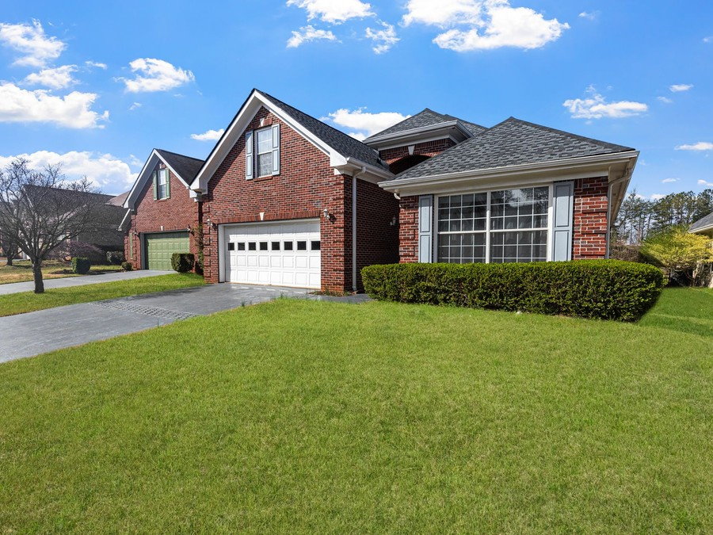
Clovercrest Lawn Care is a lawn care company launching in Charlotte, North Carolina, with two-person crews that mow, edge, trim and blow recurring residential lawns on fixed weekly routes. Owner Ryan Whitfield, a licensed applicator with nine years of crew experience, also sells fertilization and weed control programs, fall core aeration and overseeding, and spring and fall cleanups to the same households.
Its customers are homeowners on suburban lots across Mecklenburg County who would rather pay for a well kept lawn than spend their weekends on it, along with homeowners associations and small commercial properties that need dependable grounds maintenance.

1.2 Mission Statement
To keep Charlotte lawns healthy and neatly kept, week after week, by the same crew, with every treatment timed to what the grass actually needs.

1.3 Location & Market Opportunity
Mecklenburg County had 1,206,285 residents and 486,412 households in 2024, with a median household income of $90,494, and 283,521 of its housing units are single family detached houses, the homes that carry a private lawn. Charlotte sits in the turfgrass transition zone, where tall fescue needs weekly mowing from March through October and recovers from summer only if it is aerated and overseeded in the fall.
US landscaping services, the industry that includes lawn care, generates $176.7 billion in 2026. Mecklenburg County's employer lawn and landscape businesses represent a serviceable market of about $500.3 million a year, and one comparable employer business averages about $1.09 million. Local supply is fragmented and thinning: the county's employer establishments fell from 464 in 2024 to 416 in 2025.

1.4 Unique Selling Points
- Mowing and treatment from one route: a licensed program applied to lawns the crews already mow every week.
- One crew, one weekday: the same crew on the same day, with a text before each visit and a photo after it.
- A calendar built for fescue: treatments, aeration and overseeding timed to NC State Extension's Piedmont schedule.
- Plain pricing: $52 a visit on a typical lot, charged to the card on file once the crew has left.

1.5 Financial Highlights
The plan projects revenue of $329,472 in the first year, $388,777 in the second and $458,757 in the third, at a gross margin of 76.0%, because crew wages are carried below the gross line. The first year closes at a net loss of $2,341 while the routes fill; net income then reaches $9,867 and $23,392. Break-even revenue is $285,907, or 5,498 mowing visits a year.
Across the three scenarios, third year net income runs from $6,854 in the conservative case to $45,728 in the upside case.

1.6 Funding Requirement
Startup costs total $152,600, led by two trucks, two trailers and two commercial mowers. They are funded by $50,000 of the owner's savings and a $130,000 SBA 7(a) loan at 10.5% over seven years, which leaves a cash cushion to carry payroll through the first spring. No outside equity is sought, and profits stay in the business while the loan is repaid.
The plan rests on a licensed owner who knows Charlotte lawns, a route model that sells treatments to households already on the schedule, and a county of detached homes whose fescue needs work every week of the season. The money buys the trucks, trailers and mowers that put two crews on those streets.

1.6.1 Income Statement (3 Year projections)
 | Year 1 | Year 2 | Year 3 | Total
Revenue | $329,472.00 | $388,776.96 | $458,756.81 | $1,177,005.77
Cost of Sales | $79,073.28 | $93,306.47 | $110,101.63 | $282,481.38
Gross Margin | $250,398.72 | $295,470.49 | $348,655.18 | $894,524.39
Operating Expense | $217,289.66 | $247,653.80 | $283,483.48 | $748,426.94
Total Expense | $331,812.94 | $378,909.57 | $435,365.07 | $1,146,087.58
Net Income | ($2,340.94) | $9,867.39 | $23,391.74 | $30,918.19

CHAPTER 2

Company Overview

2.1 Legal Structure
2.2 Vision Statement
2.3 Background & History
2.4 Future Goals

2.1 Legal Structure
Clovercrest Lawn Care will operate as a North Carolina limited liability company, wholly owned by its founder, Ryan Whitfield. The LLC keeps the owner's personal assets apart from the risks of trucks on public roads and crews on customers' property, and it elects to be taxed as a corporation, which is the basis of the plan's tax projections. The company will carry general liability, commercial auto and equipment insurance from its first day of trading.

2.2 Vision Statement
To be the lawn care company Charlotte homeowners recommend to their neighbours: the crew that turns up on its day, leaves the edges sharp, and brings a tired fescue lawn back to full colour by the following spring.

2.3 Background & History
Clovercrest is a new company, planned for a March launch. Ryan Whitfield spent nine years running residential maintenance crews for a Charlotte landscape company, where he learned the routes, the grasses and the pace of a Mecklenburg summer, and earned his North Carolina Commercial Ground Applicator licence in the Ornamental & Turf category.
He saw the same gap on street after street. Homeowners hired one crew to mow and a separate company to feed the lawn, and neither looked at the lawn as a whole. Marketplace mowers kept prices low but changed from week to week, and the treatment companies sprayed and drove off. Clovercrest is built to close that gap: one company, on the lawn every week, answerable for how it looks in October as well as how it is cut in May.

2.4 Future Goals
In the first 0 to 18 months, the goal is to launch route one in March, open route two by the end of April and reach about 200 recurring accounts by the first fall aeration season, with most of them on a treatment program. The first winter is for renewals, equipment servicing and bids on HOA contracts for the second season.
From one to three years, the horizon the projections cover, Clovercrest aims to grow revenue from $329,472 to $458,757, move into profit in the second year, hire a licensed treatment technician so the program no longer depends on the owner alone, and add HOA and small commercial contracts invoiced each month.
From three to five years, the aim is a third crew, a second licensed applicator and a move into the suburbs of Union County, once the Mecklenburg routes are dense enough that a new route does not thin the old ones.

2.4.1 Business Owners
Ryan Whitfield

Total ownership: 100%
100% | Ryan Whitfield  1,000 Shares

2.4.2 SMART Goal
  Specific  - Fill two weekly mowing routes in Mecklenburg County with 200 recurring residential accounts.  - Put about 60% of those accounts on the five-round treatment program.  - Owner Ryan Whitfield leads sales and treatments; crew lead Luis Ortega runs the second route. |   Measurable  - Active accounts counted weekly in the routing software.  - Treatment program share of accounts reviewed each month.  - Lawns mowed per crew day, aiming for about 20. |   Achievable  - Two crews of two can each mow about 100 lawns a week.  - The owner already holds the category L licence the treatments need.  - Door hangers on route streets add lawns close to those already served.
  Relevant  - Fescue lawns need weekly mowing from March to October, so a full spring decides the year.  - Revenue in the second year of $388,777 depends on a full book at the end of the first.  - Treatments carry more margin per hour than mowing alone. |   Time-Based  - First route mowing from the March launch.  - Second route running by the end of April.  - 200 accounts by the start of October, eight months after launch.

CHAPTER 3

Market Analysis

3.1 Overview
3.2 Market Segmentation
3.3 Market Trends
3.4 Local Market Outlook
3.5 Market Size

3.1 Overview
Lawn care sits inside US landscaping services, an industry of about 556,000 businesses in 2026, roughly four in five of them owner operators with no employees. The employer side counted 123,326 establishments in 2025, employing 912,821 people. The market is fragmented: the largest commercial landscaper, BrightView, describes commercial landscape maintenance as a $124 billion industry in which it holds only 1.5%.

3.2 Market Segmentation
- Residential mowing and maintenance: recurring weekly or fortnightly cuts on owner occupied houses, the largest part of a lawn company's book.
- Lawn treatment programs: fertilizer and weed control applied in timed rounds by a licensed applicator.
- Seasonal renovation and cleanups: aeration, overseeding and leaf removal, concentrated in spring and fall.
- HOA and small commercial grounds: common areas and business properties maintained under contract.

3.3 Market Trends
- Hiring out is the habit of a large minority: 40% of Americans with a lawn hired a professional in the year surveyed, while 62% of those who did not said the cost was too high.
- An aging population that plans to stay in its homes is a durable source of demand for long term service agreements.
- Labor is the binding constraint. The median grounds maintenance wage was $19.27 an hour in May 2025, and landscape company owners report net margins falling from 19% to 17% as wages rose.
- Small engine rules are tightening at the edges: California requires most new engines in mowers, blowers and trimmers to be zero emission from model year 2024.

3.4 Local Market Outlook
The catchment is Mecklenburg County, Charlotte and the suburbs within a working drive of one yard. It had 1,206,285 residents and 486,412 households in 2024, a median household income of $90,494 and a median owner occupied home worth $457,200. Just over half of households, 55.0%, own their home, and 283,521 housing units are single family detached houses.
The county had 416 employer lawn and landscape establishments in 2025, down from 464 a year earlier, employing 4,874 people; neighbouring Union County had 178. No local count of one-person operators is published. A standard Charlotte mow runs about $40 to $50 through GreenPal, with a median accepted price near $43, against $55 to $65 from firms hired directly, and LawnStarter's Charlotte average is $51.85 on a yard of 9,226 square feet.
Crew pay in the Charlotte metro ran at a median of $18.57 an hour in May 2025, with supervisors at $28.84, far above North Carolina's $7.25 minimum wage. Applying weed control for pay needs a state Commercial Ground Applicator licence in category L, while mowing and lawn care services are exempt from the landscape contractor licence. No published rent for a contractor's yard in Charlotte was found.

3.5 Market Size
The total addressable market is US landscaping services, $176.7 billion in 2026, the industry total that includes lawn care. The serviceable market is Mecklenburg County: its 460 employer lawn and landscape establishments represent about $500.3 million a year at the national average revenue per employer establishment, a figure that leaves out one-person operators and so understates local spending. The obtainable market is the revenue of one comparable employer business, about $1.09 million; Clovercrest's first year projection of $329,472 sits well inside it.
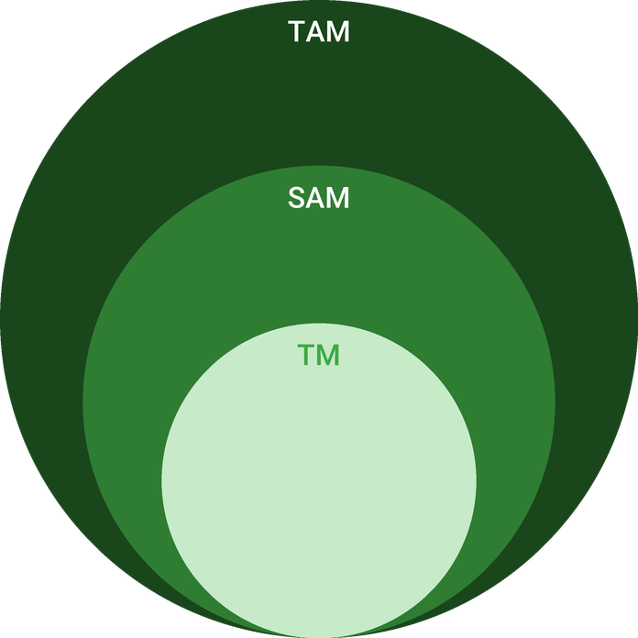
  ● | Total Available Market (TAM)  US landscaping services, the industry that includes lawn care (NAICS 56173), generates $176.7 billion in revenue in 2026 (IBISWorld), after 3.0% compound annual growth since 2021. | 176.7B
  ● | Served Available Market (SAM)  Mecklenburg County's 460 employer landscaping and lawn care establishments represent about $500.3 million of annual revenue in 2022, at the national average of $1,087,628 per employer establishment; one-person operators are excluded. | 500.3M
  ● | Target Market (TM)  One US employer landscaping and lawn care establishment averaged about $1.09 million of revenue in 2022 ($130,672 million across 120,144 establishments); a national average, pulled up by large commercial firms. | 1.1M

CHAPTER 4

Customer Analysis

4.1 Target Market
4.2 Customer Segments
4.3 Customer Persona
4.4 Customer Purchase Journey

4.1 Target Market
Clovercrest sells to owner occupied single family homes in Mecklenburg County, and above all to suburban lots large enough to need a mower and small enough to be cut in under half an hour. The county has 283,521 detached houses and 267,661 owner occupied households at a median household income of $90,494, so the homes that carry a private lawn and the incomes that pay for its upkeep are both there in volume.
The buyers are short of time rather than skill: dual income families whose weekends go to children's sport, and older homeowners who plan to stay in their houses and no longer want to push a mower in July. The second group is growing, and it buys service agreements that run for years.

4.2 Customer Segments
- Busy family homeowners: the core of the routes. They buy weekly mowing for the season and, once the lawn has been on a route for a few weeks, the treatment program.
- Homeowners aging in place: smaller lots, steady renewals and strong demand for leaf removal and cleanups they can no longer do themselves.
- Lawn improvers: owners of thin or weedy fescue who come for aeration and overseeding in September and stay on for the program.
- HOAs and small commercial properties: common areas, entrances and business grounds maintained under contract and invoiced on 30 day terms, about a fifth of revenue.

4.3 Customer Persona
  Rachel Donovan  Demographics  Age: 42  Household: Married, two children  Location: South Charlotte  Income: $140,000  Professional Role  Job: Nurse manager at a hospital  Home: Detached house on a quarter acre | “I want the lawn to look like someone cares about it, without me spending Saturday behind a mower.”
   | Identifiers / Personality Traits  - Owns a fescue lawn of about 9,000 square feet in a neighbourhood with an HOA  - Works long shifts, and weekends go to the children's sports  - Pays for services by card and expects a text before anyone arrives
   | Goals  - A lawn that stays green and weed free from spring to fall  - The same crew on the same day every week  - One company for mowing, feeding and the fall leaves
   | Challenges  - Bare patches in the back where the fescue thinned last summer  - Crabgrass along the driveway every July  - No time to compare quotes or chase a crew that did not show

4.4 Customer Purchase Journey
Most customers first see Clovercrest on their own street: a truck and trailer outside a neighbour's house, a yard sign on a finished lawn, a door hanger left the same afternoon. Others search for lawn care near them and find the company's Google listing and its reviews.
The decision rests on three things: the price for their lot, whether the crew will come on a fixed day, and what other people on the street say. Clovercrest answers the first with a quote from satellite measurement within a day, the second with a named weekday on the agreement, and the third with reviews and the neighbour referral credit. The season agreement is signed online with a card on file.
After the first few visits, the owner walks the lawn and recommends what it needs, usually the treatment program for the coming rounds and aeration in September. Renewal is offered each February, before the first cut of the new season.
HOA boards and small commercial owners buy differently. They write a scope for the common areas, invite two or three bids, usually in winter for the coming season, and decide on price, insurance and references. Clovercrest bids with its certificate of insurance, its applicator licence and a schedule naming the day each area is cut, and starts with smaller associations near its existing routes, where a common area adds an hour to a route day rather than a separate trip.
Timing shapes all of it. Most households look for a crew in March and April, when the grass starts growing and the first weekend behind a mower reminds them why they wanted help. A second, smaller wave comes in late August, when thin fescue sends owners looking for aeration and overseeding. Launch marketing is concentrated in those two windows, and the September work is where many of the following year's mowing accounts are first won.
Older homeowners often arrive by another route. A son or daughter living elsewhere finds the company online, signs the season agreement and pays by card, while the parent deals with the crew; the photo after each visit is what tells the family the lawn is being looked after. Each account can carry a second contact for exactly this, so the person paying and the person at home both hear when the crew is coming.
HOA and commercial contracts run for a season and are rebid each winter, so their renewal is won in the autumn walk-through, when the board sees the common areas at the end of a full season of weekly care.

CHAPTER 5

Competitive Analysis

5.1 Competitors
5.2 Comparison
5.3 Competitive Edge
5.4 SWOT Analysis

5.1 Competitors
Clovercrest competes for Charlotte lawns with four kinds of rival. None is named here: no revenue or performance is published for any local company, so they are described by type.
- Booking marketplaces: apps that match homeowners with independent mowers. A standard Charlotte mow runs about $40 to $50 through GreenPal, with a median accepted price near $43, and LawnStarter's Charlotte average is $51.85. Most of their Charlotte lawns are cut fortnightly, and only 7% are fertilized.
- One-person operators: the bulk of the trade, where about four in five lawn and landscape businesses nationally have no employees. They compete on price and personal service and seldom hold an applicator licence.
- Established local firms: the county's 416 employer establishments, averaging about 12 employees, which quote $55 to $65 for a mow and often carry HOA and commercial contracts.
- National treatment brands: fertilizer and weed control companies that sell programs by phone and online but do not mow.

5.2 Comparison
Each type wins on something. The marketplaces win on price and easy booking, the established firms on breadth and commercial contracts, and the national brands on treatment programs. Against the marketplaces and solo mowers, Clovercrest offers a fixed crew and a licensed program; against the established firms, a lower price for the same weekly service; against the national brands, mowing as well as treatment.
The table also shows where Clovercrest gives ground. The marketplaces are cheaper, at a median near $43, and can send someone within a day; one-person operators are often cheaper still and more flexible about odd jobs. Clovercrest does not try to match either on price. It competes for the households that have already tried the cheapest option and found that a missed week or an unlicensed spray costs more than the saving.
Feature | Clovercrest Lawn Care | Booking marketplaces | Established local firms | National treatment brands | One-person operators
Same crew on a fixed weekday | ✓ | ✗ | ✓ | ✗ | ✓
Licensed treatment program on the mowing account | ✓ | ✗ | ✓ | ✗ | ✗
Text before each visit and photo after | ✓ | ✓ | ✗ | ✓ | ✗
Fall aeration and overseeding for fescue | ✓ | ✗ | ✓ | ✓ | ✗
Maintenance for HOA common areas | ✓ | ✗ | ✓ | ✗ | ✗
Typical mow priced under $55 | ✓ | ✓ | ✗ | ✗ | ✓

5.3 Competitive Edge
The edge is the combination rather than any single service. A $52 visit sits between the marketplace median of about $43 and the $55 to $65 that established firms quote, so it is priced for households that have had a marketplace mower miss a week and want reliability without paying a premium. Treatments are applied by the licensed owner to lawns the crews see every week, so a patch of crabgrass or a thinning back lawn is noticed within days rather than at the next scheduled round.
Route density turns that into margin. Marketing is aimed at the streets either side of lawns already served, so each new account adds minutes, not miles, to a route, and the September aeration season is sold to households already on the schedule. The county's count of employer lawn businesses fell from 464 to 416 in a year, which leaves customers looking for a new crew each spring.
The position has the weaknesses any new company has: no reviews on its first day, two crews where an established firm runs ten, and an owner who is also the only licensed applicator. Each has an answer with a date on it. Reviews are requested after the third visit, so the first season builds a record street by street; Saturdays are held back so a lost weekday never becomes a missed week; and a treatment technician is budgeted for once the program outgrows one person.
   | Mowing and treatment on one route  Households get mowing and a licensed treatment program from one company that is on the lawn every week, where most rivals sell one or the other.
   | Dense routes  Door hangers and referrals are aimed at the streets the crews already mow, so more lawns are cut per hour of driving.
   | A calendar built for fescue  Treatment rounds, aeration and overseeding follow NC State Extension's Piedmont calendar, so the work is done in the weeks the grass can use it.
   | Owner on the lawn  The licensed owner applies every treatment and reviews each lawn in the fall, so a problem is seen by the person who can fix it.

5.4 SWOT Analysis
Strengths  - Mowing and licensed treatments sold to the same households from one weekly route.  - Owner holds a North Carolina category L licence and nine years of crew experience.  - Card on file billing after each visit keeps receivables near a week.  - Price of $52 a visit sits between the marketplaces and established firms. | Weaknesses  - A new name with no reviews in a market where homeowners hire on reviews.  - Two crews only, so one sick day or breakdown delays a whole route.  - Revenue falls away from December to February, when little grows.  - The owner is the only licensed applicator until a technician is hired.
Opportunities  - 283,521 detached houses in Mecklenburg County, most with a private lawn.  - Only 7% of Charlotte marketplace lawns are fertilized, leaving treatment demand unmet.  - Fall aeration and overseeding is a September job every fescue lawn needs.  - Mecklenburg's employer lawn businesses fell from 464 to 416 in a year. | Threats  - Marketplace mowers at about $43 a visit set the price many homeowners expect.  - Charlotte crew pay at a median of $18.57 an hour keeps rising.  - A summer drought can halt mowing and thin fescue across a route.  - National treatment brands outspend a new company on advertising.

 Strategic Summary
Clovercrest should sell reliability and the treatment program to the streets it already mows, not compete on the marketplace price. Filling both routes before the first September locks in the aeration season and the renewals that follow.

CHAPTER 6

Services Offered

6.1 Our Offering
6.2 Signature Items
6.3 Additional Services
6.4 What Sets Us Apart
6.5 Seasonal Service Calendar

6.1 Our Offering

Clovercrest sells a season of lawn care to a household, priced by the visit and delivered by the same crew each week. The base is weekly mowing, edging, trimming and blowing at $52 a visit on a typical lot. On top of it sit a five-round treatment program, fall core aeration and overseeding, and spring and fall cleanups, sold to the same households so that the crew already on site can see what each lawn needs.

6.2 Signature Items
Two services carry the business. Weekly lawn maintenance is the route itself, about 30 visits a year from March to November. The treatment and fall renovation program is where a lawn actually improves: fertilizer and weed control in timed rounds, and core aeration with overseeding in September for the tall fescue most Charlotte lawns are planted with.
The two are designed to be bought together. A lawn mowed every week but never fed thins out by August, and a lawn fed but cut too short burns in the same heat; selling both to one household is what lets the company stand behind the result rather than the visit.

6.3 Additional Services
- Spring cleanup: beds cleared of winter debris and the first cut taken before the season starts.
- Fall leaf removal: leaves mulched or hauled away through November, booked as one visit or a series.
- HOA and small commercial grounds: entrances, common areas and business frontages on a weekly contract, invoiced on 30 day terms.

6.4 What Sets Us Apart
The difference is accountability. One company cuts the lawn in May, feeds it in September and answers for how it looks in October, and the owner who applies the treatments is the person a customer calls. Pricing is plain: a quoted price per visit and per round, no annual contract to break, and no charge for a visit skipped for rain.
Every new account starts with a walk of the lawn with the owner, who records the grass type, the mowing height, the gate code, the beds and slopes the crew must work around, and whether the lawn would benefit from the program. That record travels with the crew on the tablet, so a stand-in crew member cuts the lawn exactly as the regular one does and a customer never has to explain the same thing twice.

6.5 Seasonal Service Calendar
A lawn program in Charlotte is a calendar, and Clovercrest's follows NC State Extension's schedule for tall fescue in the Piedmont, adjusted for the bermuda and zoysia lawns on the same streets.
- February: first feeding round for fescue lawns, and season agreements renewed.
- Early March: pre-emergent crabgrass control applied ahead of the warm spell that sets it germinating, and the first cuts of the season.
- March to October: weekly mowing, at 2.5 to 3.5 inches in spring and 3.5 inches through summer for fescue, lower and more often for bermuda.
- Spring and summer: broadleaf weeds spot treated as they appear.
- 1 September to 1 October: core aeration and overseeding of thin fescue, followed by the mid-September feeding round.
- November: the last feeding round, the final cuts and fall leaf removal.
- December and January: equipment serviced, routes redrawn and HOA bids prepared.

6.5.1 Weekly Lawn Maintenance
A two-person crew mows, edges, trims and blows each lawn on the same weekday through the growing season, from March to November. Mowing height follows the grass on the lot, so fescue is cut high in summer and bermuda lower, and every visit ends with walks and drives blown clear.
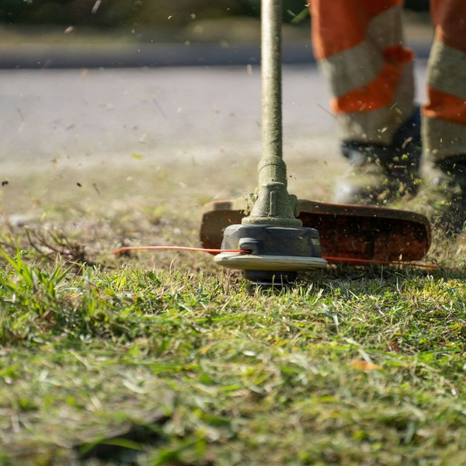 | $52 per visit  Priced for a typical Charlotte lot of about 9,000 square feet, between the marketplaces and the firms hired directly. Larger or steeper lots are quoted after a first walk. The price covers the whole visit: mowing at the height set for the grass, edging along every driveway, walk and curb, string trimming around beds and fences, and blowing hard surfaces clear. It is charged to the card on file once the crew has left, with no annual contract and no charge for a week skipped for rain. A missed strip or edge is put right within two working days.

Specifications
- About 30 visits a year, weekly in the main season and fortnightly at its ends
- Cut with a 60 inch commercial mower, with a push mower for gated yards
- Edging along every driveway, walk and curb on each visit
- Clippings mulched back into the lawn unless the customer asks for bagging
- A text the evening before and a photo when the crew leaves

6.5.2 Lawn Treatment & Fall Renovation
A five-round program of fertilizer and weed control timed to the Piedmont calendar for tall fescue, applied by the licensed owner to lawns the crews already mow. In September the same lawns can be core aerated and overseeded, which is how a fescue lawn recovers from a Charlotte summer.
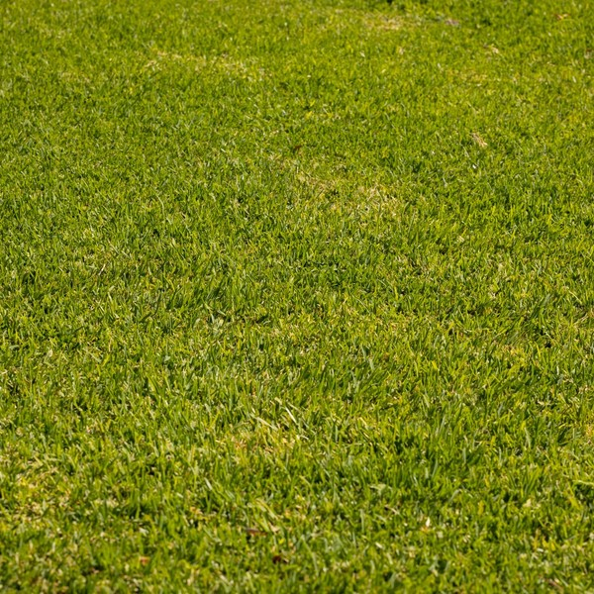 | $65 per treatment round  Each round is billed when it is applied. Core aeration with overseeding is $195 for a typical lot. A year on the program is five rounds timed to the Piedmont calendar for tall fescue: a February feed, pre-emergent crabgrass control in early March, broadleaf weed control in late spring, and feeding rounds in mid-September and November. The licensed owner applies every round to a lawn the crew already mows each week, so a patch of weeds or a thinning corner is seen between rounds rather than at the next one.

Specifications
- Pre-emergent crabgrass control in early March
- Feeding rounds in February, mid-September and November
- Broadleaf weed control spot treated as needed
- Core aeration and overseeding between 1 September and 1 October
- Turf type tall fescue seed blend
- Applied under a North Carolina category L licence

6.5.3 Features
  One crew, one weekday
  Each lawn is mowed by the same crew on the same weekday, so customers know which day to leave the gate open.
  Height set by grass type
  Fescue, bermuda and zoysia each get their own mowing height, recorded on the account.
  Text before, photo after
  Customers get a text the evening before a visit and a photo of the finished lawn when the crew leaves.
   | Card on file  Each visit is charged to the card on file once the crew has left, with no invoices to chase.
   | Licensed treatments  Fertilizer and weed control are applied by the owner under a North Carolina category L licence.
   | Return within two days  A missed strip or a skipped edge is put right by the crew within two working days at no charge.

6.5.4 Pricing
Weekly Mowing  $52  per visit  - Mowing at the height set for the grass type  - Edging of driveway, walks and curb  - String trimming and blowing off hard surfaces  - Card charged after each visit |  | Most Popular  Mowing + Treatment Program  $65  per treatment round, added to mowing  - Everything in Weekly Mowing  - Five rounds of fertilizer and weed control a year  - Pre-emergent crabgrass control in late winter  - Applied by the licensed owner |  | Full Season Care  $195  fall aeration and overseeding, added to the program  - Everything in the treatment program  - Core aeration and fescue overseeding in September  - First booking for spring and fall cleanups  - A lawn review with the owner each fall

CHAPTER 7

Marketing & Sales Strategies

7.1 Market Positioning
7.2 Marketing Objectives
7.3 Online Marketing
7.4 Public Relations and Branding
7.5 Partnership & Collaboration Strategy
7.6 Customer Loyalty & Retention
7.7 Sales Channels

7.1 Market Positioning
Clovercrest is the dependable middle of the Charlotte market: a fixed crew and a licensed treatment program at $52 a visit, priced below the established firms and sold on reliability rather than on the lowest quote.

7.2 Marketing Objectives
- Sign about 200 recurring mowing accounts across two routes by the first fall aeration season.
- Put about 60% of mowing accounts on the treatment program by the end of the first season.
- Win the first HOA common area contracts for the second season.
- Hold an average Google rating of at least 4.8 stars through the first year.
Google Local Services and search ads  $577  per month  Paid leads from Charlotte homeowners searching for lawn care and mowing near them. |  | Door hangers and yard signs  $412  per month  Hangers on the streets either side of each mowed lawn, and signs on finished lawns for a week.
Customer referral credits  $329  per month  A visit credit for each customer whose neighbour signs a season agreement. |  | HOA newsletters and sponsorships  $329  per month  Placements in neighbourhood newsletters and small sponsorships of HOA events in the route areas.

Total marketing budget: $19,768 a year, $1,647 a month.

7.3 Online Marketing
The marketing budget is 6% of revenue, spent where Charlotte homeowners look for a lawn crew. Google Business Profile and Local Services ads take the largest share, because homeowners search for lawn care near them and hire on the reviews they find. The website quotes from satellite measurement of the lot and signs agreements online with a card on file, so a lead from a search can become an account the same day. Every finished visit sends a photo and, after the third, a review request.

7.4 Public Relations and Branding
The brand is the trucks and the lawns. Both trucks and trailers carry the Clovercrest name and a clover mark, crews wear uniforms, and a yard sign goes on each finished lawn for a week with the owner's permission. Door hangers follow the crews: the houses either side of every lawn mowed get one the same afternoon, which puts the company in front of neighbours who have just seen its work.

7.5 Partnership & Collaboration Strategy
Homeowners associations are the partners that matter most. The company introduces itself to HOA boards in its route areas, places notices in their newsletters and sponsors small neighbourhood events, both to bid on common area maintenance and to reach every household in the association at once. Realtors and property managers are the second group: a listing needs a tidy lawn before the photographs, and a new owner needs a crew in the first week.

7.6 Customer Loyalty & Retention
In lawn care, loyalty is the crew turning up on its day. Clovercrest keeps each lawn with one crew, puts any miss right within two working days, and uses a fall lawn review to plan the next year's program with the customer. Renewal is offered each February before the first cut, and a customer whose neighbour signs a season agreement receives a visit credit, which turns satisfied customers into the route's best salespeople.

7.7 Sales Channels
The recurring mowing book is the base of the revenue, and the treatment program is sold to it. HOA and small commercial contracts are invoiced each month on 30 day terms, and one-off cleanups bring in households that often join the routes the following spring.
  Recurring mowing agreements
  The seasonal mowing book is most of the revenue, and depends on keeping both routes full and the same households renewing each spring.
  Treatment program add-ons
  Fertilizer, weed control and fall aeration sold to households already on a route, which depends on the owner's licence and on the lawns visibly improving.
  HOA and small commercial contracts
  Common areas and small business grounds invoiced on 30 day terms, about a fifth of revenue, won by bid and kept by turning up on schedule.
   | Seasonal one-off work  Spring and fall cleanups and leaf removal booked by households outside the mowing book, which often become mowing accounts the next spring.

CHAPTER 8

Operations Plan

8.1 Daily Operations
8.2 Working Hours
8.3 Staffing & Training
8.4 Inventory & Equipment Management
8.5 Location and Facilities
8.6 Milestones & Timeline
8.7 Pesticide Licensing & Insurance

8.1 Daily Operations
Each crew leaves the yard at 7:00 with its route on a tablet, the lawns ordered to keep driving short. On each lawn, one crew member mows with the 60 inch zero turn while the other edges and trims, and both blow walks and drives clear; a typical lot takes under half an hour, and a crew mows about 20 lawns a day. The routing software texts each customer the evening before and sends a photo when the crew leaves, and the card on file is charged after the visit.
Treatment rounds run on their own days within each round's window. The owner loads the spreader and sprayer at the yard, works through the program lawns street by street, and records product and rate on each account. Rain moves mowing a day, not a week: crews work Saturday when a weekday is lost.
Equipment checks open and close each day: blades, oil, tire pressure and trailer lights before the crew leaves, then a wash-down and refuel at the yard, so a fault is found there rather than on a customer's lawn. A spare push mower and trimmer ride on each trailer, which keeps a breakdown from costing a route day.

8.2 Working Hours
Crews work Monday to Friday, 7:00 to 5:30, from March to November, with Saturday held for rain days and cleanups. An early start gets most of the cutting done before Charlotte's summer afternoons, when heat slows the crews and stresses fescue. Calls and messages are answered from 8:00 to 6:00 on weekdays. From December to February the crews work shorter weeks on leaf removal, equipment servicing and yard work.

8.3 Staffing & Training
The company opens with four people in the field: the owner, who leads route one and applies every treatment, a crew member beside him, and a second crew of a crew lead and a crew member for route two. Pay is set to keep a crew for the whole season, because a crew that leaves in July costs more in missed visits than the wage it saved.
Training covers safe operation of the zero turn mowers, string trimming on slopes, heat safety in July and August, and how the company wants a lawn to look when the crew leaves. Every new hire works two weeks on route one with the owner before joining route two. A licensed treatment technician is planned once the program outgrows one applicator.

8.4 Inventory & Equipment Management
The fleet is two pickups, two enclosed 16 foot trailers, two 60 inch commercial zero turn mowers, two push mowers for gated yards, string trimmers, edgers and backpack blowers, a walk behind core aerator, a slit seeder, spreaders and backpack sprayers. Mower blades are sharpened weekly, because a dull blade tears fescue and leaves the tips brown, and oil and filters are changed by the engine hours logged in the routing software.
Inventory is small and seasonal: about three weeks of fertilizer, weed control product, seed and spare blades, bought ahead of each treatment round and kept dry at the yard. Suppliers invoice monthly.

8.5 Location and Facilities
Clovercrest works from a small fenced contractor yard with a storage bay, in an industrial area of Charlotte placed to reach the south and east Mecklenburg suburbs where the first routes are planned, at $1,500 a month. The yard parks both trucks and trailers overnight, keeps fertilizer and seed dry and holds the bench where blades are sharpened. Customers never visit it: sales happen online, by phone and on the lawn.

8.6 Milestones & Timeline
The launch runs from company formation in the autumn to the first aeration season the following September, with the March start set by when Charlotte's grass begins to grow.
Nov 2026  Setup |  |  | Company formed and loan approved  LLC registered and the SBA 7(a) loan application filed.  The owner commits his savings and applies for the equipment loan that funds the trucks, trailers and mowers.
Jan 2027  Setup |  |  | Yard leased and equipment bought  Contractor yard, two trucks, two trailers and two commercial mowers.  Equipment is rigged, trucks are wrapped, and the routing and billing software is set up with card on file billing.
Feb 2027  Setup |  |  | Crew hired and first sign ups  Crew lead and crew members hired; door hangers and ads go out.  The first season agreements are signed before the grass starts growing, and the pre-emergent round is booked.
Mar 2027  Launch |  |  | Route one mowing  First mowing route and the pre-emergent round.  Route one starts on the March launch, with crabgrass pre-emergent applied to every program lawn in the same weeks.
Apr 2027  Launch |  |  | Route two running  Second crew on the road under Luis Ortega.  The second route opens on the streets with the most sign ups, so both crews work dense neighbourhoods.
Sep 2027  Growth |  |  | First aeration and overseeding season  Both routes near 200 accounts.  Fescue lawns are core aerated and overseeded between 1 September and 1 October, and fall cleanups are booked.

8.7 Pesticide Licensing & Insurance
Applying weed control, or any other pesticide, to a customer's lawn for pay requires a North Carolina Commercial Ground Applicator licence from the Department of Agriculture and Consumer Services. Clovercrest's work falls in category L, Ornamental & Turf; the licence requires passing the Core exam and the category exam and is renewed every year. The owner holds it, and every treatment is applied by him or, later, by a technician who has passed the same exams.
Mowing, edging and lawn care services are exempt from the state's landscape contractor licence, which binds landscaping work of $30,000 or more on one site within 12 months, so the company would need it only if it took on installation work of that size.
Insurance covers what can go wrong on someone else's property: general liability for a stone thrown through a window or a lawn scorched by a misapplied product, commercial auto for two trucks towing trailers, equipment cover for the mowers and workers' compensation for the crews. Each treatment is logged with product, rate and weather, which is what an insurer and the department both ask to see if a customer complains.
The licence sets the discipline for every round. Spreaders and sprayers are calibrated each spring, nothing is sprayed in wind that could carry product onto beds or a neighbour's lawn, and each treated lawn gets a small flag and a note to the customer so children and pets stay off it until the product has dried. Products are bought for turf and applied at the rates on their labels, which is also what keeps the cost of sales where the plan puts it.
The cost of all this sits in the plan's $2,200 a month for insurance and administration, and none of it is optional. A crew that cannot show a certificate of insurance does not win an HOA contract, and a company that sprays without a licence puts at risk the treatment program that carries its margin.

CHAPTER 9

Management Team

9.1 Key Members
9.2 Organization Chart
9.3 Advisory Board Members

9.1 Key Members
The owner answers for revenue and for the quality of every lawn: accounts signed, renewals each February, treatment program uptake and complaints resolved within two working days. He also holds the applicator licence, so every treatment record is his. The route two crew lead answers for that route's day: lawns mowed per crew day, visits completed on their scheduled weekday and equipment returned to the yard serviced. The bookkeeper answers for accurate monthly accounts, payroll paid on time and card receipts reconciled to the routing software.
 | Ryan Whitfield  Owner and Licensed Applicator · ryan@clovercrestlawncare.example  Nine years running residential maintenance crews for a Charlotte landscape company, and holder of a North Carolina Commercial Ground Applicator licence in category L, Ornamental & Turf.

 | Luis Ortega  Crew Lead, Route Two · luis@clovercrestlawncare.example  Six years on commercial mowing crews in Mecklenburg and Union counties, including two as a crew lead responsible for equipment and route timing.

 | Dana Pruitt  Bookkeeper (contract) · dana@clovercrestlawncare.example  A bookkeeper for small trade businesses in Charlotte who keeps the books, runs payroll and reconciles card receipts each month.

9.2 Organization Chart
The structure is flat while the company runs two crews. Both crews report to the owner, who sets the routes each week; the route one crew member works beside him, and the route two crew member reports day to day to the crew lead. The contract bookkeeper reports to the owner monthly. When the treatment technician is hired, the program will report to the owner as a small team of its own.
Decisions sit with the owner for now: pricing, hiring and which streets to sell into. The crew lead decides the order of the route day and when a lawn is too wet to cut, because those calls are made on site and cannot wait for a phone call.
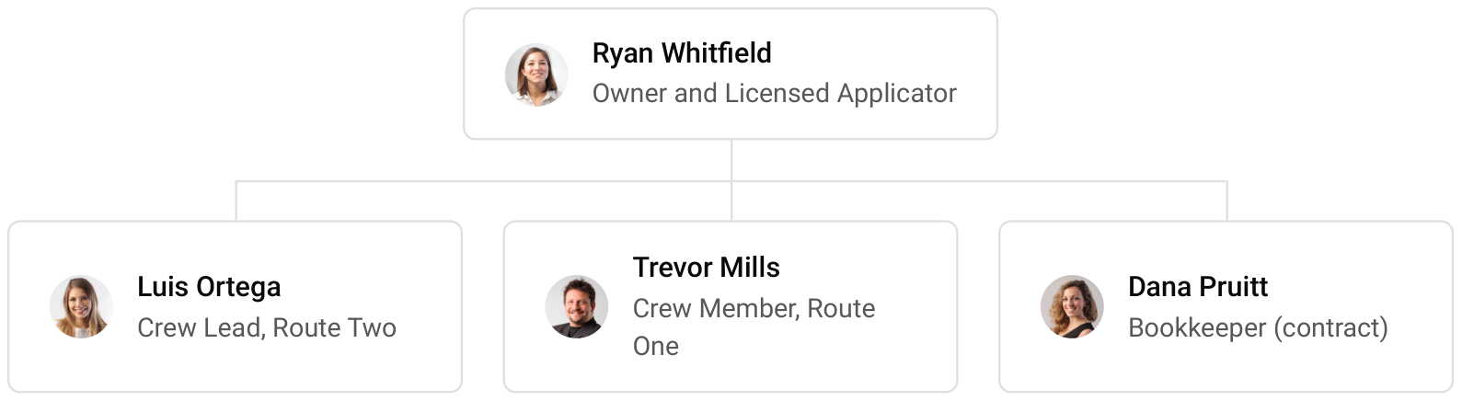

9.3 Advisory Board Members
Clovercrest has no formal advisory board. It draws instead on an outside accountant for tax and loan reporting, its insurance broker for a coverage review each winter, and the Mecklenburg County office of NC State Extension for turf questions and the continuing education the applicator licence requires.
Each adviser has a job in the calendar. The accountant reviews the monthly accounts against this plan each quarter, watching payroll as a share of revenue, the line that decides whether a route pays; the broker reviews cover before each season, when a new truck or an HOA contract changes what has to be insured; and the Extension office is the first call when a lawn shows a disease or pest the crews have not met before. Before a third crew is added, the owner intends to bring in one informal adviser who has run a larger lawn company, to test the hiring and equipment decisions that come with it.

9.3.1 Hiring Plan
1  Filled |  | 3  Hiring This Year |  | 4  Open

Group By Department | Position Filled | Time of Hire | Time of Start | Filled
Management & Sales | 1 of 1 | 0 days | 0 days | 100%
Mowing Crews | 0 of 3 | 30 days | 14 days | 0%
Lawn Treatment | 0 of 1 | 45 days | 30 days | 0%

CHAPTER 10

Financial Plan

10.1 Key Assumptions
10.2 Capital Requirements and Use of Funds
10.3 Income Statement (3 Year projections)
10.4 Balance Sheet (3 Year projections)
10.5 Cash Flow Statement (3 Year projections)
10.6 Break Even Analysis

10.1 Key Assumptions
Revenue is built from four drivers: 200 recurring accounts at full strength, 30 mowing visits per account a year, an average of $52 a visit, and treatments and enhancements worth 32% of mowing revenue. The first year ramps from 40% of capacity at launch to full routes after eight months, and revenue then grows 18% a year, giving $329,472, $388,777 and $458,757.
Gross margin is 76.0%, because crew wages sit in payroll below the gross line and cost of sales is product, fuel, blades, disposal and card fees. Payroll is 40% of revenue, marketing 6% and other operating costs 5%, with $1,500 a month for the yard, $350 for technology and $2,200 for insurance and administration. Net income moves from a loss of $2,341 in the first year to $9,867 and $23,392, and break-even revenue is $285,907, or 5,498 mowing visits.
The conservative scenario takes third year net income to $6,854 and the upside to $45,728. Working capital stays small: households are charged by card after each visit and HOA accounts are invoiced on 30 day terms, so receivables run near a week of sales, while suppliers are paid monthly and about three weeks of product is kept in stock.

10.2 Capital Requirements and Use of Funds
Startup costs total $152,600. The trucks are the largest item at $76,000, followed by the commercial mowers at $21,600 and the trailers at $14,000; treatment and aeration equipment, handheld tools, initial product, branding, licences, technology, launch marketing and the yard deposit make up the rest. They are funded by $50,000 from the owner and a $130,000 SBA 7(a) loan at 10.5% over seven years, matched to the working life of the equipment it buys. No outside equity is sought and no profits are distributed while the loan is repaid.

10.2.1 Use of Funds
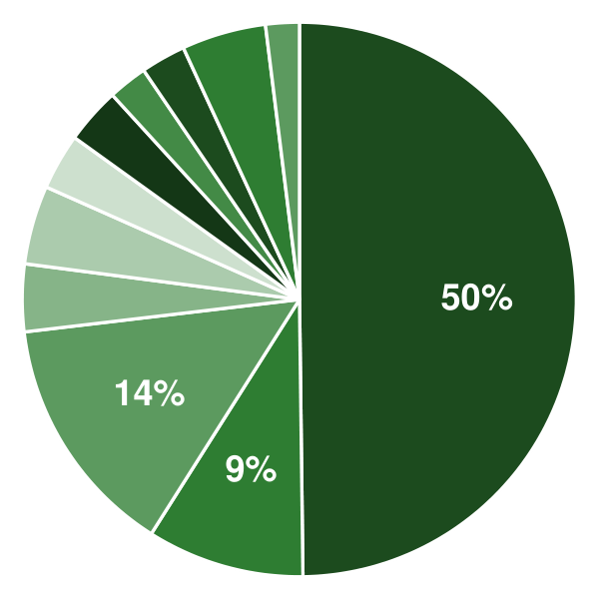 | ● Trucks 49.8%  ● Trailers 9.2%  ● Commercial Mowers 14.2%  ● Handheld Equipment 3.9%  ● Treatment & Aeration Equipment 4.6%  ● Initial Inventory 3.3%  ● Truck Wraps & Uniforms 3.3%  ● Licences, Insurance & Legal 2.3%  ● Technology & Website 2.6%  ● Launch Marketing 4.9%  ● Yard Deposit & Pre-Opening Rent 2.0%

Use Of Funds | Amount
Trucks | $76,000.00
Trailers | $14,000.00
Commercial Mowers | $21,600.00
Handheld Equipment | $6,000.00
Treatment & Aeration Equipment | $7,000.00
Initial Inventory | $5,000.00
Truck Wraps & Uniforms | $5,000.00
Licences, Insurance & Legal | $3,500.00
Technology & Website | $4,000.00
Launch Marketing | $7,500.00
Yard Deposit & Pre-Opening Rent | $3,000.00

10.3 Income Statement (3 Year projections)
 | Year 1 | Year 2 | Year 3 | Total
Revenue | $329,472.00 | $388,776.96 | $458,756.81 | $1,177,005.77
Cost of Sales | $79,073.28 | $93,306.47 | $110,101.63 | $282,481.38
General Costs | $0.00 | $0.00 | $0.00 | $0.00
Revenue Specific Costs | $55,351.30 | $65,314.53 | $77,071.14 | $197,736.97
Personnel Costs (Direct Labor) | $23,721.98 | $27,991.94 | $33,030.49 | $84,744.41
Gross Margin | $250,398.72 | $295,470.49 | $348,655.18 | $894,524.39
Gross Margin (%) | 76.00% | 76.00% | 76.00% | 76.00%
Operating Expense | $217,289.66 | $247,653.80 | $283,483.48 | $748,426.94
Payroll Expense (Indirect Labor) | $131,788.80 | $155,510.78 | $183,502.72 | $470,802.30
General Expense | $84,841.92 | $91,365.47 | $99,063.25 | $275,270.64
Bad Debt | $658.94 | $777.55 | $917.51 | $2,354.00
Amortization of Current Assets | $0.00 | $0.00 | $0.00 | $0.00
EBITDA | $33,109.06 | $47,816.69 | $65,171.70 | $146,097.45
Additional Expense | $35,450.00 | $37,949.30 | $41,779.96 | $115,179.26
Long Term Depreciation | $21,800.00 | $23,466.19 | $25,432.29 | $70,698.48
Gain or loss from Sale of Assets | $0.00 | $0.00 | $0.00 | $0.00
EBIT | $11,309.06 | $24,350.50 | $39,739.41 | $75,398.97
Interest Expense | $13,650.00 | $11,700.00 | $9,750.00 | $35,100.00
EBT | ($2,340.94) | $12,650.50 | $29,989.41 | $40,298.97
Income Tax Expense / Benefit | $0.00 | $2,783.11 | $6,597.67 | $9,380.78
Total Expense | $331,812.94 | $378,909.57 | $435,365.07 | $1,146,087.58
Net Income | ($2,340.94) | $9,867.39 | $23,391.74 | $30,918.19
Net Income (%) | -0.71% | 2.54% | 5.10% | 2.63%
Retained Earning Opening | $0.00 | ($2,340.94) | $7,526.45
Owner's Distribution | $0.00 | $0.00 | $0.00 | $0.00
Retained Earning Closing | ($2,340.94) | $7,526.45 | $30,918.19 | $30,918.19

10.4 Balance Sheet (3 Year projections)
 | Year 1 | Year 2 | Year 3 | Total
Assets | $165,586.80 | $158,748.39 | $165,902.77 | $165,902.77
Current Assets | $34,786.80 | $39,751.27 | $58,575.24 | $58,575.24
Cash | $28,973.65 | $32,891.75 | $50,481.01 | $50,481.01
Accounts Receivable | $1,263.73 | $1,491.20 | $1,759.62 | $1,759.62
Inventory | $4,549.42 | $5,368.32 | $6,334.61 | $6,334.61
Other Current Assets | $0.00 | $0.00 | $0.00 | $0.00
Long Term Assets | $130,800.00 | $118,997.12 | $107,327.53 | $107,327.53
Gross Long Term Assets | $152,600.00 | $164,263.31 | $178,026.01 | $178,026.01
Accumulated Depreciation | $21,800.00 | $45,266.19 | $70,698.48 | $70,698.48
Liabilities & Equity | $165,586.80 | $158,748.39 | $165,902.77 | $165,902.77
Liabilities | $117,927.74 | $101,221.94 | $84,984.59 | $84,984.59
Current Liabilities | $25,070.60 | $26,936.23 | $29,270.30 | $29,270.30
Accounts Payable | $6,499.17 | $7,669.02 | $9,049.45 | $9,049.45
Income Tax Payable | $0.00 | $695.78 | $1,649.42 | $1,649.42
Sales Tax Payable | $0.00 | $0.00 | $0.00 | $0.00
Short Term Debt | $18,571.43 | $18,571.43 | $18,571.43 | $18,571.43
Long Term Liabilities | $92,857.14 | $74,285.71 | $55,714.29 | $55,714.29
Long Term Debt | $92,857.14 | $74,285.71 | $55,714.29 | $55,714.29
Equity | $47,659.06 | $57,526.45 | $80,918.18 | $80,918.18
Paid-in Capital | $0.00 | $0.00 | $0.00 | $0.00
Common Stock | $0.00 | $0.00 | $0.00 | $0.00
Preferred Stock | $0.00 | $0.00 | $0.00 | $0.00
Owner's Contribution | $50,000.00 | $50,000.00 | $50,000.00 | $50,000.00
Retained Earnings | ($2,340.94) | $7,526.45 | $30,918.18 | $30,918.18
Check | $0.00 | $0.00 | $0.00 | $0.00

10.5 Cash Flow Statement (3 Year projections)
 | Year 1 | Year 2 | Year 3 | Total
Cash Received | $327,549.33 | $387,771.94 | $457,570.88 | $1,172,892.15
Cash Paid | $307,404.25 | $353,619.10 | $407,647.49 | $1,068,670.84
COS & General Expenses | $138,243.47 | $156,329.05 | $175,720.25 | $470,292.77
Salary & Wages | $155,510.78 | $183,502.72 | $216,533.21 | $555,546.71
Interest | $13,650.00 | $11,700.00 | $9,750.00 | $35,100.00
Sales Tax | $0.00 | $0.00 | $0.00 | $0.00
Income Tax | $0.00 | $2,087.33 | $5,644.03 | $7,731.36
Net Cash From Operations | $20,145.08 | $34,152.84 | $49,923.39 | $104,221.31
Assets Sell | $0.00 | $0.00 | $0.00 | $0.00
Assets Purchase | $152,600.00 | $11,663.31 | $13,762.70 | $178,026.01
Net Cash From Investments | ($152,600.00) | ($11,663.31) | ($13,762.70) | ($178,026.01)
Amount Received | $180,000.00 | $0.00 | $0.00 | $180,000.00
Loan Received | $130,000.00 | $0.00 | $0.00 | $130,000.00
Common Stock | $0.00 | $0.00 | $0.00 | $0.00
Preferred Stock | $0.00 | $0.00 | $0.00 | $0.00
Owner's Contribution | $50,000.00 | $0.00 | $0.00 | $50,000.00
Amount Paid | $18,571.43 | $18,571.43 | $18,571.43 | $55,714.29
Loan Capital | $18,571.43 | $18,571.43 | $18,571.43 | $55,714.29
Dividends & Distributions | $0.00 | $0.00 | $0.00 | $0.00
Net Cash From Financing | $161,428.57 | ($18,571.43) | ($18,571.43) | $124,285.71
Summary
Starting Cash | $0.00 | $28,973.65 | $32,891.75
Cash In | $507,549.33 | $387,771.94 | $457,570.88 | $1,352,892.15
Cash Out | $478,575.68 | $383,853.84 | $439,981.62 | $1,302,411.14
Change in Cash | $28,973.65 | $3,918.10 | $17,589.26 | $50,481.01
Ending Cash | $28,973.65 | $32,891.75 | $50,481.01 | $50,481.01

10.6 Break Even Analysis
 | Year 1 | Year 2 | Year 3 | Total
Starting Revenue | $0.00 | $329,472.00 | $718,248.96 | $718,248.96
Net Revenue | $329,472.00 | $388,776.96 | $458,756.81 | $458,756.81
Closing Revenue | $329,472.00 | $718,248.96 | $1,177,005.77 | $1,177,005.77
Starting Expense | $0.00 | $331,812.94 | $710,722.51 | $710,722.51
Net Expense | $331,812.94 | $378,909.57 | $435,365.07 | $435,365.07
Closing Expense | $331,812.94 | $710,722.51 | $1,146,087.58 | $1,146,087.58
Is Break Even? | No | Yes | Yes
Break Even Month | - | Mar '27 | -
Days Required | - | 25 Days | -
Break Even Revenue | - | $426,666.24 | -

CHAPTER 11

References

- SRC001: Landscaping Services in the US Industry Analysis, 2026, IBISWorld, 2026-05-01. https://www.ibisworld.com/united-states/industry/landscaping-services/1497/ (accessed 2026-10-13)
- SRC002: Total Revenue for Landscaping Services, All Establishments, Employer Firms (REVEF56173ALLEST), U.S. Census Bureau via FRED, Federal Reserve Bank of St. Louis, 2024-01-01. https://fred.stlouisfed.org/series/REVEF56173ALLEST (accessed 2026-10-13)
- SRC003: QCEW Annual Averages, NAICS 561730 Landscaping services, U.S. total, private ownership, 2024 and 2025, U.S. Bureau of Labor Statistics, 2026-01-01. https://data.bls.gov/cew/apps/table_maker/v4/table_maker.htm#type=1&year=2025&qtr=A&own=5&ind=561730&supp=0 (accessed 2026-10-13)
- SRC004: How Much Does Lawn Mowing Cost in 2026?, LawnStarter, 2026-10-06. https://www.lawnstarter.com/blog/cost/lawn-mowing-price/ (accessed 2026-10-13)
- SRC005: How Much Does Lawn Care and Mowing Cost in 2025?, HomeAdvisor, 2025-01-01. https://www.homeadvisor.com/cost/lawn-and-garden/maintain-a-lawn (accessed 2026-10-13)
- SRC006: How Much Does Lawn Fertilization Cost in 2026?, LawnStarter, 2025-12-27. https://www.lawnstarter.com/blog/cost/lawn-fertilization-price/ (accessed 2026-10-13)
- SRC007: How Much Does Lawn Aeration Cost in 2026?, LawnStarter, 2026-10-05. https://www.lawnstarter.com/blog/cost/lawn-aeration-price/ (accessed 2026-10-13)
- SRC008: Four in 10 Americans with yards hired pros this year, NALP survey shows, Landscape Management, 2017-11-01. https://www.landscapemanagement.net/four-in-10-americans-with-yards-hired-pros-this-year-nalp-survey-shows/ (accessed 2026-10-13)
- SRC009: Benchmarking Your Business, Lawn & Landscape, 2026-03-01. https://www.lawnandlandscape.com/page/benchmarking-your-business (accessed 2026-10-13)
- SRC010: Grounds Maintenance Workers, Occupational Outlook Handbook, U.S. Bureau of Labor Statistics, 2026-01-01. https://www.bls.gov/ooh/building-and-grounds-cleaning/grounds-maintenance-workers.htm (accessed 2026-10-13)
- SRC011: DHS and DOL announce up to 64,716 supplemental H-2B visas for FY 2026, Envoy Global, 2026-02-01. https://www.envoyglobal.com/news-alert/dhs-and-dol-announce-up-to-64716-supplemental-h-2b-visas-for-fy-2026 (accessed 2026-10-13)
- SRC012: Commercial Mowers: Zero-Turn, Walk-Behind, Stand-On, Electric & Autonomous, Exmark, 2026-10-01. https://www.exmark.com/mowers (accessed 2026-10-13)
- SRC013: Certification Standards for Pesticide Applicators, U.S. Environmental Protection Agency, 2023-01-01. https://www.epa.gov/pesticide-worker-safety/certification-standards-pesticide-applicators (accessed 2026-10-13)
- SRC014: CARB approves updated regulations requiring most new small off-road engines be zero emission by 2024, California Air Resources Board, 2021-12-09. https://ww2.arb.ca.gov/news/carb-approves-updated-regulations-requiring-most-new-small-road-engines-be-zero-emission-2024 (accessed 2026-10-13)
- SRC015: Small Off-Road Engines (SORE), California Air Resources Board, 2026-01-01. https://ww2.arb.ca.gov/our-work/programs/small-off-road-engines-sore (accessed 2026-10-13)
- SRC016: BrightView Holdings, Inc. Form 10-K for the fiscal year ended September 30, 2025, U.S. Securities and Exchange Commission, 2025-11-01. https://www.sec.gov/Archives/edgar/data/1734713/000119312525288109/bv-20250930.htm (accessed 2026-10-13)
- SRC017: QCEW Annual Averages, NAICS 561730 Landscaping services, Mecklenburg County, N.C., private ownership, 2022, U.S. Bureau of Labor Statistics, 2023-01-01. https://data.bls.gov/cew/apps/table_maker/v4/table_maker.htm#type=2&year=2022&qtr=A&own=5&ind=561730&st=37&supp=0 (accessed 2026-10-13)
- SRC018: QCEW Annual Averages, NAICS 561730 Landscaping services, Mecklenburg County, N.C., private ownership, 2024 and 2025, U.S. Bureau of Labor Statistics, 2026-01-01. https://data.bls.gov/cew/apps/table_maker/v4/table_maker.htm#type=2&year=2025&qtr=A&own=5&ind=561730&st=37&supp=0 (accessed 2026-10-13)
- SRC019: Mecklenburg County, NC profile, Census Reporter (American Community Survey 2024 1-year), 2025-01-01. https://censusreporter.org/profiles/05000US37119-mecklenburg-county-nc/ (accessed 2026-10-13)
- SRC020: Tables B25003 (Tenure) and B25024 (Units in Structure), Mecklenburg County and Charlotte city, NC, Census Reporter (American Community Survey 2024 1-year), 2025-01-01. https://censusreporter.org/data/table/?table=B25024&geo_ids=05000US37119,16000US3712000 (accessed 2026-10-13)
- SRC021: Tall Fescue Lawn Maintenance Calendar (AG-367), NC State Extension, 2021-07-08. https://content.ces.ncsu.edu/tall-fescue-lawn-maintenance-calendar (accessed 2026-10-13)
- SRC022: How Much Does Lawn Care Cost in Charlotte, NC? (2026), GreenPal, 2026-07-11. https://www.yourgreenpal.com/blog/how-much-does-lawn-care-cost-in-charlotte-nc (accessed 2026-10-13)
- SRC023: Charlotte NC Lawn Care & Mowing Services, LawnStarter, 2026-10-01. https://www.lawnstarter.com/charlotte-nc-lawn-care (accessed 2026-10-13)
- SRC024: OEWS May 2025, Charlotte-Concord-Gastonia, NC-SC (MSA 16740), U.S. Bureau of Labor Statistics, 2026-01-01. https://data.bls.gov/oes/#/area/0016740/2025 (accessed 2026-10-13)
- SRC025: Minimum Wage in NC, North Carolina Department of Labor, 2026-01-01. https://www.labor.nc.gov/workplace-rights/employee-rights-regarding-time-worked-and-wages-earned/minimum-wage-nc (accessed 2026-10-13)
- SRC026: North Carolina lawmakers approve temporary gas tax suspension, ABC11 WTVD, 2026-10-01. https://abc11.com/post/north-carolina-lawmakers-approve-temporary-gas-tax-suspension/19918421/ (accessed 2026-10-13)
- SRC027: Structural Pest Control and Pesticides - Pesticides Licenses, NC Department of Agriculture and Consumer Services, 2026-01-01. https://ncagr.gov/divisions/structural-pest-control-and-pesticides/pesticide/licensing-and-certification/licenses (accessed 2026-10-13)
- SRC028: Exemptions, North Carolina Landscape Contractors' Licensing Board, 2026-01-01. https://nclclb.com/faq-hold/exemptions/ (accessed 2026-10-13)




