

MobilePhlebotomyBusiness Plan
"ConvenientBloodDrawsatYourDoorstep!"

PreparedBy

Business
Plan
2024
JohnDoe
(650)359-3153
10200 Bolsa Ave, Westminster, CA, 92683 info@example.comhttps://www.example.com/

TableofContents

ExecutiveSummary
6
Marketopportunity 7
ServicesOffered 7
Marketing&SalesStrategies 8
FinancialHighlights 8
Units Sold v/s Revenue 8
CompanyOverview
10
Ownership 11
BusinessOwners 11
Missionstatement 11
Business history 12
Futuregoals 12
MarketAnalysis
13
TargetMarket 14
Marketsizeandgrowthpotential 14
MarketSize 15
Competitiveanalysis 15
PhlebXMobileServices 15
MobileLabPro 15
On-the-GoPhlebotomy 16
Markettrends 16
Regulatoryenvironment 17
ProductsandServices
18
Services 19
BloodCollectionServices 19
DiagnosticTesting 19
TherapeuticMonitoring 20
AdditionalServices 20

SalesAndMarketingStrategies
21
UniqueSellingProposition(USP) 22
PricingStrategy 22
Marketingstrategies 23
Online 23
Offline 23
Salesstrategies 24
Customerretention 24
OperationsPlan
26
Staffing&Training 27
OperationalProcess 27
Equipment&Tools 28
ManagementTeam
29
Founder/CEO 30
LisaNguyen 30
Keymanagers 31
JohnMartinez 31
SarahBennett 31
MichaelLee 32
Organizationalstructure 32
Organizationchart 32
Compensationplan 33
Boardofadvisors 33
Dr.EmilyCarter 34
RobertKane 34
Financial Plan
35
Profit&lossstatement 36
Cashflowstatement 41
Balancesheet 43
Break-evenPoint 45

Financingneeds 47
Appendix
49
EmbedLink 50

Businessplanningthat’ssimplerandfasterthanyouthink

CreatingabusinessplanusingUpmetricstostartandgrowabusinessisliterallytheeasiest thingintheWorld.Simplyreadtheinstructionsandfillintheblanks.It’sassimpleasthat.

Upmetrics has everything you need to create a comprehensive business plan.
❛
❜

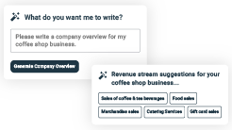
AI-poweredUpmetricsAssistant

AI-poweredinsightstostreamlineyourplan
Not sure where to start? Upmetrics’ AI Assistant will automaticallygenerateideasforeachsectionofyourplanand offerimprovedversionsofyourwriting,adjustingfortone,voice, and grammar or spelling errors.

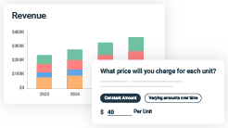
FinancialForecastingTool

Allthefinancialsarecalculatedforyou
Forget the complex formulas and clumsy spreadsheets — withautomaticfinancialsanddrag-and-dropforecasting,you canfinishyourplanfasterandbeconfidentthatyour numbers are accurate.

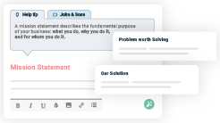
BusinessPlanBuilder

Guidesyoulikeabusinessmentor

Upmetrics’step-by-stepinstructions,prompts,andthelibraryof 400+samplebusinessplanswillguideyouthrougheachsection of your plan as a business mentor.

1.

ExecutiveSummary

MarketopportunityServices Offered
Marketing & Sales StrategiesFinancial Highlights



Anexecutivesummaryisthefirstsectionofthebusinessplanintendedto provide an overview of the whole business plan.
Tounlock helptry Upmetrics!

Helptip
PrimeCareMobilePhlebotomy
Startyourexecutivesummarybybrieflyintroducingyourbusinesstoyourreaders.
Thissectionmayincludethenameofyourmobilephlebotomybusiness,itslocation,when it
wasfounded,etc.
Tounlock helptry Upmetrics!
Startwritinghere..

Marketopportunity

Helptip
PrimeCareMobilePhlebotomy
Summarize your market research, including market size, growth potential, and marketing trends.Highlighttheopportunitiesinthemarketandhowyourbusinesswillfitintofillthegap.
Tounlock helptry Upmetrics!
Startwritinghere..

ServicesOffered

Helptip
PrimeCareMobilePhlebotomy
Highlight the Mobile phlebotomy services you offer your clients.The USPs and differentiators you offer are always a plus.
Tounlock helptry Upmetrics!
Startwritinghere..

Marketing&SalesStrategies

Helptip
PrimeCareMobilePhlebotomy
Outline your sales and marketing strategies—what marketing platforms you use, how you plan on acquiring customers, etc.
Tounlock helptry Upmetrics!
Startwritinghere..

FinancialHighlights

Helptip
PrimeCareMobilePhlebotomy
Brieflysummarizeyourfinancialprojectionsfortheinitialyearsofbusinessoperations.Include
capitalorinvestmentrequirements,associatedstartupcosts,projectedrevenues,andprofit
forecasts.
Tounlock helptry Upmetrics!
Startwritinghere..

UnitsSoldv/sRevenue

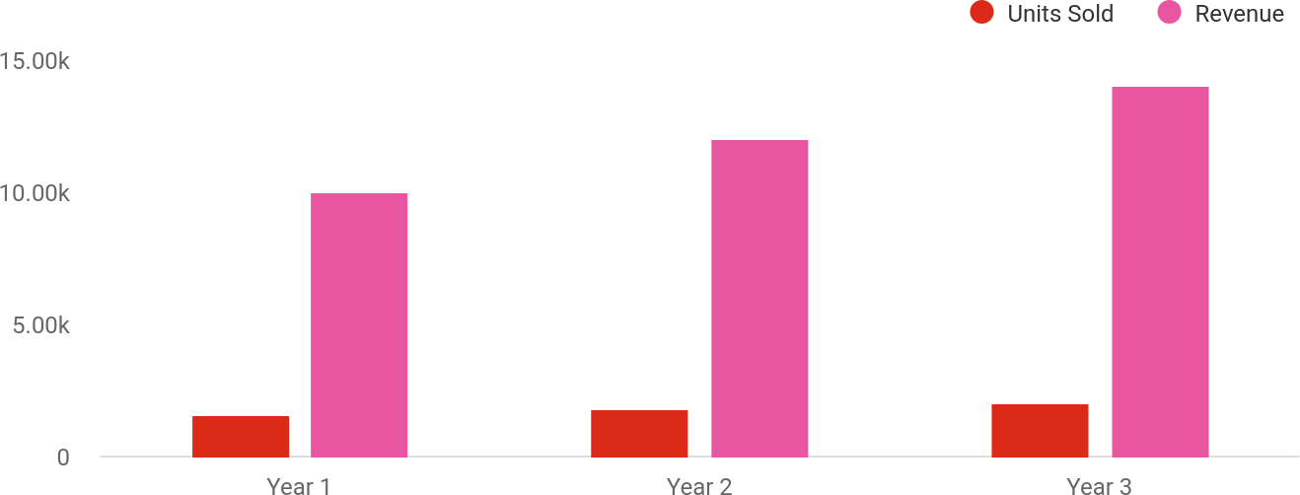

FinancialYear | UnitsSold | Revenue
Year1 | 1,550 | $10,000
Year2 | 1,800 | $12,000

FinancialYear | UnitsSold | Revenue
Year3 | 2,050 | $14,000

Helptip
PrimeCareMobilePhlebotomy
SummarizeyourexecutivesummarysectionwithaclearCTA,forexample,invitingangel investors to discuss the potential business investment.
Tounlock helptry Upmetrics!

Writeacalltoactionforyourbusinessplan.

2.

CompanyOverview

OwnershipMission statementBusiness historyFuture goals

Dependingonwhatdetailsofyourbusinessareessential,you’llneed different elements in your business overview.
Tounlock helptry Upmetrics!
Helptip
PrimeCareMobilePhlebotomy
Describewhatkindofmobilephlebotomycompanyyourunandthenameofit.Youmay specialize in one of the following mobile phlebotomy businesses:
Tounlock helptry Upmetrics!
Startwritinghere..

Ownership

Helptip
PrimeCareMobilePhlebotomy
List the names of your mobile phlebotomy company’s founders or owners. Describe how much shares they own and their responsibilities for efficiently managing the business.
Tounlock helptry Upmetrics!
Startwritinghere..

BusinessOwners

LisaNguyen
100%
100Shares

Missionstatement


Helptip
PrimeCareMobilePhlebotomy
Summarizeyourbusiness’objective,coreprinciples,andvaluesinyourmissionstatement.This statement needs to be memorable, clear, and brief.
Tounlock helptry Upmetrics!

Weaimtoenhancehealthcareaccessibilitybyproviding
❛
exceptional, patient-focused blood draw services in the comfort ofclients’chosenlocations.Wearecommittedto
professionalism, reliability,and compassion, ensuring a seamlessand stress-free experience for every client we serve.
❜

Businesshistory

Helptip
PrimeCareMobilePhlebotomy
Ifyou’reanestablishedtanningsalonserviceprovider,brieflydescribeyourbusinesshistory, like—whenitwasfounded,howitevolvedovertime,etc.
Tounlock helptry Upmetrics!
Startwritinghere..

Futuregoals

Helptip
PrimeCareMobilePhlebotomy
It’scrucialtoconveyyouraspirationsandvision.Mentionyourshort-termandlong-termgoals; they can be specific targets for revenue, market share, or expanding your services.
Tounlock helptry Upmetrics!
Startwritinghere..

3.

MarketAnalysis
TargetMarket
MarketsizeandgrowthpotentialCompetitive analysis
Market trendsRegulatoryenvironment

Marketanalysisprovidesaclearunderstandingofthemarketinwhichyour
printingbusinesswillrunalongwiththetargetmarket,competitors, and
growthopportunities.
Tounlock helptry Upmetrics!
Helptip
PrimeCareMobilePhlebotomy
Towritetheintroductionsectionofyourmarketanalysis,startbyclearlyidentifyingyour primary target market.
Tounlock helptry Upmetrics!
Startwritinghere..

TargetMarket

Helptip
PrimeCareMobilePhlebotomy
Startthissectionbydescribingyourtargetmarket.Defineyouridealcustomerandexplainwhat
typesofservicestheyprefer.Creatingabuyerpersonawillhelpyoueasilydefineyourtarget
markettoyourreaders.
Tounlock helptry Upmetrics!
Startwritinghere..

Marketsizeandgrowthpotential

Helptip
PrimeCareMobilePhlebotomy
Describeyourmarketsizeandgrowthpotentialandwhetheryouwilltargetanicheoramuch broader market.
Tounlock helptry Upmetrics!
Startwritinghere..

MarketSize

AvailableMarket
TotalU.S.populationrequiringhealthcare services, including blood draws.

331M

ServedMarket
Individuals and organizations needing accessible blood draw services nationwide.
50M

TargetMarket
Homepatients,nursingfacilities,and corporateclientsinWestminsterand neighboring areas.

500k

Helptip
PrimeCareMobilePhlebotomy
Identifyandanalyzeyourdirectandindirectcompetitors.Identifytheirstrengths and
weaknesses,and describewhat differentiatesyour mobilephlebotomy servicesfrom them.
Pointouthowyouhaveacompetitiveedgeinthemarket.
Tounlock helptry Upmetrics!

Competitiveanalysis

PhlebXMobileServices
[PhlebX Mobile Services] is a regional provider specializing in home phlebotomy for individual clients and small healthcare facilities. They operate across several cities, focusing on fast and affordable services.

Features
Flexible onlinescheduling.
Affordablepricingforroutine blood tests.
Mobileappforreal-time appointment tracking.

Strengths
Establishedclientbasein urban areas.
User-friendlydigitaltoolsfor scheduling.
Competitivepricingforroutine services.

Weaknesses
Limitedcorporatewellness offerings.
Lack of focus on personalized customer care.
Inconsistentservicequalityin suburban regions.

MobileLabPro
[MobileLab Pro] offers comprehensive diagnostic services, including mobile phlebotomy, for nursing homes,assistedlivingfacilities,andhospitals.Theirbusinessemphasizespartnershipswith healthcare providers.

Features
Broad range of diagnostic services.
Dedicatedteamsforfacility- based clients.
Advanceddataintegrationwith healthcare providers.

Strengths
Strongpresenceininstitutional settings.
Widerangeofdiagnostic offerings.
Expertiseinhealthcaredata management.

Weaknesses
Limitedavailabilityforindividual clients.
High service costs for smaller clients.
Lessfocusonhome-basedand on-demandcare.

On-the-GoPhlebotomy
[On-the-Go Phlebotomy] caters to both individual clients and small businesses, focusing on personalized care and flexible scheduling. They emphasize customer satisfaction and word-of-mouth marketing.

Features
Highlypersonalizedcarefor individual clients.
Same-dayappointment options.
Discounts for group or corporate services.

Strengths
Strong customer relationships and retention.
Excellentreputationfor personalized service.
Flexible and accommodating scheduling.

Weaknesses
Limitedgeographicreach.
Lackofadvanceddigitaltoolsfor service management.
Smaller workforce, leading to occasional scheduling delays.

Markettrends

Helptip
PrimeCareMobilePhlebotomy
Analyzeemergingtrendsintheindustry,suchastechnology,changesinaudiencebehavioror preferences, etc. Explain how your business will cope with all the trends.
Tounlock helptry Upmetrics!
Startwritinghere..

Regulatoryenvironment

Helptip
PrimeCareMobilePhlebotomy
Listregulationsandlicensingrequirementsthatmayaffectyourmobilephlebotomy,suchas age restrictions, licensing & permits, zoning regulations, etc.
Tounlock helptry Upmetrics!
Startwritinghere..

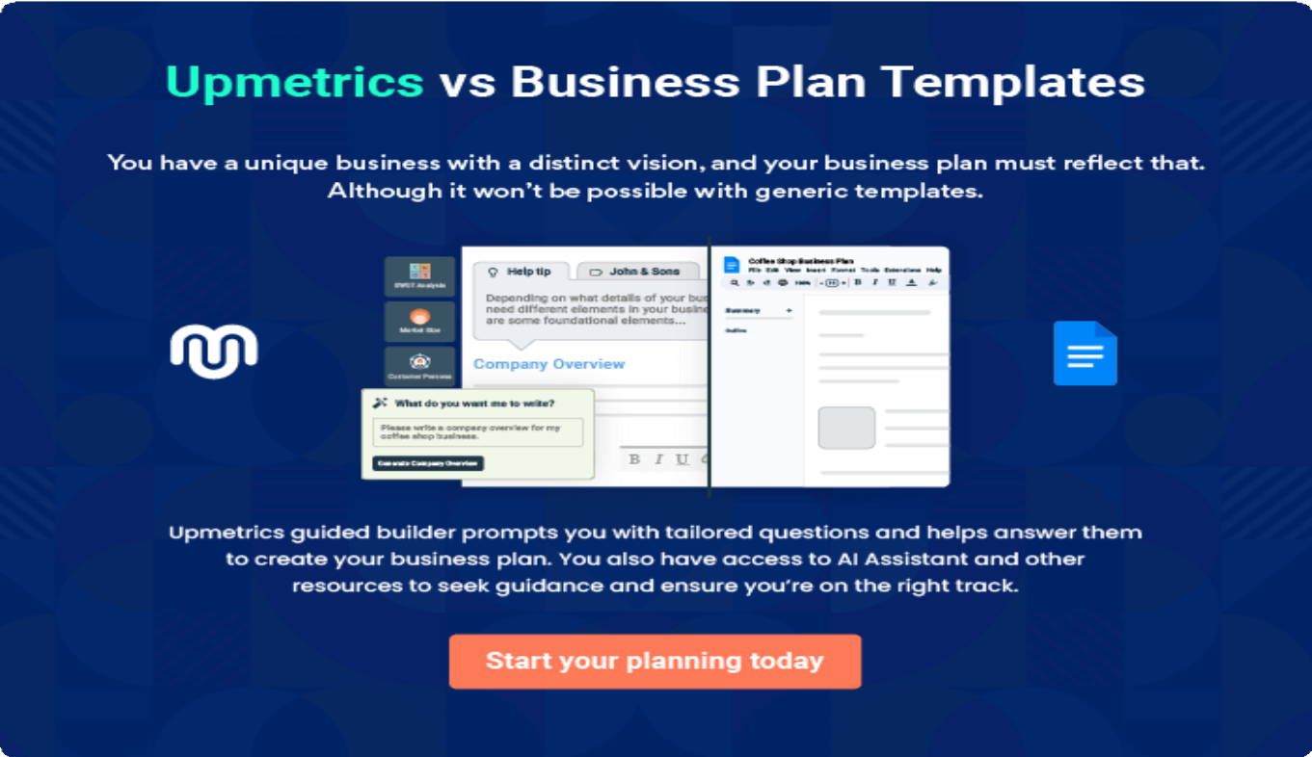

4.

Productsand Services

Services
AdditionalServices

Theproductandservicessectionofamobilephlebotomybusinessplan
shoulddescribethespecificservicesandproductsthatwillbeoffered to
customers.Towritethissectionshouldincludethefollowing:
Tounlock helptry Upmetrics!
Helptip
PrimeCareMobilePhlebotomy
Tocrafttheintroductionforyour"ProductsandServices"chapter,beginbypositioningyour business within its industry, emphasizing its unique strengths or value proposition.
Tounlock helptry Upmetrics!

Startwritinghere..
Helptip
Mention the Mobile phlebotomy services your business will offer.This list may include services like,
Tounlock helptry Upmetrics!

Services


BloodCollectionServices
Price:[$50]pervisit(standardcollection)

Mobilebloodcollectionforroutineandspecializedtests, conducted at the client’s location.

Specifications
- Appointmentschedulingavailable7daysaweek.
- Certifiedphlebotomistsensurepropercollectionand handling of samples.
- Compatiblewithmajorhealthcareprovidersandlab networks.
- Includeslabelingandsafetransportationtopartner laboratories.

DiagnosticTesting
Price:Startingat[$75]pertest(variesbytesttype)

Comprehensive diagnostic testing services, including cholesterollevels,glucosetesting,andhormonepanels.

Specifications
  - Accesstoadvanceddiagnosticlabsforaccurate results.
  - Testsincludecompletebloodcount(CBC),metabolic panels, and thyroid function tests.
  - Resultsdeliveredelectronicallywithin24-72hours.
  - SecureHIPAA-compliantdatahandling.

TherapeuticMonitoring
Price:[$100]persession

Regularbloodmonitoringforpatientsundergoing treatment for chronic conditions such as diabetes or heart disease.

Specifications
  - Includes medication level assessments and periodic reporting to healthcare providers.
  - Personalized schedules for optimal monitoring frequency.
  - Professionalrecommendationsbasedoncollected data.
  - Suitableforlong-termcarepatientsandclinicaltrials.

AdditionalServices

Helptip
PrimeCareMobilePhlebotomy
Ifyouconsiderofferingsupplementalservicesthatcomplementyourcoreofferings,mention them here.
Tounlock helptry Upmetrics!
Startwritinghere..

5.

SalesAndMarketing
Strategies

Unique Selling Proposition (USP)Pricing Strategy
Marketing strategiesSales strategiesCustomer retention

Writing the sales and marketing strategies section means a list of strategies you will use to attract and retain your clients.
Tounlock helptry Upmetrics!
HelpTip
PrimeCareMobilePhlebotomy
Tocreateaneffectiveintroductionforyour"SalesandMarketingStrategies"chapter,startby setting the stage within your specific industry or market.
Tounlock helptry Upmetrics!
Startwritinghere..

UniqueSellingProposition(USP)

Helptip
PrimeCareMobilePhlebotomy
Define your business’s USPs depending on the market you serve, the equipment you use, and theuniqueservicesyouprovide.IdentifyingUSPswillhelpyouplanyourmarketingstrategies.
Tounlock helptry Upmetrics!
Startwritinghere..

PricingStrategy

Helptip
PrimeCareMobilePhlebotomy
Describeyourpricingstrategy—howyouplantopriceyourservicesandstaycompetitiveinthe
localmarket.Youcanmentionanydiscountsyouplanonofferingtoattractnewcustomers to
yourservice.
Tounlock helptry Upmetrics!
Startwritinghere..

Helptip
Discussyourmarketingstrategiestomarketyourservices.Youmayincludesomeofthese
marketingstrategiesinyourbusinessplan—socialmediamarketing,Googleads,brochures,
emailmarketing,contentmarketing,andprintmarketing.
Tounlock helptry Upmetrics!

Marketingstrategies

Online


SocialMedia Marketing
Active presence on platforms like Facebook, Instagram, and LinkedIn to share educational content and customer success stories.

GoogleAds Campaigns
Targetedpay-per-click (PPC) advertising to capture high-intent searches for mobile phlebotomy services.

EmailMarketing
Regularnewslettersto update clients on services, promotions, and healthcare tips.

ContentMarketing
Blog posts and guides on healthcare topics to position[PrimeCare]as an industry thought leader.

Offline

BrochuresandFlyers
Distributedinclinics,pharmacies,andlocalcommunitycenters.

Helptip
Outlinethestrategiesyou’llimplementtomaximizeyoursales.Yoursalesstrategiesmay include partnering with other local businesses, offering referral programs, etc.
Tounlock helptry Upmetrics!

Salesstrategies

Referrals
Introducing a referral program with discounts for clients who bring in new customers.

Community engagement
Attendinglocalhealth fairs and community events to increase brand awareness.

Localpartnerships
Partnering with local clinics,nursinghomes, and businesses to create referral networks.

Helptip
Describeyourcustomerretentionstrategiesandhowyouplantoexecutethem.Forinstance, introducing loyalty programs, discounts on annual membership, personalized service, etc.
Tounlock helptry Upmetrics!

Customerretention

Loyaltyprograms
Offering discounts for repeat customers or annual memberships.

Personalized services
Personalized reminders for routine blood draws orwellnessscreenings.

Post-servicesupport
Exceptional post- service support to addressclientinquiries or concerns.

6.

OperationsPlan

Staffing & TrainingOperational ProcessEquipment & Tools

Whenwritingtheoperationsplansection,it’simportanttoconsiderthe various aspects of your business operations.
Tounlock helptry Upmetrics!
Helptip
PrimeCareMobilePhlebotomy
Tocreateaneffectiveintroductionforyour"OperationalPlan"chapter,startbyemphasizingthe
pivotalroleofefficientoperationsinthesuccessofyourbusiness,underscoringhowthey
directlyimpactthequalityofservicesdelivered.
Tounlock helptry Upmetrics!
Startwritinghere..

Staffing&Training

Helptip
PrimeCareMobilePhlebotomy
Mention your business’s staffing requirements, including the number of employees or workers needed.Includetheirqualifications,theexperiencerequired,andthedutiestheywillperform.
Tounlock helptry Upmetrics!
Startwritinghere..

OperationalProcess

Helptip
PrimeCareMobilePhlebotomy
OutlinetheprocessesandproceduresyouwillusetorunyourMobilephlebotomybusiness.

Youroperationalprocessesmayincludeplanning&schedulingappointments,coordinatingwith
Tounlock helptry Upmetrics!
Startwritinghere..

Equipment&Tools

Helptip
PrimeCareMobilePhlebotomy
Outline the essential medical supplies and equipment used for mobile phlebotomy services. Also, consider setting up technology and software systems to streamline your daily operations.
Tounlock helptry Upmetrics!
Startwritinghere..

7.

ManagementTeam

Founder/CEOKeymanagers
OrganizationalstructureCompensation planBoard of advisors

The management team section provides an overview of the individuals responsible for running your business plan.
Tounlock helptry Upmetrics!
Helptip
PrimeCareMobilePhlebotomy
Tocraftanintroductionforyour"ManagementTeam"chapter,beginbyemphasizingthecrucial role of leadership in the success of any business.
Tounlock helptry Upmetrics!
Startwritinghere..

Founder/CEO

HelpTip
MentionthefoundersandCEOofyourmobilephlebotomycompany,anddescribetheirroles and responsibilities in successfully running the business.
Tounlock helptry Upmetrics!
Startwritinghere..

Lisa Nguyen


FounderandCEO-lisa.nguyen@example.com



Lisa Nguyen, a seasoned healthcare professional with over 10 years of experienceinphlebotomyandhealthcareoperations,founded[PrimeCare Mobile Phlebotomy] in [2023].
Before establishing PrimeCare, Lisa worked as a lead phlebotomist at a prominenthealthcareprovider,whereshemanagedmobileblooddrawteams and optimized patient care procedures.
As the CEO, Lisa leads the company’s strategic planning, oversees daily operations,andensuresthehighestqualitystandardsinservicedelivery.

Keymanagers

Helptip
Introduceyourmanagementandkeymembersofyourteam,andexplaintheirrolesand
responsibilities.Itshouldinclude,keyexecutives,seniormanagement,andotherdepartment
managers.
Tounlock helptry Upmetrics!
Startwritinghere..

JohnMartinez


OperationsManager-john.martinez@example.com

JohnMartinezbrings8yearsofexpertiseinhealthcareadministration, specializing in operational efficiency and logistics.
He earned his Bachelor’s Degree in Healthcare Administration from the University of Southern California and previously worked as an operations supervisor for a national mobile healthcare provider.
At[PrimeCare],Johnisresponsibleforscheduling,coordinatingwithclientsand phlebotomists, and optimizing logistics to ensure timely service delivery. His meticulous approach to operational planning contributes to PrimeCare’s seamless execution of services.

SarahBennett


MarketingManager-sarah.bennett@example.com

Sarah Bennett is a results-driven marketing professional with a strong focus on digitalmarketingandbranddevelopment.
SheearnedherMBAinMarketingfromUCLAAndersonSchoolofManagement andhas6yearsofexperienceworkinginhealthcaremarketing.
At[PrimeCare],Sarahoverseesdigitalcampaigns,buildspartnerships,and crafts strategies to expand the company’s reach and market share.


MichaelLee

ClientRelationsManager-michael.lee@example.com

Michael Lee is a dedicated professional with a strong background in client relationshipmanagementandcustomerservice.
He holds a Bachelor’s Degree in Business Administration from San Diego State University and has over 5 years of experience in managing client engagement for healthcare service providers.
At[PrimeCare],Michaelensuresclientsatisfactionbymanaginginquiries, addressing concerns, and fostering long-term relationships.

Organizationalstructure

Helptip
PrimeCareMobilePhlebotomy
Explaintheorganizationalstructureofyourmanagementteam.Includethereportinglineand decision-making hierarchy.
Tounlock helptry Upmetrics!
Startwritinghere..

Organizationchart




SarahBennett
MarketingManager
Lisa Nguyen
FounderandCEO

JohnMartinez
OperationsManager



MichaelLee
ClientRelationsManager LeadPhlebotomist

Compensationplan

Helptip
PrimeCareMobilePhlebotomy
Describeyourcompensationplanforthemanagementandstaff.Includetheirsalaries, incentives, and other benefits.
Tounlock helptry Upmetrics!
Startwritinghere..

Helptip
Mentioningadvisorsorconsultantsinyourbusinessplansaddscredibilitytoyourbusiness idea.
Tounlock helptry Upmetrics!

Boardofadvisors


Dr.EmilyCarter

HealthcareAdvisor

Dr. Carter is a licensed physician with 15 years of experience in primary care andmobilehealthcareservices.SheadvisesPrimeCareonregulatory compliance and patient care standards, ensuring services align with healthcare best practices.

RobertKane


BusinessConsultant

Robert is a seasoned business consultant with over 20 years of experience in startupsandhealthcarebusinesses.Heprovidesstrategicadviceonscaling operations,optimizingcosts,andmarketpositioningtofostersustainable growth.

8.

FinancialPlan

Profit&lossstatementCash flow statementBalance sheet
Break-evenPointFinancing needs

Helptip
Describedetailssuchasprojectedrevenue,operationalcosts,andservicecostsinyourprojectedprofitandlossstatement.Makesuretoinclude
yourbusiness’sexpectednetprofitorloss.

Whenwritingthefinancialplansectionofabusinessplan,it’simportanttoprovideacomprehensiveoverviewofyourfinancial projections for the first few years of your business, You may provide the following:
Tounlock helptry Upmetrics!
Helptip
PrimeCareMobilePhlebotomy
Tocreateaneffectiveintroductionforyour"FinancialPlan"chapter,beginbystressingthecriticalroleofawell-structuredfinancialplaninthe success of your venture.
Tounlock helptry Upmetrics!
Startwritinghere..

 |  |  | Tounlock helptry Upmetrics!
Profit&lossstatement | 2024 | 2025 | 2026
Revenue | $330,458 | $759,848 | $1,413,404.50
HomeBloodDrawService | $79,591 | $142,936 | $256,692

 | 2024 | 2025 | 2026
UnitSales | 796 | 1,429 | 2,567
UnitPrice | $100 | $100 | $100
CorporateWellness Screenings | $123,915 | $198,330 | $317,520.50
UnitSales | 225 | 361 | 577
UnitPrice | $550 | $550 | $550

Monthly Membership for RegularTesting

$126,952 $418,582 $839,192

Users | 408 | 974 | 1,811
RecurringCharges | $50 | $50 | $50

CostOf Sales | $76,689.98 | $121,845.54 | $187,309.45
GeneralCosts | $76,689.98 | $121,845.54 | $187,309.45
MedicalSupplies | $39,848.67 | $77,797.41 | $134,644.69
BloodCollectionKits | $13,412.03 | $17,009.57 | $21,572.33

TransportationCostsfor SampleDelivery
$26,436.64 $60,787.84 $113,072.36

LaborCosts $36,841.31 $44,048.13 $52,664.76

 | 2024 | 2025 | 2026
ContractPhlebotomists | $32,602.93 | $38,980.65 | $46,605.98
EquipmentSterilization | $4,238.38 | $5,067.48 | $6,058.78
RevenueSpecificCosts | $0 | $0 | $0

PersonnelCosts(Direct Labor)

$0 $0 $0

GrossMargin | $253,768.02 | $638,002.46 | $1,226,095.05
GrossMargin(%) | 76.79% | 83.96% | 86.75%
Operating Expense | $383,869.39 | $408,052.30 | $438,126.71

PayrollExpense(Indirect Labor)

$354,000 $365,836.80 $378,096.12

PhlebotomyStaff | $149,760 | $155,328 | $161,116.80
LeadPhlebotomist | $53,760 | $56,448 | $59,270.40
Part-timePhlebotomists | $96,000 | $98,880 | $101,846.40
AdministrativeStaff | $93,360 | $96,302.40 | $99,346.68
OfficeManager | $53,760 | $55,910.40 | $58,146.84

 | 2024 | 2025 | 2026
AdministrativeAssistant | $39,600 | $40,392 | $41,199.84
MarketingandCustomer Support | $110,880 | $114,206.40 | $117,632.64
Marketing Specialist | $38,880 | $40,046.40 | $41,247.84
Customer Support Team | $72,000 | $74,160 | $76,384.80
GeneralExpense | $29,869.39 | $42,215.50 | $60,030.59
MarketingExpenses | $20,021.19 | $32,206.53 | $49,840.42
OnlineAdvertising | $13,412.03 | $17,009.57 | $21,572.33
Print MarketingMaterials | $6,609.16 | $15,196.96 | $28,268.09
AdministrativeCosts | $6,068.20 | $6,228.97 | $6,410.17
OfficeSupplies | $1,268.20 | $1,428.97 | $1,610.17
SoftwareSubscriptions | $4,800 | $4,800 | $4,800
UtilitiesandMaintenance | $3,780 | $3,780 | $3,780
MobileDataand Communication | $3,600 | $3,600 | $3,600
VehicleMaintenance | $180 | $180 | $180
BadDebt | $0 | $0 | $0

Assets
2024 | 2025 | 2026
AmortizationofCurrent $0 | $0 | $0

EBITDA ($130,101.37) $229,950.16 $787,968.34

AdditionalExpense | $15,950.04 | $13,400.84 | $10,640.04
LongTermDepreciation | $9,060 | $9,060 | $9,060
GainorlossfromSaleof Assets | $0 | $0 | $0
EBIT | ($139,161.37) | $220,890.16 | $778,908.34
InterestExpense | $6,890.04 | $4,340.83 | $1,580.03
EBT | ($146,051.41) | $216,549.32 | $777,328.30

IncomeTaxExpense/ Benefit

$0 $0 $0

TotalExpense | $476,509.41 | $543,298.68 | $636,076.20
NetIncome | ($146,051.41) | $216,549.32 | $777,328.30
NetIncome(%) | (44.20%) | 28.50% | 55%

2024 2025 2026

RetainedEarningOpening | $0 | ($181,051.41) | $15,497.91
Owner'sDistribution | $35,000 | $20,000 | $15,000
RetainedEarningClosing | ($181,051.41) | $15,497.91 | $777,826.21

Helptip
Thecashflowforthefirstfewyearsofyouroperationshouldbeestimatedanddescribedinthissection.Thismayincludebillinginvoices, payment receipts, loan payments, and any other cash flow statements.
Tounlock helptry Upmetrics!

Cashflowstatement | 2024 | 2025 | 2026
CashReceived | $330,458 | $759,848 | $1,413,404.50
CashPaid | $467,449.41 | $534,238.68 | $627,016.20
COS&GeneralExpenses | $106,559.37 | $164,061.04 | $247,340.04
Salary&Wages | $354,000 | $365,836.80 | $378,096.12
Interest | $6,890.04 | $4,340.83 | $1,580.03

 | 2024 | 2025 | 2026
SalesTax | $0 | $0 | $0
IncomeTax | $0 | $0 | $0

NetCashFrom Operations

($136,991.41) $225,609.32 $786,388.30

AssetsSell | $0 | $0 | $0
AssetsPurchase | $65,000 | $0 | $0

NetCashFrom Investments

($65,000) $0 $0

AmountReceived | $150,000 | $0 | $0
LoanReceived | $100,000 | $0 | $0
CommonStock
PreferredStock | $0 | $0 | $0
Owner'sContribution | $50,000 | $0 | $0
AmountPaid | $65,713.64 | $53,262.84 | $51,023.50
LoanCapital | $30,713.64 | $33,262.85 | $36,023.51

 | 2024 | 2025 | 2026
Dividends&Distributions | $35,000 | $20,000 | $15,000

NetCashFrom Financing

$84,286.36 ($53,262.84) ($51,023.50)

Summary
StartingCash | $0 | ($117,705.05) | $54,641.43
CashIn | $480,458 | $759,848 | $1,413,404.50
CashOut | $598,163.05 | $587,501.52 | $678,039.70
Change inCash | ($117,705.05) | $172,346.48 | $735,364.80
Ending Cash | ($117,705.05) | $54,641.43 | $790,006.23

Helptip
Createaprojectedbalancesheetdocumentingyourmobilephlebotomybusiness’sassets,liabilities,andequity.
Tounlock helptry Upmetrics!

Balancesheet

 | 2024 | 2025 | 2026
Assets | ($61,765.05) | $101,521.43 | $827,826.23
CurrentAssets | ($117,705.05) | $54,641.43 | $790,006.23
Cash | ($117,705.05) | $54,641.43 | $790,006.23
AccountsReceivable | $0 | $0 | $0
Inventory | $0 | $0 | $0
OtherCurrentAssets | $0 | $0 | $0
LongTermAssets | $55,940 | $46,880 | $37,820
GrossLong TermAssets | $65,000 | $65,000 | $65,000
Accumulated Depreciation | ($9,060) | ($18,120) | ($27,180)

Liabilities&Equity | ($61,765.05) | $101,521.42 | $827,826.21
Liabilities | $69,286.36 | $36,023.51 | $0
CurrentLiabilities | $33,262.84 | $36,023.50 | $0
AccountsPayable | $0 | $0 | $0
IncomeTaxPayable | $0 | $0 | $0
SalesTaxPayable | $0 | $0 | $0
ShortTermDebt | $33,262.84 | $36,023.50 | $0

 | 2024 | 2025 | 2026
LongTermLiabilities | $36,023.52 | $0.01 | $0
LongTermDebt | $36,023.52 | $0.01 | $0
Equity | ($131,051.41) | $65,497.91 | $827,826.21
Paid-inCapital | $0 | $0 | $0
CommonStock | $0 | $0 | $0
PreferredStock | $0 | $0 | $0
Owner'sContribution | $50,000 | $50,000 | $50,000
RetainedEarnings | ($181,051.41) | $15,497.91 | $777,826.21

Check $0 $0 $0

Helptip
Determineandmentionyourbusiness’sbreak-evenpoint—thepointatwhichyourbusinesscostsandrevenuewillbeequal.Thisexercisewill help you understand how much revenue you need to generate to sustain or be profitable.
Tounlock helptry Upmetrics!

Break-evenPoint

 | 2024 | 2025 | 2026
StartingRevenue | $0 | $330,458 | $1,090,306
NetRevenue | $330,458 | $759,848 | $1,413,404.50
ClosingRevenue | $330,458 | $1,090,306 | $2,503,710.50
StartingExpense | $0 | $476,509.41 | $1,019,808.09
NetExpense | $476,509.41 | $543,298.68 | $636,076.20
ClosingExpense | $476,509.41 | $1,019,808.09 | $1,655,884.29
IsBreakEven? | No | Yes | Yes
BreakEvenMonth | 0 | Oct'25 | 0
DaysRequired | 0 | 29Days | 0
BreakEvenRevenue | $476,509.41 | $923,322.22 | $0
HomeBloodDrawService | $0 | $192,075.63 | $0
CorporateWellness $0 |  | $281,765.92 | $0
MonthlyMembershipfor $0 |  | $449,480.67 | $0

Screenings

RegularTesting

Screenings
2024 | 2025 | 2026
BreakEvenUnits
HomeBloodDrawService 0 | 1,921 | 0
CorporateWellness 0 | 512 | 0
MonthlyMembershipfor 0 | 878 | 0

RegularTesting

Financingneeds

Helptip
PrimeCareMobilePhlebotomy
Calculate costs associated with starting a mobile phlebotomy business, and estimate your financing needs and how much capital you need to raise to operate your business.
Tounlock helptry Upmetrics!
Startwritinghere..

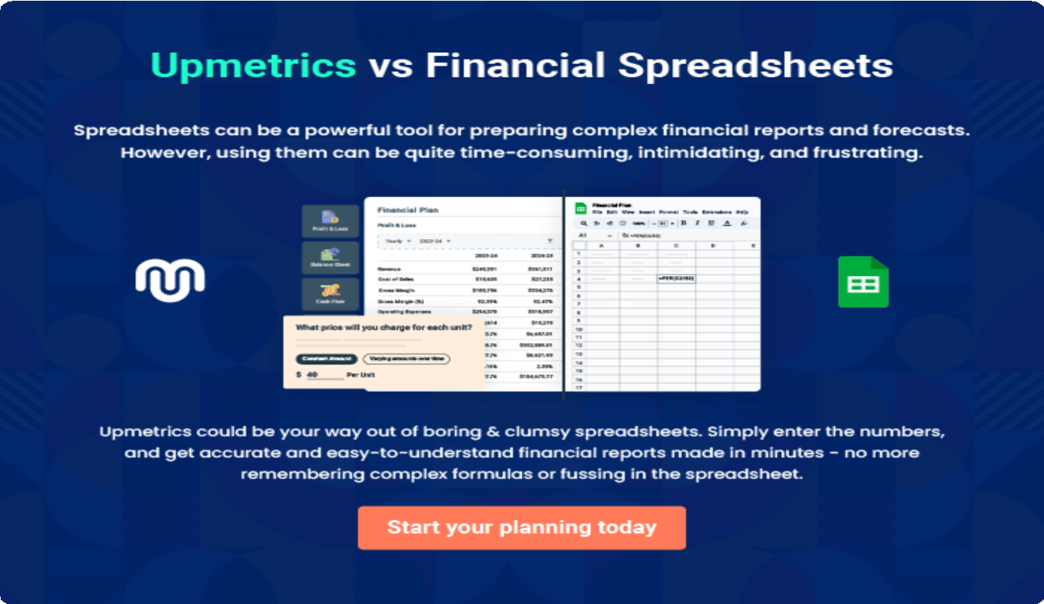

9.

Appendix
EmbedLink

Whenwritingtheappendixsection,youshouldincludeanyadditional
informationthatsupportsthemaincontentofyourplan.Thismayinclude
financialstatements,marketresearchdata,legaldocuments,andother
Tounlock helptry Upmetrics!
EmbedLink

Createawinningbusinessplanthatgetsyoufunded

Creatingastunningandinvestment-readyplanrequiresnowriting,graphicdesigning,orfinancial planning expertise.

Upmetricshasallthefeaturesrequiredtohelpyoucreateacomprehensivebusinessplan—fromstarttofinish. Makenomistakes,it’sthemodernwayofplanningtostructureideas,makeplans,andcreatestunningpitch decks to awe investors.

Pitchdecksthatimpressinvestors
Create pitch decks that provide a visual representation of your business, engage investors,andmakethemwanttoinvestinyour businessidea.

Interactiveplansinnotime
Import business plan sections like—SWOT analysis,comparisontables,andotherstocreate an interactive business plan. No designing skills arerequired.

Stunningcoverpagedesigns
WithUpmetrics,youhavethelibertytochoose from multiple stunning cover page designs.
Chooseacreativedesignandmakeyourplan standout.

500+samplebusinessplans
Simplyimportatemplatefromourlibraryof sample plans into the editor and start customizingittomakeityours.Ittakesonlyafew clicks to get started.

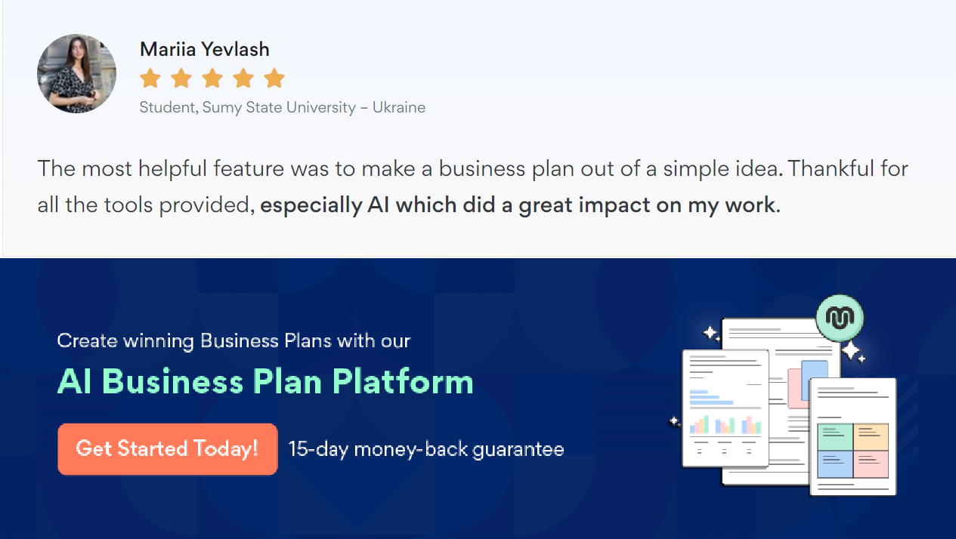Onlinesharingmadesimple
Upmetricsmakesonlinesharingquickandeasier forusers.Easilyshareyourbusinessplanswitha linkwhiletrackingreaderactivity.

Collaboratewithteaminreal-time
Invite team members, initiate conversations, discussideas&strategies,sharefeedback,and work on a business plan in real-time.

