
Table of Contents
1. Executive Summary 6
1.1 Business Overview 7
1.2 Mission Statement 7
1.3 Location & Market Opportunity 7
1.4 Unique Selling Points 7
1.5 Financial Highlights 8
1.6 Funding Requirement 8
1.6.1 Income Statement (3 Year projections) 8
2. Company Overview 9
2.1 Legal Structure 10
2.2 Vision Statement 10
2.3 Background & History 10
2.4 Future Goals 10
2.4.1 Business Owners 11
2.4.2 SMART Goal 11
3. Market Analysis 12
3.1 Overview 13
3.2 Market Segmentation 13
3.3 Market Trends 13
3.4 Local Market Outlook 13
3.5 Market Size 14
4. Customer Analysis 15
4.1 Target Market 16
4.2 Customer Segments 16
4.3 Customer Persona 17
4.4 Customer Purchase Journey 17
5. Competitive Analysis 18
5.1 Competitors 19
5.2 Comparison 19
5.3 Competitive Edge 20
5.4 SWOT Analysis 21
6. Services Offered 22
6.1 Our Offering 23
6.2 Signature Items 23
6.3 Additional Services 23
6.4 What Sets Us Apart 23
6.5 Client Assessment & Program Design 24
6.5.1 Personal Training Packages 24
6.5.2 Bluestem Online Coaching 25
6.5.3 Features 26
6.5.4 Pricing 26
7. Marketing & Sales Strategies 27
7.1 Market Positioning 28
7.2 Marketing Objectives 28
7.3 Online Marketing 29
7.4 Public Relations and Branding 29
7.5 Partnership & Collaboration Strategy 29
7.6 Customer Loyalty & Retention 29
7.7 Sales Channels 29
8. Operations Plan 31
8.1 Daily Operations 32
8.2 Working Hours 32
8.3 Staffing & Training 32
8.4 Inventory & Equipment Management 32
8.5 Location and Facilities 33
8.6 Milestones & Timeline 33
8.7 Certifications, Screening & Liability 34
9. Management Team 35
9.1 Key Members 36
9.2 Organization Chart 36
9.3 Advisory Board Members 37
9.3.1 Hiring Plan 37
10. Financial Plan 38
10.1 Key Assumptions 39
10.2 Capital Requirements and Use of Funds 39
10.2.1 Use of Funds 40
10.3 Income Statement (3 Year projections) 41
10.4 Balance Sheet (3 Year projections) 42
10.5 Cash Flow Statement (3 Year projections) 43
10.6 Break Even Analysis 44
11. References 45
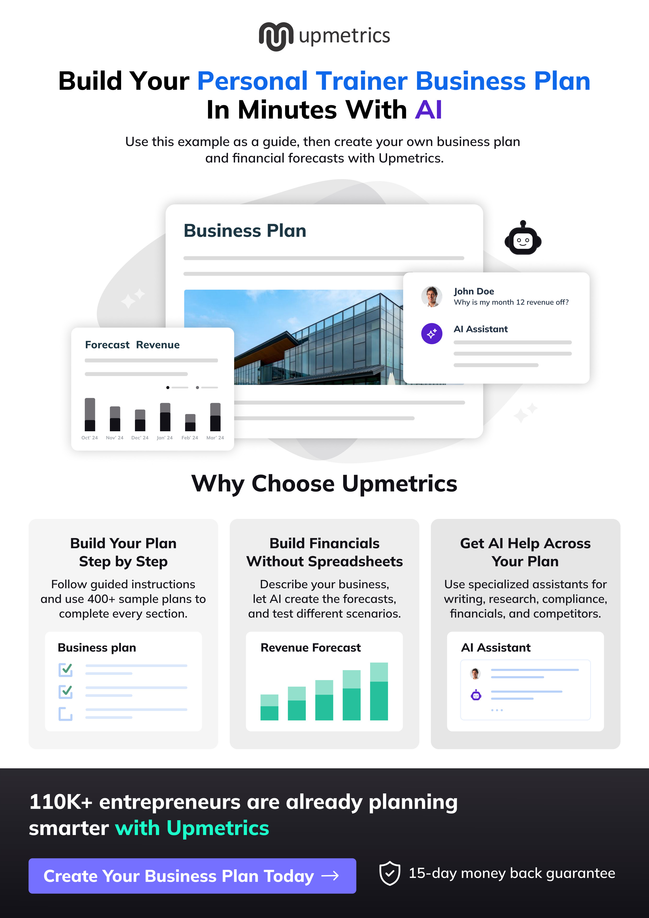

CHAPTER 1

Executive Summary

1.1 Business Overview
1.2 Mission Statement
1.3 Location & Market Opportunity
1.4 Unique Selling Points
1.5 Financial Highlights
1.6 Funding Requirement

1.1 Business Overview
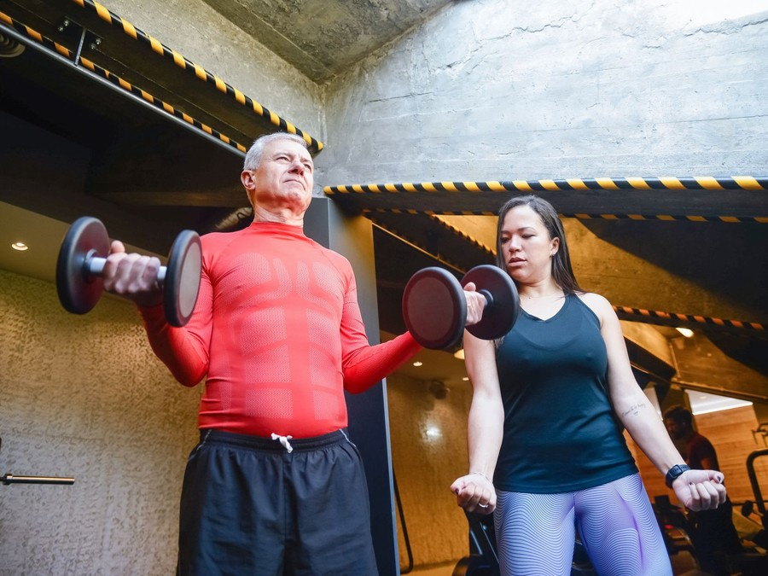
Bluestem Strength is a private personal training studio planned for Naperville, Illinois. Certified trainers coach clients by appointment, one to one and in semi-private groups of two to four, in a 2,500 square foot studio of racks, dumbbells, a cable machine and a turf lane.
Every client starts with a movement assessment and trains from a written program, sold as a monthly package from $299 to $649. The studio is built for Naperville adults aged about 30 to 65 who want supervised strength training rather than a gym membership, with online coaching, nutrition coaching and a small retail shelf sold alongside.

1.2 Mission Statement
To help Naperville adults get stronger safely and keep training for years, by coaching every client from an assessment, a written plan and progress they can see.

1.3 Location & Market Opportunity
Naperville had 153,337 residents and 56,170 households in 2024, with a median household income of $150,360, about twice the national median, and 71.9% of its adults hold a bachelor's degree or higher. That is a population that can pay for coaching priced well above a gym membership.
The studio will lease retail space in north Naperville, close to the offices of the I-88 corridor and the neighborhoods north of downtown, so a client can train before work, at lunch or on the way home. Its competition is mostly franchise class studios and big-box gyms, which sell group workouts rather than supervised strength training from an assessment.
US personal trainers earn $12.1 billion a year. The DuPage County fitness facility market, built from the county's 158 fitness establishments and the national revenue per establishment, is about $142.5 million a year, and one personal training studio takes about $220,800 a year on the national benchmark.

1.4 Unique Selling Points
- A 60 minute movement assessment and a written twelve week program for every client.
- Semi-private groups capped at four clients per trainer, from $299 a month.
- Progress retested every eight weeks, with the results shown to the client.
- A dedicated program for adults over 50 and clients returning after injury.
- Online coaching that keeps clients on their program while they travel.

1.5 Financial Highlights
Revenue comes from 80 active studio clients at a blended $400 a month, add-on sales worth a further 8% of the package book, and 30 online coaching clients at $99 a month. The studio opens at 40% of that book on its founding clients and fills it over ten months.
Revenue is projected at $337,770 in the first year, $388,436 in the second and $446,701 in the third, at a gross margin of 90.0% throughout. Net income is $3,756 in the first year, then $16,478 and $30,970, a net margin of 6.9% by the third year. Break-even revenue is $299,501, the equivalent of 62 clients, which the first year clears. Third-year net income is $10,168 in the conservative case and $59,066 in the upside case.

1.6 Funding Requirement
The startup budget is $142,100. It pays for the training equipment, the flooring and fit-out, assessment technology, the AED and trainer certification, deposits, launch marketing and a working capital reserve. It is funded by a $60,000 owner contribution and an $85,000 SBA 7(a) loan at 10.5% over seven years, and profits stay in the business while the client book fills.
The plan rests on a head trainer who opens with an existing client book, a well-off and educated town whose fitness market sells classes rather than supervised strength, and a package model that clears break-even in its first year. The money builds one well-equipped studio and the client book that keeps its trainers busy.

1.6.1 Income Statement (3 Year projections)
 | Year 1 | Year 2 | Year 3 | Total
Revenue | $337,770.00 | $388,435.50 | $446,700.82 | $1,172,906.32
Cost of Sales | $33,777.00 | $38,843.55 | $44,670.08 | $117,290.63
Gross Margin | $303,993.00 | $349,591.95 | $402,030.74 | $1,055,615.69
Operating Expense | $269,551.20 | $297,923.88 | $330,552.46 | $898,027.54
Total Expense | $334,013.90 | $371,957.79 | $415,730.96 | $1,121,702.65
Net Income | $3,756.10 | $16,477.71 | $30,969.86 | $51,203.67

CHAPTER 2

Company Overview

2.1 Legal Structure
2.2 Vision Statement
2.3 Background & History
2.4 Future Goals

2.1 Legal Structure
Bluestem Strength will trade as Bluestem Strength LLC, a limited liability company registered in Illinois, which keeps the owners' personal assets separate from the studio's lease, loan and client liabilities.
The two founders own it in proportion to the capital and the client book each brings. An operating agreement sets out decision rights, what happens if either owner leaves, and how a future trainer could buy a share.

2.2 Vision Statement
To become the place in Naperville where adults learn to lift safely and keep at it into their seventies, known for the progress its clients can measure rather than for the size of its floor.

2.3 Background & History
Bluestem Strength is a pre-launch business. Rachel Danforth has spent eleven years as a personal trainer at a large health club in DuPage County, building a book of about thirty regular clients there. Many of them were adults over 50 or people returning after surgery, and most wanted the same thing: a quiet room, a coach who watched every lift and a plan that changed as they did.
The club could not give them that. Its trainers worked on a crowded floor, sessions were sold one at a time, and nobody tracked whether a client was actually getting stronger. Rachel planned a studio that would start every client with an assessment, sell training by the month and retest progress on a fixed schedule.
Owen Kessler joins as co-founder after seven years running scheduling, billing and patient intake at a suburban physical therapy clinic. At the clinic, Owen saw patients finish rehabilitation with nowhere supervised to go next, one of the client groups the studio is built to serve.

2.4 Future Goals
In the first 0 to 18 months, Bluestem Strength will sign 32 founding clients before it opens in March 2027, pass its break-even point of 62 clients during the first year, and reach a full book of 80 studio clients and 30 online clients about ten months after opening. It will hire a senior trainer before opening and a part-time active aging trainer that summer, and build referral relationships with physical therapy clinics in Naperville and Lisle.
Over 1 to 3 years, the projection years this plan models, the studio will grow revenue from $337,770 in the first year to $446,701 in the third by keeping its trainers' calendars full, growing the online program and reviewing prices once in the third year. It will keep every profit in the business, add equipment as the book grows and pay down the SBA loan from operations.
Over 3 to 5 years, the founders intend to open a second studio in south Naperville or a neighboring suburb once the first has held a full book for a year, led by a senior trainer from the first studio with the option of buying a minority share.

2.4.1 Business Owners
Rachel Danforth | Owen Kessler

Total ownership: 100%
75% | Rachel Danforth  7,500 Shares
25% | Owen Kessler  2,500 Shares

2.4.2 SMART Goal
  Specific  - Fill a north Naperville studio to 80 active training clients and 30 online coaching clients.  - Rachel Danforth leads it, with Owen Kessler running scheduling, billing and partner referrals.  - A full book covers the payroll, rent and loan from operations rather than from the founders' savings. |   Measurable  - Active studio clients counted weekly from the booking system.  - Free assessments booked and the share that become a monthly package, tracked monthly.  - Break-even of 62 clients passed, then the 80 client full book. |   Achievable  - The founder starts with about thirty regular clients from a previous club.  - A 32 client founding pre-sale covers 40% of the book before opening.  - Four trainers have the hours to coach 80 clients at one to three sessions a week.
  Relevant  - Strength training for older and returning adults is a growing need the class studios nearby do not meet.  - A full book is what makes the second and third years profitable.  - Both founders have spent their careers in coaching or clinic operations, the two halves of this business. |   Time-Based  - Founding pre-sale completed in February 2027, before the March 2027 opening.  - Break-even client numbers passed within the first year of trading.  - Full book of 80 studio clients reached by December 2027, ten months after opening.

CHAPTER 3

Market Analysis

3.1 Overview
3.2 Market Segmentation
3.3 Market Trends
3.4 Local Market Outlook
3.5 Market Size

3.1 Overview
Personal training in the United States is a $12.1 billion industry in 2026. Revenue grew at 3.7% a year from 2021 to 2026 and was close to flat in the latest year. IBISWorld counts 326,000 businesses, most of them self-employed trainers, and no company holds more than 5% of the market, so it is fragmented and won locally.
Demand sits inside a growing fitness habit. A record 81 million Americans held a fitness facility membership in 2025, and 23% of members used a personal trainer in 2024. Only 32% of Americans met the federal guideline of 150 minutes of activity a week, which leaves most adults with room to start.

3.2 Market Segmentation
The market splits by how clients are coached and what they pay for:
- One-to-one training: the highest price per session and the closest supervision, bought by clients with specific goals, injuries or little time.
- Semi-private and small group training: one trainer with a few clients at a lower price per place. 32% of facility members trained in small groups in 2024.
- Online and hybrid coaching: a written program and remote check-ins, sold alone or between in-person sessions.
- Training inside big-box gyms: sold by the session to members of a large club.

3.3 Market Trends
- Older adults are the fastest growing fitness group: members aged 65 and over grew 8.6% a year, and they come with goals of strength, balance and independence that a trainer can measure.
- Clients train with a professional less often each: members averaged 21 personal training sessions in 2024, down from 28 in 2019, which favors monthly packages and semi-private places over single sessions.
- Small groups are mainstream: one in three facility members trained in a small group in 2024, more than used a personal trainer, which makes semi-private training an easy step for class-goers.
- Women drove the growth in personal training, with female users up 16% to 7.3 million in 2024.

3.4 Local Market Outlook
Naperville, which lies across DuPage and Will Counties, had 153,337 residents and 56,170 households in 2024. Its median household income was $150,360 and its median age 41.5, and 71.9% of adults hold a bachelor's degree or higher. That profile, older and better paid than the country, is the one that buys supervised strength training.
DuPage County held 158 private fitness and recreational sports center establishments in 2025, down 12 from 2024, and Will County 77. These county counts include every kind of fitness facility; no published figure separates personal training studios or gives local spend on training. In Naperville itself, franchise class studios such as Orangetheory Fitness and F45 Training trade alongside appointment-based training from The Perfect Workout and Beyond Measure Fitness.
Trading here costs more than the national average in pay and less in rent. Trainers in the Chicago-Naperville-Elgin metro earned a mean of $26.47 an hour in May 2025, and the Illinois minimum wage is $15.00. Retail space in Naperville is advertised at $16.00 a square foot a year triple net, below the national retail average of $25.65. Illinois requires a fitness facility to keep an AED and a trained user on staff, and its Physical Fitness Services Act gives clients three business days to cancel a contract, or seven days before a studio opens.

3.5 Market Size
The total addressable market is the US personal trainers industry, $12.1 billion in 2026.
The serviceable market is the DuPage County fitness facility market, about $142.5 million a year: 158 fitness and recreational sports center establishments in 2025 multiplied by about $902,000 of national revenue per establishment in 2022. It is a county figure that includes health clubs, so it is the market a Naperville studio competes in and an upper estimate of what is spent on training alone.
The obtainable market is about $220,800 a year, the midpoint of the 2025 average band for one personal training studio of $9,800 to $26,999 a month. It is a national figure for a single studio, not a Naperville one. Bluestem's first-year revenue projection of $337,770 sits above it because the studio opens with an established trainer's clients and prices for a high-income suburb.
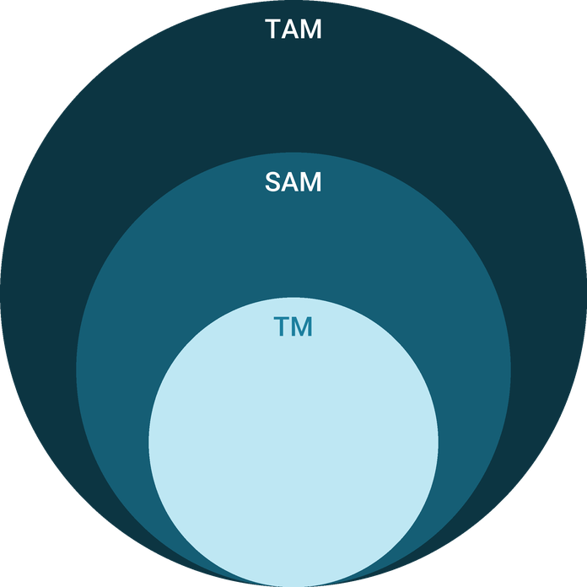
  ● | Total Available Market (TAM)  US personal trainers industry revenue is $12.1 billion in 2026 (IBISWorld), down 0.2% on the year after 3.7% compound annual growth from 2021 to 2026. | 12.1B
  ● | Served Available Market (SAM)  The DuPage County fitness facility market is about $142.5 million a year: 158 fitness and recreational sports center establishments (2025) x about $902,000 national revenue per establishment (2022). | 142.5M
  ● | Target Market (TM)  One personal training studio takes about $220,800 a year, the midpoint of Two-Brain's 2025 average band of $9,800 to $26,999 a month; a national figure, not a Naperville one. | 220.8k

CHAPTER 4

Customer Analysis

4.1 Target Market
4.2 Customer Segments
4.3 Customer Persona
4.4 Customer Purchase Journey

4.1 Target Market
Bluestem Strength sells to adults aged about 30 to 65 who live or work within a fifteen minute drive of north Naperville: the city itself and the neighboring parts of Lisle, Warrenville and Aurora. They can afford coaching, they know they should be lifting, and they want someone to plan and watch it rather than a membership they use alone.
Naperville's median household income of $150,360 and its median age of 41.5 put many households in that position. Clients buy two or three sessions a week and renew every month, so the studio needs a book of about 80 nearby clients, not a wide audience.

4.2 Customer Segments
- Busy professionals, 30 to 50: work in the I-88 office corridor or from home, train early or at lunch, and buy semi-private or hybrid packages to stay strong and keep a routine. The largest group by number.
- Active agers, 50 and over: train for strength, balance and bone health, often after a doctor's advice. They buy semi-private groups in the quieter mid-morning hours and stay the longest.
- Returners after injury or a long break: often referred by a physical therapist, they need one-to-one sessions at first and move to a hybrid package as confidence grows.
- Remote clients: studio clients who travel for work or move away, plus home trainers, who buy online coaching at $99 a month.
The segments buy differently, which is why the packages differ. Busy professionals choose by schedule: an early morning or lunchtime slot that holds every week matters more to them than the price, and they are the likeliest to share a semi-private slot with a colleague or partner. Active agers choose by trust: they want to meet the trainer, see the private room and hear how the program handles a stiff knee or a weak shoulder before they commit. Returners choose by safety and often arrive with a therapist's notes; they start one to one and move to a cheaper package once their trainer is confident they can train beside others. Remote clients choose by convenience and keep paying because their program, their history and their coach stay the same when they are away from Naperville.
Members aged 65 and over were the fastest growing group in US fitness facilities in 2025, which is why the active aging segment gets its own program. It is also the segment the studio expects to keep longest, because strength and balance work for an older adult never really ends: the goal moves from getting stronger to staying strong.

4.3 Customer Persona
  Linda, the Returning Lifter  Demographics  Age: 54  Status: Married, two teenagers  Location: Naperville, IL  Household income: $165,000  Professional Role  Education: Bachelor's in Accounting  Job: Corporate finance manager in the I-88 corridor | “I know I need to lift, but I want someone watching my form who knows what my knee went through.”
   | Identifiers / Personality Traits  - Stopped going to the gym after knee surgery two years ago  - Reads about bone density and wants to start strength training  - Has a fixed hour before work and one at lunch
   | Goals  - Squat and climb stairs without knee pain  - Build strength to protect bone health with age  - Train twice a week on a schedule that holds
   | Challenges  - Unsure which exercises are safe after surgery  - Felt lost and self-conscious on a big gym floor  - Work travel breaks the training routine every month

4.4 Customer Purchase Journey
- Trigger: a doctor's advice, a physical therapist's discharge, a birthday or a back that hurts after a weekend of yard work.
- Search: a local search for a personal trainer in Naperville, a referral from a friend or a recommendation from a clinic.
- First visit: a free 60 minute assessment, where the trainer screens movement, records baselines and explains the program the client would follow.
- Decision: the client chooses a package in the same visit or within a week, usually after comparing it with a gym membership or a class studio.
- First weeks: the trainer sends the program to the app and checks in after the first week to adjust loads and schedule.
- Renewal: progress is retested every eight weeks, and the results are what keep the client on autopay.
The two points that decide whether a client stays are the assessment, where they first see the plan, and the first retest, where they first see the change. Both are built into every package.

CHAPTER 5

Competitive Analysis

5.1 Competitors
5.2 Comparison
5.3 Competitive Edge
5.4 SWOT Analysis

5.1 Competitors
Bluestem Strength competes for the same monthly budget as four kinds of business in Naperville. DuPage County held 158 private fitness and recreational sports center establishments in 2025, 12 fewer than a year earlier, and the city's mix runs from big clubs to one-room studios.
- Franchise class studios: Orangetheory Fitness and F45 Training both trade in Naperville, selling coached group workouts by membership. They compete for clients who want structure and accountability.
- Appointment-based training studios: The Perfect Workout sells short one-to-one strength sessions, and Beyond Measure Fitness runs semi-private training in groups of three to six. These are the closest substitutes.
- Big-box gyms with personal trainers: large clubs sell training by the session to their own members on a busy floor.
- Independent and mobile trainers: self-employed trainers who rent gym time or visit clients' homes, part of the 326,000 businesses that make up a fragmented national market.
No revenue or client figures are published for any of these businesses, and none are estimated here.

5.2 Comparison
Class studios win on price and energy but coach a room, not a person. Big-box gyms offer every machine but sell training one session at a time to clients who then train alone. Independent trainers offer close attention but rarely a dedicated room or a structured program. The closest rivals, the appointment studios, sell supervised strength too, which puts the contest on how well each studio assesses, programs and keeps its clients.
Bluestem's offer differs in three ways a client can see on the first visit: a formal assessment before any training, groups capped at four, and a retest every eight weeks that shows the change in numbers.
Feature | Bluestem Strength | Franchise class studios | Big-box gyms | Independent mobile trainers
Movement assessment and written program for every client | ✓ | ✗ | ✗ | ✓
Four clients or fewer per trainer | ✓ | ✗ | ✗ | ✓
Racks, cable machine and sled in a private room | ✓ | ✗ | ✗ | ✗
Online coaching between sessions | ✓ | ✗ | ✗ | ✓
Monthly price under $100 | ✗ | ✗ | ✓ | ✗

5.3 Competitive Edge
Its edge comes from the founder, the format and the client it is built for. Rachel Danforth opens with eleven years of one-to-one experience and about thirty regular clients, so the studio does not start from an empty calendar. Semi-private groups put coached strength work at $299 a month, closer to a class studio than to one-to-one training. And the studio is set up for the clients the crowded formats serve least: adults over 50 and people returning after injury, a group growing faster than any other in US fitness facilities.
Each part of the edge is something a rival would have to rebuild rather than copy. A class studio could add an assessment, but its business depends on filling a room, not on writing a program for every client. A big-box gym could sell semi-private sessions, but its trainers work on a floor shared with members, which is the setting the studio's older and returning clients are leaving. An independent trainer can match the attention but rarely the room, the equipment or the cover when they are ill or away. The appointment studios compete on the same ground, so Bluestem's answer there is measurement: a retest every eight weeks and a written report, which turns progress from a feeling into a number a client can show their doctor or their family. None of this depends on a lower price or a bigger room, so it does not erode if a competitor discounts or a new club opens nearby.
The edge has limits. The studio is small, has no brand on opening day and cannot match a big club on price or hours, so it competes on supervision and results rather than access.
   | Assessment Before Exercise  Every client is screened and given a written program before the first session, and retested every eight weeks, so progress is measured rather than assumed.
   | Small Groups at a Lower Price  Semi-private groups of two to four put supervised strength training at $299 a month, against $649 for one-to-one.
   | Built for Returning and Older Adults  Trainers coach clients after injury and over 50, with a dedicated active aging program, which crowded class formats do not set out to do.
   | A Founder With Clients  The head trainer brings eleven years of one-to-one work and a regular client book, so the studio opens with revenue rather than a blank calendar.
 | Coaching That Travels  The online program keeps clients training while away and keeps them paying when they move.

5.4 SWOT Analysis
Strengths  - The founder brings eleven years of one-to-one training and about thirty regular clients from a DuPage County club.  - Every client trains from a written program built on a movement assessment and retested every eight weeks.  - Semi-private groups of two to four bring coached training to $299 a month.  - Payroll flexes with the client book because trainers are paid largely per session. | Weaknesses  - A new studio has no reviews or local name on opening day.  - Revenue depends on four trainers' hours, so one departure removes a large share of capacity.  - At about 2,500 square feet the studio cannot run large groups or open gym hours.  - Ending cash in the first year is thin while the client book fills.
Opportunities  - Naperville's median household income of $150,360 supports training priced above a gym membership.  - Members aged 65 and over are the fastest growing group in US fitness facilities.  - Physical therapy clinics discharge patients who need supervised strength work afterwards.  - Hybrid coaching keeps clients paying while they travel or after they move away. | Threats  - Franchise class studios and big-box gyms already trade in Naperville at lower monthly prices.  - DuPage County lost 12 fitness establishments in 2025, a sign of a crowded market.  - A downturn hits discretionary spending on training before essentials.  - Trainers can leave and take regular clients with them.

 Strategic Summary
Bluestem should sell what crowded class studios cannot: assessed, supervised strength for older and returning adults. It should build its book through therapist referrals and hold its trainers with fair pay before it competes on price.

CHAPTER 6

Services Offered

6.1 Our Offering
6.2 Signature Items
6.3 Additional Services
6.4 What Sets Us Apart
6.5 Client Assessment & Program Design

6.1 Our Offering
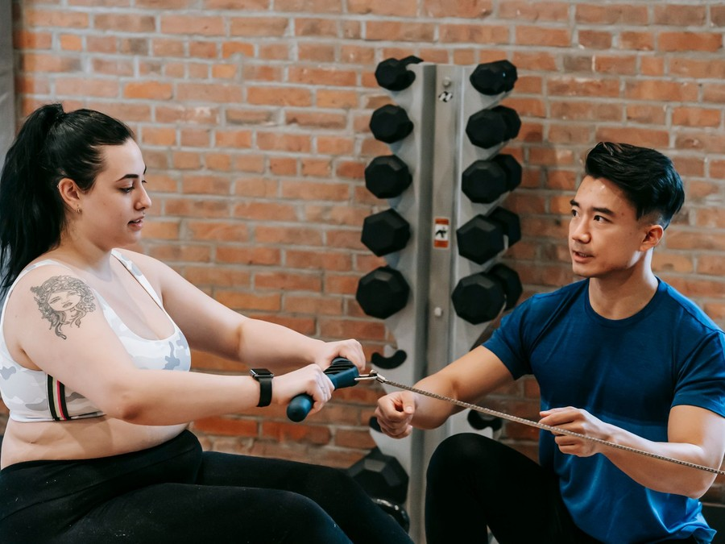
Bluestem Strength sells coached strength training by the month. A client chooses a package of one-to-one or semi-private sessions, trains two or three times a week by appointment, and follows a written program that their trainer adjusts as they progress. Packages run from $299 to $649 a month on autopay, with no long contract.
The studio holds about 2,500 square feet: two half racks, a cable machine, dumbbells to 100 pounds, kettlebells, a sled on a turf lane, a rower, an air bike and a private room for assessments. Nothing is sold as open gym time; every hour on the floor is coached.

6.2 Signature Items
- Semi-Private Strength: groups of two to four sharing a trainer, each on their own program, at $299 a month for eight sessions.
- Hybrid Training: one one-to-one and one semi-private session a week at $449, the package most clients are expected to choose.
- One-to-One Premium: eight private sessions a month with nutrition coaching included, at $649.
- Strong at 50: semi-private sessions in the weekday mid-morning hours, built around strength, balance and bone health for adults over 50.

6.3 Additional Services
Online coaching at $99 a month gives a client a written program in the Bluestem app, a video for every exercise and a monthly video check-in with a trainer. It keeps studio clients on track while they travel and lets clients who move away keep their coach.
Nutrition coaching with a certified nutrition coach sets habits and targets that fit the training. Assessments are sold to non-clients who want a baseline, and a small shelf carries protein, supplements and Bluestem apparel. Together these add-ons are expected to add about 8% to the package book.

6.4 What Sets Us Apart
Most training in Naperville is sold either as a class or one session at a time. Bluestem sells a plan: every client is assessed first, trains from a program written for them, and is retested on a fixed schedule so both client and trainer can see whether it is working. Semi-private groups make that plan affordable, and the active aging program makes it suitable for the clients a crowded floor serves least.

6.5 Client Assessment & Program Design
Every client starts with a 60 minute assessment in the private room, before any package is sold:
- Health screening: a health history and the PAR-Q+ readiness questionnaire. A client who flags a heart condition, recent surgery or uncontrolled blood pressure is asked for medical clearance before training.
- Movement screen: the trainer watches the client squat, hinge, lunge, push, pull and stand on one leg, and notes where range, control or pain limits them.
- Baselines: grip strength, a timed sit-to-stand, a plank hold and estimated working loads for the main lifts, plus a body composition scan for clients who want one.
- Goal session: the client and trainer agree two or three goals that can be measured, such as a pain-free squat to a bench or a target deadlift load.
From that the trainer writes a twelve week program in three blocks of four weeks, each building load or difficulty. It lives in the app, where every session's sets and loads are logged. Every eight weeks the baselines are retested and the results sent to the client as a one page progress report, and the next block is rewritten from them.

6.5.1 Personal Training Packages
Monthly training packages, one to one or in semi-private groups of two to four, built on a movement assessment and a written program. Clients book two sessions a week, or three on the premium package, and their trainer adjusts the program as their numbers move.
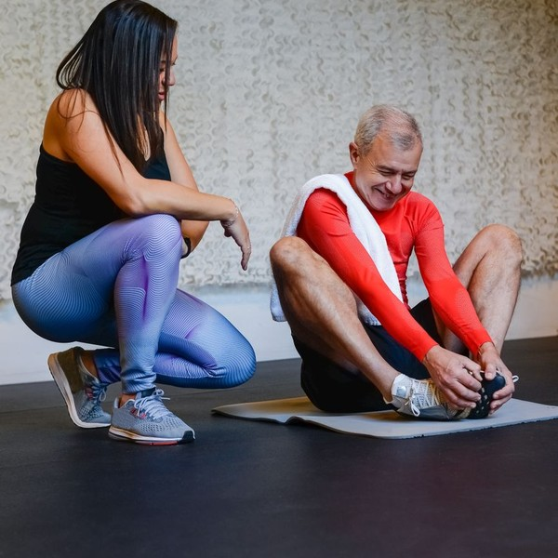 | From $299 per month  Semi-private packages start at $299 a month and one-to-one packages run to $649, charged on autopay with no long contract. Clients cancel in writing with one month's notice. Every package opens with a 60 minute movement assessment and a program written for twelve weeks and reviewed every eight. The price depends on two things: whether the client trains alone with a trainer or in a group of two to four, and whether they book two sessions a week or three on the premium package.

Specifications
- Sessions run 60 minutes by appointment.
- Semi-private groups are capped at four clients per trainer.
- Every package starts with a 60 minute movement assessment.
- Programs are written for twelve weeks and reviewed every eight.
- Clients cancel in writing with one month's notice.

6.5.2 Bluestem Online Coaching
A written program delivered through the Bluestem app, with exercise videos, logged sessions and a monthly video check-in with a Bluestem trainer. It keeps studio clients training while they travel and lets clients who move away keep their coach.
 | $99 per month  Priced well below a month of in-studio training, and open to studio clients and to people who train at home or in another gym. The monthly fee covers a program written from an in-person or video assessment, a demonstration video for every exercise, a 30 minute video check-in each month and replies to app messages within one business day. Studio clients use it to keep training while they travel, and clients who move away keep their coach. It is charged on autopay, like the studio packages, with no long contract.

Specifications
- Programs are written from an in-person or video assessment.
- Each exercise carries a demonstration video.
- Clients log sets, loads and notes in the app.
- A 30 minute video check-in is held once a month.
- Trainers answer app messages within one business day.

6.5.3 Features
  Movement Assessment
  Every client starts with a 60 minute screen of how they squat, hinge, push, pull and balance, plus a health history.
  Written Program
  Each client trains from a twelve week program written for them and kept in the Bluestem app.
  Groups of Four or Fewer
  Semi-private sessions never put more than four clients with one trainer.
   | Progress Reviews  Trainers retest strength, mobility and body composition every eight weeks and show clients the change.
   | Nutrition Coaching  A certified nutrition coach sets habits and targets that fit the training, without meal plans to follow by rote.
   | Online Check-ins  Clients who travel or move away keep their program and see their trainer on video once a month.

6.5.4 Pricing
Semi-Private Strength  $299  per month  - Eight semi-private sessions a month in groups of two to four  - Movement assessment and written program  - Program and session log in the Bluestem app  - Reassessment every eight weeks |  | Most Popular  Hybrid Training  $449  per month  - One one-to-one and one semi-private session a week  - Movement assessment and written program  - Monthly progress review with your trainer  - Program and session log in the Bluestem app |  | One-to-One Premium  $649  per month  - Eight one-to-one sessions a month, 60 minutes each  - Nutrition coaching included  - Monthly progress review with your trainer  - Priority booking for early morning slots

CHAPTER 7

Marketing & Sales Strategies

7.1 Market Positioning
7.2 Marketing Objectives
7.3 Online Marketing
7.4 Public Relations and Branding
7.5 Partnership & Collaboration Strategy
7.6 Customer Loyalty & Retention
7.7 Sales Channels

7.1 Market Positioning

Bluestem Strength is the Naperville studio for adults who want to get stronger under supervision: assessed first, coached in groups of four or fewer, and shown their progress in numbers. It sits between the class studio, which coaches a room, and the private one-to-one trainer, which few clients can afford twice a week.

7.2 Marketing Objectives
- Sign 32 founding clients before the studio opens in March 2027.
- Book enough free assessments to reach 80 active studio clients within ten months of opening.
- Draw at least a quarter of new clients from referrals by clients and physical therapists by the end of the first year.
- Enrol 30 clients in online coaching, mostly from the studio's own book.
The marketing budget is 6% of revenue, spent where people already nearby are looking for a trainer rather than on brand advertising.
Local Search & Maps  $591  per month  Search ads and a maintained business profile for people looking for a trainer near them. |  | Referral Rewards  $422  per month  A free month of online coaching for each client who refers someone who joins.
Clinic & Employer Partners  $338  per month  Printed guides, lunch talks and free assessments for physical therapists and nearby employers. |  | Community Workshops  $338  per month  Free strength and balance workshops at libraries, park district centers and the studio.

Total marketing budget: $20,266 a year, $1,689 a month.

7.3 Online Marketing
Most clients will find the studio by searching for a personal trainer in Naperville. The studio's business profile, with photographs of the room, trainer biographies and reviews requested after every eight week retest, is the first thing they see, backed by search ads limited to a short drive from the studio.
The website does one job: book a free assessment. Each trainer writes a short monthly article on a question clients ask, such as lifting after knee surgery or strength training after 50, and the email list sends it to past assessment bookings who have not yet joined.

7.4 Public Relations and Branding
The brand is calm and practical: prairie greens and blues, plain language, real clients rather than athletes in the photographs. The studio runs free strength and balance workshops at Naperville libraries, park district centers and senior living communities, and offers a free assessment week at opening. Local press interest is likeliest around the active aging program, and the founders will offer the local papers a story on lifting after 50.

7.5 Partnership & Collaboration Strategy
Physical therapy clinics are the most valuable partners. Owen Kessler knows how a clinic's discharge works, and the studio will give each nearby clinic a one page guide, a free assessment for referred patients and a progress report back to the therapist after eight weeks. That reporting is what earns a second referral.
Employers in the I-88 office corridor are the second partner group: lunch talks on strength and desk work, a free assessment day, and a semi-private slot set aside for colleagues who want to train together. Chiropractors, dietitians and orthopedic practices are approached in the same way once the first clinics are referring.

7.6 Customer Loyalty & Retention
Clients stay when they can see the change, so retention is built into the program rather than bolted on. Every eight weeks the trainer retests the client's baselines and sends a one page progress report, and the next block is written from it. A client who misses two sessions in a row gets a call from their trainer, not an automated message.
Semi-private groups keep the same members at the same time each week, so clients come for each other as well as for the coaching. A client who moves to a lower package rather than cancelling keeps their program, and online coaching keeps those who travel or move away. Each referral that joins earns the referring client a free month of online coaching.

7.7 Sales Channels
Nearly every sale starts with the free assessment, so the trainers' ability to turn that first visit into a monthly package matters more than any single campaign. Referrals from clients and therapists bring the clients who stay longest, while the online subscription is small but adds revenue without using studio hours.
In practice the free assessment carries the plan. A trainer who books the session, screens the client and walks them through the program they would follow is selling the product by showing it, so each trainer is coached on the assessment as carefully as on the lifts. A client referral costs the studio a free month of online coaching and brings someone who already trusts the trainer they will meet. Therapist referrals take longest to earn, because a clinic watches how its first patients are treated before it sends more, which is why the progress report goes back to the therapist after eight weeks. The online subscription needs no selling of its own: it is offered at every assessment and again whenever a client's travel or move changes their calendar.
Owen Kessler tracks each route monthly: assessments booked, the share that become packages, referrals by source and online sign-ups. A route that falls behind gets attention before the budget does, because a stalled referral partner or a trainer converting fewer assessments costs the studio more than any change in advertising spend.
  Free Assessment to Monthly Package
  The main route: a free 60 minute assessment, then a monthly package on autopay, worth most of the studio's revenue and dependent on trainers converting the first visit.
  Client Referrals
  Existing clients bring partners, colleagues and friends, often into a shared semi-private slot, which depends on a referral reward and on clients seeing results.
   | Physical Therapy Referrals  Clinics refer patients finishing rehabilitation who want supervised strength work, which depends on reporting progress back to the referring therapist.
  Online Coaching Subscription
  Studio clients who travel or move away, and home trainers, buy the $99 monthly program through the app, a small but steady line.

CHAPTER 8

Operations Plan

8.1 Daily Operations
8.2 Working Hours
8.3 Staffing & Training
8.4 Inventory & Equipment Management
8.5 Location and Facilities
8.6 Milestones & Timeline
8.7 Certifications, Screening & Liability

8.1 Daily Operations
Every session is booked in advance through the studio's booking app, so each hour has a known trainer, client list and program. Trainers arrive fifteen minutes before their first session to read the day's programs, set out equipment and check the AED. Sessions run 60 minutes, and the trainer logs sets, loads and notes in the app before the next client arrives.
Owen Kessler runs the front of the business: new enquiries, assessment bookings, billing, the retail shelf and partner referrals. Between sessions the floor is cleaned and equipment re-racked, and the last trainer of the day closes out the booking system and confirms the next morning's schedule.

8.2 Working Hours
- Monday to Friday: 5:30 am to 8:00 pm
- Saturday: 7:00 am to 12:00 pm
- Sunday: closed, with assessments by appointment
The hours follow when clients can train. Busy professionals want sessions before work, at lunch and after 5:00 pm; active agers prefer the mid-morning hours, which fills the studio when a commuter studio would be empty. Saturday mornings serve parents and weekend clients, and Sunday is left free so trainers get a full day off.

8.3 Staffing & Training
The studio opens with three trainers: Rachel Danforth as head trainer, Owen Kessler coaching semi-private sessions alongside running the studio, and a senior trainer and nutrition coach hired before opening. A part-time trainer joins in the summer of the first year to lead the active aging groups. Each trainer works from the same assessment and program templates, so a client can train with any of them.
New trainers shadow the head trainer for two weeks before coaching alone, and every trainer reviews one program a week with the head trainer. Each takes at least one continuing education course a year, which the studio pays for.

8.4 Inventory & Equipment Management
Equipment is the studio's main asset. Racks, the cable machine, benches and the sled are inspected weekly against a checklist, and cables, pins and upholstery are replaced at the first sign of wear. Dumbbells and plates are counted monthly. Replacement and additions are budgeted at 1.5% of revenue a year.
The retail shelf carries a few weeks of protein, supplements and apparel, reordered from the booking system's sales report. Cleaning supplies, towels and AED pads and batteries are tracked on the same weekly list.

8.5 Location and Facilities
The studio will lease about 2,500 square feet of retail space in north Naperville, close to the I-88 offices and the neighborhoods north of downtown, with free parking at the door. Rent is budgeted at $5,200 a month, including taxes and common area charges, against the $16.00 a square foot triple net that Naperville centers advertise.
The fit-out includes rubber flooring, a 20 yard turf lane, mirrors, a private assessment room, a changing area and a restroom. The layout gives each semi-private client their own station while the trainer can see the whole room.

8.6 Milestones & Timeline
The founders form the LLC and apply for the SBA loan in December 2026, sign the lease and begin the fit-out in January 2027, and run the founding client pre-sale in February. The studio opens in March 2027 at about 40% of its full book, adds the active aging program that summer and reaches its full book of 80 studio clients about ten months after opening.
Dec 2026  Setup |  |  | Company formed and loan applied for  Bluestem Strength LLC registered in Illinois.  The founders file the LLC, open business banking and submit the SBA 7(a) application with this plan.
Jan 2027  Setup |  |  | Lease signed and fit-out begins  About 2,500 square feet in a north Naperville retail center.  Rubber flooring, the turf lane, mirrors and the assessment room go in while the equipment is ordered.
Feb 2027  Launch |  |  | Founding client pre-sale  Target of 32 founding clients before the doors open.  Free assessments run from a temporary space, and the senior trainer joins to take on the first clients.
Mar 2027  Launch |  |  | Studio opens  One-to-one and semi-private training begin.  The studio opens at about 40% of its full book, with the online program offered to every founding client.
Jul 2027  Growth |  |  | Active aging program added  A part-time trainer takes the morning older adult groups.  Semi-private strength and balance sessions for adults over 50 fill the weekday mid-morning hours.
Dec 2027  Growth |  |  | Full client book reached  About 80 studio clients and 30 online clients.  Ten months after opening the trainers' calendars are full and the founders plan the next price review.

8.7 Certifications, Screening & Liability
Illinois does not license personal trainers, so the studio sets its own standard. Every trainer must hold a certification accredited by the National Commission for Certifying Agencies, such as NASM, ACE, ACSM or NSCA, and current CPR and AED training. The studio pays for recertification and keeps copies on file.
Illinois requires a physical fitness facility to keep an AED on site, a trained AED user on staff during staffed hours and a written medical emergency plan. The studio's AED hangs by the door, every trainer is trained to use it, and the emergency plan is drilled each quarter.
Every client completes the PAR-Q+ health questionnaire and signs a waiver at the assessment, and clients with flagged conditions bring medical clearance before training. Client agreements follow the Illinois Physical Fitness Services Act, including the three business day cancellation right, seven days for founding clients who sign before opening, and clear automatic renewal terms. The studio carries general liability at $1 million per occurrence and $2 million aggregate, professional liability, property cover and workers' compensation.
Incidents are handled the same way every time. A trainer stops the session at any sign of chest pain, dizziness or joint pain beyond what the client normally feels, records what happened in the client's file the same day and tells the head trainer. A client who has seen a doctor since their last session completes a short health update before training again, and faulty equipment is taken out of use and tagged until it is repaired. The founders review every incident report monthly, and the studio's lawyer reviews the waiver, health questionnaire and client agreement once a year so they keep pace with Illinois law.

CHAPTER 9

Management Team

9.1 Key Members
9.2 Organization Chart
9.3 Advisory Board Members

9.1 Key Members
The head trainer is accountable for the quality of coaching: every program written, every new trainer's development and the results clients see. The role is measured on client retention past three months and on the share of retests that show progress.
The studio manager is accountable for the book and the money: assessments booked and converted, billing, partner referrals and the monthly accounts. The role is measured on active client numbers against the plan and on cash at month end. The two trainers are measured on their calendars, the hours filled with paying sessions, and on the retention of their own clients.
 | Rachel Danforth  Founder & Head Trainer · rachel@bluestemstrength.example  NSCA Certified Strength and Conditioning Specialist with eleven years of one-to-one training at a large DuPage County health club, building a regular book of about thirty clients.

 | Owen Kessler  Co-founder & Studio Manager · owen@bluestemstrength.example  ACE certified trainer who spent seven years running scheduling, billing and patient intake at a suburban physical therapy clinic.

 | Priya Nair  Senior Trainer & Nutrition Coach · priya@bluestemstrength.example  NASM certified trainer and certified nutrition coach with six years of one-to-one and small group coaching.

 | Marcus Bell  Trainer, Active Aging · marcus@bluestemstrength.example  ACSM certified trainer with a degree in exercise science who has coached balance and strength classes for adults over 60.

9.2 Organization Chart
All three trainers report to the head trainer on coaching, programs and schedules. The studio manager runs the business side and coaches semi-private sessions under the same programming standard. The two founders meet weekly to review client numbers, cash and the coming month's schedule.
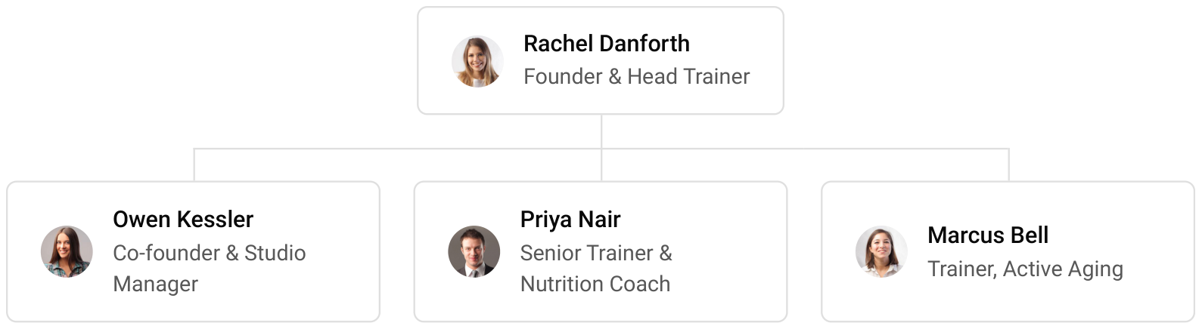

9.3 Advisory Board Members
The studio has no formal board. The founders will draw on an accountant with experience of fitness businesses for tax and payroll, a lawyer for the lease and client agreements, and a physical therapist from a referring clinic who reviews the screening process and the return-to-training programs once a year.

9.3.1 Hiring Plan
2  Filled |  | 2  Hiring This Year |  | 3  Open

Group By Department | Position Filled | Time of Hire | Time of Start | Filled
Head Training & Programming | 1 of 1 | 0 days | 0 days | 100%
Studio Operations & Client Services | 1 of 2 | 60 days | 14 days | 50%
Personal Training & Nutrition | 0 of 1 | 45 days | 21 days | 0%
Active Aging Training | 0 of 1 | 45 days | 14 days | 0%

CHAPTER 10

Financial Plan

10.1 Key Assumptions
10.2 Capital Requirements and Use of Funds
10.3 Income Statement (3 Year projections)
10.4 Balance Sheet (3 Year projections)
10.5 Cash Flow Statement (3 Year projections)
10.6 Break Even Analysis

10.1 Key Assumptions
Revenue follows one formula: active clients times the average monthly package price, uplifted by add-on sales, plus online coaching clients times the online price, over twelve months. The model assumes 80 active studio clients at a blended $400 a month, add-on revenue of 8% of the package book from nutrition coaching, assessments and the retail shelf, and 30 online coaching clients at $99 a month.
The studio opens at 40% of its client book on founding clients and fills it over ten months, then grows revenue 15% a year. Gross margin is 90.0%, since trainers sit below the gross line and cost of sales is card fees, software fees and the retail shelf. Payroll is 46% of revenue and marketing 6%. Rent is $5,200 a month, technology $400 and administration $1,100, which covers insurance and accounting. Income tax is modelled at 28%.
On these inputs revenue is $337,770 in the first year, $388,436 in the second and $446,701 in the third. Net income is $3,756, $16,478 and $30,970, a net margin of 6.9% by the third year. Break-even revenue is $299,501, equal to 62 clients, which the first year clears. In the conservative case third-year net income is $10,168, and in the upside case $59,066.

10.2 Capital Requirements and Use of Funds
The startup budget is $142,100. The largest items are the training equipment and the leasehold improvements, chiefly flooring, the turf lane and the assessment room, followed by a working capital reserve that carries the studio while its client book fills. The rest covers deposits and pre-opening rent, launch marketing, assessment and studio technology, legal and insurance costs, the AED and trainer certification, and the first retail stock.
It is funded by a $60,000 owner contribution from the founders' savings and an $85,000 SBA 7(a) loan at 10.5% over seven years, matched to the useful life of the equipment. There is no outside equity, and no profits are distributed in the first three years, so cash stays in the business to fund the part-time trainer's hours and new equipment.
The loan is serviced from operations rather than from fresh capital. Break-even revenue of $299,501 is cleared in the first year, and even the conservative case keeps the third year profitable at $10,168 of net income, so the owners do not plan to add money after opening.

10.2.1 Use of Funds
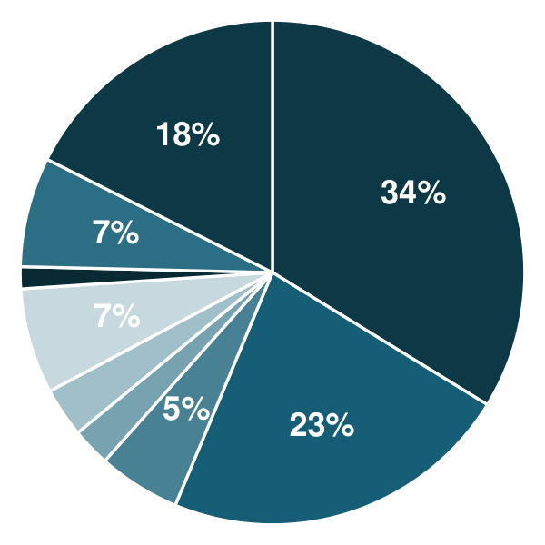 | ● Training Equipment 33.8%  ● Leasehold Improvements 22.5%  ● Assessment & Studio Technology 5.3%  ● Certifications, CPR/AED & Safety 2.5%  ● Licenses, Insurance & Legal 3.2%  ● Deposits & Pre-Opening Rent 6.8%  ● Initial Retail Inventory 1.4%  ● Launch Marketing 7.0%  ● Working Capital Reserve 17.6%

Use Of Funds | Amount
Training Equipment | $48,000.00
Leasehold Improvements | $32,000.00
Assessment & Studio Technology | $7,500.00
Certifications, CPR/AED & Safety | $3,500.00
Licenses, Insurance & Legal | $4,500.00
Deposits & Pre-Opening Rent | $9,600.00
Initial Retail Inventory | $2,000.00
Launch Marketing | $10,000.00
Working Capital Reserve | $25,000.00

10.3 Income Statement (3 Year projections)
 | Year 1 | Year 2 | Year 3 | Total
Revenue | $337,770.00 | $388,435.50 | $446,700.82 | $1,172,906.32
Cost of Sales | $33,777.00 | $38,843.55 | $44,670.08 | $117,290.63
General Costs | $0.00 | $0.00 | $0.00 | $0.00
Revenue Specific Costs | $23,643.90 | $27,190.48 | $31,269.06 | $82,103.44
Personnel Costs (Direct Labor) | $10,133.10 | $11,653.07 | $13,401.02 | $35,187.19
Gross Margin | $303,993.00 | $349,591.95 | $402,030.74 | $1,055,615.69
Gross Margin (%) | 90.00% | 90.00% | 90.00% | 90.00%
Operating Expense | $269,551.20 | $297,923.88 | $330,552.46 | $898,027.54
Payroll Expense (Indirect Labor) | $155,374.20 | $178,680.33 | $205,482.38 | $539,536.91
General Expense | $114,177.00 | $119,243.55 | $125,070.08 | $358,490.63
Bad Debt | $0.00 | $0.00 | $0.00 | $0.00
Amortization of Current Assets | $0.00 | $0.00 | $0.00 | $0.00
EBITDA | $34,441.80 | $51,668.07 | $71,478.28 | $157,588.15
Additional Expense | $30,685.70 | $35,190.36 | $40,508.42 | $106,384.48
Long Term Depreciation | $20,300.00 | $21,132.36 | $22,089.58 | $63,521.94
Gain or loss from Sale of Assets | $0.00 | $0.00 | $0.00 | $0.00
EBIT | $14,141.80 | $30,535.71 | $49,388.70 | $94,066.21
Interest Expense | $8,925.00 | $7,650.00 | $6,375.00 | $22,950.00
EBT | $5,216.80 | $22,885.71 | $43,013.70 | $71,116.21
Income Tax Expense / Benefit | $1,460.70 | $6,408.00 | $12,043.84 | $19,912.54
Total Expense | $334,013.90 | $371,957.79 | $415,730.96 | $1,121,702.65
Net Income | $3,756.10 | $16,477.71 | $30,969.86 | $51,203.67
Net Income (%) | 1.11% | 4.24% | 6.93% | 4.37%
Retained Earning Opening | $0.00 | $3,756.09 | $20,233.80
Owner's Distribution | $0.00 | $0.00 | $0.00 | $0.00
Retained Earning Closing | $3,756.10 | $20,233.80 | $51,203.66 | $51,203.66

10.4 Balance Sheet (3 Year projections)
 | Year 1 | Year 2 | Year 3 | Total
Assets | $139,754.61 | $145,742.71 | $166,457.56 | $166,457.56
Current Assets | $17,954.61 | $39,248.54 | $75,352.46 | $75,352.46
Cash | $17,029.21 | $38,184.33 | $74,128.62 | $74,128.62
Accounts Receivable | $0.00 | $0.00 | $0.00 | $0.00
Inventory | $925.40 | $1,064.21 | $1,223.84 | $1,223.84
Other Current Assets | $0.00 | $0.00 | $0.00 | $0.00
Long Term Assets | $121,800.00 | $106,494.17 | $91,105.10 | $91,105.10
Gross Long Term Assets | $142,100.00 | $147,926.53 | $154,627.04 | $154,627.04
Accumulated Depreciation | $20,300.00 | $41,432.36 | $63,521.94 | $63,521.94
Liabilities & Equity | $139,754.61 | $145,742.71 | $166,457.56 | $166,457.56
Liabilities | $75,998.52 | $65,508.91 | $55,253.90 | $55,253.90
Current Liabilities | $15,284.23 | $16,937.48 | $18,825.33 | $18,825.33
Accounts Payable | $2,776.19 | $3,192.62 | $3,671.51 | $3,671.51
Income Tax Payable | $365.18 | $1,602.00 | $3,010.96 | $3,010.96
Sales Tax Payable | $0.00 | $0.00 | $0.00 | $0.00
Short Term Debt | $12,142.86 | $12,142.86 | $12,142.86 | $12,142.86
Long Term Liabilities | $60,714.29 | $48,571.43 | $36,428.57 | $36,428.57
Long Term Debt | $60,714.29 | $48,571.43 | $36,428.57 | $36,428.57
Equity | $63,756.09 | $80,233.80 | $111,203.66 | $111,203.66
Paid-in Capital | $0.00 | $0.00 | $0.00 | $0.00
Common Stock | $0.00 | $0.00 | $0.00 | $0.00
Preferred Stock | $0.00 | $0.00 | $0.00 | $0.00
Owner's Contribution | $60,000.00 | $60,000.00 | $60,000.00 | $60,000.00
Retained Earnings | $3,756.09 | $20,233.80 | $51,203.66 | $51,203.66
Check | $0.00 | $0.00 | $0.00 | $0.00

10.5 Cash Flow Statement (3 Year projections)
 | Year 1 | Year 2 | Year 3 | Total
Cash Received | $339,458.85 | $390,377.68 | $448,934.32 | $1,178,770.85
Cash Paid | $313,186.78 | $351,253.17 | $394,146.66 | $1,058,586.61
COS & General Expenses | $135,970.11 | $146,156.41 | $156,019.88 | $438,146.40
Salary & Wages | $165,507.30 | $190,333.40 | $218,883.40 | $574,724.10
Interest | $8,925.00 | $7,650.00 | $6,375.00 | $22,950.00
Sales Tax | $1,688.85 | $1,942.18 | $2,233.50 | $5,864.53
Income Tax | $1,095.52 | $5,171.18 | $10,634.88 | $16,901.58
Net Cash From Operations | $26,272.07 | $39,124.51 | $54,787.66 | $120,184.24
Assets Sell | $0.00 | $0.00 | $0.00 | $0.00
Assets Purchase | $142,100.00 | $5,826.53 | $6,700.51 | $154,627.04
Net Cash From Investments | ($142,100.00) | ($5,826.53) | ($6,700.51) | ($154,627.04)
Amount Received | $145,000.00 | $0.00 | $0.00 | $145,000.00
Loan Received | $85,000.00 | $0.00 | $0.00 | $85,000.00
Common Stock | $0.00 | $0.00 | $0.00 | $0.00
Preferred Stock | $0.00 | $0.00 | $0.00 | $0.00
Owner's Contribution | $60,000.00 | $0.00 | $0.00 | $60,000.00
Amount Paid | $12,142.86 | $12,142.86 | $12,142.86 | $36,428.58
Loan Capital | $12,142.86 | $12,142.86 | $12,142.86 | $36,428.58
Dividends & Distributions | $0.00 | $0.00 | $0.00 | $0.00
Net Cash From Financing | $132,857.14 | ($12,142.86) | ($12,142.86) | $108,571.42
Summary
Starting Cash | $0.00 | $17,029.21 | $38,184.33
Cash In | $484,458.85 | $390,377.68 | $448,934.32 | $1,323,770.85
Cash Out | $467,429.64 | $369,222.56 | $412,990.03 | $1,249,642.23
Change in Cash | $17,029.21 | $21,155.12 | $35,944.29 | $74,128.62
Ending Cash | $17,029.21 | $38,184.33 | $74,128.62 | $74,128.62

10.6 Break Even Analysis
 | Year 1 | Year 2 | Year 3 | Total
Starting Revenue | $0.00 | $337,770.00 | $726,205.50 | $726,205.50
Net Revenue | $337,770.00 | $388,435.50 | $446,700.82 | $446,700.82
Closing Revenue | $337,770.00 | $726,205.50 | $1,172,906.32 | $1,172,906.32
Starting Expense | $0.00 | $334,013.90 | $705,971.69 | $705,971.69
Net Expense | $334,013.90 | $371,957.79 | $415,730.96 | $415,730.96
Closing Expense | $334,013.90 | $705,971.69 | $1,121,702.65 | $1,121,702.65
Is Break Even? | Yes | Yes | Yes
Break Even Month | Dec '26 | - | -
Days Required | 18 Days | - | -
Break Even Revenue | $337,770.00 | - | -

CHAPTER 11

References

- SRC001: Personal Trainers in the US - Market Size, Industry Analysis, Trends and Forecasts (2026-2031), IBISWorld, 2026-07-01. https://www.ibisworld.com/united-states/industry/personal-trainers-in-the-us/4189/ (accessed 2026-10-13)
- SRC002: Personal Trainers in the US - Number of Businesses, IBISWorld, 2026-01-01. https://www.ibisworld.com/industry-statistics/number-of-businesses/personal-trainers-united-states/ (accessed 2026-10-13)
- SRC003: Fitness Trainers and Instructors, US Bureau of Labor Statistics, Occupational Outlook Handbook, 2026-08-27. https://www.bls.gov/ooh/personal-care-and-service/fitness-trainers-and-instructors.htm (accessed 2026-10-13)
- SRC004: Two-Brain State of the Industry Report Suggests CrossFit Gyms Lag Behind Others in Key Metrics, Morning Chalk Up, 2025-11-13. https://morningchalkup.com/2025/11/13/two-brain-state-of-the-industry-report-crossfit-gyms-lag/ (accessed 2026-10-13)
- SRC005: How Much Does a Personal Trainer Cost? (2026 Pricing Guide), Trainero, 2026-01-01. https://blog.trainero.com/how-much-does-a-personal-trainer-cost (accessed 2026-10-13)
- SRC006: New HFA Data Shows How 77 Million US Fitness Facility Members Work Out, Health & Fitness Association, 2025-10-30. https://www.healthandfitness.org/new-hfa-data-shows-how-77-million-us-fitness-facility-members-work-out (accessed 2026-10-13)
- SRC007: 2026 State of the Personal Training Industry Report: What's Changing and What Comes Next, ABC Trainerize, 2026-02-12. https://trainerize.com/blog/2026-state-of-personal-training-industry-report (accessed 2026-10-13)
- SRC008: ACSM Announces Top Fitness Trends for 2026, Recreation Management, 2025-11-24. https://recmanagement.com/articles/155523/acsm-announces-top-fitness-trends-2026 (accessed 2026-10-13)
- SRC009: 81 Million Americans Were Members of a Fitness Facility in 2025, New HFA Report Finds, Health & Fitness Association, 2026-04-09. https://www.healthandfitness.org/81-million-americans-were-members-of-a-fitness-facility-in-2025-new-hfa-report-finds/ (accessed 2026-10-13)
- SRC010: Participation Hits New High, But Majority of Americans Not Yet Meeting Recommended Guidelines of 150 Minutes of Weekly Activity, SFIA's 2026 Topline Report Finds, Sports & Fitness Industry Association, 2026-03-01. https://sfia.org/resources/participation-hits-new-high-but-majority-of-americans-not-yet-meeting-recommended-guidelines-of-150-minutes-of-weekly-activity-sfias-2026-topline-report-finds/ (accessed 2026-10-13)
- SRC011: 2025 Fitness Industry Benchmarking Report, Health & Fitness Association, 2025-09-30. https://www.healthandfitness.org/2025-fitness-industry-benchmarking-report/ (accessed 2026-10-13)
- SRC012: Personal Trainer Certification Cost Comparison 2026: NASM vs ISSA, ACE, ACSM, CSCS, NASM, 2026-06-30. https://www.nasm.org/resource-center/blog/certification/personal-trainer-certification-cost-comparison-2026-nasm-vs-issa-ace-acsm-cscs (accessed 2026-10-13)
- SRC013: Personal Trainer Insurance Costs, Insureon, 2025-06-03. https://www.insureon.com/sports-fitness-business-insurance/personal-trainers/cost (accessed 2026-10-13)
- SRC014: How much does gym and fitness center insurance cost?, Insureon, 2025-06-11. https://www.insureon.com/sports-fitness-business-insurance/gyms-and-fitness-centers/cost (accessed 2026-10-13)
- SRC015: US Retail MarketBeat Q2 2026, Cushman & Wakefield, 2026-07-15. https://www.cushmanwakefield.com/en/united-states/news/2026/07/us-retail-marketbeat (accessed 2026-10-13)
- SRC016: Q2 2026 U.S. Retail Figures, CBRE, 2026-01-01. https://www.cbre.com/insights/figures/q2-2026-us-retail-figures (accessed 2026-10-13)
- SRC017: QCEW Open Data: 2025 Annual Averages, NAICS 713940, US Bureau of Labor Statistics, 2026-01-01. https://data.bls.gov/cew/data/api/2025/a/industry/713940.csv (accessed 2026-10-14)
- SRC018: QCEW Open Data: 2024 Annual Averages, NAICS 713940, US Bureau of Labor Statistics, 2025-01-01. https://data.bls.gov/cew/data/api/2024/a/industry/713940.csv (accessed 2026-10-14)
- SRC019: Total Revenue for Fitness and Recreational Sports Centers, All Establishments, Employer Firms (REVEF71394ALLEST), Federal Reserve Bank of St. Louis (FRED), from US Census Bureau Service Annual Survey, 2024-01-31. https://fred.stlouisfed.org/series/REVEF71394ALLEST (accessed 2026-10-14)
- SRC020: QCEW Open Data: 2022 Annual Averages, NAICS 713940, US Bureau of Labor Statistics, 2023-01-01. https://data.bls.gov/cew/data/api/2022/a/industry/713940.csv (accessed 2026-10-14)
- SRC021: Naperville, IL - Profile data, Census Reporter (US Census Bureau American Community Survey 2024 1-year), 2025-01-01. https://censusreporter.org/profiles/16000US1751622-naperville-il/ (accessed 2026-10-14)
- SRC022: Orangetheory Fitness - South Naperville, Wellhub, 2026-01-01. https://wellhub.com/en-us/search/partners/0b1781f1-a1d9-4f0c-8644-e3e869bf24f3/ (accessed 2026-10-14)
- SRC023: Orangetheory Fitness - Naperville, Wellhub, 2026-01-01. https://wellhub.com/en-us/search/partners/A7IzE8tf1tp0w0jOQK6Di-1ZJRXUkkczy_Tvtg9kn4BKUYfVr_C9WNLQnElXhr7_ (accessed 2026-10-14)
- SRC024: F45 Naperville, Wellhub, 2026-01-01. https://wellhub.com/en-ca/search/partners/f45-naperville/ (accessed 2026-10-14)
- SRC025: The Perfect Workout - Naperville, The Perfect Workout, 2026-01-01. https://www.theperfectworkout.com/?p=40971 (accessed 2026-10-14)
- SRC026: Watch: How Semi-Private Personal Training Works at Beyond Measure Fitness, Naperville, Naperville.com, 2026-01-01. https://naperville.com/health-wellness/watch-beyond-measure-fitness-naperville/ (accessed 2026-10-14)
- SRC027: CityGate Centre, CommercialSearch, 2026-09-29. https://www.commercialsearch.com/commercial-property/us/il/naperville/citygate-centre-1/ (accessed 2026-10-14)
- SRC028: Occupational Employment and Wage Statistics: Chicago-Naperville-Elgin, IL-IN, May 2025, US Bureau of Labor Statistics, 2026-01-01. https://data.bls.gov/oes/#/area/0016980/2025 (accessed 2026-10-14)
- SRC029: Illinois Minimum Wage 2026: $15.00 Statewide, $17.05 in Chicago, HiveDesk, 2026-01-01. https://www.hivedesk.com/compliance/united-states/minimum-wage-illinois (accessed 2026-10-14)
- SRC030: Physical Fitness Services Act, 815 ILCS 645/6, Illinois General Assembly. https://ilga.gov/legislation/ilcs/documents/081506450K6.htm (accessed 2026-10-14)
- SRC031: Public Act 103-0838, Illinois General Assembly, 2024-01-01. https://ilga.gov/legislation/publicacts/103/103-0838.htm (accessed 2026-10-14)
- SRC032: Physical Fitness Facility Medical Emergency Preparedness Act, 210 ILCS 74, Illinois General Assembly. https://www.ilga.gov/legislation/ilcs/ilcs3.asp?ActID=2616 (accessed 2026-10-14)
