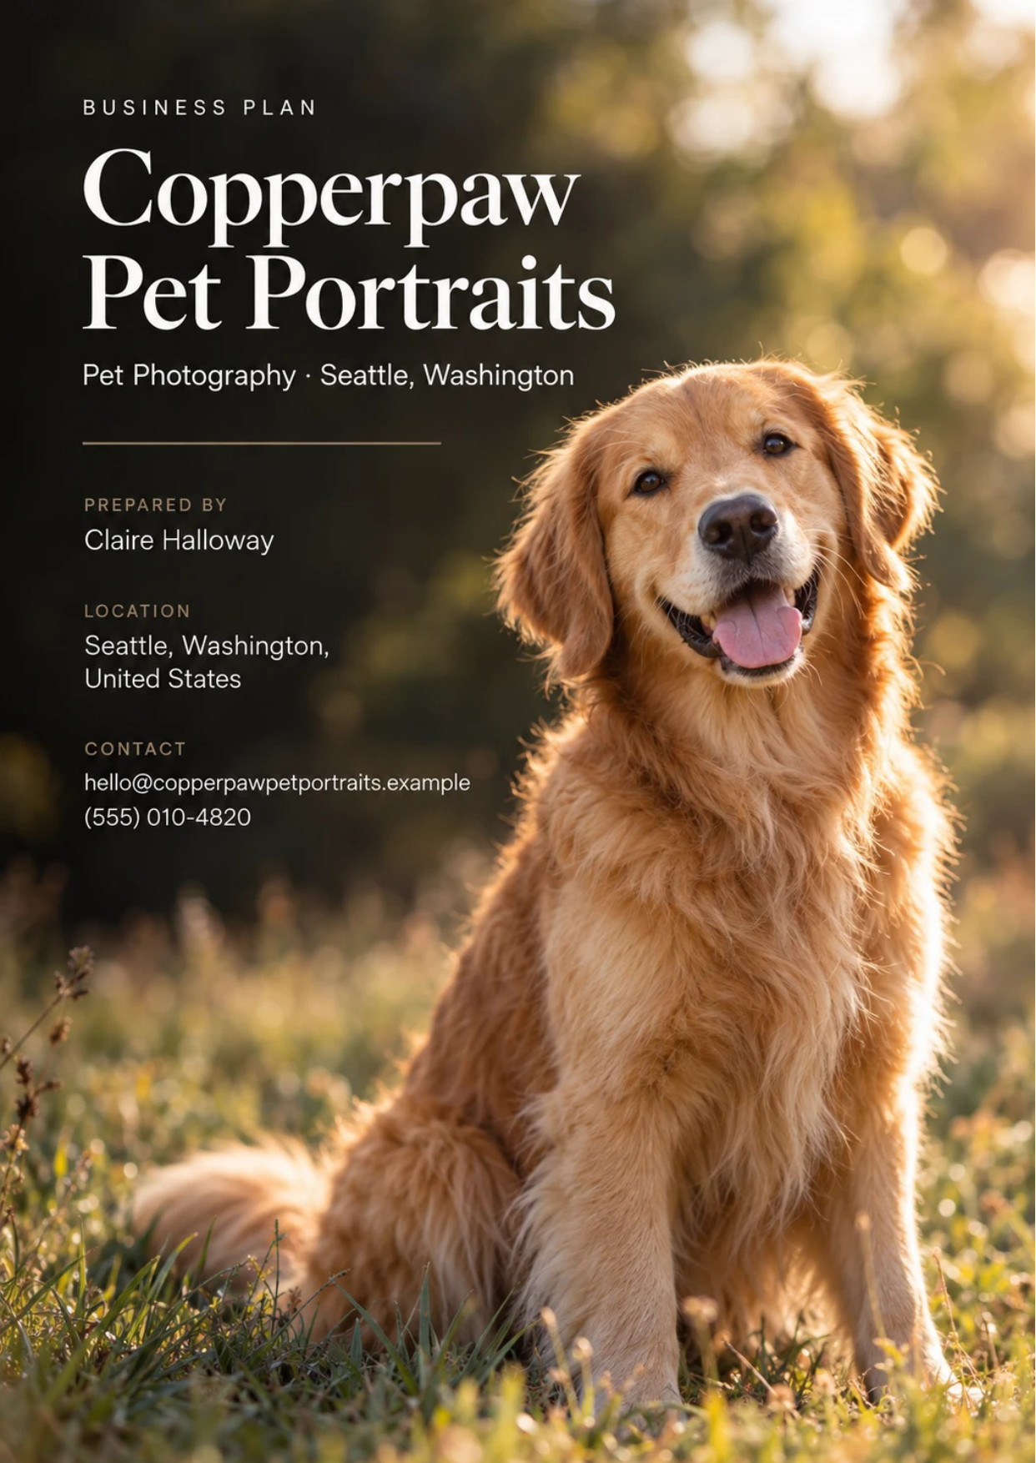
Table of Contents
1. Executive Summary 6
1.1 Business Overview 7
1.2 Mission Statement 7
1.3 Location & Market Opportunity 7
1.4 Unique Selling Points 7
1.5 Financial Highlights 8
1.6 Funding Requirement 8
1.6.1 Income Statement (3 Year projections) 8
2. Company Overview 9
2.1 Legal Structure 10
2.2 Vision Statement 10
2.3 Background & History 10
2.4 Future Goals 10
2.4.1 Business Owners 11
2.4.2 SMART Goal 11
3. Market Analysis 12
3.1 Overview 13
3.2 Market Segmentation 13
3.3 Market Trends 13
3.4 Local Market Outlook 13
3.5 Market Size 14
4. Customer Analysis 15
4.1 Target Market 16
4.2 Customer Segments 16
4.3 Customer Persona 17
4.4 Customer Purchase Journey 17
5. Competitive Analysis 18
5.1 Competitors 19
5.2 Comparison 19
5.3 Competitive Edge 20
5.4 SWOT Analysis 21
6. Services Offered 22
6.1 Our Offering 23
6.2 Signature Items 23
6.3 Additional Services 23
6.4 What Sets Us Apart 23
6.5 Session Experience & Ordering Appointment 23
6.5.1 Signature Pet Portrait Session 24
6.5.2 Seasonal Mini Sessions 24
6.5.3 Features 25
6.5.4 Pricing 26
7. Marketing & Sales Strategies 27
7.1 Market Positioning 28
7.2 Marketing Objectives 28
7.3 Online Marketing 29
7.4 Public Relations and Branding 29
7.5 Partnership & Collaboration Strategy 29
7.6 Customer Loyalty & Retention 29
7.7 Sales Channels 30
8. Operations Plan 31
8.1 Daily Operations 32
8.2 Working Hours 32
8.3 Staffing & Training 32
8.4 Inventory & Equipment Management 32
8.5 Location and Facilities 32
8.6 Milestones & Timeline 32
8.7 Animal Handling & Session Safety 33
9. Management Team 35
9.1 Key Members 36
9.2 Organization Chart 36
9.3 Advisory Board Members 36
9.3.1 Hiring Plan 37
10. Financial Plan 38
10.1 Key Assumptions 39
10.2 Capital Requirements and Use of Funds 39
10.2.1 Use of Funds 40
10.3 Income Statement (3 Year projections) 41
10.4 Balance Sheet (3 Year projections) 42
10.5 Cash Flow Statement (3 Year projections) 43
10.6 Break Even Analysis 44
11. References 45


CHAPTER 1

Executive Summary

1.1 Business Overview
1.2 Mission Statement
1.3 Location & Market Opportunity
1.4 Unique Selling Points
1.5 Financial Highlights
1.6 Funding Requirement

1.1 Business Overview
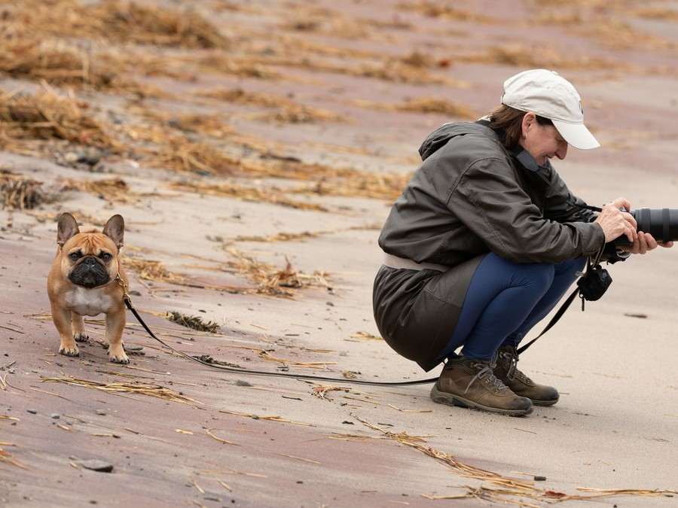
Copperpaw Pet Portraits is a pet portrait photography studio opening in a street-level space in Seattle's Ballard neighborhood. It photographs dogs, cats and their owners in the studio and on location in the city's parks and beaches, and sells the finished work as framed prints, canvas, acrylic and metal wall art, albums and keepsake boxes.
Clients choose their art at an in-person ordering appointment after the session, and seasonal mini sessions around the holidays, spring and autumn bring owners back each year. The studio serves pet owners across Seattle and its close-in suburbs, especially households that treat their pets as family.

1.2 Mission Statement
To give Seattle pet owners portraits of their animals worth hanging on the wall: photographed patiently, printed properly and chosen in person.

1.3 Location & Market Opportunity
Seattle had 383,698 households in 2024 and a median household income of $118,745, about 1.5 times the US median. Its households are small, about two people each, and many of them have a dog or cat rather than children at home. Ballard sits beside Golden Gardens Park and some of the city's most dog-friendly streets, and a studio there keeps sessions running through the wet months, when outdoor photographers reschedule.
US portrait photography studios with employees took in $4,762,000,000 in 2022. King County's portrait studios represent about $33,900,000 of annual revenue, and a single studio averages about $428,600 nationally. Copperpaw's first-year revenue of $195,929 sits well inside that single-studio figure.

1.4 Unique Selling Points
- A studio built for animals, with a gated shooting bay and non-slip floor, so nervous pets settle and rain never cancels a session.
- An in-person ordering appointment with real framed, canvas, acrylic and metal samples, so clients buy art sized for their own walls.
- A certified dog trainer handling pets on every mini session day.
- Seasonal mini sessions that introduce new clients at a fixed price and bring past clients back every holiday season.
- Referral partners at veterinary clinics, groomers and dog daycares across north Seattle.

1.5 Financial Highlights
Revenue comes from twelve full portrait sessions a month at an average client sale of $1,350, covering the session fee and the wall art order, plus 22 mini sessions a month at $245. The studio opens at 35% of that level and reaches it over nine months as reviews and partner referrals build.
Revenue is projected at $195,929 in 2026, $227,278 in 2027 and $263,642 in 2028, at a gross margin of 72.0% throughout. The opening year closes with a net loss of $1,471 once depreciation and loan interest are counted; net income then rises to $6,786 in 2027 and $15,847 in 2028, a net margin of 6.0%. Break-even revenue is $167,806, the equivalent of 124 full-session clients a year. In 2028, net income is $3,727 in the conservative case and $32,217 in the upside case.

1.6 Funding Requirement
The startup budget is $77,100. Cameras and lenses and the studio fit-out take most of it; the rest covers studio lighting and sets, the editing computer, sample wall art and albums, viewing room furniture, the deposit and pre-opening rent, licenses and insurance, the website and launch marketing. It is funded by a $45,000 owner contribution from the founder's savings and a $60,000 SBA 7(a) loan at 10.5% over five years, which leaves opening cash above the budget. Profits stay in the business while the loan is repaid.
The plan rests on an experienced pet and family photographer, a high-income city of small households that treat their pets as family, and an offer built around finished art chosen in person. The money builds a studio that works in any weather and fills its calendar through the people pet owners already trust.

1.6.1 Income Statement (3 Year projections)
 | Year 1 | Year 2 | Year 3 | Total
Revenue | $195,929.24 | $227,277.92 | $263,642.39 | $686,849.55
Cost of Sales | $54,860.19 | $63,637.82 | $73,819.87 | $192,317.88
Gross Margin | $141,069.05 | $163,640.10 | $189,822.52 | $494,531.67
Operating Expense | $120,819.97 | $133,680.77 | $148,599.30 | $403,100.04
Total Expense | $197,400.16 | $220,491.65 | $247,795.35 | $665,687.16
Net Income | ($1,470.92) | $6,786.27 | $15,847.04 | $21,162.39

CHAPTER 2

Company Overview

2.1 Legal Structure
2.2 Vision Statement
2.3 Background & History
2.4 Future Goals

2.1 Legal Structure
Copperpaw Pet Portraits will operate as a single-member limited liability company registered in Washington and owned entirely by its founder, Claire Halloway. The structure separates her personal assets from the studio's lease, its loan and its client contracts, and lets profits pass through to her personal return.
The business will hold a Seattle business license tax certificate and collect Washington sales tax on photographs and digital images, which the state treats as retail sales. From 2026, Seattle's business and occupation tax applies only above $2,000,000 of Seattle revenue, far above this studio's projections, although it still files an annual return.

2.2 Vision Statement
To be the studio Seattle pet owners think of when they want their animal on the wall: known for patient sessions, honest advice on what to hang and where, and prints made to last for decades.

2.3 Background & History
Copperpaw is a new business with no trading history. Its founder, Claire Halloway, intends to build it on eight years of photographing families and their dogs as a freelance portrait photographer in Seattle, working mostly outdoors and delivering digital files. Before that she worked at the front desk of a veterinary clinic, where she learned how frightened animals behave and how much their owners will do for them.
Two problems in that freelance work shaped this plan. Bookings collapsed every wet season, when outdoor sessions were cancelled or pushed back, and clients who received a gallery link rarely printed anything. Claire intends to solve both with a small studio in Ballard and an in-person ordering appointment, where clients see their images at full size and choose finished pieces from real samples. The name comes from her own dog, a copper-colored rescue who will be the studio's first model and its logo.

2.4 Future Goals
In the first 0 to 18 months, the aim is to open the Ballard studio in January 2026, reach twelve full sessions a month by September and run a first holiday mini season that fills its slots. The same period builds the referral network: veterinary clinics, groomers and dog daycares across north Seattle displaying sample prints and session cards, and a base of reviews that brings in owners the partners do not reach.
Over 1 to 3 years, through 2028, revenue grows from $195,929 in 2026 to $263,642 in 2028 through repeat clients, mini session clients returning for full sessions and modest price rises, while the SBA loan is repaid from operating cash. The session assistant's role on mini days becomes a regular part-time position as the seasonal calendar grows.
Over 3 to 5 years, Claire intends to add an associate photographer so the studio can take more full sessions than one person can shoot, and to offer legacy sessions for senior and seriously ill pets in partnership with veterinary practices. A second location is not part of this plan; the goal is one studio, full and profitable.

2.4.1 Business Owners
Claire Halloway

Total ownership: 100%
100% | Claire Halloway  10,000 Shares

2.4.2 SMART Goal
  Specific  - Claire Halloway fills the Ballard studio calendar to twelve full portrait sessions a month.  - The work sells wall art at ordering appointments rather than digital files alone.  - It matters because the full session, not the mini, carries most of the revenue. |   Measurable  - Full sessions booked each month, tracked in the studio management software.  - Average client sale against the planned $1,350.  - Share of bookings arriving through referral partners. |   Achievable  - Twelve sessions is about three a week for one experienced photographer.  - Maya Torres takes bookings, gallery delivery and orders off the photographer's desk.  - Launch sessions for existing clients and partner referrals start the calendar at about a third full.
  Relevant  - Break-even revenue of $167,806 needs a full calendar, not an occasional booking.  - A full calendar before November leaves the holiday minis to add margin rather than cover costs.  - It builds the review base every later goal depends on. |   Time-Based  - Referral partner kits go to clinics, groomers and daycares before opening in January 2026.  - Monthly booking reviews from February 2026 show whether the ramp is on track.  - Twelve sessions a month is reached by September 2026.

CHAPTER 3

Market Analysis

3.1 Overview
3.2 Market Segmentation
3.3 Market Trends
3.4 Local Market Outlook
3.5 Market Size

3.1 Overview
Pet photography sits inside portrait photography, the largest revenue segment of a US photography industry estimated at $15.8 billion in 2025. Portrait studios with employees took in $4,762,000,000 in 2022, and 12,139 of them were operating in 2024. Pet photography as a specialty was a $143.4 million business in 2025, spread across about 2,695 businesses, most of them solo photographers turning over about $53,000 a year.
Demand rests on pet ownership. In 2025, 95 million US households owned a pet and total pet industry spending reached $158 billion, up 3.7% on the year before.

3.2 Market Segmentation
- Dog owners: 71 million US households in 2025, 53% of all households, and the core of portrait demand.
- Cat owners: 53 million households, photographed at home or in a quiet studio rather than a park.
- Milestone buyers: owners marking a new puppy, an adoption anniversary or a senior pet's later years, who buy the largest wall pieces.
- Seasonal buyers: households booking holiday card photographs, who buy fixed-price mini sessions and come back each year.
- Families: households who want the pet and the people in one frame.

3.3 Market Trends
Owners treat pets as family. In a 2023 Pew survey, 97% of pet owners said their pets are part of the family and 51% said a pet is as much a part of it as a human member; a June 2026 survey of 4,095 owners found 95% strongly agree. That attachment is what a portrait sells to.
Spending on pet services outside veterinary care reached $14.3 billion in 2025 and is projected at $14.9 billion in 2026. Pet photography moves with discretionary spending, rising 2.1% in 2025 after a fall in 2024, and owners are becoming choosier: 22% spent less on their pets in 2025, moving money from extras toward essential care. A portrait has to be worth more to the owner than a toy or a treat to survive that.
The substitute is the phone in every owner's pocket. A UK poll found owners keep about 176 photographs of their pets on their phones and add about 20 a month. A studio's answer is the finished, printed piece, which a camera roll never becomes on its own.

3.4 Local Market Outlook
Seattle had 780,992 residents in 383,698 households in 2024, with a median household income of $118,745 and a median home value of $950,800. Households are small, about two people each, and a Seattle Met reader poll found more respondents with a dog or cat (55.1%) than with a child (33.1%), though that poll is not a representative sample. No official count of the city's pet-owning households is published.
King County, the smallest geography with published figures, had 61 portrait studios with employees in 2024, down from 79 in 2022. Its location quotient of 0.74 means it carries about a quarter fewer portrait studios relative to its economy than the nation does. No count of pet photography studios alone exists for the county or the city.
Trading costs are high. Seattle's minimum wage is $21.30 an hour in 2026, north Seattle retail space averaged $22.87 a square foot a year in net rent in late 2025, and a session in a city park needs a Seattle Parks photography permit at $32 per four-hour block.

3.5 Market Size
The total addressable market is $4,762,000,000: the 2022 revenue of US portrait photography studios with employees, the industry a pet portrait studio is classified in and competes within for portrait spending.
The serviceable available market is $33,900,000: King County's 79 portrait studios with employees in 2022, multiplied by the national average of about $428,600 per studio. It leaves out owner-operators with no employees, so local portrait spending is higher than this figure.
The serviceable obtainable market is $428,600, the revenue of one average US portrait studio with employees. It is a national average rather than a Seattle figure. Copperpaw's first-year revenue of $195,929 is under half of it.
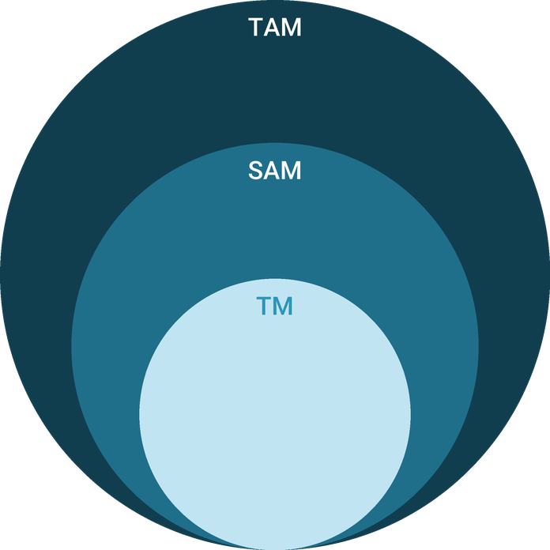
  ● | Total Available Market (TAM)  US portrait photography studios with employees took in $4,762 million in 2022 (Census Service Annual Survey, NAICS 541921), the industry a pet portrait studio is classified in and competes within for portrait spending. | 4.8B
  ● | Served Available Market (SAM)  King County's portrait photography studios with employees took in about $33.9 million in 2022: 79 establishments times US revenue of about $428,600 per establishment ($4,762 million across 11,110). | 33.9M
  ● | Target Market (TM)  One US portrait photography studio with employees took in about $428,600 in 2022 ($4,762 million across 11,110 employer establishments); a national average, not a Seattle figure. | 428.6k

CHAPTER 4

Customer Analysis

4.1 Target Market
4.2 Customer Segments
4.3 Customer Persona
4.4 Customer Purchase Journey

4.1 Target Market
Copperpaw's market is pet owners in Seattle and the close-in suburbs a short drive from Ballard: the north Seattle neighborhoods, Magnolia, Queen Anne and Shoreline for studio sessions, and the wider city for park and beach sessions. The core buyer is a dual-income household with one or two dogs or a cat, a home with wall space worth filling, and the income to spend about $1,350 on a portrait.
Seattle's median household income of $118,745, about 1.5 times the national figure, puts a large share of the city's 383,698 households in that position. Most clients will be dog owners, as 53% of US households owned a dog in 2025.
Three conditions make a likely client. The pet is treated as family, which describes nearly every owner: 97% of US pet owners say their pets are part of the family. The household has wall space and the means to fill it, and Seattle's median home value of $950,800 points to owners who furnish with care. And there is a moment to mark: a new puppy, an adoption anniversary, a move, a holiday card or an older pet slowing down. Copperpaw markets to the moment rather than to pet owners in general, because the moment is what turns a pleasant idea into a booking.

4.2 Customer Segments
- Devoted dog owners: couples and singles, often without children, who treat their dog as family, book a full session and buy wall art. The largest segment, and the one the persona stands for.
- Milestone clients: owners of a new puppy or a senior pet, booking because time matters. They buy the largest pieces and albums.
- Holiday card families: households with children and pets who book a mini session each November, some of whom return for a full session.
- Cat owners: a smaller group who need a quiet, closed studio, since few cats will cooperate in a park.
- Gift buyers: friends and relatives buying a session gift certificate for a new pet or a birthday.
The first two segments carry the full sessions and most of the revenue. Holiday card families and gift buyers mostly buy minis and certificates, and they matter because a share of them return for a full session the following year. Cat owners are a small group, but few photographers serve them well, which makes a quiet studio day each month worth keeping for them.

4.3 Customer Persona
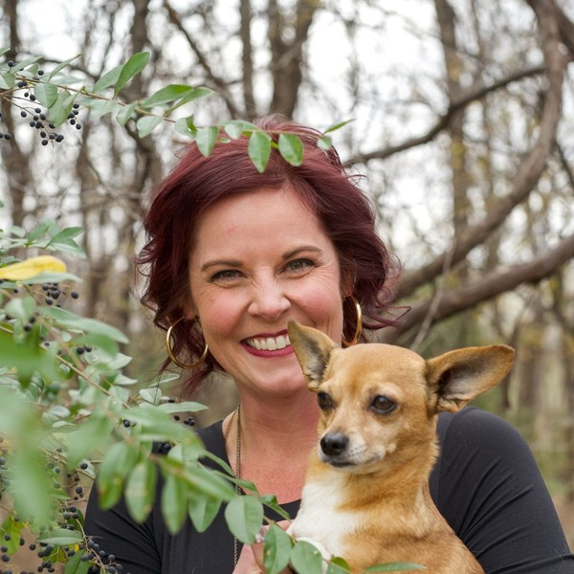  Jenna, the Devoted Dog Parent  Demographics  Age: 41  Household: Married, no children  Location: Ballard, Seattle  Income: 165,000 dollars household  Professional Role  Education: Bachelor's degree  Job: Product manager at a Seattle software company | “Our dog is part of every family photo on my phone, but there is nothing of him on our walls.”
   | Identifiers / Personality Traits  - Owns a small rescue dog she adopted six years ago and plans weekends around him  - Shops locally, follows Ballard businesses on Instagram and trusts her groomer's recommendations  - Takes hundreds of phone photos a year and prints almost none of them
   | Goals  - A portrait of her dog worth hanging in the living room before he gets much older  - A session that suits a small, anxious dog without a stressful outing  - Holiday cards the family will actually keep
   | Challenges  - Worries her dog will not sit still or will be frightened by lights and strangers  - Has no idea what size or finish to choose for the wall  - Seattle weather makes outdoor plans unreliable for much of the year

4.4 Customer Purchase Journey
A client usually moves from noticing the studio to hanging a finished piece in about five weeks:
- Discovery: a session card at the groomer's counter, a sample print in a veterinary waiting room, an Instagram ad or a friend's wall.
- Consultation: a call to plan the session around the pet's temperament, the location and the wall the art is for.
- Session: up to two unhurried hours in the studio or a park, with treats, breaks and a handler where needed.
- Ordering appointment: two weeks later, the edited gallery on a large screen beside real samples, where the order is placed and paid.
- Delivery and return: finished pieces collected or delivered, followed by an invitation to the next holiday mini season.

CHAPTER 5

Competitive Analysis

5.1 Competitors
5.2 Comparison
5.3 Competitive Edge
5.4 SWOT Analysis

5.1 Competitors
No national pet photography chain operates, so Copperpaw competes with independents. King County had 61 portrait studios with employees in 2024, and the owner-operators with no employees who make up most of the trade are not counted at all. Across the US, about 2,695 businesses specialize in pet photography.
- Independent pet photographers: mostly solo, shooting outdoors and often selling digital files. Strong with animals, exposed to the weather for half the year.
- Family portrait studios: studios that add pets to family, newborn and senior work. Strong on products and studio space, less practiced with nervous animals.
- Marketplace photographers: low-priced listings selling short sessions with digital files only, near the national average of up to $230 for pet photography.
- Pet stores and shelters: occasional photo days, often for charity. Cheap and infrequent, and rarely printed.
The groups also differ in how they sell. Some sell digital galleries for a session fee, some sell wall art and albums at an in-person appointment, and some mix the two; volume photographers earn less per client across many short sessions. An average session nationally costs up to $500 before any prints. Copperpaw sells wall art in person, at an average client sale of $1,350 for the session and order together. Behind all of them is the owner's own phone, the substitute every one of these competitors is up against.

5.2 Comparison
The table compares Copperpaw with the three groups that sell portrait sessions. Its one gap is deliberate: Copperpaw offers no digital-only package, because the business depends on clients choosing printed art at the ordering appointment. Its advantages are everything around the camera: a studio for wet-season work, a handler on set and samples to choose from.
Feature | Copperpaw Pet Portraits | Independent pet photographers | Family portrait studios | Marketplace photographers
Indoor studio for wet-season sessions | ✓ | ✗ | ✓ | ✗
Trained pet handler on set | ✓ | ✓ | ✗ | ✗
Ordering appointment with printed samples | ✓ | ✗ | ✓ | ✗
Professional lab wall art and albums | ✓ | ✓ | ✓ | ✗
Seasonal styled mini sessions | ✓ | ✗ | ✓ | ✗
Low-price digital-only package | ✗ | ✓ | ✗ | ✓

5.3 Competitive Edge
The edge is practical rather than artistic. Plenty of photographers in Seattle can take a good picture of a dog. Few can do it in a warm, gated studio in February, with a trainer keeping the dog calm, and then sell the owner a finished piece sized for their wall. Each advantage below is something a competitor would have to change its business to copy.
None of it is protected by more than effort, and that cuts both ways. An outdoor photographer who rents a studio takes on a fixed cost of about $2,200 a month, which digital-file prices cannot carry; a family studio that hires a trainer adds a wage for a minority of its sessions. Copperpaw's edge holds for as long as its average client sale of $1,350 pays for the space, which is why the ordering appointment, not the camera, sits at the centre of the business.
   | A studio set up for animals  Non-slip flooring, a gated shooting bay and a trained handler on mini days let nervous dogs and cats settle before the camera comes out.
   | A calendar that survives the rain  The Ballard studio means a session goes ahead through Seattle's wet months instead of being moved, while park and beach sessions fill the drier ones.
   | Art chosen in person, not from a link  Clients choose sizes and finishes at an ordering appointment with real framed, canvas, acrylic and metal samples, so they buy pieces sized for their own walls.
   | Referrals from people pet owners trust  Veterinary clinics, groomers and dog daycares in north Seattle hand out session cards and display sample prints, reaching owners at the moments they care most.

5.4 SWOT Analysis
Strengths  - An indoor studio keeps sessions running through Seattle's wet months, when on-location photographers reschedule.  - Ordering appointments with real samples raise the average client sale to about $1,350.  - A founder with years of pet and family portrait work and veterinary clinic experience.  - Seattle households earn a median $118,745, about 1.5 times the national figure. | Weaknesses  - One photographer limits capacity to about twelve full sessions a month.  - A new studio starts with no local reviews or client base of its own.  - Studio rent is a fixed cost that runs whether sessions are booked or not.
Opportunities  - US spending on pet services outside veterinary care is projected to rise from $14.3 billion to $14.9 billion in 2026.  - 97% of pet owners call their pets family, the motive a portrait sells to.  - Holiday mini sessions bring owners back every year and convert some to full sessions.  - King County has fewer portrait studios relative to its economy than the nation. | Threats  - Owners already photograph their pets daily on phones that keep improving.  - Low-priced marketplace photographers sell digital files for a fraction of a collection.  - 22% of pet owners spent less on their pets in 2025, and wall art is an easy purchase to postpone.

 Strategic Summary
Copperpaw should sell what a phone cannot: finished wall art, chosen in person, from a studio that works in any weather. Referral partners and yearly holiday minis should fill one photographer's calendar before any second shooter is added.

CHAPTER 6

Services Offered

6.1 Our Offering
6.2 Signature Items
6.3 Additional Services
6.4 What Sets Us Apart
6.5 Session Experience & Ordering Appointment

6.1 Our Offering
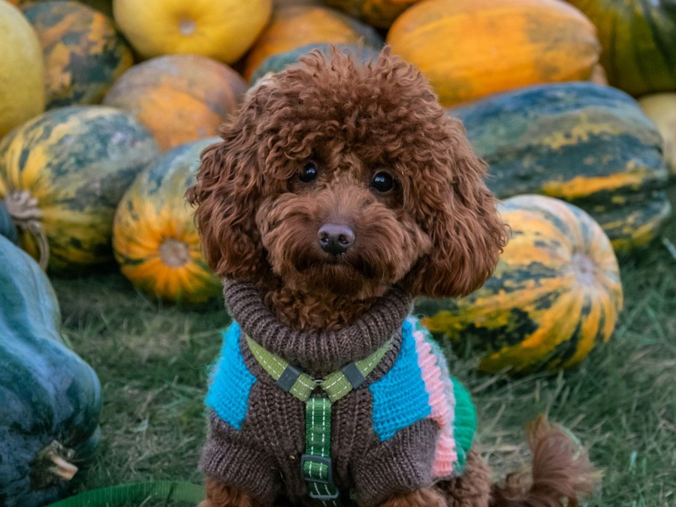
Copperpaw sells two things: a full portrait session that ends in finished wall art, and seasonal mini sessions at a fixed price. The full session carries the business. About three quarters of revenue comes from twelve sessions a month at an average client sale of $1,350, and the rest from 22 mini sessions a month at $245.
Every piece is printed by a professional lab. The lab, frames, albums, gallery fees and card processing together come to about 28% of revenue, a gross margin of 72.0%.

6.2 Signature Items
The Signature Pet Portrait Session is the headline: a session fee covering a consultation, up to two hours of shooting and the ordering appointment, followed by a collection chosen at that appointment. Wall pieces come as framed prints, canvas, acrylic and metal, and albums and keepsake boxes suit clients who want the whole session rather than one image. Three collections give clients a clear starting point, and the middle one, a large framed print or canvas with a set of matted prints, is the one most clients are expected to choose.

6.3 Additional Services
Seasonal Mini Sessions run on set days: a holiday set through November and December, a spring blossom set in April and an autumn set in October. Each is a short slot at $245 with a small gallery of edited images and a holiday card design, and prints can be added from the gallery. Session gift certificates are sold year round, and legacy sessions for very old or ill pets are booked at short notice when an owner needs one.

6.4 What Sets Us Apart
Three things: the studio, the handler and the appointment. The gated studio means a nervous dog or a cat can be photographed calmly in any weather. A certified dog trainer works every mini session day. And the ordering appointment, with real samples on the wall, turns a gallery of images into finished pieces a client is proud to hang.

6.5 Session Experience & Ordering Appointment
A full session runs in four steps. The consultation call covers the pet's age, health and temperament, the location and the wall the art is for, and the client is asked to bring favorite treats and a toy that squeaks. The session lasts up to two hours because animals need breaks: the first fifteen minutes are spent letting the pet explore the studio or the park before the camera comes out. Fast shutter speeds and either continuous light or off-camera flash are chosen around the animal's tolerance, never the other way round.
Claire culls and edits the strongest 25 to 35 images over the following ten days. At the ordering appointment, two weeks after the session, the client sees them projected at full size alongside framed, canvas, acrylic and metal samples in the sizes that suit their wall, and the order is paid in full. It goes to a professional lab, is checked on arrival and is collected or delivered about three weeks later, framed and ready to hang. Digital files of every purchased image are included.

6.5.1 Signature Pet Portrait Session
A relaxed session of up to two hours in the Ballard studio or at a Seattle park or beach, planned around the pet's temperament after a consultation call. Two weeks later the client returns for an ordering appointment to see the edited gallery on a large screen and choose wall art, albums and prints from real samples.
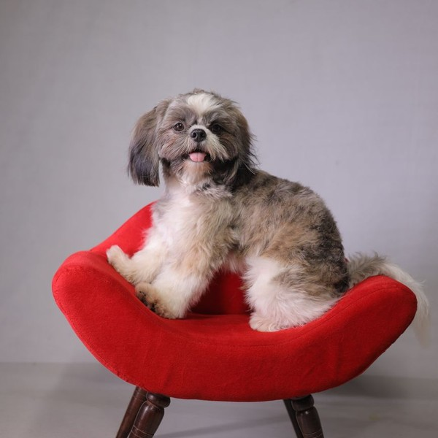 | $295 session fee, collections from $850  The session fee covers the consultation call, up to two hours of shooting and the ordering appointment. Most clients choose a collection, and the session fee and order together average about $1,350. Collections start at $850 and are built from framed prints, canvas, acrylic and metal pieces printed by a professional lab, with the digital file of every image bought in print. Prices are set out before the session, and the ordering appointment shows each piece at the size it will hang, so the client chooses with the wall in mind.

Specifications
- Pre-session consultation call about the pet, the location and the wall the art is for
- Up to two hours of shooting in the studio or at one Seattle location
- Ordering appointment two weeks after the session with an edited gallery
- Framed prints, canvas, acrylic and metal pieces printed by a professional lab
- Digital files of every image purchased in print

6.5.2 Seasonal Mini Sessions
Short fixed-price sessions on a styled set, run on set days around the holidays, the spring blossom season and autumn. Each slot is booked online in advance, and the client chooses images from a small online gallery a week later.
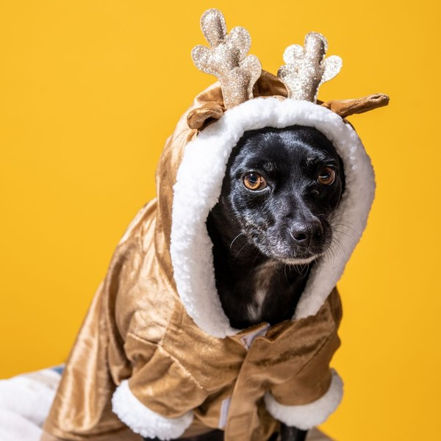 | $245 per 15-minute session  A fixed price that includes five edited digital images and a holiday card design, sold mostly in November and December. Prints and wall art can be added from the same gallery. Each 15-minute slot is booked and paid online in advance, on set days around the holidays, the spring blossom season and autumn, and covers one pet or two from the same household. Mini sessions are also how many clients first meet the studio, and some come back for a full session once they have seen their gallery.

Specifications
- A 15-minute session on a styled seasonal set in the studio
- One pet, or two from the same household
- Five edited digital images delivered in an online gallery
- A printable holiday card design using the client's favorite image
- Prints and wall art available to order from the same gallery

6.5.3 Features
  Pre-session consultation
  A call before every full session to plan the location, the pet's temperament and the wall the art is meant for.
  Pet-safe studio sessions
  A gated shooting bay with non-slip flooring and quiet, flash-free lighting options for nervous animals.
   | On-location sessions  Sessions at Seattle parks and beaches in drier months, with the park photography permit arranged by the studio.
   | In-person ordering appointment  The edited gallery shown on a large screen beside real framed, canvas, acrylic and metal samples.
  Professional lab printing
  Every print, album and wall piece produced by a professional photo lab and checked before delivery.
   | Seasonal mini session days  Short styled sessions around the holidays, the spring blossom season and autumn, booked online.

6.5.4 Pricing
Keepsake  $850  per collection  - Session fee and ordering appointment  - Five matted 8x10 prints  - Digital files of the printed images |  | Most Popular  Signature  $1,450  per collection  - Session fee and ordering appointment  - One 20x30 framed print or canvas  - Five matted 8x10 prints  - Digital files of the printed images |  | Heirloom  $2,450  per collection  - Session fee and ordering appointment  - A three-piece framed wall grouping  - A 20-page lay-flat album  - Digital files of every image in the album

CHAPTER 7

Marketing & Sales Strategies

7.1 Market Positioning
7.2 Marketing Objectives
7.3 Online Marketing
7.4 Public Relations and Branding
7.5 Partnership & Collaboration Strategy
7.6 Customer Loyalty & Retention
7.7 Sales Channels

7.1 Market Positioning
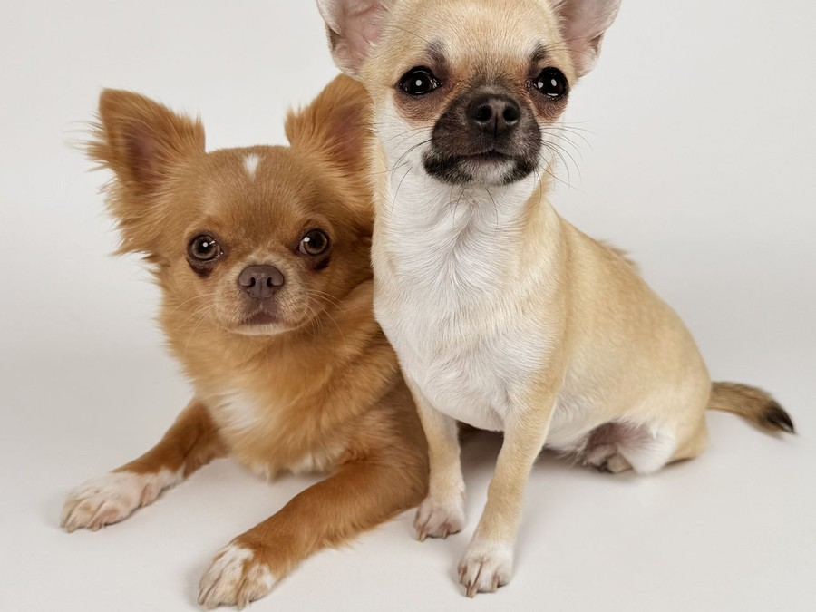
Copperpaw is the Seattle pet portrait studio for owners who want art on the wall, not more files on a phone: priced above digital-only photographers, below luxury studios, and open in any weather.

7.2 Marketing Objectives
- Reach twelve full sessions a month by September 2026.
- Sign referral agreements with veterinary clinics, groomers and dog daycares across north Seattle before opening.
- Fill every slot of the first holiday mini season in November and December 2026.
- Hold the average client sale at $1,350 through the ordering appointment.
- Build to 100 Google reviews by the end of 2027.
Referral partner program  $342  per month  Sample prints, session cards and thank-you credits for veterinary clinics, groomers and dog daycares. |  | Instagram and local search ads  $343  per month  Targeted ads to pet owners within a short drive of Ballard, timed to mini session launches.
Shelter charity mini days  $229  per month  Set dressing, prints and promotion for mini days that raise money for local animal shelters. |  | Website and email list  $229  per month  The portfolio site, online booking and the email list that sells each season's mini sessions.

Total marketing budget: $13,715 a year, $1,143 a month.

7.3 Online Marketing
The marketing budget is 7% of revenue, $13,715 in 2026. Instagram carries the work: short videos from sessions and finished pieces on clients' walls, with paid posts aimed at pet owners within a short drive of Ballard and timed to each mini season. The website takes consultation requests and mini session bookings directly, and a Google Business Profile with reviews catches owners searching for a pet photographer in Seattle. The email list, built from every client and mini booking, sells each season's mini days before they are advertised anywhere else.
Reviews are asked for at the moment of delivery, when the client is holding the finished piece, with a direct link to the Google profile. Each finished piece the client agrees to share becomes a post showing the art on its wall, which shows prospective clients the product they are buying rather than one more good photograph of a dog.

7.4 Public Relations and Branding
The brand is warm and plain: copper accents, the founder's rescue dog in the logo, and finished pieces photographed in real Seattle homes rather than staged rooms. Charity mini days with local animal shelters raise money for adoptions and put the studio in front of exactly the owners it serves, and the adoption stories from those days give neighborhood blogs and local press a reason to write about the studio.

7.5 Partnership & Collaboration Strategy
Referral partners are the main source of new clients. Veterinary clinics, groomers and dog daycares in Ballard, Fremont, Greenwood and Magnolia display a framed sample print and hand out session cards. Each referred booking earns the client a print credit and the partner a free portrait of its own shop dog or staff pets each year. Dog-friendly businesses near the studio, such as pet supply shops and outdoor cafes, host pop-up mini days in the spring and autumn.
Every partner gets its own booking code, so the studio knows which counters produce sessions and which only hold cards. Partners are reviewed each quarter: those sending bookings get new sample prints and first claim on pop-up days, and those sending none are replaced. A dozen active partners across north Seattle is the target by the end of the first year.

7.6 Customer Loyalty & Retention
Pet portraits are bought at moments, and the moments recur: a new puppy, a birthday, a holiday card, a pet growing old. Every full-session client is invited to the next holiday mini season at a returning-client rate, and mini clients receive a credit toward a full session the following year. A handwritten card goes out on each pet's adoption anniversary, and clients whose pets reach their senior years are offered a legacy session while there is still time to book one.
Retention is measured simply: the share of each year's full-session clients who book again within two years, and the share of mini clients who return the next season. A client who has not booked in eighteen months gets a personal note from Claire.

7.7 Sales Channels
Revenue reaches the studio four ways, in order of what each is worth:
  Full sessions with an ordering appointment
  About three quarters of revenue, and it depends on clients seeing their gallery in person, where wall art is chosen.
  Seasonal mini session days
  About a quarter of revenue, concentrated in November and December and sold mostly to the studio's email list.
   | Referral partner bookings  Sessions booked through cards and sample prints at veterinary clinics, groomers and dog daycares, worth more as partners are added.
  Upgrades from minis to full sessions
  Mini clients who return for a full session the following year, which depends on a good first experience.

CHAPTER 8

Operations Plan

8.1 Daily Operations
8.2 Working Hours
8.3 Staffing & Training
8.4 Inventory & Equipment Management
8.5 Location and Facilities
8.6 Milestones & Timeline
8.7 Animal Handling & Session Safety

8.1 Daily Operations
A working week holds about three full sessions, two or three ordering appointments and the editing in between. Mornings are for shooting, when dogs are fresh and park light is soft; afternoons are for culling, editing and appointments. Maya Torres handles enquiries, consultation scheduling, gallery delivery and lab orders, and checks every finished piece on arrival before it goes to the client. Mini session days run as blocks of short slots, with Sam Okafor handling the pets and Maya checking clients in.

8.2 Working Hours
The studio opens by appointment Tuesday to Saturday, 9:00 a.m. to 6:00 p.m., with ordering appointments until 8:00 p.m. on Wednesdays and Thursdays for clients who work office hours. Saturday is the busiest session day. Sunday and Monday are closed except on mini session weekends in November and December, when sets run on both weekend days. Outdoor sessions follow the light, early morning and the hour before sunset, from May to September.

8.3 Staffing & Training
The studio starts with the founder and a part-time client experience coordinator working about 20 hours a week, paid above Seattle's $21.30 minimum wage, with a certified dog trainer engaged as session assistant on mini days. Payroll is planned at 30% of revenue. Everyone completes pet first aid training before opening, and Claire trains Maya to run an ordering appointment so either of them can take one.

8.4 Inventory & Equipment Management
Equipment is the main asset: two full-frame mirrorless bodies, a fast portrait prime, a 70-200mm telephoto and a wide prime, studio strobes and a portable flash kit, depreciated over five years, with 2% of revenue a year set aside for replacements. Stock is small: frames, album covers, keepsake boxes and holiday card stock, about ten days' worth. Every session is backed up to two drives and the cloud the same day, and client galleries are kept online for a year.

8.5 Location and Facilities
The studio is about 850 square feet of street-level space in Ballard at $2,200 a month. It holds a gated shooting bay with non-slip flooring and a paper backdrop wall, a viewing room with seating, a large display screen and sample pieces on the walls, and a small editing desk. Ballard puts the studio within a short drive of Golden Gardens Park and the north Seattle neighborhoods where its referral partners trade.

8.6 Milestones & Timeline
The path from signing the lease to a full calendar takes about a year:
Nov 2025  Setup |  |  | Ballard lease signed  Street-level studio secured  The studio lease is signed and the SBA loan for cameras, lighting and the fit-out closes.
Dec 2025  Setup |  |  | Studio fit-out  Shooting bay and viewing room built  Flooring, lighting rails, the gated shooting bay and the viewing room are finished, and sample wall art is hung.
Jan 2026  Launch |  |  | Studio opens  First full sessions booked  The studio opens with launch sessions for the founder's existing clients and the first referral partners.
Apr 2026  Growth |  |  | Spring blossom mini day  First seasonal mini sessions  The first mini session day runs on a spring set, testing the online booking and gallery flow at volume.
Sep 2026  Milestone |  |  | Full session calendar  Twelve sessions a month  The calendar reaches its planned twelve full sessions a month as reviews and partner referrals build.
Nov 2026  Growth |  |  | First holiday mini season  Peak season for minis  Holiday mini days run through November and December, with Sam Okafor handling pets on every set.

8.7 Animal Handling & Session Safety
Every booking starts with a temperament questionnaire covering age, health, reactions to strangers, other dogs and flash, and any medical conditions. Reactive dogs are booked into the first slot of a quiet day, and cats are photographed only in the studio with the doors closed. Dogs stay on a leash in public parks, with the leash removed in editing, and outdoor sessions move to shade or end early in hot weather, when short-nosed breeds overheat quickly.
Treats are the owner's own or a limited-ingredient brand checked against allergies, and water bowls and cleanup kits go to every session. In the studio the shooting bay is gated, the floor is non-slip and cables are taped down. Park sessions run under a Seattle Parks photography permit, and the studio carries general and professional liability cover.
Some animals need their own rules. Puppies are booked only after their vaccinations are complete, for short sessions with long breaks, and never on the floor of a busy mini day. Senior and seriously ill pets are photographed close to the ground on soft bedding, with the owner beside them and no pressure to hold a pose; these legacy sessions are booked at a day's notice when time matters. Households with several pets bring them in one at a time before a group frame is attempted.
On mini session days the set is cleaned between every slot and the floor between every dog, and slots are spaced so two unfamiliar dogs never meet in the doorway. A pet first aid kit is kept in the studio and in the location bag, and the route to the nearest emergency veterinary hospital is posted in the studio and saved on every phone. If an animal shows signs of stress, the session stops; the client keeps the slot and books another day at no charge.

CHAPTER 9

Management Team

9.1 Key Members
9.2 Organization Chart
9.3 Advisory Board Members

9.1 Key Members
Claire Halloway is accountable for the work and the money: session quality, the average client sale against the $1,350 plan and monthly revenue against the projection. Maya Torres is measured on response time to enquiries, ordering appointments booked within two weeks of each session, and orders delivered on schedule without a reprint. Sam Okafor is measured on mini session days that run to time with no incident involving an animal.
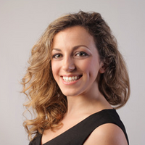 | Claire Halloway  Founder & Lead Photographer · claire@copperpawpetportraits.example  Eight years photographing families and their dogs as a freelance portrait photographer, and a former veterinary clinic receptionist who learned to read a nervous animal.

 | Maya Torres  Client Experience Coordinator · maya@copperpawpetportraits.example  Ran front desk scheduling and client follow-up at a busy grooming salon, and now owns bookings, gallery delivery and order tracking.

 | Sam Okafor  Session Assistant & Pet Handler · sam@copperpawpetportraits.example  A certified professional dog trainer who works mini session days and larger shoots, keeping pets calm, safe and looking at the camera.

9.2 Organization Chart
The structure is flat. Both team members report directly to Claire, who makes every pricing, hiring and spending decision. Maya runs the studio calendar and client communication day to day, and Sam works to Maya's schedule on mini session days.
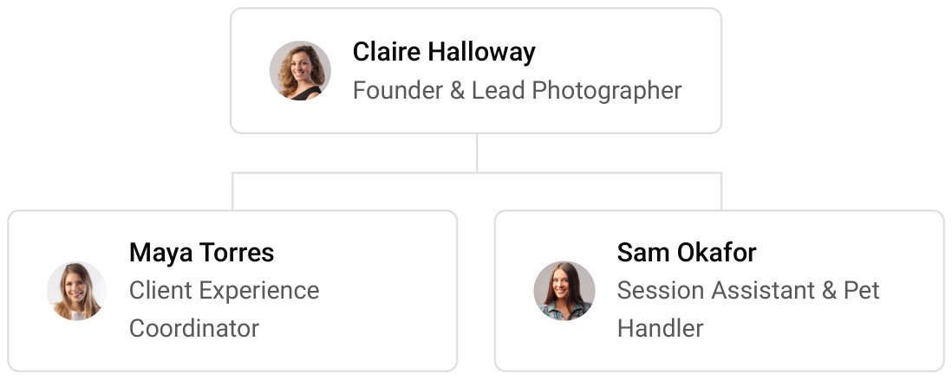

9.3 Advisory Board Members
Copperpaw has no formal board. Claire draws on three informal advisers: a bookkeeper who reviews the monthly accounts and sales tax returns, a veterinary practice manager who advises on animal welfare and the referral program, and an established portrait photographer outside Seattle who mentors her on ordering appointments and pricing. None of them holds equity.
Their time is used on a fixed rhythm. The bookkeeper and Claire review revenue, average client sale and cash against the plan each month, and the mentor reviews pricing and collections each quarter, before the spring and holiday mini seasons are priced. The veterinary adviser is consulted whenever the safety rules change.

9.3.1 Hiring Plan
1  Filled |  | 2  Hiring This Year |  | 2  Open

Group By Department | Position Filled | Time of Hire | Time of Start | Filled
Photography | 1 of 1 | 0 days | 0 days | 100%
Client Experience | 0 of 1 | 30 days | 14 days | 0%
Session Support | 0 of 1 | 45 days | 14 days | 0%

CHAPTER 10

Financial Plan

10.1 Key Assumptions
10.2 Capital Requirements and Use of Funds
10.3 Income Statement (3 Year projections)
10.4 Balance Sheet (3 Year projections)
10.5 Cash Flow Statement (3 Year projections)
10.6 Break Even Analysis

10.1 Key Assumptions
Revenue follows (Portrait Sessions × Average Client Sale + Mini Sessions × Average Mini Session Price) × 12. At a full calendar the studio runs twelve full portrait sessions a month at an average client sale of $1,350 and 22 mini sessions a month at $245. It opens at 35% of that level, reaches it over nine months, and grows 16% a year after the first.
Cost of sales, meaning the print lab, frames, albums, gallery fees and card processing, is 28% of revenue, a gross margin of 72.0%. Payroll is 30% of revenue, marketing 7% and other operating costs 4%. Rent is $2,200 a month, technology $320 and administration $850. Washington levies no corporate income tax, so tax is federal at 21%, and sales tax of 10.55% is collected on top of prices and remitted.
On those assumptions revenue is $195,929 in 2026, $227,278 in 2027 and $263,642 in 2028. Break-even revenue, measured against operating costs before depreciation and interest, is $167,806, or 124 full-session clients a year. The first year clears it, but depreciation on the equipment and interest on the loan leave a net loss of $1,471. Net income is $6,786 in 2027 and $15,847 in 2028. In 2028 it is $3,727 in the conservative case and $32,217 in the upside case.

10.2 Capital Requirements and Use of Funds
The studio needs $77,100 before it opens. Cameras and lenses and the studio fit-out are the largest items. Studio lighting and sets, the editing computer, sample wall art and albums, viewing room furniture, the deposit and pre-opening rent, licenses and insurance, the website and launch marketing make up the rest.
It is funded by a $45,000 owner contribution from the founder's savings and a $60,000 SBA 7(a) loan at 10.5% over five years, matched to the working life of the equipment it buys. The funding exceeds the budget, so the studio opens with cash to carry it through the ramp. No profits are distributed while the loan is repaid.

10.2.1 Use of Funds
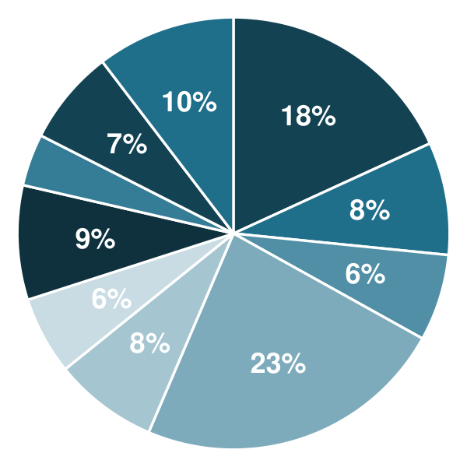 | ● Cameras & Lenses 18.2%  ● Studio Lighting & Sets 8.4%  ● Editing Computer & Storage 6.5%  ● Studio Fit-Out 23.3%  ● Sample Wall Art & Albums 7.8%  ● Viewing Room Furniture & Display 5.8%  ● Deposit & Pre-Opening Rent 8.6%  ● Licenses, Insurance & Legal 3.9%  ● Website, Branding & Software Setup 7.1%  ● Launch Marketing 10.4%

Use Of Funds | Amount
Cameras & Lenses | $14,000.00
Studio Lighting & Sets | $6,500.00
Editing Computer & Storage | $5,000.00
Studio Fit-Out | $18,000.00
Sample Wall Art & Albums | $6,000.00
Viewing Room Furniture & Display | $4,500.00
Deposit & Pre-Opening Rent | $6,600.00
Licenses, Insurance & Legal | $3,000.00
Website, Branding & Software Setup | $5,500.00
Launch Marketing | $8,000.00

10.3 Income Statement (3 Year projections)
 | Year 1 | Year 2 | Year 3 | Total
Revenue | $195,929.24 | $227,277.92 | $263,642.39 | $686,849.55
Cost of Sales | $54,860.19 | $63,637.82 | $73,819.87 | $192,317.88
General Costs | $0.00 | $0.00 | $0.00 | $0.00
Revenue Specific Costs | $54,860.19 | $63,637.82 | $73,819.87 | $192,317.88
Personnel Costs (Direct Labor) | $0.00 | $0.00 | $0.00 | $0.00
Gross Margin | $141,069.05 | $163,640.10 | $189,822.52 | $494,531.67
Gross Margin (%) | 72.00% | 72.00% | 72.00% | 72.00%
Operating Expense | $120,819.97 | $133,680.77 | $148,599.30 | $403,100.04
Payroll Expense (Indirect Labor) | $58,778.77 | $68,183.38 | $79,092.72 | $206,054.87
General Expense | $61,992.22 | $65,440.57 | $69,440.67 | $196,873.46
Bad Debt | $48.98 | $56.82 | $65.91 | $171.71
Amortization of Current Assets | $0.00 | $0.00 | $0.00 | $0.00
EBITDA | $20,249.08 | $29,959.33 | $41,223.22 | $91,431.63
Additional Expense | $21,720.00 | $23,173.06 | $25,376.18 | $70,269.24
Long Term Depreciation | $15,420.00 | $16,329.11 | $17,383.68 | $49,132.79
Gain or loss from Sale of Assets | $0.00 | $0.00 | $0.00 | $0.00
EBIT | $4,829.08 | $13,630.22 | $23,839.54 | $42,298.84
Interest Expense | $6,300.00 | $5,040.00 | $3,780.00 | $15,120.00
EBT | ($1,470.92) | $8,590.22 | $20,059.54 | $27,178.84
Income Tax Expense / Benefit | $0.00 | $1,803.95 | $4,212.50 | $6,016.45
Total Expense | $197,400.16 | $220,491.65 | $247,795.35 | $665,687.16
Net Income | ($1,470.92) | $6,786.27 | $15,847.04 | $21,162.39
Net Income (%) | -0.75% | 2.99% | 6.01% | 3.08%
Retained Earning Opening | $0.00 | ($1,470.92) | $5,315.35
Owner's Distribution | $0.00 | $0.00 | $0.00 | $0.00
Retained Earning Closing | ($1,470.92) | $5,315.35 | $21,162.39 | $21,162.39

10.4 Balance Sheet (3 Year projections)
 | Year 1 | Year 2 | Year 3 | Total
Assets | $96,038.14 | $91,996.85 | $97,282.90 | $97,282.90
Current Assets | $34,358.14 | $42,100.40 | $59,497.28 | $59,497.28
Cash | $32,801.44 | $40,294.63 | $57,402.59 | $57,402.59
Accounts Receivable | $53.68 | $62.27 | $72.23 | $72.23
Inventory | $1,503.02 | $1,743.50 | $2,022.46 | $2,022.46
Other Current Assets | $0.00 | $0.00 | $0.00 | $0.00
Long Term Assets | $61,680.00 | $49,896.45 | $37,785.62 | $37,785.62
Gross Long Term Assets | $77,100.00 | $81,645.56 | $86,918.41 | $86,918.41
Accumulated Depreciation | $15,420.00 | $31,749.11 | $49,132.79 | $49,132.79
Liabilities & Equity | $96,038.14 | $91,996.85 | $97,282.90 | $97,282.90
Liabilities | $52,509.06 | $41,681.50 | $31,120.51 | $31,120.51
Current Liabilities | $16,509.06 | $17,681.50 | $19,120.51 | $19,120.51
Accounts Payable | $4,509.06 | $5,230.51 | $6,067.39 | $6,067.39
Income Tax Payable | $0.00 | $450.99 | $1,053.12 | $1,053.12
Sales Tax Payable | $0.00 | $0.00 | $0.00 | $0.00
Short Term Debt | $12,000.00 | $12,000.00 | $12,000.00 | $12,000.00
Long Term Liabilities | $36,000.00 | $24,000.00 | $12,000.00 | $12,000.00
Long Term Debt | $36,000.00 | $24,000.00 | $12,000.00 | $12,000.00
Equity | $43,529.08 | $50,315.35 | $66,162.39 | $66,162.39
Paid-in Capital | $0.00 | $0.00 | $0.00 | $0.00
Common Stock | $0.00 | $0.00 | $0.00 | $0.00
Preferred Stock | $0.00 | $0.00 | $0.00 | $0.00
Owner's Contribution | $45,000.00 | $45,000.00 | $45,000.00 | $45,000.00
Retained Earnings | ($1,470.92) | $5,315.35 | $21,162.39 | $21,162.39
Check | $0.00 | $0.00 | $0.00 | $0.00

10.5 Cash Flow Statement (3 Year projections)
 | Year 1 | Year 2 | Year 3 | Total
Cash Received | $216,497.11 | $251,190.33 | $291,380.79 | $759,068.23
Cash Paid | $199,595.67 | $227,151.58 | $256,999.98 | $683,747.23
COS & General Expenses | $113,846.37 | $128,597.42 | $142,702.62 | $385,146.41
Salary & Wages | $58,778.77 | $68,183.38 | $79,092.72 | $206,054.87
Interest | $6,300.00 | $5,040.00 | $3,780.00 | $15,120.00
Sales Tax | $20,670.53 | $23,977.82 | $27,814.27 | $72,462.62
Income Tax | $0.00 | $1,352.96 | $3,610.37 | $4,963.33
Net Cash From Operations | $16,901.44 | $24,038.75 | $34,380.81 | $75,321.00
Assets Sell | $0.00 | $0.00 | $0.00 | $0.00
Assets Purchase | $77,100.00 | $4,545.56 | $5,272.85 | $86,918.41
Net Cash From Investments | ($77,100.00) | ($4,545.56) | ($5,272.85) | ($86,918.41)
Amount Received | $105,000.00 | $0.00 | $0.00 | $105,000.00
Loan Received | $60,000.00 | $0.00 | $0.00 | $60,000.00
Common Stock | $0.00 | $0.00 | $0.00 | $0.00
Preferred Stock | $0.00 | $0.00 | $0.00 | $0.00
Owner's Contribution | $45,000.00 | $0.00 | $0.00 | $45,000.00
Amount Paid | $12,000.00 | $12,000.00 | $12,000.00 | $36,000.00
Loan Capital | $12,000.00 | $12,000.00 | $12,000.00 | $36,000.00
Dividends & Distributions | $0.00 | $0.00 | $0.00 | $0.00
Net Cash From Financing | $93,000.00 | ($12,000.00) | ($12,000.00) | $69,000.00
Summary
Starting Cash | $0.00 | $32,801.44 | $40,294.63
Cash In | $321,497.11 | $251,190.33 | $291,380.79 | $864,068.23
Cash Out | $288,695.67 | $243,697.14 | $274,272.83 | $806,665.64
Change in Cash | $32,801.44 | $7,493.19 | $17,107.96 | $57,402.59
Ending Cash | $32,801.44 | $40,294.63 | $57,402.59 | $57,402.59

10.6 Break Even Analysis
 | Year 1 | Year 2 | Year 3 | Total
Starting Revenue | $0.00 | $195,929.24 | $423,207.16 | $423,207.16
Net Revenue | $195,929.24 | $227,277.92 | $263,642.39 | $263,642.39
Closing Revenue | $195,929.24 | $423,207.16 | $686,849.55 | $686,849.55
Starting Expense | $0.00 | $197,400.16 | $417,891.81 | $417,891.81
Net Expense | $197,400.16 | $220,491.65 | $247,795.35 | $247,795.35
Closing Expense | $197,400.16 | $417,891.81 | $665,687.16 | $665,687.16
Is Break Even? | No | Yes | Yes
Break Even Month | - | Mar '27 | -
Days Required | - | 18 Days | -
Break Even Revenue | - | $252,748.72 | -

CHAPTER 11

References

- SRC001: Total Revenue for Photography Studios, Portrait, All Establishments, Employer Firms (REVEF541921ALLEST), U.S. Census Bureau via FRED, Federal Reserve Bank of St. Louis, 2024-01-31. https://fred.stlouisfed.org/data/REVEF541921ALLEST (accessed 2026-10-13)
- SRC002: QCEW Open Data: Annual Averages, NAICS 541921, U.S. Bureau of Labor Statistics, 2025-01-01. https://data.bls.gov/cew/data/api/2024/a/industry/541921.csv (accessed 2026-10-13)
- SRC003: Pet Photography Services in the US - Market Size (2008-2030), IBISWorld, 2025-04-01. https://www.ibisworld.com/industry-statistics/market-size/pet-photography-services-united-states/ (accessed 2026-10-13)
- SRC004: Pet Photography Services in the US - Number of Businesses (2008-2030), IBISWorld, 2025-01-01. https://script.ibisworld.com/united-states/number-of-businesses/pet-photography-services/6365 (accessed 2026-10-13)
- SRC005: Photography in the US - Market Size, IBISWorld, 2025-10-01. https://www.ibisworld.com/united-states/market-size/photography/1443/ (accessed 2026-10-13)
- SRC006: Photography in the US - Number of Businesses, IBISWorld, 2025-10-01. https://www.ibisworld.com/united-states/number-of-businesses/photography/1443 (accessed 2026-10-13)
- SRC007: U.S. Pet Industry Reaches $158 Billion in 2025, Poised for Continued Growth in 2026, American Pet Products Association, 2026-03-26. https://americanpetproducts.org/news/u.s.-pet-industry-reaches-158-billion-in-2025-poised-for-continued-growth-in-2026 (accessed 2026-10-13)
- SRC008: The American Pet Products Association (APPA) Releases 2025 State of the Industry Report, American Pet Products Association, 2025-03-26. https://americanpetproducts.org/news/the-american-pet-products-association-appa-releases-2025-state-of-the-industry-report-archive (accessed 2026-10-13)
- SRC009: About half of U.S. pet owners say their pets are as much a part of their family as a human member, Pew Research Center, 2023-07-07. https://www.pewresearch.org/short-reads/2023/07/07/about-half-us-of-pet-owners-say-their-pets-are-as-much-a-part-of-their-family-as-a-human-member/ (accessed 2026-10-13)
- SRC010: Survey finds 95% of owners consider pets family members, Petfood Industry, 2026-01-01. https://www.petfoodindustry.com/pet-food-market/market-trends-and-reports/news/15830677/survey-finds-95-of-owners-consider-pets-family-members (accessed 2026-10-13)
- SRC011: Industry Trends and Stats, American Pet Products Association, 2026-01-01. https://americanpetproducts.org/industry-trends-and-stats (accessed 2026-10-13)
- SRC012: U.S. pet industry hits $158 billion in 2025, Petfood Industry, 2026-01-01. https://www.petfoodindustry.com/pet-food-market/market-trends-and-reports/news/15825309/us-pet-industry-hits-158-billion-in-2025 (accessed 2026-10-13)
- SRC013: Holiday Mini Portrait Sessions for Your Pet, Patch. https://patch.com/new-jersey/eastwindsor/holiday-mini-portrait-sessions-your-pet (accessed 2026-10-13)
- SRC014: Holidays, Sarah Deremer Photography. https://www.sarahderemer.com/holidays (accessed 2026-10-13)
- SRC015: How much does pet photography cost?, Thumbtack. https://www.thumbtack.com/p/pet-photography-prices (accessed 2026-10-13)
- SRC016: How Much Does a Pet Photographer Make?, Hepper, 2026-01-01. https://www.hepper.com/how-much-does-a-pet-photographer-make/ (accessed 2026-10-13)
- SRC017: Professional Tips for the Aspiring Pet Photographer, Canon U.S.A., 2016-07-07. https://www.usa.canon.com/learning/training-articles/training-articles-list/professional-tips-for-the-aspiring-pet-photographer (accessed 2026-10-13)
- SRC018: Pet Photography Pricing, Diana Lundin Photography. https://dlundin.photobiz.com/pet-photography-pricing (accessed 2026-10-13)
- SRC019: Pet Photography Pricing: 5 Important Questions!, ShootProof, 2021-03-01. https://www.shootproof.com/blog/pet-photography-pricing-5-important-questions/ (accessed 2026-10-13)
- SRC020: Photographers: Occupational Outlook Handbook, U.S. Bureau of Labor Statistics, 2025-01-01. https://www.bls.gov/ooh/media-and-communication/photographers.htm (accessed 2026-10-13)
- SRC021: WHCC and Richard Photo Lab price updates 2024, Pic-Time Help Center, 2024-01-01. https://help.pic-time.com/en/articles/9299271-whcc-and-richard-photo-lab-price-updates-2024 (accessed 2026-10-13)
- SRC022: Understand WHCC lab fulfillment, Pixpa Help. https://help.pixpa.com/kb/understand-whcc-lab-fulfilment/ (accessed 2026-10-13)
- SRC023: Photography Studio Insurance Cost, Insureon. https://www.insureon.com/photography-video-business-insurance/photo-studios/cost (accessed 2026-10-13)
- SRC024: Freelance Photographer / Videographer Insurance Cost, Insureon. https://www.insureon.com/photography-video-business-insurance/photographers/cost (accessed 2026-10-13)
- SRC025: Estimate Photography Business Insurance Costs, MoneyGeek. https://www.moneygeek.com/insurance/business/photography/cost/ (accessed 2026-10-13)
- SRC026: Pet pics rule phones as owners store more snaps of pets than loved ones, Derbyshire Times. https://www.derbyshiretimes.co.uk/read-this/pet-pics-rule-phones-as-owners-store-more-snaps-of-pets-than-loved-ones-6910692 (accessed 2026-10-13)
- SRC027: QCEW Open Data: 2022 Annual Averages, NAICS 541921, U.S. Bureau of Labor Statistics, 2023-01-01. https://data.bls.gov/cew/data/api/2022/a/industry/541921.csv (accessed 2026-10-14)
- SRC028: QCEW Open Data: 2023 Annual Averages, NAICS 541921, U.S. Bureau of Labor Statistics, 2024-01-01. https://data.bls.gov/cew/data/api/2023/a/industry/541921.csv (accessed 2026-10-14)
- SRC029: Seattle, WA - Profile data, Census Reporter (American Community Survey 2024 1-year), 2025-01-01. https://censusreporter.org/profiles/16000US5363000-seattle-wa/ (accessed 2026-10-14)
- SRC030: Who We Are: The Poll, Seattle Met. https://www.seattlemet.com/articles/who-we-are-the-poll/ (accessed 2026-10-14)
- SRC031: Office of Labor Standards Announces Seattle's 2026 Minimum Wage, Seattle Office of Labor Standards, 2025-09-30. https://laborstandards.seattle.gov/2025/09/30/office-of-labor-standards-announces-seattles-2026-minimum-wage (accessed 2026-10-14)
- SRC032: Puget Sound Retail Figures Q1 2026, CBRE, 2026-01-01. https://cbre.com/insights/figures/puget-sound-retail-figures-q1-2026 (accessed 2026-10-14)
- SRC033: Puget Sound Retail Figures Q4 2025, CBRE, 2026-01-01. https://cbre.com/insights/figures/puget-sound-retail-figures-q4-2025 (accessed 2026-10-14)
- SRC034: 2026 Photo/Film Application, Seattle Parks and Recreation, 2026-01-01. https://www.seattle.gov/documents/Departments/ParksAndRecreation/Reserve/Permits/2026%20Photo%20Film%20Application%20_ADA.pdf (accessed 2026-10-14)
- SRC035: Seattle, WA Sales Tax Rate (2026), Kintsugi, 2026-01-01. https://trykintsugi.com/sales-tax-guides/usa/washington/seattle (accessed 2026-10-14)
- SRC036: Photography Permits, Seattle Parks and Recreation. https://seattle.gov/parks/reserve/photography-permits (accessed 2026-10-14)
- SRC037: Photography tax guide: Overview of taxes and terms, Washington State Department of Revenue. https://dor.wa.gov/education/industry-guides/photography-tax-guide/overview-taxes-and-terms (accessed 2026-10-14)
- SRC038: Seattle Shield Business & Occupation (B&O) Tax Changes, City of Seattle Office of City Finance, 2026-01-01. https://seattle.gov/city-finance/business-taxes-and-licenses/business-taxes/seattle-shield-business-and-occupation-(bando)-tax-changes (accessed 2026-10-14)




