

PlayCafe
BusinessPlan
"Sip,Play,andStayAllDay!"

Business Plan
2024

JohnDoe
10200BolsaAve,Westminster,CA,92683

(650)359-3153

info@example.comhttps://www.example.com/
CONFIDENTIAL

TableofContents

ExecutiveSummary
6
Marketopportunity 7
PlayCafeFacilities 7
Marketing&SalesStrategies 8
FinancialHighlights 8
UnitsSoldv/sRevenueChart 8
CompanyOverview
10
Ownership 11
BusinessOwners 11
Missionstatement 12
Business history 12
Futuregoals 12
MarketAnalysis
13
TargetMarket 14
Marketsizeandgrowthpotential 14
MarketSize 15
Competitiveanalysis 15
ThePlayroomCafé 15
JumpstartPlayCafé 15
Markettrends 16
Regulatoryenvironment 16
ProductsandServices
18
PlayCafeServices 19
GeneralAdmission-PlayArea Access 19
Toddler PlayZone(Ages1-3) 19
SpecialEventTicket-ThemedWorkshops 20
MembershipProgram-FamilyPackage 20
Quality Measures 21

SalesAndMarketingStrategies
22
UniqueSellingProposition(USP) 23
PricingStrategy 23
Marketingstrategies 24
Online 24
Offline 24
Salesstrategies 24
Customerretention 25
OperationsPlan
27
Staffing&Training 28
OperationalProcess 28
Equipment&Tools 29
ManagementTeam
30
Keymanagers 31
Laura Mitchell 31
EmmaCruz 32
SophieTurner 32
MarkStevens 32
Organizationalstructure 33
Organizationchart 33
Compensationplan 34
Boardofadvisors 34
Dr.EmilyRoberts 34
SarahJenkins 34
Financial Plan
35
Profit&lossstatement 36
Cashflowstatement 41
Balancesheet 43
Break-evenPoint 45
Financingneeds 47

Appendix
49
EmbedLink 50


Businessplanningthat’ssimplerandfasterthanyouthink

CreatingabusinessplanusingUpmetricstostartandgrowabusinessisliterallytheeasiest thingintheWorld.Simplyreadtheinstructionsandfillintheblanks.It’sassimpleasthat.

Upmetrics has everything you need to create a comprehensive business plan.
❛
❜

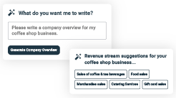
AI-poweredUpmetricsAssistant

AI-poweredinsightstostreamlineyourplan
Not sure where to start? Upmetrics’ AI Assistant will automaticallygenerateideasforeachsectionofyourplanand offerimprovedversionsofyourwriting,adjustingfortone,voice, and grammar or spelling errors.

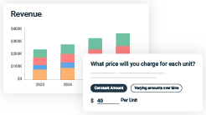
FinancialForecastingTool

Allthefinancialsarecalculatedforyou
Forget the complex formulas and clumsy spreadsheets — withautomaticfinancialsanddrag-and-dropforecasting,you canfinishyourplanfasterandbeconfidentthatyour numbers are accurate.

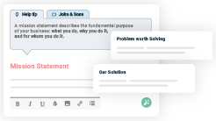
BusinessPlanBuilder

Guidesyoulikeabusinessmentor
Upmetrics’step-by-stepinstructions,prompts,andthelibraryof 400+samplebusinessplanswillguideyouthrougheachsection of your plan as a business mentor.

1.

ExecutiveSummary

MarketopportunityPlayCafeFacilities
Marketing & Sales StrategiesFinancial Highlights



Anexecutivesummaryisthefirstsectionofthebusinessplanintendedto provide an overview of the whole business plan.
Tounlock helptry Upmetrics!

Helptip
TinyTykesPlayCafe
Startyourexecutivesummarybybrieflyintroducingyourbusinesstoyourreaders.Thissection may include the name of your play cafe business, its location when it was founded, etc.
Tounlock helptry Upmetrics!
Startwritinghere..

Marketopportunity

Helptip
TinyTykesPlayCafe
Summarizeyourmarketresearch,includingmarketsize,growthpotential,andmarketing trends.
Tounlock helptry Upmetrics!
Startwritinghere..

PlayCafeFacilities

Helptip
TinyTykesPlayCafe
Highlighttheplaycafefacilitiesyouofferyourclients.TheUSPsanddifferentiatorsyouoffer are always a plus.
Tounlock helptry Upmetrics!
Startwritinghere..

Marketing&SalesStrategies

Helptip
TinyTykesPlayCafe
Outline your sales and marketing strategies—what marketing platforms you use, how you plan on acquiring customers, etc.
Tounlock helptry Upmetrics!
Startwritinghere..

FinancialHighlights

Helptip
TinyTykesPlayCafe
Brieflysummarizeyourfinancialprojectionsfortheinitialyearsofbusinessoperations.Include
capitalorinvestmentrequirements,associatedstartupcosts,projectedrevenues,andprofit
forecasts.
Tounlock helptry Upmetrics!
Startwritinghere..

UnitsSoldv/sRevenueChart

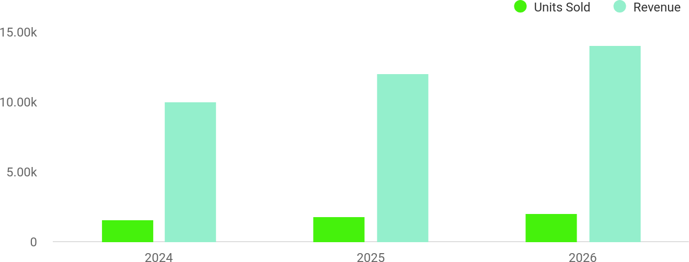

FinancialYear | UnitsSold | Revenue
2024 | 1,550 | $10,000
2025 | 1,800 | $12,000

FinancialYear | UnitsSold | Revenue
2026 | 2,050 | $14,000

Helptip
TinyTykesPlayCafe
SummarizeyourexecutivesummarysectionwithaclearCTA,forexample,invitingangel investors to discuss the potential business investment.
Tounlock helptry Upmetrics!

Writeacalltoactionforyourbusinessplan.

2.

CompanyOverview

OwnershipMission statementBusiness historyFuture goals

Dependingonwhatdetailsofyourbusinessareessential,you’llneed different elements in your business overview.
Tounlock helptry Upmetrics!
Helptip
TinyTykesPlayCafe
Describewhatkindofplaycafebusinessyourunandthenameofit.Youmayspecializeinone of the following play cafe businesses:
Tounlock helptry Upmetrics!
Startwritinghere..

Ownership

Helptip
TinyTykesPlayCafe
List the names of your play cafe business’s founders or owners. Describe what shares they own and their responsibilities for efficiently managing the business.
Tounlock helptry Upmetrics!
Startwritinghere..

BusinessOwners

LauraMitchell
75%

JamesPeterson
25%

Missionstatement

Helptip
TinyTykesPlayCafe
Summarizeyourbusiness’objective,coreprinciples,andvaluesinyourmissionstatement.This statement needs to be memorable, clear, and brief.
Tounlock helptry Upmetrics!

At[TinyTykesPlayCafe],ourmissionistonurturecreativity,
❛
foster learning, and inspire joy in children through engaging play experienceswhileprovidingparentswithawelcomingand
relaxing atmosphere. Our core values of safety, inclusivity, and innovation guide everything we do.
❜

Businesshistory

Helptip
TinyTykesPlayCafe
Ifyou’reanestablishedplaycafe,brieflydescribeyourbusinesshistory,like—whenitwas founded, how it evolved, etc.
Tounlock helptry Upmetrics!
Startwritinghere..

Futuregoals

Helptip
TinyTykesPlayCafe
It’scrucialtoconveyyouraspirationsandvision.Mentionyourshort-termandlong-termgoals; they can be specific targets for revenue, market share, or expanding your services.
Tounlock helptry Upmetrics!
Startwritinghere..

3.

MarketAnalysis
TargetMarket
MarketsizeandgrowthpotentialCompetitive analysis
Market trendsRegulatoryenvironment

Marketanalysisprovidesaclearunderstandingofthemarketinwhichyour
printingbusinesswillrunalongwiththetargetmarket,competitors, and
growthopportunities.
Tounlock helptry Upmetrics!
Helptip
TinyTykesPlayCafe
Towritetheintroductionsectionofyourmarketanalysis,startbyclearlyidentifyingyour primary target market.
Tounlock helptry Upmetrics!
Startwritinghere..

TargetMarket

Helptip
TinyTykesPlayCafe
Startthissectionbydescribingyourtargetmarket.Defineyouridealcustomerandexplainwhat
typesofservicestheyprefer.Creatingabuyerpersonawillhelpyoueasilydefineyourtarget
markettoyourreaders.
Tounlock helptry Upmetrics!
Startwritinghere..

Marketsizeandgrowthpotential

Helptip
TinyTykesPlayCafe
Describeyourmarketsizeandgrowthpotentialandwhetheryouwilltargetanicheoramuch broader market.
Tounlock helptry Upmetrics!
Startwritinghere..

MarketSize

AvailableMarket
Families with children aged 1-10 years withina30-mileradiusofWestminster,CA.

500k

ServedMarket
Familieswithina10-mileradiusactively seeking play cafe services for entertainment and education

150k

TargetMarket
FamiliesinWestminster,CA,prioritizing safe, educational, and inclusive play spaces for their chi
25k

Helptip
Identifyandanalyzeyourdirectandindirectcompetitors.Identifytheirstrengths and
weaknesses,anddescribewhatdifferentiatesyourplaycafefromthem.Pointouthow you
haveacompetitiveedgeinthemarket.
Tounlock helptry Upmetrics!

Competitiveanalysis

ThePlayroomCafé
Localfamily-friendlycaféthatoffersabasicplayareaforchildren,focusingprimarilyonprovidinga casual, budget-friendly space for families to enjoy a simple coffee break.

Features
Alocalcaféofferingabasic play area for children.
Limitedfoodandbeverage offerings.
Theplayareaissmallandnot specifically designed for educational benefits.

Strengths
Attracts budget-conscious familieswithbasicservices.
A local, easy-to-access space forparentswhowantaquick break.
Locatedinawell-trafficked area with many local customers.

Weaknesses
Limitedplayoptions.
Weakfoodandbeveragequality.
Limitedfocusonchild development.

JumpstartPlayCafé
Largerplaycenterwithawiderangeofplayequipment,cateringtoactivechildren,butitlacksa premium café experience and does not focus on educational or developmental activities.

Features
Alargerplaycenterwith diverseplayequipment.
Morespacededicatedtoplay.
Basiccaféofferingssuchas snacks, coffee, and soda.

Strengths
Providesabroadrangeofplay equipment.
Attractsahighvolumeof customers.

Weaknesses
Doesnotofferthehigh-quality beverages or fresh, organic options.
Lacksarelaxingenvironmentfor parents.

Markettrends


Helptip
TinyTykesPlayCafe
Analyzeemergingtrendsintheindustry,suchastechnologydisruptions,focusoncontainment, etc. Explain how your business will cope with all the trends.
Tounlock helptry Upmetrics!
Startwritinghere..

Regulatoryenvironment

Helptip
TinyTykesPlayCafe
Listregulationsandlicensingrequirementsthatmayaffectyourplaycafebusiness,suchas
licensing&permits,safetystandards,health&sanitation,employeebackgroundchecks,data
protection,etc.
Tounlock helptry Upmetrics!
Startwritinghere..

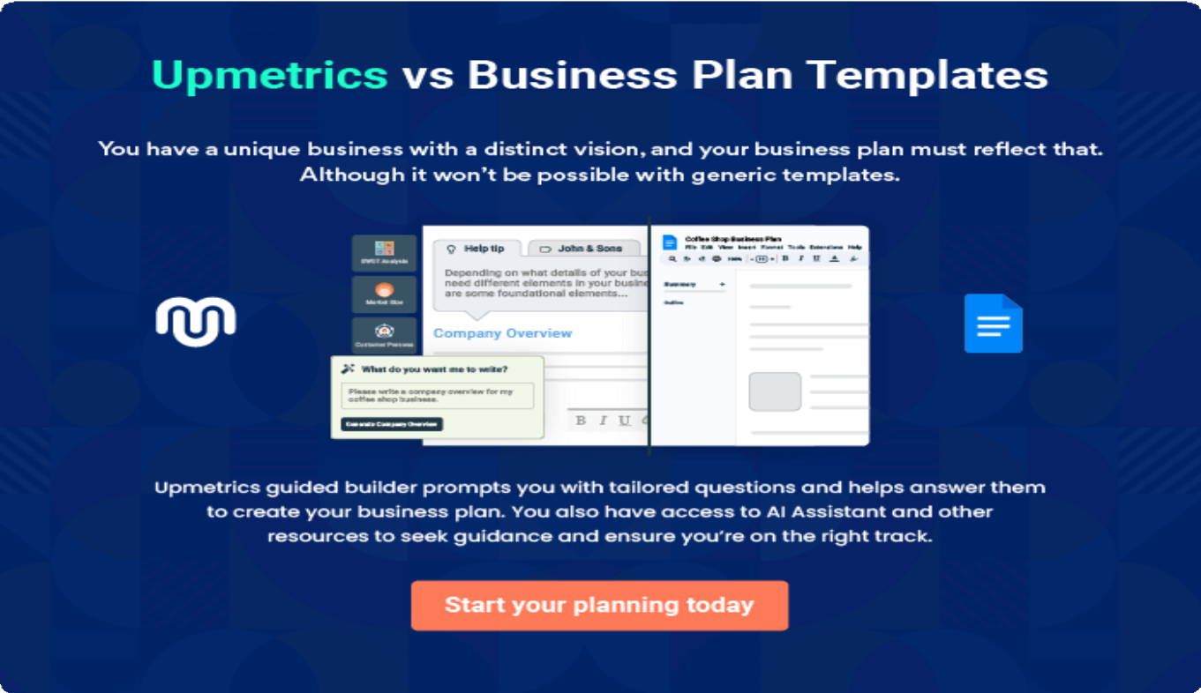

4.

Productsand Services

PlayCafeServicesQuality Measures

Theproductandservicessectionofaseniordaycarebusinessplanshould
describethespecificservicesandproductsthatwillbeofferedtocustomers.
Towritethissectionshouldincludethefollowing:
Tounlock helptry Upmetrics!
Helptip
TinyTykesPlayCafe
Tocrafttheintroductionforyour"ProductsandServices"chapter,beginbypositioningyour business within its industry, emphasizing its unique strengths or value proposition.
Tounlock helptry Upmetrics!

Startwritinghere..
Helptip
Mentiontheplaycafefacilitiesyourbusinesswilloffer.Thislistmayinclude:

- Indoorplaystructures
Tounlock helptry Upmetrics!

PlayCafeServices


GeneralAdmission-PlayAreaAccess
Price:[$15]perchild(2hours)

General admission grants access to all play structures, ballpits,creativeplayzones,andotherinteractiveplay areas for children aged 1-10

Specifications
- Validforupto2hoursofplay
- Access to allindoor play zones
- FreeWi-Fiforaccompanying parents
- Supervisionrequiredforchildrenunder4yearsold

ToddlerPlayZone(Ages1-3)
Price:[$10]perchild(1hour)

Speciallydesignedfortoddlers,thisplayzoneofferssoft, safe equipment for crawling, ball pits, and sensory play stations.

Specifications
  - Softplayequipmentandsafetymats
  - Age-appropriatetoysandinteractiveelements
  - Supervisedplayarea
  - Limitedtochildrenaged1-3yearsforsafety

SpecialEventTicket-ThemedWorkshops
Price:[$25]perchild

Special workshops and events are held throughout the year,includingarts&crafts,storytellingsessions,and holiday-themed activities.

Specifications
  - 1.5-hourevent
  - Materialsandactivitiesprovidedforeachchild
  - Supervisedbytrainedstaff
  - Includessnackanddrink

MembershipProgram-FamilyPackage

Price:[$199] annually (forup to 4family members)

The Family Membership offers exclusive benefits includingunlimitedaccesstotheplayarea,discountson birthday party packages, and special event priority booking.

Specifications
  - Unlimitedplayareaaccessforupto4family members
  - 10%discountonallfoodandbeverages
  - Priorityaccessforeventsandbirthday parties
  - Exclusivemember-onlyevents
  - Additionalfamilymembers:$50each annually

QualityMeasures

Helptip
TinyTykesPlayCafe
This section should explain how you maintain quality standards and consistently provide the highest quality service.
Tounlock helptry Upmetrics!
Startwritinghere..

5.

SalesAndMarketing
Strategies

Unique Selling Proposition (USP)Pricing Strategy
Marketing strategiesSales strategiesCustomer retention

Writing the sales and marketing strategies section means a list of strategies you will use to attract and retain your clients.
Tounlock helptry Upmetrics!
Helptip
TinyTykesPlayCafe
Tocreateaneffectiveintroductionforyour"SalesandMarketingStrategies"chapter,startby setting the stage within your specific industry or market.
Tounlock helptry Upmetrics!
Startwritinghere..

UniqueSellingProposition(USP)

Helptip
TinyTykesPlayCafe
Define your business’s USPs depending on the market you serve, the equipment you use, and theuniqueservicesyouprovide.IdentifyingUSPswillhelpyouplanyourmarketingstrategies.
Tounlock helptry Upmetrics!
Startwritinghere..

PricingStrategy

Helptip
TinyTykesPlayCafe
Describeyourpricingstrategy—howyouplantopriceyourservicesandstaycompetitiveinthe local market. You can mention any discounts you plan on offering to attract new customers.
Tounlock helptry Upmetrics!
Startwritinghere..

Helptip
Discussyourmarketingstrategiestomarketyourservices.Youmayincludesomeofthese
marketing strategies inyour business plan—socialmedia marketing, brochures,content
marketing,printmarketing,etc.
Tounlock helptry Upmetrics!

Marketingstrategies

Online


SocialMedia Marketing
We will leverage platforms like Instagram, Facebook, and TikTok to create engaging content featuring fun activities, kids’events,behind-the- scenes looks at playtime, and promotions.

EmailMarketing&Newsletters
Monthly newsletters willfeatureupdateson new events, upcoming promotions, healthy recipes, and parenting tips.

Offline

Salesstrategies
Helptip
Outlinethestrategiesyou’llimplementtomaximizeyoursales.Yoursalesstrategiesmay includedirectsalescalls,offeringreferralmarketing,etc.
Tounlock helptry Upmetrics!

LocalPartnerships
We will partner with localschools,parenting blogs,andpediatricians to spread the word about Tiny Tykes.

PrintMarketing
Wewilldistributeflyers, posters, and brochures inlocalareastoattract families looking for fun spacefortheirchildren.

Product Demonstrations
We will host free trial days or demo sessions, where potential customers can experience our play areas and sample our café offerings.

SpecialOffers
For families with multiple children, we will offer sibling discounts and bundle packagesthatinclude both admission and food.

LoyaltyProgram
Apoints-basedloyalty program will reward customers for every visit or purchase they make.

Helptip
Describeyourcustomerretentionstrategiesandhowyouplantoexecutethem.Forinstance, introducing loyalty programs, discounts on annual membership, personalized service, etc
Tounlock helptry Upmetrics!

Customerretention

Personalized
Recommendations
Offer personalized recommendations for events,partypackages, or food items.

EducationalContent & Workshops
Offer periodic educational workshops for parents, such as child development sessions, art classes, and fun cooking activities.

ExclusiveMember- Only Events
Host exclusive events formemberstofostera sense of community and encourage membershiprenewals.

6.

OperationsPlan

Staffing & TrainingOperational ProcessEquipment & Tools

Whenwritingtheoperationsplansection,it’simportanttoconsiderthe various aspects of your business operations.
Tounlock helptry Upmetrics!
Helptip
TinyTykesPlayCafe
Tocreateaneffectiveintroductionforyour"OperationalPlan"chapter,startbyemphasizingthe
pivotalroleofefficientoperationsinthesuccessofyourbusiness,underscoringhowthey
directlyimpactthequalityofservicesdelivered.
Tounlock helptry Upmetrics!
Startwritinghere..

Staffing&Training

Helptip
TinyTykesPlayCafe
Mentionyourbusiness’sstaffingrequirements,includingthenumberofretailstafforworkers needed.Includetheirqualifications,thetrainingrequired,andthedutiestheywillperform.
Tounlock helptry Upmetrics!
Startwritinghere..

OperationalProcess

Helptip
TinyTykesPlayCafe
Outlinetheprocessesandproceduresyouwillusetorunyourplaycafebusiness.
Tounlock helptry Upmetrics!
Startwritinghere..

Equipment&Tools

Helptip
TinyTykesPlayCafe
Includethelistofequipmentortoolsusedforplaycafebusiness.
Tounlock helptry Upmetrics!
Startwritinghere..

7.

ManagementTeam

Key managersOrganizationalstructureCompensation planBoard of advisors

The management team section provides an overview of the individuals responsible for running your business plan.
Tounlock helptry Upmetrics!
Helptip
TinyTykesPlayCafe
Tocraftanintroductionforyour"ManagementTeam"chapter,beginbyemphasizingthecrucial role of leadership in the success of any business.
Tounlock helptry Upmetrics!
Startwritinghere..

Keymanagers

Helptip
Introduceyourmanagementandkeymembersofyourteam,andexplaintheirrolesand responsibilities.
Tounlock helptry Upmetrics!
Startwritinghere..

Laura Mitchell


Founder&CEO-laura.mitchell@example.com

LauraMitchellisthevisionarybehindTinyTykesPlayCafe,responsiblefor overseeing the overall direction and day-to-day operations


Education&Background:

- Bachelor’sinEarlyChildhoodEducation,CaliforniaStateUniversity,Long Beach.
- FounderofLittleLearnersAcademy(2018-2024),with5+yearsinearly childhood education and business management.


EmmaCruz

OperationsManager-emma.cruz@example.com

Emma Cruz oversees daily operations, staff coordination, and ensures high service standards.

Education&Background:

- MBA,UniversityofSouthernCalifornia(USC).
- 7+yearsinoperationsmanagementatfamilyentertainmentcenters.

SophieTurner


CaféManager-sophie.turner@example.com

SophieTurnermanagesthecafé,ensuringqualityfoodandbeverageofferings, inventory, and staff performance.

Education&Background:

- CulinaryArtsdegree,LeCordonBleu,LosAngeles.
- 6+yearsofexperienceinfamily-orientedcaféandrestaurant management.

Mark Stevens


EventCoordinator-mark.stevens@example.com

Mark Stevens organizes birthday parties, special events, and workshops, ensuring smooth execution.

Education&Background:

- BAinEventManagement,UniversityofCalifornia,Irvine.
- 4+yearsofexperienceinplanningchildren’seventsandparties.

Organizationalstructure

Helptip
TinyTykesPlayCafe
Explaintheorganizationalstructureofyourmanagementteam.Includethereportinglineand decision-making hierarchy.
Tounlock helptry Upmetrics!
Startwritinghere..

Organizationchart


LauraMitchell
Founder&CEO


EmmaCruz
OperationsManager


SophieTurner
CaféManager

MarkStevens

EventCoordinator
AnnaGray
PlayAreaSupervisor


LucasWhite CustomerService&SalesAssociate

Compensationplan

Helptip
TinyTykesPlayCafe
Describeyourcompensationplanforthemanagementandstaff.Includetheirsalaries, incentives, and other benefits.
Tounlock helptry Upmetrics!
Startwritinghere..

Helptip
Mentioningadvisorsorconsultantsinyourbusinessplansaddscredibilitytoyourbusiness idea.
Tounlock helptry Upmetrics!

Boardofadvisors

Dr.EmilyRoberts


ChildDevelopment Consultant

Dr. Emily Roberts will advise on child development aspects of the play areas, ensuringourofferingspromotelearning,creativity,andsafety.Shewillassist withdesigningplaystructuresandactivitiesthatarebothfunandeducational for children.

SarahJenkins


BusinessAdvisor

Sarah Jenkins will serve as an advisor to the management team, providing strategic guidance on business growth, marketing, and community outreach. Sarah brings extensive experience in small business development and family- oriented services.

8.

FinancialPlan

Profit&lossstatementCash flow statementBalance sheet
Break-evenPointFinancing needs

Helptip
Describedetailssuchasprojectedrevenue,operationalcosts,andservicecostsinyourprojectedprofitandlossstatement.Makesuretoinclude
yourbusiness’sexpectednetprofitorloss.

Whenwritingthefinancialplansectionofabusinessplan,it’simportanttoprovideacomprehensiveoverviewofyourfinancial projections for the first few years of your business, You may provide the following:
Tounlock helptry Upmetrics!
Helptip
TinyTykesPlayCafe
Tocreateaneffectiveintroductionforyour"FinancialPlan"chapter,beginbystressingthecriticalroleofawell-structuredfinancialplaninthe success of your venture.
Tounlock helptry Upmetrics!
Startwritinghere..

Sales
 |  | Tounlock helptry Upmetrics!
Profit&lossstatement  2024 | 2025 | 2026
Revenue $268,174.08 | $383,630.70 | $589,763.70
CafeFood&Beverage $143,254.08 | $257,264.70 | $462,011.70

 | 2024 | 2025 | 2026
UnitSales | 23,876 | 42,877 | 77,002
UnitPrice | $6 | $6 | $6
PlayAreaEntryFees | $96,000 | $96,000 | $96,000
UnitSales | 9,600 | 9,600 | 9,600
UnitPrice | $10 | $10 | $10
BirthdayPartyPackages | $28,920 | $30,366 | $31,752

CostOf Sales | $46,447.52 | $51,272.91 | $56,709.97
GeneralCosts | $46,447.52 | $51,272.91 | $56,709.97
CafeSupplies | $38,047.52 | $42,872.91 | $48,309.97
FoodIngredients | $25,364.99 | $28,581.81 | $32,206.53
BeverageIngredients | $12,682.53 | $14,291.10 | $16,103.44
PlayAreaCosts | $8,400 | $8,400 | $8,400
ToyReplacementand Maintenance | $3,600 | $3,600 | $3,600
CleaningSupplies | $4,800 | $4,800 | $4,800
RevenueSpecificCosts | $0 | $0 | $0

Labor)
2024 | 2025 | 2026
PersonnelCosts(Direct $0 | $0 | $0

GrossMargin | $221,726.56 | $332,357.79 | $533,053.73
GrossMargin(%) | 82.68% | 86.63% | 90.38%

Operating Expense | $270,000 | $281,520 | $293,934
PayrollExpense(Indirect Labor) | $222,000 | $233,520 | $245,934
Management | $66,000 | $71,400 | $77,280
CafeManager | $42,000 | $46,200 | $50,820
AssistantManager | $24,000 | $25,200 | $26,460
PlayAreaStaff | $48,000 | $51,720 | $55,758
PlayAreaSupervisor | $26,400 | $29,040 | $31,944
PlayAreaAttendant | $21,600 | $22,680 | $23,814
CafeStaff | $108,000 | $110,400 | $112,896
Barista | $60,000 | $62,400 | $64,896

 | 2024 | 2025 | 2026
KitchenStaff | $48,000 | $48,000 | $48,000
GeneralExpense | $48,000 | $48,000 | $48,000
RentandUtilities | $28,800 | $28,800 | $28,800
Rent | $24,000 | $24,000 | $24,000

Utilities(Electricity,Water, Internet)
$4,800 $4,800 $4,800

Marketingand Advertising | $12,000 | $12,000 | $12,000
SocialMediaAdvertising | $9,600 | $9,600 | $9,600
Print Materials | $2,400 | $2,400 | $2,400
MaintenanceandSupplies | $7,200 | $7,200 | $7,200
EquipmentMaintenance | $2,400 | $2,400 | $2,400
ConsumableSupplies | $4,800 | $4,800 | $4,800
BadDebt | $0 | $0 | $0

AmortizationofCurrent Assets

$0 $0 $0

EBITDA ($48,273.44) $50,837.79 $239,119.73

 | 2024 | 2025 | 2026
AdditionalExpense | $4,373.33 | $4,323.71 | $4,273.85
LongTermDepreciation | $4,146 | $4,146 | $4,146
GainorlossfromSaleof Assets | $0 | $0 | $0
EBIT | ($52,419.44) | $46,691.79 | $234,973.73
InterestExpense | $227.33 | $177.72 | $127.85
EBT | ($52,646.77) | $46,514.08 | $234,845.88

IncomeTaxExpense/ Benefit

$0 $0 $0

TotalExpense | $320,820.85 | $337,116.62 | $354,917.82
NetIncome | ($52,646.77) | $46,514.08 | $234,845.88
NetIncome(%) | (19.63%) | 12.12% | 39.82%

RetainedEarningOpening | $0 | ($82,646.77) | ($66,132.69)
Owner'sDistribution | $30,000 | $30,000 | $30,000
RetainedEarningClosing | ($82,646.77) | ($66,132.69) | $138,713.19

Cashflowstatement | 2024 | 2025 | 2026
CashReceived | $268,174.08 | $383,630.70 | $589,763.70
CashPaid | $316,674.85 | $332,970.62 | $350,771.82
COS&GeneralExpenses | $94,447.52 | $99,272.91 | $104,709.97
Salary&Wages | $222,000 | $233,520 | $245,934
Interest | $227.33 | $177.72 | $127.85
SalesTax | $0 | $0 | $0
IncomeTax | $0 | $0 | $0

NetCashFrom Operations

($48,500.77) $50,660.08 $238,991.88

Helptip
Thecashflowforthefirstfewyearsofyouroperationshouldbeestimatedanddescribedinthissection.Thismayincludebillinginvoices, payment receipts, loan payments, and any other cash flow statements.
Tounlock helptry Upmetrics!

AssetsSell $0 $0 $0

 | 2024 | 2025 | 2026
AssetsPurchase | $25,000 | $0 | $0

NetCashFrom Investments

($25,000) $0 $0

AmountReceived | $125,000 | $0 | $0
LoanReceived | $50,000 | $0 | $0
CommonStock
PreferredStock | $0 | $0 | $0
Owner'sContribution | $75,000 | $0 | $0
AmountPaid | $39,900.31 | $39,949.93 | $39,999.79
LoanCapital | $9,900.31 | $9,949.92 | $9,999.79
Dividends&Distributions | $30,000 | $30,000 | $30,000

NetCashFrom Financing

$85,099.69 ($39,949.93) ($39,999.79)

Summary

StartingCash $0 $11,598.92 $22,309.07

 | 2024 | 2025 | 2026
CashIn | $393,174.08 | $383,630.70 | $589,763.70
CashOut | $381,575.16 | $372,920.55 | $390,771.61
Change inCash | $11,598.92 | $10,710.15 | $198,992.09
Ending Cash | $11,598.92 | $22,309.07 | $221,301.16

Helptip
Createaprojectedbalancesheetdocumentingyourplaycafebusiness’sassets,liabilities,andequity.
Tounlock helptry Upmetrics!

Balancesheet | 2024 | 2025 | 2026
Assets | $32,452.92 | $39,017.07 | $233,863.16
CurrentAssets | $11,598.92 | $22,309.07 | $221,301.16
Cash | $11,598.92 | $22,309.07 | $221,301.16
AccountsReceivable | $0 | $0 | $0
Inventory | $0 | $0 | $0

 | 2024 | 2025 | 2026
OtherCurrentAssets | $0 | $0 | $0
LongTermAssets | $20,854 | $16,708 | $12,562
GrossLong TermAssets | $25,000 | $25,000 | $25,000
Accumulated Depreciation | ($4,146) | ($8,292) | ($12,438)

Liabilities&Equity | $32,452.92 | $39,017.08 | $233,863.17
Liabilities | $40,099.69 | $30,149.77 | $20,149.98
CurrentLiabilities | $9,949.93 | $9,999.79 | $10,049.89
AccountsPayable | $0 | $0 | $0
IncomeTaxPayable | $0 | $0 | $0
SalesTaxPayable | $0 | $0 | $0
ShortTermDebt | $9,949.93 | $9,999.79 | $10,049.89
LongTermLiabilities | $30,149.76 | $20,149.98 | $10,100.09
LongTermDebt | $30,149.76 | $20,149.98 | $10,100.09
Equity | ($7,646.77) | $8,867.31 | $213,713.19
Paid-inCapital | $0 | $0 | $0
CommonStock | $0 | $0 | $0

Helptip
Determineandmentionyourbusiness’sbreak-evenpoint—thepointatwhichyourbusinesscostsandrevenuewillbeequal.

Thisexercisewillhelpyouunderstandhowmuchrevenueyouneedtogeneratetosustainorbeprofitable.
 | 2024 | 2025 | 2026
PreferredStock | $0 | $0 | $0
Owner'sContribution | $75,000 | $75,000 | $75,000
RetainedEarnings | ($82,646.77) | ($66,132.69) | $138,713.19

Check $0 $0 $0

 |  |  | Tounlock helptry Upmetrics!
Break-evenPoint | 2024 | 2025 | 2026
StartingRevenue | $0 | $268,174.08 | $651,804.78
NetRevenue | $268,174.08 | $383,630.70 | $589,763.70
ClosingRevenue | $268,174.08 | $651,804.78 | $1,241,568.48

 | 2024 | 2025 | 2026
StartingExpense | $0 | $320,820.85 | $657,937.47
NetExpense | $320,820.85 | $337,116.62 | $354,917.82
ClosingExpense | $320,820.85 | $657,937.47 | $1,012,855.29
IsBreakEven? | No | No | Yes
BreakEvenMonth | 0 | 0 | Jan'26
DaysRequired | 0 | 0 | 18Days
BreakEvenRevenue | $320,820.85 | $657,937.47 | $675,608.03
CafeFood&Beverage Sales | $0 | $0 | $417,934.43
PlayAreaEntryFees | $0 | $0 | $196,800
BirthdayPartyPackages | $0 | $0 | $60,873.60
BreakEvenUnits  CafeFood&Beverage Sales | 0 | 0 | 69,656
PlayAreaEntryFees | 0 | 0 | 19,680
BirthdayPartyPackages | $0 | $0 | $60,873.60

Financingneeds

Helptip
TinyTykesPlayCafe
Calculate costs associated with starting a play cafe business, and estimate your financing needs and how much capital you need to raise to operate your business.
Tounlock helptry Upmetrics!
Startwritinghere..

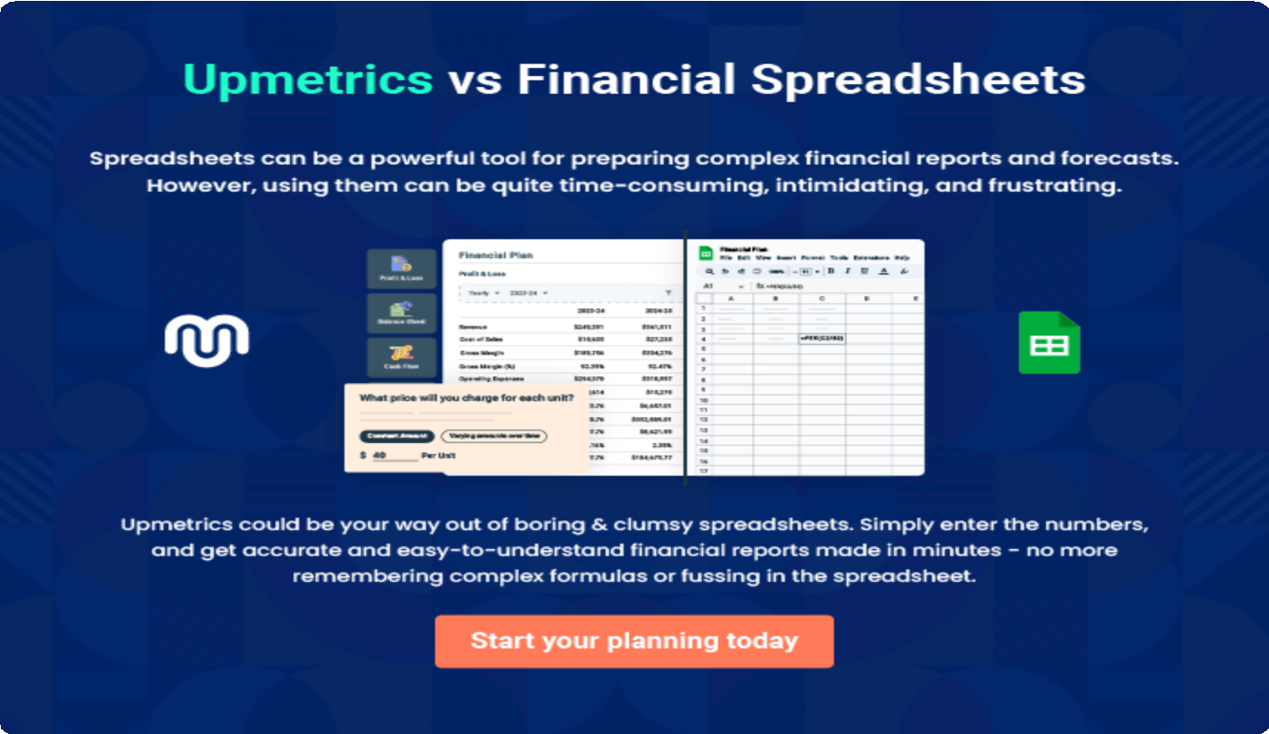

9.

Appendix
EmbedLink

Whenwritingtheappendixsection,youshouldincludeanyadditional
informationthatsupportsthemaincontentofyourplan.Thismayinclude
financialstatements,marketresearchdata,legaldocuments,andother
Tounlock helptry Upmetrics!
EmbedLink

Createawinningbusinessplanthatgetsyoufunded

Creatingastunningandinvestment-readyplanrequiresnowriting,graphicdesigning,orfinancial planning expertise.

Upmetricshasallthefeaturesrequiredtohelpyoucreateacomprehensivebusinessplan—fromstarttofinish. Makenomistakes,it’sthemodernwayofplanningtostructureideas,makeplans,andcreatestunningpitch decks to awe investors.

Pitchdecksthatimpressinvestors
Create pitch decks that provide a visual representation of your business, engage investors,andmakethemwanttoinvestinyour businessidea.

Interactiveplansinnotime
Import business plan sections like—SWOT analysis,comparisontables,andotherstocreate an interactive business plan. No designing skills arerequired.

Stunningcoverpagedesigns
WithUpmetrics,youhavethelibertytochoose from multiple stunning cover page designs.
Chooseacreativedesignandmakeyourplan standout.

500+samplebusinessplans
Simplyimportatemplatefromourlibraryof sample plans into the editor and start customizingittomakeityours.Ittakesonlyafew clicks to get started.

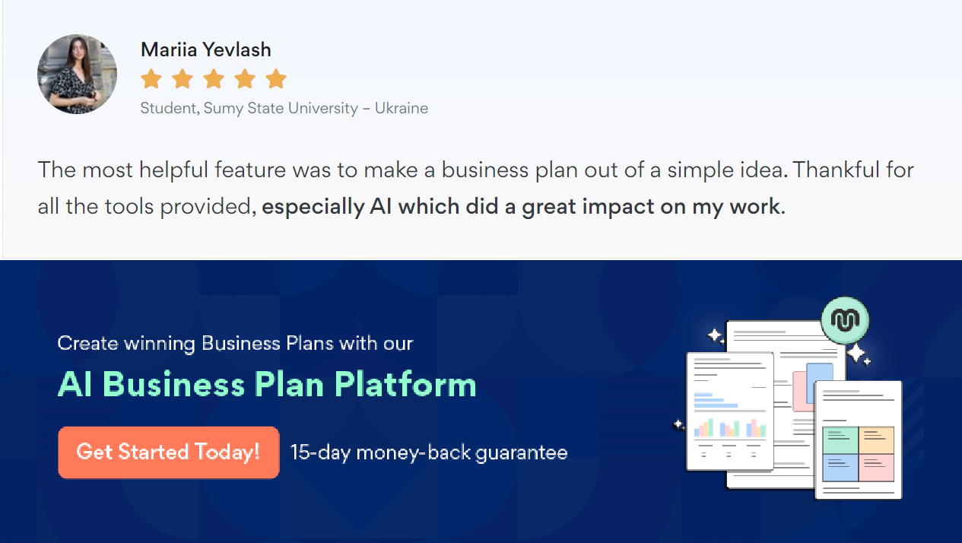Onlinesharingmadesimple
Upmetricsmakesonlinesharingquickandeasier forusers.Easilyshareyourbusinessplanswitha linkwhiletrackingreaderactivity.

Collaboratewithteaminreal-time
Invite team members, initiate conversations, discussideas&strategies,sharefeedback,and work on a business plan in real-time.

