

BUSINESSPLAN
2024



PoolHallBusinessPlan
"Break.Aim.Win.PoolLikeNeverBefore!"

JohnDoe
10200BolsaAve,Westminster,CA,92683

(650)359-3153

info@example.comhttps://www.example.com/

Information provided in this business plan is unique to this business and confidential; therefore,anyonereadingthisplanagreesnottodiscloseanyoftheinformationinthis business plan without prior written permission of the company.

TableofContents

ExecutiveSummary
6
Marketopportunity 7
UniqueSellingPoints(USPs) 7
Marketing&SalesStrategies 8
FinancialHighlights 8
UnitsSoldv/sRevenueChart 8
CompanyOverview
10
Ownership 11
BusinessOwners 11
Missionstatement 12
Business history 12
Futuregoals 12
MarketAnalysis
13
TargetMarket 14
Marketsizeandgrowthpotential 14
MarketSize 15
Competitiveanalysis 15
Rack&RollBilliards 15
TheCornerPocketSportsBar 15
EliteBilliardsLounge 16
Markettrends 16
Regulatoryenvironment 16
ProductsandServices
18
Services 19
PoolTableRentals 19
TournamentsandLeagues 19
MembershipPrograms 20
Qualitymeasures 20

SalesAndMarketingStrategies
21
UniqueSellingProposition(USP) 22
PricingStrategy 22
Marketingstrategies 23
Online 23
Offline 23
Salesstrategies 24
CustomerRetentionStrategies 24
OperationsPlan
26
Staffing&Training 27
OperationalProcess 27
Equipment&Tools 28
Quality Assurance 28
ManagementTeam
29
Founders/CEO 30
MikeHarper 30
Keymanagers 31
ElenaMartinez 31
DavidChen 31
SamanthaLee 32
Organizationalstructure 32
Organizationchart 32
Compensationplan 33
Boardofadvisors 33
JohnReynolds 34
RebeccaTaylor 34
Financial Plan
35
Profit&lossstatement 36
Cashflowstatement 41
Balancesheet 44

Break-evenPoint 46
Financingneeds 47
Appendix
49
EmbedLink 50


Businessplanningthat’ssimplerandfasterthanyouthink

CreatingabusinessplanusingUpmetricstostartandgrowabusinessisliterallytheeasiest thingintheWorld.Simplyreadtheinstructionsandfillintheblanks.It’sassimpleasthat.

Upmetrics has everything you need to create a comprehensive business plan.
❛
❜

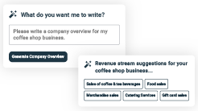
AI-poweredUpmetricsAssistant

AI-poweredinsightstostreamlineyourplan
Not sure where to start? Upmetrics’ AI Assistant will automaticallygenerateideasforeachsectionofyourplanand offerimprovedversionsofyourwriting,adjustingfortone,voice, and grammar or spelling errors.

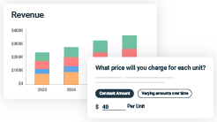
FinancialForecastingTool

Allthefinancialsarecalculatedforyou
Forget the complex formulas and clumsy spreadsheets — withautomaticfinancialsanddrag-and-dropforecasting,you canfinishyourplanfasterandbeconfidentthatyour numbers are accurate.

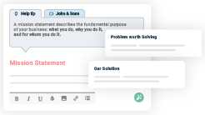
BusinessPlanBuilder

Guidesyoulikeabusinessmentor
Upmetrics’step-by-stepinstructions,prompts,andthelibraryof 400+samplebusinessplanswillguideyouthrougheachsection of your plan as a business mentor.

1.

ExecutiveSummary

Marketopportunity
Unique Selling Points (USPs)Marketing & Sales StrategiesFinancial Highlights



Anexecutivesummaryisthefirstsectionofthebusinessplanintendedto provide an overview of the whole business plan.
Tounlock helptry Upmetrics!

Helptip
BreakPointBilliards
Startyourexecutivesummarybybrieflyintroducingyourbusinesstoyourreaders.Thissection may include the name of your pool hall business, its location, when it was founded, etc.
Tounlock helptry Upmetrics!
Startwritinghere..

Marketopportunity

Helptip
BreakPointBilliards
Summarize your market research, including market size, growth potential, and marketing trends.Highlighttheopportunitiesinthemarketandhowyourbusinesswillfitintofillthegap.
Tounlock helptry Upmetrics!
Startwritinghere..

UniqueSellingPoints(USPs)

Helptip
BreakPointBilliards
Emphasize what sets your pool hall business apart—highlighting unique selling points (USPs) and special features that make it distinctive is always a plus.
Tounlock helptry Upmetrics!
Startwritinghere..

Marketing&SalesStrategies

Helptip
BreakPointBilliards
Outline your sales and marketing strategies—what marketing platforms you use, how you plan on acquiring customers, etc.
Tounlock helptry Upmetrics!
Startwritinghere..

FinancialHighlights

Helptip
BreakPointBilliards
Brieflysummarizeyourfinancialprojectionsfortheinitialyearsofbusinessoperations.Include
anycapitalorinvestmentrequirements,associatedstartupcosts,projectedrevenues,and
profitforecasts.
Tounlock helptry Upmetrics!
Startwritinghere..

UnitsSoldv/sRevenueChart

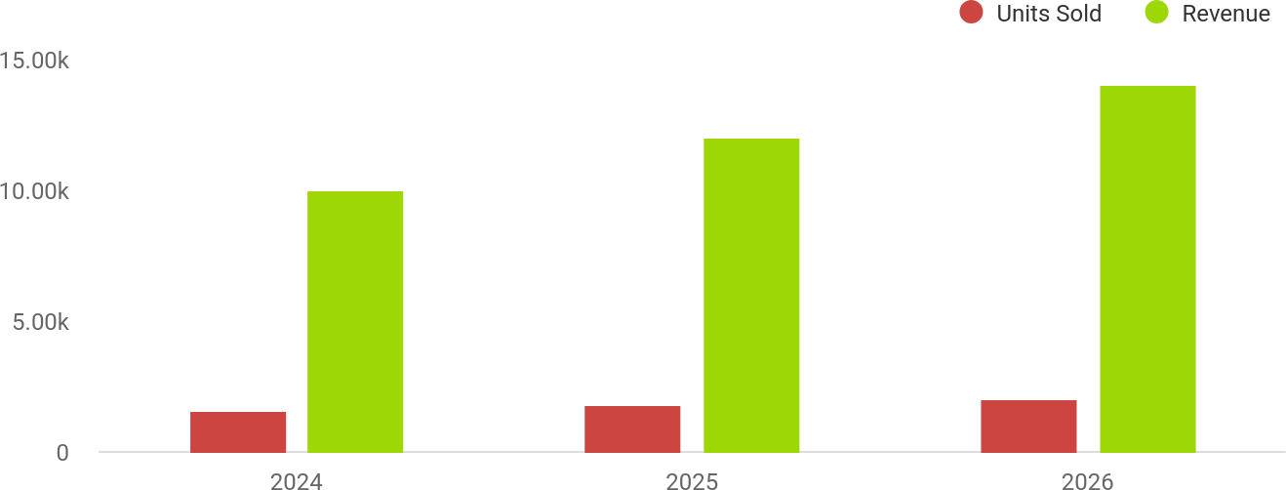

FinancialYear | UnitsSold | Revenue
2024 | 1,550 | $10,000
2025 | 1,800 | $12,000

FinancialYear | UnitsSold | Revenue
2026 | 2,050 | $14,000

Helptip
BreakPointBilliards
SummarizeyourexecutivesummarysectionwithaclearCTA,forexample,invitingangel investors to discuss the potential business investment.
Tounlock helptry Upmetrics!

Writeacalltoactionforyourbusinessplan.

2.

CompanyOverview

OwnershipMission statementBusiness historyFuture goals

Dependingonwhatdetailsofyourbusinessareessential,you’llneed different elements in your business overview.
Tounlock helptry Upmetrics!
Helptip
BreakPointBilliards
Describewhatkindofpoolhallbusinessyourunandthenameofit.Youmayspecializeinone of the following pool hall businesses:
Tounlock helptry Upmetrics!
Startwritinghere..

Ownership

Helptip
BreakPointBilliards
List the names of your pool hall business’s founders or owners. Describe what shares they own and their responsibilities for efficiently managing the business.
Tounlock helptry Upmetrics!
Startwritinghere..

BusinessOwners

MikeHarper
70%

ElenaMartinez
30%

Missionstatement

Helptip
BreakPointBilliards
Summarizeyourbusiness’objective,coreprinciples,andvaluesinyourmissionstatement.This statement needs to be memorable, clear, and brief.
Tounlock helptry Upmetrics!

At [BreakPoint Billiards], ourmissionistocreatean engaging and inclusive space where people can unwind, connect, and enjoy the timelessgameofbilliards.Wearecommittedtooffering
❛
exceptional service, premium facilities, and a vibrant atmosphere that fosters community and fun.
❜

Businesshistory

Helptip
BreakPointBilliards
Ifyou’reanestablishedpoolhallbusiness,brieflydescribeyourbusinesshistory,like—whenit was founded, how it evolved over time, etc.
Tounlock helptry Upmetrics!
Startwritinghere..

Futuregoals

Helptip
BreakPointBilliards
It’scrucialtoconveyyouraspirationsandvision.Mentionyourshort-termandlong-termgoals; they can be specific targets for revenue, market share, or expanding your services.
Tounlock helptry Upmetrics!
Startwritinghere..

3.

MarketAnalysis

TargetMarket
MarketsizeandgrowthpotentialCompetitive analysis
Market trendsRegulatoryenvironment

Marketanalysisprovidesaclearunderstandingofthemarketinwhichyour
printingbusinesswillrunalongwiththetargetmarket,competitors, and
growthopportunities.
Tounlock helptry Upmetrics!
Helptip
BreakPointBilliards
Towritetheintroductionsectionofyourmarketanalysis,startbyclearlyidentifyingyour primary target market.
Tounlock helptry Upmetrics!
Startwritinghere..

TargetMarket

Helptip
BreakPointBilliards
Startthissectionbydescribingyourtargetmarket.Defineyouridealcustomerandexplainwhat
typesofactivitiestheyprefer.Creatingabuyerpersonawillhelpyoueasilydefineyourtarget
markettoyourreaders.
Tounlock helptry Upmetrics!
Startwritinghere..

Marketsizeandgrowthpotential

Helptip
BreakPointBilliards
Describeyourmarketsizeandgrowthpotential,andwhetheryouwilltargetanicheoramuch broader market.
Tounlock helptry Upmetrics!
Startwritinghere..

MarketSize

AvailableMarket
5M
Totalpopulationwithina30-mileradius interested in recreational activities.

ServedMarket
1M
IndividualsinWestminsterandnearbyareas with accesstopoolhallsandsocialvenues.

TargetMarket
Young professionals, students, and families actively seeking premium billiards experiences.
75k


Helptip
BreakPointBilliards
Identifyandanalyzeyourdirectandindirectcompetitors.Identifytheirstrengths and
weaknesses,anddescribewhatdifferentiatesyourpoolhallbusinessfromthem.Pointouthow
youhaveacompetitiveedgeinthemarket.
Tounlock helptry Upmetrics!

Competitiveanalysis

Rack&RollBilliards
LocatedinAnaheim,CA,Rack&Rollisatraditionalpoolhallofferinganold-schoolbilliards experience.

Features
10 classic pool tables Weeklyleaguetournaments Affordable hourly rates

Strengths
Loyalcustomerbaseofregular players
Strongreputationforleague hosting
Cost-effectiverates

Weaknesses
Outdatedfacilitiesanddécor
Limitedfoodandbeverage options
Poorsocialmediapresence

TheCornerPocketSportsBar
Asportsbarwithafocusoncasualpoolplay,locatedinHuntingtonBeach,CA.

Features
6pooltablescombinedwitha full bar
Large-screenTVsforlive sports
Happyhourdiscountsandlive musicevents

Strengths
Appealstosportsfanswithlive broadcasts
Affordable drinkspecials
Casualandfriendly atmosphere

Weaknesses
Limitedfocusonbilliards;tables often occupied by non- enthusiasts
Crowdedenvironmentduring gamenights
Noloyaltyprogramsforreturning customers

EliteBilliardsLounge
Ahigh-endbilliardsvenueinIrvine,CA,knownforitsluxuriousambiance.

Features
12tournament-gradepool tables
Upscalediningandpremium cocktails
Privateroomsforevents

Strengths
High-qualityequipmentand facilities
Strongbrandrecognition

Weaknesses
Highpricesdeterbudget- consciouscustomers
Limitedcommunity-drivenevents

Markettrends

Helptip
BreakPointBilliards
Analyze emerging trends in the industry, such as technology disruptions, changes in customer behavior or preferences, etc. Explain how your business will cope with all the trends.
Tounlock helptry Upmetrics!
Startwritinghere..

Regulatoryenvironment

Helptip
BreakPointBilliards
List regulations and licensing requirements that may affect your pool hall business, such as business licensing, health & safety regulations, alcohol licensing, etc.
Tounlock helptry Upmetrics!

Startwritinghere..



4.

Productsand Services

Services
Qualitymeasures

Theproductandservicessectionofthepoolhallbusinessplanshould
describethespecificservicesandproductsthatwillbeofferedtocustomers.
Towritethissectionshouldincludethefollowing:
Tounlock helptry Upmetrics!
Helptip
BreakPointBilliards
Tocrafttheintroductionforyour"ProductsandServices"chapter,beginbypositioningyour business within its industry, emphasizing its unique strengths or value proposition.
Tounlock helptry Upmetrics!

Startwritinghere..
Helptip
Mentionthepoolhallservicesyourbusinesswilloffer.Thislistmayincludeserviceslike:

- Poolgamerentals
Tounlock helptry Upmetrics!

Services


PoolTableRentals
Price:[$15/hour]pertable

Rent tournament-grade pool tables for casual or competitivegameplay.Perfectforgroupsorindividuals looking to enjoy a premium billiards experience.

Specifications
- Professional-gradeBrunswickandDiamondtables.
- High-qualityAramithballsandPredatorcues available.
- Adjustabletablelightsforoptimalgameplayvisibility.

TournamentsandLeagues

Price:[$25]entryfeeperplayerfortournaments;[$100/ season] for league membership.
Participate in weekly tournaments or join seasonal leagues.Competeforcashprizes,trophies,andlocal recognition.

Specifications
  - Double-eliminationtournamentformat.
  - League standings updated weekly on our website and app.
  - Cashprizesupto$500fortournaments.

MembershipPrograms

Price:BasicMembership:[$50]/month;Premium Membership: [$100]/month
Enjoyexclusivebenefits,includingdiscounts,priority reservations, and access to member-only events.

Specifications
  - Basic Membership: 10% discount on rentals, free entry to monthly member tournaments.
  - PremiumMembership:20%discount,freeweekly coaching session, and early access to events.

Qualitymeasures

Helptip
BreakPointBilliards
Thissectionshouldexplainhowyou maintainqualitystandardsandconsistentlyprovide the
highestquality service.This mayinclude table maintenance,equipment quality, cleanliness&
hygiene,ambiance,etc.
Tounlock helptry Upmetrics!
Startwritinghere..

5.

SalesAndMarketing
Strategies
Unique Selling Proposition (USP)Pricing Strategy
Marketing strategiesSales strategies
CustomerRetentionStrategies

Writing the sales and marketing strategies section means a list of strategies you will use to attract and retain your clients.
Tounlock helptry Upmetrics!
HelpTip
BreakPointBilliards
Tocreateaneffectiveintroductionforyour"SalesandMarketingStrategies"chapter,startby setting the stage within your specific industry or market.
Tounlock helptry Upmetrics!
Startwritinghere..

UniqueSellingProposition(USP)

Helptip
BreakPointBilliards
Define your business’s USPs depending on the market you serve, the equipment you use, and theuniqueservicesyouprovide.IdentifyingUSPswillhelpyouplanyourmarketingstrategies.
Tounlock helptry Upmetrics!
Startwritinghere..

PricingStrategy

Helptip
PoolHallBusinessPlan
Describeyourpricingstrategy—howyouplantopriceyourservicesandstaycompetitivein the
localmarket.Youcanmentionanydiscountsyouplanonofferingtoattractnewcustomers to
yourservice.
Tounlock helptry Upmetrics!
Startwritinghere..

Helptip
Discussyourmarketingstrategiestomarketyourservices.Youmayincludesomeofthese
marketingstrategiesinyourbusinessplan—socialmediamarketing,Googleads,brochures,
emailmarketing,contentmarketing,andprintmarketing.
Tounlock helptry Upmetrics!

Marketingstrategies

Online


Offline

SocialMedia Marketing
Daily posts on Instagram and Facebook featuring events, offers, and customer highlights.

EmailMarketing
Monthly newsletters with updates, discounts,andevent announcements.

LocalAdvertising
Flyers, posters, and print ads distributed acrosscolleges,offices, and communitycenters.

ContentMarketing
Regular blogs about billiards techniques, communityevents,and recreation trends to engage customers.

Collaborations
Partnering with local businesses and schools for cross- promotionsandgroup discounts.

Helptip
Outlinethestrategiesyou’llimplementtomaximizeyoursales.Yoursalesstrategiesmay include partnering with other local businesses, offering referral programs, etc.
Tounlock helptry Upmetrics!

Salesstrategies

DirectSales Outreach
Contacting local businesses for hosting corporate events.

GroupDiscounts
Special pricing for college groups and families.

ReferralPrograms
Offering discounts for customers who refer friends and family.

On-SitePromotions
Happy hour specials andlimited-timeoffers for walk-in customers.

Helptip
Describeyourcustomerretentionstrategiesandhowyouplantoexecutethem.Forinstance, introducing loyalty programs, discounts on annual membership, personalized service, etc.
Tounlock helptry Upmetrics!

CustomerRetentionStrategies

LoyaltyPrograms
Points-based rewards redeemable for discounts and free sessions.

PersonalizedService
Tailored coaching sessionsandevent customization for regular patrons.

ExclusivePerksfor Members
Earlyaccesstoevents, priority reservations, and free monthly coaching sessions.

Community Engagement
Hosting annual tournaments and charity events to strengthen connections with customers.

6.

OperationsPlan

Staffing & TrainingOperational ProcessEquipment & ToolsQuality Assurance

Whenwritingtheoperationsplansection,it’simportanttoconsiderthe various aspects of your business operations.
Tounlock helptry Upmetrics!
Helptip
BreakPointBilliards
Tocreateaneffectiveintroductionforyour"OperationalPlan"chapter,startbyemphasizingthe
pivotalroleofefficientoperationsinthesuccessofyourbusiness,underscoringhowthey
directlyimpactthequalityofservicesdelivered.
Tounlock helptry Upmetrics!
Startwritinghere..

Staffing&Training

Helptip
BreakPointBilliards
Mentionyourbusiness’sstaffingrequirements,includingthenumberofemployeesortrainers needed.Includetheirqualifications,thetrainingrequired,andthedutiestheywillperform.
Tounlock helptry Upmetrics!
Startwritinghere..

OperationalProcess

Helptip
BreakPointBilliards
Outlinetheprocessesandproceduresyouwillusetorunyourpoolhallbusiness.Your
operational processesmay includetable allocation,customerservices, membershipservices,
etc.
Tounlock helptry Upmetrics!
Startwritinghere..

Equipment&Tools

Helptip
BreakPointBilliards
Includethelistofequipmentrequiredforthepoolhall,suchaspooltables,cues,racks,POS system, reservation system, etc.
Tounlock helptry Upmetrics!
Startwritinghere..

QualityAssurance

HelpTip
BreakPointBilliards
Explainhowyoumaintainqualitystandardsandimprovetheefficiencyofyourbusiness operations.
Tounlock helptry Upmetrics!
Startwritinghere..

7.

ManagementTeam

Founders/CEOKeymanagers
OrganizationalstructureCompensation planBoard of advisors

The management team section provides an overview of the individuals responsible for running your business plan.
Tounlock helptry Upmetrics!
Helptip
BreakPointBilliards
Tocraftanintroductionforyour"ManagementTeam"chapter,beginbyemphasizingthecrucial role of leadership in the success of any business.
Tounlock helptry Upmetrics!
Startwritinghere..

Founders/CEO

HelpTip
Mention the founders and CEO of your pool hall business and describe their roles and responsibilities in successfully running the business.
Tounlock helptry Upmetrics!
Startwritinghere..

MikeHarper


Founder/CEO-mike.harper@example.com



As CEO, Mike oversees strategic planning, operational management, and financialhealth.Heworkscloselywiththemanagementteamtoidentifygrowth opportunities and foster a welcoming community.
- Educational Background: Mike holds a Bachelor’s degree in Business Administration from the University of Southern California.
- Professional Background: With over 10 years of experience in the recreationalgamingandhospitalityindustry,Mikehasmanagedmultiple entertainment venues, developing expertise in customer service, operational efficiency, and strategic growth.

Keymanagers

Helptip
Introduceyourmanagementandkeymembersofyourteam,andexplaintheirrolesand responsibilities.
Tounlock helptry Upmetrics!
Startwritinghere..

ElenaMartinez


MarketingandEventsManager-elena.martinez@example.com

Elena manages social media, advertising campaigns, and event planning. She also develops strategic partnerships and community outreach programs to increase BreakPoint Billiards' visibility and customer engagement.
- EducationalBackground:ElenaearnedaMaster’sdegreeinMarketing andCommunicationsfromtheUniversityofCalifornia,LosAngeles (UCLA).
- Professional Background: Elena has 7+ years of experience designing and executing marketing campaigns for entertainment venues and hospitality brands. She has successfully organized over 100 community events, including tournaments and corporate gatherings.

DavidChen


OperationsManager-david.chen@example.com

Davidisresponsiblefordailyoperations,ensuringthatthepoolhallmeetsthe highest standards of quality and efficiency. He oversees staff performance, equipment maintenance, and customer satisfaction.
- EducationalBackground:DavidholdsaBachelor’sdegreeinHospitality Management from San Diego State University.
- Professional Background: With 8 years of experience managing entertainment and recreational facilities, David has specialized in streamlining operational processes, staff training, and customer service delivery.


SamanthaLee

FinancialController-samantha.lee@example.com

Samantha oversees BreakPoint Billiards’ financial health, ensuring the business stays on track to achieve its revenue and profitability goals. She manages budgets, financial reporting, and compliance.
- EducationalBackground:SamanthaholdsaMaster’sdegreein Accounting and Finance from Stanford University. She is also a Certified Public Accountant (CPA).
- ProfessionalBackground:Withover10yearsofexperienceinfinancial management for small businesses and startups, Samantha has developed expertise in budget planning, tax compliance, and financial forecasting.

Organizationalstructure

Helptip
BreakPointBilliards
Explaintheorganizationalstructureofyourmanagementteam.Includethereportinglineand decision-making hierarchy.
Tounlock helptry Upmetrics!
Startwritinghere..

Organizationchart


MikeHarper
CEO


ElenaMartinez MarketingandEvents Manager
David Chen

OperationsManager
SamanthaLee

FinanceManager

SophiaBennett CustomerService Lead

MarkLopez Maintenance Supervisor

Compensationplan

Helptip
BreakPointBilliards
Describeyourcompensationplanforthemanagementandstaff.Includetheirsalaries, incentives, and other benefits.
Tounlock helptry Upmetrics!
Startwritinghere..

Helptip
Mentioningadvisorsorconsultantsinyourbusinessplansaddscredibilitytoyourbusiness idea.
Tounlock helptry Upmetrics!

Boardofadvisors


JohnReynolds

LegalAdvisor

With 20 years of experience in business law, John ensures that [BreakPoint Billiards]complieswithalllicensing,contractual,andregulatoryrequirements. He also assists in drafting agreements with vendors and partners.

RebeccaTaylor


Business Development Consultant - [thomas.walker@mobileeasephlebotomy.com]
Rebeccaisaseasonedbusinessconsultantwithover15yearsofexperience helping startups and small businesses thrive. She advises [BreakPoint Billiards] on growth strategies, franchise potential, and community engagement initiatives.

8.

FinancialPlan

Profit&lossstatementCash flow statementBalance sheet
Break-evenPointFinancing needs

Helptip
Describedetailssuchasprojectedrevenue,operationalcosts,andservicecostsinyourprojectedprofitandlossstatement.Makesuretoinclude
yourbusiness’sexpectednetprofitorloss.

Whenwritingthefinancialplansectionofabusinessplan,it’simportanttoprovideacomprehensiveoverviewofyourfinancial projections for the first few years of your business, You may provide the following:
Tounlock helptry Upmetrics!
Helptip
BreakPointBilliards
Tocreateaneffectiveintroductionforyour"FinancialPlan"chapter,beginbystressingthecriticalroleofawell-structuredfinancialplaninthe success of your venture.
Tounlock helptry Upmetrics!
Startwritinghere..

 |  |  | Tounlock helptry Upmetrics!
Profit&lossstatement | 2024 | 2025 | 2026
Revenue | $407,791.64 | $886,184.26 | $1,624,497.84
PoolTableRentals | $50,400 | $50,400 | $50,400

 | 2024 | 2025 | 2026
TotalHours | 1,680 | 1,680 | 1,680
HourlyPrice | $30 | $30 | $30
FoodandBeveragesSales | $191,006.64 | $343,022.76 | $616,022.64
UnitSales | 15,917 | 28,585 | 51,335
UnitPrice | $12 | $12 | $12
MembershipFees | $166,385 | $492,761.50 | $958,075.20
Users | 710 | 1,722 | 3,164
RecurringCharges | $30 | $30 | $30

CostOf Sales | $155,620.07 | $315,975.33 | $562,359.96
GeneralCosts | $155,620.07 | $315,975.33 | $562,359.96
PoolTableOperations | $18,097.07 | $28,469.03 | $44,141.48
MaintenanceCosts | $6,341.24 | $7,145.34 | $8,051.52
PoolCue Supplies | $3,600 | $3,600 | $3,600
TableClothReplacement | $8,155.83 | $17,723.69 | $32,489.96
FoodandBeverageSales | $137,523 | $287,506.30 | $518,218.48
BeverageSupplies | $122,337.49 | $265,855.28 | $487,349.35

 | 2024 | 2025 | 2026
FoodIngredients | $14,192.08 | $20,234.60 | $28,849.65
PackagingCosts | $993.43 | $1,416.42 | $2,019.48
RevenueSpecificCosts | $0 | $0 | $0

PersonnelCosts(Direct Labor)

$0 $0 $0

GrossMargin | $252,171.57 | $570,208.93 | $1,062,137.88
GrossMargin(%) | 61.84% | 64.34% | 65.38%
Operating Expense | $397,963.49 | $429,510.63 | $472,278.16

PayrollExpense(Indirect Labor)

$334,980 $345,228.60 $355,822.80

ManagementTeam | $76,980 | $80,139 | $83,435.28
General Manager | $42,480 | $44,604 | $46,834.20
AssistantManager | $34,500 | $35,535 | $36,601.08
OperationsStaff | $161,280 | $165,043.20 | $168,898.08
Bartenders | $107,520 | $109,670.40 | $111,864

 | 2024 | 2025 | 2026
TableMaintenanceStaff | $53,760 | $55,372.80 | $57,034.08
MarketingandSalesStaff | $96,720 | $100,046.40 | $103,489.44
Marketing Specialist | $42,480 | $44,179.20 | $45,946.32
SalesRepresentative | $54,240 | $55,867.20 | $57,543.12
GeneralExpense | $62,983.51 | $84,282.03 | $116,455.34
FacilityExpenses | $34,164.79 | $35,603.94 | $37,429.37
Rent | $26,400 | $26,400 | $26,400
Utilities | $5,364.79 | $6,803.94 | $8,629.37
Insurance | $2,400 | $2,400 | $2,400
MarketingExpenses | $15,160.53 | $25,210.82 | $40,520.69
OnlineAdvertising | $8,155.83 | $17,723.69 | $32,489.96
EventPromotions | $3,200 | $3,200 | $3,200
SocialMediaManagement | $3,804.70 | $4,287.13 | $4,830.73

Maintenanceand MiscellaneousExpenses
$13,658.19 $23,467.27 $38,505.28

CleaningServices | $3,600 | $3,600 | $3,600
RepairsandMaintenance | $8,155.83 | $17,723.69 | $32,489.96

 | 2024 | 2025 | 2026
OfficeSupplies | $1,902.36 | $2,143.58 | $2,415.32
BadDebt | $0 | $0 | $0

AmortizationofCurrent Assets

$0 $0 $0

EBITDA ($145,791.92) $140,698.30 $589,859.70

AdditionalExpense | $11,878.93 | $9,944.77 | $7,891.31
LongTermDepreciation | $6,732 | $6,732 | $6,732
GainorlossfromSaleof Assets | $0 | $0 | $0
EBIT | ($152,523.92) | $133,966.30 | $583,127.70
InterestExpense | $5,146.94 | $3,212.76 | $1,159.29
EBT | ($157,670.85) | $130,753.53 | $581,968.39

IncomeTaxExpense/ Benefit

$0 $0 $0

TotalExpense $565,462.49 $755,430.73 $1,042,529.45

Helptip
Thecashflowforthefirstfewyearsofyouroperationshouldbeestimatedanddescribedinthissection.Thismayincludebillinginvoices,
paymentreceipts,loanpayments,andanyothercashflowstatements.
 | 2024 | 2025 | 2026
NetIncome | ($157,670.85) | $130,753.53 | $581,968.39
NetIncome(%) | (38.66%) | 14.75% | 35.82%

RetainedEarningOpening | $0 | ($179,670.85) | ($60,917.32)
Owner'sDistribution | $22,000 | $12,000 | $12,000
RetainedEarningClosing | ($179,670.85) | ($60,917.32) | $509,051.07

 |  |  | Tounlock helptry Upmetrics!
Cashflowstatement | 2024 | 2025 | 2026
CashReceived | $407,791.64 | $886,184.26 | $1,624,497.84
CashPaid | $558,730.49 | $748,698.73 | $1,035,797.45
COS&GeneralExpenses | $218,603.56 | $400,257.36 | $678,815.34

 | 2024 | 2025 | 2026
Salary&Wages | $334,980 | $345,228.60 | $355,822.80
Interest | $5,146.94 | $3,212.76 | $1,159.29
SalesTax | $0 | $0 | $0
IncomeTax | $0 | $0 | $0

NetCashFrom Operations

($150,938.85) $137,485.53 $588,700.39

AssetsSell | $0 | $0 | $0
AssetsPurchase | $35,000 | $0 | $0

NetCashFrom Investments

($35,000) $0 $0

AmountReceived | $150,000 | $0 | $0
LoanReceived | $100,000 | $0 | $0
CommonStock
PreferredStock | $0 | $0 | $0
Owner'sContribution | $50,000 | $0 | $0

 | 2024 | 2025 | 2026
AmountPaid | $53,359.35 | $45,293.51 | $47,347.12
LoanCapital | $31,359.34 | $33,293.52 | $35,347.14
Dividends&Distributions | $22,000 | $12,000 | $12,000

NetCashFrom Financing

$96,640.65 ($45,293.51) ($47,347.12)

Summary
StartingCash | $0 | ($89,298.20) | $2,893.82
CashIn | $557,791.64 | $886,184.26 | $1,624,497.84
CashOut | $647,089.84 | $793,992.24 | $1,083,144.57
Change inCash | ($89,298.20) | $92,192.02 | $541,353.27
Ending Cash | ($89,298.20) | $2,893.82 | $544,247.09

Helptip
Createaprojectedbalancesheetdocumentingyourpoolhallbusiness’sassets,liabilities,andequity.
Tounlock helptry Upmetrics!

Balancesheet
 | 2024 | 2025 | 2026
Assets | ($61,030.20) | $24,429.82 | $559,051.09
CurrentAssets | ($89,298.20) | $2,893.82 | $544,247.09
Cash | ($89,298.20) | $2,893.82 | $544,247.09
AccountsReceivable | $0 | $0 | $0
Inventory | $0 | $0 | $0
OtherCurrentAssets | $0 | $0 | $0
LongTermAssets | $28,268 | $21,536 | $14,804
GrossLong TermAssets | $35,000 | $35,000 | $35,000
Accumulated Depreciation | ($6,732) | ($13,464) | ($20,196)
Liabilities&Equity | ($61,030.19) | $24,429.82 | $559,051.07
Liabilities | $68,640.66 | $35,347.14 | $0
CurrentLiabilities | $33,293.51 | $35,347.12 | $0
AccountsPayable | $0 | $0 | $0
IncomeTaxPayable | $0 | $0 | $0

 | 2024 | 2025 | 2026
SalesTaxPayable | $0 | $0 | $0
ShortTermDebt | $33,293.51 | $35,347.12 | $0
LongTermLiabilities | $35,347.15 | $0.02 | $0
LongTermDebt | $35,347.15 | $0.02 | $0
Equity | ($129,670.85) | ($10,917.32) | $559,051.07
Paid-inCapital | $0 | $0 | $0
CommonStock | $0 | $0 | $0
PreferredStock | $0 | $0 | $0
Owner'sContribution | $50,000 | $50,000 | $50,000
RetainedEarnings | ($179,670.85) | ($60,917.32) | $509,051.07

Check $0 $0 $0

Helptip
Determineandmentionyourbusiness’sbreak-evenpoint—thepointatwhichyourbusinesscostsandrevenuewillbeequal.

Thisexercisewillhelpyouunderstandhowmuchrevenueyouneedtogeneratetosustainorbeprofitable.
Tounlock helptry Upmetrics!

Break-evenPoint
 | 2024 | 2025 | 2026
StartingRevenue | $0 | $407,791.64 | $1,293,975.90
NetRevenue | $407,791.64 | $886,184.26 | $1,624,497.84
ClosingRevenue | $407,791.64 | $1,293,975.90 | $2,918,473.74
StartingExpense | $0 | $565,462.49 | $1,320,893.22
NetExpense | $565,462.49 | $755,430.73 | $1,042,529.45
ClosingExpense | $565,462.49 | $1,320,893.22 | $2,363,422.67
IsBreakEven? | No | No | Yes
BreakEvenMonth | 0 | 0 | Jan'26
DaysRequired | 0 | 0 | 29Days
BreakEvenRevenue | $565,462.49 | $1,320,893.22 | $1,393,238.65
PoolTableRentals | $0 | $0 | $104,860
FoodandBeveragesSales | $0 | $0 | $571,441.14
MembershipFees | $0 | $0 | $716,937.51

 | 2024 | 2025 | 2026
BreakEvenUnits
PoolTableRentals | 0 | 0 | 3,495
FoodandBeveragesSales | 0 | 0 | 47,620
MembershipFees | 0 | 0 | 1,820

Financingneeds

Helptip
BreakPointBilliards
Calculate costs associated with starting a pool hall business and estimate your financing needs and how much capital you need to raise to operate your business.
Tounlock helptry Upmetrics!
Startwritinghere..

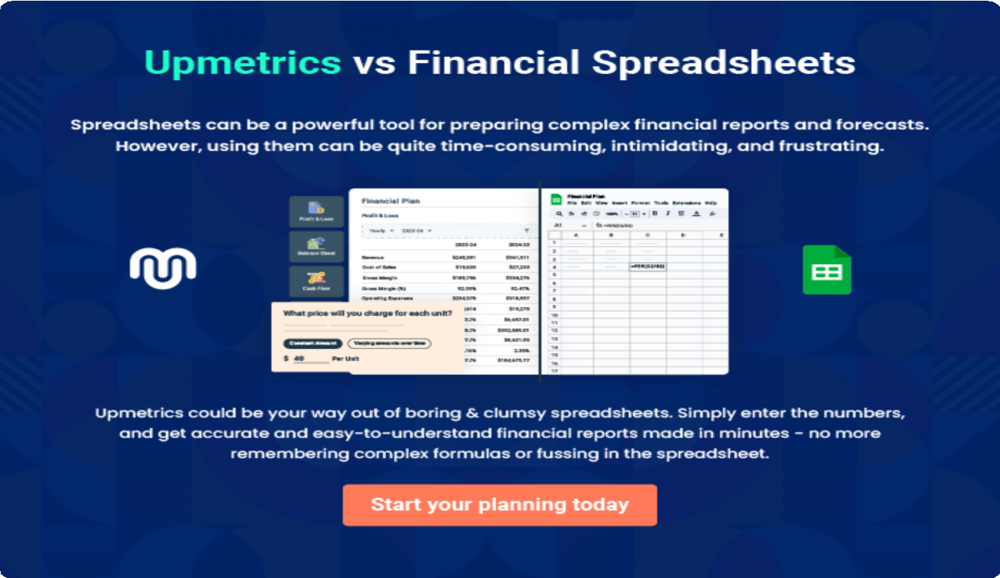

9.

Appendix
EmbedLink

Whenwritingtheappendixsection,youshouldincludeanyadditional
informationthatsupportsthemaincontentofyourplan.Thismayinclude
financialstatements,marketresearchdata,legaldocuments,andother
Tounlock helptry Upmetrics!
EmbedLink

Createawinningbusinessplanthatgetsyoufunded

Creatingastunningandinvestment-readyplanrequiresnowriting,graphicdesigning,orfinancial planning expertise.

Upmetricshasallthefeaturesrequiredtohelpyoucreateacomprehensivebusinessplan—fromstarttofinish. Makenomistakes,it’sthemodernwayofplanningtostructureideas,makeplans,andcreatestunningpitch decks to awe investors.

Pitchdecksthatimpressinvestors
Create pitch decks that provide a visual representation of your business, engage investors,andmakethemwanttoinvestinyour businessidea.

Interactiveplansinnotime
Import business plan sections like—SWOT analysis,comparisontables,andotherstocreate an interactive business plan. No designing skills arerequired.

Stunningcoverpagedesigns
WithUpmetrics,youhavethelibertytochoose from multiple stunning cover page designs.
Chooseacreativedesignandmakeyourplan standout.

500+samplebusinessplans
Simplyimportatemplatefromourlibraryof sample plans into the editor and start customizingittomakeityours.Ittakesonlyafew clicks to get started.

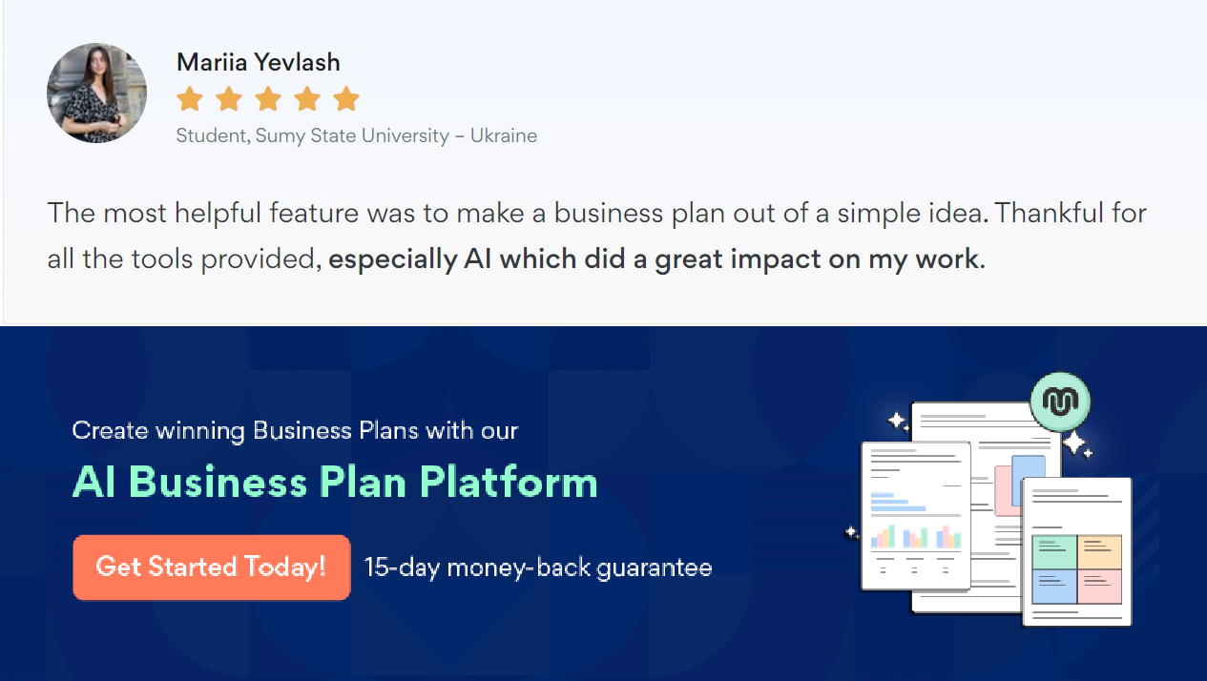Onlinesharingmadesimple
Upmetricsmakesonlinesharingquickandeasier forusers.Easilyshareyourbusinessplanswitha linkwhiletrackingreaderactivity.

Collaboratewithteaminreal-time
Invite team members, initiate conversations, discussideas&strategies,sharefeedback,and work on a business plan in real-time.

