
SEOBusinessPlan
"TurningClicksintoCustomers!"

PreparedBy

Business
Plan
2024
JohnDoe
(650)359-3153
10200 Bolsa Ave, Westminster, CA, 92683 info@example.comhttps://www.example.com

TableofContents

ExecutiveSummary
6
Marketopportunity 7
SEOServices 7
Marketing&SalesStrategies 8
FinancialHighlights 8
UnitsSoldv/sRevenueChart 8
CompanyOverview
10
Ownership 11
BusinessOwners 11
Missionstatement 11
Business history 12
Futuregoals 12
MarketAnalysis
13
TargetMarket 14
Marketsizeandgrowthpotential 14
MarketSize 15
Competitiveanalysis 15
Moz 15
WebFX 15
VictoriousSEO 16
Markettrends 16
Regulatoryenvironment 17
ProductsandServices
18
Services 19
KeywordResearch 19
On-PageOptimization 19
TechnicalSEO 20
LinkBuilding 20

LocalSEO 21
Quality Measures 21
SalesAndMarketingStrategies
22
UniqueSellingProposition(USP) 23
PricingStrategy 23
Marketingstrategies 24
Online 24
Salesstrategies 24
Customerretention 25
OperationsPlan
26
Staffing&Training 27
OperationalProcess 27
Equipment&Tools 28
ManagementTeam
29
Founders/CEO 30
LisaTran 30
Keymanagers 31
MarkReynolds 31
SophiaLee 32
MichaelPatel 32
Organizationalstructure 32
Organizationchart 33
Compensationplan 33
Boardofadvisors 34
David Martinez 34
EvelynCarter 34
Financial Plan
35
Profit&lossstatement 36
Cashflowstatement 41

Balancesheet 43
Break-evenPoint 45
Financingneeds 47
Appendix
49
EmbedLink 50

Businessplanningthat’ssimplerandfasterthanyouthink

CreatingabusinessplanusingUpmetricstostartandgrowabusinessisliterallytheeasiest thingintheWorld.Simplyreadtheinstructionsandfillintheblanks.It’sassimpleasthat.

Upmetrics has everything you need to create a comprehensive business plan.
❛
❜

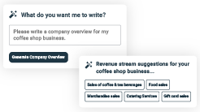
AI-poweredUpmetricsAssistant

AI-poweredinsightstostreamlineyourplan
Not sure where to start? Upmetrics’ AI Assistant will automaticallygenerateideasforeachsectionofyourplanand offerimprovedversionsofyourwriting,adjustingfortone,voice, and grammar or spelling errors.

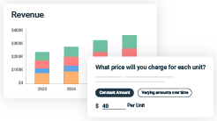
FinancialForecastingTool

Allthefinancialsarecalculatedforyou
Forget the complex formulas and clumsy spreadsheets — withautomaticfinancialsanddrag-and-dropforecasting,you canfinishyourplanfasterandbeconfidentthatyour numbers are accurate.

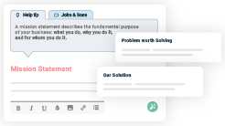
BusinessPlanBuilder

Guidesyoulikeabusinessmentor

Upmetrics’step-by-stepinstructions,prompts,andthelibraryof 400+samplebusinessplanswillguideyouthrougheachsection of your plan as a business mentor.

1.

ExecutiveSummary

MarketopportunitySEO Services
Marketing & Sales StrategiesFinancial Highlights



Anexecutivesummaryisthefirstsectionofthebusinessplanintendedto provide an overview of the whole business plan.
Tounlock helptry Upmetrics!

Helptip
OptimizeHubSEOAgency
Startyourexecutivesummarybybrieflyintroducingyourbusinesstoyourreaders.

ThissectionmayincludethenameofyourSEObusiness,whenitwasfounded,thetypeofSEO
Tounlock helptry Upmetrics!
Startwritinghere..

Marketopportunity

Helptip
OptimizeHubSEOAgency
Summarizeyourmarketresearch,includingmarketsize,growthpotential,andmarketing trends.
Tounlock helptry Upmetrics!
Startwritinghere..

SEOServices

Helptip
OptimizeHubSEOAgency
HighlighttheSEOservicesyouofferyourclients.TheUSPsanddifferentiatorsyouofferare always a plus.
Tounlock helptry Upmetrics!
Startwritinghere..

Marketing&SalesStrategies

Helptip
OptimizeHubSEOAgency
Outline your sales and marketing strategies—what marketing platforms you use, how you plan on acquiring customers, etc.
Tounlock helptry Upmetrics!
Startwritinghere..

FinancialHighlights

Helptip
OptimizeHubSEOAgency
Brieflysummarizeyourfinancialprojectionsfortheinitialyearsofbusinessoperations.Include
capitalorinvestmentrequirements,associatedstartupcosts,projectedrevenues,andprofit
forecasts.
Tounlock helptry Upmetrics!
Startwritinghere..

UnitsSoldv/sRevenueChart

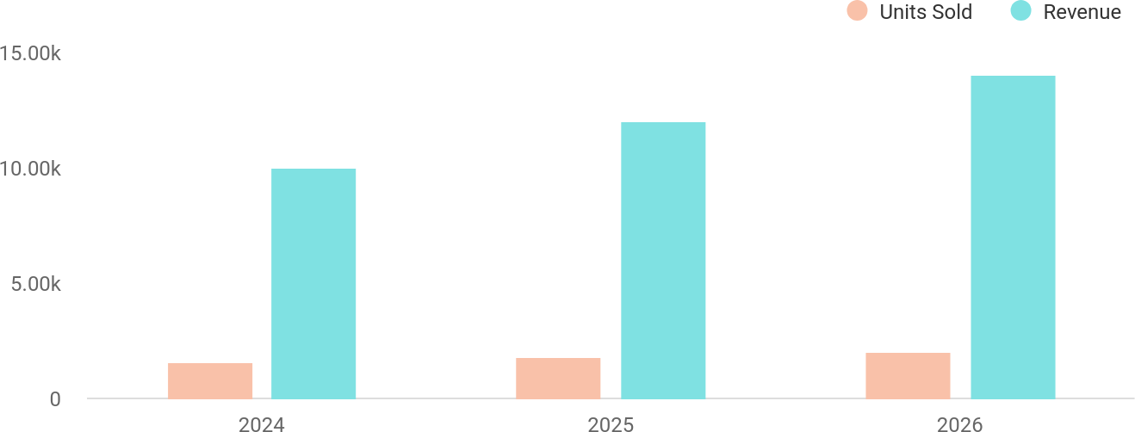

FinancialYear | UnitsSold | Revenue
2024 | 1,550 | $10,000
2025 | 1,800 | $12,000

FinancialYear | UnitsSold | Revenue
2026 | 2,050 | $14,000

Helptip
OptimizeHubSEOAgency
SummarizeyourexecutivesummarysectionwithaclearCTA,forexample,invitingangel investors to discuss the potential business investment.
Tounlock helptry Upmetrics!

Writeacalltoactionforyourbusinessplan.

2.

CompanyOverview

OwnershipMission statementBusiness historyFuture goals

Dependingonwhatdetailsofyourbusinessareessential,you’llneed different elements in your business overview.
Tounlock helptry Upmetrics!
Helptip
OptimizeHubSEOAgency
DescribewhatkindofSEOcompanyyourunandthenameofit.Youmayspecializeinoneof the following SEO businesses:
Tounlock helptry Upmetrics!
Startwritinghere..

Ownership

Helptip
OptimizeHubSEOAgency
List the names of your SEO company’s founders or owners. Describe what shares they own and their responsibilities for efficiently managing the business.
Tounlock helptry Upmetrics!
Startwritinghere..

BusinessOwners

LisaTran
100%

Missionstatement


Helptip
OptimizeHubSEOAgency
Summarizeyourbusiness’objective,coreprinciples,andvaluesinyourmissionstatement.This statement needs to be memorable, clear, and brief.
Tounlock helptry Upmetrics!

Ourmissionistohelpbusinessessucceedinthedigital
❛
landscape by providing innovative, transparent, and results- oriented SEO solutions. At [OptimizeHub], we believe in
empowering our clients with the knowledge and tools needed to achieve sustained online growth.
❜

Businesshistory

Helptip
OptimizeHubSEOAgency
Ifyou’reanestablishedSEOserviceprovider,brieflydescribeyourbusinesshistory,like—when it was founded, how it evolved, etc.
Tounlock helptry Upmetrics!
Startwritinghere..

Futuregoals

Helptip
OptimizeHubSEOAgency
It’scrucialtoconveyyouraspirationsandvision.Mentionyourshort-termandlong-termgoals; they can be specific targets for revenue, market share, or expanding your services.
Tounlock helptry Upmetrics!
Startwritinghere..

3.

MarketAnalysis
TargetMarket
MarketsizeandgrowthpotentialCompetitive analysis
Market trendsRegulatoryenvironment

Marketanalysisprovidesaclearunderstandingofthemarketinwhichyour
printingbusinesswillrunalongwiththetargetmarket,competitors, and
growthopportunities.
Tounlock helptry Upmetrics!
Helptip
OptimizeHubSEOAgency
Towritetheintroductionsectionofyourmarketanalysis,startbyclearlyidentifyingyour primary target market.
Tounlock helptry Upmetrics!
Startwritinghere..

TargetMarket

Helptip
OptimizeHubSEOAgency
Startthissectionbydescribingyourtargetmarket.Defineyouridealcustomerandexplainwhat
typesofservicestheyprefer.Creatingabuyerpersonawillhelpyoueasilydefineyourtarget
markettoyourreaders.
Tounlock helptry Upmetrics!
Startwritinghere..

Marketsizeandgrowthpotential

Helptip
OptimizeHubSEOAgency
Describeyourmarketsize,growthpotential,andwhetheryouwilltargetanicheorbroader market.
Tounlock helptry Upmetrics!
Startwritinghere..

MarketSize

AvailableMarket
TheglobalSEOservicesindustryin2024.

100B

ServedMarket
5B
SEOservicesdemandfromSMBsand eCommerce in California.

TargetMarket
LocalSMBsandnichebusinessesin Westminster,CA.

500M

Helptip
OptimizeHubSEOAgency
Identifyandanalyzeyourdirectandindirectcompetitors.Identifytheirstrengths and
weaknesses, and describe what differentiates your SEO services from them.Point out how you
haveacompetitiveedgeinthemarket.
Tounlock helptry Upmetrics!

Competitiveanalysis

Moz
Moz is a leading SEO software company known for its robust tools and resources tailored for digital marketers.

Features
Keywordresearchwith Keyword Explorer
Site audits with Moz Pro Backlink analysis and tracking
Ranktrackingforcompetitive keywords

Strengths
Industry-leading SEO tools Strong brand reputation
Comprehensive educational resources

Weaknesses
Highsubscriptioncosts, unaffordable for small businesses
Limitedcustomersupportfor smaller accounts
Focusonsoftwareratherthan personalized services

WebFX
WebFXisafull-servicedigitalmarketingagencyspecializinginSEO,PPC,andcontentmarketing solutions.

Features
Local SEO and national campaigns
TechnicalSEOandwebsite optimization
Contentmarketingandcreation

Strengths
Proventrackrecordwithcase studies
Full-suitedigitalmarketing services
StrongfocusonROIanddata analytics

Weaknesses
Lesscost-effectiveforsmaller businesses
Limitedfocusonniche-specific SEO
Longeronboardingtimefornew clients

VictoriousSEO
Victorious SEO is an agency focused on delivering tailored SEO strategies to improve organic traffic and conversions.

Features
Technical and on-page SEO optimization
Link-buildingstrategies
LocalSEOfortargetedmarkets
Transparentreportingand analytics

Strengths
Transparent,data-driven results
Expertiseinlink-building strategies
Focusedapproachonclient- specific needs

Weaknesses
Premiumpricingtiers
Limited geographic focus outside of major US cities
Smallerserviceportfolio comparedtofull-service agencies

Markettrends

Helptip
OptimizeHubSEOAgency
Analyzeemergingtrendsintheindustryandexplainhowwillyoucopewithallthemarket
trends.Someofthemarkettrendsintheindustryareartificialintelligence,machinelearning,
userexperience,videoSEO,voicesearchSEO,etc.
Tounlock helptry Upmetrics!
Startwritinghere..

Regulatoryenvironment

Helptip
OptimizeHubSEOAgency
PresentthelistoflicensesorpermitsyouneedtooperatetheSEObusinessinaparticular location.
Tounlock helptry Upmetrics!
Startwritinghere..

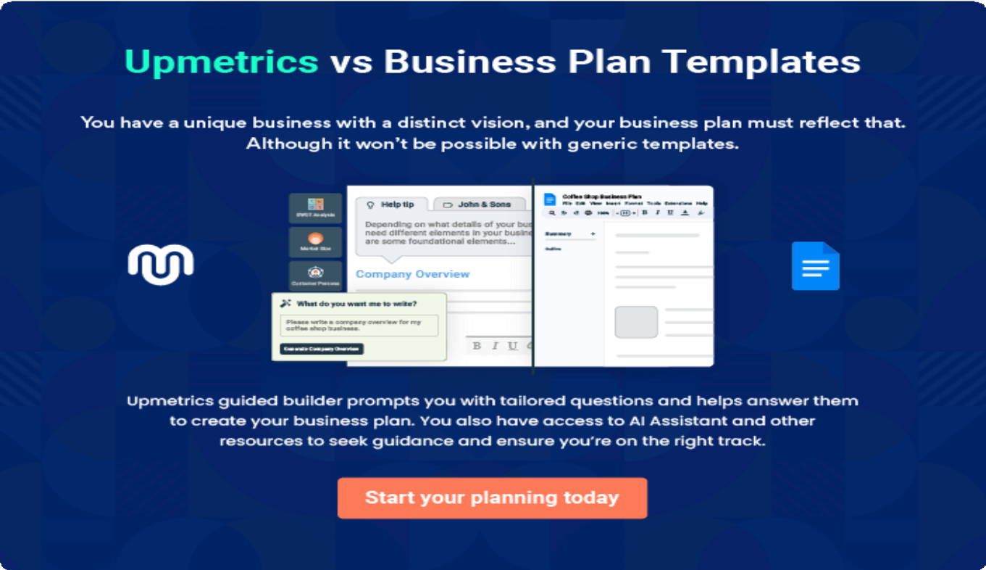

4.

Productsand Services

Services
QualityMeasures

TheproductandservicessectionofanSEObusinessplanshoulddescribe
thespecificservicesandproductsthatwillbeofferedtocustomers.Towrite
thissectionshouldincludethefollowing:
Tounlock helptry Upmetrics!
Helptip
OptimizeHubSEOAgency
Tocrafttheintroductionforyour"ProductsandServices"chapter,beginbypositioningyour business within its industry, emphasizing its unique strengths or value proposition.
Tounlock helptry Upmetrics!

Startwritinghere..
Helptip
Mention theSEO servicesyour businesswill offer.Thislist mayinclude serviceslike,

- Keyword research
Tounlock helptry Upmetrics!

Services


KeywordResearch
Price:[$300]perproject

Weconductin-depthkeywordresearchtoidentifyhigh- volume, low-competition keywords relevant to your industry. This includes analyzing search intent, competitor keywords, and seasonal trends to maximize your content's visibility.

Specifications
- Identificationof50+primaryandsecondarykeywords
- Competitorkeywordanalysis
- Searchintentcategorization(informational, transactional, navigational)
- Deliveryinacomprehensivereportwithactionable insights

On-Page Optimization

Price:[$500]perwebsite(upto 20pages)

We optimize website elements such as meta titles, descriptions,headings,andinternallinkingtoimprove on-page SEO. This service enhances content relevancy and alignment with search engine algorithms.

Specifications
  - Optimizationofmetatitlesanddescriptions
  - Keywordplacementinheadings(H1,H2,etc.)
  - URLstructurerefinement
  - Imageoptimizationwithalttags
  - Internallinkingstrategy

TechnicalSEO
Price:[$700]perwebsite

Our technical SEO service ensures your website is crawlable,indexable,andfreeoftechnicalerrorsthat impact search engine rankings.

Specifications
  - Sitespeedoptimization
  - Mobile-friendlinesstestingandimprovements
  - XMLsitemapcreationandsubmission
  - Fixingcrawlerrors(brokenlinks,redirects,etc.)
  - HTTPSandSSLcertificationverification

LinkBuilding

Price: [$100] per high-quality backlink

Webuildauthoritativebacklinksthroughethical,white- hat practices to improve your domain authority and search engine rankings.

Specifications
  - LinksfromwebsiteswithDA50+
  - Guestpostingandoutreach-basedbacklinkstrategies
  - Monthlybacklinkreports
  - Focusonindustry-relevant,high-trafficsites

Local SEO
Price:[$400]perlocation

[OptimizeHub] specializes in boosting visibility for local businesses with targeted local SEO strategies, including Google My Business optimization.

Specifications
  - GoogleMyBusinesssetupandoptimization
  - Localizedkeywordtargeting
  - CitationmanagementandNAPconsistency
  - Locallink-buildingstrategies
  - Monthlyperformancereporting

QualityMeasures

Helptip
OptimizeHubSEOAgency
This section should explain how you maintain quality standards and consistently provide the highest quality services.
Tounlock helptry Upmetrics!
Startwritinghere..

5.

SalesAndMarketing
Strategies

Unique Selling Proposition (USP)Pricing Strategy
Marketing strategiesSales strategiesCustomer retention

Writing the sales and marketing strategies section means a list of strategies you will use to attract and retain your clients.
Tounlock helptry Upmetrics!
HelpTip
OptimizeHubSEOAgency
Tocreateaneffectiveintroductionforyour"SalesandMarketingStrategies"chapter,startby setting the stage within your specific industry or market.
Tounlock helptry Upmetrics!
Startwritinghere..

UniqueSellingProposition(USP)

Helptip
OptimizeHubSEOAgency
Standingoutinthiscompetitiveworldisamust.Especially,whentheworldisdigitalizingand the number of SEO companies are rising constantly.
Tounlock helptry Upmetrics!
Startwritinghere..

PricingStrategy

Helptip
OptimizeHubSEOAgency
Describeyourpricingstrategy—howyouplantopriceyourservicesandstaycompetitiveinthe local market. You can mention any discounts you plan on offering to attract new customers.
Tounlock helptry Upmetrics!
Startwritinghere..

Helptip
Discussyourmarketingstrategiestomarketyourservices.Youmayincludesomeofthese
marketingstrategiesinyourbusinessplan—socialmediamarketing,emailmarketing,content
marketing,andsearchenginemarketing(SEM).
Tounlock helptry Upmetrics!

Marketingstrategies

Online


SocialMedia Marketing
Promoting success stories and thought leadership content acrossplatformslike LinkedIn,Instagram, and Facebook.

ContentMarketing
Publishing blogs, case studies,andSEOguides to establish authority and drive inbound leads.

EmailMarketing
Sending newsletters, service updates, and exclusive offers to engage with prospects and existing clients.

Search Engine Marketing(SEM)
Running paid ad campaigns on Googleto capture high-intent trafficandimprovelead generation.

Helptip
Outlinethestrategiesyou’llimplementtomaximizeyoursales.Yoursalesstrategiesmay include direct sales calls, offering referral marketing, etc.
Tounlock helptry Upmetrics!

Salesstrategies

Partnerships
Collaboratingwithlocal web development and marketing agencies to offer bundled services.

TargetedOutreach
Personalized outreach to niche-specific businesses and eCommerce platforms in the [Westminster] area.

ReferralPrograms
Incentivizing existing clients with discounts or free services for referring new customers.

Helptip
Describeyourcustomerretentionstrategiesandhowyouplantoexecutethem.Forinstance, introducing loyalty programs, discounts on annual membership, personalized service, etc
Tounlock helptry Upmetrics!

Customerretention

LoyaltyProgram
Discountsonannual SEO packages and exclusive perks for long-term clients.

PersonalizedSupport
Dedicated account managerswhoensure seamless communication and quick resolution of queries.

Monthly
PerformanceReports
Regular updates to demonstrate progress and maintain client satisfaction.

FeedbackIntegration
Activelyseekingand implementing client feedbacktoimprove services.

6.

OperationsPlan

Staffing & TrainingOperational ProcessEquipment & Tools

Whenwritingtheoperationsplansection,it’simportanttoconsiderthe various aspects of your business operations.
Tounlock helptry Upmetrics!
Helptip
OptimizeHubSEOAgency
Tocreateaneffectiveintroductionforyour"OperationalPlan"chapter,startbyemphasizingthe
pivotalroleofefficientoperationsinthesuccessofyourbusiness,underscoringhowthey
directlyimpactthequalityofservicesdelivered.
Tounlock helptry Upmetrics!
Startwritinghere..

Staffing&Training

Helptip
OptimizeHubSEOAgency
Mention your business’s staffing requirements, including the number of employees or workers needed.Includetheirqualifications,theexperiencerequired,andthedutiestheywillperform.
Tounlock helptry Upmetrics!
Startwritinghere..

OperationalProcess

Helptip
OptimizeHubSEOAgency
OutlinetheprocessesandproceduresyouwillusetorunyourSEO business.
Tounlock helptry Upmetrics!
Startwritinghere..

Equipment&Tools

Helptip
OptimizeHubSEOAgency
Outline the essential medical supplies and equipment used for SEO services. Also, consider setting up technology and software systems to streamline your daily operations.
Tounlock helptry Upmetrics!
Startwritinghere..

7.

ManagementTeam

Founders/CEOKeymanagers
OrganizationalstructureCompensation planBoard of advisors

The management team section provides an overview of the individuals responsible for running your business plan.
Tounlock helptry Upmetrics!
Helptip
OptimizeHubSEOAgency
Tocraftanintroductionforyour"ManagementTeam"chapter,beginbyemphasizingthecrucial role of leadership in the success of any business.
Tounlock helptry Upmetrics!
Startwritinghere..

Founders/CEO

HelpTip
Mention the founders and CEO of your SEO company, and describe their roles and responsibilities in successfully running the business.
Tounlock helptry Upmetrics!
Startwritinghere..

LisaTran


FounderandCEO-lisa.tran@example.com

EducationalBackground:

- Bachelor’sDegreeinMarketing,UniversityofCalifornia,Berkeley


- Master’sinDigitalStrategy,StanfordUniversity

ProfessionalBackground:

- LisaTranbringsoveradecadeofexperienceinSEOanddigital marketing.
- Before founding [OptimizeHub], she worked as the SEO Lead at a prominentdigitalmarketingagency,whereshemanagedmulti-million- dollar campaigns for Fortune 500 clients.
- Herstrategicvisionandresults-drivenapproachhaveearnedherindustry recognition and a loyal client base.

Keymanagers

Helptip
Introduceyourmanagementandkeymembersofyourteam,andexplaintheirrolesand responsibilities.
Tounlock helptry Upmetrics!
Startwritinghere..

Mark Reynolds


SEOHeadManager-mark.reynolds@example.com

EducationalBackground:

- Bachelor’sinComputerScience,UniversityofSouthernCalifornia
- CertifiedSEOProfessional(Google,Moz,Ahrefs)

ProfessionalBackground:

- Markhas8yearsofexperienceinSEOstrategyandimplementation.
- Beforejoining[OptimizeHub],heworkedasanSEOSpecialistatatech- focused agency, where he helped improve organic rankings for tech startups.
- HisexpertiseliesintechnicalSEO,advancedkeywordresearch,and backlink strategies.


SophiaLee

ContentWritingManager -sophia.lee@example.com

EducationalBackground:

- Bachelor’sinEnglishLiterature,UniversityofCalifornia,LosAngeles (UCLA)
- CertificationinContentMarketing,HubSpotAcademy

ProfessionalBackground:

- Sophia has over 6 years of experience in creating and managing SEO- optimizedcontent.Previously,sheservedasaSeniorContentStrategist at a renowned content marketing agency.
- She specializes in developing engaging content that aligns with search engine algorithms and audience preferences.

MichaelPatel


ClientServicesManager-michael.patel@example.com

EducationalBackground:

- Bachelor’sinBusinessAdministration,CaliforniaStateUniversity,Long Beach
- MBAinCustomerRelationshipManagement,PepperdineUniversity

ProfessionalBackground:

- Michaelbrings7yearsofexperienceinclientrelationsandaccount management.
- Before joining OptimizeHub, he worked as an Account Manager for a marketingSaaScompany,whereheexcelledinbuildinglong-termclient relationships and achieving high client retention rates.

Organizationalstructure

Helptip
OptimizeHubSEOAgency
Explaintheorganizationalstructureofyourmanagementteam.Includethereportinglineand decision-making hierarchy.
Tounlock helptry Upmetrics!

Startwritinghere..

Organizationchart


Lisa Tran
Founder&CEO



MarkReynolds
SEOHeadManager
MichaelPatel ClientServices Manager
Sophia Lee ContentWriting Manager


JohnDavis
SEOSpecialist1
EmilyCarter


SEOSpecialist RachelSimmons
Contentwriter



Compensationplan

Helptip
OptimizeHubSEOAgency
Describe your compensation plan for the management and other members. Include their salaries, incentives, and other benefits.
Tounlock helptry Upmetrics!
Startwritinghere..

Helptip
Mentioningadvisorsorconsultantsinyourbusinessplansaddscredibilitytoyourbusiness idea.
Tounlock helptry Upmetrics!

Boardofadvisors

DavidMartinez


SEOConsultant

With12yearsofexperienceinthedigitalmarketingindustry,Davidprovides strategic insights to improve SEO strategies and align them with industry trends.

EvelynCarter


BusinessDevelopmentAdvisor

Evelyn brings 15 years of experience in business growth strategies. She assists with market expansion plans and client acquisition strategies.

8.

FinancialPlan

Profit&lossstatementCash flow statementBalance sheet
Break-evenPointFinancing needs

Helptip
Describedetailssuchasprojectedrevenue,operationalcosts,andservicecostsinyourprojectedprofitandlossstatement.Makesuretoinclude
yourbusiness’sexpectednetprofitorloss.

Whenwritingthefinancialplansectionofabusinessplan,it’simportanttoprovideacomprehensiveoverviewofyourfinancial projections for the first few years of your business, You may provide the following:
Tounlock helptry Upmetrics!
Helptip
OptimizeHubSEOAgency
Tocreateaneffectiveintroductionforyour"FinancialPlan"chapter,beginbystressingthecriticalroleofawell-structuredfinancialplaninthe success of your venture.
Tounlock helptry Upmetrics!
Startwritinghere..

 |  |  | Tounlock helptry Upmetrics!
Profit&lossstatement | 2024 | 2025 | 2026
Revenue | $220,646.08 | $403,974.20 | $636,339.45
MonthlySEOServices | $98,454 | $275,739.60 | $499,489.80

 | 2024 | 2025 | 2026
Users | 128 | 284 | 484
RecurringCharges | $100 | $100 | $100
One-Time SEO Audits | $14,192.08 | $20,234.60 | $28,849.65
Pay-Per-HourConsulting | $108,000 | $108,000 | $108,000
TotalHours | 540 | 540 | 540
HourlyPrice | $200 | $200 | $200

CostOf Sales | $23,889.60 | $26,457.60 | $29,353.60
GeneralCosts | $23,889.60 | $26,457.60 | $29,353.60
SEOToolsandSoftware | $3,600 | $3,600 | $3,600
KeywordResearchTool | $1,200 | $1,200 | $1,200
WebsiteAuditSoftware | $2,400 | $2,400 | $2,400
OutsourcedServices | $20,289.60 | $22,857.60 | $25,753.60
ContentWritingServices | $12,681 | $14,286 | $16,096
Link-BuildingServices | $7,608.60 | $8,571.60 | $9,657.60
RevenueSpecificCosts | $0 | $0 | $0

Labor)
2024 | 2025 | 2026
PersonnelCosts(Direct $0 | $0 | $0

GrossMargin | $196,756.48 | $377,516.60 | $606,985.85
GrossMargin(%) | 89.17% | 93.45% | 95.39%

Operating Expense $245,372.92 $257,263.68 $270,527.47

PayrollExpense(Indirect Labor)

$201,060 $209,284.20 $217,900.68

Management | $99,000 | $103,950 | $109,147.56
SEOManager | $52,800 | $55,440 | $58,212
ProjectManager | $46,200 | $48,510 | $50,935.56
TechnicalTeam | $57,960 | $60,667.20 | $63,502.08
SEOSpecialist | $38,880 | $40,824 | $42,865.20
ContentWriter | $19,080 | $19,843.20 | $20,636.88
SupportStaff | $44,100 | $44,667 | $45,251.04
AdministrativeAssistant | $25,200 | $25,200 | $25,200

 | 2024 | 2025 | 2026
ITSupportSpecialist | $18,900 | $19,467 | $20,051.04
GeneralExpense | $44,312.92 | $47,979.48 | $52,626.79
MarketingExpenses | $14,012.92 | $17,679.48 | $22,326.79
PaidSocialMediaAds | $4,412.92 | $8,079.48 | $12,726.79
GoogleAdsCampaigns | $9,600 | $9,600 | $9,600
Office&Administration | $16,800 | $16,800 | $16,800
OfficeRent | $12,000 | $12,000 | $12,000
Utilities | $4,800 | $4,800 | $4,800
ProfessionalServices | $13,500 | $13,500 | $13,500
AccountingServices | $1,500 | $1,500 | $1,500
LegalServices | $12,000 | $12,000 | $12,000
BadDebt | $0 | $0 | $0
AmortizationofCurrent Assets | $0 | $0 | $0

EBITDA ($48,616.44) $120,252.92 $336,458.38

 | 2024 | 2025 | 2026
AdditionalExpense | $7,973 | $7,347.35 | $6,676.46
LongTermDepreciation | $4,747.20 | $4,747.20 | $4,747.20
GainorlossfromSaleof Assets | $0 | $0 | $0
EBIT | ($53,363.64) | $115,505.72 | $331,711.18
InterestExpense | $3,225.82 | $2,600.16 | $1,929.27
EBT | ($56,589.44) | $112,905.57 | $329,781.92

IncomeTaxExpense/ Benefit

$0 $0 $0

TotalExpense | $277,235.52 | $291,068.63 | $306,557.53
NetIncome | ($56,589.44) | $112,905.57 | $329,781.92
NetIncome(%) | (25.65%) | 27.95% | 51.82%

RetainedEarningOpening | $0 | ($96,589.44) | ($23,683.87)
Owner'sDistribution | $40,000 | $40,000 | $40,000
RetainedEarningClosing | ($96,589.44) | ($23,683.87) | $266,098.05

Cashflowstatement | 2024 | 2025 | 2026
CashReceived | $220,646.08 | $403,974.20 | $636,339.45
CashPaid | $272,488.32 | $286,321.43 | $301,810.33
COS&GeneralExpenses | $68,202.52 | $74,437.08 | $81,980.39
Salary&Wages | $201,060 | $209,284.20 | $217,900.68
Interest | $3,225.82 | $2,600.16 | $1,929.27
SalesTax | $0 | $0 | $0
IncomeTax | $0 | $0 | $0

NetCashFrom Operations

($51,842.24) $117,652.77 $334,529.12

Helptip
Thecashflowforthefirstfewyearsofyouroperationshouldbeestimatedanddescribedinthissection.Thismayincludebillinginvoices, payment receipts, loan payments, and any other cash flow statements.
Tounlock helptry Upmetrics!

AssetsSell $0 $0 $0

 | 2024 | 2025 | 2026
AssetsPurchase | $22,000 | $0 | $0

NetCashFrom Investments

($22,000) $0 $0

AmountReceived | $150,000 | $0 | $0
LoanReceived | $50,000 | $0 | $0
CommonStock
PreferredStock | $0 | $0 | $0
Owner'sContribution | $100,000 | $0 | $0
AmountPaid | $48,654.92 | $49,280.57 | $49,951.46
LoanCapital | $8,654.90 | $9,280.56 | $9,951.45
Dividends&Distributions | $40,000 | $40,000 | $40,000

NetCashFrom Financing

$101,345.08 ($49,280.57) ($49,951.46)

Summary

StartingCash $0 $27,502.84 $95,875.04

 | 2024 | 2025 | 2026
CashIn | $370,646.08 | $403,974.20 | $636,339.45
CashOut | $343,143.24 | $335,602 | $351,761.79
Change inCash | $27,502.84 | $68,372.20 | $284,577.66
Ending Cash | $27,502.84 | $95,875.04 | $380,452.70

Helptip
CreateaprojectedbalancesheetdocumentingyourSEObusiness’sassets,liabilities,andequity.
Tounlock helptry Upmetrics!

Balancesheet | 2024 | 2025 | 2026
Assets | $44,755.64 | $108,380.64 | $388,211.10
CurrentAssets | $27,502.84 | $95,875.04 | $380,452.70
Cash | $27,502.84 | $95,875.04 | $380,452.70
AccountsReceivable | $0 | $0 | $0
Inventory | $0 | $0 | $0

 | 2024 | 2025 | 2026
OtherCurrentAssets | $0 | $0 | $0
LongTermAssets | $17,252.80 | $12,505.60 | $7,758.40
GrossLong TermAssets | $22,000 | $22,000 | $22,000
Accumulated Depreciation | ($4,747.20) | ($9,494.40) | ($14,241.60)

Liabilities&Equity | $44,755.66 | $108,380.67 | $388,211.13
Liabilities | $41,345.10 | $32,064.54 | $22,113.08
CurrentLiabilities | $9,280.57 | $9,951.46 | $10,670.86
AccountsPayable | $0 | $0 | $0
IncomeTaxPayable | $0 | $0 | $0
SalesTaxPayable | $0 | $0 | $0
ShortTermDebt | $9,280.57 | $9,951.46 | $10,670.86
LongTermLiabilities | $32,064.53 | $22,113.08 | $11,442.22
LongTermDebt | $32,064.53 | $22,113.08 | $11,442.22
Equity | $3,410.56 | $76,316.13 | $366,098.05
Paid-inCapital | $0 | $0 | $0
CommonStock | $0 | $0 | $0

Helptip
Determineandmentionyourbusiness’sbreak-evenpoint—thepointatwhichyourbusinesscostsandrevenuewillbeequal.

Thisexercisewillhelpyouunderstandhowmuchrevenueyouneedtogeneratetosustainorbeprofitable.
 | 2024 | 2025 | 2026
PreferredStock | $0 | $0 | $0
Owner'sContribution | $100,000 | $100,000 | $100,000
RetainedEarnings | ($96,589.44) | ($23,683.87) | $266,098.05

Check $0 $0 $0

 |  |  | Tounlock helptry Upmetrics!
Break-evenPoint | 2024 | 2025 | 2026
StartingRevenue | $0 | $220,646.08 | $624,620.28
NetRevenue | $220,646.08 | $403,974.20 | $636,339.45
ClosingRevenue | $220,646.08 | $624,620.28 | $1,260,959.73

 | 2024 | 2025 | 2026
StartingExpense | $0 | $277,235.52 | $568,304.15
NetExpense | $277,235.52 | $291,068.63 | $306,557.53
ClosingExpense | $277,235.52 | $568,304.15 | $874,861.68

IsBreakEven? | No | Yes | Yes
BreakEvenMonth | 0 | Sep'25 | 0
DaysRequired | 0 | 6Days | 0
BreakEvenRevenue | $277,235.52 | $474,470.87 | $0
MonthlySEOServices | $0 | $265,439.12 | $0
One-TimeSEOAudits | $0 | $27,231.75 | $0
Pay-Per-HourConsulting | $0 | $181,800 | $0
BreakEvenUnits
MonthlySEOServices | 0 | 231 | 0
One-TimeSEOAudits | $0 | $27,231.75 | $0
Pay-Per-HourConsulting | 0 | 909 | 0

Financingneeds

Helptip
OptimizeHubSEOAgency
Calculate costs associated with starting an SEO business, and estimate your financing needs and how much capital you need to raise to operate your business.
Tounlock helptry Upmetrics!
Startwritinghere..

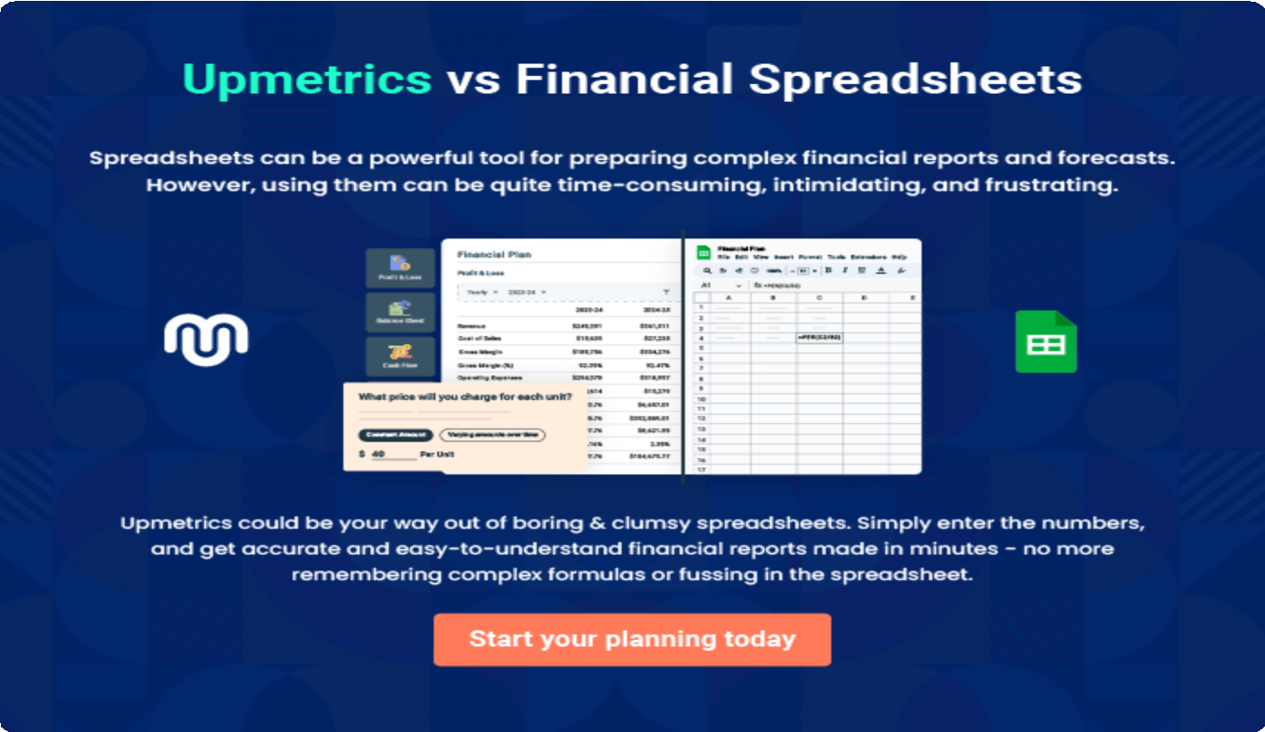

9.

Appendix
EmbedLink

Whenwritingtheappendixsection,youshouldincludeanyadditional
informationthatsupportsthemaincontentofyourplan.Thismayinclude
financialstatements,marketresearchdata,legaldocuments,andother
Tounlock helptry Upmetrics!
EmbedLink

Createawinningbusinessplanthatgetsyoufunded

Creatingastunningandinvestment-readyplanrequiresnowriting,graphicdesigning,orfinancial planning expertise.

Upmetricshasallthefeaturesrequiredtohelpyoucreateacomprehensivebusinessplan—fromstarttofinish. Makenomistakes,it’sthemodernwayofplanningtostructureideas,makeplans,andcreatestunningpitch decks to awe investors.

Pitchdecksthatimpressinvestors
Create pitch decks that provide a visual representation of your business, engage investors,andmakethemwanttoinvestinyour businessidea.

Interactiveplansinnotime
Import business plan sections like—SWOT analysis,comparisontables,andotherstocreate an interactive business plan. No designing skills arerequired.

Stunningcoverpagedesigns
WithUpmetrics,youhavethelibertytochoose from multiple stunning cover page designs.
Chooseacreativedesignandmakeyourplan standout.

500+samplebusinessplans
Simplyimportatemplatefromourlibraryof sample plans into the editor and start customizingittomakeityours.Ittakesonlyafew clicks to get started.

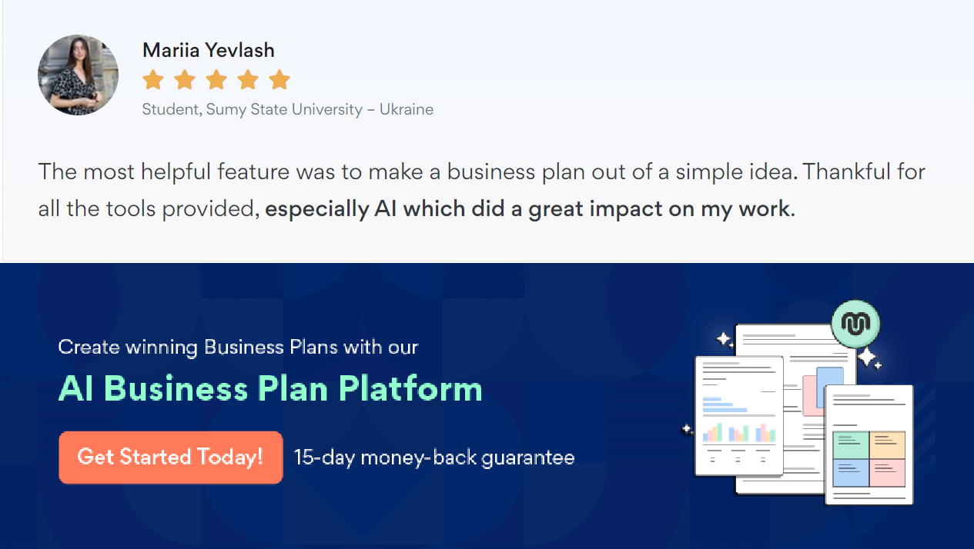Onlinesharingmadesimple
Upmetricsmakesonlinesharingquickandeasier forusers.Easilyshareyourbusinessplanswitha linkwhiletrackingreaderactivity.

Collaboratewithteaminreal-time
Invite team members, initiate conversations, discussideas&strategies,sharefeedback,and work on a business plan in real-time.

