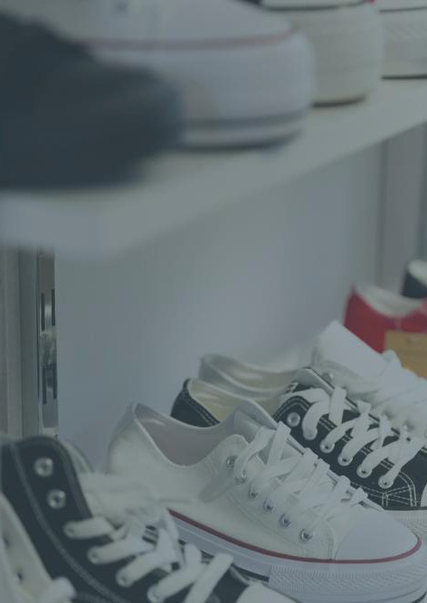

Sneaker Reselling
BusinessPlan
"FromSolestoSuccess."

Business Plan
2024

JohnDoe
10200BolsaAve,Westminster,CA,92683

(650)359-3153

info@example.comhttps://www.example.com/
CONFIDENTIAL

TableofContents

ExecutiveSummary
6
Marketopportunity 7
Products/ServicesOffered 7
Marketing&SalesStrategies 8
FinancialHighlights 8
UnitsSoldv/sRevenueChart 8
CompanyOverview
10
Ownership 11
BusinessOwners 11
Missionstatement 12
Business history 12
Futuregoals 12
MarketAnalysis
13
TargetMarket 14
Marketsizeandgrowthpotential 14
MarketSize 15
Competitiveanalysis 15
StockX 15
GOAT 15
FlightClub 16
Markettrends 16
Regulatoryenvironment 17
ProductsandServices
18
Products/Services 19
LimitedEditionSneakers 19
RetroandVintageModels 19
AthleteSignatureShoes 20
CustomCollaborations 20

Sneaker CareServices 20
SneakerMembershipProgram 21
Quality Measures 21
SalesAndMarketingStrategies
22
UniqueSellingProposition(USP) 23
PricingStrategy 23
Marketingstrategies 24
Online 24
Offline 24
Salesstrategies 25
Customerretention 25
OperationsPlan
27
Staffing&Training 28
OperationalProcess 28
Equipment&Technology 29
ManagementTeam
30
Keymanagers 31
EthanBlake 32
SophiaCarter 32
EmmaHayes 33
DanielTorres 33
Organizationalstructure 34
Organizationchart 34
Compensationplan 34
Boardofadvisors 35
MichaelTrent 35
LindaHoffman 35
Financial Plan
36
Profit&lossstatement 37

Cashflowstatement 42
Balancesheet 44
Break-evenPoint 46
Financingneeds 48
Appendix
50
EmbedLink 51


Businessplanningthat’ssimplerandfasterthanyouthink

CreatingabusinessplanusingUpmetricstostartandgrowabusinessisliterallytheeasiest thingintheWorld.Simplyreadtheinstructionsandfillintheblanks.It’sassimpleasthat.

Upmetrics has everything you need to create a comprehensive business plan.
❛
❜

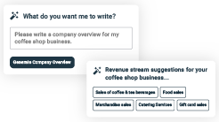
AI-poweredUpmetricsAssistant

AI-poweredinsightstostreamlineyourplan
Not sure where to start? Upmetrics’ AI Assistant will automaticallygenerateideasforeachsectionofyourplanand offerimprovedversionsofyourwriting,adjustingfortone,voice, and grammar or spelling errors.

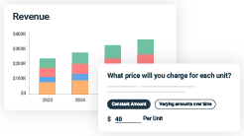
FinancialForecastingTool

Allthefinancialsarecalculatedforyou
Forget the complex formulas and clumsy spreadsheets — withautomaticfinancialsanddrag-and-dropforecasting,you canfinishyourplanfasterandbeconfidentthatyour numbers are accurate.

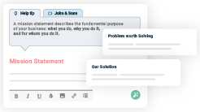
BusinessPlanBuilder

Guidesyoulikeabusinessmentor
Upmetrics’step-by-stepinstructions,prompts,andthelibraryof 400+samplebusinessplanswillguideyouthrougheachsection of your plan as a business mentor.

1.

ExecutiveSummary

Market opportunityProducts/Services OfferedMarketing & Sales StrategiesFinancial Highlights



Anexecutivesummaryisthefirstsectionofthebusinessplanintendedto provide an overview of the whole business plan.
Tounlock helptry Upmetrics!

Helptip
PrimeKicksResale
Startyourexecutivesummarybybrieflyintroducingyourbusinesstoyourreaders.

Thissectionmayincludethenameofyoursneakerresellingbusiness,itslocation,whenit was
Tounlock helptry Upmetrics!
Startwritinghere..

Marketopportunity

Helptip
PrimeKicksResale
Summarizeyourmarketresearch,includingmarketsize,growthpotential,andmarketing trends.
Tounlock helptry Upmetrics!
Startwritinghere..

Products/ServicesOffered

Helptip
PrimeKicksResale
Highlighttheservicesyouofferyourclients.TheUSPsanddifferentiatorsyouofferarealways a plus.
Tounlock helptry Upmetrics!
Startwritinghere..

Marketing&SalesStrategies

Helptip
PrimeKicksResale
Outline your sales and marketing strategies—what marketing platforms you use, how you plan on acquiring customers, etc.
Tounlock helptry Upmetrics!
Startwritinghere..

FinancialHighlights

Helptip
PrimeKicksResale
Brieflysummarizeyourfinancialprojectionsfortheinitialyearsofbusinessoperations.Include
anycapitalorinvestmentrequirements,associatedstartupcosts,projectedrevenues,and
profitforecasts.
Tounlock helptry Upmetrics!
Startwritinghere..

UnitsSoldv/sRevenueChart

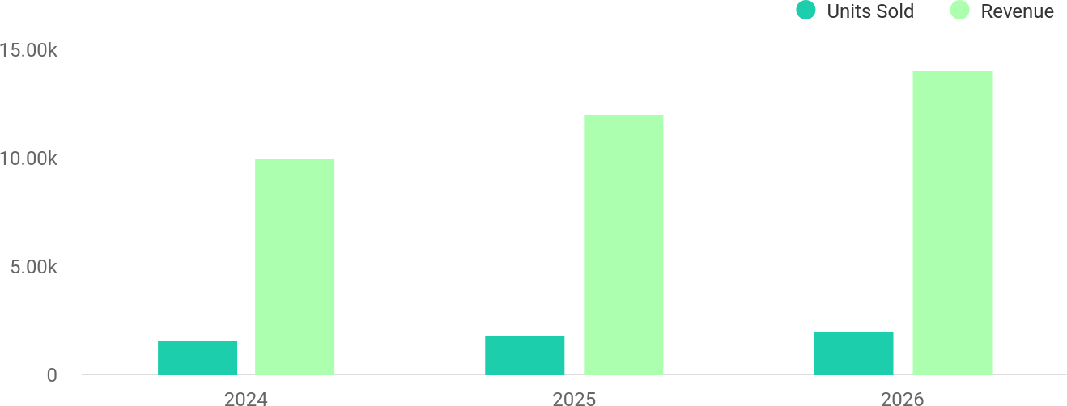

FinancialYear | UnitsSold | Revenue
2024 | 1,550 | $10,000
2025 | 1,800 | $12,000

FinancialYear | UnitsSold | Revenue
2026 | 2,050 | $14,000

Helptip
PrimeKicksResale
SummarizeyourexecutivesummarysectionwithaclearCTA,forexample,invitingangel investors to discuss the potential business investment.
Tounlock helptry Upmetrics!

Writeacalltoactionforyourbusinessplan.

2.

CompanyOverview

OwnershipMission statementBusiness historyFuture goals

Dependingonwhatdetailsofyourbusinessareessential,you’llneed different elements in your business overview.
Tounlock helptry Upmetrics!
Helptip
PrimeKicksResale
Describewhatkindofsneakerresellingcompanyyourunandthenameofit.Youmay specialize in one of the following sneaker reselling businesses:
Tounlock helptry Upmetrics!
Startwritinghere..

Ownership

Helptip
PrimeKicksResale
List the names of your sneaker reselling business’s founders or owners. Describe what shares they own and their responsibilities for efficiently managing the business.
Tounlock helptry Upmetrics!
Startwritinghere..

BusinessOwners

EthanBlake
70%

SophiaCarter
30%

Missionstatement

Helptip
PrimeKicksResale
Summarizeyourbusiness’objective,coreprinciples,andvaluesinyourmissionstatement.This statement needs to be memorable, clear, and brief.
Tounlock helptry Upmetrics!

At[PrimeKicksResale],ourmissionistoredefinethesneaker
❛
reselling experience by providing authentic, exclusive sneakers throughacustomer-centricapproach.Weaimtoinspire
confidence, fuel passion, and build a loyal community of sneakerenthusiasts.
❜

Businesshistory

Helptip
PrimeKicksResale
Ifyouhavebeeninthesneakerresellingbusinessforquitethepast,thenbrieflydescribeyour businesshistory,like—whenitwasfounded,howitevolvedovertime,etc.
Tounlock helptry Upmetrics!
Startwritinghere..

Futuregoals

Helptip
PrimeKicksResale
It’scrucialtoconveyyouraspirationsandvision.Mentionyourshort-termandlong-termgoals; they can be specific targets for revenue, market share, or expanding your services.
Tounlock helptry Upmetrics!
Startwritinghere..

3.

MarketAnalysis
TargetMarket
MarketsizeandgrowthpotentialCompetitive analysis
Market trendsRegulatoryenvironment

Marketanalysisprovidesaclearunderstandingofthemarketinwhichyour
printingbusinesswillrunalongwiththetargetmarket,competitors, and
growthopportunities.
Tounlock helptry Upmetrics!
Helptip
PrimeKicksResale
Towritetheintroductionsectionofyourmarketanalysis,startbyclearlyidentifyingyour primary target market.
Tounlock helptry Upmetrics!
Startwritinghere..

TargetMarket

Helptip
PrimeKicksResale
Startthissectionbydescribingyourtargetmarket.Defineyouridealcustomerandexplainwhat types of services they prefer.
Tounlock helptry Upmetrics!
Startwritinghere..

Marketsizeandgrowthpotential

Helptip
PrimeKicksResale
Describeyourmarketsize,growthpotential,andwhetheryouwilltargetanicheorbroader market.
Tounlock helptry Upmetrics!
Startwritinghere..

MarketSize

AvailableMarket
1B
Totalglobalsneakerbuyersannually.

ServedMarket
Buyersactiveinpremiumsneakerresale globally.

TargetMarket
US-basedsneakerenthusiasts,aged16-35.

250M

25M


Helptip
PrimeKicksResale
Identifyandanalyzeyourdirectandindirectcompetitors.Identifytheirstrengths and
weaknesses,anddescribewhatdifferentiatesyoursneakerresellingbusinessfromthem.Point
outhowyouhaveacompetitiveedgeinthemarket.
Tounlock helptry Upmetrics!

Competitiveanalysis

StockX
StockX is a leading sneaker reselling marketplace known for its unique "bid and ask" pricing model. It offers a transparent platform for buyers and sellers to transact.

Features
Real-timepricingbasedon supply and demand.
Authenticationofallsneakers sold on the platform.
Broad range of products, includingsneakers,apparel, andaccessories.

Strengths
Trustedauthentication process.
Transparentpricing mechanism.
Large customer base and strong brand reputation.

Weaknesses
Highsellerfees(around9.5%for new sellers).
Slow shipping times during peak demand.
Limitedpersonalizationfor buyers.

GOAT
GOATstands for "Greatest of AllTime" and is a sneaker marketplace with a strong focus on authenticity and premium sneaker collections.

Features
Hybridmarketplace(newand used sneakers).
AI-poweredsneaker authentication.
Flexiblepaymentoptions, including installment payments.

Strengths
Extensiveinventorywith exclusive, hard-to-find sneakers.
Strongmobile app experience.
Quick shipping options for premium customers.

Weaknesses
Higherpricesforbuyersdueto service fees.
Limitedofflinepresence.
Complexreturnprocessfor international customers.

FlightClub
FlightCluboperatesbothonlineandoffline,withbrick-and-mortarstoresinNewYork,LosAngeles, and Miami. It targets sneaker collectors and enthusiasts seeking in-store experiences.

Features
In-storeandonlinesneaker sales.
Exclusive sneaker collections from top brands.
Professional-grade sneaker cleaning and restoration services.

Strengths
Establishedofflinepresence with iconic retail stores.
Strong community and brand loyalty.
Uniquein-storeserviceslike sneaker customization.

Weaknesses
Higheroperationalcosts,leading to increased product prices.
Limitedglobalshippingoptions.
Smaller online inventory comparedtocompetitors.

Markettrends

Helptip
PrimeKicksResale
Analyze emerging trends in the industry, such as changes in customer behavior or preferences. Explain how your business will cope with all the trends.
Tounlock helptry Upmetrics!
Startwritinghere..

Regulatoryenvironment

Helptip
PrimeKicksResale
Listregulationsandlicensingrequirementsthatmayaffectyoursneakerresellingbusiness,
suchastrademark&intellectualpropertylaws,consumerprotectionlaws,onlineplatform
policies,authenticationregulations,etc.
Tounlock helptry Upmetrics!
Startwritinghere..

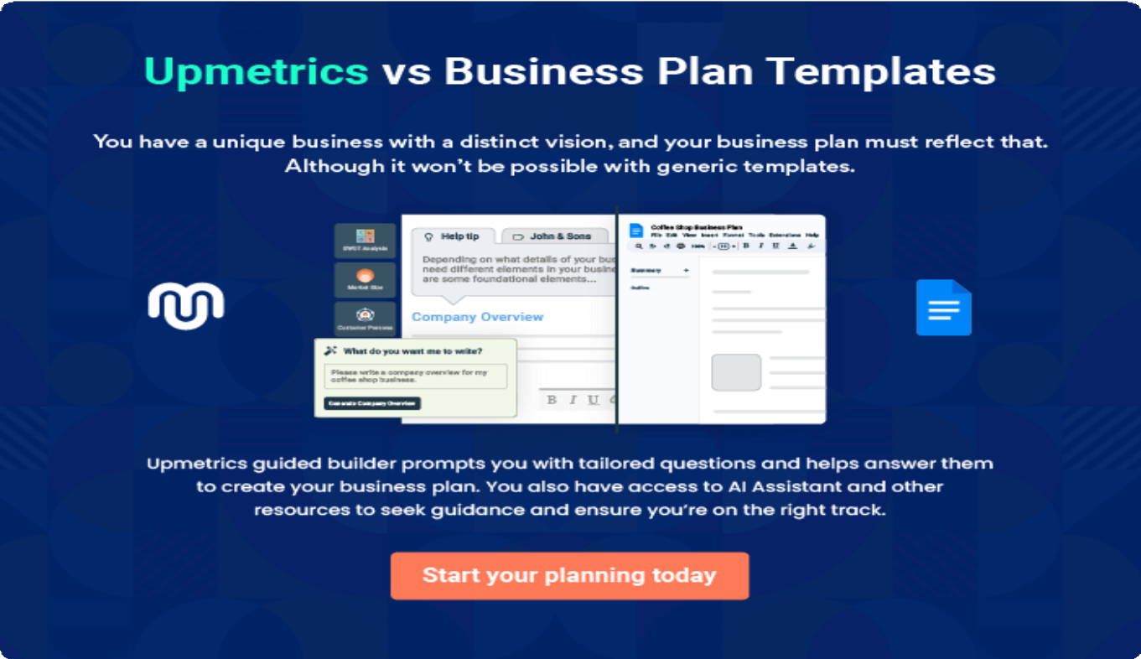

4.

Productsand Services

Products/ServicesQuality Measures

Theproductandservicessectionofasneakerresellingbusinessplanshould
describethespecificservicesandproductsthatwillbeofferedtocustomers.
Towritethissectionshouldincludethefollowing:
Tounlock helptry Upmetrics!
Helptip
PrimeKicksResale
Tocrafttheintroductionforyour"ProductsandServices"chapter,beginbypositioningyour business within its industry, emphasizing its unique strengths or value proposition.
Tounlock helptry Upmetrics!

Startwritinghere..
Helptip
The productsandservices asneakerresellingbusiness providesdifferdueto theirvision,
offerings,location,andvariousotherfactors.Buthereisagenerallistofproductsandservices
asneakerresellingbusinessmightprovide:
Tounlock helptry Upmetrics!

Products/Services


LimitedEditionSneakers
Price:[$250–$2,000+]

Exclusive sneakers from brands like Nike, Adidas, and Jordan,includingcollaborationsandspecialreleases.

ProductSpecifications
- Brandnew,authenticsneakers.
- Limitedstock availability.
- Sizesvary perrelease.

RetroandVintageModels
Price:[$200–$1,500+]

Iconic designs from past collections, sought after by collectors and nostalgic enthusiasts.

ProductSpecifications
  - Gentlyusedornew.
  - Gradedforcondition(A+,A,B).
  - Includesoriginalpackaging(ifavailable).

AthleteSignatureShoes
Price:[$300–$5,000+]

Sneakers endorsed by top athletes like Michael Jordan and LeBron James, including rare player editions.

ProductSpecifications
  - Exclusive athlete collaborations.
  - Limitedsizesandruns.
  - Guaranteedauthenticity.

CustomCollaborations
Price:[$500–$2,500+]

Uniquesneakersdesignedbyartistsoraspartoflimited- time brand collaborations.

Specifications
  - Specialeditionpackaging.
  - Artist-signedauthenticitycards(forselectreleases).

SneakerCareServices
Price:[$30–$100]

Professional cleaning and restoration services for worn sneakers.

ServiceSpecifications
  - Basiccleaning:[$30]
  - Deepcleaningandrestoration:[$100]

SneakerMembershipProgram
Price:[$100]/year

Exclusive membership perks, including early access to drops and discounts on purchases.

ServiceSpecifications
  - [10%]discountonallpurchases.
  - Monthlymember-exclusivenewsletter.
  - Prioritysupport.

QualityMeasures

Helptip
PrimeKicksResale
This section should explain how you maintain quality standards and consistently provide the highest quality service.
Tounlock helptry Upmetrics!
Startwritinghere..

5.

SalesAndMarketing
Strategies

Unique Selling Proposition (USP)Pricing Strategy
Marketing strategiesSales strategiesCustomer retention

Writing the sales and marketing strategies section means a list of strategies you will use to attract and retain your clients.
Tounlock helptry Upmetrics!
HelpTip
PrimeKicksResale
Tocreateaneffectiveintroductionforyour"SalesandMarketingStrategies"chapter,startby setting the stage within your specific industry or market.
Tounlock helptry Upmetrics!
Startwritinghere..

UniqueSellingProposition(USP)

Helptip
PrimeKicksResale
Define your business’s USPs depending on the market you serve, the equipment you use, and theuniqueservicesyouprovide.IdentifyingUSPswillhelpyouplanyourmarketingstrategies.
Tounlock helptry Upmetrics!
Startwritinghere..

PricingStrategy

Helptip
PrimeKicksResale
Outlineyourpricingstrategytoeffectivelypositionyourproductsandservicescompetitivelyin
thelocalmarket.Craftingastrategicapproachtopricingiscrucialforachievingacompetitive
edge.
Tounlock helptry Upmetrics!
Startwritinghere..

Helptip
Discussyourmarketingstrategiestomarketyourservices.Youmayincludesomeofthese
marketingstrategiesinyourbusinessplan—socialmediamarketing,Googleads,email
marketing,contentmarketing,andprintmarketing.
Tounlock helptry Upmetrics!

Marketingstrategies

Online



Offline

SocialMedia
Engaging content, influencer collaborations,andpaid ads on platforms like Instagram and TikTok.

ContentMarketing
Blog posts and videos showcasing sneaker trends,stylingtips,and market insights.

EmailMarketing
Personalized newsletters featuring product drops, promotions,andevent announcements.

GoogleAds
Targetedadcampaigns forsneakerenthusiasts searchingforexclusive releases.

Pop-UpEvents
Local events to build brand awareness and foster direct customer relationships.

Helptip
Outline the strategies you’ll implement to maximize your sales. Your sales strategies may includedirectsalescalls,partneringwithotherbusinesses,offeringreferralprograms,etc.
Tounlock helptry Upmetrics!

Salesstrategies

ReferralPrograms
Offering discounts or credits to customers who bring in new buyers.

DirectSalesCalls
Personalized outreach topotentialhigh-value customers and collectors.

Partnerships
Collaboratingwithlocal sneaker stores and fashion brands to expand our reach.

Helptip
Describeyourcustomerretentionstrategiesandhowyouplantoexecutethem.Forinstance, introducing loyalty programs, discounts on annual membership, personalized service, etc.
Tounlock helptry Upmetrics!

Customerretention

LoyaltyPrograms
Rewardsforfrequent buyers, such as discounts and early access to drops.

PersonalizedService
Customized recommendations basedonpurchase history and preferences.

ExclusivePerks
Special offers for members, such as free shipping or limited- edition giveaway

6.

OperationsPlan

Staffing & TrainingOperational ProcessEquipment&Technology

Whenwritingtheoperationsplansection,it’simportanttoconsiderthe various aspects of your business operations.
Tounlock helptry Upmetrics!
Helptip
PrimeKicksResale
Tocreateaneffectiveintroductionforyour"OperationalPlan"chapter,startbyemphasizingthe
pivotalroleofefficientoperationsinthesuccessofyourbusiness,underscoringhowthey
directlyimpactthequalityofservicesdelivered.
Tounlock helptry Upmetrics!
Startwritinghere..

Staffing&Training

Helptip
PrimeKicksResale
Mentionyourbusiness’sstaffingrequirements,includingthenumberofsalesassociatesor
authenticatorsneeded.Includetheirqualifications,thetrainingrequired,andthedutiestheywill
perform.
Tounlock helptry Upmetrics!
Startwritinghere..

OperationalProcess

Helptip
PrimeKicksResale
Outline theprocessesandproceduresyou willusetorunyoursneaker resellingbusiness.Your
operationalprocessesmayincludesourcingsneakers,authentication,inventorymanagement,
shipping & logistics, etc.
Tounlock helptry Upmetrics!
Startwritinghere..

Equipment&Technology

Helptip
PrimeKicksResale
Outline the essential medical supplies and equipment used for sneaker reselling services. Also, consider setting up technology and software systems to streamline your daily operations.
Tounlock helptry Upmetrics!
Startwritinghere..

7.

ManagementTeam

Key managersOrganizationalstructureCompensation planBoard of advisors

The management team section provides an overview of the individuals responsible for running your business plan.
Tounlock helptry Upmetrics!
Helptip
PrimeKicksResale
Tocraftanintroductionforyour"ManagementTeam"chapter,beginbyemphasizingthecrucial role of leadership in the success of any business.
Tounlock helptry Upmetrics!
Startwritinghere..

Keymanagers

Helptip
Mentionthefounders/CEOofyoursneakerresellingbusinessaswellasyourmanagementand
keymembersofyourteam.Describetheirrolesandresponsibilitiesinsuccessfullyrunningthe
business.
Tounlock helptry Upmetrics!
Startwritinghere..


EthanBlake

FounderandCEO-ethan.blake@example.com



Ethanoverseesstrategicplanning,partnerships,andtheoverallgrowthofthe business. He ensures that the company’s vision aligns with market demands and customer expectations.

EducationalBackground:

- Ethan holds a Bachelor’s degree in Business Administration from the University of California, Los Angeles (UCLA).

ProfessionalBackground:

- Ethanhasovereightyearsofexperienceinthee-commerceandretail industry, working with prominent online marketplaces and startups.
- His expertise in sneaker culture and passion for entrepreneurship inspired him to launch [PrimeKicks Resale], aiming to redefine the sneaker reselling experience.

SophiaCarter


MarketingManager-sophia.carter@example.com

Sophia leads marketing strategies, manages social media campaigns, and overseescollaborationswithinfluencerstoexpandthebrand’sreachanddrive sales.

EducationalBackground:

- Sophia holds a Master’s degree in Marketing from the University of Southern California (USC).

ProfessionalBackground:

- Sophiahasfiveyearsofexperienceindigitalbrandingandmarketing,with aproventrackrecordofgrowingonlinecommunitiesforfashionand lifestyle brands.
- Priortojoining[PrimeKicksResale],sheworkedasaDigitalMarketing Specialist for a popular streetwear brand, where she increased online engagement by 40%.


EmmaHayes

CustomerServiceManager-emma.hayes@example.com

Emma manages the customer support team, ensuring prompt and satisfactory responses to inquiries, resolving issues efficiently, and implementing loyalty programs.

EducationalBackground:

- Emma holds a Bachelor’s degree in Communications from the University of Texas, Austin.

ProfessionalBackground:

- Emma has seven years of experience in customer service, specializing in retailande-commerceindustries.
- Before joining [PrimeKicks Resale], she worked as a Customer Experience Lead for a nationwide electronics retailer, where she implemented new service protocols that increased customer retention by 20%.

DanielTorres


OperationsManager-daniel.torres@example.com

Danieloverseessourcing,inventorytracking,andlogisticstoensureefficient and timely delivery of sneakers to customers.

EducationalBackground:

- Daniel holds a Bachelor’s degree in Supply Chain Management from the University of Michigan.

ProfessionalBackground:

- Withoveradecadeofexperienceinlogisticsandinventorymanagement, Daniel has worked with top e-commerce platforms, ensuring efficient operations and cost reductions.
- Before joining [PrimeKicks Resale], Daniel was a Logistics Supervisor at a global distribution company, where he optimized shipping processes and reduced delivery times by 15%.

Organizationalstructure
Helptip
PrimeKicksResale
Explaintheorganizationalstructureofyourmanagementteam.Includethereportinglineand decision-making hierarchy.
Tounlock helptry Upmetrics!

Startwritinghere..

Organizationchart



EthanBlake Founderand CEO


DanielTorres Operations Manager
SophiaCarter Marketing Manager
EmmaHayes CustomerService Manager
KellyPatel Finance Manager


RyanMorrison Technology Lead

Compensationplan

Helptip
PrimeKicksResale
Describeyourcompensationplanforthemanagementandstaff.Includetheirsalaries, incentives, and other benefits.
Tounlock helptry Upmetrics!
Startwritinghere..

Helptip
Mentioningadvisorsorconsultantsinyourbusinessplansaddscredibilitytoyourbusiness idea.
Tounlock helptry Upmetrics!

Boardofadvisors

MichaelTrent


E-commerceAdvisor

Withover15yearsinonlineretail,Michaelprovidesinsightsintoscalingdigital platforms and optimizing customer journeys.


LindaHoffman

LegalConsultant

Linda specializes in intellectual property and consumer protection laws, ensuringcompliancewithregulationscriticaltothesneakerresalemarket.

8.

FinancialPlan

Profit&lossstatementCash flow statementBalance sheet
Break-evenPointFinancing needs

Helptip
Describedetailssuchasprojectedrevenue,operationalcosts,andservicecostsinyourprojectedprofitandlossstatement.Makesuretoinclude
yourbusiness’sexpectednetprofitorloss.

Whenwritingthefinancialplansectionofabusinessplan,it’simportanttoprovideacomprehensiveoverviewofyourfinancial projections for the first few years of your business, You may provide the following:
Tounlock helptry Upmetrics!
Helptip
PrimeKicksResale
Tocreateaneffectiveintroductionforyour"FinancialPlan"chapter,beginbystressingthecriticalroleofawell-structuredfinancialplaninthe success of your venture.
Tounlock helptry Upmetrics!
Startwritinghere..

Platform)
 |  | Tounlock helptry Upmetrics!
Profit&lossstatement  2024 | 2025 | 2026
Revenue $653,775.50 | $843,156.90 | $1,141,322.40
OnlineSales(E-commerce $380,460 | $428,691 | $483,051

 | 2024 | 2025 | 2026
UnitSales | 1,268 | 1,429 | 1,610
UnitPrice | $300 | $300 | $300
ConsignmentSales | $159,174.50 | $285,852 | $513,349.50
UnitSales | 3,183 | 5,717 | 10,267
UnitPrice | $50 | $50 | $50

Sneaker Cleaning & Restoration Services

$114,141 $128,613.90 $144,921.90

UnitSales | 3,805 | 4,287 | 4,831
UnitPrice | $30 | $30 | $30

CostOf Sales | $281,030.25 | $288,280.50 | $298,620.90
GeneralCosts | $281,030.25 | $288,280.50 | $298,620.90
Sneaker Procurement | $257,030.25 | $264,280.50 | $274,620.90
DirectPurchaseCosts | $240,000 | $240,000 | $240,000
Import/CustomsFees | $17,030.25 | $24,280.50 | $34,620.90
PackagingandShipping | $24,000 | $24,000 | $24,000
PremiumPackagingBoxes | $6,000 | $6,000 | $6,000

 | 2024 | 2025 | 2026
ShippingCosts | $18,000 | $18,000 | $18,000
RevenueSpecificCosts | $0 | $0 | $0
PersonnelCosts(Direct Labor) | $0 | $0 | $0

GrossMargin | $372,745.25 | $554,876.40 | $842,701.50
GrossMargin(%) | 57.01% | 65.81% | 73.84%

Operating Expense | $433,032.93 | $450,807.09 | $469,633.38
PayrollExpense(Indirect Labor) | $390,996 | $405,006.48 | $419,591.64
ManagementTeam | $97,200 | $102,060 | $107,163
BusinessOwner | $57,600 | $60,480 | $63,504
OperationsManager | $39,600 | $41,580 | $43,659
SalesandCustomer Support | $153,936 | $159,533.28 | $165,368.52
SalesRepresentative | $69,984 | $71,383.68 | $72,811.44
Customer Support Staff | $83,952 | $88,149.60 | $92,557.08

 | 2024 | 2025 | 2026
Warehouse andLogistics | $139,860 | $143,413.20 | $147,060.12
WarehouseWorker | $64,260 | $65,545.20 | $66,855.96
DeliveryDriver | $75,600 | $77,868 | $80,204.16
GeneralExpense | $42,036.93 | $45,800.61 | $50,041.74
Marketingand Advertising | $19,745.95 | $21,032.68 | $22,482.69
Digital Advertising | $10,145.95 | $11,432.68 | $12,882.69
InfluencerPartnerships | $9,600 | $9,600 | $9,600
StoreOperations | $20,823.72 | $23,236.34 | $25,955.06
Rent | $19,023.72 | $21,436.34 | $24,155.06
Utilities | $1,800 | $1,800 | $1,800
SoftwareandSubscriptions | $1,467.26 | $1,531.59 | $1,603.99
eCommerceSubscription | $960 | $960 | $960
AnalyticsTools | $507.26 | $571.59 | $643.99
BadDebt | $0 | $0 | $0
AmortizationofCurrent Assets | $0 | $0 | $0

 | 2024 | 2025 | 2026
EBITDA | ($60,287.68) | $104,069.31 | $373,068.12

AdditionalExpense | $13,808.44 | $12,187.41 | $10,483.41
LongTermDepreciation | $9,528 | $9,528 | $9,528
GainorlossfromSaleof Assets | $0 | $0 | $0
EBIT | ($69,815.68) | $94,541.31 | $363,540.12
InterestExpense | $4,280.43 | $2,659.39 | $955.41
EBT | ($74,096.12) | $91,881.90 | $362,584.71

IncomeTaxExpense/ Benefit

$0 $0 $0

TotalExpense | $727,871.62 | $751,275 | $778,737.69
NetIncome | ($74,096.12) | $91,881.90 | $362,584.71
NetIncome(%) | (11.33%) | 10.90% | 31.77%

RetainedEarningOpening $0 ($94,096.12) ($12,214.22)

Helptip
Thecashflowforthefirstfewyearsofyouroperationshouldbeestimatedanddescribedinthissection.Thismayincludebillinginvoices, payment receipts, loan payments, and any other cash flow statements.
Tounlock helptry Upmetrics!
 | 2024 | 2025 | 2026
Owner'sDistribution | $20,000 | $10,000 | $10,000
RetainedEarningClosing | ($94,096.12) | ($12,214.22) | $340,370.49

Cashflowstatement | 2024 | 2025 | 2026
CashReceived | $653,775.50 | $843,156.90 | $1,141,322.40
CashPaid | $718,343.62 | $741,747 | $769,209.69
COS&GeneralExpenses | $323,067.18 | $334,081.11 | $348,662.64
Salary&Wages | $390,996 | $405,006.48 | $419,591.64
Interest | $4,280.43 | $2,659.39 | $955.41
SalesTax | $0 | $0 | $0
IncomeTax | $0 | $0 | $0

Operations
2024 | 2025 | 2026
NetCashFrom ($64,568.12) | $101,409.90 | $372,112.71

AssetsSell | $0 | $0 | $0
AssetsPurchase | $80,000 | $0 | $0

NetCashFrom Investments

($80,000) $0 $0

AmountReceived | $160,000 | $60,000 | $60,000
LoanReceived | $100,000 | $0 | $0
CommonStock
PreferredStock | $0 | $0 | $0
Owner'sContribution | $60,000 | $60,000 | $60,000
AmountPaid | $51,684.64 | $43,305.67 | $45,009.66
LoanCapital | $31,684.65 | $33,305.69 | $35,009.66
Dividends&Distributions | $20,000 | $10,000 | $10,000

NetCashFrom Financing

$108,315.36 $16,694.33 $14,990.34

Helptip
Createaprojectedbalancesheetdocumentingyoursneakerresellingbusiness’sassets,liabilities,andequity.
2024 |  | 2025 | 2026
Summary
StartingCash | $0 | ($36,252.76) | $81,851.47
CashIn | $813,775.50 | $903,156.90 | $1,201,322.40
CashOut | $850,028.26 | $785,052.67 | $814,219.35
Change inCash | ($36,252.76) | $118,104.23 | $387,103.05
Ending Cash | ($36,252.76) | $81,851.47 | $468,954.52

 |  |  | Tounlock helptry Upmetrics!
Balancesheet | 2024 | 2025 | 2026
Assets | $34,219.24 | $142,795.47 | $520,370.52
CurrentAssets | ($36,252.76) | $81,851.47 | $468,954.52

 | 2024 | 2025 | 2026
Cash | ($36,252.76) | $81,851.47 | $468,954.52
AccountsReceivable | $0 | $0 | $0
Inventory | $0 | $0 | $0
OtherCurrentAssets | $0 | $0 | $0
LongTermAssets | $70,472 | $60,944 | $51,416
GrossLong TermAssets | $80,000 | $80,000 | $80,000
Accumulated Depreciation | ($9,528) | ($19,056) | ($28,584)

Liabilities&Equity | $34,219.23 | $142,795.44 | $520,370.49
Liabilities | $68,315.35 | $35,009.66 | $0
CurrentLiabilities | $33,305.67 | $35,009.66 | $0
AccountsPayable | $0 | $0 | $0
IncomeTaxPayable | $0 | $0 | $0
SalesTaxPayable | $0 | $0 | $0
ShortTermDebt | $33,305.67 | $35,009.66 | $0
LongTermLiabilities | $35,009.68 | $0 | $0
LongTermDebt | $35,009.68 | $0 | $0

 | 2024 | 2025 | 2026
Equity | ($34,096.12) | $107,785.78 | $520,370.49
Paid-inCapital | $0 | $0 | $0
CommonStock | $0 | $0 | $0
PreferredStock | $0 | $0 | $0
Owner'sContribution | $60,000 | $120,000 | $180,000
RetainedEarnings | ($94,096.12) | ($12,214.22) | $340,370.49

Check $0 $0 $0

Helptip
Determineandmentionyourbusiness’sbreak-evenpoint—thepointatwhichyourbusinesscostsandrevenuewillbeequal.

Thisexercisewillhelpyouunderstandhowmuchrevenueyouneedtogeneratetosustainorbeprofitable.
Tounlock helptry Upmetrics!

Break-evenPoint

2024 2025 2026

StartingRevenue $0 $653,775.50 $1,496,932.40

 | 2024 | 2025 | 2026
NetRevenue | $653,775.50 | $843,156.90 | $1,141,322.40
ClosingRevenue | $653,775.50 | $1,496,932.40 | $2,638,254.80
StartingExpense | $0 | $727,871.62 | $1,479,146.62
NetExpense | $727,871.62 | $751,275 | $778,737.69
ClosingExpense | $727,871.62 | $1,479,146.62 | $2,257,884.31
IsBreakEven? | No | Yes | Yes
BreakEvenMonth | 0 | Nov'25 | 0
DaysRequired | 0 | 28Days | 0
BreakEvenRevenue | $727,871.62 | $1,412,006.80 | $0
OnlineSales(E-commerce Platform) | $0 | $768,951.80 | $0
ConsignmentSales | $0 | $412,360.80 | $0

Sneaker Cleaning & RestorationServices
$0 $230,694.20 $0

BreakEvenUnits

Platform)
2024 | 2025 | 2026
OnlineSales(E-commerce 0 | 2,563 | 0
ConsignmentSales 0 | 8,247 | 0
SneakerCleaning& 0 | 7,690 | 0

RestorationServices

Financingneeds

Helptip
PrimeKicksResale
Calculate costs associated with starting a sneaker reselling business, and estimate your financing needs and how much capital you need to raise to operate your business.
Tounlock helptry Upmetrics!
Startwritinghere..

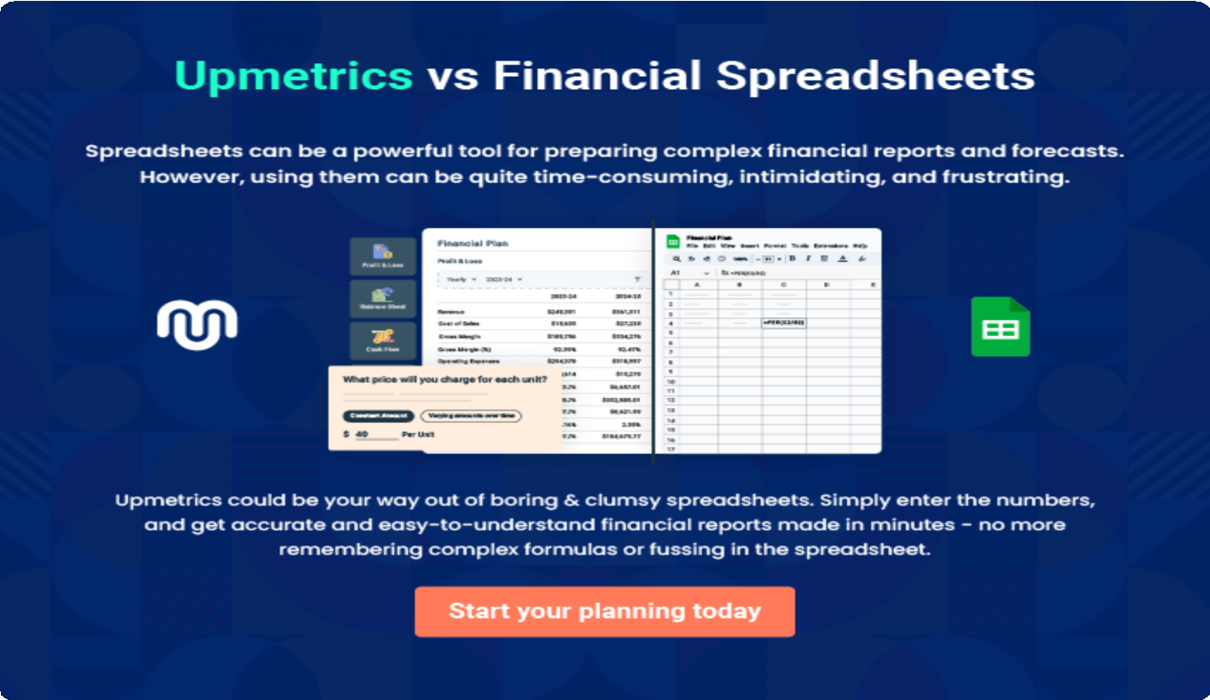

9.

Appendix
EmbedLink

Whenwritingtheappendixsection,youshouldincludeanyadditional
informationthatsupportsthemaincontentofyourplan.Thismayinclude
financialstatements,marketresearchdata,legaldocuments,andother
Tounlock helptry Upmetrics!
EmbedLink

Createawinningbusinessplanthatgetsyoufunded

Creatingastunningandinvestment-readyplanrequiresnowriting,graphicdesigning,orfinancial planning expertise.

Upmetricshasallthefeaturesrequiredtohelpyoucreateacomprehensivebusinessplan—fromstarttofinish. Makenomistakes,it’sthemodernwayofplanningtostructureideas,makeplans,andcreatestunningpitch decks to awe investors.

Pitchdecksthatimpressinvestors
Create pitch decks that provide a visual representation of your business, engage investors,andmakethemwanttoinvestinyour businessidea.

Interactiveplansinnotime
Import business plan sections like—SWOT analysis,comparisontables,andotherstocreate an interactive business plan. No designing skills arerequired.

Stunningcoverpagedesigns
WithUpmetrics,youhavethelibertytochoose from multiple stunning cover page designs.
Chooseacreativedesignandmakeyourplan standout.

500+samplebusinessplans
Simplyimportatemplatefromourlibraryof sample plans into the editor and start customizingittomakeityours.Ittakesonlyafew clicks to get started.

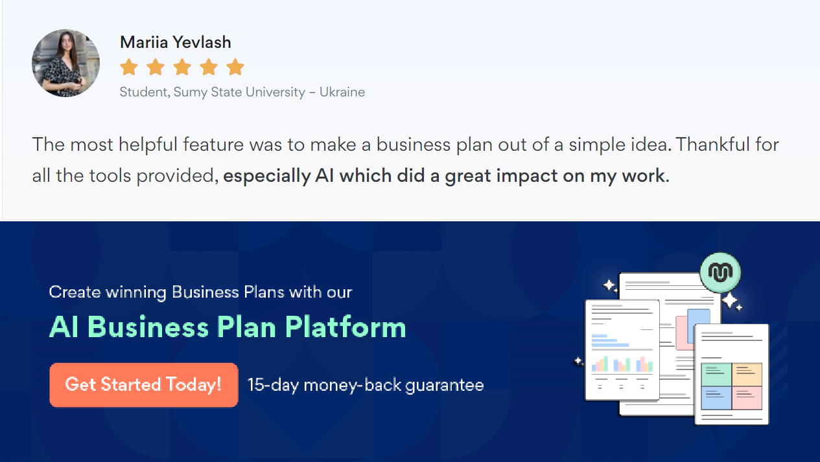Onlinesharingmadesimple
Upmetricsmakesonlinesharingquickandeasier forusers.Easilyshareyourbusinessplanswitha linkwhiletrackingreaderactivity.

Collaboratewithteaminreal-time
Invite team members, initiate conversations, discussideas&strategies,sharefeedback,and work on a business plan in real-time.

