

Sober Living Home Business Plan
"AFreshStart,ALifeRenewed."

BusinessPlan
2024

JohnDoe
10200BolsaAve,Westminster,CA,92683

(650)359-3153

info@example.comhttps://www.example.com/

Information provided in this business plan is unique to this business and confidential; therefore, anyone readingthisplanagreesnottodiscloseanyoftheinformationinthisbusinessplanwithoutpriorwritten permission of the company.

TableofContents

ExecutiveSummary
6
Marketopportunity 7
ServicesOffered 7
Marketing&SalesStrategies 8
FinancialHighlights 8
UnitsSoldv/sRevenueChart 8
CompanyOverview
10
Ownership 11
BusinessOwners 11
Missionstatement 11
Business history 12
Futuregoals 12
MarketAnalysis
13
TargetMarket 14
Marketsizeandgrowthpotential 14
MarketSize 15
Competitiveanalysis 15
Hope bytheSeaSoberLiving 15
Safe Harbor RecoveryHomes 15
Markettrends 16
Regulatoryenvironment 16
ProductsandServices
18
Services 19
ResidentialAccommodation 19
MealServices 19
DrugTesting 20
AdditionalServices 20

SalesAndMarketingStrategies
21
UniqueSellingProposition(USP) 22
PricingStrategy 22
Marketingstrategies 23
Online 23
Offline 23
Salesstrategies 24
Customerretention 24
OperationsPlan
26
Staffing&Training 27
OperationalProcess 27
Equipment&Tools 28
ManagementTeam
29
Keymanagers 30
Dr.EmilyHarper 31
MichaelLopez 31
RebeccaOwens 32
JamesTurner 32
Organizationalstructure 33
Organizationchart 33
Compensationplan 33
Boardofadvisors 34
JohnMatthews 34
Dr.RachelSimmons 34
Financial Plan
35
Profit&lossstatement 36
Cashflowstatement 41
Balancesheet 43
Break-evenPoint 45
Financingneeds 47

Appendix
49
EmbedLink 50


Businessplanningthat’ssimplerandfasterthanyouthink

CreatingabusinessplanusingUpmetricstostartandgrowabusinessisliterallytheeasiest thingintheWorld.Simplyreadtheinstructionsandfillintheblanks.It’sassimpleasthat.

Upmetrics has everything you need to create a comprehensive business plan.
❛
❜

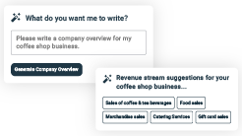
AI-poweredUpmetricsAssistant

AI-poweredinsightstostreamlineyourplan
Not sure where to start? Upmetrics’ AI Assistant will automaticallygenerateideasforeachsectionofyourplanand offerimprovedversionsofyourwriting,adjustingfortone,voice, and grammar or spelling errors.

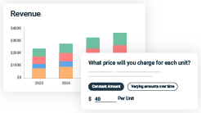
FinancialForecastingTool

Allthefinancialsarecalculatedforyou
Forget the complex formulas and clumsy spreadsheets — withautomaticfinancialsanddrag-and-dropforecasting,you canfinishyourplanfasterandbeconfidentthatyour numbers are accurate.

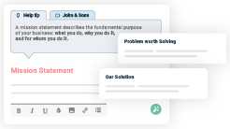
BusinessPlanBuilder

Guidesyoulikeabusinessmentor
Upmetrics’step-by-stepinstructions,prompts,andthelibraryof 400+samplebusinessplanswillguideyouthrougheachsection of your plan as a business mentor.

1.

ExecutiveSummary

MarketopportunityServices Offered
Marketing & Sales StrategiesFinancial Highlights



Anexecutivesummaryisthefirstsectionofthebusinessplanintendedto provide an overview of the whole business plan.
Tounlock helptry Upmetrics!

Helptip
PhoenixPathwaySoberLiving
Startyourexecutivesummarybybrieflyintroducingyourbusinesstoyourreaders.Itmust includetheinformationlikenameofyoursoberlivinghome,location,etc.
Tounlock helptry Upmetrics!
Startwritinghere..

Marketopportunity

Helptip
PhoenixPathwaySoberLiving
Summarizeyourmarketresearch,includingmarketsize,growthpotential,andmarketing trends.
Tounlock helptry Upmetrics!
Startwritinghere..

ServicesOffered

Helptip
PhoenixPathwaySoberLiving
Highlightthesoberlivinghomeservicesyouoffer.TheUSPsanddifferentiatorsyouofferare always a plus.
Tounlock helptry Upmetrics!
Startwritinghere..

Marketing&SalesStrategies

Helptip
PhoenixPathwaySoberLiving
Outline your sales and marketing strategies—what marketing platforms you use, how you plan on acquiring customers, etc.
Tounlock helptry Upmetrics!
Startwritinghere..

FinancialHighlights

Helptip
PhoenixPathwaySoberLiving
Brieflysummarizeyourfinancialprojectionsfortheinitialyearsofbusinessoperations.Include
capitalorinvestmentrequirements,associatedstartupcosts,projectedrevenues,andprofit
forecasts.
Tounlock helptry Upmetrics!
Startwritinghere..

UnitsSoldv/sRevenueChart

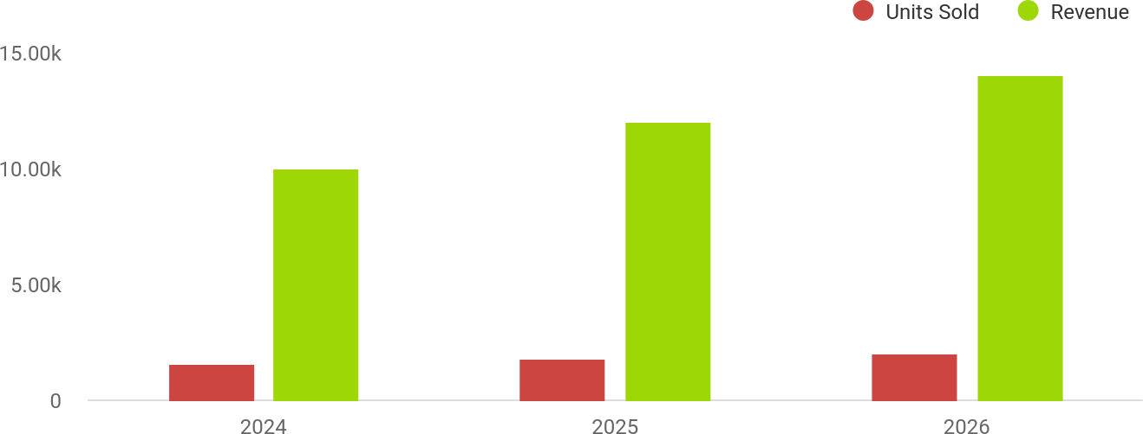

FinancialYear | UnitsSold | Revenue
2024 | 1,550 | $10,000
2025 | 1,800 | $12,000

FinancialYear | UnitsSold | Revenue
2026 | 2,050 | $14,000

Helptip
PhoenixPathwaySoberLiving
SummarizeyourexecutivesummarysectionwithaclearCTA,forexample,invitinginvestorsto discuss the potential business investment.
Tounlock helptry Upmetrics!

Writeacalltoactionforyourbusinessplan.

2.

CompanyOverview

OwnershipMission statementBusiness historyFuture goals

Dependingonwhatdetailsofyourbusinessareessential,you’llneed different elements in your business overview.
Tounlock helptry Upmetrics!
Helptip
PhoenixPathwaySoberLiving
Describewhatkindofsoberlivinghomebusinessyourunandtheregisterednameofit.You mayspecializeinoneofthefollowingsoberlivinghomebusinesses:
Tounlock helptry Upmetrics!
Startwritinghere..

Ownership

Helptip
PhoenixPathwaySoberLiving
List the names of your sober living home’s founders or owners. Describe how much shares they own and their responsibilities for efficiently managing the business.
Tounlock helptry Upmetrics!
Startwritinghere..

BusinessOwners

Dr.EmilyHarper
100%

Missionstatement


Helptip
PhoenixPathwaySoberLiving
Summarizeyourbusiness’objective,coreprinciples,andvaluesinyourmissionstatement.This statement needs to be memorable, clear, and brief.
Tounlock helptry Upmetrics!

Ourmissionat[PhoenixPathwaySoberLiving]istoempower
❛
individuals in recovery by providing a structured, compassionateenvironment that supports their journey to independence. We are committed to fostering a community of accountability, personal growth, and hope for a brighter future.
❜

Businesshistory

Helptip
PhoenixPathwaySoberLiving
Ifyou’reanestablishedsoberlivinghomeserviceprovider,brieflydescribeyourbusiness history,like—whenitwasfounded,howitevolvedovertime,etc.
Tounlock helptry Upmetrics!
Startwritinghere..

Futuregoals

Helptip
PhoenixPathwaySoberLiving
It’scrucialtoconveyyouraspirationsandvision.Mentionyourshort-termandlong-termgoals; they can be specific targets for revenue, market share, or expanding your services.
Tounlock helptry Upmetrics!
Startwritinghere..

3.

MarketAnalysis
TargetMarket
MarketsizeandgrowthpotentialCompetitive analysis
Market trendsRegulatoryenvironment

Marketanalysisprovidesaclearunderstandingofthemarketinwhichyour
printingbusinesswillrunalongwiththetargetmarket,competitors, and
growthopportunities.
Tounlock helptry Upmetrics!
Helptip
PhoenixPathwaySoberLiving
Towritetheintroductionsectionofyourmarketanalysis,startbyclearlyidentifyingyour primary target market.
Tounlock helptry Upmetrics!
Startwritinghere..

TargetMarket

Helptip
Phoenix Pathway Sober LivingPhoenix Pathway Sober Living
Startthissectionbydescribingyourtargetmarket.Defineyouridealcustomerandexplainwhat types of services they prefer.
Tounlock helptry Upmetrics!
Startwritinghere..

Marketsizeandgrowthpotential

Helptip
PhoenixPathwaySoberLiving
Describeyourmarketsizeandgrowthpotentialandwhetheryouwilltargetanicheoramuch broader market.
Tounlock helptry Upmetrics!
Startwritinghere..

MarketSize

AvailableMarket
TotalnumberofpeopleintheU.S.seeking recovery and addiction support services.
10M

ServedMarket
1M
IndividualsinCaliforniaseekingstructured sober living facilities for transitional recovery.

TargetMarket
Adultsaged18-50in[OrangeCounty,CA], seeking premium sober living environments.
50k

Helptip
PhoenixPathwaySoberLiving
Identifyandanalyzeyourdirectandindirectcompetitors.Identifytheirstrengths and
weaknesses,anddescribewhatdifferentiatesyourseniordaycareservicesfromthem. Point
outhowyouhaveacompetitiveedgeinthemarket.
Tounlock helptry Upmetrics!

Competitiveanalysis

HopebytheSeaSoberLiving
Hope by the Sea, located in San Juan Capistrano, CA, offers a range of sober living and addiction treatmentservices.Theyemphasizestructuredroutinesandastrongsupportnetworktoaidrecovery.

Features
Comfortableresidential accommodations.
Lifeskillstrainingandcareer support.
Accesstocounselingand therapyservices.

Strengths
Strong reputation and establishedpresenceinthe industry.
Comprehensive recovery programs and partnerships with treatment facilities.

Weaknesses
Limited focus on wellness programs like yoga or meditation.
Higher costs compared to other options,limitingaccessibilityfor some clients.

SafeHarborRecoveryHomes
Safe Harbor Recovery Homes, based in Costa Mesa, CA, provides sober living housing tailored primarily to women. Their programs emphasize peer accountability and building life skills.

Features
Women-focusedresidential facilities.
Strong community support and mentorshipprograms.
Vocational training and educational workshops.

Strengths
Niche focus on women’s recovery needs.
Affordablepricingcomparedto luxury options.

Weaknesses
Limited to women, excluding a significantportionofthemarket.
Feweramenitiesandwellness- focused programs.

Markettrends

Helptip
PhoenixPathwaySoberLiving
Analyze emerging trends in the industry, such as technology disruptions, changes in customer behavior or preferences, etc. Explain how your business will cope with all the trends.
Tounlock helptry Upmetrics!
Startwritinghere..

Regulatoryenvironment

Helptip
PhoenixPathwaySoberLiving
List regulations and licensing requirements that may affect your sober living home, such as age restrictions, licensing & permits, zoning regulations, etc.
Tounlock helptry Upmetrics!
Startwritinghere..

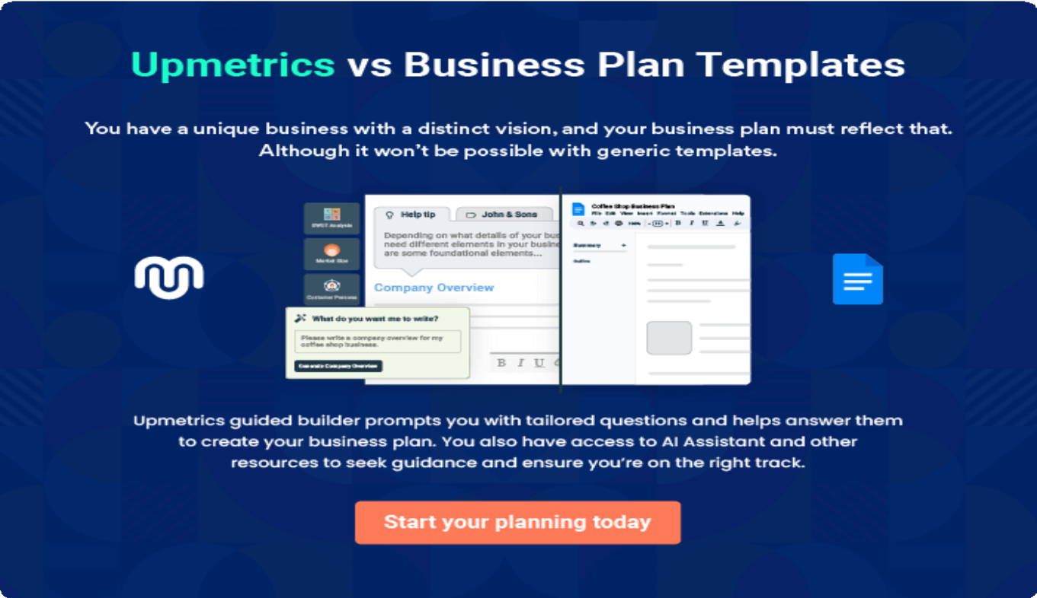

4.

Productsand Services

Services
AdditionalServices

Theproductandservicessectionofasoberlivinghomebusinessplan
shoulddescribethespecificservicesandproductsthatwillbeoffered to
customers.Towritethissectionshouldincludethefollowing:
Tounlock helptry Upmetrics!
Helptip
PhoenixPathwaySoberLiving,
Tocrafttheintroductionforyour"ProductsandServices"chapter,beginbypositioningyour business within its industry, emphasizing its unique strengths or value proposition.
Tounlock helptry Upmetrics!

Startwritinghere..
Helptip
Mentionthesoberlivinghomeproducts&servicesyouwilloffer.Thislistmayincludeservices like,
Tounlock helptry Upmetrics!

Services


ResidentialAccommodation

Price: [$1,500]/month (shared room), [$2,500]/month (private room)
Comfortable,fullyfurnishedroomsdesignedtoprovidea peaceful environment for recovery.

Specifications
- Sharedroomsaccommodate2-3residents.
- Private rooms include personal workspace and storage.
- Utilities,Wi-Fi,andhousekeepingincluded.
- Accesstocommunalspacessuchaslivingrooms, dining areas, and kitchens.

MealServices
Price:[$300]/monthperresident

Nutritiousmealplanstailoredtoresidents’dietaryneeds, prepared by professional kitchen staff.

Specifications
  - Threemealsperday,includingsnacks.
  - Optionsforvegetarian,vegan,andgluten-freediets.
  - Weeklymenuconsultationswith residents.

DrugTesting
Price:[$100]/monthperresident

Regularandrandomdrugtestingtoensureadrug-free environment and accountability.

Specifications
  - Testsconductedweeklyandasneeded.
  - Instantresultswithlabconfirmationifrequired.
  - Discreetandprofessionaltestingprocedures.

AdditionalServices

Helptip
PhoenixPathwaySoberLiving,
Ifyouconsiderofferingsupplementalservicesthatcomplementyourcoreofferings,mention them here.
Tounlock helptry Upmetrics!
Startwritinghere..

5.

SalesAndMarketing
Strategies

Unique Selling Proposition (USP)Pricing Strategy
Marketing strategiesSales strategiesCustomer retention

Writing the sales and marketing strategies section means a list of strategies you will use to attract and retain your clients.
Tounlock helptry Upmetrics!
HelpTip
PhoenixPathwaySoberLiving
Tocreateaneffectiveintroductionforyour"SalesandMarketingStrategies"chapter,startby setting the stage within your specific industry or market.
Tounlock helptry Upmetrics!
Startwritinghere..

UniqueSellingProposition(USP)

Helptip
PhoenixPathwaySoberLiving
Define your business’s USPs depending on the market you serve, the equipment you use, and theuniqueservicesyouprovide.IdentifyingUSPswillhelpyouplanyourmarketingstrategies.
Tounlock helptry Upmetrics!
Startwritinghere..

PricingStrategy

Helptip
PhoenixPathwaySoberLiving
Describeyourpricingstrategy—howyouplantopriceyourservicesandstaycompetitiveinthe local market. You can mention any discounts you plan on offering to attract new customers.
Tounlock helptry Upmetrics!
Startwritinghere..

Helptip
Discussyourmarketingstrategiestomarketyourservices.Youmayincludesomeofthese
marketing strategies inyour business plan—socialmedia marketing, brochures,content
marketing,printmarketing,etc.
Tounlock helptry Upmetrics!

Marketingstrategies

Online



Offline

GoogleAds
Targetedpay-per-click campaigns to increase online visibility.

ContentMarketing
Informative blog posts and guides on addiction recovery to build authority and trust.

SocialMedia Marketing
Regular updates, success stories, and wellness tips shared on platforms like Facebook, Instagram, and LinkedIn.

EmailCampaigns
Personalized outreach to rehabilitation centers, healthcare providers,andpotential residents.

PrintMarketing
Brochuresandflyersdistributedatlocalcommunitycenters,clinics,and events.

Helptip
Outlinethestrategiesyou’llimplementtomaximizeyoursales.Yoursalesstrategiesmay include direct sales calls, offering referral marketing, etc.
Tounlock helptry Upmetrics!

Salesstrategies

Partnerships
Collaborations with local rehab centers, hospitals,andaddiction recovery groups for resident referrals.

CommunityOutreach
Hosting workshops and events to connect with therecoverycommunity and build trust.

ReferralPrograms
Incentives for current residents and alumni to referfriendsandfamily.

Helptip
Describeyourcustomerretentionstrategiesandhowyouplantoexecutethem.Forinstance, introducing loyalty programs, discounts on annual membership, personalized service, etc
Tounlock helptry Upmetrics!

Customerretention

LoyaltyPrograms
Discounts for long-term residents and returning clients.

Personalized Services
Tailoringcareplansand services to meet individual needs.

AlumniSupport
Virtual support groups and ongoing access to resources for former residents.

6.

OperationsPlan

Staffing & TrainingOperational ProcessEquipment & Tools

Whenwritingtheoperationsplansection,it’simportanttoconsiderthe various aspects of your business operations.
Tounlock helptry Upmetrics!
Helptip
PhoenixPathwaySoberLiving
Tocreateaneffectiveintroductionforyour"OperationalPlan"chapter,startbyemphasizingthe
pivotalroleofefficientoperationsinthesuccessofyourbusiness,underscoringhowthey
directlyimpactthequalityofservicesdelivered.
Tounlock helptry Upmetrics!
Startwritinghere..

Staffing&Training

Helptip
PhoenixPathwaySoberLiving
Mention your business’s staffing requirements, including the number of employees or workers needed.Includetheirqualifications,theexperiencerequired,andthedutiestheywillperform.
Tounlock helptry Upmetrics!
Startwritinghere..

OperationalProcess

Helptip
PhoenixPathwaySoberLiving
Outlinetheprocessesandproceduresyouwillusetorunyoursoberlivinghome business.
Tounlock helptry Upmetrics!
Startwritinghere..

Equipment&Tools

Helptip
PhoenixPathwaySoberLiving
Outline the essential medical supplies and equipment used for sober living home services.Also, consider setting up technology and software systems to streamline your daily operations.
Tounlock helptry Upmetrics!
Startwritinghere..

7.

ManagementTeam

Key managersOrganizationalstructureCompensation planBoard of advisors

The management team section provides an overview of the individuals responsible for running your business plan.
Tounlock helptry Upmetrics!
Helptip
PhoenixPathwaySoberLiving
Tocraftanintroductionforyour"ManagementTeam"chapter,beginbyemphasizingthecrucial role of leadership in the success of any business.
Tounlock helptry Upmetrics!
Startwritinghere..

Keymanagers

Helptip
PhoenixPathwaySoberLiving
Introduceyourmanagementandkeymembersofyourteam,andexplaintheirrolesand responsibilities.
Tounlock helptry Upmetrics!
Startwritinghere..


Dr.EmilyHarper

Founder&CEO-emily.harper@example.com

Responsibilities:



- Overseestheoverallstrategicvision,operationalplanning,and community partnerships for Phoenix Pathway.
- Ensures compliance with regulatory standards and manages investor relations.

EducationalBackground:

- DoctorateinClinicalPsychologyfromtheUniversityofSouthern California.
- CertifiedAddictionRecoverySpecialist(CARS).

ProfessionalBackground:

- Over15yearsofexperienceinaddictionrecoveryandmentalhealth services.
- FormerDirectorofClinicalProgramsat[PathwaystoRecoveryCenter], whereshemanagedresidentialcarefacilitiesanddevelopedevidence- based recovery programs.

MichaelLopez


OperationsManager-michael.lopez@example.com

Responsibilities:

- Managesdailyoperations,staffscheduling,facilitymaintenance,and compliance with safety and health regulations.

Developsandmonitorsoperationalbudgetstoensurecost-effectiveness.

EducationalBackground:

- MBAinHealthcareManagementfromUCLAAndersonSchoolof Management.
- CertifiedFacilityManagementProfessional(CFMP).

ProfessionalBackground:

- 8yearsofexperiencemanagingresidentialcarefacilities,includingroles at [Healthy Horizons Housing].
- Expertiseinstafftraining,complianceoversight,andoperational efficiency.


RebeccaOwens

ClinicalProgramDirector-rebecca.owens@example.com

Responsibilities:

- Develops and oversees the implementation of recovery programs, wellness activities, and aftercare plans.
- Trainsandsupervisescasemanagerstoensurethehighestqualityof resident care.

EducationalBackground:

- Master’sinSocialWork(MSW)fromColumbiaUniversity.
- LicensedClinicalSocialWorker(LCSW).

ProfessionalBackground:

- 10 years of experience designing and implementing recovery programs in organizations like [Hope Haven Recovery].
- Specializedintrauma-informedcareandrelapsepreventionstrategies.

JamesTurner


MarketingandOutreachManager-alice.brown@example.com

Responsibilities:

- Develops and executes marketing strategies, manages digital campaigns, andbuildspartnershipswithlocalrehabcentersandhealthcareproviders.
- Overseescontentcreationforsocialmedia,emailcampaigns,andprint marketing materials.

EducationalBackground:

- Bachelor’sin Marketing fromCalifornia State University, Fullerton.
- Certified Digital MarketingProfessional (CDMP).

ProfessionalBackground:

- 7yearsofexperienceinhealthcaremarketing,includingrolesat [Renewed Life Solutions].
- Expertiseindigitalmarketing,communityengagement,andpartnership building.

Organizationalstructure

Helptip
PhoenixPathwaySoberLiving
Explaintheorganizationalstructureofyourmanagementteam.Includethereportinglineand decision-making hierarchy.
Tounlock helptry Upmetrics!
Startwritinghere..

Organizationchart

Dr.EmilyHarper
Founder&CEO


RebeccaOwens ClinicalProgram Director


MichaelLopez
OperationsManager
JamesTurner Marketingand OutreachManager



SamanthaCarter
CaseManager
JohnDavis SupportStaff Supervisor

Compensationplan

Helptip
PhoenixPathwaySoberLiving
Describeyourcompensationplanforthemanagementandstaff.Includetheirsalaries, incentives, and other benefits.
Tounlock helptry Upmetrics!
Startwritinghere..

Helptip
Mentioningadvisorsorconsultantsinyourbusinessplansaddscredibilitytoyourbusiness idea.
Tounlock helptry Upmetrics!

Boardofadvisors

JohnMatthews


LegalAdvisor

- Role: Ensures compliance with state and federal regulations, manages legal documentation, and provides guidance on liability matters.
- Experience:15yearsspecializinginhealthcareandhousinglaw.

Dr.RachelSimmons

AddictionRecoveryConsultant

- Role:Providesexpertguidanceonprogramdevelopmentandevidence- based practices.
- Experience:20yearsinaddictionrecovery,including5yearsasa consultant for rehabilitation centers.

8.

FinancialPlan

Profit&lossstatementCash flow statementBalance sheet
Break-evenPointFinancing needs

Helptip
Describedetailssuchasprojectedrevenue,operationalcosts,andservicecostsinyourprojectedprofitandlossstatement.Makesuretoinclude
yourbusiness’sexpectednetprofitorloss.

Whenwritingthefinancialplansectionofabusinessplan,it’simportanttoprovideacomprehensiveoverviewofyourfinancial projections for the first few years of your business, You may provide the following:
Tounlock helptry Upmetrics!
Helptip
PhoenixPathwaySoberLiving
Tocreateaneffectiveintroductionforyour"FinancialPlan"chapter,beginbystressingthecriticalroleofawell-structuredfinancialplaninthe success of your venture.
Tounlock helptry Upmetrics!
Startwritinghere..

 |  |  | Tounlock helptry Upmetrics!
Profit&lossstatement | 2024 | 2025 | 2026
Revenue | $612,719 | $1,746,994.34 | $3,184,324.78
ResidentialRent | $560,447.50 | $1,663,612 | $3,049,591.50

 | 2024 | 2025 | 2026
Users | 103 | 227 | 386
RecurringCharges | $800 | $800 | $800
TherapyServices | $23,887.50 | $42,913.50 | $77,034
UnitSales | 159 | 286 | 514
UnitPrice | $150 | $150 | $150
GroupWorkshops | $28,384 | $40,468.84 | $57,699.28

CostOf Sales | $157,899.28 | $282,539.80 | $442,783.37
GeneralCosts | $157,899.28 | $282,539.80 | $442,783.37
FacilityCosts | $116,077.99 | $224,808.49 | $362,608.46
Rent | $67,060.47 | $85,048.94 | $107,862.48
Utilities | $49,017.52 | $139,759.55 | $254,745.98
FoodandSupplies | $41,821.29 | $57,731.31 | $80,174.91
Groceries | $35,480.05 | $50,585.97 | $72,123.39
CleaningSupplies | $6,341.24 | $7,145.34 | $8,051.52
RevenueSpecificCosts | $0 | $0 | $0

Labor)
2024 | 2025 | 2026
PersonnelCosts(Direct $0 | $0 | $0

GrossMargin | $454,819.72 | $1,464,454.54 | $2,741,541.41
GrossMargin(%) | 74.23% | 83.83% | 86.09%

Operating Expense | $571,716.91 | $616,973.77 | $669,367.92
PayrollExpense(Indirect Labor) | $525,180 | $546,142.80 | $567,978
ManagementTeam | $149,640 | $156,315.60 | $163,292.76
Facility Manager | $69,000 | $72,450 | $76,072.56
OperationsManager | $80,640 | $83,865.60 | $87,220.20
SupportStaff | $179,640 | $185,029.20 | $190,580.16
Housekeepers | $99,000 | $101,970 | $105,029.28
MaintenanceStaff | $80,640 | $83,059.20 | $85,550.88
SpecializedStaff | $195,900 | $204,798 | $214,105.08
Therapist | $106,200 | $111,510 | $117,085.56

 | 2024 | 2025 | 2026
CaseManager | $89,700 | $93,288 | $97,019.52
GeneralExpense | $46,536.91 | $70,830.99 | $101,389.94
AdministrativeCosts | $14,654.38 | $37,339.89 | $66,086.50
OfficeSupplies | $2,400 | $2,400 | $2,400
SoftwareSubscriptions | $12,254.38 | $34,939.89 | $63,686.50
Marketingand Advertising | $18,682.53 | $20,291.10 | $22,103.44
Digital Ads | $12,682.53 | $14,291.10 | $16,103.44
CommunityOutreach Programs | $6,000 | $6,000 | $6,000
MaintenanceandRepairs | $13,200 | $13,200 | $13,200
BuildingMaintenance | $9,600 | $9,600 | $9,600
RepairCosts | $3,600 | $3,600 | $3,600
BadDebt | $0 | $0 | $0
AmortizationofCurrent Assets | $0 | $0 | $0

EBITDA ($116,897.19) $847,480.78 $2,072,173.47

 | 2024 | 2025 | 2026
AdditionalExpense | $24,469.88 | $31,651.26 | $27,510.07
LongTermDepreciation | $14,134.80 | $25,140 | $25,140
GainorlossfromSaleof Assets | $0 | $0 | $0
EBIT | ($131,031.99) | $822,340.78 | $2,047,033.47
InterestExpense | $10,335.07 | $6,511.26 | $2,370.07
EBT | ($141,367.07) | $815,829.52 | $2,044,663.40

IncomeTaxExpense/ Benefit

$0 $0 $0

TotalExpense | $754,086.07 | $931,164.82 | $1,139,661.38
NetIncome | ($141,367.07) | $815,829.52 | $2,044,663.40
NetIncome(%) | (23.07%) | 46.70% | 64.21%

RetainedEarningOpening | $0 | ($181,367.07) | $614,462.45
Owner'sDistribution | $40,000 | $20,000 | $20,000
RetainedEarningClosing | ($181,367.07) | $614,462.45 | $2,639,125.85

Cashflowstatement | 2024 | 2025 | 2026
CashReceived | $612,719 | $1,746,994.34 | $3,184,324.78
CashPaid | $739,951.27 | $906,024.82 | $1,114,521.38
COS&GeneralExpenses | $204,436.19 | $353,370.76 | $544,173.31
Salary&Wages | $525,180 | $546,142.80 | $567,978
Interest | $10,335.07 | $6,511.26 | $2,370.07
SalesTax | $0 | $0 | $0
IncomeTax | $0 | $0 | $0

NetCashFrom Operations

($127,232.27) $840,969.52 $2,069,803.40

Helptip
Thecashflowforthefirstfewyearsofyouroperationshouldbeestimatedanddescribedinthissection.Thismayincludebillinginvoices, payment receipts, loan payments, and any other cash flow statements.
Tounlock helptry Upmetrics!

AssetsSell $0 $0 $0

 | 2024 | 2025 | 2026
AssetsPurchase | $49,000 | $24,000 | $24,000

NetCashFrom Investments

($49,000) ($24,000) ($24,000)

AmountReceived | $200,000 | $0 | $0
LoanReceived | $150,000 | $0 | $0
CommonStock
PreferredStock | $0 | $0 | $0
Owner'sContribution | $50,000 | $0 | $0
AmountPaid | $86,070.32 | $69,894.14 | $74,035.53
LoanCapital | $46,070.33 | $49,894.14 | $54,035.53
Dividends&Distributions | $40,000 | $20,000 | $20,000

NetCashFrom Financing

$113,929.68 ($69,894.14) ($74,035.53)

Summary

StartingCash $0 ($62,302.59) $684,772.79

 | 2024 | 2025 | 2026
CashIn | $812,719 | $1,746,994.34 | $3,184,324.78
CashOut | $875,021.59 | $999,918.96 | $1,212,556.91
Change inCash | ($62,302.59) | $747,075.38 | $1,971,767.87
Ending Cash | ($62,302.59) | $684,772.79 | $2,656,540.66

Helptip
Createaprojectedbalancesheetdocumentingyoursoberlivinghome’sassets,liabilities,andequity.
Tounlock helptry Upmetrics!

Balancesheet | 2024 | 2025 | 2026
Assets | ($27,437.39) | $718,497.99 | $2,689,125.86
CurrentAssets | ($62,302.59) | $684,772.79 | $2,656,540.66
Cash | ($62,302.59) | $684,772.79 | $2,656,540.66
AccountsReceivable | $0 | $0 | $0
Inventory | $0 | $0 | $0

 | 2024 | 2025 | 2026
OtherCurrentAssets | $0 | $0 | $0
LongTermAssets | $34,865.20 | $33,725.20 | $32,585.20
GrossLong TermAssets | $49,000 | $73,000 | $97,000
Accumulated Depreciation | ($14,134.80) | ($39,274.80) | ($64,414.80)

Liabilities&Equity | ($27,437.40) | $718,497.98 | $2,689,125.85
Liabilities | $103,929.67 | $54,035.53 | $0
CurrentLiabilities | $49,894.14 | $54,035.53 | $0
AccountsPayable | $0 | $0 | $0
IncomeTaxPayable | $0 | $0 | $0
SalesTaxPayable | $0 | $0 | $0
ShortTermDebt | $49,894.14 | $54,035.53 | $0
LongTermLiabilities | $54,035.53 | $0 | $0
LongTermDebt | $54,035.53 | $0 | $0
Equity | ($131,367.07) | $664,462.45 | $2,689,125.85
Paid-inCapital | $0 | $0 | $0
CommonStock | $0 | $0 | $0

Helptip
Determineandmentionyourbusiness’sbreak-evenpoint—thepointatwhichyourbusinesscostsandrevenuewillbeequal.

Thisexercisewillhelpyouunderstandhowmuchrevenueyouneedtogeneratetosustainorbeprofitable.
 | 2024 | 2025 | 2026
PreferredStock | $0 | $0 | $0
Owner'sContribution | $50,000 | $50,000 | $50,000
RetainedEarnings | ($181,367.07) | $614,462.45 | $2,639,125.85

Check $0 $0 $0

 |  |  | Tounlock helptry Upmetrics!
Break-evenPoint | 2024 | 2025 | 2026
StartingRevenue | $0 | $612,719 | $2,359,713.34
NetRevenue | $612,719 | $1,746,994.34 | $3,184,324.78
ClosingRevenue | $612,719 | $2,359,713.34 | $5,544,038.12

 | 2024 | 2025 | 2026
StartingExpense | $0 | $754,086.07 | $1,685,250.89
NetExpense | $754,086.07 | $931,164.82 | $1,139,661.38
ClosingExpense | $754,086.07 | $1,685,250.89 | $2,824,912.27

IsBreakEven? | No | Yes | Yes
BreakEvenMonth | 0 | Apr'25 | 0
DaysRequired | 0 | 24Days | 0
BreakEvenRevenue | $754,086.07 | $1,032,468.38 | $0
ResidentialRent | $0 | $957,891.20 | $0
TherapyServices | $0 | $34,886.70 | $0
GroupWorkshops | $0 | $39,690.48 | $0
BreakEvenUnits
ResidentialRent | 0 | 141 | 0
TherapyServices | 0 | 233 | 0
GroupWorkshops | $0 | $39,690.48 | $0

Financingneeds

Helptip
PhoenixPathwaySoberLiving
Calculate costs associated with starting a sober living business, and estimate your financing needs and how much capital you need to raise to operate your business.
Tounlock helptry Upmetrics!
Startwritinghere..

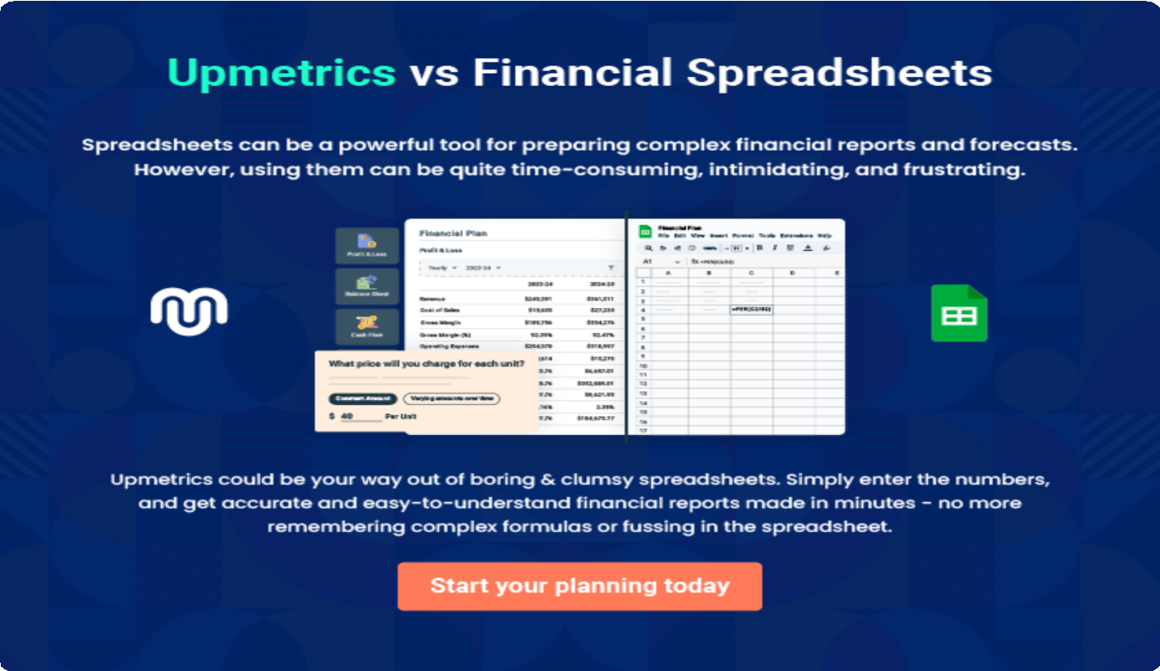

9.

Appendix
EmbedLink

Whenwritingtheappendixsection,youshouldincludeanyadditional
informationthatsupportsthemaincontentofyourplan.Thismayinclude
financialstatements,marketresearchdata,legaldocuments,andother
Tounlock helptry Upmetrics!
EmbedLink

Createawinningbusinessplanthatgetsyoufunded

Creatingastunningandinvestment-readyplanrequiresnowriting,graphicdesigning,orfinancial planning expertise.

Upmetricshasallthefeaturesrequiredtohelpyoucreateacomprehensivebusinessplan—fromstarttofinish. Makenomistakes,it’sthemodernwayofplanningtostructureideas,makeplans,andcreatestunningpitch decks to awe investors.

Pitchdecksthatimpressinvestors
Create pitch decks that provide a visual representation of your business, engage investors,andmakethemwanttoinvestinyour businessidea.

Interactiveplansinnotime
Import business plan sections like—SWOT analysis,comparisontables,andotherstocreate an interactive business plan. No designing skills arerequired.

Stunningcoverpagedesigns
WithUpmetrics,youhavethelibertytochoose from multiple stunning cover page designs.
Chooseacreativedesignandmakeyourplan standout.

500+samplebusinessplans
Simplyimportatemplatefromourlibraryof sample plans into the editor and start customizingittomakeityours.Ittakesonlyafew clicks to get started.

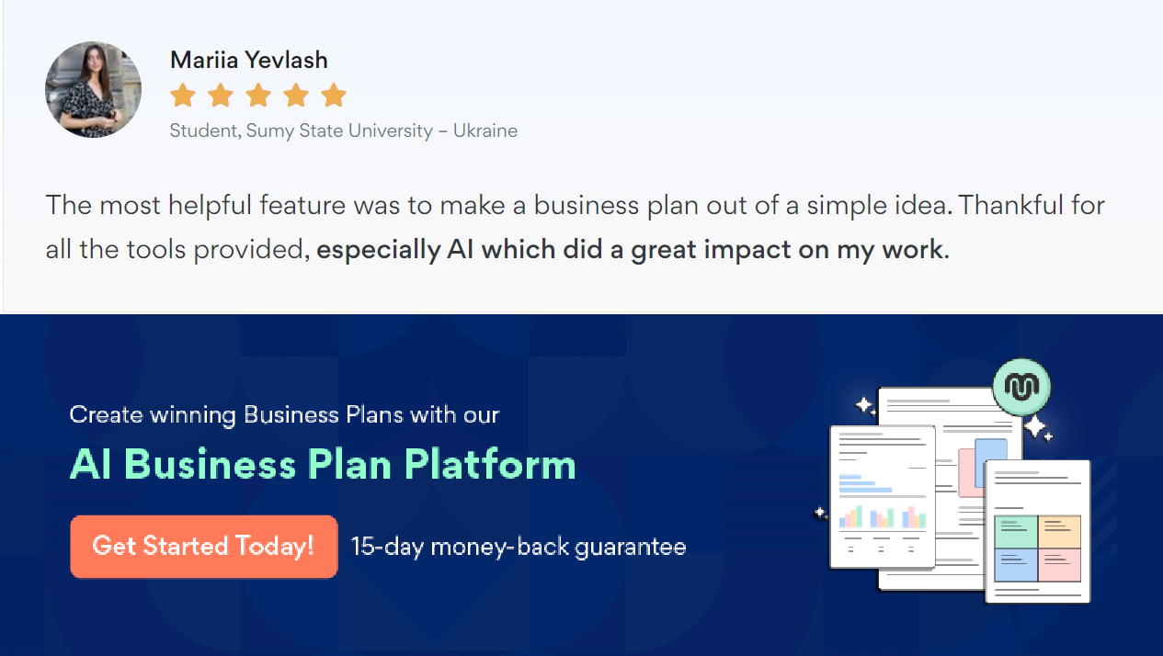Onlinesharingmadesimple
Upmetricsmakesonlinesharingquickandeasier forusers.Easilyshareyourbusinessplanswitha linkwhiletrackingreaderactivity.

Collaboratewithteaminreal-time
Invite team members, initiate conversations, discussideas&strategies,sharefeedback,and work on a business plan in real-time.

