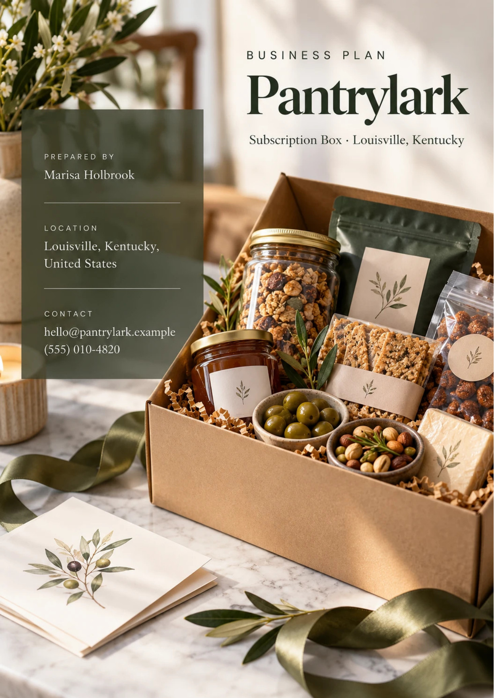
Table of Contents
1. Executive Summary 6
1.1 Business Overview 7
1.2 Mission Statement 7
1.3 Market Opportunity 7
1.4 Unique Selling Points 7
1.5 Financial Highlights 8
1.6 Funding Requirement 8
1.6.1 Income Statement (3 Year projections) 8
2. Company Overview 9
2.1 Legal Structure 10
2.2 Vision Statement 10
2.3 Background & History 10
2.4 Future Goals 10
2.4.1 Business Owners 11
2.4.2 SMART Goal 11
3. Market Analysis 12
3.1 Overview 13
3.2 Market Segmentation 13
3.3 Market Trends 13
3.4 Market Size 13
3.4.1 PESTEL Analysis 14
4. Customer Analysis 16
4.1 Target Market 17
4.2 Customer Segments 17
4.3 Customer Persona 18
4.4 Customer Purchase Journey 18
5. Competitive Analysis 19
5.1 Competitors 20
5.2 Comparison 20
5.3 Competitive Edge 21
5.4 SWOT Analysis 22
6. Products & Services 23
6.1 Our Offering 24
6.2 Signature Items 24
6.3 Additional Services 24
6.4 What Sets Us Apart 24
6.5 Box Curation & Maker Sourcing 25
6.5.1 The Monthly Snack Box 25
6.5.2 Gift Subscriptions 26
6.5.3 Features 26
6.5.4 Pricing 27
7. Marketing & Sales Strategies 28
7.1 Market Positioning 29
7.2 Marketing Objectives 29
7.3 Online Marketing 30
7.4 Public Relations and Branding 30
7.5 Partnership & Collaboration Strategy 30
7.6 Customer Loyalty & Retention 30
7.7 Sales Channels 31
8. Operations Plan 32
8.1 Daily Operations 33
8.2 Staffing & Training 33
8.3 Inventory & Equipment Management 33
8.4 Location and Facilities 33
8.5 Milestones & Timeline 34
8.6 Monthly Fulfillment & Shipping 35
9. Management Team 36
9.1 Key Members 37
9.2 Organization Chart 37
9.3 Advisory Board Members 38
9.3.1 Hiring Plan 38
10. Financial Plan 39
10.1 Key Assumptions 40
10.2 Capital Requirements and Use of Funds 40
10.2.1 Use of Funds 41
10.3 Income Statement (3 Year projections) 42
10.4 Balance Sheet (3 Year projections) 43
10.5 Cash Flow Statement (3 Year projections) 44
10.6 Break Even Analysis 45
11. References 46


CHAPTER 1

Executive Summary

1.1 Business Overview
1.2 Mission Statement
1.3 Market Opportunity
1.4 Unique Selling Points
1.5 Financial Highlights
1.6 Funding Requirement

1.1 Business Overview
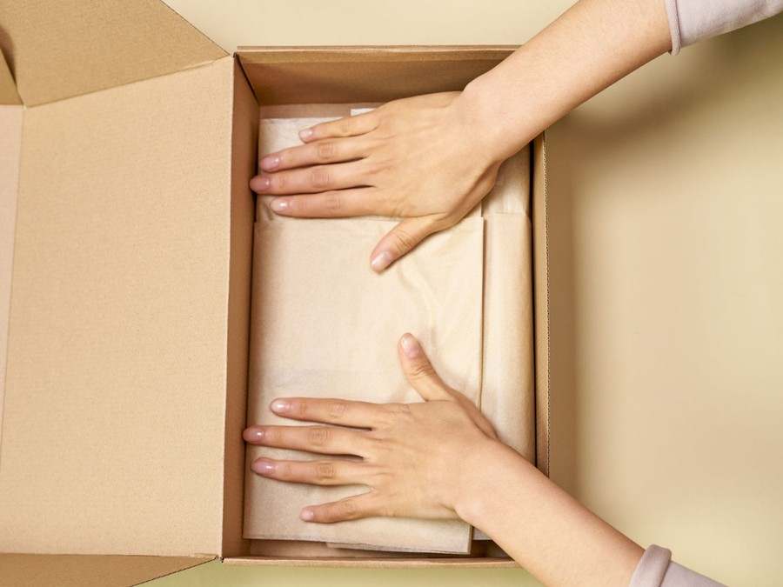
Pantrylark is a monthly snack subscription box based in Louisville, Kentucky. Each month it ships subscribers across the United States a themed box of eight to ten small-batch snacks bought directly from independent American makers: kettle chips, jerky, cookies, candy, popcorn and pantry condiments from producers too small for a supermarket shelf.
Subscribers pay $49 a month or prepay three, six or twelve months at a lower price per box, and gift subscriptions and one-off gift boxes are sold alongside them. Founders Marisa Holbrook and Andre Whitfield plan to ship the first box in March 2027 from a packing room on Louisville's south side.

1.2 Mission Statement
To bring the work of America's small snack makers to doorsteps every month, chosen with care, described honestly and packed so it arrives the way it left the kitchen.

1.3 Market Opportunity
Snacks and drinks are the subscription box Americans use most: 14% of adults subscribe to one, ahead of clothing at 12%, and convenience and the chance to try new products are the reasons subscribers give most often.
The U.S. subscription box market was about $10.9 billion in 2025 and is forecast to grow 17.11% a year to 2034, and food and beverage boxes account for about $3.64 billion of U.S. box revenue.
Pantrylark sells to that national market from a city built around parcels. Louisville is home to UPS Worldport, which handles about 2 million packages a day, so the packing room sits beside dense carrier networks and a deep pool of warehouse labor, in a market where industrial space averages $6.78 a square foot.

1.4 Unique Selling Points
- Makers, not brands: every item comes from an independent American producer, and a menu card in each box tells subscribers who made it and where to buy more.
- One theme a month: each box is built around an idea, such as smoke and spice or a Southern porch, so it reads as a collection rather than a bag of samples.
- Clear allergen information: the menu card lists the declared allergens of every item, and a peanut and tree nut free version of each box is offered.
- Easy to pause, skip or cancel online: no subscriber has to call or email to stop a charge.
- Gift subscriptions that end when they are meant to, with no renewal the recipient did not ask for.

1.5 Financial Highlights
Pantrylark projects revenue of $409,266 in its first year, $491,119 in the second and $589,342 in the third, at a 46.0% gross margin throughout. Net income is $5,375 in the first year, rising to $13,699 and then $23,589 as fixed costs are spread across a larger subscriber book.
Break-even revenue is $357,214, the equivalent of 676 subscribers, a level the book is planned to pass during the first year. In the conservative case, with slower acquisition, higher churn and a lower average box price, third-year net income is $12,219; in the upside case it is $40,040.

1.6 Funding Requirement
Pantrylark needs $66,700 to launch. The two founders are contributing $30,000 of their own savings, $15,000 each, and the remaining $40,000 is sought as an SBA Microloan through a Louisville community lender at about 9.5% over six years.
The money buys the first two months of snacks, the first run of printed boxes, the packing room's equipment and move-in costs, the website and subscription checkout, a $14,000 pre-launch campaign to build the waitlist, and a $12,000 working capital reserve.
The plan rests on a product Americans already subscribe to, filled with makers the large retailers pass over, and sold nationally from a low-cost packing room beside one of the country's largest parcel networks. The founders' savings and the loan carry Pantrylark from a waitlist to a profitable subscriber book in its first year.

1.6.1 Income Statement (3 Year projections)
 | Year 1 | Year 2 | Year 3 | Total
Revenue | $409,265.50 | $491,118.60 | $589,342.32 | $1,489,726.42
Cost of Sales | $221,003.37 | $265,204.04 | $318,244.85 | $804,452.26
Gross Margin | $188,262.13 | $225,914.56 | $271,097.47 | $685,274.16
Operating Expense | $164,318.64 | $190,102.37 | $221,042.84 | $575,463.85
Total Expense | $403,890.74 | $477,419.17 | $565,753.35 | $1,447,063.26
Net Income | $5,374.76 | $13,699.43 | $23,588.97 | $42,663.16

CHAPTER 2

Company Overview

2.1 Legal Structure
2.2 Vision Statement
2.3 Background & History
2.4 Future Goals

2.1 Legal Structure
Pantrylark will be organized as a Kentucky limited liability company, Pantrylark LLC, registered with the Kentucky Secretary of State and owned in equal shares by its two founders, Marisa Holbrook and Andre Whitfield. The LLC form limits each founder's personal liability, and the operating agreement sets out how decisions are made, that profits stay in the business for the first three years, and what happens to a founder's share if either leaves.
Pantrylark will register with Louisville Metro for the occupational license tax, register for sales tax wherever its sales require it, and carry product and general liability insurance.

2.2 Vision Statement
Pantrylark's vision is to become the way Americans discover small-batch snacks: a monthly box trusted enough that subscribers go on to buy from the makers they met in it, and a sales channel that independent producers can plan around.

2.3 Background & History
Pantrylark is a new business and has not yet shipped a box. The idea comes from Marisa Holbrook's years as a specialty food buyer for a regional grocery chain, where she tasted strong products from small producers that never reached the shelf because the makers could not carry the volumes, fees and promotions a supermarket asks for.
Andre Whitfield brings the other half of the business. He spent eight years supervising shifts at a Louisville distribution center and knows what it takes to receive stock, pack to a standard and hand thousands of parcels to a carrier on a deadline. The founders' plan is to pair a buyer's palate with a warehouse's discipline: choose well, pack right, ship on time, every month.
Between November 2026 and February 2027 the founders intend to build a waitlist, sign the first makers and fit out the packing room, so that the first box ships to founding subscribers in March 2027.

2.4 Future Goals
In the first 0 to 18 months, the goal is a working business: ship the first box on time in March 2027, carry the founding subscribers through their first renewals, pass the 676 subscribers the plan needs to break even, and run a first holiday gift season with a trained packing team.
Over 1 to 3 years, the goal is steady growth within the projection: revenue of $491,119 in the second year and $589,342 in the third, with monthly churn held at or below 9%. Corporate gifting grows into a regular line, a part-time customer care role is added, and the founders review whether packing should move to a third-party warehouse once volume justifies it.
Over 3 to 5 years, Pantrylark plans to widen what it sells without diluting the box: a second box line, such as a sweets box or a regional pantry box, and a reorder shop where subscribers buy full-size items from past boxes, on terms agreed with the makers.

2.4.1 Business Owners
Marisa Holbrook | Andre Whitfield

Total ownership: 100%
50% | Marisa Holbrook  5,000 Shares
50% | Andre Whitfield  5,000 Shares

2.4.2 SMART Goal
  Specific  - Grow Pantrylark's active subscriber book from about 550 founding subscribers to the 676 the plan needs to break even.  - Marisa Holbrook leads acquisition and curation; Andre Whitfield leads fulfillment and cost control.  - Reaching break even pays the founders' salaries and the loan from the business itself. |   Measurable  - Active subscribers, counted on the 1st of each month when renewals bill.  - New subscribers a month against the target of 90 at full run rate.  - Monthly churn against the 9% plan, reported by plan type. |   Achievable  - The book needs about 126 net new subscribers on top of the founding group.  - The marketing budget of $45,019 in the first year funds acquisition at about $42 a subscriber.  - Prepaid plans and failed-payment recovery are already built into the subscription software.
  Relevant  - Every box above break even adds to profit.  - Passing break even before the holidays gives the gift season a stable base.  - Loan repayments depend on the business carrying itself early. |   Time-Based  - Waitlist opens November 2026; the first box ships March 2027.  - Churn and acquisition reviewed at every billing date from April 2027.  - Break-even level reached before the November 2027 gift season.

CHAPTER 3

Market Analysis

3.1 Overview
3.2 Market Segmentation
3.3 Market Trends
3.4 Market Size

3.1 Overview
Subscribers buy a box for the discovery, not the snack itself. Snacks and drinks are the most common subscription box Americans use, at 14% of adults, and those who subscribe cite convenience (46%) and trying new products (33%) as their main reasons. Cost is what keeps others away, cited by 60% of non-subscribers, so the value a box shows for its price decides how far its market reaches.
The habit underneath is large and growing. U.S. snack food sales reached about $156 billion, up 4.8%, with snacking now more than half of all eating occasions, and online buying keeps widening the pool: e-commerce reached 17.1% of U.S. retail sales in the second quarter of 2026, up from 16.3% a year earlier.

3.2 Market Segmentation
The subscription box market splits three ways that matter to Pantrylark:
- By category: food and beverage boxes are the largest segment, expected to hold about 46% of the global market, ahead of beauty, apparel and pet boxes.
- By buyer: people subscribing for themselves, people buying a subscription as a gift, and companies sending boxes to employees or clients.
- By plan: month-to-month subscriptions that can be cancelled at any renewal, and prepaid plans of three, six or twelve months that hold a subscriber for the term.
Pantrylark's segment is food and beverage, and within it the curated snack box rather than meal kits or replenishment of known brands. It serves all three buyer types, with gift and corporate orders concentrated in the fourth quarter.

3.3 Market Trends
- Gifting sells subscriptions: 63% of U.S. consumers would consider giving a subscription as a gift, and holiday retail sales grew 4.1% in 2025 to pass $1 trillion.
- Churn is the trade's central problem: box-of-the-month subscriptions churned 12.71% a month in Recurly's analysis, against 4.25% for e-commerce subscriptions in 2026, which is why boxes now push prepaid plans, skips and pauses.
- Postage keeps rising: USPS Ground Advantage prices rose about 7.8% in January 2026, and 9.6% at commercial prices.
- Cancellation rules are tightening: California's amended Automatic Renewal Law took effect for contracts from July 2025, and the FTC reopened its negative option rulemaking in March 2026.
- Growth costs money: BARK, the largest listed U.S. box company, saw revenue fall 18.5% after cutting marketing spend.

3.4 Market Size
The total addressable market is the U.S. subscription box market, about $10.9 billion in 2025, forecast to reach $46.9 billion by 2034.
The serviceable available market is U.S. food and beverage subscription box revenue, about $3.64 billion, derived by applying the 35.4% food and beverage share of the global market to the U.S. total. The segment includes meal kits, so it overstates the snack boxes Pantrylark actually competes with.
The serviceable obtainable market is set at the scale of one business: about $136,000, the average annual receipts of an owner-run food retailer. Pantrylark's first-year projection of $409,266 sits above that average because it sells nationally by subscription and is run by two full-time founders rather than one owner.
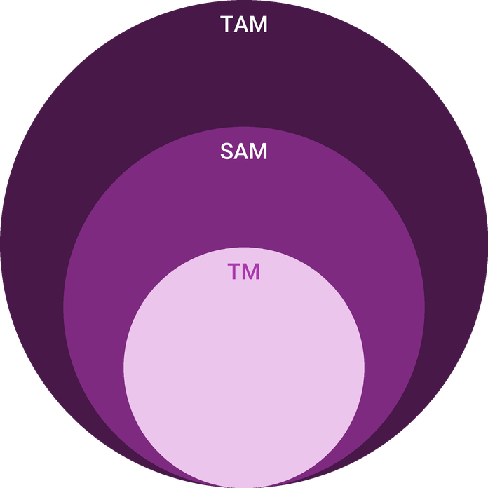
  ● | Total Available Market (TAM)  The U.S. | 10.9B
  ● | Served Available Market (SAM)  U.S. | 3.6B
  ● | Target Market (TM)  One owner-run food retailer averaged about $136,000 of annual business receipts in tax year 2023 (267,490 sole proprietorships, $36.37 billion in total). | 136.0k

3.4.1 PESTEL Analysis
  Political  - Tariffs on imported packaging materials can raise the cost of printed mailers and inserts.  - Kentucky exempts most food bought for home use from sales tax, but other states tax candy and snacks differently.  - Remote sellers must register for sales tax in states where their sales pass the state's threshold. |   Economic  - A $44 box is discretionary spending, and the first line cut when household budgets tighten.  - Postage, the largest cost after the goods, rises each January with carrier price changes.  - Food inflation raises makers' wholesale prices, which the box price cannot always pass on. |   Social  - Snacking is now more than half of all American eating occasions.  - Buyers increasingly want to know who made their food and where it came from.  - Food allergies make clear ingredient information a reason to choose one box over another.
  Technological  - Subscription billing apps handle renewals, skips, pauses and card updates without custom software.  - Shipping software buys commercial postage and prints labels in batches by zone.  - Social advertising targets food interests nationally on a small budget. |   Environmental  - Summer heat in transit softens chocolate and some candy, so June to September boxes leave them out.  - Subscribers expect recyclable packaging, so mailers are corrugated cardboard with paper fill.  - Shipping every box in one window lets the carrier collect in bulk rather than daily. |   Legal  - ROSCA requires clear terms, express consent and a simple way to cancel recurring charges.  - California's amended Automatic Renewal Law requires online cancellation and annual reminders.  - Every item's label must declare the nine major food allergens, including sesame.

CHAPTER 4

Customer Analysis

4.1 Target Market
4.2 Customer Segments
4.3 Customer Persona
4.4 Customer Purchase Journey

4.1 Target Market
Pantrylark's target market is adults across the United States who like to try new food, shop online, and would rather buy from a small producer than a national brand when they can. They are concentrated in the 25 to 54 age range, live in households with income to spend on small treats, and already buy other things by subscription, from streaming to coffee.
Alongside them is a second market that buys for someone else: family members and friends looking for a gift that lasts beyond the day it is opened, and employers sending something to staff or clients. These buyers rarely eat the snacks themselves, so they judge the box on how it looks, how easy it is to send, and whether it arrives on time.
Both markets are national rather than local. A box posted from Louisville reaches a subscriber in Phoenix as easily as one across the river in Indiana, so Pantrylark finds customers by interest rather than by place: followers of food creators, farmers market regulars, people searching for small-batch or regional snacks, and those already paying for another food subscription.

4.2 Customer Segments
- Curious snackers: adults subscribing for themselves on the monthly or three-month plan, who want something new each month and are the core of the recurring book.
- Gift buyers: people buying a prepaid three, six or twelve month gift subscription or a one-off gift box, most of them between mid-November and Christmas, with smaller peaks at birthdays and Father's Day.
- Corporate buyers: office managers and small business owners ordering ten or more gift boxes for employees or clients, usually once or twice a year.
- Allergy-aware households: subscribers who need the peanut and tree nut free box and value a clear ingredient list more than variety.
Each segment buys differently. Curious snackers decide on content and price, gift buyers on presentation and delivery dates, corporate buyers on reliability and invoicing, and allergy-aware households on trust. The persona below stands for the first and largest group.
Gift buyers matter beyond their own orders. When a prepaid gift ends, the recipient has already received three, six or twelve boxes and is offered a subscription of their own at the founding price, which makes gifting the cheapest route Pantrylark has to a new subscriber.

4.3 Customer Persona
  Megan, the Curious Snacker  Demographics  Age: 36  Status: Married, two children  Location: Raleigh, NC  Income: $92,000 household  Professional Role  Education: Bachelor's in Marketing  Job: Project manager at a health insurer | “I want to find snacks I would never see at the grocery store, without spending a Saturday hunting for them.”
   | Identifiers / Personality Traits  - Follows food creators and saves recipes on social media  - Already subscribes to streaming services and a coffee delivery  - Buys from farmers markets and makers when traveling
   | Goals  - Try something new each month without the effort of finding it  - Support small producers rather than national brands  - Have a treat on hand for the family and for guests
   | Challenges  - Has cancelled boxes that filled up with familiar, sample-size snacks  - Needs clear allergen information before anything reaches her children  - Dislikes subscriptions that make cancelling hard

4.4 Customer Purchase Journey
- Discovery: a creator's unboxing video, a paid social post, a friend's referral link or a gift box received from someone else.
- Consideration: the website shows past boxes item by item, with makers, allergens and the price per box on every plan, so the buyer can judge the value before paying.
- Purchase: checkout states the renewal date, the price and how to cancel before the card is taken, and the first box ships in the next monthly window.
- Experience: the box arrives with a menu card telling each maker's story, and a link to rate every item, which feeds the next month's choices.
- Renewal: a reminder goes out before each charge with the next theme, and the subscriber can skip a month, swap to the nut free box or pause online.
- Advocacy: each subscriber has a referral link worth a credit on their next box, and gift recipients are offered their own subscription at the founding price.

CHAPTER 5

Competitive Analysis

5.1 Competitors
5.2 Comparison
5.3 Competitive Edge
5.4 SWOT Analysis

5.1 Competitors
Pantrylark competes for a share of the snack budget and the gift budget, against four kinds of rival:
- International snack boxes: themed boxes of snacks from a different country each month. Universal Yums, one of the established names, grew revenue 2,096% between 2015 and 2018, which shows how large the curiosity market can become.
- General snack and variety boxes: lower-priced boxes of familiar or sample-size snacks, often sold through marketplaces and built on price rather than provenance.
- Retail replenishment programs: subscribe-and-save offers from large online retailers that sell known brands at a discount on a schedule, with no curation and no surprise.
- Gift box companies and makers' own websites: one-off gift baskets and direct sales from the producers themselves, which compete hardest at the holidays.
The largest box companies show the trade's economics clearly. BARK, the largest listed U.S. subscription box company, reported revenue of $394.8 million in its 2026 fiscal year, down 18.5% after it cut marketing spend, with an average order value of $31.06. A box business lives on the subscribers it keeps, and loses them quickly when acquisition stops.
Price places Pantrylark in the middle of the market. At $49 for a single month and $40 a box on the annual plan, it costs more than the variety boxes and replenishment programs, which compete on price per item, and less than many one-off gift baskets, which charge for presentation. Its value argument is not quantity: each item is one a subscriber is unlikely to find in a supermarket, from a maker they can name.

5.2 Comparison
The comparison below sets Pantrylark against those four rival groups on the things a snack box buyer weighs: whether the snacks come from small American makers, whether each month is curated around a theme, how clearly allergens are shown, how easy it is to cancel, and whether a gift can be sent without a renewal attached. The rival groups split most on allergen information and on gifts without a renewal, which matter most to two of Pantrylark's own segments: allergy-aware households and gift buyers.
Feature | Pantrylark | International snack boxes | General snack boxes | Retail subscribe-and-save | Gift box companies
Snacks from small independent American makers | ✓ | ✗ | ✗ | ✗ | ✓
A curated theme every month | ✓ | ✓ | ✗ | ✗ | ✗
Allergens listed for every item | ✓ | ✗ | ✗ | ✓ | ✗
Cancel, skip or pause online | ✓ | ✓ | ✓ | ✓ | ✗
Gift plans with no automatic renewal | ✓ | ✓ | ✗ | ✗ | ✓

5.3 Competitive Edge
Pantrylark's edge is narrow on purpose. It does not try to be the cheapest box or the one with the most items; it sells the story of who made each snack, a clear account of what is in it, and a subscription that is easy to leave, which also makes it easier to join. Each of the advantages below is something the founders control directly rather than a claim about the market.
   | A maker roster large retailers pass over  The founders source from producers too small for supermarket shelves, so most items in a box are ones a subscriber has not seen in a store.
   | A buyer's palate and a warehouse's discipline  One founder spent years as a specialty food buyer and the other supervising a distribution center, so curation and on-time shipping are both owned by someone who has done them.
   | Honest information in every box  The menu card names each maker, lists declared allergens and gives the full-size reorder price, so subscribers know exactly what they are getting.
   | A subscription built to be easy to leave  Renewal reminders, online skip and pause, and one-step cancellation meet federal and state rules and lower the risk a new subscriber feels at checkout.
 | Low-cost shipping base  A small packing room in Louisville, beside dense parcel networks, keeps rent and postage per box low enough to hold a mid-market price.

5.4 SWOT Analysis
Strengths  - Founders combine specialty food buying with distribution center experience, covering curation and fulfillment between them.  - Every box features named independent makers, a story large variety boxes cannot tell.  - A 46% gross margin at a $44 average box leaves room for postage increases.  - Prepaid plans and an easy online exit lower churn and the risk new subscribers feel. | Weaknesses  - A new brand with no reviews, subscriber history or unboxing content at launch.  - Two founders carry curation, marketing and operations, leaving little cover for illness or a missed month.  - Small makers can run short of stock, forcing late swaps in a month's box.  - Thin first-year net margin of 1.3% leaves little room for a costly mistake.
Opportunities  - 63% of consumers would consider giving a subscription as a gift, which favors prepaid gift plans.  - Corporate gifting orders of ten or more boxes fill the fourth quarter.  - Makers share their featured month with their own customers at no cost to Pantrylark.  - A reorder shop for full-size items could add revenue from subscribers already paying. | Threats  - Box-of-the-month churn runs well above other subscriptions, measured at 12.71% a month.  - Postage keeps rising, with Ground Advantage commercial prices up 9.6% in January 2026.  - Paid social costs can rise faster than subscriber value, as large box companies have found.  - Tighter automatic renewal rules could add compliance costs to checkout and cancellation.

 Strategic Summary
Pantrylark should grow through gifts, prepaid plans and makers' own audiences rather than paid acquisition alone. Its maker stories and easy exit win trust; churn and postage, watched monthly, decide whether that trust turns into profit.

CHAPTER 6

Products & Services

6.1 Our Offering
6.2 Signature Items
6.3 Additional Services
6.4 What Sets Us Apart
6.5 Box Curation & Maker Sourcing

6.1 Our Offering
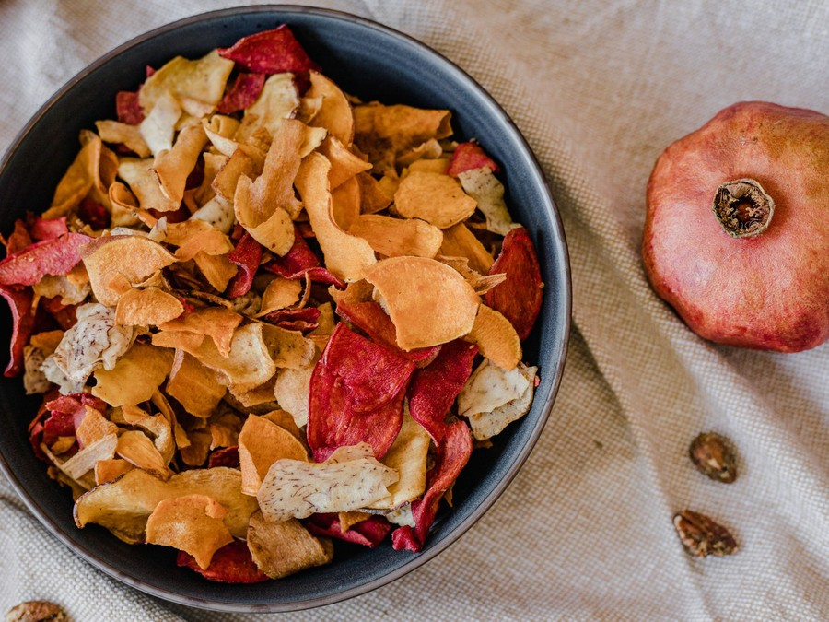
Pantrylark sells one box, made well each month. Every box carries eight to ten small-batch snacks from four to six independent American makers, chosen around a theme, packed in a printed mailer with a menu card that names each maker, lists every declared allergen and says where to buy more. Boxes ship once a month, in a window that closes by the 15th, so every subscriber receives the same month's box within a few days of each other.
Subscribers choose how to pay. The monthly plan is $49 a box with shipping included, and prepaid plans bring the price down to $45 a box for three months, $43 for six and $40 for twelve. Gift subscriptions use the same prepaid terms and end when the term is up.

6.2 Signature Items
The monthly box is the product the business is built on, and the gift subscription is the one it grows by. Themes rotate through the year, for example a smoke and spice box of jerky, smoked nuts and hot honey in winter, a Southern porch box of benne wafers, cheese straws and chow chow in spring, and a holiday pantry box of brittle, cookies and spiced popcorn in December.

6.3 Additional Services
- One-off gift boxes: the current month's box sold once, without a subscription, with a printed gift note, mainly for holidays and birthdays.
- Corporate gifting: orders of ten or more gift boxes with a custom card, shipped to a list of addresses or in bulk to one office, invoiced to the buyer.
- Peanut and tree nut free boxes: a version of each month's box with every item free of those two allergens, for subscribers who need it.
- Skip, swap and pause: subscribers can skip a month, switch to the nut free box or pause for up to three months online.

6.4 What Sets Us Apart
Three things separate Pantrylark from a cheaper snack box. Every item comes from a named, independent American producer, not a sample from a large brand's marketing budget. The menu card treats subscribers as adults, with the maker's story, the allergens and the price of a full-size reorder printed plainly. And the subscription is built to be easy to leave, with the renewal date, price and cancellation link on every reminder, because a subscriber who trusts the exit is more willing to come in.

6.5 Box Curation & Maker Sourcing
Curation runs three months ahead of each box. Marisa Holbrook tastes samples from makers each month, scores them for flavor, shelf life, packaging and how they travel, and builds each theme from a shortlist of about fifteen candidates. The goods budget is about $13.00 a box at wholesale, so the box is balanced between one or two premium items and several smaller ones.
- Every item ships in its maker's own sealed, labelled packaging, and its label must declare the nine major allergens, including sesame, which federal law has required since January 2023.
- Items must have at least 60 days of shelf life left on the day the box ships.
- Each item is shipped in a test box through a full transit cycle before it is accepted, and chocolate and anything that softens in heat are left out of the June to September boxes.
- Makers supply proof of product liability insurance and their state food license or registration.
- Orders are placed six weeks before the pack week, prepaid for a maker's first two orders and on net 30 terms after that.
Because Pantrylark sells almost all of its food directly to consumers, its packing room qualifies as a retail food establishment and does not have to register with the FDA as a food facility. It still follows the same storage discipline: stock is kept off the floor, rotated first in first out, and held at room temperature away from the loading door.

6.5.1 The Monthly Snack Box
A themed box of eight to ten small-batch snacks from four to six independent American makers, shipped once a month. Each box carries a menu card naming every maker, listing declared allergens and giving the price of a full-size reorder.
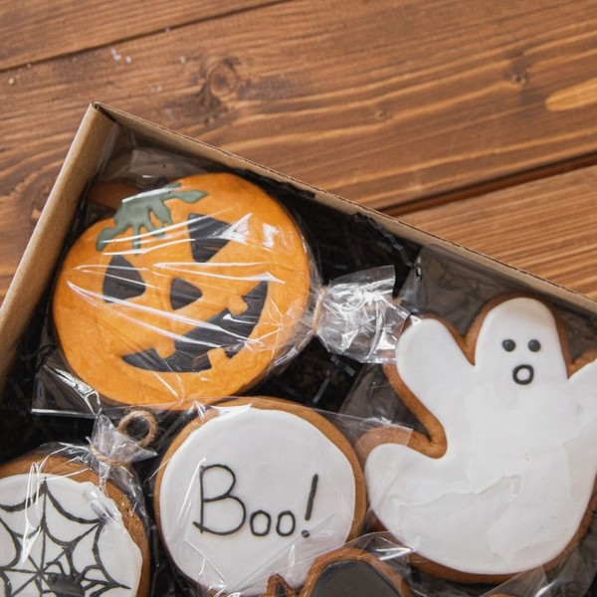 | From $40 to $49 per box  The monthly plan is $49 a box, and prepaid plans bring it down to $45 for three months, $43 for six and $40 for twelve, with shipping included on all of them. Every box carries eight to ten items from four to six makers, and its menu card gives the price of a full-size reorder from each. A peanut and tree nut free version is offered at the same price every month. Boxes ship in one window each month, closing by the 15th, so every subscriber knows when the next box will arrive.

Specifications
- Eight to ten items from four to six makers in every box.
- One theme a month, planned three months ahead.
- Ships in one window each month, closing by the 15th.
- Packed in a printed corrugated mailer under two pounds.
- A peanut and tree nut free version is offered every month.

6.5.2 Gift Subscriptions
A prepaid run of monthly boxes bought for someone else, sent with a printed gift note and ending when the term is up, with no renewal charged to anyone. Buyers choose the start month, so a gift can arrive in time for a birthday or the holidays.
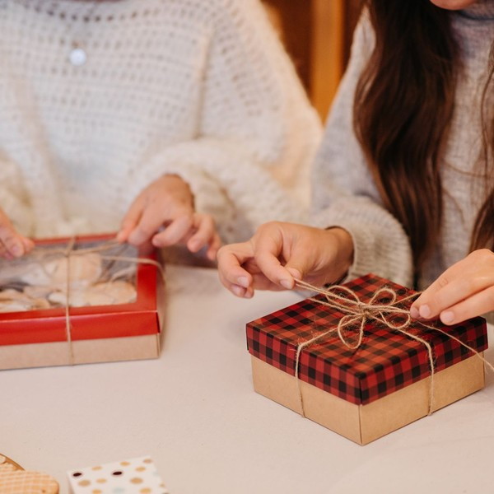 | From $135 for three months  Gift plans use the prepaid prices: $135 for three months, $258 for six and $480 for twelve, with shipping included. The full term is paid at purchase and no renewal is charged to the buyer or the recipient. The buyer chooses the start month, so the first box can arrive for a birthday or the holidays with a printed gift note inside. Each month's box is the same one subscribers receive, with its menu card and the nut free option, and when the gift ends the recipient is offered a subscription of their own.

Specifications
- Three, six or twelve months, paid in full at purchase.
- Printed gift note in the first box.
- Start month chosen by the buyer.
- No automatic renewal at the end of the term.
- Recipient offered their own subscription when the gift ends.

6.5.3 Features
  Monthly themes
  Each box is built around one idea, planned three months ahead and announced before renewal.
   | Maker menu card  A card in every box tells each maker's story and gives the full-size reorder price.
   | Allergen listing  Every item's declared allergens are printed on the menu card and on the website.
  Nut free option
  A peanut and tree nut free version of every box for subscribers who need it.
  Skip, swap and pause
  Subscribers change their plan online without calling or emailing.
  Gift plans
  Prepaid gift subscriptions that end on schedule with no renewal attached.

6.5.4 Pricing
Monthly  $49  per month  - One themed box of eight to ten snacks  - Shipping included  - Skip, pause or cancel online at any time  - Menu card with makers and allergens |  | Most Popular  Three Months  $135  every three months  - Three monthly boxes at $45 a box  - Shipping included  - Renewal reminder before each charge  - Available as a gift with no renewal |  | Twelve Months  $480  per year  - Twelve monthly boxes at $40 a box  - Shipping included  - Holiday pantry box in December  - Annual reminder before renewal

CHAPTER 7

Marketing & Sales Strategies

7.1 Market Positioning
7.2 Marketing Objectives
7.3 Online Marketing
7.4 Public Relations and Branding
7.5 Partnership & Collaboration Strategy
7.6 Customer Loyalty & Retention
7.7 Sales Channels

7.1 Market Positioning

Pantrylark is positioned as the snack box for people who care who made their food: smaller producers, clearer information and an easier subscription than the large variety boxes, at a price that sits in the middle of the market rather than at the bottom.

7.2 Marketing Objectives
- Convert about 550 founding subscribers from the waitlist in the launch month of March 2027.
- Reach 90 new paying subscribers a month by the sixth month after launch.
- Hold monthly churn at or below 9% across all plans.
- Earn about 14% of revenue from gift subscriptions, gift boxes and corporate orders.
- Keep the marketing budget within 11% of revenue, about $45,019 in the first year.
- Win at least one in five new subscribers through referrals and gift recipients rather than paid media.
Paid Social  $1,689  per month  Unboxing videos and photographs of each month's box on Instagram, Facebook and TikTok. |  | Creator Sample Boxes  $750  per month  Boxes sent to food creators each month, with tracked codes for the subscribers they bring.
Referral Credits  $563  per month  A credit on the next box for every subscriber who brings a friend. |  | Holiday Gift Campaigns  $750  per month  Email, text and paid placements for gift plans and corporate orders from November.

Total marketing budget: $45,019 a year, $3,752 a month.

7.3 Online Marketing
Paid social carries most of the acquisition budget, because a box is bought on what it looks like opened. Short unboxing videos and photographs of each month's items run on Instagram, Facebook and TikTok, aimed at food interests and lookalikes of existing subscribers, and every advertisement links to that month's box rather than to the home page. Sample boxes go to food creators each month, chosen for the fit of their audience rather than its size, with a code that tracks the subscribers each one brings.
Every campaign is judged on cost per paying subscriber, not on clicks. Each new advertisement runs on a small test budget for two weeks; those that win subscribers near the planned $42 keep running and the rest are switched off. Creators are judged the same way, and one whose code converts well is invited back the following month.
Email and text messages do the rest: the waitlist before launch, the next theme before each renewal, and holiday gift reminders from November. Each maker gets a page on the website telling their story, which gives search engines something worth indexing and gives the makers something worth sharing.

7.4 Public Relations and Branding
The brand is warm, plain and specific: kraft and orchid packaging, photographs of real makers and their kitchens, and copy that says exactly what is in the box. Public relations follows the makers. Every month's box is a story about four to six small producers, which suits local newspapers, food newsletters and podcasts in the makers' own towns, and Louisville's food press will hear about the business that ships its city's producers nationwide. A press page carries photographs of every past box and a short profile of each maker, so a writer covering a featured producer has what they need without asking.

7.5 Partnership & Collaboration Strategy
Makers are partners as well as suppliers. Each one featured receives photographs and copy to share with their own customers, and a discount code that credits them with the subscribers they bring. Pantrylark will also work with office managers and small business owners on corporate gift orders, and with Louisville food events and markets, where the founders can sample past boxes and sign up subscribers in person.

7.6 Customer Loyalty & Retention
Retention is the whole business: a subscriber who stays a year is worth twelve boxes, and one who leaves after two barely covers what it cost to win them. Pantrylark keeps subscribers by giving them reasons to stay and easy alternatives to leaving.
- A reminder before every charge with the next theme, so a subscriber stays for a box they want rather than one they forgot.
- Skip a month, pause for up to three months or swap to the nut free box online, each offered on the cancellation page before the final step.
- Prepaid plans at a lower price per box, offered at the third renewal, when a subscriber has seen enough boxes to commit.
- A referral credit on the next box for every friend who subscribes.
- Failed card payments retried automatically with a card updater, since a lapsed card is the cheapest subscriber to keep.
Retention is measured by cohort, not by the monthly total. Each month's new subscribers are tracked as a group through their first six renewals, so the founders can see whether a change to the box, the price or the reminder emails moved the share that stays. The founding subscribers of March 2027 set the benchmark, and any cohort that churns well above the 9% plan in its first three months prompts a review of how it was acquired.

7.7 Sales Channels
Revenue arrives by four routes, listed below in order of what each is worth. The website subscription carries the business, and the gift and corporate routes add the remaining 14% of revenue and feed new subscribers back into it.
The website is the only checkout. Pantrylark does not plan to sell through marketplaces in its first year, which keeps each subscriber's card, email address and renewal history in its own systems and avoids a commission on every renewal. Corporate orders are quoted by email, paid before packing and packed in the same week as the subscription boxes, so they add revenue without adding a second shipping schedule.
   | Website subscriptions  Monthly and prepaid plans bought on Pantrylark's own site carry most of the revenue and depend on keeping churn near 9%.
  Gift subscriptions
  Prepaid gift plans sold mostly from mid-November to Christmas, worth the most in the fourth quarter and a source of new subscribers when gifts end.
  One-off gift boxes
  Single boxes bought without a subscription, depending on holiday and birthday demand.
  Corporate orders
  Orders of ten or more boxes for employees or clients, invoiced to the buyer and concentrated in the fourth quarter.

CHAPTER 8

Operations Plan

8.1 Daily Operations
8.2 Staffing & Training
8.3 Inventory & Equipment Management
8.4 Location and Facilities
8.5 Milestones & Timeline
8.6 Monthly Fulfillment & Shipping

8.1 Daily Operations
Pantrylark runs to a monthly rhythm rather than a daily one. In the first week, the month's snacks arrive from the makers and are counted and checked against the purchase orders. Renewals bill on the 1st, which fixes the box count. Packing runs from about the 6th to the 12th, and every box is handed to the carrier by the 15th. The rest of the month goes to customer messages, next month's sourcing and the following quarter's themes.
Marisa Holbrook runs curation, maker relationships, marketing and the website. Andre Whitfield runs the packing room, purchasing, carriers, the books and customer service. Both pack in the busiest week.

8.2 Staffing & Training
At launch the two founders are the only full-time staff. A part-time packing lead, Keisha Monroe, joins before the first pack week to set up the line and run it with two part-time packers, paid at about the Louisville mean of $19.04 an hour for hand packers. The metro employs 29,400 hand material movers, so packing labor is available, but it competes with the large distribution centers for hires, so Pantrylark offers fixed monthly shifts that suit students and parents.
Training is short and specific: the packing standard for each box, the allergen check on the nut free line, and the label software. New packers work beside the packing lead for a full pack week before working alone. A part-time customer care role is budgeted for the second year.
Pack week is staffed to the box count fixed on the 1st, with each packer on a set shift confirmed a week ahead. Outside pack week the packing lead works about one day a week receiving deliveries and counting stock, which keeps the founders' time on sourcing and subscribers.

8.3 Inventory & Equipment Management
Inventory runs at about 35 days of sales. Each month's snacks are ordered six weeks ahead and arrive two to three weeks before packing, with a margin of about 3% over the box count for damage and late signups. Gift box stock is built from September for the holidays. Every lot is recorded with its best-by date, and anything within 60 days of it is sold off in add-on offers or donated. Stock is counted before every pack week and checked against the box count, so a short delivery from a maker is caught in time to swap in an approved alternative.
Equipment is simple: steel shelving, three packing tables laid out as a line, a pallet jack, shipping scales, two thermal label printers and tape dispensers. A spare printer is kept so a failure in pack week does not stop shipping.

8.4 Location and Facilities
Pantrylark will lease about 2,000 square feet of small-bay flex space on Louisville's industrial south side, at a rent of $1,850 a month. The unit has a dock-height or drive-in door for maker deliveries and carrier pickups, room for about 20 pallets of stock, the packing line and a small office. Louisville's industrial vacancy rose to 5.9% in the third quarter of 2026 as new buildings delivered, so space is available, though small units rent above the $6.78 a square foot market average set by large distribution buildings.

8.5 Milestones & Timeline
The timeline below runs from opening the waitlist in November 2026 to the first corporate gifting season in late 2027. The milestone that matters most is the first renewal after launch, in April 2027, which shows how many founding subscribers stay once the novelty of the first box has passed.
Nov 2026  Setup |  |  | Waitlist opens  Brand, website and founding member offer go live  Open the waitlist with a founding member price and begin paid social and creator sample boxes.
Dec 2026  Setup |  |  | Packing room leased  About 2,000 square feet on the south side  Sign the lease, install shelving and the packing line, and set up the shipping software.
Jan 2027  Setup |  |  | First makers signed  Themes planned for the first three boxes  Approve the first makers after tasting, label and transit checks, and place the first orders.
Mar 2027  Launch |  |  | First box ships  Founding subscribers receive box one  Convert the waitlist, run the first pack week with the packing lead and two packers, and ship every box by the 15th.
Apr 2027  Growth |  |  | First renewal  The first test of churn  Measure how many founding subscribers renew and offer prepaid plans to those who stay.
Nov 2027  Growth |  |  | First holiday gift season  Gift plans and corporate orders peak  Run holiday gift campaigns, pack corporate orders and build the gift box stock bought from September.

8.6 Monthly Fulfillment & Shipping
A subscription box ships all of its orders in one short window, so fulfillment is designed around the pack week rather than around single orders. Every box in a month holds the same items, which lets the line run as an assembly: one packer builds and lines the mailer, one places the items in a fixed order with the menu card on top, and one seals, weighs and labels.
- Three packers at full pace pack about 40 boxes an hour, so a book of 800 boxes needs about 20 hours of line time.
- Each packed box weighs under two pounds and ships by USPS Ground Advantage at commercial prices, about $7.20 a box, bought through shipping software.
- Labels print in batches by postal zone, and the carrier collects from the dock on scheduled pickups through the pack week.
- Every subscriber gets a tracking email on the day their box is labelled.
- A box reported damaged or lost is replaced from the 3% overage the same week, and the claim is filed with the carrier afterwards.
Postage is the largest cost after the snacks, and it moves: Ground Advantage prices rose about 7.8% in January 2026, and 9.6% at commercial prices. Box dimensions are chosen to stay in the lowest weight bands, and rates are reviewed whenever a carrier changes its prices, with UPS ground quoted against USPS for heavier holiday boxes.
The holiday months are planned separately. November and December add gift subscriptions, one-off gift boxes and corporate orders to the regular book, so the holiday pack runs in two waves: subscription boxes in the usual window, then gift and corporate orders packed against the carriers' last ground shipping dates for Christmas delivery. Extra packing shifts are scheduled from October, gift box stock is counted twice before the first wave, and the website shows the last order date for holiday delivery from mid-November, so no buyer is promised a date the carrier cannot meet.
In summer, boxes leave early in the week so they do not sit in a hot depot over a weekend. A box returned as undeliverable is held for 30 days while the subscriber confirms the address, then reshipped once at no charge.

CHAPTER 9

Management Team

9.1 Key Members
9.2 Organization Chart
9.3 Advisory Board Members

9.1 Key Members
Accountability is split at the dock door. Marisa Holbrook answers for everything a subscriber judges before the box is opened and the moment after: the themes, the makers, the goods cost per box, the website and acquisition. She is measured on monthly churn against the 9% plan, on new subscribers against the 90 a month target, and on the goods cost staying near $13.00 a box.
Andre Whitfield answers for everything from the maker's delivery to the subscriber's doorstep: receiving, the pack week, carriers, customer service and the books. He is measured on every box handed to the carrier by the 15th, on damage and loss below 1% of boxes shipped, and on monthly costs against budget. The packing lead answers to him for packing accuracy and labor hours per box.
 | Marisa Holbrook  Co-Founder & Head of Curation · marisa@pantrylark.example  Spent nine years as a specialty food buyer for a regional grocery chain, sourcing from small producers across the South and Midwest.

 | Andre Whitfield  Co-Founder & Head of Operations · andre@pantrylark.example  Supervised receiving and packing shifts for eight years at a Louisville distribution center shipping to every state.

 | Keisha Monroe  Packing Lead (part-time) · keisha@pantrylark.example  Ran the holiday packing line for a regional gift basket company for four seasons.

9.2 Organization Chart
The structure is flat because the business is small. Marisa Holbrook leads and has the final say on product and spending; Andre Whitfield has it on operations. The two meet weekly to set the next month's box count, orders and pack schedule. The part-time packers take direction from the packing lead, who reports to Andre.
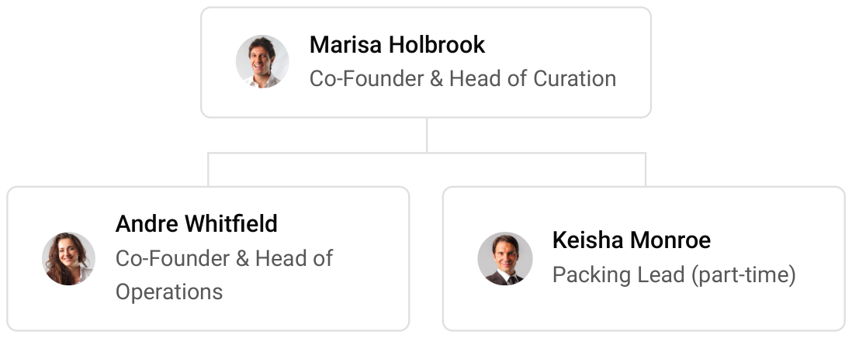

9.3 Advisory Board Members
The founders will draw on two outside advisers rather than a formal board: an accountant who works with small e-commerce businesses, to review the monthly accounts, sales tax registrations and quarterly tax estimates, and a food business attorney, to review the subscription terms against federal and state automatic renewal rules before launch. Both are paid by the hour as needed, for advice rather than oversight. The accountant also prepares the annual statements the loan's lender asks for and checks the cash forecast against the plan each quarter.
Once the subscriber book passes the first year, the founders intend to add an informal mentor from the specialty food trade, ideally someone who has grown a direct-to-consumer food brand, to review box pricing and the case for moving packing to a third-party warehouse. The role is unpaid and meets the founders once a quarter.

9.3.1 Hiring Plan
2  Filled |  | 3  Hiring This Year |  | 4  Open

Group By Department | Position Filled | Time of Hire | Time of Start | Filled
Curation & Marketing | 1 of 1 | 0 days | 0 days | 100%
Operations & Fulfillment | 1 of 4 | 30 days | 14 days | 25%
Customer Care | 0 of 1 | 45 days | 14 days | 0%

CHAPTER 10

Financial Plan

10.1 Key Assumptions
10.2 Capital Requirements and Use of Funds
10.3 Income Statement (3 Year projections)
10.4 Balance Sheet (3 Year projections)
10.5 Cash Flow Statement (3 Year projections)
10.6 Break Even Analysis

10.1 Key Assumptions
Revenue is the active subscriber book times the average box price, uplifted by gift and one-time sales. The book opens with 550 founding subscribers converted from the pre-launch waitlist, adds 90 new subscribers a month at full run rate, and loses 9% a month to churn. The average box price is $44 across the monthly and prepaid plans, and gift subscriptions, gift boxes and corporate orders add 14% on top.
Gross margin is 46.0%: about $13.00 of snacks, $2.10 of packaging, $7.20 of postage and $1.50 of card processing on a $44 box. Payroll is 18% of revenue and marketing 11%. Fixed costs are rent of $1,850 a month, technology of $450 and administration of $650. Revenue grows 20% a year after the first, held at the plan's ceiling.
On those assumptions revenue is $409,266 in the first year, $491,119 in the second and $589,342 in the third, with net income of $5,375, $13,699 and $23,589. Break-even revenue is $357,214, or 676 subscribers. Churn is the assumption that matters most: in the conservative case, with fewer new subscribers, higher churn and a lower box price, third-year net income falls to $12,219, and in the upside case it rises to $40,040.
The projection is cautious in two places. Revenue after the first year grows at the plan's 20% ceiling rather than at the rate the subscriber book could support, and break-even is stated in subscribers paying the full average box price, which overstates the number needed in a month when gift sales are strong.
No further owner money is assumed. The founders' $30,000 and the $40,000 loan cover the $66,700 startup budget, loan repayments come from operating cash, and every dollar of profit stays in the business. The first year's net income of $5,375 is small by design: its job is to show that the book pays its own way while it grows.

10.2 Capital Requirements and Use of Funds
Pantrylark needs $66,700 before the first box ships. The founders contribute $30,000 of their own savings and the remaining $40,000 is an SBA Microloan at 9.5% over six years. No outside equity is sought, and profits stay in the business for the first three years. The loan carries no ownership, so the founders keep the whole company, and at 9.5% its interest is a small fixed cost set against a 46.0% gross margin. If the book grows faster than planned, the cash it generates funds extra stock and acquisition before any new borrowing is considered.
The largest uses are $15,000 of initial inventory for the first two monthly boxes and opening gift stock, $14,000 of launch marketing to build the waitlist, and a $12,000 working capital reserve. The rest pays for packaging and printing, packing equipment, the website and branding, the lease deposit, and licenses, insurance and formation, as itemized in the table below.

10.2.1 Use of Funds
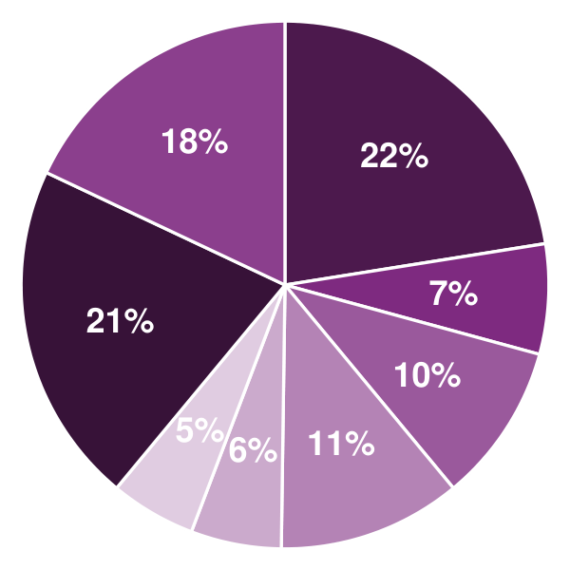 | ● Initial Inventory 22.5%  ● Packaging & Printing 6.7%  ● Packing Equipment & Fixtures 9.7%  ● Website, Branding & Photography 11.2%  ● Lease Deposit & Move-In 5.5%  ● Licenses, Insurance & Formation 5.2%  ● Launch Marketing 21.0%  ● Working Capital Reserve 18.0%

Use Of Funds | Amount
Initial Inventory | $15,000.00
Packaging & Printing | $4,500.00
Packing Equipment & Fixtures | $6,500.00
Website, Branding & Photography | $7,500.00
Lease Deposit & Move-In | $3,700.00
Licenses, Insurance & Formation | $3,500.00
Launch Marketing | $14,000.00
Working Capital Reserve | $12,000.00

10.3 Income Statement (3 Year projections)
 | Year 1 | Year 2 | Year 3 | Total
Revenue | $409,265.50 | $491,118.60 | $589,342.32 | $1,489,726.42
Cost of Sales | $221,003.37 | $265,204.04 | $318,244.85 | $804,452.26
General Costs | $0.00 | $0.00 | $0.00 | $0.00
Revenue Specific Costs | $221,003.37 | $265,204.04 | $318,244.85 | $804,452.26
Personnel Costs (Direct Labor) | $0.00 | $0.00 | $0.00 | $0.00
Gross Margin | $188,262.13 | $225,914.56 | $271,097.47 | $685,274.16
Gross Margin (%) | 46.00% | 46.00% | 46.00% | 46.00%
Operating Expense | $164,318.64 | $190,102.37 | $221,042.84 | $575,463.85
Payroll Expense (Indirect Labor) | $73,667.79 | $88,401.35 | $106,081.62 | $268,150.76
General Expense | $90,650.85 | $101,701.02 | $114,961.22 | $307,313.09
Bad Debt | $0.00 | $0.00 | $0.00 | $0.00
Amortization of Current Assets | $0.00 | $0.00 | $0.00 | $0.00
EBITDA | $23,943.49 | $35,812.19 | $50,054.63 | $109,810.31
Additional Expense | $18,568.73 | $22,112.76 | $26,465.66 | $67,147.15
Long Term Depreciation | $13,340.00 | $15,304.47 | $17,661.84 | $46,306.31
Gain or loss from Sale of Assets | $0.00 | $0.00 | $0.00 | $0.00
EBIT | $10,603.49 | $20,507.72 | $32,392.79 | $63,504.00
Interest Expense | $3,800.00 | $3,166.67 | $2,533.33 | $9,500.00
EBT | $6,803.49 | $17,341.05 | $29,859.46 | $54,004.00
Income Tax Expense / Benefit | $1,428.73 | $3,641.62 | $6,270.49 | $11,340.84
Total Expense | $403,890.74 | $477,419.17 | $565,753.35 | $1,447,063.26
Net Income | $5,374.76 | $13,699.43 | $23,588.97 | $42,663.16
Net Income (%) | 1.31% | 2.79% | 4.00% | 2.86%
Retained Earning Opening | $0.00 | $5,374.75 | $19,074.18
Owner's Distribution | $0.00 | $0.00 | $0.00 | $0.00
Retained Earning Closing | $5,374.76 | $19,074.18 | $42,663.15 | $42,663.15

10.4 Balance Sheet (3 Year projections)
 | Year 1 | Year 2 | Year 3 | Total
Assets | $83,845.31 | $93,905.51 | $114,460.74 | $114,460.74
Current Assets | $30,485.31 | $46,027.61 | $72,457.83 | $72,457.83
Cash | $9,293.21 | $20,597.09 | $41,941.20 | $41,941.20
Accounts Receivable | $0.00 | $0.00 | $0.00 | $0.00
Inventory | $21,192.10 | $25,430.52 | $30,516.63 | $30,516.63
Other Current Assets | $0.00 | $0.00 | $0.00 | $0.00
Long Term Assets | $53,360.00 | $47,877.90 | $42,002.91 | $42,002.91
Gross Long Term Assets | $66,700.00 | $76,522.37 | $88,309.22 | $88,309.22
Accumulated Depreciation | $13,340.00 | $28,644.47 | $46,306.31 | $46,306.31
Liabilities & Equity | $83,845.31 | $93,905.51 | $114,460.74 | $114,460.74
Liabilities | $48,470.56 | $44,831.33 | $41,797.59 | $41,797.59
Current Liabilities | $21,803.89 | $24,831.33 | $28,464.26 | $28,464.26
Accounts Payable | $15,137.22 | $18,164.66 | $21,797.59 | $21,797.59
Income Tax Payable | $0.00 | $0.00 | $0.00 | $0.00
Sales Tax Payable | $0.00 | $0.00 | $0.00 | $0.00
Short Term Debt | $6,666.67 | $6,666.67 | $6,666.67 | $6,666.67
Long Term Liabilities | $26,666.67 | $20,000.00 | $13,333.33 | $13,333.33
Long Term Debt | $26,666.67 | $20,000.00 | $13,333.33 | $13,333.33
Equity | $35,374.75 | $49,074.18 | $72,663.15 | $72,663.15
Paid-in Capital | $0.00 | $0.00 | $0.00 | $0.00
Common Stock | $0.00 | $0.00 | $0.00 | $0.00
Preferred Stock | $0.00 | $0.00 | $0.00 | $0.00
Owner's Contribution | $30,000.00 | $30,000.00 | $30,000.00 | $30,000.00
Retained Earnings | $5,374.75 | $19,074.18 | $42,663.15 | $42,663.15
Check | $0.00 | $0.00 | $0.00 | $0.00

10.5 Cash Flow Statement (3 Year projections)
 | Year 1 | Year 2 | Year 3 | Total
Cash Received | $409,265.50 | $491,118.60 | $589,342.32 | $1,489,726.42
Cash Paid | $396,605.62 | $463,325.68 | $549,544.69 | $1,409,475.99
COS & General Expenses | $317,709.10 | $368,116.04 | $434,659.25 | $1,120,484.39
Salary & Wages | $73,667.79 | $88,401.35 | $106,081.62 | $268,150.76
Interest | $3,800.00 | $3,166.67 | $2,533.33 | $9,500.00
Sales Tax | $0.00 | $0.00 | $0.00 | $0.00
Income Tax | $1,428.73 | $3,641.62 | $6,270.49 | $11,340.84
Net Cash From Operations | $12,659.88 | $27,792.92 | $39,797.63 | $80,250.43
Assets Sell | $0.00 | $0.00 | $0.00 | $0.00
Assets Purchase | $66,700.00 | $9,822.37 | $11,786.85 | $88,309.22
Net Cash From Investments | ($66,700.00) | ($9,822.37) | ($11,786.85) | ($88,309.22)
Amount Received | $70,000.00 | $0.00 | $0.00 | $70,000.00
Loan Received | $40,000.00 | $0.00 | $0.00 | $40,000.00
Common Stock | $0.00 | $0.00 | $0.00 | $0.00
Preferred Stock | $0.00 | $0.00 | $0.00 | $0.00
Owner's Contribution | $30,000.00 | $0.00 | $0.00 | $30,000.00
Amount Paid | $6,666.67 | $6,666.67 | $6,666.67 | $20,000.01
Loan Capital | $6,666.67 | $6,666.67 | $6,666.67 | $20,000.01
Dividends & Distributions | $0.00 | $0.00 | $0.00 | $0.00
Net Cash From Financing | $63,333.33 | ($6,666.67) | ($6,666.67) | $49,999.99
Summary
Starting Cash | $0.00 | $9,293.21 | $20,597.09
Cash In | $479,265.50 | $491,118.60 | $589,342.32 | $1,559,726.42
Cash Out | $469,972.29 | $479,814.72 | $567,998.21 | $1,517,785.22
Change in Cash | $9,293.21 | $11,303.88 | $21,344.11 | $41,941.20
Ending Cash | $9,293.21 | $20,597.09 | $41,941.20 | $41,941.20

10.6 Break Even Analysis
 | Year 1 | Year 2 | Year 3 | Total
Starting Revenue | $0.00 | $409,265.50 | $900,384.10 | $900,384.10
Net Revenue | $409,265.50 | $491,118.60 | $589,342.32 | $589,342.32
Closing Revenue | $409,265.50 | $900,384.10 | $1,489,726.42 | $1,489,726.42
Starting Expense | $0.00 | $403,890.74 | $881,309.91 | $881,309.91
Net Expense | $403,890.74 | $477,419.17 | $565,753.35 | $565,753.35
Closing Expense | $403,890.74 | $881,309.91 | $1,447,063.26 | $1,447,063.26
Is Break Even? | Yes | Yes | Yes
Break Even Month | Dec '26 | - | -
Days Required | 7 Days | - | -
Break Even Revenue | $409,265.50 | - | -

CHAPTER 11

References

- SRC001: United States Subscription Box Market Size, Share, Trends and Forecast by Type, Gender, Application, and Region, 2026-2034, IMARC Group, 2026-07-07. https://www.imarcgroup.com/united-states-subscription-box-market (accessed 2026-10-13)
- SRC002: USA Subscription Box Market, Ken Research, 2025-01-01. https://www.kenresearch.com/usa-subscription-box-market (accessed 2026-10-13)
- SRC003: United States Subscription Box Market, Renub Research, 2025-01-01. https://www.renub.com/united-states-subscription-box-market-p.php (accessed 2026-10-13)
- SRC004: Subscription Box Market, Roots Analysis, 2025-01-01. https://www.rootsanalysis.com/subscription-box-market (accessed 2026-10-13)
- SRC005: E-Commerce Retail Sales as a Percent of Total Sales (ECOMPCTSA), Federal Reserve Bank of St. Louis (FRED), from U.S. Census Bureau data, 2026-08-18. https://fred.stlouisfed.org/series/ECOMPCTSA (accessed 2026-10-13)
- SRC006: What's stopping Americans from using subscription boxes and what's getting them interested, YouGov, 2023-01-31. https://yougov.com/articles/46148-whats-stopping-americans-from-using-subscription-boxes-and-whats-getting-them-interested (accessed 2026-10-13)
- SRC007: Churn rate benchmarks: SaaS, media, retail & more industries, Recurly, 2026-07-01. https://recurly.com/research/churn-rate-benchmarks/ (accessed 2026-10-13)
- SRC008: Data: New Subscription E-Commerce Benchmarks, MarketingCharts, 2019-01-01. https://dev.marketingcharts.com/industries/retail-and-e-commerce-109475 (accessed 2026-10-13)
- SRC009: BARK Reports Fiscal Fourth Quarter and Full Year 2026 Results, BARK, Inc. (Form 8-K, Exhibit 99.1), SEC EDGAR, 2026-06-09. https://www.sec.gov/Archives/edgar/data/0001819574/000162828026041892/exhibit991-q4fy26pressrele.htm (accessed 2026-10-13)
- SRC010: One Of NJ's Fastest Growing Companies Is In Morris County, Patch, 2019-08-20. https://patch.com/new-jersey/longvalley/one-njs-fastest-growing-companies-morris-county (accessed 2026-10-13)
- SRC011: NRF report: holiday sales grow 4.1 percent, driven by consumer spending surge, FashionUnited (reporting the National Retail Federation), 2026-01-13. https://fashionunited.com/news/business/nrf-report-holiday-sales-grow-4-1-percent-driven-by-consumer-spending-surge/2026011369970 (accessed 2026-10-13)
- SRC012: Subscriptions for the Holidays: Nearly 70 percent of consumers want to give and receive gift subscriptions, Recurly, 2022-09-29. https://recurly.com/press/subscriptions-for-the-holidays-biz (accessed 2026-10-13)
- SRC013: Scentbird Sees Giftable Subscriptions Capture Consumers' Last-Minute Holiday Spending, PYMNTS. https://pymnts.com/?p=1644277 (accessed 2026-10-13)
- SRC014: USPS Recommends New Competitive Prices for 2026, United States Postal Service, 2025-11-14. https://about.usps.com/newsroom/national-releases/2025/1114-usps-recommends-new-competitive-prices-for-2026.htm (accessed 2026-10-13)
- SRC015: USPS prepares 2026 rate hikes for Ground Advantage, other services, Supply Chain Dive, 2025-11-17. https://www.supplychaindive.com/news/us-postal-service-2026-price-increases/805613/ (accessed 2026-10-13)
- SRC016: FedEx and UPS 2026 General Rate Increases: Strategic Impact on Shippers and 3PLs, Enveyo, 2025-01-01. https://enveyo.com/resources/fedex-and-ups-2026-general-rate-increases-strategic-impact (accessed 2026-10-13)
- SRC017: How Much Does a 3PL Cost in 2026?, Fulfill.com, 2026-01-01. https://fulfill.com/3pl-pricing (accessed 2026-10-13)
- SRC018: 3PL pricing explained: a complete cost guide for 2025, Red Stag Fulfillment, 2025-01-01. https://redstagfulfillment.com/freight-rates-and-fuel-surcharges/ (accessed 2026-10-13)
- SRC019: Restore Online Shoppers' Confidence Act, Federal Trade Commission. https://www.ftc.gov/legal-library/browse/statutes/restore-online-shoppers-confidence-act (accessed 2026-10-13)
- SRC020: Eighth Circuit Vacates FTC's Click-to-Cancel Rule, Greenberg Traurig, 2025-07-01. https://www.gtlaw.com/en/insights/2025/7/eighth-circuit-vacates-ftcs-click-to-cancel-rule (accessed 2026-10-13)
- SRC021: FTC Issues New Advance Notice of Proposed Rulemaking on Negative Option Marketing, Cooley, 2026-03-20. https://www.cooley.com/news/insight/2026/2026-03-19-ftc-issues-new-advance-notice-of-proposed-rulemaking-on-negative-option-marketing (accessed 2026-10-13)
- SRC022: AB 2863 Updates California Automatic Renewal Law, Davis Wright Tremaine, 2024-10-01. https://www.dwt.com/insights/2024/10/ab-2863-updates-california-automatic-renewal-law (accessed 2026-10-13)
- SRC023: The FASTER Act: Sesame as a Major Food Allergen, Michigan State University Extension, 2023-01-01. https://www.canr.msu.edu/news/the-faster-act-sesame-as-major-food-allergen (accessed 2026-10-13)
- SRC024: 21 CFR 1.227 Definitions, Electronic Code of Federal Regulations. https://www.ecfr.gov/current/title-21/chapter-I/subchapter-A/part-1/subpart-H/section-1.227 (accessed 2026-10-13)
- SRC025: Subscription Box Market, Global Market Insights, 2026-09-01. https://www.gminsights.com/industry-analysis/subscription-box-market (accessed 2026-10-14)
- SRC026: Crunching the numbers: A 'snackshot' of what's driving the $156bn industry forward, BakeryandSnacks, 2025-05-13. https://www.bakeryandsnacks.com/Article/2025/05/13/trends-shaping-the-156b-snack-industry/ (accessed 2026-10-14)
- SRC027: Table 1. Nonfarm Sole Proprietorships: Business Receipts, Selected Deductions, Payroll, and Net Income, by Industrial Sectors, Tax Year 2023, IRS Statistics of Income Division, 2025-01-01. https://www.irs.gov/pub/irs-soi/23sp01br.xls (accessed 2026-10-14)
- SRC028: Factbox-UPS Worldport in Louisville: a nerve center of global logistics, Reuters (via The Sunday Guardian), 2025-11-05. https://sundayguardianlive.com/business/factbox-ups-worldport-in-louisville-a-nerve-center-of-global-logistics-159611/ (accessed 2026-10-14)
- SRC029: Louisville Industrial Figures Q3 2026, CBRE, 2026-10-08. https://www.cbre.com/insights/figures/louisville-industrial-figures-q3-2026 (accessed 2026-10-14)
- SRC030: Occupational Employment and Wage Statistics, Louisville/Jefferson County, KY-IN, May 2025, U.S. Bureau of Labor Statistics, 2026-01-01. https://data.bls.gov/oes/#/area/0031140/2025 (accessed 2026-10-14)
