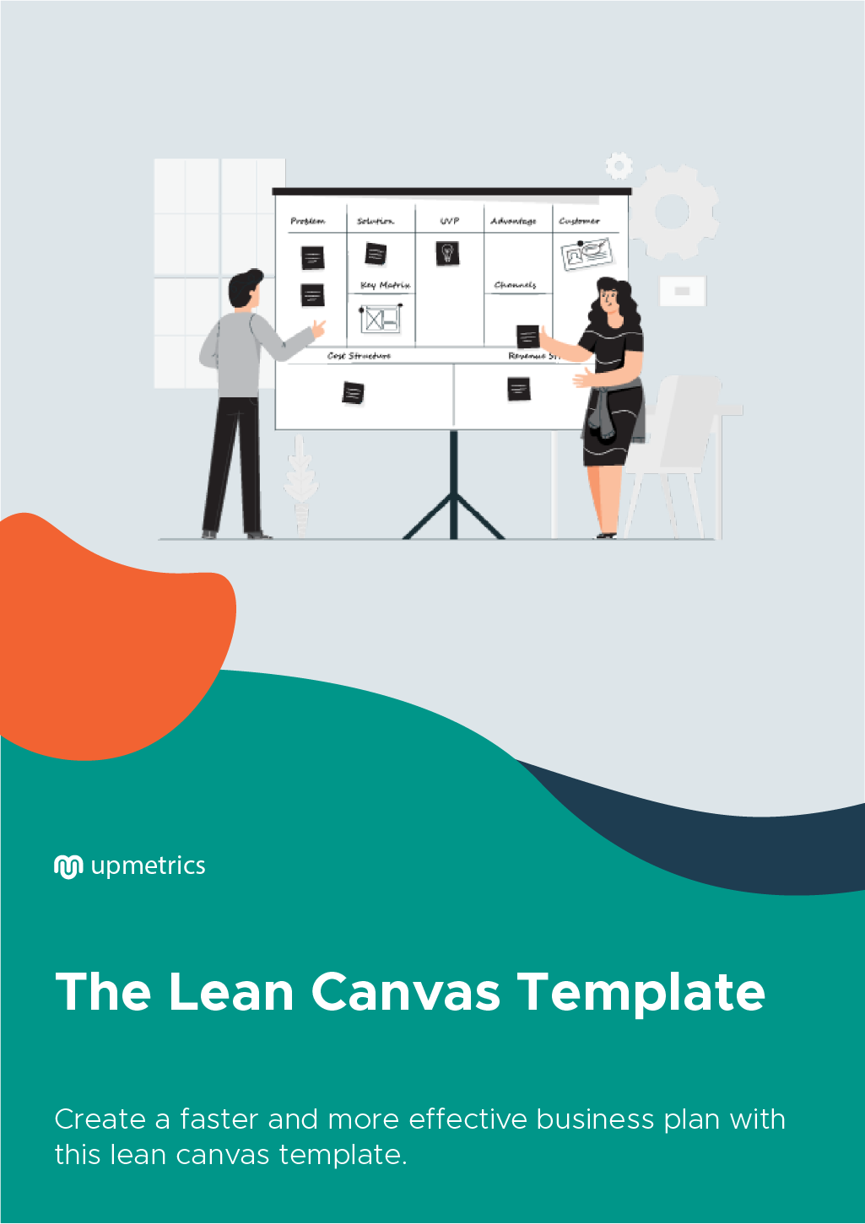

Hi There!

Thanks for downloading this template.


You Can Edit This Version To Fit Your Needs.

What is a Lean Canvas?
The Lean Canvas is a version of the Business Model Canvas and it is specially designed for Start-ups and Entrepreneurs. The Lean Canvas focuses on addressing broad customer problems, solutions, key metrics, competitive advantages and delivering them to customer segments through a unique value proposition.

It is also called a one-page business plan template. It was adapted from Alex Osterwalder's Business Model Canvas by Ash Maurya and optimized for the Lean Start-up methodology with an emphasis on finding customer problems worth solving — specifically by building a solid foundation on the customer, problem, and solution assumptions before anything else. Lean Canvas promises an actionable and entrepreneur-focused business plan. It focuses on problems, solutions, key metrics, and competitive advantages.

Do you need collaborative version of this canvas?  Upmetrics can help you bringing planning and collaboration to the next level with great canvases and a great app! | 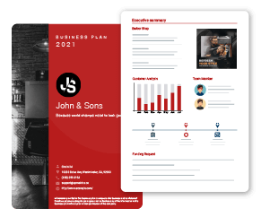
Get Started With Online Canvas Today!

 |  | Designed for: |  |  |  |  | Designed by: |  | Date: |  | Version:
Lean Canvas
Problem | Solution |  | Unique Value Proposition |  |  | Unfair Advantage |  |  | Customer Segments
List your top 1 to 3 problems | Outline a possible solution for each problems |  | Single, clear and compelling message that states why you are different and paying attention. |  |  |  | Something that can’t be easily bought or copied |  | List your target customers & users
Existing Alternatives | Key Metrics |  | High-Level Concept |  |  |  | Channels |  | Early Adopters
List how these problems are solved today. | List the key numbers that tell you how your business is doing |  | List your X for Y analogy  (e.g. YouTube = Flickr for videos) |  |  |  | List to path to customers (Inbound or outbound) |  | List the characteristics of your ideal customers
Cost Structure |  |  |  | Revenue Structure
List your fixed and variable costs.  - Customer acquisition costs  - Distribution costs  - Hosting  - People  - Etc. |  |  |  | List your sources of revenue.  - Revenue Model  - Life Time Value  - Revenue  - Gross Margin
A Template by: Upmetrics (https://upmetrics.co).

