

BUSINESSPLAN
2024


UberBusinessPlan
"Fast,Safe,ReliableRides."

JohnDoe
10200BolsaAve,Westminster,CA,92683

(650)359-3153

info@example.comhttps://www.example.com/

Information provided in this business plan is unique to this business and confidential; therefore,anyonereadingthisplanagreesnottodiscloseanyoftheinformationinthis business plan without prior written permission of the company.

TableofContents

ExecutiveSummary
6
Marketopportunity 7
UberServices 7
Marketing&SalesStrategies 8
FinancialHighlights 8
UnitsSoldv/sRevenueChart 8
CompanyOverview
10
Ownership 11
BusinessOwners 11
Missionstatement 11
Business history 12
Futuregoals 12
MarketAnalysis
13
TargetMarket 14
Marketsizeandgrowthpotential 14
MarketSize 15
Competitiveanalysis 15
Lyft 15
DoorDash 15
Via 16
Markettrends 16
Regulatoryenvironment 17
ProductsandServices
18
Services 19
UberX 19
UberXL 19
UberPOOL 20
UberEATS 20

UberEVENTS 20
Qualitymeasures 21
SalesAndMarketingStrategies
22
UniqueSellingProposition(USP) 23
PricingStrategy 23
Marketingstrategies 24
Online 24
Offline 24
Salesstrategies 25
Customerretention 25
OperationsPlan
27
Staffing&Training 28
OperationalProcess 28
Equipment&Tools 29
ManagementTeam
30
Keymanagers 31
JamesParker 31
EmmaRodriguez 32
SophiaNguyen 32
MichaelLee 33
DanielCarter 33
Organizationalstructure 33
Organizationchart 33
Compensationplan 34
Boardofadvisors 34
Raj Patel 35
LisaThompson 35
Financial Plan
36
Profit&lossstatement 37

Cashflowstatement 42
Balancesheet 44
Break-evenPoint 46
Financingneeds 48
Appendix
50
EmbedLink 51


Businessplanningthat’ssimplerandfasterthanyouthink

CreatingabusinessplanusingUpmetricstostartandgrowabusinessisliterallytheeasiest thingintheWorld.Simplyreadtheinstructionsandfillintheblanks.It’sassimpleasthat.

Upmetrics has everything you need to create a comprehensive business plan.
❛
❜

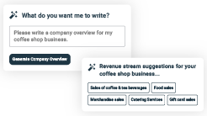
AI-poweredUpmetricsAssistant

AI-poweredinsightstostreamlineyourplan
Not sure where to start? Upmetrics’ AI Assistant will automaticallygenerateideasforeachsectionofyourplanand offerimprovedversionsofyourwriting,adjustingfortone,voice, and grammar or spelling errors.

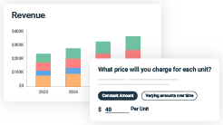
FinancialForecastingTool

Allthefinancialsarecalculatedforyou
Forget the complex formulas and clumsy spreadsheets — withautomaticfinancialsanddrag-and-dropforecasting,you canfinishyourplanfasterandbeconfidentthatyour numbers are accurate.

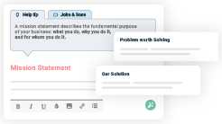
BusinessPlanBuilder

Guidesyoulikeabusinessmentor
Upmetrics’step-by-stepinstructions,prompts,andthelibraryof 400+samplebusinessplanswillguideyouthrougheachsection of your plan as a business mentor.

1.

ExecutiveSummary

MarketopportunityUber Services
Marketing & Sales StrategiesFinancial Highlights



Anexecutivesummaryisthefirstsectionofthebusinessplanintendedto provide an overview of the whole business plan.
Tounlock helptry Upmetrics!

Helptip
WestminsterRideConnect
Startyourexecutivesummarybybrieflyintroducingyourbusinesstoyourreaders.

Thissectionmayincludethenameofyouruberbusiness,itslocation,whenitwasfounded,
Tounlock helptry Upmetrics!
Startwritinghere..

Marketopportunity

Helptip
WestminsterRideConnect
Summarizeyourmarketresearch,includingmarketsize,growthpotential,andmarketing trends.
Tounlock helptry Upmetrics!
Startwritinghere..

UberServices

Helptip
WestminsterRideConnect
HighlighttheUberservicesyouofferyourclients.Listalltheserviceshereasdelivery,pick-up& drop, or any other services your Uber business provides.
Tounlock helptry Upmetrics!
Startwritinghere..

Marketing&SalesStrategies

Helptip
WestminsterRideConnect
Defineyoursalesandmarketingstrategies,specifyingtheplatformsyouwillutilizefor marketing and outlining your approach to customer acquisition.
Tounlock helptry Upmetrics!
Startwritinghere..

FinancialHighlights

Helptip
WestminsterRideConnect
Brieflysummarizeyourfinancialprojectionsfortheinitialyearsofbusinessoperations.Include your financing needs in this section incorporating your startup costs.
Tounlock helptry Upmetrics!
Startwritinghere..

UnitsSoldv/sRevenueChart

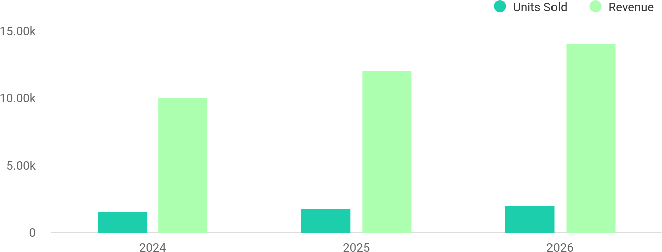

FinancialYear | UnitsSold | Revenue
2024 | 1,550 | $10,000
2025 | 1,800 | $12,000

FinancialYear | UnitsSold | Revenue
2026 | 2,050 | $14,000

Helptip
WestminsterRideConnect
SummarizeyourexecutivesummarysectionwithaclearCTA,forexample,invitingangel investors to discuss the potential business investment.
Tounlock helptry Upmetrics!

Writeacalltoactionforyourbusinessplan.

2.

CompanyOverview

OwnershipMission statementBusiness historyFuture goals

Dependingonwhatdetailsofyourbusinessareessential,you’llneed different elements in your business overview.
Tounlock helptry Upmetrics!
Helptip
WestminsterRideConnect
DescribewhatkindofUberbusinessyourunandthenameofit.Youmayspecializeinoneof the following Uber businesses:
Tounlock helptry Upmetrics!
Startwritinghere..

Ownership

Helptip
WestminsterRideConnect
List the names of your Uber business’s founders or owners. Describe what shares they own and their responsibilities for efficiently managing the business.
Tounlock helptry Upmetrics!
Startwritinghere..

BusinessOwners

JamesParker
100%

Missionstatement


Helptip
WestminsterRideConnect
Summarizeyourbusiness’objective,coreprinciples,andvaluesinyourmissionstatement.This statement needs to be memorable, clear, and brief.
Tounlock helptry Upmetrics!

Our mission at [Westminster RideConnect] isto deliver safe, efficient, and customer-centric transportation and delivery
❛
services that enhance the quality of life for our clients. Weare committed to sustainability, innovation, and community
engagement, striving to set a new standard in on-demand ride- hailing and delivery services.
❜

Businesshistory

Helptip
WestminsterRideConnect
Ifyou’reanestablishedUberserviceprovider,brieflydescribeyourbusinesshistory,like—when itwasfounded,howitevolvedovertime,etc.
Tounlock helptry Upmetrics!
Startwritinghere..

Futuregoals

Helptip
WestminsterRideConnect
It’scrucialtoconveyyouraspirationsandvision.Mentionyourshort-termandlong-termgoals; they can be specific targets for revenue, market share, or expanding your services.
Tounlock helptry Upmetrics!
Startwritinghere..

3.

MarketAnalysis
TargetMarket
MarketsizeandgrowthpotentialCompetitive analysis
Market trendsRegulatoryenvironment

Marketanalysisprovidesaclearunderstandingofthemarketinwhichyour
printingbusinesswillrunalongwiththetargetmarket,competitors, and
growthopportunities.
Tounlock helptry Upmetrics!
Helptip
WestminsterRideConnect
Towritetheintroductionsectionofyourmarketanalysis,startbyclearlyidentifyingyour primary target market.
Tounlock helptry Upmetrics!
Startwritinghere..

TargetMarket

Helptip
WestminsterRideConnect
Startthissectionbydescribingyourtargetmarket.Defineyouridealcustomerandexplainwhat
typesofservicestheyprefer.Creatingabuyerpersonawillhelpyoueasilydefineyourtarget
markettoyourreaders.
Tounlock helptry Upmetrics!
Startwritinghere..

Marketsizeandgrowthpotential

Helptip
WestminsterRideConnect
Describeyourmarketsize,growthpotential,andwhetheryouwilltargetanicheorbroader market.
Tounlock helptry Upmetrics!
Startwritinghere..

MarketSize

AvailableMarket
TotalpopulationinWestminster,CA,and surrounding areas eligible for Uber services.

500k

ServedMarket
Urban commuters, businesses, and familiesactivelyusingride-hailingand delivery services.

300k

TargetMarket
Tech-savvy professionals, families, and businesses prioritizing convenience and reliability.

150k

Helptip
WestminsterRideConnect
Identifyandanalyzeyourdirectandindirectcompetitors.Identifytheirstrengths and
weaknesses,anddescribewhatdifferentiatesyourUberservicesfromthem.Pointouthowyou
haveacompetitiveedgeinthemarket.
Tounlock helptry Upmetrics!

Competitiveanalysis

Lyft
Lyftisawell-knownride-hailingserviceoperatinginthesamemarketasUber,offeringsimilarservices such as ride-sharing, bike rentals, and car rentals. Lyft has positioned itself as a community-focused and environmentally friendly option.

Features
Ride-hailingservices(Lyft,Lyft XL, and Shared Rides).
SubscriptionplanslikeLyft Pink for frequent users.
Integration with public transportationservices.

Strengths
Strongbrandrecognitionand extensive user base.
Comprehensive service options,includingbikeand scooter rentals.
Competitive pricing with discountsforfrequentusers.

Weaknesses
Limitedpresenceinsmallercities compared to Uber.
Highdriverturnoverrate affectingservicequality.
Loweremphasisonlocal customerengagement.

DoorDash
DoorDash focuses primarily on delivery services, competing with Uber Eats. It has become a dominant player in the food delivery market with partnerships with a wide array of restaurants and businesses.

Features
On-demandfooddeliveryfrom restaurants.
DashPasssubscriptionfor reduceddeliveryfees.
Expansionintogroceryand retail delivery.

Strengths
Large restaurant network offeringdiversefoodoptions.
Highusersatisfactionwith delivery times.
Innovativefeatureslikegroup ordering and delivery time slots.

Weaknesses
Limitedfocusonride-hailing services.
Dependence on delivery commissions impacts restaurant partnerships.
Lackofsustainabilityinitiatives compared to competitors.

Via
Viafocusesonshared,affordabletransportationbyoptimizingrideroutes.Whilesmallerinscale,its operationalefficiencyandaffordabilitymakeitaformidablecompetitor.

Features
Sharedride-hailingservices optimized for cost- effectiveness.
Partnerships with municipalities and schools for transit solutions.
Fixedrouteservicesfor frequent users.

Strengths
Highly efficient route optimization reduces costs for riders.
Strongpartnershipswithpublic transportation systems.
Focusedmarkettargeting improvescustomerloyalty.

Weaknesses
Smaller geographic coverage compared to Uber and Lyft.
Limitedserviceoptionsoutside shared rides.
Less recognized brand name in competitive markets.

Markettrends

Helptip
WestminsterRideConnect
Analyze emerging trends in the industry, such as technology disruptions, changes in customer behavior or preferences, etc. Explain how your business will cope with all the trends.
Tounlock helptry Upmetrics!
Startwritinghere..

Regulatoryenvironment

Helptip
WestminsterRideConnect
List regulations and licensing requirements that may affect your senior daycare company, such as business registration, licensing, staffing requirements, financial regulations, etc.
Tounlock helptry Upmetrics!
Startwritinghere..

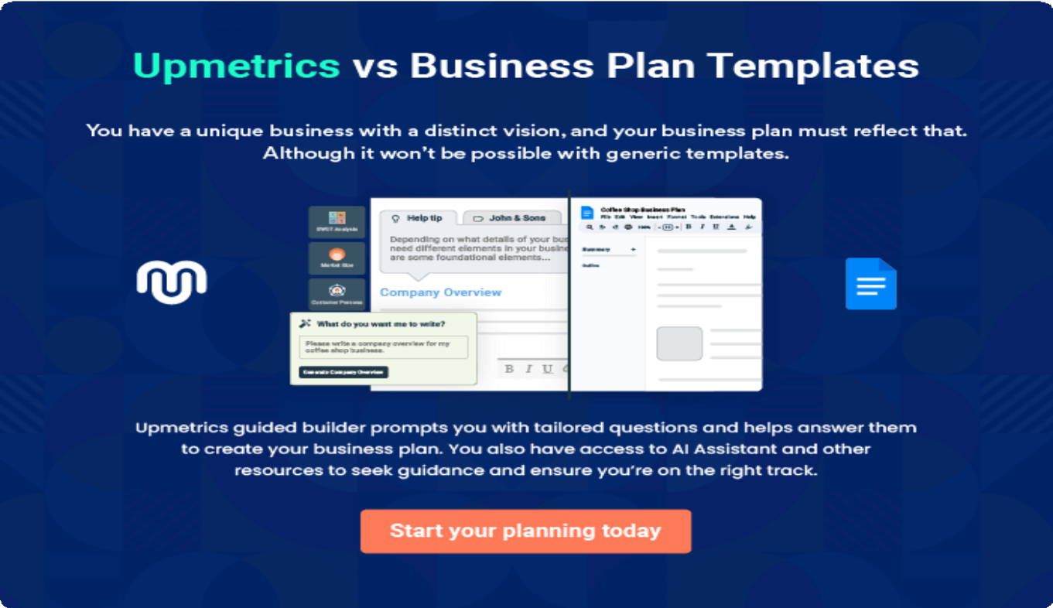

4.

Productsand Services

Services
Qualitymeasures

Theproductandservicessectionofauberbusinessplanshoulddescribethe
specificservicesandproductsthatwillbeofferedtocustomers.Towritethis
sectionshouldincludethefollowing:
Tounlock helptry Upmetrics!
Helptip
WestminsterRideConnect
Tocrafttheintroductionforyour"ProductsandServices"chapter,beginbypositioningyour business within its industry, emphasizing its unique strengths or value proposition.
Tounlock helptry Upmetrics!

Startwritinghere..
Helptip
MentiontheUberservicesyourbusinesswilloffer.Thislistmayincludeserviceslike:

- UberX
Tounlock helptry Upmetrics!

Services


UberX

Price:$0.97permile+$1.50basefare

Affordable,everydayridesforindividualsorsmallgroups, perfect for daily commutes or casual trips.

Specifications
- Upto4passengers.
- Clean,modernvehicleswithcomfortableseating.
- StandardUberin-appfeatureslikeupfrontpricingand live tracking.

UberXL

Price:$1.45permile+$3.00basefare

Spacious rides designed for larger groups or families, providing comfort and convenience.

Specifications
  - Accommodatesupto6passengers.
  - LargervehicleslikeSUVsorvans.
  - Amplespaceforluggageorequipment.

UberPOOL

Price:$0.65permile+$1.00basefare

Cost-effectivesharedrides,idealforbudget-conscious customers and environmentally friendly travel.

Specifications
  - Sharedridewithupto2additionalpassengers.
  - Smartrouteoptimizationtominimizetraveltime.
  - Real-timeupdatesonpickupanddrop-offschedules.

UberEATS

Price:$2.99-$4.99deliveryfee(variesbydistance)

On-demand food delivery connecting local restaurants with customers for fast and reliable service.

ServiceSpecifications
  - Deliverywithin30-45minutesonaverage.
  - Real-timeordertracking.
  - Contactlessdeliveryoptionsavailable.

UberEVENTS

Price:Custompricingbasedoneventrequirements.

Tailored ride solutions for weddings, corporate events, and special occasions, ensuring group transportation is smooth and stress-free.

Specifications
  - Flexiblevehicleoptions(sedans,SUVs,orbuses).
  - Pre-scheduledpickupsanddrop-offs.
  - Dedicatedsupportforeventplanning.

Qualitymeasures

Helptip
WestminsterRideConnect
This section should explain how you maintain quality standards and consistently provide the highest quality service.
Tounlock helptry Upmetrics!
Startwritinghere..

5.

SalesAndMarketing
Strategies

Unique Selling Proposition (USP)Pricing Strategy
Marketing strategiesSales strategiesCustomer retention

Writing the sales and marketing strategies section means a list of strategies you will use to attract and retain your clients.
Tounlock helptry Upmetrics!
HelpTip
WestminsterRideConnect
Tocreateaneffectiveintroductionforyour"SalesandMarketingStrategies"chapter,startby setting the stage within your specific industry or market.
Tounlock helptry Upmetrics!
Startwritinghere..

UniqueSellingProposition(USP)

Helptip
WestminsterRideConnect
Define your business’s USPs depending on the market you serve, the equipment you use, and theuniqueservicesyouprovide.IdentifyingUSPswillhelpyouplanyourmarketingstrategies.
Tounlock helptry Upmetrics!
Startwritinghere..

PricingStrategy

Helptip
WestminsterRideConnect
Describeyourpricingstrategy—howyouplantopriceyourservicesandstaycompetitivein the
localmarket.Youcanmentionanydiscountsyouplantoattractnewcustomerstoyour
business.
Tounlock helptry Upmetrics!
Startwritinghere..

Helptip
Discussyourmarketingstrategiestomarketyourservices.Youmayincludesomeofthese
marketingstrategiesinyourbusinessplan—socialmediamarketing,Googleads,email
marketing,contentmarketing,andprintmarketing.
Tounlock helptry Upmetrics!

Marketingstrategies

Online


SocialMedia
Engaging content on Instagram, Facebook, andTwittertopromote services and interact with customers.

ContentMarketing
Blogs and videos showcasing customer stories,servicequality, and eco-friendly initiatives.

GoogleAds
Targeted campaigns to capture search traffic for ride-hailing and delivery services in Westminster.

EmailMarketing
Personalized emails highlighting promotions,discounts, and service updates to keep customers informed.

Offline

PrintMarketing
Flyersandpostersinhigh-trafficareaslikemalls,restaurants,andpublic transport hubs.

Helptip
Outline the strategies you’ll implement to maximize your sales. Your sales strategies may includedirectsalescalls,partneringwithotherbusinesses,offeringreferralprograms,etc.
Tounlock helptry Upmetrics!

Salesstrategies

Partnerships
Collaboratingwithlocal businesses and restaurants for cross- promotions and exclusive offers.

DirectSalesCalls
Reaching out to potential corporate clients for event transportation and employee commute services.

ReferralPrograms
Encouraging existing customerstorefernew users in exchange for discounts or rewards.

Helptip
Describeyourcustomerretentionstrategiesandhowyouplantoexecutethem.Forinstance, introducing loyalty programs, discounts, referral rewards, etc.
Tounlock helptry Upmetrics!

Customerretention

LoyaltyPrograms
Rewarding frequent riders with points redeemable for discountsorfreerides.

ExclusiveOffers
Seasonalandfestive promotions to encourage repeat usage.

Feedback
Mechanisms
Actively seeking customer feedback and implementing improvements to enhance service satisfaction.

6.

OperationsPlan

Staffing & TrainingOperational ProcessEquipment & Tools

Whenwritingtheoperationsplansection,it’simportanttoconsiderthe various aspects of your business operations.
Tounlock helptry Upmetrics!
Helptip
WestminsterRideConnect
Tocreateaneffectiveintroductionforyour"OperationalPlan"chapter,startbyemphasizingthe
pivotalroleofefficientoperationsinthesuccessofyourbusiness,underscoringhowthey
directlyimpactthequalityofservicesdelivered.
Tounlock helptry Upmetrics!
Startwritinghere..

Staffing&Training

Helptip
WestminsterRideConnect
MentionyourUberbusiness’sstaffingrequirements,includingthenumberofdriversorother
employeesneeded.Includetheirqualifications,thetrainingrequired,andthedutiestheywill
perform.
Tounlock helptry Upmetrics!
Startwritinghere..

OperationalProcess

Helptip
WestminsterRideConnect
OutlinetheprocessesandproceduresyouwillusetorunyourUberbusiness.Your operational
processesmayincludedriveronboarding,vehiclemaintenance,paymentsystem,customer
support,datasecurity,etc.
Tounlock helptry Upmetrics!
Startwritinghere..

Equipment&Tools

Helptip
WestminsterRideConnect
Outlinetheessentialtools,suppliesandequipmentusedforuberservices.Also,consider setting up technology and software systems to streamline your daily operations.
Tounlock helptry Upmetrics!
Startwritinghere..

7.

ManagementTeam

Key managersOrganizationalstructureCompensation planBoard of advisors

The management team section provides an overview of the individuals responsible for running your business plan.
Tounlock helptry Upmetrics!
Helptip
WestminsterRideConnect
Tocraftanintroductionforyour"ManagementTeam"chapter,beginbyemphasizingthecrucial role of leadership in the success of any business.
Tounlock helptry Upmetrics!
Startwritinghere..

Keymanagers

Helptip
MentionthefoundersandCEOofyourUberbusinessaswellasyourmanagementandkey
membersofyourteam,anddescribetheirrolesandresponsibilitiesinsuccessfullyrunningthe
business.
Tounlock helptry Upmetrics!
Startwritinghere..

JamesParker


Founder/CEO-james.parker@example.com

EducationalBackground:



- James holds a Bachelor’s degree in Business Administration from California State University, Fullerton.

ProfessionalBackground:

- With over 10 years of experience in logistics and transportation, James has managed large-scale fleet operations for prominent companies before starting [Westminster RideConnect].
- Hisexpertiseinstrategicplanningandoperationalefficiencyhasbeen instrumental in the company’s vision and growth.


EmmaRodriguez

ChiefOperatingOfficer(COO)-emma.rodriguez@example.com

EducationalBackground:

- Emma holds an MBA with a specialization in Operations Management from California State University, Long Beach.

ProfessionalBackground:

- She has 8 years of experience in managing operational processes and quality assurance in the transportation sector.
- EmmapreviouslyworkedastheOperationsManagerataleadingride- hailingcompany,whereshestreamlinedworkflowsandimproveddriver satisfaction rates.

SophiaNguyen


CustomerServiceManager-sophia.nguyen@example.com

EducationalBackground:

- Sophia has a Bachelor’s degree in Business Administration from University of California, Irvine.

ProfessionalBackground:

- With 5 years of experience in customer service, Sophia specializes in customer relations and team management.
- Shepreviouslymanagedacallcenterteamforamajore-commerce company, achieving high satisfaction scores and quick resolution times.


MichaelLee

ChiefMarketingOfficer(CMO) -michael.lee@example.com

EducationalBackground:

- MichaelgraduatedwithadegreeinMarketingfromUniversityof California, Los Angeles (UCLA).

ProfessionalBackground:

- Withover6yearsofexperienceindigitalmarketingandbranding,Michael hasledsuccessfulcampaignsforseveralon-demandservicecompanies.
- His expertise lies in customer acquisition strategies and leveraging social media to boost brand visibility.

DanielCarter


FleetOperationsManager-daniel.carter@example.com

EducationalBackground:

- DanielholdsadegreeinAutomotiveEngineeringfromCalifornia Polytechnic State University, San Luis Obispo.

ProfessionalBackground:

- Withover7yearsofexperienceinfleetmanagement,Danielisanexpert in vehicle maintenance, compliance, and logistics.
- Hepreviouslyworkedwitharegionallogisticsfirm,whereheoptimized fleet operations and reduced maintenance costs by 15%.

Organizationalstructure

Helptip
WestminsterRideConnect
Explaintheorganizationalstructureofyourmanagementteam.Includethereportinglineand decision-making hierarchy.
Tounlock helptry Upmetrics!
Startwritinghere..

Organizationchart


JamesParker
Founder&CEO


EmmaRodriguez
ChiefOperatingOfficer
-COO
MichaelLee
ChiefMarketingOfficer
-CMO

LindaCollins
FinancialAnalyst



SophiaNguyen CustomerService Manager
Daniel Carter FleetOperations Manager

Compensationplan

Helptip
WestminsterRideConnect
Describeyourcompensationplanforthemanagementandstaff.Includetheirsalaries, incentives, and other benefits.
Tounlock helptry Upmetrics!
Startwritinghere..

Helptip
Mentioningadvisorsorconsultantsinyourbusinessplansaddscredibilitytoyourbusiness idea.
Tounlock helptry Upmetrics!

Boardofadvisors


RajPatel

BusinessStrategyAdvisor

A seasoned business consultant with over 20 years of experience, Raj supports [Westminster RideConnect] in strategic growth planning and competitive positioning.

LisaThompson


TransportationConsultant

With15yearsofexperienceinurbantransportationplanning,Lisaadviseson optimizing route efficiency and implementing sustainability initiatives.

8.

FinancialPlan

Profit&lossstatementCash flow statementBalance sheet
Break-evenPointFinancing needs

Helptip
Describedetailssuchasprojectedrevenue,operationalcosts,andservicecostsinyourprojectedprofitandlossstatement.Makesuretoinclude
yourbusiness’sexpectednetprofitorloss.

Whenwritingthefinancialplansectionofabusinessplan,it’simportanttoprovideacomprehensiveoverviewofyourfinancial projections for the first few years of your business, You may provide the following:
Tounlock helptry Upmetrics!
Helptip
WestminsterRideConnect
Tocreateaneffectiveintroductionforyour"FinancialPlan"chapter,beginbystressingthecriticalroleofawell-structuredfinancialplaninthe success of your venture.
Tounlock helptry Upmetrics!
Startwritinghere..

 |  |  | Tounlock helptry Upmetrics!
Profit&lossstatement | 2024 | 2025 | 2026
Revenue | $1,971,092.21 | $2,896,806.83 | $4,215,466.52
RideCommissions | $851,522.40 | $1,214,066.25 | $1,730,966.85

 | 2024 | 2025 | 2026
UnitSales | 56,768 | 80,938 | 115,398
UnitPrice | $15 | $15 | $15
UberPassSubscriptions | $358,469.81 | $825,088.58 | $1,518,079.67
Users | 9,524 | 22,721 | 42,242
RecurringCharges | $2.50 | $2.50 | $2.50
AdvertisingRevenue | $761,100 | $857,652 | $966,420
UnitSales | 634 | 715 | 805
UnitPrice | $1,200 | $1,200 | $1,200

CostOf Sales | $212,310.92 | $221,568.07 | $234,754.67
GeneralCosts | $212,310.92 | $221,568.07 | $234,754.67
DriverCosts | $148,710.92 | $157,968.07 | $171,154.67
DriverPayments | $36,000 | $36,000 | $36,000
DriverIncentives/Bonuses | $19,710.92 | $28,968.07 | $42,154.67
VehicleLeaseAssistance | $93,000 | $93,000 | $93,000
PlatformCosts | $63,600 | $63,600 | $63,600
TechnologyMaintenance | $9,600 | $9,600 | $9,600

 | 2024 | 2025 | 2026
PaymentProcessingFees | $18,000 | $18,000 | $18,000
CustomerSupport | $36,000 | $36,000 | $36,000
RevenueSpecificCosts | $0 | $0 | $0

PersonnelCosts(Direct Labor)

$0 $0 $0

GrossMargin | $1,758,781.29 | $2,675,238.76 | $3,980,711.85
GrossMargin(%) | 89.23% | 92.35% | 94.43%
Operating Expense | $1,897,554.62 | $2,011,896.34 | $2,154,637.98

PayrollExpense(Indirect Labor)

$1,454,400 $1,527,456 $1,604,264.64

ExecutiveTeam | $117,600 | $122,304 | $127,196.16
General Manager | $67,200 | $69,888 | $72,683.52
OperationsManager | $50,400 | $52,416 | $54,512.64
AdministrativeStaff | $136,800 | $145,152 | $154,068.48
Customer Support Team | $64,800 | $67,392 | $70,087.68

 | 2024 | 2025 | 2026
BackOfficeSupport | $72,000 | $77,760 | $83,980.80
Drivers | $1,200,000 | $1,260,000 | $1,323,000
Full-TimeDrivers | $960,000 | $1,008,000 | $1,058,400
Part-TimeDrivers | $240,000 | $252,000 | $264,600
GeneralExpense | $438,154.61 | $484,440.34 | $550,373.33
Driver-RelatedCosts | $108,554.61 | $154,840.34 | $220,773.33
DriverPayouts | $98,554.61 | $144,840.34 | $210,773.33
InsuranceforDrivers | $10,000 | $10,000 | $10,000
Operational Expenses | $329,600 | $329,600 | $329,600
VehicleMaintenance | $320,000 | $320,000 | $320,000
FuelCosts | $9,600 | $9,600 | $9,600
BadDebt | $0 | $0 | $0
AmortizationofCurrent Assets | $5,000 | $0 | $0

EBITDA ($138,773.34) $663,342.40 $1,826,073.87

 | 2024 | 2025 | 2026
AdditionalExpense | $167,990.45 | $157,085.62 | $145,508.20
LongTermDepreciation | $112,800 | $112,800 | $112,800
GainorlossfromSaleof Assets | $0 | $0 | $0
EBIT | ($251,573.34) | $550,542.40 | $1,713,273.87
InterestExpense | $55,190.45 | $44,285.62 | $32,708.20
EBT | ($306,763.79) | $506,256.78 | $1,680,565.67

IncomeTaxExpense/ Benefit

$0 $0 $0

TotalExpense | $2,277,856 | $2,390,550.05 | $2,534,900.85
NetIncome | ($306,763.79) | $506,256.78 | $1,680,565.67
NetIncome(%) | (15.56%) | 17.48% | 39.87%

RetainedEarningOpening | $0 | ($706,763.79) | ($600,507.01)
Owner'sDistribution | $400,000 | $400,000 | $400,000
RetainedEarningClosing | ($706,763.79) | ($600,507.01) | $680,058.66

Cashflowstatement | 2024 | 2025 | 2026
CashReceived | $1,971,092.21 | $2,896,806.83 | $4,215,466.52
CashPaid | $2,160,056 | $2,277,750.05 | $2,422,100.85
COS&GeneralExpenses | $650,465.55 | $706,008.43 | $785,128.01
Salary&Wages | $1,454,400 | $1,527,456 | $1,604,264.64
Interest | $55,190.45 | $44,285.62 | $32,708.20
SalesTax | $0 | $0 | $0
IncomeTax | $0 | $0 | $0

NetCashFrom Operations

($188,963.79) $619,056.78 $1,793,365.67

Helptip
Thecashflowforthefirstfewyearsofyouroperationshouldbeestimatedanddescribedinthissection.Thismayincludebillinginvoices, payment receipts, loan payments, and any other cash flow statements.
Tounlock helptry Upmetrics!

AssetsSell $0 $0 $0

 | 2024 | 2025 | 2026
AssetsPurchase | $2,005,000 | $0 | $0

NetCashFrom Investments

($2,005,000) $0 $0

AmountReceived | $1,500,000 | $0 | $0
LoanReceived | $1,000,000 | $0 | $0
CommonStock
PreferredStock | $0 | $0 | $0
Owner'sContribution | $500,000 | $0 | $0
AmountPaid | $576,803.15 | $587,707.98 | $599,285.40
LoanCapital | $176,803.15 | $187,707.98 | $199,285.40
Dividends&Distributions | $400,000 | $400,000 | $400,000

NetCashFrom Financing

$923,196.85 ($587,707.98) ($599,285.40)

Summary

StartingCash $0 ($1,270,766.94) ($1,239,418.14)

 | 2024 | 2025 | 2026
CashIn | $3,471,092.21 | $2,896,806.83 | $4,215,466.52
CashOut | $4,741,859.15 | $2,865,458.03 | $3,021,386.25
Change inCash | ($1,270,766.94) | $31,348.80 | $1,194,080.27
Ending Cash | ($1,270,766.94) | ($1,239,418.14) | ($45,337.87)

Helptip
Createaprojectedbalancesheetdocumentingyouruberbusiness’sassets,liabilities,andequity.
Tounlock helptry Upmetrics!

Balancesheet | 2024 | 2025 | 2026
Assets | $616,433.06 | $534,981.86 | $1,616,262.13
CurrentAssets | ($1,270,766.94) | ($1,239,418.14) | ($45,337.87)
Cash | ($1,270,766.94) | ($1,239,418.14) | ($45,337.87)
AccountsReceivable | $0 | $0 | $0
Inventory | $0 | $0 | $0

 | 2024 | 2025 | 2026
OtherCurrentAssets | $0 | $0 | $0
LongTermAssets | $1,887,200 | $1,774,400 | $1,661,600
GrossLong TermAssets | $2,000,000 | $2,000,000 | $2,000,000
Accumulated Depreciation | ($112,800) | ($225,600) | ($338,400)

Liabilities&Equity | $616,433.06 | $534,981.86 | $1,616,262.13
Liabilities | $823,196.85 | $635,488.87 | $436,203.47
CurrentLiabilities | $187,707.98 | $199,285.40 | $211,576.89
AccountsPayable | $0 | $0 | $0
IncomeTaxPayable | $0 | $0 | $0
SalesTaxPayable | $0 | $0 | $0
ShortTermDebt | $187,707.98 | $199,285.40 | $211,576.89
LongTermLiabilities | $635,488.87 | $436,203.47 | $224,626.58
LongTermDebt | $635,488.87 | $436,203.47 | $224,626.58
Equity | ($206,763.79) | ($100,507.01) | $1,180,058.66
Paid-inCapital | $0 | $0 | $0
CommonStock | $0 | $0 | $0

Helptip
Determineandmentionyourbusiness’sbreak-evenpoint—thepointatwhichyourbusinesscostsandrevenuewillbeequal.

Thisexercisewillhelpyouunderstandhowmuchrevenueyouneedtogeneratetosustainorbeprofitable.
 | 2024 | 2025 | 2026
PreferredStock | $0 | $0 | $0
Owner'sContribution | $500,000 | $500,000 | $500,000
RetainedEarnings | ($706,763.79) | ($600,507.01) | $680,058.66

Check $0 $0 $0

 |  |  | Tounlock helptry Upmetrics!
Break-evenPoint | 2024 | 2025 | 2026
StartingRevenue | $0 | $1,971,092.21 | $4,867,899.04
NetRevenue | $1,971,092.21 | $2,896,806.83 | $4,215,466.52
ClosingRevenue | $1,971,092.21 | $4,867,899.04 | $9,083,365.56

 | 2024 | 2025 | 2026
StartingExpense | $0 | $2,277,856 | $4,668,406.05
NetExpense | $2,277,856 | $2,390,550.05 | $2,534,900.85
ClosingExpense | $2,277,856 | $4,668,406.05 | $7,203,306.90

IsBreakEven? | No | Yes | Yes
BreakEvenMonth | 0 | Oct'25 | 0
DaysRequired | 0 | 7Days | 0
BreakEvenRevenue | $2,277,856 | $4,100,934.50 | $0
RideCommissions | $0 | $1,746,633.95 | $0
UberPassSubscriptions | $0 | $942,392.16 | $0
AdvertisingRevenue | $0 | $1,411,908.40 | $0
BreakEvenUnits
RideCommissions | 0 | 116,442 | 0
UberPassSubscriptions | 0 | 19,325 | 0
AdvertisingRevenue | 0 | 1,177 | 0

Financingneeds

Helptip
WestminsterRideConnect
Calculate costs associated with starting a uber business, and estimate your financing needs and how much capital you need to raise to operate your business.
Tounlock helptry Upmetrics!
Startwritinghere..

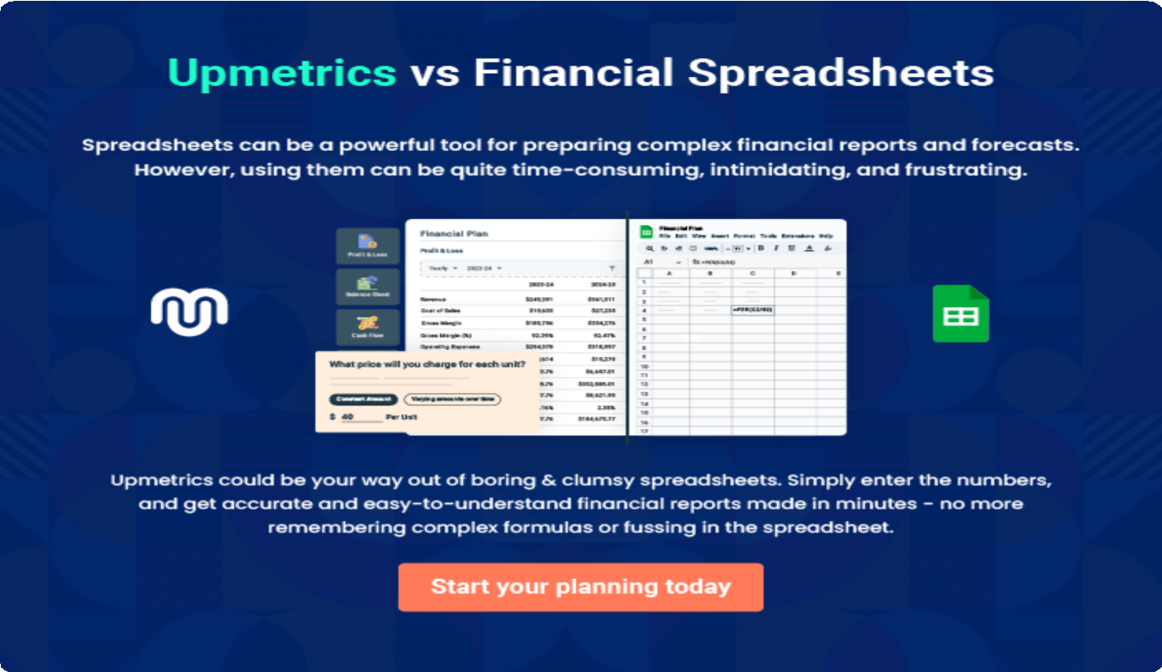

9.

Appendix
EmbedLink

Whenwritingtheappendixsection,youshouldincludeanyadditional
informationthatsupportsthemaincontentofyourplan.Thismayinclude
financialstatements,marketresearchdata,legaldocuments,andother
Tounlock helptry Upmetrics!
EmbedLink

Createawinningbusinessplanthatgetsyoufunded

Creatingastunningandinvestment-readyplanrequiresnowriting,graphicdesigning,orfinancial planning expertise.

Upmetricshasallthefeaturesrequiredtohelpyoucreateacomprehensivebusinessplan—fromstarttofinish. Makenomistakes,it’sthemodernwayofplanningtostructureideas,makeplans,andcreatestunningpitch decks to awe investors.

Pitchdecksthatimpressinvestors
Create pitch decks that provide a visual representation of your business, engage investors,andmakethemwanttoinvestinyour businessidea.

Interactiveplansinnotime
Import business plan sections like—SWOT analysis,comparisontables,andotherstocreate an interactive business plan. No designing skills arerequired.

Stunningcoverpagedesigns
WithUpmetrics,youhavethelibertytochoose from multiple stunning cover page designs.
Chooseacreativedesignandmakeyourplan standout.

500+samplebusinessplans
Simplyimportatemplatefromourlibraryof sample plans into the editor and start customizingittomakeityours.Ittakesonlyafew clicks to get started.

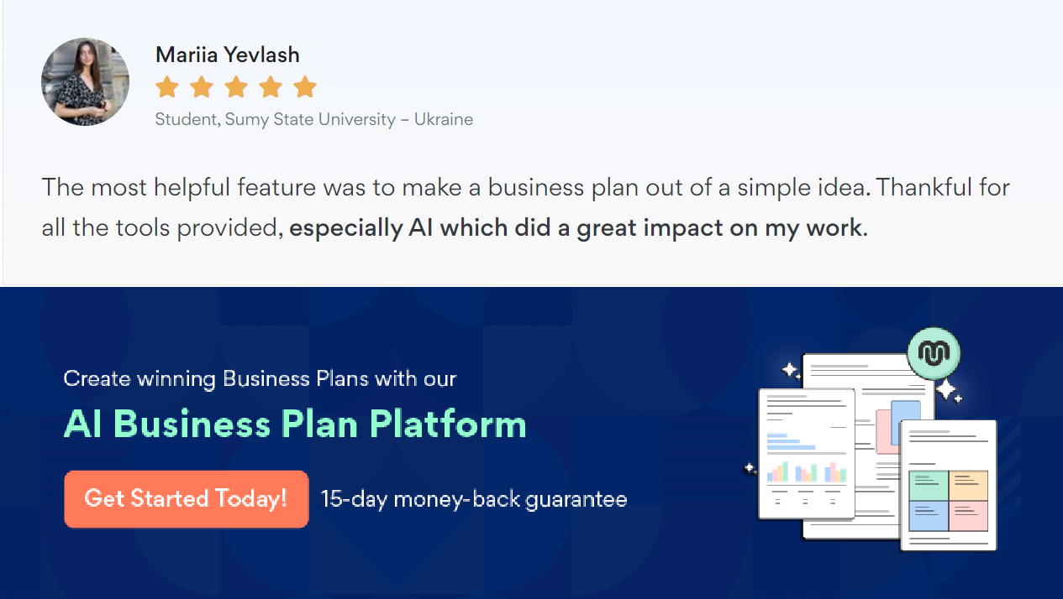Onlinesharingmadesimple
Upmetricsmakesonlinesharingquickandeasier forusers.Easilyshareyourbusinessplanswitha linkwhiletrackingreaderactivity.

Collaboratewithteaminreal-time
Invite team members, initiate conversations, discussideas&strategies,sharefeedback,and work on a business plan in real-time.

