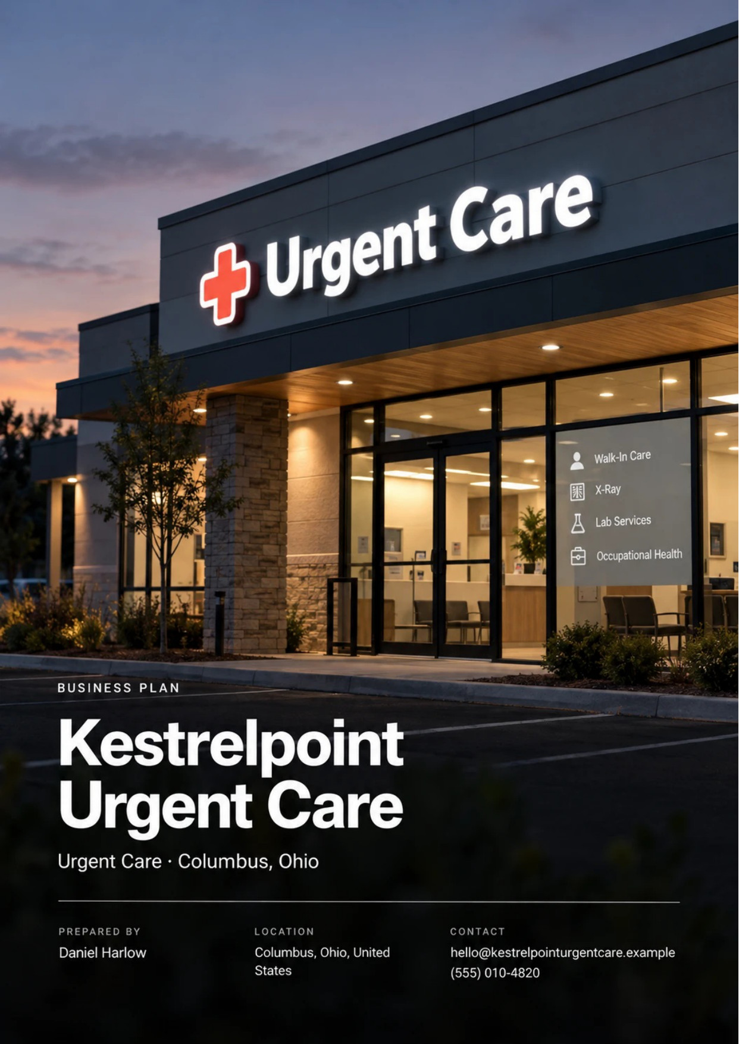
Table of Contents
1. Executive Summary 6
1.1 Business Overview 7
1.2 Mission Statement 7
1.3 Location & Market Opportunity 7
1.4 Unique Selling Points 7
1.5 Financial Highlights 8
1.6 Funding Requirement 8
1.6.1 Income Statement (3 Year projections) 8
2. Company Overview 9
2.1 Legal Structure 10
2.2 Vision Statement 10
2.3 Background & History 10
2.4 Future Goals 10
2.4.1 Business Owners 11
2.4.2 SMART Goal 11
3. Market Analysis 12
3.1 Overview 13
3.2 Market Segmentation 13
3.3 Market Trends 13
3.4 Local Market Outlook 13
3.5 Market Size 14
3.5.1 PESTEL Analysis 14
4. Customer Analysis 16
4.1 Target Market 17
4.2 Customer Segments 17
4.3 Customer Persona 18
4.4 Customer Purchase Journey 18
5. Competitive Analysis 19
5.1 Competitors 20
5.2 Comparison 20
5.3 Competitive Edge 20
5.4 SWOT Analysis 22
6. Services Offered 23
6.1 Our Offering 24
6.2 Signature Items 24
6.3 Additional Services 24
6.4 What Sets Us Apart 24
6.5 Scope of Care & Referral Pathways 24
6.5.1 Walk-In Urgent Care Visit 25
6.5.2 Occupational Health Program 25
6.5.3 Features 26
6.5.4 Pricing 27
7. Marketing & Sales Strategies 28
7.1 Market Positioning 29
7.2 Marketing Objectives 29
7.3 Online Marketing 29
7.4 Public Relations and Branding 30
7.5 Partnership & Collaboration Strategy 30
7.6 Customer Loyalty & Retention 30
7.7 Sales Channels 30
8. Operations Plan 31
8.1 Daily Operations 32
8.2 Working Hours 32
8.3 Staffing & Training 32
8.4 Inventory & Equipment Management 32
8.5 Location and Facilities 33
8.6 Milestones & Timeline 33
8.7 Licensing, Credentialing & Payer Contracts 34
9. Management Team 35
9.1 Key Members 36
9.2 Organization Chart 36
9.3 Advisory Board Members 37
9.3.1 Hiring Plan 37
10. Financial Plan 38
10.1 Key Assumptions 39
10.2 Capital Requirements and Use of Funds 39
10.2.1 Use of Funds 39
10.3 Income Statement (3 Year projections) 41
10.4 Balance Sheet (3 Year projections) 42
10.5 Cash Flow Statement (3 Year projections) 43
10.6 Break Even Analysis 44
11. References 45


CHAPTER 1

Executive Summary

1.1 Business Overview
1.2 Mission Statement
1.3 Location & Market Opportunity
1.4 Unique Selling Points
1.5 Financial Highlights
1.6 Funding Requirement

1.1 Business Overview

Kestrelpoint Urgent Care is an independent walk-in clinic opening on the northwest side of Columbus, Ohio, toward Hilliard. A physician or nurse practitioner sees patients of all ages from 8 a.m. to 8 p.m. every day but five holidays, for illness and injury that cannot wait for a family doctor and does not need an emergency room.
The clinic treats fevers, infections, sprains, cuts and simple fractures, with digital X-ray, a point of care lab and a procedure room on site. It also runs physicals, DOT exams, drug screens and work injury care for local employers. Insurers pay for most visits, and self-pay patients pay posted prices from $149.

1.2 Mission Statement
To give every family and worker on Columbus's northwest side same-day care they can reach after work, at a price they know before they walk in, with the record sent back to their own doctor.

1.3 Location & Market Opportunity
Franklin County had about 1,361,536 residents in July 2025, and the Columbus metro grew twice as fast as the nation that year. Hilliard, at the edge of the clinic's catchment, is a city of young families: 27.3% of its residents are under 18 and its median household income is $128,189. Nearer the city, Columbus households earn less and 11.1% have no insurance, so the clinic needs both a pediatric-ready offer and a posted self-pay price.
US urgent care centers took $44.3 billion in 2025. The Franklin County market for the freestanding care category that holds urgent care is about $362 million a year, an upper bound that also counts surgery centers and freestanding emergency rooms, and one average urgent care center takes about $2.03 million. Kestrelpoint's first-year revenue sits below that average because the clinic opens at 40% of its planned daily census.

1.4 Unique Selling Points
- Open 8 a.m. to 8 p.m. every day, when the health system clinic nearest the site closes at 3:30 p.m. on weekends.
- X-ray, a lab and a procedure room, so most injuries are treated in one visit.
- Self-pay prices posted from $149, with each add-on priced before the visit.
- Physicals, drug screens and DOT exams for employers on evenings and weekends as well as weekdays.
- Visit notes sent to the family doctor by the next morning.

1.5 Financial Highlights
Revenue comes from patient visits at an average of $148 collected per visit across all payers, plus occupational health services worth a further 8% of visit revenue. The clinic plans for 30 patients a day once its census is built, opening at 40% of that and reaching it over twelve months.
Revenue is projected at $1,208,390 in the first year, $1,450,068 in the second and $1,740,082 in the third, at a gross margin of 84.0% throughout. The first year closes with a net loss of $3,649, after which net income reaches $46,623 and then $105,121, a net margin of 6.0% by the third year. Break-even revenue is $1,066,662, or 7,207 patient visits. Third-year net income is $41,149 in the conservative case and $191,526 in the upside case.

1.6 Funding Requirement
The startup budget is $652,000. It builds out about 3,600 square feet into seven exam rooms, a procedure room and an X-ray room, equips them, and covers licences, payer credentialing, opening supplies, pre-opening staff training and launch marketing. It is funded by $250,000 from the two founders and a $575,000 SBA 7(a) loan at 10% over ten years, which together leave about $173,000 of opening cash to carry payroll while insurer payments begin. Profits stay in the clinic while the loan is repaid.
The plan rests on a physician owner who works the schedule, a catchment that keeps adding families and jobs, and hours that the clinics around it do not keep. The money opens one fully equipped clinic that can treat most of what walks in the door in a single visit.

1.6.1 Income Statement (3 Year projections)
 | Year 1 | Year 2 | Year 3 | Total
Revenue | $1,208,390.40 | $1,450,068.48 | $1,740,082.18 | $4,398,541.06
Cost of Sales | $193,342.46 | $232,010.96 | $278,413.15 | $703,766.57
Gross Margin | $1,015,047.94 | $1,218,057.52 | $1,461,669.03 | $3,694,774.49
Operating Expense | $895,996.49 | $1,039,915.78 | $1,212,618.95 | $3,148,531.22
Total Expense | $1,212,038.95 | $1,403,445.33 | $1,634,960.95 | $4,250,445.23
Net Income | ($3,648.55) | $46,623.15 | $105,121.23 | $148,095.83

CHAPTER 2

Company Overview

2.1 Legal Structure
2.2 Vision Statement
2.3 Background & History
2.4 Future Goals

2.1 Legal Structure
Kestrelpoint Urgent Care will be organized as an Ohio limited liability company owned by its two founders, Dr. Daniel Harlow and Rachel Imler. The LLC holds the lease, the payer contracts, the employer accounts and the equipment, and employs every member of the clinical and front office team. Dr. Harlow serves as medical director and as the collaborating physician named in each nurse practitioner's standard care arrangement, as Ohio requires.
The company carries professional liability cover for every provider, general liability for the premises and workers' compensation for staff. Ohio does not license urgent care centers as facilities, so the regulatory work sits in the clinic's individual registrations: X-ray equipment, the lab waiver, the drug license and the payer and BWC enrollments.

2.2 Vision Statement
To be the clinic families and employers on Columbus's northwest side call first when something cannot wait, because it is open when they need it, priced where they can see it and connected to the doctors they already have.

2.3 Background & History
The founders met while working for a multi-site urgent care group in central Ohio, Dr. Harlow on the clinical schedule and Rachel Imler running its credentialing and billing. Both watched patients drive past closed clinics on weekend afternoons and employers send injured workers to the emergency room after 5 p.m. because their occupational health clinic had gone home.
Kestrelpoint is their plan to run one clinic the way they would want it run: every day, into the evening, with prices posted and records returned to the family doctor. The business is pre-launch. The founders intend to sign a lease in October 2026, start credentialing with payers the same month and open the doors in March 2027.

2.4 Future Goals
In the first 0 to 18 months the founders intend to open on schedule, have every major commercial plan, Medicare and all seven Ohio Medicaid plans contracted, reach 30 patients a day within twelve months of opening and sign the first employer accounts for physicals, drug screens and work injury care.
Over 1 to 3 years, which the financial projection covers, the aim is to grow revenue from $1,208,390 in the first year to $1,740,082 in the third, add a second provider during the busiest hours of the respiratory season, repay the SBA loan on schedule and keep door to discharge time under an hour as volume rises.
Over 3 to 5 years the founders intend to decide on a second clinic in another growing part of the metro, using the systems, staff training and payer contracts built at the first, and to add telehealth follow-up visits for patients the clinic has already seen.

2.4.1 Business Owners
Daniel Harlow | Rachel Imler

Total ownership: 100%
60% | Daniel Harlow  60,000 Shares
40% | Rachel Imler  40,000 Shares

2.4.2 SMART Goal
  Specific  - Open a seven-room walk-in urgent care with X-ray and a point of care lab on the northwest side of Columbus toward Hilliard.  - Dr. Daniel Harlow leads the clinical team and Rachel Imler runs operations, credentialing and the employer program.  - Build the daily census to 30 patients a day in the first year of operation. |   Measurable  - Average daily patient visits, tracked weekly against the ramp from about 12 a day at opening.  - Door to discharge time, reported monthly from the check-in system, with a target under one hour.  - Revenue of $1,208,390 in the first year and break-even revenue of $1,066,662. |   Achievable  - The founders bring urgent care medicine and multi-site clinic management to the launch.  - 30 patients a day sits below the 33.96 national average for an urgent care center.  - Credentialing starts five months before opening so contracts are live early in the first year.
  Relevant  - Health system urgent cares near the site close earlier on weekends or keep shorter hours.  - Local employers buy DOT exams and drug screens from weekday-only clinics.  - The goal matches the funding plan and the first-year revenue in the model. | 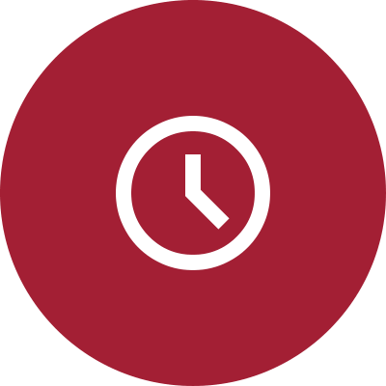  Time-Based  - Sign the lease and submit payer applications in October 2026.  - Open in March 2027 and pass 20 patients a day by the first winter.  - Reach the full census of 30 patients a day by March 2028.

CHAPTER 3

Market Analysis

3.1 Overview
3.2 Market Segmentation
3.3 Market Trends
3.4 Local Market Outlook
3.5 Market Size

3.1 Overview
Urgent care sits between the family doctor and the emergency room: walk-in care for illness and injury that cannot wait for an appointment but does not need a hospital. The trade has grown into 15,309 centers nationally by the end of 2025, and the average center saw 33.96 patients a day that year. No operator holds more than 5% of the market, and independents opened 63% of the new centers in 2025.

3.2 Market Segmentation
- Insured illness and injury visits: the core of the trade, with private insurers paying 54% of urgent care revenue nationally.
- Medicare and Medicaid patients: a growing share, as older adults use urgent care far more than a decade ago.
- Self-pay patients: uninsured or high-deductible patients who choose on posted price.
- Employers: physicals, drug screens, DOT exams and work injury care billed on account or to workers' compensation.

3.3 Market Trends
- Nurse practitioners and physician assistants lead most clinics: 71.6% of urgent care organizations used them as primary providers in 2022.
- Retail clinics are shrinking: in-store clinics fell 33% between May 2023 and June 2026, leaving more walk-in demand for urgent care.
- Patients book ahead: online check-in shortens waits and brings patients back more often.
- Volume is seasonal, peaking in the winter respiratory season and easing by spring.

3.4 Local Market Outlook
Franklin County had 72 private establishments in the freestanding ambulatory and emergency care category in 2025, up from 67 in 2022. That is a county figure, and it includes surgery centers and freestanding emergency rooms as well as urgent care. Around the site, urgent care is mostly health system owned, with OhioHealth, Ohio State and Nationwide Children's pediatric sites alongside one chain and a few independents, and several nearby occupational health clinics open on weekdays only.
Demand is growing: the county added about 2.9% to its population between 2020 and 2025. In Franklin County 9.5% of residents are uninsured and about 21.3% have Medicaid or other means-tested cover, while west side employers in warehousing, construction and manufacturing buy the occupational health line. Trading costs are set locally too: anchored strip retail in neighboring Dublin asked $24.00 a square foot NNN in Q2 2026, and Ohio requires X-ray registration and a pharmacy license but no facility license.

3.5 Market Size
The total market is the US urgent care industry, at $44.3 billion in 2025. The serviceable market is about $362 million a year in Franklin County, built from the county's 72 establishments and national revenue per establishment; it is an upper bound because the category also holds surgery centers and freestanding emergency rooms. The obtainable market is about $2.03 million, what one average urgent care center takes in a year at the national commercial rate. Kestrelpoint's first-year revenue of $1,208,390 sits below that because the clinic opens at 40% of its planned census.
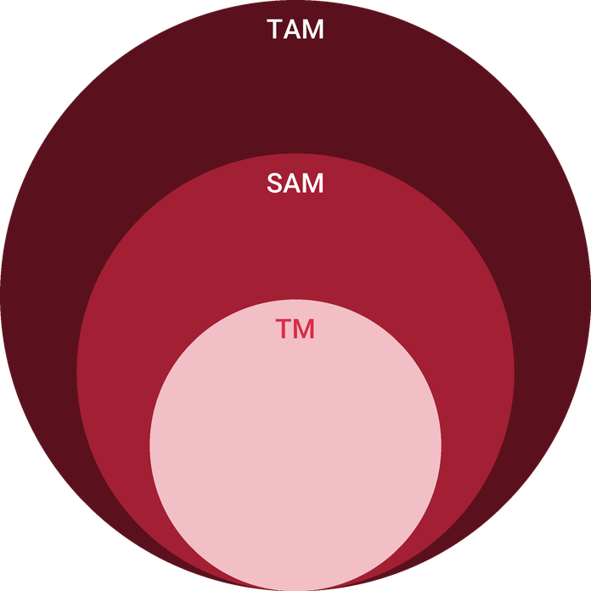
  ● | Total Available Market (TAM)  US urgent care centers industry revenue is $44.3 billion in 2025 (IBISWorld), up 2.5% on the year after 1.3% compound annual growth over five years, with profit at 14.9% of revenue. | 44.3B
  ● | Served Available Market (SAM)  The Franklin County market for freestanding ambulatory and emergency care, the category that holds urgent care, is about $362 million a year: 72 county establishments (2025) x about $5.03 million national revenue per establishment (2022). | 362.0M
  ● | Target Market (TM)  One average urgent care center takes about $2.0 million a year: 33.96 patients a day x 365 days x $163.91 national median commercial net revenue per visit. | 2.0M

3.5.1 PESTEL Analysis
  Political  - Medicare sets its 2026 conversion factor at $33.40, and commercial payers index many urgent care rates to it.  - Ohio Medicaid runs seven managed care plans with one shared credentialing process.  - State policy on nurse practitioner collaboration shapes how many providers one physician can support. |   Economic  - Franklin County keeps adding residents, and the Columbus metro grew twice the national rate in 2025.  - High-deductible plans push insured patients to compare visit prices.  - Clinical wages rise as hospitals compete for the same nurse practitioners and medical assistants. |   Social  - More than a quarter of Hilliard residents are under 18, so pediatric visits and school physicals run high.  - Working adults want care after 5 p.m. and on weekends rather than during the workday.  - About 17% of urgent care visits nationally come from patients aged 62 and over.
  Technological  - Online check-in lets patients wait at home and arrive when a room is ready.  - Digital X-ray images go to a radiologist for overread within the day.  - Most urgent care organizations now offer telehealth, a service the clinic can add for follow-ups. |   Environmental  - Ohio's respiratory season sets the winter peak in volume.  - Icy sidewalks and summer sports bring the injury visits that fill the procedure room.  - Medical and sharps waste is collected by a licensed hauler on a fixed schedule. |   Legal  - X-ray equipment is registered with the Ohio Department of Health.  - Stocking prescription drugs needs a Board of Pharmacy terminal distributor license.  - Self-pay patients get a good faith estimate under the No Surprises Act when a service is scheduled ahead.

CHAPTER 4

Customer Analysis

4.1 Target Market
4.2 Customer Segments
4.3 Customer Persona
4.4 Customer Purchase Journey

4.1 Target Market
Kestrelpoint serves households and employers within about a fifteen minute drive of its site on Columbus's northwest side, reaching into Hilliard and the neighborhoods along the Interstate 270 corridor. Hilliard alone has 38,033 residents, 27.3% of them under 18, and a median household income of $128,189. Columbus city households closer in earn a median of $67,084, and 11.1% of residents have no insurance.
The clinic's patients are the people in that catchment who need care the same day: a child with a fever after school, an adult with a cut hand on a Saturday, a worker hurt on the second shift. Hilliard's principal employers include its school district with 1,942 staff, Nationwide with 620, Advanced Drainage Systems with 465 and Honda with 213, and every one of those employers needs physicals and injury care.
Coverage in the catchment is mixed. In Franklin County about 57.0% of residents have employer coverage, about 21.3% have Medicaid or other means-tested cover and 9.5% have none, a higher uninsured rate than Ohio's 6.7%. The clinic is planned around that mix: contracts with the main commercial plans and every Ohio Medicaid plan, and a posted self-pay price for everyone else.

4.2 Customer Segments
- Families with children: fevers, ear infections, sprains and sports physicals, mostly on evenings and weekends, paid through employer plans.
- Working adults: infections, back strains and minor injuries seen after work, often by adults without a regular family doctor.
- Self-pay and high-deductible patients: who choose on the posted $149 visit and need a price before they come in.
- Older adults on Medicare: respiratory illness and falls, a growing share of urgent care visits nationally.
- Local employers: pre-employment physicals, drug screens, DOT exams and work injury care, billed monthly or to the Ohio BWC.
Families and working adults make up most of the volume and most of the insured revenue, and they arrive in the evenings and at weekends. Employers are fewer but steadier: an account sends new hires and injured workers all year, including the summer months when respiratory illness is low. The persona below stands for the largest segment, the working parent.

4.3 Customer Persona
  Working Parent Megan  Demographics  Age: 38  Location: Hilliard, OH  Household: married, two children  Insurance: employer plan  Professional Role  Job: Claims supervisor at an insurance office  Schedule: in office weekdays | “I need someone to look at my son's ankle tonight, not a three-hour wait or an appointment next Tuesday.”
   | Identifiers / Personality Traits  - Books care for the whole family and checks wait times on her phone first  - Has a family doctor whose next opening is often a week or more away  - Pays a high-deductible plan, so she notices what a visit costs
   | Goals  - Have a child seen the same evening for fevers, sprains and ear pain  - Get school and sports physicals done without missing work  - Know the price of a visit before she goes
   | Challenges  - Her pediatrician's office closes before she leaves work  - Emergency room visits cost far more and take most of a night  - Weekend urgent care hours near her close by mid-afternoon

4.4 Customer Purchase Journey
Most patients find the clinic the moment they need it, by searching for urgent care near them on a phone. What decides the visit is what the search result shows: hours that run past 5 p.m., a wait time, an online check-in button and reviews from neighbors. A parent reserves a place from home, waits there until a text says a room is ready, and is in and out in under an hour.
Self-pay patients look for the price first, and the posted list answers that before they call. Employers arrive another way: a safety or HR manager meets the clinic's operations director, receives a rate sheet and sends the first new hire for a drug screen. After each visit the clinic sends notes to the patient's family doctor and a text asking for a review, which is how the next neighbor finds it.
The choice is made again at every visit, so the clinic has to win it each time. A family that waited under an hour, paid what the website said and found the records already with their pediatrician the next morning has no reason to try the emergency room or a clinic across town the next time a child is sick on a Sunday.

CHAPTER 5

Competitive Analysis

5.1 Competitors
5.2 Comparison
5.3 Competitive Edge
5.4 SWOT Analysis

5.1 Competitors
Urgent care near the site is run mostly by the region's health systems. OhioHealth operates an urgent care in Hilliard open every day from 9 a.m. to 9 p.m. with X-ray and lab, and a 24-hour freestanding emergency department nearby. Ohio State's Hilliard urgent care is staffed by nurse practitioners and physician assistants, closes at 6:30 p.m. on weekdays and 3:30 p.m. on weekends, and posts a self-pay visit from $150.
Nationwide Children's runs pediatric urgent cares in Hilliard and Dublin, most opening in the afternoon. WellNow's Hometown sites on the west side and in Hilliard post a $175 self-pay visit that includes X-ray. Occupational health is sold by Mount Carmel and Concentra clinics that open on weekdays only.
Two changes widen the field for an independent. Humana ended its Medicare Advantage and Medicaid contracts with Ohio State's medical center from October 1, 2026, affecting about 26,000 central Ohio patients, and in-store retail clinics nationally fell 33% between May 2023 and June 2026.

5.2 Comparison
Measured on what a patient or an employer actually needs from a visit, Kestrelpoint is the only clinic type in the comparison below that keeps every-day evening hours, posts its prices and serves employers outside weekday office hours.
Feature | Kestrelpoint Urgent Care | Health system urgent cares | Hospital emergency departments | Retail clinics | Weekday occupational health clinics
Open 8 a.m. to 8 p.m. every day of the year | ✓ | ✗ | ✓ | ✗ | ✗
On-site digital X-ray | ✓ | ✓ | ✓ | ✗ | ✓
Stitches and fracture splinting on site | ✓ | ✓ | ✓ | ✗ | ✓
Posted self-pay price list | ✓ | ✗ | ✗ | ✓ | ✗
Employer services on evenings and weekends | ✓ | ✗ | ✗ | ✗ | ✗
Visit priced close to a primary care visit | ✓ | ✓ | ✗ | ✓ | ✓

5.3 Competitive Edge
Kestrelpoint competes on access rather than scale. Its hours run longer than the nearest health system clinic on weekends, its prices are posted where the systems' are not, and its employer program runs every day the doors are open. Being independent also lets it contract with every Ohio Medicaid plan and with carriers a health system has dropped.
The health systems hold real advantages: recognized names, shared medical records and hospital specialists one referral away. Kestrelpoint does not try to match them on those. It answers instead with the things a patient notices on the day: a clinic that is open when the family doctor is closed, a price that is known before the visit, a wait spent at home rather than in a waiting room and a note waiting at the family doctor's office the next morning.
Price is part of the edge but not the whole of it. The posted $149 self-pay visit sits just below Ohio State's $150 starting price and the $175 WellNow posts, close enough that cost alone will not move an insured family. What moves them is the evening and weekend door, and for employers the ability to send a new hire for a drug screen at 6 p.m. on a Saturday.
Two edges are temporary and the plan treats them that way. Contracts with Humana and other carriers a health system has dropped can be matched if those networks are repaired, and a health system can extend its hours. The lasting edge is the habit a family forms after two or three good visits, which is why the clinic measures waits, reviews and return visits from its first month.
   | Open Every Evening and Weekend  The doors stay open 8 a.m. to 8 p.m. every day but five holidays, so a parent after work and a second-shift employee with an injury are both seen the same day.
   | One Clinic for Families and Employers  The rooms that treat a child's ear infection also run DOT exams, drug screens and work injury visits, so a local employer has one account and one contact.
   | Prices Posted Before the Visit  A self-pay visit is $149 and every add-on is listed on the website and at the desk, so an uninsured patient knows the bill before seeing a provider.
   | Contracts With Every Medicaid Plan  As an independent, Kestrelpoint applies to all seven Ohio Medicaid plans and to Medicare Advantage carriers, including those a health system has dropped.
 | Records Back to the Family Doctor  Every visit note, X-ray and test result goes to the patient's own physician by the next morning, which keeps primary care offices referring after hours.

5.4 SWOT Analysis
Strengths  - Open 8 a.m. to 8 p.m. every day, longer than the Ohio State Hilliard site's weekend hours.  - Digital X-ray, a point of care lab and a procedure room handle most injuries in one visit.  - A physician owner on the schedule and as collaborating physician keeps clinical decisions inside the clinic.  - Posted self-pay prices start at $149, below the $175 a chain posts locally. | Weaknesses  - A new independent opens at about 12 patients a day while families learn it exists.  - Insurer revenue waits on credentialing, and claims pay about 38 days after a visit.  - One site means no network of sister clinics for referrals or shared staff.  - Health system rivals carry brand recognition and patients' existing records.
Opportunities  - Humana members lost in-network access to Ohio State's urgent cares on October 1, 2026.  - Franklin County's 9.5% uninsured rate creates demand for clear self-pay pricing.  - Warehouses, construction and trades on the west side need DOT exams, drug screens and injury care.  - Hilliard's young families bring a steady flow of fevers, sprains and sports physicals. | Threats  - Health systems can open another urgent care nearby faster than an independent can grow.  - Commercial payers may cut case rates or deny claims coded at higher levels.  - Recruiting nurse practitioners competes with hospital employers on pay and benefits.  - A mild respiratory season lowers winter volume, the clinic's busiest months.

 Strategic Summary
Kestrelpoint should sell what the health systems leave open: evening and weekend hours, posted prices and employer services every day. Fast credentialing and an employer book carry the first year while families find the clinic.

CHAPTER 6

Services Offered

6.1 Our Offering
6.2 Signature Items
6.3 Additional Services
6.4 What Sets Us Apart
6.5 Scope of Care & Referral Pathways

6.1 Our Offering
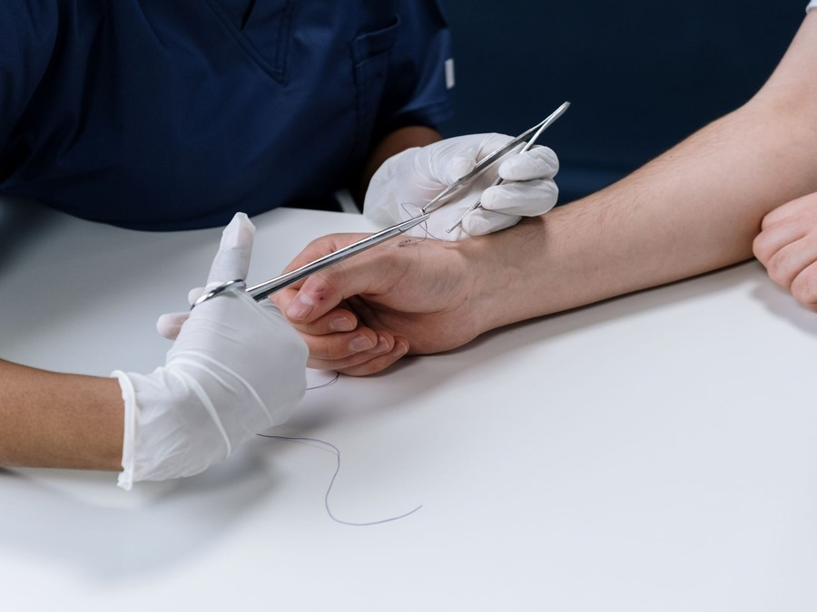
Kestrelpoint sells two things from the same seven exam rooms. The first is the walk-in urgent care visit: same-day diagnosis and treatment for illness and minor injury, for patients of all ages, with X-ray, lab tests and minor procedures done in the clinic. The second is an occupational health program for local employers. Every visit is seen by a nurse practitioner, physician assistant or physician, and every visit note goes to the patient's own doctor by the next morning.

6.2 Signature Items
The walk-in visit is the core of the business and most of its revenue. Insured patients pay their plan's copay at the desk; self-pay patients pay a posted $149, $179 with a rapid test and $229 with an X-ray or minor procedure. The occupational health program, priced from $55 a service and billed to employers monthly, is the second offering, and it keeps the rooms busy outside the respiratory season.

6.3 Additional Services
- School, sports and camp physicals, busiest from June to August.
- Flu shots and routine adult vaccines, walk-in during autumn.
- IV fluids for dehydration from stomach illness or heat.
- Telehealth follow-up visits for patients already seen in the clinic.

6.4 What Sets Us Apart
Three things the patient sees before the visit: the hours, the price and the wait. The clinic opens 8 a.m. to 8 p.m. every day, its self-pay prices are posted online and at the desk, and online check-in tells a parent when to leave home. Inside, a physician owner on the schedule means difficult cases are reviewed in the building, and the X-ray and procedure room mean a sprained ankle or a cut hand is treated in one visit rather than referred on.

6.5 Scope of Care & Referral Pathways
The clinic treats what an urgent care can treat safely: respiratory and ear infections, strep throat, urinary infections, rashes, minor burns, cuts needing stitches, sprains, simple fractures that can be splinted, eye irritation and dehydration. Point of care tests cover strep, flu, COVID and urinalysis under a CLIA certificate of waiver, and digital X-rays are overread by a radiologist the same day.
It does not treat chest pain, stroke symptoms, severe breathing difficulty, major trauma or anything needing CT or admission. Those patients are stabilized, the clinic calls 911 or arranges transfer to the nearest emergency department, and the visit record goes with them. Fractures that need setting go to an orthopedic practice the next day with the images. Every patient without a family doctor leaves with the names of local primary care practices taking new patients, so urgent care never becomes their only care.

6.5.1 Walk-In Urgent Care Visit
Same-day care for illness and minor injury for patients of all ages, with online check-in so patients can wait at home. Each visit includes the exam, any treatment given in the room and a written note sent to the patient's own doctor.
 | From $149 self-pay; insurance copays apply  Insured patients pay their plan's urgent care copay at the desk, and the clinic bills the insurer for the rest. Self-pay patients pay a posted $149 for a standard visit. A rapid strep, flu, COVID or urinalysis test brings a self-pay visit to $179, and an X-ray or a minor procedure such as stitches or splinting brings it to $229. Prescriptions go to the patient's own pharmacy. A work or school note, a follow-up call and records sent to the family doctor come with every visit at no extra charge.

Specifications
- Open 8 a.m. to 8 p.m. every day except five holidays.
- Seen by a nurse practitioner, physician assistant or physician.
- Online check-in with a text message when a room is ready.
- Digital X-ray and point of care lab on site.
- Visit notes sent to the primary care physician by the next morning.

6.5.2 Occupational Health Program
Pre-employment physicals, DOT exams, drug and alcohol screens and work injury care for local employers, offered every day the clinic is open. Each employer has an account, a rate sheet and results sent within one business day.
 | From $55 per service  Employers are billed monthly on account rather than at the desk. A urine drug screen with collection and lab costs $55, a pre-employment physical $85 and a DOT exam by a provider on the federal medical examiner registry $95. Work injury visits are billed to the Ohio BWC or the employer's managed care organization under the state fee schedule. Volume pricing applies to employers sending more than 20 screens a month. Results, return to work forms and injury reports reach the employer's contact within one business day.

Specifications
- Available during all clinic hours, including evenings and weekends.
- DOT exams performed by a certified medical examiner.
- Ohio BWC certified for work injury care.
- Monthly invoicing on an employer account.
- Results sent to the employer within one business day.

6.5.3 Features
   | Online Check-In  Patients reserve a place in line from home and get a text when a room is ready.
   | On-Site Digital X-ray  Fractures and chest X-rays are imaged in the clinic and overread by a radiologist the same day.
  Point of Care Lab
  Rapid strep, flu, COVID and urinalysis results come back before the patient leaves.
   | Procedure Room  Cuts are stitched, sprains and simple fractures splinted and abscesses drained without a trip to the emergency room.
  Posted Self-Pay Prices
  Every visit level and add-on is priced on the website and at the front desk.
  Records to the Family Doctor
  Visit notes and results go to the patient's own physician by the next morning.

6.5.4 Pricing
Standard Visit  $149  per self-pay visit  - Exam and treatment by a nurse practitioner, physician assistant or physician  - Prescriptions sent to the patient's pharmacy  - Visit notes sent to the family doctor |  | Most Popular  Visit With Rapid Test  $179  per self-pay visit  - Everything in the standard visit  - One rapid strep, flu, COVID or urinalysis test  - Results before the patient leaves  - Work or school note included |  | X-ray or Procedure Visit  $229  per self-pay visit  - Everything in the standard visit  - Digital X-ray with radiologist overread, or one minor procedure  - Splinting or simple stitches included  - Follow-up call within two days

CHAPTER 7

Marketing & Sales Strategies

7.1 Market Positioning
7.2 Marketing Objectives
7.3 Online Marketing
7.4 Public Relations and Branding
7.5 Partnership & Collaboration Strategy
7.6 Customer Loyalty & Retention
7.7 Sales Channels

7.1 Market Positioning
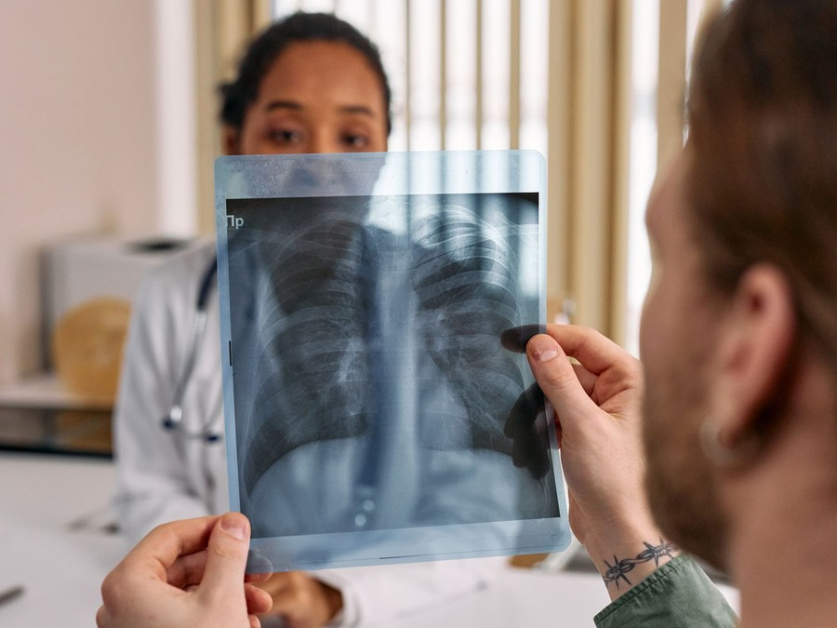
Kestrelpoint is the northwest side's every-day clinic: open into the evening every day, priced in public and run for both families and employers, where its nearest competitors close earlier, keep prices private or serve employers only on weekdays.

7.2 Marketing Objectives
- Build daily volume from about 12 patients at opening to 30 a day within twelve months.
- Rank in the top three map results for urgent care searches across Hilliard and northwest Columbus by the first winter.
- Sign employer accounts for physicals, drug screens and injury care in the first year.
- Hold an average review rating of 4.7 stars or higher.
Search Ads & Google Business Profile  $1,611  per month  Ads on urgent care searches near Hilliard and a maintained profile with hours, wait times and photos. |  | Employer Outreach  $1,007  per month  Visits, a rate sheet and lunch meetings with west side warehouses, contractors and fleets.
Schools, Sports & Community  $806  per month  Sports physical days, youth league sponsorships and flu shot clinics at local events. |  | Reviews & Patient Follow-Up  $604  per month  Post-visit texts asking for reviews and reminding patients of flu shots and physicals.

Total marketing budget: $48,336 a year, $4,028 a month.

7.3 Online Marketing
Almost every patient finds an urgent care by searching on a phone, so most of the $48,336 first-year marketing budget, 4% of revenue, goes to being found there. The clinic keeps its Google Business Profile current with hours, photos and live wait times, runs search ads on urgent care terms within its catchment and links every listing to online check-in. A post-visit text asks each patient for a review, and seasonal posts remind families about flu shots and sports physicals.

7.4 Public Relations and Branding
The brand is plain and local: a red cross mark, the clinic's hours on every sign and the price list on the front page of the website. The opening is announced through community papers and school newsletters, and the clinic runs free sports physical days for youth leagues in its first summer.

7.5 Partnership & Collaboration Strategy
Family practices without evening hours are the most valuable partners, because their answering services can point after-hours callers to Kestrelpoint and receive the visit notes the next morning. The clinic also builds referral routes out, to an orthopedic group for fractures and to the nearest emergency department for transfers, and works with schools and youth sports leagues on physicals.

7.6 Customer Loyalty & Retention
Patients return to an urgent care when the last visit was quick, fair and followed up. Each visit ends with a call or text two days later, records go to the family doctor without being asked, and the clinic keeps a family's history on file so the next visit starts faster. Employers stay for results delivered within one business day and a single monthly invoice.

7.7 Sales Channels
Insured walk-in visits carry the business; the other four routes steady it through the year.
  Insured Walk-In Visits
  Visits billed to commercial plans, Medicare and Ohio Medicaid plans bring in most revenue and depend on credentialing being live with each payer.
  Self-Pay Visits
  Patients without insurance or with high deductibles pay posted prices at the desk, so this route depends on prices being easy to find online.
   | Employer Accounts  Physicals, DOT exams and drug screens billed monthly to local employers add a steady base that does not rise and fall with flu season.
  Work Injury Claims
  Injured workers sent by their employer are billed to the Ohio BWC, which depends on certification and a quick report back to the employer.
 | Seasonal Physicals and Vaccines  School, sports and camp physicals in summer and flu shots in autumn fill quieter months and bring new families in.

CHAPTER 8

Operations Plan

8.1 Daily Operations
8.2 Working Hours
8.3 Staffing & Training
8.4 Inventory & Equipment Management
8.5 Location and Facilities
8.6 Milestones & Timeline
8.7 Licensing, Credentialing & Payer Contracts

8.1 Daily Operations
Each day runs as one twelve hour shift with one provider, two medical assistants and a front desk coordinator, with a second provider added at peak hours in the respiratory season. Patients check in online or at the desk, are roomed by a medical assistant who takes vital signs and history, and are seen by the provider, who orders any X-ray or test in the building. The visit is coded and sent to the billing service that evening, and the note goes to the patient's family doctor the next morning.
Rachel Imler runs the business side from the clinic office: payer follow-up, denials, employer accounts and the staff schedule. Dr. Harlow reviews charts, X-ray overreads and any patient transferred out each week as collaborating physician.
Quality and safety run on a fixed routine. Each provider's charts are sampled every month for coding, prescribing and follow-up, and every transfer to an emergency department is reviewed within a week. The crash cart, defibrillator and oxygen are checked at the start of every shift, exam rooms are cleaned between patients, and sharps and medical waste are collected by a licensed hauler. X-ray staff wear dosimeter badges, and their readings are reviewed each quarter. Patients with abnormal test results or X-ray overreads that change a diagnosis are called back the same day, and every call is recorded in the chart.

8.2 Working Hours
The clinic opens 8 a.m. to 8 p.m. every day of the year except Thanksgiving, Christmas, New Year's Day, Easter and Independence Day, which is 360 days. Evenings and weekends are when family doctors are closed and when working parents can come, and the nearest health system clinic closes at 3:30 p.m. on weekends, so those hours are the clinic's main reason to exist. The occupational health program runs during all of them, which lets second-shift workers be seen after an injury.

8.3 Staffing & Training
At opening the team is Dr. Harlow, a lead nurse practitioner, two further part-time providers, five medical assistants, three front office staff and Rachel Imler. Columbus metro wages set the budget: nurse practitioners average $58.38 an hour, medical assistants $20.88 and receptionists $18.04. Every medical assistant who takes X-rays holds an Ohio Department of Health operator licence, every clinical staff member holds current BLS certification, and new staff shadow for two weeks on the EMR and clinical protocols before working a shift alone.

8.4 Inventory & Equipment Management
Supplies, test kits, vaccines and dispensed medications are counted weekly against par levels and reordered from a medical distributor, with about three weeks on the shelf. Vaccines are kept in a monitored refrigerator with temperature logs, and expiring stock is rotated forward. The X-ray unit, defibrillator and lab analyzers are serviced on manufacturer schedules, and every check is logged.

8.5 Location and Facilities
The clinic leases about 3,600 square feet in a strip center with road frontage and parking on Columbus's northwest side toward Hilliard. It is built out into seven exam rooms with sinks, a procedure room, a shielded X-ray room, a lab, a waiting room and accessible restrooms. Strip space nearby is scarce: anchored strip retail in neighboring Dublin asked $24.00 a square foot NNN in Q2 2026 and was fully let.

8.6 Milestones & Timeline
Credentialing sets the pace of the launch, because insured visits cannot be billed until contracts are live. Applications therefore go in at lease signing, five months before the doors open.
Oct 2026  Setup |  |  | Lease and Payer Applications  Site secured and credentialing started  The founders sign a lease on about 3,600 square feet and submit applications to commercial payers, Medicare and Ohio Medicaid.
Jan 2027  Setup |  |  | Build-Out and Licences  Rooms built and equipment installed  Seven exam rooms, a procedure room and an X-ray room are built, and the X-ray registration, CLIA waiver and pharmacy license are filed.
Mar 2027  Launch |  |  | Doors Open  First patients seen  The clinic opens 8 a.m. to 8 p.m. every day with online check-in, at about 12 patients a day.
Aug 2027  Growth |  |  | Physicals and Employer Accounts  School season and employer sales  Sports and school physicals peak while the occupational health program signs its first employer accounts.
Dec 2027  Growth |  |  | First Respiratory Season  Winter peak in volume  Flu and respiratory illness bring the busiest weeks of the first year, staffed with a second provider at peak hours.
Mar 2028  Milestone |  |  | Full Census  30 patients a day  Twelve months after opening the clinic reaches its planned average of 30 patients a day.

8.7 Licensing, Credentialing & Payer Contracts
Ohio does not license urgent care centers, so the clinic's permissions are individual. The X-ray unit is registered with the Ohio Department of Health before first use. The lab runs under a CLIA certificate of waiver at $248 every two years. Because the clinic stocks prescription drugs and vaccines, it holds a terminal distributor of dangerous drugs license from the Board of Pharmacy. Each nurse practitioner works under a standard care arrangement with Dr. Harlow, who may collaborate with no more than five at once.
Payer contracts decide when revenue starts. The clinic applies to the main commercial plans, Medicare and Ohio Medicaid, whose seven managed care plans credential a provider once through a shared process. Treating injured workers on state-fund claims needs Ohio BWC provider certification, and DOT exams need a provider on the federal medical examiner registry.
Credentialing is run as a project with a deadline. Rachel Imler files each provider's applications at lease signing, five months before opening, tracks every payer weekly and books no insured visit to a provider until that payer has confirmed them. Commercial and Medicaid plans that pay urgent care a global case rate per visit are billed that way, and Medicare pays a nurse practitioner's or physician assistant's visit at 85% of the physician rate, which the payer mix assumes. Until a contract is live, patients on that plan are seen as self-pay at the posted price and told so before the visit.
Self-pay patients who schedule a service ahead receive a written good faith estimate under the No Surprises Act, and the posted price list doubles as that estimate for walk-in visits. The clinic keeps no controlled substances, which holds its pharmacy license to the category for non-controlled prescription drugs. Malpractice cover is held for every provider, the X-ray unit's registration and the CLIA waiver are renewed on a shared calendar, and every credential and licence expiry date is logged so nothing lapses between renewals.

CHAPTER 9

Management Team

9.1 Key Members
9.2 Organization Chart
9.3 Advisory Board Members

9.1 Key Members
Dr. Harlow is accountable for clinical quality: chart review, prescribing patterns, transfer decisions and patient safety events, measured monthly against door to discharge time, return visit rates and review scores. Rachel Imler is accountable for the business: credentialing, collections, denials, payroll and employer accounts, measured on days to payment, the denial rate and the census against plan. The lead nurse practitioner owns provider scheduling and protocols, and the lead medical assistant owns rooming speed, supply levels and X-ray quality.
 | Daniel Harlow  Medical Director & Co-Founder · daniel@kestrelpointurgentcare.example  Board-certified family physician with eleven years of practice, the last seven in urgent care, who will work clinical shifts and act as collaborating physician.

 | Rachel Imler  Director of Operations & Co-Founder · rachel@kestrelpointurgentcare.example  Former practice manager for a multi-site urgent care group, responsible for payer credentialing, billing and employer contracts.

 | Jordan Ellis  Lead Nurse Practitioner · jordan@kestrelpointurgentcare.example  Board-certified family nurse practitioner with six years in urgent and family care, including pediatric visits.

 | Kelsey Ward  Lead Medical Assistant · kelsey@kestrelpointurgentcare.example  Certified medical assistant licensed by the Ohio Department of Health to take X-rays, who trains and schedules the support team.

9.2 Organization Chart
Every clinical and operations lead reports to Dr. Harlow as medical director. Medical assistants report day to day to the lead medical assistant, and front office staff to Rachel Imler. The founders meet weekly to review volume, payer performance and staffing against the plan.
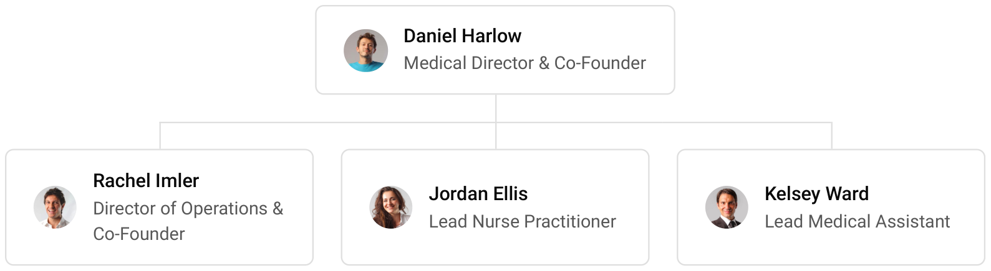

9.3 Advisory Board Members
The founders draw on three outside advisers rather than a formal board: a healthcare attorney for payer contracts, employment and compliance; an accountant who works with medical practices for tax, payroll and the SBA loan reporting; and an urgent care billing consultant who audits coding and denials each quarter in the first year. An emergency physician colleague reviews the clinic's transfer protocols before opening.

9.3.1 Hiring Plan
2  Filled |  | 10  Hiring This Year |  | 11  Open

Group By Department | Position Filled | Time of Hire | Time of Start | Filled
Clinical Providers | 1 of 4 | 75 days | 30 days | 25%
Medical Assistants & X-ray | 0 of 5 | 45 days | 14 days | 0%
Front Office & Billing | 0 of 3 | 30 days | 14 days | 0%
Operations | 1 of 1 | 0 days | 0 days | 100%

CHAPTER 10

Financial Plan

10.1 Key Assumptions
10.2 Capital Requirements and Use of Funds
10.3 Income Statement (3 Year projections)
10.4 Balance Sheet (3 Year projections)
10.5 Cash Flow Statement (3 Year projections)
10.6 Break Even Analysis

10.1 Key Assumptions
Revenue is daily patient visits multiplied by the average collected per visit, 360 days a year, with occupational health adding a further 8%. The clinic plans for 30 patients a day once its census is built, a little below the national average, and collects an average of $148 a visit across commercial plans, Medicare, Medicaid and self-pay. It opens at 40% of that volume and reaches it over twelve months, after which revenue grows 20% a year as the census builds toward the national average.
Gross margin is 84.0%, with supplies, outside lab and radiology fees and the billing service in cost of sales. Payroll runs at 48% of revenue, marketing at 4%, rent at $9,000 a month and other operating costs at 5%. Insurers pay about 38 days after a visit, and 3% of revenue is assumed never to be collected.
The model turns a first-year loss of $3,649 into net income of $46,623 in the second year and $105,121 in the third as the daily census builds. Break-even revenue of $1,066,662 is what pays operating costs before depreciation and loan interest, so first-year revenue clears it and the small loss that remains is the cost of the build-out and the loan. Even the conservative case keeps the third year profitable, at $41,149.

10.2 Capital Requirements and Use of Funds
The clinic needs $652,000 to open. The largest share builds out the leased suite into exam rooms, a procedure room and a shielded X-ray room; the rest buys the X-ray unit and medical equipment, sets up technology and signage, pays for licences and credentialing, stocks opening supplies and covers deposits, pre-opening staff training and launch marketing.
Funding is $250,000 from the founders and a $575,000 SBA 7(a) loan at 10% over ten years. The difference over the startup budget, about $173,000, is held as opening cash to carry payroll and rent while insurer payments begin. No profits are distributed while the loan is repaid.

10.2.1 Use of Funds
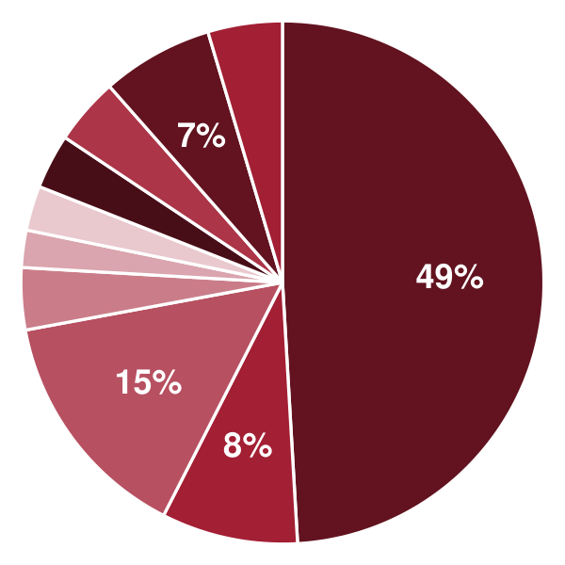 | ● Leasehold Improvements 49.1%  ● Digital X-ray Room 8.4%  ● Medical Equipment & Furniture 14.6%  ● Technology & Systems Setup 3.8%  ● Signage & Exterior 2.3%  ● Licenses, Credentialing & Legal 2.8%  ● Opening Supplies, Vaccines & Medication 3.4%  ● Deposits & Pre-Opening Rent 4.1%  ● Pre-Opening Staffing & Training 6.9%  ● Launch Marketing 4.6%

Use Of Funds | Amount
Leasehold Improvements | $320,000.00
Digital X-ray Room | $55,000.00
Medical Equipment & Furniture | $95,000.00
Technology & Systems Setup | $25,000.00
Signage & Exterior | $15,000.00
Licenses, Credentialing & Legal | $18,000.00
Opening Supplies, Vaccines & Medication | $22,000.00
Deposits & Pre-Opening Rent | $27,000.00
Pre-Opening Staffing & Training | $45,000.00
Launch Marketing | $30,000.00

10.3 Income Statement (3 Year projections)
 | Year 1 | Year 2 | Year 3 | Total
Revenue | $1,208,390.40 | $1,450,068.48 | $1,740,082.18 | $4,398,541.06
Cost of Sales | $193,342.46 | $232,010.96 | $278,413.15 | $703,766.57
General Costs | $0.00 | $0.00 | $0.00 | $0.00
Revenue Specific Costs | $193,342.46 | $232,010.96 | $278,413.15 | $703,766.57
Personnel Costs (Direct Labor) | $0.00 | $0.00 | $0.00 | $0.00
Gross Margin | $1,015,047.94 | $1,218,057.52 | $1,461,669.03 | $3,694,774.49
Gross Margin (%) | 84.00% | 84.00% | 84.00% | 84.00%
Operating Expense | $895,996.49 | $1,039,915.78 | $1,212,618.95 | $3,148,531.22
Payroll Expense (Indirect Labor) | $580,027.39 | $696,032.87 | $835,239.45 | $2,111,299.71
General Expense | $285,155.14 | $306,906.16 | $333,007.40 | $925,068.70
Bad Debt | $30,813.96 | $36,976.75 | $44,372.10 | $112,162.81
Amortization of Current Assets | $0.00 | $0.00 | $0.00 | $0.00
EBITDA | $119,051.45 | $178,141.74 | $249,050.08 | $546,243.27
Additional Expense | $122,700.00 | $131,518.59 | $143,928.85 | $398,147.44
Long Term Depreciation | $65,200.00 | $67,375.10 | $69,985.23 | $202,560.33
Gain or loss from Sale of Assets | $0.00 | $0.00 | $0.00 | $0.00
EBIT | $53,851.45 | $110,766.64 | $179,064.85 | $343,682.94
Interest Expense | $57,500.00 | $51,750.00 | $46,000.00 | $155,250.00
EBT | ($3,648.55) | $59,016.64 | $133,064.85 | $188,432.94
Income Tax Expense / Benefit | $0.00 | $12,393.49 | $27,943.62 | $40,337.11
Total Expense | $1,212,038.95 | $1,403,445.33 | $1,634,960.95 | $4,250,445.23
Net Income | ($3,648.55) | $46,623.15 | $105,121.23 | $148,095.83
Net Income (%) | -0.30% | 3.22% | 6.04% | 3.37%
Retained Earning Opening | $0.00 | ($3,648.55) | $42,974.60
Owner's Distribution | $0.00 | $0.00 | $0.00 | $0.00
Retained Earning Closing | ($3,648.55) | $42,974.60 | $148,095.83 | $148,095.83

10.4 Balance Sheet (3 Year projections)
 | Year 1 | Year 2 | Year 3 | Total
Assets | $779,742.61 | $775,142.36 | $830,465.00 | $830,465.00
Current Assets | $192,942.61 | $233,966.43 | $333,173.07 | $333,173.07
Cash | $74,884.53 | $92,296.72 | $163,169.43 | $163,169.43
Accounts Receivable | $106,934.27 | $128,321.13 | $153,985.35 | $153,985.35
Inventory | $11,123.81 | $13,348.58 | $16,018.29 | $16,018.29
Other Current Assets | $0.00 | $0.00 | $0.00 | $0.00
Long Term Assets | $586,800.00 | $541,175.93 | $497,291.93 | $497,291.93
Gross Long Term Assets | $652,000.00 | $673,751.03 | $699,852.26 | $699,852.26
Accumulated Depreciation | $65,200.00 | $132,575.10 | $202,560.33 | $202,560.33
Liabilities & Equity | $779,742.61 | $775,142.36 | $830,465.00 | $830,465.00
Liabilities | $533,391.16 | $482,167.76 | $432,369.17 | $432,369.17
Current Liabilities | $73,391.16 | $79,667.76 | $87,369.17 | $87,369.17
Accounts Payable | $15,891.16 | $19,069.39 | $22,883.27 | $22,883.27
Income Tax Payable | $0.00 | $3,098.37 | $6,985.90 | $6,985.90
Sales Tax Payable | $0.00 | $0.00 | $0.00 | $0.00
Short Term Debt | $57,500.00 | $57,500.00 | $57,500.00 | $57,500.00
Long Term Liabilities | $460,000.00 | $402,500.00 | $345,000.00 | $345,000.00
Long Term Debt | $460,000.00 | $402,500.00 | $345,000.00 | $345,000.00
Equity | $246,351.45 | $292,974.60 | $398,095.83 | $398,095.83
Paid-in Capital | $0.00 | $0.00 | $0.00 | $0.00
Common Stock | $0.00 | $0.00 | $0.00 | $0.00
Preferred Stock | $0.00 | $0.00 | $0.00 | $0.00
Owner's Contribution | $250,000.00 | $250,000.00 | $250,000.00 | $250,000.00
Retained Earnings | ($3,648.55) | $42,974.60 | $148,095.83 | $148,095.83
Check | $0.00 | $0.00 | $0.00 | $0.00

10.5 Cash Flow Statement (3 Year projections)
 | Year 1 | Year 2 | Year 3 | Total
Cash Received | $1,070,642.17 | $1,391,704.87 | $1,670,045.86 | $4,132,392.90
Cash Paid | $1,111,257.64 | $1,295,041.65 | $1,515,571.92 | $3,921,871.21
COS & General Expenses | $473,730.25 | $537,963.66 | $610,276.38 | $1,621,970.29
Salary & Wages | $580,027.39 | $696,032.87 | $835,239.45 | $2,111,299.71
Interest | $57,500.00 | $51,750.00 | $46,000.00 | $155,250.00
Sales Tax | $0.00 | $0.00 | $0.00 | $0.00
Income Tax | $0.00 | $9,295.12 | $24,056.09 | $33,351.21
Net Cash From Operations | ($40,615.47) | $96,663.22 | $154,473.94 | $210,521.69
Assets Sell | $0.00 | $0.00 | $0.00 | $0.00
Assets Purchase | $652,000.00 | $21,751.03 | $26,101.23 | $699,852.26
Net Cash From Investments | ($652,000.00) | ($21,751.03) | ($26,101.23) | ($699,852.26)
Amount Received | $825,000.00 | $0.00 | $0.00 | $825,000.00
Loan Received | $575,000.00 | $0.00 | $0.00 | $575,000.00
Common Stock | $0.00 | $0.00 | $0.00 | $0.00
Preferred Stock | $0.00 | $0.00 | $0.00 | $0.00
Owner's Contribution | $250,000.00 | $0.00 | $0.00 | $250,000.00
Amount Paid | $57,500.00 | $57,500.00 | $57,500.00 | $172,500.00
Loan Capital | $57,500.00 | $57,500.00 | $57,500.00 | $172,500.00
Dividends & Distributions | $0.00 | $0.00 | $0.00 | $0.00
Net Cash From Financing | $767,500.00 | ($57,500.00) | ($57,500.00) | $652,500.00
Summary
Starting Cash | $0.00 | $74,884.53 | $92,296.72
Cash In | $1,895,642.17 | $1,391,704.87 | $1,670,045.86 | $4,957,392.90
Cash Out | $1,820,757.64 | $1,374,292.68 | $1,599,173.15 | $4,794,223.47
Change in Cash | $74,884.53 | $17,412.19 | $70,872.71 | $163,169.43
Ending Cash | $74,884.53 | $92,296.72 | $163,169.43 | $163,169.43

10.6 Break Even Analysis
 | Year 1 | Year 2 | Year 3 | Total
Starting Revenue | $0.00 | $1,208,390.40 | $2,658,458.88 | $2,658,458.88
Net Revenue | $1,208,390.40 | $1,450,068.48 | $1,740,082.18 | $1,740,082.18
Closing Revenue | $1,208,390.40 | $2,658,458.88 | $4,398,541.06 | $4,398,541.06
Starting Expense | $0.00 | $1,212,038.95 | $2,615,484.28 | $2,615,484.28
Net Expense | $1,212,038.95 | $1,403,445.33 | $1,634,960.95 | $1,634,960.95
Closing Expense | $1,212,038.95 | $2,615,484.28 | $4,250,445.23 | $4,250,445.23
Is Break Even? | No | Yes | Yes
Break Even Month | - | Jan '27 | -
Days Required | - | 28 Days | -
Break Even Revenue | - | $1,329,229.44 | -

CHAPTER 11

References

- SRC001: Urgent Care Centers in the US Industry Analysis, 2025, IBISWorld, 2025-12-01. https://www.ibisworld.com/united-states/industry/urgent-care-centers/5458/ (accessed 2026-10-15)
- SRC002: U.S. Urgent Care Centers: Growth & Outlook, Health Industry Distributors Association, 2025-06-01. https://hida.org/distribution/markets/urgent-care/growth-outlook.aspx (accessed 2026-10-15)
- SRC003: U.S. Urgent Care Centers Market (2026 - 2033) Size, Share & Trends Analysis Report, Grand View Research, 2026-01-01. https://grandviewresearch.com/industry-analysis/us-urgent-care-market (accessed 2026-10-15)
- SRC004: Total Revenue for Freestanding Ambulatory Surgical and Emergency Centers, All Establishments, Employer Firms (REVEF621493ALLEST), Federal Reserve Bank of St. Louis (US Census Bureau Service Annual Survey), 2024-01-31. https://fred.stlouisfed.org/series/REVEF621493ALLEST (accessed 2026-10-15)
- SRC005: 2025 Recap: New Urgent Care Centers, Urgent Care Association, 2025-12-30. https://thecheckin.urgentcareassociation.org/wp-content/uploads/2025/12/new-UCs-2025-1.pdf (accessed 2026-10-15)
- SRC006: Urgent Care Data, Urgent Care Association, 2026-01-01. https://urgentcareassociation.org/about/urgent-care-data/ (accessed 2026-10-15)
- SRC007: The 2026 Urgent Care Top 100 By Number of Locations, The Journal of Urgent Care Medicine, 2026-06-01. https://www.jucm.com/documents/2026/06/the-2026-urgent-care-top-100-by-number-of-locations.pdf/ (accessed 2026-10-15)
- SRC008: Size and Ownership of U.S. Urgent Care Centers, The Journal of Urgent Care Medicine, 2024-10-30. https://www.jucm.com/size-and-ownership-of-u-s-urgent-care-centers/ (accessed 2026-10-15)
- SRC009: Private Equity Investment In Urgent Care, By Number Of Centers, 2025, The Journal of Urgent Care Medicine, 2025-06-30. https://www.jucm.com/tag/private-equity-investment-in-urgent-care/ (accessed 2026-10-15)
- SRC010: Developing Data, The Journal of Urgent Care Medicine, 2025-03-01. https://jucm.com/wp-content/uploads/2025/02/2025-19661-Developing-Data.pdf (accessed 2026-10-15)
- SRC011: As Flu Season Fades, Urgent Care Volume Remains Solid, The Journal of Urgent Care Medicine, 2026-04-06. https://www.jucm.com/as-flu-season-fades-urgent-care-volume-remains-solid/ (accessed 2026-10-15)
- SRC012: Retail Clinic and Urgent Care Center Utilization Each Decreased 12 Percent Nationally from 2022 to 2023, FAIR Health, 2025-03-31. https://www.fairhealth.org/press-release/retail-clinic-and-urgent-care-center-utilization-each-decreased-12-percent-nationally-from-2022-to-2023-according-to-eighth-annual-fair-health-report (accessed 2026-10-15)
- SRC013: Trends in Urgent Care Utilization Among Medicare Beneficiaries From 2012 to 2019, JAMA Network Open, 2026-01-26. https://jamanetwork.com/journals/jamanetworkopen/fullarticle/2844219 (accessed 2026-10-15)
- SRC014: Commercial Reimbursement In Urgent Care, The Journal of Urgent Care Medicine, 2025-12-30. https://jucm.com/commercial-reimbursement-in-urgent-care/ (accessed 2026-10-15)
- SRC015: Calendar Year (CY) 2026 Medicare Physician Fee Schedule Final Rule (CMS-1832-F), Centers for Medicare & Medicaid Services, 2025-10-31. https://www.cms.gov/newsroom/fact-sheets/calendar-year-cy-2026-medicare-physician-fee-schedule-final-rule-cms-1832-f (accessed 2026-10-15)
- SRC016: Transmittal R2656CP, Centers for Medicare & Medicaid Services. https://www.cms.gov/Regulations-and-Guidance/Guidance/Transmittals/Downloads/R2656CP.pdf (accessed 2026-10-15)
- SRC017: Procedure Codes S9083 and S9088 Update, PA Health & Wellness (Centene), 2026-01-01. https://www.pahealthwellness.com/content/dam/centene/Pennsylvania/pdfs/Procedure%20Codes%20S9083%20S9088%20Update%20Eff%208.1.2026.pdf (accessed 2026-10-15)
- SRC018: Developing Data: Distribution of Primary Payors, The Journal of Urgent Care Medicine, 2009-11-01. https://www.jucm.com/wp-content/uploads/2021/02/2009-4240-Data.pdf (accessed 2026-10-15)
- SRC019: APPs Manage Half of Medicare Urgent Care Visits as Volume Doubles, The Journal of Urgent Care Medicine, 2026-02-02. https://www.jucm.com/apps-manage-half-of-medicare-urgent-care-visits-as-volume-doubles/ (accessed 2026-10-15)
- SRC020: Urgent Care Scope of Services, The Journal of Urgent Care Medicine, 2023-12-01. https://www.jucm.com/?p=78661 (accessed 2026-10-15)
- SRC021: Failing to Plan, or Planning To Fail? Designing a Clinic for Success, The Journal of Urgent Care Medicine, 2008-12-01. https://www.jucm.com/failing-to-plan-or-planning-to-fail-designing-a-clinic-for-success/ (accessed 2026-10-15)
- SRC022: May 2025 National Occupational Employment and Wage Estimates, US Bureau of Labor Statistics, 2026-01-01. https://www.bls.gov/oes/current/oes_nat.htm (accessed 2026-10-15)
- SRC023: Nurse Anesthetists, Nurse Midwives, and Nurse Practitioners, US Bureau of Labor Statistics, 2026-08-27. https://www.bls.gov/ooh/healthcare/nurse-anesthetists-nurse-midwives-and-nurse-practitioners.htm (accessed 2026-10-15)
- SRC024: How To Start An Urgent Care: What You Need To Know About Costs, Experity, 2026-02-14. https://www.experityhealth.com/resource/blog/cost-to-open-urgent-care/ (accessed 2026-10-15)
- SRC025: Portable X-Ray in Urgent Care: Why Cheaper Isn't Better, The Journal of Urgent Care Medicine, 2026-03-31. https://www.jucm.com/portable-x-ray-in-urgent-care-why-cheaper-isnt-better/ (accessed 2026-10-15)
- SRC026: Emerging Strategies to Ensure Access to Health Care Services: Urgent Care Centers, American Hospital Association, 2017-11-01. https://www.aha.org/system/files/content/17/emerging-strategies-urgent-care-centers.pdf (accessed 2026-10-15)
- SRC027: UCA Benchmarking Report Spring 2021, Urgent Care Association, 2021-03-01. https://urgentcareassociation.org/wp-content/uploads/2023/04/UCA-Benchmarking-Report-Spring-2021.pdf (accessed 2026-10-15)
- SRC028: Urgent Care Centers Deter Some Emergency Department Visits But, On Net, Increase Spending, Health Affairs, 2021-04-01. https://www.healthaffairs.org/doi/10.1377/hlthaff.2020.01869 (accessed 2026-10-15)
- SRC029: Emergency Department Visits Exceed Affordability Threshold For Many Consumers With Private Insurance, Peterson-KFF Health System Tracker, 2022-01-01. https://www.kff.org/health-costs/issue-brief/emergency-department-visits-exceed-affordability-threshold-for-many-consumers-with-private-insurance/ (accessed 2026-10-15)
- SRC030: How Many Emergency Department Visits Could be Managed at Urgent Care Centers and Retail Clinics?, Health Affairs, 2010-09-01. https://pmc.ncbi.nlm.nih.gov/articles/PMC3412873 (accessed 2026-10-15)
- SRC031: United States Occupational Health Market Size & Share Analysis, Growth Trends and Forecast (2026 - 2031), Mordor Intelligence, 2026-04-13. https://www.mordorintelligence.com/industry-reports/united-states-occupational-health-market (accessed 2026-10-15)
- SRC032: Urgent care centers in the U.S.: Findings from a national survey, BMC Health Services Research, 2009-01-01. https://link.springer.com/article/10.1186/1472-6963-9-79 (accessed 2026-10-15)
- SRC033: Employer-Reported Workplace Injuries and Illnesses, 2023-2024, US Bureau of Labor Statistics, 2026-01-22. https://www.bls.gov/news.release/osh.nr0.htm (accessed 2026-10-15)
- SRC034: DOT Medical Exam and Commercial Motor Vehicle Certification, Federal Motor Carrier Safety Administration. https://www.fmcsa.dot.gov/medical/driver-medical-requirements/dot-medical-exam-and-commercial-motor-vehicle-certification (accessed 2026-10-15)
- SRC035: Drug Testing Index 2026, Quest Diagnostics, 2026-07-10. https://s2.q4cdn.com/390454341/files/doc_news/One-in-Five-American-Workers-Tested-Had-a-Positive-Hair-Drug-Test-in-2025-Signaling-Persistent-Long-Term-Substance-Use-Patterns-2026.pdf (accessed 2026-10-15)
- SRC036: Telehealth Adoption Rises Steadily in Urgent Care, The Journal of Urgent Care Medicine, 2023-11-01. https://www.jucm.com/telehealth-adoptionrises-steadily-in-urgent-care (accessed 2026-10-15)
- SRC037: Digital Patient Experience Hinges on Online Appointment Scheduling, TechTarget, 2023-10-10. https://www.techtarget.com/patientengagement/news/366584384/Digital-Patient-Experience-Hinges-on-Online-Appointment-Scheduling (accessed 2026-10-15)
- SRC038: Retail Clinics Shrink By 33%, The Journal of Urgent Care Medicine, 2026-08-31. https://www.jucm.com/retail-clinics-shrink-by-33/ (accessed 2026-10-15)
- SRC039: Walmart Health Is Closing, Walmart Inc., 2024-04-30. https://corporate.walmart.com/news/2024/04/30/walmart-health-is-closing (accessed 2026-10-15)
- SRC040: Good Faith Estimate and Patient-Provider Dispute Resolution Process for Uninsured or Self-Pay Individuals, Centers for Medicare & Medicaid Services, 2021-12-01. https://www.cms.gov/cciio/resources/regulations-and-guidance/downloads/good-faith-estimate-patient-provider-dispute-resolution-process-for-uninsured-or-self-pay-individuals.pdf (accessed 2026-10-15)
- SRC041: QCEW Open Data: 2025 Annual Averages, NAICS 621493, US Bureau of Labor Statistics, 2026-01-01. https://data.bls.gov/cew/data/api/2025/a/industry/621493.csv (accessed 2026-10-15)
- SRC042: QCEW Open Data: 2022 Annual Averages, NAICS 621493, US Bureau of Labor Statistics, 2023-01-01. https://data.bls.gov/cew/data/api/2022/a/industry/621493.csv (accessed 2026-10-15)
- SRC043: Commercial Reimbursement In Urgent Care, The Journal of Urgent Care Medicine, 2025-12-30. https://www.jucm.com/commercial-reimbursement-in-urgent-care/ (accessed 2026-10-15)
- SRC044: Ohio County Indicators: Population Counts and Estimates, Ohio Department of Development, Office of Research, 2026-06-01. https://dam.assets.ohio.gov/image/upload/development.ohio.gov/research/indicators/2025/CI-CntEst.pdf (accessed 2026-10-15)
- SRC045: Metro Columbus gains 21,000 residents, according to new census numbers, WOSU Public Media, 2026-03-26. https://www.wosu.org/news/2026-03-26/metro-columbus-gains-21-000-residents-according-to-new-census-numbers (accessed 2026-10-15)
- SRC046: Columbus, OH, Census Reporter (ACS 2024 1-year), 2025-01-01. https://censusreporter.org/profiles/16000US3918000-columbus-oh/ (accessed 2026-10-15)
- SRC047: Hilliard, OH, Census Reporter (ACS 2020-2024 5-year), 2025-01-01. https://censusreporter.org/profiles/16000US3935476-hilliard-oh/ (accessed 2026-10-15)
- SRC048: Franklin County, OH, Census Reporter (ACS 2024 1-year), 2025-01-01. https://censusreporter.org/profiles/05000US39049-franklin-county-oh/ (accessed 2026-10-15)
- SRC049: Annual Comprehensive Financial Report for the Year Ended December 31, 2023, City of Hilliard, 2024-01-01. https://ohioauditor.gov/auditsearch/Reports/2024/City_of_Hilliard_23_Franklin_FINAL.pdf (accessed 2026-10-15)
- SRC050: City of Dublin Top Employers, Dublin Chamber of Commerce, 2026-09-01. https://www.dublinchamber.org/top-dublin-employers (accessed 2026-10-15)
- SRC051: QCEW Open Data: 2025 Annual Averages, Franklin County, US Bureau of Labor Statistics, 2026-01-01. https://data.bls.gov/cew/data/api/2025/a/area/39049.csv (accessed 2026-10-15)
- SRC052: Intel delays New Albany, Ohio chip manufacturing project again to 2030-2031, Manufacturing Dive, 2025-02-01. https://www.manufacturingdive.com/news/intel-delays-new-albany-ohio-chip-manufacturing-project-again-2030-2031/741321/ (accessed 2026-10-15)
- SRC053: Ohio Bureau of Workers' Compensation Certified Providers, Franklin County, Ohio, Human Resources, 2026-09-01. https://www.franklincountyohio.gov/files/assets/public/v/3/human-resources/documents/employees/list-of-providers.pdf (accessed 2026-10-15)
- SRC054: OhioHealth Urgent Care Hilliard, OhioHealth, 2026-01-01. https://www.ohiohealth.com/locations/urgent-care/ohiohealth-urgent-care-hilliard (accessed 2026-10-15)
- SRC055: OhioHealth Emergency Care - Hilliard to open on September 13, OhioHealth, 2017-09-07. https://newsroom.ohiohealth.com/ohiohealth-emergency-care--hilliard-to-open-on-september-13/ (accessed 2026-10-15)
- SRC056: Ohio State Urgent Care Hilliard Station, Ohio State Wexner Medical Center, 2026-01-01. https://wexnermedical.osu.edu/locations/hilliard-station-urgent-care (accessed 2026-10-15)
- SRC057: Nationwide Children's Urgent Care, Nationwide Children's Hospital, 2026-01-01. https://www.nationwidechildrens.org/urgent-care (accessed 2026-10-15)
- SRC058: Self-Pay Pricing, WellNow, 2023-01-01. https://wellnow.com/about/self-pay-pricing (accessed 2026-10-15)
- SRC059: Humana statement on our contract with The Ohio State University, Humana, 2026-01-01. https://news.humana.com/news/articles/humana-statement-on-our-contract-with-the-ohio-state-university (accessed 2026-10-15)
- SRC060: May 2025 Metropolitan Area Occupational Employment and Wage Estimates: Columbus, OH, US Bureau of Labor Statistics, 2026-01-01. https://www.bls.gov/oes/current/oes_18140.htm (accessed 2026-10-15)
- SRC061: Ohio set to raise minimum wage in 2026, Spectrum News 1, 2025-09-30. https://spectrumnews1.com/oh/columbus/news/2025/09/30/ohio-set-to-raise-minimum-wage-in-2026 (accessed 2026-10-15)
- SRC062: Dublin Commercial Q2 2026 Real Estate Statistics, City of Dublin Economic Development and Colliers, 2026-07-01. https://www.econdev.dublinohiousa.gov/2020/wp-content/uploads/2026/08/Dublin-Trends-Report-Q2-2026.pdf (accessed 2026-10-15)
- SRC063: CLIA User Fees and Payments, Tennessee Department of Health. https://www.tn.gov/hfc/division-of-licensure-and-regulation/certification/clinical-laboratory-improvement-amendments/user-fees-and-payments.html (accessed 2026-10-15)
- SRC064: Ohio Administrative Code 3701-83-01, Legal Information Institute, Cornell Law School, 2016-07-01. https://www.law.cornell.edu/regulations/ohio/Ohio-Admin-Code-3701-83-01 (accessed 2026-10-15)
- SRC065: Ohio Administrative Code 3701-83-51, Legal Information Institute, Cornell Law School, 2022-07-15. https://www.law.cornell.edu/regulations/ohio/Ohio-Admin-Code-3701-83-51 (accessed 2026-10-15)
- SRC066: Ohio Administrative Code Chapter 3701-12, Certificate of Need, Legal Information Institute, Cornell Law School. https://www.law.cornell.edu/regulations/ohio/title-3701/chapter-3701-12 (accessed 2026-10-15)
- SRC067: Ohio Administrative Code 3701:1-38-03, Legal Information Institute, Cornell Law School. https://www.law.cornell.edu/regulations/ohio/Ohio-Admin-Code-3701-1-38-03 (accessed 2026-10-15)
- SRC068: Ohio Revised Code 4723.431, State of Ohio. https://codes.ohio.gov/ohio-revised-code/section-4723.431 (accessed 2026-10-15)
- SRC069: Ohio Revised Code 4730.21, State of Ohio. https://codes.ohio.gov/ohio-revised-code/section-4730.21 (accessed 2026-10-15)
- SRC070: Terminal Distributor (TDDD) Licenses, State of Ohio Board of Pharmacy. https://pharmacy.ohio.gov/licensing/TDDD (accessed 2026-10-15)
- SRC071: Open Enrollment, Make Your Choices Now!, Ohio Department of Medicaid, 2025-10-02. https://dam.assets.ohio.gov/image/upload/medicaid.ohio.gov/October_Open_Enrollment.pdf (accessed 2026-10-15)
- SRC072: Centralized Credentialing & Single Pharmacy Benefit Manager, CareSource. https://www.caresource.com/providers/tools-resources/centralized-credentialing-single-pharmacy-benefit-manager/ (accessed 2026-10-15)
- SRC073: Provider Enrollment and Certification, Ohio Bureau of Workers' Compensation. https://www.bwc.ohio.gov/provider/services/enrollandcert.asp (accessed 2026-10-15)




