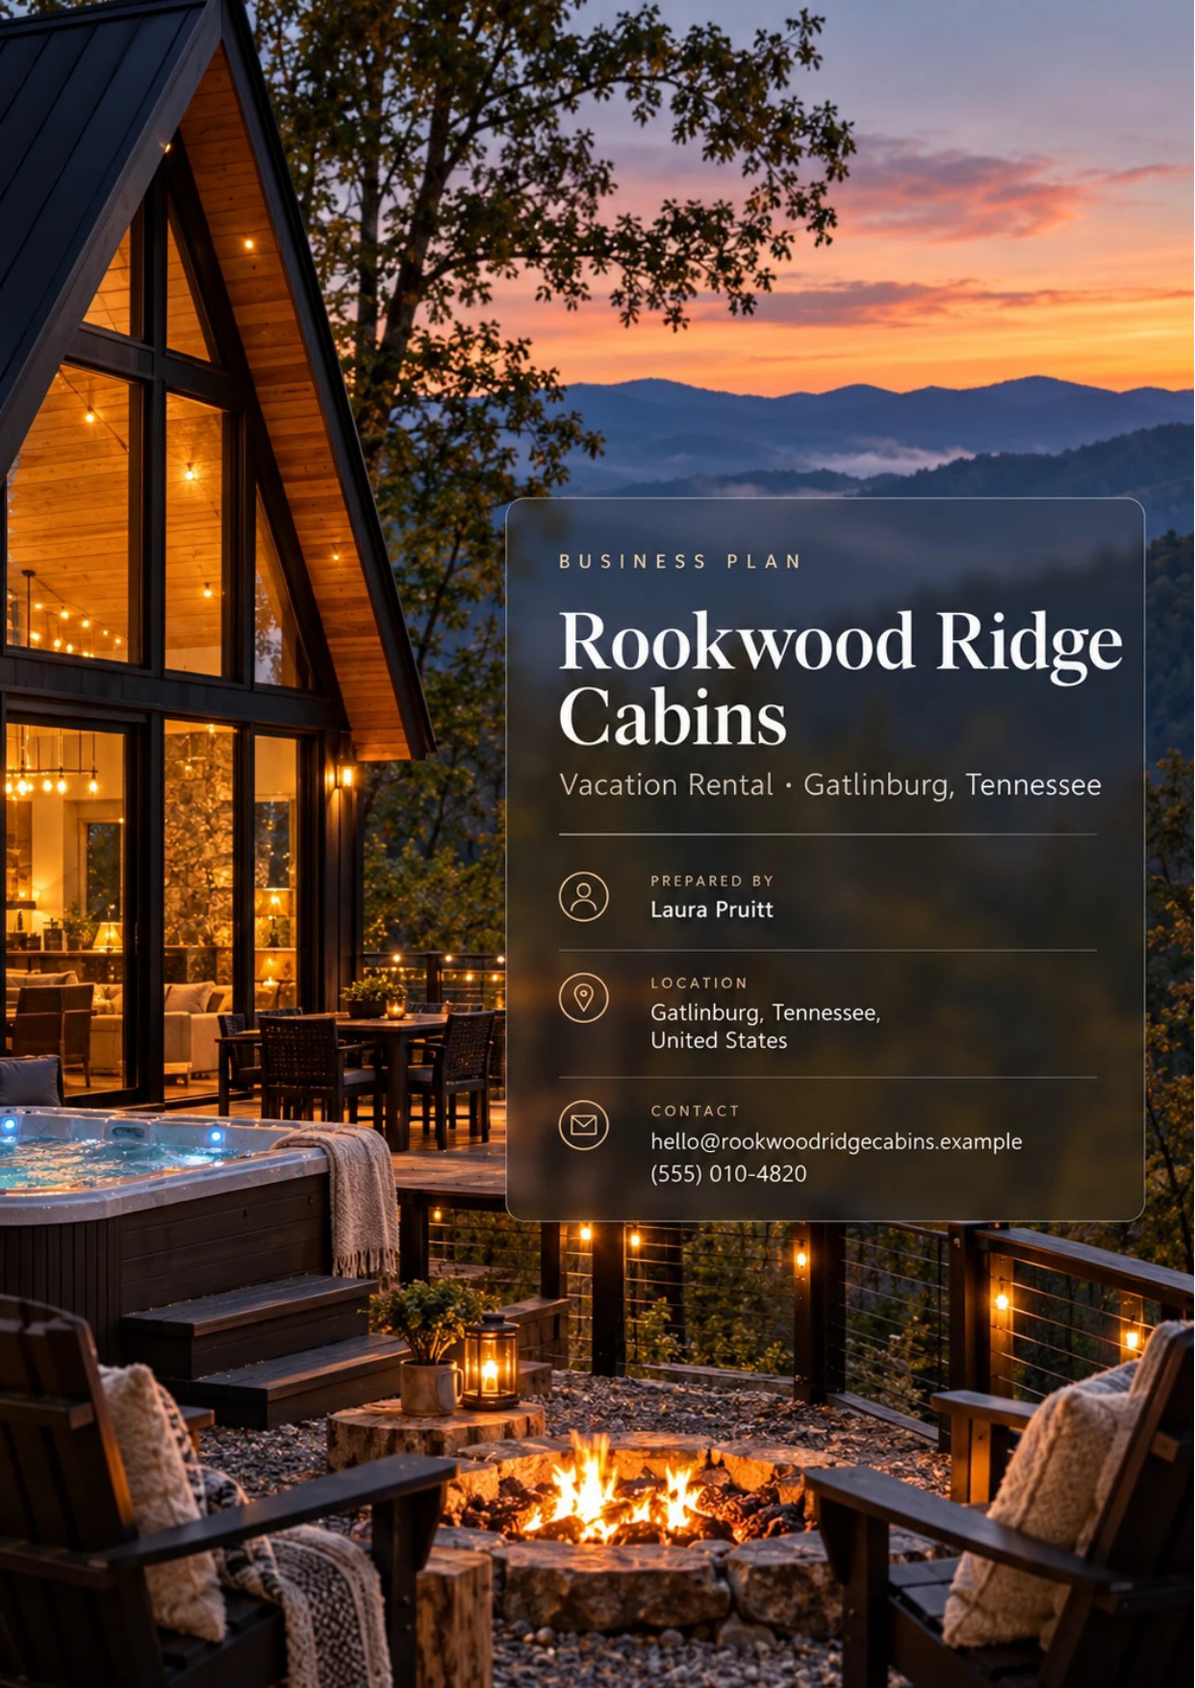
Table of Contents
1. Executive Summary 6
1.1 Business Overview 7
1.2 Mission Statement 7
1.3 Location & Market Opportunity 7
1.4 Unique Selling Points 7
1.5 Financial Highlights 8
1.6 Funding Requirement 8
1.6.1 Income Statement (3 Year projections) 8
2. Company Overview 9
2.1 Legal Structure 10
2.2 Vision Statement 10
2.3 Background & History 10
2.4 Future Goals 10
2.4.1 Business Owners 11
2.4.2 SMART Goal 11
3. Market Analysis 12
3.1 Overview 13
3.2 Market Segmentation 13
3.3 Market Trends 13
3.4 Local Market Outlook 13
3.5 Market Size 14
4. Customer Analysis 15
4.1 Target Market 16
4.2 Customer Segments 16
4.3 Customer Persona 17
4.4 Customer Purchase Journey 17
5. Competitive Analysis 18
5.1 Competitors 19
5.2 Comparison 19
5.3 Competitive Edge 20
5.4 SWOT Analysis 21
6. Services Offered 22
6.1 Our Offering 23
6.2 Signature Items 23
6.3 Additional Services 23
6.4 What Sets Us Apart 23
6.5 Rental Properties & Amenities 24
6.5.1 Two- and Three-Bedroom Cabin Stays 24
6.5.2 Celebration and Add-On Packages 25
6.5.3 Features 26
6.5.4 Pricing 26
7. Marketing & Sales Strategies 27
7.1 Market Positioning 28
7.2 Marketing Objectives 28
7.3 Online Marketing 29
7.4 Public Relations and Branding 29
7.5 Partnership & Collaboration Strategy 29
7.6 Customer Loyalty & Retention 29
7.7 Sales Channels 29
8. Operations Plan 31
8.1 Daily Operations 32
8.2 Working Hours 32
8.3 Staffing & Training 32
8.4 Inventory & Equipment Management 32
8.5 Location and Facilities 32
8.6 Milestones & Timeline 33
8.7 Permits, Zoning & Occupancy Tax 34
9. Management Team 35
9.1 Key Members 36
9.2 Organization Chart 36
9.3 Advisory Board Members 37
9.3.1 Hiring Plan 37
10. Financial Plan 38
10.1 Key Assumptions 39
10.2 Capital Requirements and Use of Funds 39
10.2.1 Use of Funds 40
10.3 Income Statement (3 Year projections) 41
10.4 Balance Sheet (3 Year projections) 42
10.5 Cash Flow Statement (3 Year projections) 43
10.6 Break Even Analysis 44
11. References 45


CHAPTER 1

Executive Summary

1.1 Business Overview
1.2 Mission Statement
1.3 Location & Market Opportunity
1.4 Unique Selling Points
1.5 Financial Highlights
1.6 Funding Requirement

1.1 Business Overview
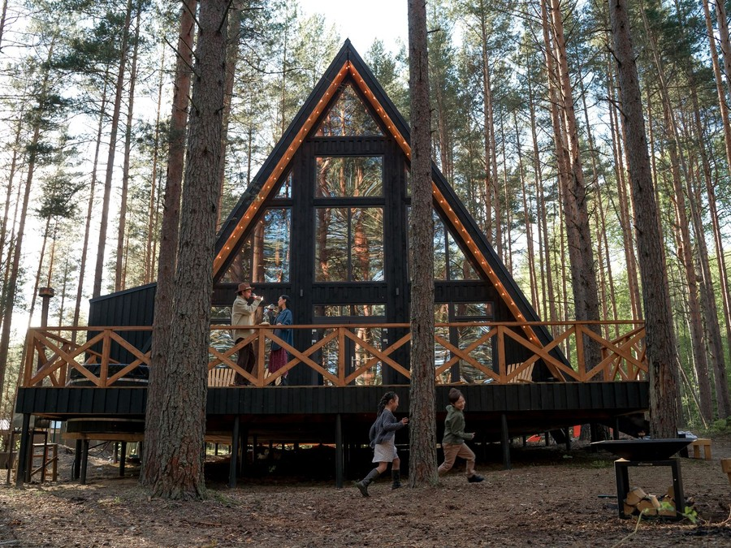
Rookwood Ridge Cabins is a vacation rental business that will own and run five new log-sided cabins on a wooded ridge of about seven acres off East Parkway, east of downtown Gatlinburg, Tennessee, near the Arts and Crafts Community and Great Smoky Mountains National Park. Three cabins have two bedrooms and sleep six; two have three bedrooms and sleep eight.
Each cabin is rented whole by the night through Airbnb, Vrbo and the business's own booking site, with a private hot tub, a mountain view deck, a fire pit, a full kitchen and a game loft. Guests are families and couples driving in from Knoxville, Nashville, Atlanta, Charlotte and the Ohio Valley, who add celebration packages, pet stays and grocery pre-stocking to the trip.

1.2 Mission Statement
To give families and couples a cabin in the Smokies that matches its photographs: new, clean and private, with a hot tub on the deck and the mountains in front of it, run by owners who answer the message themselves.

1.3 Location & Market Opportunity
Gatlinburg is the main gateway to Great Smoky Mountains National Park, which recorded 11,527,939 recreation visits in 2025, more than any other national park. Visitors spent $3,929,693,370 in Sevier County in 2024, the third highest total of Tennessee's 95 counties. The cabins sit outside the city limits, a short drive from downtown and the park, on land quiet enough for every deck to face the mountains rather than a neighbour.
Across the United States, online vacation rental bookings reached $21.3 billion in 2025. Gatlinburg's own short-term rental market is worth about $486.7 million a year: 7,243 active listings earning an average of $67,200 each, at 57% occupancy. Five cabins at that average come to about $336,000 a year, the scale at which Rookwood Ridge is planned.

1.4 Unique Selling Points
- New cabins built to current fire and building codes, with ignition-resistant siding and cleared defensible space, in a market where much of the stock is older.
- Five cabins spread across seven acres, so each deck faces the mountains rather than another cabin.
- A private hot tub, fire pit, full kitchen and game loft in every cabin, sized and priced for a family of six to eight.
- Owners who answer guest messages themselves and keep the 20% to 30% a rental program would charge.
- Returning guests rebook directly at a lower rate than the platforms show.

1.5 Financial Highlights
Revenue comes from five cabins at 56% occupancy and a $330 average nightly rate, with cleaning, pet and add-on fees worth a further 15% of nightly revenue. The cabins open at 55% of that level and reach it over eight months as reviews build.
Revenue is projected at $329,672 in the first year, $382,419 in the second and $443,606 in the third, at a gross margin of 72.0% throughout. The first two years close with net losses of $41,201 and $11,882 and the third with net income of $16,043, a net margin of 3.6%. The losses are depreciation and interest on the cabins; the business generates cash from operations from its first year. Break-even revenue, the level that covers operating costs before depreciation and interest, is $181,154 a year, the equivalent of 549 booked nights. In the conservative case the third year ends with a net loss of $21,712, and in the upside case with net income of $59,413.

1.6 Funding Requirement
The startup budget is $2,344,000. It buys the seven-acre parcel, the road, utilities and five septic systems, the five cabins, their furnishings, hot tubs and fire pits, design and permits, technology and the launch. It is funded by a $1,450,000 contribution from the two founders and a $1,000,000 construction-to-permanent loan at 7% over 25 years, which leaves an opening cash reserve. Profits stay in the business while the loan is repaid.
The plan rests on the most visited national park in the country, a market where guests look for newer and better kept cabins, and founders who have built on these slopes and sold hotel rooms for a living. The money builds five cabins the business owns, sized for the families who already drive here.

1.6.1 Income Statement (3 Year projections)
 | Year 1 | Year 2 | Year 3 | Total
Revenue | $329,671.64 | $382,419.10 | $443,606.16 | $1,155,696.90
Cost of Sales | $92,308.06 | $107,077.35 | $124,209.72 | $323,595.13
Gross Margin | $237,363.58 | $275,341.75 | $319,396.44 | $832,101.77
Operating Expense | $130,431.05 | $141,508.01 | $154,357.29 | $426,296.35
Total Expense | $370,872.44 | $394,301.11 | $427,563.12 | $1,192,736.67
Net Income | ($41,200.80) | ($11,882.01) | $16,043.04 | ($37,039.77)

CHAPTER 2

Company Overview

2.1 Legal Structure
2.2 Vision Statement
2.3 Background & History
2.4 Future Goals

2.1 Legal Structure
Rookwood Ridge Cabins will be organised as a Tennessee limited liability company, Rookwood Ridge Cabins LLC, owned by its two founders, Laura and Caleb Pruitt, and managed by its members. The LLC holds title to the land and the five cabins, carries the construction-to-permanent loan, and holds the county business licence and the sales and occupancy tax registrations. Holding the cabins in the company keeps the founders' personal assets separate from the liabilities of a lodging business.

2.2 Vision Statement
To be the cabins in the Smokies that families book again by name: new, cared for, quiet, and run by owners who live nearby and answer their own messages. Rookwood Ridge wants a guest who stayed once to come back the next October and bring the grandparents with them.

2.3 Background & History
Rookwood Ridge Cabins is a new business and has no trading history. It is the founders' plan for five cabins they intend to build on a parcel they are under contract to buy.
Laura Pruitt has spent nine years in hotel sales and revenue management in Knoxville, most recently setting nightly rates and running the booking channels for a 140-room hotel. Caleb Pruitt is a licensed Tennessee general contractor who has built custom homes on steep Sevier County lots for fourteen years: retaining walls, septic systems on slopes, access roads and the fire-resistant construction the county has favoured since 2016.
The idea came from Caleb's work. Many of the clients behind those builds were investors putting cabins on the rental market, and the cabins that booked best were the newest and best kept, while older cabins in large rental programs competed on price. The founders decided to build their own, small enough to run themselves and good enough to hold their rates.

2.4 Future Goals
In the first 0 to 18 months, the goal is to close on the land and the loan, secure the building and septic permits, build the five cabins and open them in September 2027, in time for the October leaf season. By May 2028 the cabins should be selling 56% of their nights, carry a rating of at least 4.8 on Airbnb and Vrbo, and take a growing share of bookings direct.
Over 1 to 3 years, the period the projections cover, the aim is to grow revenue from $329,672 to $443,606 and move from a net loss of $41,201 to net income of $16,043, through full years at planned occupancy, rate increases as reviews build, more direct bookings and more packages sold before arrival.
Over 3 to 5 years, with the loan being repaid and cash building, the founders intend to refresh the furnishings and decks on schedule and consider one or two further cabins on the parcel's remaining building sites, funded from retained cash. Any expansion waits until the first five have shown two full years of steady occupancy.

2.4.1 Business Owners
Laura Pruitt | Caleb Pruitt

Total ownership: 100%
55% | Laura Pruitt  5,500 Shares
45% | Caleb Pruitt  4,500 Shares

2.4.2 SMART Goal
  Specific  - Laura and Caleb Pruitt open five cabins on a ridge east of downtown Gatlinburg.  - Sell 56% of available nights across the five cabins once reviews are in.  - Build a direct-booking list of returning guests to cut platform fees. |   Measurable  - Occupancy, nightly rate and revenue per available night, tracked weekly in the pricing software.  - Average review score of 4.8 or higher on Airbnb and Vrbo.  - Direct bookings as a share of nights, reviewed each quarter. |   Achievable  - Caleb has built custom homes on steep Sevier County lots for fourteen years.  - Laura has set hotel rates and run booking channels for nine years.  - The target sits at the Gatlinburg market's 57% occupancy, not above it.
  Relevant  - Occupancy and rate decide whether the cabins carry their loan.  - Reviews decide search ranking, and ranking fills weekdays. |   Time-Based  - Open all five cabins in September 2027.  - Reach planned occupancy by May 2028.

CHAPTER 3

Market Analysis

3.1 Overview
3.2 Market Segmentation
3.3 Market Trends
3.4 Local Market Outlook
3.5 Market Size

3.1 Overview
Vacation rentals sell a whole home for the length of a trip, and the trip is what drives them. Americans are forecast to take 1.99 billion domestic leisure trips in 2026, up from 1.95 billion in 2025, and to spend $909 billion on them, the one part of US travel spending above its pre-pandemic level in real terms.
The supply side is fragmented. Most homes belong to individual owners and small operators, and the largest management company, Casago after its purchase of Vacasa in May 2025, runs more than 40,000 properties. Airbnb, the largest booking platform, booked 533 million nights and seats worldwide in 2025, up 8%.

3.2 Market Segmentation
- Families with children, booking a whole home with a kitchen and separate bedrooms for a week in summer or a long weekend in the school holidays.
- Couples on a getaway, honeymoon or anniversary, booking two or three nights and adding a package for the occasion.
- Extended families and groups of friends sharing one home so that grandparents, cousins or couples can stay together.
- By price: budget listings that compete on rate, and upscale homes with hot tubs, views and newer fittings that compete on what the photographs show.

3.3 Market Trends
- Rates, not occupancy, are carrying growth: occupancy is forecast at 57.4% for 2026, with revenue per available rental up 2.9% almost entirely on nightly rates.
- Platform fees are rising. Airbnb's host-only fee of 15.5% is now mandatory for most hosts, and Vrbo moves all hosts to a 12% commission from 29 October 2026, which makes direct bookings worth more to an owner every year.
- Travelers want rest with the people they travel with: 91% of those surveyed by Vrbo want getaways built around reading, relaxation and time with loved ones, which is what a whole cabin with a deck and a fire sells.

3.4 Local Market Outlook
Gatlinburg borders Great Smoky Mountains National Park, which recorded 11,527,939 recreation visits in 2025, the most of any national park, in a year when a federal shutdown closed services through part of the autumn. Visitors spent $3,929,693,370 in Sevier County in 2024, up 2.03% on 2023 and the third highest total among Tennessee's 95 counties, though local officials described the year as broadly flat.
The local market is deep and crowded. Gatlinburg had 7,243 active short-term rentals in the year to September 2026, booked 57% of available nights at an average of $343 a night. Revenue per listing rose 28.8% over the year while the nightly rate fell 4.5% and supply was flat, so the market is filling nights rather than raising prices. Across Sevier County, a wider geography, officials estimated about 13,000 short-term rentals in 2023, split between owners of one or two cabins and management companies running large portfolios.
Trading here carries local costs a reader should price in. Housekeepers in Tennessee, the smallest published geography that certainly contains Sevier County, earned a mean of $15.24 an hour in May 2025. Sevier County assesses a licensed rental that is not the owner's home at the 40% commercial ratio for property tax, and each stay carries 9.75% sales tax plus a county occupancy tax of up to 3%. Tennessee's Short-Term Rental Unit Act of 2018 holds a rental to the local rules in force when its use began.

3.5 Market Size
US online vacation rental bookings reached a gross booking value of $21.3 billion in 2025, after compound growth of 20.6% a year since 2020. That is the total market for the trade.
The serviceable market is Gatlinburg itself: 7,243 active short-term rentals earning an average of $67,200 a year each, including cleaning and guest fees, about $486.7 million a year in all. The obtainable market for one business of this size is five cabins at that average, about $336,000 a year. Rookwood Ridge's first-year revenue projection of $329,672 sits just below it, because the cabins open at reduced occupancy and build toward the market average over their first eight months.
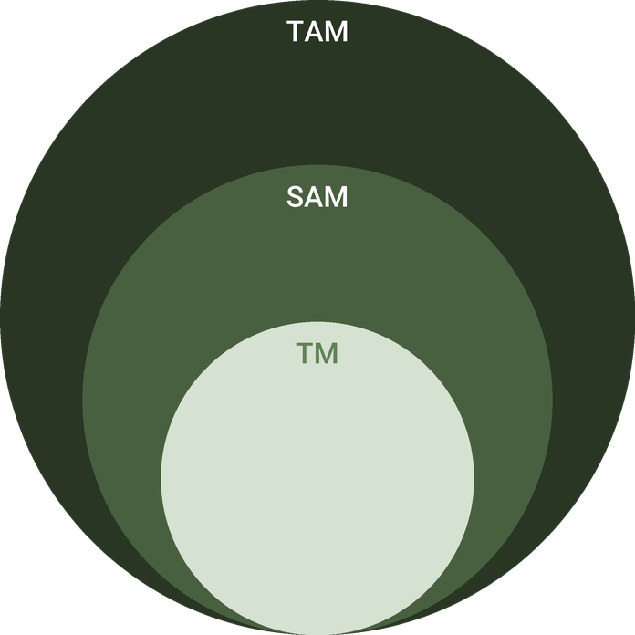
  ● | Total Available Market (TAM)  The US online vacation rental market recorded a gross booking value of $21.3 billion in 2025, after compound growth of 20.6% a year over 2020 to 2025 and growth of 12.6% in 2025. | 21.3B
  ● | Served Available Market (SAM)  The Gatlinburg short-term rental market earns about $486.7 million a year: 7,243 active listings times $67,200 average annual revenue per listing, including cleaning and guest fees (AirDNA, data through September 2026). | 486.7M
  ● | Target Market (TM)  Five cabins at the Gatlinburg average revenue per short-term rental listing of $67,200 a year come to about $336,000 a year, a derived figure at the scale of one business. | 336.0k

CHAPTER 4

Customer Analysis

4.1 Target Market
4.2 Customer Segments
4.3 Customer Persona
4.4 Customer Purchase Journey

4.1 Target Market
Rookwood Ridge sells to families and couples who live within a day's drive of the Smokies and come to Gatlinburg for the national park, the mountains and the town. Most drive in from Knoxville, Nashville, Atlanta, Charlotte and the cities of the Ohio Valley. Great Smoky Mountains National Park recorded 11,527,939 recreation visits in 2025, more than any other national park, and the cabins are aimed at the part of that traffic that wants a whole home with a hot tub rather than a hotel room.
The typical booking is a family of four to eight for three or four nights, made weeks or months ahead for the summer holidays, October or a school break, and paid for from a household income that treats the trip as the year's main holiday. Couples fill the shorter stays and the quieter months. What both groups want is rest together: 91% of travelers surveyed by Vrbo want getaways built around relaxation and time with loved ones, which a cabin with a deck, a fire and a game loft sells directly.
Most of these guests have been to Gatlinburg before and know the Parkway, the park and the traffic. They are not choosing the destination; they are choosing which cabin to stay in, and they choose on photographs, reviews and the total price with fees.

4.2 Customer Segments
- Families with children: the largest group, booking a three-bedroom cabin for three to five nights in summer, October and the school holidays, and buying grocery pre-stocking and firewood kits.
- Couples, honeymooners and anniversary guests: booking a two-bedroom cabin for two or three nights, often midweek or in the quieter months, and buying the Celebration Weekend.
- Extended families and friend groups: booking two or more cabins together for a reunion or a birthday, so that grandparents or a second family stay a short walk away.
- Returning guests: any of the above, coming back for the same week the next year and booking direct at the returning-guest rate.
Families carry occupancy and revenue in the peak months, and couples fill the weeknights and winter weeks that families leave empty. The persona below stands for the family, the group that decides whether the cabins sell their best weeks.
The segments also book on different clocks. Families plan summer and October trips months ahead and book the three-bedroom cabins first, so those fill early and carry the highest rates. Couples book closer to the date and fill the two-bedroom cabins midweek and in winter, when a lower rate and a celebration package make the trip. Extended families take two cabins at once, usually for a holiday week, and come back the next year if both worked. Minimum stays and rates are set to steer each group to the nights it fills best: three nights on peak family weeks, two the rest of the year, and midweek rates that make a couple's January trip worth taking.

4.3 Customer Persona
  Kristen, the Family Trip Planner  Demographics  Age: 39  Status: Married, two children  Location: Marietta, GA  Income: $135,000 household  Professional Role  Education: Bachelor's in Nursing  Job: Pediatric nurse at a hospital | “I need one place where the kids can play, my husband can sit in the hot tub and I can cook breakfast without packing everyone into a hotel room.”
   | Identifiers / Personality Traits  - Plans two family trips a year, both within a five-hour drive  - Books a whole cabin so grandparents can join the same stay  - Reads every review on Airbnb and Vrbo before booking
   | Goals  - A cabin with room for the family and a game loft for the children  - A hot tub and a view that make the trip feel like a holiday  - Hiking and the national park by day, a fire and a meal in at night
   | Challenges  - Older cabins look different from their photographs  - Cleaning and service fees push the total well above the nightly rate  - Steep, narrow drives worry her in winter weather

4.4 Customer Purchase Journey
- Inspiration: a park trip planned for the summer or October, or a friend's photographs of a cabin deck, starts the search months ahead.
- Search: the guest compares cabins on Airbnb and Vrbo by bedrooms, hot tub, view and the total price including cleaning and service fees.
- Decision: recent reviews, photographs that look current, and a plain description of the drive and the bed layout close the booking.
- Booking: most first stays are booked on a platform; the cabin website takes returning and referred guests at a lower rate.
- Before arrival: a message a week ahead offers packages and grocery pre-stocking, and a door code arrives on the day.
- Return: a thank-you email with the returning-guest rate, first access to next October's dates, and a review request that shapes the next family's decision.

CHAPTER 5

Competitive Analysis

5.1 Competitors
5.2 Comparison
5.3 Competitive Edge
5.4 SWOT Analysis

5.1 Competitors
A family choosing a stay in Gatlinburg chooses between four kinds of lodging, and Rookwood Ridge competes with all of them.
- Cabins in rental programs: most of the 7,243 active short-term rentals in Gatlinburg and the roughly 13,000 across Sevier County, many of them older cabins in dense communities.
- Condos and chalets near the Parkway: walkable to downtown, but without the privacy, the view or a private hot tub.
- Downtown hotels and motels: a short stay on foot, with no kitchen, no deck and rooms too small for a family of six.
- Large group lodges: sleeping twelve to thirty, priced above a family's budget for most of the year.
No revenue or performance figures are published for any named local business, and none are estimated here. The market as a whole sold 57% of its nights in the year to September 2026 at an average of $343 a night, and most of its supply is run by individual owners or by companies managing portfolios for them, the fragmented pattern of the trade nationally.

5.2 Comparison
Rookwood Ridge is built to beat the rental program cabins on age, condition and privacy, the condos on space and the view, the hotels on everything a family needs for a week, and the group lodges on price for a family of six to eight. It gives up the walk to downtown that a Parkway condo or hotel offers, and the scale and amenities a large lodge sells to a reunion.
Feature | Rookwood Ridge Cabins | Downtown hotels and motels | Older cabins in rental programs | Parkway condos and chalets | Large group lodges
Private hot tub at the unit | ✓ | ✗ | ✓ | ✗ | ✓
Built new to current fire and building codes | ✓ | ✗ | ✗ | ✗ | ✓
Cabins spaced apart on a private ridge | ✓ | ✗ | ✗ | ✗ | ✗
Sized and priced for a family of six to eight | ✓ | ✗ | ✓ | ✓ | ✗
Owners answer guest messages themselves | ✓ | ✗ | ✗ | ✗ | ✗
Walk to downtown Gatlinburg | ✗ | ✓ | ✗ | ✓ | ✗

5.3 Competitive Edge
The edge rests on things a guest can check before booking. The cabins are new, and their photographs are of the cabin the guest will find. Five cabins on seven acres means trees between decks, where cabin communities put neighbours a few yards apart. Each cabin has its own hot tub and game loft at a family's price rather than a group's.
The founders' skills match the two hardest parts of the trade. Laura has set hotel rates and run booking channels, which decides occupancy; Caleb has built on steep Sevier County lots, which decides what a cabin costs to build and to keep. Owners who answer messages themselves also keep the 20% to 30% a management company would charge, which is most of the margin a small portfolio has.
Price is where the market is weakest. Gatlinburg listings sold 57% of their nights in the year to September 2026 while the average nightly rate fell 4.5%, which is what a crowded market looks like when owners of older cabins cut rates to fill them. Rookwood Ridge does not plan to compete there. Its rates sit close to the market average, and the case for paying them is made in the listing: photographs of new cabins, a hot tub facing the mountains, and reviews that mention how clean the cabin was. A new listing has to earn those reviews first, which is why the launch months are priced to fill and the full rate waits for a review history.
The second advantage over the rental programs is control. A company running hundreds of cabins sets its cleaning standard for the average cabin and sends whichever crew is free; Rookwood Ridge has one crew, one checklist and five cabins it knows. That shows in reviews, where cleanliness and an accurate listing decide the score, and in the calendar, where a cabin the founders can reach in twenty minutes is rarely blocked for a repair. Against the hotels and condos the advantage is the stay itself: a family of eight in one cabin with a kitchen and a hot tub can pay less than for three hotel rooms.
The cabins give some things up, and the plan says so. They start with no reviews against competitors with hundreds. They are a drive from downtown, so a guest who wants to walk to dinner will book a condo. And a single business with five cabins has no other properties to move a guest to if a hot tub fails. Rookwood Ridge answers these with launch pricing and early review requests, a plain description of the drive, and a maintenance technician on call.
   | Built new, after the 2016 fire  Ignition-resistant siding, metal roofs and cleared defensible space around each cabin, built to current code, where much of the cabin stock nearby predates it.
   | Five cabins on seven acres  Each deck looks at the mountains rather than at a neighbour, which the dense cabin communities on the Parkway side cannot offer.
   | The owners run it  Guests message the founders, not a call centre, and the 20% to 30% a rental program would charge stays in the business.
   | Sized for the middle of the market  Two and three bedrooms for families of six to eight, priced for them, rather than lodges for twenty that sit empty midweek.

5.4 SWOT Analysis
Strengths  - Five new cabins built to current fire and building codes, each with a private hot tub and mountain view.  - A founder who built homes on steep Sevier County lots and one who ran hotel rates and channels.  - Owned land and cabins, so there is no rent and the property is the business's own asset.  - Cabins spaced across seven wooded acres, where most cabin communities sit close together. | Weaknesses  - No reviews at opening, so the first months sell below planned occupancy.  - Five cabins spread fixed costs thinly, and one cabin out of service costs a fifth of capacity.  - A $1,000,000 loan makes interest the largest cost after cost of sales.  - Two founders cover guest messaging, pricing and marketing with no back-up.
Opportunities  - Great Smoky Mountains National Park drew 11.5 million visits in 2025, the most of any national park.  - Upscale listings grew occupancy faster than budget ones through 2025.  - Returning guests booking direct avoid Airbnb's 15.5% and Vrbo's 12% fees.  - Honeymoon and anniversary packages through Gatlinburg wedding chapels. | Threats  - About 13,000 short-term rentals compete across Sevier County, many cutting rates midweek.  - Wildfire, as in 2016, and winter storms can close roads and cancel stays.  - Platform fee rises, like Vrbo's move to 12%, take margin directly.  - Sevier County or state rules on short-term rentals could tighten.

 Strategic Summary
New, well-spaced cabins can hold rates in an oversupplied market if reviews come quickly. Rookwood Ridge should push early reviews, grow direct bookings to cut fees, and keep a cash reserve against fire and weather closures.

CHAPTER 6

Services Offered

6.1 Our Offering
6.2 Signature Items
6.3 Additional Services
6.4 What Sets Us Apart
6.5 Rental Properties & Amenities

6.1 Our Offering
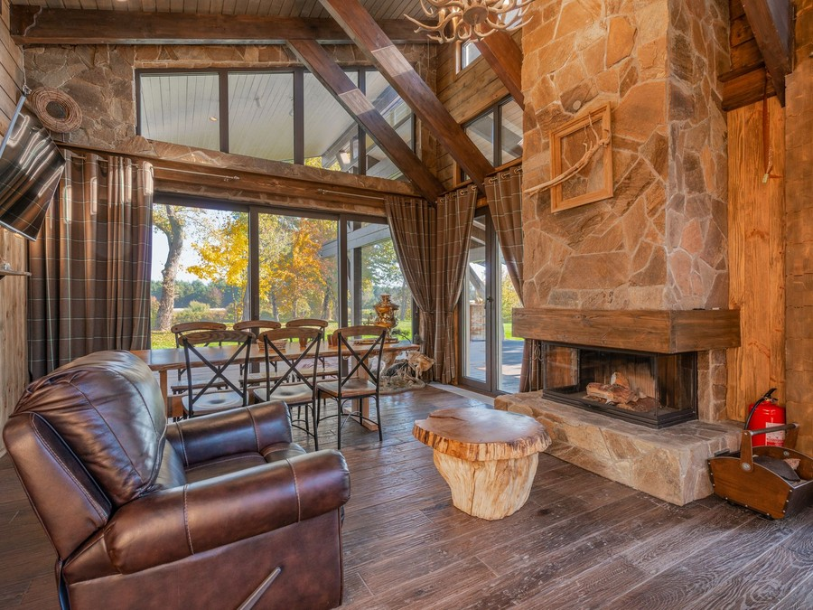
Rookwood Ridge sells a whole cabin in the Smokies by the night. Guests book one of five cabins, check themselves in with a door code, and find the beds made, the hot tub hot, the kitchen stocked with the basics and a fire pit ready to light on a deck facing the mountains. Around the stay the business sells the things that turn a trip into an occasion: celebration packages, firewood kits, grocery pre-stocking, pet stays and early check-in.
Stays run two nights or more, three on holiday weekends, and rates move by season and day of the week: October, the summer holidays and Christmas cost the most, and January weeknights the least.

6.2 Signature Items
- Two-bedroom cabin stay: one of three cabins sleeping six, about $295 a night on average across the year.
- Three-bedroom cabin stay: one of two cabins sleeping eight, about $385 a night on average.
- Celebration Weekend: two nights in a two-bedroom cabin with flowers, a cheese board, candles and late checkout, $845 as a package.

6.3 Additional Services
- Firewood and s'mores kit of seasoned hardwood, set by the fire pit before arrival, from $25.
- Grocery pre-stocking from an order placed three days ahead, for a $40 service fee plus the groceries.
- Pet stays in the two pet-friendly cabins, up to two dogs, for a fee per stay.
- Early check-in from 1pm when the cabin stood empty the night before.
- Mid-stay clean with fresh linens and towels for stays of five nights or more, $120.

6.4 What Sets Us Apart
The cabins are new and built for renting. Every surface a guest touches was chosen to survive a busy season and to clean quickly, so the cabin in July looks the way it did in the photographs. They stand apart on a wooded ridge, so the hot tub faces the mountains and not a neighbour's deck. And the people who built them answer the messages, so a question about the drive, a late arrival or a broken lamp reaches someone who knows the cabin, not a call centre.

6.5 Rental Properties & Amenities
The three two-bedroom cabins are about 1,150 square feet over two floors: a king suite and a queen room on the main floor, and a loft with a sleeper sofa and the game area above. The two three-bedroom cabins are about 1,500 square feet, with two king suites, a bunk room with two sets of twin bunks, and a larger game loft. All five are log-sided with ignition-resistant materials and metal roofs.
- Bathrooms: two full baths in each two-bedroom cabin and three in each three-bedroom cabin, with towels, toiletries and a hair dryer.
- Kitchen: a full kitchen with a range, dishwasher, coffee maker and cookware for eight, and a gas grill on the deck.
- Outside: a covered deck with rocking chairs facing south, a private hot tub for six and a stone fire pit below the deck.
- Game loft: a pool table in the three-bedroom cabins and an arcade cabinet in the two-bedroom cabins, with board games.
- Comfort: heat pumps for heating and cooling, a gas log fireplace in the living room, and blackout curtains in every bedroom.
- Connection and safety: fibre Wi-Fi, smart televisions, smart locks, smoke and carbon monoxide alarms, and an exterior noise sensor.

6.5.1 Two- and Three-Bedroom Cabin Stays
Whole-cabin stays in five new log-sided cabins on a wooded ridge east of downtown Gatlinburg. Each cabin has a private hot tub, a covered deck facing the mountains, a fire pit, a full kitchen and a game loft, and is booked by the night through Airbnb, Vrbo or the cabin website.
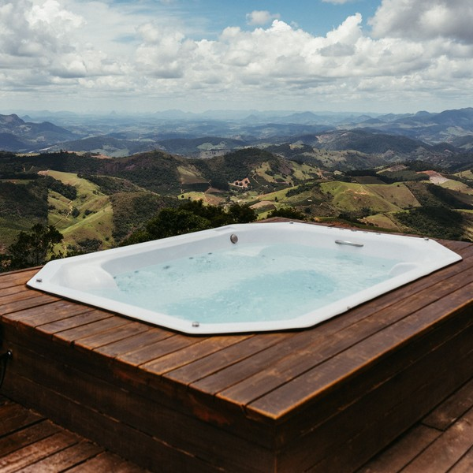 | $295 to $385 per night  The nightly rate averages $295 for a two-bedroom cabin and $385 for a three-bedroom cabin across the year, set daily by pricing software against demand in Gatlinburg. October weekends, holidays and summer weeks cost more, and January and February weeknights cost less. A cleaning fee of $145 or $185 is added once per stay, with Tennessee and Sevier County taxes on top. Stays run two nights or more, and three on holiday weekends. Guests who book again directly receive a lower rate than the platforms show, and pet stays, early check-in and grocery pre-stocking can be added.

Specifications
- Three two-bedroom cabins sleeping six and two three-bedroom cabins sleeping eight.
- Two-night minimum stay, three nights on holiday weekends.
- Check-in from 4pm with a smart lock code; checkout by 10am.
- Two cabins accept up to two dogs.
- Linens, towels, firewood starter and hot tub chemicals included.

6.5.2 Celebration and Add-On Packages
Extras chosen when the stay is booked and set out before arrival: celebration packages for honeymoons and anniversaries, firewood and s'mores kits, grocery pre-stocking, early check-in and mid-stay cleans. The Celebration Weekend bundles two nights in a two-bedroom cabin with flowers, a cheese board and late checkout.
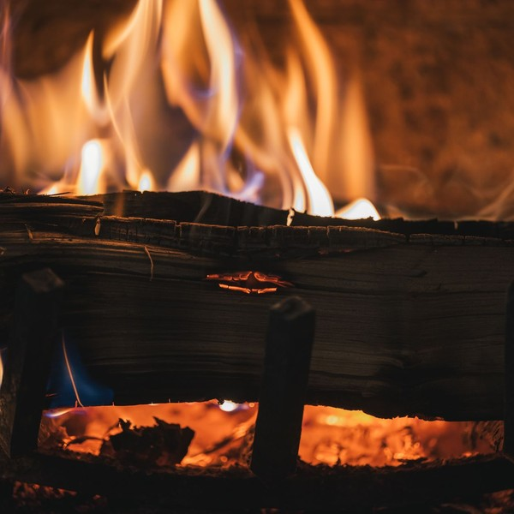 | From $25 per add-on; Celebration Weekend $845 per package  Add-ons are priced per stay by what they include, from $25 for a firewood and s'mores kit to $120 for a mid-stay clean. Grocery pre-stocking carries a $40 service fee plus the cost of the groceries ordered. The Celebration Weekend is priced as one package: two nights in a two-bedroom cabin, the cleaning fee, flowers, a cheese board, candles and late checkout on the second morning. Most packages are sold in the message sent a week before arrival, when guests are planning the trip, and each one is ready before they walk in.

Specifications
- Firewood and s'mores kit with seasoned hardwood and a lighter.
- Grocery pre-stocking from an order placed three days ahead.
- Early check-in from 1pm when the cabin is free the night before.
- Mid-stay clean with fresh towels and linens for stays of five nights or more.
- Celebration set-up of flowers, candles and a cheese board before arrival.

6.5.3 Features
  Private hot tub
  Every cabin has its own hot tub on a covered deck, cleaned and tested between every stay.
  Mountain view deck and fire pit
  A covered deck facing the Smokies, with rocking chairs and a stone fire pit below it.
   | Game loft  A loft with a pool table or arcade cabinet, board games and a sleeper sofa for the children.
   | Full kitchen and grocery pre-stocking  A full kitchen and a grill, with groceries ordered ahead and stocked before the family arrives.
  Self check-in
  Smart locks send each guest a door code on arrival day, so a late arrival needs no office.
   | Pet-friendly cabins  Two of the five cabins take up to two dogs, with a fenced yard and a pet fee per stay.

6.5.4 Pricing
Two-Bedroom Cabin  $295  per night  - Sleeps six: a king suite, a queen room and a sleeper sofa in the loft  - Private hot tub on a covered deck facing the mountains  - Fire pit, full kitchen and game loft  - Average rate across the year; October and holiday weekends cost more |  | Most Popular  Three-Bedroom Cabin  $385  per night  - Sleeps eight: two king suites and a bunk room  - Private hot tub, mountain view deck and fire pit  - Game loft with a pool table and arcade cabinet  - Average rate across the year; October and holiday weekends cost more |  | Celebration Weekend  $845  per package  - Two nights in a two-bedroom cabin, cleaning fee included  - Flowers, a cheese board and a firewood and s'mores kit  - Rose petals and lit candles set out before arrival  - Late checkout on the second morning

CHAPTER 7

Marketing & Sales Strategies

7.1 Market Positioning
7.2 Marketing Objectives
7.3 Online Marketing
7.4 Public Relations and Branding
7.5 Partnership & Collaboration Strategy
7.6 Customer Loyalty & Retention
7.7 Sales Channels

7.1 Market Positioning

Rookwood Ridge is positioned as the new, quiet, owner-run cabin near Gatlinburg: newer than the older cabins in large rental programs, more private than the condos and chalets along the Parkway, and smaller and less expensive than the group lodges, at a nightly rate close to the market's average.

7.2 Marketing Objectives
- Reach 56% occupancy across the five cabins by May 2028, eight months after opening.
- Hold an average rating of 4.8 or higher on Airbnb and Vrbo from the first season.
- Raise the share of nights booked direct every year, starting with guests who have stayed before.
- Sell a package or add-on with at least one stay in four.
- Build an email list of past guests large enough to fill January and February weeknights without paid advertising.
Search and social ads  $384  per month  Ads to families planning trips from Knoxville, Nashville, Atlanta and Charlotte, sent to the direct site. |  | Direct site and guest email  $275  per month  The booking site, its search listing and seasonal emails to guests who have stayed.
Listing photography  $220  per month  Seasonal photographs and video of each cabin for the Airbnb and Vrbo listings. |  | Local wedding partners  $220  per month  Referral packages with Gatlinburg wedding chapels and officiants for honeymoon and anniversary stays.

Total marketing budget: $13,187 a year, $1,099 a month.

7.3 Online Marketing
The listings are the shop window, so they get most of the care: professional photographs of every cabin by day and at dusk, video of the deck and the view, seasonal photographs refreshed each year, and descriptions that state the drive, the steps and the bed layout plainly. The cabin website carries the same photographs, a live calendar, the packages and a lower rate for returning guests. Search and social advertising reaches families planning trips from Knoxville, Nashville, Atlanta and Charlotte, timed to when they book: summer and October trips are planned months ahead, and spring break in the winter.
The marketing budget is 4% of revenue, $13,187 in the first year. Every booking records where the guest came from, and the founders review the cost per booked night each month, moving money toward whatever fills nights at the lowest cost.

7.4 Public Relations and Branding
The brand rests on the ridge and the quiet: a simple woodland identity, the view from the deck in every image, and a plain, warm voice that tells a guest what to expect rather than what to feel. Before opening, the founders will host travel writers and regional family and lifestyle editors for trial stays, and pitch the story of two locals building new cabins to the post-2016 standard. Every review is answered by the founders, which is part of the brand as much as the logo.

7.5 Partnership & Collaboration Strategy
- Gatlinburg wedding chapels and officiants, which refer honeymoon and anniversary couples to the Celebration Weekend.
- Studios in the Arts and Crafts Community, which guests visit from the cabins and which can share a guest itinerary in return.
- Licensed hiking guides and outfitters, booked by guests through the pre-arrival message.
- A local grocery delivery service for pre-stocking, which handles the shopping while the crew stocks the cabin.

7.6 Customer Loyalty & Retention
A cabin trip is bought for a season or an occasion, so loyalty means the next one. Every guest receives a returning-guest rate valid for a year, first access to October and Christmas dates when they open, and a note when the leaves turn. Couples who came for an anniversary are invited back on the same date, and a guest who sends a friend receives a credit toward the next stay. Booking direct is how each of these is redeemed, which moves a returning family off the platforms. Anything a guest reports is fixed before the next arrival, because a returning guest remembers the broken lamp longer than the view.

7.7 Sales Channels
In the first months Airbnb brings most of the new guests, because a new listing has no list of its own and search ranking follows reviews. Airbnb's host-only fee of 15.5% makes it the most expensive route, and Vrbo's move to a 12% commission narrows the gap with it. Each platform guest receives the returning-guest rate by email after checkout, so the second stay is booked on the cabin website, which costs only card processing and carries the packages chosen at checkout. The plan is for the direct share to grow each year as the guest list does, which is where most of the margin gain in the later years comes from.
Packages are the fourth route and carry the highest margin. They are offered in the message a week before arrival, when a family is planning meals and a couple is planning the occasion, and cost nothing to sell beyond the time to set them out. Celebration Weekends also arrive by referral from the wedding chapel partners, booked direct.
The channel mix is reviewed each quarter against three numbers: the share of nights booked direct, platform fees as a share of revenue, and the share of stays that bought a package. A channel whose guests never return is worth less than its booking count suggests, and the founders adjust accordingly: a returning-guest rate on the cabin website, longer minimum stays on the platforms in peak weeks, and the email list used first whenever a gap opens in the calendar.
Group bookings follow the same rule. An extended family taking two cabins for a reunion books on the cabin website, where both cabins are held together under one deposit, rather than across two platform listings that might not both stay free. Those bookings arrive months ahead, which makes them the easiest nights on the calendar to plan around, and the reunion family that books a second year is the guest the email list exists for.
  Airbnb
  The largest share of nights, at Airbnb's 15.5% host-only fee, and it depends on reviews and search ranking in the first months.
  Direct bookings
  Returning and referred guests booking on the cabin website pay only card processing, and this share grows as the guest list does.
  Vrbo
  Families booking a whole cabin for a week, at Vrbo's 12% commission, strongest in summer and at the holidays.
  Packages and add-ons
  Celebration weekends, pet stays, early check-in and grocery pre-stocking sold to guests already booked, through the pre-arrival message.

CHAPTER 8

Operations Plan

8.1 Daily Operations
8.2 Working Hours
8.3 Staffing & Training
8.4 Inventory & Equipment Management
8.5 Location and Facilities
8.6 Milestones & Timeline
8.7 Permits, Zoning & Occupancy Tax

8.1 Daily Operations
The day turns on checkout at 10am and check-in from 4pm. Between them the contract turnover crew cleans every departing cabin to a written checklist: linens stripped and bagged for the linen service, kitchen and bathrooms cleaned and restocked, the game loft reset, the deck swept, the fire pit cleared and the hot tub tested and dosed. A two-bedroom cabin takes about two and a half hours and a three-bedroom cabin about three. The crew photographs each room, and the guest side checks the photographs before releasing the cabin, which sends the arriving guest a door code.
Pricing software sets each cabin's rate daily against demand in Gatlinburg, and the founders review it each morning. The maintenance technician works through the preventive schedule midweek, when the fewest cabins are occupied.

8.2 Working Hours
The cabins are let every night of the year, because Gatlinburg draws visitors in every season and a night left empty is not sold later. Check-in opens at 4pm with no office to reach, and checkout is by 10am to give the crew six hours. Messages are answered from 7am to 10pm, and an emergency line covers the night, with the founders twenty minutes away. January and February weeknights, the quietest of the year, are kept for deep cleaning and larger repairs.

8.3 Staffing & Training
In the first year the two founders run the business full time without a salary. A part-time maintenance and grounds technician is hired before opening, and seasonal weekend guest support is added once the first summer shows where it is needed. Cleaning is done by a contract turnover crew of three, paid per turnover at rates above the Tennessee mean of $15.24 an hour for housekeepers, so a busy Saturday costs no more than the cleans it brings. Everyone is trained before opening on the turnover checklist and photograph standard, hot tub water testing, fire safety and the evacuation routes, winter driving on the access road, and how to talk to a guest when something is wrong.

8.4 Inventory & Equipment Management
Stock is small and fast-moving: linens on a weekly service contract, toiletries, paper goods, coffee, firewood starter and hot tub chemicals, counted weekly in a lockable storage shed on the parcel and reordered from regional suppliers. Equipment is tracked in a maintenance log for each cabin: hot tub filters and water every turnover, heat pump filters monthly, smoke and carbon monoxide alarms tested monthly, fire extinguishers serviced yearly, septic tanks pumped on schedule and decks restained every two years. Mattresses, hot tub covers and small appliances are replaced on a rolling cycle from the capital budget, at 3% of revenue.

8.5 Location and Facilities
The parcel is about seven wooded acres on a ridge off East Parkway, east of downtown Gatlinburg and outside the city limits in Sevier County, close to the studios of the Arts and Crafts Community and a short drive from downtown and the park. A gravel access road climbs to five building sites spaced along the ridge, each with parking for three cars, its own septic system and a deck facing south toward the mountains. The cabins have ignition-resistant siding, metal roofs and a cleared zone around each one, and a small storage shed near the entrance holds supplies and tools.

8.6 Milestones & Timeline
The sequence runs from land to a full season: the land and loan first, then the building and septic permits, construction of the road, utilities and cabins, a soft opening with trial stays and photography, the public opening before the October leaf season, and a review of occupancy, rates and the direct-booking share once the cabins reach planned occupancy.
Nov 2026  Setup |  |  | Land and financing  The ridge and the loan  Close on the seven-acre ridge parcel and the construction-to-permanent loan.
Jan 2027  Setup |  |  | Permits approved  Building, septic and tax  Receive building and septic permits, the county business licence and sales and occupancy tax registrations.
Feb 2027  Build |  |  | Construction starts  Road, utilities and cabins  Cut the access road, run power and water, install five septic systems and frame the cabins.
Aug 2027  Launch |  |  | Soft opening  Trial stays and photography  Run trial turnovers, shoot listing photographs and host friends and family to test every cabin.
Sep 2027  Launch |  |  | Public opening  Ahead of leaf season  List all five cabins on Airbnb, Vrbo and the direct site before the October leaf season.
May 2028  Growth |  |  | Planned occupancy reached  End of the ramp  Reach 56% occupancy and review rates, minimum stays and the direct-booking share before summer.

8.7 Permits, Zoning & Occupancy Tax
Every cabin is permitted, licensed and registered for tax before its first night is sold.
- Building and septic: each cabin needs a building permit and inspections through Sevier County, and each septic system a state subsurface sewage permit sized to its bedrooms, which caps how many guests a cabin may sleep.
- Licensing: the LLC holds a county business licence and registers with the Tennessee Department of Revenue before opening.
- Sales tax: each stay carries 9.75% sales tax, the 7% state rate plus Sevier County's 2.75% local option, with no city add-on outside the city limits.
- Occupancy tax: Sevier County levies a privilege tax of up to 3% on the occupancy of lodgings, cabin rentals included, remitted to the county clerk by the twentieth of each month.
- Platform collection: Airbnb and Vrbo collect and remit taxes on the stays they book, and the business files and pays the tax on direct bookings itself.
- Property tax: Sevier County assesses a licensed rental that is not the owner's home at the 40% commercial ratio rather than 25% residential, which the budget carries.
Tennessee's Short-Term Rental Unit Act of 2018 holds a rental to the local rules in force when its use began, so long as it is not sold, left unused for 30 months or found in violation three times, which makes a clean compliance record worth protecting. Occupancy is set at two guests per bedroom plus two, and every cabin carries posted exit routes, smoke and carbon monoxide alarms and extinguishers.
Insurance and fire safety sit beside the permits. The cabins are insured for short-term rental use, with liability cover for guests and loss-of-income cover for a cabin closed by damage, because a standard homeowner's policy excludes paying guests. Wildfire is the hazard this county remembers best: the Chimney Tops 2 fire of 2016 burned homes and cabins across the Gatlinburg area. Each cabin keeps a cleared zone free of brush and leaf litter, gutters and roofs are cleared before the autumn fire season, and every guest receives the evacuation route with the door code. When a fire, storm or road closure warning is issued, the founders move or refund the stays it affects, and the booking terms say so before a guest pays.

CHAPTER 9

Management Team

9.1 Key Members
9.2 Organization Chart
9.3 Advisory Board Members

9.1 Key Members
Each person on the team answers for one part of the stay a guest can judge, and is measured on it. Guest experience and revenue owns occupancy, the average nightly rate, the share of nights booked direct and the average rating across Airbnb and Vrbo, reviewed every month against the plan, and every guest message answered within fifteen minutes between 7am and 10pm.
Construction and property owns the build and then the buildings: the cabins finished on budget and on schedule, permits and inspections kept current, and no cabin taken off the calendar for a fault that routine maintenance should have caught. Maintenance is measured on response time to a guest's report, under an hour in the day, and on the preventive schedule kept. The turnover crew is paid per clean and measured on every cabin passing inspection before 4pm and on cleanliness scores in reviews, the comment that most affects the next booking.
 | Laura Pruitt  Co-Founder, Guest Experience and Revenue · laura@rookwoodridgecabins.example  Nine years in Knoxville hotel sales and revenue management, most recently setting rates and running booking channels for a 140-room hotel.

 | Caleb Pruitt  Co-Founder, Construction and Property · caleb@rookwoodridgecabins.example  A licensed Tennessee general contractor who has built custom homes on steep Sevier County lots for fourteen years.

 | Jason Reed  Maintenance and Grounds Technician · jason@rookwoodridgecabins.example  Six years maintaining hot tubs, heat pumps and decks for a cabin rental program in Pigeon Forge.

 | Tasha Greene  Turnover Crew Lead (contract) · tasha@rookwoodridgecabins.example  Runs a three-person cleaning crew that has turned over mountain cabins between guests for seven years.

9.2 Organization Chart
The guest and revenue lead runs the business day to day, and the property co-founder works alongside that lead on anything to do with the land, the buildings and safety. The maintenance technician reports to the property side, and the cleaners on the turnover crew report to their crew lead, who works to the guest side's checklist. Outside contractors for pest control, septic service, snow and ice treatment and hot tub repair are managed by the property side. The two founders meet weekly on bookings, costs and the maintenance log.
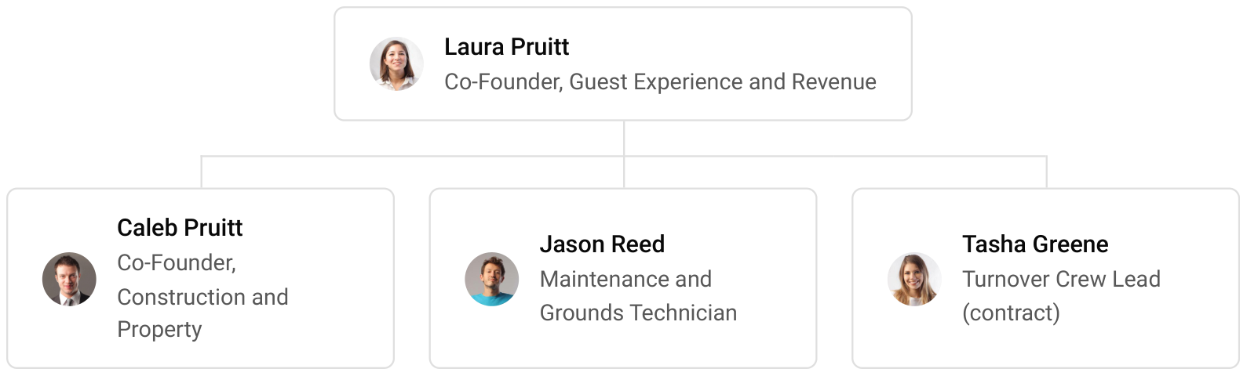

9.3 Advisory Board Members
The founders will build an informal advisory group before opening rather than a formal board: an accountant with short-term rental clients to set up the books, the sales and occupancy tax filings and the loan reporting; an insurance broker who writes cover for rental cabins in wildfire country; and a Sevier County cabin owner who has run rentals through several seasons. The group meets quarterly in the first year and is consulted on pricing, insurance and any expansion.

9.3.1 Hiring Plan
2  Filled |  | 1  Hiring This Year |  | 2  Open

Group By Department | Position Filled | Time of Hire | Time of Start | Filled
Management | 2 of 2 | 0 days | 0 days | 100%
Maintenance & Grounds | 0 of 1 | 30 days | 14 days | 0%
Guest Support | 0 of 1 | 45 days | 14 days | 0%

CHAPTER 10

Financial Plan

10.1 Key Assumptions
10.2 Capital Requirements and Use of Funds
10.3 Income Statement (3 Year projections)
10.4 Balance Sheet (3 Year projections)
10.5 Cash Flow Statement (3 Year projections)
10.6 Break Even Analysis

10.1 Key Assumptions
Revenue is five cabins multiplied by occupancy, the average nightly rate and 365 nights, plus cleaning, pet and add-on fees. The cabins are planned at 56% occupancy, just under the Gatlinburg market's 57%, at an average nightly rate of $330: about $295 for a two-bedroom cabin and $385 for a three-bedroom cabin, before fees. Fees add 15% to nightly revenue. The cabins open at 55% of the planned level and reach it over eight months as reviews build, so the first year carries the ramp, and revenue grows 16% a year after it as the cabins sell full years, rates rise and more guests book direct.
Gross margin is 72.0%, after the contract cleaning crew paid per turnover, Airbnb's 15.5% host-only fee and Vrbo's 12% commission on the nights they sell, card processing, linen service and guest supplies. Below it, payroll is 9% of revenue for a part-time maintenance technician and seasonal weekend help, because the two founders draw no salary in the projection years. Marketing is 4% of revenue, technology $900 a month, and administration $4,200 a month for insurance, property tax at Sevier County's 40% commercial assessment, bookkeeping and licences. Other operating costs, mostly electricity for five hot tubs and heat pumps, run at 8%. The business owns its land, so it pays no rent. Assets are depreciated over a blended 30 years and profits are taxed at 26%.
On those assumptions revenue grows from $329,672 in the first year to $382,419 and $443,606. The first two years close with net losses of $41,201 and $11,882, and the third with net income of $16,043, a 3.6% net margin. Break-even revenue of $181,154 a year, or 549 booked nights, is the level that covers operating costs before depreciation and interest, and first-year revenue clears it; the losses are depreciation and interest on the cabins, which is why the business generates cash from its first year while it reports a loss. Third-year net income is a loss of $21,712 in the conservative case and $59,413 in the upside case.

10.2 Capital Requirements and Use of Funds
The cabins need $2,344,000 before the first guest arrives. Construction of the five cabins is the largest item, followed by the land, the road, utilities and septic systems, and the furnishings, hot tubs and fire pits; the rest covers design and permits, technology, opening supplies, launch marketing and pre-opening training.
It is funded by a $1,450,000 contribution from the two founders and a $1,000,000 construction-to-permanent loan at 7% over 25 years, a term matched to buildings with a long life. The difference between the funding and the startup cost stays in the bank as an opening cash reserve for the ramp. No profits are distributed while the loan is being repaid.

10.2.1 Use of Funds
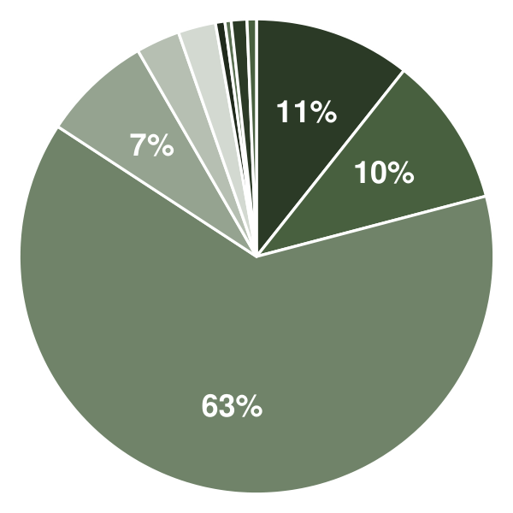 | ● Land: Seven-Acre Ridge Parcel 10.7%  ● Site Work: Road, Utilities, Septic & Grading 10.2%  ● Cabin Construction (Five Cabins, 6,450 sq ft) 63.3%  ● Furnishings, Linens & Game Lofts 7.5%  ● Hot Tubs, Fire Pits & Deck Furniture 3.0%  ● Design, Permits, Legal & Inspections 2.6%  ● Technology & Security 0.6%  ● Initial Supplies Inventory 0.4%  ● Launch Marketing & Photography 1.1%  ● Pre-Opening Cleaning Crew Training 0.6%

Use Of Funds | Amount
Land: Seven-Acre Ridge Parcel | $250,000.00
Site Work: Road, Utilities, Septic & Grading | $240,000.00
Cabin Construction (Five Cabins, 6,450 sq ft) | $1,484,000.00
Furnishings, Linens & Game Lofts | $175,000.00
Hot Tubs, Fire Pits & Deck Furniture | $70,000.00
Design, Permits, Legal & Inspections | $60,000.00
Technology & Security | $15,000.00
Initial Supplies Inventory | $10,000.00
Launch Marketing & Photography | $25,000.00
Pre-Opening Cleaning Crew Training | $15,000.00

10.3 Income Statement (3 Year projections)
 | Year 1 | Year 2 | Year 3 | Total
Revenue | $329,671.64 | $382,419.10 | $443,606.16 | $1,155,696.90
Cost of Sales | $92,308.06 | $107,077.35 | $124,209.72 | $323,595.13
General Costs | $0.00 | $0.00 | $0.00 | $0.00
Revenue Specific Costs | $64,615.64 | $74,954.14 | $86,946.80 | $226,516.58
Personnel Costs (Direct Labor) | $27,692.42 | $32,123.21 | $37,262.92 | $97,078.55
Gross Margin | $237,363.58 | $275,341.75 | $319,396.44 | $832,101.77
Gross Margin (%) | 72.00% | 72.00% | 72.00% | 72.00%
Operating Expense | $130,431.05 | $141,508.01 | $154,357.29 | $426,296.35
Payroll Expense (Indirect Labor) | $29,670.45 | $34,417.72 | $39,924.55 | $104,012.72
General Expense | $100,760.60 | $107,090.29 | $114,432.74 | $322,283.63
Bad Debt | $0.00 | $0.00 | $0.00 | $0.00
Amortization of Current Assets | $0.00 | $0.00 | $0.00 | $0.00
EBITDA | $106,932.53 | $133,833.74 | $165,039.15 | $405,805.42
Additional Expense | $148,133.33 | $145,715.75 | $148,996.11 | $442,845.19
Long Term Depreciation | $78,133.33 | $78,515.75 | $78,959.36 | $235,608.44
Gain or loss from Sale of Assets | $0.00 | $0.00 | $0.00 | $0.00
EBIT | $28,799.20 | $55,317.99 | $86,079.79 | $170,196.98
Interest Expense | $70,000.00 | $67,200.00 | $64,400.00 | $201,600.00
EBT | ($41,200.80) | ($11,882.01) | $21,679.79 | ($31,403.02)
Income Tax Expense / Benefit | $0.00 | $0.00 | $5,636.75 | $5,636.75
Total Expense | $370,872.44 | $394,301.11 | $427,563.12 | $1,192,736.67
Net Income | ($41,200.80) | ($11,882.01) | $16,043.04 | ($37,039.77)
Net Income (%) | -12.50% | -3.11% | 3.62% | -3.20%
Retained Earning Opening | $0.00 | ($41,200.80) | ($53,082.81)
Owner's Distribution | $0.00 | $0.00 | $0.00 | $0.00
Retained Earning Closing | ($41,200.80) | ($53,082.81) | ($37,039.77) | ($37,039.77)

10.4 Balance Sheet (3 Year projections)
 | Year 1 | Year 2 | Year 3 | Total
Assets | $2,376,386.16 | $2,325,718.07 | $2,304,578.44 | $2,304,578.44
Current Assets | $110,519.49 | $126,894.58 | $171,406.13 | $171,406.13
Cash | $106,039.57 | $121,697.87 | $165,377.95 | $165,377.95
Accounts Receivable | $2,709.63 | $3,143.17 | $3,646.08 | $3,646.08
Inventory | $1,770.29 | $2,053.54 | $2,382.10 | $2,382.10
Other Current Assets | $0.00 | $0.00 | $0.00 | $0.00
Long Term Assets | $2,265,866.67 | $2,198,823.49 | $2,133,172.31 | $2,133,172.31
Gross Long Term Assets | $2,344,000.00 | $2,355,472.57 | $2,368,780.75 | $2,368,780.75
Accumulated Depreciation | $78,133.33 | $156,649.08 | $235,608.44 | $235,608.44
Liabilities & Equity | $2,376,386.16 | $2,325,718.07 | $2,304,578.44 | $2,304,578.44
Liabilities | $967,586.96 | $928,800.88 | $891,618.21 | $891,618.21
Current Liabilities | $47,586.96 | $48,800.88 | $51,618.21 | $51,618.21
Accounts Payable | $7,586.96 | $8,800.88 | $10,209.02 | $10,209.02
Income Tax Payable | $0.00 | $0.00 | $1,409.19 | $1,409.19
Sales Tax Payable | $0.00 | $0.00 | $0.00 | $0.00
Short Term Debt | $40,000.00 | $40,000.00 | $40,000.00 | $40,000.00
Long Term Liabilities | $920,000.00 | $880,000.00 | $840,000.00 | $840,000.00
Long Term Debt | $920,000.00 | $880,000.00 | $840,000.00 | $840,000.00
Equity | $1,408,799.20 | $1,396,917.19 | $1,412,960.23 | $1,412,960.23
Paid-in Capital | $0.00 | $0.00 | $0.00 | $0.00
Common Stock | $0.00 | $0.00 | $0.00 | $0.00
Preferred Stock | $0.00 | $0.00 | $0.00 | $0.00
Owner's Contribution | $1,450,000.00 | $1,450,000.00 | $1,450,000.00 | $1,450,000.00
Retained Earnings | ($41,200.80) | ($53,082.81) | ($37,039.77) | ($37,039.77)
Check | $0.00 | $0.00 | $0.00 | $0.00

10.5 Cash Flow Statement (3 Year projections)
 | Year 1 | Year 2 | Year 3 | Total
Cash Received | $368,995.14 | $430,744.00 | $499,663.04 | $1,299,402.18
Cash Paid | $328,955.57 | $363,613.13 | $402,674.78 | $1,095,243.48
COS & General Expenses | $159,559.57 | $181,113.76 | $200,299.96 | $540,973.29
Salary & Wages | $57,362.87 | $66,540.93 | $77,187.47 | $201,091.27
Interest | $70,000.00 | $67,200.00 | $64,400.00 | $201,600.00
Sales Tax | $42,033.13 | $48,758.44 | $56,559.79 | $147,351.36
Income Tax | $0.00 | $0.00 | $4,227.56 | $4,227.56
Net Cash From Operations | $40,039.57 | $67,130.87 | $96,988.26 | $204,158.70
Assets Sell | $0.00 | $0.00 | $0.00 | $0.00
Assets Purchase | $2,344,000.00 | $11,472.57 | $13,308.18 | $2,368,780.75
Net Cash From Investments | ($2,344,000.00) | ($11,472.57) | ($13,308.18) | ($2,368,780.75)
Amount Received | $2,450,000.00 | $0.00 | $0.00 | $2,450,000.00
Loan Received | $1,000,000.00 | $0.00 | $0.00 | $1,000,000.00
Common Stock | $0.00 | $0.00 | $0.00 | $0.00
Preferred Stock | $0.00 | $0.00 | $0.00 | $0.00
Owner's Contribution | $1,450,000.00 | $0.00 | $0.00 | $1,450,000.00
Amount Paid | $40,000.00 | $40,000.00 | $40,000.00 | $120,000.00
Loan Capital | $40,000.00 | $40,000.00 | $40,000.00 | $120,000.00
Dividends & Distributions | $0.00 | $0.00 | $0.00 | $0.00
Net Cash From Financing | $2,410,000.00 | ($40,000.00) | ($40,000.00) | $2,330,000.00
Summary
Starting Cash | $0.00 | $106,039.57 | $121,697.87
Cash In | $2,818,995.14 | $430,744.00 | $499,663.04 | $3,749,402.18
Cash Out | $2,712,955.57 | $415,085.70 | $455,982.96 | $3,584,024.23
Change in Cash | $106,039.57 | $15,658.30 | $43,680.08 | $165,377.95
Ending Cash | $106,039.57 | $121,697.87 | $165,377.95 | $165,377.95

10.6 Break Even Analysis
 | Year 1 | Year 2 | Year 3 | Total
Starting Revenue | $0.00 | $329,671.64 | $712,090.74 | $712,090.74
Net Revenue | $329,671.64 | $382,419.10 | $443,606.16 | $443,606.16
Closing Revenue | $329,671.64 | $712,090.74 | $1,155,696.90 | $1,155,696.90
Starting Expense | $0.00 | $370,872.44 | $765,173.55 | $765,173.55
Net Expense | $370,872.44 | $394,301.11 | $427,563.12 | $427,563.12
Closing Expense | $370,872.44 | $765,173.55 | $1,192,736.67 | $1,192,736.67
Is Break Even? | No | No | No
Break Even Month | - | - | -
Days Required | - | - | -
Break Even Revenue | - | - | -

CHAPTER 11

References

- SRC001: United States (USA) Vacation Rental Market Summary, Competitive Analysis and Forecast to 2030, GlobalData, 2026-05-21. https://www.globaldata.com/store/report/usa-vacation-rental-market-analysis/ (accessed 2026-10-15)
- SRC002: U.S. Review December 2025: Year-End Insights and 2025 Overview, AirDNA, 2026-01-21. https://www.airdna.co/blog/us-review-december-2025 (accessed 2026-10-15)
- SRC003: Slower STR supply growth boosts pricing power, AirDNA reports, ShortTermRentalz, 2026-07-09. https://shorttermrentalz.com/news/slower-str-supply-growth-airdna/ (accessed 2026-10-15)
- SRC004: U.S. Travel Forecast, Spring 2026, U.S. Travel Association, 2026-05-01. https://www.ustravel.org/sites/default/files/2026-05/US_Travel-Forecast_Spring26.pdf (accessed 2026-10-15)
- SRC005: Vrbo Readaways rise, Expedia Group Newsroom, 2025-01-01. https://www.expedia.com/newsroom/vrbo-readaways-rise (accessed 2026-10-15)
- SRC006: Airbnb service fees, Airbnb Help Center, 2026-01-01. https://www.airbnb.com/help/article/1857 (accessed 2026-10-15)
- SRC007: Vrbo Moves All Hosts to a Single 12% Commission: What Changes on October 29, Rental Scale-Up, 2026-09-30. https://www.rentalscaleup.com/vrbo-12-commission-2026/ (accessed 2026-10-15)
- SRC008: Vacation Rental Channel Mix 2026: Airbnb Hits 51% as Direct Slips, RedAwning, 2026-09-08. https://www.redawning.com/pm/post/vacation-rental-channel-mix-2026 (accessed 2026-10-15)
- SRC009: Lodgify report outlines stats of US vacation rental market, ShortTermRentalz, 2026-01-27. https://shorttermrentalz.com/news/lodgify-report-outlines-stats-of-us-vacation-rental-market/ (accessed 2026-10-15)
- SRC010: Occupational Employment and Wage Statistics, National, May 2025, U.S. Bureau of Labor Statistics, 2026-01-01. https://data.bls.gov/oes/#/area/0000000/2025 (accessed 2026-10-15)
- SRC011: Short-Term Rental Cleaning Fees, the Global Numbers, Skift, 2025-05-05. https://skift.com/2025/05/05/short-term-rental-cleaning-fees-the-global-numbers/ (accessed 2026-10-15)
- SRC012: How much do Airbnb property managers charge? A 2026 host's guide, Guesty, 2026-01-01. https://www.guesty.com/blog/airbnb-property-manager-fees-2/ (accessed 2026-10-15)
- SRC013: DSCR Loan Requirements in 2026, LendFriend Mortgage, 2026-01-01. https://www.lendfriendmtg.com/learning-center/dscr-loan-requirements-in-2026 (accessed 2026-10-15)
- SRC014: Field Guide to Short-Term Rental Restrictions, National Association of REALTORS. https://www.nar.realtor/field-guides/field-guide-to-short-term-rental-restrictions (accessed 2026-10-15)
- SRC015: What's in store for lodging in 2026: Avalara Tax Changes report, Avalara, 2026-04-01. https://www.avalara.com/mylodgetax/en/blog/2026/04/lodging-tax-trends-for-2026-key-takeaways-from-the-avalara-tax-changes-report.html (accessed 2026-10-15)
- SRC016: Casago Completes Acquisition of Vacasa, Business Wire, 2025-05-01. https://www.businesswire.com/news/home/20250501075877/en/Casago-Completes-Acquisition-of-Vacasa (accessed 2026-10-15)
- SRC017: Airbnb, Inc. Form 10-K for fiscal year 2025, U.S. Securities and Exchange Commission, 2026-02-01. https://www.sec.gov/Archives/edgar/data/1559720/000155972026000004/abnb-20251231.htm (accessed 2026-10-15)
- SRC018: Gatlinburg, Tennessee Airbnb and short-term rental market data, AirDNA, 2026-10-13. https://www.airdna.co/vacation-rental-data/app/us/tennessee/gatlinburg/overview (accessed 2026-10-15)
- SRC019: STR owners in Sevier County, Tennessee, must now pay commercial property tax rates, Avalara, 2023-05-04. https://www.avalara.com/mylodgetax/en/blog/2023/05/str-owners-in-sevier-county-tennessee-must-now-pay-commercial-property-tax-rates.html (accessed 2026-10-15)
- SRC020: Public Interest in National Parks Remains Strong as Visits Top 323 Million in 2025, National Park Service, 2026-03-13. https://www.nps.gov/orgs/1207/03-13-26-2025-visitation-statsitics.htm (accessed 2026-10-15)
- SRC021: Sevier County tourism generated nearly $4 billion in 2024, WATE, 2025-01-01. https://digital-release.wate.com/news/sevier-county-news/sevier-county-tourism-generated-nearly-4-billion-in-2024/amp/ (accessed 2026-10-15)
- SRC022: Occupational Employment and Wage Statistics, Tennessee, May 2025, U.S. Bureau of Labor Statistics, 2026-01-01. https://data.bls.gov/oes/#/area/4700000/2025 (accessed 2026-10-15)
- SRC023: State Minimum Wage Laws, U.S. Department of Labor Wage and Hour Division. https://www.dol.gov/agencies/whd/minimum-wage/state (accessed 2026-10-15)
- SRC024: Tennessee Sales Tax Rates: Gatlinburg, Sales Tax Handbook, 2026-01-01. https://www.salestaxhandbook.com/tennessee/rates/gatlinburg (accessed 2026-10-15)
- SRC025: Private Acts of 2007 Chapter 12, County Technical Assistance Service, University of Tennessee, 2007-01-01. https://ctas.tennessee.edu/node/98900/printable/print (accessed 2026-10-15)
- SRC026: Short-Term Rental Unit Act (2018), County Technical Assistance Service, University of Tennessee, 2018-01-01. https://www.ctas.tennessee.edu/eli/short-term-rental-unit-act-2018 (accessed 2026-10-15)
