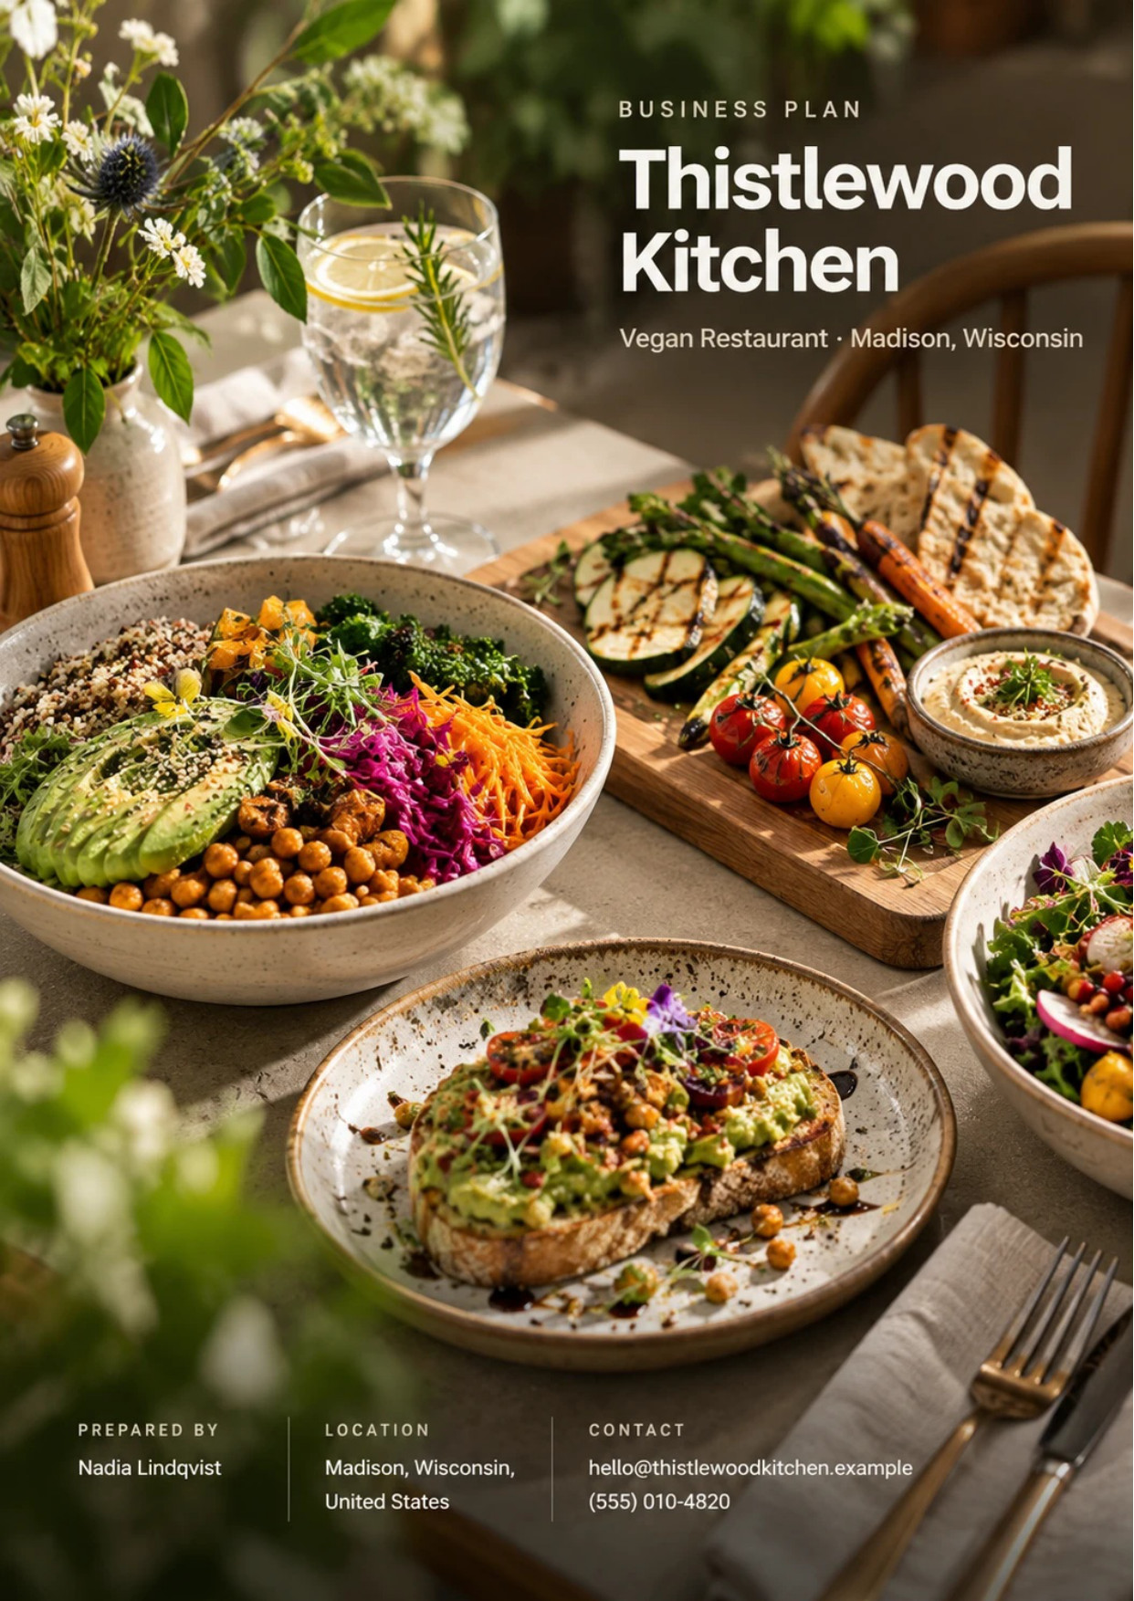
Table of Contents
1. Executive Summary 6
1.1 Business Overview 7
1.2 Mission Statement 7
1.3 Location & Market Opportunity 7
1.4 Unique Selling Points 7
1.5 Financial Highlights 8
1.6 Funding Requirement 8
1.6.1 Income Statement (3 Year projections) 8
2. Company Overview 9
2.1 Legal Structure 10
2.2 Vision Statement 10
2.3 Background & History 10
2.4 Future Goals 10
2.4.1 Business Owners 11
2.4.2 SMART Goal 11
3. Market Analysis 12
3.1 Overview 13
3.2 Market Segmentation 13
3.3 Market Trends 13
3.4 Local Market Outlook 13
3.5 Market Size 14
4. Customer Analysis 15
4.1 Target Market 16
4.2 Customer Segments 16
4.3 Customer Persona 17
4.4 Customer Purchase Journey 17
5. Competitive Analysis 18
5.1 Competitors 19
5.2 Comparison 19
5.3 Competitive Edge 20
5.4 SWOT Analysis 21
6. Sample Menu 22
6.1 Our Offering 23
6.2 Signature Items 23
6.3 Additional Services 23
6.4 What Sets Us Apart 23
6.5 Seasonal Menu Development 24
6.5.1 Seasonal Plates and Grain Bowls 24
6.5.2 Features 25
6.5.3 Pricing 25
7. Marketing & Sales Strategies 26
7.1 Market Positioning 27
7.2 Marketing Objectives 27
7.3 Online Marketing 27
7.4 Public Relations and Branding 28
7.5 Partnership & Collaboration Strategy 28
7.6 Customer Loyalty & Retention 28
7.7 Sales Channels 28
8. Operations Plan 29
8.1 Daily Operations 30
8.2 Working Hours 30
8.3 Staffing & Training 30
8.4 Supply Chain Management 30
8.5 Inventory & Equipment Management 30
8.6 Location and Facilities 31
8.7 Milestones & Timeline 31
8.8 Food Safety & Allergen Control 32
9. Management Team 33
9.1 Key Members 34
9.2 Organization Chart 34
9.3 Advisory Board Members 35
9.3.1 Hiring Plan 35
10. Financial Plan 36
10.1 Key Assumptions 37
10.2 Capital Requirements and Use of Funds 37
10.2.1 Use of Funds 38
10.3 Income Statement (3 Year projections) 39
10.4 Balance Sheet (3 Year projections) 40
10.5 Cash Flow Statement (3 Year projections) 41
10.6 Break Even Analysis 42
11. References 43


CHAPTER 1

Executive Summary

1.1 Business Overview
1.2 Mission Statement
1.3 Location & Market Opportunity
1.4 Unique Selling Points
1.5 Financial Highlights
1.6 Funding Requirement

1.1 Business Overview
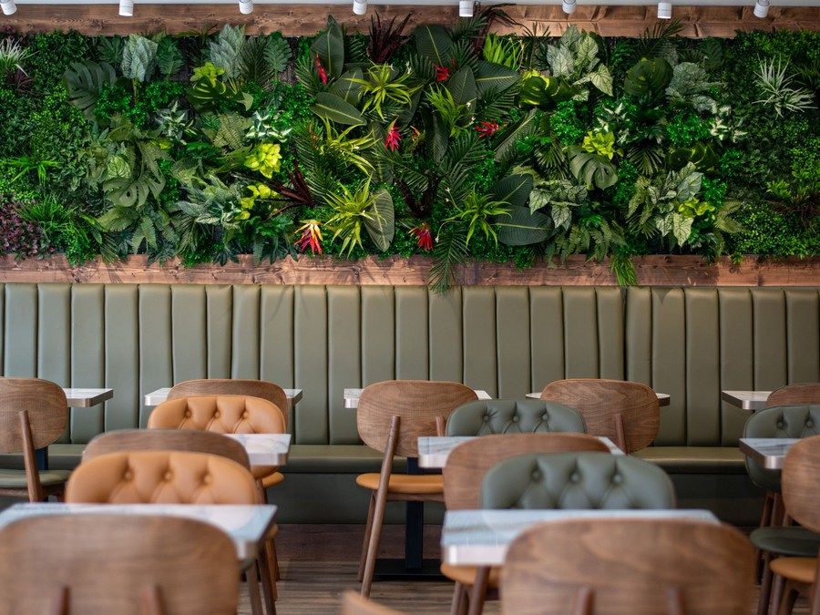
Thistlewood Kitchen is an independent, fully plant-based restaurant opening in April 2027 on Williamson Street, on Madison's near east side. It seats 62 diners, 48 at tables and 14 at the bar, and serves lunch Tuesday to Friday, dinner Tuesday to Sunday and brunch on weekends, with takeout, delivery and catering from the same kitchen.
The menu is built on Dane County produce and on tempeh, seitan and cashew cheeses made in house, with a bar pouring cocktails, Wisconsin craft beer and natural wine. It is written for vegans, for the larger group of flexitarians cutting back on meat, and for mixed tables where everyone needs to eat well.

1.2 Mission Statement
To cook plant-based food good enough that nobody at the table thinks of it as a compromise, made from what Dane County grows and served with the care of a full-service dining room.

1.3 Location & Market Opportunity
Madison ranks ninth of 100 US cities for vegans and vegetarians in a 2026 ranking, and its east side draws on a well-educated, young population: the city's median age is 31.7, and UW-Madison adds 51,822 students and 28,017 faculty and staff. Dane County's 588,347 residents have a median household income of $90,999. Even so, since Jardin closed, no fully plant-based restaurant with table service and a full bar is listed in the city; the vegan choices left are counter-service spots and mainstream menus with a few vegan dishes.
US full-service restaurants took $400.0 billion in revenue in 2024. Dane County's 459 full-service restaurants make up a serviceable market of about $694.9 million a year, and one full-service restaurant takes about $1,513,961 a year on the national average, the obtainable share this plan is measured against.

1.4 Unique Selling Points
- A full-service vegan room: table service, a full bar and weekend brunch, which no fully vegan venue in Madison currently offers.
- Protein made in house: tempeh, seitan and cashew cheeses cooked in the kitchen rather than reheated from branded packs.
- A seasonal menu: dishes change four times a year with what Dane County growers harvest.
- Allergen labelling on every dish for soy, wheat, tree nuts, peanuts and sesame, the allergens a vegan kitchen relies on.
Together these make the restaurant a choice for an occasion rather than a diet: a dinner out with friends, a weekend brunch or a catered office lunch where every guest can order freely.

1.5 Financial Highlights
Thistlewood Kitchen projects revenue of $1,176,724 in Year 1, rising to $1,270,862 in Year 2 and $1,372,531 in Year 3, at a gross margin of 68.0% throughout. Net income grows from $42,049 to $60,474 and then $80,132 as the room fills and interest on the loan falls. Break-even revenue is $950,750, about 28,811 covers a year, which the first year clears while trade is still building. The plan was also tested against weaker and stronger trade: Year 3 net income falls to $33,474 in the conservative case and rises to $143,152 in the upside case.

1.6 Funding Requirement
The total startup cost is $550,600, covering the build-out of a former restaurant space, kitchen and bar equipment, furniture, licences, pre-opening training and launch marketing. The founders contribute $220,000 of their own capital and seek an SBA 7(a) loan of $400,000 over 10 years at 10.25%. Profits stay in the business while the loan is repaid.
The plan rests on two experienced restaurant operators, a menu no other Madison dining room serves at the table, and a city that already ranks among the most vegan-friendly in the country. The funding builds that room, and the room is aimed at the flexitarians and mixed tables who make up most of the demand.

1.6.1 Income Statement (3 Year projections)
 | Year 1 | Year 2 | Year 3 | Total
Revenue | $1,176,723.74 | $1,270,861.64 | $1,372,530.57 | $3,820,115.95
Cost of Sales | $376,551.60 | $406,675.72 | $439,209.78 | $1,222,437.10
Gross Margin | $800,172.14 | $864,185.92 | $933,320.79 | $2,597,678.85
Operating Expense | $646,510.16 | $687,478.98 | $731,725.31 | $2,065,714.45
Total Expense | $1,134,674.29 | $1,210,387.97 | $1,292,398.19 | $3,637,460.45
Net Income | $42,049.45 | $60,473.67 | $80,132.38 | $182,655.50

CHAPTER 2

Company Overview

2.1 Legal Structure
2.2 Vision Statement
2.3 Background & History
2.4 Future Goals

2.1 Legal Structure
Thistlewood Kitchen LLC is a Wisconsin limited liability company owned by its two founders, Nadia Lindqvist and Caleb Okafor, and elects to be taxed as a corporation. The company holds the lease, the retail food licence from Public Health Madison & Dane County and the Class B liquor and beer licence from the City of Madison, and it employs every member of staff directly.
The operating agreement divides the work along the lines of the trade. Nadia runs the kitchen, the menu and purchasing; Caleb runs the dining room, the bar, hiring and the books.

2.2 Vision Statement
To be the restaurant Madison names first when a table of friends with different diets needs one place to eat, and to show that a plant-based dining room built on local produce can run as a sound business for the long term.

2.3 Background & History
Thistlewood Kitchen is a planned business and has not yet traded. The idea comes from the founders' own experience on both sides of the pass. Nadia spent twelve years cooking in Midwest restaurants, the last five running a seasonal farm-to-table kitchen, and watched vegan guests order three side dishes while the rest of the table ordered dinner. Caleb managed front of house and the bar for a 90-seat restaurant and saw the same tables choose somewhere else entirely because one guest could not eat there.
Madison gave them a reason to act: the city's one fully plant-based restaurant with table service and a full bar, Jardin, has closed. The founders spent 2026 testing dishes at pop-up dinners and settled on a former restaurant space on Williamson Street, where the existing hood, grease trap and plumbing reduce the cost of the build-out.

2.4 Future Goals
In the first 0 to 18 months, the goal is to open in April 2027, reach steady trade by January 2028, launch catering in June 2027 and build a base of regulars who return at least monthly. The kitchen needs to hold food cost near 29% through its first full cycle of seasonal menus, and the floor needs to turn reviews and repeat visits into weekday covers.
Over 1 to 3 years, the projection carries revenue from $1,176,724 in Year 1 to $1,372,531 in Year 3 and net income from $42,049 to $80,132. In that period the restaurant aims to repay the SBA loan on schedule, sign standing catering accounts with offices and university departments, and add a Thursday tasting menu that keeps the dining room busy midweek.
Over 3 to 5 years, the founders intend to expand only from cash the restaurant earns, through a larger catering kitchen or a small counter selling the house-made tempeh, seitan and cashew cheeses to take home.

2.4.1 Business Owners
Nadia Lindqvist | Caleb Okafor

Total ownership: 100%
55% | Nadia Lindqvist  55,000 Shares
45% | Caleb Okafor  45,000 Shares

2.4.2 SMART Goal
  Specific  - Open a 62-seat plant-based restaurant with a bar on Williamson Street in Madison.  - Serve lunch Tuesday to Friday, dinner Tuesday to Sunday and weekend brunch.  - Build a catering trade with offices and event hosts across Dane County. |   Measurable  - Revenue of $1,176,724 in Year 1, rising to $1,372,531 in Year 3.  - An average check of $33 per cover across lunch, dinner and brunch.  - Break-even revenue of $950,750, about 28,811 covers a year. |   Achievable  - Both owners have run full-service kitchens and dining rooms before.  - The space is a former restaurant, so the hood, plumbing and grease trap are reused.  - Funding of $620,000 covers the $550,600 startup cost with cash left for the first months.
  Relevant  - Madison has no fully plant-based dining room with a full bar since Jardin closed.  - Flexitarians and diners avoiding dairy are a far larger group than vegans alone.  - The plan gives the owners a business built on the cooking they already know. |   Time-Based  - Lease signed in November 2026 and doors open in April 2027.  - Catering launches in June 2027, after the dining room has settled.  - Steady trade reached by January 2028, nine months after opening.

CHAPTER 3

Market Analysis

3.1 Overview
3.2 Market Segmentation
3.3 Market Trends
3.4 Local Market Outlook
3.5 Market Size

3.1 Overview
A vegan restaurant competes inside the full-service restaurant trade, which took $400.0 billion in US revenue in 2024 across 264,208 establishments. Growth has slowed to what menu prices add: restaurant prices are forecast to rise 3.5% in 2026, and 42% of operators said they were not profitable in 2025. The plant-based end of the trade is estimated at $43.2 billion for vegetarian and vegan restaurants in 2025, up 0.5% on the year, though that figure is a commercial estimate rather than a measured one.

3.2 Market Segmentation
The diners who choose a plant-based restaurant fall into three groups. Strict vegans and vegetarians are a small share of adults, 1% and 4% in the most recent national survey, but they visit often and bring others. Flexitarians are far larger: 60% of US households bought plant-based foods in 2025, and most of them still eat meat. The third group is the mixed table, where one guest avoids dairy, eggs or meat and the others simply want a good dinner.
By occasion, the market splits into dinner with drinks, weekend brunch, quick weekday lunch, and food eaten away from the table. Nearly 75% of US restaurant traffic is now off premises, so takeout, delivery and catering are a segment of their own rather than an afterthought.

3.3 Market Trends
- Meat analogues are losing ground: plant-based meat retail sales fell 10% in 2025, while whole-food plant dishes and plant-based milk kept growing, which favours a kitchen that makes its own proteins.
- Fully vegan restaurants are fewer: the national count fell to 1,509 as mainstream menus added vegan dishes, so the remaining rooms compete on cooking and occasion rather than on being vegan.
- Costs keep rising: fresh vegetable prices are forecast up 5.7% in 2026, which rewards close buying relationships with growers.
- Allergens matter more: sesame became the ninth major allergen in 2023, and vegan menus lean on soy, wheat, tree nuts and sesame.
- Protein is what diners look for: 23% of Americans followed a high-protein diet in 2025, and a menu built on tempeh, seitan and legumes answers that directly.

3.4 Local Market Outlook
Dane County had 459 private full-service restaurants in 2025, up from 425 in 2022, employing 11,238 people. Within Madison, plant-based supply is thin: HappyCow lists 95 restaurants with vegan options but only one fully vegan restaurant, The Walking Jerk, a counter-service spot, and three vegetarian ones. Jardin, the city's fully plant-based restaurant with table service and a vegan bar, has closed.
Demand rests on a city of 285,318 residents with a median age of 31.7, where 62.0% of adults hold a bachelor's degree or higher, and on a county of 590,375 that grew 4.9% from 2020 to 2025. Dane County visitors spent $450 million on food and beverage in 2024. Costs are local too: Madison retail space averaged $17.38 a square foot NNN in Q2 2026 with vacancy at 2.1%, restaurant cooks in the Madison metro averaged $18.82 an hour in May 2025, and meals carry 5.5% sales tax.
Licensing is set locally as well. Public Health Madison & Dane County charges a complex restaurant with sales of $1,000,001 to $5,000,000 a first-year total of $2,438.34, and the City of Madison charges $600 a year for a Class B liquor and beer licence, with six regular licences currently available.

3.5 Market Size
The total addressable market is the $400.0 billion US full-service restaurant trade in 2024. The serviceable market is about $694.9 million a year: Dane County's 459 full-service restaurants multiplied by the national average of about $1,513,961 per establishment. It covers the whole county and every full-service restaurant, not plant-based dining alone. The obtainable market is one restaurant's share, about $1,513,961 a year on the national average, against which Thistlewood Kitchen's Year 1 projection of $1,176,724 is set.
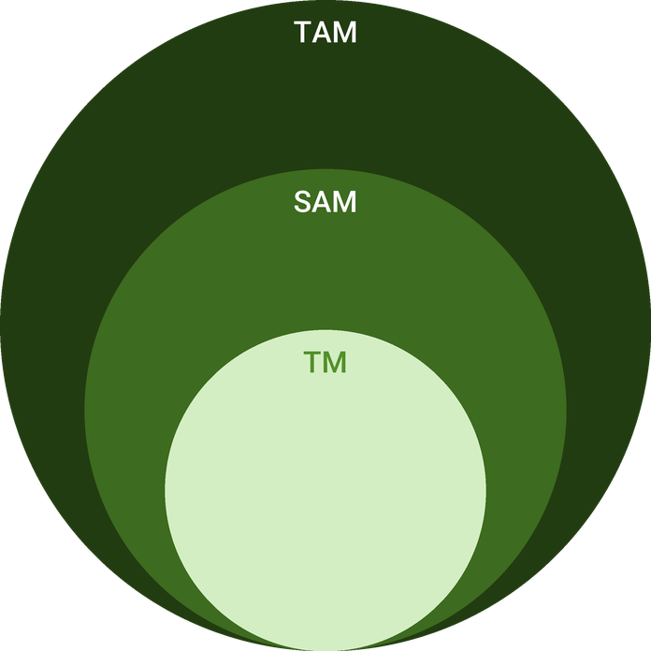
  ● | Total Available Market (TAM)  US full-service restaurants (NAICS 722511) took $400.0 billion in revenue in 2024 (Census Bureau Annual Integrated Economic Survey, employer firms), up 1.8% from $393.0 billion in 2023. | 400.0B
  ● | Served Available Market (SAM)  The Dane County full-service restaurant market is about $694.9 million a year: 459 private full-service restaurant establishments (2025) x about $1,513,961 national revenue per establishment (2024). | 694.9M
  ● | Target Market (TM)  One full-service restaurant takes about $1,513,961 a year, the 2024 national average revenue per establishment ($400.0 billion across 264,208 establishments); a national figure, not a Madison one. | 1.5M

CHAPTER 4

Customer Analysis

4.1 Target Market
4.2 Customer Segments
4.3 Customer Persona
4.4 Customer Purchase Journey

4.1 Target Market
Thistlewood Kitchen sells to adults aged roughly 25 to 55 who live, work or study within a short drive of Madison's near east side, and to the visitors who eat out while they are in town. Madison's median age is 31.7, its median household income is $79,254, and 62.0% of its adults hold a bachelor's degree or higher, a profile that eats out often and tries new places.
The restaurant is not aimed at vegans alone. Only 1% of US adults call themselves vegan, while 60% of households bought plant-based foods in 2025. The target is the much larger group that eats plant-based some of the time, and the tables where at least one guest needs a meal free of meat, dairy or eggs.
The catchment changes with the meal. Weekday lunch draws people working and studying within a few minutes of the restaurant, dinner draws residents from across the east side and the isthmus, and weekend brunch pulls from the whole city and from visitors staying the weekend.

4.2 Customer Segments
- Flexitarian professionals: residents in their late 20s to 40s who eat meat but cook vegetarian at home; they book dinner and brunch and order takeout on busy weeknights.
- Vegans and vegetarians: a smaller, loyal group who visit often, bring friends and judge the kitchen on whether its proteins are cooked with care.
- Mixed groups and families: tables where one guest is vegan or avoids dairy, nuts or eggs; they choose the restaurant so nobody has to settle.
- University staff and graduate students: UW-Madison's 28,017 faculty and staff and its graduate students, who come for weekday lunch and order catering for departments.
- Visitors: Dane County drew 9.2 million visitors in 2024, and a vegan-friendly reputation brings some of them across town for dinner.
Flexitarian professionals and mixed groups carry most of the revenue, because they book dinner with drinks at the highest check. Vegans and vegetarians fill quieter weeknights and bring new guests with them, while university staff and visitors shape weekday lunch and weekend brunch.
Each segment also buys differently. Flexitarians and mixed groups book ahead for weekend dinner and brunch, vegans and vegetarians walk in on weeknights and try each new menu early, university staff order lunch and catering on department accounts, and visitors find the restaurant through search and listings in the days before they arrive.

4.3 Customer Persona
  Mariela, the Flexitarian Regular  Demographics  Age: 34  Status: Partnered  Location: East side, Madison  Income: $82,000  Professional Role  Education: Master's degree  Job: Research coordinator at UW-Madison | “I want one place where my vegan friend, my partner and I all order what we actually want.”
   | Identifiers / Personality Traits  - Eats meat a few times a week and cooks vegetarian at home  - Books a table for friends with mixed diets about twice a month  - Finds restaurants on Instagram and through friends' recommendations
   | Goals  - A dinner spot where nobody at the table has to settle  - Food that feels like a night out, not a health choice  - A brunch worth returning to on weekends
   | Challenges  - Vegan options at most restaurants are a single salad or bowl  - Counter-service vegan places do not suit a night out  - Unclear allergen information when friends have dairy or nut allergies

4.4 Customer Purchase Journey
Most first visits start with a recommendation or a photograph. A diner sees a dish on Instagram, hears about the restaurant from a friend, or searches for vegan dinner in Madison and finds it on HappyCow or Google. Before booking, they read the menu online, check prices against the occasion and, for a mixed group, confirm that the allergen labelling covers what their friends avoid.
The decision is made at the table. A first dinner has to show that the food stands on its own, that the bar is a real bar and that the staff can answer allergen questions without hesitation. A good first visit leads to a second occasion, usually brunch or takeout, and the loyalty program and monthly menu email turn that into a habit. Catering customers follow a separate path: a tasting tray sent to an office, a quote, and then a standing order for meetings and events.
A guest is most at risk between the first and second visit. Slow service, a dish that changes without notice or an allergen question answered vaguely is enough to send a mixed table back to a familiar mainstream restaurant, so the restaurant tracks repeat visits through the loyalty program and follows up on every review that mentions a problem.

CHAPTER 5

Competitive Analysis

5.1 Competitors
5.2 Comparison
5.3 Competitive Edge
5.4 SWOT Analysis

5.1 Competitors
Madison's plant-based dining falls into three groups, and none of them offers what Thistlewood Kitchen does. Fully vegan and vegetarian venues are few and mostly counter service: The Walking Jerk serves vegan Caribbean food from a counter on South Park Street, The Green Owl Cafe on Atwood Avenue is the longest-running vegetarian menu, and Mother Fool's Coffeehouse, Juicy Organics, Level 5 Donuts and BeneBlends sell coffee, bowls, smoothies and baked goods. The one venue that combined a vegan menu with table service and a bar, Jardin on East Washington Avenue, is no longer open.
The larger competitive set is mainstream full-service restaurants with vegan menus or marked vegan dishes, such as Monty's Blue Plate Diner, Bar Corallini and Osteria Novella. They are where a mixed group goes today, and they win on familiarity and range. Below them sit chains and counter concepts with vegan options, including Chipotle and Bartaco, which compete on speed and price for weekday lunch and takeout.
No source reports sales for any of these businesses, and none is assumed here. What the comparison shows is a gap in format: a fully plant-based menu served at the table with a full bar and brunch is not currently on offer in the city.
For takeout and delivery the field is wider. Every restaurant on the delivery apps with a vegan bowl or burrito competes for the same weeknight order, which is why the restaurant treats off-premises sales as an addition to the dining room rather than the core of the business, and prices them at the same menu price as dishes eaten at the table.

5.2 Comparison
Thistlewood Kitchen matches the mainstream restaurants on table service, the bar and brunch, and matches the vegan counter spots on a fully plant-based menu. The capabilities it holds alone are the combination of the two and an allergen-controlled kitchen, which neither group runs as a routine. Catering is open to every group and is where competition is most even.
Price is not where the restaurant competes. Average checks of $19 at lunch, $26 at brunch and $38 at dinner sit with the mainstream full-service restaurants and above the counter spots, so the case for choosing it rests on the food, the bar and the evening.
Feature | Thistlewood Kitchen | Vegan counter spots | Mainstream restaurants with vegan menus | National chains
Fully plant-based menu | ✓ | ✓ | ✗ | ✗
Table service at dinner | ✓ | ✗ | ✓ | ✗
Full bar with cocktails | ✓ | ✗ | ✓ | ✗
Weekend brunch | ✓ | ✗ | ✓ | ✗
Allergen-controlled kitchen | ✓ | ✗ | ✗ | ✗
Catering for offices and events | ✓ | ✓ | ✓ | ✓

5.3 Competitive Edge
The edge is the format rather than the ingredient list. A mainstream restaurant can add a vegan bowl in a week; it cannot easily rebuild its kitchen around house-made tempeh, seitan and cashew cheeses, or train its floor to answer allergen questions for soy, tree nuts and sesame on every dish. A counter-service vegan spot can match the food but not the evening: the table, the bar and the brunch sitting.
The position is also defensible on cost. With beef and veal prices forecast up 9.4% in 2026 and fresh vegetables up 5.7%, a menu built on vegetables and legumes bought directly from growers carries less exposure to the fastest-rising protein line than an omnivore kitchen does.
The edge has limits. A mainstream restaurant with a strong vegan menu remains the likeliest alternative for a mixed table, and it starts with regulars and reviews Thistlewood Kitchen does not yet have. The answer is consistency and range: enough dishes that a guest who eats meat does not feel short of choice, cooked the same way every time.
Catering gives the edge a second outlet. An office ordering lunch for a group that includes vegans, people avoiding dairy and people with nut allergies needs one supplier that can label every tray, and few Madison caterers build their whole menu around that need.
   | The only full-service vegan room  With Jardin closed, no fully plant-based restaurant with table service and a full bar is listed in Madison, so dinner and brunch have no direct equal.
   | One menu for a mixed table  Every dish works for the vegan, the flexitarian and the diner avoiding dairy or eggs, so a group does not have to negotiate where to eat.
   | Protein made in house  Tempeh, seitan and cashew cheeses are made in the kitchen, which keeps the menu distinct from chains reheating branded meat analogues.
   | Dane County produce  Buying from growers within the county lets the menu change with the season and gives the room a story local press and diners repeat.
 | Allergen control as routine  Every dish is labelled for soy, wheat, tree nuts, peanuts and sesame, and staff are trained to answer allergen questions at the table.

5.4 SWOT Analysis
Strengths  - Madison's only fully plant-based, full-service restaurant with a bar since Jardin closed.  - House-made tempeh, seitan and cashew cheeses give the menu dishes no chain can copy.  - A chef-owner and a general manager who both come from full-service restaurant kitchens and floors.  - Weekend brunch and catering add sales outside the dinner service. | Weaknesses  - A new name with no reviews, regulars or catering accounts on the day it opens.  - Only 1% of US adults are vegan, so the room depends on flexitarians choosing it again.  - A 62-seat room limits how far dinner sales can grow before a second sitting is full.  - An SBA loan of $400,000 adds interest of $41,000 in Year 1.
Opportunities  - Madison ranks ninth of 100 US cities for vegans and vegetarians in WalletHub's 2026 list.  - UW-Madison's 51,822 students and 28,017 staff sit within a short trip of the east side.  - Visitors to Dane County spent $450 million on food and drink in 2024, a market for weekend brunch.  - Office and event catering for mixed dietary groups is underserved by counter-service vegan spots. | Threats  - Mainstream restaurants keep adding vegan dishes, giving flexitarians a reason not to switch.  - Fresh vegetable prices are forecast to rise 5.7% in 2026.  - The all-vegan restaurant count fell to 1,509 nationally as closures rose.  - Madison cook wages average $18.82 an hour, well above the state minimum.

 Strategic Summary
Thistlewood Kitchen should sell itself as the place a mixed table can agree on, not as a restaurant for vegans alone. Brunch, catering and the bar must carry enough trade to fill the weeknights a new dining room finds hardest.

CHAPTER 6

Sample Menu

6.1 Our Offering
6.2 Signature Items
6.3 Additional Services
6.4 What Sets Us Apart
6.5 Seasonal Menu Development

6.1 Our Offering
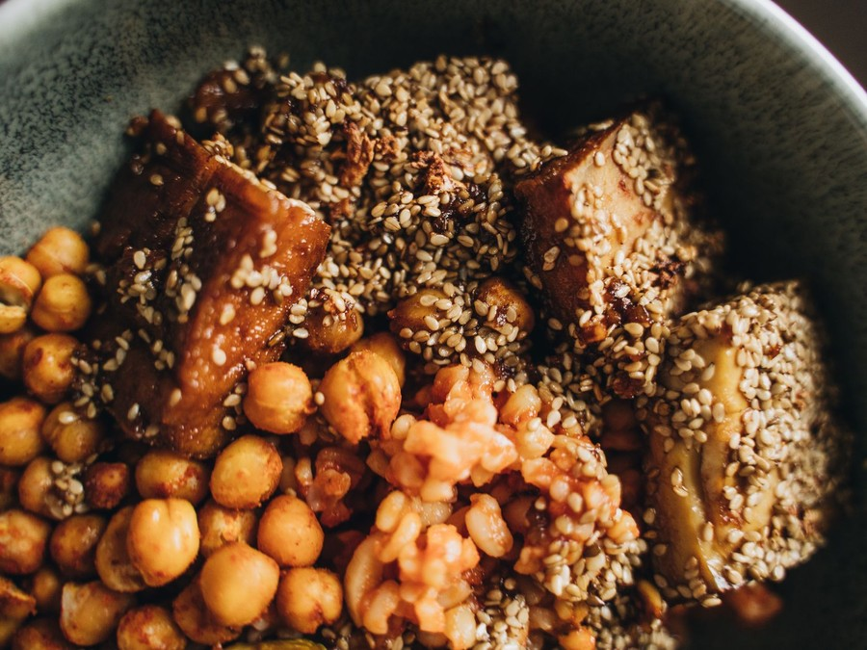
Thistlewood Kitchen sells one thing in several settings: plant-based food cooked from scratch and served at the table. Dinner, Tuesday to Sunday, is the heart of the menu, with shared plates, mains, grain bowls and desserts. Weekday lunch serves bowls, sandwiches and soup at a quicker pace, and weekend brunch adds tofu scramble, buckwheat pancakes and savoury plates. The bar pours cocktails, Wisconsin craft beer and natural wine, and every dish can be ordered for takeout or delivery.

6.2 Signature Items
- Maple-glazed tempeh with sweet potato mash and charred greens, the dish the kitchen is built around.
- Seitan schnitzel with herbed spaetzle and braised red cabbage, a nod to Wisconsin's German kitchens.
- Fried cashew-cheese curds with dill ranch, a plant-based answer to the state's best-known snack.
- Harvest grain bowl with quinoa, black beans, roasted corn, salsa, avocado and smoked jackfruit.
- Wild mushroom and white bean cassoulet with a toasted breadcrumb crust in the colder months.
- Oat-milk custard tart with seasonal fruit, and a buckwheat pancake stack with maple and berries at brunch.

6.3 Additional Services
Catering is the main service sold alongside the dining room. Trays of bowls, salads and shared plates are packed for offices, university departments and events of 10 to 60 guests, booked ahead and invoiced. The restaurant also hosts private dinners for up to 24 guests on Mondays, when it is closed to the public, and runs a seasonal tasting menu on Thursday evenings. Takeout and delivery use compostable packaging chosen so that bowls and fried dishes travel without going soft.

6.4 What Sets Us Apart
Most vegan dishes in Madison are a single bowl on a mainstream menu or a counter-service order. Thistlewood Kitchen makes its proteins in house each week, labels every dish for soy, wheat, tree nuts, peanuts and sesame, and serves the full evening a dinner out promises, from cocktail to dessert. The menu is written so that a guest who eats meat orders from it as readily as a vegan does, which is what makes it work for a mixed table.
The bar is part of the offer, not an extra. Cocktails are built on Wisconsin spirits and house syrups, the beer list rotates with local breweries, and the wine list leans on low-intervention producers, so a dinner check carries a drink as often as it would anywhere else.

6.5 Seasonal Menu Development
The menu changes four times a year, timed to what Dane County growers harvest. Each change starts six weeks ahead: Nadia and Rosa agree the vegetables with growers, develop dishes in the test kitchen on Mondays, cost each plate against a food cost target near 29%, and taste the final menu with front-of-house staff before it goes live. Spring leans on greens, ramps and asparagus, summer on tomatoes, sweet corn and squash, autumn on roots and mushrooms, and winter on stored roots, dried beans and preserves put up in the summer.
Proteins are the constant. The kitchen makes tempeh on a weekly culture cycle, seitan in batches twice a week and cashew cheeses that age for up to ten days, so each menu change rebuilds the vegetables around a stable set of house proteins. A dish stays only if it holds its margin and sells at least as well as the one it replaced.

6.5.1 Seasonal Plates and Grain Bowls
The core of the menu: shared plates, mains and grain bowls built on Dane County vegetables and on tempeh, seitan and cashew cheeses made in the kitchen. The menu changes with the growing season, and every dish is fully plant-based and labelled for allergens.
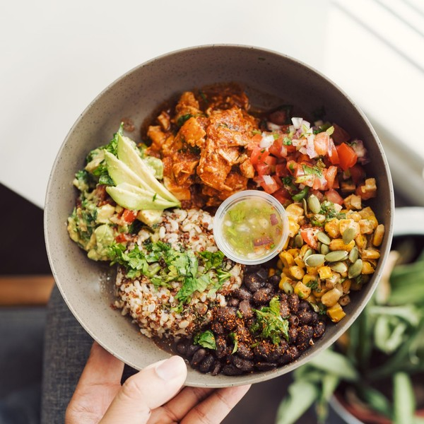 | $15 to $26 per plate  Grain bowls run $15 to $17 and mains $18 to $26, with shared plates from $9; a dinner check with a drink averages about $38 a guest and lunch about $19. Prices are set per plate and charged at the table, or online for takeout and delivery at the same menu price. A dish costs more when it carries more house-made protein or out-of-season produce, and less at lunch, when portions are smaller. Most tables add a cocktail, beer or glass of wine, and many share a dessert.

Specifications
- Every dish is fully plant-based, with no animal products in the kitchen.
- Tempeh, seitan and cashew cheeses are made in house each week.
- The menu changes four times a year with the Dane County growing season.
- Each dish is labelled for soy, wheat, tree nuts, peanuts and sesame.
- Available for dine-in, takeout, delivery and catering.

6.5.2 Features
  Seasonal Menu
  Shared plates, mains and bowls that change four times a year with what Dane County growers harvest.
  House-Made Proteins
  Tempeh, seitan and cashew cheeses made in the kitchen each week rather than bought as branded analogues.
  Full Bar
  Cocktails, Wisconsin craft beer and natural wine poured at a 14-seat bar and at the table.
  Weekend Brunch
  Tofu scramble, buckwheat pancakes and savoury plates served Saturday and Sunday mornings.
   | Allergen Labelling  Every dish marked for soy, wheat, tree nuts, peanuts and sesame, with staff trained to answer questions.
   | Catering Trays  Bowls, salads and shared plates packed for offices and events of 10 to 60 guests.

6.5.3 Pricing
Weekday Lunch  $19  average check per guest  - Grain bowls, sandwiches and a soup of the day  - Tuesday to Friday, 11 a.m. to 2:30 p.m.  - Takeout and delivery from the same menu |  | Most Popular  Weekend Brunch  $26  average check per guest  - Tofu scramble, buckwheat pancakes and savoury plates  - Saturday and Sunday, 9 a.m. to 2 p.m.  - Coffee, fresh juice and brunch cocktails  - Reservations for groups of six or more |  | Dinner  $38  average check per guest  - Shared plates, mains and desserts  - Cocktails, Wisconsin craft beer and natural wine  - Tuesday to Sunday from 5 p.m.  - Seasonal tasting menu on Thursdays

CHAPTER 7

Marketing & Sales Strategies

7.1 Market Positioning
7.2 Marketing Objectives
7.3 Online Marketing
7.4 Public Relations and Branding
7.5 Partnership & Collaboration Strategy
7.6 Customer Loyalty & Retention
7.7 Sales Channels

7.1 Market Positioning
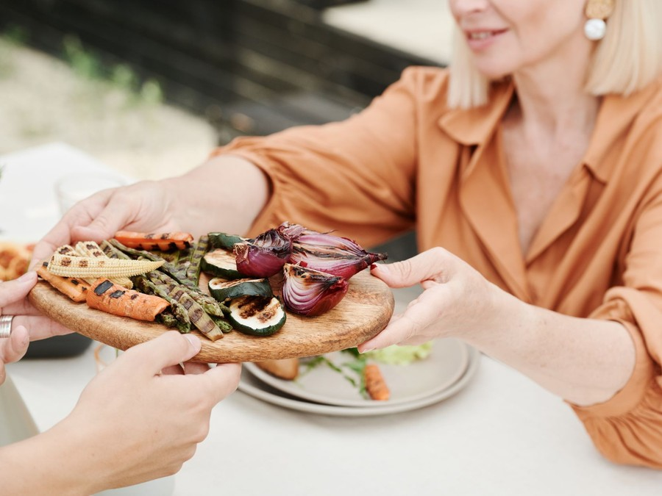
Thistlewood Kitchen is positioned as the place a mixed table can agree on: a full-service restaurant with a bar where the food happens to be plant-based, not a restaurant for vegans alone. That position follows from the gap the competitive picture shows, and it sets the tone of everything below.

7.2 Marketing Objectives
- Fill the dining room on weeknights within the nine-month ramp to steady trade.
- Turn first visits into regulars, with a growing share of covers from the loyalty program.
- Sign standing catering accounts with offices and university departments in the first year.
- Hold marketing spend at 2.5% of revenue once launch marketing is spent.
Instagram and Local Social  $859  per month  Dish photography, short videos and paid posts aimed at east side and campus neighbourhoods. |  | Loyalty and Email  $490  per month  The loyalty program, a monthly menu email and birthday offers that bring regulars back.
Community Events  $613  per month  Farm dinners, pop-ups at markets and tastings with neighbourhood groups and festivals. |  | Catering Outreach  $490  per month  Sample trays and menus delivered to offices, departments and event planners.

Total marketing budget: $29,418 a year, $2,452 a month.

7.3 Online Marketing
Instagram carries most of the online effort, because diners choose restaurants from photographs and the menu changes four times a year. The restaurant posts dishes, the kitchen's tempeh and seitan work, and growers' deliveries, with paid posts aimed at the east side and campus neighbourhoods. Its listings on Google, HappyCow and the reservation platform are kept current with the menu, hours and allergen information.

7.4 Public Relations and Branding
The brand is warm and plain-spoken, led by the food rather than by the word vegan. Before opening, the founders invite Madison's food writers and the hosts of local food podcasts to preview dinners, and each seasonal menu change gives the press a new story.

7.5 Partnership & Collaboration Strategy
Partnerships are built where the restaurant buys and where its diners gather. Dane County growers are credited by name on the menu and invited to host farm dinners in the dining room. The bar features Wisconsin breweries and distilleries in rotating collaborations, and the catering team works with university departments, local employers and event venues looking for food every guest can eat.

7.6 Customer Loyalty & Retention
In a restaurant, a regular is made by the second visit, so retention starts with consistency: the same dish cooked the same way, and staff who remember a guest's allergies. A points-based loyalty program rewards visits across dinner, brunch and takeout, a monthly email announces each new menu before it launches, and regulars get first booking for the Thursday tasting menus and farm dinners.

7.7 Sales Channels
The dining room carries most of the revenue; the model adds 16% on top for takeout, delivery and catering, which bring sales without needing a seat.
  Dinner Service
  Table service Tuesday to Sunday carries most of the revenue and the highest checks, and depends on reservations and repeat regulars.
  Weekend Brunch
  Two busy sittings on Saturday and Sunday fill the room at a lower check and bring in diners who later return for dinner.
  Weekday Lunch
  Tuesday to Friday lunch sells bowls and sandwiches to people working and studying nearby, and depends on speed at the table.
   | Takeout and Delivery  Orders placed online or through delivery apps add sales without using a seat, and depend on packaging that keeps food at its best.
Catering
Trays for offices, university departments and events are booked ahead and invoiced, and depend on a few repeat accounts.

CHAPTER 8

Operations Plan

8.1 Daily Operations
8.2 Working Hours
8.3 Staffing & Training
8.4 Supply Chain Management
8.5 Inventory & Equipment Management
8.6 Location and Facilities
8.7 Milestones & Timeline
8.8 Food Safety & Allergen Control

8.1 Daily Operations
The day starts at 8 a.m. with deliveries and prep: Rosa checks produce against orders, the kitchen starts the day's sauces and stocks, and the tempeh and seitan schedule runs alongside service prep. Lunch service runs Tuesday to Friday, followed by a reset and a second prep block before dinner. Caleb runs a pre-shift meeting before each service covering the specials, allergen notes and reservations. After close, the kitchen breaks down, the bar counts its stock, and the closing manager reconciles sales in the POS.

8.2 Working Hours
Lunch runs Tuesday to Friday, 11 a.m. to 2:30 p.m., for people working and studying nearby. Dinner runs Tuesday to Sunday from 5 p.m. until 9:30 p.m., and until 10:30 p.m. on Friday and Saturday. Weekend brunch runs Saturday and Sunday, 9 a.m. to 2 p.m., replacing lunch on those days. The restaurant closes on Mondays, the quietest night in the trade, and uses the day for menu development, deep cleaning and private events. These hours give 307 trading days a year.

8.3 Staffing & Training
At steady trade the restaurant employs 22 people: the two co-owners, a kitchen of 8 under the sous chef, a front of house of 9, and 3 at the bar under the bar manager. Many front-of-house and bar roles are part-time, built around the lunch, dinner and brunch peaks. Every hire trains for two weeks before opening on the menu, allergen procedures and service standards, and each seasonal menu change brings a staff tasting and a written briefing.

8.4 Supply Chain Management
Produce comes directly from a small group of Dane County growers, ordered weekly against the season's menu, with a regional distributor covering dry goods, oils, legumes and out-of-season staples. Soybeans for tempeh, vital wheat gluten for seitan and cashews are bought in bulk under standing orders, since they are the kitchen's protein base. The bar buys from Wisconsin breweries and distributors. Suppliers are paid on terms of about 21 days, and every key ingredient has a second supplier named in advance so a missed delivery does not take a dish off the menu.

8.5 Inventory & Equipment Management
Inventory turns quickly: produce lasts days, while dry goods, oils and the bar stock last a few weeks. The kitchen counts weekly and the bar counts after each service, and both counts feed food and beverage cost reports reviewed every Monday. The main equipment is a range, combi oven, fryer, walk-in cooler and dish machine under an existing hood, plus a temperature-controlled cabinet for culturing tempeh and aging cashew cheeses. Equipment is serviced on a fixed schedule to avoid losing a service to a breakdown.

8.6 Location and Facilities
The restaurant leases about 3,600 square feet on Williamson Street, a former restaurant space with an existing hood, grease trap and plumbing that cut the build-out cost. Rent is $7,200 a month all in. The space holds a dining room of 48 seats, a 14-seat bar, an open view of the pass and a small dry storage room. A sidewalk patio, licensed by the city at $3.00 a square foot, adds seats from late spring to early autumn.

8.7 Milestones & Timeline
Nov 2026  Setup |  |  | Lease signed  Former restaurant space on Williamson Street.  A ten-year lease on about 3,600 square feet with an existing hood, grease trap and plumbing.
Jan 2027  Setup |  |  | Build-out and plan review  Kitchen, bar and dining room fitted out.  Public Health Madison & Dane County reviews the plans while the kitchen and bar equipment are installed.
Feb 2027  Licensing |  |  | Alcohol licence hearing  Class B liquor and beer licence.  The application goes through the Alcohol License Review Committee and the Common Council after a neighbourhood information session.
Mar 2027  Hiring |  |  | Team hired and trained  Kitchen, floor and bar staff in place.  Seventeen new hires train for two weeks on the menu, allergen procedures and service before friends and family previews.
Apr 2027  Launch |  |  | Doors open  Lunch, dinner and weekend brunch.  The dining room opens after the food licence pre-inspection, with takeout and delivery from the first week.
Jun 2027  Growth |  |  | Catering and patio  Second revenue line and summer seating.  Catering trays launch for offices and events, and the sidewalk patio opens for the summer season.

8.8 Food Safety & Allergen Control
A vegan kitchen removes milk, eggs, fish and shellfish but depends on four of the nine major allergens: soy in tempeh and tofu, wheat in seitan and breads, tree nuts in cashew cheeses and creams, and sesame in dressings and crusts. Peanuts are kept to a short list of dishes. Every recipe carries an allergen card, the menu marks all five on every dish, and a written allergen notice is available to every diner, as the FDA Food Code recommends for unpackaged food.
Cross-contact is managed by process rather than by promise. Nut cheeses are made in a separate morning block with dedicated equipment, the fryer oil is kept free of nuts, and allergen orders are flagged on the ticket and plated by a named cook. Public Health Madison & Dane County inspects the restaurant each year under the Wisconsin Food Code, and the kitchen always has a certified food manager on duty. The restaurant does not claim to be allergen free and says so on the menu.
Training makes the regime hold on a busy night. Every new hire learns the allergen cards and the ticket flag before working a shift, servers are trained to check allergies when taking the order rather than at the end, and a laminated allergen matrix for the current menu sits at the pass and the bar. When the menu changes, the matrix is rebuilt from the recipes and checked by both Nadia and Rosa before the first service.
Cleaning and records run to a written schedule: cold holding temperatures are logged twice a day, the tempeh cabinet's temperature and humidity at every check, and surfaces used for nut cheeses are washed and sanitised before any other work starts there. If a guest reports a reaction, the manager on duty follows a written procedure, keeps the dish and its ticket, and reviews the case with the kitchen the next morning.

CHAPTER 9

Management Team

9.1 Key Members
9.2 Organization Chart
9.3 Advisory Board Members

9.1 Key Members
Nadia is accountable for the kitchen and is measured on food cost, which the plan holds near 29%, ticket times and inspection results. Caleb is accountable for the dining room, the bar and the books, and is measured on covers, average check, labour cost against the 33% of revenue the model allows, and the monthly accounts. Rosa answers for prep, the house protein schedule and allergen procedures on every shift; Owen answers for beverage cost and the bar's share of each check. Each of the four reviews their numbers weekly against the targets set at the start of each season, and the two co-owners review all four together every month.
 | Nadia Lindqvist  Executive Chef and Co-Owner · nadia@thistlewoodkitchen.example  Twelve years in Midwest restaurant kitchens, the last five as chef de cuisine of a seasonal farm-to-table dining room.

 | Caleb Okafor  General Manager and Co-Owner · caleb@thistlewoodkitchen.example  Ran front of house and the bar program for a 90-seat full-service restaurant, with responsibility for hiring, scheduling and the weekly P&L.

 | Rosa Delgado  Sous Chef · rosa@thistlewoodkitchen.example  Seven years on the line and in prep, including fermentation, house-made tempeh and allergen-controlled production for a catering kitchen.

 | Owen Prater  Bar Manager · owen@thistlewoodkitchen.example  Built a cocktail list around Wisconsin spirits and craft beer for a neighbourhood bar and holds a Wisconsin responsible beverage server certificate.

9.2 Organization Chart
The chart shows the two levels that run the restaurant. Below it, line cooks, prep cooks and dishwashers report to Rosa, servers and hosts report to Caleb, and bartenders report to Owen. The two co-owners meet weekly to review sales, costs and the coming week's staffing, and any decision over $10,000 needs both of them.
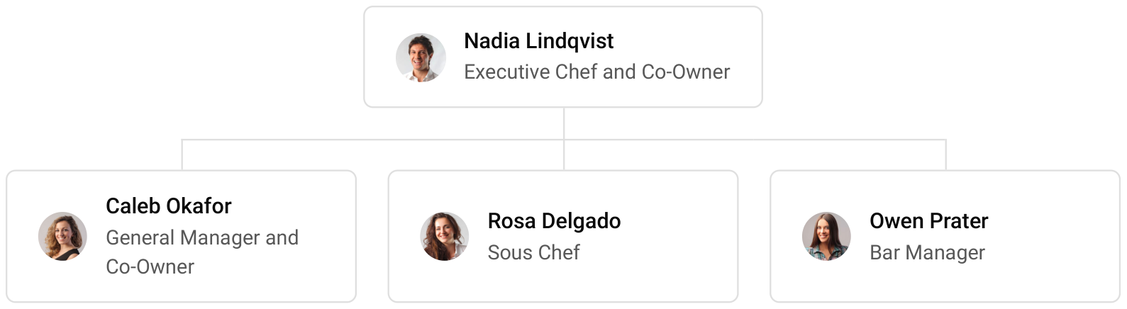

9.3 Advisory Board Members
The founders draw on three advisers. An accountant with restaurant clients reviews the monthly accounts and the loan covenants. A food safety consultant audits the allergen procedures twice a year. A Dane County grower who supplies the kitchen advises on crop planning, so each seasonal menu is set around what can actually be harvested. None holds equity or a formal role.

9.3.1 Hiring Plan
4  Filled |  | 17  Hiring This Year |  | 18  Open

Group By Department | Position Filled | Time of Hire | Time of Start | Filled
Ownership & Management | 2 of 2 | 0 days | 0 days | 100%
Kitchen | 1 of 8 | 45 days | 14 days | 12%
Front of House | 0 of 9 | 30 days | 14 days | 0%
Bar | 1 of 3 | 30 days | 14 days | 33%

CHAPTER 10

Financial Plan

10.1 Key Assumptions
10.2 Capital Requirements and Use of Funds
10.3 Income Statement (3 Year projections)
10.4 Balance Sheet (3 Year projections)
10.5 Cash Flow Statement (3 Year projections)
10.6 Break Even Analysis

10.1 Key Assumptions
Revenue is modelled as seats multiplied by table turns, average ticket and trading days, with takeout, delivery and catering on top. The room has 62 seats turning 1.9 times a day across lunch, dinner and brunch, at an average ticket of $33 per cover, over 307 trading days, and off-premises sales add 16%. Trade opens at 60% of its steady level and builds over 9 months, and revenue grows 8% a year after that, close to menu price inflation plus catering growth.
Gross margin is 68.0%, from food cost near 29% and beverage cost near 24%. Payroll is 33% of revenue, marketing 2.5% and other operating costs 8%. Rent is $7,200 a month, with $700 a month for technology and $3,300 for insurance, accounting and other administration. Startup assets are depreciated over 10 years, and tax is set at 27%.
On these assumptions revenue is $1,176,724 in Year 1, $1,270,862 in Year 2 and $1,372,531 in Year 3, and net income is $42,049, $60,474 and $80,132, a net margin rising from 3.6% to 5.8%. Break-even revenue is $950,750, about 28,811 covers a year. In the conservative scenario Year 3 net income is $33,474; in the upside scenario it is $143,152.
The projection is most sensitive to covers and the average ticket, since rent, technology and administration stay fixed as sales move. That is why the conservative and upside cases are built on table turns and check size. The gross margin of 68.0% is protected by repricing each seasonal menu rather than by holding prices for a year, and payroll is scheduled to covers, so a slow month cuts hours before it cuts margin.

10.2 Capital Requirements and Use of Funds
The total startup cost is $550,600. The largest lines are the build-out of the former restaurant space and the kitchen equipment and hood, followed by furniture and tableware, pre-opening staffing and training, professional fees, deposits and pre-opening rent, bar equipment, launch marketing, signage, the POS system, and licences and permits.
The founders contribute $220,000 and the company borrows $400,000 through an SBA 7(a) loan over 10 years at 10.25%. The $620,000 raised covers the startup cost and leaves cash to carry the restaurant through its ramp-up months. No outside equity is taken, and profits stay in the business while the loan is repaid.

10.2.1 Use of Funds
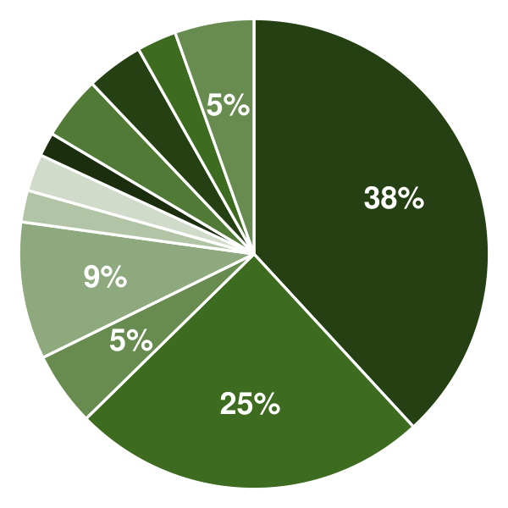 | ● Leasehold Improvements 38.1%  ● Kitchen Equipment and Hood 24.5%  ● Bar and Beverage Equipment 5.1%  ● Furniture, Fixtures and Tableware 9.4%  ● Point of Sale and Technology 2.2%  ● Signage and Branding 2.5%  ● Licenses, Permits and Plan Review 1.6%  ● Professional Fees 4.4%  ● Deposits and Pre-Opening Rent 3.9%  ● Launch Marketing 2.7%  ● Pre-Opening Staffing and Training 5.4%

Use Of Funds | Amount
Leasehold Improvements | $210,000.00
Kitchen Equipment and Hood | $135,000.00
Bar and Beverage Equipment | $28,000.00
Furniture, Fixtures and Tableware | $52,000.00
Point of Sale and Technology | $12,000.00
Signage and Branding | $14,000.00
Licenses, Permits and Plan Review | $9,000.00
Professional Fees | $24,000.00
Deposits and Pre-Opening Rent | $21,600.00
Launch Marketing | $15,000.00
Pre-Opening Staffing and Training | $30,000.00

10.3 Income Statement (3 Year projections)
 | Year 1 | Year 2 | Year 3 | Total
Revenue | $1,176,723.74 | $1,270,861.64 | $1,372,530.57 | $3,820,115.95
Cost of Sales | $376,551.60 | $406,675.72 | $439,209.78 | $1,222,437.10
General Costs | $0.00 | $0.00 | $0.00 | $0.00
Revenue Specific Costs | $263,586.12 | $284,673.00 | $307,446.85 | $855,705.97
Personnel Costs (Direct Labor) | $112,965.48 | $122,002.72 | $131,762.93 | $366,731.13
Gross Margin | $800,172.14 | $864,185.92 | $933,320.79 | $2,597,678.85
Gross Margin (%) | 68.00% | 68.00% | 68.00% | 68.00%
Operating Expense | $646,510.16 | $687,478.98 | $731,725.31 | $2,065,714.45
Payroll Expense (Indirect Labor) | $388,318.83 | $419,384.34 | $452,935.09 | $1,260,638.26
General Expense | $257,955.99 | $267,840.47 | $278,515.71 | $804,312.17
Bad Debt | $235.34 | $254.17 | $274.51 | $764.02
Amortization of Current Assets | $0.00 | $0.00 | $0.00 | $0.00
EBITDA | $153,661.98 | $176,706.94 | $201,595.48 | $531,964.40
Additional Expense | $111,612.53 | $116,233.27 | $121,463.10 | $349,308.90
Long Term Depreciation | $55,060.00 | $56,966.29 | $59,025.09 | $171,051.38
Gain or loss from Sale of Assets | $0.00 | $0.00 | $0.00 | $0.00
EBIT | $98,601.98 | $119,740.65 | $142,570.39 | $360,913.02
Interest Expense | $41,000.00 | $36,900.00 | $32,800.00 | $110,700.00
EBT | $57,601.98 | $82,840.65 | $109,770.39 | $250,213.02
Income Tax Expense / Benefit | $15,552.53 | $22,366.98 | $29,638.01 | $67,557.52
Total Expense | $1,134,674.29 | $1,210,387.97 | $1,292,398.19 | $3,637,460.45
Net Income | $42,049.45 | $60,473.67 | $80,132.38 | $182,655.50
Net Income (%) | 3.57% | 4.76% | 5.84% | 4.78%
Retained Earning Opening | $0.00 | $42,049.45 | $102,523.12
Owner's Distribution | $0.00 | $0.00 | $0.00 | $0.00
Retained Earning Closing | $42,049.45 | $102,523.12 | $182,655.50 | $182,655.50

10.4 Balance Sheet (3 Year projections)
 | Year 1 | Year 2 | Year 3 | Total
Assets | $647,602.19 | $671,512.64 | $715,334.60 | $715,334.60
Current Assets | $152,062.19 | $213,876.01 | $296,135.10 | $296,135.10
Cash | $136,453.78 | $197,658.93 | $279,260.66 | $279,260.66
Accounts Receivable | $386.87 | $417.82 | $451.24 | $451.24
Inventory | $7,221.54 | $7,799.26 | $8,423.20 | $8,423.20
Other Current Assets | $8,000.00 | $8,000.00 | $8,000.00 | $8,000.00
Long Term Assets | $495,540.00 | $457,636.63 | $419,199.50 | $419,199.50
Gross Long Term Assets | $550,600.00 | $569,662.92 | $590,250.88 | $590,250.88
Accumulated Depreciation | $55,060.00 | $112,026.29 | $171,051.38 | $171,051.38
Liabilities & Equity | $647,602.19 | $671,512.64 | $715,334.60 | $715,334.60
Liabilities | $385,552.74 | $348,989.52 | $312,679.10 | $312,679.10
Current Liabilities | $65,552.74 | $68,989.52 | $72,679.10 | $72,679.10
Accounts Payable | $21,664.61 | $23,397.78 | $25,269.60 | $25,269.60
Income Tax Payable | $3,888.13 | $5,591.74 | $7,409.50 | $7,409.50
Sales Tax Payable | $0.00 | $0.00 | $0.00 | $0.00
Short Term Debt | $40,000.00 | $40,000.00 | $40,000.00 | $40,000.00
Long Term Liabilities | $320,000.00 | $280,000.00 | $240,000.00 | $240,000.00
Long Term Debt | $320,000.00 | $280,000.00 | $240,000.00 | $240,000.00
Equity | $262,049.45 | $322,523.12 | $402,655.50 | $402,655.50
Paid-in Capital | $0.00 | $0.00 | $0.00 | $0.00
Common Stock | $0.00 | $0.00 | $0.00 | $0.00
Preferred Stock | $0.00 | $0.00 | $0.00 | $0.00
Owner's Contribution | $220,000.00 | $220,000.00 | $220,000.00 | $220,000.00
Retained Earnings | $42,049.45 | $102,523.12 | $182,655.50 | $182,655.50
Check | $0.00 | $0.00 | $0.00 | $0.00

10.5 Cash Flow Statement (3 Year projections)
 | Year 1 | Year 2 | Year 3 | Total
Cash Received | $1,240,821.34 | $1,340,473.91 | $1,447,711.82 | $4,029,007.07
Cash Paid | $1,133,767.56 | $1,220,205.84 | $1,305,522.13 | $3,659,495.53
COS & General Expenses | $515,099.04 | $551,358.02 | $584,714.68 | $1,651,171.74
Salary & Wages | $501,284.31 | $541,387.06 | $584,698.02 | $1,627,369.39
Interest | $41,000.00 | $36,900.00 | $32,800.00 | $110,700.00
Sales Tax | $64,719.81 | $69,897.39 | $75,489.18 | $210,106.38
Income Tax | $11,664.40 | $20,663.37 | $27,820.25 | $60,148.02
Net Cash From Operations | $107,053.78 | $120,268.07 | $142,189.69 | $369,511.54
Assets Sell | $0.00 | $0.00 | $0.00 | $0.00
Assets Purchase | $550,600.00 | $19,062.92 | $20,587.96 | $590,250.88
Net Cash From Investments | ($550,600.00) | ($19,062.92) | ($20,587.96) | ($590,250.88)
Amount Received | $620,000.00 | $0.00 | $0.00 | $620,000.00
Loan Received | $400,000.00 | $0.00 | $0.00 | $400,000.00
Common Stock | $0.00 | $0.00 | $0.00 | $0.00
Preferred Stock | $0.00 | $0.00 | $0.00 | $0.00
Owner's Contribution | $220,000.00 | $0.00 | $0.00 | $220,000.00
Amount Paid | $40,000.00 | $40,000.00 | $40,000.00 | $120,000.00
Loan Capital | $40,000.00 | $40,000.00 | $40,000.00 | $120,000.00
Dividends & Distributions | $0.00 | $0.00 | $0.00 | $0.00
Net Cash From Financing | $580,000.00 | ($40,000.00) | ($40,000.00) | $500,000.00
Summary
Starting Cash | $0.00 | $136,453.78 | $197,658.93
Cash In | $1,860,821.34 | $1,340,473.91 | $1,447,711.82 | $4,649,007.07
Cash Out | $1,724,367.56 | $1,279,268.76 | $1,366,110.09 | $4,369,746.41
Change in Cash | $136,453.78 | $61,205.15 | $81,601.73 | $279,260.66
Ending Cash | $136,453.78 | $197,658.93 | $279,260.66 | $279,260.66

10.6 Break Even Analysis
 | Year 1 | Year 2 | Year 3 | Total
Starting Revenue | $0.00 | $1,176,723.74 | $2,447,585.38 | $2,447,585.38
Net Revenue | $1,176,723.74 | $1,270,861.64 | $1,372,530.57 | $1,372,530.57
Closing Revenue | $1,176,723.74 | $2,447,585.38 | $3,820,115.95 | $3,820,115.95
Starting Expense | $0.00 | $1,134,674.29 | $2,345,062.26 | $2,345,062.26
Net Expense | $1,134,674.29 | $1,210,387.97 | $1,292,398.19 | $1,292,398.19
Closing Expense | $1,134,674.29 | $2,345,062.26 | $3,637,460.45 | $3,637,460.45
Is Break Even? | Yes | Yes | Yes
Break Even Month | Oct '26 | - | -
Days Required | 29 Days | - | -
Break Even Revenue | $945,993.60 | - | -

CHAPTER 11

References

- SRC001: Vegetarian & Vegan Restaurants in the US Market Size Statistics for 2026, IBISWorld, 2026-01-01. https://www.ibisworld.com/united-states/market-size/vegetarian-vegan-restaurants/6164/ (accessed 2026-10-15)
- SRC002: Where did all the vegan restaurants go?, Vox (Recode newsletter, archived on Milled), 2026-01-01. https://milled.com/recode/where-did-all-the-vegan-restaurants-go-klThx6uVC7RV7y_k (accessed 2026-10-15)
- SRC003: Top 25 Vegan-Friendly Cities in the World 2025, HappyCow, 2025-01-01. https://happycow.net/vegtopics/travel/top-vegan-friendly-cities (accessed 2026-10-15)
- SRC004: U.S. foodservice market insights for plant-based foods, The Good Food Institute, 2026-01-01. https://gfi.org/resource/us-foodservice-market-insights-for-plant-based-foods/ (accessed 2026-10-15)
- SRC005: 2024 AIES Data, U.S. Census Bureau, 2026-09-03. https://www.census.gov/data/tables/2024/econ/aies/2024-aies-tables.html (accessed 2026-10-15)
- SRC006: 2023 AIES Data, U.S. Census Bureau, 2026-09-02. https://www.census.gov/data/tables/2023/econ/aies/2023-aies-tables.html (accessed 2026-10-15)
- SRC007: QCEW Open Data: 2024 Annual Averages, NAICS 722511 Full-service restaurants, U.S. Bureau of Labor Statistics, 2025-01-01. https://data.bls.gov/cew/data/api/2024/a/industry/722511.csv (accessed 2026-10-15)
- SRC008: Restaurant industry faces modest growth amid cost pressures in 2026, Nation's Restaurant News, 2026-02-12. https://www.nrn.com/restaurant-insights/restaurant-industry-faces-modest-growth-amid-cost-pressures-in-2026 (accessed 2026-10-15)
- SRC009: U.S. retail market insights for the plant-based industry, The Good Food Institute, 2026-01-01. https://gfi.org/marketresearch/ (accessed 2026-10-15)
- SRC010: Plant-Based Foods Are a Staple in American Households: Regional Data Highlights Growing Opportunity, Plant Based Foods Association, 2026-06-03. https://www.plantbasedfoods.org/news/plant-based-food-sales-regional-data-2025 (accessed 2026-10-15)
- SRC011: In U.S., 4% Identify as Vegetarian, 1% as Vegan, Gallup, 2023-08-24. https://news.gallup.com/poll/510038/percentage-americans-vegetarian.aspx (accessed 2026-10-15)
- SRC012: The Growing Interest in Plant-Based Proteins in Food and Beverages, Nutritional Outlook, 2026-06-05. https://www.nutritionaloutlook.com/view/growing-interest-plant-based-proteins-food-beverages (accessed 2026-10-15)
- SRC013: Occupational Employment and Wage Statistics, May 2025: NAICS 722511 Full-Service Restaurants, U.S. Bureau of Labor Statistics, 2026-01-01. https://www.bls.gov/oes/current/naics5_722511.htm (accessed 2026-10-15)
- SRC014: QCEW Open Data: 2025 Annual Averages, NAICS 722511 Full-service restaurants, U.S. Bureau of Labor Statistics, 2026-01-01. https://data.bls.gov/cew/data/api/2025/a/industry/722511.csv (accessed 2026-10-15)
- SRC015: Food Price Outlook: Summary Findings, USDA Economic Research Service, 2026-09-25. https://www.ers.usda.gov/data-products/food-price-outlook/summary-findings (accessed 2026-10-15)
- SRC016: From Trend to Transformation: Off-Premises Dining Now Essential for Restaurant Consumers, Operators, National Restaurant Association, 2025-04-16. https://restaurant.org/research-and-media/media/press-releases/from-trend-to-transformation-off-premises-dining-now-essential-for-restaurant-consumers,-operators/ (accessed 2026-10-15)
- SRC017: Food Allergies, U.S. Food and Drug Administration, 2026-03-11. https://www.fda.gov/food/nutrition-food-labeling-and-critical-foods/food-allergies (accessed 2026-10-15)
- SRC018: FDA Issues 2022 Food Code, Food Safety Tech, 2022-12-28. https://foodsafetytech.com/news_article/fda-issues-2022-food-code/ (accessed 2026-10-15)
- SRC019: The FDA Releases 2026 Food Code, U.S. Food and Drug Administration, 2026-09-17. https://www.fda.gov/food/hfp-constituent-updates/fda-releases-2026-food-code (accessed 2026-10-15)
- SRC020: Menu Labeling Requirements, U.S. Food and Drug Administration, 2023-12-13. https://www.fda.gov/food/nutrition-food-labeling-and-critical-foods/menu-labeling-requirements (accessed 2026-10-15)
- SRC021: Survey: Restaurant remodels still cost less than building from the ground up, Restaurant Dive, 2018-11-16. https://www.restaurantdive.com/news/survey-restaurant-remodels-still-cost-less-than-building-from-the-ground-u/542422/ (accessed 2026-10-15)
- SRC022: Table 7. Survival of private sector establishments by opening year: Accommodation and Food Services, U.S. Bureau of Labor Statistics, 2025-01-01. https://www.bls.gov/bdm/us_age_naics_72_table7.txt (accessed 2026-10-15)
- SRC023: The Hard Truth About Why the Vegan Restaurants We Love Keep Closing, VegNews, 2026-09-24. https://vegnews.com/the-hard-truth-about-why-vegan-restaurants-keep-closing (accessed 2026-10-15)
- SRC024: Vegan Restaurants in Madison, Wisconsin, USA, HappyCow, 2026-10-15. https://www.happycow.net/north_america/usa/wisconsin/madison/ (accessed 2026-10-15)
- SRC025: Jardin Restaurant - Madison Wisconsin - Robinia Courtyard, Jardin, 2024-05-01. https://www.jardin-madison.com/ (accessed 2026-10-15)
- SRC026: Madison dining 2025, Isthmus, 2026-01-08. https://isthmus.com/food-drink/madison-dining-2025-roundup/ (accessed 2026-10-15)
- SRC027: Madison, WI, Census Reporter, 2026-01-01. https://censusreporter.org/profiles/16000US5548000-madison-wi/ (accessed 2026-10-15)
- SRC028: Dane County, WI, Census Reporter, 2026-01-01. https://censusreporter.org/profiles/05000US55025-dane-county-wi/ (accessed 2026-10-15)
- SRC029: Resident Population in Dane County, WI (WIDANE5POP), Federal Reserve Bank of St. Louis (FRED), 2026-03-27. https://fred.stlouisfed.org/series/WIDANE5POP (accessed 2026-10-15)
- SRC030: Facts, University of Wisconsin-Madison, 2025-11-05. https://www.wisc.edu/about/facts (accessed 2026-10-15)
- SRC031: Tourism spending in 2024 reaches highest record yet in Dane County and Madison, WMTV, 2025-06-10. https://www.wmtv15news.com/2025/06/10/tourism-spending-2024-reaches-highest-record-yet-dane-county-madison/ (accessed 2026-10-15)
- SRC032: 4 California Cities Rank Among America's Top 10 for Vegans and Vegetarians, edhat, 2026-09-23. https://www.edhat.com/california/news/best-cities-vegetarians-us/ (accessed 2026-10-15)
- SRC033: Occupational Employment and Wage Statistics, Madison, WI, May 2025, U.S. Bureau of Labor Statistics, 2026-01-01. https://data.bls.gov/oes/#/area/0031540/2025 (accessed 2026-10-15)
- SRC034: Minimum Wage, Wisconsin Department of Workforce Development, 2026-01-01. https://dwd.wi.gov/er/laborstandards/minimumwage.htm (accessed 2026-10-15)
- SRC035: Q2 2026 Retail Market Overview, Madison, WI, Lee & Associates, 2026-07-01. https://www.lee-associates.com/wp-content/uploads/2026/07/2026-Q2-Madison-WI-Retail.pdf (accessed 2026-10-15)
- SRC036: Food License Fees, Public Health Madison & Dane County, 2026-05-04. https://publichealthmdc.com/documents/food_license_fees.pdf (accessed 2026-10-15)
- SRC037: License Fee Schedule for New Applications, City of Madison Clerk's Office, 2025-05-01. https://www.cityofmadison.com/clerk/documents/licensing/LicensingFeeSchedule.pdf (accessed 2026-10-15)
- SRC038: Food Establishments, Public Health Madison & Dane County, 2026-01-01. https://publichealthmdc.com/businesses-licensing/food-establishments (accessed 2026-10-15)
- SRC039: Certificates of Food Protection for Small Operators, Wisconsin Department of Agriculture, Trade and Consumer Protection, 2025-04-01. https://datcp.wi.gov/Documents/CFMRequirements.pdf (accessed 2026-10-15)
- SRC040: Alcohol License Checklist, City of Madison Clerk's Office, 2026-01-01. https://www.cityofmadison.com/clerk/licenses-permits/alcohol-license-checklist (accessed 2026-10-15)
- SRC041: Tax Rates, Wisconsin Department of Revenue, 2026-01-01. https://www.revenue.wi.gov/Pages/FAQS/pcs-taxrates.aspx (accessed 2026-10-15)




