
Table of Contents
1. Executive Summary 6
1.1 Business Overview 7
1.2 Mission Statement 7
1.3 Location & Market Opportunity 7
1.4 Unique Selling Points 7
1.5 Financial Highlights 8
1.6 Funding Requirement 8
1.6.1 Income Statement (3 Year projections) 8
2. Company Overview 9
2.1 Legal Structure 10
2.2 Vision Statement 10
2.3 Background & History 10
2.4 Future Goals 10
2.4.1 Business Owners 11
2.4.2 SMART Goal 11
3. Market Analysis 12
3.1 Overview 13
3.2 Market Segmentation 13
3.3 Market Trends 13
3.4 Local Market Outlook 13
3.5 Market Size 14
4. Customer Analysis 15
4.1 Target Market 16
4.2 Customer Segments 16
4.3 Customer Persona 17
4.4 Customer Purchase Journey 17
5. Competitive Analysis 18
5.1 Competitors 19
5.2 Comparison 19
5.3 Competitive Edge 20
5.4 SWOT Analysis 21
6. Services Offered 22
6.1 Our Offering 23
6.2 Signature Items 23
6.3 Additional Services 23
6.4 What Sets Us Apart 23
6.5 Class Schedule & Formats 24
6.5.1 Unlimited Studio Membership 24
6.5.2 Online Studio Subscription 25
6.5.3 Features 26
6.5.4 Pricing 26
7. Marketing & Sales Strategies 27
7.1 Market Positioning 28
7.2 Marketing Objectives 28
7.3 Online Marketing 28
7.4 Public Relations and Branding 29
7.5 Partnership & Collaboration Strategy 29
7.6 Customer Loyalty & Retention 29
7.7 Sales Channels 29
8. Operations Plan 30
8.1 Daily Operations 31
8.2 Working Hours 31
8.3 Staffing & Training 31
8.4 Inventory & Equipment Management 31
8.5 Location and Facilities 31
8.6 Milestones & Timeline 32
8.7 Online Studio & Livestream Setup 32
9. Management Team 34
9.1 Key Members 35
9.2 Organization Chart 35
9.3 Advisory Board Members 36
9.3.1 Hiring Plan 36
10. Financial Plan 37
10.1 Key Assumptions 38
10.2 Capital Requirements and Use of Funds 38
10.2.1 Use of Funds 39
10.3 Income Statement (3 Year projections) 40
10.4 Balance Sheet (3 Year projections) 41
10.5 Cash Flow Statement (3 Year projections) 42
10.6 Break Even Analysis 43
11. References 44
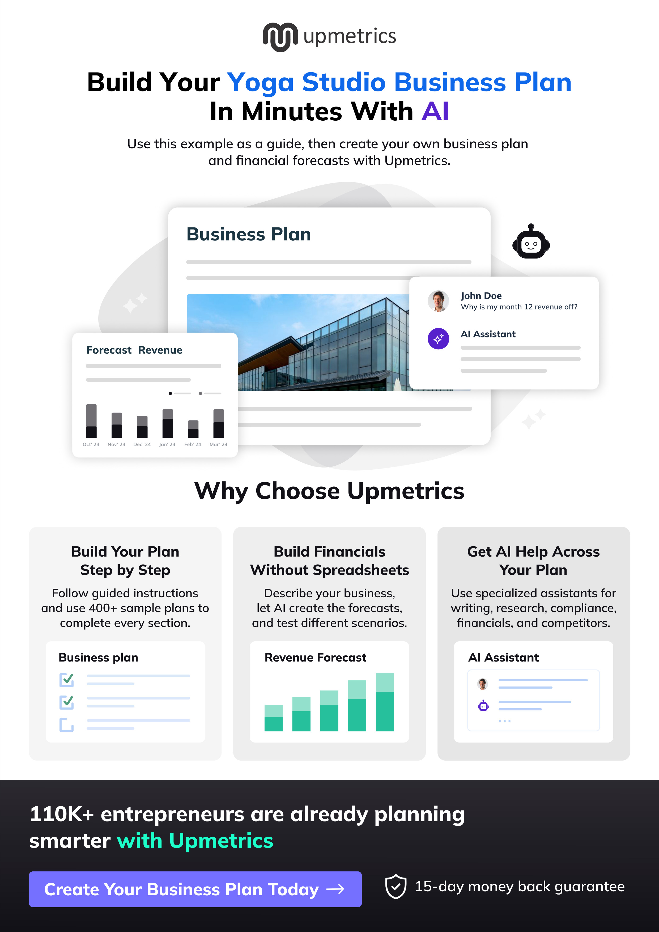

CHAPTER 1

Executive Summary

1.1 Business Overview
1.2 Mission Statement
1.3 Location & Market Opportunity
1.4 Unique Selling Points
1.5 Financial Highlights
1.6 Funding Requirement

1.1 Business Overview

Stillfern Yoga is an independent yoga studio planned for Chattanooga, Tennessee, teaching group classes in vinyasa, hatha, yin and restorative formats from one room of about 28 mats. A four-week foundations series runs every month for students who are new to yoga.
Members practise on an unlimited monthly membership, with class packs and drop-ins for those who come less often. An online subscription carries livestreamed classes and an on-demand library to the towns around Chattanooga that are too far for a regular drive. The studio serves adults aged roughly 25 to 55, from first-time students to runners and climbers looking for recovery.

1.2 Mission Statement
To give Chattanooga a studio where a first-time student and a ten-year practitioner can share one room, taught by the same teachers each week, and to carry that teaching to the people who live too far away to come in.

1.3 Location & Market Opportunity
The studio will lease about 2,400 square feet of in-line retail space in Chattanooga, where retail asking rents averaged $17.73 per square foot a year in Q1 2026, against a US retail average of $25.69. Chattanooga had 185,783 residents in 2024 with a median household income of $64,523, and Hamilton County grew 5.3% between 2020 and 2024 to 386,256 residents. The wider metro, which the online subscription reaches, holds about 588,763 people.
US Pilates and yoga studios generated $19.2 billion in 2025. Chattanooga's own yoga studio market is about $7.2 million a year across about 14 studios, an upper estimate built from the national average of about $515,000 per studio business. That average is also the obtainable market for one studio of this kind, and Stillfern's first-year revenue of $288,950 sits well inside it.

1.4 Unique Selling Points
- A foundations series every month, so beginners have a structured way into mixed-level classes.
- One schedule, two products: classes in the room and the same classes livestreamed to online subscribers.
- Classes capped at 28 mats, so the teacher can cue and adjust every student.
- Yin, restorative and mobility classes timed for runners, cyclists and climbers after training.
- An unlimited membership at $129 a month with no long-term contract.

1.5 Financial Highlights
Revenue comes from 170 members at $129 a month, class packs and drop-ins worth a further 35% of the membership book, and 100 online subscribers at $25 a month. The studio opens at 40% of that base and builds to it over ten months as introductory students convert.
Revenue is projected at $288,950 in the first year, $340,960 in the second and $402,333 in the third, at a gross margin of 87.0% throughout. Net income is $1,557 in the first year, rising to $15,375 and then $31,521, a net margin of 7.8% by the third year. Break-even revenue is $252,016, the equivalent of 163 members, which the first year clears. Third-year net income is $11,688 in the conservative case and $58,307 in the upside case.

1.6 Funding Requirement
The startup budget is $151,400. It covers the studio build-out, props and livestream equipment, launch marketing, deposits and a working capital reserve, and it is funded by a $75,000 owner contribution and an $80,000 SBA-backed loan at 10.5% over seven years. Profits stay in the business while the member base builds.
The plan rests on a founder with years of teaching in the region, a growing county with room for a studio built around beginners, and a second product that reaches past the drive. The money builds one well-run room and the stream that carries it further.

1.6.1 Income Statement (3 Year projections)
 | Year 1 | Year 2 | Year 3 | Total
Revenue | $288,949.50 | $340,960.41 | $402,333.28 | $1,032,243.19
Cost of Sales | $37,563.43 | $44,324.85 | $52,303.33 | $134,191.61
Gross Margin | $251,386.07 | $296,635.56 | $350,029.95 | $898,051.58
Operating Expense | $219,253.74 | $246,299.41 | $278,213.31 | $743,766.46
Total Expense | $287,392.72 | $325,585.47 | $370,812.76 | $983,790.95
Net Income | $1,556.78 | $15,374.94 | $31,520.52 | $48,452.24

CHAPTER 2

Company Overview

2.1 Legal Structure
2.2 Vision Statement
2.3 Background & History
2.4 Future Goals

2.1 Legal Structure
Stillfern Yoga will be organised as a Tennessee limited liability company owned by its two founders. An LLC limits the owners' personal liability for the lease and the SBA-backed loan, and in Tennessee it pays the state franchise and excise tax rather than any income tax on wages: excise tax at 6.5% of net earnings and a franchise tax with a $100 minimum.
Before opening, the studio will take out City of Chattanooga and Hamilton County business licenses and register to collect sales tax, because Tennessee taxes fitness memberships and per-class fees, yoga classes included. Once gross receipts pass $100,000, which the first year's revenue does, the studio holds a standard license and files business tax returns through the state's online system.

2.2 Vision Statement
To be the studio Chattanooga recommends to a friend who has never tried yoga, and the one its regulars keep for years: a room where teaching comes first, a schedule that fits working lives, and a practice that continues online on the days members cannot come in.

2.3 Background & History
Stillfern Yoga is a new business with no trading history. It is the plan of Maren Holt, who has taught vinyasa and yin in Chattanooga and Atlanta studios for nine years, and Owen Pierce, who spent six years running memberships and scheduling at a regional fitness club. Everything below is their stated intent for the studio rather than an account of a business already operating.
Two things in Maren's teaching shaped the plan. New students arrived on an introductory offer, struggled through a mixed-level class and did not come back, so the studio is built around a beginner series that runs every month. And students who moved out to Ringgold, Fort Oglethorpe or Jasper kept asking for a way to practise with the same teachers, which became the online subscription.
The name joins the stillness the founders want the room to hold with the ferns on the ridges around the city, where many of their students run, climb and ride.

2.4 Future Goals
In the first 0 to 18 months the studio signs its lease, completes the build-out, sells founding memberships before the doors open, and opens with a full schedule of about 35 classes a week. The online studio launches two months later. The goal for this horizon is the planned base of 170 members and 100 online subscribers by the tenth month of trading, with at least one in three introductory students converting to a membership.
Over 1 to 3 years the studio grows into the room it has. Revenue is planned at $340,960 in the second year and $402,333 in the third, as more of the schedule fills, the on-demand library grows and a weekend workshop series becomes a regular second line. Corporate wellness classes for Chattanooga employers are added to fill the midday slots.
From 3 to 5 years the founders intend to register a 200-hour teacher training with Yoga Alliance, which earns revenue from the same room and trains the next teachers. A second location is considered only once the first room is consistently full.

2.4.1 Business Owners
Maren Holt | Owen Pierce

Total ownership: 100%
75% | Maren Holt  7,500 Shares
25% | Owen Pierce  2,500 Shares

2.4.2 SMART Goal
  Specific  - Build Stillfern Yoga to 170 active members and 100 online subscribers.  - About 35 classes a week from one Chattanooga room.  - That base moves the studio from break-even to steady profit. |   Measurable  - Members, online subscribers and class fill, tracked weekly.  - One in three introductory students converting to a membership.  - Monthly cancellations under 3% after the first 90 days. |   Achievable  - The founder brings nine years of teaching in the region.  - A founding-member presale fills the schedule before opening.  - 28 mats across 35 classes a week holds well over 170 members.
  Relevant  - Yoga leads US fitness member activity.  - Hamilton County grew 5.3% from 2020 to 2024.  - Online reaches the metro without a second lease. |   Time-Based  - Founding-member presale one month before opening.  - Online studio two months after opening.  - Full member base by the tenth month of trading.

CHAPTER 3

Market Analysis

3.1 Overview
3.2 Market Segmentation
3.3 Market Trends
3.4 Local Market Outlook
3.5 Market Size

3.1 Overview
US Pilates and yoga studios generated $19.2 billion in revenue in 2025, down 2.0% on the year after five years of 11.1% compound annual growth, and IBISWorld projects $19.0 billion for 2026. The industry is made up of 37,317 businesses employing about 101,000 people, so the trade is large but fragmented, and most of it is single-room studios.
Demand underneath it is broad. A record 81 million Americans belonged to a gym, studio or other fitness facility in 2025, up 5.2% on 2024, and yoga is the most widely practised activity among those members. Studios held 23.1 million members in 2024, more than any other facility type.

3.2 Market Segmentation
Yoga's market splits clearly by sex, age and income. In 2022, 16.9% of US adults practised yoga, but the rate was 23.3% among women against 10.3% among men, and 21.3% among adults aged 18 to 44 against 14.1% at 45 to 64 and 8.0% at 65 and over. Use rises with income, from 10.4% in the lowest family income group to 23.0% in the highest.
Motive divides it too. About 80% of practitioners practise to restore overall health, 57% meditate as part of their practice, and about 29% use yoga to treat or manage pain. That gives a studio three overlapping groups to serve: people building general fitness, people seeking calm, and people managing pain or recovering from other training.

3.3 Market Trends
- Record facility use: 7 billion visits to US fitness facilities in 2025, with members aged 65 and over the fastest-growing group, up 8.6%.
- Class-based activity is back: 80% of Americans aged six and over were active in 2024, and class-based activities including yoga had their best year since 2020.
- Studios share their members: over 75% of studio users keep at least one other membership, so a studio competes for part of a routine rather than all of it.

3.4 Local Market Outlook
Chattanooga has about 14 yoga studios by a 2026 city guide's count, and a local directory lists 16. With 185,783 residents in the city in 2024, that is roughly one studio for every 13,000 people, and the supply is mostly independent studios, several with two sites.
The catchment is growing. Hamilton County, which contains the city, reached an estimated 386,256 residents in July 2024, up 5.3% since the 2020 census, and the Chattanooga metro across southeast Tennessee and northwest Georgia held about 588,763 people. The city's median household income was $64,523 in 2024 and its median age 36.3, close to the age band where yoga use is highest. No local measure of yoga participation is published, so the national rates above stand in for one.
Trading here is relatively cheap. Retail asking rents averaged $17.73 per square foot a year in Q1 2026, though vacancy was a tight 3.5%. Tennessee has no state minimum wage, and the studio must collect sales tax on memberships and classes.

3.5 Market Size
The total addressable market is the US Pilates and yoga studio industry, $19.2 billion in 2025. The serviceable market is Chattanooga's own yoga studios, about $7.2 million a year: the city's 14 studios at the national average of about $515,000 revenue per studio business. Because chains lift that average, $7.2 million is an upper estimate for a market made mostly of independents.
The obtainable market is the revenue of one average studio business, about $515,000 a year. It is a national figure rather than a Chattanooga one. Stillfern's projected first-year revenue of $288,950 is below it, and its third-year revenue of $402,333 would still be under 6% of the serviceable market.
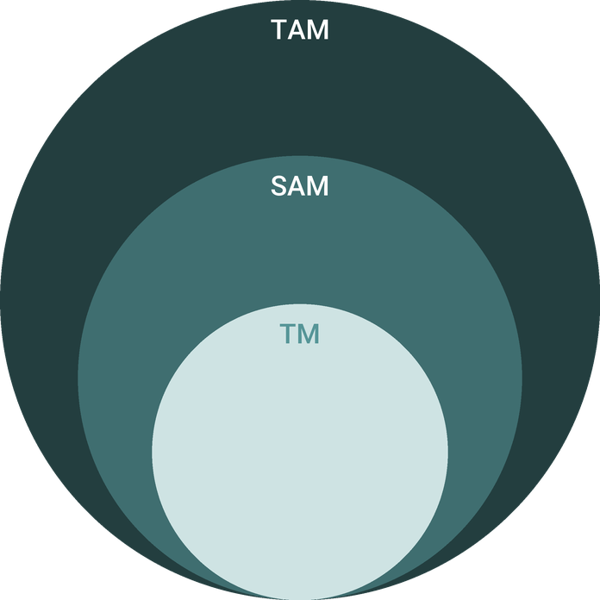
  ● | Total Available Market (TAM)  US Pilates and yoga studios generated $19.2 billion in revenue in 2025 (IBISWorld), down 2.0% on the year after an 11.1% five-year compound annual growth rate. | 19.2B
  ● | Served Available Market (SAM)  Chattanooga's yoga studio market is about $7.2 million a year: 14 studios in the city at the 2025 US average of about $515,000 revenue per Pilates and yoga studio business. | 7.2M
  ● | Target Market (TM)  One average US Pilates and yoga studio business turned over about $515,000 in 2025 ($19.2 billion across 37,317 businesses); a national average, not a Chattanooga figure. | 515.0k

CHAPTER 4

Customer Analysis

4.1 Target Market
4.2 Customer Segments
4.3 Customer Persona
4.4 Customer Purchase Journey

4.1 Target Market
Stillfern's market is adults aged roughly 25 to 55 who live or work within a short drive of the studio, in Chattanooga and the surrounding parts of Hamilton County. The city had 185,783 residents in 2024 with a median age of 36.3, and the county 386,256.
Nationally, 16.9% of adults practised yoga in 2022, and the rate is highest among women (23.3%), adults aged 18 to 44 (21.3%) and households in the top income group (23.0%). No Chattanooga figure is published, so these national rates describe who the studio should expect rather than a local count. Most practitioners come for overall health, and about 29% use yoga to manage pain, which shapes the schedule as much as the marketing.
A second, smaller market sits outside the drive: practitioners across the Chattanooga metro of about 588,763 people, in towns such as Ringgold, Fort Oglethorpe and Jasper, reached through the online subscription.

4.2 Customer Segments
- Beginners: adults who have tried an app or a single class and want a guided start. They buy the introductory offer, then the foundations series, then a membership if the first month goes well.
- Regular practitioners: people who practise two to four times a week and want consistent teachers. They buy the unlimited membership and are the core of the revenue.
- Active recovery: runners, cyclists and climbers who want yin, restorative and mobility classes after training. They often buy class packs rather than a membership.
- Online subscribers: practitioners in the outlying towns, and members while they travel, who buy the online subscription or the Unlimited Plus membership that includes it.
Over 75% of studio users nationally keep at least one other fitness membership, so most of these customers will pair Stillfern with a gym, a climbing wall or a run club rather than replace it.

4.3 Customer Persona
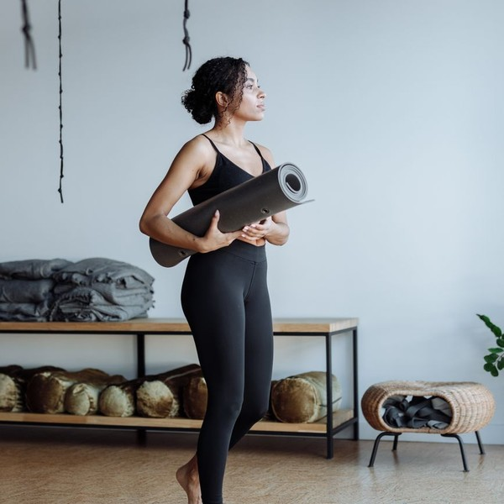  Lauren, the Busy Beginner  Demographics  Age: 34  Marital Status: Married, one child  Location: North Shore, Chattanooga  Income: $78,000 annually  Professional Role  Education: Bachelor's degree in Nursing  Job: Registered Nurse on rotating shifts | “I know yoga would help my back and my stress. I just need a class where I won't feel lost.”
   | Identifiers / Personality Traits  - Runs on the Riverwalk twice a week and feels tight afterwards  - Has tried yoga apps but never stuck with one  - Books on her phone and wants the schedule at a glance
   | Goals  - Ease lower back pain from long shifts  - A routine that fits a changing schedule  - Feel confident in a class without prior experience
   | Challenges  - Worries about being the least flexible person in the room  - Shift work makes fixed class times hard to keep  - Wary of contracts after an unused gym membership

4.4 Customer Purchase Journey
Most students find a studio by searching for yoga near them, through a friend, or by meeting a teacher at a community class. Stillfern's journey is built around those three doors: a complete Google Business Profile and schedule, a referral credit for members, and free outdoor classes and run club recovery sessions.
The first visit is the introductory offer, booked on the app. A new student is greeted by name, shown the room and props, and steered towards the foundations series or a beginner-friendly class rather than the fastest flow on the schedule. The front desk follows up after the first and third visits.
The decision to join comes in the first month, when the student has felt the difference in their back or their sleep and knows two or three teachers. The membership converts on autopay with no contract, which removes the main objection from anyone burned by an unused gym membership. Online subscribers follow a shorter path: a free trial week of livestreams, then the subscription.

CHAPTER 5

Competitive Analysis

5.1 Competitors
5.2 Comparison
5.3 Competitive Edge
5.4 SWOT Analysis

5.1 Competitors
Chattanooga has about 14 yoga studios by a 2026 city guide's count, roughly one for every 13,000 residents. Most are independents, several running two sites, offering heated and room-temperature classes across the city's neighbourhoods. Franchised heat and infrared fitness concepts compete for the same members, and so do gyms that include yoga classes in a general membership.
National chains are expanding. Xponential Fitness ended 2025 with 3,097 studios across its brands, its yoga brand YogaSix has opened its 200th studio, and CorePower Yoga plans more than 20 new studios a year. A chain entering Chattanooga would compete on brand and heated classes, with a higher price.
Online, the competition is free and low-cost app classes. Only 8% of Americans pay for an online or at-home fitness plan, so the online subscription has to win on the one thing an app cannot offer: the same teachers students know from the room.

5.2 Comparison
The table compares Stillfern with the three kinds of competitor a Chattanooga student chooses between. Independent studios share Stillfern's small classes and flexible memberships, and some already stream. Franchise studios sell intensity and heat rather than instruction. Gyms are the cheapest way to get a yoga class, but the class is one line in a broad timetable, often without a consistent teacher. Stillfern's position is the combination: a beginner path, recovery classes, small rooms and a stream from one schedule.
Feature | Stillfern Yoga | Independent yoga studios | Franchise heat and infrared studios | Gyms with yoga in the membership
Beginner foundations series every month | ✓ | ✗ | ✗ | ✗
Livestream and on-demand online classes | ✓ | ✓ | ✗ | ✗
Class capacity capped for hands-on cues | ✓ | ✓ | ✗ | ✗
Restorative and yin classes every week | ✓ | ✓ | ✗ | ✓
No long-term contract on memberships | ✓ | ✓ | ✗ | ✓
Unlimited membership under $130 a month | ✓ | ✓ | ✗ | ✓

5.3 Competitive Edge
Each of these is something the studio does by design rather than a claim about quality, and each costs a competitor real effort to copy.
   | A room and a stream from one schedule  Selected classes are livestreamed from the studio and kept in an on-demand library, so members keep practising when they travel and the outlying towns can join without the drive.
   | A path in for beginners  A four-week foundations series runs every month, so a new student learns the basic poses and the studio's cues before joining mixed-level classes, where many studios lose them.
   | Small classes with hands-on teaching  Classes are capped at 28 mats so the teacher can see every student, adjust alignment and offer options for injuries.
   | Recovery for an active city  Yin, restorative and mobility classes are scheduled around the evenings and weekends when runners, cyclists and climbers want them, rather than as an occasional add-on.
 | Teachers on payroll, not contract  Instructors are employees with a set weekly schedule, which keeps the same faces on the schedule and avoids the misclassification risk per-class contracting carries.

5.4 SWOT Analysis
Strengths  - One schedule serves two products: classes in the room and the same classes livestreamed to subscribers.  - A monthly foundations series gives beginners a structured way in, where many studios lose them.  - Instructors on payroll keep the same teachers on the schedule week to week.  - Modest fixed costs for the trade: one room of about 2,400 square feet. | Weaknesses  - A new name with no members, reviews or teacher following on opening day.  - Revenue depends on one room, so its class capacity caps the membership book.  - Thin early margins: net income is about 0.5% of revenue in the first year.  - The founder teaches and directs, so the studio leans heavily on one person at first.
Opportunities  - Metro towns beyond the commute can subscribe online without a second location.  - Members aged 65 and over are the fastest-growing group in US fitness facilities.  - Workshops and a future 200-hour teacher training add revenue from the same room.  - Corporate wellness packages for Chattanooga employers can fill midday classes. | Threats  - About 14 studios already compete in the city, several with two sites.  - Pilates bookings are growing faster than yoga and compete for the same members.  - Tennessee charges 9.25% sales tax on memberships, which lifts the price members pay.  - Free and low-cost app classes compete with the online subscription on price.

 Strategic Summary
Stillfern should win on the way in and on the stream: convert beginners through the foundations series and sell online subscriptions in the towns the room cannot reach, while keeping the schedule tight enough to protect thin early margins.

CHAPTER 6

Services Offered

6.1 Our Offering
6.2 Signature Items
6.3 Additional Services
6.4 What Sets Us Apart
6.5 Class Schedule & Formats

6.1 Our Offering

Stillfern sells group yoga classes, taught in one room of about 28 mats and, for part of the schedule, streamed live. Students buy access three ways: an unlimited monthly membership, class packs and drop-ins for those who come less often, or an online subscription for those who practise at home. Every class is taught by one of a small team of teachers on payroll, so students see the same faces each week.

6.2 Signature Items
- Unlimited Studio Membership: every class on the schedule for $129 a month on autopay, with no long-term contract.
- Foundations Series: a four-week course each month covering the basic poses, breath and alignment cues, included in the membership.
- Yin and Restorative Evenings: slower classes with bolsters and blankets, scheduled for recovery after work and training.

6.3 Additional Services
Class packs and drop-ins serve students who practise once a week or visit the city, and together with the introductory offer and workshops they are planned at 35% of the membership book. Weekend workshops of about two hours cover inversions, mobility for runners and breathwork, and are open to members and non-members. A small retail shelf carries mats, props and practice clothing.
The Online Studio Subscription is the second product, priced at $25 a month. It carries livestreamed classes and the on-demand library to students who cannot reach the room, and it is included in the Unlimited Plus membership at $149 a month.

6.4 What Sets Us Apart
Most studios teach beginners and regulars in the same class and hope the beginners keep up. Stillfern gives them a separate way in, then moves them into mixed-level classes taught with options. Classes are capped so the teacher can see every student, and the yin, restorative and mobility classes are on the schedule every week rather than as an occasional special. The online subscription extends the same teaching beyond the drive.

6.5 Class Schedule & Formats
The studio runs about 35 classes a week. Weekdays carry an early class before work, a midday class and two evening classes; weekends carry morning classes and an afternoon yin or restorative session. Midday is kept on purpose, since ClassPass reservations between 11:00 a.m. and 1:00 p.m. rose 38% in 2025.
- Vinyasa flow: 60 minutes in a warm room, the core of the schedule, taught with options for every level.
- Hatha: 60 minutes at a steadier pace, holding poses longer, for students who want alignment over pace.
- Yin and restorative: 75 minutes of long-held, supported poses with bolsters and blankets.
- Mobility for athletes: 45 minutes of hips, hamstrings and shoulders for runners, cyclists and climbers.
- Foundations: a 60-minute weekly session across four weeks, starting at the beginning of each month.
Booking opens seven days ahead in the studio app, with a waitlist that fills a spot automatically when a student cancels. Late cancellations and no-shows forfeit the class for pack holders, which keeps the room full. About 10 classes a week are livestreamed, chosen to cover each format and time of day.

6.5.1 Unlimited Studio Membership
Unlimited access to every class on the studio schedule, from vinyasa and hatha to yin, restorative and the monthly foundations series. Members book through the app and practise in a room of about 28 mats with the same core teachers each week.
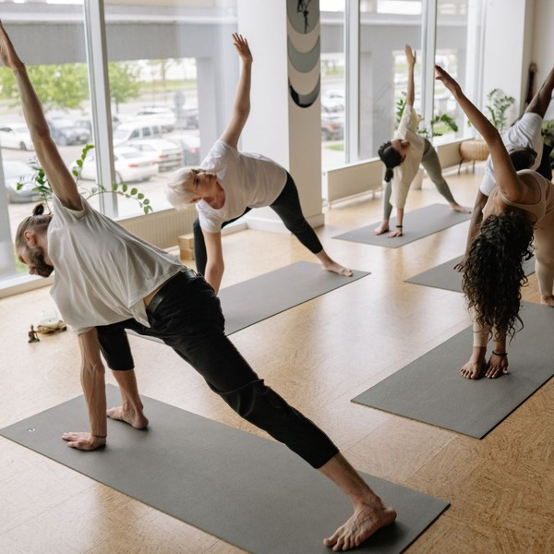 | $129 per month  Billed monthly on autopay with no long-term contract. Class packs and drop-ins are sold alongside it for students who come less often.

Specifications
- About 35 classes a week across seven days
- Classes capped at 28 mats
- Mats, towels and props provided
- Booking and waitlist through the studio app
- Cancel or pause with 30 days' notice

6.5.2 Online Studio Subscription
Livestreamed classes from the studio schedule and an on-demand library of recorded classes, for practitioners who cannot reach the room several times a week. It serves the metro's outlying towns, and studio members while they travel.
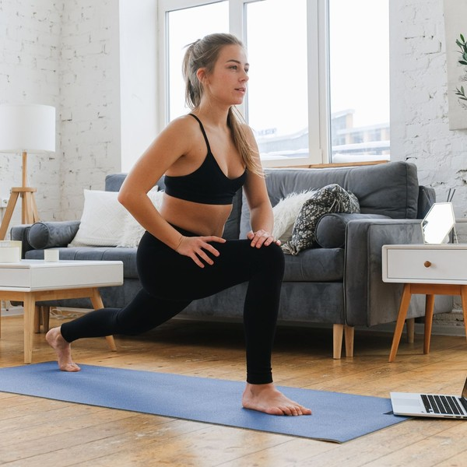 | $25 per month  About a fifth of the studio membership, for students who practise at home. It is included in the Unlimited Plus membership.

Specifications
- About 10 livestreamed classes a week
- On-demand library of recorded studio classes
- Classes from 20 to 75 minutes
- Streams on phone, tablet, computer or TV
- Cancel any time

6.5.3 Features
  Foundations series
  A four-week beginner course each month covering the basic poses, breath and the cues used in every class.
  Mixed-level vinyasa and hatha
  The core of the schedule, taught with options so beginners and experienced students share one room.
  Yin and restorative evenings
  Slower classes using bolsters and blankets, scheduled for recovery after work and training.
   | Weekend workshops  Two-hour sessions on topics such as inversions, mobility for runners and breathwork, sold separately.
Livestream and on-demand
Selected studio classes streamed live and kept in a library members and subscribers can use any time.

6.5.4 Pricing
Online Studio  $25  per month  - Livestreamed classes from the studio schedule  - Full on-demand video library  - Cancel any time |  | Most Popular  Unlimited Studio  $129  per month  - Unlimited in-studio classes  - Monthly foundations series included  - Mat and towel provided  - No long-term contract |  | Unlimited Plus  $149  per month  - Everything in Unlimited Studio  - Online Studio included  - Two guest passes a month  - 15% off workshops

CHAPTER 7

Marketing & Sales Strategies

7.1 Market Positioning
7.2 Marketing Objectives
7.3 Online Marketing
7.4 Public Relations and Branding
7.5 Partnership & Collaboration Strategy
7.6 Customer Loyalty & Retention
7.7 Sales Channels

7.1 Market Positioning
Stillfern is the Chattanooga studio built for the way in and the long stay: a structured start for beginners, the same teachers every week for regulars, and a stream for those beyond the drive, at $129 a month with no contract.

7.2 Marketing Objectives
- Reach 170 active members and 100 online subscribers by the tenth month of trading.
- Convert at least one in three introductory students to a membership.
- Keep monthly member cancellations under 3% once members pass their first 90 days.
- Spend the first-year marketing budget of $17,337, 6% of revenue, on channels that reach people within a short drive.
Local search and social ads  $578  per month  Targeted ads within a short drive of the studio, pointing to the introductory offer. |  | Introductory offer  $361  per month  Funds the discounted first month that turns a curious visitor into a regular.
Community events  $289  per month  Free outdoor classes, run club recovery sessions and pop-ups at local businesses. |  | Online studio promotion  $217  per month  Ads and email aimed at the metro towns beyond the drive, for the online subscription.

Total marketing budget: $17,337 a year, $1,445 a month.

7.3 Online Marketing
Search is where most new students start, so the first job is a complete Google Business Profile with the live schedule, photographs of the room and a steady flow of reviews, which members are asked for after their first month. Paid search and social ads are targeted within a short radius of the studio and point to one thing, the introductory offer.
Instagram carries short clips from classes, teacher introductions and the weekly schedule. A monthly email gives members the workshop calendar and new on-demand classes, and a separate sequence goes to people who took the introductory offer and did not join.

7.4 Public Relations and Branding
The brand is quiet and specific: the fern mark, natural materials in the room, and plain language about who each class is for. Opening month includes free community classes in a riverside park, and the founders will pitch the beginner series and the online studio to local media and city guides as stories about access rather than about the studio itself.

7.5 Partnership & Collaboration Strategy
- Run clubs and climbing gyms: monthly recovery sessions for their members, with a class pack offer.
- Physical therapists and chiropractors: referrals for patients ready to move from treatment to practice.
- Employers: lunchtime and on-site classes sold as corporate wellness packages to fill midday slots.
- Neighbouring businesses: pop-up classes and shared promotions with cafes and outdoor retailers.

7.6 Customer Loyalty & Retention
In yoga, members leave in the first three months or they stay for years, so retention work starts on the first visit. Every new member gets a check-in from a teacher in the first two weeks and a plan for which classes to take. The schedule keeps the same teacher on the same slot, so students build a habit around a person.
After that, members are recognised at their 50th and 100th class, can pause a membership for travel or injury instead of cancelling it, and get access to the online library when they are away. Workshops and member events give regulars a reason to stay connected beyond the timetable.

7.7 Sales Channels
Revenue arrives through four routes, in order of what each is worth. The studio does not list on class aggregator apps at launch, to protect the membership price while the base builds.
  Monthly memberships
  The largest share of revenue, recurring on autopay and dependent on keeping members past their first 90 days.
  Class packs and drop-ins
  Worth about a third of the membership book, from students who come less often and visitors to the city.
   | Online subscriptions  Recurring revenue from outside the drive-in catchment, dependent on a steady livestream schedule.
  Workshops
  Separately priced weekend sessions that bring in both members and new students.

CHAPTER 8

Operations Plan

8.1 Daily Operations
8.2 Working Hours
8.3 Staffing & Training
8.4 Inventory & Equipment Management
8.5 Location and Facilities
8.6 Milestones & Timeline
8.7 Online Studio & Livestream Setup

8.1 Daily Operations
The opening teacher or front desk lead arrives 30 minutes before the first class to set the room temperature, lay out props and open the booking list. Students check in on the app at the desk. Between classes the room is reset in 15 minutes: mats wiped, props returned, blankets and towels collected for laundry.
The operations manager handles payroll, the booking system, supplier orders and member questions during the day, and reviews class fill and cancellations each week. The schedule is adjusted each quarter based on that data rather than on instinct.

8.2 Working Hours
The studio opens from about 6:00 a.m. to 8:30 p.m. on weekdays and from 7:30 a.m. to early evening at weekends. Those hours follow when people can practise: before work, at lunch and after work on weekdays, and in the mornings at weekends. Weekday mid-afternoons are kept free for private sessions, cleaning and teacher training rather than classes that would run half empty.

8.3 Staffing & Training
The founder directs the studio and teaches part of the schedule, the operations manager runs the business side, and a lead instructor coordinates five part-time teachers. Two part-time front desk staff cover opening hours, and a part-time producer is planned for the online studio.
Instructors are W-2 employees on a set weekly schedule. A teacher who teaches the studio's classes, in its room and to its format, is in most cases an employee under IRS and Department of Labor tests, and employing them keeps the schedule consistent. Pay is per class, with payroll planned at 42% of revenue. Every teacher holds at least a 200-hour registered training and current CPR certification, and the team meets monthly for peer observation and cueing practice.

8.4 Inventory & Equipment Management
The studio provides mats, blocks, bolsters, straps and blankets for a full room, with spares. Props are inspected monthly and worn pieces replaced from the capital budget of 1.5% of revenue a year. The retail shelf of mats, props and clothing is kept to about 10 days of stock and reordered monthly from suppliers who invoice on 30-day terms. Towels and blankets are laundered on site each day.

8.5 Location and Facilities
The studio will lease about 2,400 square feet of in-line retail space, at $4,200 a month including common area charges. Chattanooga retail asked $17.73 per square foot a year in Q1 2026, but vacancy was only 3.5%, so the search starts well ahead of the opening date. The site needs parking, visibility from a main road and a short drive from residential neighbourhoods.
The space holds one practice room for about 28 mats with heating controls for warm classes, a lobby with the front desk and retail shelf, two changing rooms with showers, prop storage and a small office that doubles as the livestream control desk.

8.6 Milestones & Timeline
The studio moves from lease to full member base in about a year, with the online studio launching two months after the doors open.
Jan 2027  Setup |  |  | Lease signed and financing closed  About 2,400 square feet of retail space in Chattanooga.  The SBA-backed loan and the owners' contribution close, and the business licenses and sales tax registration are filed.
Feb 2027  Setup |  |  | Studio build-out  Flooring, changing rooms, lighting and heating controls.  The room is fitted for about 28 mats, the livestream cameras and audio are installed, and the booking system is set up.
Mar 2027  Launch |  |  | Founding-member presale  Teachers hired and the first members signed.  Instructors are auditioned and onboarded, and founding memberships are sold at an opening rate through local events and ads.
Apr 2027  Launch |  |  | Studio opens  Full weekly schedule of about 35 classes.  The doors open with a free first week, the foundations series and the introductory offer.
Jun 2027  Growth |  |  | Online studio launches  Livestream and on-demand subscription opens.  About 10 classes a week go live online, marketed to the metro towns beyond the drive.
Jan 2028  Growth |  |  | Full member base  About 170 members and 100 online subscribers.  The studio reaches its planned base and adds a weekend workshop series.

8.7 Online Studio & Livestream Setup
The online studio is built into the room rather than added to it. Two fixed cameras, one wide and one closer on the teacher, feed an encoder at the office desk, and the teacher wears a wireless microphone so cues are clear over the music. The equipment, about $8,500 of the startup budget, is installed during the build-out.
- About 10 classes a week are streamed live, chosen to cover each format and time of day.
- Each stream is recorded and edited into the on-demand library within a day, filed by style, level and length.
- The front two rows of the room are marked as the camera zone; students who prefer not to appear take the back rows.
- Music is played under a licence that covers streaming, which ordinary studio music licences do not.
- The video platform connects to the booking system, so one login covers both and Unlimited Plus members get online access automatically.
Subscribers in Ringgold, Fort Oglethorpe and Jasper see the same teachers as the room, which is what separates the subscription from a generic app. Platform, hosting and music licensing are part of the $650 a month technology budget.
The online line is measured on its own: subscribers, livestream attendance, library views per subscriber and monthly cancellations, reported beside the studio figures. A streamed slot that draws few viewers for two months running is swapped for another class, and the most-watched recordings decide which workshops are filmed for the library. Online subscribers also get a free class in the room each quarter, so that someone who drives in from Ringgold or Jasper on a weekend meets the teachers in person and has one more reason to keep the subscription.

CHAPTER 9

Management Team

9.1 Key Members
9.2 Organization Chart
9.3 Advisory Board Members

9.1 Key Members
The founder is accountable for the teaching: the schedule, the quality of every class and the teachers who deliver it, measured by class fill, introductory conversion and member retention after 90 days. The operations manager is accountable for the business running to plan: payroll inside 42% of revenue, rent and running costs on budget, the booking and payment systems, and monthly reporting against the financial model. The lead instructor answers for teacher onboarding, cover for absences and the foundations series. As the lead instructor takes on more of the schedule, the founder's own teaching hours come down, so that by the end of the first year most of her week goes to teacher development and the studio's numbers.
 | Maren Holt  Founder & Studio Director · maren@stillfernyoga.example  Nine years teaching vinyasa and yin in Chattanooga and Atlanta studios, with a 500-hour registered teacher training.

 | Owen Pierce  Operations Manager · owen@stillfernyoga.example  Six years managing memberships, scheduling and front desk teams at a regional fitness club.

 | Priya Nair  Lead Instructor · priya@stillfernyoga.example  RYT 200 teacher specialising in restorative and prenatal yoga, with five years of studio teaching.

9.2 Organization Chart
The operations manager, the lead instructor and the front desk and community coordinator report to the founder. Part-time teachers report to the lead instructor for scheduling and teaching standards, and front desk staff to the coordinator. The planned online producer will report to the operations manager. The founders meet weekly to review bookings, cancellations and cash against the plan.
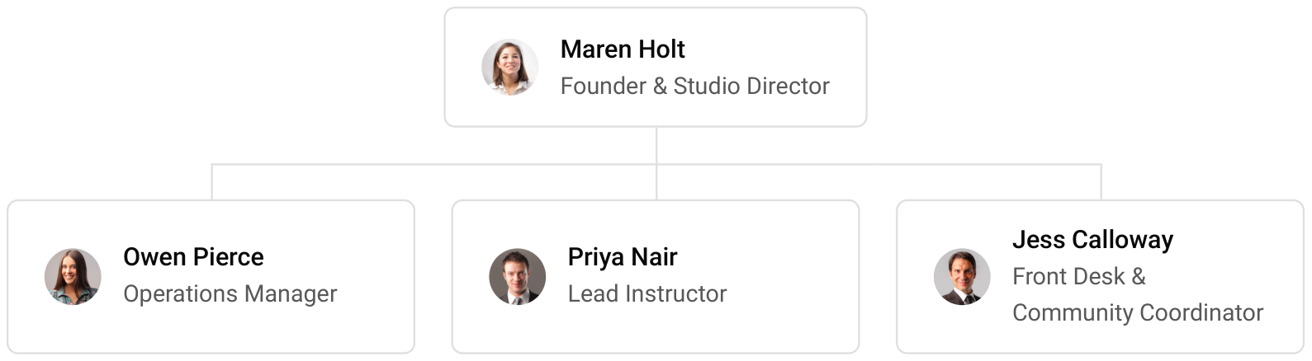

9.3 Advisory Board Members
The studio will draw on two informal advisers rather than a formal board. Dana Whitfield, an accountant who works with small fitness and wellness businesses in Chattanooga, advises on sales tax, payroll and the annual accounts. Marcus Avery, a physical therapist, reviews the mobility and recovery classes and teacher guidance on common injuries, and refers patients ready to move from treatment to practice.
Both advisers are paid by the hour rather than retained, which keeps fixed costs down in the first year. Once the studio nears its planned base, the founders intend to add a third adviser with experience of running more than one fitness site, to test any case for a second room against the first year's results.

9.3.1 Hiring Plan
2  Filled |  | 8  Hiring This Year |  | 9  Open

Group By Department | Position Filled | Time of Hire | Time of Start | Filled
Leadership & Operations | 2 of 2 | 0 days | 0 days | 100%
Teaching | 0 of 6 | 45 days | 21 days | 0%
Front Desk & Community | 0 of 2 | 30 days | 14 days | 0%
Online Studio | 0 of 1 | 60 days | 30 days | 0%

CHAPTER 10

Financial Plan

10.1 Key Assumptions
10.2 Capital Requirements and Use of Funds
10.3 Income Statement (3 Year projections)
10.4 Balance Sheet (3 Year projections)
10.5 Cash Flow Statement (3 Year projections)
10.6 Break Even Analysis

10.1 Key Assumptions
Revenue is built from the studio's own drivers: 170 active members at $129 a month, class packs and drop-ins worth a further 35% of the membership book, and 100 online subscribers at $25 a month. The studio opens at 40% of that base and builds to it over 10 months, then grows 18% a year, since the second year is the first at the full base. The membership price sits inside the $100 to $150 a month most US studios charge.
Cost of sales is card processing, booking fees, retail stock and consumables, for a gross margin of 87.0%. Payroll, including instructors, the front desk and the founder's salary, is 42% of revenue; marketing is 6%; rent is $4,200 a month; technology $650 and administration $900 a month; and other operating costs 4% of revenue. Income tax is modelled at 26%. Sales tax of 9.25% is collected on memberships and classes and passed to the state, so it is not counted as revenue.
On those assumptions revenue is $288,950 in the first year, $340,960 in the second and $402,333 in the third. Net income is $1,557, $15,375 and $31,521, a net margin rising from 0.5% to 7.8%. Break-even revenue is $252,016, the equivalent of 163 members. In the conservative case third-year net income falls to $11,688; in the upside case it reaches $58,307.

10.2 Capital Requirements and Use of Funds
The studio needs $151,400 to open. The largest items are the leasehold improvements for the practice room, changing rooms and lighting, props and livestream equipment, launch marketing and a working capital reserve held in cash while the member base builds.
It is funded by a $75,000 owner contribution and an $80,000 SBA-backed loan at 10.5% over seven years, matched to the life of the improvements it pays for. No outside equity is raised and no distributions are planned, so profits stay in the business to rebuild the cash reserve and repay the loan.

10.2.1 Use of Funds
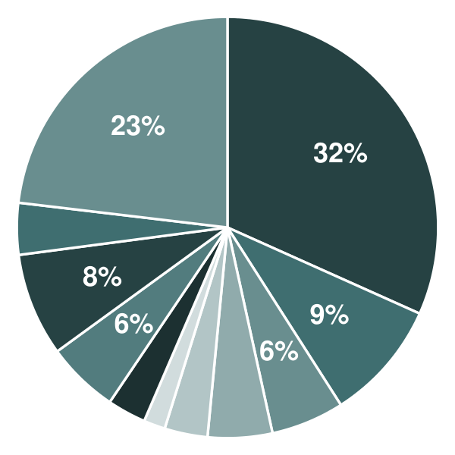 | ● Leasehold Improvements 31.7%  ● Equipment & Props 9.2%  ● Livestream Studio Setup 5.6%  ● Furniture & Retail Fixtures 5.0%  ● Initial Inventory 3.3%  ● Licenses, Permits & Insurance 1.7%  ● Professional Fees 3.0%  ● Deposits & Pre-Opening Rent 5.5%  ● Launch Marketing 7.9%  ● Pre-Opening Staffing 4.0%  ● Working Capital Reserve 23.1%

Use Of Funds | Amount
Leasehold Improvements | $48,000.00
Equipment & Props | $14,000.00
Livestream Studio Setup | $8,500.00
Furniture & Retail Fixtures | $7,500.00
Initial Inventory | $5,000.00
Licenses, Permits & Insurance | $2,500.00
Professional Fees | $4,500.00
Deposits & Pre-Opening Rent | $8,400.00
Launch Marketing | $12,000.00
Pre-Opening Staffing | $6,000.00
Working Capital Reserve | $35,000.00

10.3 Income Statement (3 Year projections)
 | Year 1 | Year 2 | Year 3 | Total
Revenue | $288,949.50 | $340,960.41 | $402,333.28 | $1,032,243.19
Cost of Sales | $37,563.43 | $44,324.85 | $52,303.33 | $134,191.61
General Costs | $0.00 | $0.00 | $0.00 | $0.00
Revenue Specific Costs | $26,294.40 | $31,027.40 | $36,612.33 | $93,934.13
Personnel Costs (Direct Labor) | $11,269.03 | $13,297.45 | $15,691.00 | $40,257.48
Gross Margin | $251,386.07 | $296,635.56 | $350,029.95 | $898,051.58
Gross Margin (%) | 87.00% | 87.00% | 87.00% | 87.00%
Operating Expense | $219,253.74 | $246,299.41 | $278,213.31 | $743,766.46
Payroll Expense (Indirect Labor) | $121,358.79 | $143,203.37 | $168,979.98 | $433,542.14
General Expense | $97,894.95 | $103,096.04 | $109,233.33 | $310,224.32
Bad Debt | $0.00 | $0.00 | $0.00 | $0.00
Amortization of Current Assets | $0.00 | $0.00 | $0.00 | $0.00
EBITDA | $32,132.33 | $50,336.15 | $71,816.64 | $154,285.12
Additional Expense | $30,575.55 | $34,961.21 | $40,296.12 | $105,832.88
Long Term Depreciation | $21,628.57 | $22,359.20 | $23,221.34 | $67,209.11
Gain or loss from Sale of Assets | $0.00 | $0.00 | $0.00 | $0.00
EBIT | $10,503.76 | $27,976.95 | $48,595.30 | $87,076.01
Interest Expense | $8,400.00 | $7,200.00 | $6,000.00 | $21,600.00
EBT | $2,103.76 | $20,776.95 | $42,595.30 | $65,476.01
Income Tax Expense / Benefit | $546.98 | $5,402.01 | $11,074.78 | $17,023.77
Total Expense | $287,392.72 | $325,585.47 | $370,812.76 | $983,790.95
Net Income | $1,556.78 | $15,374.94 | $31,520.52 | $48,452.24
Net Income (%) | 0.54% | 4.51% | 7.83% | 4.69%
Retained Earning Opening | $0.00 | $1,556.78 | $16,931.72
Owner's Distribution | $0.00 | $0.00 | $0.00 | $0.00
Retained Earning Closing | $1,556.78 | $16,931.72 | $48,452.24 | $48,452.24

10.4 Balance Sheet (3 Year projections)
 | Year 1 | Year 2 | Year 3 | Total
Assets | $148,357.83 | $154,122.24 | $176,344.87 | $176,344.87
Current Assets | $18,586.40 | $41,595.60 | $81,004.57 | $81,004.57
Cash | $17,557.26 | $40,381.22 | $79,571.60 | $79,571.60
Accounts Receivable | $0.00 | $0.00 | $0.00 | $0.00
Inventory | $1,029.14 | $1,214.38 | $1,432.97 | $1,432.97
Other Current Assets | $0.00 | $0.00 | $0.00 | $0.00
Long Term Assets | $129,771.43 | $112,526.64 | $95,340.30 | $95,340.30
Gross Long Term Assets | $151,400.00 | $156,514.41 | $162,549.41 | $162,549.41
Accumulated Depreciation | $21,628.57 | $43,987.77 | $67,209.11 | $67,209.11
Liabilities & Equity | $148,357.83 | $154,122.24 | $176,344.87 | $176,344.87
Liabilities | $71,801.05 | $62,190.52 | $52,892.62 | $52,892.62
Current Liabilities | $14,658.19 | $16,476.23 | $18,606.91 | $18,606.91
Accounts Payable | $3,087.41 | $3,643.14 | $4,298.90 | $4,298.90
Income Tax Payable | $142.21 | $1,404.52 | $2,879.44 | $2,879.44
Sales Tax Payable | $0.00 | $0.00 | $0.00 | $0.00
Short Term Debt | $11,428.57 | $11,428.57 | $11,428.57 | $11,428.57
Long Term Liabilities | $57,142.86 | $45,714.29 | $34,285.71 | $34,285.71
Long Term Debt | $57,142.86 | $45,714.29 | $34,285.71 | $34,285.71
Equity | $76,556.78 | $91,931.72 | $123,452.25 | $123,452.25
Paid-in Capital | $0.00 | $0.00 | $0.00 | $0.00
Common Stock | $0.00 | $0.00 | $0.00 | $0.00
Preferred Stock | $0.00 | $0.00 | $0.00 | $0.00
Owner's Contribution | $75,000.00 | $75,000.00 | $75,000.00 | $75,000.00
Retained Earnings | $1,556.78 | $16,931.72 | $48,452.25 | $48,452.25
Check | $0.00 | $0.00 | $0.00 | $0.00

10.5 Cash Flow Statement (3 Year projections)
 | Year 1 | Year 2 | Year 3 | Total
Cash Received | $315,677.33 | $372,499.25 | $439,549.11 | $1,127,725.69
Cash Paid | $290,291.50 | $333,132.31 | $382,895.16 | $1,006,318.97
COS & General Expenses | $122,131.08 | $133,752.95 | $145,408.49 | $401,292.52
Salary & Wages | $132,627.82 | $156,500.82 | $184,670.98 | $473,799.62
Interest | $8,400.00 | $7,200.00 | $6,000.00 | $21,600.00
Sales Tax | $26,727.83 | $31,538.84 | $37,215.83 | $95,482.50
Income Tax | $404.77 | $4,139.70 | $9,599.86 | $14,144.33
Net Cash From Operations | $25,385.83 | $39,366.94 | $56,653.95 | $121,406.72
Assets Sell | $0.00 | $0.00 | $0.00 | $0.00
Assets Purchase | $151,400.00 | $5,114.41 | $6,035.00 | $162,549.41
Net Cash From Investments | ($151,400.00) | ($5,114.41) | ($6,035.00) | ($162,549.41)
Amount Received | $155,000.00 | $0.00 | $0.00 | $155,000.00
Loan Received | $80,000.00 | $0.00 | $0.00 | $80,000.00
Common Stock | $0.00 | $0.00 | $0.00 | $0.00
Preferred Stock | $0.00 | $0.00 | $0.00 | $0.00
Owner's Contribution | $75,000.00 | $0.00 | $0.00 | $75,000.00
Amount Paid | $11,428.57 | $11,428.57 | $11,428.57 | $34,285.71
Loan Capital | $11,428.57 | $11,428.57 | $11,428.57 | $34,285.71
Dividends & Distributions | $0.00 | $0.00 | $0.00 | $0.00
Net Cash From Financing | $143,571.43 | ($11,428.57) | ($11,428.57) | $120,714.29
Summary
Starting Cash | $0.00 | $17,557.26 | $40,381.22
Cash In | $470,677.33 | $372,499.25 | $439,549.11 | $1,282,725.69
Cash Out | $453,120.07 | $349,675.29 | $400,358.73 | $1,203,154.09
Change in Cash | $17,557.26 | $22,823.96 | $39,190.38 | $79,571.60
Ending Cash | $17,557.26 | $40,381.22 | $79,571.60 | $79,571.60

10.6 Break Even Analysis
 | Year 1 | Year 2 | Year 3 | Total
Starting Revenue | $0.00 | $288,949.50 | $629,909.91 | $629,909.91
Net Revenue | $288,949.50 | $340,960.41 | $402,333.28 | $402,333.28
Closing Revenue | $288,949.50 | $629,909.91 | $1,032,243.19 | $1,032,243.19
Starting Expense | $0.00 | $287,392.72 | $612,978.19 | $612,978.19
Net Expense | $287,392.72 | $325,585.47 | $370,812.76 | $370,812.76
Closing Expense | $287,392.72 | $612,978.19 | $983,790.95 | $983,790.95
Is Break Even? | Yes | Yes | Yes
Break Even Month | Dec '26 | - | -
Days Required | 24 Days | - | -
Break Even Revenue | $288,949.50 | - | -

CHAPTER 11

References

- SRC001: Pilates & Yoga Studios in the US - Market Size (2005-2031), IBISWorld, 2026-01-01. https://www.ibisworld.com/united-states/market-size/pilates-yoga-studios/4185/ (accessed 2026-10-07)
- SRC002: Pilates & Yoga Studios in the US - Number of Businesses (2005-2031), IBISWorld, 2026-01-01. https://www.ibisworld.com/united-states/number-of-businesses/pilates-yoga-studios/4185 (accessed 2026-10-07)
- SRC003: Yoga Among Adults Age 18 and Older: United States, 2022 (NCHS Data Brief No. 501), National Center for Health Statistics, CDC, 2024-06-01. https://www.cdc.gov/nchs/products/databriefs/db501.htm (accessed 2026-10-07)
- SRC004: Highlights from the 2016 Yoga in America Study, Yoga Alliance, 2016-01-01. https://yogaalliance.org/?p=3592 (accessed 2026-10-07)
- SRC005: 81 Million Americans Were Members of a Fitness Facility in 2025, New HFA Report Finds, Health & Fitness Association, 2026-01-01. https://www.healthandfitness.org/81-million-americans-were-members-of-a-fitness-facility-in-2025-new-hfa-report-finds/ (accessed 2026-10-07)
- SRC006: New HFA Data Shows How 77 Million US Fitness Facility Members Work Out, Health & Fitness Association, 2025-01-01. https://www.healthandfitness.org/about/media-center/press-releases/new-hfa-data-shows-how-77-million-us-fitness-members-work-out/ (accessed 2026-10-07)
- SRC007: ClassPass Releases Its 2025 Look Back Report, Revealing the Global Fitness and Wellness Trends That Defined the Year, ClassPass, 2025-12-01. https://classpass.com/blog/classpass-releases-its-2025-look-back-report-revealing-the-global-fitness-and-wellness-trends-that-defined-the-year/ (accessed 2026-10-07)
- SRC008: SFIA's Topline Participation Report Shows 247.1 Million Americans Were Active in 2024, Sports & Fitness Industry Association, 2025-02-01. https://sfia.org/resources/sfias-topline-participation-report-shows-247-1-million-americans-were-active-in-20 (accessed 2026-10-07)
- SRC009: How Much Does a Yoga Studio Membership Cost?, ThePricer, 2026-01-01. https://www.thepricer.org/how-much-does-a-yoga-studio-membership-cost/ (accessed 2026-10-07)
- SRC010: How Much to Charge for Yoga Classes, Gymdesk, 2025-01-01. https://gymdesk.com/blog/how-much-to-charge-for-yoga-classes (accessed 2026-10-07)
- SRC011: Lululemon launches home workout-focused platform, YouGov, 2022-01-01. https://business.yougov.com/content/44100-us-lululemon-launches-home-workout-focused-platfor (accessed 2026-10-07)
- SRC012: Digital and live intensity, Les Mills. https://www.lesmills.com/us/articles/digital-and-live-intensity (accessed 2026-10-07)
- SRC013: Fitness Trainers and Instructors, Occupational Outlook Handbook, U.S. Bureau of Labor Statistics, 2025-01-01. https://www.bls.gov/ooh/personal-care-and-service/fitness-trainers-and-instructors.htm (accessed 2026-10-07)
- SRC014: How Much do Yoga Instructors Make?, Gymdesk, 2025-01-01. https://gymdesk.com/blog/how-much-do-yoga-instructors-make (accessed 2026-10-07)
- SRC015: Yoga Teacher Salary: How Much Do Yoga Instructors Make?, Asivana Yoga, 2025-01-01. https://asivanayoga.com/blogs/yoga-blog/yoga-teacher-salary (accessed 2026-10-07)
- SRC016: Understanding How the IRS Classifies Your Group Exercise Instructors, Health & Fitness Association. https://healthandfitness.org/improve-your-club/understanding-how-the-irs-classifies-your-group-exercise-instructors (accessed 2026-10-07)
- SRC017: Per Class, Per Session, Per Lawsuit: Wage and Hour Risks in Boutique Fitness, Dickinson Wright, 2026-04-20. https://hr.dickinson-wright.com/2026/04/20/per-class-per-session-per-lawsuit-wage-and-hour-risks-in-boutique-fitness/ (accessed 2026-10-07)
- SRC018: Yoga & Pilates Studios Retention Statistics, JeriCommerce, 2026-01-01. https://blog.jericommerce.com/resources/yoga-pilates-studios-retention-statistics (accessed 2026-10-07)
- SRC019: YogaSix Opens 200th Studio Amid Global Franchise Growth, Xponential Fitness. https://blog.xponential.com/newsroom/yogasix-opens-200th-studio-amid-global-franchise-growth (accessed 2026-10-07)
- SRC020: Xponential Fitness Q4 Earnings Call, Yahoo Finance, 2026-01-01. https://finance.yahoo.com/news/xponential-fitness-q4-earnings-call-070514049.html (accessed 2026-10-07)
- SRC021: CorePower Yoga plans 20 new studios in key markets across US, Athletech News, 2026-01-01. https://athletechnews.com/corepower-yoga-plans-20-new-studios-in-key-markets-across-us/ (accessed 2026-10-07)
- SRC022: Five trends that shaped retail performance in 2025, CoStar, 2026-01-01. https://www.costar.com/article/1564503020/five-trends-that-shaped-retail-performance-in-2025 (accessed 2026-10-07)
- SRC023: RYT 200, Yoga Alliance. https://www.yogaalliance.org/credentialing/for_teachers/ryt_200 (accessed 2026-10-07)
- SRC024: Standards for RYT Credentials, Yoga Alliance. https://yogaalliance.org/Standards-for-RYT-Credentials (accessed 2026-10-07)
- SRC025: Flow at these Chattanooga yoga studios, Nooga Today (6AM City), 2026-01-01. https://noogatoday.6amcity.com/city-guide/live/yoga-guide-chattanooga-tn (accessed 2026-10-07)
- SRC026: Yoga Studios in Chattanooga, TN, Lantern, 2026-01-01. https://lantern.llc/tn/chattanooga/fitness/yoga (accessed 2026-10-07)
- SRC027: Chattanooga, TN, Data USA, 2025-01-01. https://datausa.io/profile/geo/chattanooga-tn/ (accessed 2026-10-07)
- SRC028: QuickFacts: Chattanooga city, Tennessee, U.S. Census Bureau, 2025-01-01. https://census.gov/quickfacts/fact/table/chattanoogacitytennessee/INC110223 (accessed 2026-10-07)
- SRC029: QuickFacts: Hamilton County, Tennessee, U.S. Census Bureau, 2025-01-01. https://census.gov/quickfacts/fact/table/hamiltoncountytennessee/PST045224 (accessed 2026-10-07)
- SRC030: Chattanooga, TN-GA Metro Area, Census Reporter (U.S. Census Bureau ACS 2024 1-year), 2025-01-01. https://censusreporter.org/profiles/31000US16860 (accessed 2026-10-07)
- SRC031: How many people live in the Chattanooga, TN area?, USAFacts, 2025-01-01. https://usafacts.org/answers/how-many-people-live-in-the-us/metro-area/chattanooga-tn/ (accessed 2026-10-07)
- SRC032: Chattanooga, TN Retail Market Report Q1 2026, Matthews Real Estate Investment Services, 2026-01-01. https://matthews.com/insights/chattanooga-tn-retail-market-report-q1-2026 (accessed 2026-10-07)
- SRC033: State Minimum Wage Laws, U.S. Department of Labor, Wage and Hour Division, 2026-01-01. https://www.dol.gov/agencies/whd/minimum-wage/state (accessed 2026-10-07)
- SRC034: Business Licenses, City of Chattanooga, 2026-01-01. https://register.chattanooga.gov/pay-and-apply/permits-applications/business-licenses (accessed 2026-10-07)
- SRC035: Business, Hamilton County Clerk, 2026-01-01. https://www.countyclerkanytime.com/business.aspx (accessed 2026-10-07)
- SRC036: Important Notice No. 18-09: Sales Tax on Fitness Facilities, Tennessee Department of Revenue, 2018-01-01. https://www.tn.gov/content/dam/tn/revenue/documents/notices/sales/sales18-09.pdf (accessed 2026-10-07)
- SRC037: Taxable and exempt fitness fees in Tennessee, Avalara, 2018-11-01. https://www.avalara.com/us/en/blog/2018/11/taxable-and-exempt-fitness-fees-in-tennessee-wacky-tax-wednesday.html (accessed 2026-10-07)
- SRC038: Tennessee Sales Tax Rates: Chattanooga, Sales Tax Handbook, 2026-01-01. https://www.salestaxhandbook.com/tennessee/rates/chattanooga (accessed 2026-10-07)
- SRC039: Franchise & Excise Tax, Tennessee Department of Revenue, 2026-01-01. https://www.tn.gov/revenue/taxes/franchise---excise-tax.html (accessed 2026-10-07)
