
[Your Company Name]

[Your Tagline]

STARTUP BUSINESS PLAN

[YEAR]

John Doe

10200 Bolsa Ave, Westminster, CA, 92683 | (650) 359-3153

info@upmetrics.co https://upmetrics.co

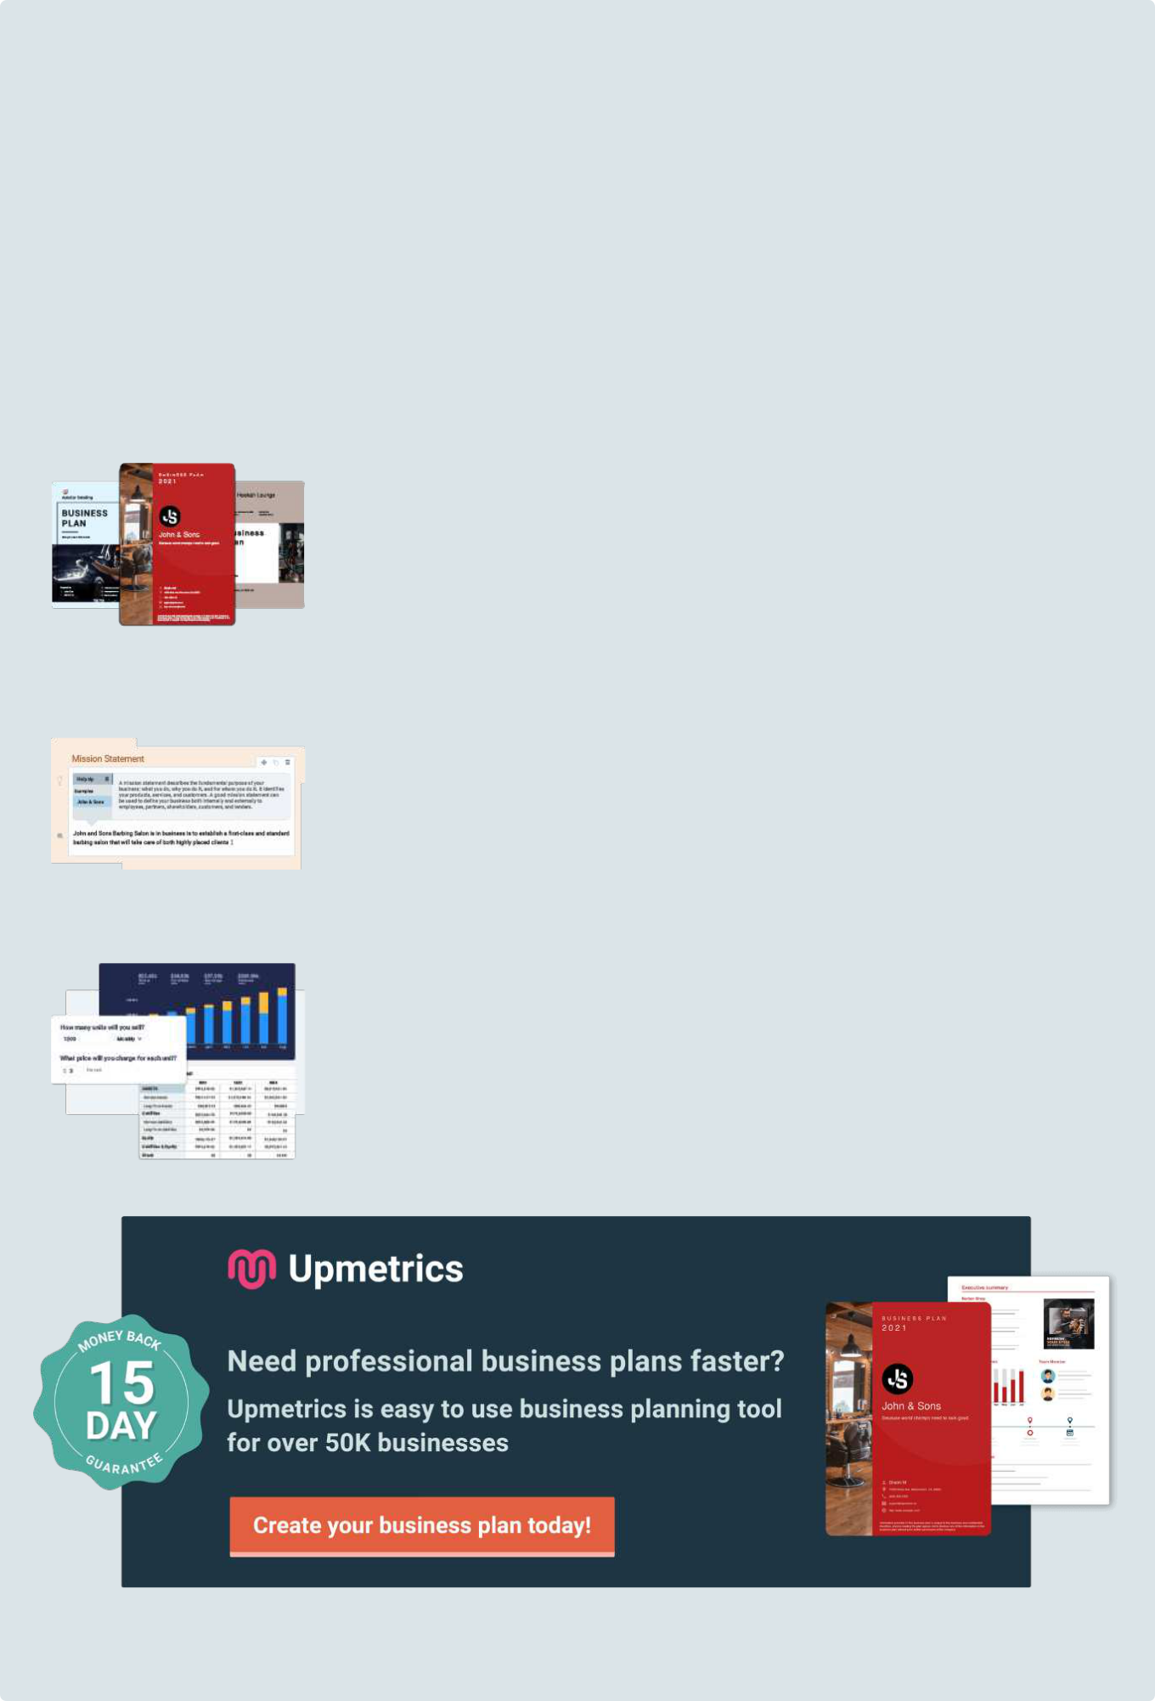
Easy to use Business Plan Software

Get started using a business plan template is always the fastest way to write your business plan, but as you know, you can't just fill in the blanks along with a template. You will need a collaborative tool that guides you on every step of your planning.

Upmetrics can help. With Upmetrics, you can easily bring your team to write a professional business plan with automated financial forecasts. You can also do:

200+ Sample business plans

Get access to hundreds of sample business plans covering almost all industries to kick start your business plan writing. This helps you to get an idea how the perfect business plan should look like.

View Sample Business Plans

Step-By-Step Guide

You'll receive step-by-step instruction as soon as you select any business plan template. We made business planning easy with prompt help and examples on every step of your business plan writing.

See How It Works

Conduct accurate financial projections

Do not worry about not having accounting skills. With Upmetrics, Simply enter your sales and costs figures, and we'll prepare all of your monthly/quarterly and yearly financial projections.

See How It Works

1.


Executive Summary

Business Overview

Mission Statement

Product/Service Summary

Market Opportunity Summary

Traction Summary

Next Steps

Vision Statement

Capital Request
Business Overview

Start Writing here...

Mission Statement

Start Writing here...

Product/Service Summary

Start Writing here...

Market Opportunity Summary

Start Writing here...

Traction Summary

Start Writing here...

Next Steps

Start Writing here...

Vision Statement

Start Writing here...

Capital Request

Start Writing here...

2.

Company Synopsis

Problem

Solution
Problem

Start Writing here...

Problem Analysis

Solution

Start Writing here...

3.

Market Overview

Industry Analysis

Market Size & Growth

Market Trends

Market Segments

Customers

Industry Success Stories
Industry Analysis

Start Writing here...

Market Size & Growth

Start Writing here...


Available Market | 10k

Served Market | 7k

Target Market | 5k

Market Trends

Start Writing here...

Market Segments

Start Writing here...

Customers

Start Writing here...

Industry Success Stories

Start Writing here...

4.

Product & Services

Products/Services

Market position

Unique selling position

Pricing strategy

Value to customer
Products/Services

Start Writing here...

Features


Product 1 | Product 2 | Product 3
Write something about a | Write something about a | Write something about a
feature. | feature. | feature.

Market position

Start Writing here...

Unique selling position

Start Writing here...

Pricing strategy

Start Writing here...

Value to customer

Start Writing here...

5.

Revenue Model

Revenue Channels

Pricing

COGS

Margins
Revenue Channels

Start Writing here...

Pricing

Start Writing here...

COGS

Start Writing here...

Margins

Start Writing here...

6.

Operating Model

Critical Costs

Cost Maturation & Milestones

Investment Costs

Operating Efficiencies
Critical Costs

Start Writing here...

Cost Maturation & Milestones

Start Writing here...

Investment Costs

Start Writing here...

Operating Efficiencies

Start Writing here...

7.

Competitive

Analysis

Competitors

Traction

Similarities & Differences
Competitors

Start Writing here...

Competitor 1

Competitor 2

Traction

Start Writing here...

Similarities & Differences

Start Writing here...

8.

Marketing Plan

Customer Definition

Customer Acquisition

SWOT – Internal and external forces

Launch Strategy and Budget

Distribution Channels
Customer Definition

Start Writing here...

Customer Acquisition

Start Writing here...

Channels

Start writing here...

Channel Cost Assumptions

Start writing here...

SWOT – Internal and external forces

Start Writing here...


Strengths

Mention positive tangible and intangible attributes. Internal to your organization. which are within the organization's control.


Weaknesses


Factors that are within an organization's control that detract from its ability to attain the core goal. In which areas might the organization improve?


Opportunities

External attractive factors that represent the reason for an organization to exist and develop. What opportunities exist in the environment which will propel the organization?

Threats

External factors, beyond an organization‘s control, which could place the organization‘s mission or operation at risk. The organization may benefit by having contingency plans to address them should they occur.

Launch Strategy and Budget

Explain your launch marketing strategy and then note your budget. Few businesses make their name purely on word-of-mouth; they need to promote their business to effectively set up their stall in the marketplace. The budget for this should be part of the start-up costs mentioned in the Finance section and reflect the total cost of the launch marketing tactics outlined in your marketing strategy.


Area Of Spend

Cost($)

[Cost title]

[Cost Amount]

Total

Distribution Channels

Start Writing here...

9.

Traction

Product Development

Manufacturing/Distribution

Early Customers & Revenue

Testimonials & Social Proof

Partnerships

Intellectual Property

Press Mentions
Product Development

Start Writing here...

Manufacturing/Distribution

Start Writing here...

Early Customers & Revenue

Start Writing here...

Testimonials & Social Proof

Start Writing here...

Partnerships

Start Writing here...

Intellectual Property

Start Writing here...

Press Mentions

Start Writing here...

10.

Management &

Organization

Management Team

Advisory Board Members

Organization Chart

Hiring Plan

Professional Services
Management Team


JOHN DOE

Owner & Founder- johnd@example.com

Advisory Board Members


JOHN DOE

Advisory board member- johnd@example.com

Organization Chart

Start Writing here...

Hiring Plan

Start Writing here...

Professional Services

Start Writing here...

11.

Funding

Funding Goal

Terms

Use of Funds

Milestones

Why Invest? / Conclusion
Funding Goal

Start Writing here...

Terms

Start Writing here...

Use of Funds

Start Writing here...

Milestones

What key milestones will you and your company be able to achieve with the help of this funding?

Date | Milestone
[Date 1] | [Name]
[Date 2] | [Name]
[Date 3] | [Name]
[Date 4] | [Name]
[Date 5] | [Name]

Why Invest? / Conclusion

Start Writing here...

12.

Financial Plan

Financial Position

Historical Performance

Income Statement

Cashflow

Balance Sheet

Break-Even Analysis

Capital Request
Financial Position

Start Writing here...

Historical Performance

Start Writing here...

Income Statement

A financial statement that showcases your revenues, expenses, and profit for a particular period and whether or not your business is profitable at that point in time. It is an important tool to help you determine if your plan is financially feasible.

 | Year1 | Year2 | Year3 | Year4 | Year5
Revenues
Product/Service-A | $151,200 | $333,396 | $367,569 | $405,245 | $446,783
Product/Service B | $100,800 | $222,264 | $245,046 | $270,163 | $297,855
Total Revenues | $252,000 | $555,660 | $612,615 | $675,408 | $744,638
Expenses & Costs
Cost of goods sold | $57,960 | $122,245 | $122,523 | $128,328 | $134,035
Lease | $60,000 | $61,500 | $63,038 | $64,613 | $66,229
Marketing | $20,000 | $25,000 | $25,000 | $25,000 | $25,000
Salaries | $133,890 | $204,030 | $224,943 | $236,190 | $248,000
Other Expenses | $3,500 | $4,000 | $4,500 | $5,000 | $5,500
Total Expenses & Costs | $271,850 | $412,775 | $435,504 | $454,131 | $473,263
EBITDA | ($19,850) | $142,885 | $177,112 | $221,277 | $271,374
Depreciation | $36,960 | $36,960 | $36,960 | $36,960 | $36,960
EBIT | ($56,810) | $105,925 | $140,152 | $184,317 | $234,414
Interest | $23,621 | $20,668 | $17,716 | $14,763 | $11,810
EBT | ($80,431) | $85,257 | $122,436 | $169,554 | $222,604

 | Year1 | Year2 | Year3 | Year4 | Year5
Net Operating Loss | ($80,431) | ($80,431) | $0 | $0 | $0
Income Tax Expense | $0 | $1,689 | $42,853 | $59,344 | $77,911
NET INCOME | ($80,431) | $83,568 | $79,583 | $110,210 | $144,693
Net Profit Margin (%) | - | 15.00% | 13.00% | 16.30% | 19.40%

Cashflow

Projected cash flow will help you determine if your plan can meet expenses, make debt payments and make it through the transition period.

 | Year1 | Year2 | Year3 | Year4 | Year5
CASH FLOW FROM OPERATIONS
Net Income (Loss) | ($80,431) | $83,568 | $79,583 | $110,210 | $144,693
Change in working capital | ($11,340) | ($1,625) | ($2,350) | ($2,133) | ($2,409)
Depreciation | $36,960 | $36,960 | $36,960 | $36,960 | $36,960
Net Cash Flow from Operations | ($54,811) | $118,902 | $114,193 | $145,037 | $179,244
CASH FLOW FROM INVESTMENTS
Investment | ($246,450) | $0 | $0 | $0 | $0
Net Cash Flow from Investments | ($246,450) | $0 | $0 | $0 | $0
CASH FLOW FROM FINANCING
Cash from equity | $0 | $0 | $0 | $0 | $0
Cash from debt | $317,971 | ($45,424) | ($45,424) | ($45,424) | ($45,424)
Net Cash Flow from Financing | $317,971 | ($45,424) | ($45,424) | ($45,424) | ($45,424)
SUMMARY
Net Cash Flow | $16,710 | $73,478 | $68,769 | $99,613 | $133,819
Cash at Beginning of Period | $0 | $16,710 | $90,188 | $158,957 | $258,570

 | Year1 | Year2 | Year3 | Year4 | Year5
Cash at End of Period | $16,710 | $90,188 | $158,957 | $258,570 | $392,389

Balance Sheet

You may also want to develop a projected balance sheet to evaluate how your plan will impact your solvency or net worth. It shows a summary of your business’ net worth at a particular point, breaking it into assets, liabilities, and capital.

 | Year1 | Year2 | Year3 | Year4 | Year5
ASSETS
Cash | $16,710 | $90,188 | $158,957 | $258,570 | $392,389
Accounts receivable | $0 | $0 | $0 | $0 | $0
Inventory | $21,000 | $23,153 | $25,526 | $28,142 | $31,027
Total Current Assets | $37,710 | $113,340 | $184,482 | $286,712 | $423,416
Fixed assets | $246,450 | $246,450 | $246,450 | $246,450 | $246,450
Depreciation | $36,960 | $73,920 | $110,880 | $147,840 | $184,800
Net fixed assets | $209,490 | $172,530 | $135,570 | $98,610 | $61,650
TOTAL ASSETS | $247,200 | $285,870 | $320,052 | $385,322 | $485,066
LIABILITIES & EQUITY
Debt | $317,971 | $272,546 | $227,122 | $181,698 | $136,273
Accounts payable | $9,660 | $10,187 | $10,210 | $10,694 | $11,170
Total Liabilities | $327,631 | $282,733 | $237,332 | $192,391 | $147,443
Share Capital | $0 | $0 | $0 | $0 | $0
Retained earnings | ($80,431) | $3,137 | $82,720 | $192,930 | $337,623
Total Equity | ($80,431) | $3,137 | $82,720 | $192,930 | $337,623
TOTAL LIABILITIES & EQUITY | $247,200 | $285,870 | $320,052 | $385,322 | $485,066

Break-Even Analysis

Start Writing here...

Capital Request

Start Writing here...

Want to make it more presentable?

Want help tips on each section?

You'll save time and can write your professional business plan effectively and faster with Upmetrics' business plan software.

Every feature you need to convert your great business idea into a reality.

Write your plan easily and faster without any hassles.

Structure your idea and create stunning pitches that awe your investors.

Get access to Upmetrics software, invite your team members and start writing your business plan.

1. Get tried and tested tips

Upmetrics business plan builder gives you everything you need to stay in sync and guides you on every step of your business plan writing.

2. Write an interactive plan

Use our business plan sections - competitive Analysis, comparison tables, SWOT Analysis, charts, timelines, milestones, etc to create a visually impactful business plan.

- Stunning business plan cover pages

Upmetrics business plan builder comes with beautifully designed cover pages. Choose professional, creative cover pages to make your business plan stand out.

4. Financial forecasting

With Upmetrics you don’t have to worry about navigating complex spreadsheets. Just input your numbers and we’ll provide you with well-structured financial reports that you and your investors understand.

5. Share easily with anyone

Upmetrics plans are easily shareable in pdf and word documents. And if either doesn’t work, you can share it with a quick link too and track the reader's activity!

6. Real-time and Collaborative

Invite your team members to initiate conversations, discuss ideas and strategies in real-time, share respective feedback, and write your business plan.

Join over 100k+ entrepreneurs who have used Upmetrics to create their business plans.

Start writing your business plan today

